UNITED STATES

SECURITIES AND EXCHANGE COMMISSION
Washington, D.C. 20549

FORM 8-K

CURRENT REPORT

PURSUANT TO SECTION 13 OR 15(D) OF THE

SECURITIES EXCHANGE ACT OF 1934, AS AMENDED

Date of Report (Date of earliest event reported): September 10, 2012

WYNN RESORTS, LIMITED

(Exact name of registrant as specified in its charter)

Nevada | 000-50028 | 46-0484987
(State or other jurisdiction | (Commission | (IRS Employer
of incorporation) | File Number) | Identification No.)
3131 Las Vegas Boulevard South
Las Vegas, Nevada |  | 89109
(Address of principal executive offices) |  | (Zip Code)

(702) 770-7555

(Registrant’s telephone number, including area code)

Not Applicable

(Former name or former address, if changed since last report.)

Check the appropriate box below if the Form 8-K filing is intended to simultaneously satisfy the filing obligation of the registrant under any of the following provisions:

- Written communications pursuant to Rule 425 under the Securities Act (17 CFR 230.425)

- Soliciting material pursuant to Rule 14a-12 under the Exchange Act (17 CFR 240.14a-12)

- Pre-commencement communications pursuant to Rule 14d-2(b) under the Exchange Act (17 CFR 240.14d-2(b))

- Pre-commencement communications pursuant to Rule 13e-4(c) under the Exchange Act (17 CFR 240.13e-4(c))

Item 7.01. Regulation FD Disclosure.

On September 10, 2012, Wynn Macau, Limited (“WML”), an indirect subsidiary of Wynn Resorts, Limited (the “Registrant”) with its ordinary shares listed on The Stock Exchange of Hong Kong Limited, filed its interim report in respect of the six months ended June 30, 2012 (the “Interim Report”) with The Stock Exchange of Hong Kong Limited. The Registrant owns approximately 72.3% of WML’s ordinary shares. The Interim Report is furnished herewith as Exhibit 99.1. The information in this Form 8-K and Exhibit 99.1 attached hereto shall not be deemed “filed” for purposes of Section 18 of the Securities Exchange Act of 1934, as amended, nor shall it be deemed incorporated by reference in any filing under the Securities Act of 1933, as amended, except as shall be expressly set forth by specific reference in such filing.

Item 9.01. |  | Financial Statements and Exhibits
(d) Exhibits.
Exhibit No. |  |  | Description
99.1 |  |  | Interim Report of Wynn Macau, Limited in respect of the six months ended June 30, 2012

SIGNATURES

Pursuant to the requirements of the Securities Exchange Act of 1934, as amended, the Registrant has duly caused this report to be signed on its behalf by the undersigned hereunto duly authorized.

 | WYNN RESORTS, LIMITED
Date: September 10, 2012 | By: | /s/ Matt Maddox
 | Name: | Matt Maddox
 | Title: | Chief Financial Officer and Treasurer

Exhibit 99.1
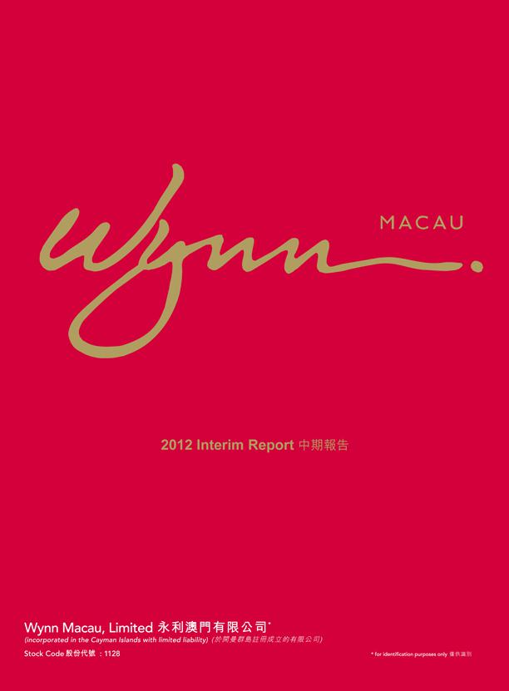

2012 Interim Report
ForWynnidentificationMacau,Limitedpurposes(incorporatedonly in the Cayman island with limited liability) Stock Code:1128

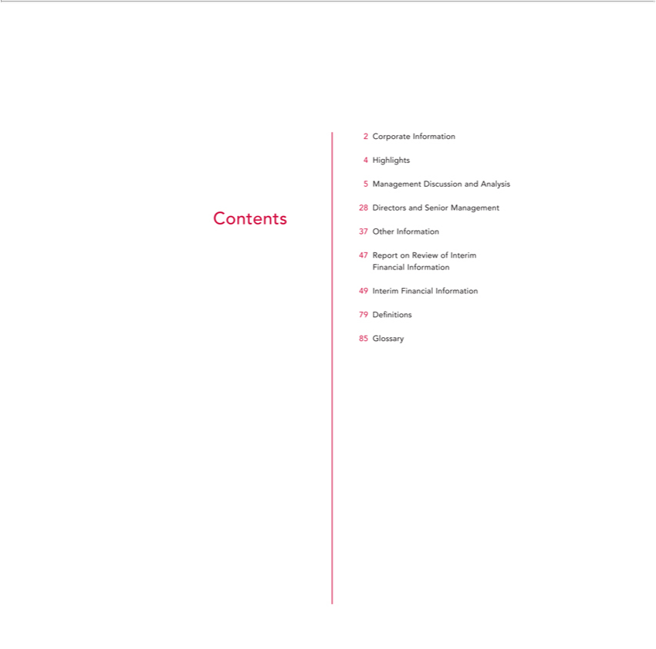

2 | Corporate Information
4 | Highlights
5 | Management Discussion and Analysis
28 | Directors and Senior Management
Contents
37 | Other
47 | ReportInformationReview of Interim
Financial Information
49 | Interim Financial Information
79 | Definitions
85 | Glossary

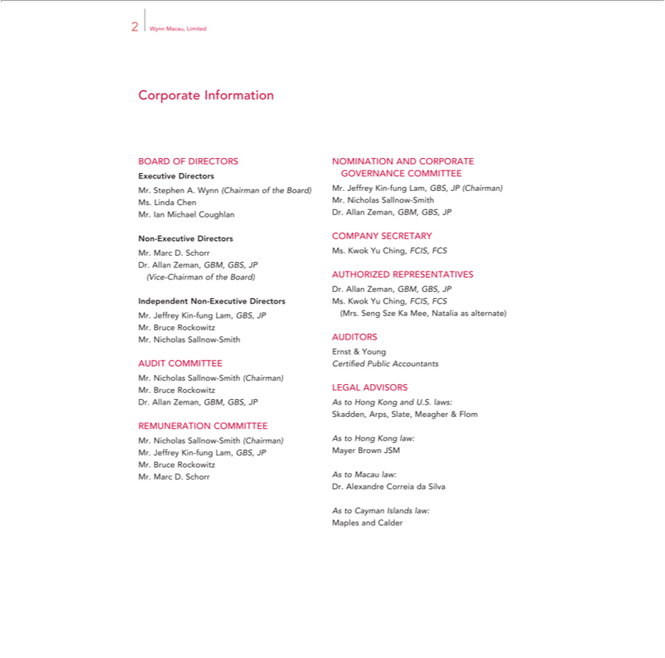

- Wynn Macau, Limited
Corporate Information

BOARD OF DIRECTORS Executive Directors
_{Mrs}. Stephen A. Wynn (Chairman of the Board)
. Linda Chen

. Ian Michael Coughlan Non-Executive Directors Mr. Marc D. Schorr
Dr. Allan Zeman, GBM, GBS, JP (Vice-Chairman of the Board) Independent Non-Executive Directors
Mr. Jeffrey Kin-fung Lam, GBS, JP Mr. Bruce Rockowitz Mr. Nicholas Sallnow-Smith

AUDIT COMMITTEE

Mr. Nicholas Sallnow-Smith (Chairman) Mr. Bruce Rockowitz Dr. Allan Zeman, GBM, GBS, JP REMUNERATION COMMITTEE
Mr. Nicholas Sallnow-Smith (Chairman) Mr. Jeffrey Kin-fung Lam, GBS, JP Mr. Bruce Rockowitz Mr. Marc D. Schorr

NOMINATION AND CORPORATE GOVERNANCE COMMITTEE

Mr. Jeffrey Kin-fung Lam, GBS, JP (Chairman) Mr. Nicholas Sallnow-Smith Dr. Allan Zeman, GBM, GBS, JP COMPANY SECRETARY
Ms. Kwok Yu Ching, FCIS, FCS AUTHORIZED REPRESENTATIVES

Dr. Allan Zeman, GBM, GBS, JP Ms. Kwok Yu Ching, FCIS, FCS (Mrs. Seng Sze Ka Mee, Natalia as alternate)
AUDITORS Ernst & Young

Certified? ed Public Accountants

LEGAL ADVISORS

As to Hong Kong and U.S. laws: Skadden, Arps, Slate, Meagher & Flom As to Hong Kong law:
Mayer Brown JSM As to Macau law:

Dr. Alexandre Correia da Silva As to Cayman Islands law: Maples and Calder

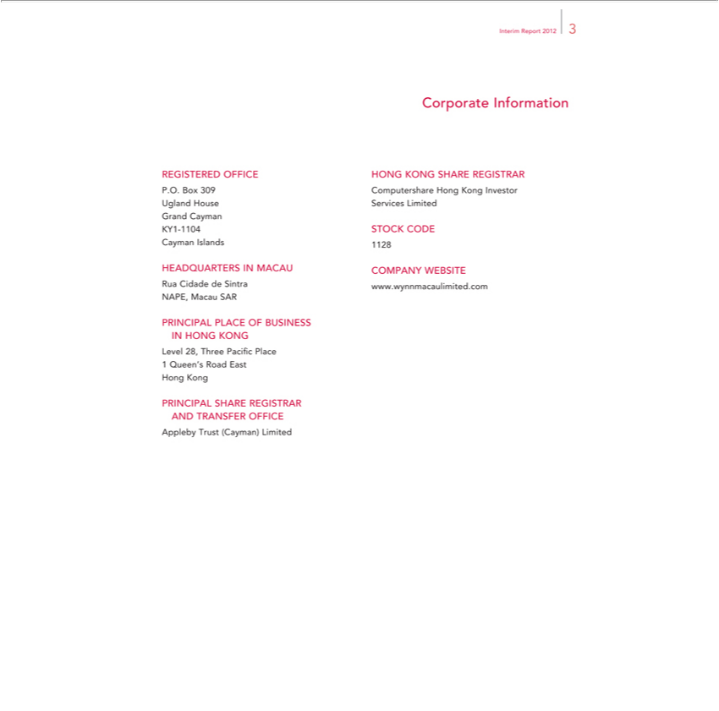

Interim Report 2012 3
Corporate Information
P.O.REGISTEREDBox309ComputershareOFFICEHONGHongKONGKongSHAREInvestorREGISTRAR
GrandUglandCaymanHouseServices Limited
CaymanKY1-1104IslandsSTOCK1128CODE
HEADQUARTERS IN MACAU COMPANY WEBSITE
NAPE,RuaCidadeMacaude SARSintra www.wynnmacaulimited.com
_{PRINCIP}HONGALKONGPLACE OF BUSINESS
Level 28, Three Pacific Place
Hong1 KongQueen’s Road East
ApplebyPRINCIPALNDTRANSFERSHARE^{OFFICE}REGISTRAR
rust (Cayman) Limited

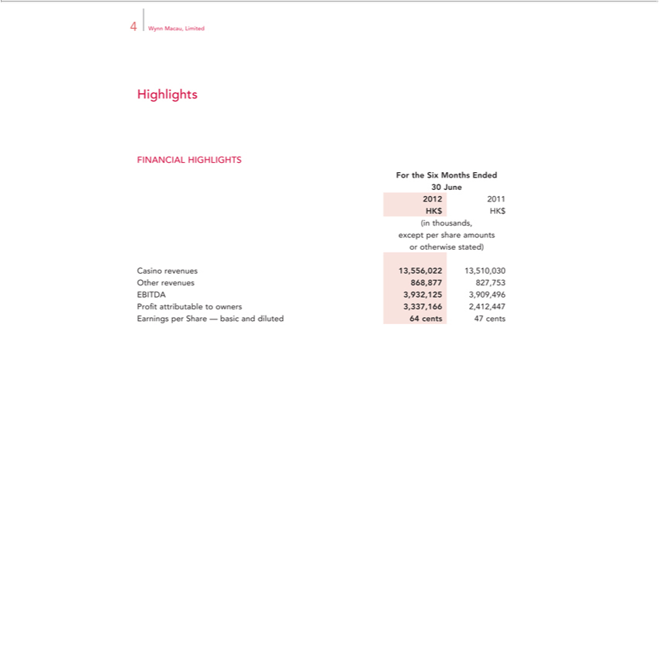

Highlights4Wynn Macau, Limited
^{For}INANCIAL HIGHLIGHTS
₂₀₁₂30Junethe Six Months Ended
2011
(inHKthousands,$HK$
orexceptotherwisepersharestated)amounts
OtherCasinorevenuesrevenues_{868,877}13556,0_{827,753}13,510,030
EBITDA 3,932,125 3,909,496
EarningsProfitattributableperShareto—ownersbasic and3,337,166diluted2,412,44764cents47 cents

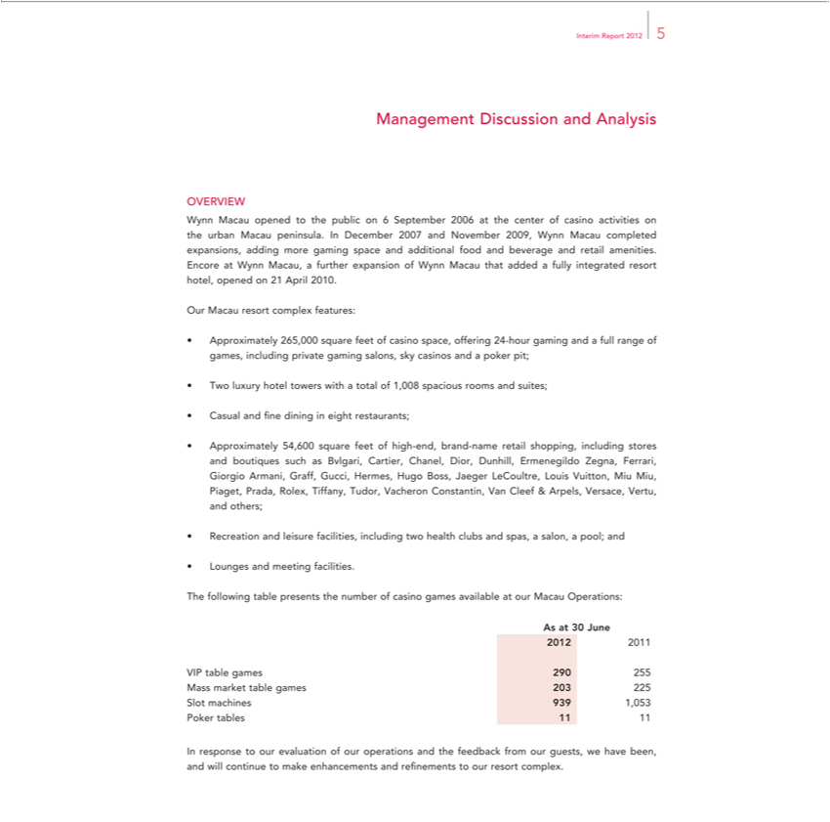

Interim Report 2012 5
Management Discussion and Analysis
OVERVIEW | Macau peninsula. In December 2007 and November 2009, Wynn Macau completed expansions, adding
Wynn Macau opened to the public on 6 September 2006 at the center of casino activities on the
more gaming space and additional food and beverage and retail amenities. Encore at Wynn Macau,urbanfurther expansion of Wynn Macau that added a fully integrated resort hotel, opened on 21 April 2010.
Our Macau resort complex features:
Approximately 265,000 square feet of casino space, offering 24-hour gaming and a full range of games, including private gaming salons, sky casinos and a poker pit;
Two luxury hotel towers with a total of 1,008 spacious rooms and suites;
Casual and fine dining in eight restaurants; |  | Dior Dunhill, Ermenegildo Zegna, Ferrari, Giorgio Armani, Graff,
Approximately 54,600 square feet of high-end, brand-name retail shopping, including stores and boutiques such as Bvlgari, Cartier,
Gucci, Hermes, Hugo Boss, Jaeger LeCoultre, Louis Vuitton, Miu Miu, Piaget, Prada, Rolex, Tiffany, Tudor, Vacheron Constantin, VChanel,Cleef & Arpels, Versace, Vertu, and others; Recreation and leisure facilities, including two health clubs and spas, a salon, a pool; and
Lounges and meeting facilities.
AsTheatfollowing30June table presents the number of casino games available at our Macau Operations:
2012 2011
VIP table games 290 255
SlotMassmachinesmarkettable939 games1,053 203 225
Poker tables 11 11
In response to our evaluation of our operations and the feedback from our guests, we have been, and will continue to make enhancements and refinements to our resort complex.

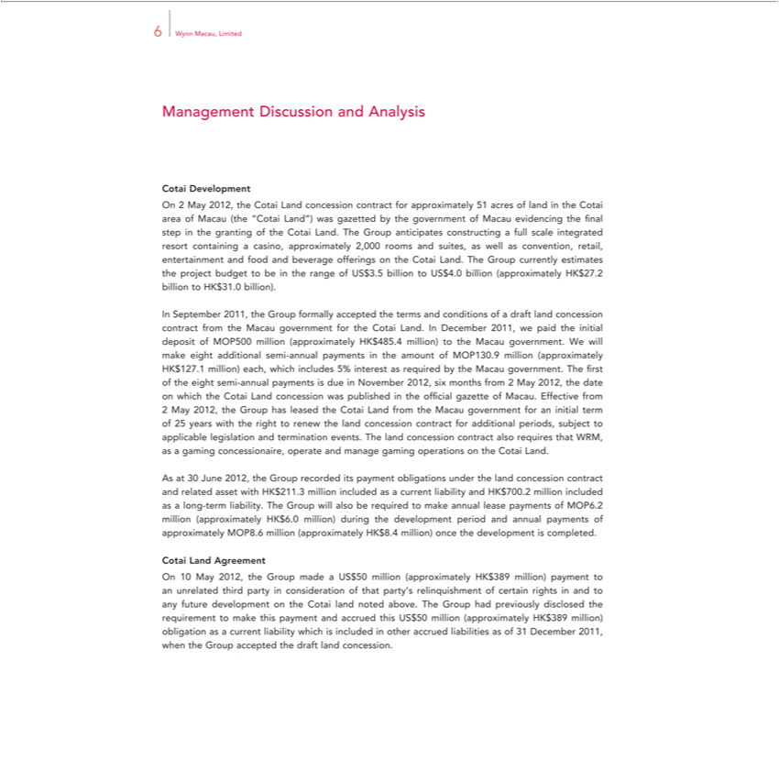

6 | Wynn Macau, Limited
Management Discussion and Analysis
Cotai Development |  |  | 51 acres of land in the Cotai |  | of Macau (the “Cotai Land”) was gazetted by the government of Macau evidencing the final step in the
On 2 May 2012, the Cotai Land concession contract for
granting of the Cotai Land. The Group anticipates constructingapproximatelyfullscale integrated resort |  |  |  |  | area casino, approximately 2,000 rooms and suites, as well as convention, retail, entertainment and food and
beverage offerings on the Cotai Land. The Group currently estimates the project budget to becontainingtherange of US$3.5 billion to US$4.0 billion (approximately HK$27.2 billion to HK$31.0 billion).
In September 2011, the Group formally accepted the terms and conditions of a draft land concession contract from the Macau government for the Cotai Land. In December 2011, we paid the initial deposit of
MOP500 million (approximately HK$485.4 million) to the Macau government. We will make eight additional semi-annual payments in the amount of MOP130.9 million (approximately HK$127.1 million)
each, which includes 5% |  | as required by the Macau government. The first of the eight semi-annual payments is due in November 2012, six months from 2 May 2012, the date on which the Cotai Land
concession was publishedinteresttheofficial gazette of Macau. Effective from |  |  |  |  |  | for additional periods, subject to applicable
2 May 2012, the Group has leased the Cotai Land from the Macau government for an initial term of 25 years with the right to renew the land concession |  |  |  |  |  | for additional periods, subject to applicable
 | and termination events. The land concession contract also requires that WRM, as |  |  | gaming concessionaire, operate and manage gaming |  | contract the Cotai Land.
legislationAs30June 2012, the Group recorded its payment obligations under the land concession contract and related asset with HK$211.3 million includedoperationsascurrent liability and HK$700.2 million_{approximately}includedas long-term liability. The Group will also be required to make annual lease payments of MOP6.2 million (approximately HK$6.0 million) during the development period and annual payments of

CotaiMOP8.6LandmillionAgreement(approximately HK$8.4 million) once the development is completed.

On 10 May 2012, the Group made a US$50 million (approximately HK$389 million) payment to an unrelated third party in consideration of that party’s relinquishment of certain rights in and to any future development on the Cotai land noted above. The Group had previously disclosed the requirement to make this payment and accrued this US$50 million (approximately HK$389 million) obligation as a current liability which is included in other accrued liabilities as of 31 December 2011, when the Group accepted the draft land concession.

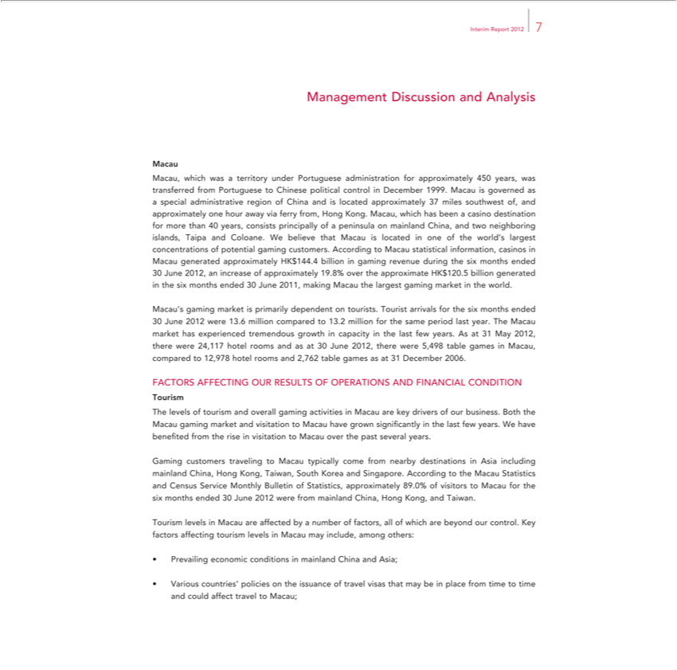

Interim Report 2012 7
Macau,nagement Discussion and Analysis
administrativewhich wasregionaterritoryofChinaunderandisPortugueselocatedapproximatelyadministration37formilesapproximatelysouthwestof,450islands,years,approximatelywastransferredonehourfromawayPortugueseviaferryto from,ChineseHongpoliticalKong.controlMacau,inwhichDecemberhasbeen1999.a casinoMacaudestinationisgovernedforasmoreaspecialthan 40 years, consists principally of peninsula on mainland China, and two neighboring Taipa and Coloane. We believe that Macau is located in one of the world’s largest concentrations of potential gaming
30customers.June2012,AccordinganincreasetoMacauofapproximatelystatsticalinformation,19.8%over casinostheapproximateinMacau HKgenerated$120.5 approximatelybilliongeneratedHKin$144.4thesixbillionmonthsin endedgaming30revenueJune2011,duringmakingthesixMacaumonthstheendedlargest gaming market in the world. Macau’s gaming market is primarily dependent on tourists. Tourist arrivals for the six months ended
24,11730Junehotel2012roomswere 13.6and asmillionat30 comparedJune2012,tothere13.2weremillion5,498for tablethesamegamesperiodinMacau,lastyear.comparedTheMacauto12,978markethotelhasroomsexperiencedand2,762tremendoustablegamesgrowthasatin31capacityDecemberinthe2006.last few years. As at 31 May 2012, there were FACTORS AFFECTING OUR RESULTS OF OPERATIONS AND FINANCIAL CONDITION
Theourismlevels of tourism and overall gaming activities in Macau are key drivers of our business. Both the Macau gaming market and visitation to Macau have grown significantly in the last few years. We have benefited from the risetravelingvisitation to Macau over the past several years.

ServiceGaming MonthlycustomersBulletin of Statistics,toMacau typicallyapproximatelycome 89.0%fromnearbyofvisitorsdestinationstoMacauin forAsiatheincludingsixmonthsmainlandended 30China,JuneHong2012 Kong,werefromTaiwan,mainlandSouthChina,Korea HongandSingapore.Kong,andAccordingTaiwan. to the Macau Statistics and Census Tourism levels in Macau are affected by number of factors, all of which are beyond our control. Key factors affecting tourism levels Macau may include, among others:
VariousPrevailingcountries’economicpoliciesconditionstheinissuancemainlandofChinatravelandvisasAsia;that may be in place from time to time and could affect travel to Macau;

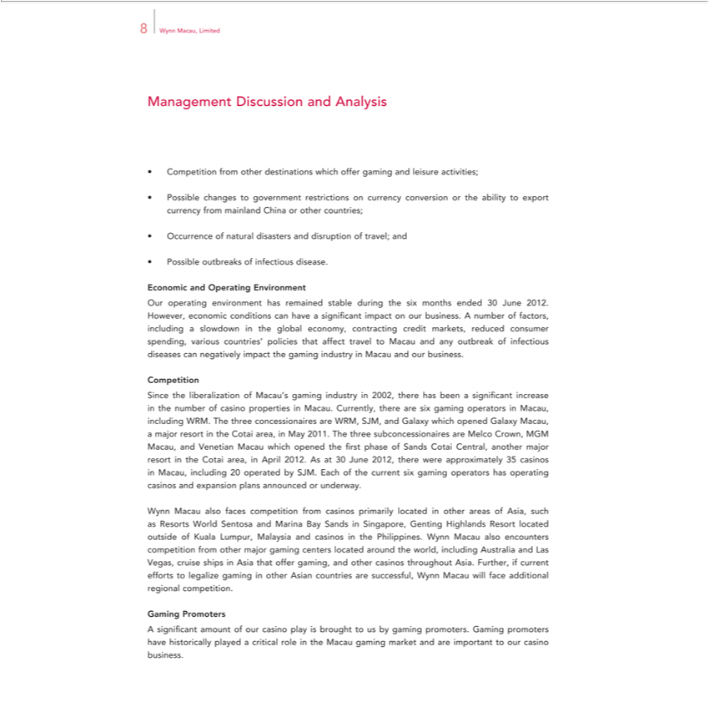

Wynn Macau, Limited 8
Management Discussion and Analysis
Competition from other destina ions which offer gaming and leisure activities;
Possible changes to government restrictions on currency conversion or the ability to export currency from mainland China or other countries;
Occurrence of natural disasters and disruption of travel; and
Possible outbreaks of infectious disease.
Economic and Operating Environment
Our | environment has remained stable during the six months ended 30 June 2012. However, economic conditions can have significant impact on our business. A number of factors, including
slowdownoperatingthe global economy, contracting credit markets, reduced consumer spending, various countries’ policies that affect travel to Macau and any outbreak of infectious diseases can negatively impact the
gaming industry in Macau and our business.
Competition |  |  |  | in the number of casino properties in Macau. Currently, there are six gaming operators in Macau, including
Since the liberalization of M cau’s gaming industry in 2002, there has been a significant
WRM. The three concessionaires are WRM, SJM, |  | Galaxy which opened Galaxy Macau, |  | major resort in the Cotai area, in May 2011. The three subconcessionaires are Melco Crown, MGM Macau, and
Venetian Macau which opened the first phase of Sands Cotai Central, another major resortincreasetheCotai area, in April 2012. As at 30 June 2012, there were approximately 35 casinos in Macau, including 20
operated by SJM. Each of the current six gaming operators has |  |  | casinos and expansion plans announced or underway. |  | Resort located outside of Kuala
Wynn Macau also faces competition from casinos primarily locatedoperatingother areas of Asia, such as Resorts World Sentosa and Marina Bay Sands in Singapore, Genting |  |  |  |  | Resort located outside of Kuala
Lumpur, Malaysia and casinos_{casinos}the Philippines. Wynn Macau also encounters competition from other major gaming centers located around the world, including AustraliaHighlandsLas Vegas, cruise ships in Asia
that offer gaming, and other throughout Asia. Further, if current efforts to legalize gaming in other Asian countries are successful, Wynn Macau will face additional regional competition. Gaming Promoters
A significant amount of our casino play is brought to us by gaming promoters. Gaming promoters have historically played a critical role in the Macau gaming market and are important to our casino business.

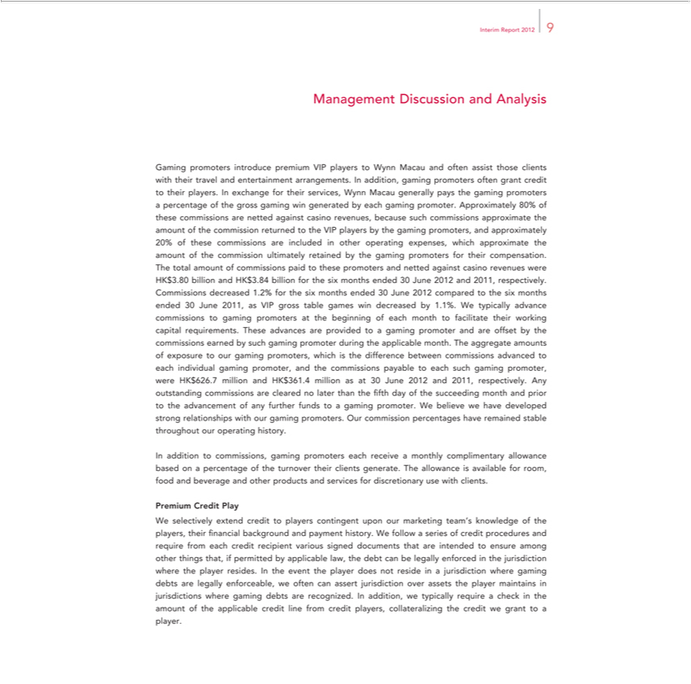

Interim Report 2012 9
Management Discussion and Analysis
Gaming promoters introduce premium VIP players to Wynn Macau and often assist those clients with their travel and entertainment arrangements. In addition, gaming promoters often grant credit to their
players. In exchange for their services, Wynn Macau generally pays the gaming promoters a percentage of the gross gaming win generated by each gaming promoter. Approximately 80% of these commissions
are netted against casino revenues, because such commissions approximate the amount of the commission returned to the VIP players by |  |  |  | gaming promoters, and approximately 20% of these commissions are
included in other operating expenses, which approximate the amount of the commission ultimately retained by the gaming promoters for their compensation. The total amount of commissions paid to these
promoters and netted against casino revenues were HK$3.80 billion and HK$3.84 billion for the six months ended 30 June 2012 and 2011, respectively. Commissions decreased 1.2% for the six months ended
30 June 2012 compared to the six months ended 30 June 2011, as VIP gross |  | games win decreased by 1.1%. W typically advance commissions to gaming promoters at the beginning of each month to
facilitate their working capital requirements. These advances are provided totablegaming promoter and are offset by the commissions earned by such gaming promoter during the applicable month. The aggregate
amounts of exposure to our gaming promoters, which is the difference between commissions advanced to each individual gaming promoter, and the commissions payable to each such gaming promoter, were
HK$626.7 million | HK$361.4 million as at 30 June 2012 and 2011, respectively. Any outstanding commissions are cleared no later than the fifth day of the succeeding month and prior to the advancement of
any further funds toandgaming promoter. W believe we have developed strong relationships with our |  |  | promoters. Our commission percentages have remained stable throughout our operating history.
In addition to commissions, gaming promoters each receive a monthly complimentary allowance basedgamingonpercentage of the turnover their clients generate. The allowance is available for room, food and
beverage and other products and services for discretionary use with clients.
Credit Play |  |  |  |  | follow a series of credit procedures and require from
PremiumWselectively extend credit to players contingent upon our marketing team’s knowledge of the players, their financial background and payment history. W
each credit recipient various signed documents that are intended to ensure among other things that, if permitted by applicable law, the debt can be legally enforced in the jurisdiction where the player resides. In
the event the player does not reside in a jurisdiction where gaming debts are legally enforceable, we often can assert jurisdiction over assets the player |  |  |  |  |  | in jurisdictions where gaming debts are
recognized. In addition, we typically require a check in the amount of the applicable credit line from credit players, collateralizing the credit we grant tomaintainsplayer.

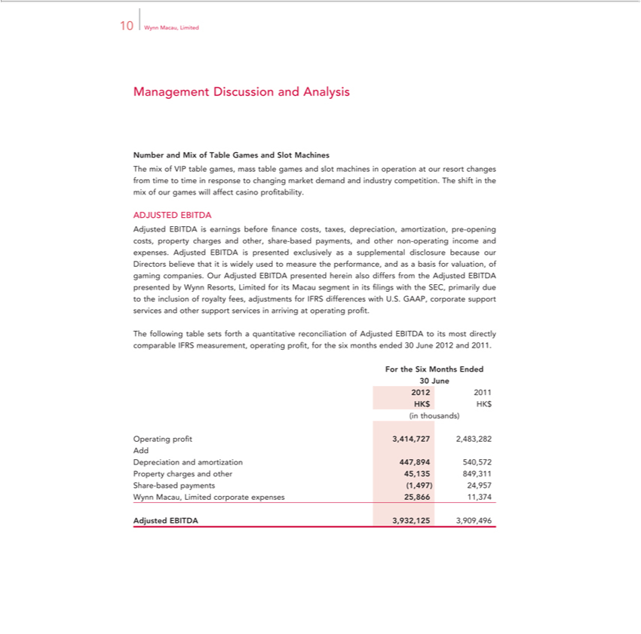

10 Wynn Macau, Limited
Management Discussion and Analysis
Number and Mix of Table Games and Slot Machines
The mix of VIP table games, mass table games and slot machines in operation at our resort changes from time to time in response to changing market demand and industry competition. The shift in the mix of
our games will affect casino profitability.
DJUSTED EBITDA
 | earnings before finance costs, taxes, depreciation, amortization, pre-opening costs, property charges and other, share-based payments, and other non-operating income and expenses.
 | is presented exclusively as a supplemental disclosure because our Directors believe that is widely used to measure the performance, and as a basis for valuation, of gaming companies. Our
Adjusted EBITDA presented herein also differs from the Adjusted EBITDA presented by Wynn Resorts, Limited for its Macau segment in its Filings with the SEC, primarily due to the inclusion of royalty fees,
adjustments for IFRS differences with U.S. GAAP, corporate support services and other support services in arriving at operating profit.
The following table sets forth a quantitative reconciliation of Adjusted EBITDA to its most directly comparable IFRS measurement, operating profit, for the six months ended 30 June 2012 and 2011.
For the Six Months Ended
30 June
2012 | 2011
(inHKthousands)$HK$
Depreciation and amortization 447,894 540,572
Property charges and other 45,135 849,311
Share-based payments (1,497) 24,957
Wynn Macau, Limited corporate expenses 25,866 11,374
Adjusted EBITDA

3,909,496³²¹²⁵

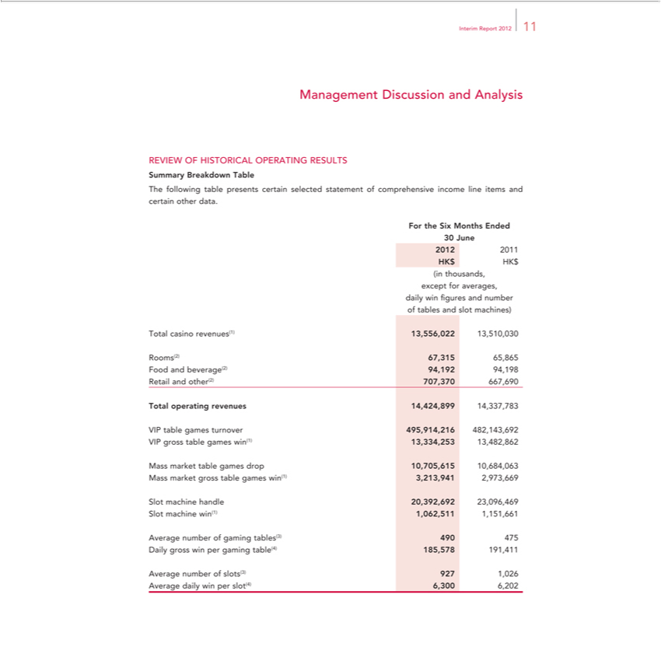

InterimManagementReportDiscussion201211 and Analysis
REVIEW OF HISTORICAL OPERATING RESULTS
TheSummaryfollowingBreakdowntablepresentsTable certain selected statement of comprehensive income line items and certain other data.
For the Six Months Ended
302012June2011
HK$ HK$
except(inthousands,foraverages,
daily win figures and number
Totaloftablescasinoandrevenues(1)slotmachines)13,556,022 13,510,030
Rooms(2) 67,315 65,865
RetailFoodandandbeverage(2)other(2)707,37094,192667,69094,198
Total operating revenues 14,424,899 14,337,783
VIP grosstable gamestablegamesturnoverwin(1)495,914,21613,334,253482,143,69213,482,862
table games drop 10,705,615 10,684,063
SlotMassmachinemarket grosshandletable20,392,692gameswin(1)23,096,4693,213,941 2,973,669
win(1) 1,062,511 1,151,661
DailyAveragegrossnumberwinperof gaminggaming tables(3)table(4) 185,578490475 191,411
Average dailynumberwinofperslots(3)slot(4)9276,3001,266,202

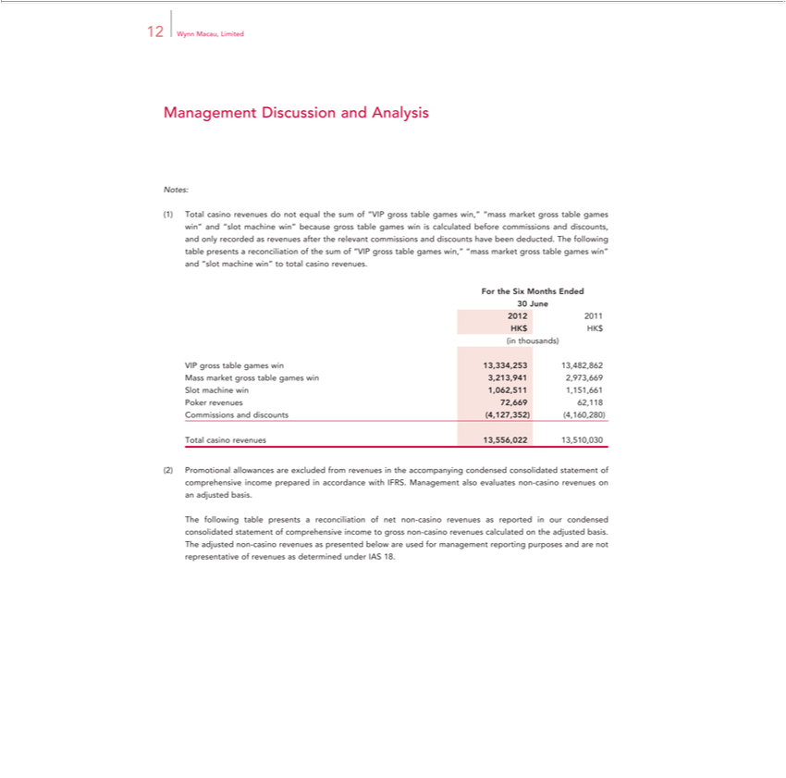

12 Wynn Macau, Limited
Management Discussion and Analysis
Notes:
(1) Total casino revenues do not equal the sum of “VIP gross table games win,” “mass market gross table games win” and “slot machine win” because gross table games win is calculated before commissions and
discounts, and only recorded as revenues after the relevant commissions and discounts have been deducted. The following table presents a reconciliation of the sum of “VIP gross table games win,” “mass market
gross table games win” and “slot machine win” to total casino revenues.
For the Six Months Ended
30 June
2012 | 2011
HK$ HK$
(in thousands)
VIP gross table games win 13,334,253 13,482,862
Mass market gross table games win 3,213,941 2,973,669
Slot machi win 1,062,511 1,151,661
Poker revenues 72,669 62,118
Commissions and discounts (4,127,352) (4,160,280)
Total casino revenues 13,556,022 13,510,030
(2)Pr | motional | are excluded from revenues in the accompanying condensed consolidated statement of comprehensive income prepared in accordance with IFRS. Management also evaluates non-
casino revenuesallowanceson |  | basis.
The following table presentsadjustedreconciliation of net non-casino revenues as reported in our condensed consolidated statement of comprehensive income to gross non-casino revenues calculated on the adjusted basis.

The adjusted non-casino revenues as presented below are used for management reporting purposes and are not representative of revenues as determined under IAS 18.

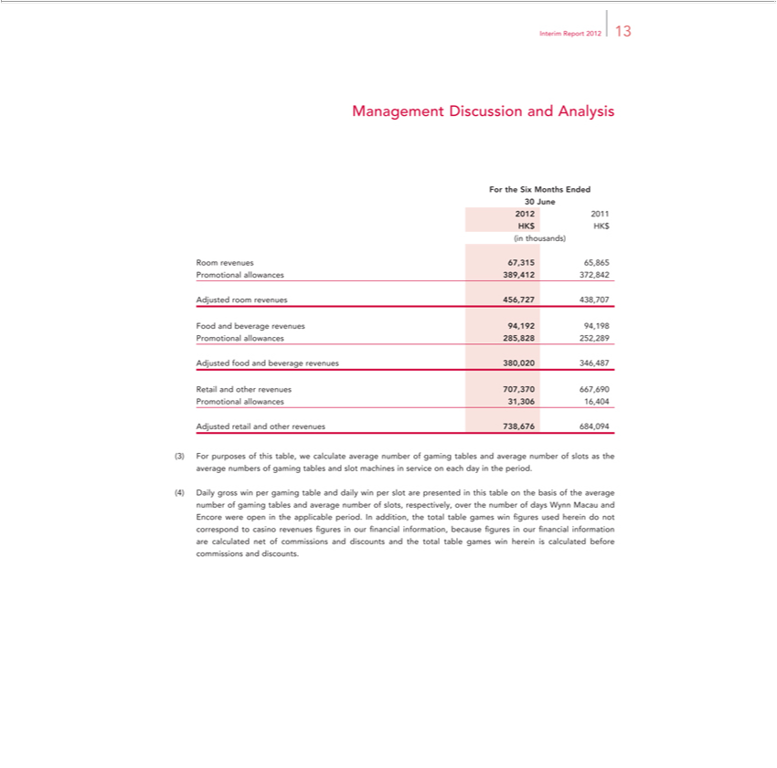

Interim Report 2012 13
ForManagementtheSixMonthsDiscussionEndedand Analysis
₂₀₁₂30June
2011 HK$ HK$ (in thousands)
AdjustedRoomrevenuesroomrevenues67,31565,865456,727Promotional438,707 allowances 389,412 372,842
AdjustedFoodand foodbeverageand beveragerevenues revenues94,19294,198380,020Promotional346,487 allowances 285,828 252,289
AdjustedRetailandretailotherandrevenuesotherrevenues707,370 667,690738,676 Promotional684,094 allowances 31,306 16,404

⁽⁴⁾3^{Daily}Forpurposes of this table, we calculate average number of gaming tables and average number of slots as the average numbers of gaming tables and slot machines in service on each day in the period. gross win per gaming table and daily win per slot are presented in this table on the basis of the average number of gaming tables and average number of slots, respectively, over the number of days

Wynn Macau and Encore were open in the applicable period. In addition, the total table games win figures used herein do not correspond to casino revenues figures in our financial information, because figures in our financial information are calculated net of commissions and discounts and the total table games win herein is calculated before commissions and discounts.

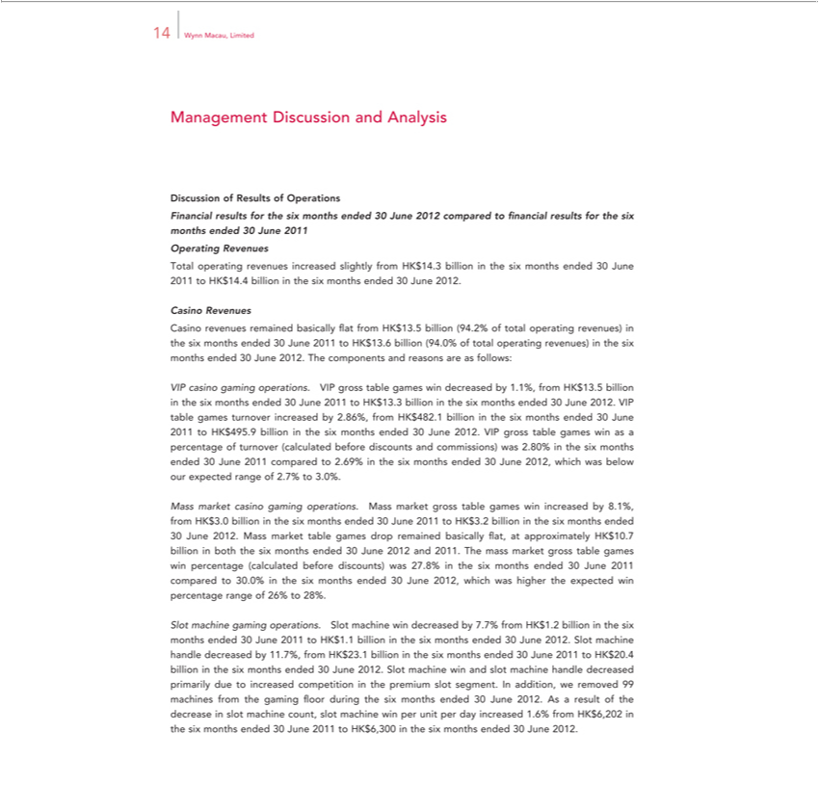

14 Wynn Macau, Limited
Management Discussion and Analysis
Discussion of Results of Operations
Financ al results for the six months ended 30 June 2012 compared to financial results for the six months ended 30 June 2011
Operating Revenues
Total operating revenues increased slightly from HK$14.3 billion in the six months ended 30 June 2011 to HK$14.4 billion in the six months ended 30 June 2012.
Revenues
Casino revenues remained basically flat from HK$13.5 billion (94.2% of total operating revenues) in the six months ended 30 June 2011 to HK$13.6 billion (94.0% of total operating revenues) in the six months
ended 30 June 2012. The components and reasons are as follows:
VIP casino gaming operations. VIP gross table games win decreased by 1.1%, from HK$13.5 billion in the six months ended 30 June 2011 to HK$13.3 billion in the six months ended 30 June 2012. VIP table
games turnover increased by 2.86%, from HK$482.1 billion in the six months ended 30 June 2011 to HK$495.9 billion in the six months ended 30 June 2012. VIP gross table games win as a percentage of
urnover (calculated before discounts and commissions) was 2.80% in the six months ended 30 June 2011 compared to 2.69% in the six months ended 30 June 2012, which was below our expected range of 2.7%
to 3.0%.
Mass market casino gaming operations. Mass market gross table games win increased by 8.1%, from HK$3.0 billion in the six months ended 30 June 2011 to HK$3.2 billion in the six months ended 30 June
2012. Mass market table games drop | basically flat, at approximately HK$10.7 billion in both the six months ended 30 June 2012 and 2011. The mass market gross table games win percentage
(calculated before discounts) was 27.8%remainedthe six months ended 30 June 201 compared to 30.0% in the six months ended 30 June 2012, which was higher the expected win percentage range of 26% to 28%.
Slot machine gaming operations. Slot | win decreased by 7.7% from | .2 billion in the six months ended 30 June 2011 to HK$1.1 billion the six months ended 30 June 2012. Slot machine handle
decreased by 11.7%, from HK$23.1 billionmachinethe six months ended 30 June 201HK$1to HK$20.4 billion the six months ended 30 June 2012. Slot machine win |  |  | slot machine handle decreased primarily due to
increased competition in the premium slot segment. In addition, we removed 99 |  | from the gaming floor during the six months ended 30 June 2012. Asandresult of the decrease in
slot machine count, slot machine win per unit per day increased 1.6% from HK$6,202machinesthe six months ended 30 June 2011 to HK$6,300 in the six months ended 30 June 2012.

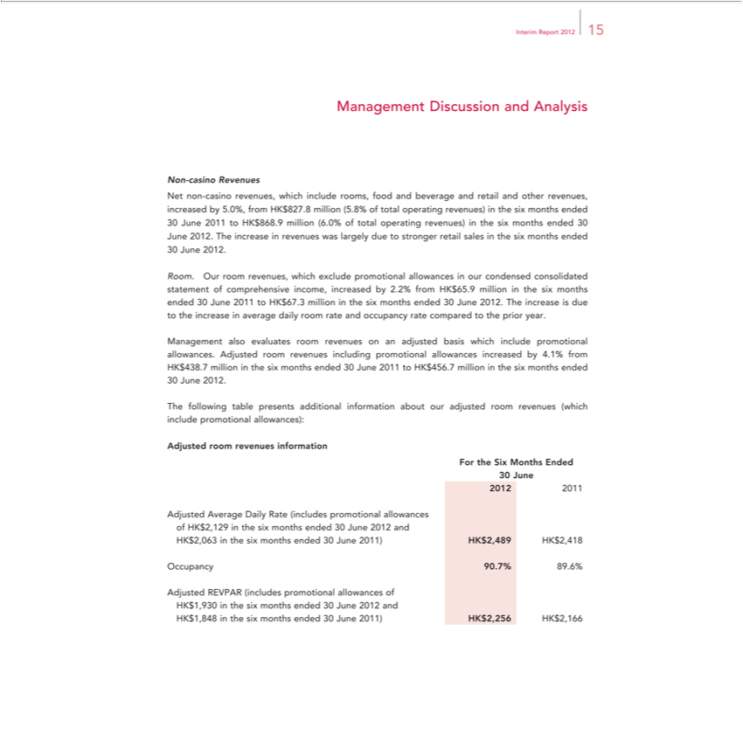

Interim Report 2012 15
^{Net}Managementon-casinoRevenuesDiscussion and Analysis
non-casino revenues, which include rooms, food and beverage and retail and other revenues, increased by 5.0%, from HK$827.8 million (5.8% of _{to}tal_{stronger}perating revenues) in the six months ended
^{30 June} ²⁰¹².to HK$868.9 million (6.0% of total operating revenues) in the six months ended 30 June 2012. The increase in revenues was largely due retail sales in the six months ended
Room. Our room revenues, which exclude promotional allowances in our condensed consolidated statement of comprehensive income, increased by 2.2% from HK$65.9 million in the six months ended 30 June 2011 to HK$67.3 million in the six months ended 30 June 2012. The increase is due to the increase in average daily room rate and occupancy rate compared to the prior year.

Management also evaluates room revenues on an adjusted basis which include promotional allowances. Adjusted room revenues including promotional allowances increased by 4.1% from HK$438.7 million in the six months ended 30 June 2011 to HK$456.7 million in the six months ended
30 June 2012.
AdjustedThefollowingroomtablerevenuespresentsinformationadditional information about our adjusted room revenues (which include promotional allowances):
For the Six Months Ended
₂₀₁₂30June
2011
ofAdjustedHK$2,129AverageintheDailysixmonthsRate(includesended30promotionalJune2012 andallowances
OccupancyHK$2,063in90.7%thesix89.6%months ended 30 June 2011) HK$2,489 HK$2,418
HKAdjusted$1,848⁹³⁰REVPARinthesix(includesmonthsendedpromotional30Juneallowances201^{2and} of
1) HK$2,256 HK$2,166

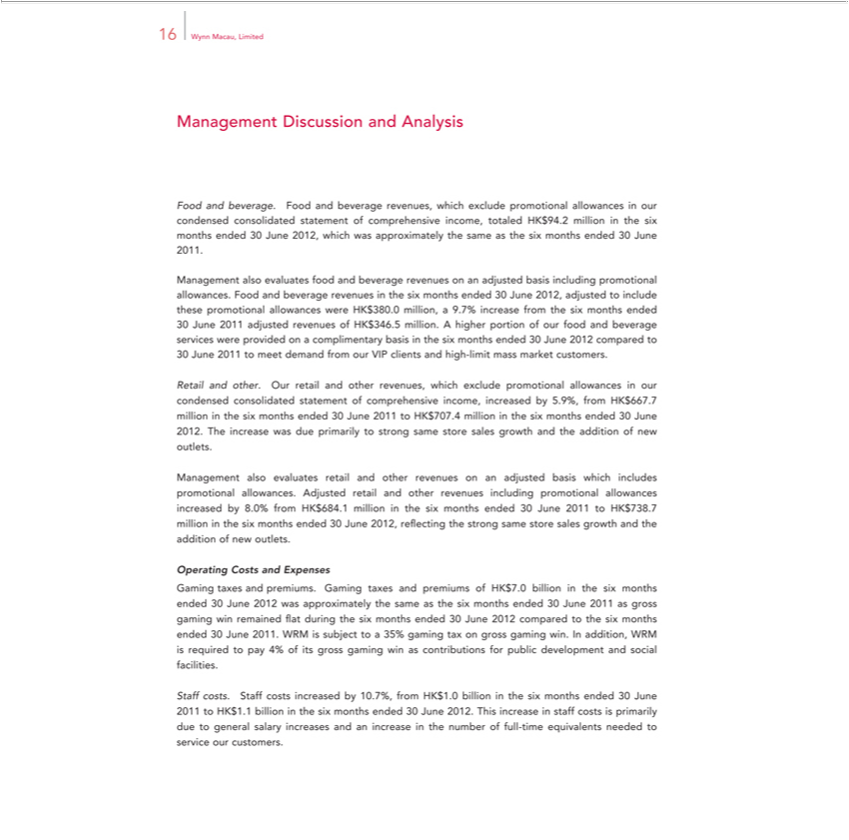

16 Wynn Macau, Limited
Management Discussion and Analysis
Food and beverage. Food and beverage revenues, which exclude promotional allowances in our condensed consolidated statement of comprehensive income, totaled HK$94.2 million in the six months ended
30 June 2012, which was approximately the same as the six months ended 30 June 2011.
Management also evaluates food and beverage revenues on an adjusted basis including promotional allowances. Food and beverage revenues in the six months ended 30 June 2012, adjusted to include these
promotional allowances were HK$380.0 million, a 9.7% increase from the six months ended
adjusted revenues of HK$346.5 million. A higher portion of our food and beverage services were provided on a complimentary basis in the six months ended 30 June 2012 compared to
30 June 2011 to meet demand from our VIP clients and high-limit mass market customers.
Retail and other. Our retail and other revenues, which exclude promotional allowances in our condensed consolidated statement of comprehensive income, increased by 5.9%, from HK$667.7 million in the six
months ended 30 June 2011 to HK$707.4 million in the six months ended 30 June 2012. The increase was due primarily to strong same store sales growth and the addition of new outlets.
Management also evaluates retail and other revenues on an adjusted basis which includes promotional allowances. Adjusted retail and other revenues including promotional allowances increased by 8.0% from
HK$684.1 million in the six months ended 30 June 2011 to HK$738.7 million in the six months ended 30 June 2012, reflecting the strong same store sales growth and the addition of new outlets.
Operating Costs and Expenses | the same as the six months ended 30 June 2011 as gross gaming win
Gaming taxes and premiums. Gaming taxes and premiums of HK$7.0 billion in the six months ended 30 June 2012 was
remained fl at during the six months ended 30 June 2012 compared to the six months ended 30 June 2011. WRM is subjectapproximatelyto35%gaming tax on gross gaming win. In addition, WRM is required to pay 4% of its gross gaming win as contributions for public development and social facilities.
Staff costs. Staff costs increased by 10.7%, from HK$1.0 billion in the six months ended 30 June 2011_{customers}HK$1.1 billion in the six months ended 30 June 2012. This increase in staff costs is primarily due to
general salary increases and an increase in the number of full-time equivalents needed to service our .

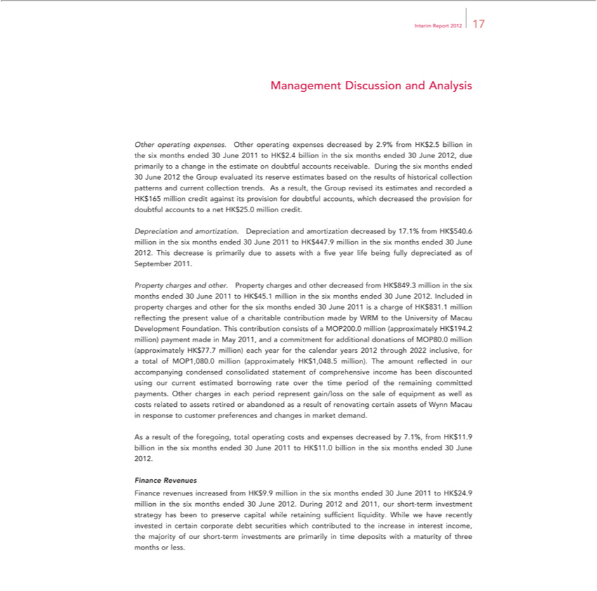

Interim Report 2012 17
Management Discussion and Analysis
Other | expenses. Other operating expenses decreased by 2.9% from HK$2.5 billion in the six months ended 30 June 2011 to HK$2.4 billion in the six months ended 30 June 2012, due primarily to a
changeoperatingtheestimate on doubtful accounts receivable. During the six months ended
30 June 2012 the Group evaluated its reserve estimates based on the results of historical collection patterns and current collection trends. As a result, the Group revised its estimates and recorded a HK$165
million credit against its provision for doubtful accounts, which decreased the provision for doubtful accounts to a net HK$25.0 million credit.
Depreciation and amortization. |  |  | and amortization decreased by 17.1% from HK$540.6 million in the six months ended 30 June 2011 to HK$447.9 million in the six months ended 30 June 2012. This
decrease is primarily due to assetsDepreciationwithfive year life being fully depreciated as of September 2011.
Property charges and |  | . Property charges and other |  | from HK$849.3 million in the six months ended 30 June 2011 to HK$45.1 million in the six months ended 30 June 2012. Included in property
charges and other for othersix months ended 30 June |  |  |  | decreased1ischarge of HK$831. million reflecting the present value of a charitable contribution made by WRM to the University of Macau Development
Foundation. This contribution consists of |  |  | MOP200.201million (approximately HK$194.2 million) payment made in May 2011, and a commitment for additional donations of MOP80.0 million (approximately
HK$77.7 million) each year for the calendar years 2012 through 2022 inclusive, for a total of MOP1,080.0 million (approximately HK$1,048.5 million). The amount reflected in our |  |  |  |  | condensed
consolidated statement of comprehensive income has been discounted using our current estimated borrowing rate over the time period of the remaining committed payments. Other chargesaccompanyingeachperiod represent gain/loss on the sale of equipment as well as costs related to assets retired or abandoned as a result of renovating certain assets of Wynn Macau in response to customer preferences and changes in _{market} demand.

As result of the foregoing, total operating costs and expenses decreased by 7.1%, from HK$11.9 billion in the six months ended 30 June 2011 to HK$11.0 billion in the six months ended 30 June 2012. _{Finance} Revenues
revenues increased from HK$9.9 million in the six months ended 30 June 2011 to HK$24.9 million in the six months ended 30 June 2012. During 2012 and 2011, our short-term investment strategy has been to preserve capital while retaining sufficient liquidity. While we have recently invested in certain corporate debt securities which contributed to the increase in interest income, the majority of our short-term investments are primarily in time deposits with a maturity of three months or less.

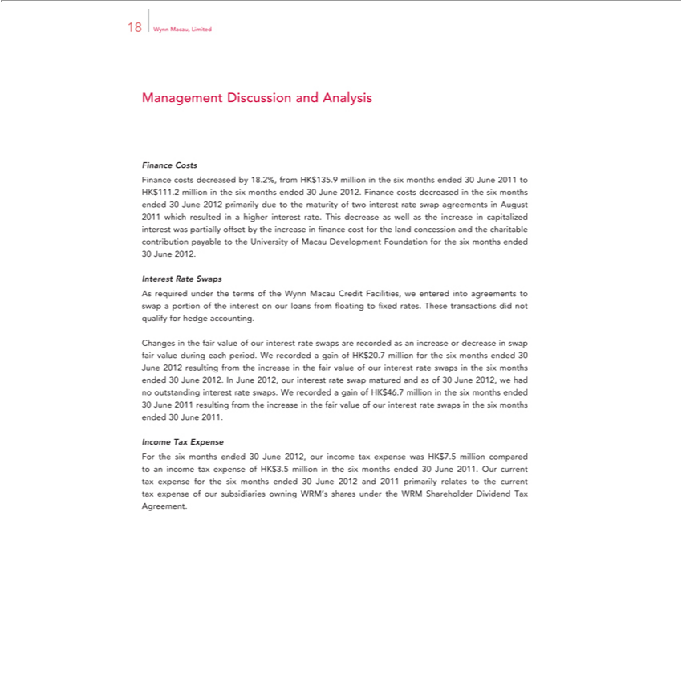

18 Wynn Macau, Limited
Management Discussion and Analysis
Costs |  |  |  | 1 to HK$111.2 million in the six months ended 30 June 2012. Finance costs decreased in the six months ended
Finance costs decreased by 18.2%, from HK$135.9 million in the six months ended 30 June
30 June 2012 primarily due to the maturity of two interest rate swap agreements in August 201201 which resulted in a higher interest rate. This decrease as well as the increase in capitalized interest was partially
offset by the increase in finance cost for the land concession and the charitable contribution payable to the University of Macau Development Foundation for the six months ended
30 June 2012.
Interest Rate Swaps
As required under the terms of the Wynn Macau Credit Facilities, we entered into agreements to swap a portion of the interest on our loans from floating to fixed rates. These transactions did not qualify for
hedge | .
Changesaccountingthefair value of our interest rate swaps are recorded as an increase or decrease in swap fair value during each period. W recorded gain of HK$20.7 million for the six months ended 30 June 2012
esulting from the |  | the fair value of our | rate swaps in the six months ended 30 June 2012. In June 2012, our interest rate swap matured and as of 30 June 2012, we had no outstanding interest
rate increase gain interest
swaps. W_{resulting}recorded of HK$46.7 million the six months ended
Income30June Tax2011Expense from the increase in the fair value of our interest rate swaps in the six months ended 30 June 2011.

For the six months ended 30 June 2012, our income tax expense was HK$7.5 million compared to an income tax expense of HK$3.5 million in the six months ended 30 June 2011. Our current tax expense for the six months ended 30 June 2012 and 2011 primarily relates to the current tax expense of our subsidiaries owning WRM’s shares under the WRM Shareholder Dividend Tax Agreement.

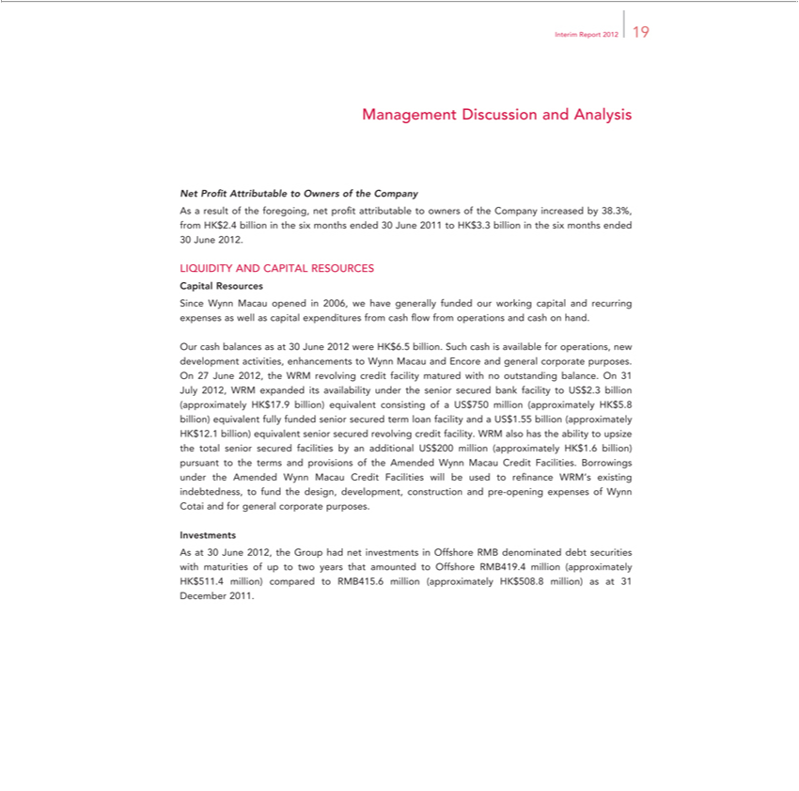

Interim Report 2012 19
Management Discussion and Analysis
Net Profit Attributable to Owners the Company
As a result of the foregoing, net profit attributable to owners of the Company increased by 38.3%, from HK$2.4 billion in the six months ended 30 June 2011 to HK$3.3 billion in the six months ended
30 June 2012.
LIQUIDITY AND CAPITAL RESOURCES
Capital Resources
Since Wynn Macau opened in 2006, we have generally funded our working capital and recurring expenses as well as capital expenditures from cash flow from operations and cash on hand.
Our cash balances as at 30 June 2012 were HK$6.5 billion. Such cash is available for operations, new development activities, enhancements to Wynn Macau and Encore and general corporate purposes. On
27 June 2012, the WRM revolving credit | matured with no outstanding balance. On 31 July 2012, WRM expanded its availability under the senior secured bank facility to US$2.3 billion (approximately
HK$17.9 billion) equivalent consisting offacilityUS$750 million (approximately HK$5.8 billion) equivalent fully funded senior secured term loan facility and US$1.55 billion (approximately HK$12.1 billion)
equivalent senior secured revolving credit facility. WRM also has the ability to upsize the total senior secured facilities by an additional US$200 million (approximately HK$1.6 billion) pursuant to the terms and
provisions of the Amended Wynn Macau Credit Facilities. Borrowings under the Amended Wynn Macau Credit Facilities will be used to refinance WRM’s existing indebtedness, to fund the design,
development, construction and pre-opening expenses of Wynn Cotai and for general corporate purposes.
Investments |  | debt securities with maturities of up to two years that amounted to Offshore RMB419.4 million (approximately HK$511.4
As at 30 June 2012, the Group had net investments in Offshore RMB
million) compared to RMB415.6 million (approximately HK$508.8 million)denominatedas31 December 2011.

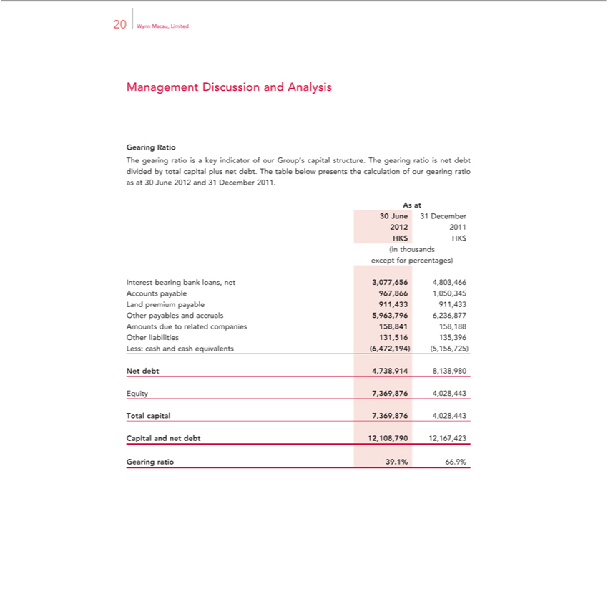

20 Wynn Macau, Limited
Management Discussion and Analysis
Gearing Ratio
The gearing ratio is a key indicator of our Group’s capital structure. The gearing ratio is net debt divided by total capital plus net debt. The table below presents the calculation of our gearing ratio as at 30 June 2012 and 31 December 2011.
As at
²⁰¹²30June ³¹ December
201
(inHKthousands$HK$
except for percentages)
AccountsInterest-bearingpayablebank967,866loans,1,050,345net3,077,656 4,803,466
Land premium payable 911,433 911,433
Other payables and accruals 5,963,796 6,236,877
OtherAmountsliabilitiesdueto 131,516relatedcompanies135,396 158,841 158,188
NetLess:debtcash_{7,369,876}4,73and,914cash_{4,028,443}8,138,980equivalents (6,472,194) (5,156,725)
Equity
Total capital 7,369,876 4,028,443
GearingCapitalandrationet39.1%debt 12,108,79066.9% 12,167,423

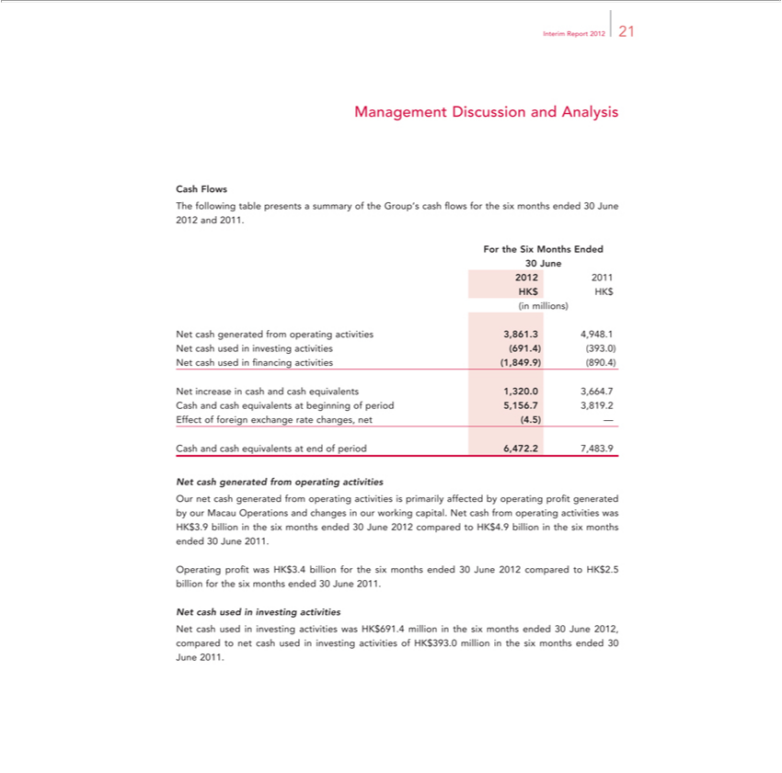

Interim Report 2012 21
Management Discussion and Analysis
Cash Flows
The following table presents a summary of the Group’s cash flows for the six months ended 30 June 2012 and 2011.
For the Six Months Ended
30 June
2012 | 2011
HK$ HK$
(in millions)
 | generated from operating activities 3,861.3 4,948.1
 | investing activities (691.4) (393.0)
cash used in financing activities (1,849.9) |  | .4)
Net increase in cash and cash equivalents 1,320.(8903,664.7
Cash and cash equivalents at beginning of period 5,156.7 3,819.2
Effect of foreign exchange rate changes, net (4.5) —
Cash and cash equivalents end of period 6,472.2 7,483.9
Net cash generated from operating activities |  |  | profit generated by our Macau Operations and changes in our working capital. Net cash from operating activities was HK$3.9
Our net cash generated from operating activities is primarily affected by
billion the six months ended 30 June 2012 co |  | pared to HK$4.9 billionoperatingthesix months ended 30 June 2011.
Operating profit was HK$3.4 billion for the six months ended 30 June 2012 compared to HK$2.5 billion for the six months ended 30 June 2011.

Net cash used in investing activities was HK$691.4 million in the six months ended 30 June 2012, compared to net cash used in investing activities of HK$393.0 million in the six months ended 30 June 2011.

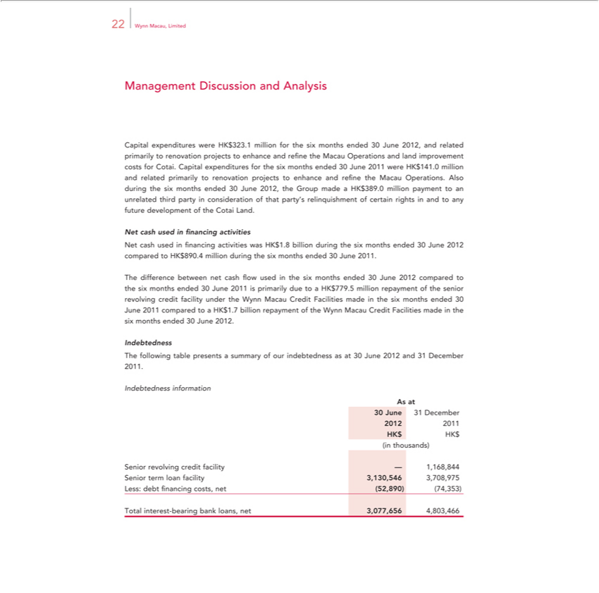

Management22WynnMacau,DiscussionLimitedand Analysis
^{Cotai}apital expenditures were HK$323.1 million for the six months ended 30 June ^{2012,} and related primarily to renovation projects to enhance and refine the Macau Operations and land improvement costs for
. Capital expenditures for the six months ended 30 June 2011 were HK$141. million and related primarily to renovation projects to enhance and refine the Macau Operations. Also during the six months ended 30 June 2012, the Group made a HK$389.0 million payment to an unrelated third party in consideration of that party’s relinquishment of certain rights in and to any future development of the Cotai Land. Net cash used in financing activities was HK$1.8 billion during the six months ended 30 June 2012 compared to HK$890.4 million during the six months ended 30 June 2011.
The difference between net cash flow used in the six months ended 30 June 2012 compared to the six months ended 30 June 2011 is primarily due to_{Macau}HK$779.5 million repayment of the senior revolving credit
facility under the Wynn Macau Credit Facilities made in the six months ended 30 June 2011 compared to a HK$1.7 billion repayment of the Wynn Credit Facilities made in the six months ended 30 June 2012.
Indebtedness
IndebtednessThefollowinginformationtablepresents a summary of our indebtedness as at 30 June 2012 and 31 December 2011.
As at
30²⁰¹²June ³¹ December
201
(inHKthousands)$HK$
^{Senior}
termrevolvingloan facilitycreditfacility3,130,546—1,168,8443,708,975
Less: debt financing costs, net (52,890) (74,353)
4,803,466Total⁰⁷⁷interest⁶⁵⁶-bearing bank loans, net

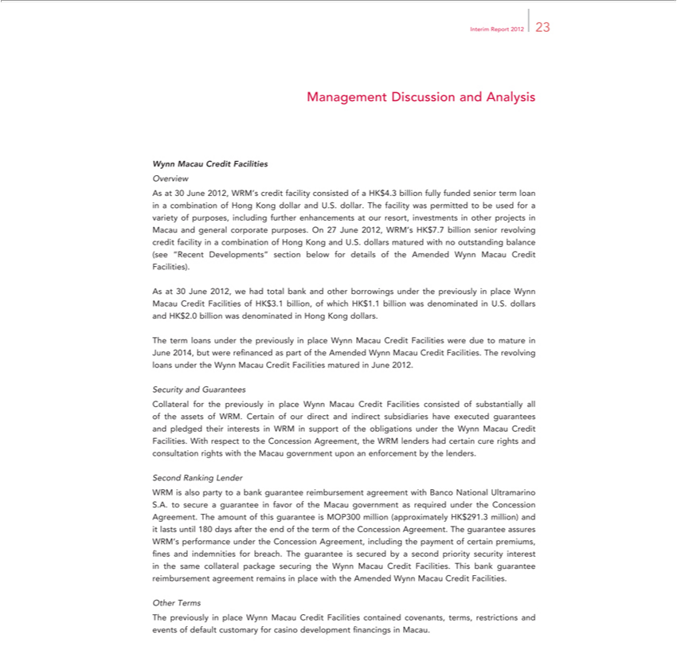

Interim Report 2012 23
Management Discussion and Analysis
Wynn Macau Credit Facilities
Overview | of
As at 30 June 2012, WRM’s credit facility consisted of a HK$4.3 billion fully funded senior term loan in combination of Hong Kong dollar and U.S. dollar. The facility was permitted to be used for | of
purposes, including further enhancements at our resort, investments_{outstanding}other projects in Macau and general corporate purposes. On 27 June 2012, WRM’s HK$7.7 billion senior revolving credit facility varietyin
_{combination} of Hong Kong and U.S. dollars matured with no balance (see “Recent Developments” section below for details of the Amended Wynn Macau Credit Facilities).
As 30 June_{denominated}2012,wehad total bank and other borrowings under the previously in place Wynn Macau Credit Facilities of HK$3.1 billion, of which HK$1.1 billion was denominated in U.S. dollars and HK$2.0
billion was in Hong Kong dollars.

The term loans under the previously in place Wynn Macau Credit Facilities were due to mature in June 2014, but were refinanced as part of the Amended Wynn Macau Credit Facilities. The revolving loans _{Security}underthe Wynn Macau Credit Facilities matured in June 2012.
and Guarantees

Collateral for the previously in place Wynn Macau Credit Facilities consisted of substantially all of the assets of WRM. Certain of our direct and indirect subsidiaries have executed guarantees and pledged their interests in WRM in support of the obligations under the Wynn Macau Credit Facilities. With respect to the Concession Agreement, the WRM lenders had certain cure rights and consultation rights with the Macau government upon an enforcement by the lenders.
Second Ranking Lender
WRM is also party _{guarantee}tobank guarantee reimbursement agreement with Banco National Ultramarino S.A. to secure a guarantee in favor of the Macau government as required under the Concession Agreement.
The amount of this is MOP300 million (approximately HK$291.3 million) and_{indemnities}lastsuntil 180 days after the end of the term of the Concession Agreement. The guarantee assures WRM’s performance
under the Concession Agreement, including the payment of certain premiums, fines and for breach. The guarantee is secured by a second priority security interest in the same collateral package securing the Wynn Macau Credit Facilities. This bank guarantee reimbursement agreement remains in place with the Amended Wynn Macau Credit Facilities.

Other Terms

The previously in place Wynn Macau Credit Facilities contained covenants, terms, restrictions and events of default customary for casino development financings in Macau.

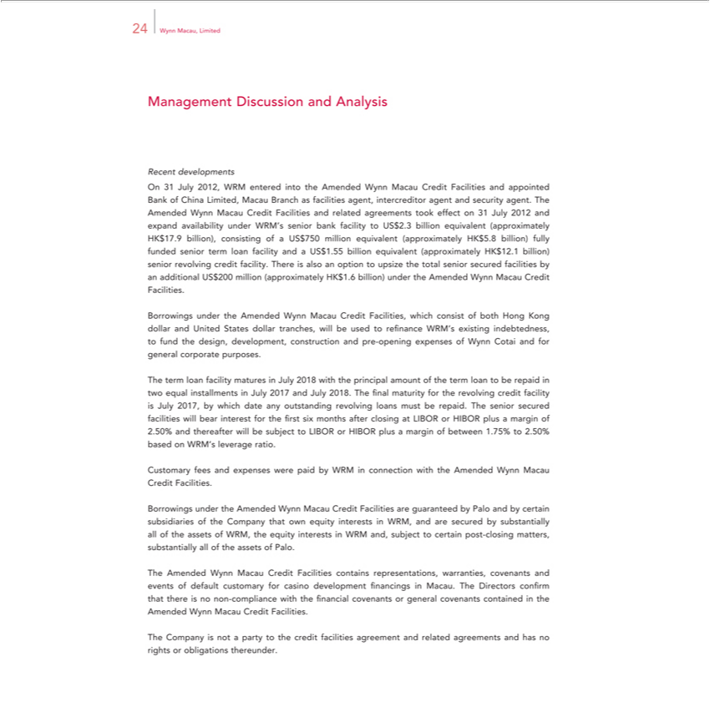

Management24WynndevelopmentsMacau,DiscusLimitedionand Analysis Recent
WynnOn31 MacauJuly2012,CreditWRMFacilitiesenteredandintorelatedtheAmendedagreementsWynntookMacaueffect Crediton31 JulyFacilities2012 andand appointedexpandavailabilityBankofChinaunderLimited,WRM’s Macausenior bankBranchfacilityasfacilitiestoUS$2.3agent,billionintercreditorequivalentagent(approximatelyandsecurityHKagent.$17.9Thebillion),Amended consisting of anUS$750 million equivalent (approximately HK$5.8 billion) fully funded senior term loan facility and a US$1.55 billion equivalent (approximately HK$12.1 billion) senior revolving credit facility.
BorrowingsTherealsounderoptiontheAmendedtoupsize WynnthetotalMacauseniorCreditsecuredFacilities,facilitieswhichbyanconsistadditionalofbothUS$Hong200millionKongdollar(approximatelyandUnitedHKStates$1.6dollarbillion)tranches,underthewillAmendedbeused toWynnrefinanceMacauWRM’sCredit existingFacilities.indebtedness, to fund the design, development, construction and pre-opening expenses of Wynn Cotai and for general corporate purposes.
The term loan facility matures July 2018 with the principal amount of the term loan to be repaid in two equal installments in July 2017 and July 2018. The final maturity for the revolving credit facility is July
2.50%017,byandwhichthereafterdate anywilloutstandingbesubjecttorevolvingLIBOR orloansHIBORmust plusberepaidmargin.Theofseniorbetweensecured1.75%facilitiesto2.50%willbasedbear oninterestWRM’sfor leveragethefirstsixratio.months after closing at LIBOR or HIBOR plus a margin of
BorrowingsCustmaryfeesunderandtheexpensesAmendedwereWynnpaidMacaubyWRMCreditinconnectionFacilitiesarewithguaranteedtheAmendedbyPaloWynnandMacaubycertainCreditsubsidiariesFacilities.of the Company that own equity interests in WRM, and are secured by substantially all of the assets of WRM, the equity interests in WRM and, subject to certain post-closing matters, substantially all of the assets of Palo.

The Company is not a party to the credit facilities agreement and related agreements and has no rights or obligations thereunder.

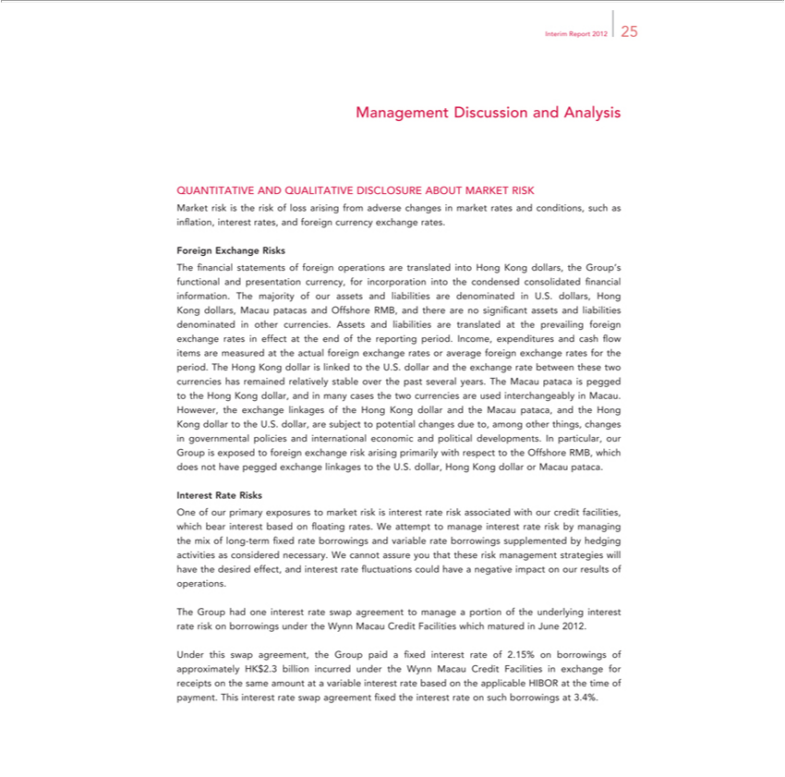

Interim Report 2012 25
Management Discussion and
QUANTITATIVE AND QUALITAnalysisTIVE DISCLOSURE ABOUT MARKET RISK
Market risk is the risk of loss arising from adverse changes in market rates and conditions, such as inflation, interest rates, and foreign currency exchange rates.
Foreign Exchange Risks |  |  |  |  |  | information.
financial statements of foreign operations are translated into Hong Kong dollars, the Group’s functional and presentation currency, for incorporation into the condensed consolidated |  |  |  |  |  | information.
The majority of our assets and liabilities are |  | U.S. dollars, Hong Kong dollars, Macau patacas and Offshore RMB, and there are no significant assets and liabilities |  |  |  | financial other
currencies. Assets and liabilities are translateddenominatedprevailingthe |  |  | foreign exchange rates in effect at the end of the reporting period. Income, expenditures and cash flow items are measureddenominatedthe actual foreign
exchange rates or average foreign exchange rates for the period. The Hong Kong dollar is linked to the U.S. dollar and the exchange rate between these two currencies has remained relatively stable over the past
several years. The Macau pataca is pegged to the Hong Kong dollar, and in many cases the two currencies are used |  |  |  | in Macau. However, the exchange linkages of the Hong Kong dollar and the
Macau | and the Hong Kong dollar to the U.S. dollar, are subject to potential changes due to, among other things,interchangeablychangesgovernmental policies and international economic and political developments.
In particularpataca,our Group is exposed to foreign exchange risk arising primarily with respect to the Offshore RMB, which does not have pegged exchange linkages to the U.S. dollar, Hong Kong dollar or Macau
pataca.
Interest Rate Risks |  |  |  |  | risk by managing the mix of
One of our primary exposures to market risk is interest rate risk associated with our credit facilities, which bear intere t based on floating rates. We attempt to manage interest
long-term fixed rate borrowings and |  | rate borrowings supplemented by hedging activities as considered necessary. We cannot assure you that these risk management strategies will have the desired effect,
and interest rate fluctuations could havevariablenegative impact on our results of operations.
The Group had one interest rate swap |  | to manage portion of the underlying interest rate risk on borrowings under the Wynn Macau Credit Facilities which matured in June 2012.
Under this swap agreement, the Groupagreementpaidfixed interest rate of 2.15% on borrowings of approximately HK$2.3 billion incurred under the Wynn Macau Credit Facilities in exchange for receipts on the same amount at a variable interest rate based on the applicable HIBOR at the time of payment. This interest rate swap agreement fixed the interest rate on such borrowings at 3.4%.

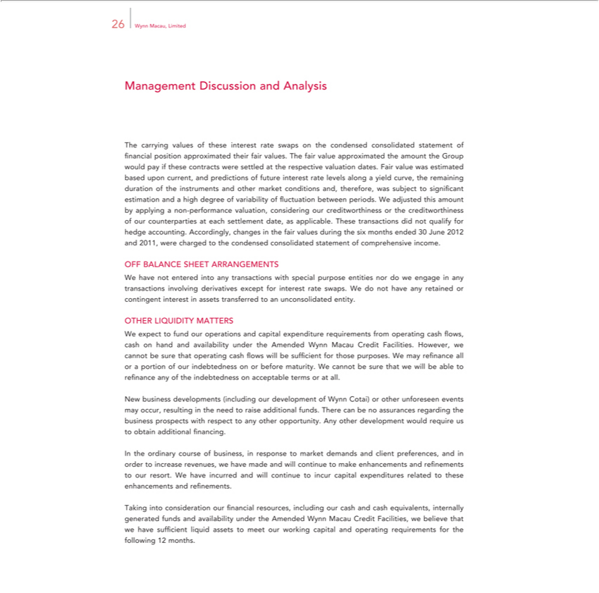

26 Wynn Macau, Limited
Management Discussion and Analysis |  | the condensed consolidated statement of financial position approximated their fair values. The fair value |  |  |  |  | the amount the Group would pay if
The carrying values of these interest rate swaps |  |  |  |  |  |  | the amount the Group would pay if
these contracts were settled at the respective valuation dates. Fair value was estimated based upon current, and predictions of future interest rate levels along |  |  |  |  |  |  | yield curve, the remaining duration of the
instruments and other market conditions and, therefore, was subject to significant estimation and |  |  |  |  | high degree of variability of fluctuation between periods. approximatedWadjustedthis amount by pplying non-
performance valuation, considering our creditworthiness or the creditworthiness of our counterparties at each settlement date, as applicable. These transactions did not qualify for hedge accounting. Accordingly,
changes in the fair values during the six months ended 30 June 2012 and 2011, were charged to the condensed consolidated statement of comprehensive income.
OFF BALANCE SHEET ARRANGEMENTS
W have not entered into any | with special purpose entities nor do we engage in any transactions involving derivatives except for interest rate swaps. We do not have any retained or contingent
interest in assets transferred totransactionsunconsolidated entity.
OTHER LIQUIDITY MATTERS |  |  | from operating | flows, cash on hand and availability under the |  | Wynn Macau Credit Facilities. However, we cannot be sure
We expect to fund our operations and capital expenditure |  |  | from operating
that operating cash flows will be sufficient for those purposes.requirementsWmay refinance all or cashportion of our indebtedness on or before maturity.AmendedWcannot be sure that we will be able to refinance any of the
indebtedness on acce table terms or at all.
New business developments (including our development of Wynn Cotai) or other unforeseen events may occur, resulting in the need to raise additional funds. There can be no assurances regarding the business
prospects with respect to any other opportunity. Any other development would require us to |  |  |  |  | additional financing.
obtain
WeInthehaveordinaryincurredcourseand willofbusiness,continueintoresponseincurcapitaltomarketexpendituresdemandsrelatedandclienttothesepreferences,enhancementsand andorderrefinements.toincrease revenues, we have made and will continue to make enhancements and refinements to our resort.

Taking into consideration our financial resources, including our cash and cash equivalents, internally generated funds and availability under the Amended Wynn Macau Credit Facilities, we believe that we have sufficient liquid assets to meet our working capital and operating requirements for the following 12 months.

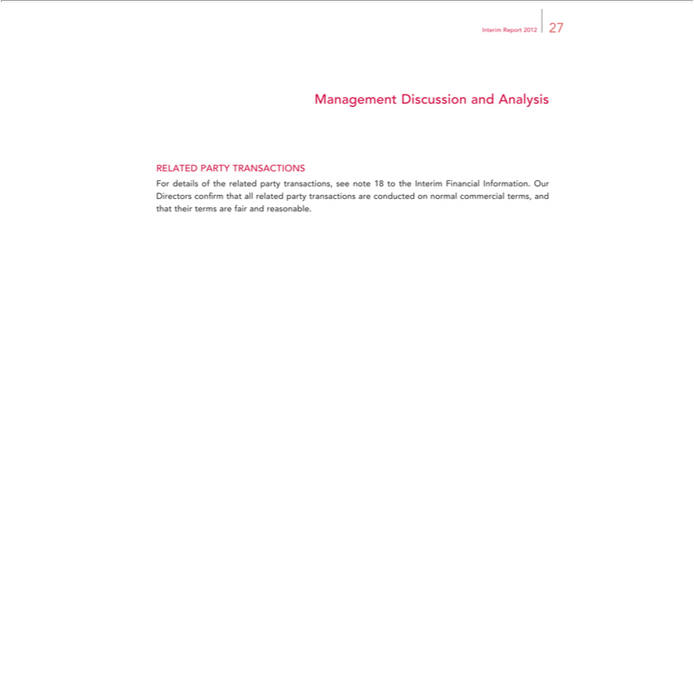

Interim Report 2012 27
Management Discussion and Analysis
RELATED PARTY TRANSACTIONS
For details of the related party transactions, see note 18 to the Interim Financial Information. Our Directors confirm that all related party transactions are conducted on normal commercial terms, and that their terms are fair and reasonable.

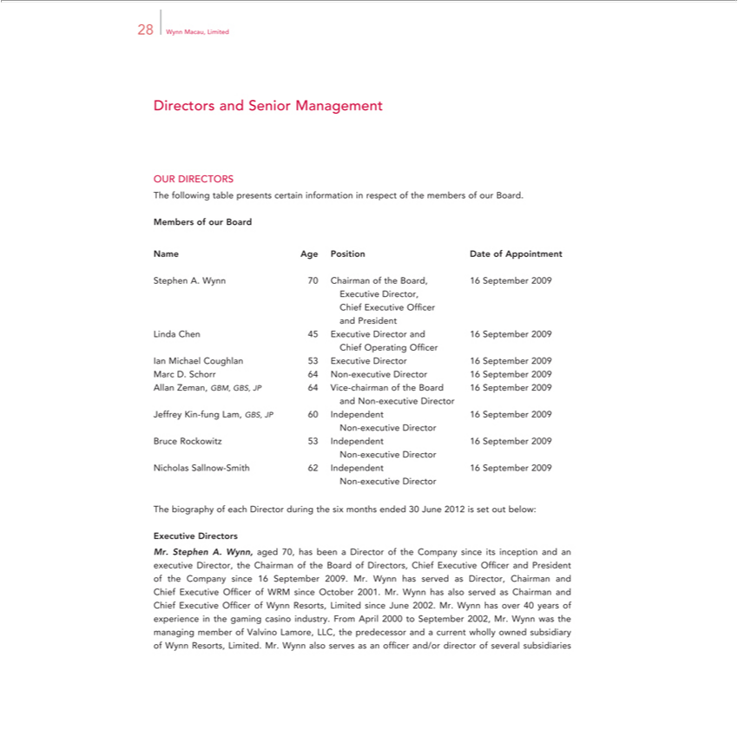

28 Wynn Macau, Limited
Directors and Senior Management
TheOURfollowingDIRECTORStable presents certain information in respect of the members of our Board.
NameMembers ofPositionurBoardDate of Appointment
Age
ExecutiveStephen .Director,Wynn70 Chairman of the Board, 16 September 2009
andChiefPresidentExecutive Officer
ChiefLinda OperatingChen45ExecutiveOfficer Director and 16 September 2009
Ian Michael Coughlan 53 Executive Director 16 September 2009
Marc D. Schorr 64 Non-executive Director 16 September 2009
andAllanNonZeman,-executiveGBM,DirectorGBS,JP 64 Vice-chairman of the Board 16 September 2009
NonJeffrey-executiveKin-fungDirectorLam,GBS, JP 60 Independent 16 September 2009
^{Non}Bruce_{icholas}-executiveRockowitzDirector53Independent 16 September 2009
-executiveSallnowDirector-Smith 62 Independent 16 September 2009
The_{Executive}biographyDirectorsofeach Director during the six months ended 30 June 2012 is set out below:
Mr. Stephen A. Wynn, aged 70, has been a Director of the Company since its inception and an executive Director, the Chairman of the Board of Directors, Chief Executive officer and President of the Company since 16 September 2009. Mr. Wynn has served as Director, Chairman and Chief Executive Officer of WRM since October 2001. Mr. Wynn has also served ^{was}Chairman and Chief Executive Officer of Wynn
Resorts, Limited since June 2002. Mr. Wynn has over 40 years of experience in the gaming casino industry. From April 2000_{director}September 2002, Mr. Wynn the managing member of Valvino Lamore, LLC,
the predecessor and a current wholly owned subsidiary of Wynn Resorts, Limited. Mr. Wynn also serves as an officer and/or of several subsidiaries

Interim Report 2012 29
Directors and Senior Management |  |  | Inc. and its predecessor, Golden Nugget Inc., between 1973 and 2000. Mr. Wynn developed
of Wynn Resorts, Limited. Mr. Wynn served as Chairman, President and Chief Executive Officer of Mirage
and opened The Mirage, Treasure | and Bellagio in 1989, 1993 and 1998, respectively. In 2011, Barron’Resorts,ranked Mr. Wynn as one of the world’s 30 best CEOs.
Ms. Linda Chen, aged 45, has beenIslandexecutive Director and the Chief Operating officer of the Company since 16 September 2009 and Chief Operating Officer of WRM since June 2002. Ms. Chen is
respons ble for the marketing and strategic development of WRM. Ms. Chen is also a director of Wynn Resorts, Limited and President of WIML. In these positions, she is responsible for the setup of
international marketing operations of Wynn Resorts, Limited. Prior to joining the Group, Ms. Chen was Executive Vice President — International Marketing at MGM Mirage, a role she held from June 2000
until May 2002, and was responsible for the international |  | operations for MGM Grand, Bellagio and The Mirage. Prior to this position, Ms. Chen served as the Executive Vice President of International
Marketing for Bellagio and was involved with its openingmarketing1998.She was also involved in the opening of the MGM Grand in 1993 and The Mirage in 1989. Ms. Chen is also a member of the Nanjing
Committee of the Chinese People’ | Political Consultative Conference (Macau). Ms. Chen holds a Bachelor of Science Degree in Hotel Administration from Cornell University in 1989 and completed the
Stanford Graduate School of Business Executive Development Program in 1997.
Mr. Ian Michael Coughlan, aged 53, has been an executive Director of the Company since 16 September 2009. Mr. Coughlan is also the President of WRM, a position he has held since July 2007. In this role, he is responsible for the_{experience}entireoperation and development of Wynn Macau. Prior to this role, Mr. Coughlan was Director of Hotel Operations — Worldwide for Wynn Resorts, Limited. Mr. Coughlan has over 30
years of hospitality with leading hotels across Asia, Europe and the United States. Before joining Wynn Resorts, Limited, he spent ten years with The Peninsula Group, including posts as General Manager of The Peninsula Hong Kong from September 2004 to January 2007, and General Manager of The Peninsula Bangkok from _{Diploma}Setember 1999 to August 2004. His previous assignments include senior
management positions at The Oriental Singapore, and a number of Ritz-Carlton properties in the United States. Mr. Coughlan holds a from Shannon College of Hotel Management, Ireland.

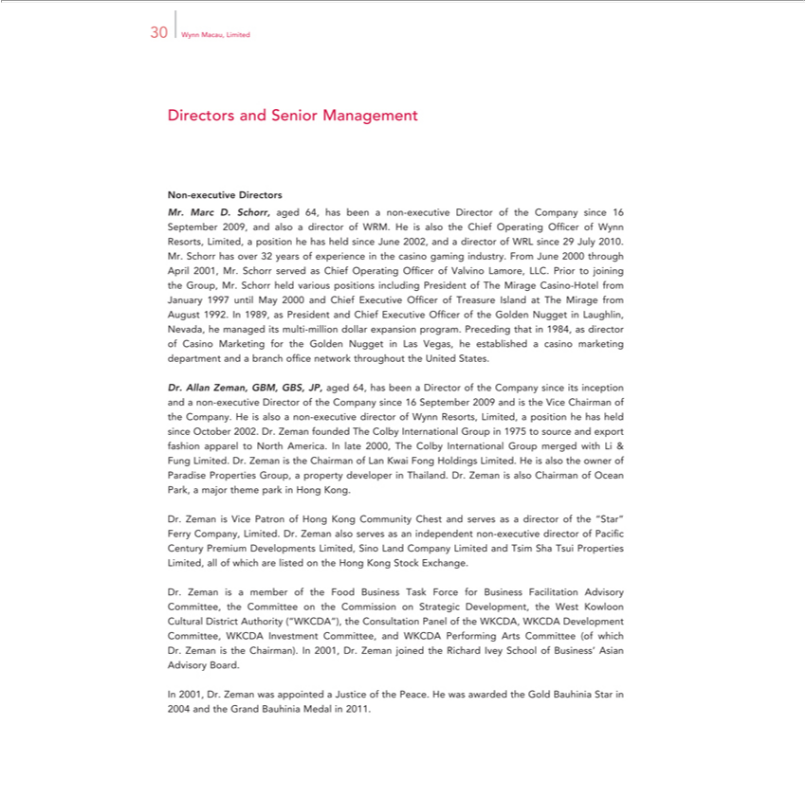

30 Wynn Macau, Limited
Directors and Senior Management
Non-executive Directors
Mr. Marc D. Sc orr, aged 64, has been non-executive Director of the Company since 16 September 2009, and also a director of WRM. He is also the Chief Operating Officer of Wynn Resorts, Limited, a
position he has held since June 2002, and |  | director of WRL since 29 July 2010. Mr. Schorr has over 32 years of experience in the casino gaming industry. From June 2000 through April 2001, Mr. Schorr served
as Chief Operating Officer of Valvino Lamore, LLC. Prior to joining the Group, Mr. Schorr held various positions including President of The Mirage Casino-Hotel from January 1997 until May 2000 and Chief
Execut ve Officer of Treasure Island at The Mirage from August 1992. In 1989, as President and Chief Executive Officer of the Golden Nugget |  |  |  | Laughlin, | he managed its multi-million dollar
expansion program. Preceding that in 1984, as director of Casino Marketing for the Golden Nugget in Las Vegas, he established a casino marketing departmentNevada,and branch office network throughout the United
States. |  |  | since its inception and a non-executive Director of the Company since 16 September 2009 and is the Vice Chairman of the
Dr. Allan Zeman, GBM, GBS, JP, aged 64, has been a Director of the
Company. He is also | non-executive director of Wynn Resorts, Limited,Companyposition he has held since October 2002. Dr. Zeman founded The Colby International Group in 1975 to source and export fashion
apparel to North | . In late 2000, The Colby International Group merged with Li & Fung Limited. Dr. Zeman is the Chairman of Lan Kwai Fong Holdings Limited. He is also the owner of Paradise
Properties Group,Americaproperty developer in Thailand. Dr. Zeman is also |  |  | f Ocean Park, a major theme park in Hong Kong.
Dr. Zeman is Vice Patron of Hong Kong Community Chest and serves Chairmanasdirector of the “Star” Ferry Company, Limited. Dr. Zeman also serves as an independent non-executive director of Pacifi c Century
Premium Developments Limited, Sino Land Company Limited and Tsim Sha Tsui Properties Limited, all of which are listed on the Hong |  |  |  | Stock Exchange.
Dr. Zeman is a member of the Food Business Task Force for Business Facilitation Advisory Committee, the Committee on the CommissionKongStrategic Development, the West Kowloon Cultural _{District} Authority (“WKCDA”), the Consultation Panel of the WKCDA, WKCDA Development Committee, WKCDA Investment Committee, and WKCDA Performing Arts Committee (of which Dr. Zeman the Chairman). In 2001, Dr. Zeman_{appointed}joined the Richard Ivey School of Business’ Asian Advisory Board.

In 2001, Dr. Zeman was a Justice of the Peace. He was awarded the Gold Bauhinia Star in 2004 and the Grand Bauhinia Medal in 2011.

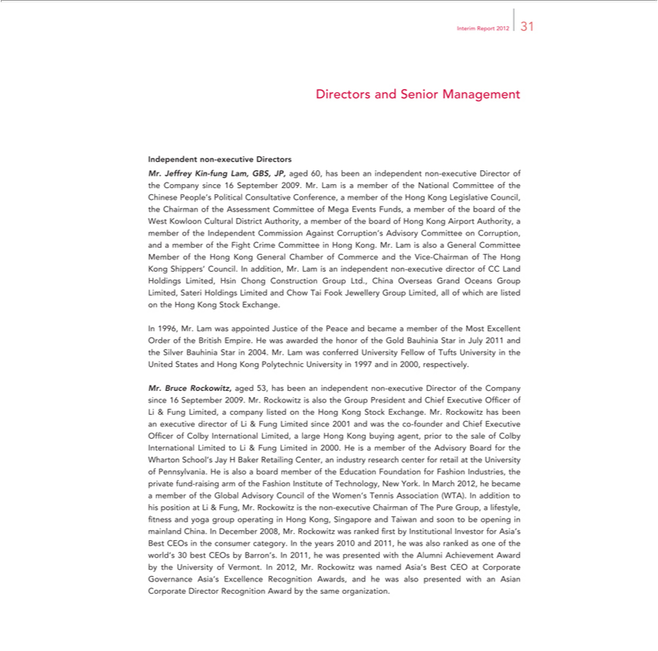

Interim Report 2012 31
Dir ctors and Senior Management
Independent non-executive Directors
Mr. Jeffrey Kin-fung Lam, GBS, JP, aged 60, has been an independent non-executive Director of the Company since 16 September 2009. Mr. Lam is a member of the National Committee of the Chinese People’s
Political | Conference, a member of the Hong Kong Legislative Council, the Chairman of the Assessment Committee of Mega |  |  |  | Funds, a member of the board of the West Kowloon Cultural
District Authority,Consultativemember of the board of Hong Kong Airport Authority, a member of the Independent Commission Against Corruption’EventsAdvisory Committee on Corruption, and a member of the Fight Crime
Committee | Hong Kong. Mr. Lam is also a General C mmittee Member of the Hong Kong General Chamber of Commerce and the Vice-Chairman of The Hong Kong Shippers’ Council. In addition, Mr. Lam
is an independent non-executive director of CC Land Holdings Limited, Hsin Chong Construction Group Ltd., China Overseas Grand Oceans Group Limited, Sateri Holdings Limited and Chow Tai Fook
Jewellery Group Limited, all of which are listed on the Hong Kong Stock Exchange.
In 1996, Mr. Lam was appointed Justice of the Peace and became a member of the Most Excellent Order of the British Empire. He was awarded the honor of the Gold Bauhinia Star in July 2011 and the Silver
Bauhinia Star in 2004. Mr. Lam was co ferred University Fellow of Tufts University in the United States and Hong Kong Polytechnic University in 1997 and in 2000, respectively.
Mr. Bruce Rockowitz, aged 53, has been an independent non-executive Director of the |  |  | since 16 September 2009. Mr. Rockowitz is also the Group President and Chief Executive Officer of Li & Fung
Limited, company listed on the Hong Kong Stock Exchange. Mr. Rockowitz has beenCompanyexecutive |  |  |  | of Li & Fung Limited since 2001 and was the co-founder and Chief Executive Officer of Colby
International Limited, a large Hong Kong buying agent, prior to the sale of Colby International LimiteddirectorLi & Fung Limited in 2000. He is |  |  |  |  | member of the Advisory Board for the Wharton School’s Jay H
Baker Retailing Center, an industry research center for retail at the University of Pennsylvania. He |  |  |  | also a board member of the Education Foundation for Fashion Industries, the private fund-raising arm of the
Fashion Institute of Technology, New York. In March 2012, he |  | a member of the Global Advisory Council of the Women’s Tennis Association (WTA). In addition to his position at Li & Fung,
Mr. Rockowitz is the non-executive Chairman of The Pure Group,became |  | fi tness and yoga group operating in Hong Kong, Singapore and Taiwan and soon to be opening in mainland China. In December
²⁰¹ lifestyle,
08,1, heMr.wasRockowitzpresentedwaswithrankedtheAlumnifirstbyAchievementInstitutional InvestorAwardbyfortheAsia’UniversityBestCEOsofVermont.intheconsumerIn2012, Mr.category.RockowitzInthewasyearsnamed2010 Asia’sand2011,BestheCEOwasatalsoCorporateranked asGovernanceoneofthe Asia’sworld’s 30 best CEOs by Barron’s. In

Excellence Recognition Awards, and he was also presented with an Asian Corporate Director Recognition Award by the same organization.

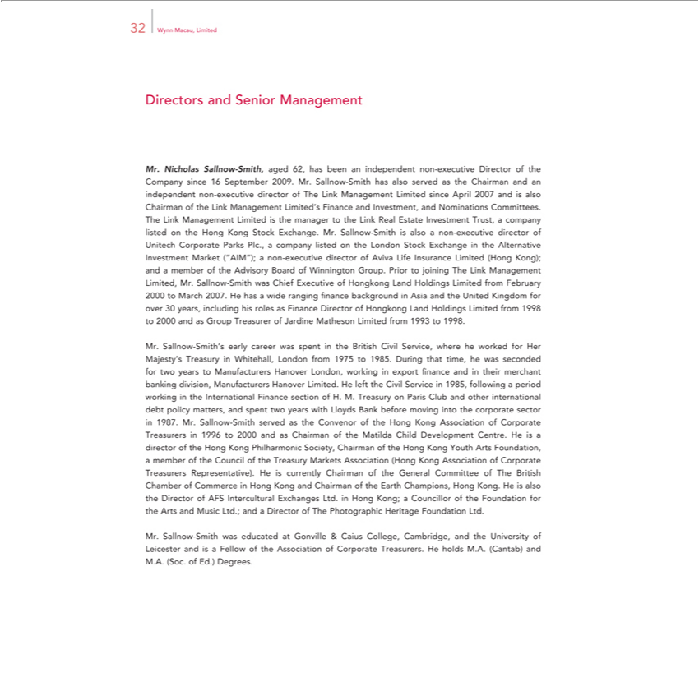

32 Wynn Macau, Limited
Directors and Senior Management
Mr. Nicholas Sallnow-Smith, aged 62, has been an independent non-executive Director of the Company since 16 September 2009. Mr. Sallnow-Smith has also served as the Chairman and an indepe dent non-
executive director of The Link Management Limited since April 2007 and is also Chairman of the Link Management Limited’s Finance and Investment, and Nominations Committees. The Link
Limited is the manager to the Link Real Estate Investment Trust, a company listed on the Hong Kong Stock Exchange. Mr. Sallnow-Smith is also a non-executive director of Unitech Corporate ParksManagementPlc.,
company listed on the London Stock Exchange in the Alternative Investment Market (“AIM”); a non-executive director of Aviva Life Insurance Limited (Hong Kong); and |  |  | member of the Advisory Board of
Winnington Group. Prior to joining The Link Management Limited, Mr. Sallnow-Smith was Chief Executive of Hongkong Land Holdings Limited from February 2000 to March 2007. He has a wide ranging
finance background in Asia and the United Kingdom for over 30 years, including his roles as Finance Director of Hongkong Land Holdings Limited from 1998 to 2000 and as Group Treasurer of Jardine
atheson Limited from 1993 to 1998.
. Sallnow-Smith’s early career was spent in the British Civil Service, where he worked for Her Majesty’ Treasury in Whitehall, London from 1975 to 1985. During that time, he was seconded for two years to
Manufacturers Hanover London, working in export finance and in their merchant banking division, Manufacturers Hanover Limited. He left the Civil Service in 1985, following a period working in the
International Finance section of H. M. Treasury on Paris Club and other intern tional debt policy matters, and spent two years with Lloyds Bank before moving into the |  |  | sector in 1987. Mr. Sallnow-
mith served as the Convenor of the Hong Kong Association of Corporate Treasurers in 1996 to 2000 and as Chairman of the Matilda Child Development Centre. He is corporatedirector of the Hong Kong Philharmonic
Society, Chairman of the Hong Kong Youth Arts Foundation, a member of the Council of the Treasury Markets Association (Hong Kong Association of Corporate Treasurers Representative). He is currently
Chairman of the General Committee of The British Chamber of Commerce in Hong Kong and C airman of the Earth Champions, Hong Kong. He is also the Director of AFS Intercultural Exchanges Ltd. in
Hong Kong; a Councillor of the | for the Arts and Music Ltd.; and Director of The Photographic | Foundation Ltd.
Mr. Sallnow-Smith was educatedFoundationGonville & Caius College, Cambridge, and the University of Leicester andHeritageisFellow of the Association of Corporate Treasurers. He holds M.A. (Cantab) and M.A. (Soc. of Ed.) Degrees.

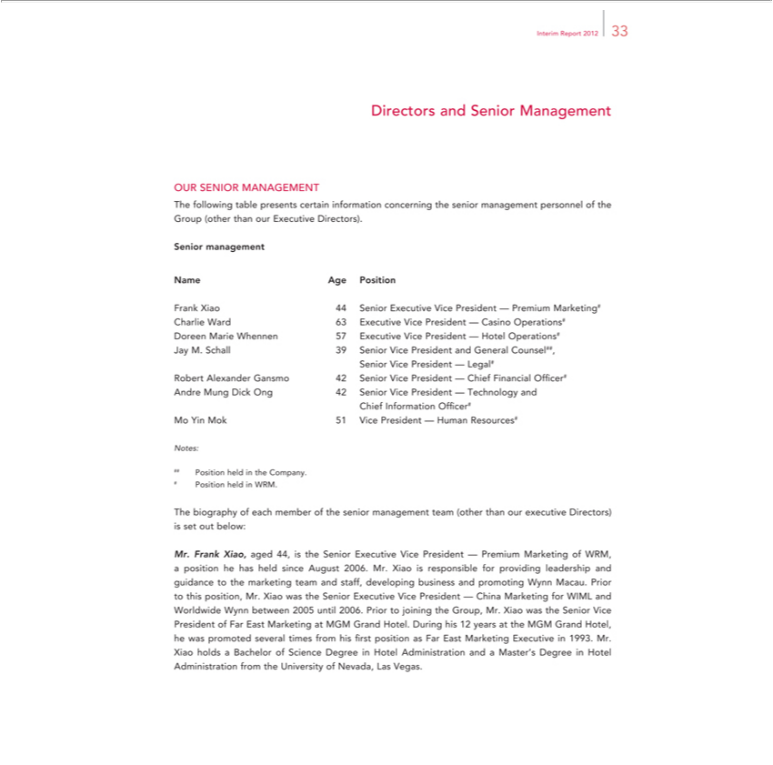

InterimDirectorsReportandSenior2012 33Management
OUR SENIOR MANAGEMENT
SeniorThefollowingmanagementtable presents certain information concerning the senior management personnel of the Group (other than our Executive Directors).
Name Age Position
CharlieFrankXiaoWard4463SeniorExecutiveExecutiveVice VicePresidentPresident—Casino—PremiumOperations#Marketing#
Doreen Marie Whennen 57 Executive Vice President — Hotel Operations#
SeniorJayM. ViceSchallPresident39Senior—ViceLegal#President and General Counsel##,
Robert Alexander Gansmo 42 Senior Vice President — Chief Financial Officer#
ChiefAndreInformationMungDick Officer#Ong42Senior Vice President — Technology and
Mo Yin Mok 51 Vice President — Human Resources#
#Notes:#Position held in the Company.
Position held in WRM.
Mr.The FrankbiographyXiao,ofagedeach44,memberisthe Seniorofthe seniorExecutivemanagementVicePresidentteam(other—PremiumthanourMarketingexecutiveofDirectors)WRM,a ispositionsetuthebelow:hasheld since August 2006. Mr. Xiao is responsible for providing leadership and guidance to the
betweenmarketing2005teamuntiland2006.staff, PriordevelopingtojoiningbusinesstheGroup,andpromotingMr.XiaoWynnwastheMacau.SeniorPriorVicetoPresidentthisposition,ofFarMr.EastXiaoMarketingwasthe atSeniorMGMExecutiveGrandHotel.Vice DuringPresidenthis—12China MarketingattheMGMforGrandWIMLHotel,and WorldwidehewaspromotedWynn several
times from his fi rst position as Far East Marketing Executive in 1993. Mr. Xiao holds a Bachelor of Science Degree in Hotel Administration and a Master’yearsDegree in Hotel Administration from the University of Nevada, Las Vegas.

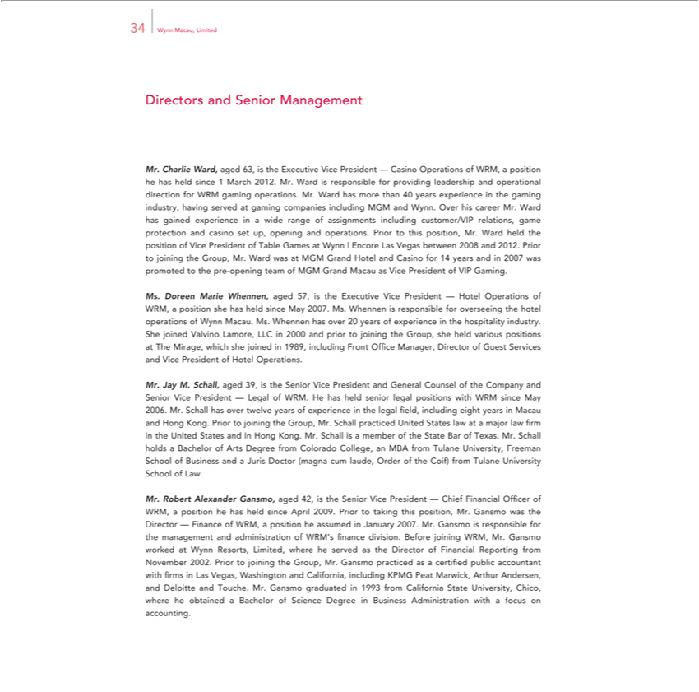

34 Wynn Macau, Limited
Directors and Senior Management
Mr. Charlie Ward, aged 63, is the Executive Vice President — Casino Operations of WRM, a position he has h ld since 1 March 2012. Mr. Ward is responsible for providing leadership and operational direction
for WRM |  | operations. Mr. Ward has more than 40 years experience in the gaming industry, having served at gaming companies including MGM and Wynn. Over his career Mr. Ward has gained
experiencegamingwide range of assignments including customer/VIP relations, game protection and casino set up, opening and operations. Prior to this position, Mr. Ward held the position of Vice President of
Table Games at Wynn | Encore Las Vegas between 2008 and 2012. Prior to joining the Group, Mr. Ward was at MGM Grand Hotel and Casino for 14 years and in 2007 was promoted to the pre-opening team of
GM Grand Macau as Vice President of VIP Gaming.
Ms. Doreen Marie |  | aged 57, is the Executive Vice President — Hotel Operations of WRM, position she has held since May 2007. Ms. Whennen is responsible for overseeing the hotel operations of
Wynn Macau. Ms. Whennen, has over 20 years of experience in the hospitality industry. She joined Valvino Lamore, LLC in 2000 and prior to joining the Group, she held various positions at The Mirage, which
she joined in 1989, including Front Offi ce Manager, Director of Guest Services and Vice President of Hotel Operat ons.
Jay M. Schall, aged 39, is the Senior Vice President and General Counsel of the Company and Senior Vice President — Legal of WRM. He has held senior legal positions with WRM since May 2006.
Mr. Schall has over twelve years of experience in the legal fi eld, including eight years in Macau and Hong Kong. Prior to joining the Group, Mr. Schall practiced United States law at a major law firm in the
United St tes and in H ng Kong. Mr. Schall is a member of the State Bar of Texas. Mr. Schall holds a Bachelor of Arts Degree from Colorado College, an MBA from Tulane University, Freeman School of
Business and | Juris Doctor (magna cum laude, Order of the Coif) from Tulane University School of Law.
Mr. Robert |  | Gansmo, aged 42, is the Senior Vice President — Chief Financial Offi cer of WRM, position he has held since April 2009. Prior to taking this position, Mr. Gansmo was the Director —
Finance of WRM,Alexanderposition he |  |  | in January 2007. Mr. Gansmo is responsible for the management and administration of WRM’s fi nance division. Before joining WRM, Mr. Gansmo worked at Wynn
Resorts, Limited, where he servedassumedthe Director of Financial Reporting from November 2002. Prior to joining the Group, Mr. Gansmo practiced as certified public accountant with firms Las Vegas,
Washington and California, including KPMG |  |  |  | Marwick, Arthur Andersen, and Deloitte and Touche. Mr. Gansmo graduated in 1993 from California State University, Chico, where he obtained a Bachelor of
Science Degree in Business Administration withPeat focus on accounting.

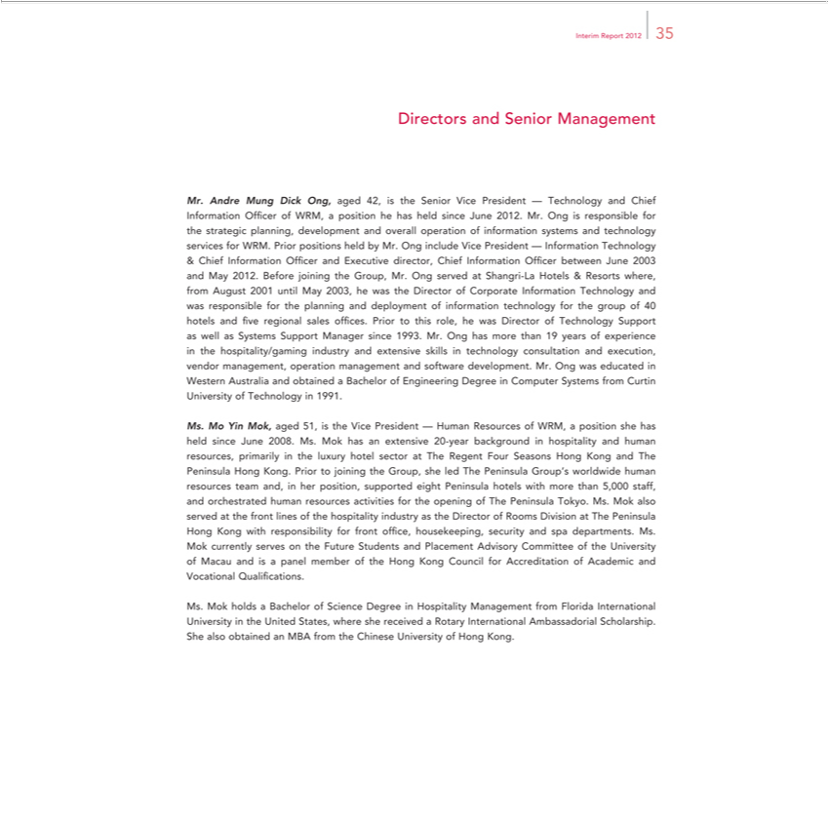

Interim Report 2012 35
Directors and Senior Management |  |  | Offi cer of WRM, a position he has held since June 2012. Mr. Ong is responsible for the strategic
Mr. Andre Mung Dick Ong, aged 42, is the Senior Vice President — Technology and Chief
planning, development and overall operation of information systems and technology servicesInformationWRM. Prior positions held by Mr. Ong include Vice President — Information Technology
& Chief Information Officer and Executive director, Chief Information Officer between June 2003 and May 2012. Before joining the Group, Mr. Ong served at Shangri-La Hotels & Resorts where, from August
2001 until May 2003, he was the Director of Corporate Information Technology and was responsible for the planning and deployment of information technology for the group of 40 hotels and five regional sales
offices. Prior to this role, he was Director of Technology Support as well as Systems Support Manager since 1993. Mr. Ong has more than 19 years of experience in the |  |  |  |  | industry and extensive
skills in technology consultation and execution, vendor management, operation management and software development. Mr. Ong was educated in Western Australia andhospitality/gamingobtainedBachelor of Engineering
Degree in Computer Systems from Curtin University of Technology in 1991.
Ms. Mo Yin Mok, aged 51, is the Vice President — Human Resources of WRM, a position she has held since June 2008. Ms. Mok has an extensive 20-year background in hospitality and human resources,
primarily in the luxury hotel sector at The Regent Four Seasons Hong Kong and The Peninsula Hong Kong. Prior to joining the Group, she led The Peninsula Group’s worldwide human resources team and, in
er position, supported eight Peninsula hotels with more than 5,000 staff, and orchestrated human resources activities for the opening of The Peninsula Tokyo. Ms. Mok also served at the front lines of the
hospitality industry as the Director of Rooms Division at The Peninsula Hong Kong with responsibility for front office, housekeeping, security and spa departments. Ms. Mok currently serves on the Future
Students and | Advisory Committee of the University of Macau and is | panel member of the Hong Kong Council for Accreditation of |  | and Vocational Qualifications.
Ms. Mok holdsPlacementBachelor of Science Degree in Hospitality Management from |  | Florida International University in the United States, where she receivedAcademicRotary International Ambassadorial Scholarship. She
also obtained an MBA from the Chinese University of Hong Kong.

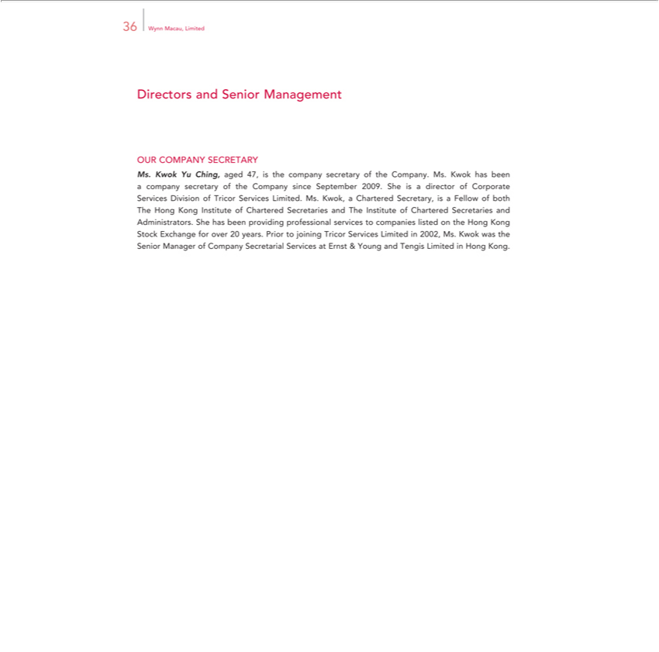

Directors36Wynn Macau,andSeniorLimitedManagement
OUR COMPANY SECRETARY
Ms. Kwok Yu Ching, aged 47, is the company secretary of the Company. Ms. Kwok has been a company secretary of the Company since September 2009. She is_{Secretaries}director of Corporate Services Division of
Tricor Services Limited. Ms. Kwok,_{companies}Chartered Secretary, is a Fellow of both The Hong Kong Institute of Chartered Secretaries and The Institute of Chartered and Administrators. She has been
providing professional services to listed on the Hong Kong Stock Exchange for over 20 years. Prior to joining Tricor Services Limited in 2002, Ms. Kwok was the Senior Manager of Company Secretarial Services at Ernst & Young and Tengis Limited in Hong Kong.

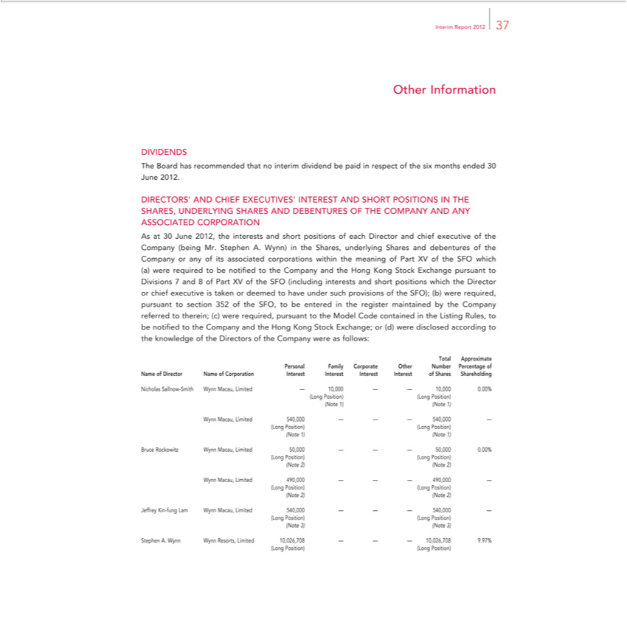

Interim Report 2012 37
Other Information
DIVIDENDS
The Board has recommended that no interim dividend be paid in respect of the six months ended 30 June 2012.
DIRECTORS’ AND CHIEF EXECUTIVES’ INTEREST AND SHORT POSITIONS IN THE SHARES, UNDERLYING SHARES AND DEBENTURES OF THE COMPANY AND ANY ASSOCIATED
CORPORATION
As | 30 June 2012, the interests and short positions of each Director and chief executive of the Company (being Mr. Stephen A. Wynn) in the Shares, underlying Shares and debentures of the Company or any of
its associated corporations within the meaning of Part XV of the SFO which (a) were required to be notified to the Company and the Hong Kong Stock Exchange pursuant to Divisions 7 and 8 of Part XV of the
SFO | interests and short positions which the | or chief executive is taken or deemed to have under such provisions of the SFO); (b) were required, pursuant to section 352 of the SFO, | be
entered(includingtheregister maintained by the Company referredDirector |  | (c) were required, pursuant to the Model Code contained in the Listing Rules, to be notified to the Company and the Hong Kong | Stock
Exchange; or (d) were disclosed according to the knowledge oftherein;Directors of the Company were as follows:
Total Approximate
Personal Family Corporate Other Number Percentage of

Nicholas
ame of DirectorSallnow-NameSmith ofWynnCorporationMacau, LimitedInterest —Interest10,000Interest—— Interest10,000 0.00%ofShares Shareholding
^{(Note}
Long 1)Position)(Note1)(Long Position)
Wynn Macau, Limited 540,000 — — — 540,000 —
^{(Note}Long Position) (Long Position)
1) (Note 1)
Bruce Rockowitz Wynn Macau, Limited 50,000 — — — 50,000 0.00%
^{(Note}Long Position) (Long Position)
2) (Note 2)
Wynn Macau, Limited 490,000 — — — 490,000 —
^{(Note}Long Position) (Long Position)
2) (Note 2)
Jeffrey Kin-fung Lam Wynn Macau, Limited 540,000 — — — 540,000 —
^{(Note}Long Position) (Long Position)
3) (Note 3)
Stephen A. Wynn Wynn Resorts, Limited 10,026,708 — — — 10,026,708 9.97%
(Long Position) (Long Position)

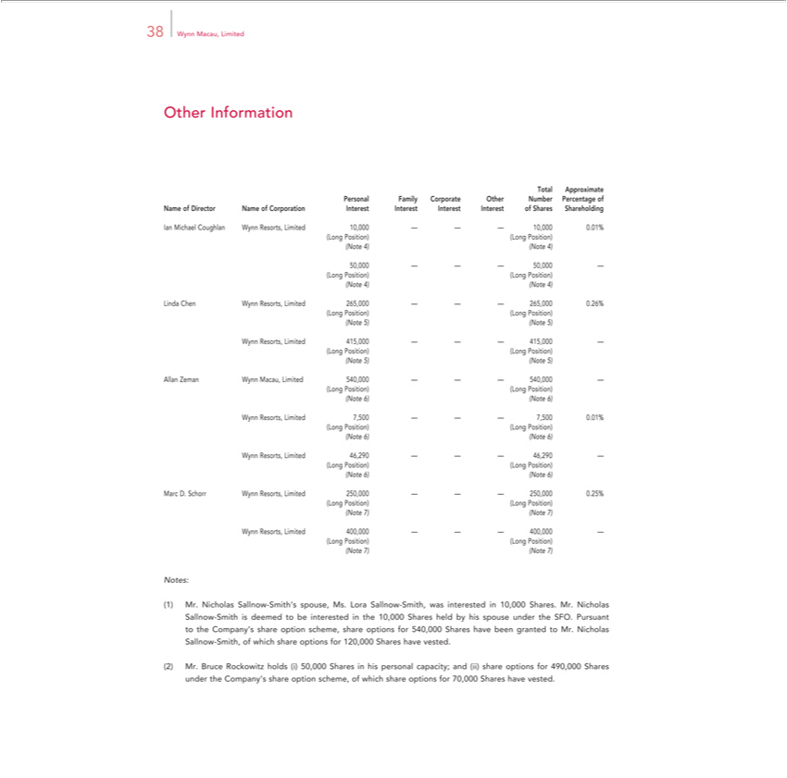

38 Wynn Macau, Limited
Other Information
Total Approximate
Personal Family Corporate Other Number Percentage of
IanNameMichaelofDirectorCoughlanNameWynnofCorporationResorts,LimitedInterest10,000Interest—Interest——10,000Interest0.01%ofShares Shareholding
^{(Note}
Long 4)Position)(Note4)(Long Position)
^{(Note}50,000LongPosition)——— (Long50,000Position)—
4) (Note 4)
^{(Note}LindaLong ChenPosition)Wynn(LongResorts,Position)Limited 265,000 — — — 265,000 0.26%
5) (Note 5)
^{(Note}WynnLong Resorts,Position)Limited(LongPosition)415,000 — — — 415,000 —
5) (Note 5)
^{(Note}AllanLong ZemanPosition)Wynn(LongMacau,Position)Limited 540,000 — — — 540,000 —
6) (Note 6)
^{(Note}WynnLong Resorts,Position)Limited(LongPosition)7,500— — — 7,500 0.01%
6) (Note 6)
^{(Note}WynnLong Resorts,Position)Limited(LongPosition)46,290— — — 46,290 —
6) (Note 6)
^{(Note}MarcLongD.Position)Schorr Wynn(Long Resorts,Position)Limited 250,000 — — — 250,000 0.25%
7) (Note 7)
^{(Note}WynnLong Resorts,Position)Limited(LongPosition)400,000 — — — 400,000 —
_{Notes:}7) (Note 7)
Mr. Nicholas Sallnow-Smith’^{share}spouse, Ms. Lora Sallnow-Smith, was interested in 10,000 Shares. Mr. Nicholas Sallnow-Smith is deemed to be interested in the 10,000 Shares held by his spouse under the SFO.
Pursuant to the Company’^{holds} option scheme, share options for 540,000 Shares have been granted to Mr. Nicholas Sallnow-Smith, of which share options for 120,000 Shares have vested.
Mr. Bruce Rockowitz (i) 50,000 Shares in his personal capacity; and (ii) share options for 490,000 Shares under the Company’s share option scheme, of which share options for 70,000 Shares have vested.

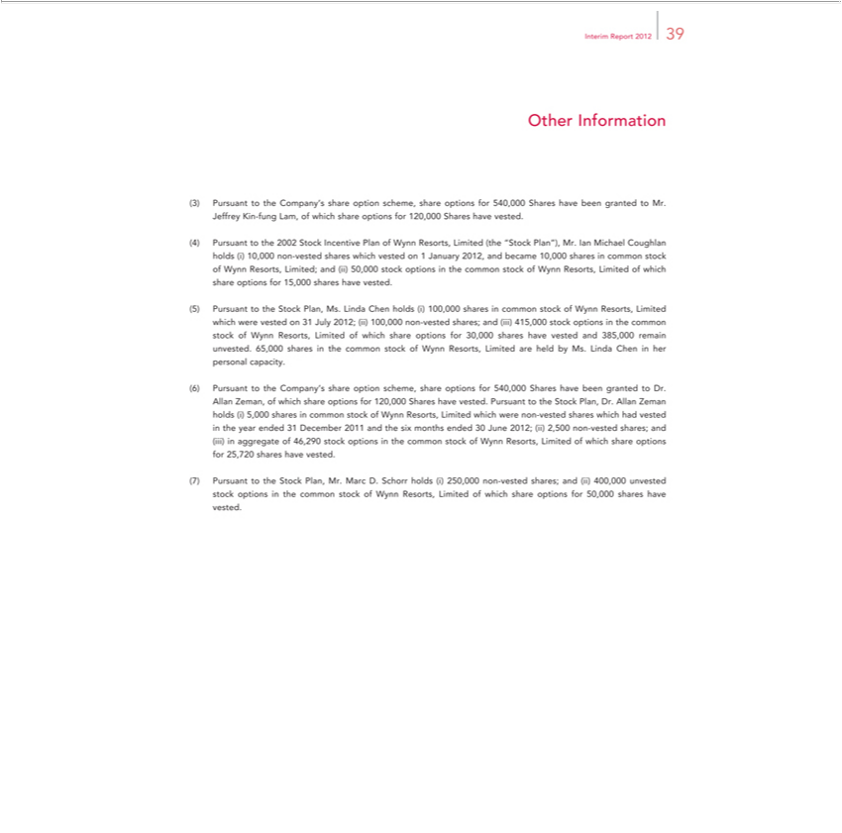

Interim Report 2012 39
Other Information
 | Company’s share option scheme, share options for 540,000 Shares have been granted to Mr. Jeffrey Kin-fung Lam, of which share options for 120,000 Shares have vested.
Pursuant to the 2002 Stock Incentive Plan of Wynn Resorts, Limited (the “Stock Plan”), Mr. Ian Michael Coughlan holds (i) 10,000 non-vested shares which vested on 1 January 2012, and became 10,000 shares
in common stock of Wynn Resorts, Limited; and (ii) 50,000 stock options in the common stock of Wynn Resorts, Limited of which share options for 15,000 shares have vested.
Pursuant to the Stock Plan, Ms. Linda Chen holds (i) 100,000 shares in common stock of Wynn Resorts, Limited which were vested on 31 July 2012; (ii) 100,000 non-vested shares; and (iii) 415,000 stock
options | the common stock of Wynn Resorts, Limited of which share options for 30,000 shares have vested and 385,000 remain unvested. 65,000 shares in the common stock of Wynn Resorts, Limited are held
by Ms. | Linda Chen in her personal capacity.
Pursuant to the Company’s share option scheme, share options for 540,000 Shares have been granted to Dr. Allan Zeman, of which share options for 120,000 Shares have vested. Pursuant to the Stock Plan,
Dr. Allan Zeman holds (i) 5,000 shares in common stock of Wynn Resorts, Limited which were non-vested shares which had vested in the year ended 31 December 2011 and the six months ended 30 June 2012; (ii) 2,500 non-vested shares; and (iii) in aggregate of 46,290 stock options in the common stock of Wynn Resorts, Limited of which share options for 25,720 shares have vested.

Pursuant to the Stock Plan, Mr. Marc D. Schorr holds (i) 250,000 non-vested shares; and (ii) 400,000 unvested stock options in the common stock of Wynn Resorts, Limited of which share options for 50,000 shares have vested.

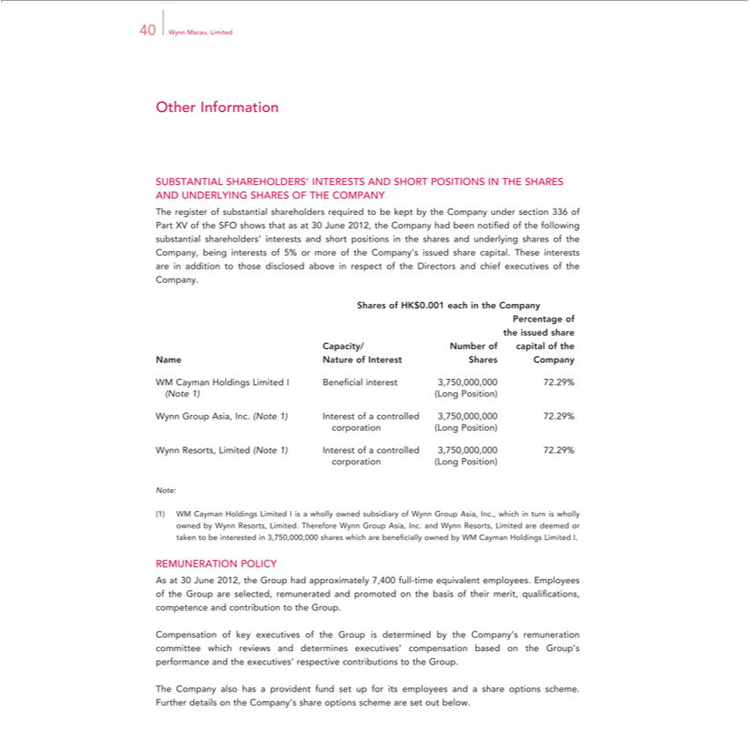

40 Wynn Macau, Limited
Other Information
SUBSTANTIAL SHAREHOLDERS’ INTERESTS AND SHORT POSITIONS IN THE SHARES AND UNDERLYING SHARES OF THE COMPANY
The register of substantial shareholders required to be kept by the Company under section 336 of Part XV of the SFO shows that as at 30 June 2012, the Company had been notified of the following substantial
shareholders’ | and short positions in the shares and underlying shares of the Company, being interests of 5% or more of the Company’s issued share capital. These interests are in addition to those
disclosed aboveinterestsrespect of the Directors and chief executives of the Company.
Shares of HK$0.001 each in the Company
Percentage of
the issued share
Capacity/ Number of capital of the
Name Nature of Interest Shares Company
WM Cayman Holdings Limited I Beneficial interest 3,750,000,000 72.29%
(Note 1) (Long Position)
Wynn Group Asia, Inc. (Note 1) Interest of a controlled 3,750,000,000 72.29%
corporation (Long Position)
Wynn Resorts, Limited (Note 1) Interest of a controlled 3,750,000,000 72.29%
corporation (Long Position)
Note:
WM Cayman Holdings Limited I is a wholly owned subsidiary of Wynn Group Asia, Inc., which in turn is wholly owned by Wynn Resorts, Limited. Therefore Wynn Group Asia, Inc. and Wynn Resorts,
Limited are deemed or taken to be interested in 3,750,000,000 shares which are beneficially owned by WM Cayman Holdings Limited I.
REMUNERATION POLICY
As at 30 June 2012, the Group had approximately 7,400 full-time equivalent employees. Employees of the Group are selected, remunerated and promoted on the basis of their merit, qualifications, competence
and contribution to the Group.
Compensation of key executives of the Group is determined by the Company’s remuneration committee which reviews and determines executives’ compensation based on the Group’s performance and the
executives’ respective contributions to the |  | .
The Company also has a provident fund setGroupfor its employees and a share options scheme. Further details on the Company’s share options scheme are set out below.

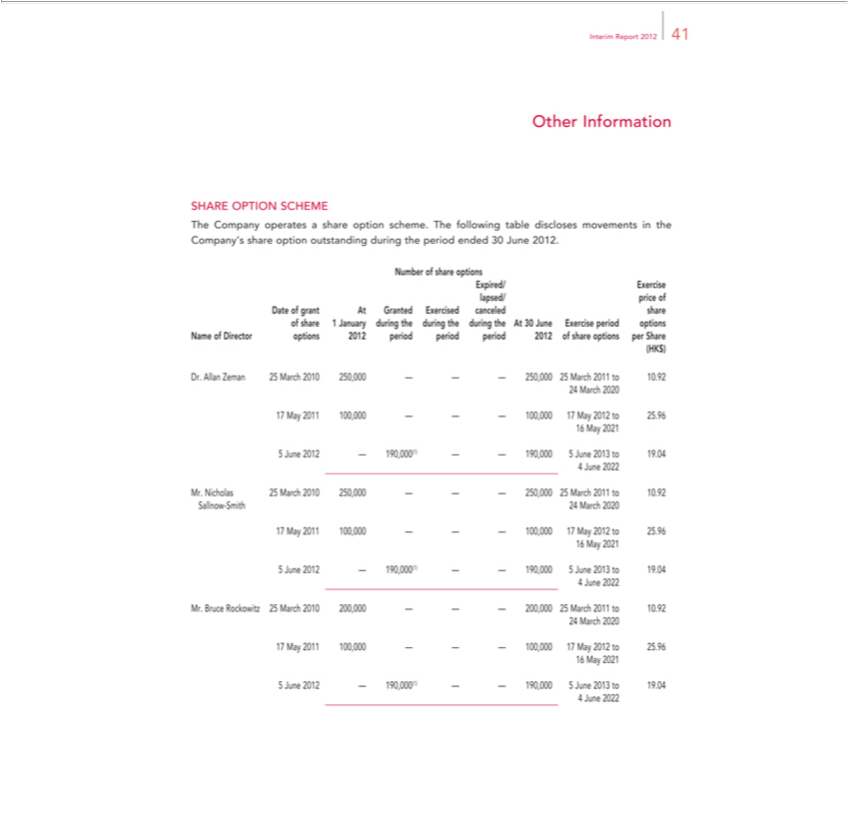

Interim Report 2012 41
Other Information
SHARE OPTION SCHEME
The Company operates a share option scheme. The following table discloses movements in the Company’s share option outstanding during the period ended 30 June 2012.
Number of share options
Expired/ Exercise
lapsed/ price of
Date of grant At Granted Exercised canceled share |  |  | options
of share 1 January during the during the during the At 30 June Exercise |  |  | options
Name of Director options 2012 period period period 2012 of share optionsperiod Share
(HK$)
Dr. Allan Zeman 25 March 2010 250,000 — — — 250,000 25 March 2011 to 10.92
24 |  | rch 2020
 | 7 | 1 100,000 — — — 100,000 17 May 2012 to 25.96
16 May 2021
5 |  | June 2012 — 190,000(1) — — 190,000 5 June 2013 to 19.04
4 |  | June 2022
Mr. Nicholas 25 March 2010 250,000 — — — 250,000 25 March 2011 to 10.92
Sallnow-Smith 24 March 2020
 | 7 | 1 100,000 — — — 100,000 17 May 2012 to 25.96
16 May 2021
5 |  | June 2012 — 190,000(1) — — 190,000 5 June 2013 to 19.04
4 |  | June 2022
Mr. Bruce Rockowitz 25 March 2010 200,000 — — — 200,000 25 March 2011 to 10.92
24 |  | rch 2020
 | 7 | 1 100,000 — — — 100,000 17 May 2012 to 25.96
16 May 2021
5 |  | June 2012 — 190,000(1) — — 190,000 5 June 2013 to 19.04
4 |  | June 2022

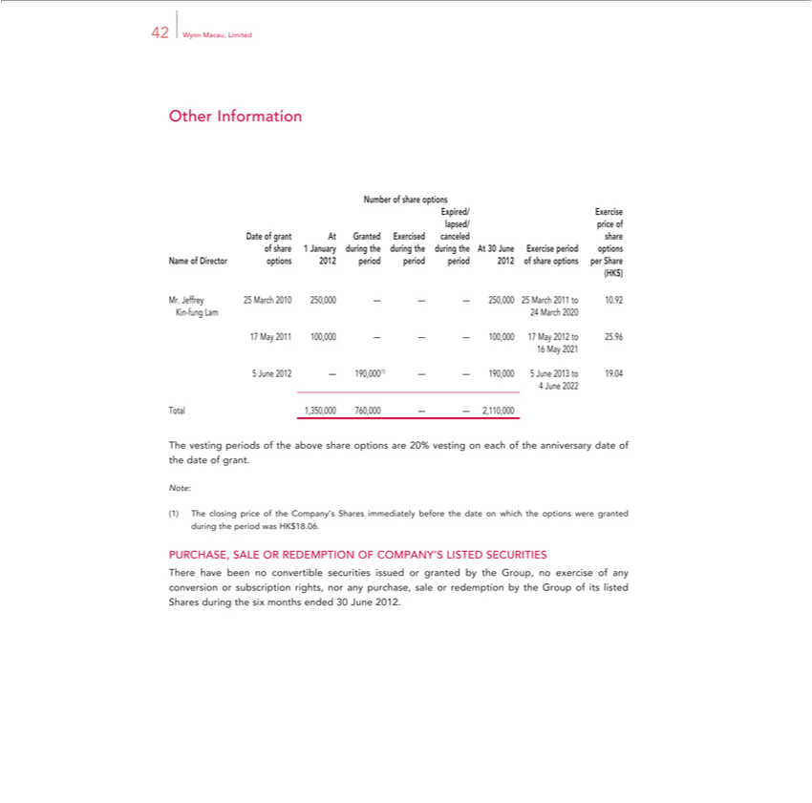

42 Wynn Macau, Limited
Other Information
Number of share options
Expired/ Exercise
lapsed/ price of
Date of grant At Granted Exercised canceled share |  |  | options
of share 1 January during the during the during the At 30 June Exercise |  |  | options
Name of Director options 2012 period period period 2012 of share optionsperiod Share
(HK$)
Mr. Jeffrey 25 March 2010 250,000 — — — 250,000 25 March 2011 to 10.92
Kin-fung Lam 24 March 2020
 | 7 | 1 100,000 — — — 100,000 17 May 2012 to 25.96
16 May 2021
5 |  | June 2012 — 190,000(1) — — 190,000 5 June 2013 to 19.04
4 |  | June 2022
^{The}otal 1,350,000 760,000 — — 2,110,000
vesting periods of the above share options are 20% vesting on each of the anniversary date of the date of grant.
The closing price of the Company’s Shares immediately before the date on which the options were granted during the period was HK$18.06.
PURCHASE, SALE OR REDEMPTION OF COMPANY’S LISTED SECURITIES

There have been no convertible securities issued or granted by the Group, no exercise of any conversion or subscription rights, nor any purchase, sale or redemption by the Group of its listed Shares during the six months ended 30 June 2012.

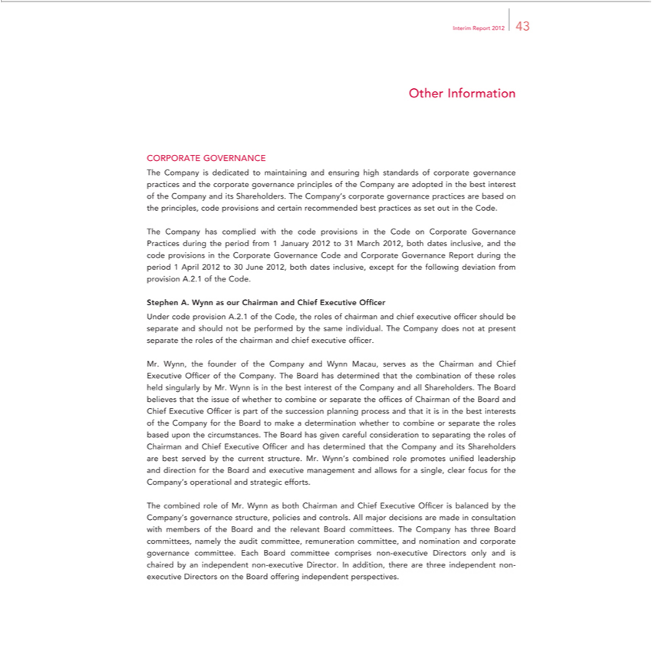

Interim Report 2012 43
Other Information
TheCORPORATECompany isGOVERNANCEdedicatedtomaintaining and ensuring high standards of corporate governance practices and the corporate governancerecommendedprinciples of the Company are adopted in the best interest of the Company
Theand itsCompanyShareholders.hascompliedTheCompany’swiththe codecorporateprovisionsgovernanceinthe Codepracticeson Corporatearebased onGovernancetheprinciples,Practicescodeduringprovisionstheperiodandcertainfrom 1 January 2012bestto31practicesMarch 2012,asset bothoutindatesthe Code.inclusive, and the code provisions in the Corporate Governance Code and Corporate Governance Report during the period 1 April 2012 to 30 June 2012, both dates inclusive, except for the following deviation from provision A.2.1 of the Code.
UnderStephencodeA. WynnprovisionasourA.2.1Chairmanofthe Code,andChieftherolesExecutiveofchairmanOfficerand chief executive officer should be separate and should not be performed by the same individual. The Company does not at present separate the roles of the chairman and chief executive officer.

Mr. Wynn,isthein founderthebest ofinteresttheCompanyoftheCompanyandWynnandMacau,allShareholders.servesastheTheChairmanBoardbelievesandChiefthatExecutivetheissue Of?cerofwhetheroftheto Company.combineorTheseparateBoardthehasofficesdeterminedofChairmanthatthe ofcombinationtheBoard andoftheseChiefrolesExecutiveheldsingularlyOfficerisbypart of the succession planning process and that it is in the best interests of the Company for the Board to make a determination whether to combine or separateare the roles based upon the circumstances. The Board has
combinedgivencarefulroleconsiderationpromotesunifito edseparatingleadershiptheandrolesdirectionofChairmanfortheandBoardChiefandExecutiveexecutiveOfficermanagementandhasanddeterminedforthat single,theCompanyclearfocusand forits ShareholderstheCompany’s operationalbestservedandby strategicthecurrentefforts.structure. Mr. Wynn’s
The combined role of Mr. Wynn as both Chairman and Chief Executive Officer is balanced by the Company’allows governance structure, policies and controls. All major decisions are made in consultation with members of the Board and the relevant Board ^{non}cmmittees. The Company has three Board committees, namely the audit committee, remuneration committee, and nomination and corporate governance committee. Each Board committee comprises -executive Directors only and is chaired by an independent non-executive Director. In addition, there are three independent non-executive Directors on the Board offering independent perspectives.

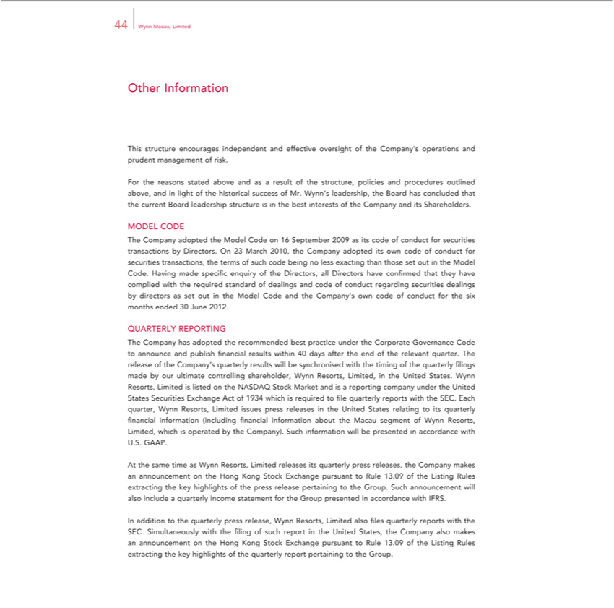

44 Wynn Macau, Limited
Other Information |  |  | operations and prudent management of risk.
This structure encourages independent and effective oversight of the Company’
For the reasons stated above and as a result of the structure, policies and procedures outlined above, and in light of the historical success of Mr. Wynn’s leadership, the Board has concluded that the current Board
leadership structure is in the best interests of the Company and its Shareholders.
MODEL CODE
The Company adopted the Model Code on 16 September 2009 as its code of conduct for securities transactions by Directors. On 23 March 2010, the Company adopted its own code of conduct for securities
transactions, the terms of such code b ing no less exacting than those set out |  | the Model Code. |  | made specific enquiry of the | all Directors have confirmed that they have complied with the
required standard of dealings and code of conduct regarding securities dealings by directors as setHavingout the Model Code and the Company’Directors,own code of conduct for the six months ended 30 June 2012.
QUARTERLY REPORTING
The Company has adopted the recommended best practice under the Corporate Governance Code to announce and publish financial results within 40 days after the end of the relevant quarter. The release of the
Company’s quarterly results will be | d with the timing of the quarterly filings made by our ultimate controlling shareholder, Wynn Resorts, Limited, in the United States. Wynn |  |  |  |  | Limited is
synchronisreporting Resorts,
listed on the NASDAQ Stock Market and _{States} company under the United States Securities Exchange Act of 1934 which is required to fi le quarterly reports with the SEC. Each quarter Wynn Resorts,
Limited issues press releases in the United relating to its quarterly financial information (including financial information about the Macau segment of Wynn Resorts, Limited, which is operated by the Company). Such information will be presented in accordance with U.S. GAAP.
At the same time as Wynn Resorts, Limited releases its quarterly press releases, the Company makes an announcement on the Hong Kong Stock Exchange pursuant to Rule 13.09 of the Listing Rules extracting the key highlights of the press release pertaining to the Group. Such announcement will also include a quarterly income statement for the Group presented in accordance with IFRS.

In addition to the quarterly press release, Wynn Resorts, Limited also ? les quarterly reports with the SEC. Simultaneously with the filing of such report in the United States, the Company also makes an announcement on the Hong Kong Stock Exchange pursuant
to Rule 13.09 of the Listing Rules extracting the key highlights of the quarterly report pertaining to the Group.

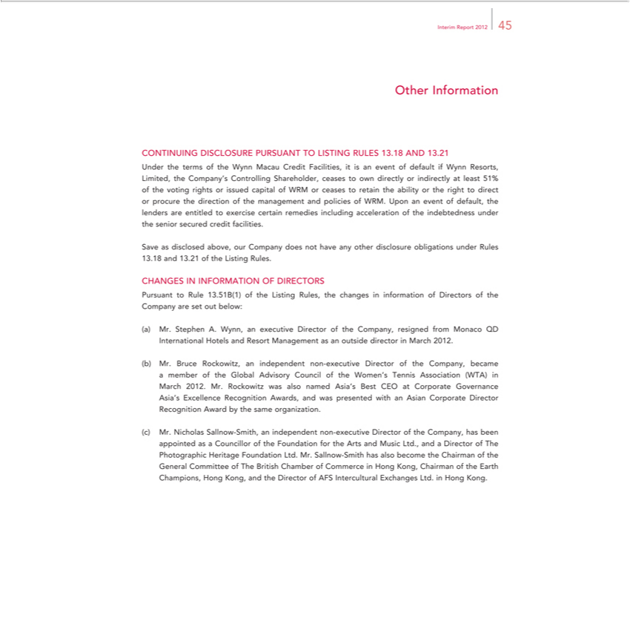

Interim Report 2012 45
Other Information
CONTINUING DISCLOSURE PURSUANT TO LISTING RULES 13.18 AND 13.21
Under the terms of the Wynn Macau Credit Facilities, it is an event of default if Wynn Resorts, Limited, the Company’s Controlling Shareholder, ceases to own directly or indirectly at least 51% of the voting
rights or issued capital of WRM or ceases to retain the ability or the right to direct or procure the direction of the management and policies of WRM. Upon an event of default, the lenders are entitled to exercise
certain remedies including acceleration of the indebtedness under the senior secured credit facilities.
Save as disclosed above, our Company does not have any other disclosure obligations under Rules
13.18 and 13.21 of the Listing Rules.
CHANGES IN INFORMATION OF DIRECTORS
Pursuant to Rule 13.51B(1) of the Listing Rules, the changes in information of Directors of the Company are set out below: | director in March 2012.
Stephen A. Wynn, an executive Director of the Company, resigned from Monaco QD Internati nal Hotels and Resort Management as an
Mr. Bruce Rockowitz, an independent non-executive Director of the Company, became a member of the Global Advisory Council of the Women’outsideTennis |  | (WTA) in March 2012. Mr. Rockowitz was
also named Asia’s Best CEO at Corporate Governance Asia’s Excellence Recognition Awards, and was presented with an Asian Corporate Director RecognitionAssociationward by the _{Director}sameganization.
Mr. Nicholas Sallnow-Smith, an independent non-executive Director of the Company, has been appointed as a Councillor of the Foundation for the Arts and Music Ltd., and a of The Photographic Heritage Foundation Ltd. Mr. Sallnow-Smith has also become the Chairman of the General Committee of The British Chamber of Commerce in Hong Kong, Chairman of the Earth Champions, Hong Kong, and the Director of AFS Intercultural Exchanges Ltd. in Hong Kong.

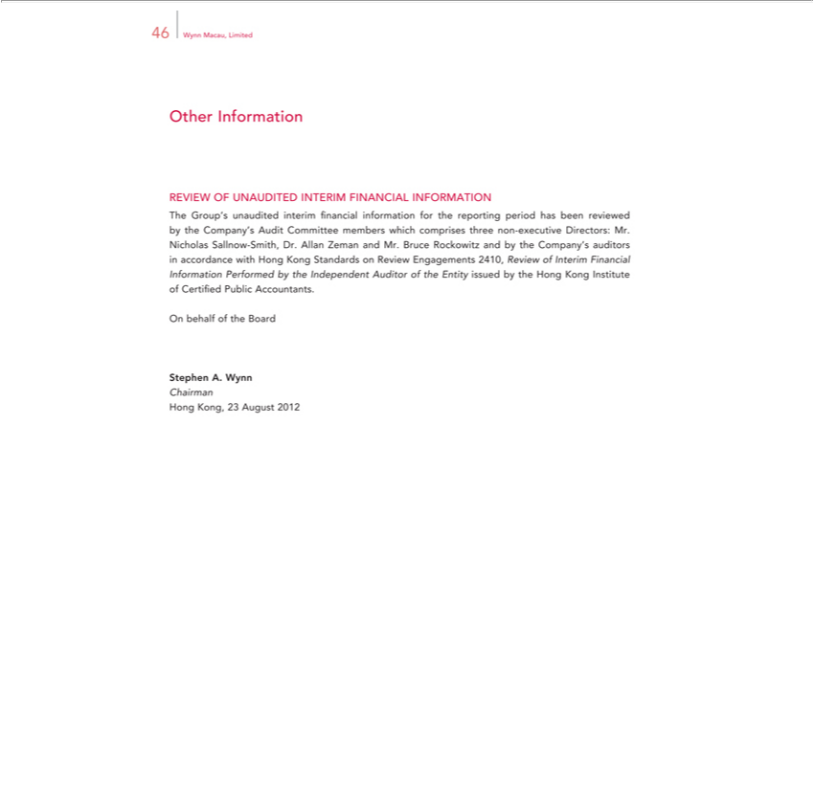

Other46WynnInformationMacau,Limited
REVIEW OF UNAUDITED INTERIM FINANCIAL INFORMATION

The Group’s unaudited interim financial information for the reporting period has been reviewed by the Company’s Audit Committee members which comprises three non-executive Directors: Mr. Nicholas Sallnow-Smith, Dr. Allan Zeman and Mr. Bruce Rockowitz and by the Company’_{Institute}auditors in accordance with Hong Kong Standards on Review Engagements 2410, Review of Interim Financial Information
OnPerformedbehalfofbythetheBoardIndependent Auditor of the Entity issued by the Hong Kong of Certified Public Accountants.
ChairmanStephenA. Wynn

Hong Kong, 23 August 2012

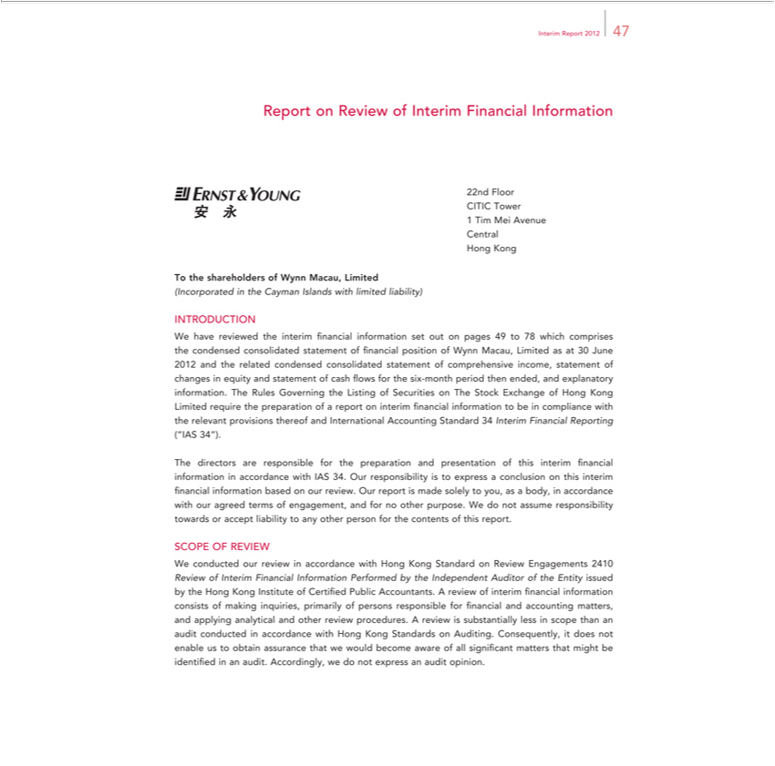

Interim Report 2012 47
Report on Review of Interim Financial Information
[Graphic Appears Here]
22nd Floor
CITIC Tower
1 | Tim Mei Avenue
Central
 | Kong
HongTthe shareholders of Wynn Macau, Limited
(Incorporated in the Cayman Islands with limited liability)
INTRODUCTION |  |  |  |  |  |  |  | 30 June 2012 and the
W | have reviewed the interim financial information set out on pages 49 to 78 which comprises the condensed consolidated statement of financial position of Wynn Macau, Limited as |  |  |  |  |  |  | 30 June 2012 and the
related condensed consolidated statement of comprehensive income, statement of changes in equity and |  |  |  |  |  | of cash flows for the six- nth period then ended, and explanatory information. The Rules
Governing the Listing of Securities on The Stock Exchange of Hong Kong Limited require the preparationstatementofreport on interim financial information to be in compliance with the relevant provisions thereof and
Int rnational Accounting Standard 34 Interim Financial Reporting (“IAS 34”). |  |  |  |  | financial information in accordance with IAS 34. Our responsibility is to |  | a conclusion on this interim financial
The directors are |  |  | for the preparation and presentation of this
information basedresponsibleourreview. Our report is made solely to you, as a body,interim accordance with our agreed terms of engagement, and for no other purpose.expressWdo not assume responsibility towards or accept
liability to any other person for the contents of this report.
SCOPE OF REVIEW |  |  | accordance with Hong Kong Standard on Review Engagements 2410
W | conducted our review |  |  |  |  |  | . A review of interim | information
Review of Interim Financial Information Performed by the Independent Auditor of the Entity issued by the Hong Kong Institute of Certi? ed Public |  |  |  |  |  |  | . A review of interim | information
 | sists of making inquiries, primarily of persons |  |  | for financial and accounting matters, and applying analytical and other review procedures.Accountantsreview is substantially less financialscope than an audit
conducted |  | accordance with Hong Kong StandardsresponsibleAuditing. Consequently, it does not enable us to obtain assurance that we would become aware of all significant matters that might be identifi ed in an
audit. Accordingly, we do not express an audit opinion.

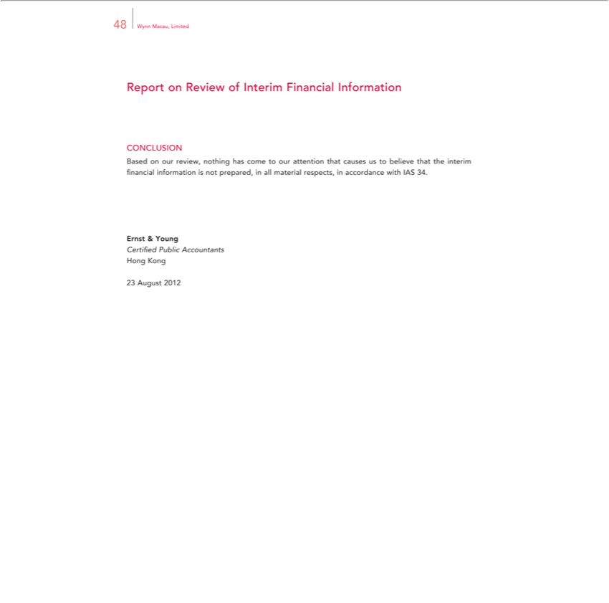

48 Wynn Macau, Limited
Report on Review of Interim Financial Information
CONCLUSION
Based on our review, nothing has come to our attention that causes us to believe that the interim financial information is not prepared, in all material respects, in accordance with IAS 34. Ernst & Young
HongCertifiedKongPublic Accountants

23 August 2012

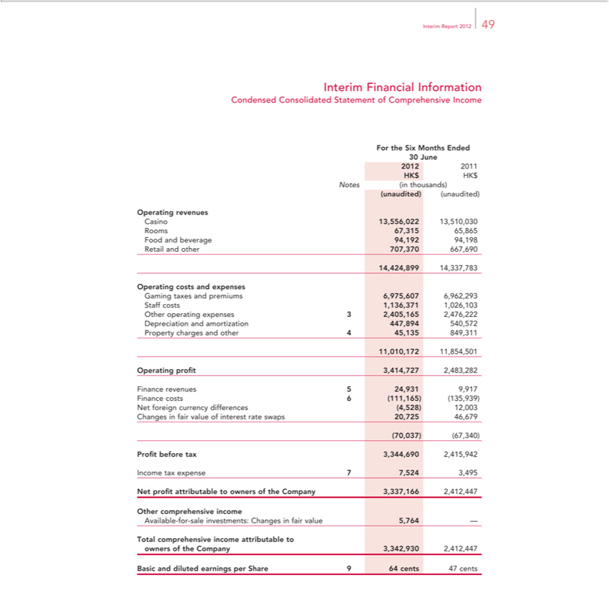

_{Interim} FinancialReport2012Information49
ForCondensedtheSix ConsolidatedMonthsEndedStatement of Comprehensive Income
₂₀₁₂30June
Notes2011(inthousands)HK$HK$
Operating(unaudited)revenues(unaudited)

Casino 13,556,022 13,510,030 Rooms 67,315 65,865 Food and beverage 94,192 94,198 Retail and other 707,370 667,690 14,424,899 14,337,783
Operating costs and expenses

Gaming taxes and premiums 6,975,607 6,962,293 Staff costs 1,136,371 1,026,103 Other operating expenses 3 2,405,165 2,476,222 Depreciation and amortization 447,894 540,572 Property charges and other 4 45,1351,010,172849,311,854,501
Operating profit 3,41_{24,931}727 _{9,917}2483,282
Finance revenues 5 Finance costs_{2,415,942}6(11,165) (135,939) Net foreign currency differences (4,528) 12,003 Changes in fair value of interest rate swaps 20,725 46,679
Net(70,037)profit(67,340)attributableProfitto beforeownerstaxof 3,344,690theCompany 3,337,166Income2,412,447taxexpense 7 7,524 3,495
Other comprehensive income
Available-for-sale investments: Changes in fair value 5,764 —
BasicTotal comprehensiveanddilutedearningsincomeperattributableShare964tocentsowners47centsofthe Company 3,342,930 2,412,447

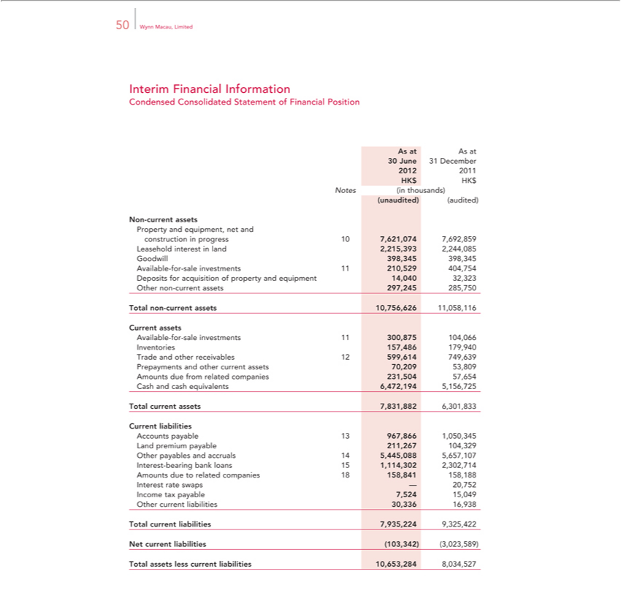

50 Wynn Macau, Limited
Interim Financial Information
Condensed Consolidated Statement of Financial Position
As at As at |  | December
30 June
2012 | 20131
HK$ HK$
Notes (in thousands)
(unaudited) (audited)
Non-current assets
Property and equipm nt, net and
construction |  |  | progress 10 7,621,074 7,692,859
Leasehold interest in land 2,215,393 2,244,085
Goodwill 398,345 398,345
Available-for-sale investments 11 210,529 404,754
Deposits for acquisition of property and equipment 14,040 32,323
Other non-current assets 297,245 285,750
Total non-current assets 10,756,626 11,058,116
Current assets
Available-for-sale investments 11 300,875 104,066
Inventories 157,486 179,940
Trade and other receivables 12 599,614 749,639
Prepayments and other current assets 70,209 53,809
Amounts due from related companies 231,504 57,654
Cash and cash equivalents 6,472,194 5,156,725
Total current assets 7,831,882 6,301,833
Current liabilities
Accounts payable 13 967,866 1,050,345
Land premium payable 211,267 104,329
Other payables and accruals 14 5,445,088 5,657,107
Interest-bearing bank loans 15 1,114,302 2,302,714
Amounts due to related companies 18 158,841 158,188
terest rate swaps — 20,752
Income tax pay |  |  | le 7,524 15,049
Other current liabilities 30,336 16,938
NetTotalcurrentcurrentliabilitiesliabilities(103,342)7,935,224(3,023,589)9,325,422
NonTotal-currentassetslessliabilitiescurrent liabilities 10,653,284 8,034,527

Interest-bearing bank loans Land premium payable Other payables and accruals Other long-term liabilities

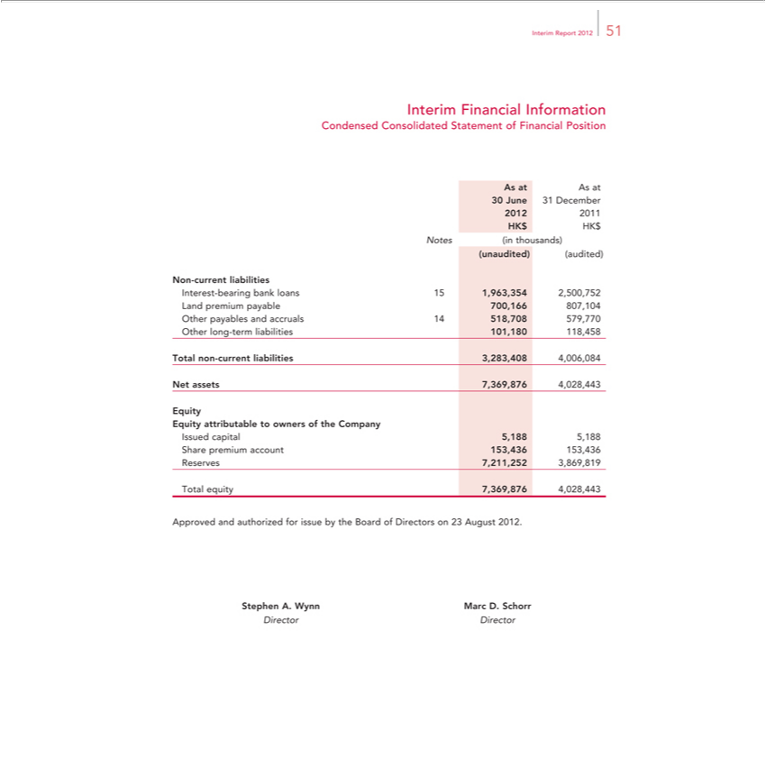

_{Interim} FinancialReport2012Information51
AsCondensedatAsat Consolidated Statement of Financial Position
²⁰¹²30June ³¹ December
HK$ HK201$
(unaudited)Notes(inthousands)(audited)
700,15⁵1,963,35466^{,708}807,1042,500,752
_{101,180}4 579,770
118,458
NetTotalassetsnon-current7,369,876liabilities4,028,4433,283,408 4,006,084
Eq ity
^{Issued}
capitalattributable5,188to5,188owners of the Company
ReservesSharepremium7,211,252account3,869,819153,436 153,436
Total equity 7,369,876 4,028,443
StephenApprovedA.andWynnauthorizedMarcD.forSchorrissue by the Board of Directors on 23 August 2012.

Director Director

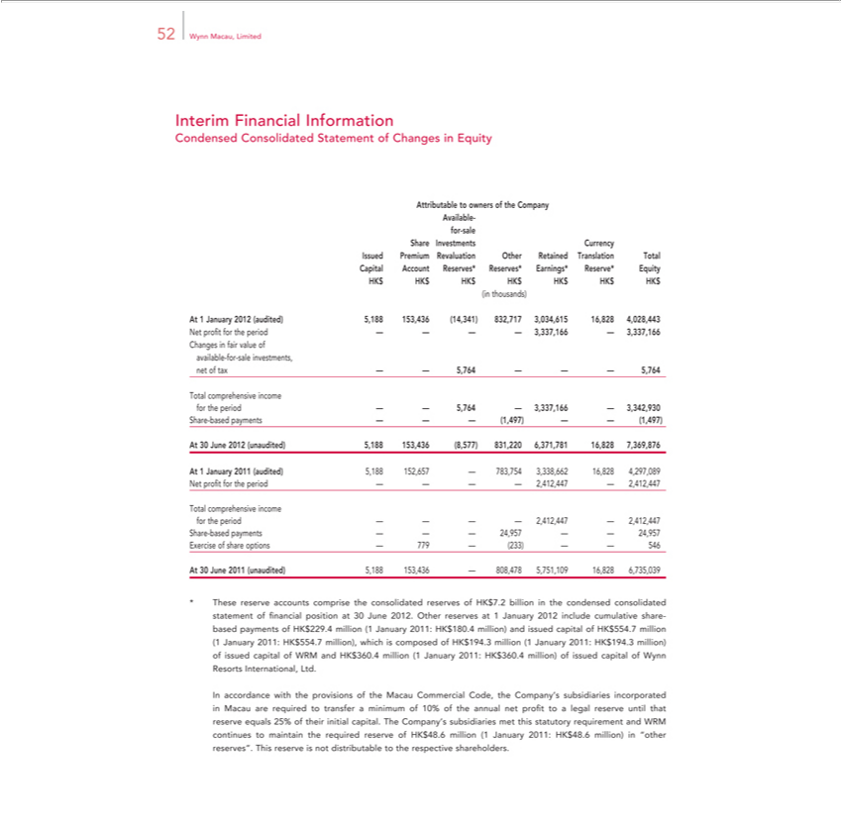

52 Wynn Macau, Limited
Interim Financial Information
Condensed C nsolidated Statement of Changes in Equity
ttributable to owners of the Company
Available-
for-sale
Share Investments Currency
Issued Premium Revaluation Other Retained Translation Total
Capital Account Reserves* Reserves* Earnings* Reserve* Equity
HK$ HK$ HK$ HK$ HK$ HK$ HK$
(in thousands)
At 1 January 2012 (audited) 5,188 153,436 (14,341) 832,717 3,034,615 16,828 4,028,443
Net profit for the period — — — — 3,337,166 — 3,337,166
Changes in fair value of
available-for-sale investments,
net of tax — — 5,764 — — — 5,764
Total comprehensive income
for the period — — 5,764 — 3,337,166 — 3,342,930
Share-based payments — — — (1,497) — — (1,497)
30 June 2012 (unaudited) 5,188 153,436 (8,577) 831,220 6,371,781 16,828 7,369,876
At 1 January 2011 (audited) 5,188 152,657 — 783,754 3,338,662 16,828 4,297,089
Net profit for the period — — — — 2,412,447 — 2,412,447
Total comprehensive income
for the period — — — — 2,412,447 — 2,412,447
Share-based payments — — — 24,957 — — 24,957
Exercise of share options — 779 — (233) — — 546 | 6,735,039
At 30 June 2011 (unaudited) 5,188 153,436 — 808,478 5,751,109 | 6,735,039
These reserve accounts comprise the consolidated reserves of HK$16,8287.billion in the condensed consolidated statement of financial position at 30 June 2012. Other reserves at 1 January 2012 include cumulative
share- based payments of HK$229.4 million (1 January 2011: HK$180.4 million) and issued capital of HK$554.7 million (1 January 2011: HK$554.7 million), which is composed of HK$194.3 million (1
January 2011: HK$194.3 million) of issued capital of WRM and HK$360.4 million (1 January 2011: HK$360.4 million) of issued capital of Wynn Resorts International, Ltd.
In accordance with the provisions of the Macau Commercial Code, the Company’ subsidiaries incorporated in Macau are required to transfer a minimum of 10% of the annual net profit to legal reserve until
that reserve equals 25% of their initial capital. The Company’s subsidiaries met this statutory requirement and WRM continues to maintain the required reserve of HK$48.6 million (1 |  | January 2011: HK$48.6
million) in “other reserves”. This reserve is not distributable to the respective shareholders.

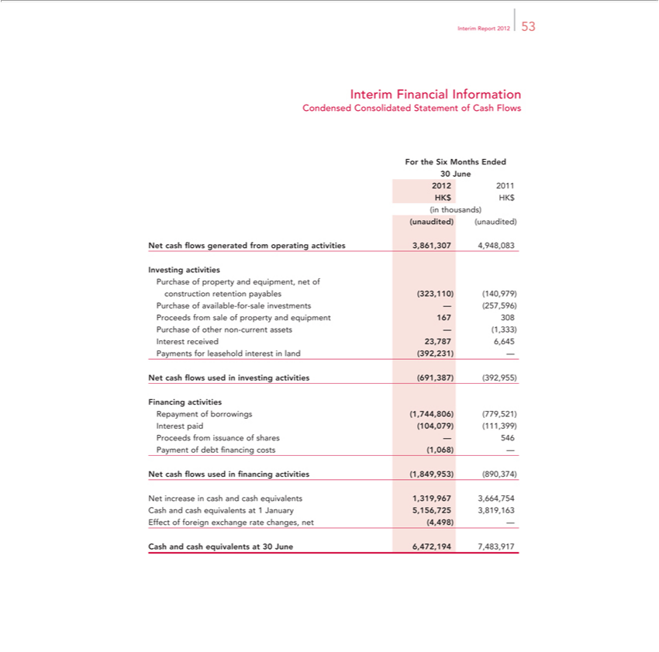

Interim Report 2012 53
Financial Information
ForCondensedtheSix ConsolidatedMonthsEndedStatement of Cash Flows
30 June
HK2012$ HK2011$
in thousands)
Net(unaudited)cash?flows(unaudited)generated from operating activities 3,861,307 4,948,083
Investing activities
constructionPurchaseofpropertyretentionandpayablesequipment,(323,110)netof(140,979)
hase of available-for-sale investments — (257,596)
Purchaseroeeds offromothersalenonof-propertycurrentassetsandequipment—(1,333)167 308
Interest received 23,787 6,645
NetPaymentscashflowsforleaseholdusedininvestinginterestinactivitiesland(392,231)(691,387)— (392,955)
Financing activities
InterestRepaymentpaidof(104,079)borrowings(111,399)(1,744,806) (779,521)
Paymentroceds offromdebtissuance of sharescosts(1,068)—546—
financing
^{Net} cash flows used ^{cash}ncing activities (1,849,953) (890,374)
Cashincreaseandcashinequivalentscashand at 1equivalentsJanuary5,156,7251,319,9673,819,1633,664,754

CashEffectandof foreigncashequivalentsexchange atrate30changes,June6,472,194net(4,498)7,483,917—

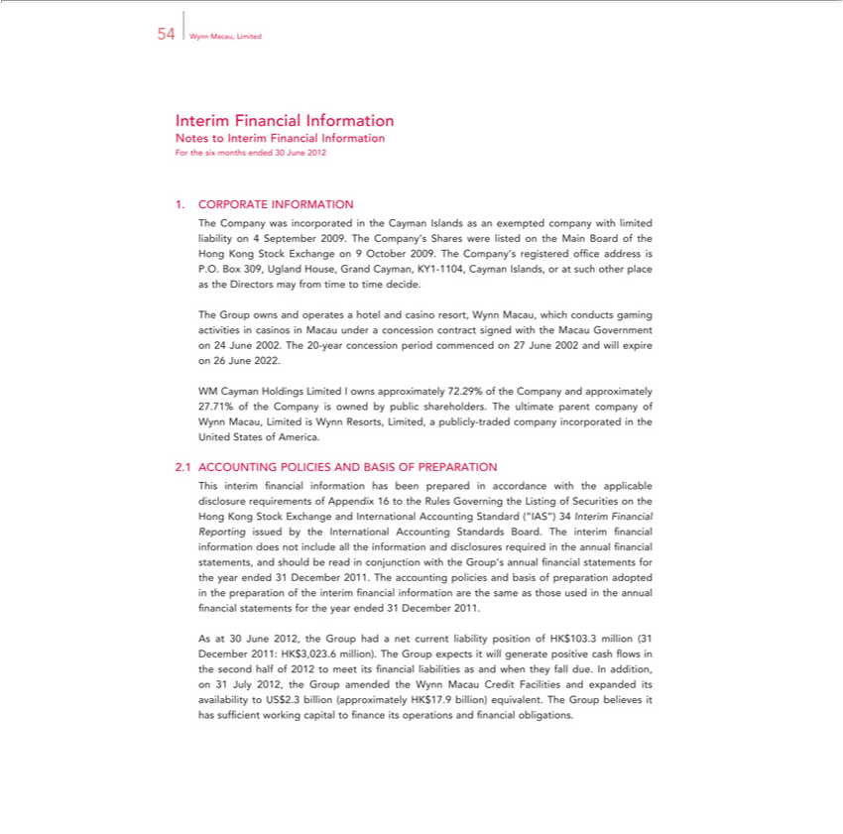

54 Wynn Macau, Limited
Interim Financial Information
Notes to Interim Financial Information
For the six months ended 30 June 2012
CORPORATE INFORMATION
The Compa y was incorporated in the Cayman Islands as an exempted company with limited liability on 4 September 2009. The Company’s Shares were listed on the Main Board of the Hong Kong Stock
Exchange on 9 October 2009. The Company’s registered office address is P.O. Box 309, Ugland House, Grand Cayman, KY1-1104, Cayman Islands, or at such other place as the Directors may from time to time
decide.
Group owns and operates a hotel and casino resort, Wynn Macau, which conducts gaming activities in casinos in Macau under a concession contract signed with the Macau Government on 24 June 2002.
The 20-year concession period commenced on 27 June 2002 and will expire on 26 June 2022.
WM Cayman Holdings Limited I owns approximately 72.29% of the Company and approximately 27.71% of the Company is owned by public shareholders. The ultimate parent company of Wynn Macau,
Limited is Wynn Resorts, Limited, a publicly-traded company incorporated in the United States of America.
ACCOUNTING POLICIES AND BASIS OF PREPARATION
This interim financial information has been prepared in accordance with the applicable disclosure requirements of Appendix 16 to the Rules Governing the Listing of Securities the Hong Kong Stock
Exchange and International | Standard (“IAS”) 34 Interim Financial Reporting issued by the I ternational Accounting Standards Board. The interim financial information does not include all the
information and disclosures Accountingrequired the annual financial statements, and should be read |  | conjunction with the Group’s annual financial statements for the year ended 31 December 2011. The accounting
policies and basis of preparation | in the preparation of the interim financial information are the same as those used in the annual financial statements for the year ended 31 December 2011.
As at 30 June 2012, the Group hadadoptednetcurrent liability position of HK$103.3 million (31 December 2011: HK$3,023.6 million). The Group expects it will generate positive cash flows in the second half of 2012 to meet its financial liabilities as and when they fall due. In addition, on 31 July 2012, the Group amended the Wynn Macau Credit Facilities and expanded its availability to US$2.3 billion (approximately HK$17.9 billion) equivalent. The Group believes it has sufficient working capital to finance its operations and financial obligations.

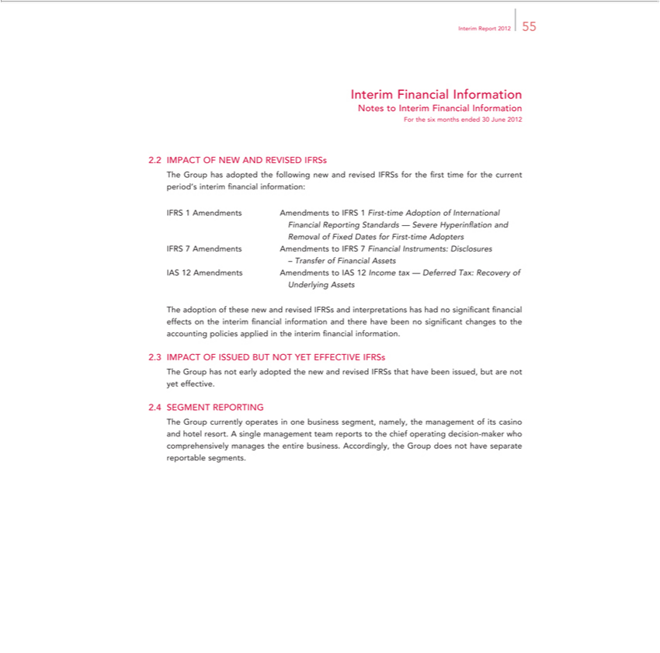

Interiminterim ReportFinancial2012Information55
Notes to Interim Financial Information
IMPACTForthesixOFmonthsNEWendedAND 30REVISEDJune2012IFRSs
IFRSTheGroup1AmendmentshasadoptedAmendmentsthefollowingto newIFRSand1Firstrevised-timeIFRSsAdoptionfortheof firstInternationaltimefor the current period’s interim financial information:
RemovalFinancial ofReportingFixedDatesStandardsforFirst—-timeSevereAdoptersHyperinflation and
IFRS 7 Amendments Amendments to IFRS 7 Financial Instruments: Disclosures
– Transfer of Financial Assets
UnderlyingIAS12AmendmentsAssets Amendments to IAS 12 Income tax — Deferred Tax: Recovery of

The adoption of these new and revised IFRSs and interpretations has had no significant financial effects on the interim financial information and there have been no significant changes to the accounting policies applied in the interim financial information.
IMPACT OF ISSUED BUT NOT YET EFFECTIVE IFRSs
The Group has not early adopted the new and revised IFRSs that have been issued, but are not yet effective.
SEGMENT REPORTING
The Group currently operates_{Accordingly}onebusiness segment, namely,_{have}the management of its casino and hotel resort. A single management team reports to the chief operating decision-maker who comprehensively
manages the entire business. , the Group does not separate reportable segments.

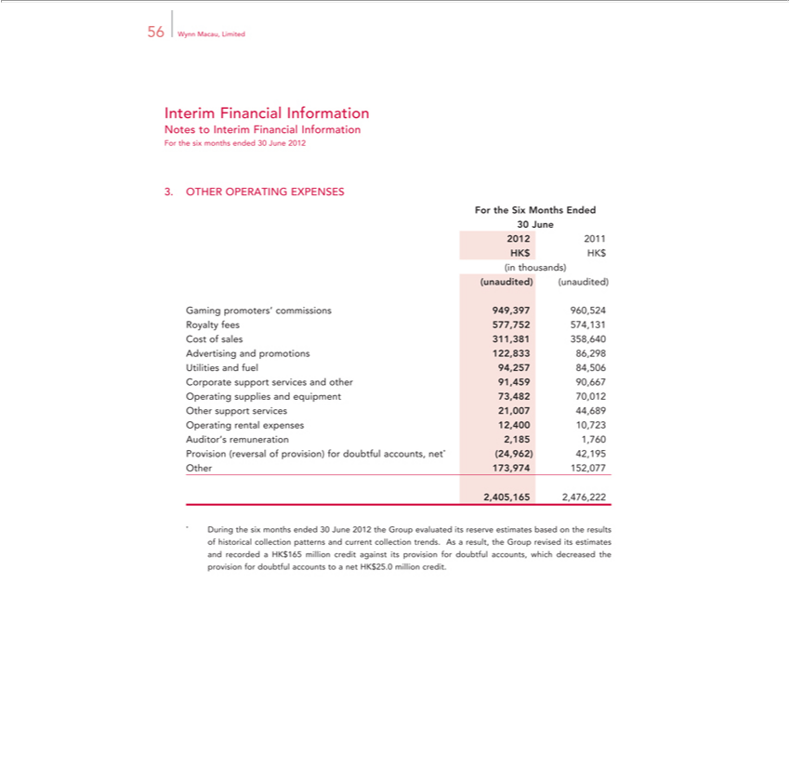

56 Wynn Macau, Limited
Interim Financial Information
Notes to Interim Financial Information
For the six months ended 30 June 2012
3. OTHER OPERATING EXPENSES
For the Six Months Ended
30 June
2012 | 2011
HK$ HK$
in thousands)
(unaudited) (unaudited)
Gaming promoters’ commissions 949,397 960,524
R yalty fees 577,752 574,131
Cost of sales 311,381 358,640
Advertising and promotions 122,833 86,298
Utilities and fuel 94,257 84,506
Corporate |  | ort services and other 91,459 90,667
 |  | supplies and equipment 73,482 70,012
ther support services 21,007 44,689
Operating rental expenses 12,400 10,723
Auditor’ |  | remuneration 2,185 1,760
Provision |  | (reversal of provision) for doubtful accounts, net* (24,962) 42,195
Other 173,974 152,077
2,405,165 2,476,222 |  |  | current collection trends. As a result, the Group revised its estimates
During the six months ended 30 June 2012 the Group evaluated its reserve estimates based on the results of historical collection patterns
and recorded a HK$165 million credit against its provision for doubtful accounts, which decreased the provision for doubtful accounts to andnet HK$25.0 million credit.

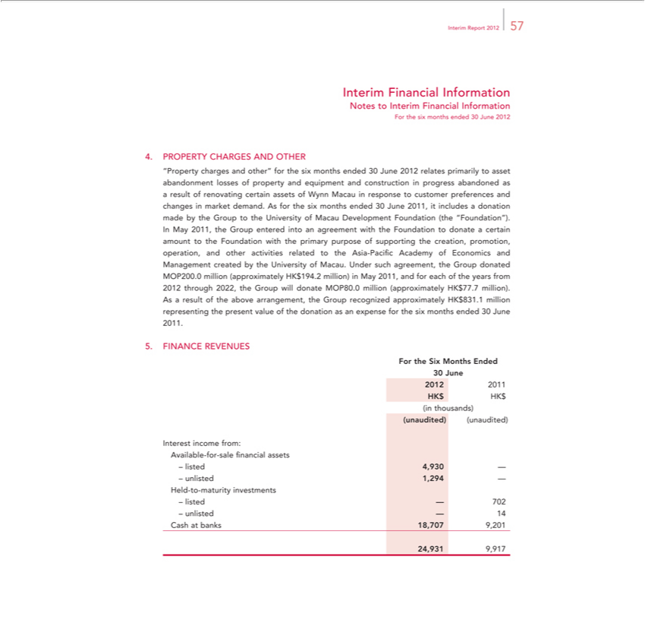

 | Report 2012 57
Interim Financial Information
Notes to Interim Financial Information
For the six months ended 30 June 2012
PROPERTY CHARGES AND OTHER
“Property charges and other” for the six months ended 30 June 2012 relates primarily to asset abandonment losses of property and equipment and construction in progress abandoned as a result of renovating
certain assets of Wynn Macau in response to customer preferences and changes in market demand. As for the six months ended 30 June 2011, it includes a donation made by the Group to the University of
Macau Development Foundation (the “Foundation”).
In May 2011, the Group entered into an agreement with the Foundation to donate certain amount to the Foundation with the primary purpose of supporting the creation, promotion, operation, and other
activities related to the Asia-Pacific Academy of Economics and Management created by the University of Macau. Under such agreement, the Group donated MOP200.0 million (approximately HK$194.2
million) in May 2011, and for each of the years from 2012 through 2022, the Group will donate MOP80.0 million (approximately HK$77.7 million).
As a result of the above arrangement, the Group recognized approximately HK$831.1 million representing the present value of the donation as an expense for the six months ended 30 June 2011.
FINANCE REVENUES
30 June
2012 | 2011
_{(unaudited)}HKinthousands)$HK$
(unaudited)
– unlisted^{4,930}1,294——
Held-to-maturity investments
–
unlislisted^{at}ed——70214
Cash banks 18,707 9,201
9,91724,931

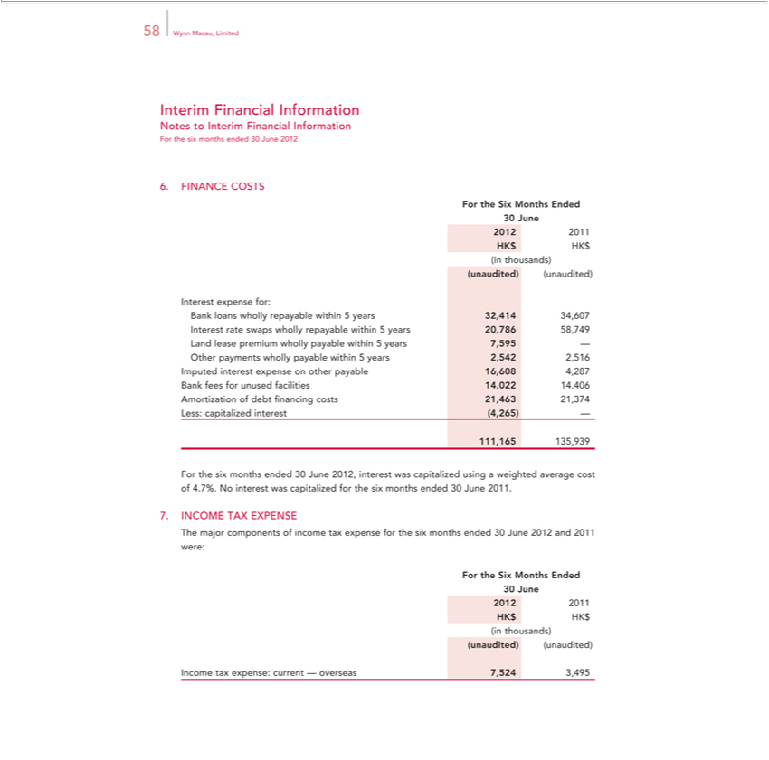

58 Wynn Macau, Limited
Interim Financial Information
Notes to Interim Financial Information
For the six months ended 30 June 2012
6. FINANCE COSTS
For the Six Months Ended
30 June
2012 | 2011
HK$ HK$
in thousands)
(unaudited) (unaudited)
Interest expense for:
Bank loans wholly repayable within 5 years 32,414 34,607
Interest rate swaps wholly |  | within 5 years 20,786 58,749
Land le se premium whollyrepayable within 5 years 7,595 —
Other payments wholly payable within 5 years 2,5 |  |  |  | 2,516
Imputed interest expense on other payable |  |  | ,608 | 4,287
Bank fees for unused facilities 14,022 4,406
Amortization of debt financing costs 21,463 |  |  | 21,374
Less: capitalized interest (4,265) —
111,165 135,939
For the six months ended 30 June 2012, interest was capitalized using a weighted average cost of 4.7%. No interest was capitalized for the six months ended 30 June 2011.
INCOME TAX EXPENSE
The major components of income tax expense for the six months ended 30 June 2012 and 2011 were:
For the Six Months Ended
30 | June
2012 2011
HK$ HK$
_{(unaudited)}inthousands)(unaudited)
3,495⁷⁵²⁴

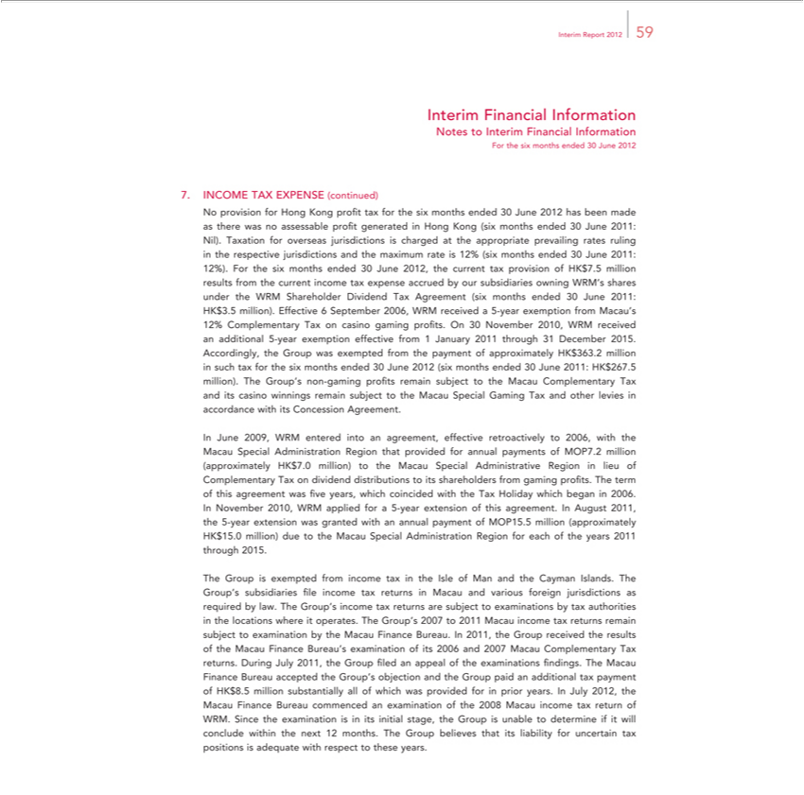

Report 2012 59
Interim Financial Information
Notes to Interim Financial Information
For the six months ended 30 June 2012
7. INCOME TAX EXPENSE (continued)
No provision for Hong Kong profit tax for the six months ended 30 June 2012 has been made as there was no assessable profit generated in Hong Kong (six months ended 30 June 2011: Nil). Taxation for
overseas jurisdictions charged at the appropriate prevailing rates ruling in the respective jurisdictions and the maximum rate is 12% (six months ended 30 June 2011: 12%). For the six months ended 30 June
2012, the current tax provision of HK$7.5 million results from the current income tax expense accrued by our subsidiaries owning WRM’s shares under the WRM Shareholder Dividend Tax Agreement (six
months ended 30 June 2011: HK$3.5 million). Effective 6 September 2006, WRM received a -year exemption from Macau’s 12% Complementary Tax on casino gaming profits. On 30 November 2010, WRM
received an additional 5-year exemption effective from 1 January 2011 through 31 December 2015.
Accordingly, the Group was exempted from the payment of approximately HK$363.2 million |  |  |  | such tax for the six months ended 30 June 2012 (six months ended 30 June 2011: HK$267.5 million). The
Group’s non-gaming profits remain subject to the Macau Complementary Tax and its casino winnings remain subject to the Macau Special Gaming Tax and other levies in accordance with its Concession
Agreement.
In June 2009, WRM entered into an agreement, effective retroactively to 2006, with the Macau Special Administration Region that provided for annual payments of MOP7.2 million (approximately HK$7.0
million) to the Macau Special | 2006. | Region in lieu of Complementary Tax on dividend distributions to its shareholders from gaming profits. The term of this agreement was five years, which coincided
with the Tax Holiday which began | 2006.
In November 2010, WRM appliedAdministrativefor5-year extension of this agreement. In August 2011, the 5-year extension was granted with an annual payment of MOP15.5 million (approximately HK$15.0 million) due
to the Macau Special | Region for each of the years 2011 through 2015. |  |  | subsidiaries file income tax returns Macau and various foreign jurisdictions as required by law. The Group’s
The Group is exempt Administrationfromincome tax the Isle of Man and the Cayman Islands. The Group’
income tax returns are subject to examinations by tax authorities the |  |  | where it operates. The Group’s 2007 to 2011 Macau income tax returns remain subject to examination by the Macau Finance
Bureau. In 2011, the Group received the results of the Macau Finance Bureau’locationsexamination of its 2006 and 2007 Macau Complementary Tax returns. During July 2011, the Group filed an appeal of the examinations findings. The Macau Finance Bureau accepted the Group’s objection and the Group paid an additional tax payment of HK$8.5 million substantially all of which was provided for in prior years. In July 2012, the Macau Finance Bureau commenced an examination of the 2008 Macau income tax return of WRM. Since the examination is in its initial stage, the Group is unable to determine if it will conclude within the next 12 months. The Group believes that its liability for uncertain tax positions is adequate with respect to these years.

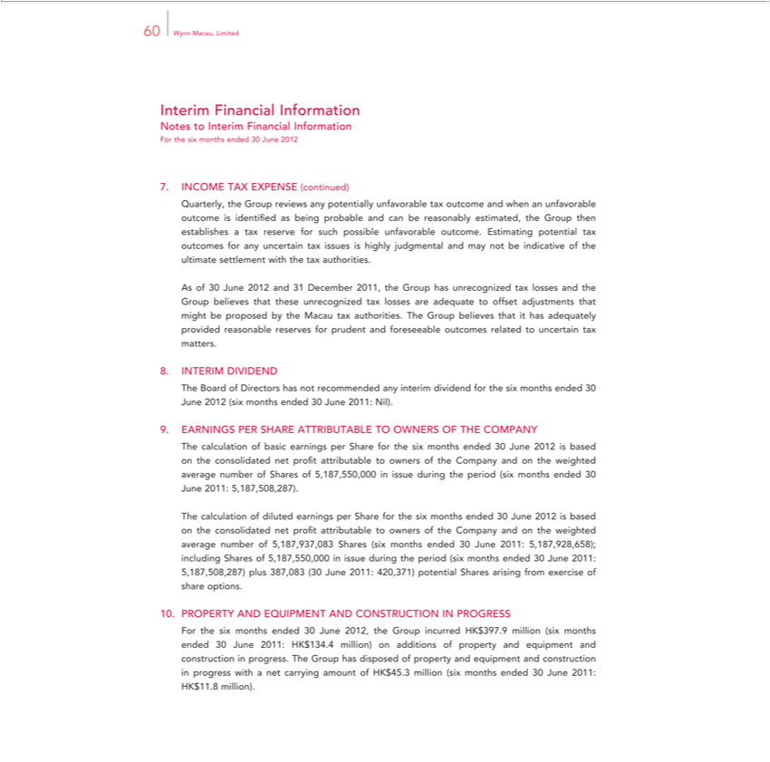

60 Wynn Macau, Limited
Interim Financial Information
Notes to Interim Financial Information
For the six months ended 30 June 2012
7. INCOME TAX EXPENSE (continued) |  |  |  | establishes tax reserve
Quarterly, the Group reviews any potentially unfavorable tax outcome and when an unfavorable outcome is identified as being probable and can be reasonably estimated, the Group |  |  |  | establishes tax reserve
for such possible unfavorable outcome. Estimating potential tax outcomes for any uncertain tax issues is highly judgmental and may not be indicative of the ultimate settlement with thentax authorities.
As of 30 June 2012 and 31 December 2011, the Group has unrecognized tax losses and the Group believes that these unrecognized tax losses are adequate to offset adjustments that might be proposed by the
Macau tax authorities. The Group believes that it has adequately provided reasonable reserves for prudent and foreseeable outcomes related to uncertain tax matters.
8. INTERIM DIVIDEND
The Board of Directors has not recommended any interim dividend for the six months ended 30 June 2012 (six months ended 30 June 2011: Nil).
9. EARNINGS PER SHARE ATTRIBUTABLE TO OWNERS OF THE COMPANY
The calculation of basic earnings per Share for the six months ended 30 June 2012 is based on the consolidated net profit attributable to owners of the Company and on the weighted average number of Shares of
5,187,550,000 in issue during the | (six months ended 30 June 2011: 5,187,508,287).
The calculation of diluted earningsperiodShare for the six months ended 30 June 2012 is based on the consolidated net profit attributable to owners of the Company and on the weighted average number of
5,187,937,083 Shares (six months ended 30 June 2011: 5,187,928,658); including Shares of 5,187,550,000 in issue during the period (six months ended 30 June 2011: 5,187,508,287) plus 387,083 (30 June 2011:
420,371) potential Shares arising from exercise of share options.
10. PROPERTY AND EQUIPMENT AND CONSTRUCTION IN PROGRESS |  | .4 million) additions of property and equipment and construction in progress. The
For the six months ended 30 June 2012, the Group incurred HK$397.9 million (six months ended 30 June 2011:
Group has disposed of property and equipment and construction in progress with a net carrying amount of HK$45.HK$million134 |  |  | (six months ended 30 June 2011: HK$11.8 million).

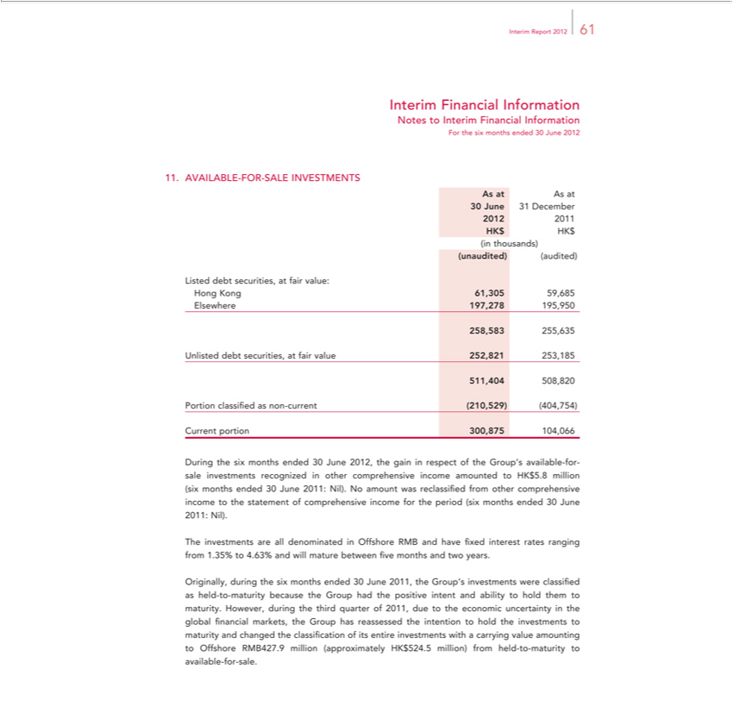

_{Interim} FinancialReport2012Information61
ForNotesthetosixInterimmonthsFinancialended30InformationJune2012
As11. at AsAVAILABLEat-FOR-SALE INVESTMENTS
30²⁰¹²June ³¹ December
201
_{(unaudited)}HKinthousands)$HK$
(audited)
ListedHongKongdebt securities,61,30559,685atfair value:
258,583Elsewhere255,635197,278 195,950
511,404Unlisted 508,820debtsecurities, at fair value 252,821 253,185
CurrentPortion classifiedportion300,875asnon-104,066current (210,529) (404,754)

During the six months ended 30 June 2012, the gain in respect of the Group’s available-for-sale investments recognized in other comprehensive income amounted to HK$5.8 million (six months ended 30 June 2011: Nil). No amount was reclassified from other comprehensive income to the statement of comprehensive income for the period (six months ended 30 June 2011: Nil).
The investments are all denominated in Offshore RMB and have fixed interest rates ranging from 1.35% to 4.63% and will mature between five months and two years.
Originally, during the six months ended 30 June 2011, the Group’s investments were classified as held-to-maturity because the Group had the positive intent and ability to hold ^{them} to maturity. However, during the third quarter of 2011, due to the economic uncertainty in the global financial markets, the Group has reassessed the intention to hold the investments to maturity and changed classification of its entire investments with a carrying value amounting to Offshore RMB427.9 million (approximately HK$524.5 million) from held-to-maturity to available-for-sale.

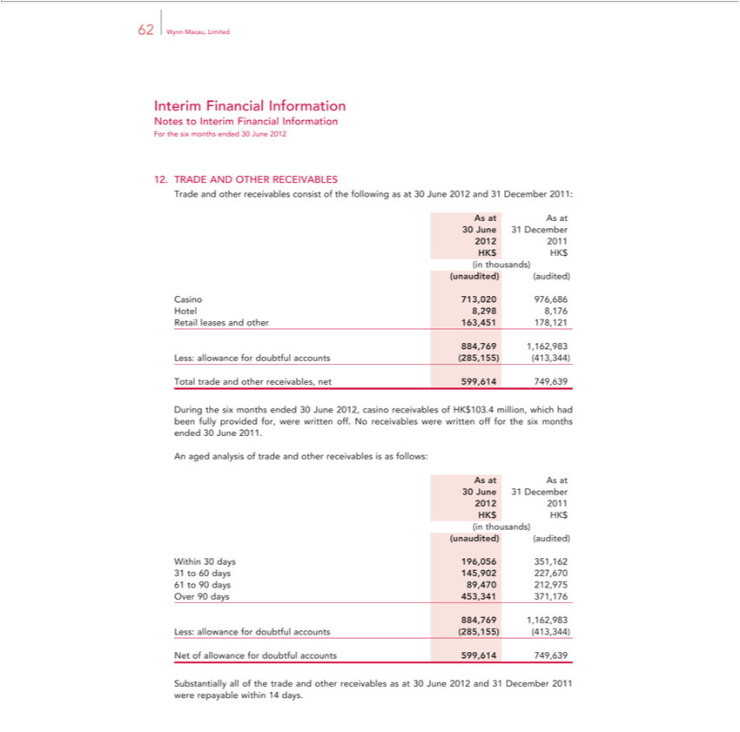

62 Wynn Macau, Limited
Interim Financial Information
Notes to Interim Financial Information
For the six months ended 30 June 2012
RADE AND OTHER RECEIVABLES
Trade and other receivables consist of the following as at 30 June 2012 and 31 December 2011:
As at As at |  | December
30 June
2012 | 20131
HK$ HK$
in thousands)
(unaudited) (audited)
Casino 713,020 976,686
Hotel 8,298 8,176
Retail leases and other 163,451 178,121
884,769 1,162,983
Less: allowance for doubtful accounts (285,155) (413,344)
Total trade and other receivables, net 599,614 749,639
 | the six months ended 30 June 2012, casino receivables of HK$103.4 million, which had been fully provided for, were written off. No receivables were written off for the six months ended 30 June 2011.
Duringaged analysis of trade and other receivables is as follows:
As at As at |  | December
30 June
2012 | 20131
HK$ HK$
in thousands)
(unaudited) (audited)
Within 30 days 196,056 351,162
31 | 60 | 145,9 | 2 | 7,670
61 to 90 days 89,470 212,975
Over 90 days 453,341 371,176
884,769 1,162,983
Less: allowance for doubtful accounts (285,155) (413,344)
Net of |  | for doubtful accounts 599,614 749,639
Substantiallyallowanceof the trade and other receivables as at 30 June 2012 and 31 December 2011 were repayable within 14 days.

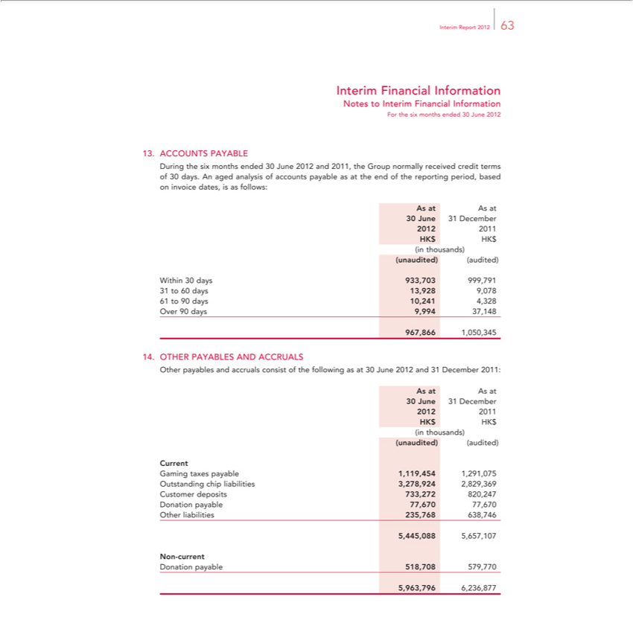

_{Interim} FinancialReport2012Information63
ForNotesthetosixInterimmonthsFinancialended30InformationJune2012
ACCOUNTS PAYABLE
During the six months ended 30 June 2012 and 2011, the Group normally received credit terms of 30 days. An aged analysis of accounts payable as at the end of the reporting period, based on invoice dates, is as follows:
As at As at
²⁰¹²30June ³¹ December
201
_{(unaudited)}HKinthousands)$HK$
(audited)
Within 30 days _{933,703} 999,791
³¹61 to ⁶⁰90 days 10,241³⁹²⁸ 4,328⁰⁷⁸
967,866Over90 days1,050,3459,994 37,148
_{Other}THER PAYABLES AND ACCRUALS
As at Aspayablesat and accruals consist of the following as at 30 June 2012 and 31 December 2011:
²⁰¹²30June ³¹ December
HK$ HK201$
in thousands)
_{Current(unaudited)} (audited)
GamingOutstandingtaxeschippayableliabilities1,119,4543,278,9241,291,0752,829,369
DonationCustomer payabledeposits77,670733,27277,670820,247
Other liabilities 235,768 638,746
N_{Donation}5,445,088-current5,657,107
_{6,236,877}5963796^{payable 518,708 579,770}

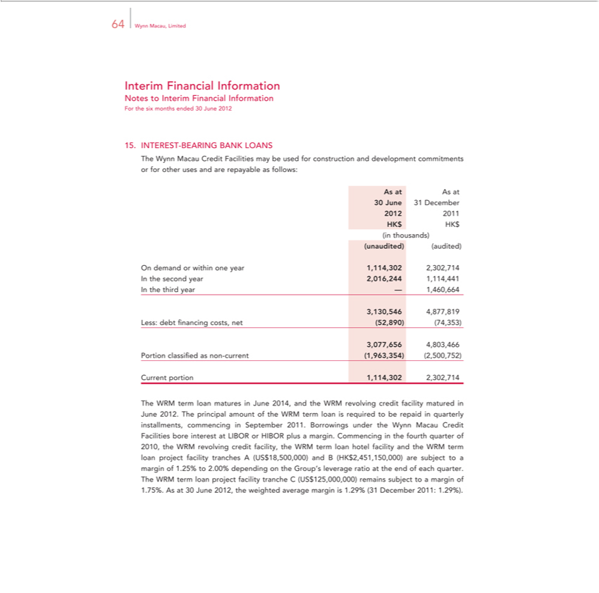

64 Wynn Macau, Limited
Interim Financial Information
Notes to Interim Financial Information
For the six months ended 30 June 2012
INTEREST-BEARING BANK LOANS
The Wynn Macau Credit Facilities may be used for construction and development commitments or for other uses and are repayable as follows:
As at As at |  | December
30 June |  | December
2012 | 20131
HK$ HK$
in thousands)
(unaudited) (audited)
On demand or within one year 1,114,302 2,302,714
 | second year 2,016,244 1,114,441
In the third year — 1,460,664
3,130,546 4,877,819
Less: debt financing costs, net (52,890) (74,353)
3,077,656 4,803,466
Portion classified as non-current (1,963,354) (2,500,752)
Current portion 1,114,302 2,302,714 |  |  | June 2012. The principal |  | of the WRM term loan is required to be repaid in quarterly installments,
The WRM term loan matures in June 2014, and the WRM revolving credit facility matured
commencing in September 2011. Borrowings under the Wynn Macau Credit Facilities bore interest at LIBOR or |  |  |  |  | amountplus margin. Commencing in the fourth quarter of | the WRM revolving credit
facility, the WRM term loan hotel facility and the WRM term loan project facility tranches A (US$18,500,000) andHIBOR(HK$2,451,150,000) are subject to a margin of 1.25% to2010,.00% depending on the Group’s
leverage |  | at the end of each quarter. The WRM term loan project facility tranche C |  | remains subject to a margin of
1.75%. Asratio30 June 2012, the weighted average margin is 1.29% (31 December 2011: (US.29%)$125,000,000).

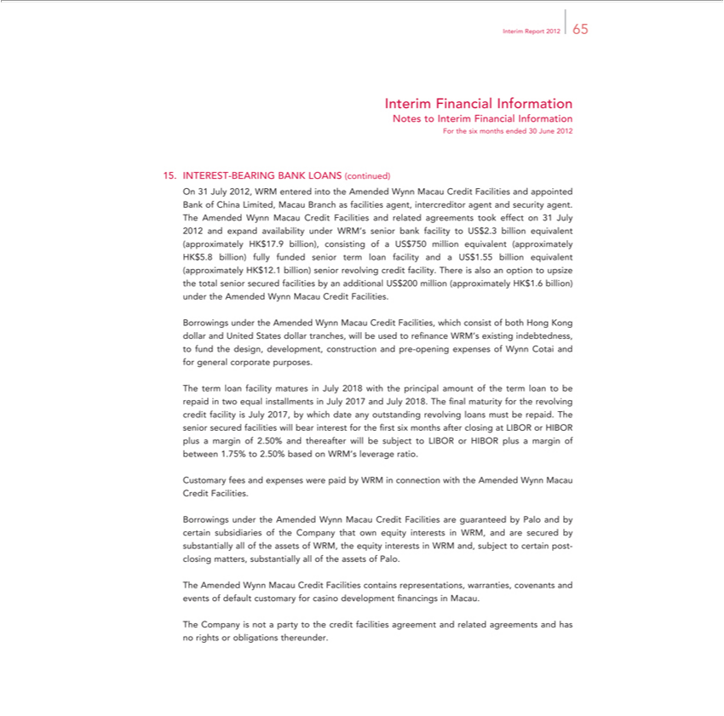

Report 2012 65
Interim Financial Information
Notes to Interim Financial Information
For the six months ended 30 June 2012
INTEREST-BEARING BANK LOANS (continued) |  | agent and security agent.
On 31 July 2012, WRM entered into the Amended Wynn Macau Credit Facilities and appointed Bank of China Limited, Macau Branch as facilities agent, |  | agent and security agent.
The Amended Wynn | Credit Facilities and related agreements took effect 31 July 2012 and expand availability under WRM’s senior bank facilityintercreditorUS$2.3billion equivalent (approximately HK$17.9
billion), consisting ofMacauUS$750 million equivalent (approximately HK$5.8 billion) fully funded senior term loan facility and US$1.55 billion equivalent (approximately HK$12.1 billion) senior revolving
credit facility. There is also an option to upsize the total senior secured facilities by an additional US$200 million (approximately HK$1.6 billion) under the Amended |  | ynn Macau Credit Facilities.
Borrowings under the Amended Wynn Macau Credit Facilities, which consist of both Hong Kong dollar and United States dollar tranches, will be used to refinance WRM’s existing indebtedness, to fund the design, development, construction and pre-opening expenses of Wynn Cotai and for general corporate purposes.
The term loan facility matures_{outstanding}July 2018 with the principal amount of the term loan to be repaid in two equal installments in July 2017 and July 2018. The final maturity for the revolving credit facility is July
2017, by which date any revolving loans must be repaid. The senior secured facilities will bear interest for the first six months after closing at LIBOR or HIBOR plus a margin of 2.50% and thereafter will be subject to LIBOR or HIBOR plus a margin of between 1.75% to 2.50% based on WRM’_{Facilities}leverage ratio.
_{Borrowings}Custmaryfees and expenses were paid by WRM in connection with the Amended Wynn Macau Credit .
under the Amended Wynn Macau Credit Facilities are guaranteed by Palo and by certain subsidiaries of the Company that own equity interests in WRM, and are secured by substantially all of the assets of WRM, the equity interests in WRM and, subject to certain post- closing matters, substantially all of the assets of Palo.
^{The}
CompanyAmended Wynnisnot aMacauparty toCreditthecreditFacilitiesfacilitiescontainsagreementrepresentations,andrelatedwarranties,agreementscovenantsandhas andnorightseventsorofobligationsdefaultcustomarythereunder.for casino development financings in Macau.

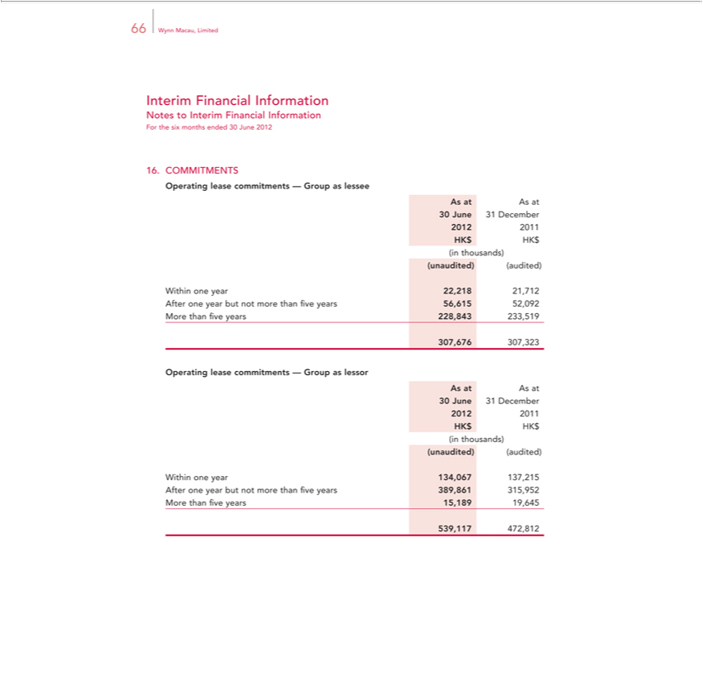

Interim66WynnFinancialMacau, LimitedInformation
ForNotesthetosixInterimmonthsFinancialended30InformationJune2012
COMMITMENTS
_{OperatingAsAsat}lease commitments — Group as lessee
²⁰¹²30June ³¹ December
201
_{(unaudited)}HKinthousands)$HK$
(audited)
Within one year 22,218 21,712
MoreAfter onethanyearfive butyearsnot228,843morethan233,519fiveyears 56,615 52,092
307,676 307,323
_{OperatingAsAsat}lease commitments — Group as lessor
²⁰¹²30June ³¹ December
201
_{(unaudited)}HKinthousands)$HK$
(audited)
Within one year 134,067 137,215
MoreAfter onethanyearfive butyearsnot15,189more than19,645five years 389,861 315,952

539,117 472,812

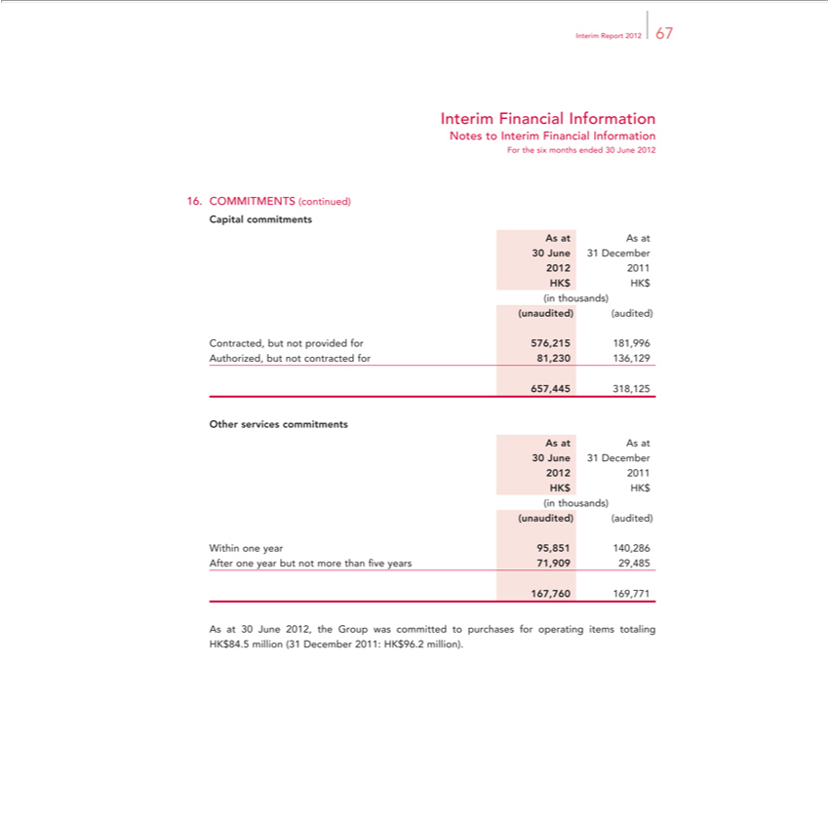

_{Interim} FinancialReport2012Information67
Notes to Interim Financial Information
^{Capital}ForOMMITMENTSthesixmonths ended(continued)30June 2012
As at Ascommitmentsat
²⁰¹²30June ³¹ December
201
_{(unaudited)}HKinthousands)$HK$
(audited)
Contracted, but not provided for 576,215 181,996
657,445Authorized,318,125butnot contracted for 81,230 136,129
AsOtherat Asservicesat commitments
²⁰¹²30June ³¹ December
201
_{(unaudited)}HKinthousands)$HK$
(audited)
Within one year 95,851 140,286
167,760Afterone169,771yearbut not more than five years 71,909 29,485

As at 30 June 2012, the Group was committed to purchases for operating items totaling HK$84.5 million (31 December 2011: HK$96.2 million).

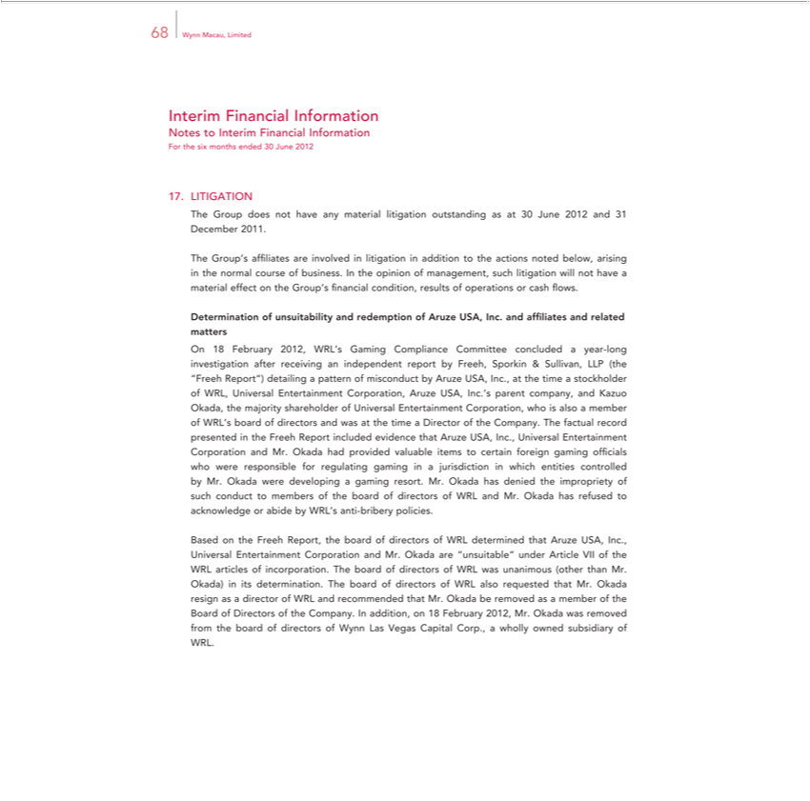

68 Wynn Macau, Limited
Interim Financial Information
Notes to Interim Financial Information
For the six months ended 30 June 2012
LITIGATION | not have any material litigation outstanding as at 30 June 2012 and 31 December 2011.
The Group’doesaffiliates are involved in litigation in addition to the actions noted below, arising in the normal course of business. In the opinion of management, such litigation will not have a material effect on the
Group’s financial condition, results of operations or cash flows. |  |  |  |  | and related matters
Determination of |  | and redemption of Aruze USA, Inc. and af |  |  | and related matters
On 18 February 2012,unsuitabilityWRL’ Gaming Compliance Committee concludedfiliatesyear-long investigation after receiving an independent report by Freeh, Sporkin & Sullivan, LLP (the “Freeh Report”) detailing
pattern of misconduct by Aruze USA, Inc., |  |  | the time a | of WRL, Universal |  | Corporation, Aruze USA, Inc.’s parent company, and Kazuo Okada, the majority shareholder of Universal
Entertainment Corporation, who is also a member of WRL’stockholderboardof directors and was atEntertainmentthetimeDirector of the Company. The factual record presented the Freeh Report included evidence that Aruze
USA, Inc., Universal Entertainment |  |  | and Mr. Okada had provided valuable items to certain foreign gaming officials who were responsible for regulating gaming in a jurisdiction in which entities
controlled by Mr. Okada were developingCorporationgaming resort. Mr. Okada has denied the impropriety of such conduct to members of the board of directors of WRL and Mr. Okada has refused to acknowledge or abide by WRL’s anti-bribery policies.
_{incorporation}Basedthe Freeh Report, the_{directors}boa of directors of WRL determined that Aruze USA, Inc., Universal Entertainment Corporation and Mr. Okada are “unsuitable” under Article VII of the WRL articles of
. The board of of WRL was unanimous (other than Mr.
Okada) its determination. The board of directors of WRL also requested that Mr. Okada resign as a director of WRL and recommended that Mr._{owned}Okaa be removed as a member of the Board of Directors of
the Company. In addition, on 18 February 2012, Mr. Okada was removed from the board of directors of Wynn Las Vegas Capital Corp., a wholly subsidiary of WRL.

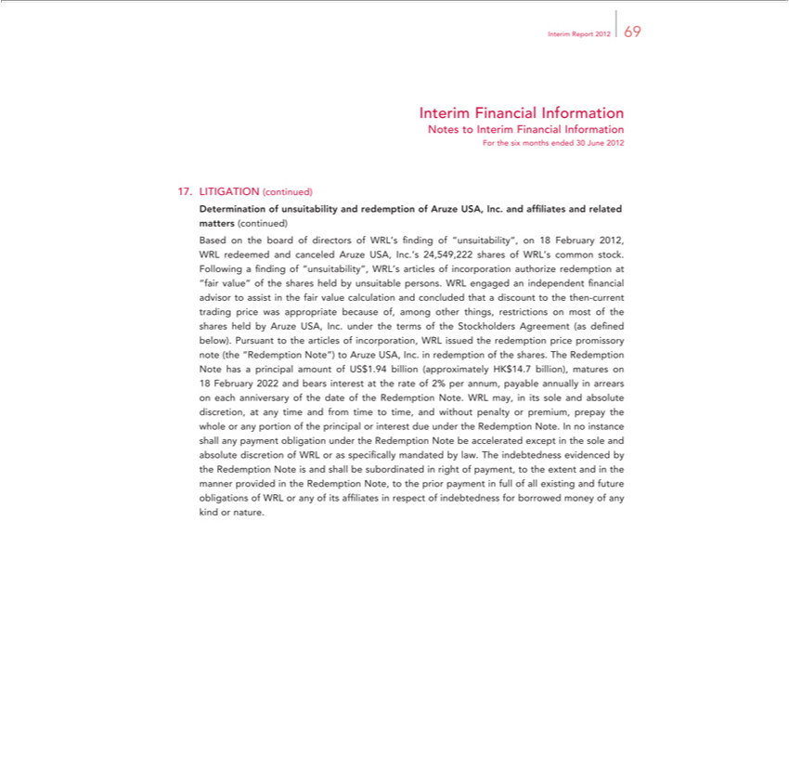

Interim ReportFinancial2012Information69
Notes to Interim Financial Information
LITIGATIONForthesixmonths(continued)ended30 June 2012
redeemedDeterminationand canceledofunsuitabilityAruze USA,andredemptionInc.’s24,549,222ofAruzesharesUSA,ofInc.WRL’sand affiliatescommonandstock.related matters (continued) Based on the board of directors of WRL’s finding of “unsuitability”, on 18 February 2012, WRL Following finding of “unsuitability”, WRL’s articles of incorporation authorize redemptionappropriate“fairvalue” of the shares held by unsuitable persons. WRL engaged an independent financial advisor to assist in
termshefairofvaluetheStockholderscalculationandAgreementconcluded(asthatdefinedadiscountbelow)to. Pursuantthethen-currenttothearticlestradingofpriceincorporation,was WRL becauseissuedtheof, among otherpricethings,promissoryrestrictionsnoteon(themost“RedemptionofthesharesNote”)held byto AruzeAruze USA,USA, Inc.Inc. inunderredemptionthe
of the shar^{each}s.The Redemption Note has a principal amount of US$1.94 billion (approximately HK$14.7 billion), maturesredemption18 February 2022 and bears interest at the rate of 2% per annum, payable annually in
arrears on anniversary of the date of the Redemption Note. WRL may, in its sole and absolute discretion, at any time and from time to time, and without penalty or premium, prepay the whole or any portion of the principal or interest due under the Redemption Note. In no instance shall any payment obligation under the Redemption Note be accelerated except in the sole and absolute discretion of WRL or as specifically mandated by law. The indebtedness evidenced by the Redemption Note is and shall be subordinated in right of payment, to the extent and in the manner provided in the Redemption Note, to the prior payment in full of all existing and future obligations of WRL or any of its affiliates in respect of indebtedness for borrowed money of any kind or nature.

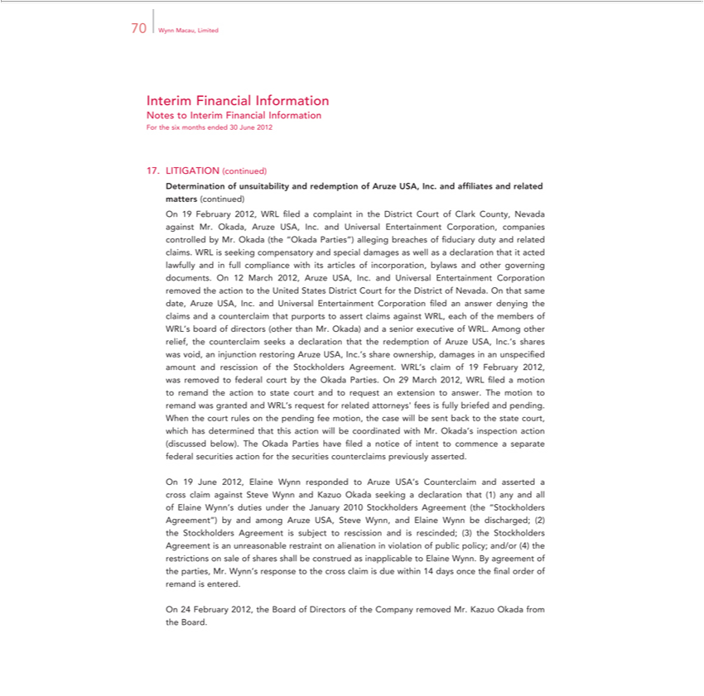

70 Wynn Macau, Limited
Interim Financial Information
Notes to Interim Financial Information
For the six months ended 30 June 2012
LITIGATION (continued)
Determination of unsuitability and redemption of Aruze USA, Inc. and affiliates and related matters (continued) On 19 February 2012, WRL filed a complaint in the District Court of Clark County, Nevada
against Mr. Okada, Aruze USA, Inc. and |  |  | Entertainment Corporation, companies controlled by Mr. Okada (the “Okada Parties”) alleging breaches of fiduciary duty and related claims. WRL is seeking
compensatory and special damages as wellUniversalasdeclaration that it acted lawfully and in full compliance with its articles of incorporation, bylaws and other governing documents. On 12 March 2012, Aruze USA,
Inc. | Universal Entertainment |  | removed the action to the United States District Court for the District of Nevada. On that same date, Aruze USA, Inc. and |  |  | Entertainment Corporation
filedand answer denying the claims and |  |  | counterclaim that purports to assert claims against WRL, each of the members of WRL’s board of directors (other than Mr. Okada)Universaland senior executive of WRL.
Among other relief, the counterclaimCorporationseeksdeclaration that the redemption of Aruze USA, Inc.’s shares was void, an injunction restoring Aruze USA, Inc.’s share ownership, damages in an unspecified amount
 | rescission of the | Agreement. WRL’s claim of 19 February 2012, |  | removed to federal court by the Okada Parties. On 29 March 2012, WRL filed a motion to remand the action to state court
and to request an |  | Stockholdersanswer. The motion to remand was granted and WRL’wasrequest for related attorneys’ fees |  |  | fully briefed and pending.
When the court rulesextensionthe pending fee motion, the case will be sent back to the state court, which has determined that this action will be coordinated with Mr. Okada’s inspection action (discussed below). The
kada Parties have filed a notice of intent to commence a separate federal securities |  |  |  | for the securities counterclaims previously asserted.
On 19 June 2012, Elaine Wynn responded to Aruze USA’ Counterclaim and assertedactioncross claim against Steve Wynn and Kazuo Okada seeking a declaration that (1) any and all of Elaine Wynn’ duties under
the January 2010 Stockholders Agreement (the “Stockholders Agreement”) by and among Aruze USA, Steve Wynn, |  |  |  |  | Elaine Wynn be discharged; (2) the Stockholders Agreement is subject to rescission and
is rescinded; (3) the Stockholders Agreement is an unreasonable restraint on alienation in violation of public policy; and/or (4) the restrictions on sale of shares shall be construed as inapplicable to Elaine Wynn.
By agreement of the parties, Mr. Wynn’ |  |  | response to the cross claim is due within 14 days once the final order of remand is entered.
On 24 February 2012, the Board of Directors of the Company removed Mr. Kazuo Okada from the Board.

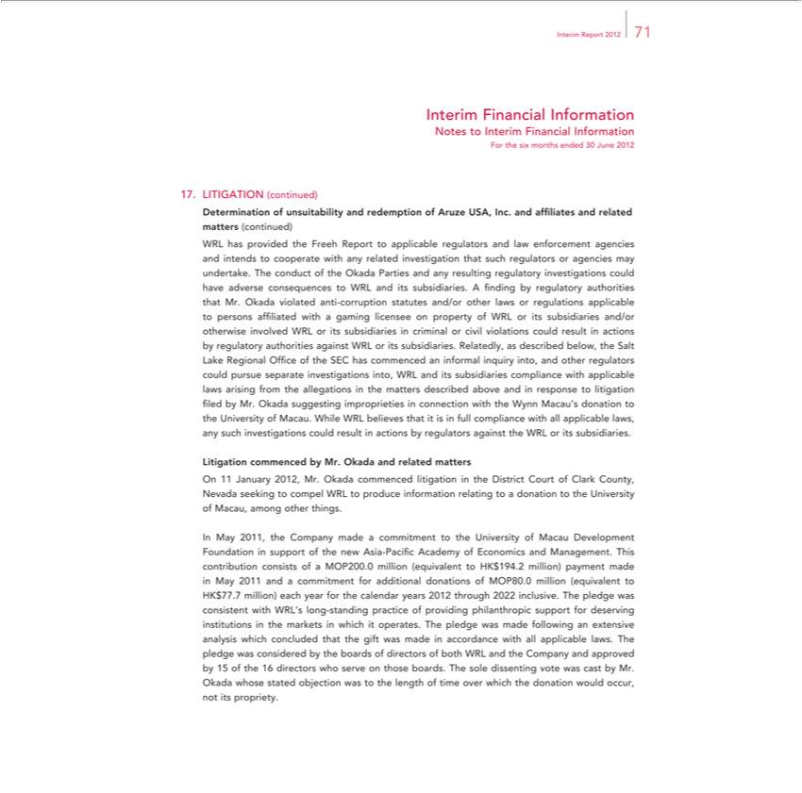

 | Report 2012 71
Interim Financial Information
Notes to Interim Financial Information
For the six months ended 30 June 2012
LITIGATION (continued)
Determination of unsuitability and redemption of Aruze USA, Inc. and affiliates and related matters (continued) WRL has provided the Freeh Report to applicable regulators and law enforcement agencies and
intends to cooperate with any related investigation that such regulators or agencies may undertake. The conduct of the Okada Parties and any resulting |  |  |  |  | investigations could have adverse
to WRL and its subsidiaries. A finding by regulatory authorities that Mr. Okada violated anti- |  |  |  | statutes and/or other laws or regulations applicableregulatorypersons affiliated with a gaming licenseeconsequences
property of WRL or its subsidiaries and/or otherwise involved WRL or its subsidiaries in criminalcorruptioncivil violations could result in actions by regulatory authorities against WRL or its subsidiaries. Relatedly, as
described below, the Salt Lake Regional Office of the SEC has commenced |  |  | inquiry into, and other regulators could pursue separate |  | into, WRL and its | compliance with
applicable laws rising from the allegations in |  | he matters described above and informalresponse to litigation filed by Mr. Okada suggesting improprietiesinvestigationsconnection with the WynnsubsidiariesMacau’donation to the
University of Macau. While WRL believes that it is in full compliance with all applicable laws, any such investigations could result in actions by regulators against the WRL or its subsidiaries.
Litigation commenced by Mr. Okada and related matters
On 11 January 2012, Mr. Okada commenced litigation in the District Court of Clark County, Nevada seeking to compel WRL to produce information relating to a donation to the University of Macau, among
other things.
In May | 1, the Company made a commitment to the University of Macau Development Foundation in support of the new Asia-Pacific Academy of Economics and Management. This contribution consists of a
MOP200.201 million (equivalent to HK$194.2 million) payment made in May 2011 |  |  | a commitment for additional donations of MOP80.0 million (equivalent to HK$77.7 million) each year for the calendar
years 2012 through 2022 inclusive. The pledge was consistent with WRL’s long-standing practice of providing philanthropic support for deserving institutions in the markets in which it operates. The pledge was
made following an extensive analysis which |  | that the gift was made accordance wi h all applicable laws. The pledge was considered by the boards of directors of both WRL and the Company and
approved by 15 of the 16 directors who serveconcludedthoseboards. The sole dissenting vote was cast by Mr.
Okada whose stated objection was to the length of time over which the donation would occur, not its propriety.

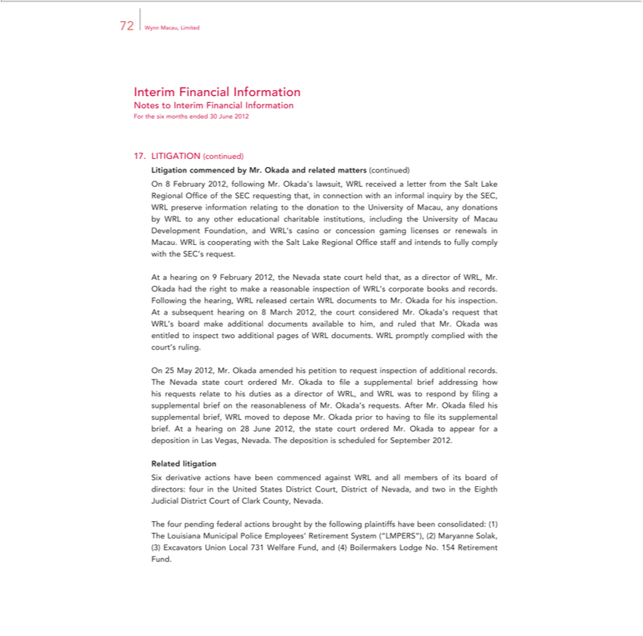

72 Wynn Macau, Limited
Interim Financial Information
Notes to Interim Financial Information
For the six months ended 30 June 2012
ITIGATION (continued)
Litigation commenced by Mr. Okada and related matters (continued)
On 8 February 2012, following Mr. Okada’ lawsuit, WRL received a letter from the Salt Lake Regional Office of the SEC requesting that, connection with an informal inquiry by the SEC, WRL preserve
casino | relating to the donation to the University of Macau, any donations by WRL to any other educational charitable institutions, including the University of Macau Development Foundation, and WRL’s
casino | gaming licenses or renewals in Macau. WRL is |  | with the Salt Lake Regional Office staff and intends to fully comply with the SEC’s request.
informationAthearingconcession9February 2012, the Nevada state court held that, as cooperatingdirectorof WRL, Mr.
Okada had the right to make a reasonable inspection of WRL’ corporate books and records.
Following the hearing, WRL released certain WRL documents to Mr. Okada for his inspection.
At subsequent hearing on 8 March 2012, the court considered Mr. Okada’s |  |  | that WRL’s board make additional documents available to him, and ruled that Mr. Okada was entitled to inspect two
additional pages of WRL docu |  | ts. WRL promptly complied with the court’requestruling.
On 25 May 2012, Mr. Okada amended his petition to request inspection of additional records. |  |  |  | of WRL, and WRL was to respond by filing supplemental brief on the
The Nevada state court ordered Mr. Okada to file a supplemental brief addressing how his requests relate to his duties as a
reasonableness of Mr. Okad_{appear}’srequests. After Mr. Okada filed his supplemental brief, WRL moved to depose Mr. Okada priordirectorhaving to file its supplemental brief. At a hearing on 28 June 2012, the state
RelatedcourtorderedlitigationMr. Okada to for a deposition in Las Vegas, Nevada. The deposition is scheduled for September 2012.

Six derivative actions have been commenced against WRL and all members of its board of directors: four in the United States District Court, District of Nevada, and two in the Eighth Judicial District Court of Clark County, Nevada.
The four pending federal actions brought by the following plaintiffs have been consolidated: (1) The Louisiana Municipal Police Employees’ Retirement System (“LMPERS”), (2) Maryanne Solak, (3) Excavators Union Local 731 Welfare Fund, and (4) Boilermakers Lodge No. 154 Retirement Fund.

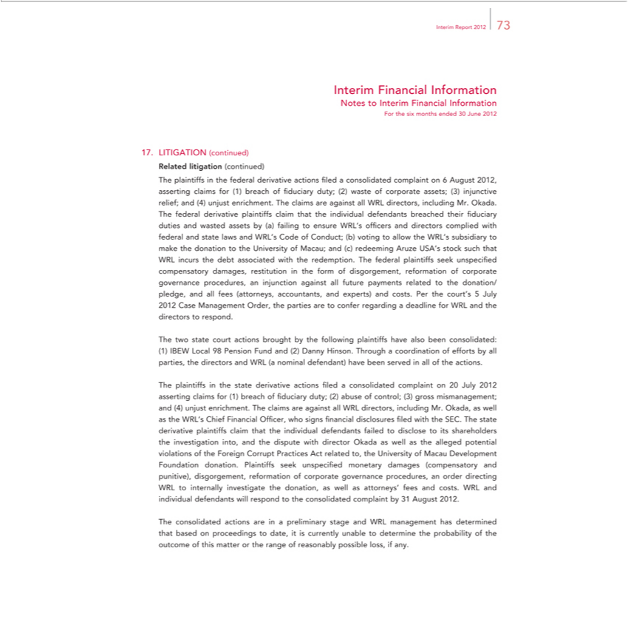

Report 2012 73
Interim Financial Information
Notes to Interim Financial Information
For the six months ended 30 June 2012
LITIGATION (continued)
Related litigation (continued)
The plaintiffs in the federal derivative actions ?led a consolidated complaint on 6 August 2012, asserting claims for (1) breach of fiduciary duty; (2) waste of corporate assets; (3) injunctive relief; and (4) unjust
enrichment. The claims are against all WRL directors, including Mr. Okada. |  |  |  |  |  | and directors complied with federal and state laws
The federal derivative plaintiffs claim that the individual |  |  |  | breached their fiduciary duties and wasted assets by (a) failing to ensure WRL’s of |  | and directors complied with federal and state laws
and WRL’s Code of Conduct; (b) voting to allow the WRL’defendantssubsidiary to make the donation to the University of Macau; and (c) redeeming Aruze USA’ficersstock such that WRL incurs the debt associated with the
demption. The federal plaintiffs seek unspecified compensatory damages, restitution in the form of |  |  |  |  | gement, reformation of corporate governance procedures, an injunction against all future payments
related to the donation/ pledge, and all fees (attorneys, accountants, and experts) and costs. Per the court’disgor5 July 2012 Case Management Order, the parties are to confer regarding a deadline for WRL and the
dir ctors to respond.
The two state court actions brought by the following plaintiffs have also been consolidated: (1) IBEW Local 98 Pension Fund and (2) Danny Hinson. Through a coordination of efforts by all parties, the directors
and WRL (a | defendant) have been served in all of the actions. |  |  |  | claims for (1) breach of fiduciary duty; (2) abuse of control; (3) gross mismanagement; and (4) unjust
The plaintiffsnominalthestate derivative actions filed a consolidated complaint on 20 July 2012
enrichment. The claims are against all WRL |  |  | including Mr. Okada, as well as the WRL’assertingChief Financial Officer, who signs financial disclosures filed with the SEC. The state derivative plaintiffs claim
hat the individual defendants failed to disclosedirectors,itsshareholders the investigation into, and the dispute with director Okada as well as the alleged potential violations of the Foreign Corrupt Practices Act related
to, the University of Macau Development Foundation donation. Plaintiffs seek unspecified monetary damages (compensatory and punitive), disgorgement, reformation of corporate governance procedures, an
order directing WRL to |  | investigate the donation, as well as attorneys’ fees and costs. WRL and individual defendants will respond to the consolidated complaint by 31 August 2012.
internally
The consolidated actions_{possible}are preliminary stage and WRL management has determined that based on proceedings to date, it is currently unable to determine the probability of the outcome of this matter or the
range of reasonably loss, if any.

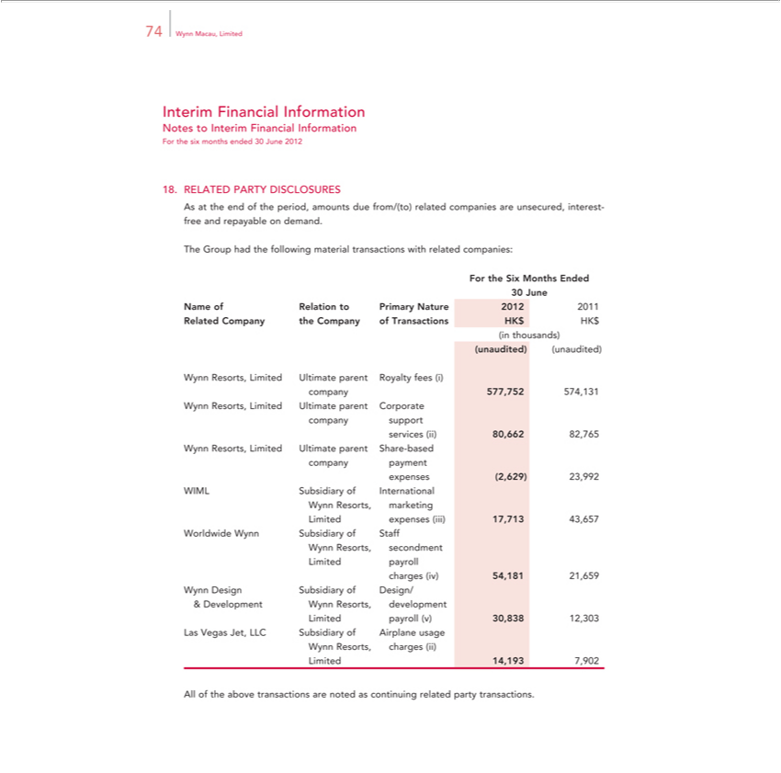

Interim74WynnFinancialMacau, LimitedInformation
ForNotesthetosixInterimmonthsFinancialended30InformationJune2012
RELATED PARTY DISCLOSURES
TheAsatGrouptheendhadofthethefollowingperiod,amountsmaterialduetransactionsfrom/(to) relatedwithrelatedcompaniescompanies:areunsecured, interest- free and repayable on demand.
30ForJunethe Six Months Ended
Name of Relation to Primary Nature 2012 2011
_{(unaudited)}Relatedinthousands)Company the Company of Transactions HK$ HK$
(unaudited)
companyWynnResorts,577,752Limited574,131Ultimate parent Royalty fees (i)
companyWynnResorts,supportLimited Ultimate parent Corporate
services (ii) 80,662 82,765
companyWynnResorts,paymentLimited Ultimate parent Share-based
expenses (2,629) 23,992
^{W}
ynnIMLResorts,SubsidiarymarketingofInternational
^{W}LimitedorldwideexpensesWynn (iii)Subsidiary17,713 of43,657Staff
LimitedynnResorts,payrollsecondment
charges (iv) 54,181 21,659
Wynn Design Subsidiary of Design/
^{Las}&imitedDevelopmentpayroll (v)Wynn30,838Resorts,12,303development
WynnVegasResorts,Jet, LLCchargesSubsidiary(ii) of Airplane usage
Limited 14,193 7,902
All of the above transactions are noted as continuing related party transactions.

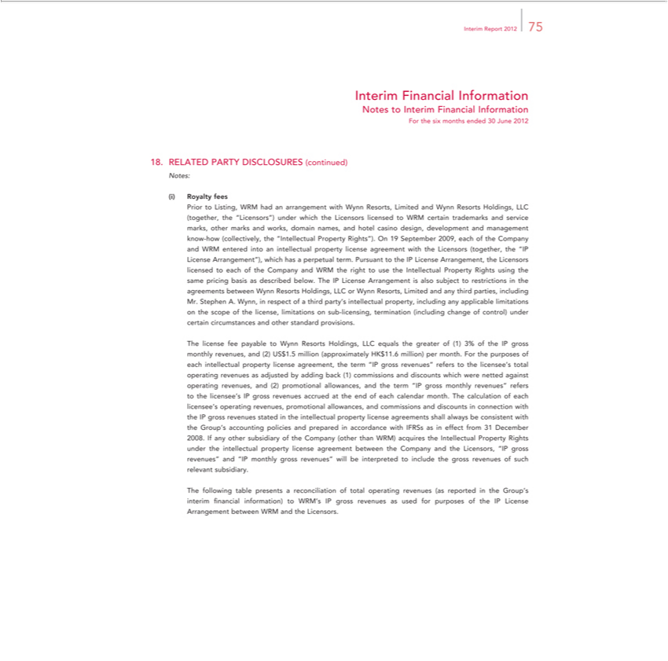

Interim | Report 2012 75
Interim | Financial Information
Notes to Interim Financial Information
For the six months ended 30 June 2012
18. | RELATED PARTY DISCLOSURES (continued)
Notes:
Royalty fees |  | WRM had an arrangement with Wynn Resorts, Limited and Wynn Resorts Holdings, LLC
Prior
(togetherListing,the“Licensors”) under which the Licensors licensed to WRM certain trademarks and service marks, other marks and works, domain names, and hotel casino design, development and management
know-how (collectively, the |  |  | Property Rights”). On 19 September 2009, each of the Company and WRM entered into an intellectual property license agreement with the Licensors (together, the “IP
License Arrangement”), which“Intellectualhasperpetual term. Pursuant to the IP License Arrangement, the Licensors licensed to each of the Company and WRM the right to use the Intellectual Property Rights using the
same pricing basis as described below. The IP License Arrangement is also subject to restrictions in the agreements between Wynn Resorts Holdings, LLC or Wynn Resorts, Limited and any third parties,
including Mr. Stephen A. Wynn, in respect of a third party’ intellectual property, including any applicable limitations on the scope of the license, limitations on sub-licensing, termination (including change of
 | under certain circumstances and other standard provisions. |  |  | monthly revenues, and (2) US$1.5 million (approximately HK$11.6 million) per month. For the purposes of
control)Thecense fee payable to Wynn Resorts Holdings, LLC equals the greater of (1) 3% of the IP
each intellectual property license agreement, the term “IP gross revenues” refers to the licensee’grosstotal operating |  |  |  |  | as adjusted by adding back (1) commissions and discounts which were netted gainst
_{licensee’}oprating revenues, and (2) promotional allowances, and the term “IP gross monthly revenues” refers to the licensee’revenuesIPgross revenues accrued at the end of each calendar month. The calculation of each
s operating revenues, promotional allowances, and commissions and discounts in connection with the IP gross revenues stated in the intellectual property license agreements shall always be consistent with the Group’s accounting policies and prepared in accordance with IFRSs as in effect from 31 December 2008. If any other subsidiary of the Company (other than WRM) acquires the Intellectual Property Rights under the intellectual property license agreement between the Company and the Licensors, “IP gross revenues” and “IP monthly gross revenues” will be interpreted to include the gross revenues of such relevant subsidiary.

The following table presents a reconciliation of total operating revenues (as reported in the Group’s interim financial information) to WRM’s IP gross revenues as used for purposes of the IP License Arrangement between WRM and the Licensors.

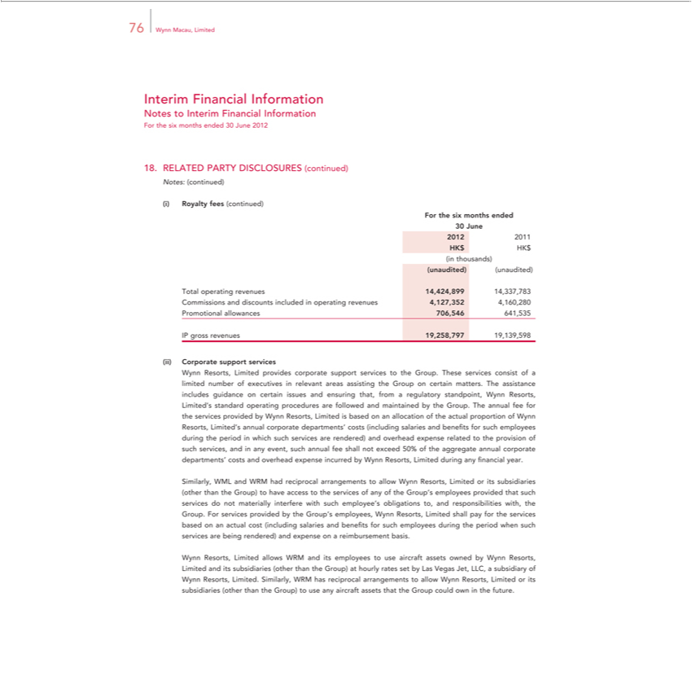

76 Wynn Macau, Limited
Interim Financial Information
Notes to Interim Financial Information
For the six months ended 30 June 2012
18. |  | RELATED PARTY DISCLOSURES (continued)
Notes: (continued)
(i) |  | Royalty fees (continued)
For the six months ended
30 June
2012 | 2011
HK$ HK$
in thousands)
(unaudited) (unaudited)
Total operating revenues 14,424,899 14,337,783
Commissions and discounts included in operating revenues 4,127,352 4,160,280
Promotional allowances 706,546 641,535
IP gross revenues 19,258,797 19,139,598
Corporate support services |  |  | the Group. These services consist of a limited number of executives in relevant areas assisting the Group on certain matters. The assistance includes
Wynn Resorts, Limited provi es corporate support services
guidance on certain issues and ensuring that, from a regulatory standpoint, Wynn Resorts, Limited’ standard operating procedures are followed and maintained by the Group. The annual fee for the services
provided by Wynn Resorts, Limited is based on allocation of the actual proportion of Wynn Resorts, Limited’s annual corporate departments’ costs (including salaries and benefits for such employees during
the period in which such services are rendered) and overhead expense related to the provision of such services, and in any event, such annual fee shall not exceed 50% of the aggregate annual corporate
departments’ costs and overhead expense incurred by Wynn Resorts, Limited during any financial year.
Similarly, WML and WRM had reciprocal arrangements to allow Wynn Resorts, Limited or its subsidiaries (other than the Group) to have access to the services of any of the Group’s employees provided that
uch services do not materially interfere with such employee’ |  |  | obligations to, and responsibilities with, the Group. For services provided by the Group’ employees, Wynn Resorts, Limited shall pay for the
services based on an actual cost (including salaries and benefits for such employees during the period when such services are being rendered) and expense on a reimbursement basis.
 |  | allows WRM and its employees to use aircraft assets owned by Wynn Resorts, Limited and its subsidiaries |  | than the Group) at hourly rates set by Las Vegas Jet, LLC, a subsidiary of
Wynn Resorts, Limited. Similarly, WRM has reciprocal arrangements to allow Wynn Resorts, Limited or its subsidiaries (other than(otherGroup) to use any aircraft assets that the Group could own in the future.

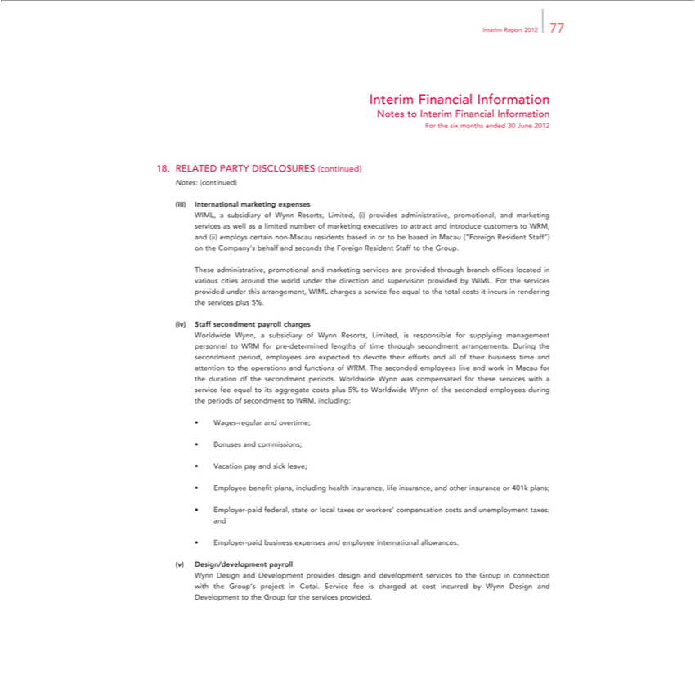

Interim | Report 2012 77
Interim | Financial Information
Notes to Interim Financial Information
For the six months ended 30 June 2012
18. | RELATED PARTY DISCLOSURES (continued)
Notes: (continued)
 | marketing expenses |  | promotional, and marketing services as well as a limited number of marketing executives to attract and introduce customers to WRM,
InternationalWIML,subsidiary of Wynn Resorts, Limited, (i) provides
and (ii) employs certain non-Macau residents based in or to beadministrative,basedMacau (“Foreign Resident Staff”) on the Company’s behalf and seconds the Foreign Resident Staff to the Group.
These administrative, promotional and marketing services are provided through branch offices located various cities around the world under the direction and supervision provided by WIML. For the services
provided under this arrangement, WIML charges a service fee equal to the total costs it incurs in rendering the services plus 5%.
Staff secondment |  | charges |  | the
Worldwide Wynn,payrollsubsidiary of Wynn Resorts, Limited, is responsible for supplying management personnel to WRM for pre-determined lengths of time through secondment arrangements. |  |  |  | the
secondment period, employees are expected to devote their efforts and all of their business time and attention to the operations and functions of WRM. The seconded employees live and workDuringMacau for the duration of the secondment periods. Worldwide Wynn was compensated for these services with a service fee equal to its aggregate costs plus 5% to Worldwide Wynn of the seconded employees during the periods of secondment to WRM, including:
Wages-regular and overtime;
VacationBonuses andpay commissions;andsickleave;
_{Employer}e_{-paid}benefitfederal,plans,stateincludingorlocalhealthtaxesinsurance,orworkers’lifecompensationinsurance,andcostsotherandinsuranceunemploymentor401ktaxes;plans;and
Design/developmentbusiness^{payroll}expenses and employee international allowances.
Wynn and Development provides design and development services to the Group in connection with the Group’s project in Cotai. Service fee is charged at cost incurred by Wynn Design and Development to the Group for the services provided.

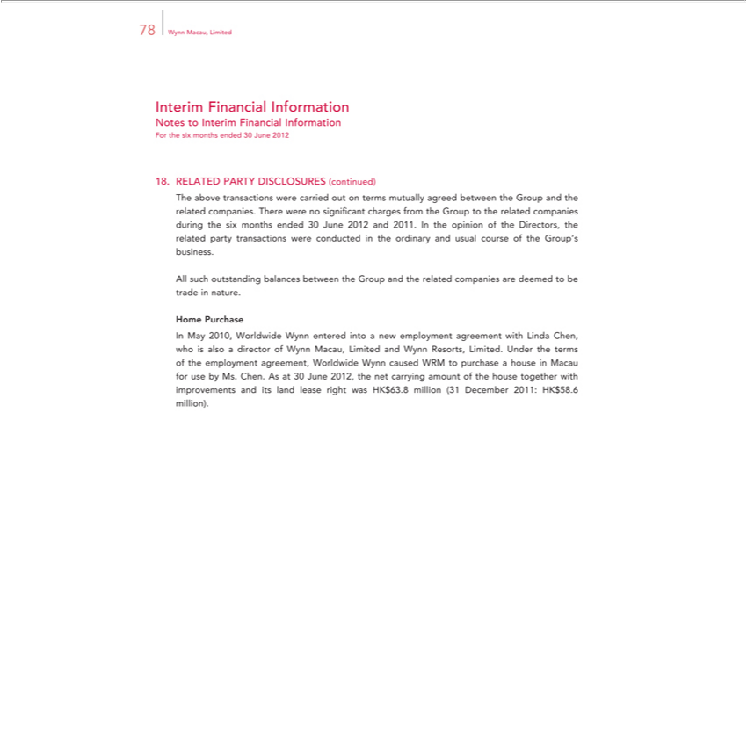

Interim78WynnFinancialMacau, LimitedInformation
Notes to Interim Financial Information
RELATEDForthesix monthsPARTYendedDISCLOSURES30June2012_{(continued)}
The above transactions were carried out terms mutually agreed between the Group and the related companies. There were no significant charges from the Group to the related companies during the six months ended 30 June 2012 and 2011. In the opinion of the Directors, the related party transactions were conducted in the ordinary and usual course of the Group’s business.
HomeAllsuchPurchaseoutstanding balances between the Group and the related companies are deemed to be trade in nature.

In May 2010, Worldwide Wynn entered into a new employment agreement with Linda Chen, who is also a director of Wynn Macau, Limited and Wynn Resorts, Limited. Under the terms of the employment agreement, Worldwide Wynn caused WRM to purchase a house in Macau for use by Ms. Chen. As at 30 June 2012, the net carrying amount of the house together with improvements and its land lease right was HK$63.8 million (31 December 2011: HK$58.6 million).

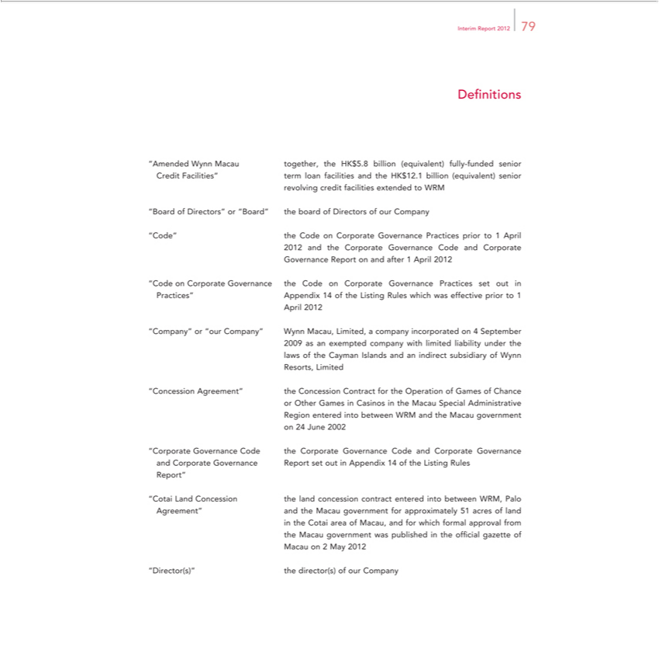

DefinitionsInterimReport 2012 79
“Amended Wynn Macau together, the HK$5.8 billion (equivalent) fully-funded senior
revolvingCreditFacilities”creditfacilitiestermloanextendedfacilitiestoandWRMthe HK$12.1 billion (equivalent) senior
_{“Code”}Bard of Directors”_{Corporate}“Board” the board of Directors of our Company
the Code on Governance Practices prior to 1 April
Governance2012andtheReportCorporateonandGovernanceafter1AprilCode2012and Corporate
Practices”“CodeonCorporateAppendix Governance14oftheListingtheCodeRulesonwhichCorporatewaseffectiveGovernancepriorPracticesto1 set out in
April 2012
_{“Company”} or “our Company” Wynn Macau, Limited, a company incorporated on 4 September 2009 as exempted company with limited liability under the
Resorts,lawsoftheLimitedCayman Islands and an indirect subsidiary of Wynn
or“ConcessionOtherGamesAgreement”^{into}Casinosthein ConcessiontheM^{and}cau SpecialContractAdministrativefortheOperation of Games of Chance
_{Region}24Juneentered2002 between WRM the Macau government
“Corporate Governance Code the Corporate _{Appendix}Govrnance Code and Corporate Governance
Report”andCorporate Governance Report set out in 14 of the Listing Rules
Agreement”“CotaiLand andConcessiontheMacauthe governmentlandconcessionforapproximatelycontractentered51 intoacresbetweenofland WRM, Palo
in the Cotai area of Macau, and for which formal approval from
MacautheMacauon 2governmentMay2012 was published in the official gazette of
“Director(s)”
the director(s) of our Company

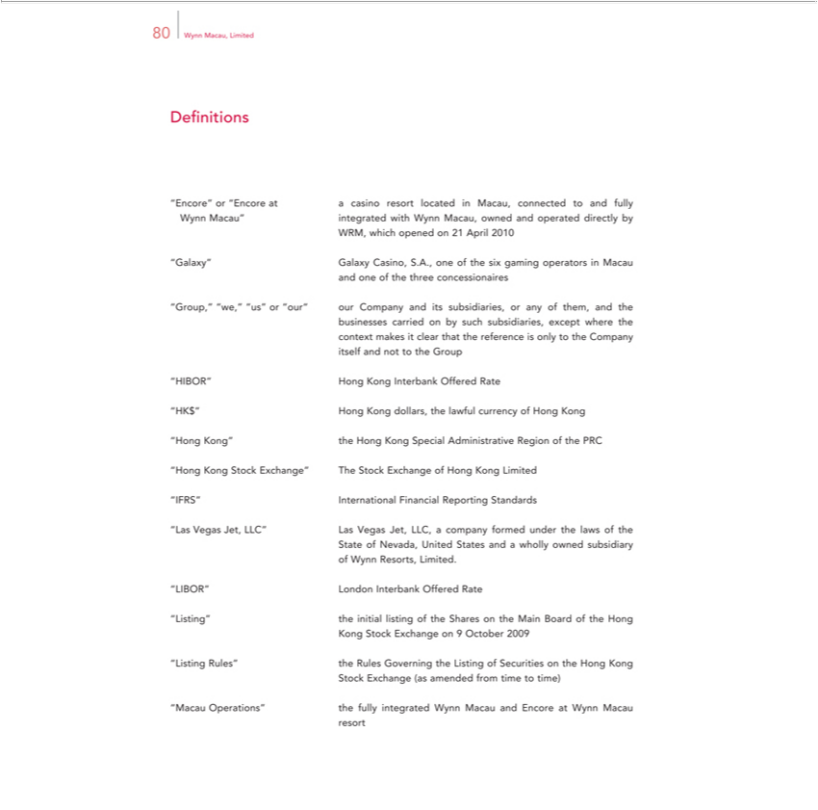

80 Wynn Macau, Limited
Definitions | casino resort located in Macau, connected to and fully
“Encore” or “Encore | casino resort located in Macau, connected to and fully
^{WRM,} integrated
ynn Macau”whichopened on 21withAprilWynn2010Macau, owned and operated directly by
and“Galaxy”oneofGalaxythethreeCasino,concessionairesS.A.,oneof the six gaming operators in Macau
businesses“Group,”“we,”carried“us”on orby“our”such oursubsidiaries,Companyexceptanditswheresubsidiaries,the or any of them, and the

itselfcontextandmakesnottoittheclearGroupthat the reference is only to the Company
^{K}IBOR”$” Hong Kong Interbank Offered Rate
Hong Kong dollars, the lawful currency of Hong Kong
^{Hong Kong}” the Hong Kong Special Administrative Region of the PRC
^{IFRS”}
^{“Las} InternationalStockExchange”Financial TheReportingStock ^{Standards}Exchange of Hong Kong Limited
State VegasofNevada,Jet,LLC”UnitedLasStatesVegasandJet,a whollyLLC, ownedcompanysubsidiaryformed under the laws of the
of Wynn Resorts, Limited.
_{“Listing”}IBOR” London Interbank Offered Rate
the_{Exchange}initillisting of the Shares on the Main Board of the Hong
Kong Stock on 9 October 2009
Stock“ListingExchangeRules” the(as RulesamendedGoverningfromtimethetoListingtime) of Securities on the Hong Kong
resort“Macau Operations” the fully integrated Wynn Macau and Encore at Wynn Macau

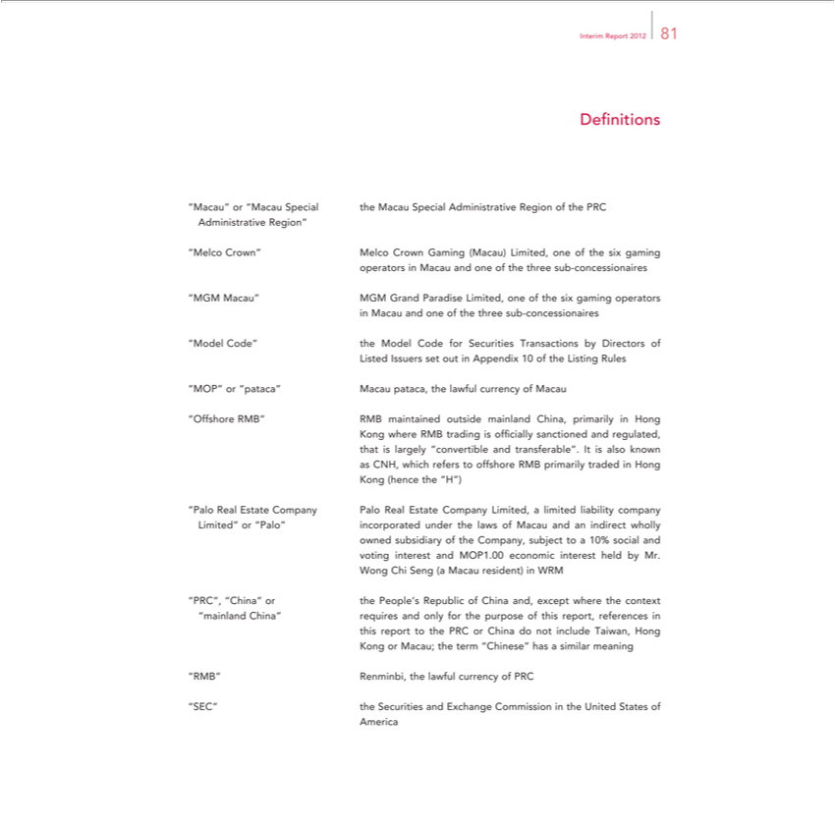

Interim Report 2012 81
Definitions
“Macau” or “Macau Special the Macau Special Administrative Region of the PRC
Administrative Region”
“Melco Crown” Melco Crown Gaming (Macau) Limited, one of the six gaming
operators in Macau and one of the three sub-concessionaires
“MGM Macau” MGM Grand Paradise Limited, one of the six gaming operators
in Macau and one of the three sub-concessionaires
“Model Code” the Model Code for Securities Transactions by Directors of
Listed Issuers set out in Appendix 10 of the Listing Rules
MOP” or “pataca” Macau pataca, the lawful currency of Macau
“Offshore RMB” RMB maintained outside mainland China, primarily in Hong
Kong where RMB trading is officially sanctioned and regulated,
that is largely “convertible and transferable”. It is also known
as CNH, which refers to offshore RMB primarily traded in Hong
Kong (hence the “H”)
“Palo Real Estate Company Palo Real Estate Company Limited, a limited liability company
Limited” or “Palo” incorporated under the |  |  | of Macau and an indirect wholly
owned subsidiary of the Company, subject lawsto10% social and
voting interest and MOP1.00 economic interest held by Mr.
Wong Chi Seng (a Macau |  | in WRM
PRC”, “China” or the People’resident)Republic of China and, except where the context
“mainland China” requires and only for the purpose of this report, references in
this | to the PRC or China do not include Taiwan, Hong
report
_{“SEC”}KongRMB” Renminbi,Macau;thethetermlawful“Chinese”currencyhasofa PRCsimilar meaning
Americathe Securities and Exchange Commission in the United States of

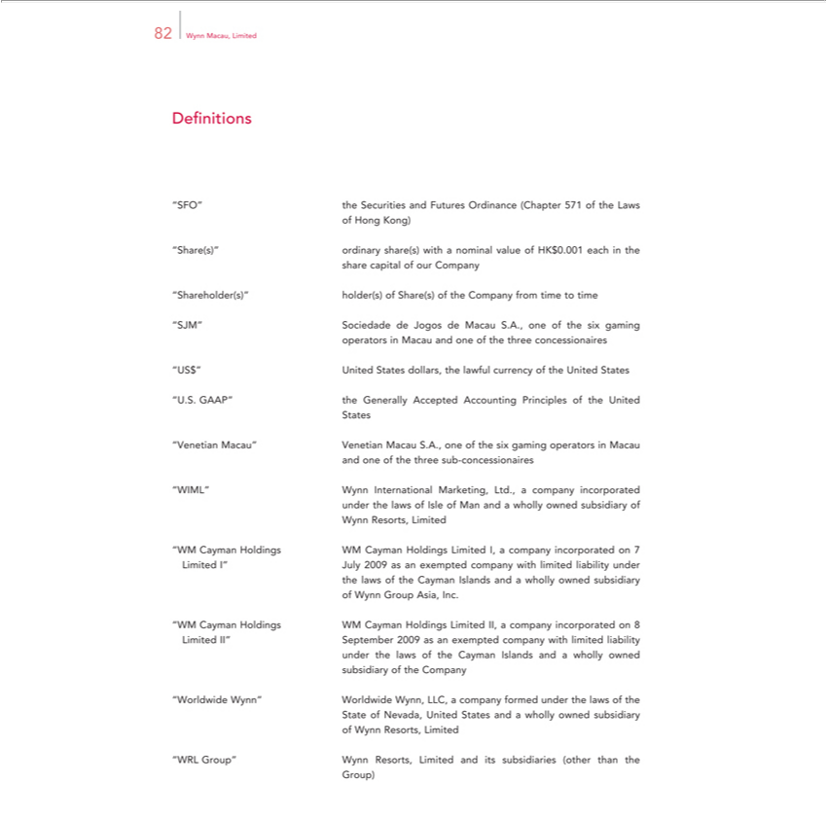

82 Wynn Macau, Limited
Definitions
“SFO” the Securities and Futures Ordinance (Chapter 571 of the Laws
of Hong Kong)
“Share(s)” ordinary share(s) with a nominal value of HK$0.001 each in the
share capital of our Company
 | hareholder(s)” |  |  | of Share(s) of the Company from time to time
“SJM” Sociedadeholder(s)Jogos de Macau S.A., one of the six gaming
operators in Macau and one of the three concessionaires
 |  | United States dollars, the lawful currency of the United States
“US.$.”GAAP” the Generally Accepted Accounting Principles of the United
States
“Venetian Macau” Venetian Macau S.A., one of the six gaming operators in Macau
and one of the three sub-concessionaires |  |  |  |  |  | Ltd., a company incorporated
“WIML” Wynn International |  |  |  |  |  | Ltd., a company incorporated
under the laws of Isle of Man Marketing,andwholly owned subsidiary of
 | ynn Resorts, Limited
“WM Cayman Holdings WM Cayman Holdings Limited I, a company incorporated on 7
Limited I” July 2009 as |  |  |  | exempted company with limited liability under
the laws of the Cayman |  |  | Islands and a wholly owned subsidiary
of | ynn Group Asia, Inc. |  |  |  | Holdings Limited II, a company incorporated on 8
“WM Cayman Holdings WM
Limited II” September 2009 asCaymanexempted company with limited liability
under the laws of the Cayman Islands and a wholly owned
subsidiary of the Company
“Worldwide Wynn” Worldwide Wynn, LLC, a company formed under the laws of the
State of Nevada, United States and a wholly owned subsidiary
of | ynn Resorts, Limited
“WRL |  | Group” Wynn Resorts, Limited and its subsidiaries (other than the
Group)

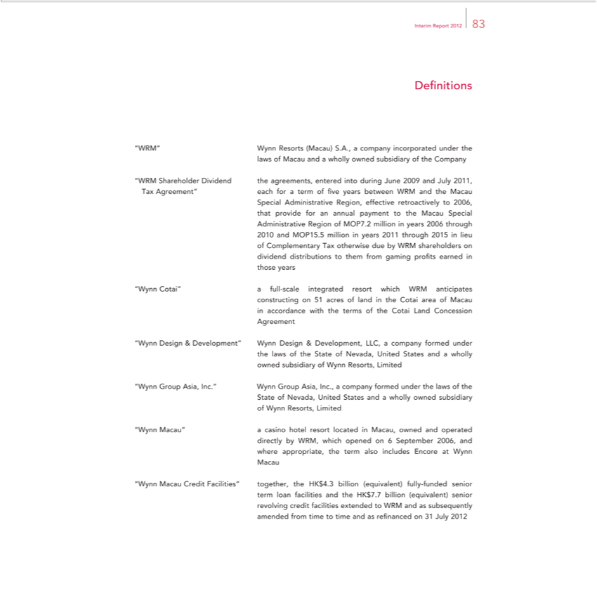

Interim Report 2012 83
Definitions
“WRM” Wynn Resorts (Macau) S.A., company incorporated under the
laws of Macau and a wholly owned subsidiary of the Company
“WRM Shareholder Dividend the agreements, entered into during June 2009 and July 2011,
Tax Agreement” each for a term of five years between WRM and the Macau
Special Administrative Region, effective retroactively to 2006,
that provide for an annual payment to the Macau Special
Administrative Region of MOP7.2 million in years 2006 through
2010 and MOP15.5 million in years 2011 through 2015 in lieu
of Complementary Tax otherwise due by WRM shareholders on
dividend distributions to them from gaming profits earned in
those years | resort which WRM anticipates
“Wynn Cotai” a full-scale | resort which WRM anticipates

on 51 acres ofintegratedlandthe Cotai area of Macau
constructingaccordance with the terms of the Cotai Land Concession
Agreement
“Wynn Design & Development” Wynn Design & Development, LLC, a company formed under
the laws of the State of Nevada, United States and a wholly
owned subsidiary of Wynn Resorts, Limited
“Wynn Group Asia, Inc.” Wynn Group Asia, Inc., a company formed under the laws of the
State of Nevada, United States and a wholly owned subsidiary
of Wynn Resorts, Limited
“Wynn Macau” a casino hotel resort located in Macau, owned and operated
directly by WRM, which opened on 6 September 2006, and
where appropriate, the term also includes Encore at Wynn
Macau
“Wynn Macau Credit Facilities” together, the HK$4.3 billion (equivalent) fully-funded senior
term loan facilities and the HK$7.7 billion (equivalent) senior
revolving credit facilities extended to WRM and as subsequently
amended from time to time and as refinanced on 31 July 2012

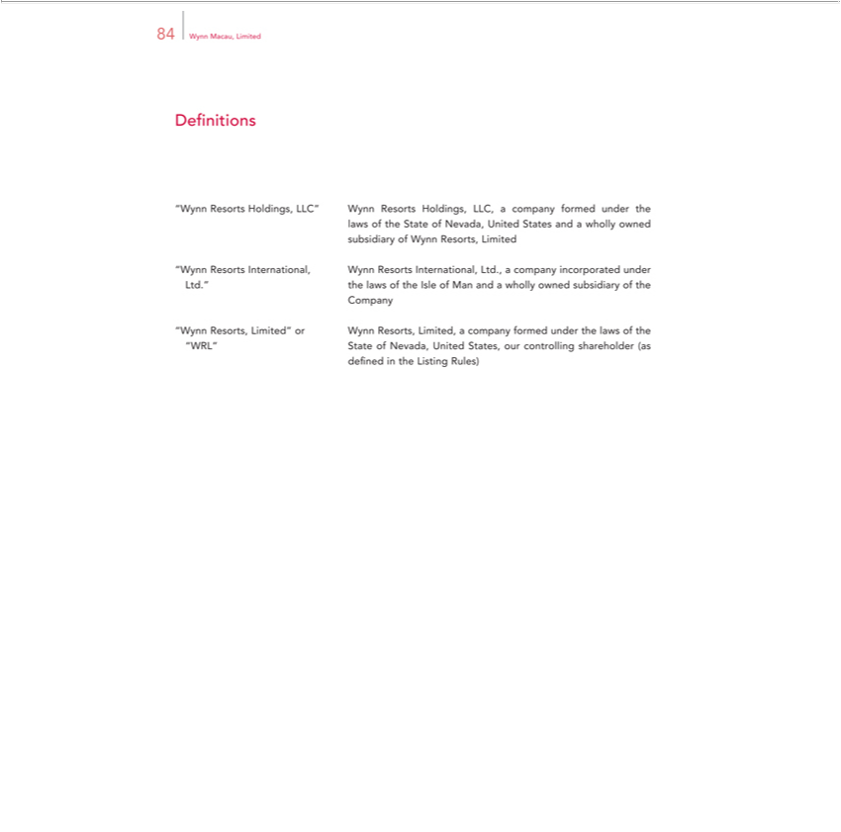

Definitions84WynnMacau, Limited
laws“Wynnof ResortstheStateHoldings,ofNevada,LLC”UnitedWynnStatesResortsand aHoldings,whollyownedLLC, a company formed under the
subsidiary of Wynn Resorts, Limited
Ltd.”“WynntheResortslawsofInternational,theIsleofManWynnandResortsawhollyInternational,ownedsubsidiaryLtd.,aofcompanythe incorporated under
Company
^{“WRL”}
ynn Resorts,Stateof Limited”Nevada, UnitedorWynnStates,Resorts,our Limited,controllingacompanyshareholderformed(as under the laws of the

defined in the Listing Rules)

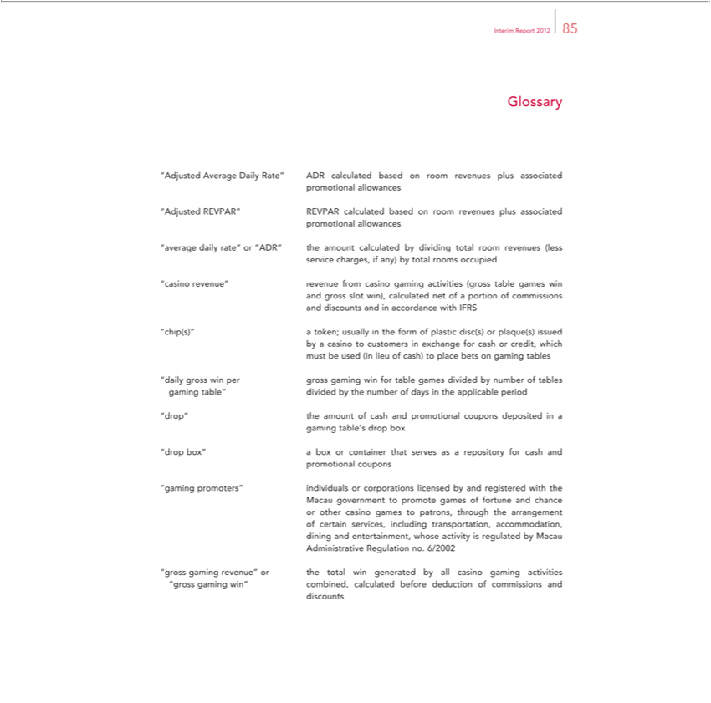

Interim Report 2012 85
Glossary
“Adjusted Average Daily Rate” ADR calculated based on room revenues plus associated
promotional allowances
“Adjusted REVPAR” REVPAR calculated based on room revenues plus associated
promotional allowances
“average daily rate” or “ADR” the amount calculated by dividing total room revenues (less
service charges, if any) by total rooms occupied
“casino revenue” revenue from casino gaming activities (gross table games win
gross slot win), calculated net of a portion of commissions
and discounts and in accordance with IFRS
“chip(s)” | usually in the form of plastic disc(s) or plaque(s) issued
by a casino token;customers in exchange for cash or credit, which
must be used (in lieu of cash) to place bets on gaming tables
“daily gross win per gross gaming win for table games divided by number of tables
gaming table” divided by the number of days in the applicable period
“drop” the amount of cash and promotional coupons deposited in a
gaming | s drop b x

“drop box”table’box or container that serves as a repository for cash and
promotional coupons
“gaming promoters” individuals or corporations licensed by and registered with the
Macau government to promote games of fortune and chance
r other casino games to patrons, through the arrangement
of certain services, including transportation, accommodation,
dining and entertainment, whose activity is regulated by Macau
Administrative Regulation no. 6/2002
revenue” or the total win generated by all casino gaming activities
“gross gaming win” combined, calculated before deduction of commissions and
discounts

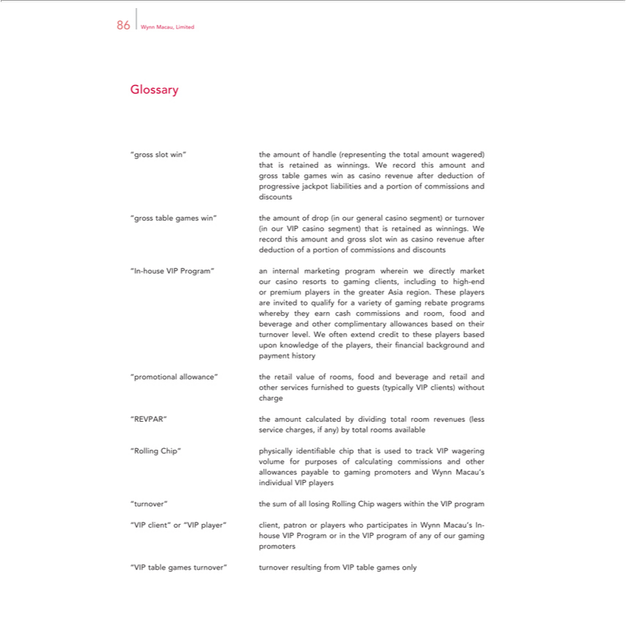

86 Wynn Macau, Limited
Glossary
 | slot win”
gross table games win”
In-house VIP Program”
promotional allowance” “REVPAR” “Rolling Chip”
turnover”
 | client” or “VIP player”
“VIP table games turnover”
the | of handle (representing the total amount wagered) that is retained as winnings. We record this amount and gross table games win as casino revenue after deduction of progressive jackpot liabilities
and | portion of commissions and discounts
the amount of drop (in our general casino segment) or turnover (in our VIP casino segment) that is retained as winnings. We record this amount and gross slot win as casino revenue after deduction of a portion
of commissions and discounts |  | are invited to qualify for
an internal marketing program wherein we directly market our casino resorts to gaming clients, including to high-end or premium players in the greater Asia region. These |  | are invited to qualify for
^{based}vriety of gaming rebate programs whereby they earn cash commissions and room, food and beverage and other complimentary allowances based on their turnover level. Wplayersoften extend credit to these players upon knowledge of the players, their financial background and payment ^{history}
^{the} retail value of rooms, food and beverage and retail and other services furnished guests (typically VIP clients) without charge amount calculated by dividing total room revenues (less service charges, if any) by total rooms available
physically identifiable chip that is used to track VIP wagering volume for purposes of calculating commissions and other allowances payable to gaming promoters and Wynn Macau’s individual VIP players the sum of all losing Rolling Chip wagers within the VIP program
client, patron or players who participates in Wynn Macau’s In-house VIP Program or in the VIP program of any of our gaming promoters turnover resulting from VIP table games only

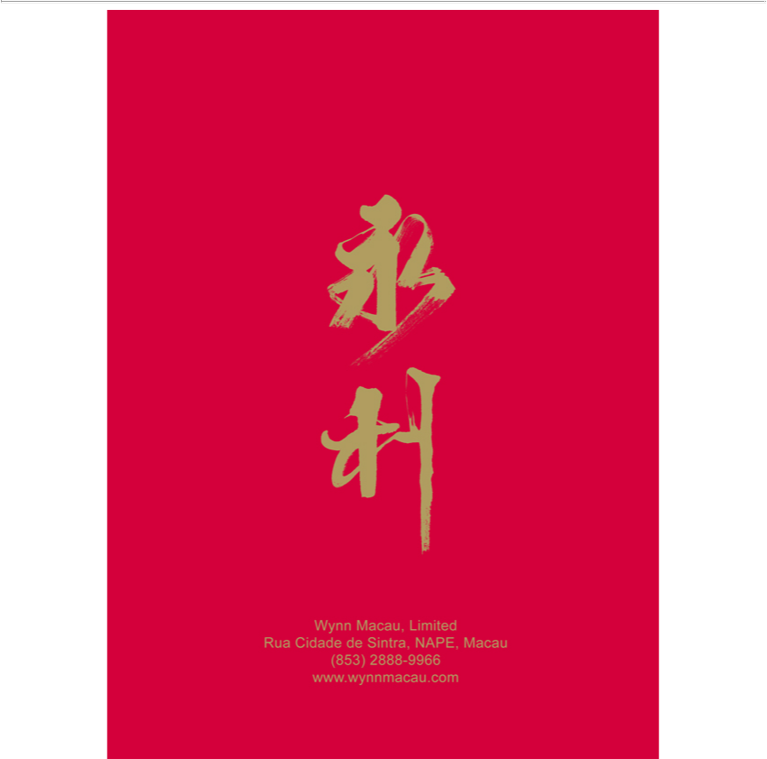

Wynn Macau, Limited Rua Cidade de Sintra, NAPE, Macau (853) 2888-9966 www.wynnmacau.com

