UNITED STATES

SECURITIES AND EXCHANGE COMMISSION
Washington, D.C. 20549

FORM 8-K

CURRENT REPORT

Pursuant to Section 13 or 15(d)

of the Securities Exchange Act of 1934, as Amended

Date of Report (Date of earliest event reported): March 20, 2014

WYNN RESORTS, LIMITED

(Exact name of registrant as specified in its charter)

Nevada | 000-50028 | 46-0484987
(State or other jurisdiction | (Commission | (IRS Employer
of incorporation | File Number) | Identification No.)
3131 Las Vegas Boulevard South
Las Vegas, Nevada |  | 89109
(Address of principal executive offices) |  | (Zip Code)

(702) 770-7555

(Registrant’s telephone number, including area code)

Not Applicable

(Former name or former address, if changed since last report.)

Check the appropriate box below if the Form 8-K filing is intended to simultaneously satisfy the filing obligation of the registrant under any of the following provisions:

- Written communications pursuant to Rule 425 under the Securities Act (17 CFR 230.425)

- Soliciting material pursuant to Rule 14a-12 under the Exchange Act (17 CFR 240.14a-12)

- Pre-commencement communications pursuant to Rule 14d-2(b) under the Exchange Act (17 CFR 240.14d-2(b))

- Pre-commencement communications pursuant to Rule 13e-4(c) under the Exchange Act (17 CFR 240.13e-4(c))

Item 1.01. Entry into a Material Definitive Agreement.

On March 20, 2014, Wynn Macau, Limited (“WML”), an indirect subsidiary of Wynn Resorts, Limited (the “Registrant”) with its ordinary shares listed on The Stock Exchange of Hong Kong Limited (the “HKSE”), issued $750 million aggregate principal amount of 5.250% Senior Notes due 2021 (the “Additional Notes”). The Additional Notes will be consolidated and form a single series with the $600 million aggregate principal amount of 5.250% Senior Notes due 2021 issued by WML on October 16, 2013 (the “Original Notes” and together with the Additional Notes, the “Notes”) pursuant to an Indenture, dated as of October 16, 2013, between WML and Deutsche Bank Trust Company Americas, as trustee (the “Indenture”). The Additional Notes will bear the same terms and conditions as the Original Notes, exclusive of the issue date and the purchase price. WML expects to receive net proceeds of approximately $749 million from the offering of the Additional Notes after deducting commissions and estimated expenses of the offering and to use the net proceeds for working capital requirements and general corporate purposes. The following is a brief description of certain terms and conditions of the Indenture and the Notes.

The Notes will bear interest at the rate of 5.250% per annum and will mature on October 15, 2021. Interest on the Notes is payable semi-annually in arrears on April 15 and October 15 of each year, beginning on April 15, 2014. At any time on or before October 14, 2016, WML may redeem the Notes, in whole or in part, at a redemption price equal to the greater of (a) 100% of the aggregate principal amount of the Notes or (b) a “make-whole” amount as determined by an independent investment banker in accordance with the terms of the Indenture, in either case, plus accrued and unpaid interest. In addition, on or after October 15, 2016, WML may redeem the Notes, in whole or in part, at a premium decreasing annually from 3.938% of the principal amount to zero, plus accrued and unpaid interest. If WML undergoes a Change of Control (as defined in the Indenture), it must offer to repurchase the Notes at a price equal to 101% of the aggregate principal amount thereof, plus accrued and unpaid interest. In addition, the Company may redeem the Notes, in whole but not in part, at a redemption price equal to 100% of the principal amount, plus accrued and unpaid interest, in response to any change in or amendment to certain tax laws or tax positions. Further, if a holder or beneficial owner of the Notes fails to meet certain requirements imposed by any Gaming Authority (as defined in the Indenture), WML may require the holder or beneficial owner to dispose of or may redeem its Notes.

The Notes are WML’s general unsecured obligations and rank pari passu in right of payment with all of WML’s existing and future senior unsecured indebtedness; will rank senior to all of WML’s future subordinated indebtedness, if any; will be effectively subordinated to all of WML’s future secured indebtedness to the extent of the value of the assets securing such debt; and will be structurally subordinated to all existing and future obligations of WML’s subsidiaries, including WML’s existing credit facilities. The Notes are not registered under the Securities Act of 1933, as amended (the “Securities Act”), and the Notes are subject to restrictions on transferability and resale. The Indenture contains covenants limiting WML’s (and certain of its subsidiaries’) ability to, among other things: merge or consolidate with another company; transfer or sell all or substantially all of its properties or assets; and lease all or substantially all of its properties or assets. The terms of the Indenture contain customary events of default, including, but not limited to: default for 30 days in the payment when due of interest on the Notes; default in the payment when due of the principal of, or premium, if any, on the Notes; failure to comply with any payment obligations relating to the repurchase by WML of the Notes upon a Change of Control; failure to comply with certain covenants in the Indenture; certain defaults on certain other indebtedness; failure to pay judgments against WML or certain subsidiaries that, in the aggregate, exceed $50 million; and certain events of bankruptcy or insolvency. In the case of an event of default arising from certain events of bankruptcy or insolvency, all Notes then outstanding will become due and payable immediately without further action or notice.

Item 2.03. Creation of a Direct Financial Obligation.

The information set forth in Item 1.01 is incorporated herein by reference.

Item 7.01. Regulation FD Disclosure.

On March 20, 2014, WML filed with the HKSE (1) a notice indicating that WML submitted an application to the HKSE for the listing of and permission to deal in the Additional Notes (the “Listing Notice”) and (2) an announcement regarding the closing of the issuance of the Additional Notes (the “Closing Announcement”),

2

as required by HKSE listing rules. The Registrant owns approximately 72.3% of WML’s ordinary shares. The Listing Notice and Closing Announcement are furnished herewith as Exhibits 99.1 and 99.2, respectively. The information contained in this Item 7.01 and the exhibits attached to this Current Report on Form
8-K shall not be deemed “filed” for purposes of Section 18 of the Securities Exchange Act of 1934, as amended, nor shall it be deemed incorporated by reference in any filing under the Securities Act, except as shall be expressly set forth by specific reference in such filing.

Item 9.01. Financial Statements and Exhibits

- Exhibits.

Exhibit

No. Description

99.1 Notice of Listing on The Stock Exchange of Hong Kong Limited, dated March 20, 2014.

99.2 Closing Announcement of Wynn Macau, Limited, dated March 21, 2014.

3

SIGNATURES

Pursuant to the requirements of the Securities Exchange Act of 1934, as amended, the Registrant has duly caused this report to be signed on its behalf by the undersigned hereunto duly authorized.

 | WYNN RESORTS, LIMITED
Date: March 21, 2014 | By: | /s/ Matt Maddox
 | Name: | Matt Maddox
 | Title: | President and Chief Financial Officer

EXHIBIT INDEX

Exhibit

No. Description

99.1 Notice of Listing on The Stock Exchange of Hong Kong Limited, dated March 20, 2014.

99.2 Closing Announcement of Wynn Macau, Limited, dated March 21, 2014.

Exhibit 99.1
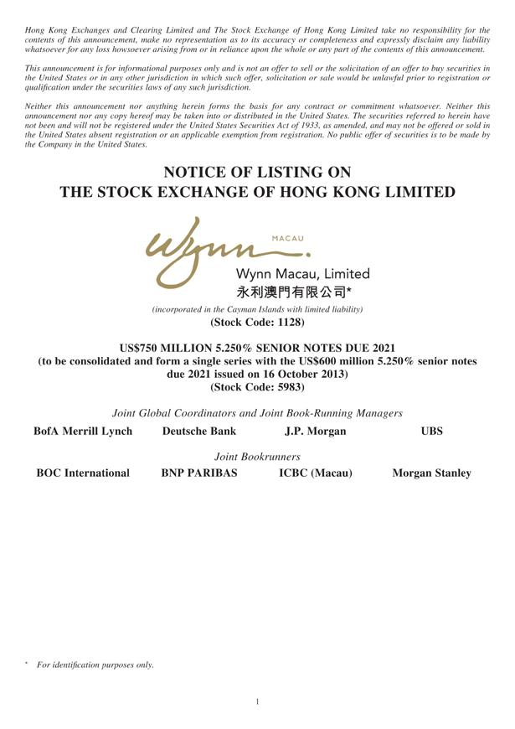

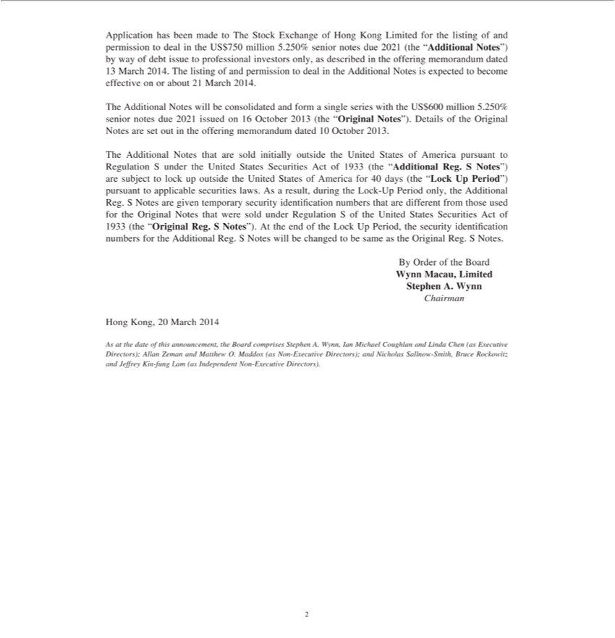

Exhibit 99.2


