UNITED STATES SECURITIES AND EXCHANGE COMMISSION

Washington, D.C. 20549

SCHEDULE 14A

Proxy Statement Pursuant to Section 14(a) of

The Securities Exchange Act of 1934

Filed by the Registrant ☒

Filed by a Party other than the Registrant ☐

Check the appropriate box:

☐

☐

Preliminary Proxy Statement

Definitive Proxy Statement

☐ Confidential, for Use of the Commission

Only (as permitted by Rule 14a-6(e)(2))

- Definitive Additional Materials

- Soliciting Material Pursuant to §240.14a-12

WYNN RESORTS, LIMITED

(Name of Registrant as Specified In Its Charter)

(Name of Person(s) Filing Proxy Statement, if other than the Registrant)

Payment of Filing Fee (Check the appropriate box):

- No fee required.

- Fee computed on table below per Exchange Act Rules 14a-6(i)(1) and 0-11.

  - Title of each class of securities to which transaction applies:

  - Aggregate number of securities to which transaction applies:

  - Per unit price or other underlying value of transaction computed pursuant to Exchange Act Rule 0-11 (set forth the amount on which the filing fee is calculated and state how it was determined):

  - Proposed maximum aggregate value of transaction:

  - Total fee paid:

- Fee paid previously with preliminary materials.

- Check box if any part of the fee is offset as provided by Exchange Act Rule 0-11(a)(2) and identify the filing for which the offsetting fee was paid previously. Identify the previous filing by registration statement number, or the Form or Schedule and the date of its filing.

  - Amount Previously Paid:

  - Form, Schedule or Registration Statement No.:

  - Filing Party:

  - Date Filed:

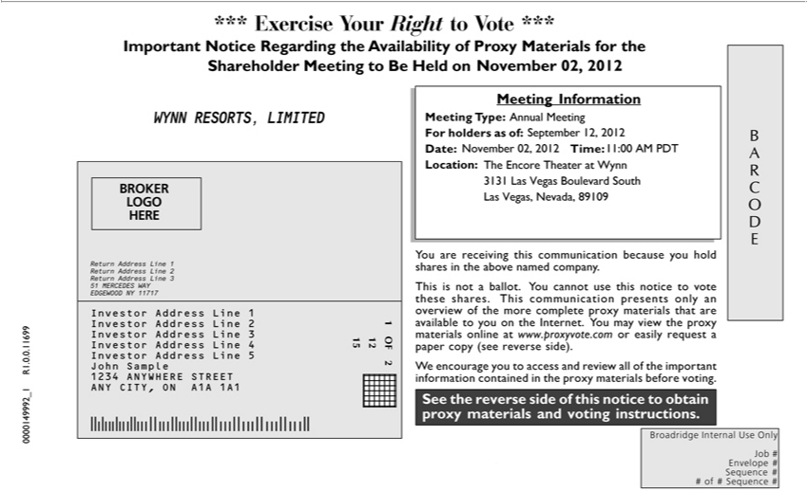

ARCODE See the reverse side of this notice to obtain proxy materials and voting instructions. BROKER LOGO HERE 1 OF 2 12 15 1234567 1234567 1234567 1234567 1234567 1234567 1234567
Broadridge I ternal Use Only Job # Envelope # Sequence # # f # Sequence # *** Exercise Your Right to Vote *** Important Notice Regarding the Availability of Proxy Materials for the Shareholder Meeting
to Be Held on <mtgdate>. You are receiving this communication because you hold shares in the above named company. This is not ballot. You cannot use this notice to vote these shares. This communication
presents only an overview of the more complete proxy materials that are available to you | the Internet. You may view the proxy materials online www.proxyvote.com or easily request a paper copy (see
reverse side). W encourage you to access and review all of the important information contained in the proxy materials before voting. Meeting Information Meeting ype: <mtgtype> For holders as of: <recdate>
Time: <mtgtime> Location: 0000149992_1 R1.0.0.11699 WYNN RESORTS, LIMITED Annual Meeting November 02, 2012 November 02, 2012 11:00 AM PDT September |  |  | 2012 The Encore Theater
Date:Wynn 3131 Las Vegas Boulevard South Las Vegas, Nevada, 89109 Return Address Line 1 Return Address Line 2 Return Address Line 3 51 MERCEDES WAY EDGEWOOD NY12,1717 Investor Address
Line 1 Investor Address Line 2 Investor Address Line 3 Investor Address Line 4 Investor Address Line John Sample 1234 ANYWHERE STREET ANY CITY, ON A1A 1A1 BARCODE See the reverse side
of this notice to obtain proxy materials and voting instructions. BROKER LOGO HERE 1 OF 2 12 15 1234567 1234567 1234567 1234567 1234567 1234567 1234567 Broadridge Internal Use Only Job #
Envelope # Sequence # # of # Sequence # *** Exercise Your Right to Vote *** Important Notice Regarding the Availability of Proxy Materials for the Shareholder Meeting to Be Held |  |  | <mtgdate>. You are
receiving this communication because you hold shares in the above named company. This is not a ballot. You cannot use this notice to vote these shares. This communication presents only an overview of the
more complete proxy materials that are available to you the Internet. You may view the proxy materials online www.proxyvote.com or easily request a paper copy (see reverse side). W encourage you to
access and review all of the important information contained in the proxy materials before voting. Meeting Information Meeting Type: <mtgtype> For holders as of: <recdate> |  | Time: <mtgtime> Location:
0000149992_1 R1.0.0.11699 WYNN RESORTS, LIMITED Annual Meeting November | 2012 November 02, 2012 11:00 AM PDT September 12, 2012 The Encore TheaterDate:Wynn |  | Las Vegas
Boulevard South Las Vegas, Nevada, 89109 Return Address Line 1 Return Address Line | 02,Return Address Line 3 51 MERCEDES WAY EDGEWOOD NY 11717 Investor Address Line3131Investor Address Line
2 Investor Address Line 3 Investor Address Line 4 Investor Address Line 5 John Sample | 1234 ANYWHERE STREET ANY CITY, ON A1A 1A1

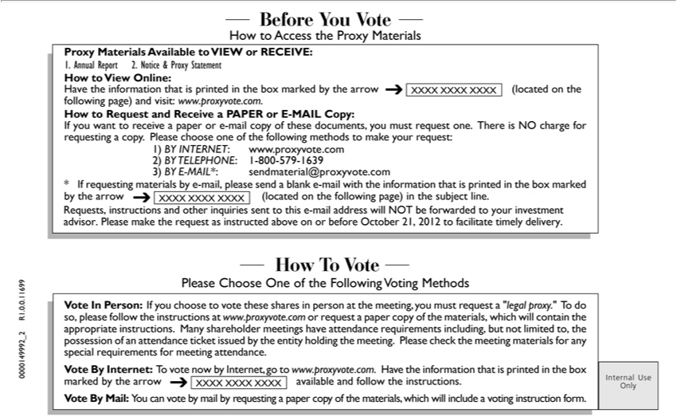

How To Vote Please Choose One of the |  |  | Voting Methods Internal Use Only Before You Vote How to Access the Proxy Materials Proxy Materials Available to VIEW or |  |  | How to View
Online: | the | that is printedFollowingthe box marked by the arrow (located on the following page) and visit: www.proxyvote.com. How to Request and Receive PAPERRECEIVE:or-MAIL Copy: If you want
to receiveHavepaper informatione-mailcopy of these documents, you must request one. There is NO charge for requesting a copy. Please choose one of the following methods to make your request: 1) BY INTERNET:
www.proxyvote.com 2) BY TELEPHONE: 1-800-579-1639 3) BY E-MAIL*: sendmaterial@proxyvote.com * If requesting materials by -mail, please send a blank -mail with the |  |  |  |  |  | that is printed in
the box | by the arrow | on the | page) | the subject line. XXXX XXXX XXXX XXXX XXXX XXXX Vote In Person: If you choose to vote these shares personinformationthe meeting, you
must requestmarked“legal proxy.” (locatedTdoso, pleasefollowingthe instructions at www.proxyvote.com or request a paper copy of the materials, which will contain the appropriate instructions. Many shareholder meetings
have attendance requirements including, but not limited to, the possession of an attendance ticket issued by the entity holding the meeting. Please check the meeting materials for any special requirements for
meeting attendance. Vote By Internet: To vote now by Internet, go to www.proxyvote.com. |  |  |  |  | the information that is printed in the box marked by the arrow available and follow the instructions. Vote By
Mail: You can vote by mail by requesting a paper copy of the |  |  |  | which will include | Havevoting instruction form. XXXX XXXX XXXX 0000149992_2 R1.0.0.11699 1. Annual Report 2. Notice & Proxy
Statement Requests, instructions and other inquiries sent to thismaterials,-mailaddress will NOT be forwarded to your investment advisor. Please make the request as instructed above on or before October 21, 2012 to facilitate timely delivery.

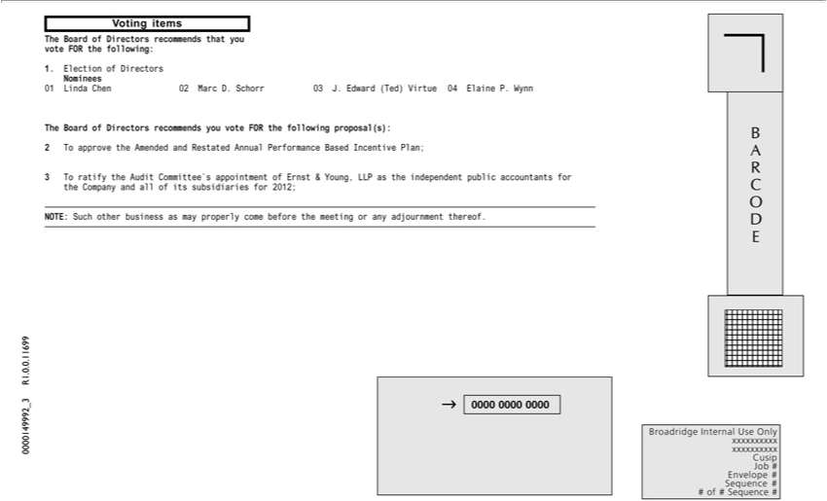

BroadridgeARCODE 123456789012 123456789012 123456789012 123456789012 123456789012 123456789012 123456789012 123456789012 123456789012 123456789012 123456789012 123456789012
that you voteInternalFORtheUse Only xxxxxxxxxx1.ElectionxxxxxxxxxxofDirectorsCusipNomineesJob# 01EnvelopeLindaChen#Sequence02Marc# #D.ofSchorr#Sequence03J.Edward#0000 0000(Ted) 0000VirtueVoting04ElaineitemsP.0000149992WynnTheBoardR1.of. Directors.1699TherecommendsBoardofDirectorsyouvote recommendsFORthe
following proposal(s): following:2Tapprove the Amended and Restated Annual Performance Based Incentive Plan; 3 T^{come}ratify the Audit Committee’s appointment of Ernst & Young, LLP as the independent public
accountants for the Company and all of its subsidiaries for 2012; NOTE: Such other business as may properly before the meeting or any adjournment thereof.

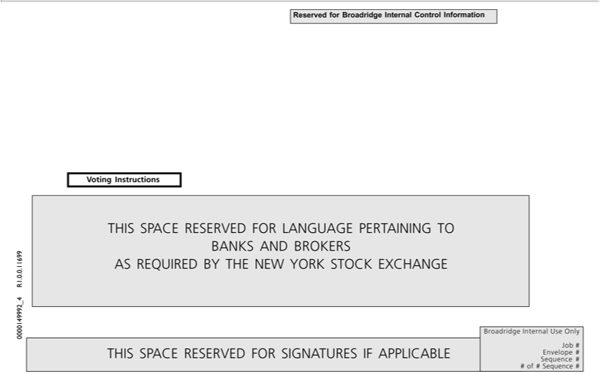

THIS SPACE RESERVED FOR LANGUAGE PERTAINING TO BANKS AND BROKERS AS REQUIRED BY THE NEW YORK STOCK EXCHANGE Voting Instructions THIS SPACE RESERVED FOR SIGNATURES IF APPLICABLE P99999-010 12 15 # OF # Broadridge Internal Use Only Job # Envelope # Sequence # # of # Sequence # Reserved for Broadridge Internal Control Information 0000149992_4 R1.0.0.11699

