UNITED STATES
SECURITIES AND EXCHANGE COMMISSION
Washington, D.C. 20549

FORM 8-K

CURRENT REPORT
PURSUANT TO SECTION 13 OR 15(d)
OF THE SECURITIES EXCHANGE ACT OF 1934
Date of Report (Date of earliest event reported): September 4, 2023

WYNN RESORTS, LIMITED
(Exact name of registrant as specified in its charter)

Nevada |  |  |  |  |  | 000-50028 |  |  | 46-0484987
(State or other jurisdiction  of incorporation) |  |  |  |  |  | (Commission  File Number) |  |  | (I.R.S. Employer  Identification No.)
3131 Las Vegas Boulevard South
Las Vegas, |  |  | Nevada |  |  |  |  |  | 89109
(Address of principal executive offices) |  |  |  |  |  |  |  |  | (Zip Code)

(702) 770-7555
(Registrant’s telephone number, including area code)
Not Applicable
(Former name or former address, if changed since last report)

Securities registered pursuant to Section 12(b) of the Act:
Title of each class |  |  |  |  |  | Trading Symbol(s) |  |  |  |  |  | Name of each exchange on which registered
Common stock, par value $0.01 |  |  |  |  |  | WYNN |  |  |  |  |  | Nasdaq Global Select Market

Check the appropriate box below if the Form 8-K filing is intended to simultaneously satisfy the filing obligation of the registrant under any of the following provisions:
☐ Written communications pursuant to Rule 425 under the Securities Act (17 CFR 230.425)
☐ Soliciting material pursuant to Rule 14a-12 under the Exchange Act (17 CFR 240.14a-12)
☐ Pre-commencement communications pursuant to Rule 14d-2(b) under the Exchange Act (17 CFR 240.14d-2(b))
☐ Pre-commencement communications pursuant to Rule 13e-4(c) under the Exchange Act (17 CFR 240.13e-4(c))
Indicate by check mark whether the registrant is an emerging growth company as defined in Rule 405 of the Securities Act of 1933 (§230.405 of this chapter) or Rule 12b-2 of the Securities Exchange Act of 1934 (§240.12b-2 of this chapter).
Emerging growth company ☐
If an emerging growth company, indicate by check mark if the registrant has elected not to use the extended transition period for complying with any new or revised financial accounting standards provided pursuant to Section 13(a) of the Exchange Act. ☐

Item 7.01 |  |  | Regulation FD Disclosure.

On September 4, 2023, Wynn Macau, Limited ("WML"), an indirect subsidiary of Wynn Resorts, Limited (the "Registrant") with its ordinary shares of common stock listed on The Stock Exchange of Hong Kong Limited (the "HKSE"), filed with the HKSE its interim report in respect of the six months ended June 30, 2023 (the "Interim Report"). The Registrant owns approximately 72% of WML's ordinary shares of common stock. The Interim Report is furnished herewith as Exhibit 99.1. The information in this Form 8-K and Exhibit 99.1 attached hereto shall not be deemed "filed" for purposes of Section 18 of the Securities Exchange Act of 1934, as amended, nor shall it be deemed incorporated by reference in any filing under the Securities Act of 1933, as amended, except as shall be expressly set forth by specific reference in such filing.

Item 9.01 |  |  | Financial Statements and Exhibits.

(d)Exhibits.
Exhibit No. |  |  | Description
99.1 |  |  | Interim Report of Wynn Macau, Limited in respect of the six months ended June 30, 2023
104 |  |  | Cover Page Interactive Data File - the cover page XBRL tags are embedded within the Inline XBRL document

SIGNATURES
Pursuant to the requirements of the Securities Exchange Act of 1934, the Registrant has duly caused this report to be signed on its behalf by the undersigned hereunto duly authorized.
 |  |  |  |  |  |  |  |  |  |  |  | WYNN RESORTS, LIMITED
Dated: September 5, 2023 |  |  |  |  |  | By: |  |  |  |  |  | /s/ Julie Cameron-Doe
 |  |  |  |  |  | Julie Cameron-Doe
 |  |  |  |  |  | Chief Financial Officer
 |  |  |  |  |  | (Principal Financial and Accounting Officer)

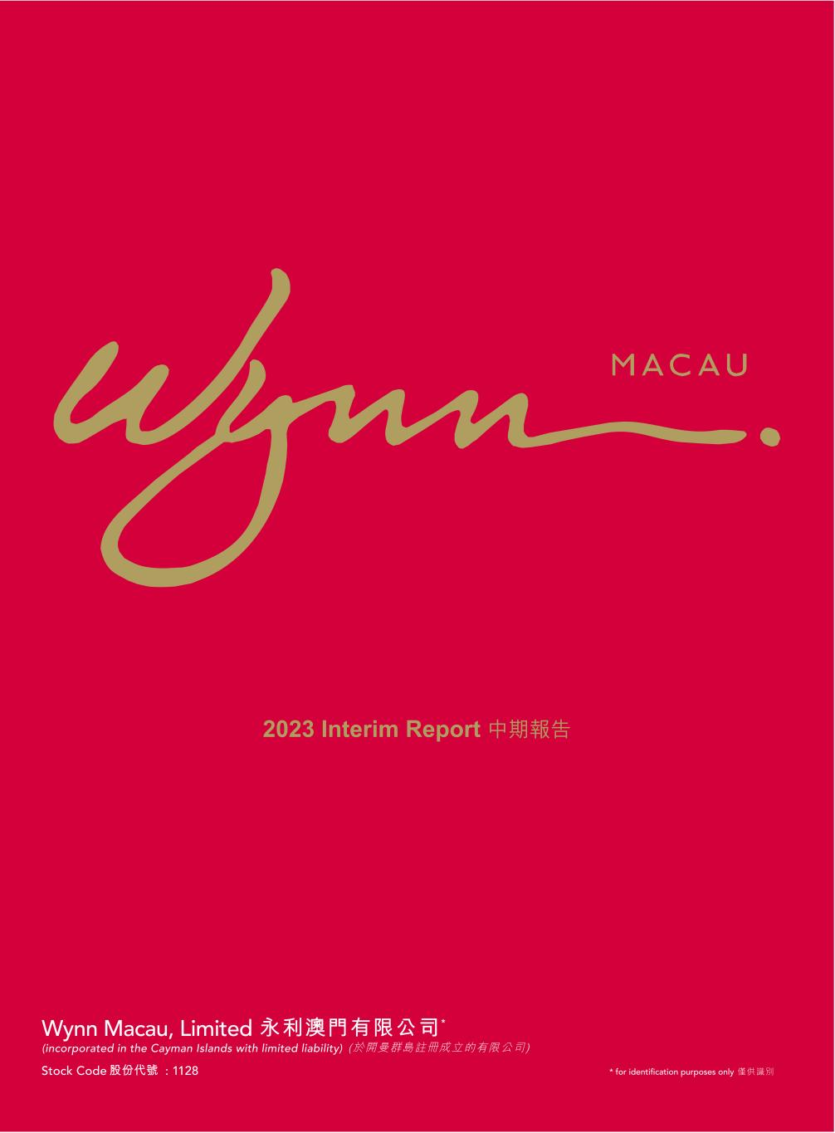

2023 Interim Report ����



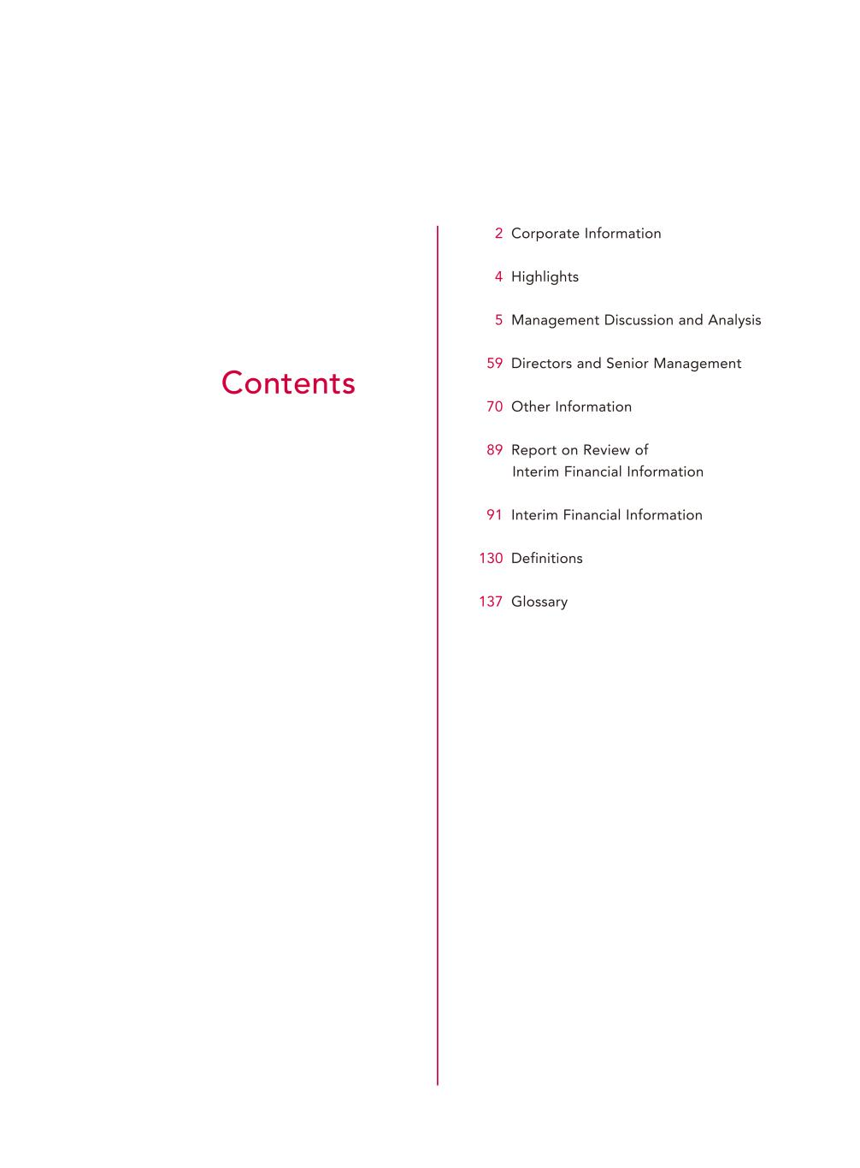
Contents 2 Corporate Information 4 Highlights 5 Management Discussion and Analysis 59 Directors and Senior Management 70 Other Information 89 Report on Review of Interim Financial Information 91 Interim Financial Information 130 Definitions 137 Glossary

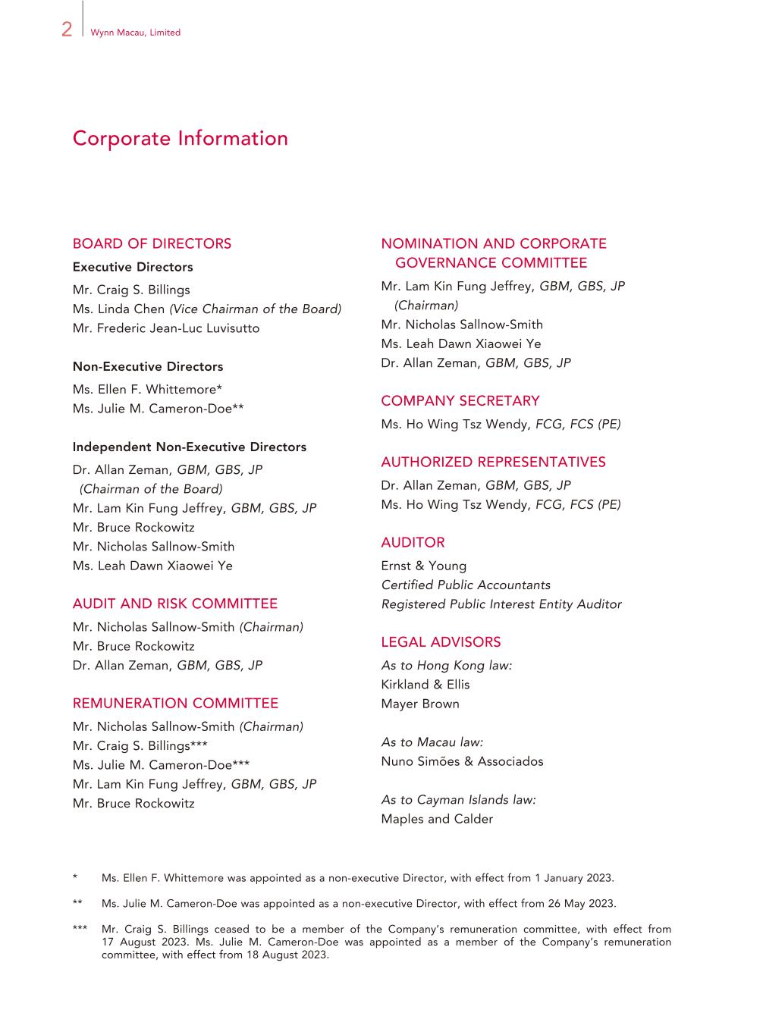
2 Wynn Macau, Limited Corporate Information BOARD OF DIRECTORS Executive Directors Mr. Craig S. Billings Ms. Linda Chen (Vice Chairman of the Board) Mr. Frederic Jean-Luc Luvisutto Non-Executive Directors Ms. Ellen F. Whittemore* Ms. Julie M. Cameron-Doe** Independent Non-Executive Directors Dr. Allan Zeman, GBM, GBS, JP (Chairman of the Board) Mr. Lam Kin Fung Jeffrey, GBM, GBS, JP Mr. Bruce Rockowitz Mr. Nicholas Sallnow-Smith Ms. Leah Dawn Xiaowei Ye AUDIT AND RISK COMMITTEE Mr. Nicholas Sallnow-Smith (Chairman) Mr. Bruce Rockowitz Dr. Allan Zeman, GBM, GBS, JP REMUNERATION COMMITTEE Mr. Nicholas Sallnow-Smith (Chairman) Mr. Craig S. Billings*** Ms. Julie M. Cameron-Doe*** Mr. Lam Kin Fung Jeffrey, GBM, GBS, JP Mr. Bruce Rockowitz * Ms. Ellen F. Whittemore was appointed as a non-executive Director, with effect from 1 January 2023. ** Ms. Julie M. Cameron-Doe was appointed as a non-executive Director, with effect from 26 May 2023. *** Mr. Craig S. Billings ceased to be a member of the Company’s remuneration committee, with effect from 17 August 2023. Ms. Julie M. Cameron-Doe was appointed as a member of the Company’s remuneration committee, with effect from 18 August 2023. NOMINATION AND CORPORATE GOVERNANCE COMMITTEE Mr. Lam Kin Fung Jeffrey, GBM, GBS, JP (Chairman) Mr. Nicholas Sallnow-Smith Ms. Leah Dawn Xiaowei Ye Dr. Allan Zeman, GBM, GBS, JP COMPANY SECRETARY Ms. Ho Wing Tsz Wendy, FCG, FCS (PE) AUTHORIZED REPRESENTATIVES Dr. Allan Zeman, GBM, GBS, JP Ms. Ho Wing Tsz Wendy, FCG, FCS (PE) AUDITOR Ernst & Young Certified Public Accountants Registered Public Interest Entity Auditor LEGAL ADVISORS As to Hong Kong law: Kirkland & Ellis Mayer Brown As to Macau law: Nuno Simões & Associados As to Cayman Islands law: Maples and Calder

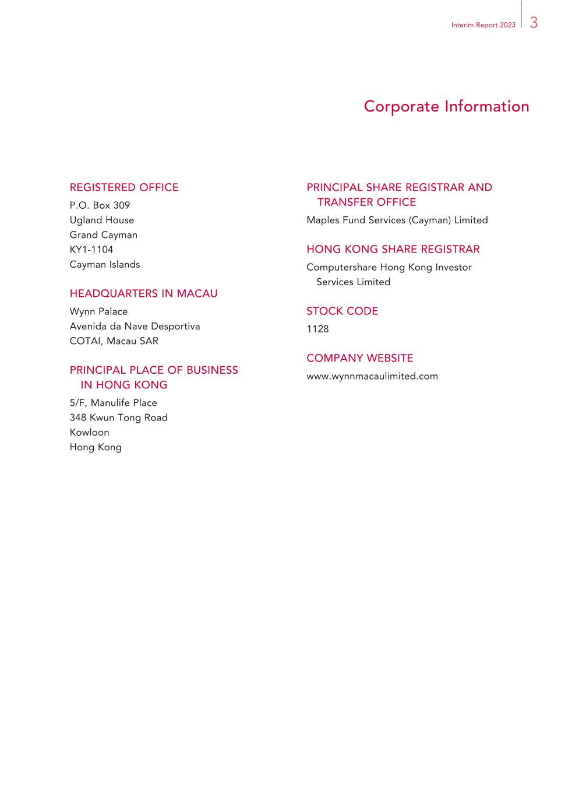
3Interim Report 2023 Corporate Information REGISTERED OFFICE P.O. Box 309 Ugland House Grand Cayman KY1-1104 Cayman Islands HEADQUARTERS IN MACAU Wynn Palace Avenida da Nave Desportiva COTAI, Macau SAR PRINCIPAL PLACE OF BUSINESS IN HONG KONG 5/F, Manulife Place 348 Kwun Tong Road Kowloon Hong Kong PRINCIPAL SHARE REGISTRAR AND TRANSFER OFFICE Maples Fund Services (Cayman) Limited HONG KONG SHARE REGISTRAR Computershare Hong Kong Investor Services Limited STOCK CODE 1128 COMPANY WEBSITE www.wynnmacaulimited.com

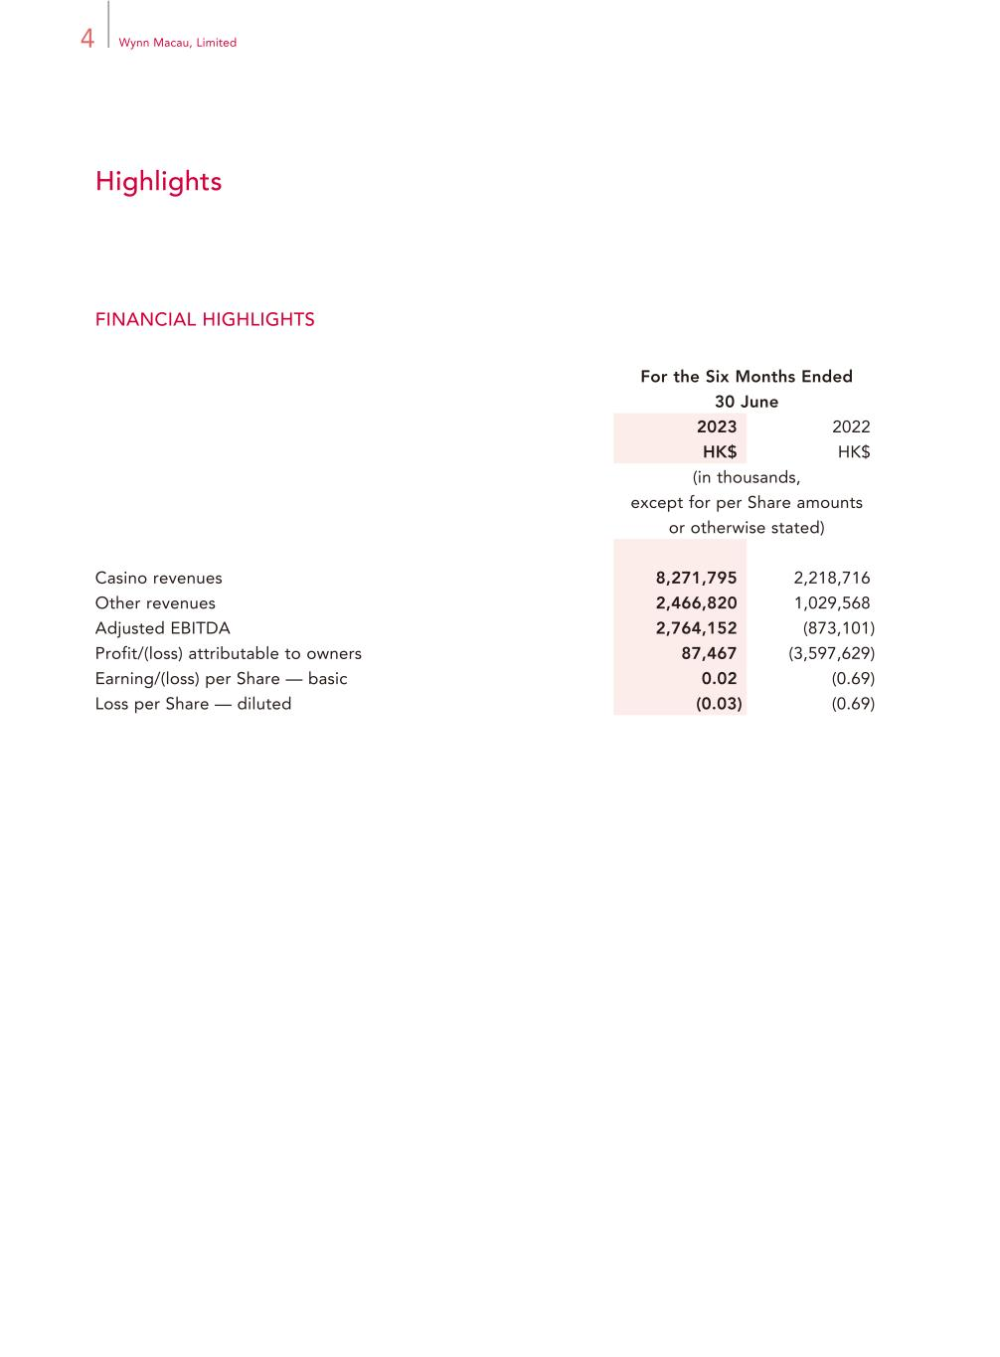
4 Wynn Macau, Limited Highlights FINANCIAL HIGHLIGHTS For the Six Months Ended 30 June 2023 2022 HK$ HK$ (in thousands, except for per Share amounts or otherwise stated) Casino revenues 8,271,795 2,218,716 Other revenues 2,466,820 1,029,568 Adjusted EBITDA 2,764,152 (873,101) Profit/(loss) attributable to owners 87,467 (3,597,629) Earning/(loss) per Share — basic 0.02 (0.69) Loss per Share — diluted (0.03) (0.69)

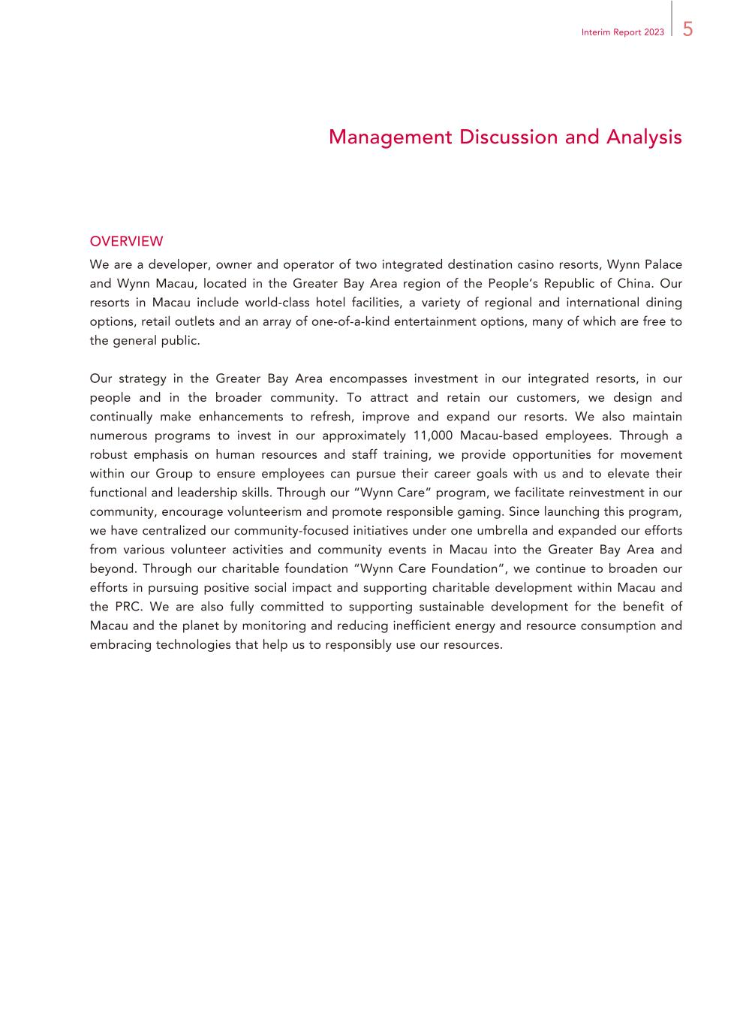
5Interim Report 2023 Management Discussion and Analysis OVERVIEW We are a developer, owner and operator of two integrated destination casino resorts, Wynn Palace and Wynn Macau, located in the Greater Bay Area region of the People’s Republic of China. Our resorts in Macau include world-class hotel facilities, a variety of regional and international dining options, retail outlets and an array of one-of-a-kind entertainment options, many of which are free to the general public. Our strategy in the Greater Bay Area encompasses investment in our integrated resorts, in our people and in the broader community. To attract and retain our customers, we design and continually make enhancements to refresh, improve and expand our resorts. We also maintain numerous programs to invest in our approximately 11,000 Macau-based employees. Through a robust emphasis on human resources and staff training, we provide opportunities for movement within our Group to ensure employees can pursue their career goals with us and to elevate their functional and leadership skills. Through our “Wynn Care” program, we facilitate reinvestment in our community, encourage volunteerism and promote responsible gaming. Since launching this program, we have centralized our community-focused initiatives under one umbrella and expanded our efforts from various volunteer activities and community events in Macau into the Greater Bay Area and beyond. Through our charitable foundation “Wynn Care Foundation”, we continue to broaden our efforts in pursuing positive social impact and supporting charitable development within Macau and the PRC. We are also fully committed to supporting sustainable development for the benefit of Macau and the planet by monitoring and reducing inefficient energy and resource consumption and embracing technologies that help us to responsibly use our resources.

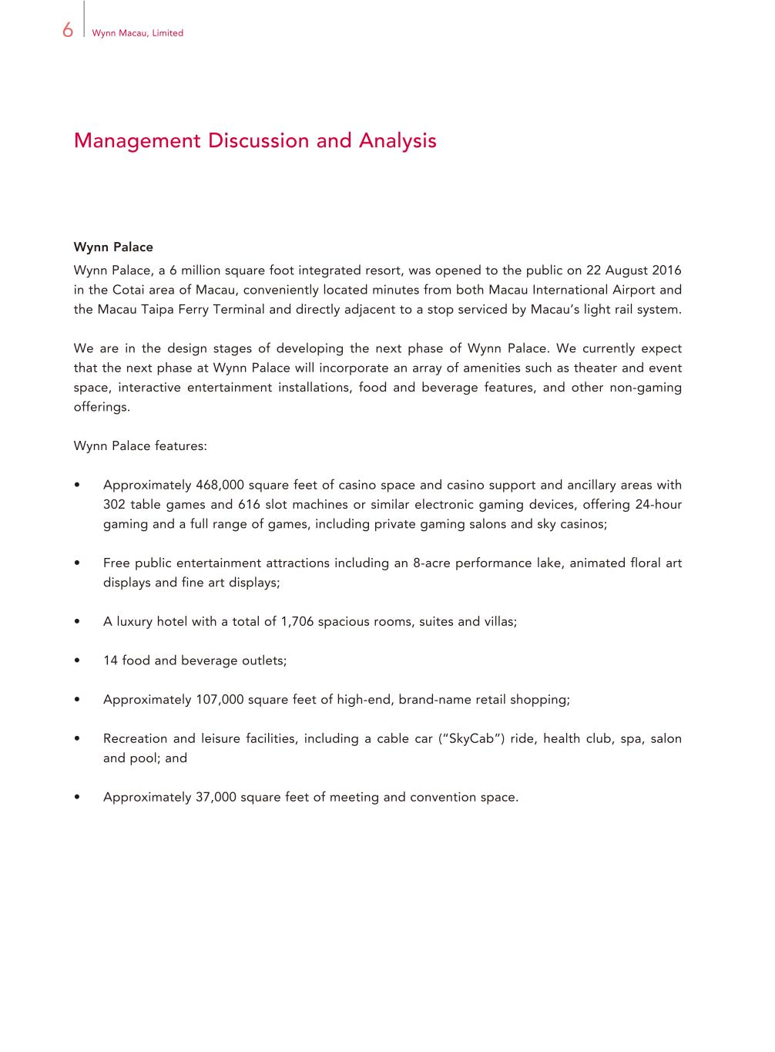
6 Wynn Macau, Limited Management Discussion and Analysis Wynn Palace Wynn Palace, a 6 million square foot integrated resort, was opened to the public on 22 August 2016 in the Cotai area of Macau, conveniently located minutes from both Macau International Airport and the Macau Taipa Ferry Terminal and directly adjacent to a stop serviced by Macau’s light rail system. We are in the design stages of developing the next phase of Wynn Palace. We currently expect that the next phase at Wynn Palace will incorporate an array of amenities such as theater and event space, interactive entertainment installations, food and beverage features, and other non-gaming offerings. Wynn Palace features: • Approximately 468,000 square feet of casino space and casino support and ancillary areas with 302 table games and 616 slot machines or similar electronic gaming devices, offering 24-hour gaming and a full range of games, including private gaming salons and sky casinos; • Free public entertainment attractions including an 8-acre performance lake, animated floral art displays and fine art displays; • A luxury hotel with a total of 1,706 spacious rooms, suites and villas; • 14 food and beverage outlets; • Approximately 107,000 square feet of high-end, brand-name retail shopping; • Recreation and leisure facilities, including a cable car (“SkyCab”) ride, health club, spa, salon and pool; and • Approximately 37,000 square feet of meeting and convention space.

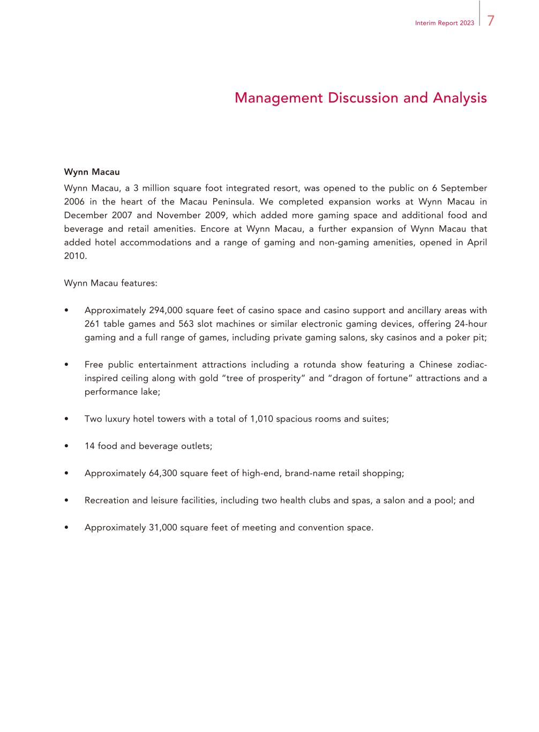
7Interim Report 2023 Management Discussion and Analysis Wynn Macau Wynn Macau, a 3 million square foot integrated resort, was opened to the public on 6 September 2006 in the heart of the Macau Peninsula. We completed expansion works at Wynn Macau in December 2007 and November 2009, which added more gaming space and additional food and beverage and retail amenities. Encore at Wynn Macau, a further expansion of Wynn Macau that added hotel accommodations and a range of gaming and non-gaming amenities, opened in April 2010. Wynn Macau features: • Approximately 294,000 square feet of casino space and casino support and ancillary areas with 261 table games and 563 slot machines or similar electronic gaming devices, offering 24-hour gaming and a full range of games, including private gaming salons, sky casinos and a poker pit; • Free public entertainment attractions including a rotunda show featuring a Chinese zodiac- inspired ceiling along with gold “tree of prosperity” and “dragon of fortune” attractions and a performance lake; • Two luxury hotel towers with a total of 1,010 spacious rooms and suites; • 14 food and beverage outlets; • Approximately 64,300 square feet of high-end, brand-name retail shopping; • Recreation and leisure facilities, including two health clubs and spas, a salon and a pool; and • Approximately 31,000 square feet of meeting and convention space.

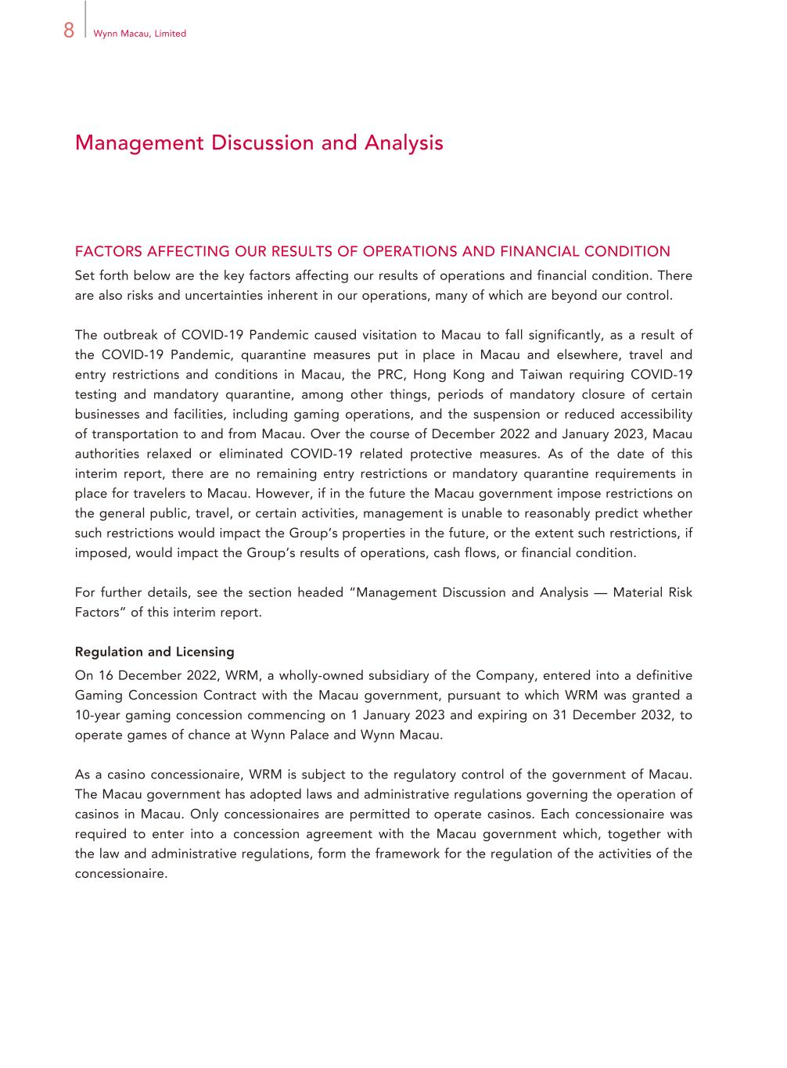
8 Wynn Macau, Limited Management Discussion and Analysis FACTORS AFFECTING OUR RESULTS OF OPERATIONS AND FINANCIAL CONDITION Set forth below are the key factors affecting our results of operations and financial condition. There are also risks and uncertainties inherent in our operations, many of which are beyond our control. The outbreak of COVID-19 Pandemic caused visitation to Macau to fall significantly, as a result of the COVID-19 Pandemic, quarantine measures put in place in Macau and elsewhere, travel and entry restrictions and conditions in Macau, the PRC, Hong Kong and Taiwan requiring COVID-19 testing and mandatory quarantine, among other things, periods of mandatory closure of certain businesses and facilities, including gaming operations, and the suspension or reduced accessibility of transportation to and from Macau. Over the course of December 2022 and January 2023, Macau authorities relaxed or eliminated COVID-19 related protective measures. As of the date of this interim report, there are no remaining entry restrictions or mandatory quarantine requirements in place for travelers to Macau. However, if in the future the Macau government impose restrictions on the general public, travel, or certain activities, management is unable to reasonably predict whether such restrictions would impact the Group’s properties in the future, or the extent such restrictions, if imposed, would impact the Group’s results of operations, cash flows, or financial condition. For further details, see the section headed “Management Discussion and Analysis — Material Risk Factors” of this interim report. Regulation and Licensing On 16 December 2022, WRM, a wholly-owned subsidiary of the Company, entered into a definitive Gaming Concession Contract with the Macau government, pursuant to which WRM was granted a 10-year gaming concession commencing on 1 January 2023 and expiring on 31 December 2032, to operate games of chance at Wynn Palace and Wynn Macau. As a casino concessionaire, WRM is subject to the regulatory control of the government of Macau. The Macau government has adopted laws and administrative regulations governing the operation of casinos in Macau. Only concessionaires are permitted to operate casinos. Each concessionaire was required to enter into a concession agreement with the Macau government which, together with the law and administrative regulations, form the framework for the regulation of the activities of the concessionaire.

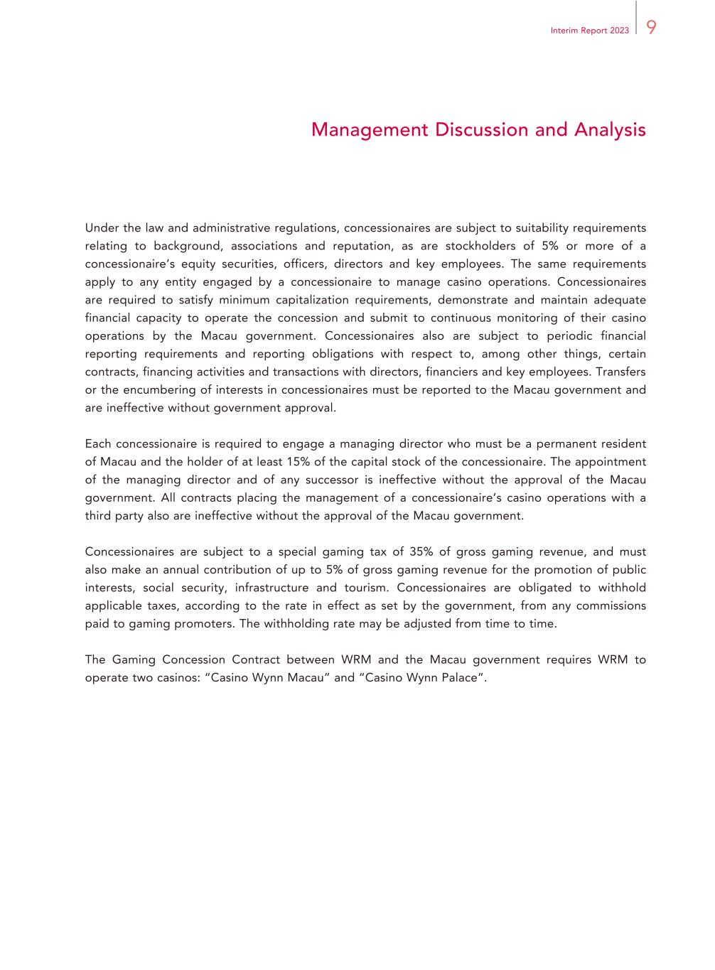
9Interim Report 2023 Management Discussion and Analysis Under the law and administrative regulations, concessionaires are subject to suitability requirements relating to background, associations and reputation, as are stockholders of 5% or more of a concessionaire’s equity securities, officers, directors and key employees. The same requirements apply to any entity engaged by a concessionaire to manage casino operations. Concessionaires are required to satisfy minimum capitalization requirements, demonstrate and maintain adequate financial capacity to operate the concession and submit to continuous monitoring of their casino operations by the Macau government. Concessionaires also are subject to periodic financial reporting requirements and reporting obligations with respect to, among other things, certain contracts, financing activities and transactions with directors, financiers and key employees. Transfers or the encumbering of interests in concessionaires must be reported to the Macau government and are ineffective without government approval. Each concessionaire is required to engage a managing director who must be a permanent resident of Macau and the holder of at least 15% of the capital stock of the concessionaire. The appointment of the managing director and of any successor is ineffective without the approval of the Macau government. All contracts placing the management of a concessionaire’s casino operations with a third party also are ineffective without the approval of the Macau government. Concessionaires are subject to a special gaming tax of 35% of gross gaming revenue, and must also make an annual contribution of up to 5% of gross gaming revenue for the promotion of public interests, social security, infrastructure and tourism. Concessionaires are obligated to withhold applicable taxes, according to the rate in effect as set by the government, from any commissions paid to gaming promoters. The withholding rate may be adjusted from time to time. The Gaming Concession Contract between WRM and the Macau government requires WRM to operate two casinos: “Casino Wynn Macau” and “Casino Wynn Palace”.

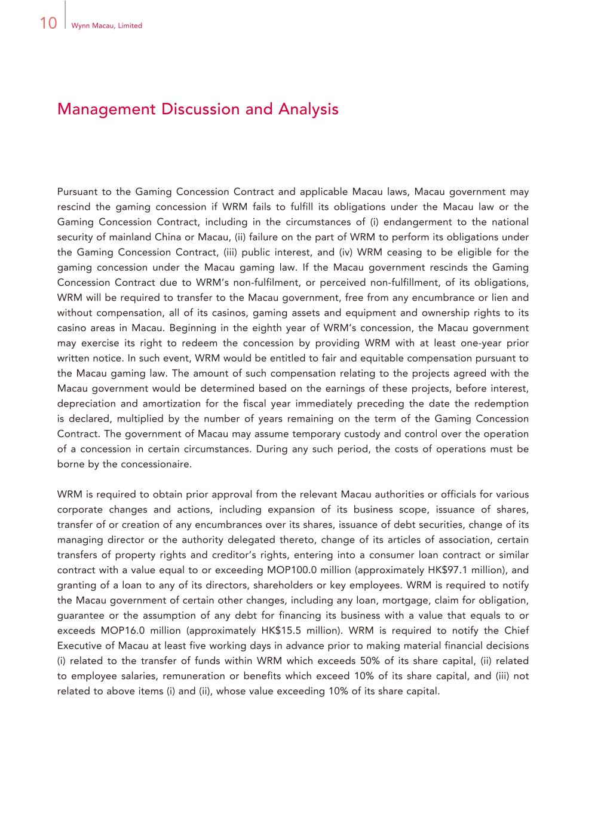
10 Wynn Macau, Limited Management Discussion and Analysis Pursuant to the Gaming Concession Contract and applicable Macau laws, Macau government may rescind the gaming concession if WRM fails to fulfill its obligations under the Macau law or the Gaming Concession Contract, including in the circumstances of (i) endangerment to the national security of mainland China or Macau, (ii) failure on the part of WRM to perform its obligations under the Gaming Concession Contract, (iii) public interest, and (iv) WRM ceasing to be eligible for the gaming concession under the Macau gaming law. If the Macau government rescinds the Gaming Concession Contract due to WRM’s non-fulfilment, or perceived non-fulfillment, of its obligations, WRM will be required to transfer to the Macau government, free from any encumbrance or lien and without compensation, all of its casinos, gaming assets and equipment and ownership rights to its casino areas in Macau. Beginning in the eighth year of WRM’s concession, the Macau government may exercise its right to redeem the concession by providing WRM with at least one-year prior written notice. In such event, WRM would be entitled to fair and equitable compensation pursuant to the Macau gaming law. The amount of such compensation relating to the projects agreed with the Macau government would be determined based on the earnings of these projects, before interest, depreciation and amortization for the fiscal year immediately preceding the date the redemption is declared, multiplied by the number of years remaining on the term of the Gaming Concession Contract. The government of Macau may assume temporary custody and control over the operation of a concession in certain circumstances. During any such period, the costs of operations must be borne by the concessionaire. WRM is required to obtain prior approval from the relevant Macau authorities or officials for various corporate changes and actions, including expansion of its business scope, issuance of shares, transfer of or creation of any encumbrances over its shares, issuance of debt securities, change of its managing director or the authority delegated thereto, change of its articles of association, certain transfers of property rights and creditor’s rights, entering into a consumer loan contract or similar contract with a value equal to or exceeding MOP100.0 million (approximately HK$97.1 million), and granting of a loan to any of its directors, shareholders or key employees. WRM is required to notify the Macau government of certain other changes, including any loan, mortgage, claim for obligation, guarantee or the assumption of any debt for financing its business with a value that equals to or exceeds MOP16.0 million (approximately HK$15.5 million). WRM is required to notify the Chief Executive of Macau at least five working days in advance prior to making material financial decisions (i) related to the transfer of funds within WRM which exceeds 50% of its share capital, (ii) related to employee salaries, remuneration or benefits which exceed 10% of its share capital, and (iii) not related to above items (i) and (ii), whose value exceeding 10% of its share capital.

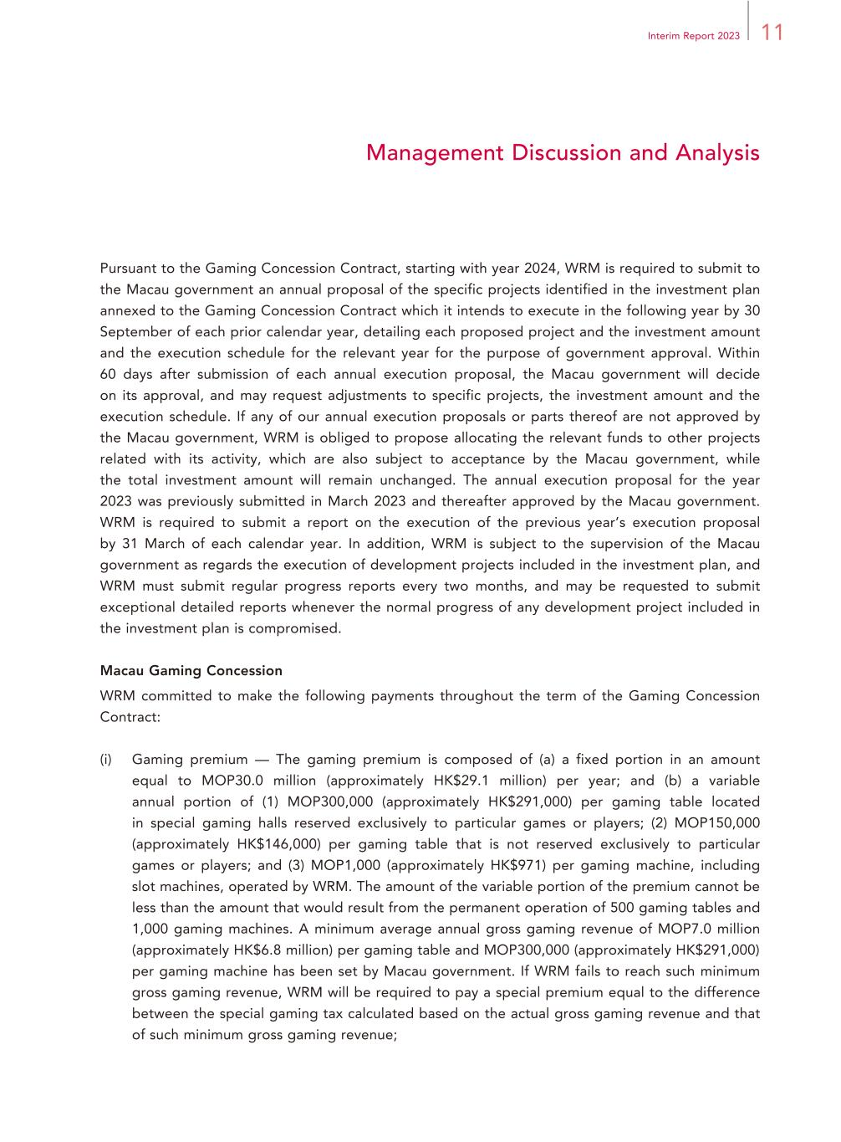
11Interim Report 2023 Management Discussion and Analysis Pursuant to the Gaming Concession Contract, starting with year 2024, WRM is required to submit to the Macau government an annual proposal of the specific projects identified in the investment plan annexed to the Gaming Concession Contract which it intends to execute in the following year by 30 September of each prior calendar year, detailing each proposed project and the investment amount and the execution schedule for the relevant year for the purpose of government approval. Within 60 days after submission of each annual execution proposal, the Macau government will decide on its approval, and may request adjustments to specific projects, the investment amount and the execution schedule. If any of our annual execution proposals or parts thereof are not approved by the Macau government, WRM is obliged to propose allocating the relevant funds to other projects related with its activity, which are also subject to acceptance by the Macau government, while the total investment amount will remain unchanged. The annual execution proposal for the year 2023 was previously submitted in March 2023 and thereafter approved by the Macau government. WRM is required to submit a report on the execution of the previous year’s execution proposal by 31 March of each calendar year. In addition, WRM is subject to the supervision of the Macau government as regards the execution of development projects included in the investment plan, and WRM must submit regular progress reports every two months, and may be requested to submit exceptional detailed reports whenever the normal progress of any development project included in the investment plan is compromised. Macau Gaming Concession WRM committed to make the following payments throughout the term of the Gaming Concession Contract: (i) Gaming premium — The gaming premium is composed of (a) a fixed portion in an amount equal to MOP30.0 million (approximately HK$29.1 million) per year; and (b) a variable annual portion of (1) MOP300,000 (approximately HK$291,000) per gaming table located in special gaming halls reserved exclusively to particular games or players; (2) MOP150,000 (approximately HK$146,000) per gaming table that is not reserved exclusively to particular games or players; and (3) MOP1,000 (approximately HK$971) per gaming machine, including slot machines, operated by WRM. The amount of the variable portion of the premium cannot be less than the amount that would result from the permanent operation of 500 gaming tables and 1,000 gaming machines. A minimum average annual gross gaming revenue of MOP7.0 million (approximately HK$6.8 million) per gaming table and MOP300,000 (approximately HK$291,000) per gaming machine has been set by Macau government. If WRM fails to reach such minimum gross gaming revenue, WRM will be required to pay a special premium equal to the difference between the special gaming tax calculated based on the actual gross gaming revenue and that of such minimum gross gaming revenue;

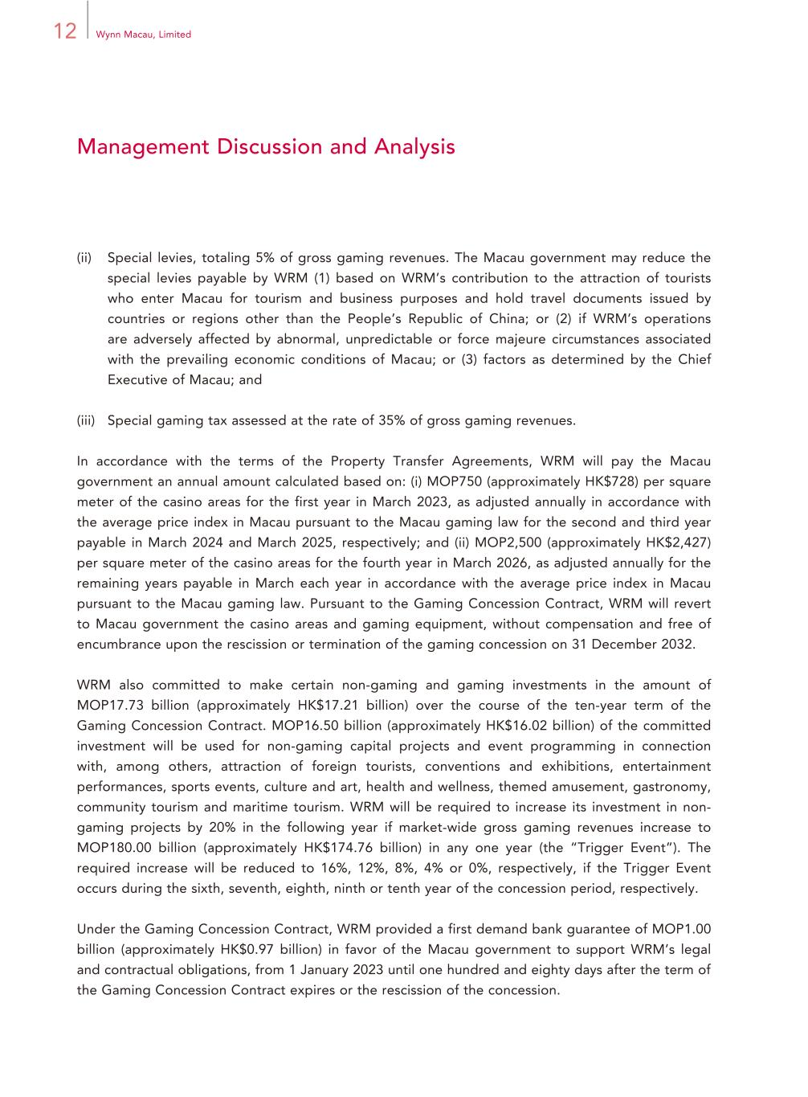
12 Wynn Macau, Limited Management Discussion and Analysis (ii) Special levies, totaling 5% of gross gaming revenues. The Macau government may reduce the special levies payable by WRM (1) based on WRM’s contribution to the attraction of tourists who enter Macau for tourism and business purposes and hold travel documents issued by countries or regions other than the People’s Republic of China; or (2) if WRM’s operations are adversely affected by abnormal, unpredictable or force majeure circumstances associated with the prevailing economic conditions of Macau; or (3) factors as determined by the Chief Executive of Macau; and (iii) Special gaming tax assessed at the rate of 35% of gross gaming revenues. In accordance with the terms of the Property Transfer Agreements, WRM will pay the Macau government an annual amount calculated based on: (i) MOP750 (approximately HK$728) per square meter of the casino areas for the first year in March 2023, as adjusted annually in accordance with the average price index in Macau pursuant to the Macau gaming law for the second and third year payable in March 2024 and March 2025, respectively; and (ii) MOP2,500 (approximately HK$2,427) per square meter of the casino areas for the fourth year in March 2026, as adjusted annually for the remaining years payable in March each year in accordance with the average price index in Macau pursuant to the Macau gaming law. Pursuant to the Gaming Concession Contract, WRM will revert to Macau government the casino areas and gaming equipment, without compensation and free of encumbrance upon the rescission or termination of the gaming concession on 31 December 2032. WRM also committed to make certain non-gaming and gaming investments in the amount of MOP17.73 billion (approximately HK$17.21 billion) over the course of the ten-year term of the Gaming Concession Contract. MOP16.50 billion (approximately HK$16.02 billion) of the committed investment will be used for non-gaming capital projects and event programming in connection with, among others, attraction of foreign tourists, conventions and exhibitions, entertainment performances, sports events, culture and art, health and wellness, themed amusement, gastronomy, community tourism and maritime tourism. WRM will be required to increase its investment in non- gaming projects by 20% in the following year if market-wide gross gaming revenues increase to MOP180.00 billion (approximately HK$174.76 billion) in any one year (the “Trigger Event”). The required increase will be reduced to 16%, 12%, 8%, 4% or 0%, respectively, if the Trigger Event occurs during the sixth, seventh, eighth, ninth or tenth year of the concession period, respectively. Under the Gaming Concession Contract, WRM provided a first demand bank guarantee of MOP1.00 billion (approximately HK$0.97 billion) in favor of the Macau government to support WRM’s legal and contractual obligations, from 1 January 2023 until one hundred and eighty days after the term of the Gaming Concession Contract expires or the rescission of the concession.

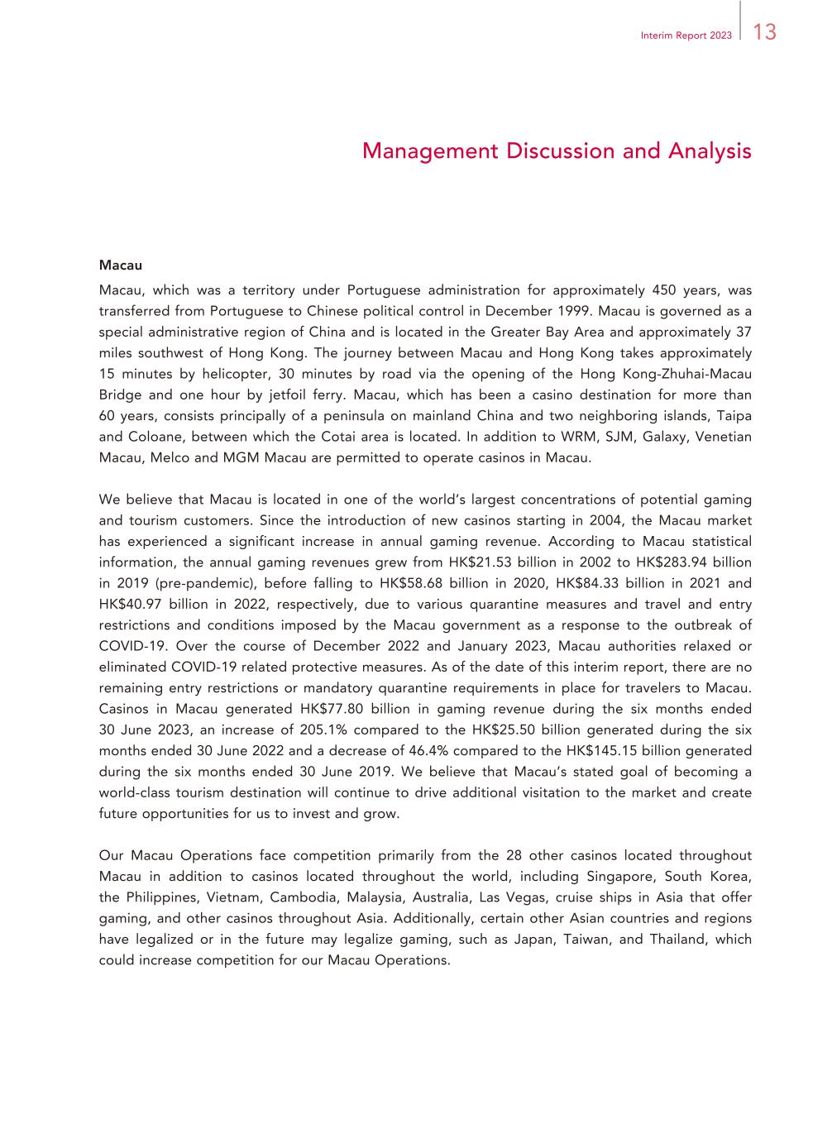
13Interim Report 2023 Management Discussion and Analysis Macau Macau, which was a territory under Portuguese administration for approximately 450 years, was transferred from Portuguese to Chinese political control in December 1999. Macau is governed as a special administrative region of China and is located in the Greater Bay Area and approximately 37 miles southwest of Hong Kong. The journey between Macau and Hong Kong takes approximately 15 minutes by helicopter, 30 minutes by road via the opening of the Hong Kong-Zhuhai-Macau Bridge and one hour by jetfoil ferry. Macau, which has been a casino destination for more than 60 years, consists principally of a peninsula on mainland China and two neighboring islands, Taipa and Coloane, between which the Cotai area is located. In addition to WRM, SJM, Galaxy, Venetian Macau, Melco and MGM Macau are permitted to operate casinos in Macau. We believe that Macau is located in one of the world’s largest concentrations of potential gaming and tourism customers. Since the introduction of new casinos starting in 2004, the Macau market has experienced a significant increase in annual gaming revenue. According to Macau statistical information, the annual gaming revenues grew from HK$21.53 billion in 2002 to HK$283.94 billion in 2019 (pre-pandemic), before falling to HK$58.68 billion in 2020, HK$84.33 billion in 2021 and HK$40.97 billion in 2022, respectively, due to various quarantine measures and travel and entry restrictions and conditions imposed by the Macau government as a response to the outbreak of COVID-19. Over the course of December 2022 and January 2023, Macau authorities relaxed or eliminated COVID-19 related protective measures. As of the date of this interim report, there are no remaining entry restrictions or mandatory quarantine requirements in place for travelers to Macau. Casinos in Macau generated HK$77.80 billion in gaming revenue during the six months ended 30 June 2023, an increase of 205.1% compared to the HK$25.50 billion generated during the six months ended 30 June 2022 and a decrease of 46.4% compared to the HK$145.15 billion generated during the six months ended 30 June 2019. We believe that Macau’s stated goal of becoming a world-class tourism destination will continue to drive additional visitation to the market and create future opportunities for us to invest and grow. Our Macau Operations face competition primarily from the 28 other casinos located throughout Macau in addition to casinos located throughout the world, including Singapore, South Korea, the Philippines, Vietnam, Cambodia, Malaysia, Australia, Las Vegas, cruise ships in Asia that offer gaming, and other casinos throughout Asia. Additionally, certain other Asian countries and regions have legalized or in the future may legalize gaming, such as Japan, Taiwan, and Thailand, which could increase competition for our Macau Operations.

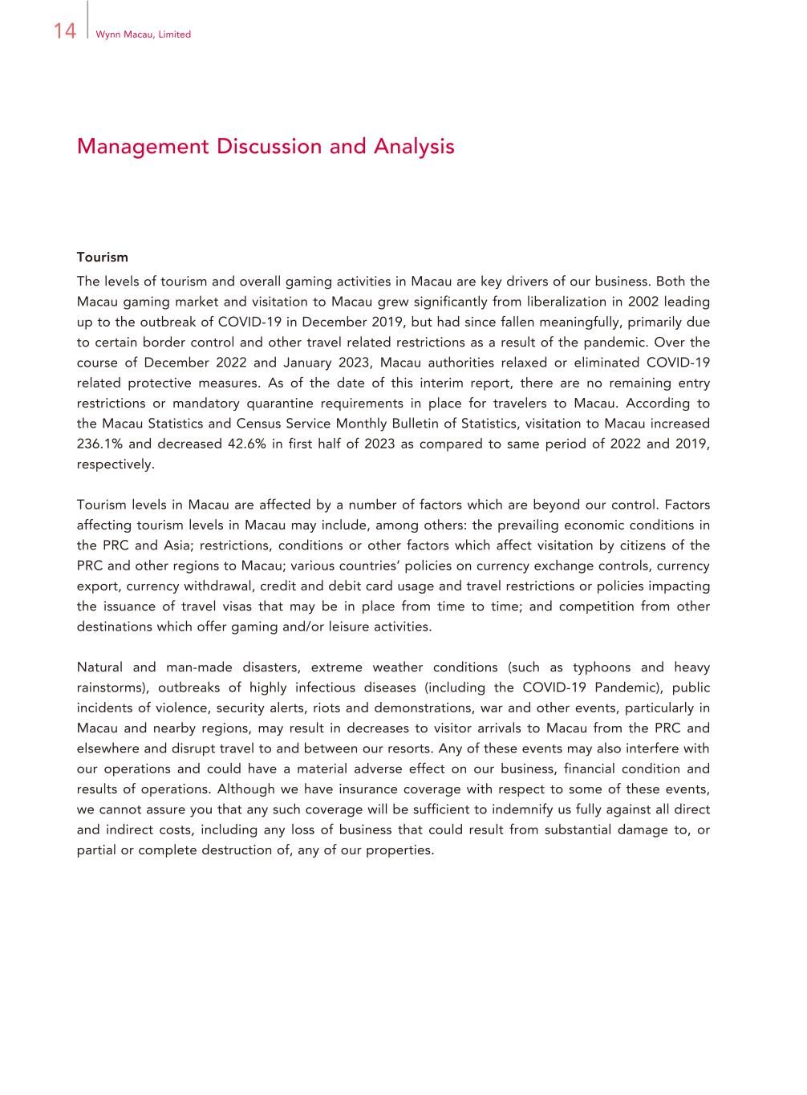
14 Wynn Macau, Limited Management Discussion and Analysis Tourism The levels of tourism and overall gaming activities in Macau are key drivers of our business. Both the Macau gaming market and visitation to Macau grew significantly from liberalization in 2002 leading up to the outbreak of COVID-19 in December 2019, but had since fallen meaningfully, primarily due to certain border control and other travel related restrictions as a result of the pandemic. Over the course of December 2022 and January 2023, Macau authorities relaxed or eliminated COVID-19 related protective measures. As of the date of this interim report, there are no remaining entry restrictions or mandatory quarantine requirements in place for travelers to Macau. According to the Macau Statistics and Census Service Monthly Bulletin of Statistics, visitation to Macau increased 236.1% and decreased 42.6% in first half of 2023 as compared to same period of 2022 and 2019, respectively. Tourism levels in Macau are affected by a number of factors which are beyond our control. Factors affecting tourism levels in Macau may include, among others: the prevailing economic conditions in the PRC and Asia; restrictions, conditions or other factors which affect visitation by citizens of the PRC and other regions to Macau; various countries’ policies on currency exchange controls, currency export, currency withdrawal, credit and debit card usage and travel restrictions or policies impacting the issuance of travel visas that may be in place from time to time; and competition from other destinations which offer gaming and/or leisure activities. Natural and man-made disasters, extreme weather conditions (such as typhoons and heavy rainstorms), outbreaks of highly infectious diseases (including the COVID-19 Pandemic), public incidents of violence, security alerts, riots and demonstrations, war and other events, particularly in Macau and nearby regions, may result in decreases to visitor arrivals to Macau from the PRC and elsewhere and disrupt travel to and between our resorts. Any of these events may also interfere with our operations and could have a material adverse effect on our business, financial condition and results of operations. Although we have insurance coverage with respect to some of these events, we cannot assure you that any such coverage will be sufficient to indemnify us fully against all direct and indirect costs, including any loss of business that could result from substantial damage to, or partial or complete destruction of, any of our properties.

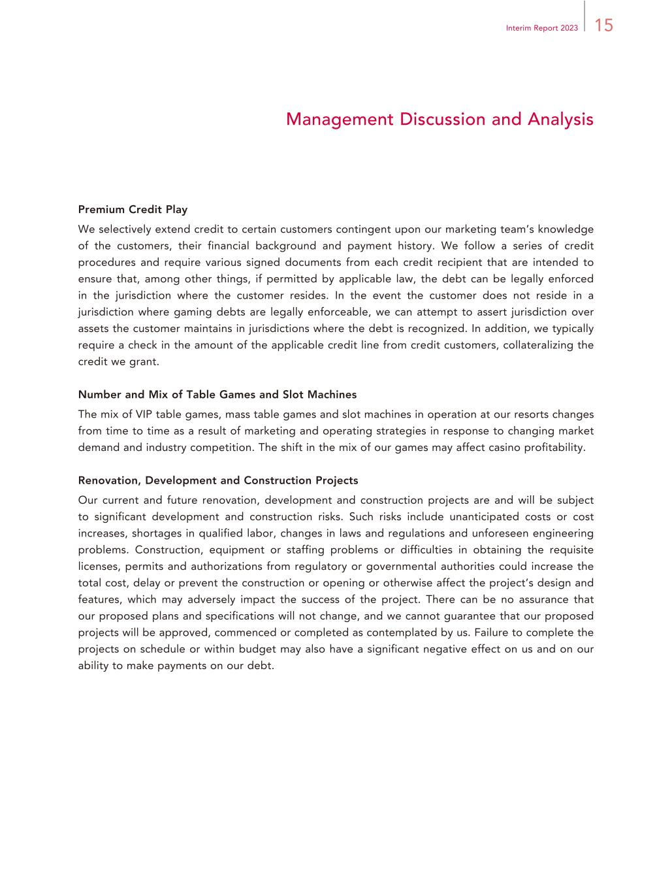
15Interim Report 2023 Management Discussion and Analysis Premium Credit Play We selectively extend credit to certain customers contingent upon our marketing team’s knowledge of the customers, their financial background and payment history. We follow a series of credit procedures and require various signed documents from each credit recipient that are intended to ensure that, among other things, if permitted by applicable law, the debt can be legally enforced in the jurisdiction where the customer resides. In the event the customer does not reside in a jurisdiction where gaming debts are legally enforceable, we can attempt to assert jurisdiction over assets the customer maintains in jurisdictions where the debt is recognized. In addition, we typically require a check in the amount of the applicable credit line from credit customers, collateralizing the credit we grant. Number and Mix of Table Games and Slot Machines The mix of VIP table games, mass table games and slot machines in operation at our resorts changes from time to time as a result of marketing and operating strategies in response to changing market demand and industry competition. The shift in the mix of our games may affect casino profitability. Renovation, Development and Construction Projects Our current and future renovation, development and construction projects are and will be subject to significant development and construction risks. Such risks include unanticipated costs or cost increases, shortages in qualified labor, changes in laws and regulations and unforeseen engineering problems. Construction, equipment or staffing problems or difficulties in obtaining the requisite licenses, permits and authorizations from regulatory or governmental authorities could increase the total cost, delay or prevent the construction or opening or otherwise affect the project’s design and features, which may adversely impact the success of the project. There can be no assurance that our proposed plans and specifications will not change, and we cannot guarantee that our proposed projects will be approved, commenced or completed as contemplated by us. Failure to complete the projects on schedule or within budget may also have a significant negative effect on us and on our ability to make payments on our debt.

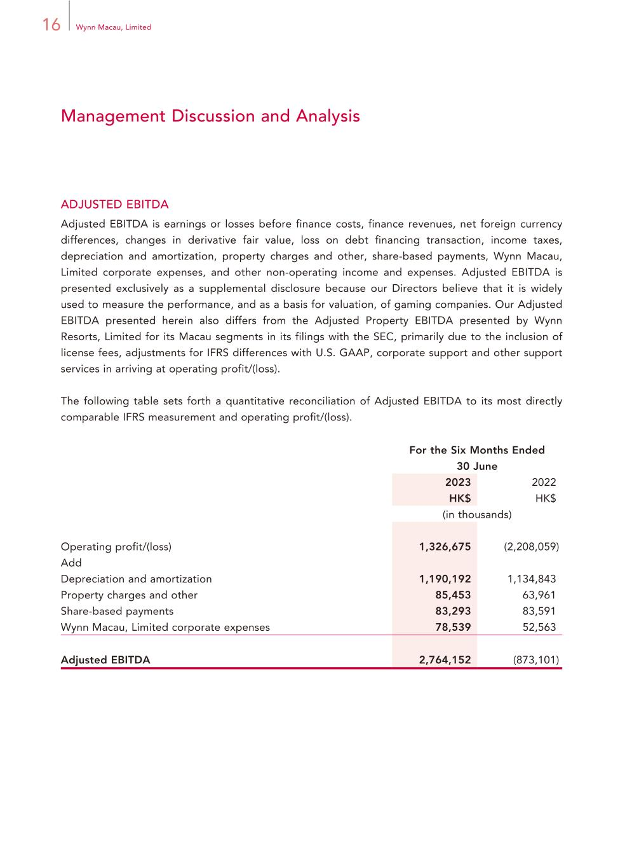
16 Wynn Macau, Limited Management Discussion and Analysis ADJUSTED EBITDA Adjusted EBITDA is earnings or losses before finance costs, finance revenues, net foreign currency differences, changes in derivative fair value, loss on debt financing transaction, income taxes, depreciation and amortization, property charges and other, share-based payments, Wynn Macau, Limited corporate expenses, and other non-operating income and expenses. Adjusted EBITDA is presented exclusively as a supplemental disclosure because our Directors believe that it is widely used to measure the performance, and as a basis for valuation, of gaming companies. Our Adjusted EBITDA presented herein also differs from the Adjusted Property EBITDA presented by Wynn Resorts, Limited for its Macau segments in its filings with the SEC, primarily due to the inclusion of license fees, adjustments for IFRS differences with U.S. GAAP, corporate support and other support services in arriving at operating profit/(loss). The following table sets forth a quantitative reconciliation of Adjusted EBITDA to its most directly comparable IFRS measurement and operating profit/(loss). For the Six Months Ended 30 June 2023 2022 HK$ HK$ (in thousands) Operating profit/(loss) 1,326,675 (2,208,059) Add Depreciation and amortization 1,190,192 1,134,843 Property charges and other 85,453 63,961 Share-based payments 83,293 83,591 Wynn Macau, Limited corporate expenses 78,539 52,563 Adjusted EBITDA 2,764,152 (873,101)

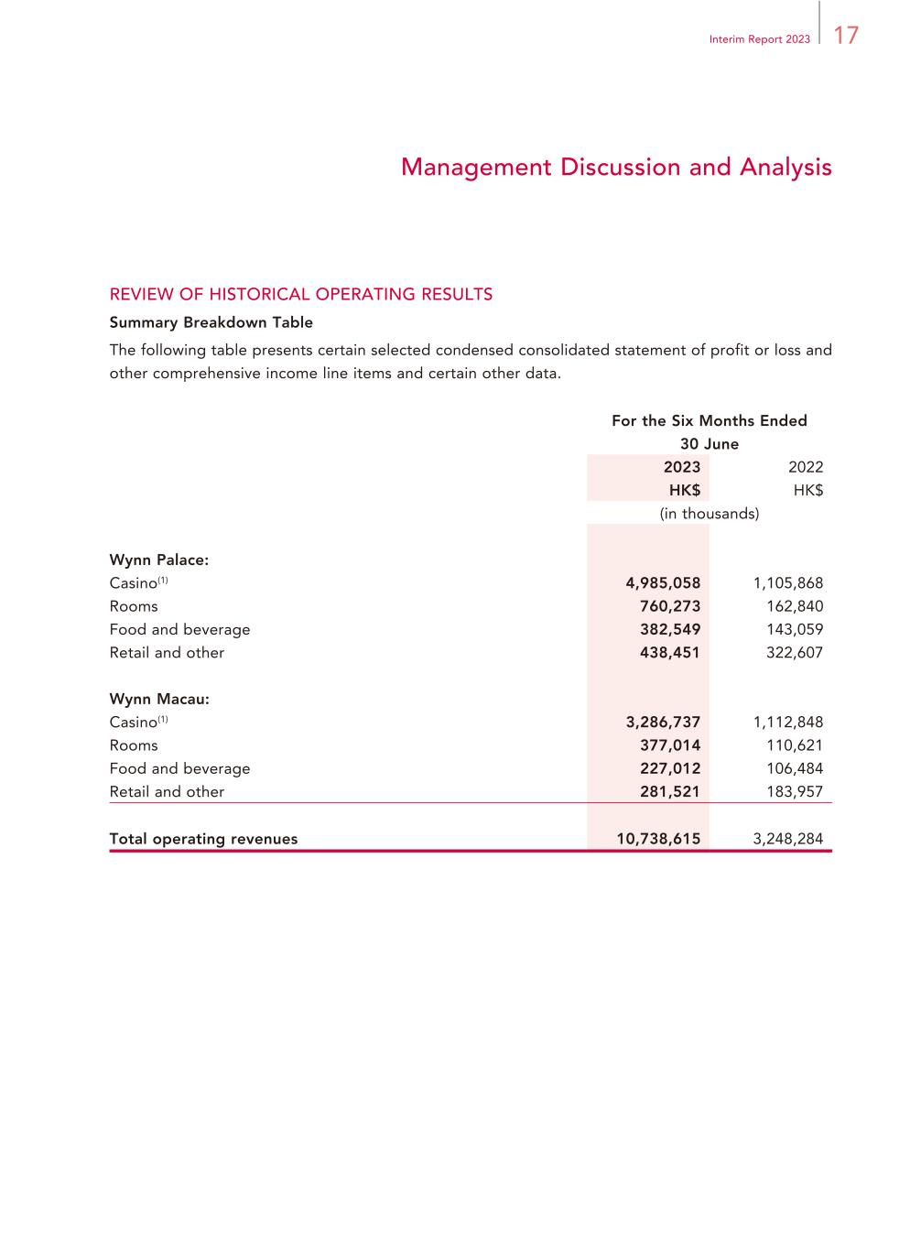
17Interim Report 2023 Management Discussion and Analysis REVIEW OF HISTORICAL OPERATING RESULTS Summary Breakdown Table The following table presents certain selected condensed consolidated statement of profit or loss and other comprehensive income line items and certain other data. For the Six Months Ended 30 June 2023 2022 HK$ HK$ (in thousands) Wynn Palace: Casino(1) 4,985,058 1,105,868 Rooms 760,273 162,840 Food and beverage 382,549 143,059 Retail and other 438,451 322,607 Wynn Macau: Casino(1) 3,286,737 1,112,848 Rooms 377,014 110,621 Food and beverage 227,012 106,484 Retail and other 281,521 183,957 Total operating revenues 10,738,615 3,248,284

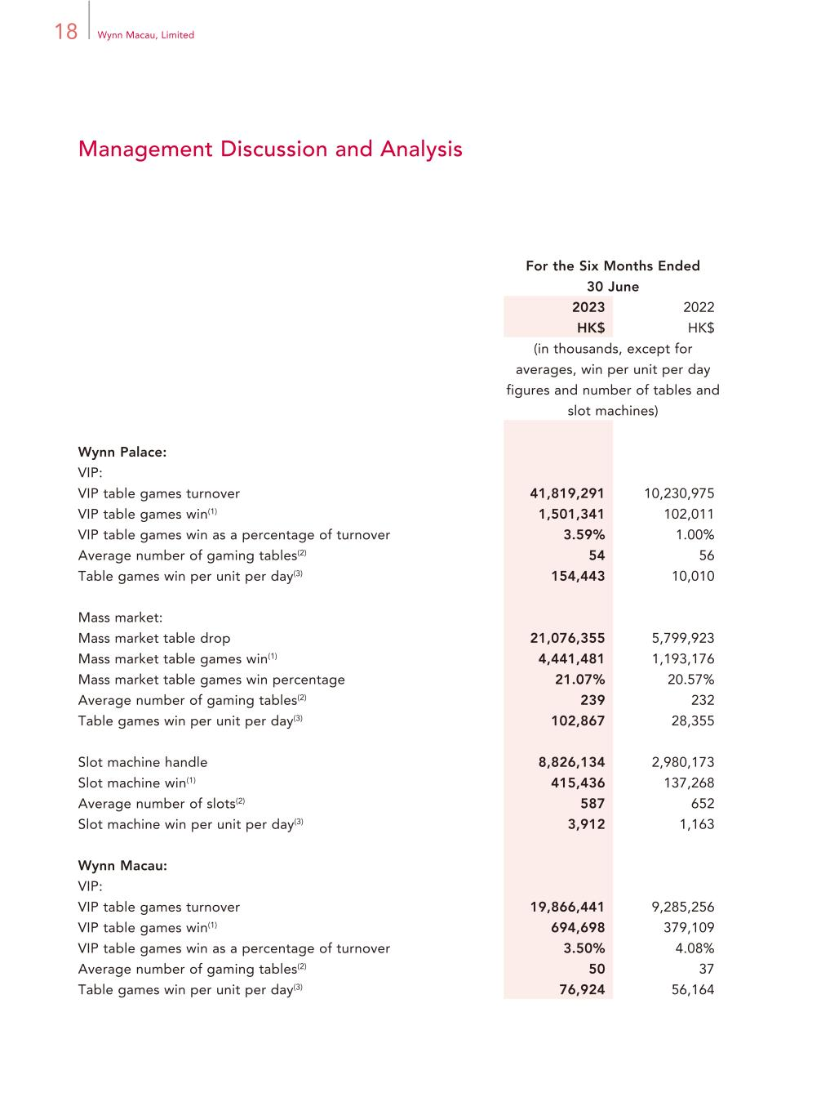
18 Wynn Macau, Limited Management Discussion and Analysis For the Six Months Ended 30 June 2023 2022 HK$ HK$ (in thousands, except for averages, win per unit per day figures and number of tables and slot machines) Wynn Palace: VIP: VIP table games turnover 41,819,291 10,230,975 VIP table games win(1) 1,501,341 102,011 VIP table games win as a percentage of turnover 3.59% 1.00% Average number of gaming tables(2) 54 56 Table games win per unit per day(3) 154,443 10,010 Mass market: Mass market table drop 21,076,355 5,799,923 Mass market table games win(1) 4,441,481 1,193,176 Mass market table games win percentage 21.07% 20.57% Average number of gaming tables(2) 239 232 Table games win per unit per day(3) 102,867 28,355 Slot machine handle 8,826,134 2,980,173 Slot machine win(1) 415,436 137,268 Average number of slots(2) 587 652 Slot machine win per unit per day(3) 3,912 1,163 Wynn Macau: VIP: VIP table games turnover 19,866,441 9,285,256 VIP table games win(1) 694,698 379,109 VIP table games win as a percentage of turnover 3.50% 4.08% Average number of gaming tables(2) 50 37 Table games win per unit per day(3) 76,924 56,164

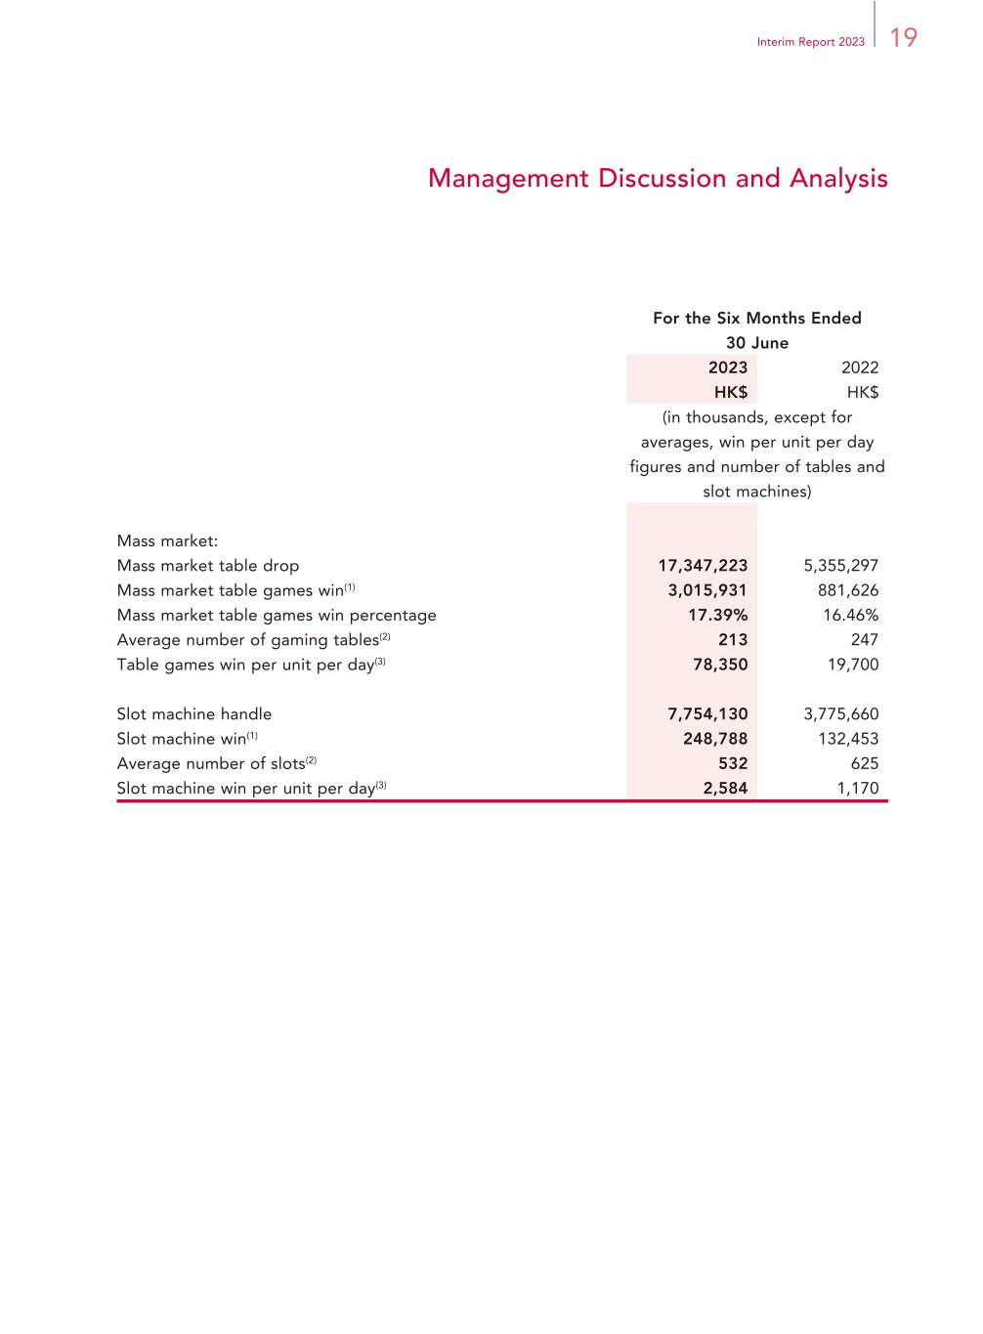
19Interim Report 2023 Management Discussion and Analysis For the Six Months Ended 30 June 2023 2022 HK$ HK$ (in thousands, except for averages, win per unit per day figures and number of tables and slot machines) Mass market: Mass market table drop 17,347,223 5,355,297 Mass market table games win(1) 3,015,931 881,626 Mass market table games win percentage 17.39% 16.46% Average number of gaming tables(2) 213 247 Table games win per unit per day(3) 78,350 19,700 Slot machine handle 7,754,130 3,775,660 Slot machine win(1) 248,788 132,453 Average number of slots(2) 532 625 Slot machine win per unit per day(3) 2,584 1,170

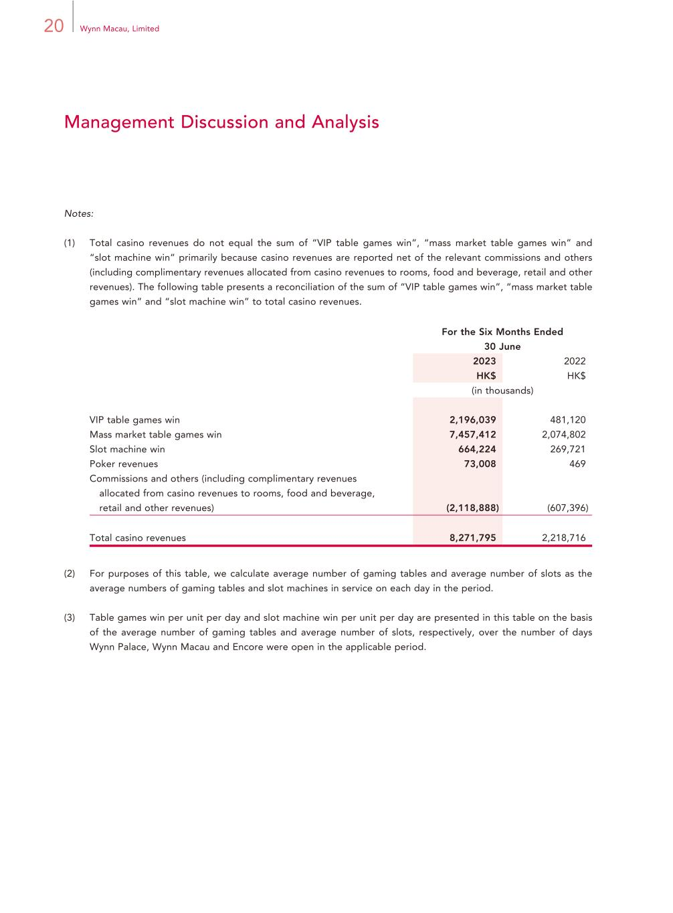
20 Wynn Macau, Limited Management Discussion and Analysis Notes: (1) Total casino revenues do not equal the sum of “VIP table games win”, “mass market table games win” and “slot machine win” primarily because casino revenues are reported net of the relevant commissions and others (including complimentary revenues allocated from casino revenues to rooms, food and beverage, retail and other revenues). The following table presents a reconciliation of the sum of “VIP table games win”, “mass market table games win” and “slot machine win” to total casino revenues. For the Six Months Ended 30 June 2023 2022 HK$ HK$ (in thousands) VIP table games win 2,196,039 481,120 Mass market table games win 7,457,412 2,074,802 Slot machine win 664,224 269,721 Poker revenues 73,008 469 Commissions and others (including complimentary revenues allocated from casino revenues to rooms, food and beverage, retail and other revenues) (2,118,888) (607,396) Total casino revenues 8,271,795 2,218,716 (2) For purposes of this table, we calculate average number of gaming tables and average number of slots as the average numbers of gaming tables and slot machines in service on each day in the period. (3) Table games win per unit per day and slot machine win per unit per day are presented in this table on the basis of the average number of gaming tables and average number of slots, respectively, over the number of days Wynn Palace, Wynn Macau and Encore were open in the applicable period.

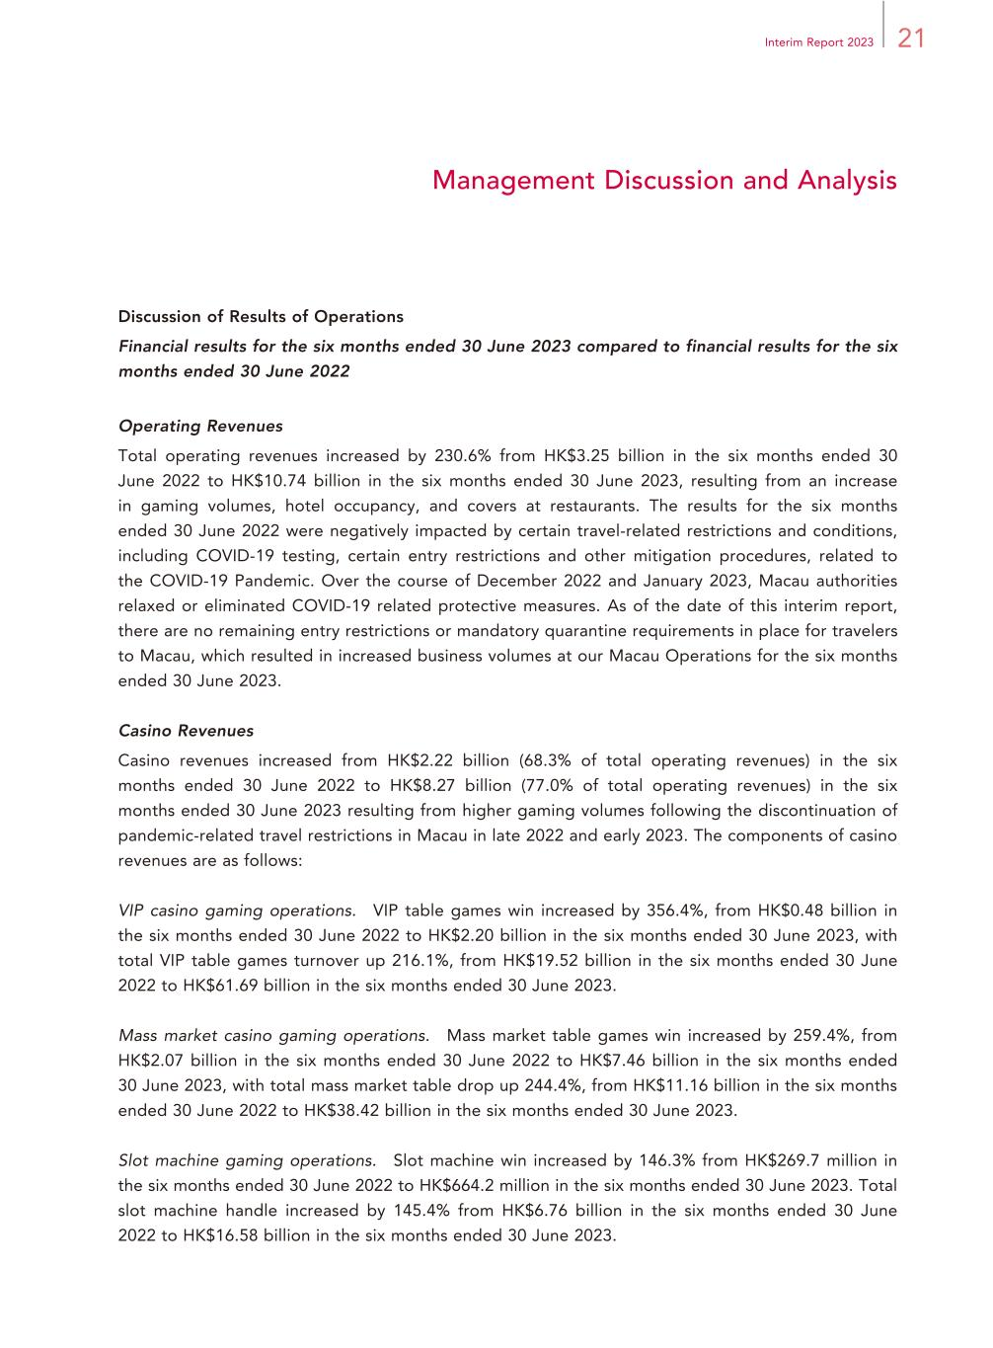
21Interim Report 2023 Management Discussion and Analysis Discussion of Results of Operations Financial results for the six months ended 30 June 2023 compared to financial results for the six months ended 30 June 2022 Operating Revenues Total operating revenues increased by 230.6% from HK$3.25 billion in the six months ended 30 June 2022 to HK$10.74 billion in the six months ended 30 June 2023, resulting from an increase in gaming volumes, hotel occupancy, and covers at restaurants. The results for the six months ended 30 June 2022 were negatively impacted by certain travel-related restrictions and conditions, including COVID-19 testing, certain entry restrictions and other mitigation procedures, related to the COVID-19 Pandemic. Over the course of December 2022 and January 2023, Macau authorities relaxed or eliminated COVID-19 related protective measures. As of the date of this interim report, there are no remaining entry restrictions or mandatory quarantine requirements in place for travelers to Macau, which resulted in increased business volumes at our Macau Operations for the six months ended 30 June 2023. Casino Revenues Casino revenues increased from HK$2.22 billion (68.3% of total operating revenues) in the six months ended 30 June 2022 to HK$8.27 billion (77.0% of total operating revenues) in the six months ended 30 June 2023 resulting from higher gaming volumes following the discontinuation of pandemic-related travel restrictions in Macau in late 2022 and early 2023. The components of casino revenues are as follows: VIP casino gaming operations. VIP table games win increased by 356.4%, from HK$0.48 billion in the six months ended 30 June 2022 to HK$2.20 billion in the six months ended 30 June 2023, with total VIP table games turnover up 216.1%, from HK$19.52 billion in the six months ended 30 June 2022 to HK$61.69 billion in the six months ended 30 June 2023. Mass market casino gaming operations. Mass market table games win increased by 259.4%, from HK$2.07 billion in the six months ended 30 June 2022 to HK$7.46 billion in the six months ended 30 June 2023, with total mass market table drop up 244.4%, from HK$11.16 billion in the six months ended 30 June 2022 to HK$38.42 billion in the six months ended 30 June 2023. Slot machine gaming operations. Slot machine win increased by 146.3% from HK$269.7 million in the six months ended 30 June 2022 to HK$664.2 million in the six months ended 30 June 2023. Total slot machine handle increased by 145.4% from HK$6.76 billion in the six months ended 30 June 2022 to HK$16.58 billion in the six months ended 30 June 2023.

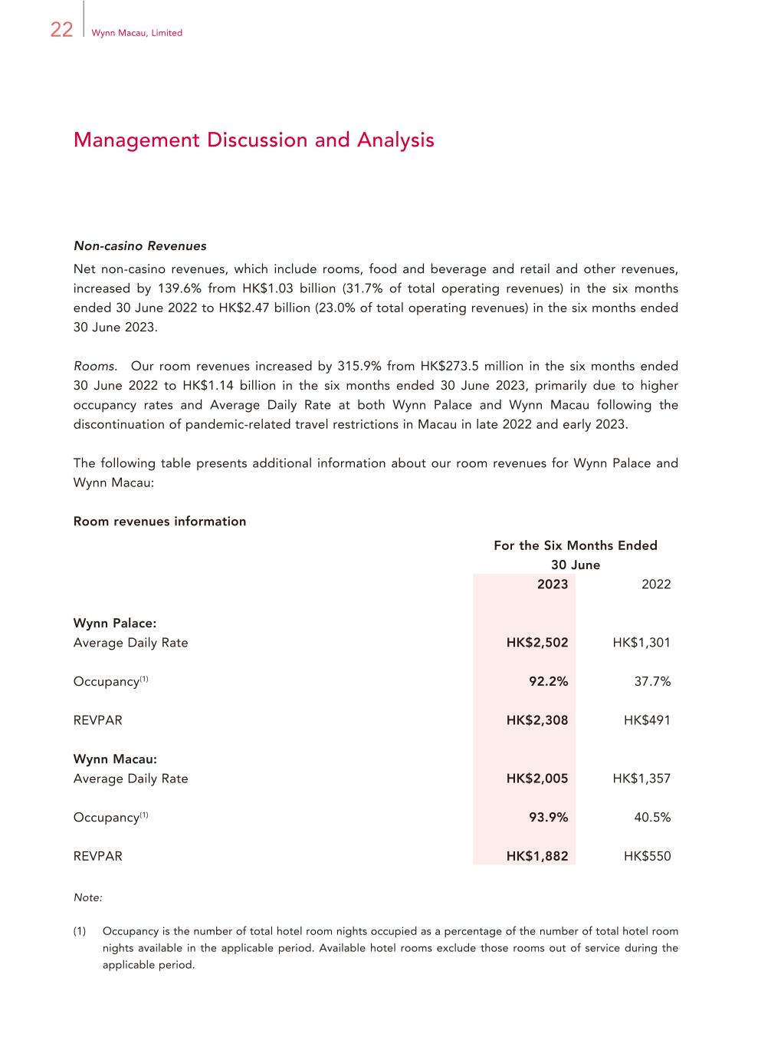
22 Wynn Macau, Limited Management Discussion and Analysis Non-casino Revenues Net non-casino revenues, which include rooms, food and beverage and retail and other revenues, increased by 139.6% from HK$1.03 billion (31.7% of total operating revenues) in the six months ended 30 June 2022 to HK$2.47 billion (23.0% of total operating revenues) in the six months ended 30 June 2023. Rooms. Our room revenues increased by 315.9% from HK$273.5 million in the six months ended 30 June 2022 to HK$1.14 billion in the six months ended 30 June 2023, primarily due to higher occupancy rates and Average Daily Rate at both Wynn Palace and Wynn Macau following the discontinuation of pandemic-related travel restrictions in Macau in late 2022 and early 2023. The following table presents additional information about our room revenues for Wynn Palace and Wynn Macau: Room revenues information For the Six Months Ended 30 June 2023 2022 Wynn Palace: Average Daily Rate HK$2,502 HK$1,301 Occupancy(1) 92.2% 37.7% REVPAR HK$2,308 HK$491 Wynn Macau: Average Daily Rate HK$2,005 HK$1,357 Occupancy(1) 93.9% 40.5% REVPAR HK$1,882 HK$550 Note: (1) Occupancy is the number of total hotel room nights occupied as a percentage of the number of total hotel room nights available in the applicable period. Available hotel rooms exclude those rooms out of service during the applicable period.

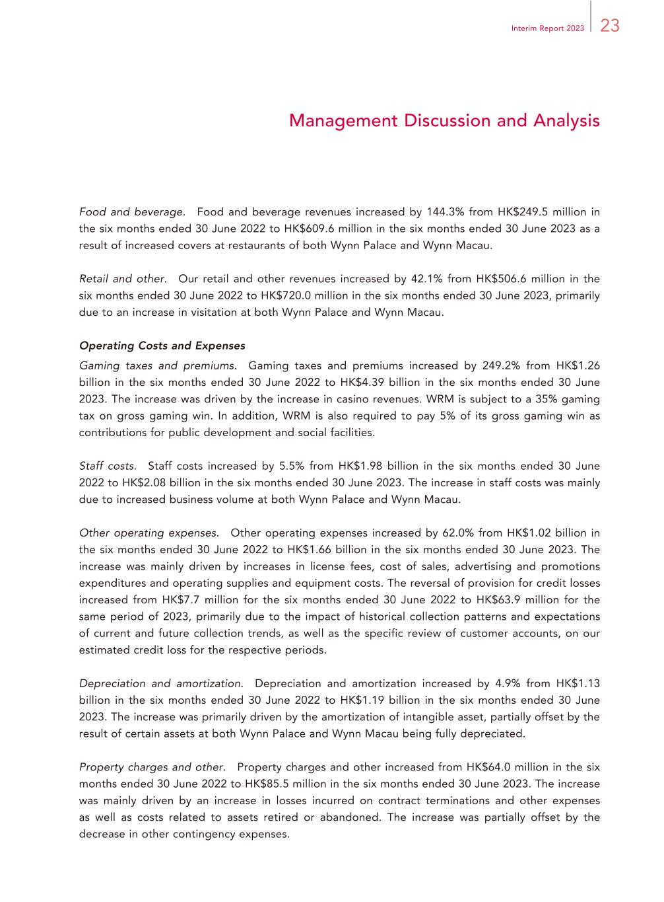
23Interim Report 2023 Management Discussion and Analysis Food and beverage. Food and beverage revenues increased by 144.3% from HK$249.5 million in the six months ended 30 June 2022 to HK$609.6 million in the six months ended 30 June 2023 as a result of increased covers at restaurants of both Wynn Palace and Wynn Macau. Retail and other. Our retail and other revenues increased by 42.1% from HK$506.6 million in the six months ended 30 June 2022 to HK$720.0 million in the six months ended 30 June 2023, primarily due to an increase in visitation at both Wynn Palace and Wynn Macau. Operating Costs and Expenses Gaming taxes and premiums. Gaming taxes and premiums increased by 249.2% from HK$1.26 billion in the six months ended 30 June 2022 to HK$4.39 billion in the six months ended 30 June 2023. The increase was driven by the increase in casino revenues. WRM is subject to a 35% gaming tax on gross gaming win. In addition, WRM is also required to pay 5% of its gross gaming win as contributions for public development and social facilities. Staff costs. Staff costs increased by 5.5% from HK$1.98 billion in the six months ended 30 June 2022 to HK$2.08 billion in the six months ended 30 June 2023. The increase in staff costs was mainly due to increased business volume at both Wynn Palace and Wynn Macau. Other operating expenses. Other operating expenses increased by 62.0% from HK$1.02 billion in the six months ended 30 June 2022 to HK$1.66 billion in the six months ended 30 June 2023. The increase was mainly driven by increases in license fees, cost of sales, advertising and promotions expenditures and operating supplies and equipment costs. The reversal of provision for credit losses increased from HK$7.7 million for the six months ended 30 June 2022 to HK$63.9 million for the same period of 2023, primarily due to the impact of historical collection patterns and expectations of current and future collection trends, as well as the specific review of customer accounts, on our estimated credit loss for the respective periods. Depreciation and amortization. Depreciation and amortization increased by 4.9% from HK$1.13 billion in the six months ended 30 June 2022 to HK$1.19 billion in the six months ended 30 June 2023. The increase was primarily driven by the amortization of intangible asset, partially offset by the result of certain assets at both Wynn Palace and Wynn Macau being fully depreciated. Property charges and other. Property charges and other increased from HK$64.0 million in the six months ended 30 June 2022 to HK$85.5 million in the six months ended 30 June 2023. The increase was mainly driven by an increase in losses incurred on contract terminations and other expenses as well as costs related to assets retired or abandoned. The increase was partially offset by the decrease in other contingency expenses.

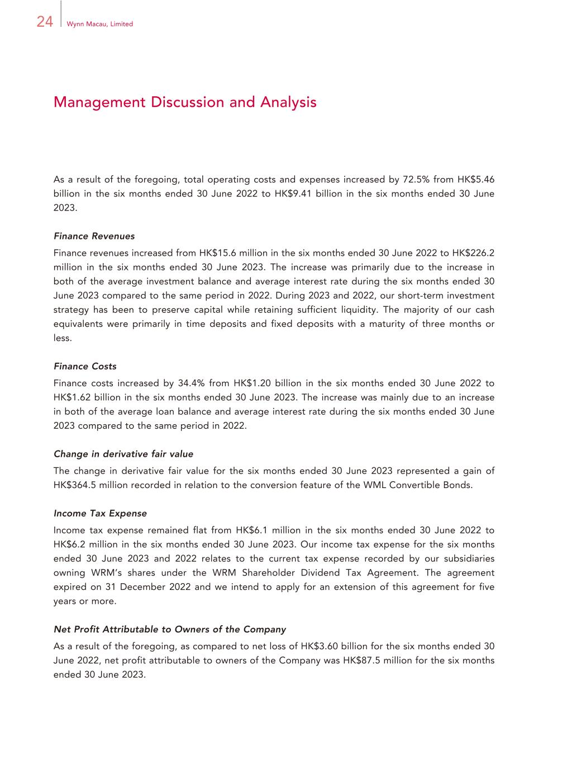
24 Wynn Macau, Limited Management Discussion and Analysis As a result of the foregoing, total operating costs and expenses increased by 72.5% from HK$5.46 billion in the six months ended 30 June 2022 to HK$9.41 billion in the six months ended 30 June 2023. Finance Revenues Finance revenues increased from HK$15.6 million in the six months ended 30 June 2022 to HK$226.2 million in the six months ended 30 June 2023. The increase was primarily due to the increase in both of the average investment balance and average interest rate during the six months ended 30 June 2023 compared to the same period in 2022. During 2023 and 2022, our short-term investment strategy has been to preserve capital while retaining sufficient liquidity. The majority of our cash equivalents were primarily in time deposits and fixed deposits with a maturity of three months or less. Finance Costs Finance costs increased by 34.4% from HK$1.20 billion in the six months ended 30 June 2022 to HK$1.62 billion in the six months ended 30 June 2023. The increase was mainly due to an increase in both of the average loan balance and average interest rate during the six months ended 30 June 2023 compared to the same period in 2022. Change in derivative fair value The change in derivative fair value for the six months ended 30 June 2023 represented a gain of HK$364.5 million recorded in relation to the conversion feature of the WML Convertible Bonds. Income Tax Expense Income tax expense remained flat from HK$6.1 million in the six months ended 30 June 2022 to HK$6.2 million in the six months ended 30 June 2023. Our income tax expense for the six months ended 30 June 2023 and 2022 relates to the current tax expense recorded by our subsidiaries owning WRM’s shares under the WRM Shareholder Dividend Tax Agreement. The agreement expired on 31 December 2022 and we intend to apply for an extension of this agreement for five years or more. Net Profit Attributable to Owners of the Company As a result of the foregoing, as compared to net loss of HK$3.60 billion for the six months ended 30 June 2022, net profit attributable to owners of the Company was HK$87.5 million for the six months ended 30 June 2023.

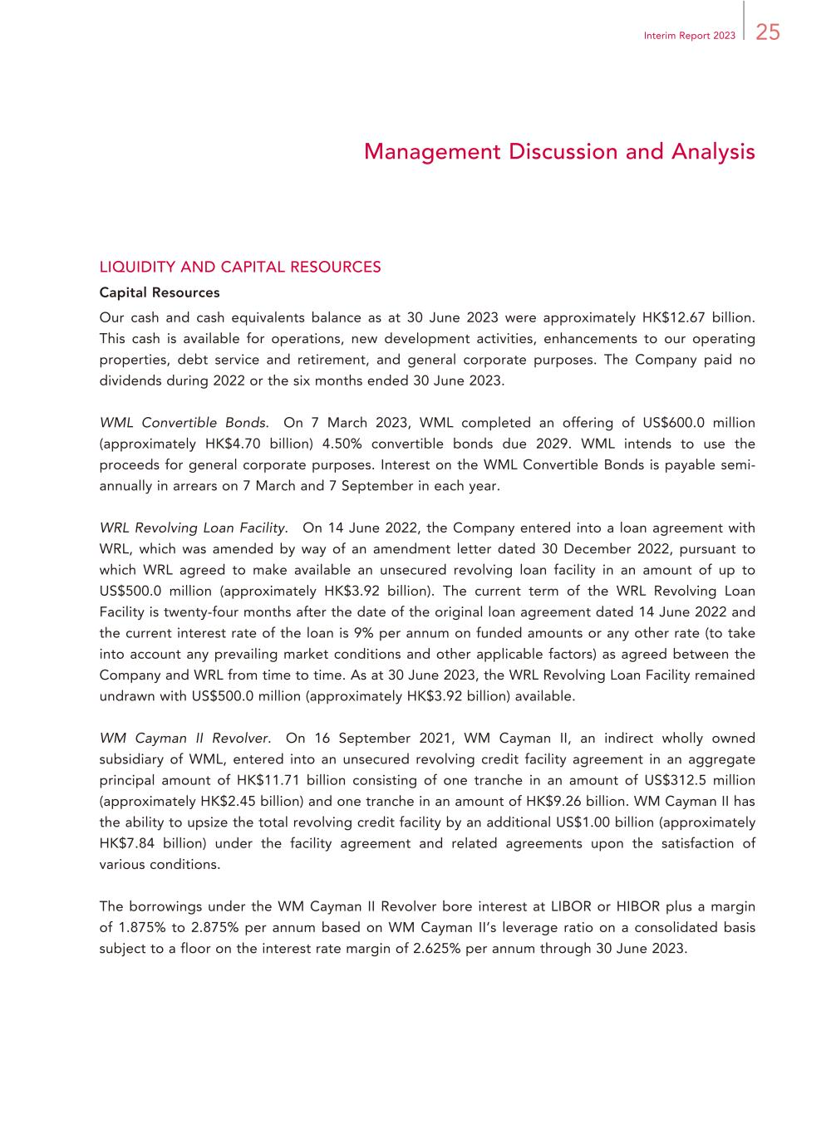
25Interim Report 2023 Management Discussion and Analysis LIQUIDITY AND CAPITAL RESOURCES Capital Resources Our cash and cash equivalents balance as at 30 June 2023 were approximately HK$12.67 billion. This cash is available for operations, new development activities, enhancements to our operating properties, debt service and retirement, and general corporate purposes. The Company paid no dividends during 2022 or the six months ended 30 June 2023. WML Convertible Bonds. On 7 March 2023, WML completed an offering of US$600.0 million (approximately HK$4.70 billion) 4.50% convertible bonds due 2029. WML intends to use the proceeds for general corporate purposes. Interest on the WML Convertible Bonds is payable semi- annually in arrears on 7 March and 7 September in each year. WRL Revolving Loan Facility. On 14 June 2022, the Company entered into a loan agreement with WRL, which was amended by way of an amendment letter dated 30 December 2022, pursuant to which WRL agreed to make available an unsecured revolving loan facility in an amount of up to US$500.0 million (approximately HK$3.92 billion). The current term of the WRL Revolving Loan Facility is twenty-four months after the date of the original loan agreement dated 14 June 2022 and the current interest rate of the loan is 9% per annum on funded amounts or any other rate (to take into account any prevailing market conditions and other applicable factors) as agreed between the Company and WRL from time to time. As at 30 June 2023, the WRL Revolving Loan Facility remained undrawn with US$500.0 million (approximately HK$3.92 billion) available. WM Cayman II Revolver. On 16 September 2021, WM Cayman II, an indirect wholly owned subsidiary of WML, entered into an unsecured revolving credit facility agreement in an aggregate principal amount of HK$11.71 billion consisting of one tranche in an amount of US$312.5 million (approximately HK$2.45 billion) and one tranche in an amount of HK$9.26 billion. WM Cayman II has the ability to upsize the total revolving credit facility by an additional US$1.00 billion (approximately HK$7.84 billion) under the facility agreement and related agreements upon the satisfaction of various conditions. The borrowings under the WM Cayman II Revolver bore interest at LIBOR or HIBOR plus a margin of 1.875% to 2.875% per annum based on WM Cayman II’s leverage ratio on a consolidated basis subject to a floor on the interest rate margin of 2.625% per annum through 30 June 2023.

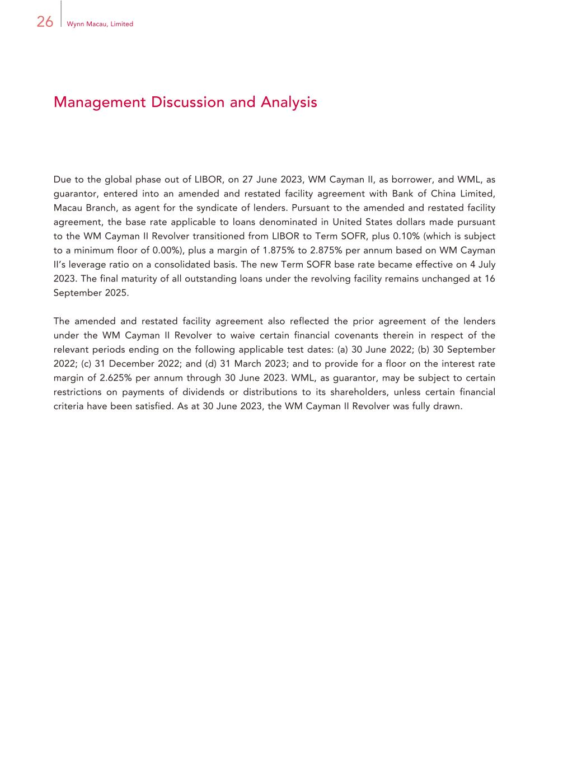
26 Wynn Macau, Limited Management Discussion and Analysis Due to the global phase out of LIBOR, on 27 June 2023, WM Cayman II, as borrower, and WML, as guarantor, entered into an amended and restated facility agreement with Bank of China Limited, Macau Branch, as agent for the syndicate of lenders. Pursuant to the amended and restated facility agreement, the base rate applicable to loans denominated in United States dollars made pursuant to the WM Cayman II Revolver transitioned from LIBOR to Term SOFR, plus 0.10% (which is subject to a minimum floor of 0.00%), plus a margin of 1.875% to 2.875% per annum based on WM Cayman II’s leverage ratio on a consolidated basis. The new Term SOFR base rate became effective on 4 July 2023. The final maturity of all outstanding loans under the revolving facility remains unchanged at 16 September 2025. The amended and restated facility agreement also reflected the prior agreement of the lenders under the WM Cayman II Revolver to waive certain financial covenants therein in respect of the relevant periods ending on the following applicable test dates: (a) 30 June 2022; (b) 30 September 2022; (c) 31 December 2022; and (d) 31 March 2023; and to provide for a floor on the interest rate margin of 2.625% per annum through 30 June 2023. WML, as guarantor, may be subject to certain restrictions on payments of dividends or distributions to its shareholders, unless certain financial criteria have been satisfied. As at 30 June 2023, the WM Cayman II Revolver was fully drawn.

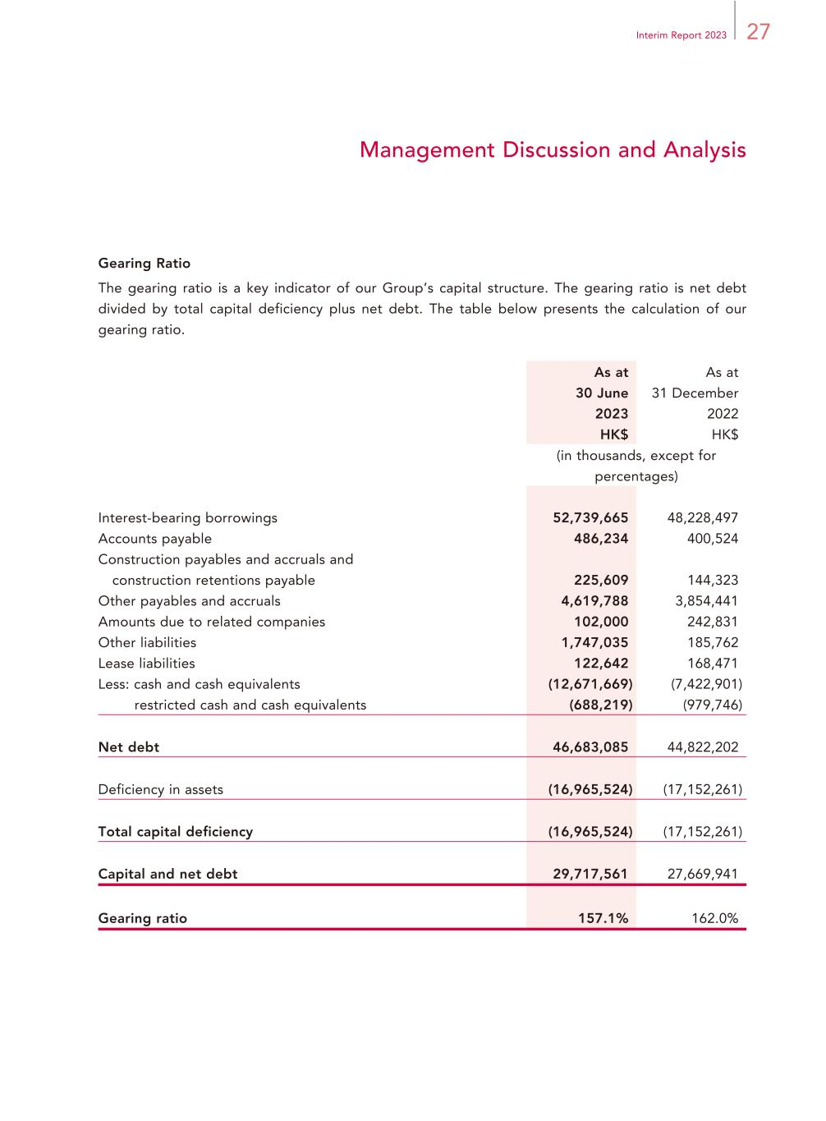
27Interim Report 2023 Management Discussion and Analysis Gearing Ratio The gearing ratio is a key indicator of our Group’s capital structure. The gearing ratio is net debt divided by total capital deficiency plus net debt. The table below presents the calculation of our gearing ratio. As at 30 June 2023 As at 31 December 2022 HK$ HK$ (in thousands, except for percentages) Interest-bearing borrowings 52,739,665 48,228,497 Accounts payable 486,234 400,524 Construction payables and accruals and construction retentions payable 225,609 144,323 Other payables and accruals 4,619,788 3,854,441 Amounts due to related companies 102,000 242,831 Other liabilities 1,747,035 185,762 Lease liabilities 122,642 168,471 Less: cash and cash equivalents (12,671,669) (7,422,901) restricted cash and cash equivalents (688,219) (979,746) Net debt 46,683,085 44,822,202 Deficiency in assets (16,965,524) (17,152,261) Total capital deficiency (16,965,524) (17,152,261) Capital and net debt 29,717,561 27,669,941 Gearing ratio 157.1% 162.0%

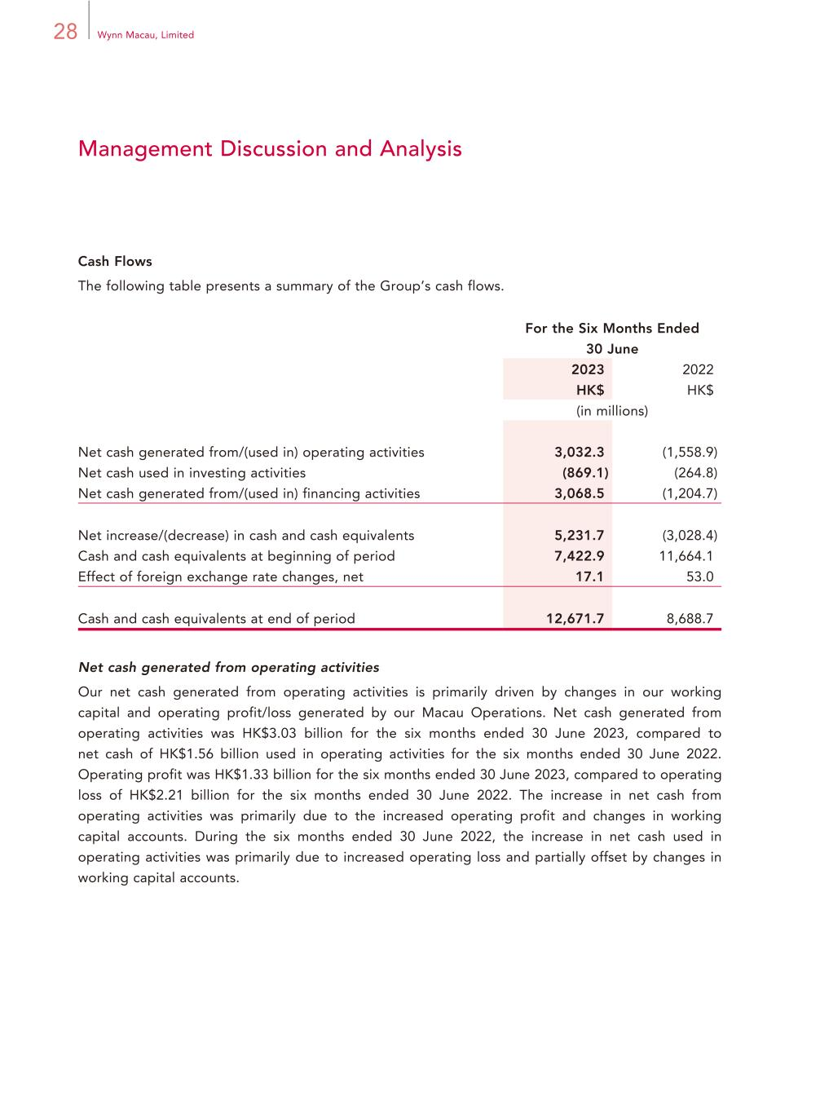
28 Wynn Macau, Limited Management Discussion and Analysis Cash Flows The following table presents a summary of the Group’s cash flows. For the Six Months Ended 30 June 2023 2022 HK$ HK$ (in millions) Net cash generated from/(used in) operating activities 3,032.3 (1,558.9) Net cash used in investing activities (869.1) (264.8) Net cash generated from/(used in) financing activities 3,068.5 (1,204.7) Net increase/(decrease) in cash and cash equivalents 5,231.7 (3,028.4) Cash and cash equivalents at beginning of period 7,422.9 11,664.1 Effect of foreign exchange rate changes, net 17.1 53.0 Cash and cash equivalents at end of period 12,671.7 8,688.7 Net cash generated from operating activities Our net cash generated from operating activities is primarily driven by changes in our working capital and operating profit/loss generated by our Macau Operations. Net cash generated from operating activities was HK$3.03 billion for the six months ended 30 June 2023, compared to net cash of HK$1.56 billion used in operating activities for the six months ended 30 June 2022. Operating profit was HK$1.33 billion for the six months ended 30 June 2023, compared to operating loss of HK$2.21 billion for the six months ended 30 June 2022. The increase in net cash from operating activities was primarily due to the increased operating profit and changes in working capital accounts. During the six months ended 30 June 2022, the increase in net cash used in operating activities was primarily due to increased operating loss and partially offset by changes in working capital accounts.

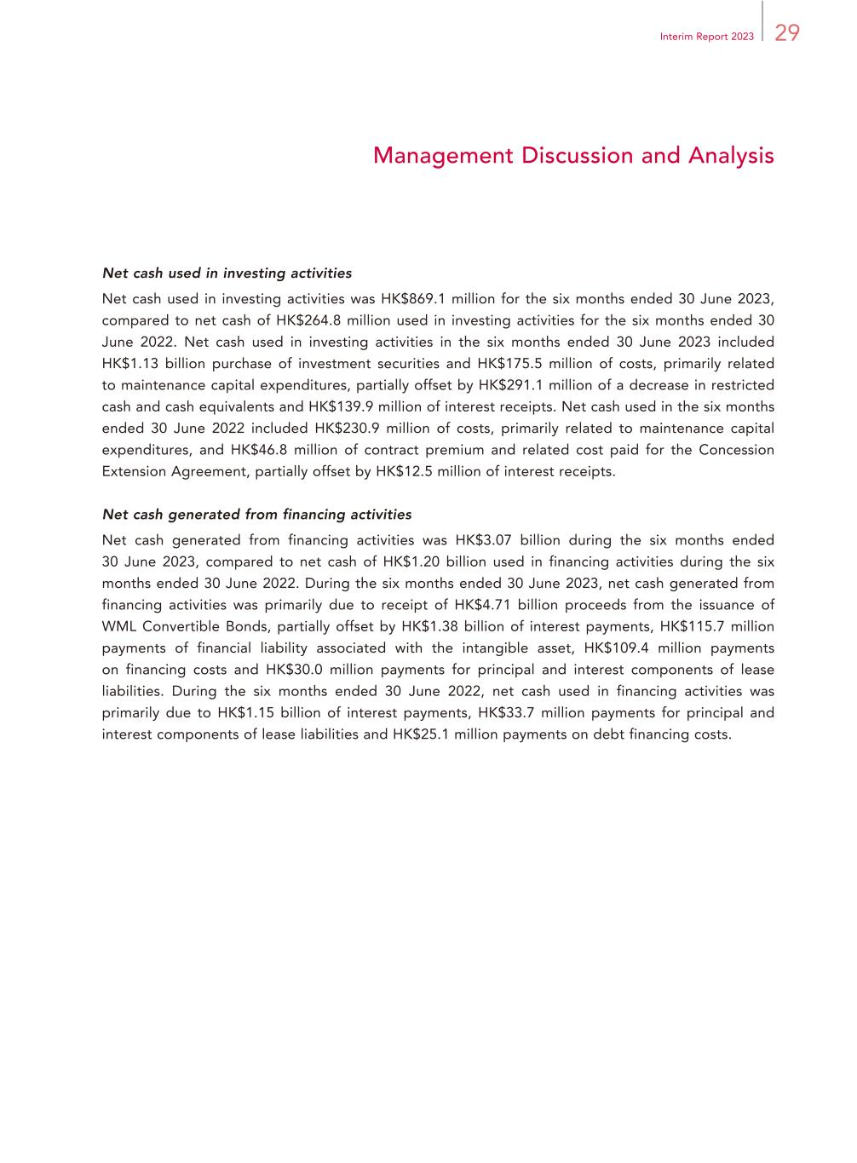
29Interim Report 2023 Management Discussion and Analysis Net cash used in investing activities Net cash used in investing activities was HK$869.1 million for the six months ended 30 June 2023, compared to net cash of HK$264.8 million used in investing activities for the six months ended 30 June 2022. Net cash used in investing activities in the six months ended 30 June 2023 included HK$1.13 billion purchase of investment securities and HK$175.5 million of costs, primarily related to maintenance capital expenditures, partially offset by HK$291.1 million of a decrease in restricted cash and cash equivalents and HK$139.9 million of interest receipts. Net cash used in the six months ended 30 June 2022 included HK$230.9 million of costs, primarily related to maintenance capital expenditures, and HK$46.8 million of contract premium and related cost paid for the Concession Extension Agreement, partially offset by HK$12.5 million of interest receipts. Net cash generated from financing activities Net cash generated from financing activities was HK$3.07 billion during the six months ended 30 June 2023, compared to net cash of HK$1.20 billion used in financing activities during the six months ended 30 June 2022. During the six months ended 30 June 2023, net cash generated from financing activities was primarily due to receipt of HK$4.71 billion proceeds from the issuance of WML Convertible Bonds, partially offset by HK$1.38 billion of interest payments, HK$115.7 million payments of financial liability associated with the intangible asset, HK$109.4 million payments on financing costs and HK$30.0 million payments for principal and interest components of lease liabilities. During the six months ended 30 June 2022, net cash used in financing activities was primarily due to HK$1.15 billion of interest payments, HK$33.7 million payments for principal and interest components of lease liabilities and HK$25.1 million payments on debt financing costs.

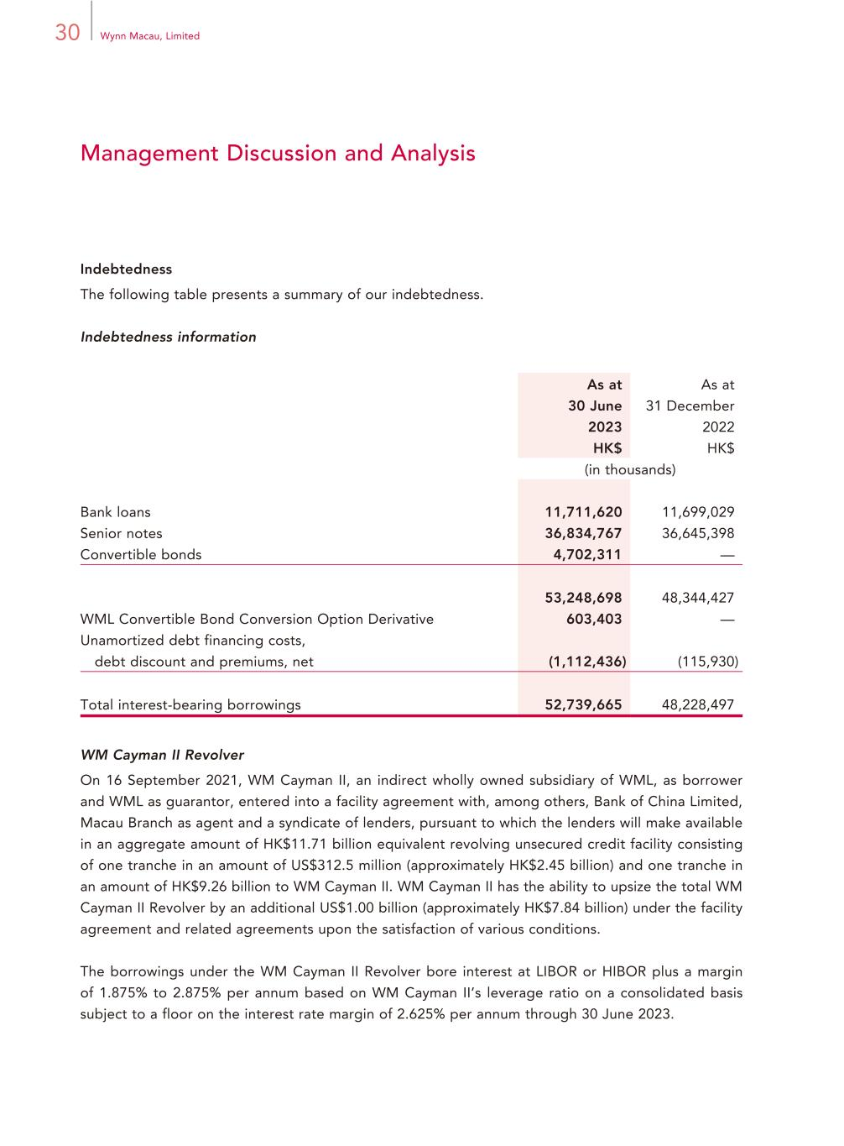
30 Wynn Macau, Limited Management Discussion and Analysis Indebtedness The following table presents a summary of our indebtedness. Indebtedness information As at 30 June 2023 As at 31 December 2022 HK$ HK$ (in thousands) Bank loans 11,711,620 11,699,029 Senior notes 36,834,767 36,645,398 Convertible bonds 4,702,311 — 53,248,698 48,344,427 WML Convertible Bond Conversion Option Derivative 603,403 — Unamortized debt financing costs, debt discount and premiums, net (1,112,436) (115,930) Total interest-bearing borrowings 52,739,665 48,228,497 WM Cayman II Revolver On 16 September 2021, WM Cayman II, an indirect wholly owned subsidiary of WML, as borrower and WML as guarantor, entered into a facility agreement with, among others, Bank of China Limited, Macau Branch as agent and a syndicate of lenders, pursuant to which the lenders will make available in an aggregate amount of HK$11.71 billion equivalent revolving unsecured credit facility consisting of one tranche in an amount of US$312.5 million (approximately HK$2.45 billion) and one tranche in an amount of HK$9.26 billion to WM Cayman II. WM Cayman II has the ability to upsize the total WM Cayman II Revolver by an additional US$1.00 billion (approximately HK$7.84 billion) under the facility agreement and related agreements upon the satisfaction of various conditions. The borrowings under the WM Cayman II Revolver bore interest at LIBOR or HIBOR plus a margin of 1.875% to 2.875% per annum based on WM Cayman II’s leverage ratio on a consolidated basis subject to a floor on the interest rate margin of 2.625% per annum through 30 June 2023.

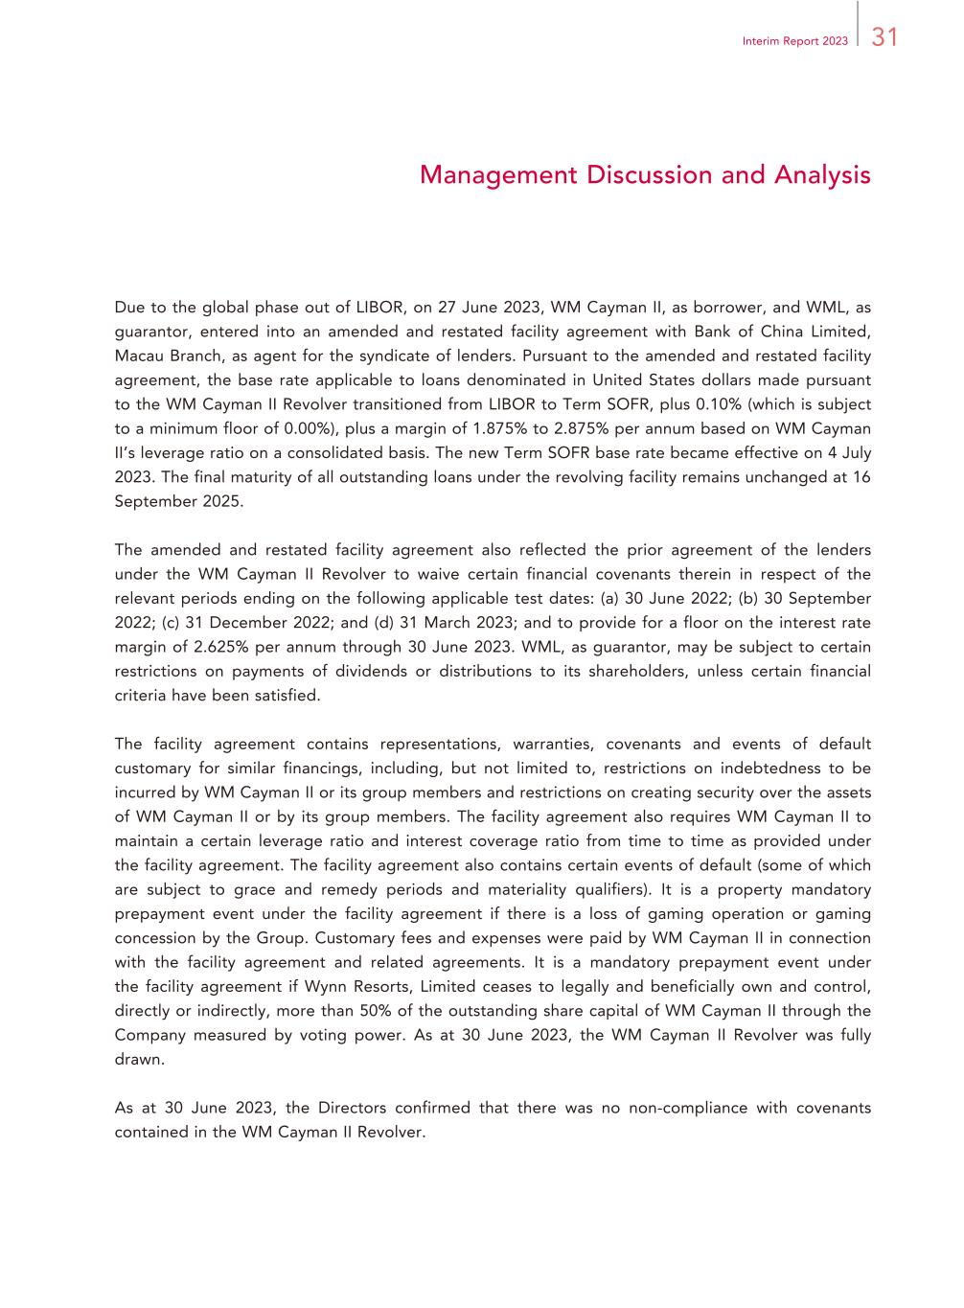
31Interim Report 2023 Management Discussion and Analysis Due to the global phase out of LIBOR, on 27 June 2023, WM Cayman II, as borrower, and WML, as guarantor, entered into an amended and restated facility agreement with Bank of China Limited, Macau Branch, as agent for the syndicate of lenders. Pursuant to the amended and restated facility agreement, the base rate applicable to loans denominated in United States dollars made pursuant to the WM Cayman II Revolver transitioned from LIBOR to Term SOFR, plus 0.10% (which is subject to a minimum floor of 0.00%), plus a margin of 1.875% to 2.875% per annum based on WM Cayman II’s leverage ratio on a consolidated basis. The new Term SOFR base rate became effective on 4 July 2023. The final maturity of all outstanding loans under the revolving facility remains unchanged at 16 September 2025. The amended and restated facility agreement also reflected the prior agreement of the lenders under the WM Cayman II Revolver to waive certain financial covenants therein in respect of the relevant periods ending on the following applicable test dates: (a) 30 June 2022; (b) 30 September 2022; (c) 31 December 2022; and (d) 31 March 2023; and to provide for a floor on the interest rate margin of 2.625% per annum through 30 June 2023. WML, as guarantor, may be subject to certain restrictions on payments of dividends or distributions to its shareholders, unless certain financial criteria have been satisfied. The facility agreement contains representations, warranties, covenants and events of default customary for similar financings, including, but not limited to, restrictions on indebtedness to be incurred by WM Cayman II or its group members and restrictions on creating security over the assets of WM Cayman II or by its group members. The facility agreement also requires WM Cayman II to maintain a certain leverage ratio and interest coverage ratio from time to time as provided under the facility agreement. The facility agreement also contains certain events of default (some of which are subject to grace and remedy periods and materiality qualifiers). It is a property mandatory prepayment event under the facility agreement if there is a loss of gaming operation or gaming concession by the Group. Customary fees and expenses were paid by WM Cayman II in connection with the facility agreement and related agreements. It is a mandatory prepayment event under the facility agreement if Wynn Resorts, Limited ceases to legally and beneficially own and control, directly or indirectly, more than 50% of the outstanding share capital of WM Cayman II through the Company measured by voting power. As at 30 June 2023, the WM Cayman II Revolver was fully drawn. As at 30 June 2023, the Directors confirmed that there was no non-compliance with covenants contained in the WM Cayman II Revolver.

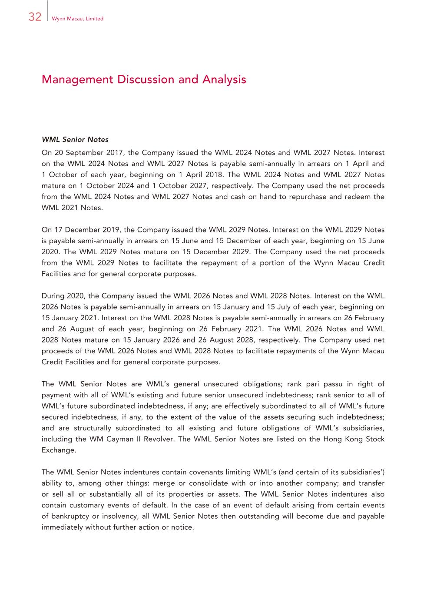
32 Wynn Macau, Limited Management Discussion and Analysis WML Senior Notes On 20 September 2017, the Company issued the WML 2024 Notes and WML 2027 Notes. Interest on the WML 2024 Notes and WML 2027 Notes is payable semi-annually in arrears on 1 April and 1 October of each year, beginning on 1 April 2018. The WML 2024 Notes and WML 2027 Notes mature on 1 October 2024 and 1 October 2027, respectively. The Company used the net proceeds from the WML 2024 Notes and WML 2027 Notes and cash on hand to repurchase and redeem the WML 2021 Notes. On 17 December 2019, the Company issued the WML 2029 Notes. Interest on the WML 2029 Notes is payable semi-annually in arrears on 15 June and 15 December of each year, beginning on 15 June 2020. The WML 2029 Notes mature on 15 December 2029. The Company used the net proceeds from the WML 2029 Notes to facilitate the repayment of a portion of the Wynn Macau Credit Facilities and for general corporate purposes. During 2020, the Company issued the WML 2026 Notes and WML 2028 Notes. Interest on the WML 2026 Notes is payable semi-annually in arrears on 15 January and 15 July of each year, beginning on 15 January 2021. Interest on the WML 2028 Notes is payable semi-annually in arrears on 26 February and 26 August of each year, beginning on 26 February 2021. The WML 2026 Notes and WML 2028 Notes mature on 15 January 2026 and 26 August 2028, respectively. The Company used net proceeds of the WML 2026 Notes and WML 2028 Notes to facilitate repayments of the Wynn Macau Credit Facilities and for general corporate purposes. The WML Senior Notes are WML’s general unsecured obligations; rank pari passu in right of payment with all of WML’s existing and future senior unsecured indebtedness; rank senior to all of WML’s future subordinated indebtedness, if any; are effectively subordinated to all of WML’s future secured indebtedness, if any, to the extent of the value of the assets securing such indebtedness; and are structurally subordinated to all existing and future obligations of WML’s subsidiaries, including the WM Cayman II Revolver. The WML Senior Notes are listed on the Hong Kong Stock Exchange. The WML Senior Notes indentures contain covenants limiting WML’s (and certain of its subsidiaries’) ability to, among other things: merge or consolidate with or into another company; and transfer or sell all or substantially all of its properties or assets. The WML Senior Notes indentures also contain customary events of default. In the case of an event of default arising from certain events of bankruptcy or insolvency, all WML Senior Notes then outstanding will become due and payable immediately without further action or notice.

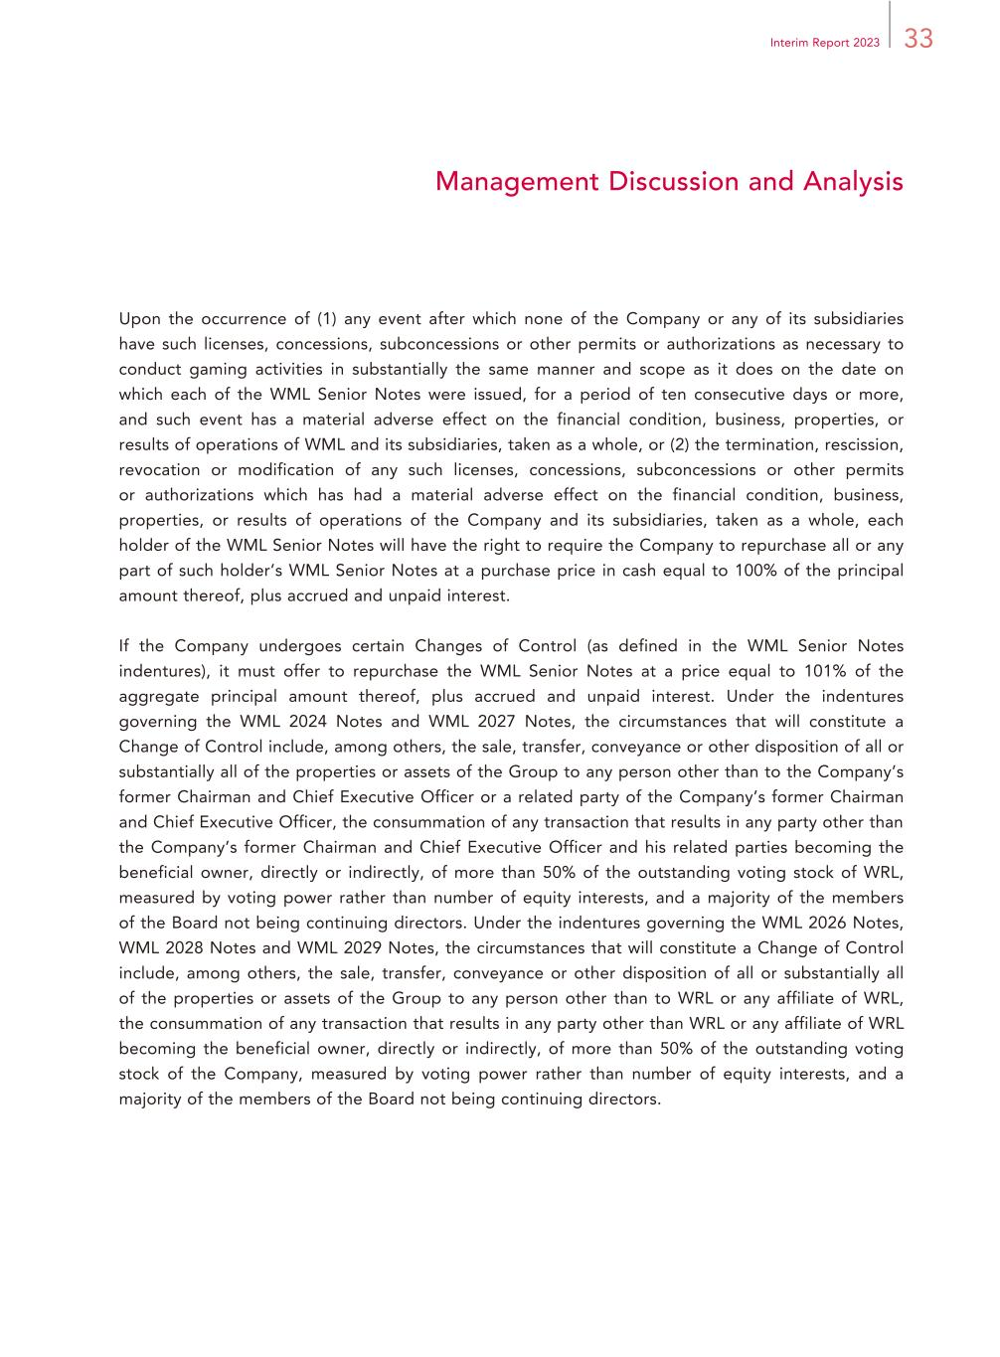
33Interim Report 2023 Management Discussion and Analysis Upon the occurrence of (1) any event after which none of the Company or any of its subsidiaries have such licenses, concessions, subconcessions or other permits or authorizations as necessary to conduct gaming activities in substantially the same manner and scope as it does on the date on which each of the WML Senior Notes were issued, for a period of ten consecutive days or more, and such event has a material adverse effect on the financial condition, business, properties, or results of operations of WML and its subsidiaries, taken as a whole, or (2) the termination, rescission, revocation or modification of any such licenses, concessions, subconcessions or other permits or authorizations which has had a material adverse effect on the financial condition, business, properties, or results of operations of the Company and its subsidiaries, taken as a whole, each holder of the WML Senior Notes will have the right to require the Company to repurchase all or any part of such holder’s WML Senior Notes at a purchase price in cash equal to 100% of the principal amount thereof, plus accrued and unpaid interest. If the Company undergoes certain Changes of Control (as defined in the WML Senior Notes indentures), it must offer to repurchase the WML Senior Notes at a price equal to 101% of the aggregate principal amount thereof, plus accrued and unpaid interest. Under the indentures governing the WML 2024 Notes and WML 2027 Notes, the circumstances that will constitute a Change of Control include, among others, the sale, transfer, conveyance or other disposition of all or substantially all of the properties or assets of the Group to any person other than to the Company’s former Chairman and Chief Executive Officer or a related party of the Company’s former Chairman and Chief Executive Officer, the consummation of any transaction that results in any party other than the Company’s former Chairman and Chief Executive Officer and his related parties becoming the beneficial owner, directly or indirectly, of more than 50% of the outstanding voting stock of WRL, measured by voting power rather than number of equity interests, and a majority of the members of the Board not being continuing directors. Under the indentures governing the WML 2026 Notes, WML 2028 Notes and WML 2029 Notes, the circumstances that will constitute a Change of Control include, among others, the sale, transfer, conveyance or other disposition of all or substantially all of the properties or assets of the Group to any person other than to WRL or any affiliate of WRL, the consummation of any transaction that results in any party other than WRL or any affiliate of WRL becoming the beneficial owner, directly or indirectly, of more than 50% of the outstanding voting stock of the Company, measured by voting power rather than number of equity interests, and a majority of the members of the Board not being continuing directors.

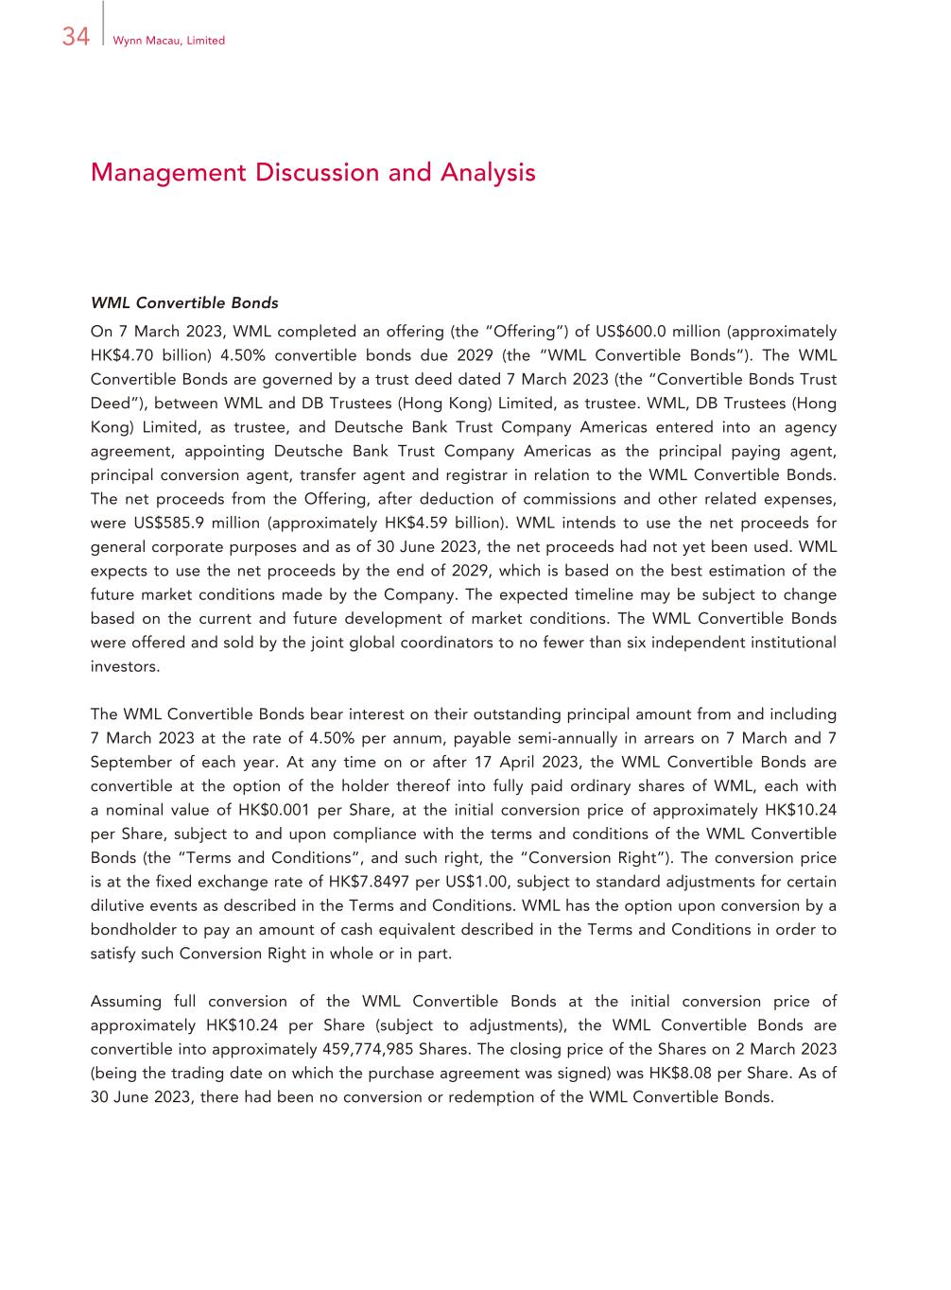
34 Wynn Macau, Limited Management Discussion and Analysis WML Convertible Bonds On 7 March 2023, WML completed an offering (the “Offering”) of US$600.0 million (approximately HK$4.70 billion) 4.50% convertible bonds due 2029 (the “WML Convertible Bonds”). The WML Convertible Bonds are governed by a trust deed dated 7 March 2023 (the “Convertible Bonds Trust Deed”), between WML and DB Trustees (Hong Kong) Limited, as trustee. WML, DB Trustees (Hong Kong) Limited, as trustee, and Deutsche Bank Trust Company Americas entered into an agency agreement, appointing Deutsche Bank Trust Company Americas as the principal paying agent, principal conversion agent, transfer agent and registrar in relation to the WML Convertible Bonds. The net proceeds from the Offering, after deduction of commissions and other related expenses, were US$585.9 million (approximately HK$4.59 billion). WML intends to use the net proceeds for general corporate purposes and as of 30 June 2023, the net proceeds had not yet been used. WML expects to use the net proceeds by the end of 2029, which is based on the best estimation of the future market conditions made by the Company. The expected timeline may be subject to change based on the current and future development of market conditions. The WML Convertible Bonds were offered and sold by the joint global coordinators to no fewer than six independent institutional investors. The WML Convertible Bonds bear interest on their outstanding principal amount from and including 7 March 2023 at the rate of 4.50% per annum, payable semi-annually in arrears on 7 March and 7 September of each year. At any time on or after 17 April 2023, the WML Convertible Bonds are convertible at the option of the holder thereof into fully paid ordinary shares of WML, each with a nominal value of HK$0.001 per Share, at the initial conversion price of approximately HK$10.24 per Share, subject to and upon compliance with the terms and conditions of the WML Convertible Bonds (the “Terms and Conditions”, and such right, the “Conversion Right”). The conversion price is at the fixed exchange rate of HK$7.8497 per US$1.00, subject to standard adjustments for certain dilutive events as described in the Terms and Conditions. WML has the option upon conversion by a bondholder to pay an amount of cash equivalent described in the Terms and Conditions in order to satisfy such Conversion Right in whole or in part. Assuming full conversion of the WML Convertible Bonds at the initial conversion price of approximately HK$10.24 per Share (subject to adjustments), the WML Convertible Bonds are convertible into approximately 459,774,985 Shares. The closing price of the Shares on 2 March 2023 (being the trading date on which the purchase agreement was signed) was HK$8.08 per Share. As of 30 June 2023, there had been no conversion or redemption of the WML Convertible Bonds.

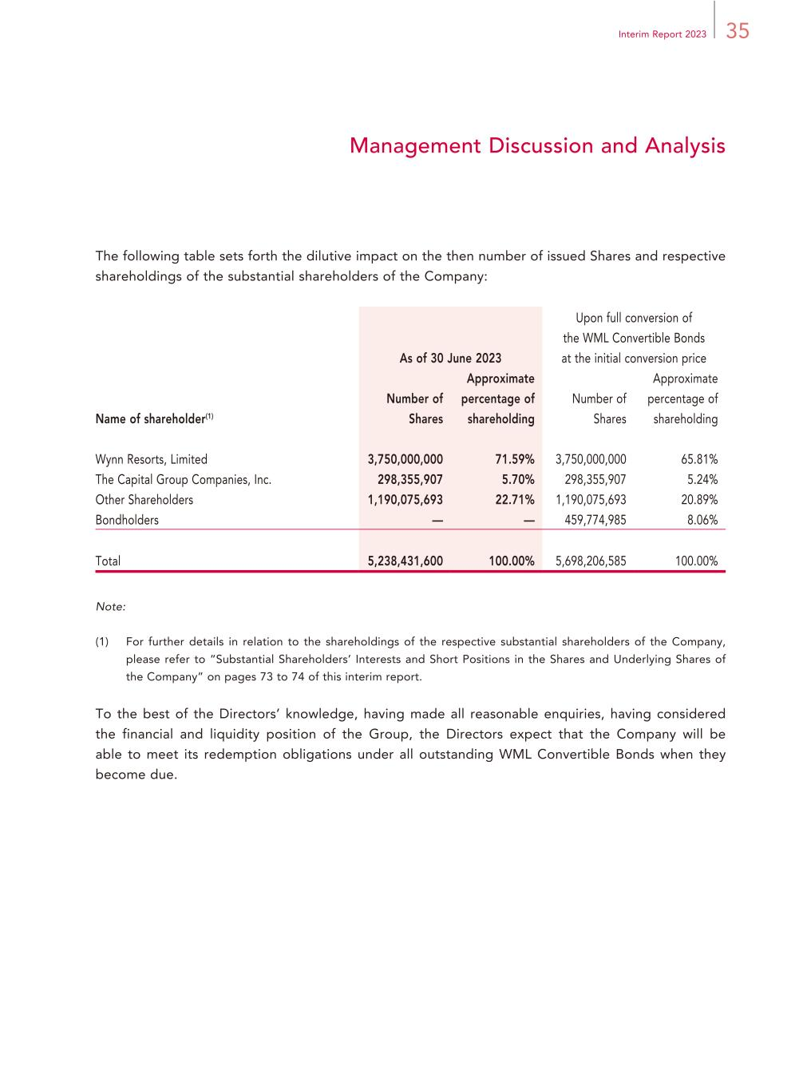
35Interim Report 2023 Management Discussion and Analysis The following table sets forth the dilutive impact on the then number of issued Shares and respective shareholdings of the substantial shareholders of the Company: As of 30 June 2023 Upon full conversion of the WML Convertible Bonds at the initial conversion price Name of shareholder(1) Number of Shares Approximate percentage of shareholding Number of Shares Approximate percentage of shareholding Wynn Resorts, Limited 3,750,000,000 71.59% 3,750,000,000 65.81% The Capital Group Companies, Inc. 298,355,907 5.70% 298,355,907 5.24% Other Shareholders 1,190,075,693 22.71% 1,190,075,693 20.89% Bondholders — — 459,774,985 8.06% Total 5,238,431,600 100.00% 5,698,206,585 100.00% Note: (1) For further details in relation to the shareholdings of the respective substantial shareholders of the Company, please refer to “Substantial Shareholders’ Interests and Short Positions in the Shares and Underlying Shares of the Company” on pages 73 to 74 of this interim report. To the best of the Directors’ knowledge, having made all reasonable enquiries, having considered the financial and liquidity position of the Group, the Directors expect that the Company will be able to meet its redemption obligations under all outstanding WML Convertible Bonds when they become due.

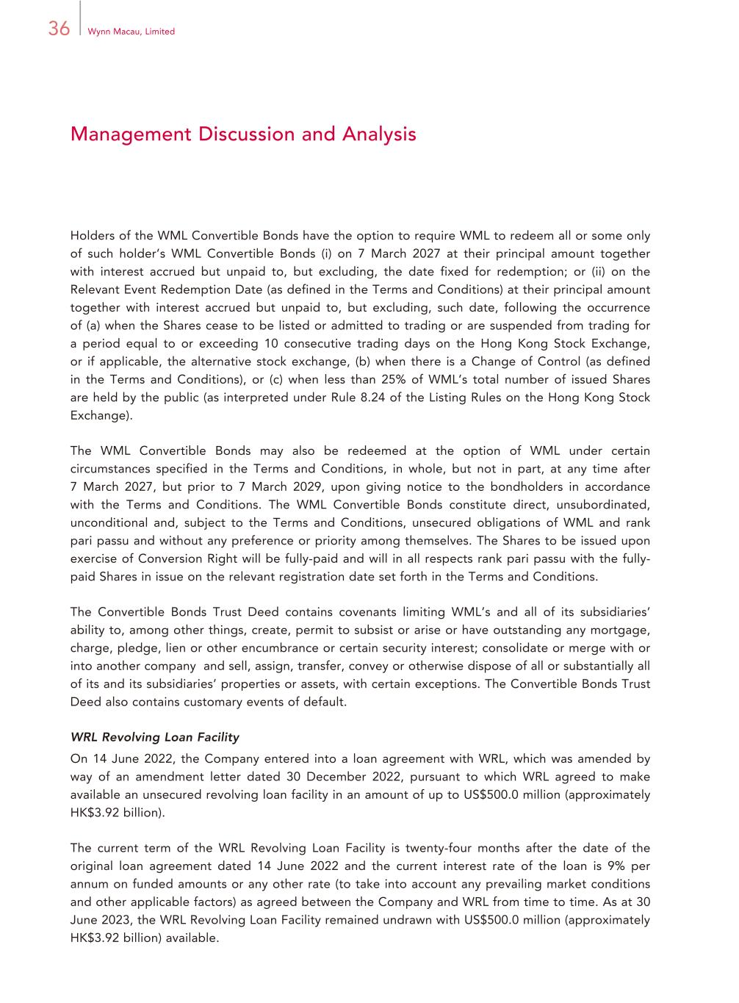
36 Wynn Macau, Limited Management Discussion and Analysis Holders of the WML Convertible Bonds have the option to require WML to redeem all or some only of such holder’s WML Convertible Bonds (i) on 7 March 2027 at their principal amount together with interest accrued but unpaid to, but excluding, the date fixed for redemption; or (ii) on the Relevant Event Redemption Date (as defined in the Terms and Conditions) at their principal amount together with interest accrued but unpaid to, but excluding, such date, following the occurrence of (a) when the Shares cease to be listed or admitted to trading or are suspended from trading for a period equal to or exceeding 10 consecutive trading days on the Hong Kong Stock Exchange, or if applicable, the alternative stock exchange, (b) when there is a Change of Control (as defined in the Terms and Conditions), or (c) when less than 25% of WML’s total number of issued Shares are held by the public (as interpreted under Rule 8.24 of the Listing Rules on the Hong Kong Stock Exchange). The WML Convertible Bonds may also be redeemed at the option of WML under certain circumstances specified in the Terms and Conditions, in whole, but not in part, at any time after 7 March 2027, but prior to 7 March 2029, upon giving notice to the bondholders in accordance with the Terms and Conditions. The WML Convertible Bonds constitute direct, unsubordinated, unconditional and, subject to the Terms and Conditions, unsecured obligations of WML and rank pari passu and without any preference or priority among themselves. The Shares to be issued upon exercise of Conversion Right will be fully-paid and will in all respects rank pari passu with the fully- paid Shares in issue on the relevant registration date set forth in the Terms and Conditions. The Convertible Bonds Trust Deed contains covenants limiting WML’s and all of its subsidiaries’ ability to, among other things, create, permit to subsist or arise or have outstanding any mortgage, charge, pledge, lien or other encumbrance or certain security interest; consolidate or merge with or into another company; and sell, assign, transfer, convey or otherwise dispose of all or substantially all of its and its subsidiaries’ properties or assets, with certain exceptions. The Convertible Bonds Trust Deed also contains customary events of default. WRL Revolving Loan Facility On 14 June 2022, the Company entered into a loan agreement with WRL, which was amended by way of an amendment letter dated 30 December 2022, pursuant to which WRL agreed to make available an unsecured revolving loan facility in an amount of up to US$500.0 million (approximately HK$3.92 billion). The current term of the WRL Revolving Loan Facility is twenty-four months after the date of the original loan agreement dated 14 June 2022 and the current interest rate of the loan is 9% per annum on funded amounts or any other rate (to take into account any prevailing market conditions and other applicable factors) as agreed between the Company and WRL from time to time. As at 30 June 2023, the WRL Revolving Loan Facility remained undrawn with US$500.0 million (approximately HK$3.92 billion) available.

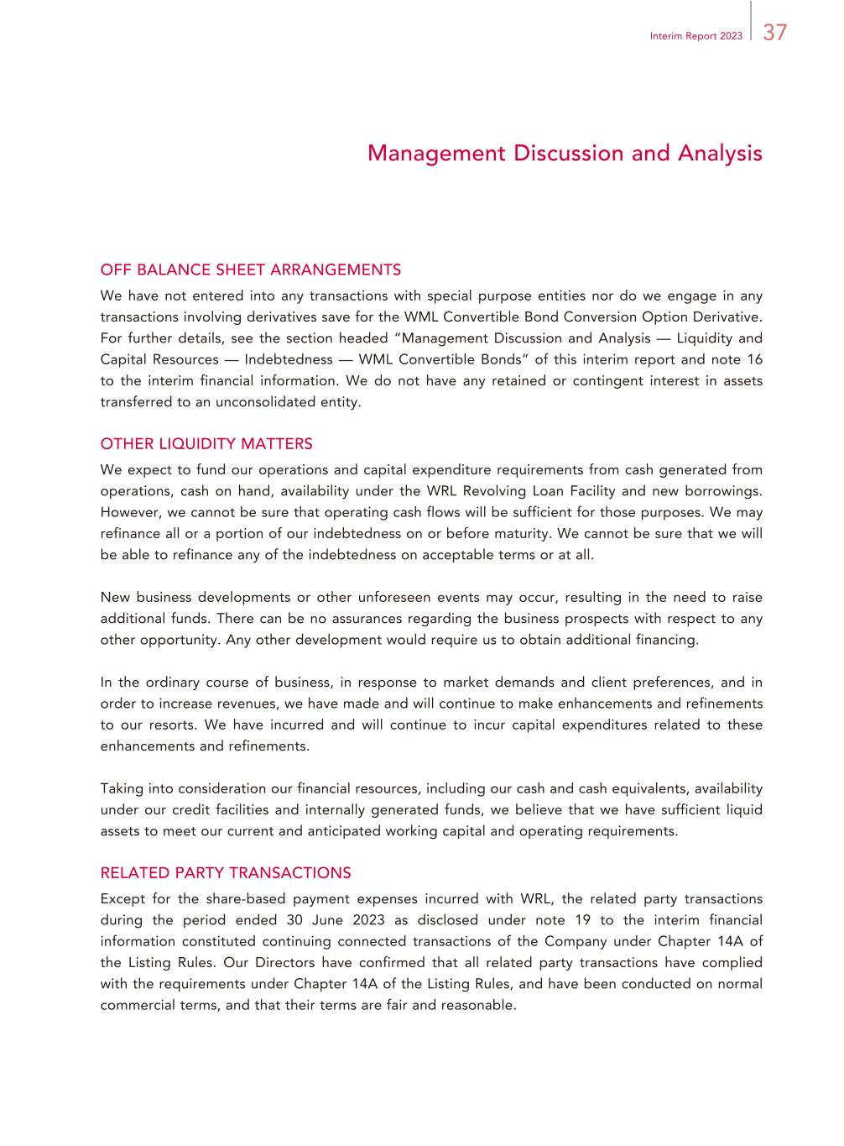
37Interim Report 2023 Management Discussion and Analysis OFF BALANCE SHEET ARRANGEMENTS We have not entered into any transactions with special purpose entities nor do we engage in any transactions involving derivatives save for the WML Convertible Bond Conversion Option Derivative. For further details, see the section headed “Management Discussion and Analysis — Liquidity and Capital Resources — Indebtedness — WML Convertible Bonds” of this interim report and note 16 to the interim financial information. We do not have any retained or contingent interest in assets transferred to an unconsolidated entity. OTHER LIQUIDITY MATTERS We expect to fund our operations and capital expenditure requirements from cash generated from operations, cash on hand, availability under the WRL Revolving Loan Facility and new borrowings. However, we cannot be sure that operating cash flows will be sufficient for those purposes. We may refinance all or a portion of our indebtedness on or before maturity. We cannot be sure that we will be able to refinance any of the indebtedness on acceptable terms or at all. New business developments or other unforeseen events may occur, resulting in the need to raise additional funds. There can be no assurances regarding the business prospects with respect to any other opportunity. Any other development would require us to obtain additional financing. In the ordinary course of business, in response to market demands and client preferences, and in order to increase revenues, we have made and will continue to make enhancements and refinements to our resorts. We have incurred and will continue to incur capital expenditures related to these enhancements and refinements. Taking into consideration our financial resources, including our cash and cash equivalents, availability under our credit facilities and internally generated funds, we believe that we have sufficient liquid assets to meet our current and anticipated working capital and operating requirements. RELATED PARTY TRANSACTIONS Except for the share-based payment expenses incurred with WRL, the related party transactions during the period ended 30 June 2023 as disclosed under note 19 to the interim financial information constituted continuing connected transactions of the Company under Chapter 14A of the Listing Rules. Our Directors have confirmed that all related party transactions have complied with the requirements under Chapter 14A of the Listing Rules, and have been conducted on normal commercial terms, and that their terms are fair and reasonable.

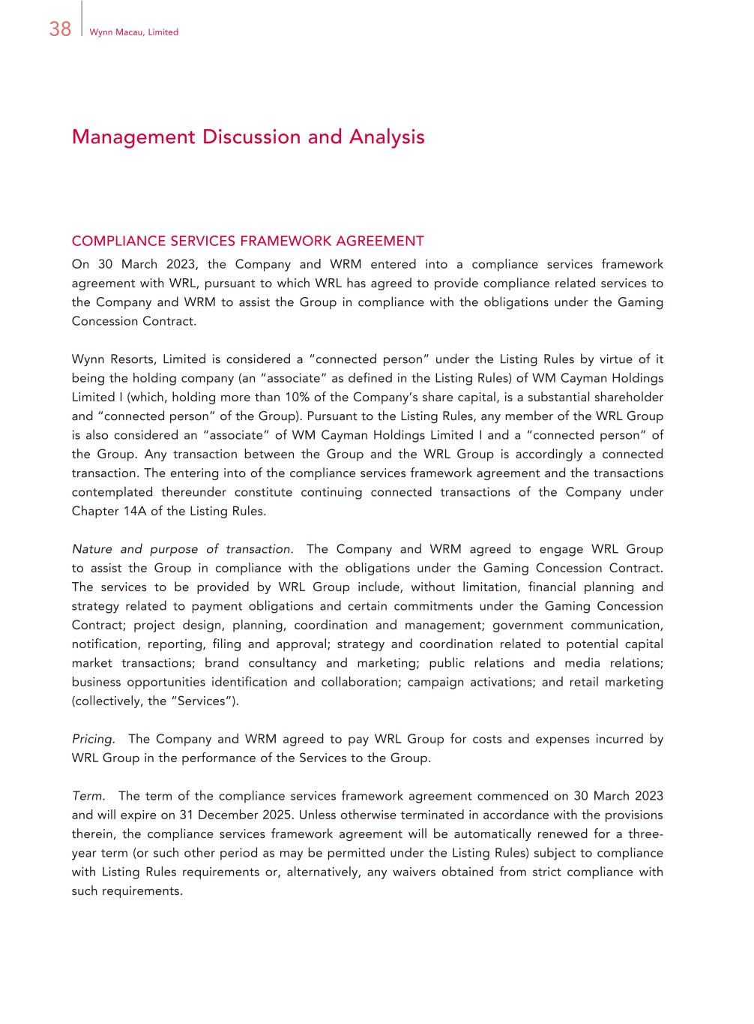
38 Wynn Macau, Limited Management Discussion and Analysis COMPLIANCE SERVICES FRAMEWORK AGREEMENT On 30 March 2023, the Company and WRM entered into a compliance services framework agreement with WRL, pursuant to which WRL has agreed to provide compliance related services to the Company and WRM to assist the Group in compliance with the obligations under the Gaming Concession Contract. Wynn Resorts, Limited is considered a “connected person” under the Listing Rules by virtue of it being the holding company (an “associate” as defined in the Listing Rules) of WM Cayman Holdings Limited I (which, holding more than 10% of the Company’s share capital, is a substantial shareholder and “connected person” of the Group). Pursuant to the Listing Rules, any member of the WRL Group is also considered an “associate” of WM Cayman Holdings Limited I and a “connected person” of the Group. Any transaction between the Group and the WRL Group is accordingly a connected transaction. The entering into of the compliance services framework agreement and the transactions contemplated thereunder constitute continuing connected transactions of the Company under Chapter 14A of the Listing Rules. Nature and purpose of transaction. The Company and WRM agreed to engage WRL Group to assist the Group in compliance with the obligations under the Gaming Concession Contract. The services to be provided by WRL Group include, without limitation, financial planning and strategy related to payment obligations and certain commitments under the Gaming Concession Contract; project design, planning, coordination and management; government communication, notification, reporting, filing and approval; strategy and coordination related to potential capital market transactions; brand consultancy and marketing; public relations and media relations; business opportunities identification and collaboration; campaign activations; and retail marketing (collectively, the “Services”). Pricing. The Company and WRM agreed to pay WRL Group for costs and expenses incurred by WRL Group in the performance of the Services to the Group. Term. The term of the compliance services framework agreement commenced on 30 March 2023 and will expire on 31 December 2025. Unless otherwise terminated in accordance with the provisions therein, the compliance services framework agreement will be automatically renewed for a three- year term (or such other period as may be permitted under the Listing Rules) subject to compliance with Listing Rules requirements or, alternatively, any waivers obtained from strict compliance with such requirements.

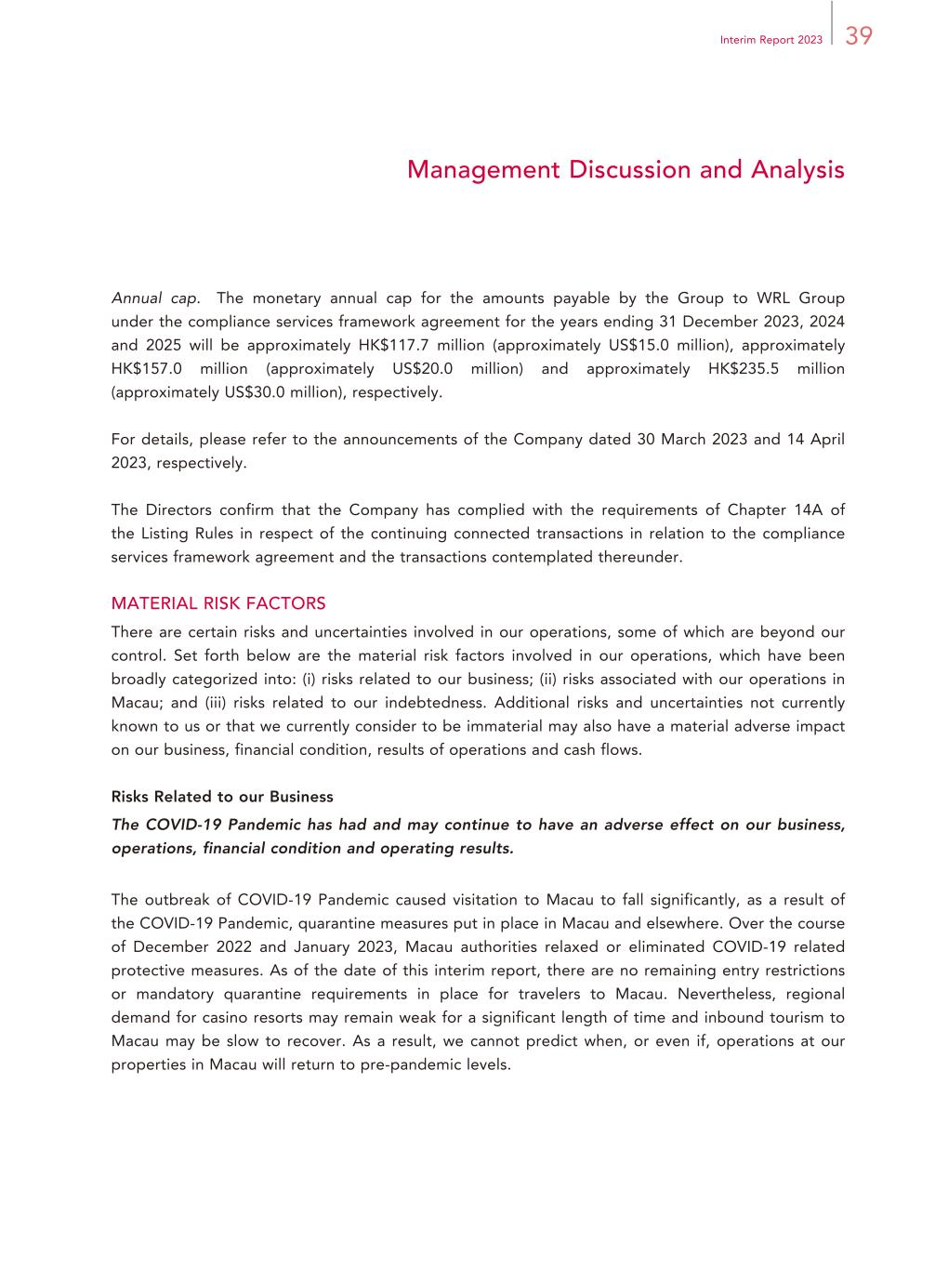
39Interim Report 2023 Management Discussion and Analysis Annual cap. The monetary annual cap for the amounts payable by the Group to WRL Group under the compliance services framework agreement for the years ending 31 December 2023, 2024 and 2025 will be approximately HK$117.7 million (approximately US$15.0 million), approximately HK$157.0 million (approximately US$20.0 million) and approximately HK$235.5 million (approximately US$30.0 million), respectively. For details, please refer to the announcements of the Company dated 30 March 2023 and 14 April 2023, respectively. The Directors confirm that the Company has complied with the requirements of Chapter 14A of the Listing Rules in respect of the continuing connected transactions in relation to the compliance services framework agreement and the transactions contemplated thereunder. MATERIAL RISK FACTORS There are certain risks and uncertainties involved in our operations, some of which are beyond our control. Set forth below are the material risk factors involved in our operations, which have been broadly categorized into: (i) risks related to our business; (ii) risks associated with our operations in Macau; and (iii) risks related to our indebtedness. Additional risks and uncertainties not currently known to us or that we currently consider to be immaterial may also have a material adverse impact on our business, financial condition, results of operations and cash flows. Risks Related to our Business The COVID-19 Pandemic has had and may continue to have an adverse effect on our business, operations, financial condition and operating results. The outbreak of COVID-19 Pandemic caused visitation to Macau to fall significantly, as a result of the COVID-19 Pandemic, quarantine measures put in place in Macau and elsewhere. Over the course of December 2022 and January 2023, Macau authorities relaxed or eliminated COVID-19 related protective measures. As of the date of this interim report, there are no remaining entry restrictions or mandatory quarantine requirements in place for travelers to Macau. Nevertheless, regional demand for casino resorts may remain weak for a significant length of time and inbound tourism to Macau may be slow to recover. As a result, we cannot predict when, or even if, operations at our properties in Macau will return to pre-pandemic levels.

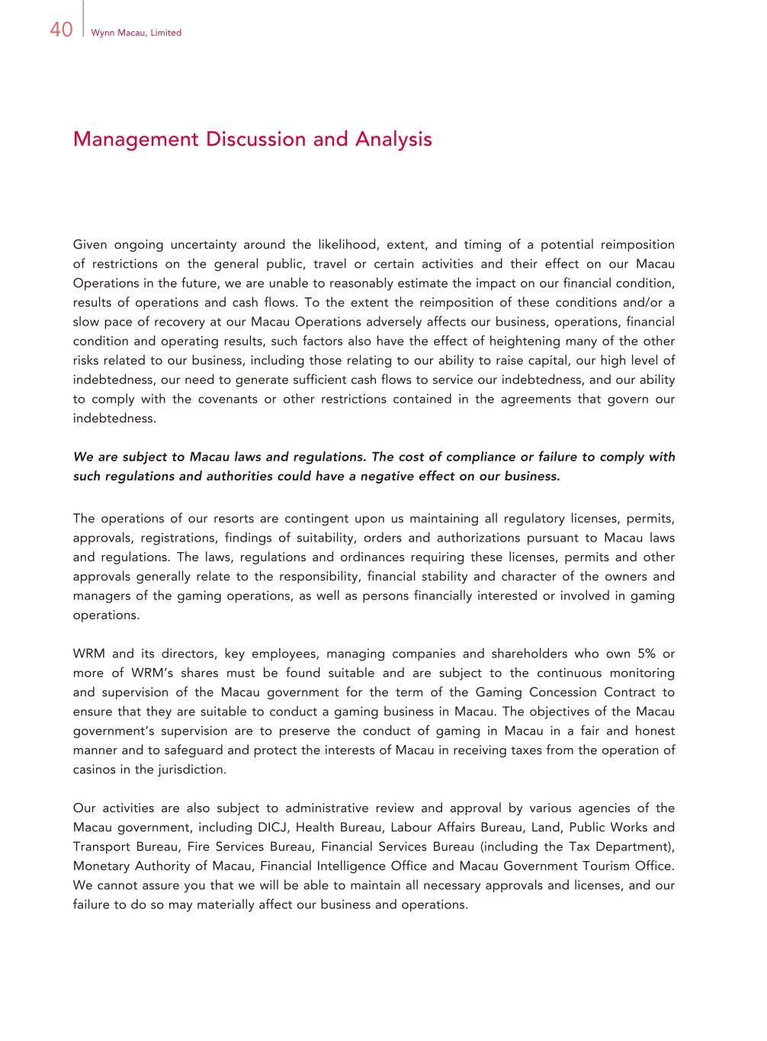
40 Wynn Macau, Limited Management Discussion and Analysis Given ongoing uncertainty around the likelihood, extent, and timing of a potential reimposition of restrictions on the general public, travel or certain activities and their effect on our Macau Operations in the future, we are unable to reasonably estimate the impact on our financial condition, results of operations and cash flows. To the extent the reimposition of these conditions and/or a slow pace of recovery at our Macau Operations adversely affects our business, operations, financial condition and operating results, such factors also have the effect of heightening many of the other risks related to our business, including those relating to our ability to raise capital, our high level of indebtedness, our need to generate sufficient cash flows to service our indebtedness, and our ability to comply with the covenants or other restrictions contained in the agreements that govern our indebtedness. We are subject to Macau laws and regulations. The cost of compliance or failure to comply with such regulations and authorities could have a negative effect on our business. The operations of our resorts are contingent upon us maintaining all regulatory licenses, permits, approvals, registrations, findings of suitability, orders and authorizations pursuant to Macau laws and regulations. The laws, regulations and ordinances requiring these licenses, permits and other approvals generally relate to the responsibility, financial stability and character of the owners and managers of the gaming operations, as well as persons financially interested or involved in gaming operations. WRM and its directors, key employees, managing companies and shareholders who own 5% or more of WRM’s shares must be found suitable and are subject to the continuous monitoring and supervision of the Macau government for the term of the Gaming Concession Contract to ensure that they are suitable to conduct a gaming business in Macau. The objectives of the Macau government’s supervision are to preserve the conduct of gaming in Macau in a fair and honest manner and to safeguard and protect the interests of Macau in receiving taxes from the operation of casinos in the jurisdiction. Our activities are also subject to administrative review and approval by various agencies of the Macau government, including DICJ, Health Bureau, Labour Affairs Bureau, Land, Public Works and Transport Bureau, Fire Services Bureau, Financial Services Bureau (including the Tax Department), Monetary Authority of Macau, Financial Intelligence Office and Macau Government Tourism Office. We cannot assure you that we will be able to maintain all necessary approvals and licenses, and our failure to do so may materially affect our business and operations.

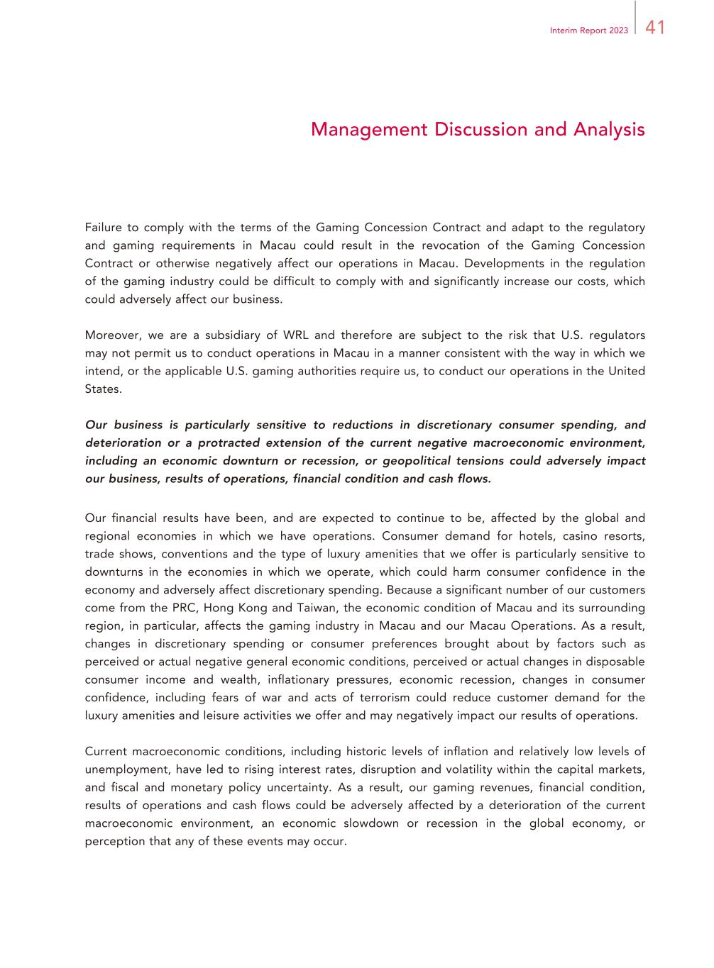
41Interim Report 2023 Management Discussion and Analysis Failure to comply with the terms of the Gaming Concession Contract and adapt to the regulatory and gaming requirements in Macau could result in the revocation of the Gaming Concession Contract or otherwise negatively affect our operations in Macau. Developments in the regulation of the gaming industry could be difficult to comply with and significantly increase our costs, which could adversely affect our business. Moreover, we are a subsidiary of WRL and therefore are subject to the risk that U.S. regulators may not permit us to conduct operations in Macau in a manner consistent with the way in which we intend, or the applicable U.S. gaming authorities require us, to conduct our operations in the United States. Our business is particularly sensitive to reductions in discretionary consumer spending, and deterioration or a protracted extension of the current negative macroeconomic environment, including an economic downturn or recession, or geopolitical tensions could adversely impact our business, results of operations, financial condition and cash flows. Our financial results have been, and are expected to continue to be, affected by the global and regional economies in which we have operations. Consumer demand for hotels, casino resorts, trade shows, conventions and the type of luxury amenities that we offer is particularly sensitive to downturns in the economies in which we operate, which could harm consumer confidence in the economy and adversely affect discretionary spending. Because a significant number of our customers come from the PRC, Hong Kong and Taiwan, the economic condition of Macau and its surrounding region, in particular, affects the gaming industry in Macau and our Macau Operations. As a result, changes in discretionary spending or consumer preferences brought about by factors such as perceived or actual negative general economic conditions, perceived or actual changes in disposable consumer income and wealth, inflationary pressures, economic recession, changes in consumer confidence, including fears of war and acts of terrorism could reduce customer demand for the luxury amenities and leisure activities we offer and may negatively impact our results of operations. Current macroeconomic conditions, including historic levels of inflation and relatively low levels of unemployment, have led to rising interest rates, disruption and volatility within the capital markets, and fiscal and monetary policy uncertainty. As a result, our gaming revenues, financial condition, results of operations and cash flows could be adversely affected by a deterioration of the current macroeconomic environment, an economic slowdown or recession in the global economy, or perception that any of these events may occur.

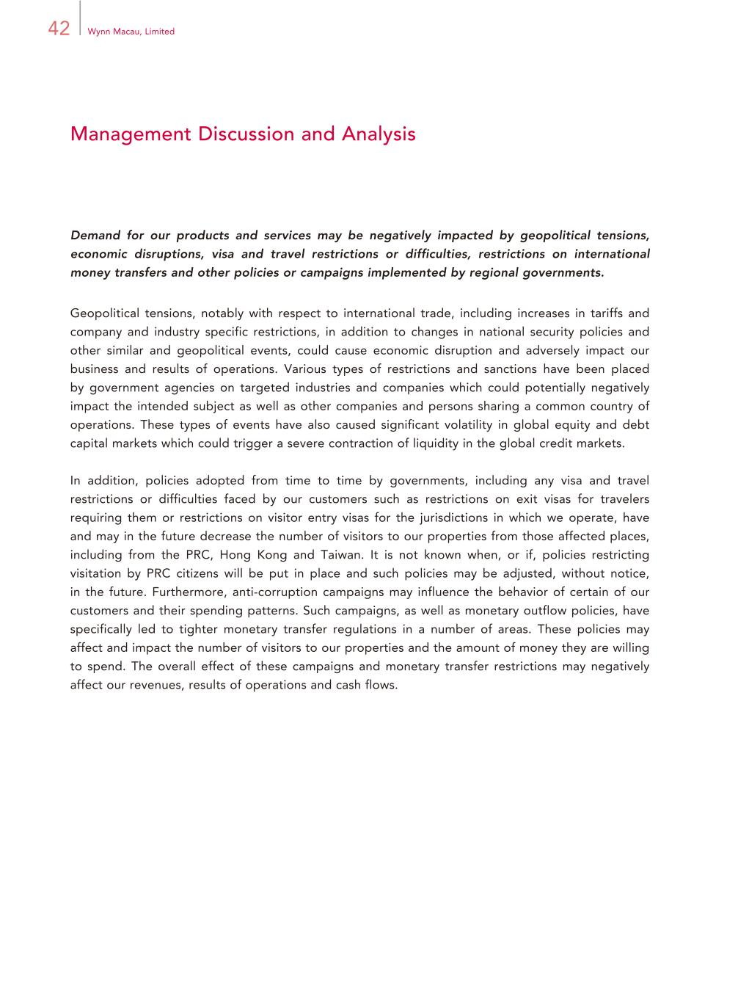
42 Wynn Macau, Limited Management Discussion and Analysis Demand for our products and services may be negatively impacted by geopolitical tensions, economic disruptions, visa and travel restrictions or difficulties, restrictions on international money transfers and other policies or campaigns implemented by regional governments. Geopolitical tensions, notably with respect to international trade, including increases in tariffs and company and industry specific restrictions, in addition to changes in national security policies and other similar and geopolitical events, could cause economic disruption and adversely impact our business and results of operations. Various types of restrictions and sanctions have been placed by government agencies on targeted industries and companies which could potentially negatively impact the intended subject as well as other companies and persons sharing a common country of operations. These types of events have also caused significant volatility in global equity and debt capital markets which could trigger a severe contraction of liquidity in the global credit markets. In addition, policies adopted from time to time by governments, including any visa and travel restrictions or difficulties faced by our customers such as restrictions on exit visas for travelers requiring them or restrictions on visitor entry visas for the jurisdictions in which we operate, have and may in the future decrease the number of visitors to our properties from those affected places, including from the PRC, Hong Kong and Taiwan. It is not known when, or if, policies restricting visitation by PRC citizens will be put in place and such policies may be adjusted, without notice, in the future. Furthermore, anti-corruption campaigns may influence the behavior of certain of our customers and their spending patterns. Such campaigns, as well as monetary outflow policies, have specifically led to tighter monetary transfer regulations in a number of areas. These policies may affect and impact the number of visitors to our properties and the amount of money they are willing to spend. The overall effect of these campaigns and monetary transfer restrictions may negatively affect our revenues, results of operations and cash flows.

43Interim Report 2023 Management Discussion and Analysis Investigations, litigation and other disputes could distract management, damage our reputation and result in negative publicity and additional scrutiny from regulators. We are subject to various investigations, litigation and other disputes related to our operations. These and any additional such matters that may arise in the future, even if routine, are expensive and divert management’s attention from the operations of our businesses. In addition, improper conduct by our employees, agents or gaming promoters could damage our reputation and/or lead to litigation or legal proceedings that could result in civil or criminal penalties, including substantial monetary fines. In certain circumstances, it may not be economical to defend against such matters and/or our legal strategy may not ultimately result in us prevailing in a matter. Investigations, litigation and other disputes have in the past, and may in the future, lead to additional scrutiny from regulators, which could lead to investigations relating to, and possibly a negative impact on, the Group’s gaming licenses and the Group’s ability to bid successfully for new gaming market opportunities. In addition, publicity from these matters have, or in the future, could negatively impact our business, reputation and competitive position and reduce investor demand for our shares and negatively impact the trading prices of our shares. We depend on the continued services of key managers and employees. If we do not retain our key personnel or attract and retain other highly skilled employees, our business will suffer. Our ability to maintain our competitive position is dependent to a large degree on the services of our senior management team. Our success depends upon our ability to attract, hire, and retain qualified operating, marketing, financial, and technical personnel in the future. We rely on the continued services of key managers and an adequate number of qualified employees to achieve our goals and to deliver our high service standards. There is intense competition for labor resources in Macau due to the limited supply of local-Macau labor and imported-labor restrictions and quotas. Competition in Macau for key managers and qualified employees is further exacerbated by the labor needs of large-scale resorts that have recently opened or are expected to open in the future and other opportunities for local-Macau labor. If we are unable to obtain, attract, retain and train key managers and an adequate number of qualified employees, and obtain any required visas or work permits for our staff, our ability to adequately manage and staff our operations and development projects could be impaired, which could have a material adverse effect on our business, financial condition, results of operations and cash flows. The loss of key management and operating personnel would likely have a material adverse effect on our business, prospects, financial condition, and results of operations.

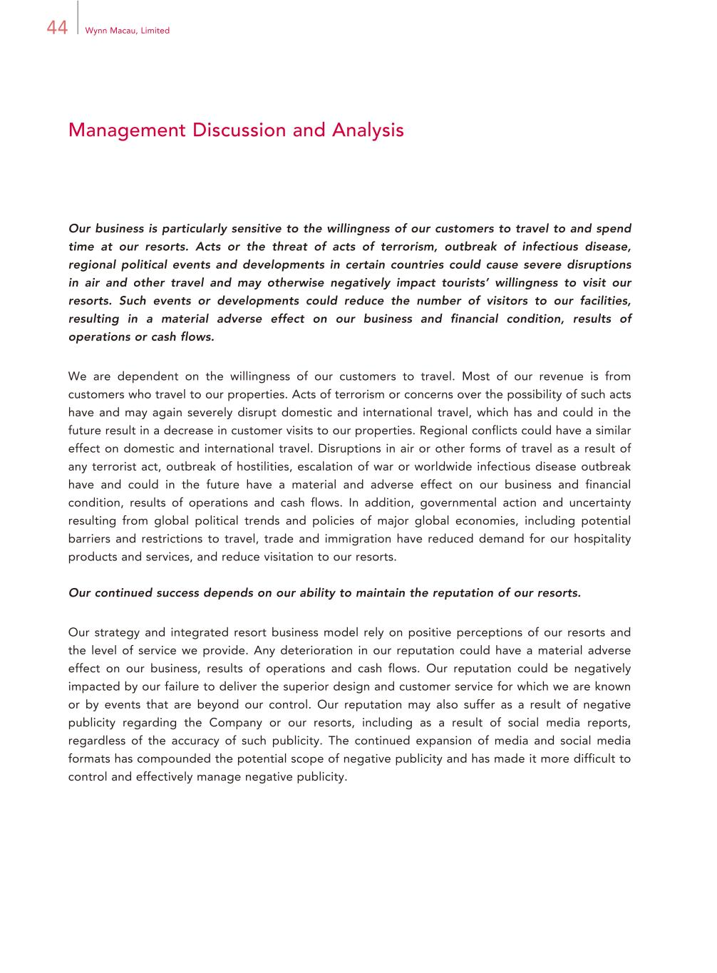
44 Wynn Macau, Limited Management Discussion and Analysis Our business is particularly sensitive to the willingness of our customers to travel to and spend time at our resorts. Acts or the threat of acts of terrorism, outbreak of infectious disease, regional political events and developments in certain countries could cause severe disruptions in air and other travel and may otherwise negatively impact tourists’ willingness to visit our resorts. Such events or developments could reduce the number of visitors to our facilities, resulting in a material adverse effect on our business and financial condition, results of operations or cash flows. We are dependent on the willingness of our customers to travel. Most of our revenue is from customers who travel to our properties. Acts of terrorism or concerns over the possibility of such acts have and may again severely disrupt domestic and international travel, which has and could in the future result in a decrease in customer visits to our properties. Regional conflicts could have a similar effect on domestic and international travel. Disruptions in air or other forms of travel as a result of any terrorist act, outbreak of hostilities, escalation of war or worldwide infectious disease outbreak have and could in the future have a material and adverse effect on our business and financial condition, results of operations and cash flows. In addition, governmental action and uncertainty resulting from global political trends and policies of major global economies, including potential barriers and restrictions to travel, trade and immigration have reduced demand for our hospitality products and services, and reduce visitation to our resorts. Our continued success depends on our ability to maintain the reputation of our resorts. Our strategy and integrated resort business model rely on positive perceptions of our resorts and the level of service we provide. Any deterioration in our reputation could have a material adverse effect on our business, results of operations and cash flows. Our reputation could be negatively impacted by our failure to deliver the superior design and customer service for which we are known or by events that are beyond our control. Our reputation may also suffer as a result of negative publicity regarding the Company or our resorts, including as a result of social media reports, regardless of the accuracy of such publicity. The continued expansion of media and social media formats has compounded the potential scope of negative publicity and has made it more difficult to control and effectively manage negative publicity.

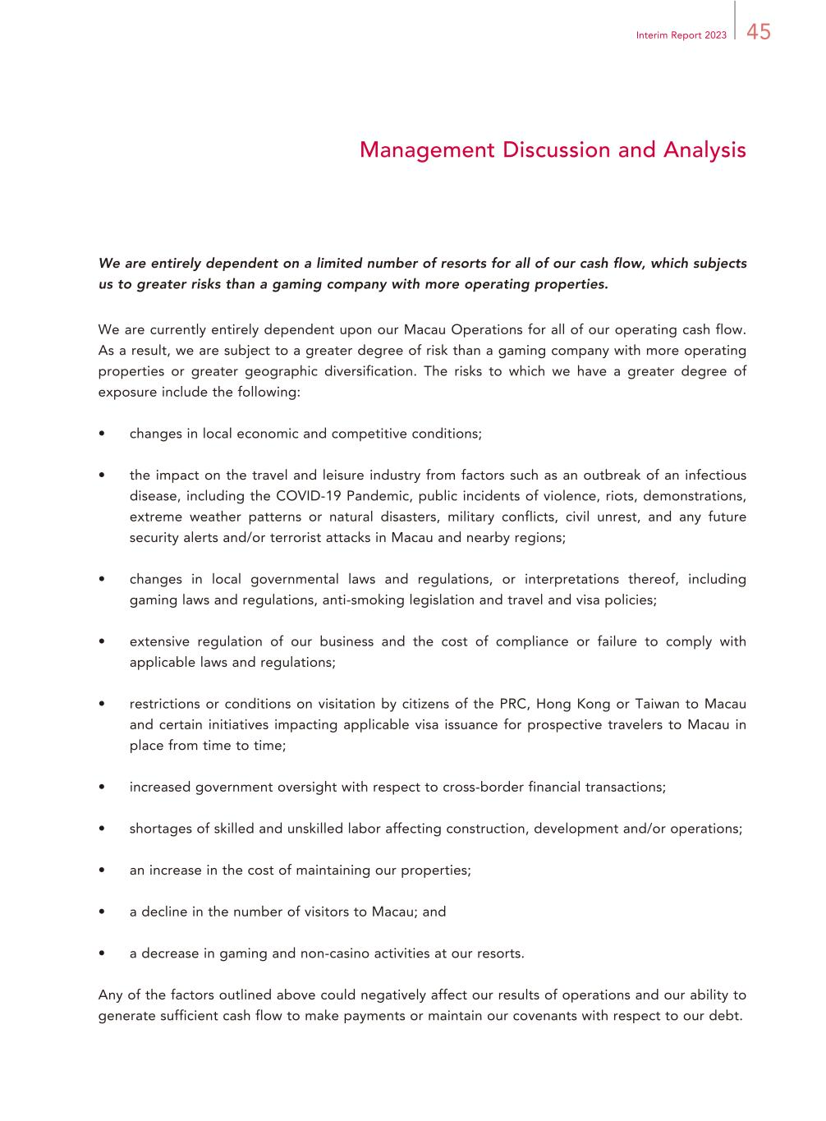
45Interim Report 2023 Management Discussion and Analysis We are entirely dependent on a limited number of resorts for all of our cash flow, which subjects us to greater risks than a gaming company with more operating properties. We are currently entirely dependent upon our Macau Operations for all of our operating cash flow. As a result, we are subject to a greater degree of risk than a gaming company with more operating properties or greater geographic diversification. The risks to which we have a greater degree of exposure include the following: • changes in local economic and competitive conditions; • the impact on the travel and leisure industry from factors such as an outbreak of an infectious disease, including the COVID-19 Pandemic, public incidents of violence, riots, demonstrations, extreme weather patterns or natural disasters, military conflicts, civil unrest, and any future security alerts and/or terrorist attacks in Macau and nearby regions; • changes in local governmental laws and regulations, or interpretations thereof, including gaming laws and regulations, anti-smoking legislation and travel and visa policies; • extensive regulation of our business and the cost of compliance or failure to comply with applicable laws and regulations; • restrictions or conditions on visitation by citizens of the PRC, Hong Kong or Taiwan to Macau and certain initiatives impacting applicable visa issuance for prospective travelers to Macau in place from time to time; • increased government oversight with respect to cross-border financial transactions; • shortages of skilled and unskilled labor affecting construction, development and/or operations; • an increase in the cost of maintaining our properties; • a decline in the number of visitors to Macau; and • a decrease in gaming and non-casino activities at our resorts. Any of the factors outlined above could negatively affect our results of operations and our ability to generate sufficient cash flow to make payments or maintain our covenants with respect to our debt.

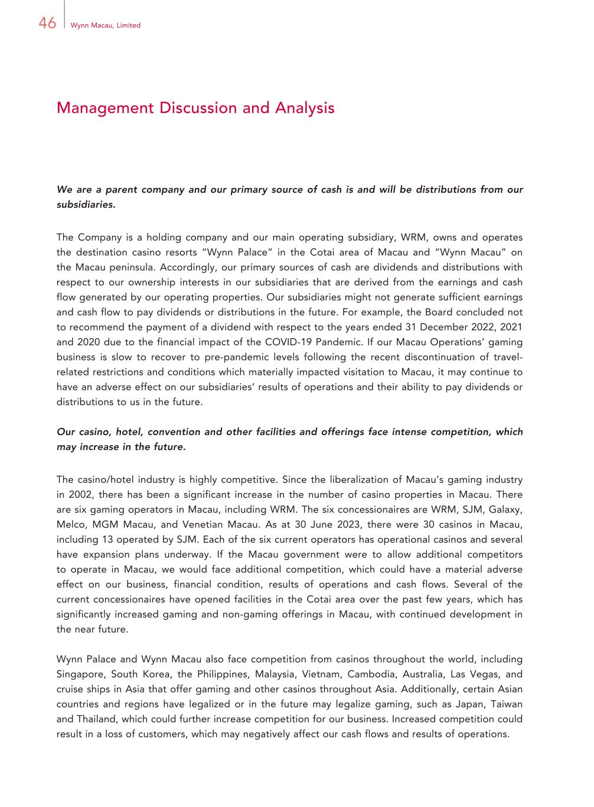
46 Wynn Macau, Limited Management Discussion and Analysis We are a parent company and our primary source of cash is and will be distributions from our subsidiaries. The Company is a holding company and our main operating subsidiary, WRM, owns and operates the destination casino resorts “Wynn Palace” in the Cotai area of Macau and “Wynn Macau” on the Macau peninsula. Accordingly, our primary sources of cash are dividends and distributions with respect to our ownership interests in our subsidiaries that are derived from the earnings and cash flow generated by our operating properties. Our subsidiaries might not generate sufficient earnings and cash flow to pay dividends or distributions in the future. For example, the Board concluded not to recommend the payment of a dividend with respect to the years ended 31 December 2022, 2021 and 2020 due to the financial impact of the COVID-19 Pandemic. If our Macau Operations’ gaming business is slow to recover to pre-pandemic levels following the recent discontinuation of travel- related restrictions and conditions which materially impacted visitation to Macau, it may continue to have an adverse effect on our subsidiaries’ results of operations and their ability to pay dividends or distributions to us in the future. Our casino, hotel, convention and other facilities and offerings face intense competition, which may increase in the future. The casino/hotel industry is highly competitive. Since the liberalization of Macau’s gaming industry in 2002, there has been a significant increase in the number of casino properties in Macau. There are six gaming operators in Macau, including WRM. The six concessionaires are WRM, SJM, Galaxy, Melco, MGM Macau, and Venetian Macau. As at 30 June 2023, there were 30 casinos in Macau, including 13 operated by SJM. Each of the six current operators has operational casinos and several have expansion plans underway. If the Macau government were to allow additional competitors to operate in Macau, we would face additional competition, which could have a material adverse effect on our business, financial condition, results of operations and cash flows. Several of the current concessionaires have opened facilities in the Cotai area over the past few years, which has significantly increased gaming and non-gaming offerings in Macau, with continued development in the near future. Wynn Palace and Wynn Macau also face competition from casinos throughout the world, including Singapore, South Korea, the Philippines, Malaysia, Vietnam, Cambodia, Australia, Las Vegas, and cruise ships in Asia that offer gaming and other casinos throughout Asia. Additionally, certain Asian countries and regions have legalized or in the future may legalize gaming, such as Japan, Taiwan and Thailand, which could further increase competition for our business. Increased competition could result in a loss of customers, which may negatively affect our cash flows and results of operations.

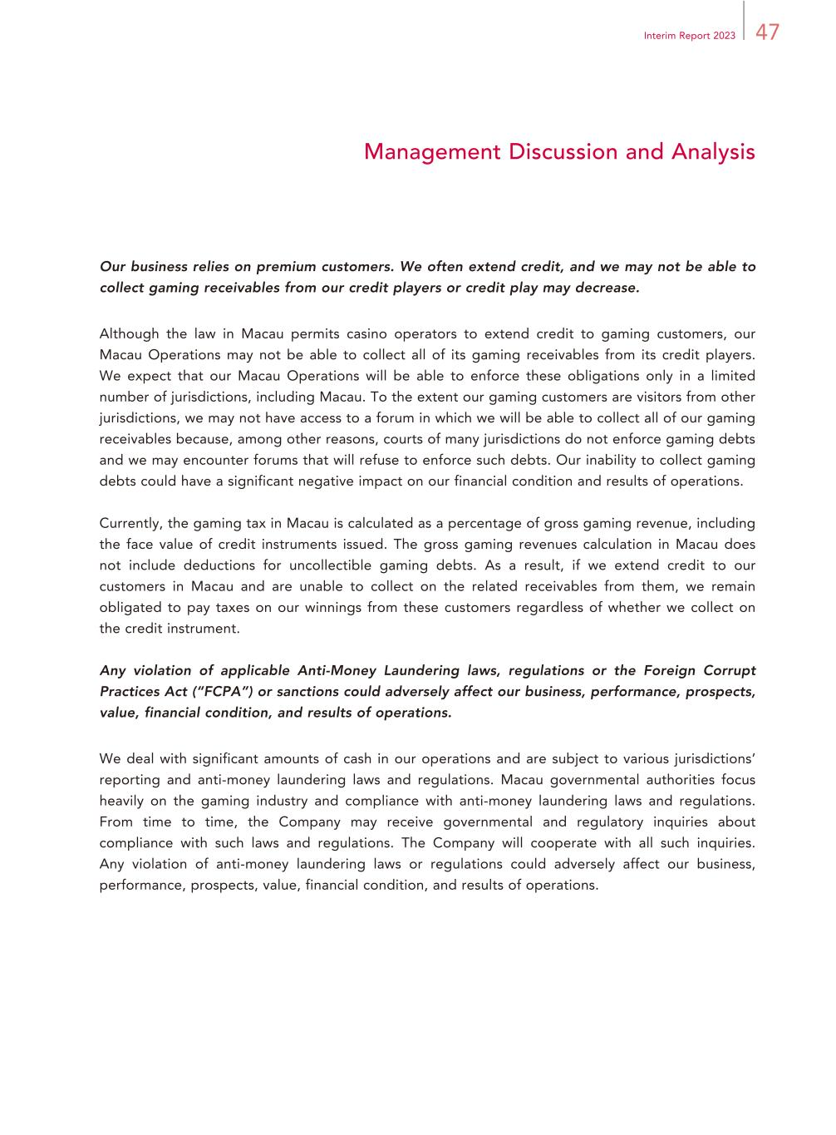
47Interim Report 2023 Management Discussion and Analysis Our business relies on premium customers. We often extend credit, and we may not be able to collect gaming receivables from our credit players or credit play may decrease. Although the law in Macau permits casino operators to extend credit to gaming customers, our Macau Operations may not be able to collect all of its gaming receivables from its credit players. We expect that our Macau Operations will be able to enforce these obligations only in a limited number of jurisdictions, including Macau. To the extent our gaming customers are visitors from other jurisdictions, we may not have access to a forum in which we will be able to collect all of our gaming receivables because, among other reasons, courts of many jurisdictions do not enforce gaming debts and we may encounter forums that will refuse to enforce such debts. Our inability to collect gaming debts could have a significant negative impact on our financial condition and results of operations. Currently, the gaming tax in Macau is calculated as a percentage of gross gaming revenue, including the face value of credit instruments issued. The gross gaming revenues calculation in Macau does not include deductions for uncollectible gaming debts. As a result, if we extend credit to our customers in Macau and are unable to collect on the related receivables from them, we remain obligated to pay taxes on our winnings from these customers regardless of whether we collect on the credit instrument. Any violation of applicable Anti-Money Laundering laws, regulations or the Foreign Corrupt Practices Act (“FCPA”) or sanctions could adversely affect our business, performance, prospects, value, financial condition, and results of operations. We deal with significant amounts of cash in our operations and are subject to various jurisdictions’ reporting and anti-money laundering laws and regulations. Macau governmental authorities focus heavily on the gaming industry and compliance with anti-money laundering laws and regulations. From time to time, the Company may receive governmental and regulatory inquiries about compliance with such laws and regulations. The Company will cooperate with all such inquiries. Any violation of anti-money laundering laws or regulations could adversely affect our business, performance, prospects, value, financial condition, and results of operations.

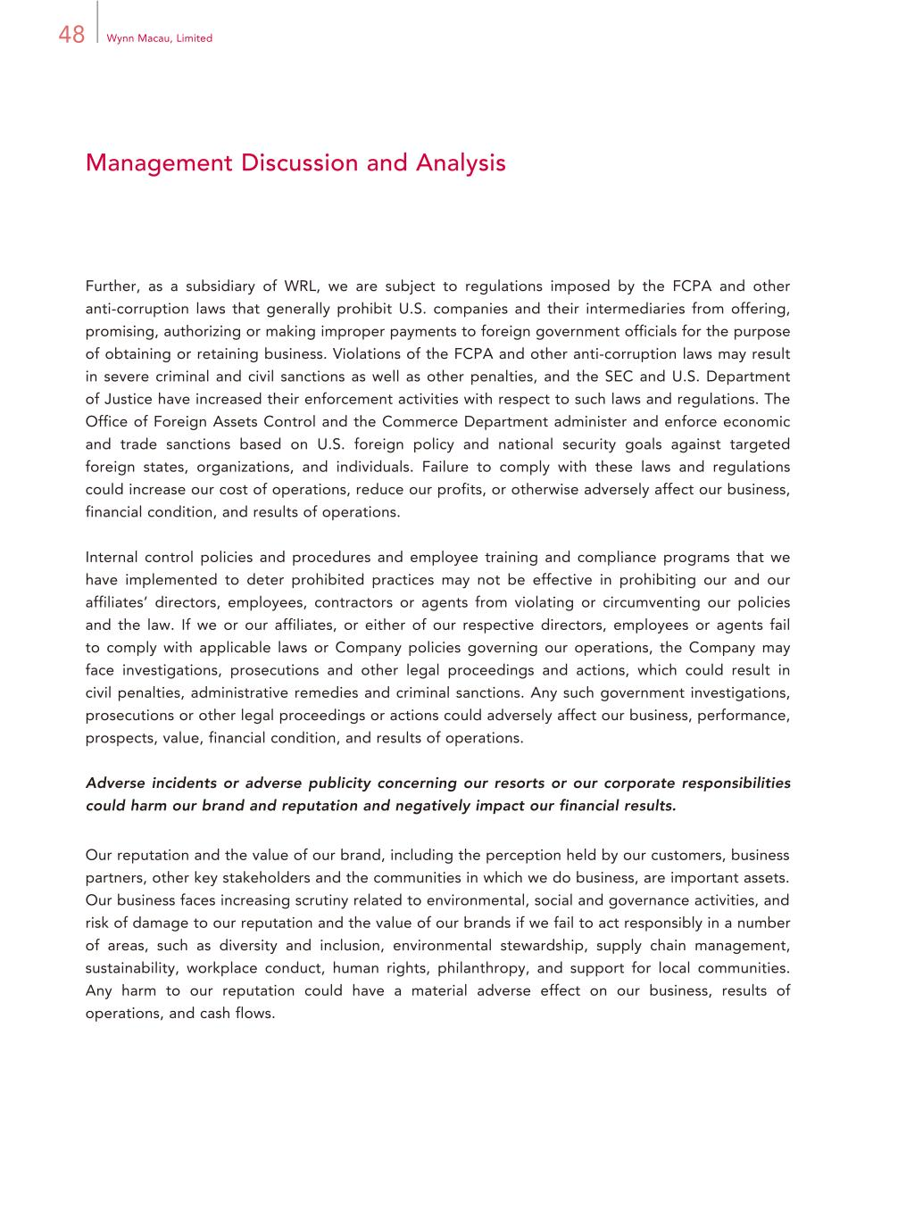
48 Wynn Macau, Limited Management Discussion and Analysis Further, as a subsidiary of WRL, we are subject to regulations imposed by the FCPA and other anti-corruption laws that generally prohibit U.S. companies and their intermediaries from offering, promising, authorizing or making improper payments to foreign government officials for the purpose of obtaining or retaining business. Violations of the FCPA and other anti-corruption laws may result in severe criminal and civil sanctions as well as other penalties, and the SEC and U.S. Department of Justice have increased their enforcement activities with respect to such laws and regulations. The Office of Foreign Assets Control and the Commerce Department administer and enforce economic and trade sanctions based on U.S. foreign policy and national security goals against targeted foreign states, organizations, and individuals. Failure to comply with these laws and regulations could increase our cost of operations, reduce our profits, or otherwise adversely affect our business, financial condition, and results of operations. Internal control policies and procedures and employee training and compliance programs that we have implemented to deter prohibited practices may not be effective in prohibiting our and our affiliates’ directors, employees, contractors or agents from violating or circumventing our policies and the law. If we or our affiliates, or either of our respective directors, employees or agents fail to comply with applicable laws or Company policies governing our operations, the Company may face investigations, prosecutions and other legal proceedings and actions, which could result in civil penalties, administrative remedies and criminal sanctions. Any such government investigations, prosecutions or other legal proceedings or actions could adversely affect our business, performance, prospects, value, financial condition, and results of operations. Adverse incidents or adverse publicity concerning our resorts or our corporate responsibilities could harm our brand and reputation and negatively impact our financial results. Our reputation and the value of our brand, including the perception held by our customers, business partners, other key stakeholders and the communities in which we do business, are important assets. Our business faces increasing scrutiny related to environmental, social and governance activities, and risk of damage to our reputation and the value of our brands if we fail to act responsibly in a number of areas, such as diversity and inclusion, environmental stewardship, supply chain management, sustainability, workplace conduct, human rights, philanthropy, and support for local communities. Any harm to our reputation could have a material adverse effect on our business, results of operations, and cash flows.

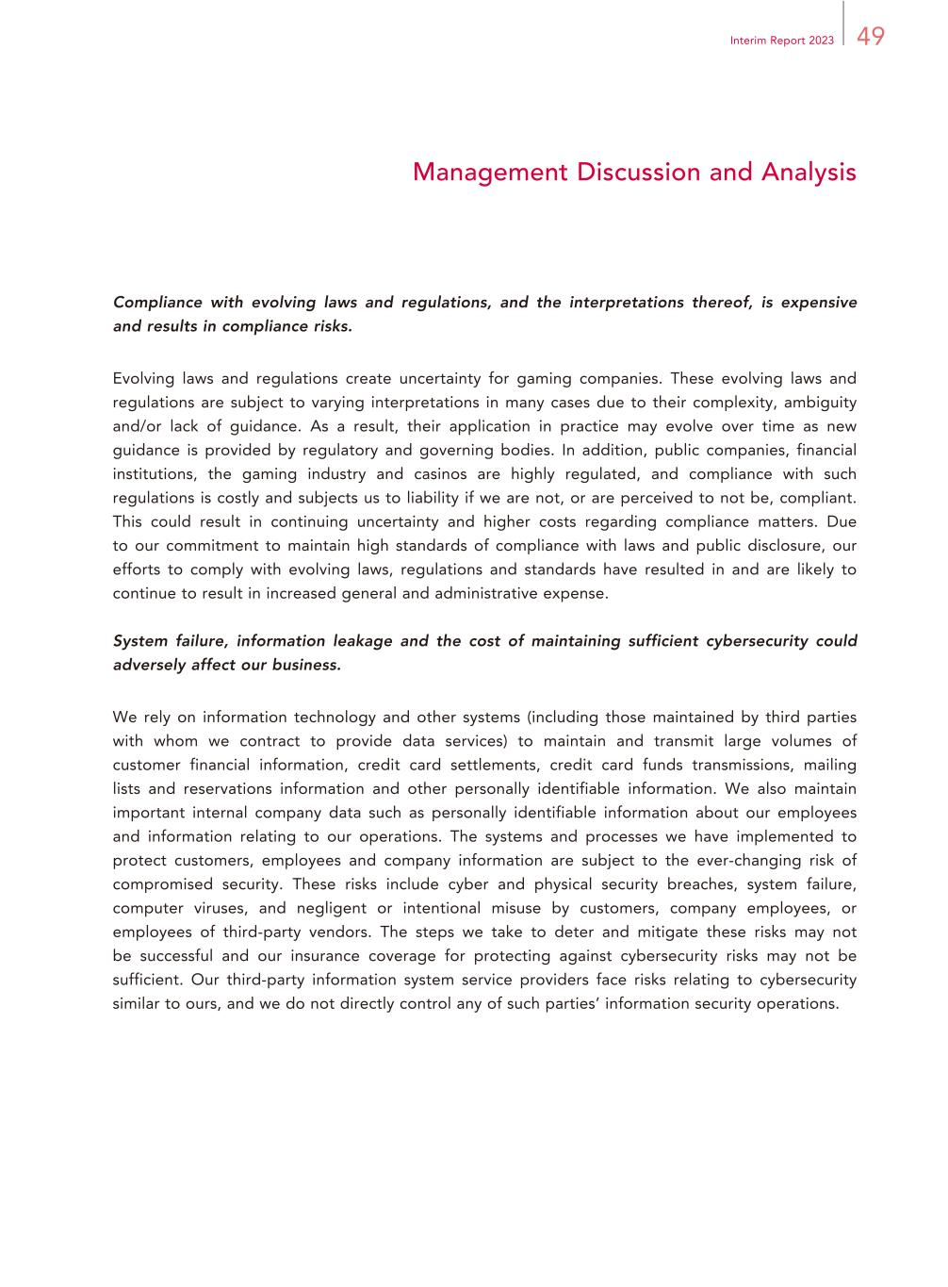
49Interim Report 2023 Management Discussion and Analysis Compliance with evolving laws and regulations, and the interpretations thereof, is expensive and results in compliance risks. Evolving laws and regulations create uncertainty for gaming companies. These evolving laws and regulations are subject to varying interpretations in many cases due to their complexity, ambiguity and/or lack of guidance. As a result, their application in practice may evolve over time as new guidance is provided by regulatory and governing bodies. In addition, public companies, financial institutions, the gaming industry and casinos are highly regulated, and compliance with such regulations is costly and subjects us to liability if we are not, or are perceived to not be, compliant. This could result in continuing uncertainty and higher costs regarding compliance matters. Due to our commitment to maintain high standards of compliance with laws and public disclosure, our efforts to comply with evolving laws, regulations and standards have resulted in and are likely to continue to result in increased general and administrative expense. System failure, information leakage and the cost of maintaining sufficient cybersecurity could adversely affect our business. We rely on information technology and other systems (including those maintained by third parties with whom we contract to provide data services) to maintain and transmit large volumes of customer financial information, credit card settlements, credit card funds transmissions, mailing lists and reservations information and other personally identifiable information. We also maintain important internal company data such as personally identifiable information about our employees and information relating to our operations. The systems and processes we have implemented to protect customers, employees and company information are subject to the ever-changing risk of compromised security. These risks include cyber and physical security breaches, system failure, computer viruses, and negligent or intentional misuse by customers, company employees, or employees of third-party vendors. The steps we take to deter and mitigate these risks may not be successful and our insurance coverage for protecting against cybersecurity risks may not be sufficient. Our third-party information system service providers face risks relating to cybersecurity similar to ours, and we do not directly control any of such parties’ information security operations.

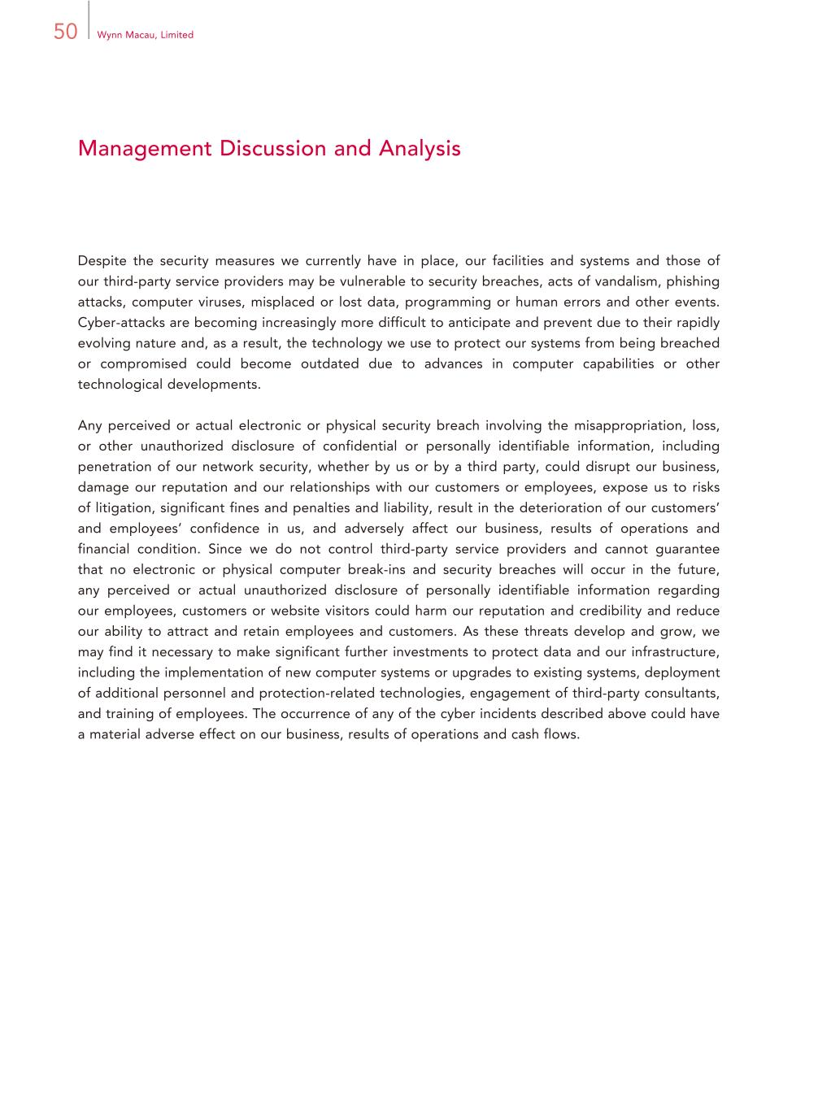
50 Wynn Macau, Limited Management Discussion and Analysis Despite the security measures we currently have in place, our facilities and systems and those of our third-party service providers may be vulnerable to security breaches, acts of vandalism, phishing attacks, computer viruses, misplaced or lost data, programming or human errors and other events. Cyber-attacks are becoming increasingly more difficult to anticipate and prevent due to their rapidly evolving nature and, as a result, the technology we use to protect our systems from being breached or compromised could become outdated due to advances in computer capabilities or other technological developments. Any perceived or actual electronic or physical security breach involving the misappropriation, loss, or other unauthorized disclosure of confidential or personally identifiable information, including penetration of our network security, whether by us or by a third party, could disrupt our business, damage our reputation and our relationships with our customers or employees, expose us to risks of litigation, significant fines and penalties and liability, result in the deterioration of our customers’ and employees’ confidence in us, and adversely affect our business, results of operations and financial condition. Since we do not control third-party service providers and cannot guarantee that no electronic or physical computer break-ins and security breaches will occur in the future, any perceived or actual unauthorized disclosure of personally identifiable information regarding our employees, customers or website visitors could harm our reputation and credibility and reduce our ability to attract and retain employees and customers. As these threats develop and grow, we may find it necessary to make significant further investments to protect data and our infrastructure, including the implementation of new computer systems or upgrades to existing systems, deployment of additional personnel and protection-related technologies, engagement of third-party consultants, and training of employees. The occurrence of any of the cyber incidents described above could have a material adverse effect on our business, results of operations and cash flows.

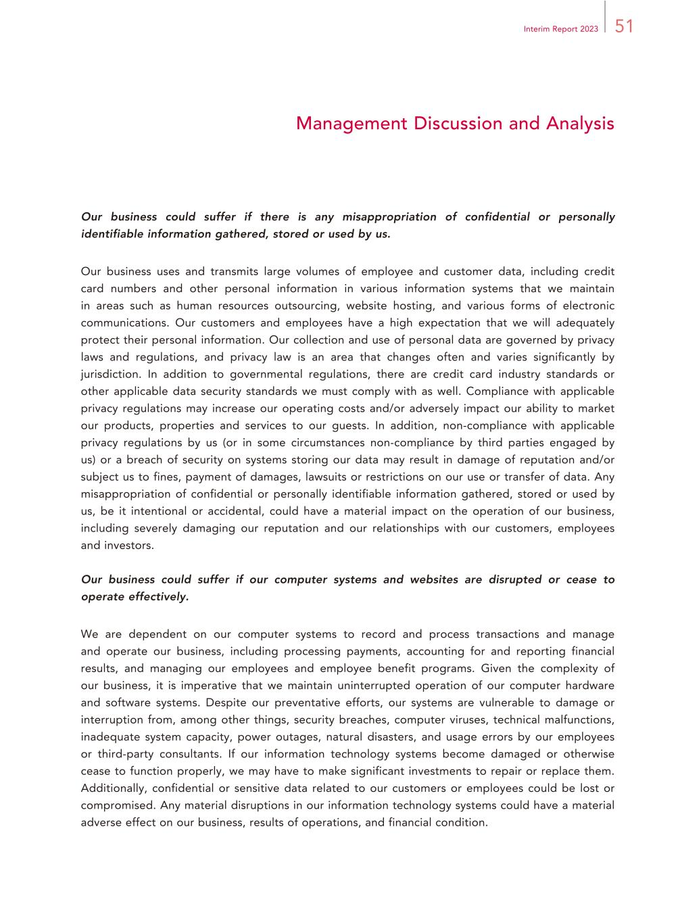
51Interim Report 2023 Management Discussion and Analysis Our business could suffer if there is any misappropriation of confidential or personally identifiable information gathered, stored or used by us. Our business uses and transmits large volumes of employee and customer data, including credit card numbers and other personal information in various information systems that we maintain in areas such as human resources outsourcing, website hosting, and various forms of electronic communications. Our customers and employees have a high expectation that we will adequately protect their personal information. Our collection and use of personal data are governed by privacy laws and regulations, and privacy law is an area that changes often and varies significantly by jurisdiction. In addition to governmental regulations, there are credit card industry standards or other applicable data security standards we must comply with as well. Compliance with applicable privacy regulations may increase our operating costs and/or adversely impact our ability to market our products, properties and services to our guests. In addition, non-compliance with applicable privacy regulations by us (or in some circumstances non-compliance by third parties engaged by us) or a breach of security on systems storing our data may result in damage of reputation and/or subject us to fines, payment of damages, lawsuits or restrictions on our use or transfer of data. Any misappropriation of confidential or personally identifiable information gathered, stored or used by us, be it intentional or accidental, could have a material impact on the operation of our business, including severely damaging our reputation and our relationships with our customers, employees and investors. Our business could suffer if our computer systems and websites are disrupted or cease to operate effectively. We are dependent on our computer systems to record and process transactions and manage and operate our business, including processing payments, accounting for and reporting financial results, and managing our employees and employee benefit programs. Given the complexity of our business, it is imperative that we maintain uninterrupted operation of our computer hardware and software systems. Despite our preventative efforts, our systems are vulnerable to damage or interruption from, among other things, security breaches, computer viruses, technical malfunctions, inadequate system capacity, power outages, natural disasters, and usage errors by our employees or third-party consultants. If our information technology systems become damaged or otherwise cease to function properly, we may have to make significant investments to repair or replace them. Additionally, confidential or sensitive data related to our customers or employees could be lost or compromised. Any material disruptions in our information technology systems could have a material adverse effect on our business, results of operations, and financial condition.

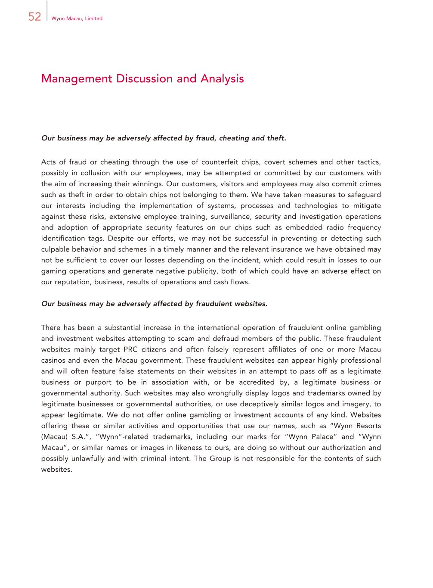
52 Wynn Macau, Limited Management Discussion and Analysis Our business may be adversely affected by fraud, cheating and theft. Acts of fraud or cheating through the use of counterfeit chips, covert schemes and other tactics, possibly in collusion with our employees, may be attempted or committed by our customers with the aim of increasing their winnings. Our customers, visitors and employees may also commit crimes such as theft in order to obtain chips not belonging to them. We have taken measures to safeguard our interests including the implementation of systems, processes and technologies to mitigate against these risks, extensive employee training, surveillance, security and investigation operations and adoption of appropriate security features on our chips such as embedded radio frequency identification tags. Despite our efforts, we may not be successful in preventing or detecting such culpable behavior and schemes in a timely manner and the relevant insurance we have obtained may not be sufficient to cover our losses depending on the incident, which could result in losses to our gaming operations and generate negative publicity, both of which could have an adverse effect on our reputation, business, results of operations and cash flows. Our business may be adversely affected by fraudulent websites. There has been a substantial increase in the international operation of fraudulent online gambling and investment websites attempting to scam and defraud members of the public. These fraudulent websites mainly target PRC citizens and often falsely represent affiliates of one or more Macau casinos and even the Macau government. These fraudulent websites can appear highly professional and will often feature false statements on their websites in an attempt to pass off as a legitimate business or purport to be in association with, or be accredited by, a legitimate business or governmental authority. Such websites may also wrongfully display logos and trademarks owned by legitimate businesses or governmental authorities, or use deceptively similar logos and imagery, to appear legitimate. We do not offer online gambling or investment accounts of any kind. Websites offering these or similar activities and opportunities that use our names, such as “Wynn Resorts (Macau) S.A.”, “Wynn”-related trademarks, including our marks for “Wynn Palace” and “Wynn Macau”, or similar names or images in likeness to ours, are doing so without our authorization and possibly unlawfully and with criminal intent. The Group is not responsible for the contents of such websites.

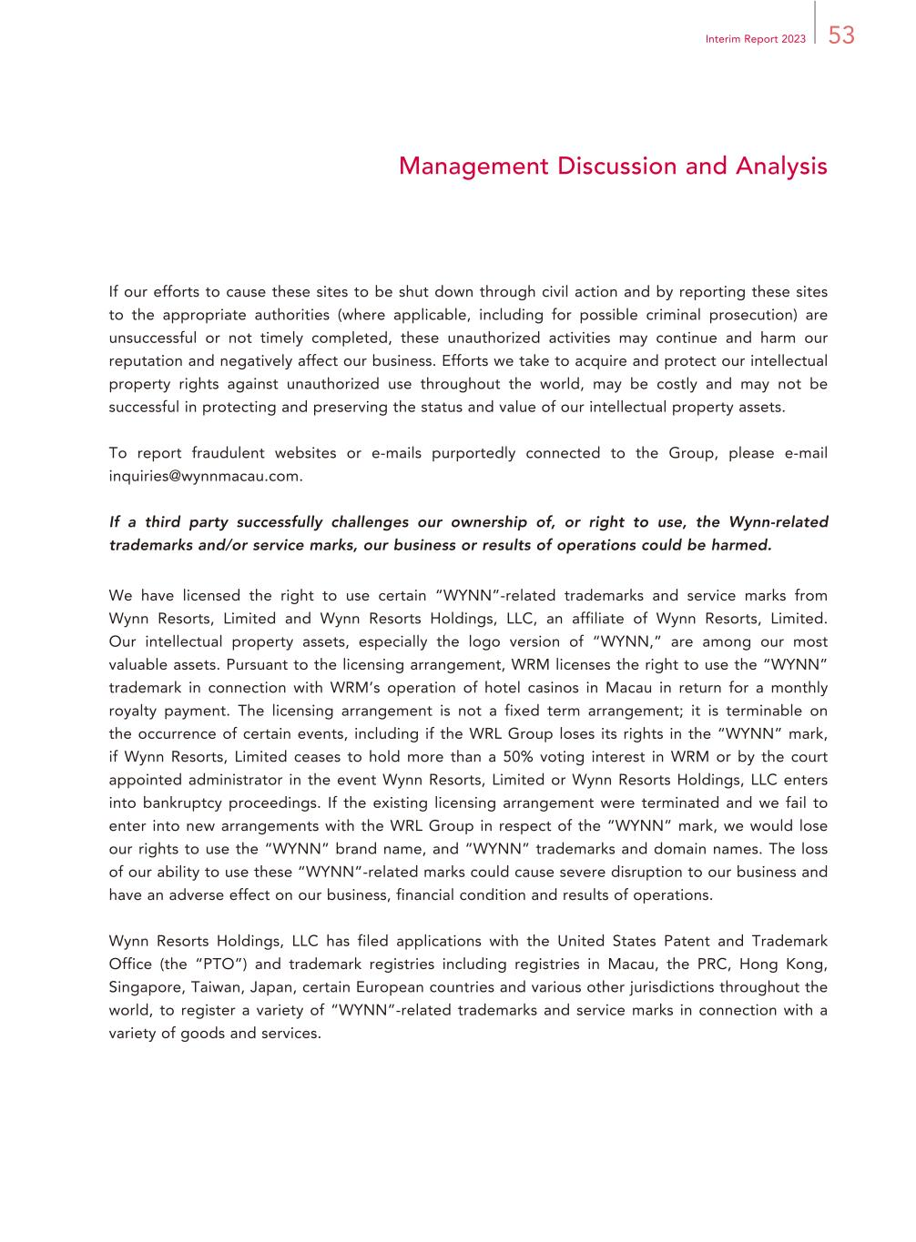
53Interim Report 2023 Management Discussion and Analysis If our efforts to cause these sites to be shut down through civil action and by reporting these sites to the appropriate authorities (where applicable, including for possible criminal prosecution) are unsuccessful or not timely completed, these unauthorized activities may continue and harm our reputation and negatively affect our business. Efforts we take to acquire and protect our intellectual property rights against unauthorized use throughout the world, may be costly and may not be successful in protecting and preserving the status and value of our intellectual property assets. To report fraudulent websites or e-mails purportedly connected to the Group, please e-mail inquiries@wynnmacau.com. If a third party successfully challenges our ownership of, or right to use, the Wynn-related trademarks and/or service marks, our business or results of operations could be harmed. We have licensed the right to use certain “WYNN”-related trademarks and service marks from Wynn Resorts, Limited and Wynn Resorts Holdings, LLC, an affiliate of Wynn Resorts, Limited. Our intellectual property assets, especially the logo version of “WYNN,” are among our most valuable assets. Pursuant to the licensing arrangement, WRM licenses the right to use the “WYNN” trademark in connection with WRM’s operation of hotel casinos in Macau in return for a monthly royalty payment. The licensing arrangement is not a fixed term arrangement; it is terminable on the occurrence of certain events, including if the WRL Group loses its rights in the “WYNN” mark, if Wynn Resorts, Limited ceases to hold more than a 50% voting interest in WRM or by the court appointed administrator in the event Wynn Resorts, Limited or Wynn Resorts Holdings, LLC enters into bankruptcy proceedings. If the existing licensing arrangement were terminated and we fail to enter into new arrangements with the WRL Group in respect of the “WYNN” mark, we would lose our rights to use the “WYNN” brand name, and “WYNN” trademarks and domain names. The loss of our ability to use these “WYNN”-related marks could cause severe disruption to our business and have an adverse effect on our business, financial condition and results of operations. Wynn Resorts Holdings, LLC has filed applications with the United States Patent and Trademark Office (the “PTO”) and trademark registries including registries in Macau, the PRC, Hong Kong, Singapore, Taiwan, Japan, certain European countries and various other jurisdictions throughout the world, to register a variety of “WYNN”-related trademarks and service marks in connection with a variety of goods and services.

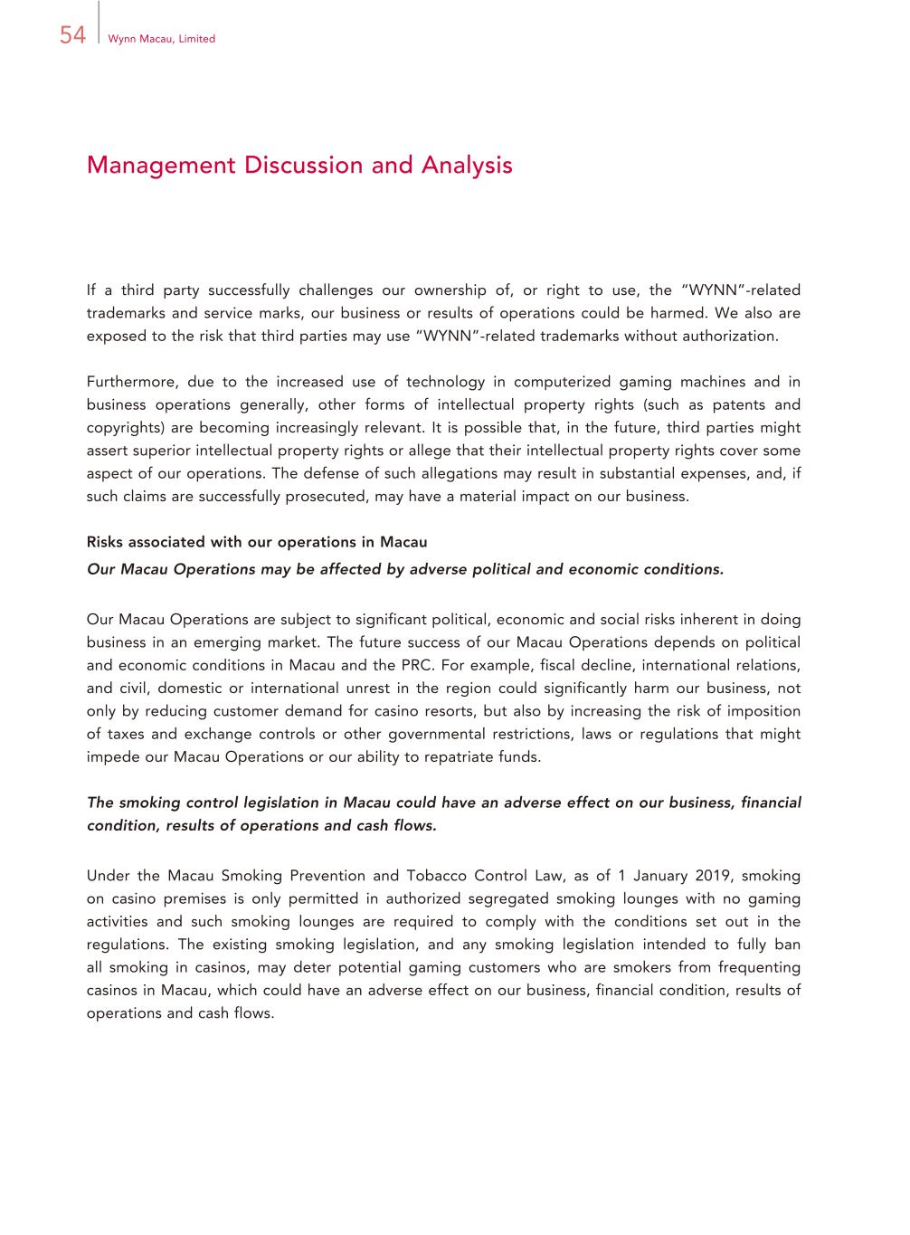
54 Wynn Macau, Limited Management Discussion and Analysis If a third party successfully challenges our ownership of, or right to use, the “WYNN”-related trademarks and service marks, our business or results of operations could be harmed. We also are exposed to the risk that third parties may use “WYNN”-related trademarks without authorization. Furthermore, due to the increased use of technology in computerized gaming machines and in business operations generally, other forms of intellectual property rights (such as patents and copyrights) are becoming increasingly relevant. It is possible that, in the future, third parties might assert superior intellectual property rights or allege that their intellectual property rights cover some aspect of our operations. The defense of such allegations may result in substantial expenses, and, if such claims are successfully prosecuted, may have a material impact on our business. Risks associated with our operations in Macau Our Macau Operations may be affected by adverse political and economic conditions. Our Macau Operations are subject to significant political, economic and social risks inherent in doing business in an emerging market. The future success of our Macau Operations depends on political and economic conditions in Macau and the PRC. For example, fiscal decline, international relations, and civil, domestic or international unrest in the region could significantly harm our business, not only by reducing customer demand for casino resorts, but also by increasing the risk of imposition of taxes and exchange controls or other governmental restrictions, laws or regulations that might impede our Macau Operations or our ability to repatriate funds. The smoking control legislation in Macau could have an adverse effect on our business, financial condition, results of operations and cash flows. Under the Macau Smoking Prevention and Tobacco Control Law, as of 1 January 2019, smoking on casino premises is only permitted in authorized segregated smoking lounges with no gaming activities and such smoking lounges are required to comply with the conditions set out in the regulations. The existing smoking legislation, and any smoking legislation intended to fully ban all smoking in casinos, may deter potential gaming customers who are smokers from frequenting casinos in Macau, which could have an adverse effect on our business, financial condition, results of operations and cash flows.

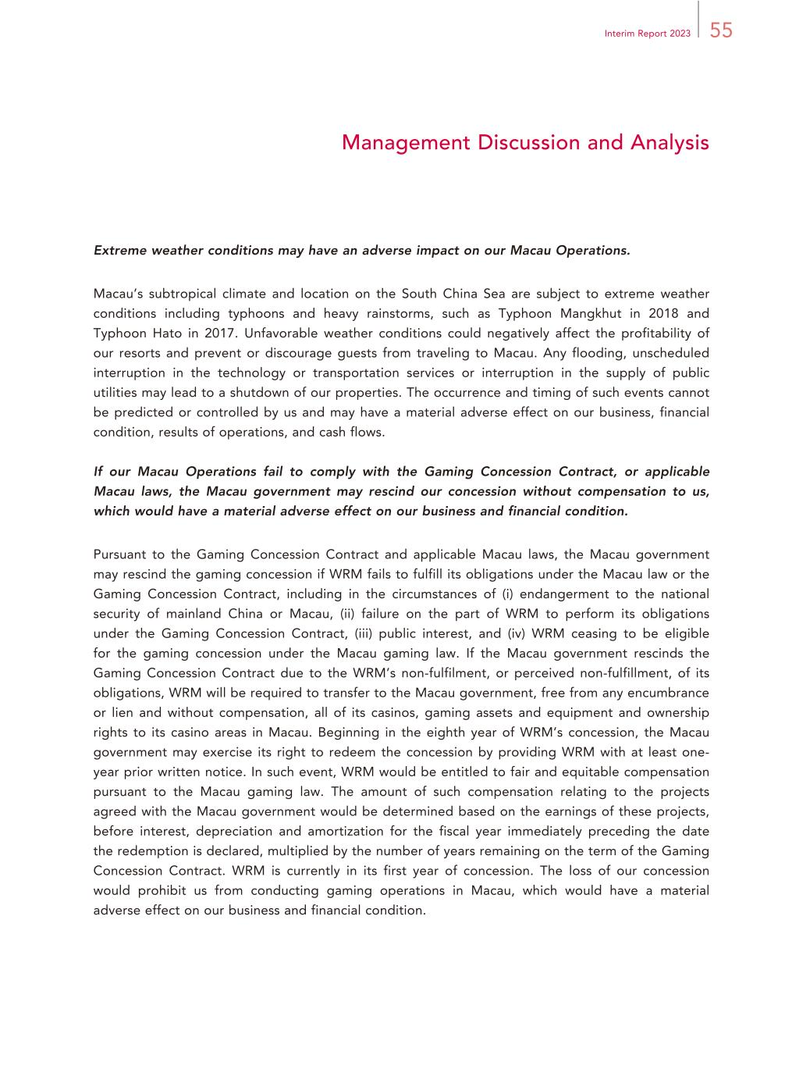
55Interim Report 2023 Management Discussion and Analysis Extreme weather conditions may have an adverse impact on our Macau Operations. Macau’s subtropical climate and location on the South China Sea are subject to extreme weather conditions including typhoons and heavy rainstorms, such as Typhoon Mangkhut in 2018 and Typhoon Hato in 2017. Unfavorable weather conditions could negatively affect the profitability of our resorts and prevent or discourage guests from traveling to Macau. Any flooding, unscheduled interruption in the technology or transportation services or interruption in the supply of public utilities may lead to a shutdown of our properties. The occurrence and timing of such events cannot be predicted or controlled by us and may have a material adverse effect on our business, financial condition, results of operations, and cash flows. If our Macau Operations fail to comply with the Gaming Concession Contract, or applicable Macau laws, the Macau government may rescind our concession without compensation to us, which would have a material adverse effect on our business and financial condition. Pursuant to the Gaming Concession Contract and applicable Macau laws, the Macau government may rescind the gaming concession if WRM fails to fulfill its obligations under the Macau law or the Gaming Concession Contract, including in the circumstances of (i) endangerment to the national security of mainland China or Macau, (ii) failure on the part of WRM to perform its obligations under the Gaming Concession Contract, (iii) public interest, and (iv) WRM ceasing to be eligible for the gaming concession under the Macau gaming law. If the Macau government rescinds the Gaming Concession Contract due to the WRM’s non-fulfilment, or perceived non-fulfillment, of its obligations, WRM will be required to transfer to the Macau government, free from any encumbrance or lien and without compensation, all of its casinos, gaming assets and equipment and ownership rights to its casino areas in Macau. Beginning in the eighth year of WRM’s concession, the Macau government may exercise its right to redeem the concession by providing WRM with at least one- year prior written notice. In such event, WRM would be entitled to fair and equitable compensation pursuant to the Macau gaming law. The amount of such compensation relating to the projects agreed with the Macau government would be determined based on the earnings of these projects, before interest, depreciation and amortization for the fiscal year immediately preceding the date the redemption is declared, multiplied by the number of years remaining on the term of the Gaming Concession Contract. WRM is currently in its first year of concession. The loss of our concession would prohibit us from conducting gaming operations in Macau, which would have a material adverse effect on our business and financial condition.

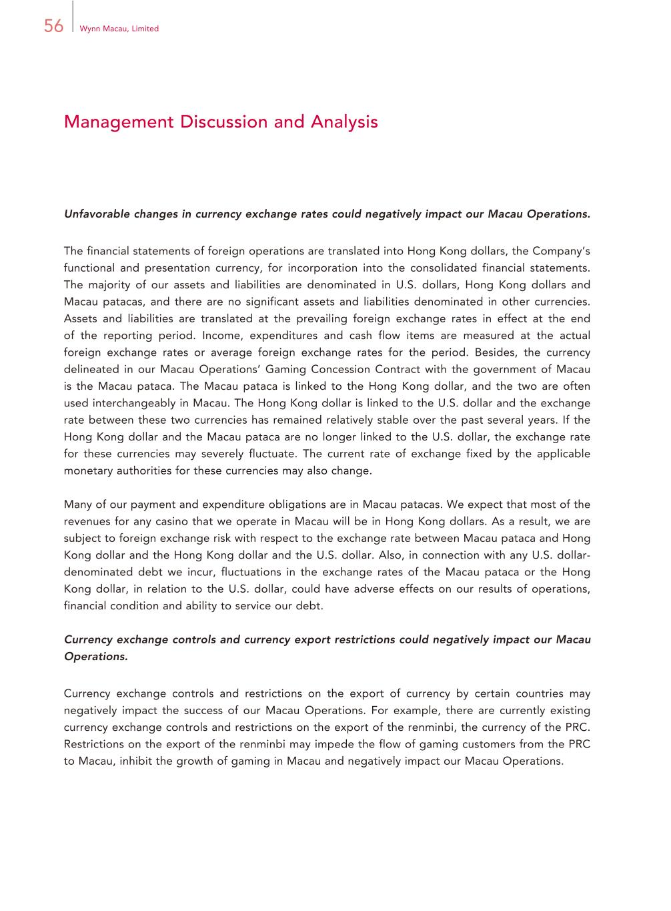
56 Wynn Macau, Limited Management Discussion and Analysis Unfavorable changes in currency exchange rates could negatively impact our Macau Operations. The financial statements of foreign operations are translated into Hong Kong dollars, the Company’s functional and presentation currency, for incorporation into the consolidated financial statements. The majority of our assets and liabilities are denominated in U.S. dollars, Hong Kong dollars and Macau patacas, and there are no significant assets and liabilities denominated in other currencies. Assets and liabilities are translated at the prevailing foreign exchange rates in effect at the end of the reporting period. Income, expenditures and cash flow items are measured at the actual foreign exchange rates or average foreign exchange rates for the period. Besides, the currency delineated in our Macau Operations’ Gaming Concession Contract with the government of Macau is the Macau pataca. The Macau pataca is linked to the Hong Kong dollar, and the two are often used interchangeably in Macau. The Hong Kong dollar is linked to the U.S. dollar and the exchange rate between these two currencies has remained relatively stable over the past several years. If the Hong Kong dollar and the Macau pataca are no longer linked to the U.S. dollar, the exchange rate for these currencies may severely fluctuate. The current rate of exchange fixed by the applicable monetary authorities for these currencies may also change. Many of our payment and expenditure obligations are in Macau patacas. We expect that most of the revenues for any casino that we operate in Macau will be in Hong Kong dollars. As a result, we are subject to foreign exchange risk with respect to the exchange rate between Macau pataca and Hong Kong dollar and the Hong Kong dollar and the U.S. dollar. Also, in connection with any U.S. dollar- denominated debt we incur, fluctuations in the exchange rates of the Macau pataca or the Hong Kong dollar, in relation to the U.S. dollar, could have adverse effects on our results of operations, financial condition and ability to service our debt. Currency exchange controls and currency export restrictions could negatively impact our Macau Operations. Currency exchange controls and restrictions on the export of currency by certain countries may negatively impact the success of our Macau Operations. For example, there are currently existing currency exchange controls and restrictions on the export of the renminbi, the currency of the PRC. Restrictions on the export of the renminbi may impede the flow of gaming customers from the PRC to Macau, inhibit the growth of gaming in Macau and negatively impact our Macau Operations.

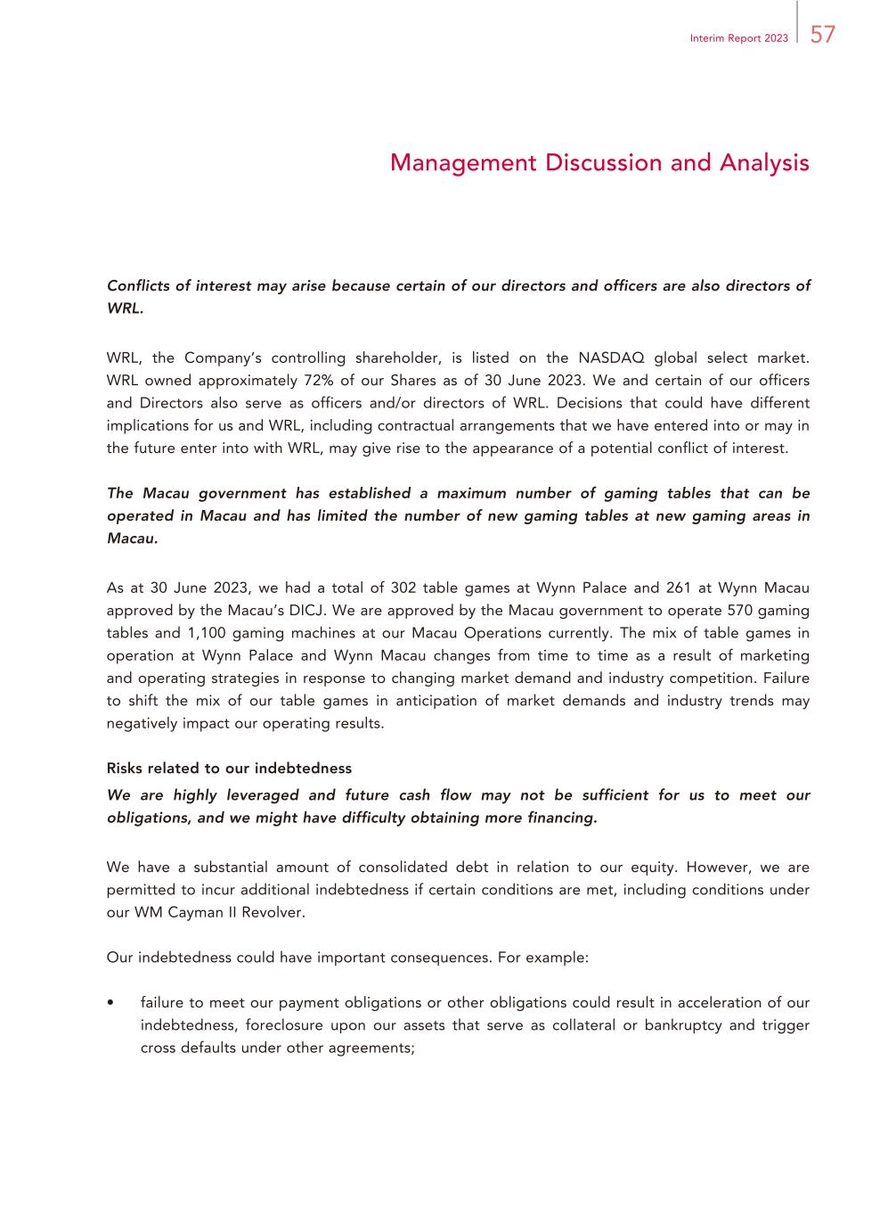
57Interim Report 2023 Management Discussion and Analysis Conflicts of interest may arise because certain of our directors and officers are also directors of WRL. WRL, the Company’s controlling shareholder, is listed on the NASDAQ global select market. WRL owned approximately 72% of our Shares as of 30 June 2023. We and certain of our officers and Directors also serve as officers and/or directors of WRL. Decisions that could have different implications for us and WRL, including contractual arrangements that we have entered into or may in the future enter into with WRL, may give rise to the appearance of a potential conflict of interest. The Macau government has established a maximum number of gaming tables that can be operated in Macau and has limited the number of new gaming tables at new gaming areas in Macau. As at 30 June 2023, we had a total of 302 table games at Wynn Palace and 261 at Wynn Macau approved by the Macau’s DICJ. We are approved by the Macau government to operate 570 gaming tables and 1,100 gaming machines at our Macau Operations currently. The mix of table games in operation at Wynn Palace and Wynn Macau changes from time to time as a result of marketing and operating strategies in response to changing market demand and industry competition. Failure to shift the mix of our table games in anticipation of market demands and industry trends may negatively impact our operating results. Risks related to our indebtedness We are highly leveraged and future cash flow may not be sufficient for us to meet our obligations, and we might have difficulty obtaining more financing. We have a substantial amount of consolidated debt in relation to our equity. However, we are permitted to incur additional indebtedness if certain conditions are met, including conditions under our WM Cayman II Revolver. Our indebtedness could have important consequences. For example: • failure to meet our payment obligations or other obligations could result in acceleration of our indebtedness, foreclosure upon our assets that serve as collateral or bankruptcy and trigger cross defaults under other agreements;

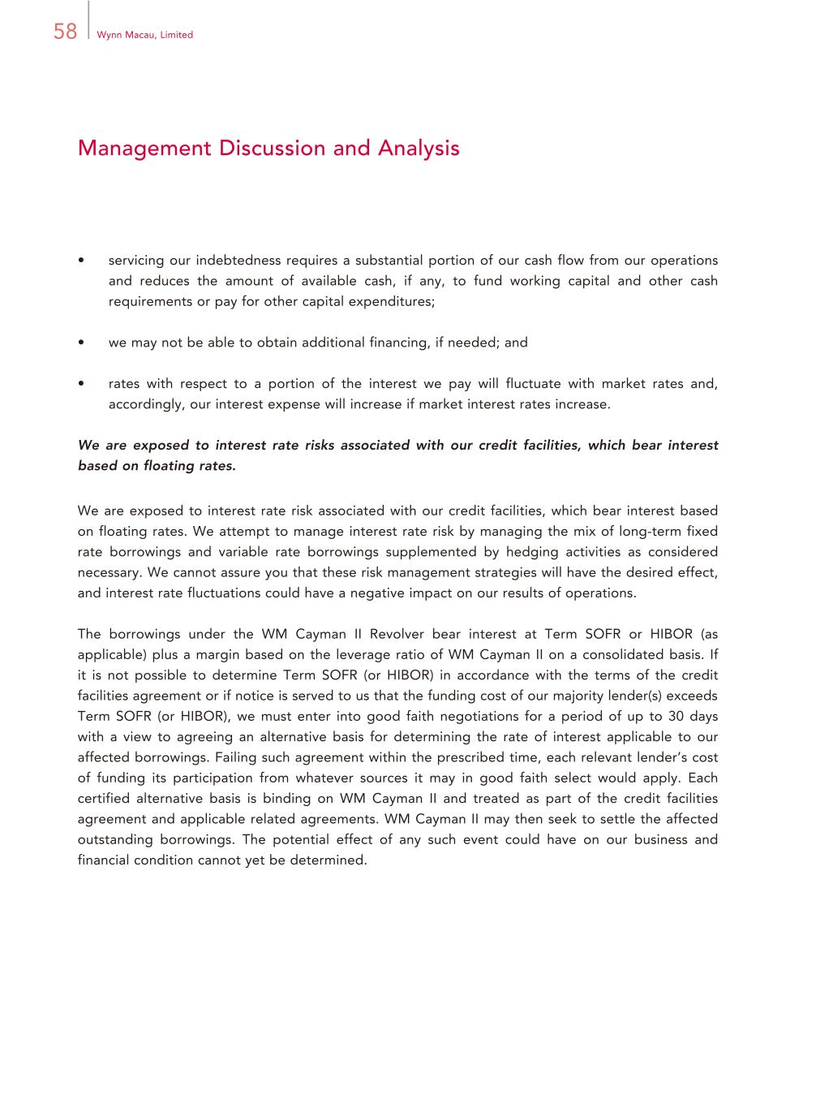
58 Wynn Macau, Limited Management Discussion and Analysis • servicing our indebtedness requires a substantial portion of our cash flow from our operations and reduces the amount of available cash, if any, to fund working capital and other cash requirements or pay for other capital expenditures; • we may not be able to obtain additional financing, if needed; and • rates with respect to a portion of the interest we pay will fluctuate with market rates and, accordingly, our interest expense will increase if market interest rates increase. We are exposed to interest rate risks associated with our credit facilities, which bear interest based on floating rates. We are exposed to interest rate risk associated with our credit facilities, which bear interest based on floating rates. We attempt to manage interest rate risk by managing the mix of long-term fixed rate borrowings and variable rate borrowings supplemented by hedging activities as considered necessary. We cannot assure you that these risk management strategies will have the desired effect, and interest rate fluctuations could have a negative impact on our results of operations. The borrowings under the WM Cayman II Revolver bear interest at Term SOFR or HIBOR (as applicable) plus a margin based on the leverage ratio of WM Cayman II on a consolidated basis. If it is not possible to determine Term SOFR (or HIBOR) in accordance with the terms of the credit facilities agreement or if notice is served to us that the funding cost of our majority lender(s) exceeds Term SOFR (or HIBOR), we must enter into good faith negotiations for a period of up to 30 days with a view to agreeing an alternative basis for determining the rate of interest applicable to our affected borrowings. Failing such agreement within the prescribed time, each relevant lender’s cost of funding its participation from whatever sources it may in good faith select would apply. Each certified alternative basis is binding on WM Cayman II and treated as part of the credit facilities agreement and applicable related agreements. WM Cayman II may then seek to settle the affected outstanding borrowings. The potential effect of any such event could have on our business and financial condition cannot yet be determined.

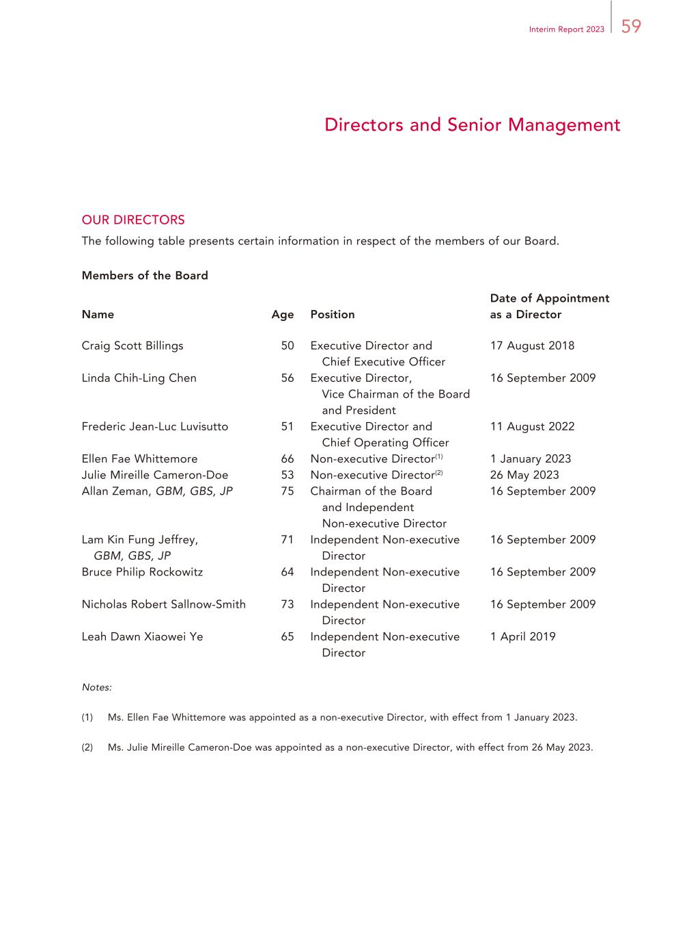
59Interim Report 2023 Directors and Senior Management OUR DIRECTORS The following table presents certain information in respect of the members of our Board. Members of the Board Name Age Position Date of Appointment as a Director Craig Scott Billings 50 Executive Director and Chief Executive Officer 17 August 2018 Linda Chih-Ling Chen 56 Executive Director, Vice Chairman of the Board and President 16 September 2009 Frederic Jean-Luc Luvisutto 51 Executive Director and Chief Operating Officer 11 August 2022 Ellen Fae Whittemore 66 Non-executive Director(1) 1 January 2023 Julie Mireille Cameron-Doe 53 Non-executive Director(2) 26 May 2023 Allan Zeman, GBM, GBS, JP 75 Chairman of the Board and Independent Non-executive Director 16 September 2009 Lam Kin Fung Jeffrey, GBM, GBS, JP 71 Independent Non-executive Director 16 September 2009 Bruce Philip Rockowitz 64 Independent Non-executive Director 16 September 2009 Nicholas Robert Sallnow-Smith 73 Independent Non-executive Director 16 September 2009 Leah Dawn Xiaowei Ye 65 Independent Non-executive Director 1 April 2019 Notes: (1) Ms. Ellen Fae Whittemore was appointed as a non-executive Director, with effect from 1 January 2023. (2) Ms. Julie Mireille Cameron-Doe was appointed as a non-executive Director, with effect from 26 May 2023.

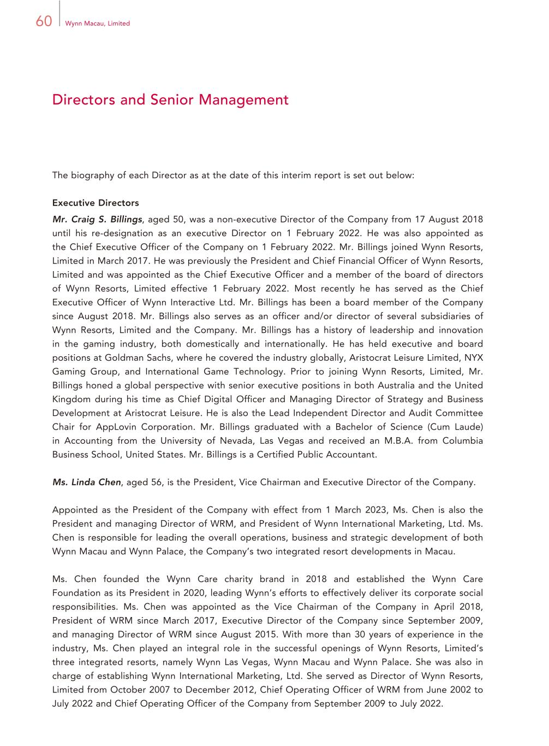
60 Wynn Macau, Limited Directors and Senior Management The biography of each Director as at the date of this interim report is set out below: Executive Directors Mr. Craig S. Billings, aged 50, was a non-executive Director of the Company from 17 August 2018 until his re-designation as an executive Director on 1 February 2022. He was also appointed as the Chief Executive Officer of the Company on 1 February 2022. Mr. Billings joined Wynn Resorts, Limited in March 2017. He was previously the President and Chief Financial Officer of Wynn Resorts, Limited and was appointed as the Chief Executive Officer and a member of the board of directors of Wynn Resorts, Limited effective 1 February 2022. Most recently he has served as the Chief Executive Officer of Wynn Interactive Ltd. Mr. Billings has been a board member of the Company since August 2018. Mr. Billings also serves as an officer and/or director of several subsidiaries of Wynn Resorts, Limited and the Company. Mr. Billings has a history of leadership and innovation in the gaming industry, both domestically and internationally. He has held executive and board positions at Goldman Sachs, where he covered the industry globally, Aristocrat Leisure Limited, NYX Gaming Group, and International Game Technology. Prior to joining Wynn Resorts, Limited, Mr. Billings honed a global perspective with senior executive positions in both Australia and the United Kingdom during his time as Chief Digital Officer and Managing Director of Strategy and Business Development at Aristocrat Leisure. He is also the Lead Independent Director and Audit Committee Chair for AppLovin Corporation. Mr. Billings graduated with a Bachelor of Science (Cum Laude) in Accounting from the University of Nevada, Las Vegas and received an M.B.A. from Columbia Business School, United States. Mr. Billings is a Certified Public Accountant. Ms. Linda Chen, aged 56, is the President, Vice Chairman and Executive Director of the Company. Appointed as the President of the Company with effect from 1 March 2023, Ms. Chen is also the President and managing Director of WRM, and President of Wynn International Marketing, Ltd. Ms. Chen is responsible for leading the overall operations, business and strategic development of both Wynn Macau and Wynn Palace, the Company’s two integrated resort developments in Macau. Ms. Chen founded the Wynn Care charity brand in 2018 and established the Wynn Care Foundation as its President in 2020, leading Wynn’s efforts to effectively deliver its corporate social responsibilities. Ms. Chen was appointed as the Vice Chairman of the Company in April 2018, President of WRM since March 2017, Executive Director of the Company since September 2009, and managing Director of WRM since August 2015. With more than 30 years of experience in the industry, Ms. Chen played an integral role in the successful openings of Wynn Resorts, Limited’s three integrated resorts, namely Wynn Las Vegas, Wynn Macau and Wynn Palace. She was also in charge of establishing Wynn International Marketing, Ltd. She served as Director of Wynn Resorts, Limited from October 2007 to December 2012, Chief Operating Officer of WRM from June 2002 to July 2022 and Chief Operating Officer of the Company from September 2009 to July 2022.

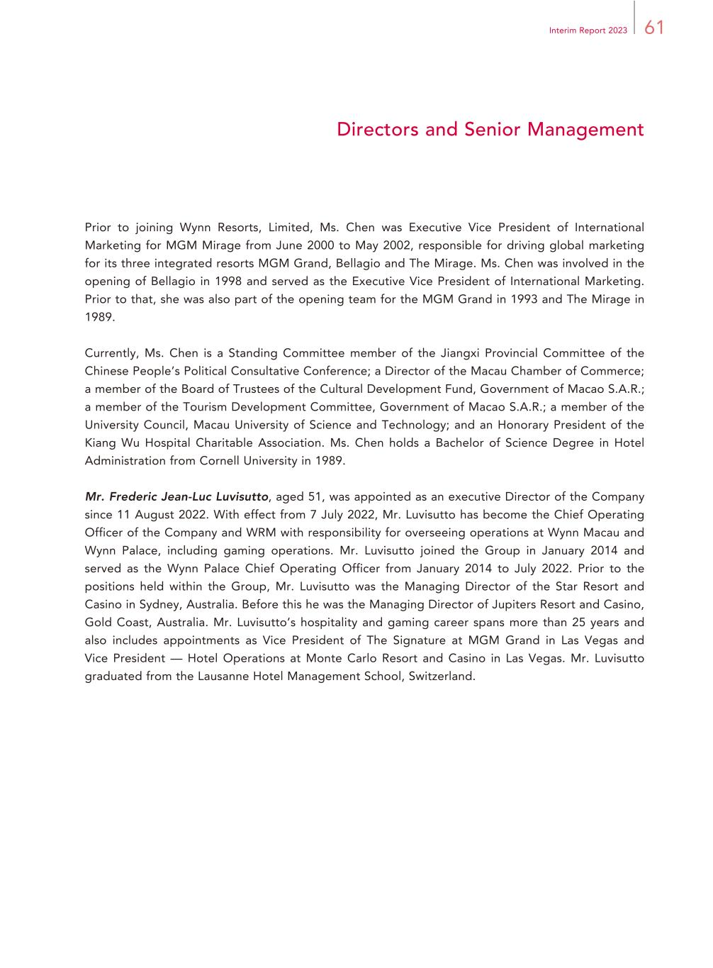
61Interim Report 2023 Directors and Senior Management Prior to joining Wynn Resorts, Limited, Ms. Chen was Executive Vice President of International Marketing for MGM Mirage from June 2000 to May 2002, responsible for driving global marketing for its three integrated resorts MGM Grand, Bellagio and The Mirage. Ms. Chen was involved in the opening of Bellagio in 1998 and served as the Executive Vice President of International Marketing. Prior to that, she was also part of the opening team for the MGM Grand in 1993 and The Mirage in 1989. Currently, Ms. Chen is a Standing Committee member of the Jiangxi Provincial Committee of the Chinese People’s Political Consultative Conference; a Director of the Macau Chamber of Commerce; a member of the Board of Trustees of the Cultural Development Fund, Government of Macao S.A.R.; a member of the Tourism Development Committee, Government of Macao S.A.R.; a member of the University Council, Macau University of Science and Technology; and an Honorary President of the Kiang Wu Hospital Charitable Association. Ms. Chen holds a Bachelor of Science Degree in Hotel Administration from Cornell University in 1989. Mr. Frederic Jean-Luc Luvisutto, aged 51, was appointed as an executive Director of the Company since 11 August 2022. With effect from 7 July 2022, Mr. Luvisutto has become the Chief Operating Officer of the Company and WRM with responsibility for overseeing operations at Wynn Macau and Wynn Palace, including gaming operations. Mr. Luvisutto joined the Group in January 2014 and served as the Wynn Palace Chief Operating Officer from January 2014 to July 2022. Prior to the positions held within the Group, Mr. Luvisutto was the Managing Director of the Star Resort and Casino in Sydney, Australia. Before this he was the Managing Director of Jupiters Resort and Casino, Gold Coast, Australia. Mr. Luvisutto’s hospitality and gaming career spans more than 25 years and also includes appointments as Vice President of The Signature at MGM Grand in Las Vegas and Vice President — Hotel Operations at Monte Carlo Resort and Casino in Las Vegas. Mr. Luvisutto graduated from the Lausanne Hotel Management School, Switzerland.

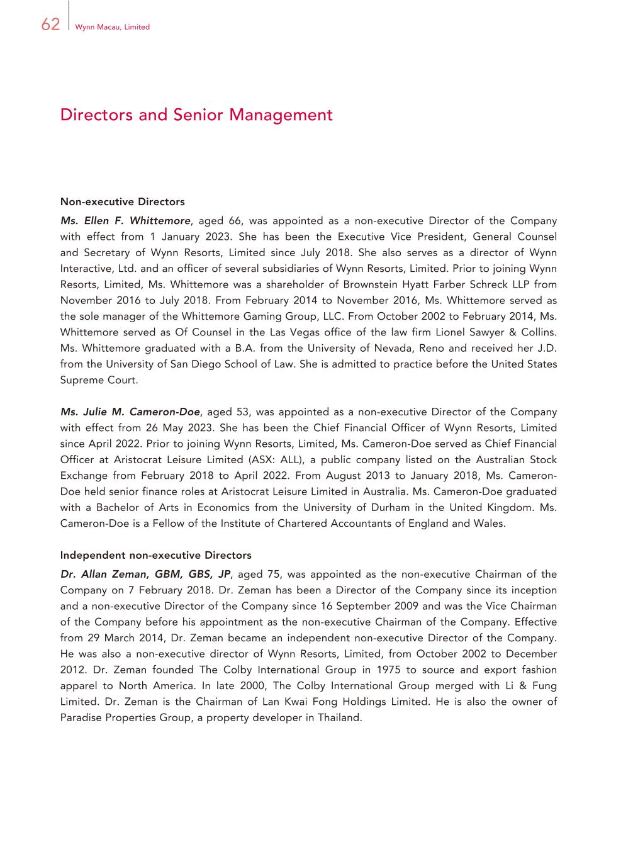
62 Wynn Macau, Limited Directors and Senior Management Non-executive Directors Ms. Ellen F. Whittemore, aged 66, was appointed as a non-executive Director of the Company with effect from 1 January 2023. She has been the Executive Vice President, General Counsel and Secretary of Wynn Resorts, Limited since July 2018. She also serves as a director of Wynn Interactive, Ltd. and an officer of several subsidiaries of Wynn Resorts, Limited. Prior to joining Wynn Resorts, Limited, Ms. Whittemore was a shareholder of Brownstein Hyatt Farber Schreck LLP from November 2016 to July 2018. From February 2014 to November 2016, Ms. Whittemore served as the sole manager of the Whittemore Gaming Group, LLC. From October 2002 to February 2014, Ms. Whittemore served as Of Counsel in the Las Vegas office of the law firm Lionel Sawyer & Collins. Ms. Whittemore graduated with a B.A. from the University of Nevada, Reno and received her J.D. from the University of San Diego School of Law. She is admitted to practice before the United States Supreme Court. Ms. Julie M. Cameron-Doe, aged 53, was appointed as a non-executive Director of the Company with effect from 26 May 2023. She has been the Chief Financial Officer of Wynn Resorts, Limited since April 2022. Prior to joining Wynn Resorts, Limited, Ms. Cameron-Doe served as Chief Financial Officer at Aristocrat Leisure Limited (ASX: ALL), a public company listed on the Australian Stock Exchange from February 2018 to April 2022. From August 2013 to January 2018, Ms. Cameron- Doe held senior finance roles at Aristocrat Leisure Limited in Australia. Ms. Cameron-Doe graduated with a Bachelor of Arts in Economics from the University of Durham in the United Kingdom. Ms. Cameron-Doe is a Fellow of the Institute of Chartered Accountants of England and Wales. Independent non-executive Directors Dr. Allan Zeman, GBM, GBS, JP, aged 75, was appointed as the non-executive Chairman of the Company on 7 February 2018. Dr. Zeman has been a Director of the Company since its inception and a non-executive Director of the Company since 16 September 2009 and was the Vice Chairman of the Company before his appointment as the non-executive Chairman of the Company. Effective from 29 March 2014, Dr. Zeman became an independent non-executive Director of the Company. He was also a non-executive director of Wynn Resorts, Limited, from October 2002 to December 2012. Dr. Zeman founded The Colby International Group in 1975 to source and export fashion apparel to North America. In late 2000, The Colby International Group merged with Li & Fung Limited. Dr. Zeman is the Chairman of Lan Kwai Fong Holdings Limited. He is also the owner of Paradise Properties Group, a property developer in Thailand.

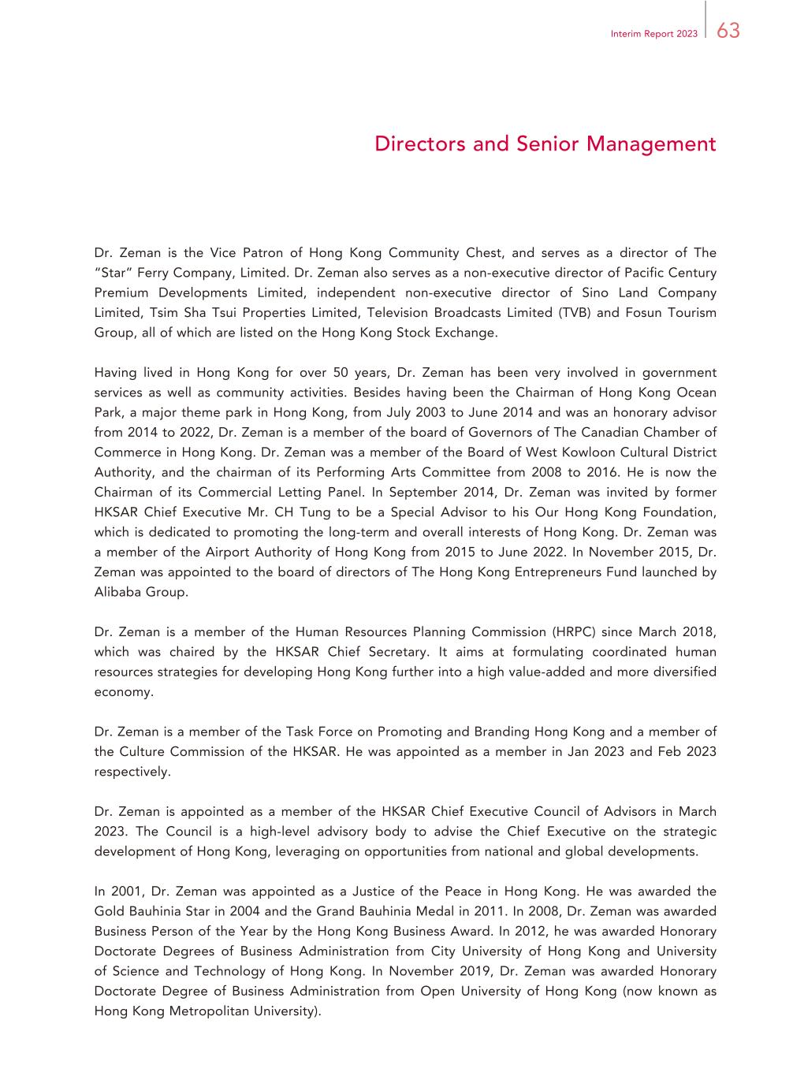
63Interim Report 2023 Directors and Senior Management Dr. Zeman is the Vice Patron of Hong Kong Community Chest, and serves as a director of The “Star” Ferry Company, Limited. Dr. Zeman also serves as a non-executive director of Pacific Century Premium Developments Limited, independent non-executive director of Sino Land Company Limited, Tsim Sha Tsui Properties Limited, Television Broadcasts Limited (TVB) and Fosun Tourism Group, all of which are listed on the Hong Kong Stock Exchange. Having lived in Hong Kong for over 50 years, Dr. Zeman has been very involved in government services as well as community activities. Besides having been the Chairman of Hong Kong Ocean Park, a major theme park in Hong Kong, from July 2003 to June 2014 and was an honorary advisor from 2014 to 2022, Dr. Zeman is a member of the board of Governors of The Canadian Chamber of Commerce in Hong Kong. Dr. Zeman was a member of the Board of West Kowloon Cultural District Authority, and the chairman of its Performing Arts Committee from 2008 to 2016. He is now the Chairman of its Commercial Letting Panel. In September 2014, Dr. Zeman was invited by former HKSAR Chief Executive Mr. CH Tung to be a Special Advisor to his Our Hong Kong Foundation, which is dedicated to promoting the long-term and overall interests of Hong Kong. Dr. Zeman was a member of the Airport Authority of Hong Kong from 2015 to June 2022. In November 2015, Dr. Zeman was appointed to the board of directors of The Hong Kong Entrepreneurs Fund launched by Alibaba Group. Dr. Zeman is a member of the Human Resources Planning Commission (HRPC) since March 2018, which was chaired by the HKSAR Chief Secretary. It aims at formulating coordinated human resources strategies for developing Hong Kong further into a high value-added and more diversified economy. Dr. Zeman is a member of the Task Force on Promoting and Branding Hong Kong and a member of the Culture Commission of the HKSAR. He was appointed as a member in Jan 2023 and Feb 2023 respectively. Dr. Zeman is appointed as a member of the HKSAR Chief Executive Council of Advisors in March 2023. The Council is a high-level advisory body to advise the Chief Executive on the strategic development of Hong Kong, leveraging on opportunities from national and global developments. In 2001, Dr. Zeman was appointed as a Justice of the Peace in Hong Kong. He was awarded the Gold Bauhinia Star in 2004 and the Grand Bauhinia Medal in 2011. In 2008, Dr. Zeman was awarded Business Person of the Year by the Hong Kong Business Award. In 2012, he was awarded Honorary Doctorate Degrees of Business Administration from City University of Hong Kong and University of Science and Technology of Hong Kong. In November 2019, Dr. Zeman was awarded Honorary Doctorate Degree of Business Administration from Open University of Hong Kong (now known as Hong Kong Metropolitan University).

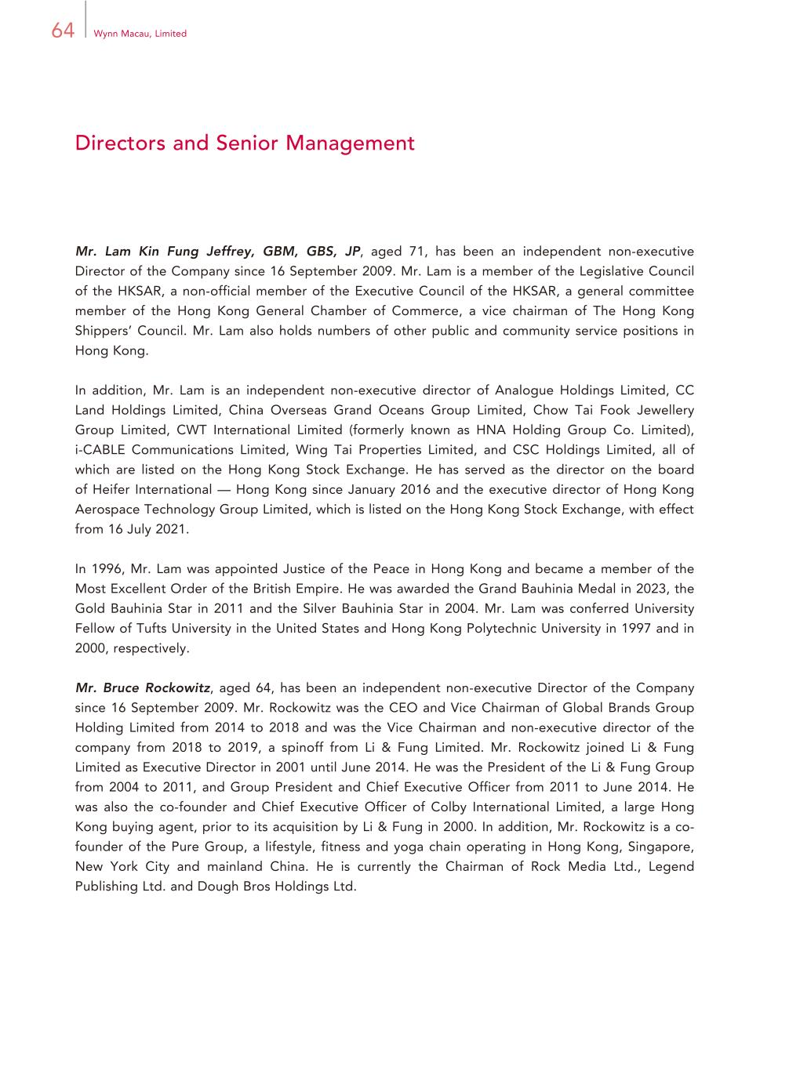
64 Wynn Macau, Limited Directors and Senior Management Mr. Lam Kin Fung Jeffrey, GBM, GBS, JP, aged 71, has been an independent non-executive Director of the Company since 16 September 2009. Mr. Lam is a member of the Legislative Council of the HKSAR, a non-official member of the Executive Council of the HKSAR, a general committee member of the Hong Kong General Chamber of Commerce, a vice chairman of The Hong Kong Shippers’ Council. Mr. Lam also holds numbers of other public and community service positions in Hong Kong. In addition, Mr. Lam is an independent non-executive director of Analogue Holdings Limited, CC Land Holdings Limited, China Overseas Grand Oceans Group Limited, Chow Tai Fook Jewellery Group Limited, CWT International Limited (formerly known as HNA Holding Group Co. Limited), i-CABLE Communications Limited, Wing Tai Properties Limited, and CSC Holdings Limited, all of which are listed on the Hong Kong Stock Exchange. He has served as the director on the board of Heifer International — Hong Kong since January 2016 and the executive director of Hong Kong Aerospace Technology Group Limited, which is listed on the Hong Kong Stock Exchange, with effect from 16 July 2021. In 1996, Mr. Lam was appointed Justice of the Peace in Hong Kong and became a member of the Most Excellent Order of the British Empire. He was awarded the Grand Bauhinia Medal in 2023, the Gold Bauhinia Star in 2011 and the Silver Bauhinia Star in 2004. Mr. Lam was conferred University Fellow of Tufts University in the United States and Hong Kong Polytechnic University in 1997 and in 2000, respectively. Mr. Bruce Rockowitz, aged 64, has been an independent non-executive Director of the Company since 16 September 2009. Mr. Rockowitz was the CEO and Vice Chairman of Global Brands Group Holding Limited from 2014 to 2018 and was the Vice Chairman and non-executive director of the company from 2018 to 2019, a spinoff from Li & Fung Limited. Mr. Rockowitz joined Li & Fung Limited as Executive Director in 2001 until June 2014. He was the President of the Li & Fung Group from 2004 to 2011, and Group President and Chief Executive Officer from 2011 to June 2014. He was also the co-founder and Chief Executive Officer of Colby International Limited, a large Hong Kong buying agent, prior to its acquisition by Li & Fung in 2000. In addition, Mr. Rockowitz is a co- founder of the Pure Group, a lifestyle, fitness and yoga chain operating in Hong Kong, Singapore, New York City and mainland China. He is currently the Chairman of Rock Media Ltd., Legend Publishing Ltd. and Dough Bros Holdings Ltd.

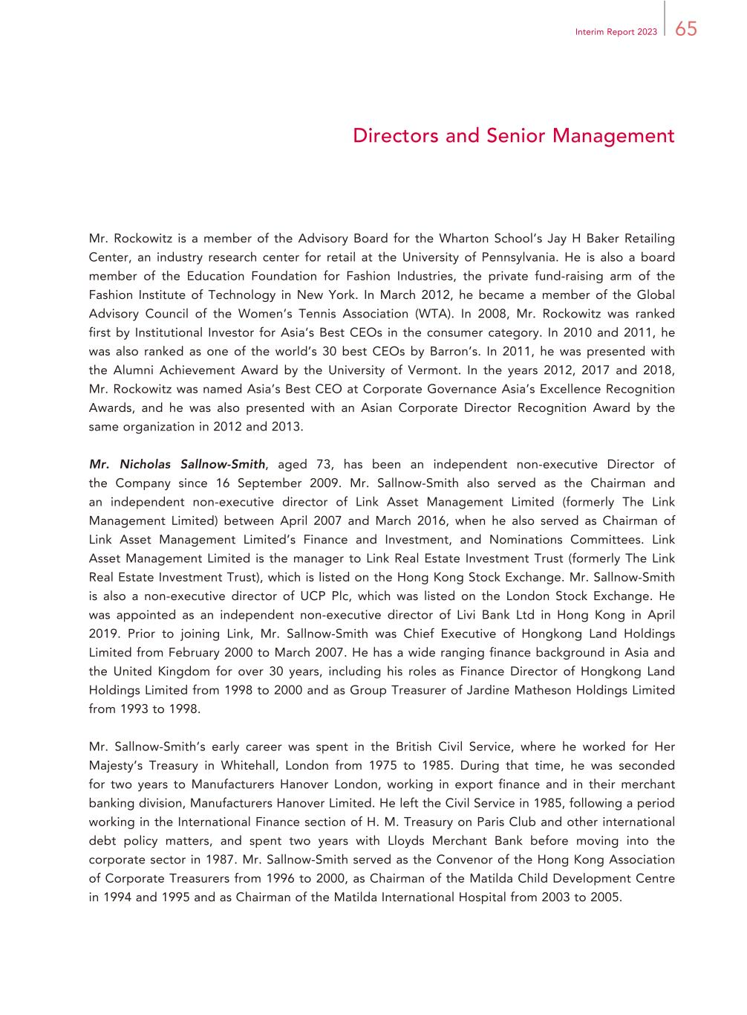
65Interim Report 2023 Directors and Senior Management Mr. Rockowitz is a member of the Advisory Board for the Wharton School’s Jay H Baker Retailing Center, an industry research center for retail at the University of Pennsylvania. He is also a board member of the Education Foundation for Fashion Industries, the private fund-raising arm of the Fashion Institute of Technology in New York. In March 2012, he became a member of the Global Advisory Council of the Women’s Tennis Association (WTA). In 2008, Mr. Rockowitz was ranked first by Institutional Investor for Asia’s Best CEOs in the consumer category. In 2010 and 2011, he was also ranked as one of the world’s 30 best CEOs by Barron’s. In 2011, he was presented with the Alumni Achievement Award by the University of Vermont. In the years 2012, 2017 and 2018, Mr. Rockowitz was named Asia’s Best CEO at Corporate Governance Asia’s Excellence Recognition Awards, and he was also presented with an Asian Corporate Director Recognition Award by the same organization in 2012 and 2013. Mr. Nicholas Sallnow-Smith, aged 73, has been an independent non-executive Director of the Company since 16 September 2009. Mr. Sallnow-Smith also served as the Chairman and an independent non-executive director of Link Asset Management Limited (formerly The Link Management Limited) between April 2007 and March 2016, when he also served as Chairman of Link Asset Management Limited’s Finance and Investment, and Nominations Committees. Link Asset Management Limited is the manager to Link Real Estate Investment Trust (formerly The Link Real Estate Investment Trust), which is listed on the Hong Kong Stock Exchange. Mr. Sallnow-Smith is also a non-executive director of UCP Plc, which was listed on the London Stock Exchange. He was appointed as an independent non-executive director of Livi Bank Ltd in Hong Kong in April 2019. Prior to joining Link, Mr. Sallnow-Smith was Chief Executive of Hongkong Land Holdings Limited from February 2000 to March 2007. He has a wide ranging finance background in Asia and the United Kingdom for over 30 years, including his roles as Finance Director of Hongkong Land Holdings Limited from 1998 to 2000 and as Group Treasurer of Jardine Matheson Holdings Limited from 1993 to 1998. Mr. Sallnow-Smith’s early career was spent in the British Civil Service, where he worked for Her Majesty’s Treasury in Whitehall, London from 1975 to 1985. During that time, he was seconded for two years to Manufacturers Hanover London, working in export finance and in their merchant banking division, Manufacturers Hanover Limited. He left the Civil Service in 1985, following a period working in the International Finance section of H. M. Treasury on Paris Club and other international debt policy matters, and spent two years with Lloyds Merchant Bank before moving into the corporate sector in 1987. Mr. Sallnow-Smith served as the Convenor of the Hong Kong Association of Corporate Treasurers from 1996 to 2000, as Chairman of the Matilda Child Development Centre in 1994 and 1995 and as Chairman of the Matilda International Hospital from 2003 to 2005.

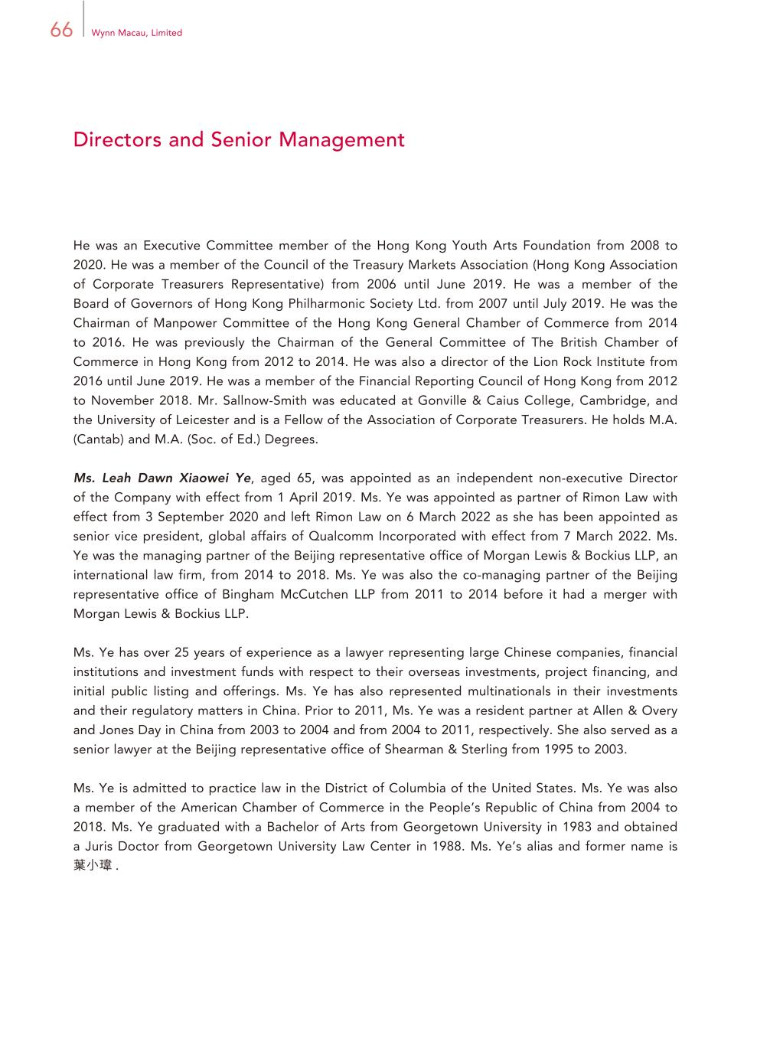
66 Wynn Macau, Limited Directors and Senior Management He was an Executive Committee member of the Hong Kong Youth Arts Foundation from 2008 to 2020. He was a member of the Council of the Treasury Markets Association (Hong Kong Association of Corporate Treasurers Representative) from 2006 until June 2019. He was a member of the Board of Governors of Hong Kong Philharmonic Society Ltd. from 2007 until July 2019. He was the Chairman of Manpower Committee of the Hong Kong General Chamber of Commerce from 2014 to 2016. He was previously the Chairman of the General Committee of The British Chamber of Commerce in Hong Kong from 2012 to 2014. He was also a director of the Lion Rock Institute from 2016 until June 2019. He was a member of the Financial Reporting Council of Hong Kong from 2012 to November 2018. Mr. Sallnow-Smith was educated at Gonville & Caius College, Cambridge, and the University of Leicester and is a Fellow of the Association of Corporate Treasurers. He holds M.A. (Cantab) and M.A. (Soc. of Ed.) Degrees. Ms. Leah Dawn Xiaowei Ye, aged 65, was appointed as an independent non-executive Director of the Company with effect from 1 April 2019. Ms. Ye was appointed as partner of Rimon Law with effect from 3 September 2020 and left Rimon Law on 6 March 2022 as she has been appointed as senior vice president, global affairs of Qualcomm Incorporated with effect from 7 March 2022. Ms. Ye was the managing partner of the Beijing representative office of Morgan Lewis & Bockius LLP, an international law firm, from 2014 to 2018. Ms. Ye was also the co-managing partner of the Beijing representative office of Bingham McCutchen LLP from 2011 to 2014 before it had a merger with Morgan Lewis & Bockius LLP. Ms. Ye has over 25 years of experience as a lawyer representing large Chinese companies, financial institutions and investment funds with respect to their overseas investments, project financing, and initial public listing and offerings. Ms. Ye has also represented multinationals in their investments and their regulatory matters in China. Prior to 2011, Ms. Ye was a resident partner at Allen & Overy and Jones Day in China from 2003 to 2004 and from 2004 to 2011, respectively. She also served as a senior lawyer at the Beijing representative office of Shearman & Sterling from 1995 to 2003. Ms. Ye is admitted to practice law in the District of Columbia of the United States. Ms. Ye was also a member of the American Chamber of Commerce in the People’s Republic of China from 2004 to 2018. Ms. Ye graduated with a Bachelor of Arts from Georgetown University in 1983 and obtained a Juris Doctor from Georgetown University Law Center in 1988. Ms. Ye’s alias and former name is 葉小瑋 .

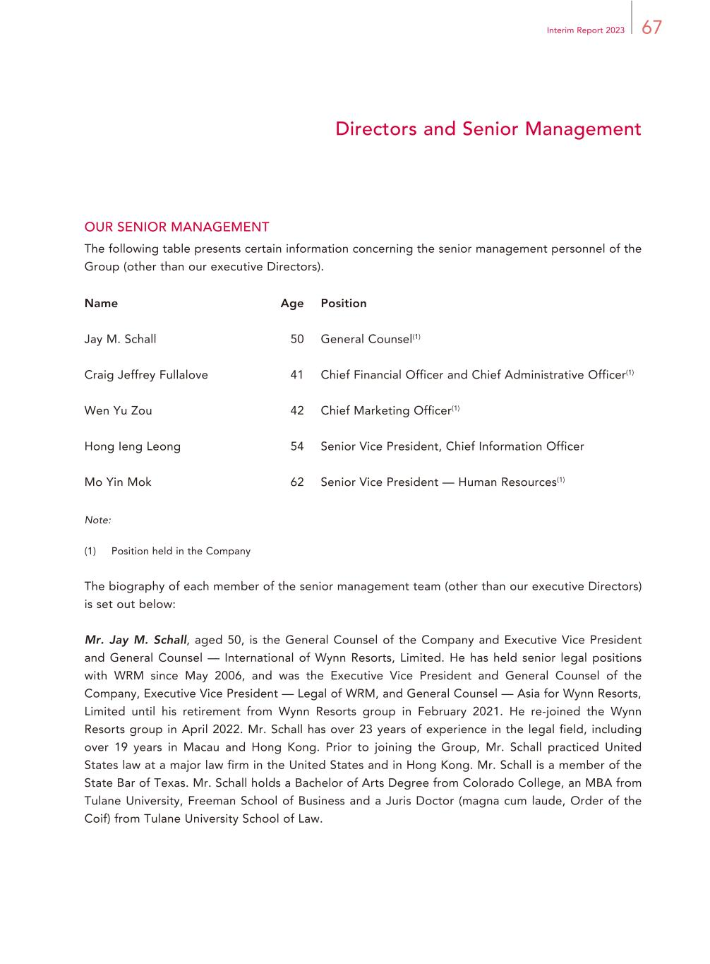
67Interim Report 2023 Directors and Senior Management OUR SENIOR MANAGEMENT The following table presents certain information concerning the senior management personnel of the Group (other than our executive Directors). Name Age Position Jay M. Schall 50 General Counsel(1) Craig Jeffrey Fullalove 41 Chief Financial Officer and Chief Administrative Officer(1) Wen Yu Zou 42 Chief Marketing Officer(1) Hong Ieng Leong 54 Senior Vice President, Chief Information Officer Mo Yin Mok 62 Senior Vice President — Human Resources(1) Note: (1) Position held in the Company The biography of each member of the senior management team (other than our executive Directors) is set out below: Mr. Jay M. Schall, aged 50, is the General Counsel of the Company and Executive Vice President and General Counsel — International of Wynn Resorts, Limited. He has held senior legal positions with WRM since May 2006, and was the Executive Vice President and General Counsel of the Company, Executive Vice President — Legal of WRM, and General Counsel — Asia for Wynn Resorts, Limited until his retirement from Wynn Resorts group in February 2021. He re-joined the Wynn Resorts group in April 2022. Mr. Schall has over 23 years of experience in the legal field, including over 19 years in Macau and Hong Kong. Prior to joining the Group, Mr. Schall practiced United States law at a major law firm in the United States and in Hong Kong. Mr. Schall is a member of the State Bar of Texas. Mr. Schall holds a Bachelor of Arts Degree from Colorado College, an MBA from Tulane University, Freeman School of Business and a Juris Doctor (magna cum laude, Order of the Coif) from Tulane University School of Law.

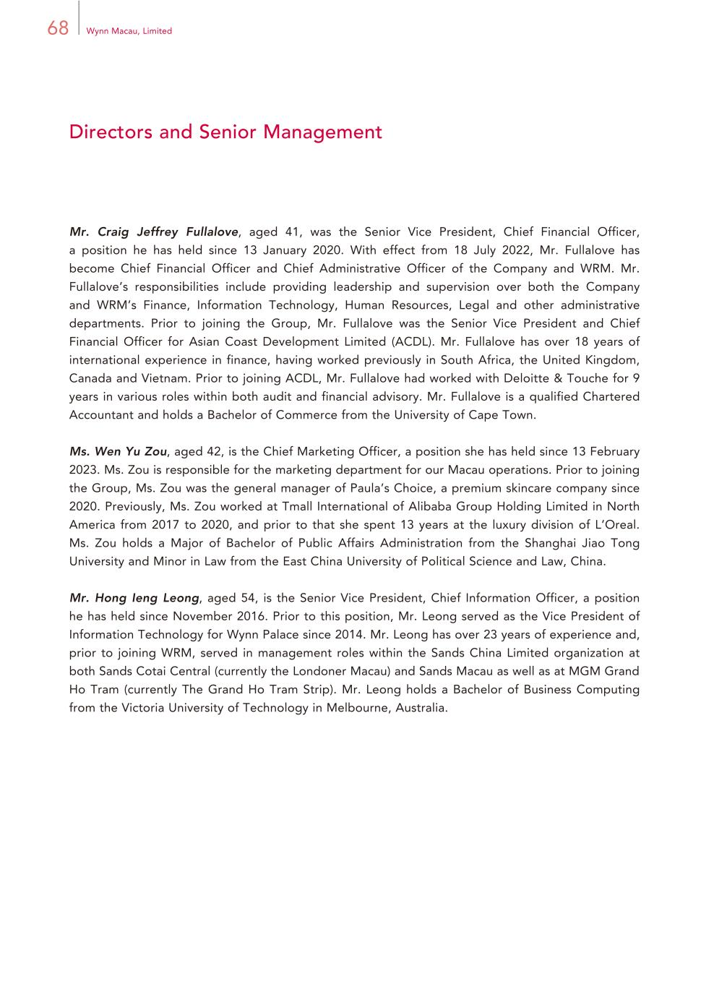
68 Wynn Macau, Limited Directors and Senior Management Mr. Craig Jeffrey Fullalove, aged 41, was the Senior Vice President, Chief Financial Officer, a position he has held since 13 January 2020. With effect from 18 July 2022, Mr. Fullalove has become Chief Financial Officer and Chief Administrative Officer of the Company and WRM. Mr. Fullalove’s responsibilities include providing leadership and supervision over both the Company and WRM’s Finance, Information Technology, Human Resources, Legal and other administrative departments. Prior to joining the Group, Mr. Fullalove was the Senior Vice President and Chief Financial Officer for Asian Coast Development Limited (ACDL). Mr. Fullalove has over 18 years of international experience in finance, having worked previously in South Africa, the United Kingdom, Canada and Vietnam. Prior to joining ACDL, Mr. Fullalove had worked with Deloitte & Touche for 9 years in various roles within both audit and financial advisory. Mr. Fullalove is a qualified Chartered Accountant and holds a Bachelor of Commerce from the University of Cape Town. Ms. Wen Yu Zou, aged 42, is the Chief Marketing Officer, a position she has held since 13 February 2023. Ms. Zou is responsible for the marketing department for our Macau operations. Prior to joining the Group, Ms. Zou was the general manager of Paula’s Choice, a premium skincare company since 2020. Previously, Ms. Zou worked at Tmall International of Alibaba Group Holding Limited in North America from 2017 to 2020, and prior to that she spent 13 years at the luxury division of L’Oreal. Ms. Zou holds a Major of Bachelor of Public Affairs Administration from the Shanghai Jiao Tong University and Minor in Law from the East China University of Political Science and Law, China. Mr. Hong Ieng Leong, aged 54, is the Senior Vice President, Chief Information Officer, a position he has held since November 2016. Prior to this position, Mr. Leong served as the Vice President of Information Technology for Wynn Palace since 2014. Mr. Leong has over 23 years of experience and, prior to joining WRM, served in management roles within the Sands China Limited organization at both Sands Cotai Central (currently the Londoner Macau) and Sands Macau as well as at MGM Grand Ho Tram (currently The Grand Ho Tram Strip). Mr. Leong holds a Bachelor of Business Computing from the Victoria University of Technology in Melbourne, Australia.

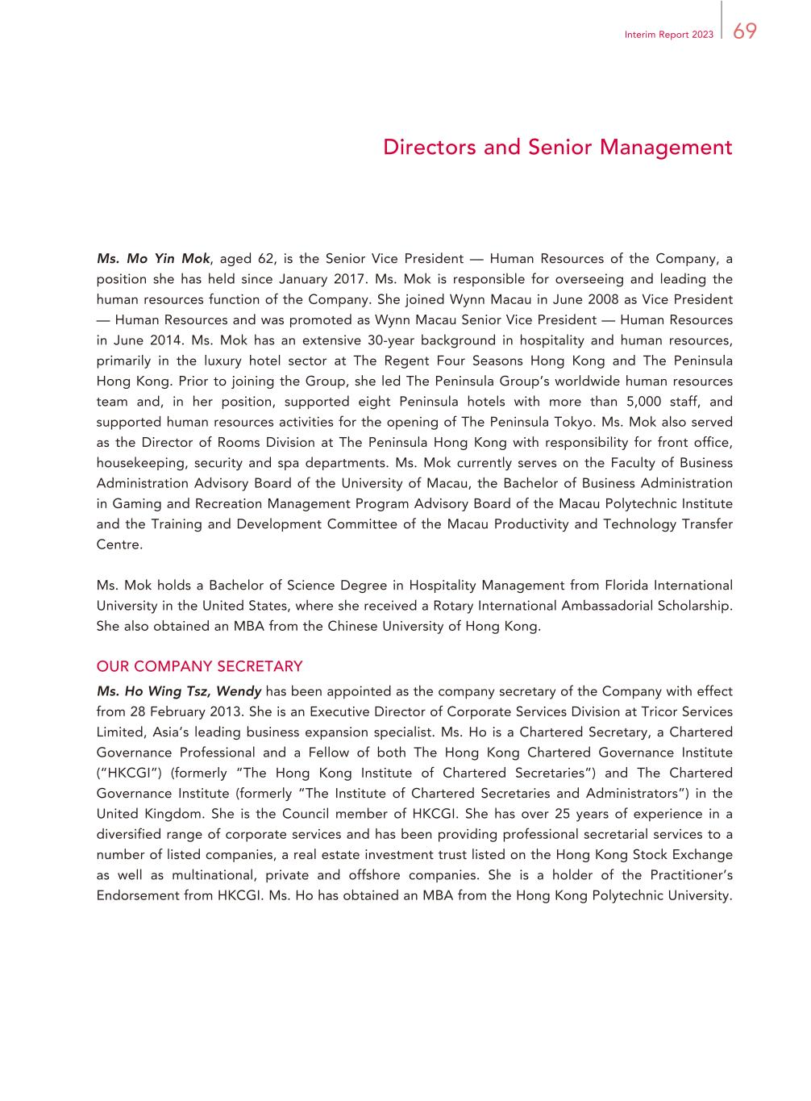
69Interim Report 2023 Directors and Senior Management Ms. Mo Yin Mok, aged 62, is the Senior Vice President — Human Resources of the Company, a position she has held since January 2017. Ms. Mok is responsible for overseeing and leading the human resources function of the Company. She joined Wynn Macau in June 2008 as Vice President — Human Resources and was promoted as Wynn Macau Senior Vice President — Human Resources in June 2014. Ms. Mok has an extensive 30-year background in hospitality and human resources, primarily in the luxury hotel sector at The Regent Four Seasons Hong Kong and The Peninsula Hong Kong. Prior to joining the Group, she led The Peninsula Group’s worldwide human resources team and, in her position, supported eight Peninsula hotels with more than 5,000 staff, and supported human resources activities for the opening of The Peninsula Tokyo. Ms. Mok also served as the Director of Rooms Division at The Peninsula Hong Kong with responsibility for front office, housekeeping, security and spa departments. Ms. Mok currently serves on the Faculty of Business Administration Advisory Board of the University of Macau, the Bachelor of Business Administration in Gaming and Recreation Management Program Advisory Board of the Macau Polytechnic Institute and the Training and Development Committee of the Macau Productivity and Technology Transfer Centre. Ms. Mok holds a Bachelor of Science Degree in Hospitality Management from Florida International University in the United States, where she received a Rotary International Ambassadorial Scholarship. She also obtained an MBA from the Chinese University of Hong Kong. OUR COMPANY SECRETARY Ms. Ho Wing Tsz, Wendy has been appointed as the company secretary of the Company with effect from 28 February 2013. She is an Executive Director of Corporate Services Division at Tricor Services Limited, Asia’s leading business expansion specialist. Ms. Ho is a Chartered Secretary, a Chartered Governance Professional and a Fellow of both The Hong Kong Chartered Governance Institute (“HKCGI”) (formerly “The Hong Kong Institute of Chartered Secretaries”) and The Chartered Governance Institute (formerly “The Institute of Chartered Secretaries and Administrators”) in the United Kingdom. She is the Council member of HKCGI. She has over 25 years of experience in a diversified range of corporate services and has been providing professional secretarial services to a number of listed companies, a real estate investment trust listed on the Hong Kong Stock Exchange as well as multinational, private and offshore companies. She is a holder of the Practitioner’s Endorsement from HKCGI. Ms. Ho has obtained an MBA from the Hong Kong Polytechnic University.

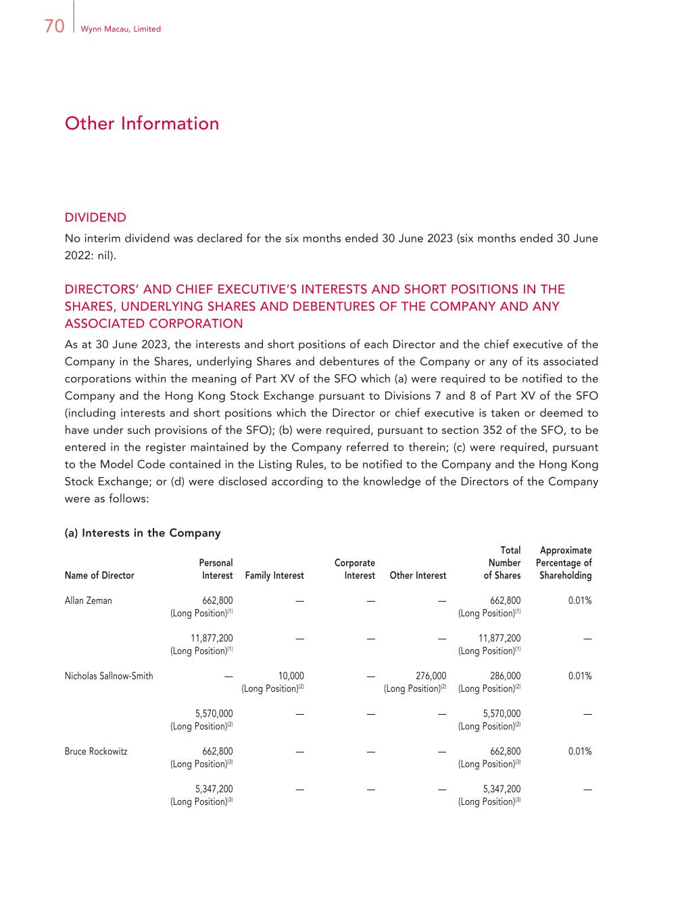
70 Wynn Macau, Limited Other Information DIVIDEND No interim dividend was declared for the six months ended 30 June 2023 (six months ended 30 June 2022: nil). DIRECTORS’ AND CHIEF EXECUTIVE’S INTERESTS AND SHORT POSITIONS IN THE SHARES, UNDERLYING SHARES AND DEBENTURES OF THE COMPANY AND ANY ASSOCIATED CORPORATION As at 30 June 2023, the interests and short positions of each Director and the chief executive of the Company in the Shares, underlying Shares and debentures of the Company or any of its associated corporations within the meaning of Part XV of the SFO which (a) were required to be notified to the Company and the Hong Kong Stock Exchange pursuant to Divisions 7 and 8 of Part XV of the SFO (including interests and short positions which the Director or chief executive is taken or deemed to have under such provisions of the SFO); (b) were required, pursuant to section 352 of the SFO, to be entered in the register maintained by the Company referred to therein; (c) were required, pursuant to the Model Code contained in the Listing Rules, to be notified to the Company and the Hong Kong Stock Exchange; or (d) were disclosed according to the knowledge of the Directors of the Company were as follows: (a) Interests in the Company Name of Director Personal Interest Family Interest Corporate Interest Other Interest Total Number of Shares Approximate Percentage of Shareholding Allan Zeman 662,800 (Long Position)(1) — — — 662,800 (Long Position)(1) 0.01% 11,877,200 (Long Position)(1) — — — 11,877,200 (Long Position)(1) — Nicholas Sallnow-Smith — 10,000 (Long Position)(2) — 276,000 (Long Position)(2) 286,000 (Long Position)(2) 0.01% 5,570,000 (Long Position)(2) — — — 5,570,000 (Long Position)(2) — Bruce Rockowitz 662,800 (Long Position)(3) — — — 662,800 (Long Position)(3) 0.01% 5,347,200 (Long Position)(3) — — — 5,347,200 (Long Position)(3) —

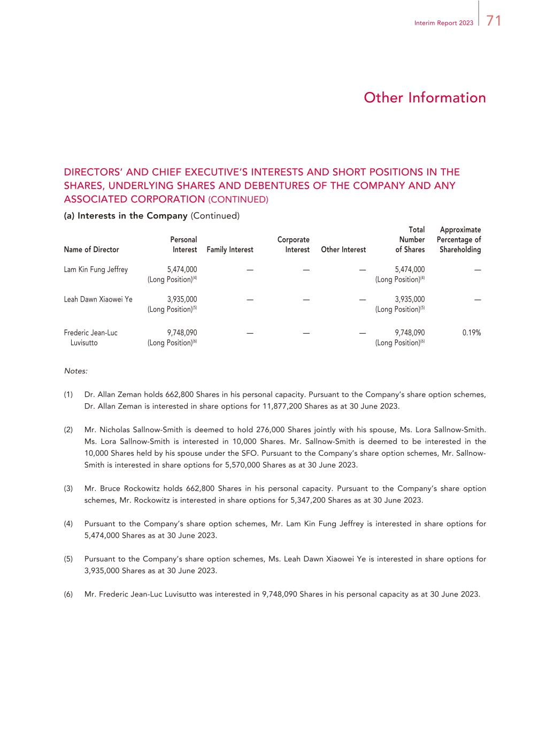
71Interim Report 2023 Other Information Name of Director Personal Interest Family Interest Corporate Interest Other Interest Total Number of Shares Approximate Percentage of Shareholding Lam Kin Fung Jeffrey 5,474,000 (Long Position)(4) — — — 5,474,000 (Long Position)(4) — Leah Dawn Xiaowei Ye 3,935,000 (Long Position)(5) — — — 3,935,000 (Long Position)(5) — Frederic Jean-Luc Luvisutto 9,748,090 (Long Position)(6) — — — 9,748,090 (Long Position)(6) 0.19% Notes: (1) Dr. Allan Zeman holds 662,800 Shares in his personal capacity. Pursuant to the Company’s share option schemes, Dr. Allan Zeman is interested in share options for 11,877,200 Shares as at 30 June 2023. (2) Mr. Nicholas Sallnow-Smith is deemed to hold 276,000 Shares jointly with his spouse, Ms. Lora Sallnow-Smith. Ms. Lora Sallnow-Smith is interested in 10,000 Shares. Mr. Sallnow-Smith is deemed to be interested in the 10,000 Shares held by his spouse under the SFO. Pursuant to the Company’s share option schemes, Mr. Sallnow- Smith is interested in share options for 5,570,000 Shares as at 30 June 2023. (3) Mr. Bruce Rockowitz holds 662,800 Shares in his personal capacity. Pursuant to the Company’s share option schemes, Mr. Rockowitz is interested in share options for 5,347,200 Shares as at 30 June 2023. (4) Pursuant to the Company’s share option schemes, Mr. Lam Kin Fung Jeffrey is interested in share options for 5,474,000 Shares as at 30 June 2023. (5) Pursuant to the Company’s share option schemes, Ms. Leah Dawn Xiaowei Ye is interested in share options for 3,935,000 Shares as at 30 June 2023. (6) Mr. Frederic Jean-Luc Luvisutto was interested in 9,748,090 Shares in his personal capacity as at 30 June 2023. DIRECTORS’ AND CHIEF EXECUTIVE’S INTERESTS AND SHORT POSITIONS IN THE SHARES, UNDERLYING SHARES AND DEBENTURES OF THE COMPANY AND ANY ASSOCIATED CORPORATION (CONTINUED) (a) Interests in the Company (Continued)

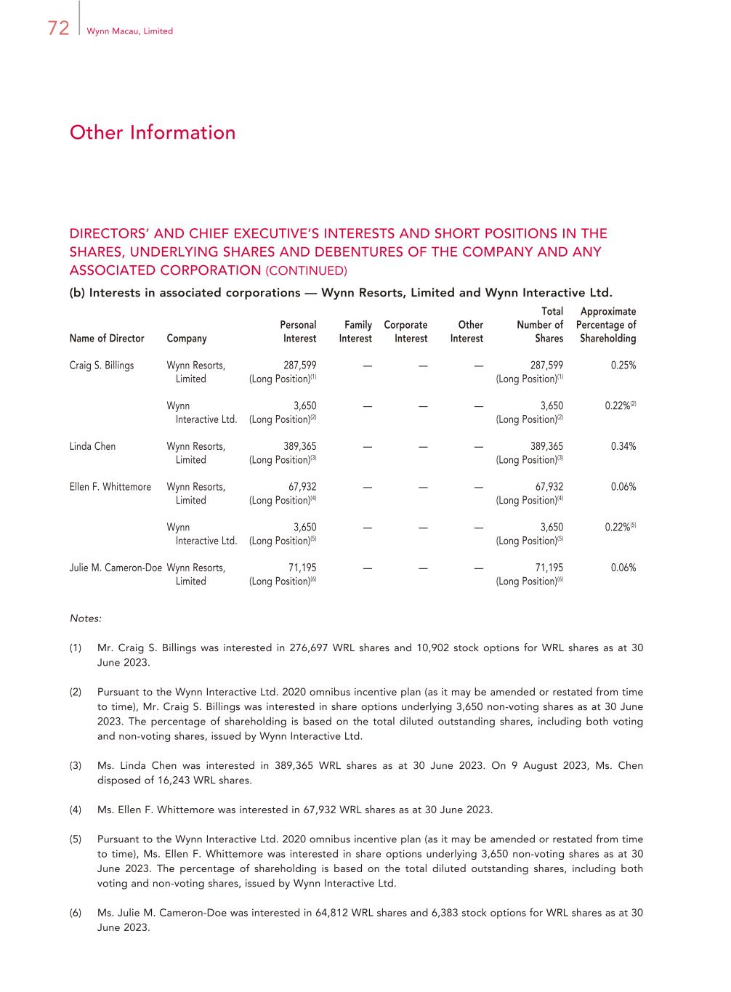
72 Wynn Macau, Limited Other Information DIRECTORS’ AND CHIEF EXECUTIVE’S INTERESTS AND SHORT POSITIONS IN THE SHARES, UNDERLYING SHARES AND DEBENTURES OF THE COMPANY AND ANY ASSOCIATED CORPORATION (CONTINUED) (b) Interests in associated corporations — Wynn Resorts, Limited and Wynn Interactive Ltd. Name of Director Company Personal Interest Family Interest Corporate Interest Other Interest Total Number of Shares Approximate Percentage of Shareholding Craig S. Billings Wynn Resorts, Limited 287,599 (Long Position)(1) — — — 287,599 (Long Position)(1) 0.25% Wynn Interactive Ltd. 3,650 (Long Position)(2) — — — 3,650 (Long Position)(2) 0.22%(2) Linda Chen Wynn Resorts, Limited 389,365 (Long Position)(3) — — — 389,365 (Long Position)(3) 0.34% Ellen F. Whittemore Wynn Resorts, Limited 67,932 (Long Position)(4) — — — 67,932 (Long Position)(4) 0.06% Wynn Interactive Ltd. 3,650 (Long Position)(5) — — — 3,650 (Long Position)(5) 0.22%(5) Julie M. Cameron-Doe Wynn Resorts, Limited 71,195 (Long Position)(6) — — — 71,195 (Long Position)(6) 0.06% Notes: (1) Mr. Craig S. Billings was interested in 276,697 WRL shares and 10,902 stock options for WRL shares as at 30 June 2023. (2) Pursuant to the Wynn Interactive Ltd. 2020 omnibus incentive plan (as it may be amended or restated from time to time), Mr. Craig S. Billings was interested in share options underlying 3,650 non-voting shares as at 30 June 2023. The percentage of shareholding is based on the total diluted outstanding shares, including both voting and non-voting shares, issued by Wynn Interactive Ltd. (3) Ms. Linda Chen was interested in 389,365 WRL shares as at 30 June 2023. On 9 August 2023, Ms. Chen disposed of 16,243 WRL shares. (4) Ms. Ellen F. Whittemore was interested in 67,932 WRL shares as at 30 June 2023. (5) Pursuant to the Wynn Interactive Ltd. 2020 omnibus incentive plan (as it may be amended or restated from time to time), Ms. Ellen F. Whittemore was interested in share options underlying 3,650 non-voting shares as at 30 June 2023. The percentage of shareholding is based on the total diluted outstanding shares, including both voting and non-voting shares, issued by Wynn Interactive Ltd. (6) Ms. Julie M. Cameron-Doe was interested in 64,812 WRL shares and 6,383 stock options for WRL shares as at 30 June 2023.

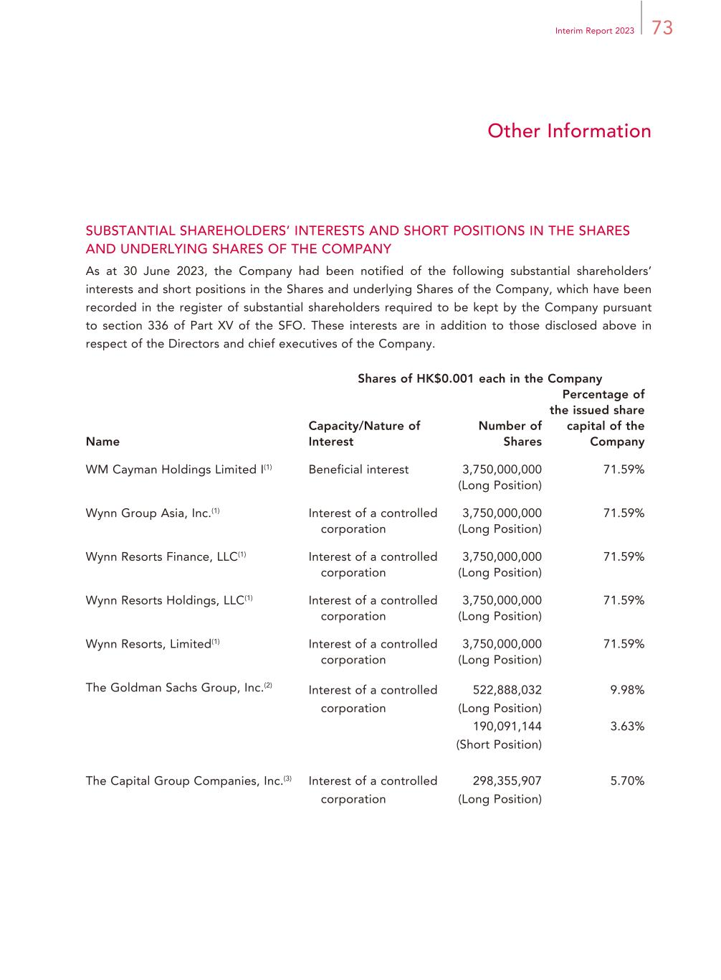
73Interim Report 2023 Other Information SUBSTANTIAL SHAREHOLDERS’ INTERESTS AND SHORT POSITIONS IN THE SHARES AND UNDERLYING SHARES OF THE COMPANY As at 30 June 2023, the Company had been notified of the following substantial shareholders’ interests and short positions in the Shares and underlying Shares of the Company, which have been recorded in the register of substantial shareholders required to be kept by the Company pursuant to section 336 of Part XV of the SFO. These interests are in addition to those disclosed above in respect of the Directors and chief executives of the Company. Shares of HK$0.001 each in the Company Name Capacity/Nature of Interest Number of Shares Percentage of the issued share capital of the Company WM Cayman Holdings Limited I(1) Beneficial interest 3,750,000,000 (Long Position) 71.59% Wynn Group Asia, Inc.(1) Interest of a controlled corporation 3,750,000,000 (Long Position) 71.59% Wynn Resorts Finance, LLC(1) Interest of a controlled corporation 3,750,000,000 (Long Position) 71.59% Wynn Resorts Holdings, LLC(1) Interest of a controlled corporation 3,750,000,000 (Long Position) 71.59% Wynn Resorts, Limited(1) Interest of a controlled corporation 3,750,000,000 (Long Position) 71.59% The Goldman Sachs Group, Inc.(2) Interest of a controlled corporation 522,888,032 (Long Position) 9.98% 190,091,144 (Short Position) 3.63% The Capital Group Companies, Inc.(3) Interest of a controlled corporation 298,355,907 (Long Position) 5.70%

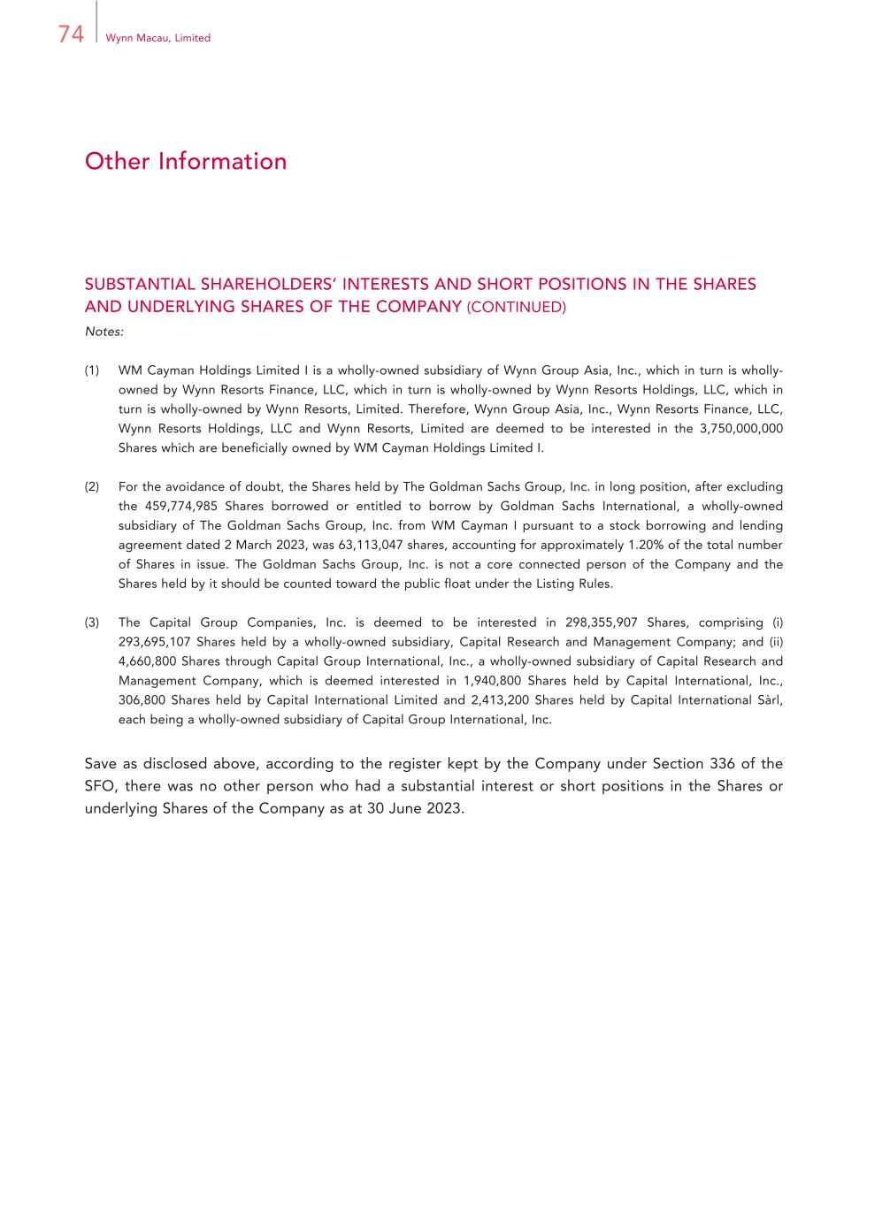
74 Wynn Macau, Limited Other Information SUBSTANTIAL SHAREHOLDERS’ INTERESTS AND SHORT POSITIONS IN THE SHARES AND UNDERLYING SHARES OF THE COMPANY (CONTINUED) Notes: (1) WM Cayman Holdings Limited I is a wholly-owned subsidiary of Wynn Group Asia, Inc., which in turn is wholly- owned by Wynn Resorts Finance, LLC, which in turn is wholly-owned by Wynn Resorts Holdings, LLC, which in turn is wholly-owned by Wynn Resorts, Limited. Therefore, Wynn Group Asia, Inc., Wynn Resorts Finance, LLC, Wynn Resorts Holdings, LLC and Wynn Resorts, Limited are deemed to be interested in the 3,750,000,000 Shares which are beneficially owned by WM Cayman Holdings Limited I. (2) For the avoidance of doubt, the Shares held by The Goldman Sachs Group, Inc. in long position, after excluding the 459,774,985 Shares borrowed or entitled to borrow by Goldman Sachs International, a wholly-owned subsidiary of The Goldman Sachs Group, Inc. from WM Cayman I pursuant to a stock borrowing and lending agreement dated 2 March 2023, was 63,113,047 shares, accounting for approximately 1.20% of the total number of Shares in issue. The Goldman Sachs Group, Inc. is not a core connected person of the Company and the Shares held by it should be counted toward the public float under the Listing Rules. (3) The Capital Group Companies, Inc. is deemed to be interested in 298,355,907 Shares, comprising (i) 293,695,107 Shares held by a wholly-owned subsidiary, Capital Research and Management Company; and (ii) 4,660,800 Shares through Capital Group International, Inc., a wholly-owned subsidiary of Capital Research and Management Company, which is deemed interested in 1,940,800 Shares held by Capital International, Inc., 306,800 Shares held by Capital International Limited and 2,413,200 Shares held by Capital International Sàrl, each being a wholly-owned subsidiary of Capital Group International, Inc. Save as disclosed above, according to the register kept by the Company under Section 336 of the SFO, there was no other person who had a substantial interest or short positions in the Shares or underlying Shares of the Company as at 30 June 2023.

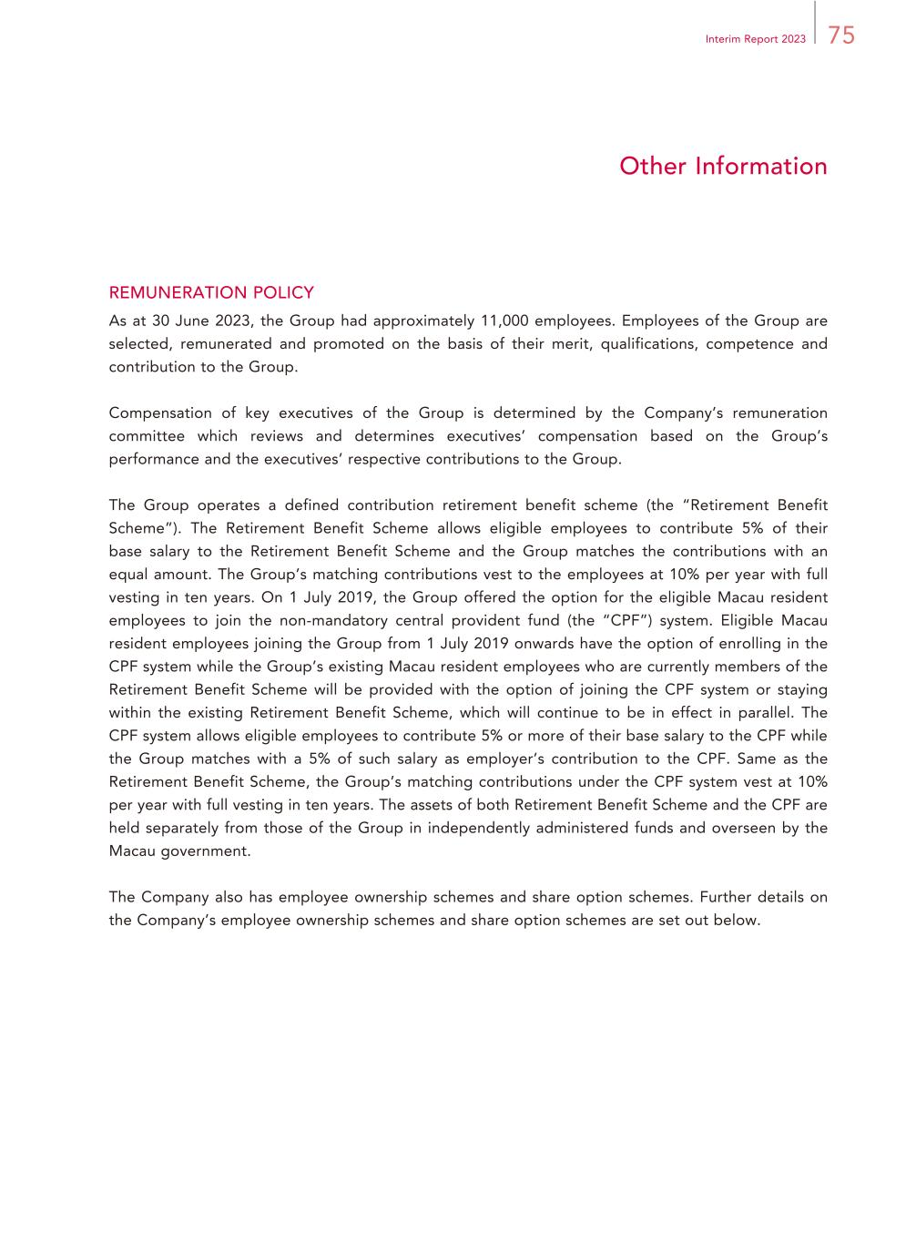
75Interim Report 2023 Other Information REMUNERATION POLICY As at 30 June 2023, the Group had approximately 11,000 employees. Employees of the Group are selected, remunerated and promoted on the basis of their merit, qualifications, competence and contribution to the Group. Compensation of key executives of the Group is determined by the Company’s remuneration committee which reviews and determines executives’ compensation based on the Group’s performance and the executives’ respective contributions to the Group. The Group operates a defined contribution retirement benefit scheme (the “Retirement Benefit Scheme”). The Retirement Benefit Scheme allows eligible employees to contribute 5% of their base salary to the Retirement Benefit Scheme and the Group matches the contributions with an equal amount. The Group’s matching contributions vest to the employees at 10% per year with full vesting in ten years. On 1 July 2019, the Group offered the option for the eligible Macau resident employees to join the non-mandatory central provident fund (the “CPF”) system. Eligible Macau resident employees joining the Group from 1 July 2019 onwards have the option of enrolling in the CPF system while the Group’s existing Macau resident employees who are currently members of the Retirement Benefit Scheme will be provided with the option of joining the CPF system or staying within the existing Retirement Benefit Scheme, which will continue to be in effect in parallel. The CPF system allows eligible employees to contribute 5% or more of their base salary to the CPF while the Group matches with a 5% of such salary as employer’s contribution to the CPF. Same as the Retirement Benefit Scheme, the Group’s matching contributions under the CPF system vest at 10% per year with full vesting in ten years. The assets of both Retirement Benefit Scheme and the CPF are held separately from those of the Group in independently administered funds and overseen by the Macau government. The Company also has employee ownership schemes and share option schemes. Further details on the Company’s employee ownership schemes and share option schemes are set out below.

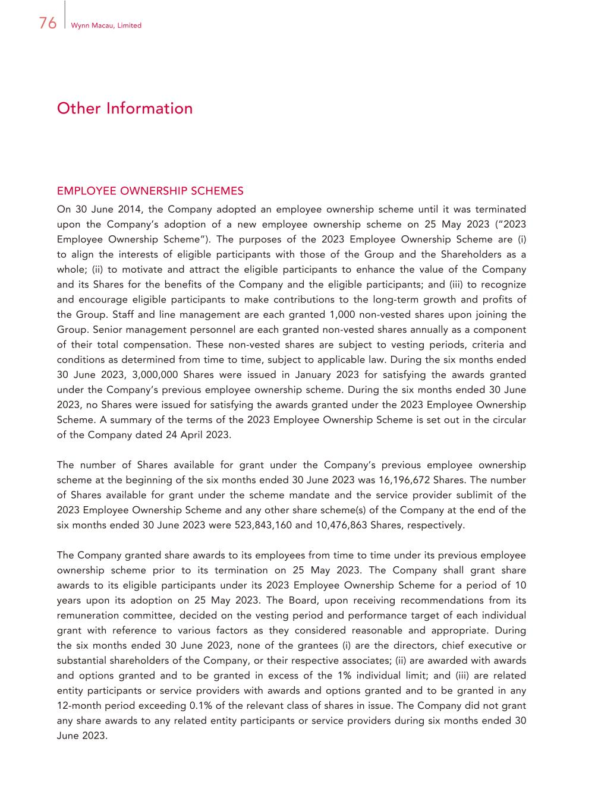
76 Wynn Macau, Limited Other Information EMPLOYEE OWNERSHIP SCHEMES On 30 June 2014, the Company adopted an employee ownership scheme until it was terminated upon the Company’s adoption of a new employee ownership scheme on 25 May 2023 (“2023 Employee Ownership Scheme”). The purposes of the 2023 Employee Ownership Scheme are (i) to align the interests of eligible participants with those of the Group and the Shareholders as a whole; (ii) to motivate and attract the eligible participants to enhance the value of the Company and its Shares for the benefits of the Company and the eligible participants; and (iii) to recognize and encourage eligible participants to make contributions to the long-term growth and profits of the Group. Staff and line management are each granted 1,000 non-vested shares upon joining the Group. Senior management personnel are each granted non-vested shares annually as a component of their total compensation. These non-vested shares are subject to vesting periods, criteria and conditions as determined from time to time, subject to applicable law. During the six months ended 30 June 2023, 3,000,000 Shares were issued in January 2023 for satisfying the awards granted under the Company’s previous employee ownership scheme. During the six months ended 30 June 2023, no Shares were issued for satisfying the awards granted under the 2023 Employee Ownership Scheme. A summary of the terms of the 2023 Employee Ownership Scheme is set out in the circular of the Company dated 24 April 2023. The number of Shares available for grant under the Company’s previous employee ownership scheme at the beginning of the six months ended 30 June 2023 was 16,196,672 Shares. The number of Shares available for grant under the scheme mandate and the service provider sublimit of the 2023 Employee Ownership Scheme and any other share scheme(s) of the Company at the end of the six months ended 30 June 2023 were 523,843,160 and 10,476,863 Shares, respectively. The Company granted share awards to its employees from time to time under its previous employee ownership scheme prior to its termination on 25 May 2023. The Company shall grant share awards to its eligible participants under its 2023 Employee Ownership Scheme for a period of 10 years upon its adoption on 25 May 2023. The Board, upon receiving recommendations from its remuneration committee, decided on the vesting period and performance target of each individual grant with reference to various factors as they considered reasonable and appropriate. During the six months ended 30 June 2023, none of the grantees (i) are the directors, chief executive or substantial shareholders of the Company, or their respective associates; (ii) are awarded with awards and options granted and to be granted in excess of the 1% individual limit; and (iii) are related entity participants or service providers with awards and options granted and to be granted in any 12-month period exceeding 0.1% of the relevant class of shares in issue. The Company did not grant any share awards to any related entity participants or service providers during six months ended 30 June 2023.

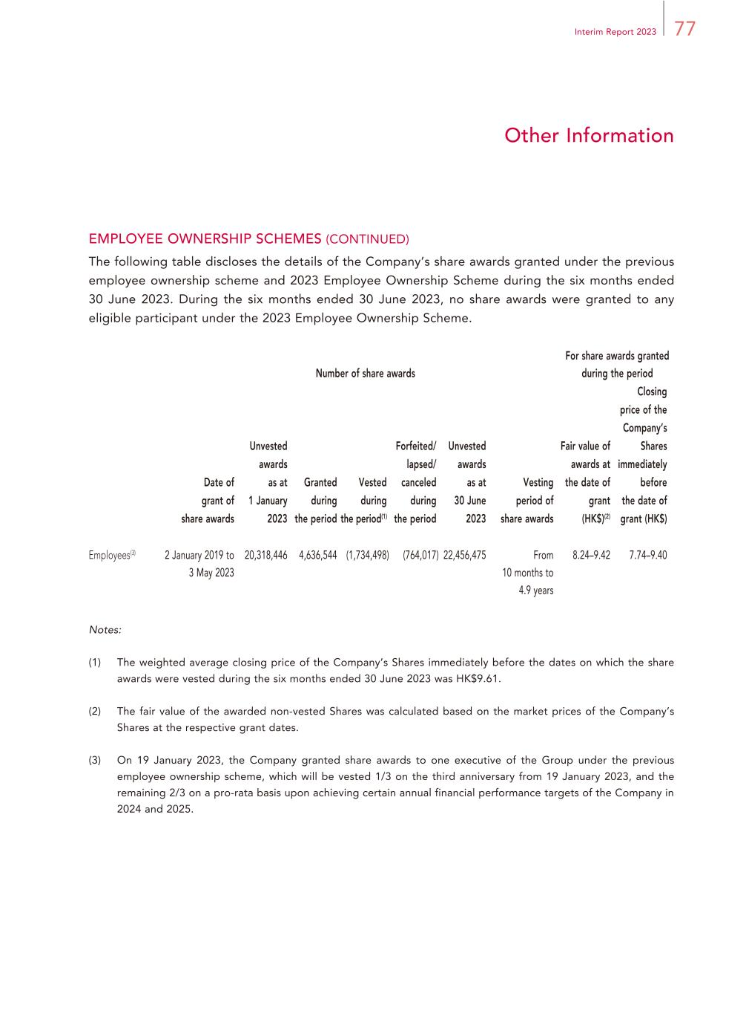
77Interim Report 2023 Other Information EMPLOYEE OWNERSHIP SCHEMES (CONTINUED) The following table discloses the details of the Company’s share awards granted under the previous employee ownership scheme and 2023 Employee Ownership Scheme during the six months ended 30 June 2023. During the six months ended 30 June 2023, no share awards were granted to any eligible participant under the 2023 Employee Ownership Scheme. Number of share awards For share awards granted during the period Date of grant of share awards Unvested awards as at 1 January 2023 Granted during the period Vested during the period(1) Forfeited/ lapsed/ canceled during the period Unvested awards as at 30 June 2023 Vesting period of share awards Fair value of awards at the date of grant (HK$)(2) Closing price of the Company’s Shares immediately before the date of grant (HK$) Employees(3) 2 January 2019 to 3 May 2023 20,318,446 4,636,544 (1,734,498) (764,017) 22,456,475 From 10 months to 4.9 years 8.24–9.42 7.74–9.40 Notes: (1) The weighted average closing price of the Company’s Shares immediately before the dates on which the share awards were vested during the six months ended 30 June 2023 was HK$9.61. (2) The fair value of the awarded non-vested Shares was calculated based on the market prices of the Company’s Shares at the respective grant dates. (3) On 19 January 2023, the Company granted share awards to one executive of the Group under the previous employee ownership scheme, which will be vested 1/3 on the third anniversary from 19 January 2023, and the remaining 2/3 on a pro-rata basis upon achieving certain annual financial performance targets of the Company in 2024 and 2025.

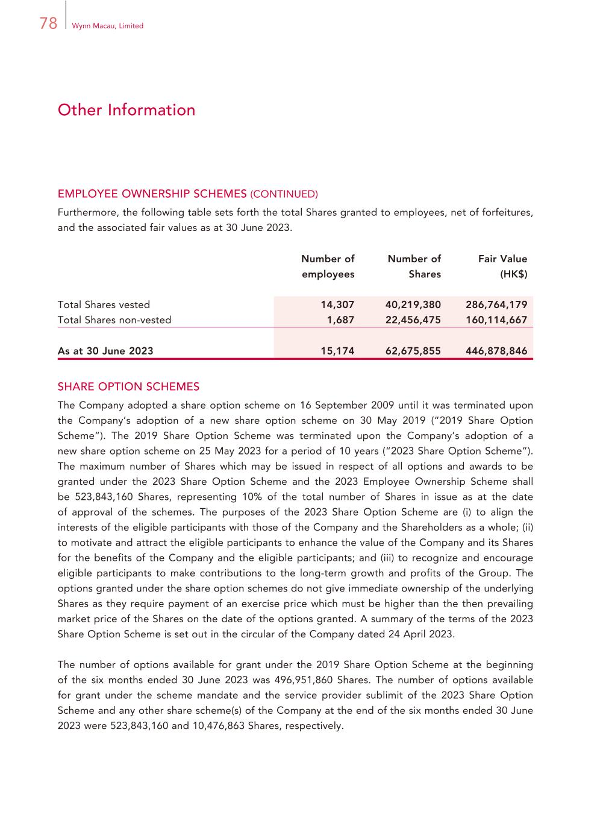
78 Wynn Macau, Limited Other Information EMPLOYEE OWNERSHIP SCHEMES (CONTINUED) Furthermore, the following table sets forth the total Shares granted to employees, net of forfeitures, and the associated fair values as at 30 June 2023. Number of employees Number of Shares Fair Value (HK$) Total Shares vested 14,307 40,219,380 286,764,179 Total Shares non-vested 1,687 22,456,475 160,114,667 As at 30 June 2023 15,174 62,675,855 446,878,846 SHARE OPTION SCHEMES The Company adopted a share option scheme on 16 September 2009 until it was terminated upon the Company’s adoption of a new share option scheme on 30 May 2019 (“2019 Share Option Scheme”). The 2019 Share Option Scheme was terminated upon the Company’s adoption of a new share option scheme on 25 May 2023 for a period of 10 years (“2023 Share Option Scheme”). The maximum number of Shares which may be issued in respect of all options and awards to be granted under the 2023 Share Option Scheme and the 2023 Employee Ownership Scheme shall be 523,843,160 Shares, representing 10% of the total number of Shares in issue as at the date of approval of the schemes. The purposes of the 2023 Share Option Scheme are (i) to align the interests of the eligible participants with those of the Company and the Shareholders as a whole; (ii) to motivate and attract the eligible participants to enhance the value of the Company and its Shares for the benefits of the Company and the eligible participants; and (iii) to recognize and encourage eligible participants to make contributions to the long-term growth and profits of the Group. The options granted under the share option schemes do not give immediate ownership of the underlying Shares as they require payment of an exercise price which must be higher than the then prevailing market price of the Shares on the date of the options granted. A summary of the terms of the 2023 Share Option Scheme is set out in the circular of the Company dated 24 April 2023. The number of options available for grant under the 2019 Share Option Scheme at the beginning of the six months ended 30 June 2023 was 496,951,860 Shares. The number of options available for grant under the scheme mandate and the service provider sublimit of the 2023 Share Option Scheme and any other share scheme(s) of the Company at the end of the six months ended 30 June 2023 were 523,843,160 and 10,476,863 Shares, respectively.

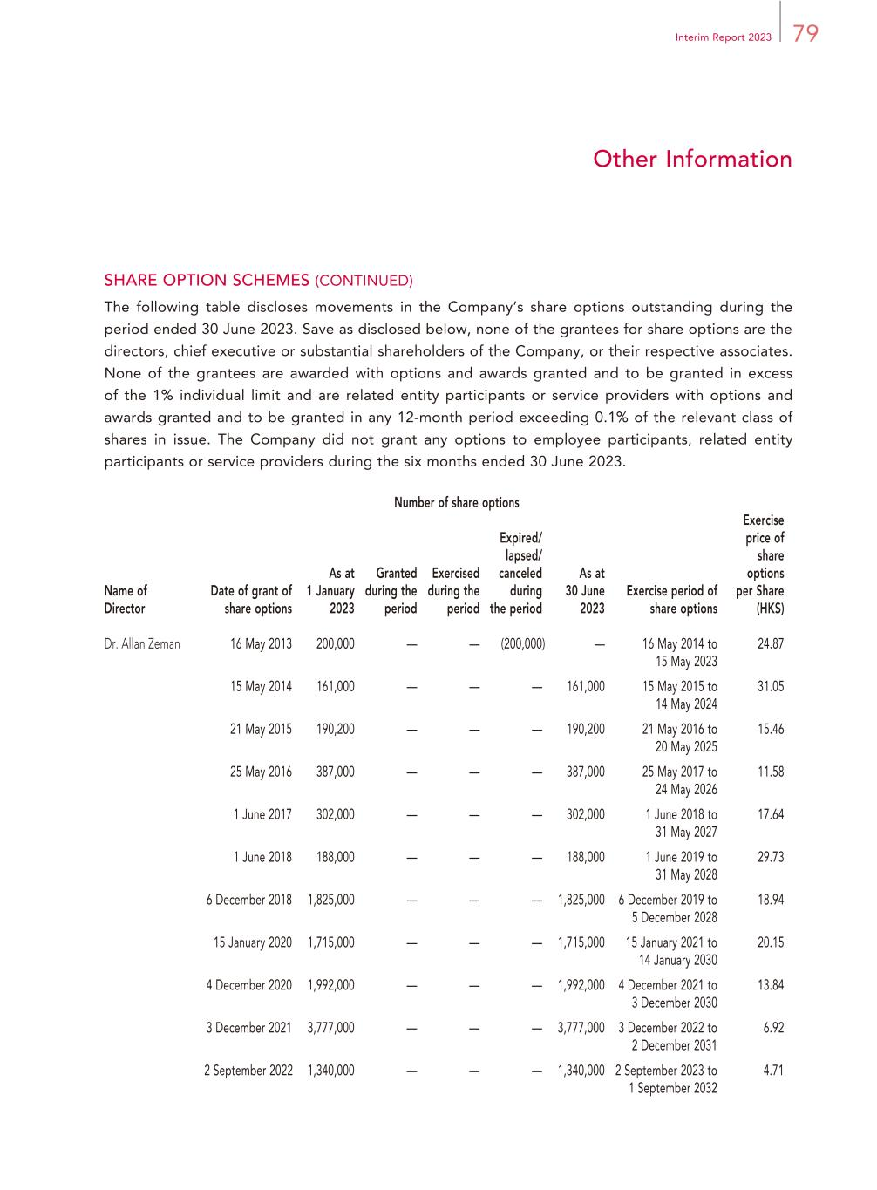
79Interim Report 2023 Other Information SHARE OPTION SCHEMES (CONTINUED) The following table discloses movements in the Company’s share options outstanding during the period ended 30 June 2023. Save as disclosed below, none of the grantees for share options are the directors, chief executive or substantial shareholders of the Company, or their respective associates. None of the grantees are awarded with options and awards granted and to be granted in excess of the 1% individual limit and are related entity participants or service providers with options and awards granted and to be granted in any 12-month period exceeding 0.1% of the relevant class of shares in issue. The Company did not grant any options to employee participants, related entity participants or service providers during the six months ended 30 June 2023. Number of share options Name of Director Date of grant of share options As at 1 January 2023 Granted during the period Exercised during the period Expired/ lapsed/ canceled during the period As at 30 June 2023 Exercise period of share options Exercise price of share options per Share (HK$) Dr. Allan Zeman 16 May 2013 200,000 — — (200,000) — 16 May 2014 to 15 May 2023 24.87 15 May 2014 161,000 — — — 161,000 15 May 2015 to 14 May 2024 31.05 21 May 2015 190,200 — — — 190,200 21 May 2016 to 20 May 2025 15.46 25 May 2016 387,000 — — — 387,000 25 May 2017 to 24 May 2026 11.58 1 June 2017 302,000 — — — 302,000 1 June 2018 to 31 May 2027 17.64 1 June 2018 188,000 — — — 188,000 1 June 2019 to 31 May 2028 29.73 6 December 2018 1,825,000 — — — 1,825,000 6 December 2019 to 5 December 2028 18.94 15 January 2020 1,715,000 — — — 1,715,000 15 January 2021 to 14 January 2030 20.15 4 December 2020 1,992,000 — — — 1,992,000 4 December 2021 to 3 December 2030 13.84 3 December 2021 3,777,000 — — — 3,777,000 3 December 2022 to 2 December 2031 6.92 2 September 2022 1,340,000 — — — 1,340,000 2 September 2023 to 1 September 2032 4.71

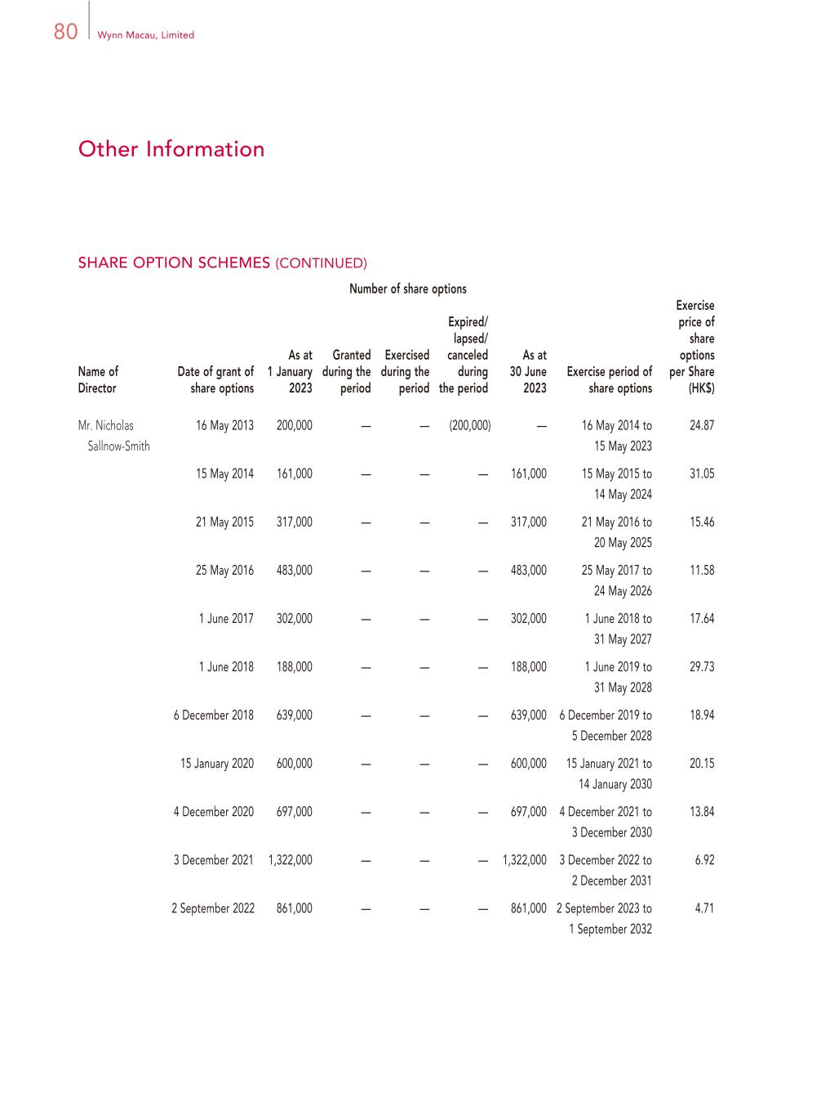
80 Wynn Macau, Limited Other Information Number of share options Name of Director Date of grant of share options As at 1 January 2023 Granted during the period Exercised during the period Expired/ lapsed/ canceled during the period As at 30 June 2023 Exercise period of share options Exercise price of share options per Share (HK$) Mr. Nicholas Sallnow-Smith 16 May 2013 200,000 — — (200,000) — 16 May 2014 to 15 May 2023 24.87 15 May 2014 161,000 — — — 161,000 15 May 2015 to 14 May 2024 31.05 21 May 2015 317,000 — — — 317,000 21 May 2016 to 20 May 2025 15.46 25 May 2016 483,000 — — — 483,000 25 May 2017 to 24 May 2026 11.58 1 June 2017 302,000 — — — 302,000 1 June 2018 to 31 May 2027 17.64 1 June 2018 188,000 — — — 188,000 1 June 2019 to 31 May 2028 29.73 6 December 2018 639,000 — — — 639,000 6 December 2019 to 5 December 2028 18.94 15 January 2020 600,000 — — — 600,000 15 January 2021 to 14 January 2030 20.15 4 December 2020 697,000 — — — 697,000 4 December 2021 to 3 December 2030 13.84 3 December 2021 1,322,000 — — — 1,322,000 3 December 2022 to 2 December 2031 6.92 2 September 2022 861,000 — — — 861,000 2 September 2023 to 1 September 2032 4.71 SHARE OPTION SCHEMES (CONTINUED)

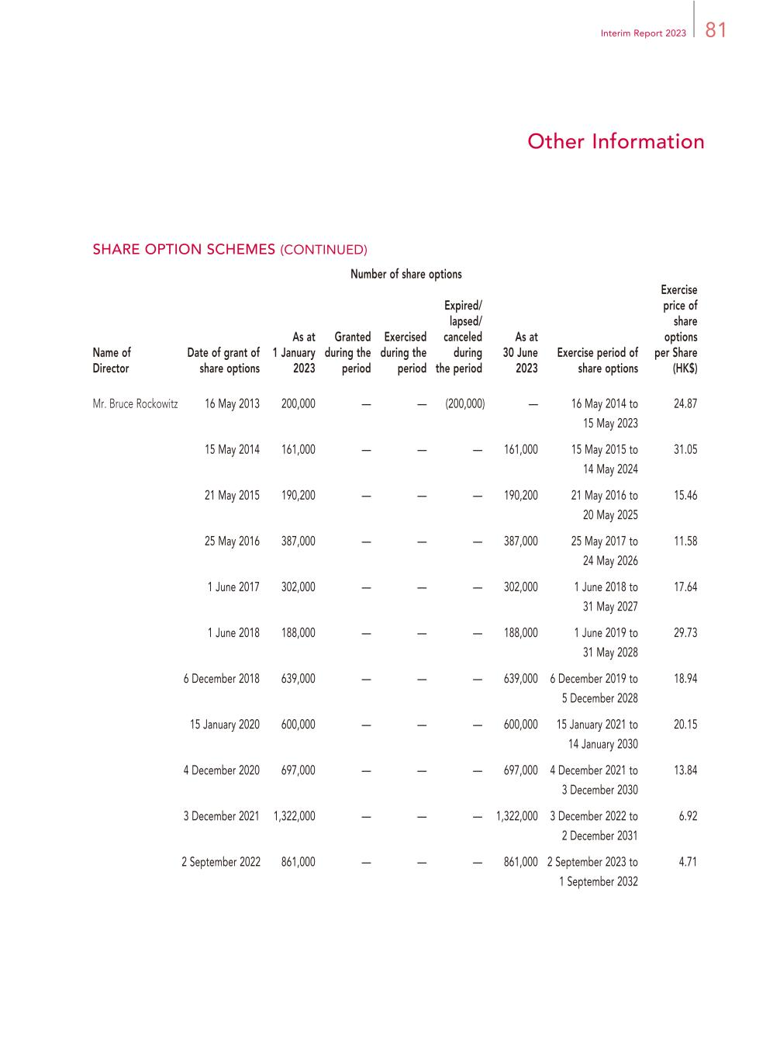
81Interim Report 2023 Other Information Number of share options Name of Director Date of grant of share options As at 1 January 2023 Granted during the period Exercised during the period Expired/ lapsed/ canceled during the period As at 30 June 2023 Exercise period of share options Exercise price of share options per Share (HK$) Mr. Bruce Rockowitz 16 May 2013 200,000 — — (200,000) — 16 May 2014 to 15 May 2023 24.87 15 May 2014 161,000 — — — 161,000 15 May 2015 to 14 May 2024 31.05 21 May 2015 190,200 — — — 190,200 21 May 2016 to 20 May 2025 15.46 25 May 2016 387,000 — — — 387,000 25 May 2017 to 24 May 2026 11.58 1 June 2017 302,000 — — — 302,000 1 June 2018 to 31 May 2027 17.64 1 June 2018 188,000 — — — 188,000 1 June 2019 to 31 May 2028 29.73 6 December 2018 639,000 — — — 639,000 6 December 2019 to 5 December 2028 18.94 15 January 2020 600,000 — — — 600,000 15 January 2021 to 14 January 2030 20.15 4 December 2020 697,000 — — — 697,000 4 December 2021 to 3 December 2030 13.84 3 December 2021 1,322,000 — — — 1,322,000 3 December 2022 to 2 December 2031 6.92 2 September 2022 861,000 — — — 861,000 2 September 2023 to 1 September 2032 4.71 SHARE OPTION SCHEMES (CONTINUED)

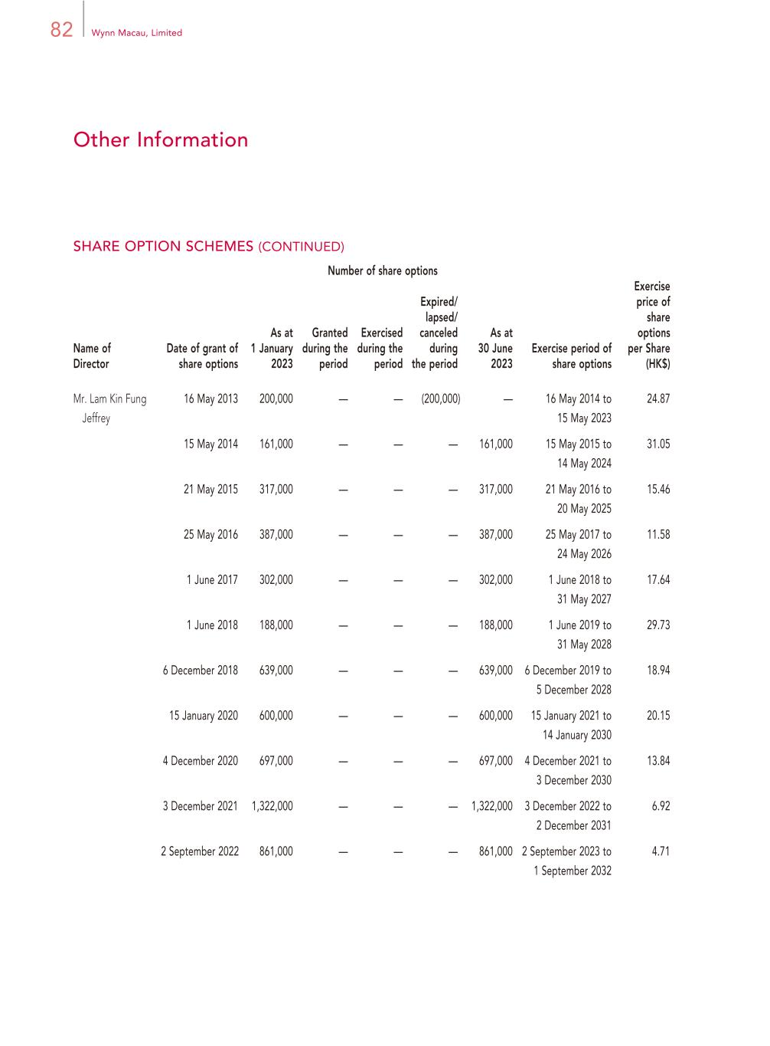
82 Wynn Macau, Limited Other Information Number of share options Name of Director Date of grant of share options As at 1 January 2023 Granted during the period Exercised during the period Expired/ lapsed/ canceled during the period As at 30 June 2023 Exercise period of share options Exercise price of share options per Share (HK$) Mr. Lam Kin Fung Jeffrey 16 May 2013 200,000 — — (200,000) — 16 May 2014 to 15 May 2023 24.87 15 May 2014 161,000 — — — 161,000 15 May 2015 to 14 May 2024 31.05 21 May 2015 317,000 — — — 317,000 21 May 2016 to 20 May 2025 15.46 25 May 2016 387,000 — — — 387,000 25 May 2017 to 24 May 2026 11.58 1 June 2017 302,000 — — — 302,000 1 June 2018 to 31 May 2027 17.64 1 June 2018 188,000 — — — 188,000 1 June 2019 to 31 May 2028 29.73 6 December 2018 639,000 — — — 639,000 6 December 2019 to 5 December 2028 18.94 15 January 2020 600,000 — — — 600,000 15 January 2021 to 14 January 2030 20.15 4 December 2020 697,000 — — — 697,000 4 December 2021 to 3 December 2030 13.84 3 December 2021 1,322,000 — — — 1,322,000 3 December 2022 to 2 December 2031 6.92 2 September 2022 861,000 — — — 861,000 2 September 2023 to 1 September 2032 4.71 SHARE OPTION SCHEMES (CONTINUED)

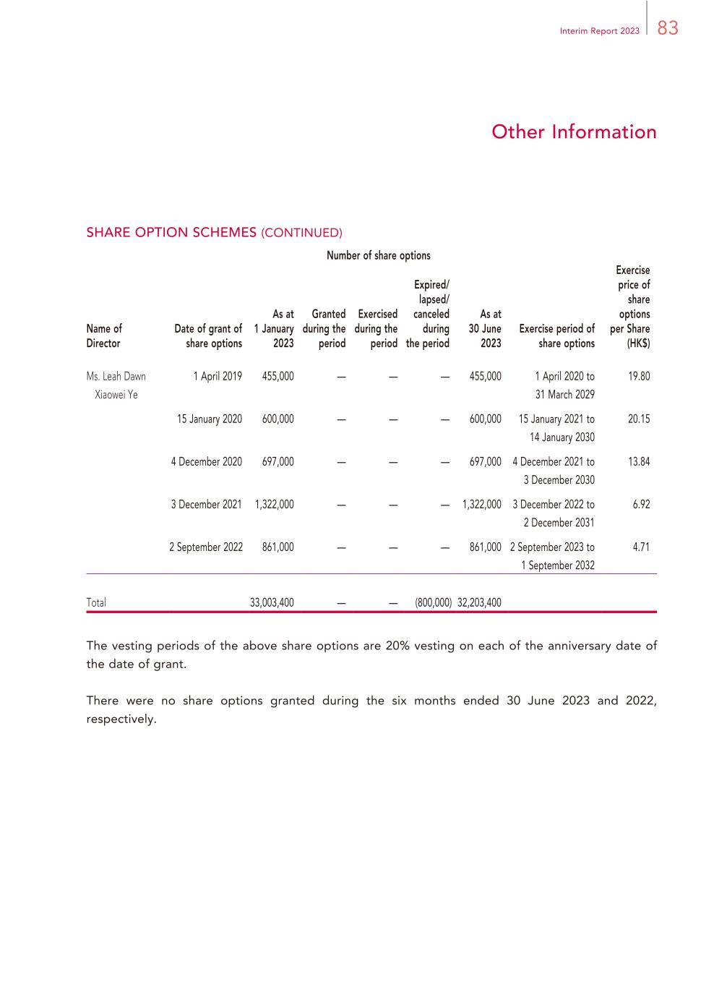
83Interim Report 2023 Other Information Number of share options Name of Director Date of grant of share options As at 1 January 2023 Granted during the period Exercised during the period Expired/ lapsed/ canceled during the period As at 30 June 2023 Exercise period of share options Exercise price of share options per Share (HK$) Ms. Leah Dawn Xiaowei Ye 1 April 2019 455,000 — — — 455,000 1 April 2020 to 31 March 2029 19.80 15 January 2020 600,000 — — — 600,000 15 January 2021 to 14 January 2030 20.15 4 December 2020 697,000 — — — 697,000 4 December 2021 to 3 December 2030 13.84 3 December 2021 1,322,000 — — — 1,322,000 3 December 2022 to 2 December 2031 6.92 2 September 2022 861,000 — — — 861,000 2 September 2023 to 1 September 2032 4.71 Total 33,003,400 — — (800,000) 32,203,400 The vesting periods of the above share options are 20% vesting on each of the anniversary date of the date of grant. There were no share options granted during the six months ended 30 June 2023 and 2022, respectively. SHARE OPTION SCHEMES (CONTINUED)

84 Wynn Macau, Limited Other Information PURCHASE, SALE OR REDEMPTION OF THE COMPANY’S LISTED SECURITIES Neither the Company nor any of its subsidiaries purchased, sold or redeemed any of the Group’s listed securities during the six months ended 30 June 2023. CORPORATE GOVERNANCE PRACTICES Our commitment to integrity and dedication to maintaining and ensuring high standards of corporate governance are fundamental to our ability to conduct our business and sustain the respect of the investment community and the people who regulate our industry. The Company’s corporate governance practices are based on the principles, code provisions and certain recommended best practices as set out in the Code and are regularly reviewed and developed in the interests of the Company, its Shareholders and other stakeholders. The Company has complied with the code provisions in the Code for the six months ended 30 June 2023. MODEL CODE The Company adopted the Model Code on 16 September 2009 as its code of conduct for securities transactions by Directors. On 23 March 2010, the Company adopted its own code of conduct for securities transactions, which was most recently updated in March 2017. The terms of such code are no less exacting than those set out in the Model Code. Having made specific enquiry of the Directors, all Directors have confirmed that they have complied with the required standard of dealings and code of conduct regarding securities dealings by directors as set out in the Model Code and the Company’s own code of conduct for the six months ended 30 June 2023. QUARTERLY REPORTING BY WYNN RESORTS, LIMITED Our ultimate controlling shareholder, Wynn Resorts, Limited, is listed on the NASDAQ global select market and is a reporting company under the United States Securities Exchange Act of 1934 which is required to file quarterly reports with the SEC. Each quarter, Wynn Resorts, Limited issues press releases in the United States relating to its quarterly financial information (including financial information about the Macau segments of Wynn Resorts, Limited, which are operated by the Company). Such information will be presented in accordance with U.S. GAAP. At the same time as Wynn Resorts, Limited releases its quarterly press releases, the Company makes an announcement on the Hong Kong Stock Exchange pursuant to Rule 13.09 and 37.47B of the Listing Rules and Part XIVA of the SFO by extracting the key highlights of the press release pertaining to the Group. Such announcement will also include a quarterly income statement for the Group presented in accordance with IFRS.

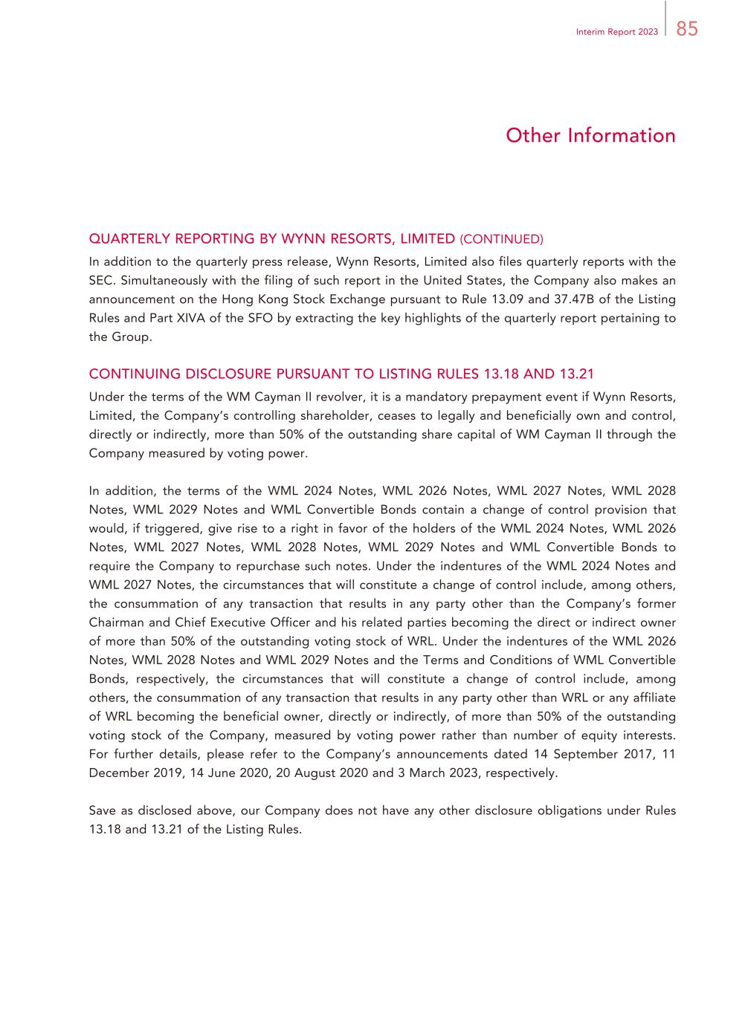
85Interim Report 2023 Other Information QUARTERLY REPORTING BY WYNN RESORTS, LIMITED (CONTINUED) In addition to the quarterly press release, Wynn Resorts, Limited also files quarterly reports with the SEC. Simultaneously with the filing of such report in the United States, the Company also makes an announcement on the Hong Kong Stock Exchange pursuant to Rule 13.09 and 37.47B of the Listing Rules and Part XIVA of the SFO by extracting the key highlights of the quarterly report pertaining to the Group. CONTINUING DISCLOSURE PURSUANT TO LISTING RULES 13.18 AND 13.21 Under the terms of the WM Cayman II revolver, it is a mandatory prepayment event if Wynn Resorts, Limited, the Company’s controlling shareholder, ceases to legally and beneficially own and control, directly or indirectly, more than 50% of the outstanding share capital of WM Cayman II through the Company measured by voting power. In addition, the terms of the WML 2024 Notes, WML 2026 Notes, WML 2027 Notes, WML 2028 Notes, WML 2029 Notes and WML Convertible Bonds contain a change of control provision that would, if triggered, give rise to a right in favor of the holders of the WML 2024 Notes, WML 2026 Notes, WML 2027 Notes, WML 2028 Notes, WML 2029 Notes and WML Convertible Bonds to require the Company to repurchase such notes. Under the indentures of the WML 2024 Notes and WML 2027 Notes, the circumstances that will constitute a change of control include, among others, the consummation of any transaction that results in any party other than the Company’s former Chairman and Chief Executive Officer and his related parties becoming the direct or indirect owner of more than 50% of the outstanding voting stock of WRL. Under the indentures of the WML 2026 Notes, WML 2028 Notes and WML 2029 Notes and the Terms and Conditions of WML Convertible Bonds, respectively, the circumstances that will constitute a change of control include, among others, the consummation of any transaction that results in any party other than WRL or any affiliate of WRL becoming the beneficial owner, directly or indirectly, of more than 50% of the outstanding voting stock of the Company, measured by voting power rather than number of equity interests. For further details, please refer to the Company’s announcements dated 14 September 2017, 11 December 2019, 14 June 2020, 20 August 2020 and 3 March 2023, respectively. Save as disclosed above, our Company does not have any other disclosure obligations under Rules 13.18 and 13.21 of the Listing Rules.

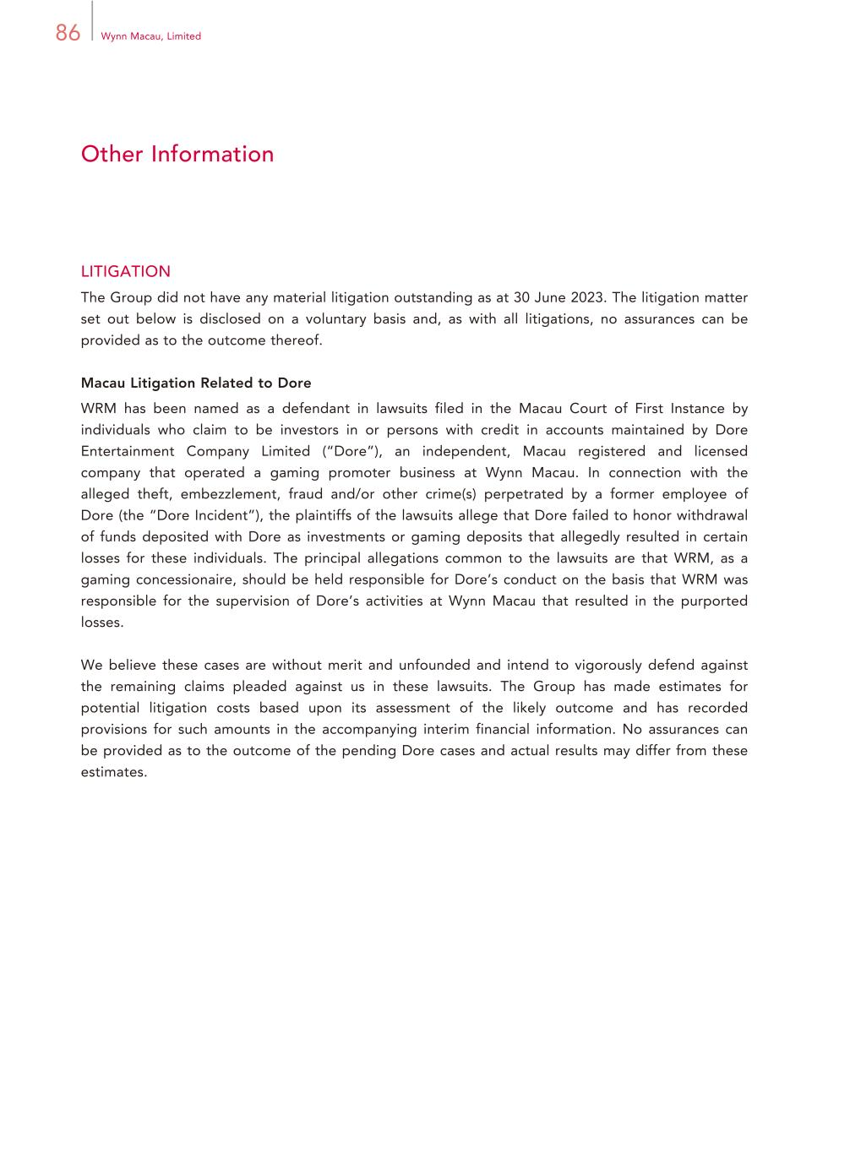
86 Wynn Macau, Limited Other Information LITIGATION The Group did not have any material litigation outstanding as at 30 June 2023. The litigation matter set out below is disclosed on a voluntary basis and, as with all litigations, no assurances can be provided as to the outcome thereof. Macau Litigation Related to Dore WRM has been named as a defendant in lawsuits filed in the Macau Court of First Instance by individuals who claim to be investors in or persons with credit in accounts maintained by Dore Entertainment Company Limited (“Dore”), an independent, Macau registered and licensed company that operated a gaming promoter business at Wynn Macau. In connection with the alleged theft, embezzlement, fraud and/or other crime(s) perpetrated by a former employee of Dore (the “Dore Incident”), the plaintiffs of the lawsuits allege that Dore failed to honor withdrawal of funds deposited with Dore as investments or gaming deposits that allegedly resulted in certain losses for these individuals. The principal allegations common to the lawsuits are that WRM, as a gaming concessionaire, should be held responsible for Dore’s conduct on the basis that WRM was responsible for the supervision of Dore’s activities at Wynn Macau that resulted in the purported losses. We believe these cases are without merit and unfounded and intend to vigorously defend against the remaining claims pleaded against us in these lawsuits. The Group has made estimates for potential litigation costs based upon its assessment of the likely outcome and has recorded provisions for such amounts in the accompanying interim financial information. No assurances can be provided as to the outcome of the pending Dore cases and actual results may differ from these estimates.

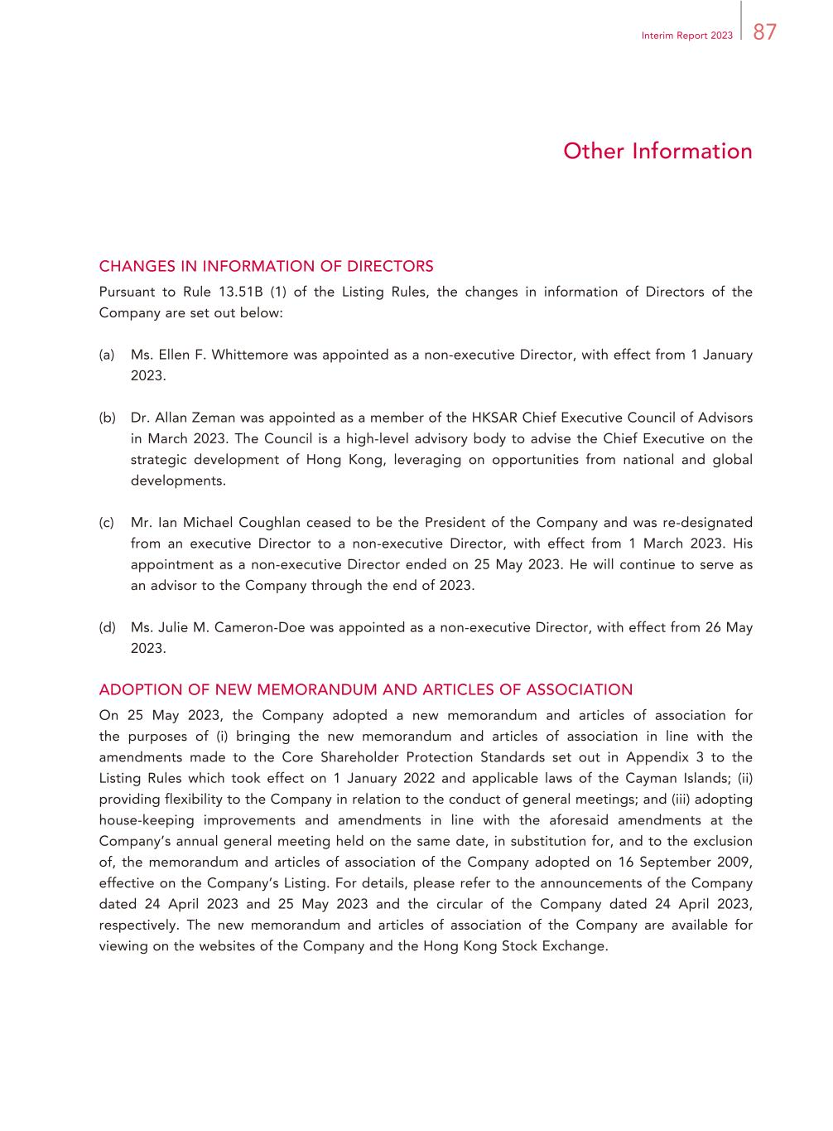
87Interim Report 2023 Other Information CHANGES IN INFORMATION OF DIRECTORS Pursuant to Rule 13.51B (1) of the Listing Rules, the changes in information of Directors of the Company are set out below: (a) Ms. Ellen F. Whittemore was appointed as a non-executive Director, with effect from 1 January 2023. (b) Dr. Allan Zeman was appointed as a member of the HKSAR Chief Executive Council of Advisors in March 2023. The Council is a high-level advisory body to advise the Chief Executive on the strategic development of Hong Kong, leveraging on opportunities from national and global developments. (c) Mr. Ian Michael Coughlan ceased to be the President of the Company and was re-designated from an executive Director to a non-executive Director, with effect from 1 March 2023. His appointment as a non-executive Director ended on 25 May 2023. He will continue to serve as an advisor to the Company through the end of 2023. (d) Ms. Julie M. Cameron-Doe was appointed as a non-executive Director, with effect from 26 May 2023. ADOPTION OF NEW MEMORANDUM AND ARTICLES OF ASSOCIATION On 25 May 2023, the Company adopted a new memorandum and articles of association for the purposes of (i) bringing the new memorandum and articles of association in line with the amendments made to the Core Shareholder Protection Standards set out in Appendix 3 to the Listing Rules which took effect on 1 January 2022 and applicable laws of the Cayman Islands; (ii) providing flexibility to the Company in relation to the conduct of general meetings; and (iii) adopting house-keeping improvements and amendments in line with the aforesaid amendments at the Company’s annual general meeting held on the same date, in substitution for, and to the exclusion of, the memorandum and articles of association of the Company adopted on 16 September 2009, effective on the Company’s Listing. For details, please refer to the announcements of the Company dated 24 April 2023 and 25 May 2023 and the circular of the Company dated 24 April 2023, respectively. The new memorandum and articles of association of the Company are available for viewing on the websites of the Company and the Hong Kong Stock Exchange.

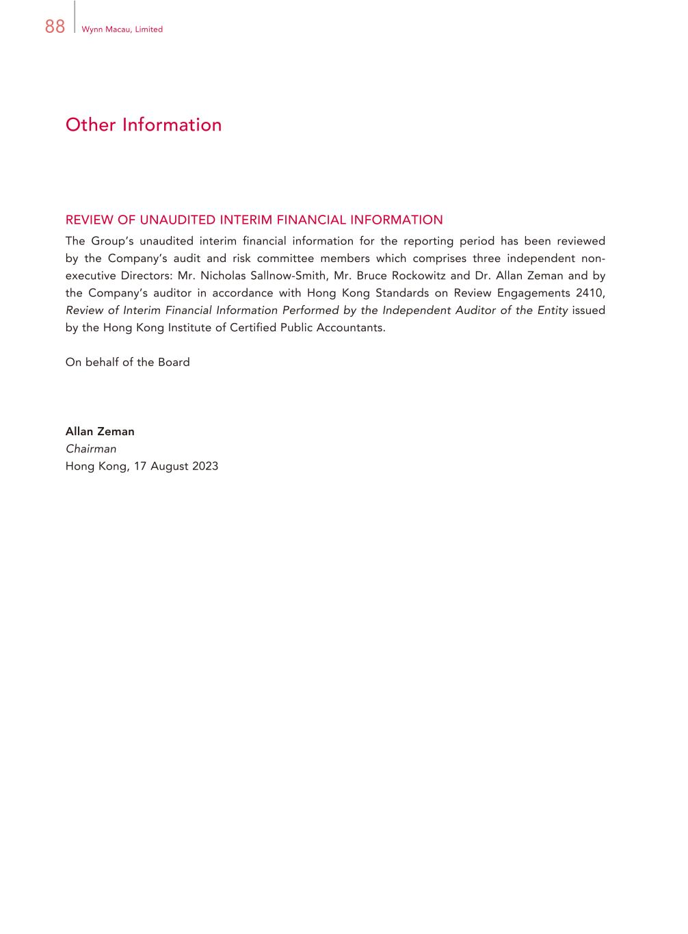
88 Wynn Macau, Limited Other Information REVIEW OF UNAUDITED INTERIM FINANCIAL INFORMATION The Group’s unaudited interim financial information for the reporting period has been reviewed by the Company’s audit and risk committee members which comprises three independent non- executive Directors: Mr. Nicholas Sallnow-Smith, Mr. Bruce Rockowitz and Dr. Allan Zeman and by the Company’s auditor in accordance with Hong Kong Standards on Review Engagements 2410, Review of Interim Financial Information Performed by the Independent Auditor of the Entity issued by the Hong Kong Institute of Certified Public Accountants. On behalf of the Board Allan Zeman Chairman Hong Kong, 17 August 2023

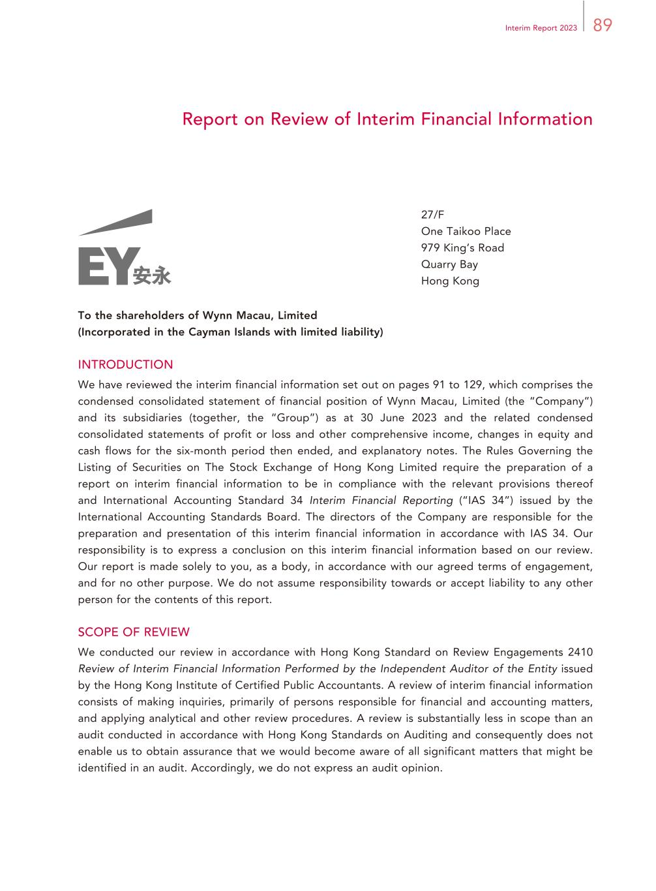
89Interim Report 2023 Report on Review of Interim Financial Information 27/F One Taikoo Place 979 King’s Road Quarry Bay Hong Kong To the shareholders of Wynn Macau, Limited (Incorporated in the Cayman Islands with limited liability) INTRODUCTION We have reviewed the interim financial information set out on pages 91 to 129, which comprises the condensed consolidated statement of financial position of Wynn Macau, Limited (the “Company”) and its subsidiaries (together, the “Group”) as at 30 June 2023 and the related condensed consolidated statements of profit or loss and other comprehensive income, changes in equity and cash flows for the six-month period then ended, and explanatory notes. The Rules Governing the Listing of Securities on The Stock Exchange of Hong Kong Limited require the preparation of a report on interim financial information to be in compliance with the relevant provisions thereof and International Accounting Standard 34 Interim Financial Reporting (“IAS 34”) issued by the International Accounting Standards Board. The directors of the Company are responsible for the preparation and presentation of this interim financial information in accordance with IAS 34. Our responsibility is to express a conclusion on this interim financial information based on our review. Our report is made solely to you, as a body, in accordance with our agreed terms of engagement, and for no other purpose. We do not assume responsibility towards or accept liability to any other person for the contents of this report. SCOPE OF REVIEW We conducted our review in accordance with Hong Kong Standard on Review Engagements 2410 Review of Interim Financial Information Performed by the Independent Auditor of the Entity issued by the Hong Kong Institute of Certified Public Accountants. A review of interim financial information consists of making inquiries, primarily of persons responsible for financial and accounting matters, and applying analytical and other review procedures. A review is substantially less in scope than an audit conducted in accordance with Hong Kong Standards on Auditing and consequently does not enable us to obtain assurance that we would become aware of all significant matters that might be identified in an audit. Accordingly, we do not express an audit opinion.

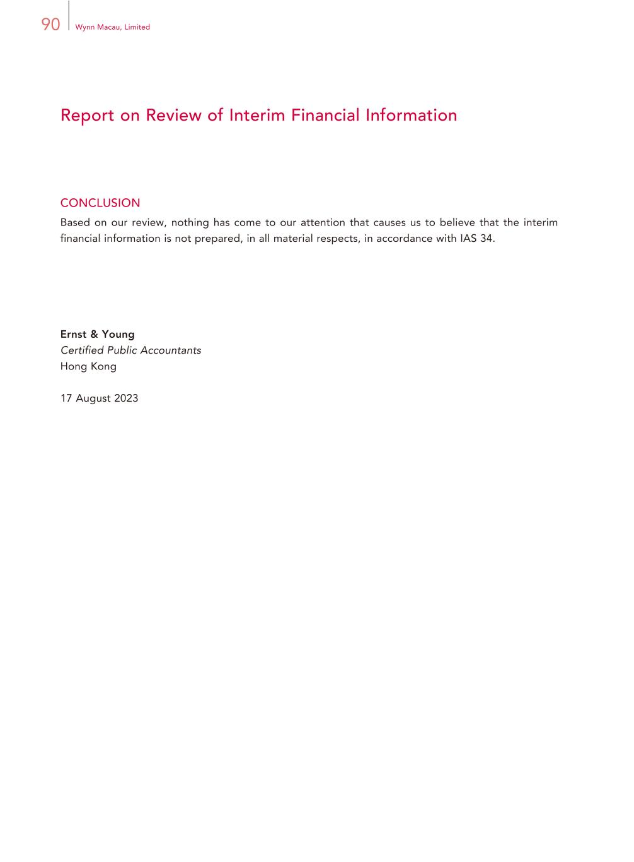
90 Wynn Macau, Limited Report on Review of Interim Financial Information CONCLUSION Based on our review, nothing has come to our attention that causes us to believe that the interim financial information is not prepared, in all material respects, in accordance with IAS 34. Ernst & Young Certified Public Accountants Hong Kong 17 August 2023

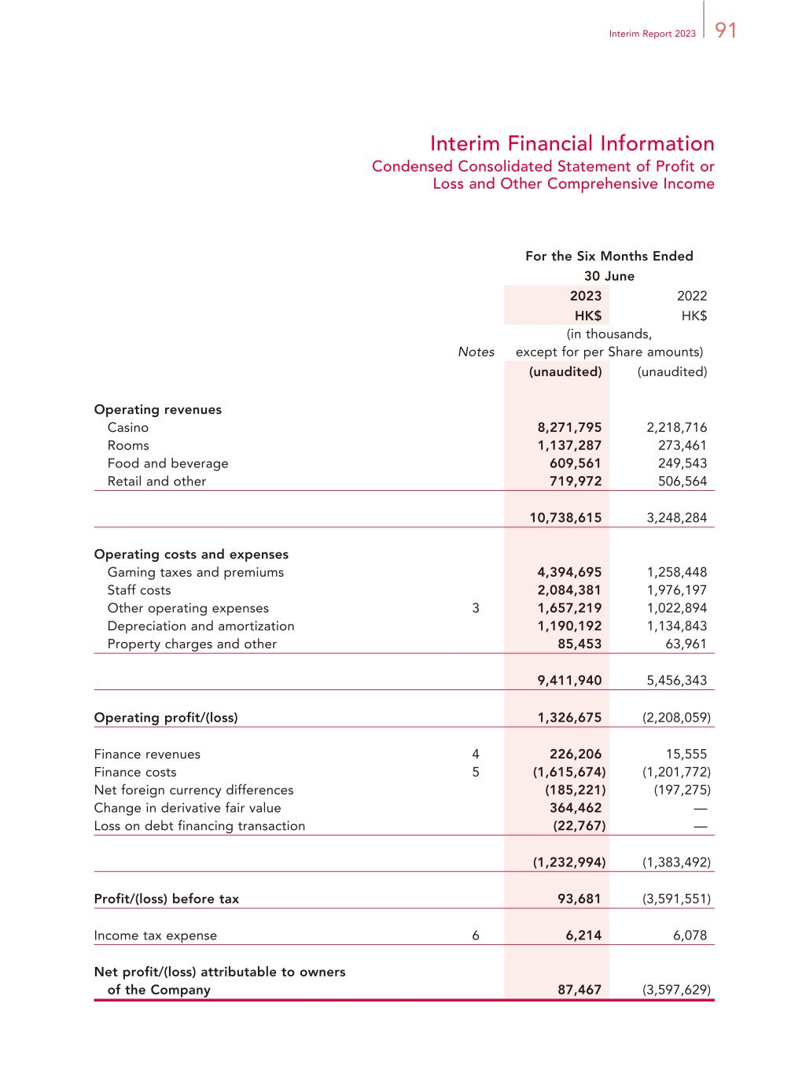
91Interim Report 2023 Interim Financial Information Condensed Consolidated Statement of Profit or Loss and Other Comprehensive Income For the Six Months Ended 30 June 2023 2022 HK$ HK$ Notes (in thousands, except for per Share amounts) (unaudited) (unaudited) Operating revenues Casino 8,271,795 2,218,716 Rooms 1,137,287 273,461 Food and beverage 609,561 249,543 Retail and other 719,972 506,564 10,738,615 3,248,284 Operating costs and expenses Gaming taxes and premiums 4,394,695 1,258,448 Staff costs 2,084,381 1,976,197 Other operating expenses 3 1,657,219 1,022,894 Depreciation and amortization 1,190,192 1,134,843 Property charges and other 85,453 63,961 9,411,940 5,456,343 Operating profit/(loss) 1,326,675 (2,208,059) Finance revenues 4 226,206 15,555 Finance costs 5 (1,615,674) (1,201,772) Net foreign currency differences (185,221) (197,275) Change in derivative fair value 364,462 — Loss on debt financing transaction (22,767) — (1,232,994) (1,383,492) Profit/(loss) before tax 93,681 (3,591,551) Income tax expense 6 6,214 6,078 Net profit/(loss) attributable to owners of the Company 87,467 (3,597,629)

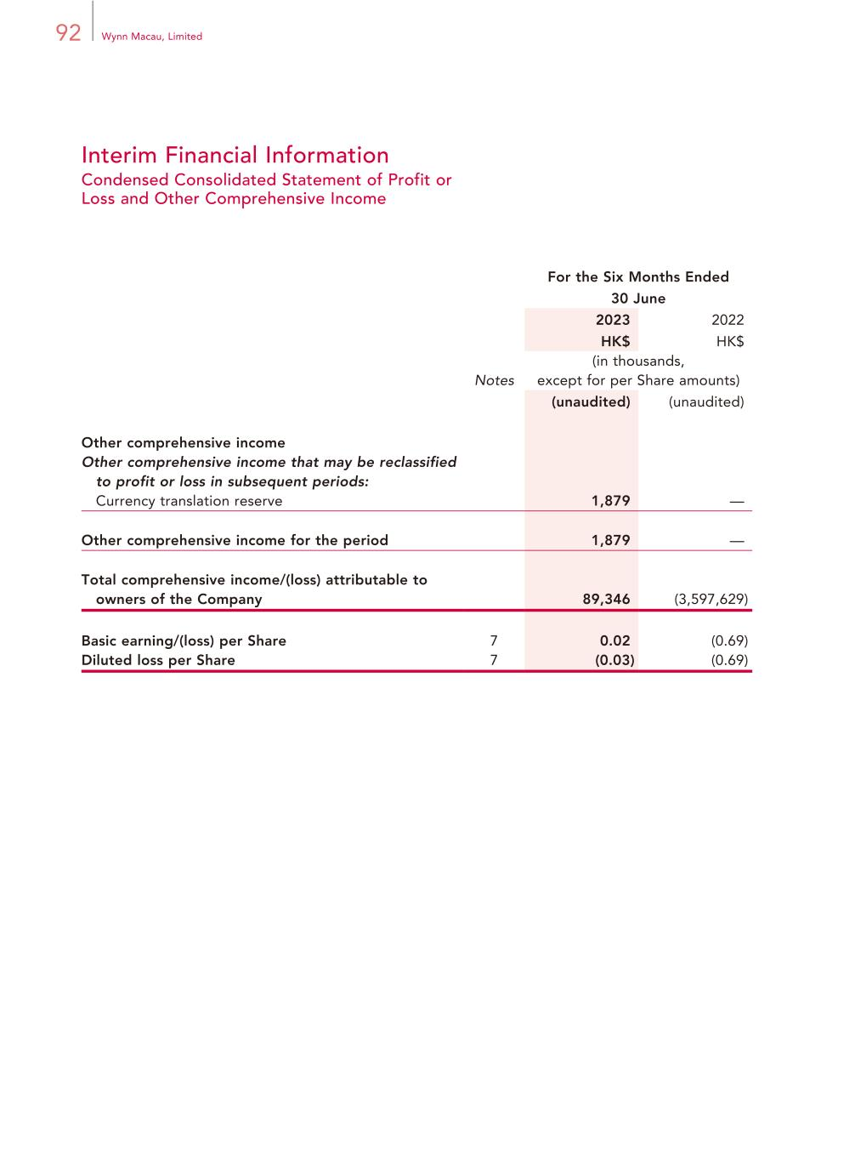
92 Wynn Macau, Limited Interim Financial Information Condensed Consolidated Statement of Profit or Loss and Other Comprehensive Income For the Six Months Ended 30 June 2023 2022 HK$ HK$ Notes (in thousands, except for per Share amounts) (unaudited) (unaudited) Other comprehensive income Other comprehensive income that may be reclassified to profit or loss in subsequent periods: Currency translation reserve 1,879 — Other comprehensive income for the period 1,879 — Total comprehensive income/(loss) attributable to owners of the Company 89,346 (3,597,629) Basic earning/(loss) per Share 7 0.02 (0.69) Diluted loss per Share 7 (0.03) (0.69)

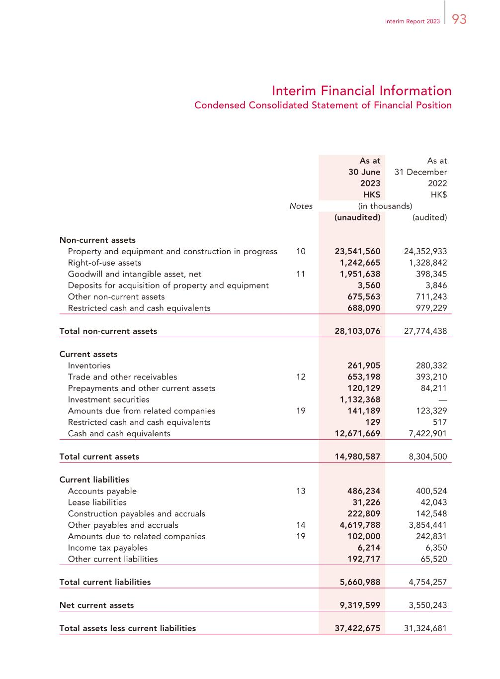
93Interim Report 2023 Interim Financial Information Condensed Consolidated Statement of Financial Position As at As at 30 June 2023 31 December 2022 HK$ HK$ Notes (in thousands) (unaudited) (audited) Non-current assets Property and equipment and construction in progress 10 23,541,560 24,352,933 Right-of-use assets 1,242,665 1,328,842 Goodwill and intangible asset, net 11 1,951,638 398,345 Deposits for acquisition of property and equipment 3,560 3,846 Other non-current assets 675,563 711,243 Restricted cash and cash equivalents 688,090 979,229 Total non-current assets 28,103,076 27,774,438 Current assets Inventories 261,905 280,332 Trade and other receivables 12 653,198 393,210 Prepayments and other current assets 120,129 84,211 Investment securities 1,132,368 — Amounts due from related companies 19 141,189 123,329 Restricted cash and cash equivalents 129 517 Cash and cash equivalents 12,671,669 7,422,901 Total current assets 14,980,587 8,304,500 Current liabilities Accounts payable 13 486,234 400,524 Lease liabilities 31,226 42,043 Construction payables and accruals 222,809 142,548 Other payables and accruals 14 4,619,788 3,854,441 Amounts due to related companies 19 102,000 242,831 Income tax payables 6,214 6,350 Other current liabilities 192,717 65,520 Total current liabilities 5,660,988 4,754,257 Net current assets 9,319,599 3,550,243 Total assets less current liabilities 37,422,675 31,324,681

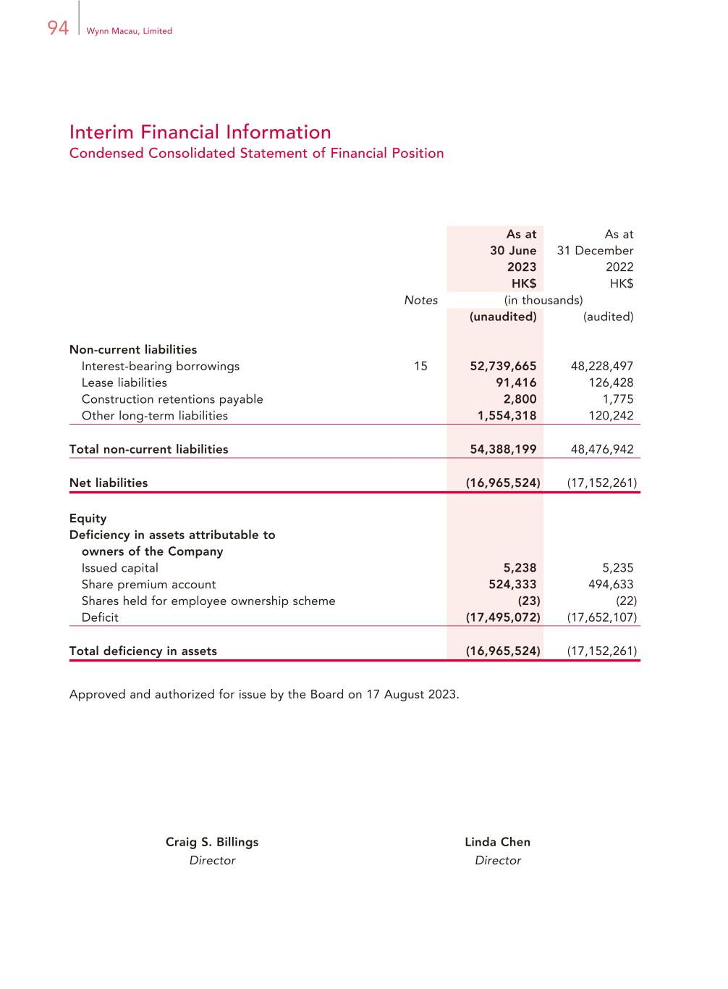
94 Wynn Macau, Limited Interim Financial Information Condensed Consolidated Statement of Financial Position As at As at 30 June 2023 31 December 2022 HK$ HK$ Notes (in thousands) (unaudited) (audited) Non-current liabilities Interest-bearing borrowings 15 52,739,665 48,228,497 Lease liabilities 91,416 126,428 Construction retentions payable 2,800 1,775 Other long-term liabilities 1,554,318 120,242 Total non-current liabilities 54,388,199 48,476,942 Net liabilities (16,965,524) (17,152,261) Equity Deficiency in assets attributable to owners of the Company Issued capital 5,238 5,235 Share premium account 524,333 494,633 Shares held for employee ownership scheme (23) (22) Deficit (17,495,072) (17,652,107) Total deficiency in assets (16,965,524) (17,152,261) Approved and authorized for issue by the Board on 17 August 2023. Craig S. Billings Linda Chen Director Director

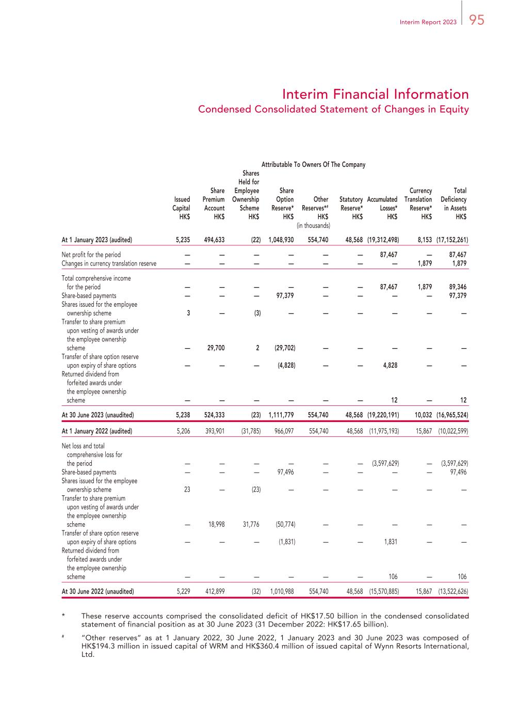
95Interim Report 2023 Interim Financial Information Condensed Consolidated Statement of Changes in Equity Attributable To Owners Of The Company Issued Capital HK$ Share Premium Account HK$ Shares Held for Employee Ownership Scheme HK$ Share Option Reserve* HK$ Other Reserves*# HK$ Statutory Reserve* HK$ Accumulated Losses* HK$ Currency Translation Reserve* HK$ Total Deficiency in Assets HK$ (in thousands) At 1 January 2023 (audited) 5,235 494,633 (22) 1,048,930 554,740 48,568 (19,312,498) 8,153 (17,152,261) Net profit for the period — — — — — — 87,467 — 87,467 Changes in currency translation reserve — — — — — — — 1,879 1,879 Total comprehensive income for the period — — — — — — 87,467 1,879 89,346 Share-based payments — — — 97,379 — — — — 97,379 Shares issued for the employee ownership scheme 3 — (3) — — — — — — Transfer to share premium upon vesting of awards under the employee ownership scheme — 29,700 2 (29,702) — — — — — Transfer of share option reserve upon expiry of share options — — — (4,828) — — 4,828 — — Returned dividend from forfeited awards under the employee ownership scheme — — — — — — 12 — 12 At 30 June 2023 (unaudited) 5,238 524,333 (23) 1,111,779 554,740 48,568 (19,220,191) 10,032 (16,965,524) At 1 January 2022 (audited) 5,206 393,901 (31,785) 966,097 554,740 48,568 (11,975,193) 15,867 (10,022,599) Net loss and total comprehensive loss for the period — — — — — — (3,597,629) — (3,597,629) Share-based payments — — — 97,496 — — — — 97,496 Shares issued for the employee ownership scheme 23 — (23) — — — — — — Transfer to share premium upon vesting of awards under the employee ownership scheme — 18,998 31,776 (50,774) — — — — — Transfer of share option reserve upon expiry of share options — — — (1,831) — — 1,831 — — Returned dividend from forfeited awards under the employee ownership scheme — — — — — — 106 — 106 At 30 June 2022 (unaudited) 5,229 412,899 (32) 1,010,988 554,740 48,568 (15,570,885) 15,867 (13,522,626) * These reserve accounts comprised the consolidated deficit of HK$17.50 billion in the condensed consolidated statement of financial position as at 30 June 2023 (31 December 2022: HK$17.65 billion). # “Other reserves” as at 1 January 2022, 30 June 2022, 1 January 2023 and 30 June 2023 was composed of HK$194.3 million in issued capital of WRM and HK$360.4 million of issued capital of Wynn Resorts International, Ltd.

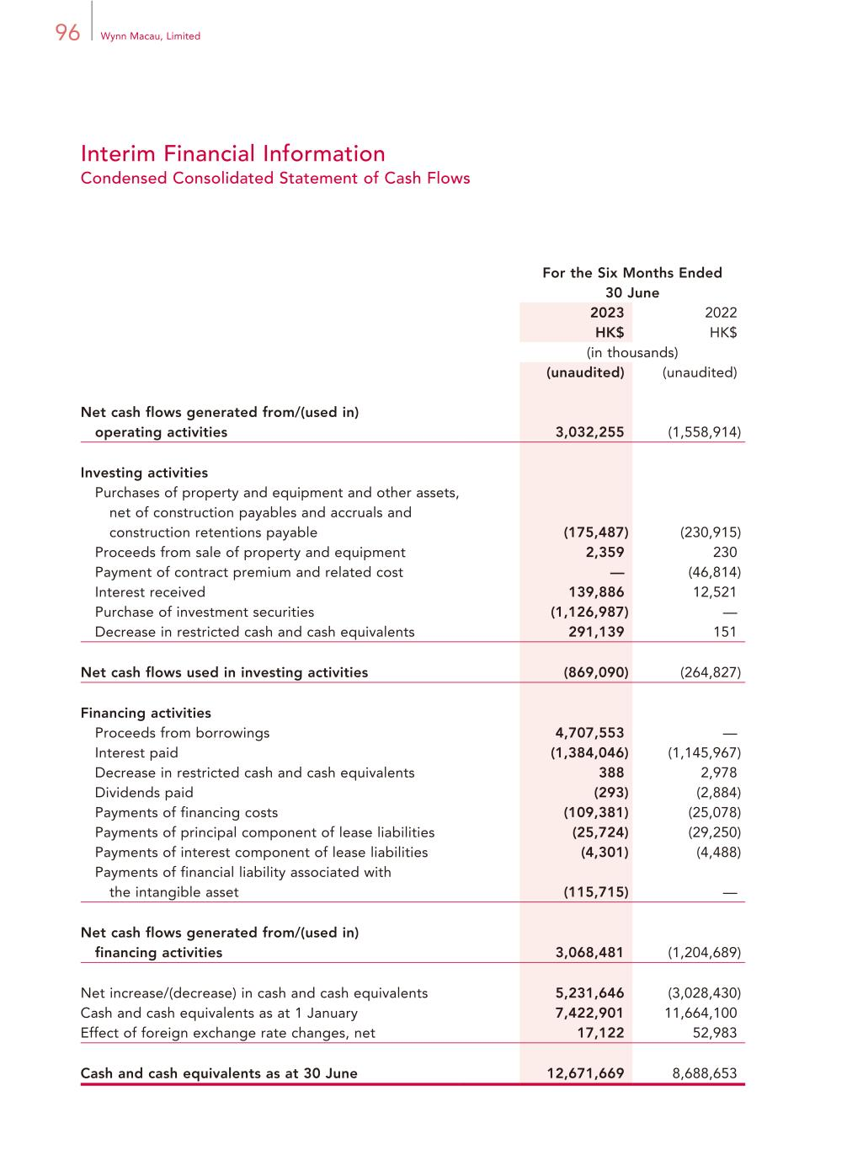
96 Wynn Macau, Limited Interim Financial Information Condensed Consolidated Statement of Cash Flows For the Six Months Ended 30 June 2023 2022 HK$ HK$ (in thousands) (unaudited) (unaudited) Net cash flows generated from/(used in) operating activities 3,032,255 (1,558,914) Investing activities Purchases of property and equipment and other assets, net of construction payables and accruals and construction retentions payable (175,487) (230,915) Proceeds from sale of property and equipment 2,359 230 Payment of contract premium and related cost — (46,814) Interest received 139,886 12,521 Purchase of investment securities (1,126,987) — Decrease in restricted cash and cash equivalents 291,139 151 Net cash flows used in investing activities (869,090) (264,827) Financing activities Proceeds from borrowings 4,707,553 — Interest paid (1,384,046) (1,145,967) Decrease in restricted cash and cash equivalents 388 2,978 Dividends paid (293) (2,884) Payments of financing costs (109,381) (25,078) Payments of principal component of lease liabilities (25,724) (29,250) Payments of interest component of lease liabilities (4,301) (4,488) Payments of financial liability associated with the intangible asset (115,715) — Net cash flows generated from/(used in) financing activities 3,068,481 (1,204,689) Net increase/(decrease) in cash and cash equivalents 5,231,646 (3,028,430) Cash and cash equivalents as at 1 January 7,422,901 11,664,100 Effect of foreign exchange rate changes, net 17,122 52,983 Cash and cash equivalents as at 30 June 12,671,669 8,688,653

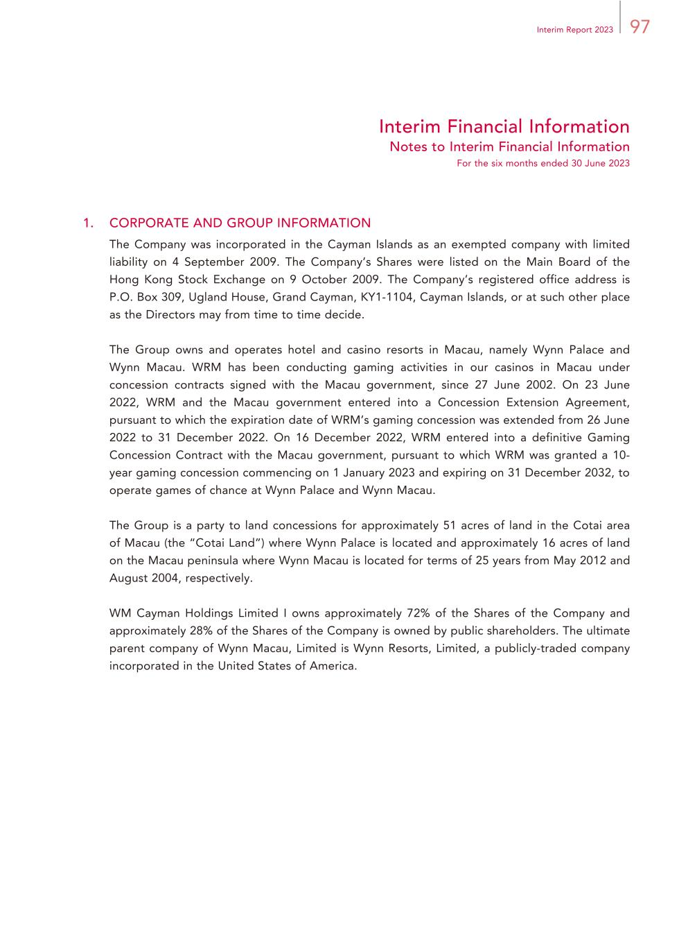
97Interim Report 2023 Interim Financial Information Notes to Interim Financial Information For the six months ended 30 June 2023 1. CORPORATE AND GROUP INFORMATION The Company was incorporated in the Cayman Islands as an exempted company with limited liability on 4 September 2009. The Company’s Shares were listed on the Main Board of the Hong Kong Stock Exchange on 9 October 2009. The Company’s registered office address is P.O. Box 309, Ugland House, Grand Cayman, KY1-1104, Cayman Islands, or at such other place as the Directors may from time to time decide. The Group owns and operates hotel and casino resorts in Macau, namely Wynn Palace and Wynn Macau. WRM has been conducting gaming activities in our casinos in Macau under concession contracts signed with the Macau government, since 27 June 2002. On 23 June 2022, WRM and the Macau government entered into a Concession Extension Agreement, pursuant to which the expiration date of WRM’s gaming concession was extended from 26 June 2022 to 31 December 2022. On 16 December 2022, WRM entered into a definitive Gaming Concession Contract with the Macau government, pursuant to which WRM was granted a 10- year gaming concession commencing on 1 January 2023 and expiring on 31 December 2032, to operate games of chance at Wynn Palace and Wynn Macau. The Group is a party to land concessions for approximately 51 acres of land in the Cotai area of Macau (the “Cotai Land”) where Wynn Palace is located and approximately 16 acres of land on the Macau peninsula where Wynn Macau is located for terms of 25 years from May 2012 and August 2004, respectively. WM Cayman Holdings Limited I owns approximately 72% of the Shares of the Company and approximately 28% of the Shares of the Company is owned by public shareholders. The ultimate parent company of Wynn Macau, Limited is Wynn Resorts, Limited, a publicly-traded company incorporated in the United States of America.

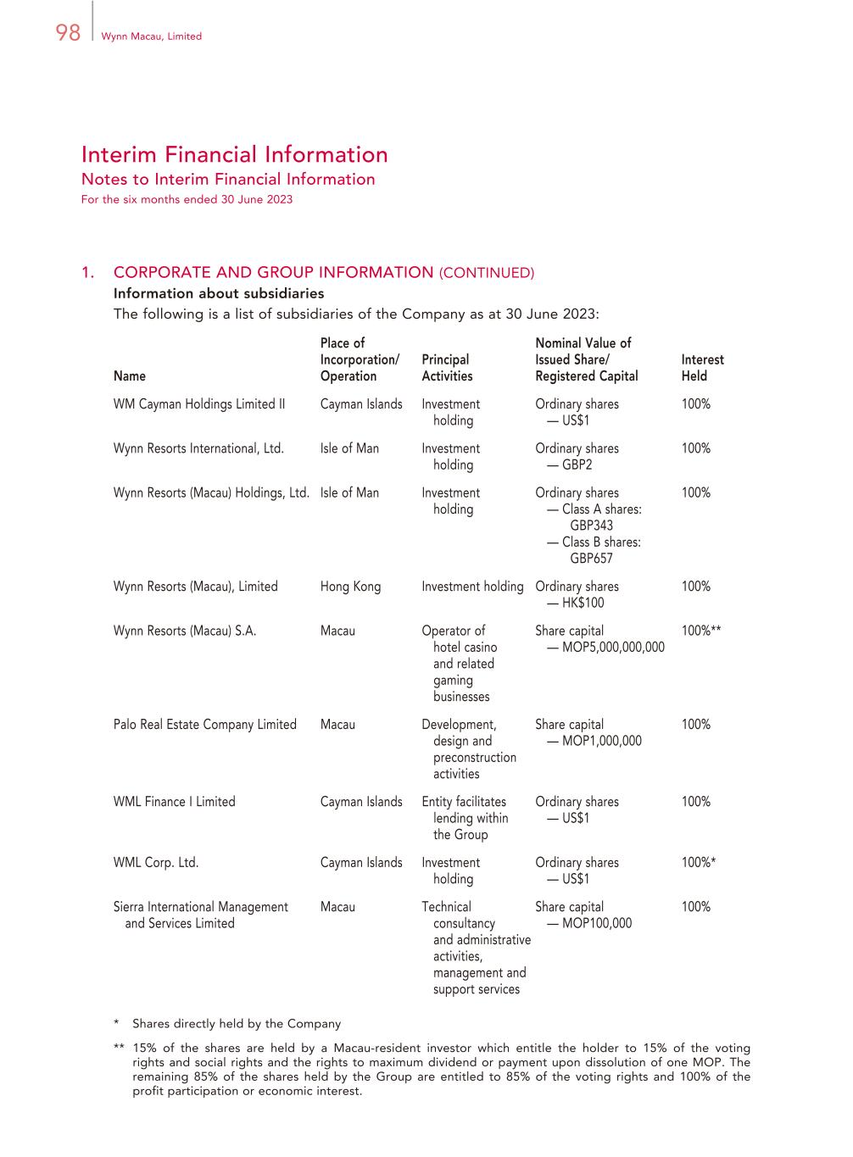
98 Wynn Macau, Limited Interim Financial Information Notes to Interim Financial Information For the six months ended 30 June 2023 1. CORPORATE AND GROUP INFORMATION (CONTINUED) Information about subsidiaries The following is a list of subsidiaries of the Company as at 30 June 2023: Name Place of Incorporation/ Operation Principal Activities Nominal Value of Issued Share/ Registered Capital Interest Held WM Cayman Holdings Limited II Cayman Islands Investment holding Ordinary shares — US$1 100% Wynn Resorts International, Ltd. Isle of Man Investment holding Ordinary shares — GBP2 100% Wynn Resorts (Macau) Holdings, Ltd. Isle of Man Investment holding Ordinary shares — Class A shares: GBP343 100% — Class B shares: GBP657 Wynn Resorts (Macau), Limited Hong Kong Investment holding Ordinary shares — HK$100 100% Wynn Resorts (Macau) S.A. Macau Operator of hotel casino and related gaming businesses Share capital — MOP5,000,000,000 100%** Palo Real Estate Company Limited Macau Development, design and preconstruction activities Share capital — MOP1,000,000 100% WML Finance I Limited Cayman Islands Entity facilitates lending within the Group Ordinary shares — US$1 100% WML Corp. Ltd. Cayman Islands Investment holding Ordinary shares — US$1 100%* Sierra International Management and Services Limited Macau Technical consultancy and administrative activities, management and support services Share capital — MOP100,000 100% * Shares directly held by the Company ** 15% of the shares are held by a Macau-resident investor which entitle the holder to 15% of the voting rights and social rights and the rights to maximum dividend or payment upon dissolution of one MOP. The remaining 85% of the shares held by the Group are entitled to 85% of the voting rights and 100% of the profit participation or economic interest.

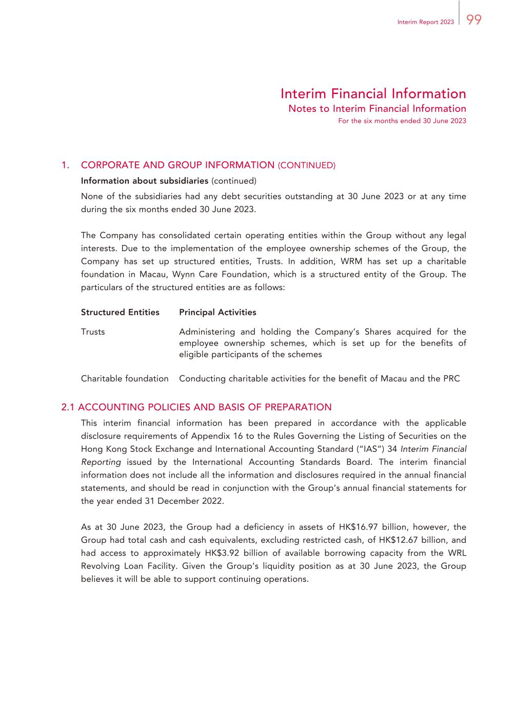
99Interim Report 2023 Interim Financial Information Notes to Interim Financial Information For the six months ended 30 June 2023 1. CORPORATE AND GROUP INFORMATION (CONTINUED) Information about subsidiaries (continued) None of the subsidiaries had any debt securities outstanding at 30 June 2023 or at any time during the six months ended 30 June 2023. The Company has consolidated certain operating entities within the Group without any legal interests. Due to the implementation of the employee ownership schemes of the Group, the Company has set up structured entities, Trusts. In addition, WRM has set up a charitable foundation in Macau, Wynn Care Foundation, which is a structured entity of the Group. The particulars of the structured entities are as follows: Structured Entities Principal Activities Trusts Administering and holding the Company’s Shares acquired for the employee ownership schemes, which is set up for the benefits of eligible participants of the schemes Charitable foundation Conducting charitable activities for the benefit of Macau and the PRC 2.1 ACCOUNTING POLICIES AND BASIS OF PREPARATION This interim financial information has been prepared in accordance with the applicable disclosure requirements of Appendix 16 to the Rules Governing the Listing of Securities on the Hong Kong Stock Exchange and International Accounting Standard (“IAS”) 34 Interim Financial Reporting issued by the International Accounting Standards Board. The interim financial information does not include all the information and disclosures required in the annual financial statements, and should be read in conjunction with the Group’s annual financial statements for the year ended 31 December 2022. As at 30 June 2023, the Group had a deficiency in assets of HK$16.97 billion, however, the Group had total cash and cash equivalents, excluding restricted cash, of HK$12.67 billion, and had access to approximately HK$3.92 billion of available borrowing capacity from the WRL Revolving Loan Facility. Given the Group’s liquidity position as at 30 June 2023, the Group believes it will be able to support continuing operations.

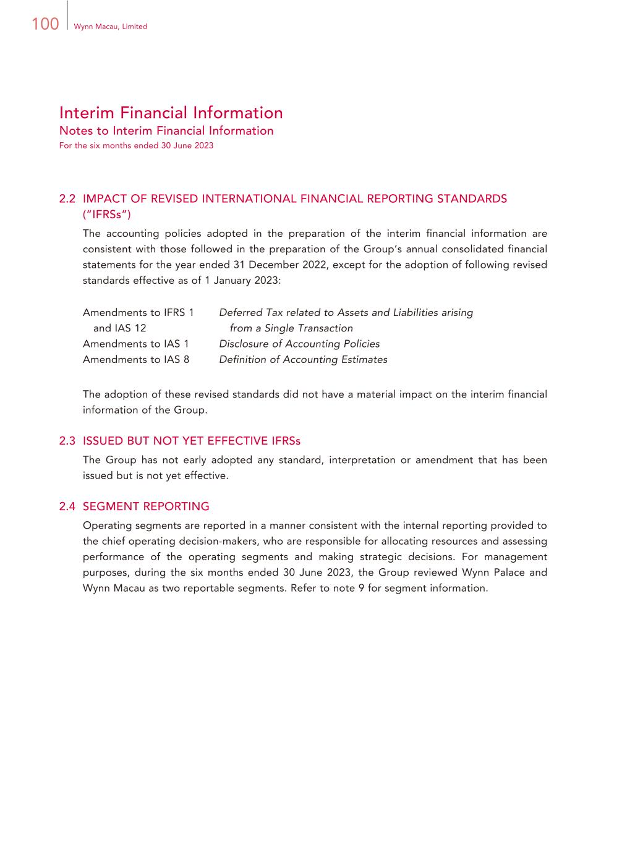
100 Wynn Macau, Limited Interim Financial Information Notes to Interim Financial Information For the six months ended 30 June 2023 2.2 IMPACT OF REVISED INTERNATIONAL FINANCIAL REPORTING STANDARDS (“IFRSs”) The accounting policies adopted in the preparation of the interim financial information are consistent with those followed in the preparation of the Group’s annual consolidated financial statements for the year ended 31 December 2022, except for the adoption of following revised standards effective as of 1 January 2023: Amendments to IFRS 1 and IAS 12 Deferred Tax related to Assets and Liabilities arising from a Single Transaction Amendments to IAS 1 Disclosure of Accounting Policies Amendments to IAS 8 Definition of Accounting Estimates The adoption of these revised standards did not have a material impact on the interim financial information of the Group. 2.3 ISSUED BUT NOT YET EFFECTIVE IFRSs The Group has not early adopted any standard, interpretation or amendment that has been issued but is not yet effective. 2.4 SEGMENT REPORTING Operating segments are reported in a manner consistent with the internal reporting provided to the chief operating decision-makers, who are responsible for allocating resources and assessing performance of the operating segments and making strategic decisions. For management purposes, during the six months ended 30 June 2023, the Group reviewed Wynn Palace and Wynn Macau as two reportable segments. Refer to note 9 for segment information.

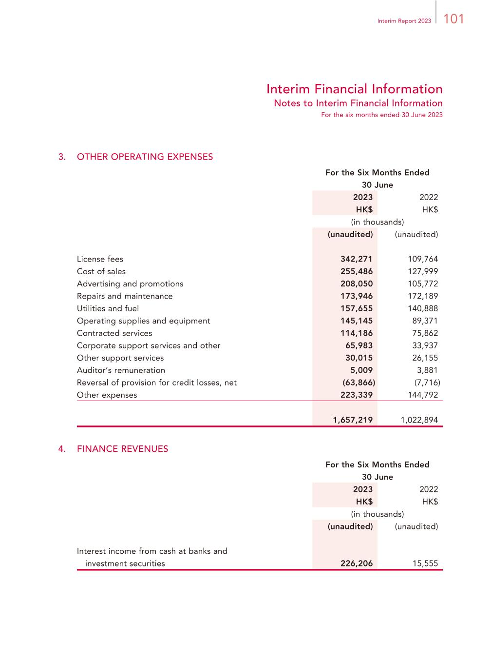
101Interim Report 2023 Interim Financial Information Notes to Interim Financial Information For the six months ended 30 June 2023 3. OTHER OPERATING EXPENSES For the Six Months Ended 30 June 2023 2022 HK$ HK$ (in thousands) (unaudited) (unaudited) License fees 342,271 109,764 Cost of sales 255,486 127,999 Advertising and promotions 208,050 105,772 Repairs and maintenance 173,946 172,189 Utilities and fuel 157,655 140,888 Operating supplies and equipment 145,145 89,371 Contracted services 114,186 75,862 Corporate support services and other 65,983 33,937 Other support services 30,015 26,155 Auditor’s remuneration 5,009 3,881 Reversal of provision for credit losses, net (63,866) (7,716) Other expenses 223,339 144,792 1,657,219 1,022,894 4. FINANCE REVENUES For the Six Months Ended 30 June 2023 2022 HK$ HK$ (in thousands) (unaudited) (unaudited) Interest income from cash at banks and investment securities 226,206 15,555

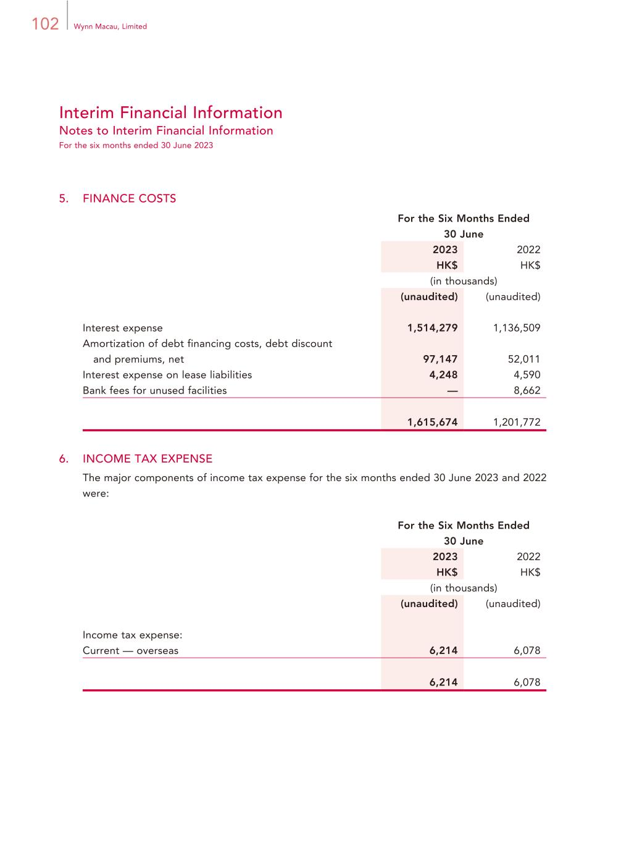
102 Wynn Macau, Limited Interim Financial Information Notes to Interim Financial Information For the six months ended 30 June 2023 5. FINANCE COSTS For the Six Months Ended 30 June 2023 2022 HK$ HK$ (in thousands) (unaudited) (unaudited) Interest expense 1,514,279 1,136,509 Amortization of debt financing costs, debt discount and premiums, net 97,147 52,011 Interest expense on lease liabilities 4,248 4,590 Bank fees for unused facilities — 8,662 1,615,674 1,201,772 6. INCOME TAX EXPENSE The major components of income tax expense for the six months ended 30 June 2023 and 2022 were: For the Six Months Ended 30 June 2023 2022 HK$ HK$ (in thousands) (unaudited) (unaudited) Income tax expense: Current — overseas 6,214 6,078 6,214 6,078

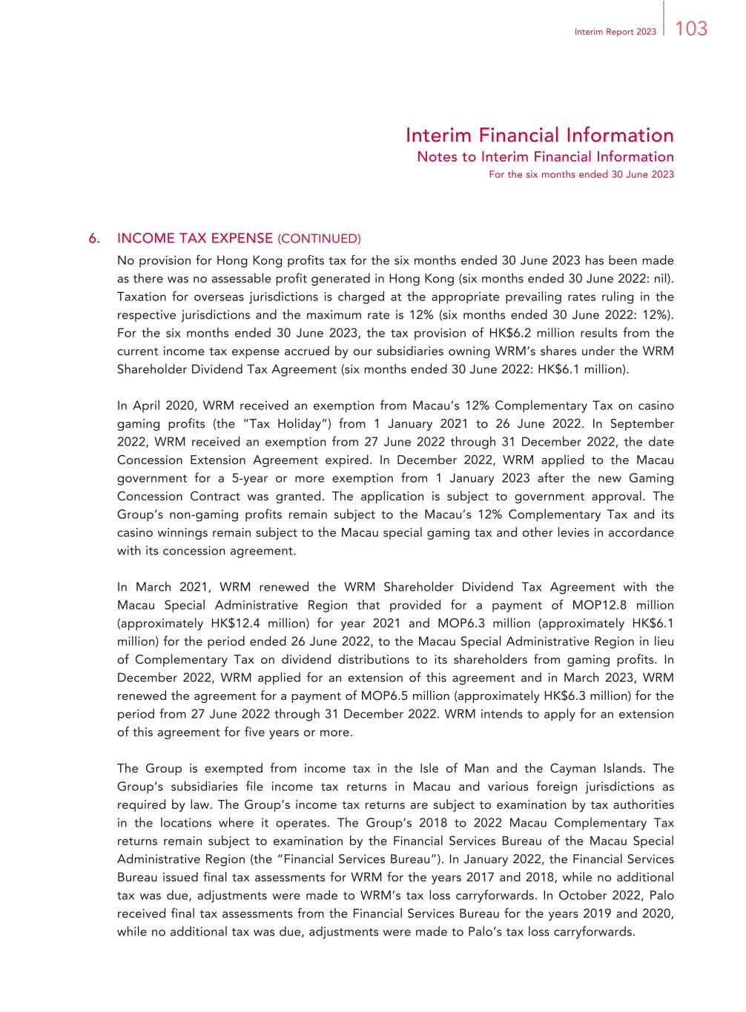
103Interim Report 2023 Interim Financial Information Notes to Interim Financial Information For the six months ended 30 June 2023 6. INCOME TAX EXPENSE (CONTINUED) No provision for Hong Kong profits tax for the six months ended 30 June 2023 has been made as there was no assessable profit generated in Hong Kong (six months ended 30 June 2022: nil). Taxation for overseas jurisdictions is charged at the appropriate prevailing rates ruling in the respective jurisdictions and the maximum rate is 12% (six months ended 30 June 2022: 12%). For the six months ended 30 June 2023, the tax provision of HK$6.2 million results from the current income tax expense accrued by our subsidiaries owning WRM’s shares under the WRM Shareholder Dividend Tax Agreement (six months ended 30 June 2022: HK$6.1 million). In April 2020, WRM received an exemption from Macau’s 12% Complementary Tax on casino gaming profits (the “Tax Holiday”) from 1 January 2021 to 26 June 2022. In September 2022, WRM received an exemption from 27 June 2022 through 31 December 2022, the date Concession Extension Agreement expired. In December 2022, WRM applied to the Macau government for a 5-year or more exemption from 1 January 2023 after the new Gaming Concession Contract was granted. The application is subject to government approval. The Group’s non-gaming profits remain subject to the Macau’s 12% Complementary Tax and its casino winnings remain subject to the Macau special gaming tax and other levies in accordance with its concession agreement. In March 2021, WRM renewed the WRM Shareholder Dividend Tax Agreement with the Macau Special Administrative Region that provided for a payment of MOP12.8 million (approximately HK$12.4 million) for year 2021 and MOP6.3 million (approximately HK$6.1 million) for the period ended 26 June 2022, to the Macau Special Administrative Region in lieu of Complementary Tax on dividend distributions to its shareholders from gaming profits. In December 2022, WRM applied for an extension of this agreement and in March 2023, WRM renewed the agreement for a payment of MOP6.5 million (approximately HK$6.3 million) for the period from 27 June 2022 through 31 December 2022. WRM intends to apply for an extension of this agreement for five years or more. The Group is exempted from income tax in the Isle of Man and the Cayman Islands. The Group’s subsidiaries file income tax returns in Macau and various foreign jurisdictions as required by law. The Group’s income tax returns are subject to examination by tax authorities in the locations where it operates. The Group’s 2018 to 2022 Macau Complementary Tax returns remain subject to examination by the Financial Services Bureau of the Macau Special Administrative Region (the “Financial Services Bureau”). In January 2022, the Financial Services Bureau issued final tax assessments for WRM for the years 2017 and 2018, while no additional tax was due, adjustments were made to WRM’s tax loss carryforwards. In October 2022, Palo received final tax assessments from the Financial Services Bureau for the years 2019 and 2020, while no additional tax was due, adjustments were made to Palo’s tax loss carryforwards.

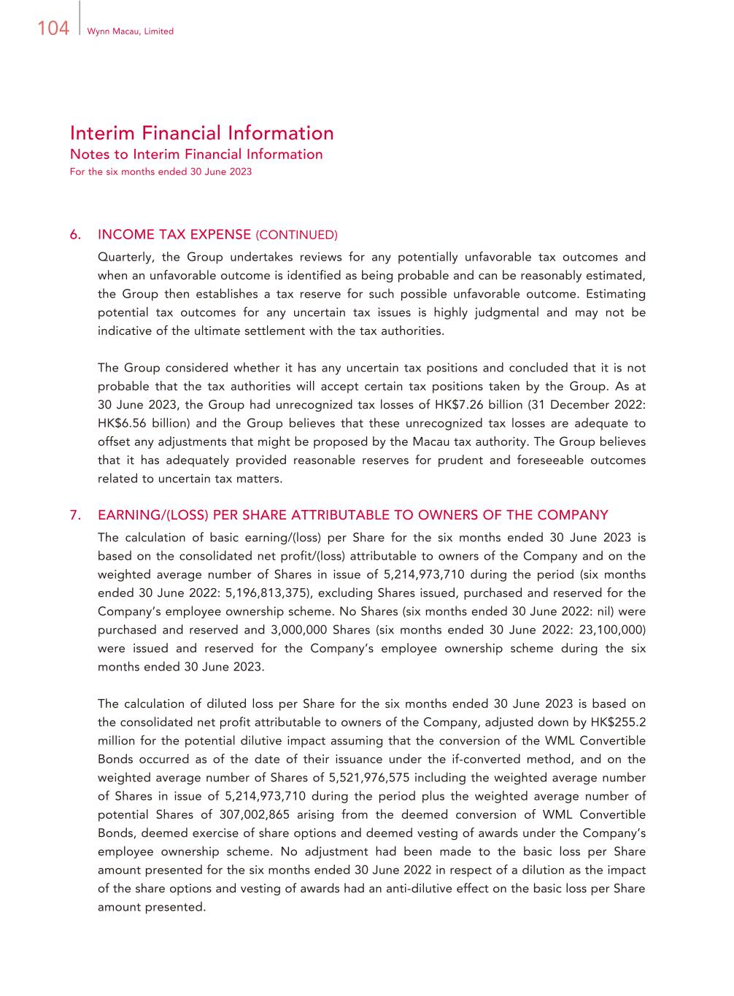
104 Wynn Macau, Limited Interim Financial Information Notes to Interim Financial Information For the six months ended 30 June 2023 6. INCOME TAX EXPENSE (CONTINUED) Quarterly, the Group undertakes reviews for any potentially unfavorable tax outcomes and when an unfavorable outcome is identified as being probable and can be reasonably estimated, the Group then establishes a tax reserve for such possible unfavorable outcome. Estimating potential tax outcomes for any uncertain tax issues is highly judgmental and may not be indicative of the ultimate settlement with the tax authorities. The Group considered whether it has any uncertain tax positions and concluded that it is not probable that the tax authorities will accept certain tax positions taken by the Group. As at 30 June 2023, the Group had unrecognized tax losses of HK$7.26 billion (31 December 2022: HK$6.56 billion) and the Group believes that these unrecognized tax losses are adequate to offset any adjustments that might be proposed by the Macau tax authority. The Group believes that it has adequately provided reasonable reserves for prudent and foreseeable outcomes related to uncertain tax matters. 7. EARNING/(LOSS) PER SHARE ATTRIBUTABLE TO OWNERS OF THE COMPANY The calculation of basic earning/(loss) per Share for the six months ended 30 June 2023 is based on the consolidated net profit/(loss) attributable to owners of the Company and on the weighted average number of Shares in issue of 5,214,973,710 during the period (six months ended 30 June 2022: 5,196,813,375), excluding Shares issued, purchased and reserved for the Company’s employee ownership scheme. No Shares (six months ended 30 June 2022: nil) were purchased and reserved and 3,000,000 Shares (six months ended 30 June 2022: 23,100,000) were issued and reserved for the Company’s employee ownership scheme during the six months ended 30 June 2023. The calculation of diluted loss per Share for the six months ended 30 June 2023 is based on the consolidated net profit attributable to owners of the Company, adjusted down by HK$255.2 million for the potential dilutive impact assuming that the conversion of the WML Convertible Bonds occurred as of the date of their issuance under the if-converted method, and on the weighted average number of Shares of 5,521,976,575 including the weighted average number of Shares in issue of 5,214,973,710 during the period plus the weighted average number of potential Shares of 307,002,865 arising from the deemed conversion of WML Convertible Bonds, deemed exercise of share options and deemed vesting of awards under the Company’s employee ownership scheme. No adjustment had been made to the basic loss per Share amount presented for the six months ended 30 June 2022 in respect of a dilution as the impact of the share options and vesting of awards had an anti-dilutive effect on the basic loss per Share amount presented.

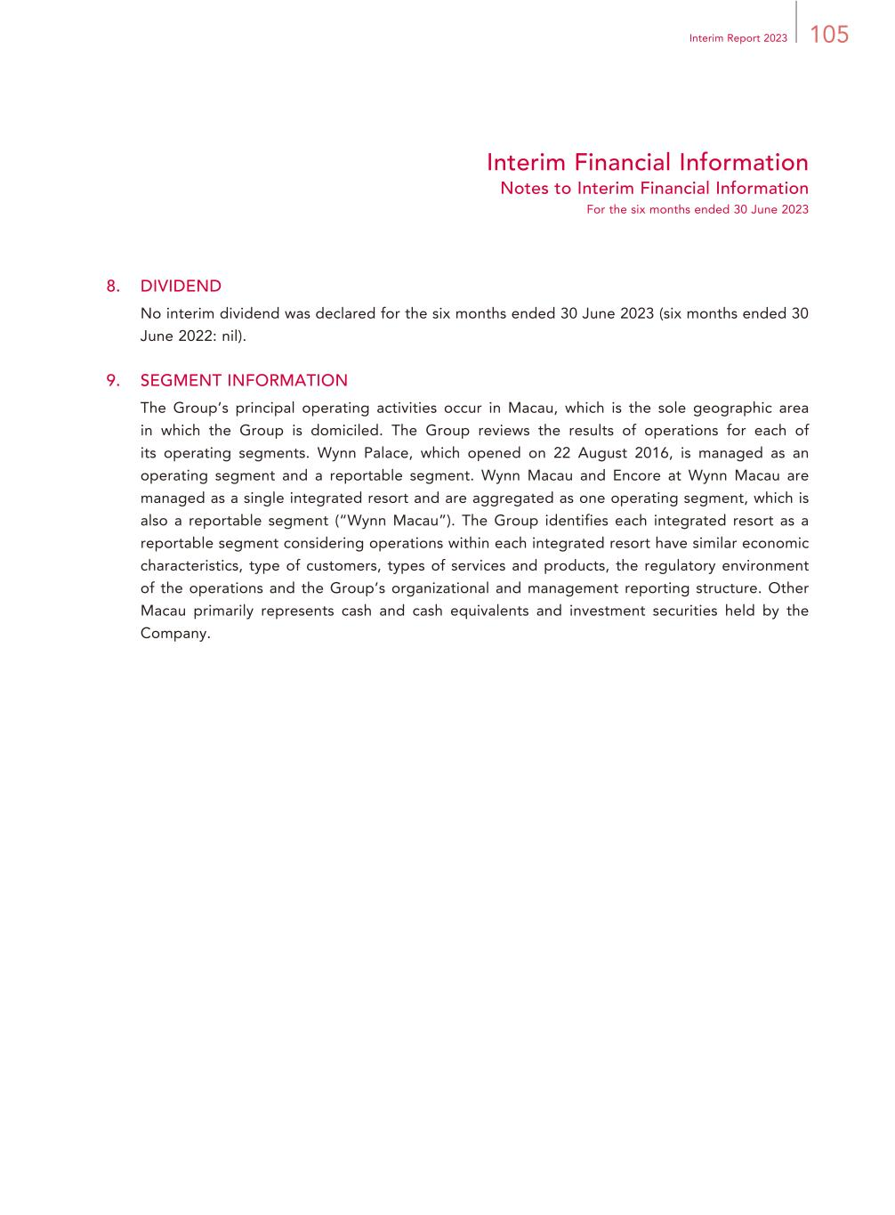
105Interim Report 2023 Interim Financial Information Notes to Interim Financial Information For the six months ended 30 June 2023 8. DIVIDEND No interim dividend was declared for the six months ended 30 June 2023 (six months ended 30 June 2022: nil). 9. SEGMENT INFORMATION The Group’s principal operating activities occur in Macau, which is the sole geographic area in which the Group is domiciled. The Group reviews the results of operations for each of its operating segments. Wynn Palace, which opened on 22 August 2016, is managed as an operating segment and a reportable segment. Wynn Macau and Encore at Wynn Macau are managed as a single integrated resort and are aggregated as one operating segment, which is also a reportable segment (“Wynn Macau”). The Group identifies each integrated resort as a reportable segment considering operations within each integrated resort have similar economic characteristics, type of customers, types of services and products, the regulatory environment of the operations and the Group’s organizational and management reporting structure. Other Macau primarily represents cash and cash equivalents and investment securities held by the Company.

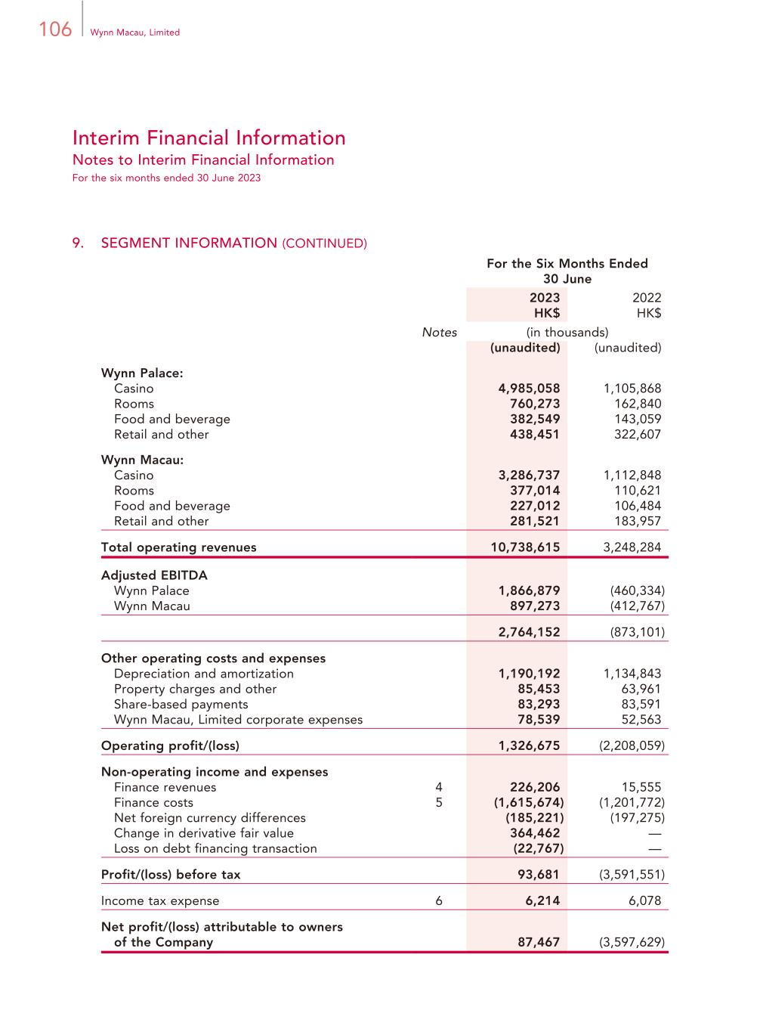
106 Wynn Macau, Limited Interim Financial Information Notes to Interim Financial Information For the six months ended 30 June 2023 9. SEGMENT INFORMATION (CONTINUED) For the Six Months Ended 30 June 2023 2022 HK$ HK$ Notes (in thousands) (unaudited) (unaudited) Wynn Palace: Casino 4,985,058 1,105,868 Rooms 760,273 162,840 Food and beverage 382,549 143,059 Retail and other 438,451 322,607 Wynn Macau: Casino 3,286,737 1,112,848 Rooms 377,014 110,621 Food and beverage 227,012 106,484 Retail and other 281,521 183,957 Total operating revenues 10,738,615 3,248,284 Adjusted EBITDA Wynn Palace 1,866,879 (460,334) Wynn Macau 897,273 (412,767) 2,764,152 (873,101) Other operating costs and expenses Depreciation and amortization 1,190,192 1,134,843 Property charges and other 85,453 63,961 Share-based payments 83,293 83,591 Wynn Macau, Limited corporate expenses 78,539 52,563 Operating profit/(loss) 1,326,675 (2,208,059) Non-operating income and expenses Finance revenues 4 226,206 15,555 Finance costs 5 (1,615,674) (1,201,772) Net foreign currency differences (185,221) (197,275) Change in derivative fair value 364,462 — Loss on debt financing transaction (22,767) — Profit/(loss) before tax 93,681 (3,591,551) Income tax expense 6 6,214 6,078 Net profit/(loss) attributable to owners of the Company 87,467 (3,597,629)

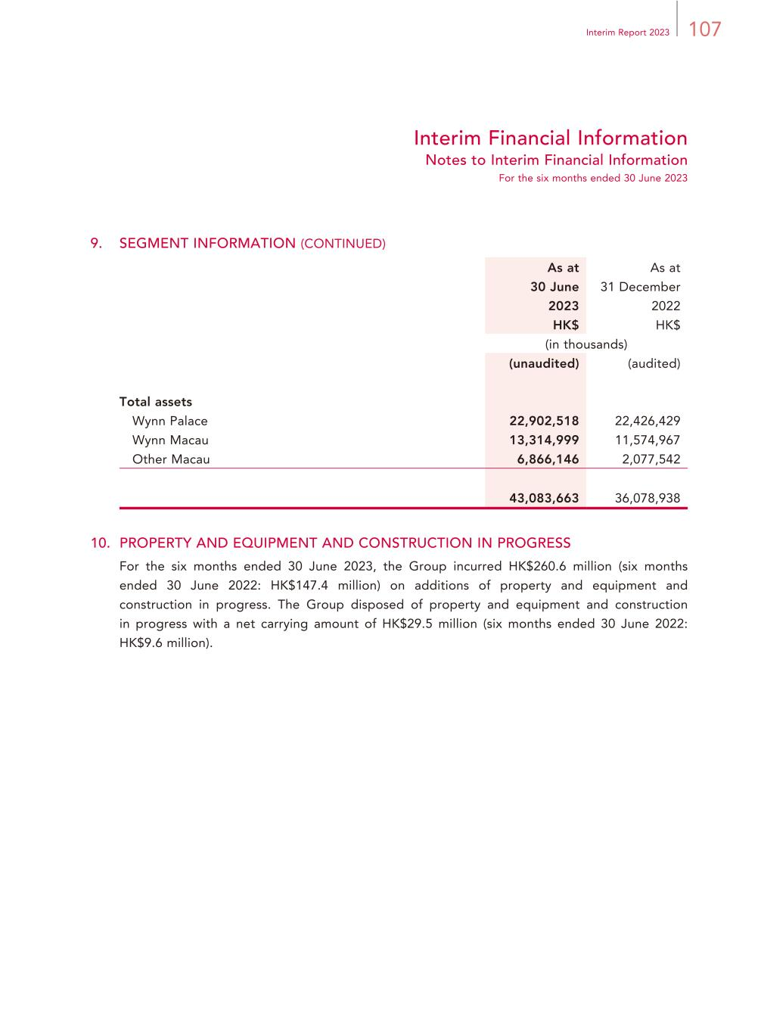
107Interim Report 2023 Interim Financial Information Notes to Interim Financial Information For the six months ended 30 June 2023 9. SEGMENT INFORMATION (CONTINUED) As at 30 June 2023 As at 31 December 2022 HK$ HK$ (in thousands) (unaudited) (audited) Total assets Wynn Palace 22,902,518 22,426,429 Wynn Macau 13,314,999 11,574,967 Other Macau 6,866,146 2,077,542 43,083,663 36,078,938 10. PROPERTY AND EQUIPMENT AND CONSTRUCTION IN PROGRESS For the six months ended 30 June 2023, the Group incurred HK$260.6 million (six months ended 30 June 2022: HK$147.4 million) on additions of property and equipment and construction in progress. The Group disposed of property and equipment and construction in progress with a net carrying amount of HK$29.5 million (six months ended 30 June 2022: HK$9.6 million).

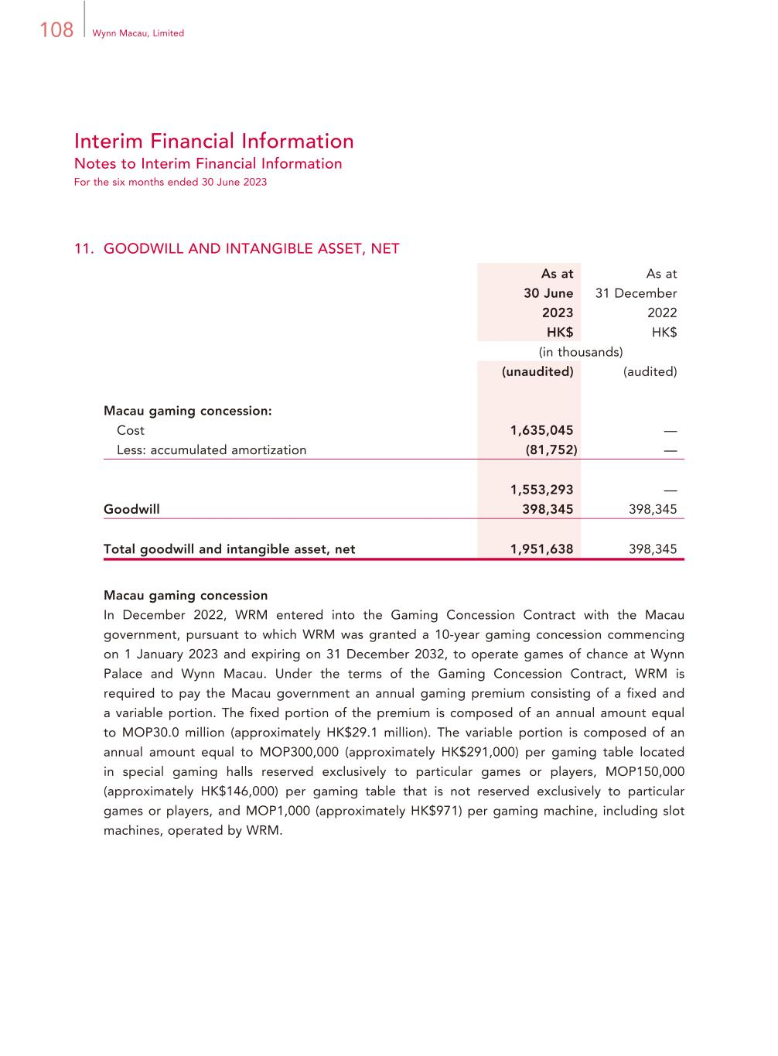
108 Wynn Macau, Limited Interim Financial Information Notes to Interim Financial Information For the six months ended 30 June 2023 11. GOODWILL AND INTANGIBLE ASSET, NET As at 30 June 2023 As at 31 December 2022 HK$ HK$ (in thousands) (unaudited) (audited) Macau gaming concession: Cost 1,635,045 — Less: accumulated amortization (81,752) — 1,553,293 — Goodwill 398,345 398,345 Total goodwill and intangible asset, net 1,951,638 398,345 Macau gaming concession In December 2022, WRM entered into the Gaming Concession Contract with the Macau government, pursuant to which WRM was granted a 10-year gaming concession commencing on 1 January 2023 and expiring on 31 December 2032, to operate games of chance at Wynn Palace and Wynn Macau. Under the terms of the Gaming Concession Contract, WRM is required to pay the Macau government an annual gaming premium consisting of a fixed and a variable portion. The fixed portion of the premium is composed of an annual amount equal to MOP30.0 million (approximately HK$29.1 million). The variable portion is composed of an annual amount equal to MOP300,000 (approximately HK$291,000) per gaming table located in special gaming halls reserved exclusively to particular games or players, MOP150,000 (approximately HK$146,000) per gaming table that is not reserved exclusively to particular games or players, and MOP1,000 (approximately HK$971) per gaming machine, including slot machines, operated by WRM.

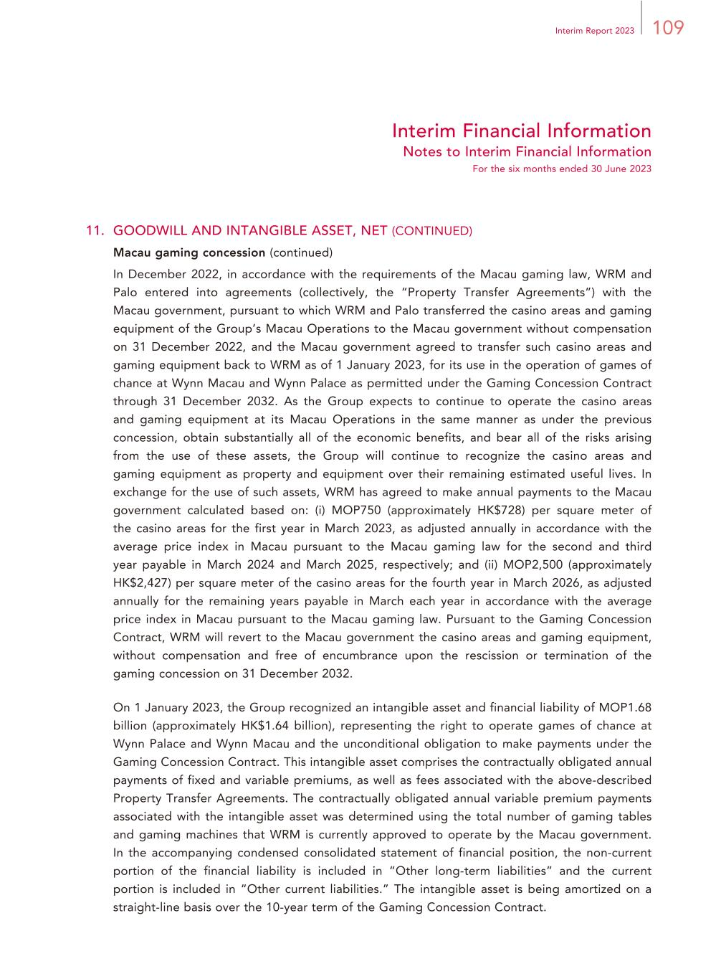
109Interim Report 2023 Interim Financial Information Notes to Interim Financial Information For the six months ended 30 June 2023 11. GOODWILL AND INTANGIBLE ASSET, NET (CONTINUED) Macau gaming concession (continued) In December 2022, in accordance with the requirements of the Macau gaming law, WRM and Palo entered into agreements (collectively, the “Property Transfer Agreements”) with the Macau government, pursuant to which WRM and Palo transferred the casino areas and gaming equipment of the Group’s Macau Operations to the Macau government without compensation on 31 December 2022, and the Macau government agreed to transfer such casino areas and gaming equipment back to WRM as of 1 January 2023, for its use in the operation of games of chance at Wynn Macau and Wynn Palace as permitted under the Gaming Concession Contract through 31 December 2032. As the Group expects to continue to operate the casino areas and gaming equipment at its Macau Operations in the same manner as under the previous concession, obtain substantially all of the economic benefits, and bear all of the risks arising from the use of these assets, the Group will continue to recognize the casino areas and gaming equipment as property and equipment over their remaining estimated useful lives. In exchange for the use of such assets, WRM has agreed to make annual payments to the Macau government calculated based on: (i) MOP750 (approximately HK$728) per square meter of the casino areas for the first year in March 2023, as adjusted annually in accordance with the average price index in Macau pursuant to the Macau gaming law for the second and third year payable in March 2024 and March 2025, respectively; and (ii) MOP2,500 (approximately HK$2,427) per square meter of the casino areas for the fourth year in March 2026, as adjusted annually for the remaining years payable in March each year in accordance with the average price index in Macau pursuant to the Macau gaming law. Pursuant to the Gaming Concession Contract, WRM will revert to the Macau government the casino areas and gaming equipment, without compensation and free of encumbrance upon the rescission or termination of the gaming concession on 31 December 2032. On 1 January 2023, the Group recognized an intangible asset and financial liability of MOP1.68 billion (approximately HK$1.64 billion), representing the right to operate games of chance at Wynn Palace and Wynn Macau and the unconditional obligation to make payments under the Gaming Concession Contract. This intangible asset comprises the contractually obligated annual payments of fixed and variable premiums, as well as fees associated with the above-described Property Transfer Agreements. The contractually obligated annual variable premium payments associated with the intangible asset was determined using the total number of gaming tables and gaming machines that WRM is currently approved to operate by the Macau government. In the accompanying condensed consolidated statement of financial position, the non-current portion of the financial liability is included in “Other long-term liabilities” and the current portion is included in “Other current liabilities.” The intangible asset is being amortized on a straight-line basis over the 10-year term of the Gaming Concession Contract.

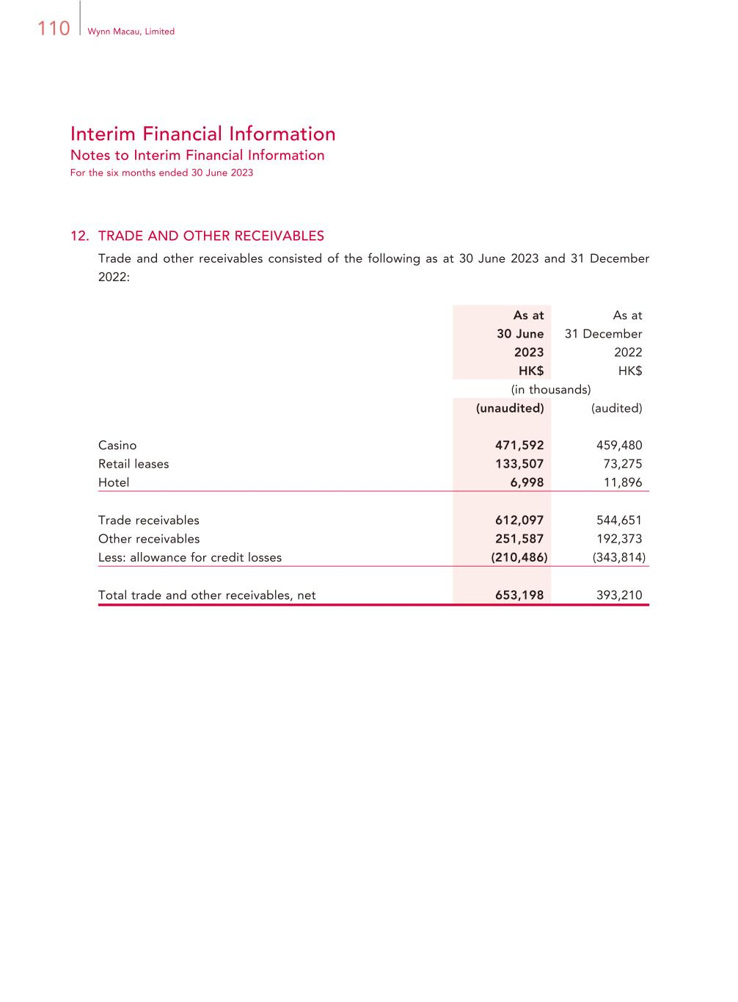
110 Wynn Macau, Limited Interim Financial Information Notes to Interim Financial Information For the six months ended 30 June 2023 12. TRADE AND OTHER RECEIVABLES Trade and other receivables consisted of the following as at 30 June 2023 and 31 December 2022: As at 30 June 2023 As at 31 December 2022 HK$ HK$ (in thousands) (unaudited) (audited) Casino 471,592 459,480 Retail leases 133,507 73,275 Hotel 6,998 11,896 Trade receivables 612,097 544,651 Other receivables 251,587 192,373 Less: allowance for credit losses (210,486) (343,814) Total trade and other receivables, net 653,198 393,210

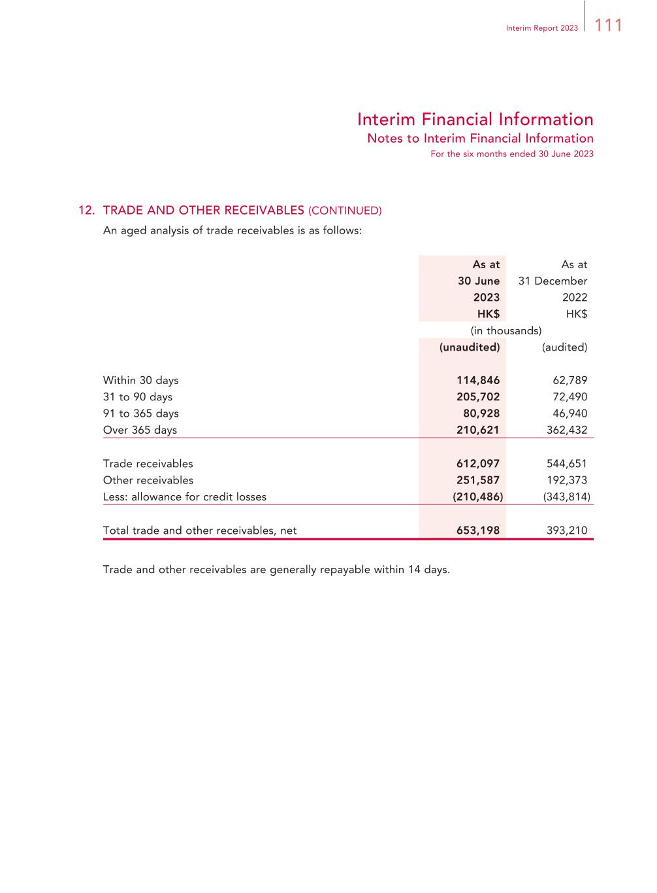
111Interim Report 2023 Interim Financial Information Notes to Interim Financial Information For the six months ended 30 June 2023 12. TRADE AND OTHER RECEIVABLES (CONTINUED) An aged analysis of trade receivables is as follows: As at 30 June 2023 As at 31 December 2022 HK$ HK$ (in thousands) (unaudited) (audited) Within 30 days 114,846 62,789 31 to 90 days 205,702 72,490 91 to 365 days 80,928 46,940 Over 365 days 210,621 362,432 Trade receivables 612,097 544,651 Other receivables 251,587 192,373 Less: allowance for credit losses (210,486) (343,814) Total trade and other receivables, net 653,198 393,210 Trade and other receivables are generally repayable within 14 days.

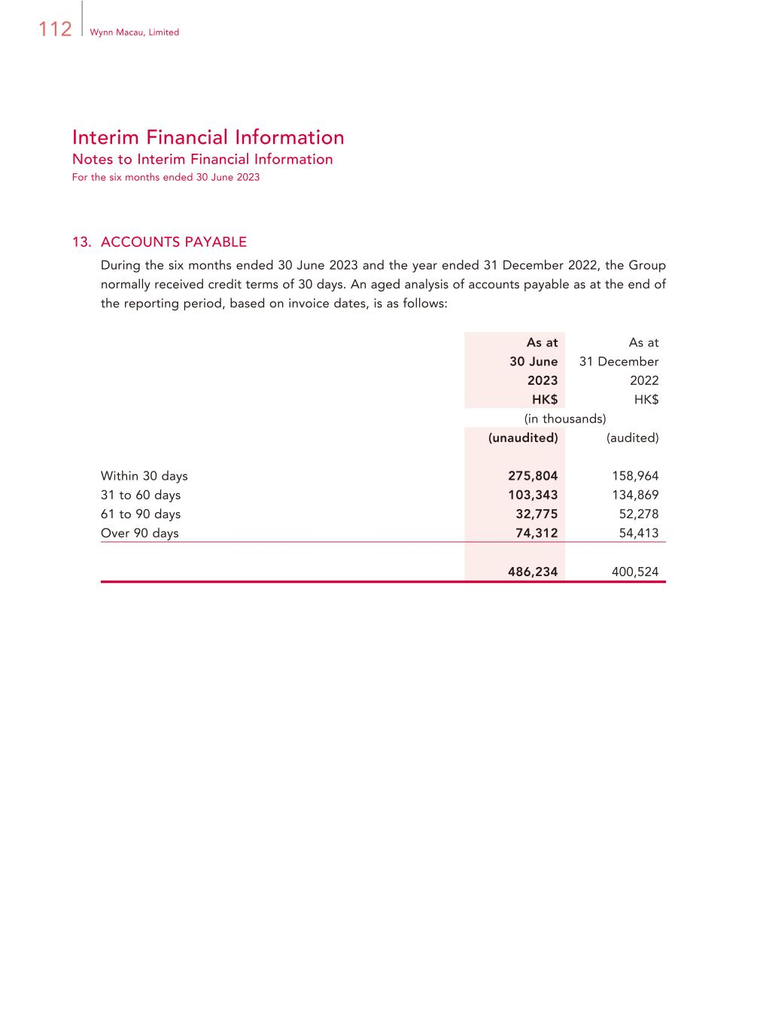
112 Wynn Macau, Limited Interim Financial Information Notes to Interim Financial Information For the six months ended 30 June 2023 13. ACCOUNTS PAYABLE During the six months ended 30 June 2023 and the year ended 31 December 2022, the Group normally received credit terms of 30 days. An aged analysis of accounts payable as at the end of the reporting period, based on invoice dates, is as follows: As at 30 June 2023 As at 31 December 2022 HK$ HK$ (in thousands) (unaudited) (audited) Within 30 days 275,804 158,964 31 to 60 days 103,343 134,869 61 to 90 days 32,775 52,278 Over 90 days 74,312 54,413 486,234 400,524

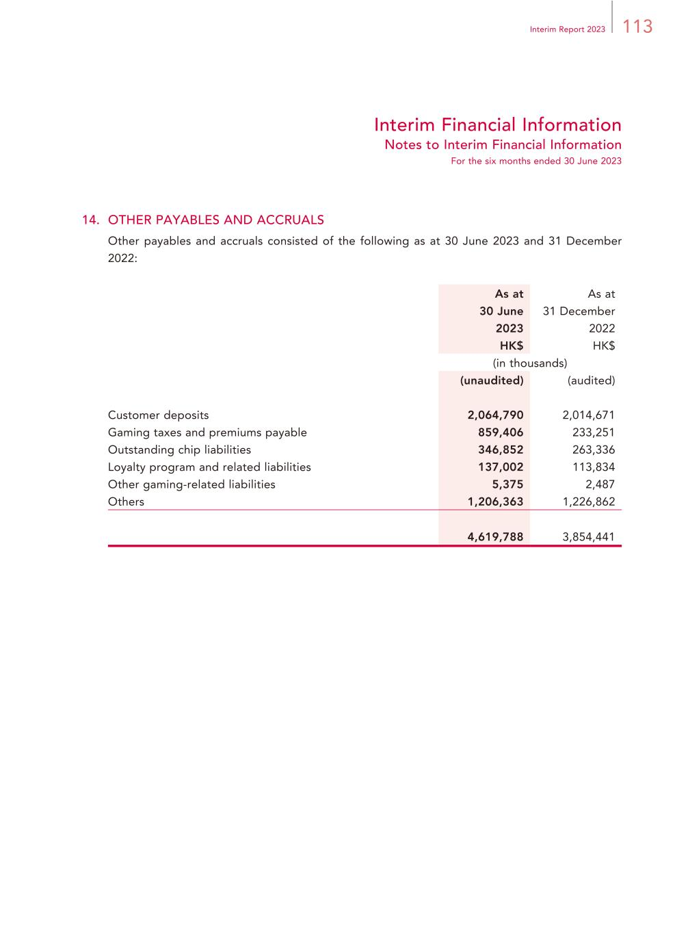
113Interim Report 2023 Interim Financial Information Notes to Interim Financial Information For the six months ended 30 June 2023 14. OTHER PAYABLES AND ACCRUALS Other payables and accruals consisted of the following as at 30 June 2023 and 31 December 2022: As at 30 June 2023 As at 31 December 2022 HK$ HK$ (in thousands) (unaudited) (audited) Customer deposits 2,064,790 2,014,671 Gaming taxes and premiums payable 859,406 233,251 Outstanding chip liabilities 346,852 263,336 Loyalty program and related liabilities 137,002 113,834 Other gaming-related liabilities 5,375 2,487 Others 1,206,363 1,226,862 4,619,788 3,854,441

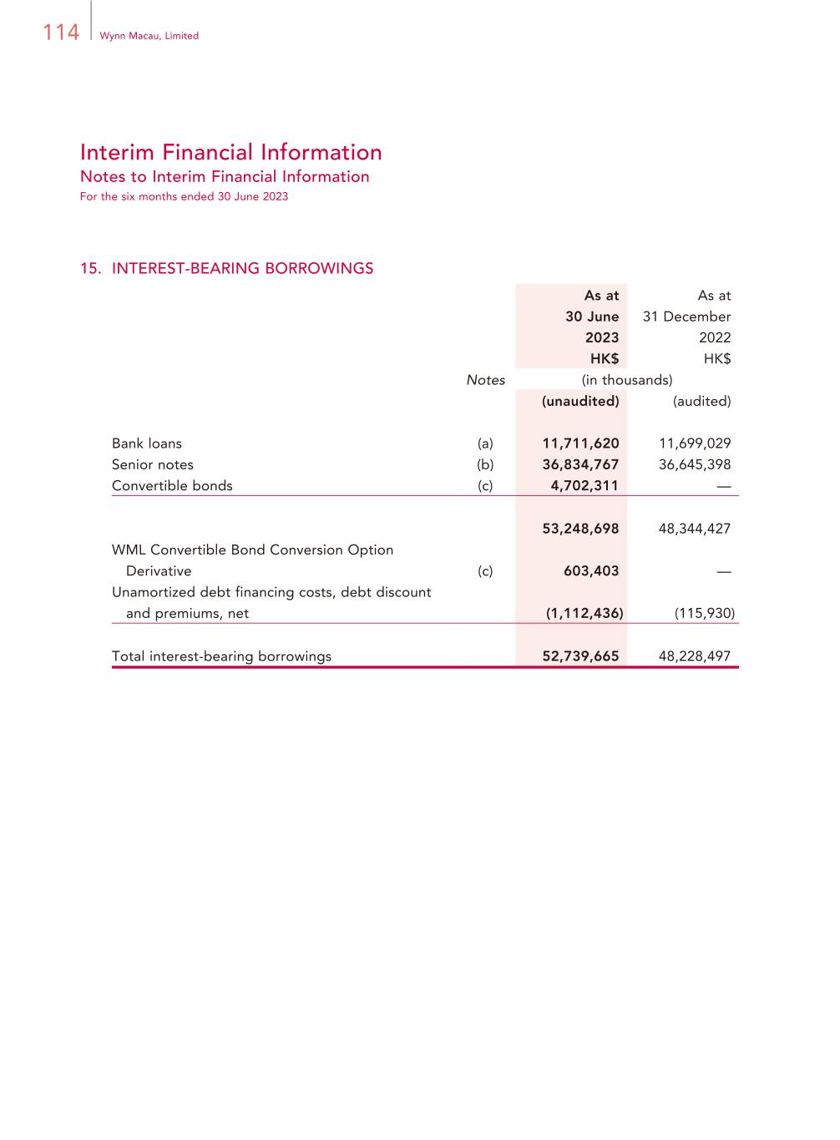
114 Wynn Macau, Limited Interim Financial Information Notes to Interim Financial Information For the six months ended 30 June 2023 15. INTEREST-BEARING BORROWINGS As at 30 June 2023 As at 31 December 2022 HK$ HK$ Notes (in thousands) (unaudited) (audited) Bank loans (a) 11,711,620 11,699,029 Senior notes (b) 36,834,767 36,645,398 Convertible bonds (c) 4,702,311 — 53,248,698 48,344,427 WML Convertible Bond Conversion Option Derivative (c) 603,403 — Unamortized debt financing costs, debt discount and premiums, net (1,112,436) (115,930) Total interest-bearing borrowings 52,739,665 48,228,497

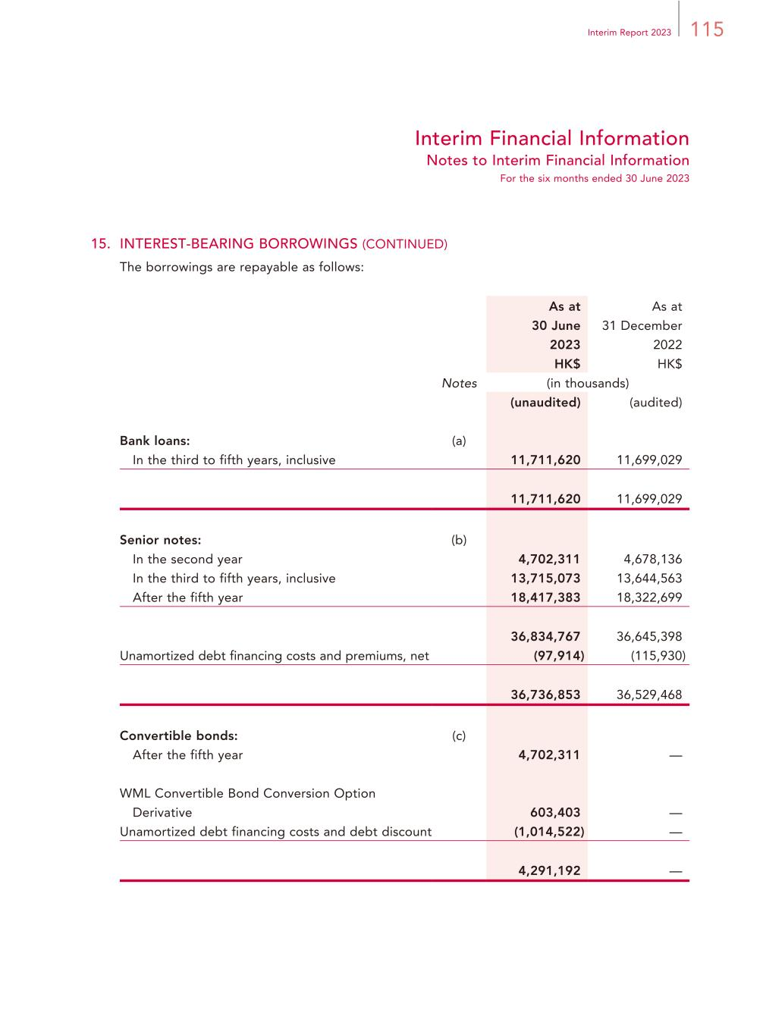
115Interim Report 2023 Interim Financial Information Notes to Interim Financial Information For the six months ended 30 June 2023 15. INTEREST-BEARING BORROWINGS (CONTINUED) The borrowings are repayable as follows: As at 30 June 2023 As at 31 December 2022 HK$ HK$ Notes (in thousands) (unaudited) (audited) Bank loans: (a) In the third to fifth years, inclusive 11,711,620 11,699,029 11,711,620 11,699,029 Senior notes: (b) In the second year 4,702,311 4,678,136 In the third to fifth years, inclusive 13,715,073 13,644,563 After the fifth year 18,417,383 18,322,699 36,834,767 36,645,398 Unamortized debt financing costs and premiums, net (97,914) (115,930) 36,736,853 36,529,468 Convertible bonds: (c) After the fifth year 4,702,311 — WML Convertible Bond Conversion Option Derivative 603,403 — Unamortized debt financing costs and debt discount (1,014,522) — 4,291,192 —

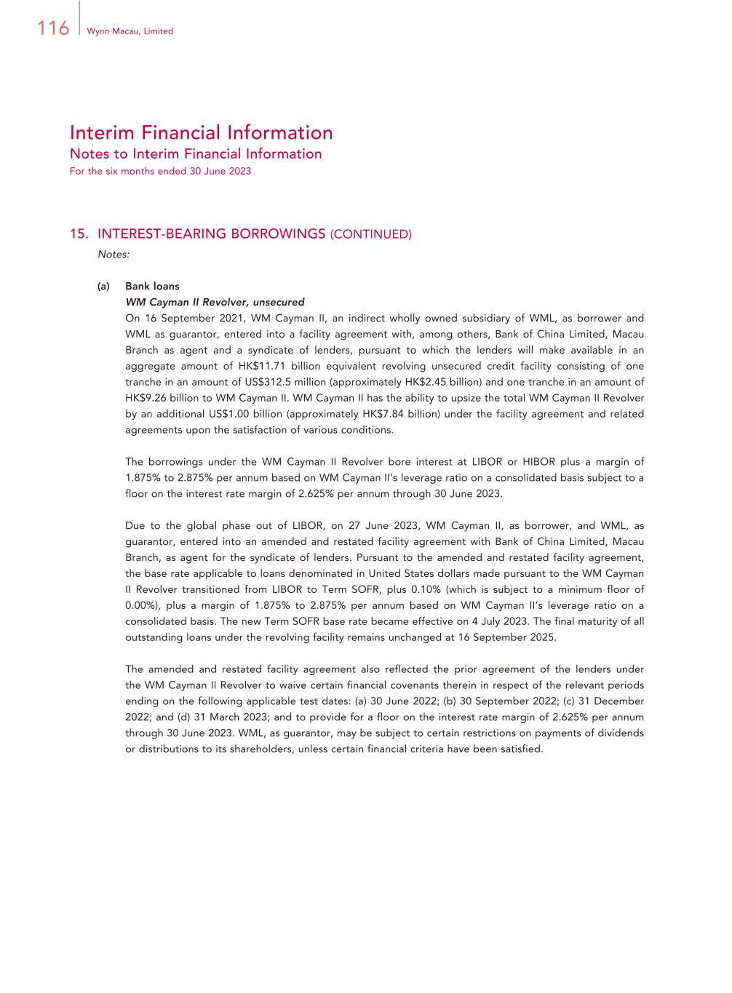
116 Wynn Macau, Limited Interim Financial Information Notes to Interim Financial Information For the six months ended 30 June 2023 15. INTEREST-BEARING BORROWINGS (CONTINUED) Notes: (a) Bank loans WM Cayman II Revolver, unsecured On 16 September 2021, WM Cayman II, an indirect wholly owned subsidiary of WML, as borrower and WML as guarantor, entered into a facility agreement with, among others, Bank of China Limited, Macau Branch as agent and a syndicate of lenders, pursuant to which the lenders will make available in an aggregate amount of HK$11.71 billion equivalent revolving unsecured credit facility consisting of one tranche in an amount of US$312.5 million (approximately HK$2.45 billion) and one tranche in an amount of HK$9.26 billion to WM Cayman II. WM Cayman II has the ability to upsize the total WM Cayman II Revolver by an additional US$1.00 billion (approximately HK$7.84 billion) under the facility agreement and related agreements upon the satisfaction of various conditions. The borrowings under the WM Cayman II Revolver bore interest at LIBOR or HIBOR plus a margin of 1.875% to 2.875% per annum based on WM Cayman II’s leverage ratio on a consolidated basis subject to a floor on the interest rate margin of 2.625% per annum through 30 June 2023. Due to the global phase out of LIBOR, on 27 June 2023, WM Cayman II, as borrower, and WML, as guarantor, entered into an amended and restated facility agreement with Bank of China Limited, Macau Branch, as agent for the syndicate of lenders. Pursuant to the amended and restated facility agreement, the base rate applicable to loans denominated in United States dollars made pursuant to the WM Cayman II Revolver transitioned from LIBOR to Term SOFR, plus 0.10% (which is subject to a minimum floor of 0.00%), plus a margin of 1.875% to 2.875% per annum based on WM Cayman II’s leverage ratio on a consolidated basis. The new Term SOFR base rate became effective on 4 July 2023. The final maturity of all outstanding loans under the revolving facility remains unchanged at 16 September 2025. The amended and restated facility agreement also reflected the prior agreement of the lenders under the WM Cayman II Revolver to waive certain financial covenants therein in respect of the relevant periods ending on the following applicable test dates: (a) 30 June 2022; (b) 30 September 2022; (c) 31 December 2022; and (d) 31 March 2023; and to provide for a floor on the interest rate margin of 2.625% per annum through 30 June 2023. WML, as guarantor, may be subject to certain restrictions on payments of dividends or distributions to its shareholders, unless certain financial criteria have been satisfied.

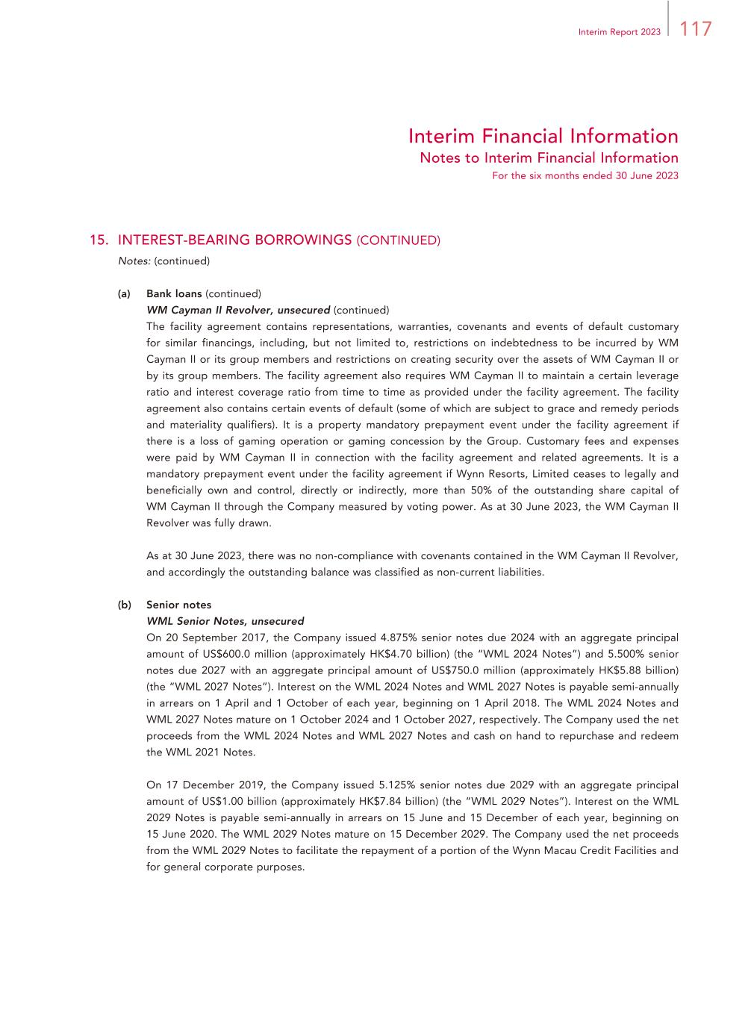
117Interim Report 2023 Interim Financial Information Notes to Interim Financial Information For the six months ended 30 June 2023 15. INTEREST-BEARING BORROWINGS (CONTINUED) Notes: (continued) (a) Bank loans (continued) WM Cayman II Revolver, unsecured (continued) The facility agreement contains representations, warranties, covenants and events of default customary for similar financings, including, but not limited to, restrictions on indebtedness to be incurred by WM Cayman II or its group members and restrictions on creating security over the assets of WM Cayman II or by its group members. The facility agreement also requires WM Cayman II to maintain a certain leverage ratio and interest coverage ratio from time to time as provided under the facility agreement. The facility agreement also contains certain events of default (some of which are subject to grace and remedy periods and materiality qualifiers). It is a property mandatory prepayment event under the facility agreement if there is a loss of gaming operation or gaming concession by the Group. Customary fees and expenses were paid by WM Cayman II in connection with the facility agreement and related agreements. It is a mandatory prepayment event under the facility agreement if Wynn Resorts, Limited ceases to legally and beneficially own and control, directly or indirectly, more than 50% of the outstanding share capital of WM Cayman II through the Company measured by voting power. As at 30 June 2023, the WM Cayman II Revolver was fully drawn. As at 30 June 2023, there was no non-compliance with covenants contained in the WM Cayman II Revolver, and accordingly the outstanding balance was classified as non-current liabilities. (b) Senior notes WML Senior Notes, unsecured On 20 September 2017, the Company issued 4.875% senior notes due 2024 with an aggregate principal amount of US$600.0 million (approximately HK$4.70 billion) (the “WML 2024 Notes”) and 5.500% senior notes due 2027 with an aggregate principal amount of US$750.0 million (approximately HK$5.88 billion) (the “WML 2027 Notes”). Interest on the WML 2024 Notes and WML 2027 Notes is payable semi-annually in arrears on 1 April and 1 October of each year, beginning on 1 April 2018. The WML 2024 Notes and WML 2027 Notes mature on 1 October 2024 and 1 October 2027, respectively. The Company used the net proceeds from the WML 2024 Notes and WML 2027 Notes and cash on hand to repurchase and redeem the WML 2021 Notes. On 17 December 2019, the Company issued 5.125% senior notes due 2029 with an aggregate principal amount of US$1.00 billion (approximately HK$7.84 billion) (the “WML 2029 Notes”). Interest on the WML 2029 Notes is payable semi-annually in arrears on 15 June and 15 December of each year, beginning on 15 June 2020. The WML 2029 Notes mature on 15 December 2029. The Company used the net proceeds from the WML 2029 Notes to facilitate the repayment of a portion of the Wynn Macau Credit Facilities and for general corporate purposes.

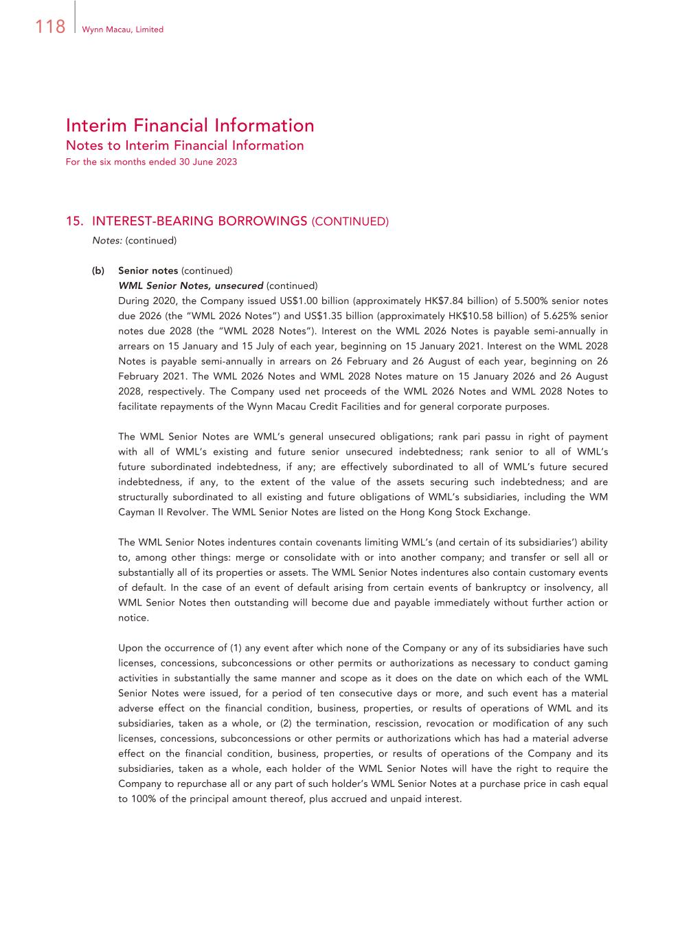
118 Wynn Macau, Limited Interim Financial Information Notes to Interim Financial Information For the six months ended 30 June 2023 15. INTEREST-BEARING BORROWINGS (CONTINUED) Notes: (continued) (b) Senior notes (continued) WML Senior Notes, unsecured (continued) During 2020, the Company issued US$1.00 billion (approximately HK$7.84 billion) of 5.500% senior notes due 2026 (the “WML 2026 Notes”) and US$1.35 billion (approximately HK$10.58 billion) of 5.625% senior notes due 2028 (the “WML 2028 Notes”). Interest on the WML 2026 Notes is payable semi-annually in arrears on 15 January and 15 July of each year, beginning on 15 January 2021. Interest on the WML 2028 Notes is payable semi-annually in arrears on 26 February and 26 August of each year, beginning on 26 February 2021. The WML 2026 Notes and WML 2028 Notes mature on 15 January 2026 and 26 August 2028, respectively. The Company used net proceeds of the WML 2026 Notes and WML 2028 Notes to facilitate repayments of the Wynn Macau Credit Facilities and for general corporate purposes. The WML Senior Notes are WML’s general unsecured obligations; rank pari passu in right of payment with all of WML’s existing and future senior unsecured indebtedness; rank senior to all of WML’s future subordinated indebtedness, if any; are effectively subordinated to all of WML’s future secured indebtedness, if any, to the extent of the value of the assets securing such indebtedness; and are structurally subordinated to all existing and future obligations of WML’s subsidiaries, including the WM Cayman II Revolver. The WML Senior Notes are listed on the Hong Kong Stock Exchange. The WML Senior Notes indentures contain covenants limiting WML’s (and certain of its subsidiaries’) ability to, among other things: merge or consolidate with or into another company; and transfer or sell all or substantially all of its properties or assets. The WML Senior Notes indentures also contain customary events of default. In the case of an event of default arising from certain events of bankruptcy or insolvency, all WML Senior Notes then outstanding will become due and payable immediately without further action or notice. Upon the occurrence of (1) any event after which none of the Company or any of its subsidiaries have such licenses, concessions, subconcessions or other permits or authorizations as necessary to conduct gaming activities in substantially the same manner and scope as it does on the date on which each of the WML Senior Notes were issued, for a period of ten consecutive days or more, and such event has a material adverse effect on the financial condition, business, properties, or results of operations of WML and its subsidiaries, taken as a whole, or (2) the termination, rescission, revocation or modification of any such licenses, concessions, subconcessions or other permits or authorizations which has had a material adverse effect on the financial condition, business, properties, or results of operations of the Company and its subsidiaries, taken as a whole, each holder of the WML Senior Notes will have the right to require the Company to repurchase all or any part of such holder’s WML Senior Notes at a purchase price in cash equal to 100% of the principal amount thereof, plus accrued and unpaid interest.

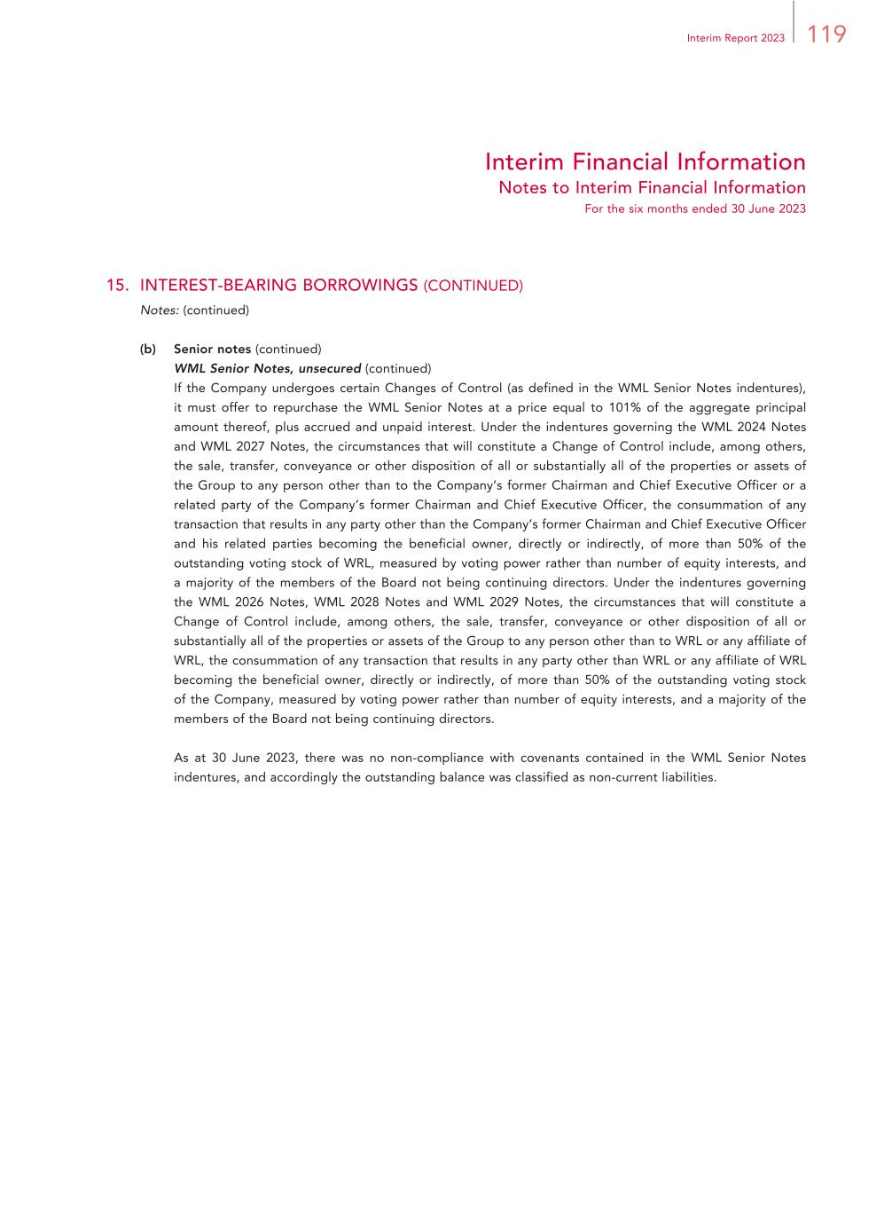
119Interim Report 2023 Interim Financial Information Notes to Interim Financial Information For the six months ended 30 June 2023 15. INTEREST-BEARING BORROWINGS (CONTINUED) Notes: (continued) (b) Senior notes (continued) WML Senior Notes, unsecured (continued) If the Company undergoes certain Changes of Control (as defined in the WML Senior Notes indentures), it must offer to repurchase the WML Senior Notes at a price equal to 101% of the aggregate principal amount thereof, plus accrued and unpaid interest. Under the indentures governing the WML 2024 Notes and WML 2027 Notes, the circumstances that will constitute a Change of Control include, among others, the sale, transfer, conveyance or other disposition of all or substantially all of the properties or assets of the Group to any person other than to the Company’s former Chairman and Chief Executive Officer or a related party of the Company’s former Chairman and Chief Executive Officer, the consummation of any transaction that results in any party other than the Company’s former Chairman and Chief Executive Officer and his related parties becoming the beneficial owner, directly or indirectly, of more than 50% of the outstanding voting stock of WRL, measured by voting power rather than number of equity interests, and a majority of the members of the Board not being continuing directors. Under the indentures governing the WML 2026 Notes, WML 2028 Notes and WML 2029 Notes, the circumstances that will constitute a Change of Control include, among others, the sale, transfer, conveyance or other disposition of all or substantially all of the properties or assets of the Group to any person other than to WRL or any affiliate of WRL, the consummation of any transaction that results in any party other than WRL or any affiliate of WRL becoming the beneficial owner, directly or indirectly, of more than 50% of the outstanding voting stock of the Company, measured by voting power rather than number of equity interests, and a majority of the members of the Board not being continuing directors. As at 30 June 2023, there was no non-compliance with covenants contained in the WML Senior Notes indentures, and accordingly the outstanding balance was classified as non-current liabilities.

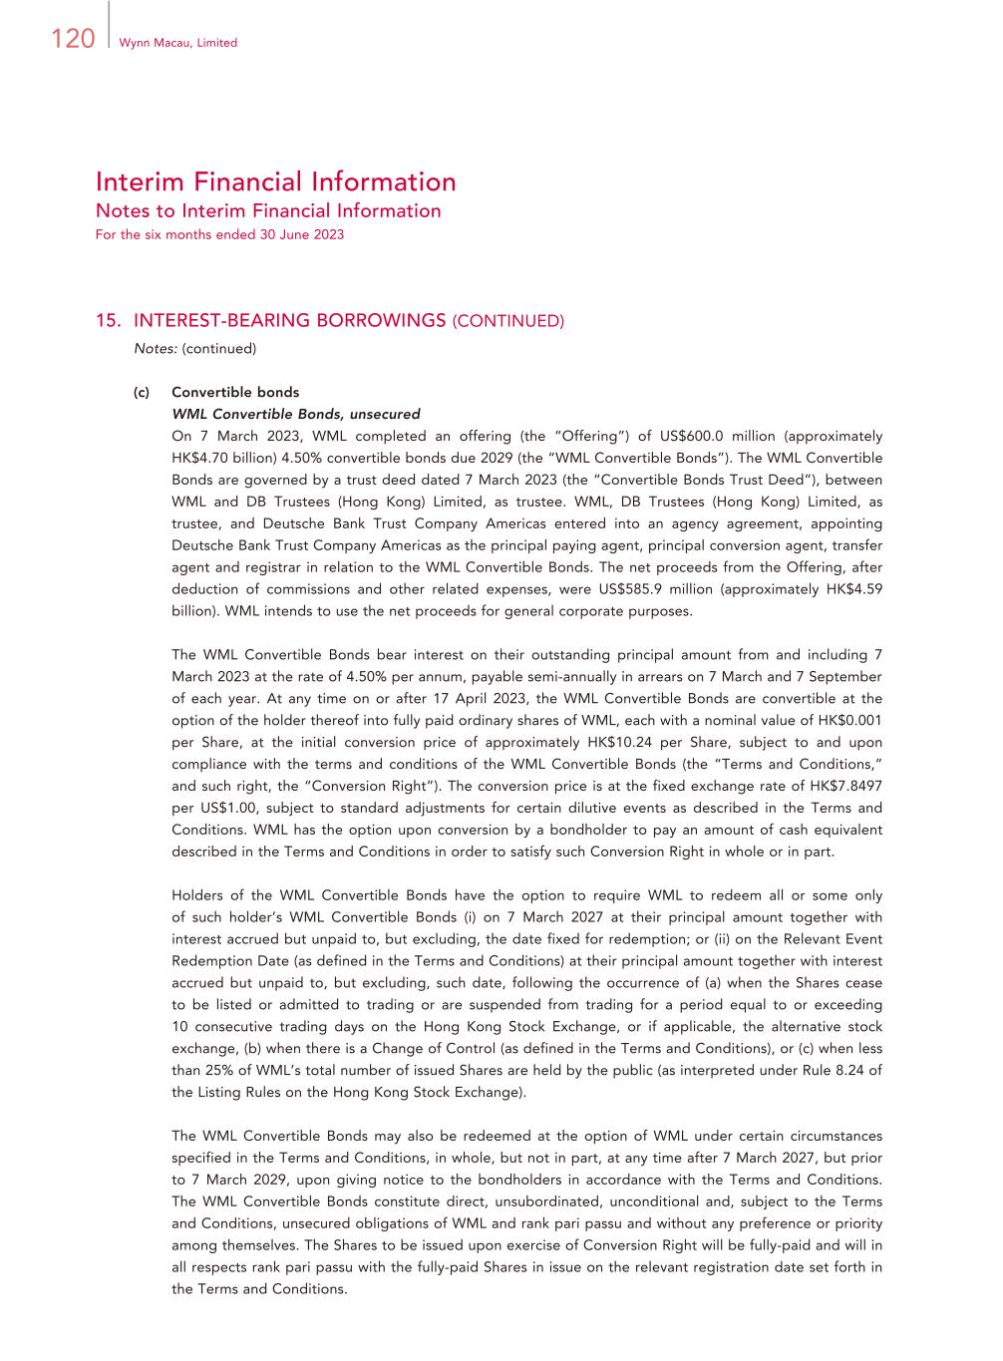
120 Wynn Macau, Limited Interim Financial Information Notes to Interim Financial Information For the six months ended 30 June 2023 15. INTEREST-BEARING BORROWINGS (CONTINUED) Notes: (continued) (c) Convertible bonds WML Convertible Bonds, unsecured On 7 March 2023, WML completed an offering (the “Offering”) of US$600.0 million (approximately HK$4.70 billion) 4.50% convertible bonds due 2029 (the “WML Convertible Bonds”). The WML Convertible Bonds are governed by a trust deed dated 7 March 2023 (the “Convertible Bonds Trust Deed”), between WML and DB Trustees (Hong Kong) Limited, as trustee. WML, DB Trustees (Hong Kong) Limited, as trustee, and Deutsche Bank Trust Company Americas entered into an agency agreement, appointing Deutsche Bank Trust Company Americas as the principal paying agent, principal conversion agent, transfer agent and registrar in relation to the WML Convertible Bonds. The net proceeds from the Offering, after deduction of commissions and other related expenses, were US$585.9 million (approximately HK$4.59 billion). WML intends to use the net proceeds for general corporate purposes. The WML Convertible Bonds bear interest on their outstanding principal amount from and including 7 March 2023 at the rate of 4.50% per annum, payable semi-annually in arrears on 7 March and 7 September of each year. At any time on or after 17 April 2023, the WML Convertible Bonds are convertible at the option of the holder thereof into fully paid ordinary shares of WML, each with a nominal value of HK$0.001 per Share, at the initial conversion price of approximately HK$10.24 per Share, subject to and upon compliance with the terms and conditions of the WML Convertible Bonds (the “Terms and Conditions,” and such right, the “Conversion Right”). The conversion price is at the fixed exchange rate of HK$7.8497 per US$1.00, subject to standard adjustments for certain dilutive events as described in the Terms and Conditions. WML has the option upon conversion by a bondholder to pay an amount of cash equivalent described in the Terms and Conditions in order to satisfy such Conversion Right in whole or in part. Holders of the WML Convertible Bonds have the option to require WML to redeem all or some only of such holder’s WML Convertible Bonds (i) on 7 March 2027 at their principal amount together with interest accrued but unpaid to, but excluding, the date fixed for redemption; or (ii) on the Relevant Event Redemption Date (as defined in the Terms and Conditions) at their principal amount together with interest accrued but unpaid to, but excluding, such date, following the occurrence of (a) when the Shares cease to be listed or admitted to trading or are suspended from trading for a period equal to or exceeding 10 consecutive trading days on the Hong Kong Stock Exchange, or if applicable, the alternative stock exchange, (b) when there is a Change of Control (as defined in the Terms and Conditions), or (c) when less than 25% of WML’s total number of issued Shares are held by the public (as interpreted under Rule 8.24 of the Listing Rules on the Hong Kong Stock Exchange). The WML Convertible Bonds may also be redeemed at the option of WML under certain circumstances specified in the Terms and Conditions, in whole, but not in part, at any time after 7 March 2027, but prior to 7 March 2029, upon giving notice to the bondholders in accordance with the Terms and Conditions. The WML Convertible Bonds constitute direct, unsubordinated, unconditional and, subject to the Terms and Conditions, unsecured obligations of WML and rank pari passu and without any preference or priority among themselves. The Shares to be issued upon exercise of Conversion Right will be fully-paid and will in all respects rank pari passu with the fully-paid Shares in issue on the relevant registration date set forth in the Terms and Conditions.

121Interim Report 2023 Interim Financial Information Notes to Interim Financial Information For the six months ended 30 June 2023 15. INTEREST-BEARING BORROWINGS (CONTINUED) Notes: (continued) (c) Convertible bonds (continued) WML Convertible Bonds, unsecured (continued) The Convertible Bonds Trust Deed contains covenants limiting WML’s and all of its subsidiaries’ ability to, among other things, create, permit to subsist or arise or have outstanding any mortgage, charge, pledge, lien or other encumbrance or certain security interest; consolidate or merge with or into another company; and sell, assign, transfer, convey or otherwise dispose of all or substantially all of its and its subsidiaries’ properties or assets, with certain exceptions. The Convertible Bonds Trust Deed also contains customary events of default. The Company determined that the conversion feature contained within the WML Convertible Bonds is required to be bifurcated from the debt host contract and accounted for as a free-standing derivative (the “WML Convertible Bond Conversion Option Derivative”). In accordance with applicable accounting standards, the WML Convertible Bond Conversion Option Derivative will be recorded at fair value at the end of each reporting period, with changes recognized in the condensed consolidated statement of profit or loss and other comprehensive income. For more information, see “Note 16 — WML Convertible Bond Conversion Option Derivative”. As a result, the Company recognized a debt discount of US$123.5 million (approximately HK$0.97 billion) within non-current interest-bearing borrowings, representing the estimated fair value of the holders’ conversion option upon completion of the Offering. The debt discount will be amortized to interest expense over the term of the WML Convertible Bonds using the effective interest method. As of 30 June 2023, the estimated fair value of the WML Convertible Bond Conversion Option Derivative was a liability of US$77.0 million (approximately HK$0.60 billion), recorded within non-current interest-bearing borrowings within the accompanying condensed consolidated statement of financial position. As at 30 June 2023, there was no non-compliance with covenants contained in the Terms and Conditions of the WML Convertible Bonds, and accordingly the outstanding balance was classified as non-current liabilities. (d) WRL Revolving Loan Facility, unsecured On 14 June 2022, the Company entered into a loan agreement with WRL, which was amended by way of an amendment letter dated 30 December 2022, pursuant to which WRL agreed to make available an unsecured revolving loan facility in an amount of up to US$500.0 million (approximately HK$3.92 billion). The current term of the WRL Revolving Loan Facility is twenty-four months after the date of the original loan agreement dated 14 June 2022 and the current interest rate of the loan is 9% per annum on funded amounts or any other rate (to take into account any prevailing market conditions and other applicable factors) as agreed between the Company and WRL from time to time. As at 30 June 2023, the WRL Revolving Loan Facility remained undrawn with US$500.0 million (approximately HK$3.92 billion) available.

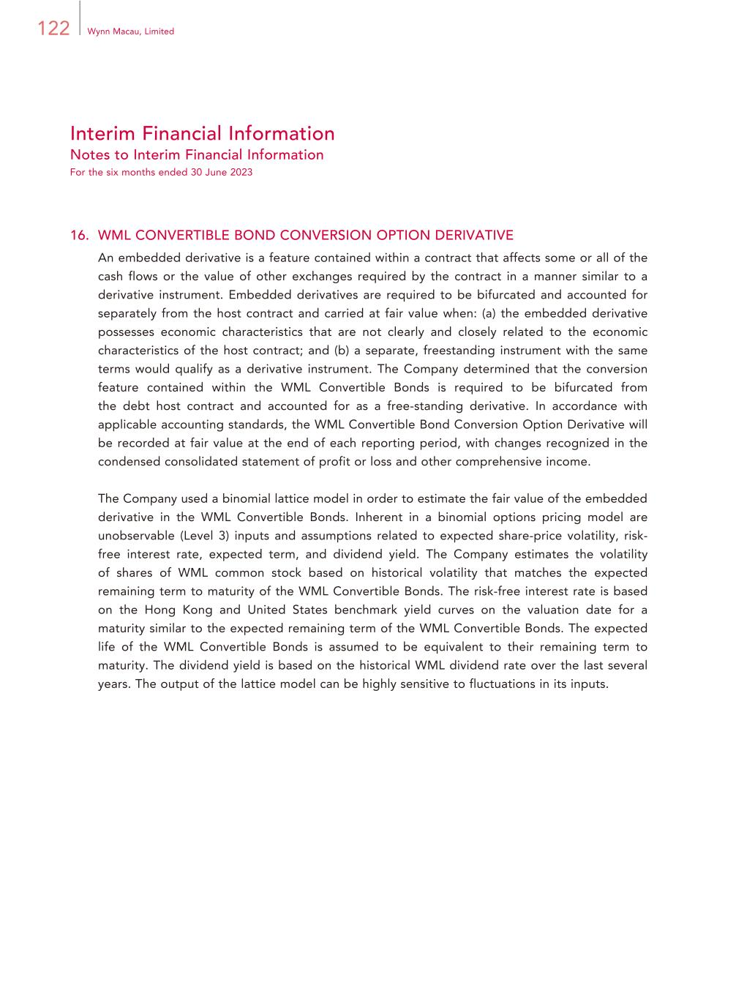
122 Wynn Macau, Limited Interim Financial Information Notes to Interim Financial Information For the six months ended 30 June 2023 16. WML CONVERTIBLE BOND CONVERSION OPTION DERIVATIVE An embedded derivative is a feature contained within a contract that affects some or all of the cash flows or the value of other exchanges required by the contract in a manner similar to a derivative instrument. Embedded derivatives are required to be bifurcated and accounted for separately from the host contract and carried at fair value when: (a) the embedded derivative possesses economic characteristics that are not clearly and closely related to the economic characteristics of the host contract; and (b) a separate, freestanding instrument with the same terms would qualify as a derivative instrument. The Company determined that the conversion feature contained within the WML Convertible Bonds is required to be bifurcated from the debt host contract and accounted for as a free-standing derivative. In accordance with applicable accounting standards, the WML Convertible Bond Conversion Option Derivative will be recorded at fair value at the end of each reporting period, with changes recognized in the condensed consolidated statement of profit or loss and other comprehensive income. The Company used a binomial lattice model in order to estimate the fair value of the embedded derivative in the WML Convertible Bonds. Inherent in a binomial options pricing model are unobservable (Level 3) inputs and assumptions related to expected share-price volatility, risk- free interest rate, expected term, and dividend yield. The Company estimates the volatility of shares of WML common stock based on historical volatility that matches the expected remaining term to maturity of the WML Convertible Bonds. The risk-free interest rate is based on the Hong Kong and United States benchmark yield curves on the valuation date for a maturity similar to the expected remaining term of the WML Convertible Bonds. The expected life of the WML Convertible Bonds is assumed to be equivalent to their remaining term to maturity. The dividend yield is based on the historical WML dividend rate over the last several years. The output of the lattice model can be highly sensitive to fluctuations in its inputs.

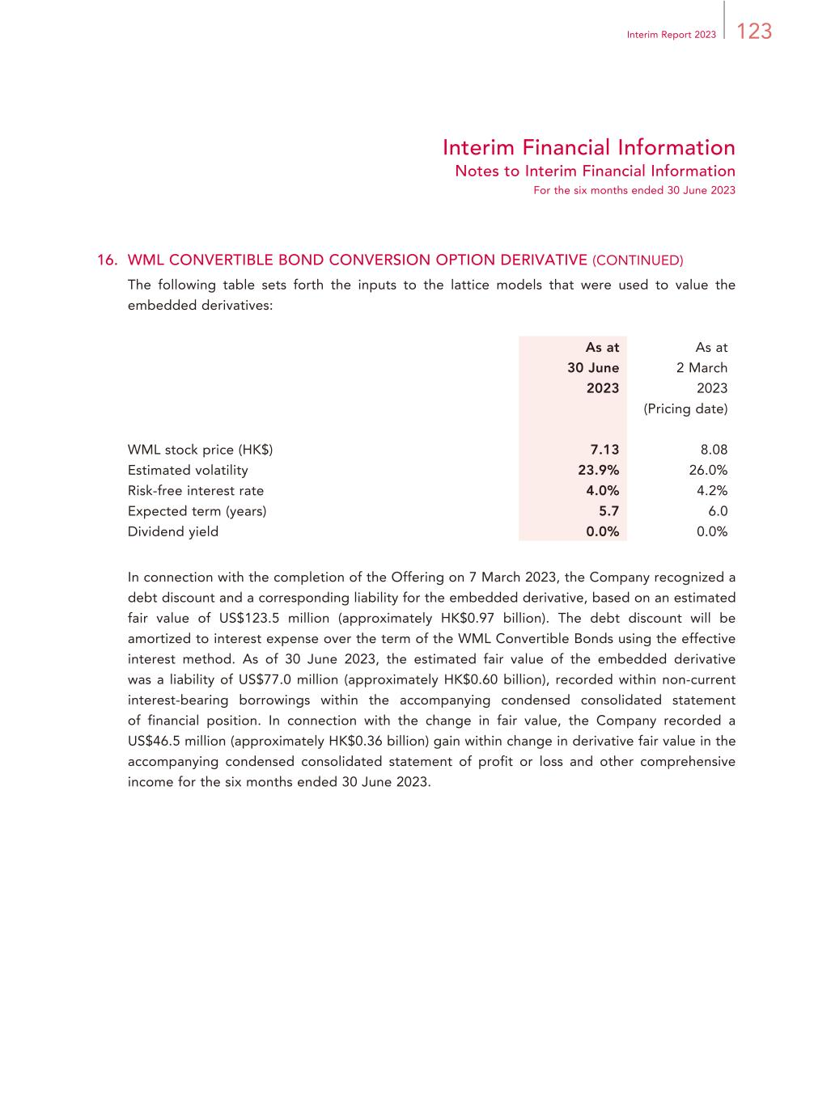
123Interim Report 2023 Interim Financial Information Notes to Interim Financial Information For the six months ended 30 June 2023 16. WML CONVERTIBLE BOND CONVERSION OPTION DERIVATIVE (CONTINUED) The following table sets forth the inputs to the lattice models that were used to value the embedded derivatives: As at 30 June 2023 As at 2 March 2023 (Pricing date) WML stock price (HK$) 7.13 8.08 Estimated volatility 23.9% 26.0% Risk-free interest rate 4.0% 4.2% Expected term (years) 5.7 6.0 Dividend yield 0.0% 0.0% In connection with the completion of the Offering on 7 March 2023, the Company recognized a debt discount and a corresponding liability for the embedded derivative, based on an estimated fair value of US$123.5 million (approximately HK$0.97 billion). The debt discount will be amortized to interest expense over the term of the WML Convertible Bonds using the effective interest method. As of 30 June 2023, the estimated fair value of the embedded derivative was a liability of US$77.0 million (approximately HK$0.60 billion), recorded within non-current interest-bearing borrowings within the accompanying condensed consolidated statement of financial position. In connection with the change in fair value, the Company recorded a US$46.5 million (approximately HK$0.36 billion) gain within change in derivative fair value in the accompanying condensed consolidated statement of profit or loss and other comprehensive income for the six months ended 30 June 2023.

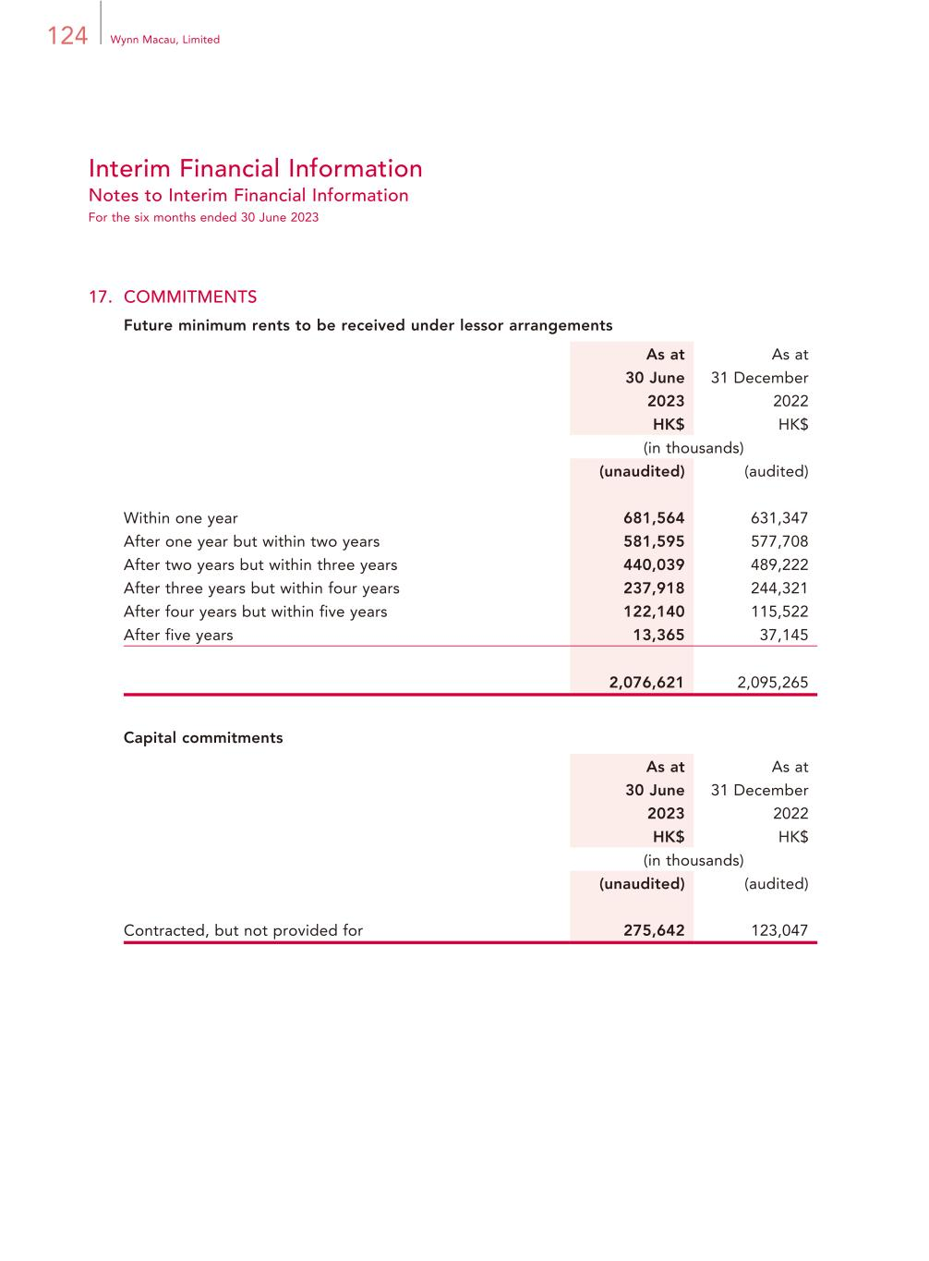
124 Wynn Macau, Limited Interim Financial Information Notes to Interim Financial Information For the six months ended 30 June 2023 17. COMMITMENTS Future minimum rents to be received under lessor arrangements As at 30 June 2023 HK$ As at 31 December 2022 HK$ (in thousands) (unaudited) (audited) Within one year 681,564 631,347 After one year but within two years 581,595 577,708 After two years but within three years 440,039 489,222 After three years but within four years 237,918 244,321 After four years but within five years 122,140 115,522 After five years 13,365 37,145 2,076,621 2,095,265 Capital commitments As at 30 June 2023 HK$ As at 31 December 2022 HK$ (in thousands) (unaudited) (audited) Contracted, but not provided for 275,642 123,047

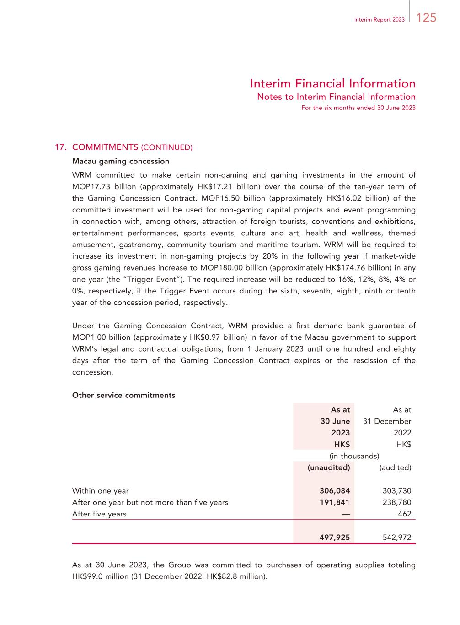
125Interim Report 2023 Interim Financial Information Notes to Interim Financial Information For the six months ended 30 June 2023 17. COMMITMENTS (CONTINUED) Macau gaming concession WRM committed to make certain non-gaming and gaming investments in the amount of MOP17.73 billion (approximately HK$17.21 billion) over the course of the ten-year term of the Gaming Concession Contract. MOP16.50 billion (approximately HK$16.02 billion) of the committed investment will be used for non-gaming capital projects and event programming in connection with, among others, attraction of foreign tourists, conventions and exhibitions, entertainment performances, sports events, culture and art, health and wellness, themed amusement, gastronomy, community tourism and maritime tourism. WRM will be required to increase its investment in non-gaming projects by 20% in the following year if market-wide gross gaming revenues increase to MOP180.00 billion (approximately HK$174.76 billion) in any one year (the “Trigger Event”). The required increase will be reduced to 16%, 12%, 8%, 4% or 0%, respectively, if the Trigger Event occurs during the sixth, seventh, eighth, ninth or tenth year of the concession period, respectively. Under the Gaming Concession Contract, WRM provided a first demand bank guarantee of MOP1.00 billion (approximately HK$0.97 billion) in favor of the Macau government to support WRM’s legal and contractual obligations, from 1 January 2023 until one hundred and eighty days after the term of the Gaming Concession Contract expires or the rescission of the concession. Other service commitments As at 30 June 2023 HK$ As at 31 December 2022 HK$ (in thousands) (unaudited) (audited) Within one year 306,084 303,730 After one year but not more than five years 191,841 238,780 After five years — 462 497,925 542,972 As at 30 June 2023, the Group was committed to purchases of operating supplies totaling HK$99.0 million (31 December 2022: HK$82.8 million).

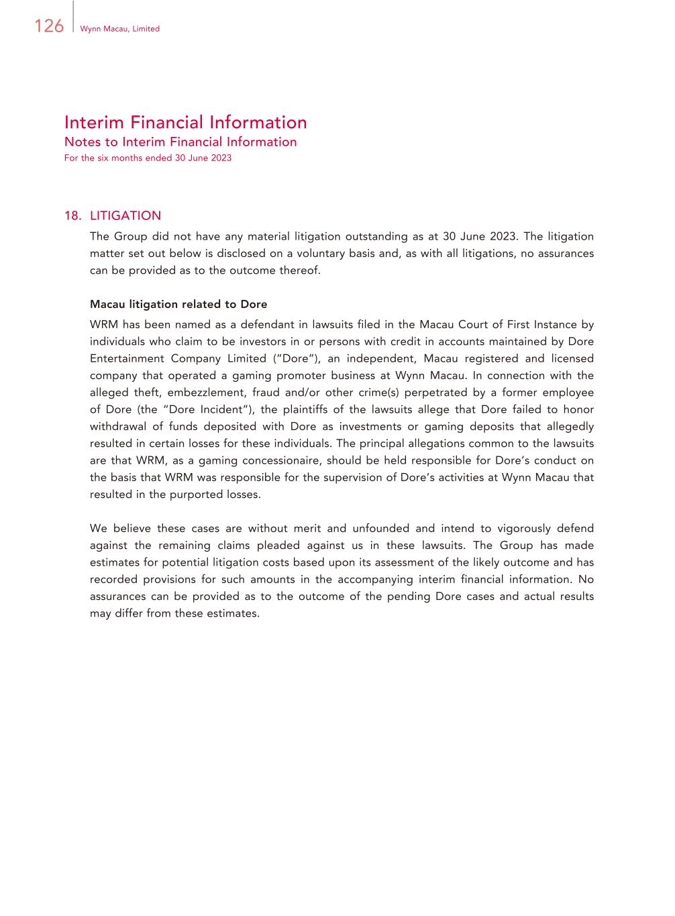
126 Wynn Macau, Limited Interim Financial Information Notes to Interim Financial Information For the six months ended 30 June 2023 18. LITIGATION The Group did not have any material litigation outstanding as at 30 June 2023. The litigation matter set out below is disclosed on a voluntary basis and, as with all litigations, no assurances can be provided as to the outcome thereof. Macau litigation related to Dore WRM has been named as a defendant in lawsuits filed in the Macau Court of First Instance by individuals who claim to be investors in or persons with credit in accounts maintained by Dore Entertainment Company Limited (“Dore”), an independent, Macau registered and licensed company that operated a gaming promoter business at Wynn Macau. In connection with the alleged theft, embezzlement, fraud and/or other crime(s) perpetrated by a former employee of Dore (the “Dore Incident”), the plaintiffs of the lawsuits allege that Dore failed to honor withdrawal of funds deposited with Dore as investments or gaming deposits that allegedly resulted in certain losses for these individuals. The principal allegations common to the lawsuits are that WRM, as a gaming concessionaire, should be held responsible for Dore’s conduct on the basis that WRM was responsible for the supervision of Dore’s activities at Wynn Macau that resulted in the purported losses. We believe these cases are without merit and unfounded and intend to vigorously defend against the remaining claims pleaded against us in these lawsuits. The Group has made estimates for potential litigation costs based upon its assessment of the likely outcome and has recorded provisions for such amounts in the accompanying interim financial information. No assurances can be provided as to the outcome of the pending Dore cases and actual results may differ from these estimates.

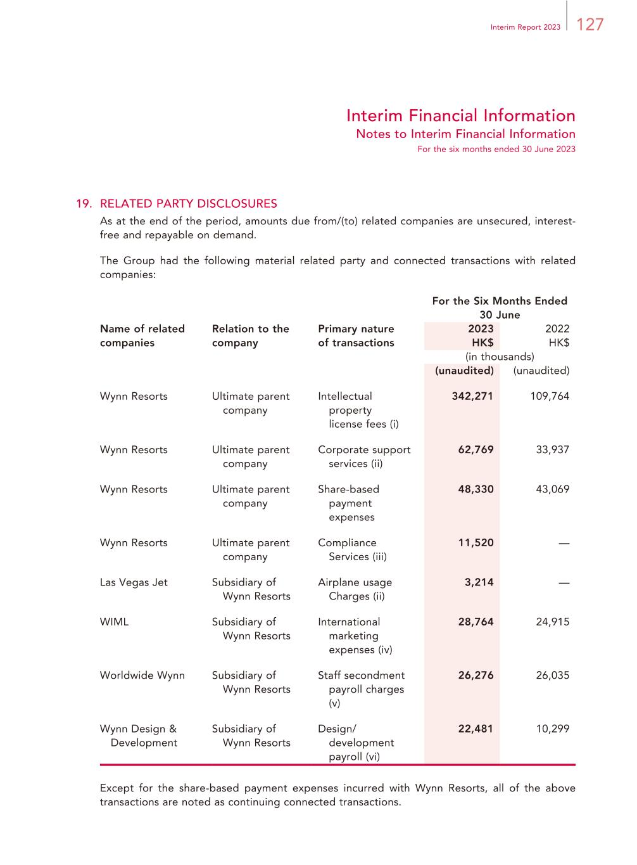
127Interim Report 2023 Interim Financial Information Notes to Interim Financial Information For the six months ended 30 June 2023 19. RELATED PARTY DISCLOSURES As at the end of the period, amounts due from/(to) related companies are unsecured, interest- free and repayable on demand. The Group had the following material related party and connected transactions with related companies: For the Six Months Ended 30 June Name of related companies Relation to the company Primary nature of transactions 2023 2022 HK$ HK$ (in thousands) (unaudited) (unaudited) Wynn Resorts Ultimate parent company Intellectual property license fees (i) 342,271 109,764 Wynn Resorts Ultimate parent company Corporate support services (ii) 62,769 33,937 Wynn Resorts Ultimate parent company Share-based payment expenses 48,330 43,069 Wynn Resorts Ultimate parent company Compliance Services (iii) 11,520 — Las Vegas Jet Subsidiary of Wynn Resorts Airplane usage Charges (ii) 3,214 — WIML Subsidiary of Wynn Resorts International marketing expenses (iv) 28,764 24,915 Worldwide Wynn Subsidiary of Wynn Resorts Staff secondment payroll charges (v) 26,276 26,035 Wynn Design & Development Subsidiary of Wynn Resorts Design/ development payroll (vi) 22,481 10,299 Except for the share-based payment expenses incurred with Wynn Resorts, all of the above transactions are noted as continuing connected transactions.

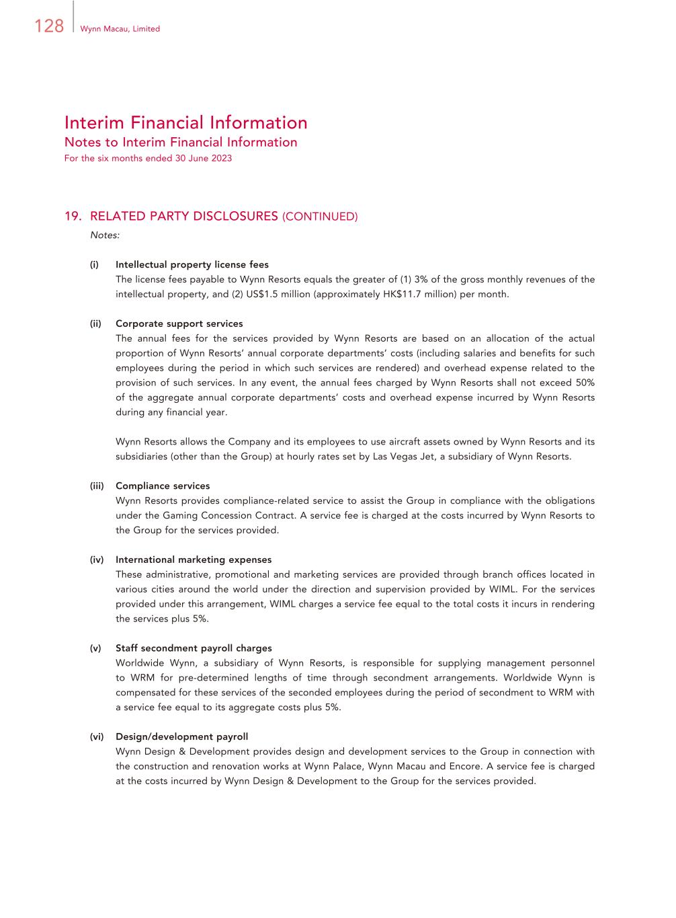
128 Wynn Macau, Limited Interim Financial Information Notes to Interim Financial Information For the six months ended 30 June 2023 19. RELATED PARTY DISCLOSURES (CONTINUED) Notes: (i) Intellectual property license fees The license fees payable to Wynn Resorts equals the greater of (1) 3% of the gross monthly revenues of the intellectual property, and (2) US$1.5 million (approximately HK$11.7 million) per month. (ii) Corporate support services The annual fees for the services provided by Wynn Resorts are based on an allocation of the actual proportion of Wynn Resorts’ annual corporate departments’ costs (including salaries and benefits for such employees during the period in which such services are rendered) and overhead expense related to the provision of such services. In any event, the annual fees charged by Wynn Resorts shall not exceed 50% of the aggregate annual corporate departments’ costs and overhead expense incurred by Wynn Resorts during any financial year. Wynn Resorts allows the Company and its employees to use aircraft assets owned by Wynn Resorts and its subsidiaries (other than the Group) at hourly rates set by Las Vegas Jet, a subsidiary of Wynn Resorts. (iii) Compliance services Wynn Resorts provides compliance-related service to assist the Group in compliance with the obligations under the Gaming Concession Contract. A service fee is charged at the costs incurred by Wynn Resorts to the Group for the services provided. (iv) International marketing expenses These administrative, promotional and marketing services are provided through branch offices located in various cities around the world under the direction and supervision provided by WIML. For the services provided under this arrangement, WIML charges a service fee equal to the total costs it incurs in rendering the services plus 5%. (v) Staff secondment payroll charges Worldwide Wynn, a subsidiary of Wynn Resorts, is responsible for supplying management personnel to WRM for pre-determined lengths of time through secondment arrangements. Worldwide Wynn is compensated for these services of the seconded employees during the period of secondment to WRM with a service fee equal to its aggregate costs plus 5%. (vi) Design/development payroll Wynn Design & Development provides design and development services to the Group in connection with the construction and renovation works at Wynn Palace, Wynn Macau and Encore. A service fee is charged at the costs incurred by Wynn Design & Development to the Group for the services provided.

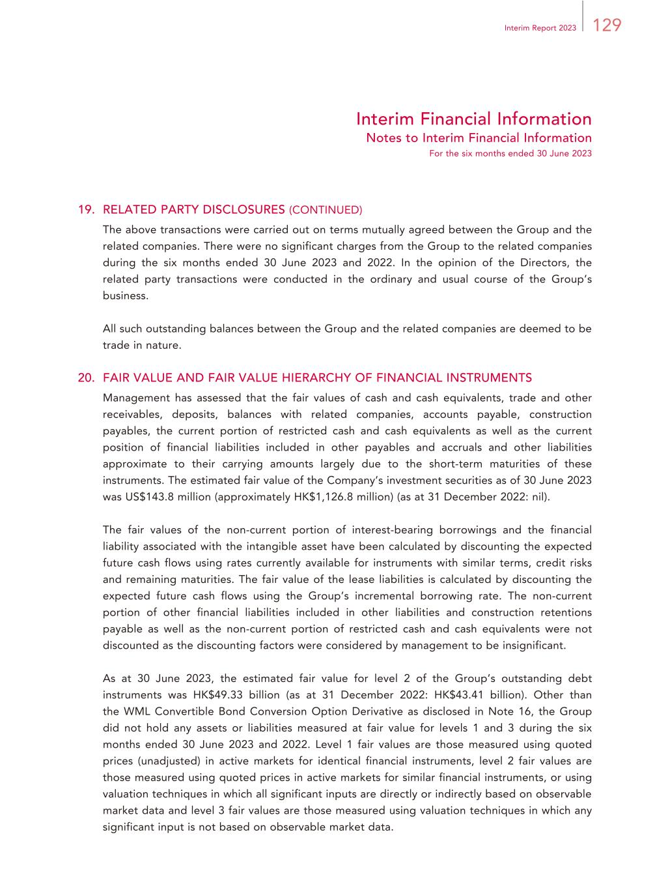
129Interim Report 2023 Interim Financial Information Notes to Interim Financial Information For the six months ended 30 June 2023 19. RELATED PARTY DISCLOSURES (CONTINUED) The above transactions were carried out on terms mutually agreed between the Group and the related companies. There were no significant charges from the Group to the related companies during the six months ended 30 June 2023 and 2022. In the opinion of the Directors, the related party transactions were conducted in the ordinary and usual course of the Group’s business. All such outstanding balances between the Group and the related companies are deemed to be trade in nature. 20. FAIR VALUE AND FAIR VALUE HIERARCHY OF FINANCIAL INSTRUMENTS Management has assessed that the fair values of cash and cash equivalents, trade and other receivables, deposits, balances with related companies, accounts payable, construction payables, the current portion of restricted cash and cash equivalents as well as the current position of financial liabilities included in other payables and accruals and other liabilities approximate to their carrying amounts largely due to the short-term maturities of these instruments. The estimated fair value of the Company’s investment securities as of 30 June 2023 was US$143.8 million (approximately HK$1,126.8 million) (as at 31 December 2022: nil). The fair values of the non-current portion of interest-bearing borrowings and the financial liability associated with the intangible asset have been calculated by discounting the expected future cash flows using rates currently available for instruments with similar terms, credit risks and remaining maturities. The fair value of the lease liabilities is calculated by discounting the expected future cash flows using the Group’s incremental borrowing rate. The non-current portion of other financial liabilities included in other liabilities and construction retentions payable as well as the non-current portion of restricted cash and cash equivalents were not discounted as the discounting factors were considered by management to be insignificant. As at 30 June 2023, the estimated fair value for level 2 of the Group’s outstanding debt instruments was HK$49.33 billion (as at 31 December 2022: HK$43.41 billion). Other than the WML Convertible Bond Conversion Option Derivative as disclosed in Note 16, the Group did not hold any assets or liabilities measured at fair value for levels 1 and 3 during the six months ended 30 June 2023 and 2022. Level 1 fair values are those measured using quoted prices (unadjusted) in active markets for identical financial instruments, level 2 fair values are those measured using quoted prices in active markets for similar financial instruments, or using valuation techniques in which all significant inputs are directly or indirectly based on observable market data and level 3 fair values are those measured using valuation techniques in which any significant input is not based on observable market data.

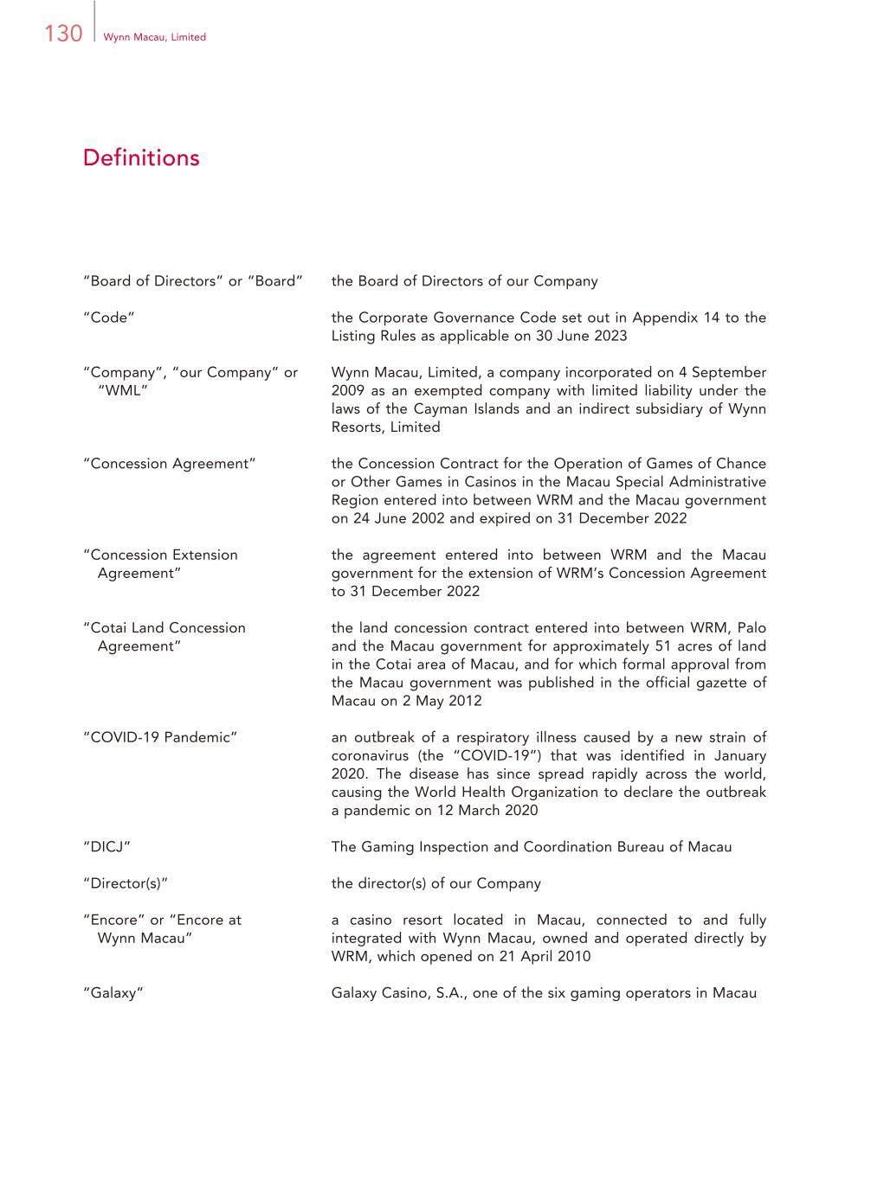
130 Wynn Macau, Limited Definitions “Board of Directors” or “Board” the Board of Directors of our Company “Code” the Corporate Governance Code set out in Appendix 14 to the Listing Rules as applicable on 30 June 2023 “Company”, “our Company” or “WML” Wynn Macau, Limited, a company incorporated on 4 September 2009 as an exempted company with limited liability under the laws of the Cayman Islands and an indirect subsidiary of Wynn Resorts, Limited “Concession Agreement” the Concession Contract for the Operation of Games of Chance or Other Games in Casinos in the Macau Special Administrative Region entered into between WRM and the Macau government on 24 June 2002 and expired on 31 December 2022 “Concession Extension Agreement” the agreement entered into between WRM and the Macau government for the extension of WRM’s Concession Agreement to 31 December 2022 “Cotai Land Concession Agreement” the land concession contract entered into between WRM, Palo and the Macau government for approximately 51 acres of land in the Cotai area of Macau, and for which formal approval from the Macau government was published in the official gazette of Macau on 2 May 2012 “COVID-19 Pandemic” an outbreak of a respiratory illness caused by a new strain of coronavirus (the “COVID-19”) that was identified in January 2020. The disease has since spread rapidly across the world, causing the World Health Organization to declare the outbreak a pandemic on 12 March 2020 “DICJ” The Gaming Inspection and Coordination Bureau of Macau “Director(s)” the director(s) of our Company “Encore” or “Encore at Wynn Macau” a casino resort located in Macau, connected to and fully integrated with Wynn Macau, owned and operated directly by WRM, which opened on 21 April 2010 “Galaxy” Galaxy Casino, S.A., one of the six gaming operators in Macau

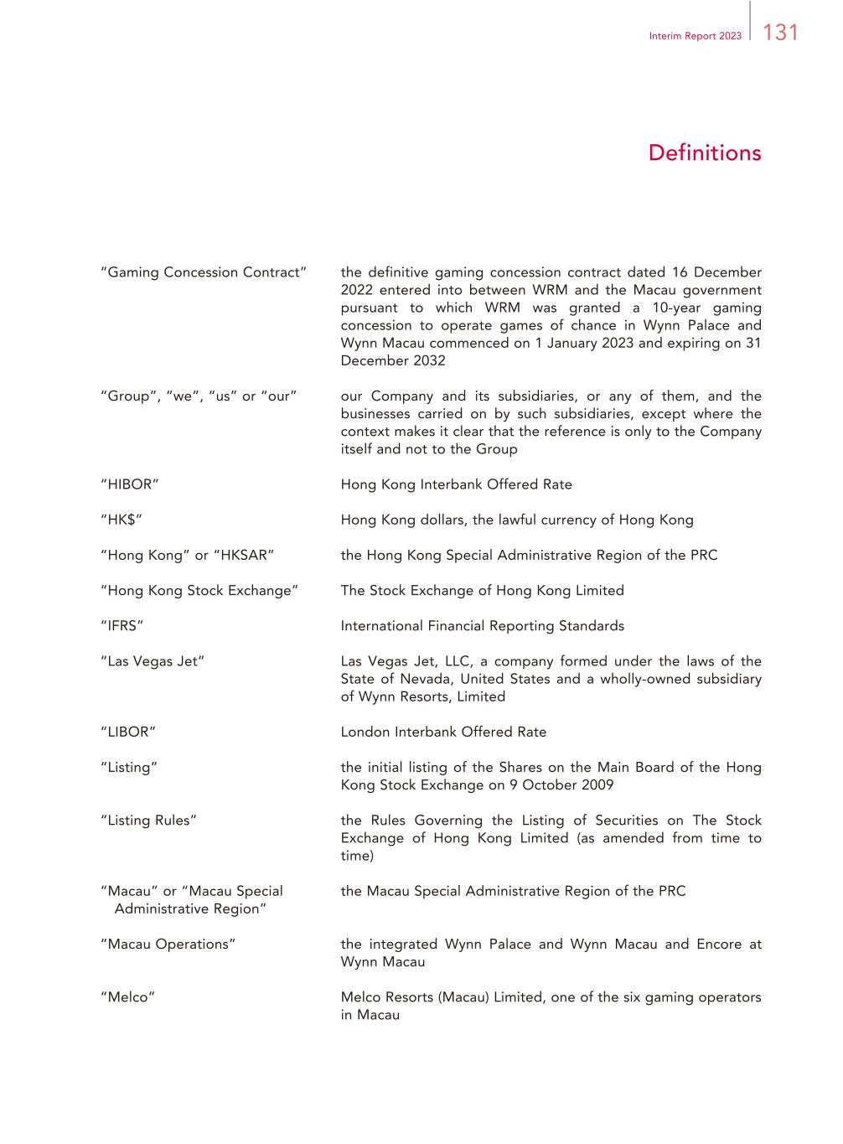
131Interim Report 2023 Definitions “Gaming Concession Contract” the definitive gaming concession contract dated 16 December 2022 entered into between WRM and the Macau government pursuant to which WRM was granted a 10-year gaming concession to operate games of chance in Wynn Palace and Wynn Macau commenced on 1 January 2023 and expiring on 31 December 2032 “Group”, “we”, “us” or “our” our Company and its subsidiaries, or any of them, and the businesses carried on by such subsidiaries, except where the context makes it clear that the reference is only to the Company itself and not to the Group “HIBOR” Hong Kong Interbank Offered Rate “HK$” Hong Kong dollars, the lawful currency of Hong Kong “Hong Kong” or “HKSAR” the Hong Kong Special Administrative Region of the PRC “Hong Kong Stock Exchange” The Stock Exchange of Hong Kong Limited “IFRS” International Financial Reporting Standards “Las Vegas Jet” Las Vegas Jet, LLC, a company formed under the laws of the State of Nevada, United States and a wholly-owned subsidiary of Wynn Resorts, Limited “LIBOR” London Interbank Offered Rate “Listing” the initial listing of the Shares on the Main Board of the Hong Kong Stock Exchange on 9 October 2009 “Listing Rules” the Rules Governing the Listing of Securities on The Stock Exchange of Hong Kong Limited (as amended from time to time) “Macau” or “Macau Special Administrative Region” the Macau Special Administrative Region of the PRC “Macau Operations” the integrated Wynn Palace and Wynn Macau and Encore at Wynn Macau “Melco” Melco Resorts (Macau) Limited, one of the six gaming operators in Macau

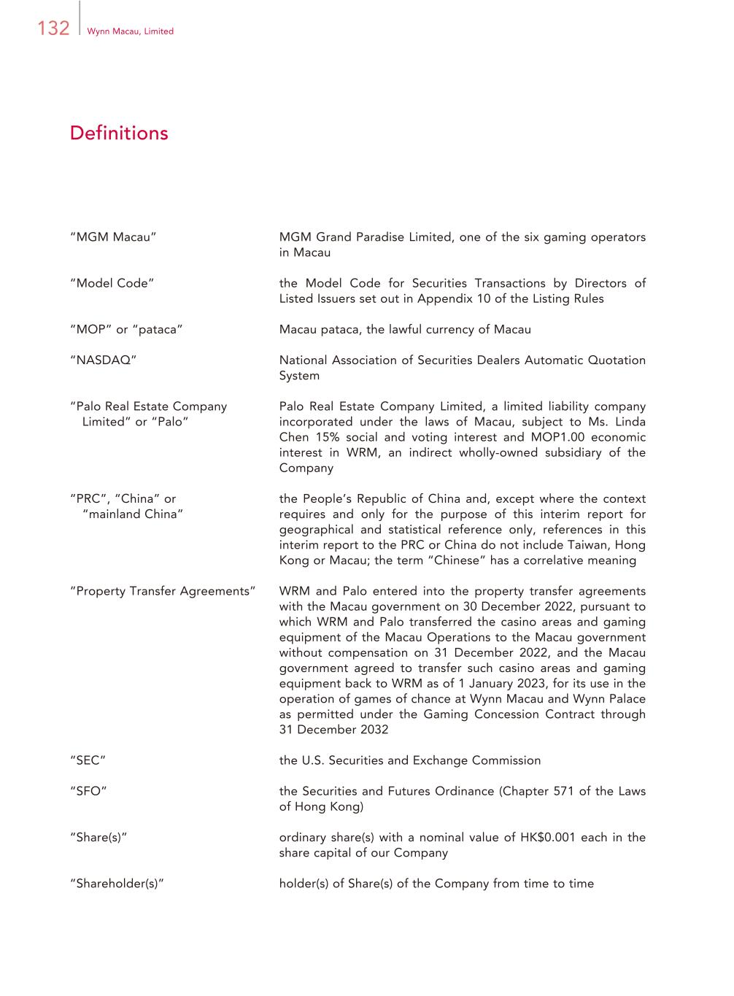
132 Wynn Macau, Limited Definitions “MGM Macau” MGM Grand Paradise Limited, one of the six gaming operators in Macau “Model Code” the Model Code for Securities Transactions by Directors of Listed Issuers set out in Appendix 10 of the Listing Rules “MOP” or “pataca” Macau pataca, the lawful currency of Macau “NASDAQ” National Association of Securities Dealers Automatic Quotation System “Palo Real Estate Company Limited” or “Palo” Palo Real Estate Company Limited, a limited liability company incorporated under the laws of Macau, subject to Ms. Linda Chen 15% social and voting interest and MOP1.00 economic interest in WRM, an indirect wholly-owned subsidiary of the Company “PRC”, “China” or “mainland China” the People’s Republic of China and, except where the context requires and only for the purpose of this interim report for geographical and statistical reference only, references in this interim report to the PRC or China do not include Taiwan, Hong Kong or Macau; the term “Chinese” has a correlative meaning “Property Transfer Agreements” WRM and Palo entered into the property transfer agreements with the Macau government on 30 December 2022, pursuant to which WRM and Palo transferred the casino areas and gaming equipment of the Macau Operations to the Macau government without compensation on 31 December 2022, and the Macau government agreed to transfer such casino areas and gaming equipment back to WRM as of 1 January 2023, for its use in the operation of games of chance at Wynn Macau and Wynn Palace as permitted under the Gaming Concession Contract through 31 December 2032 “SEC” the U.S. Securities and Exchange Commission “SFO” the Securities and Futures Ordinance (Chapter 571 of the Laws of Hong Kong) “Share(s)” ordinary share(s) with a nominal value of HK$0.001 each in the share capital of our Company “Shareholder(s)” holder(s) of Share(s) of the Company from time to time

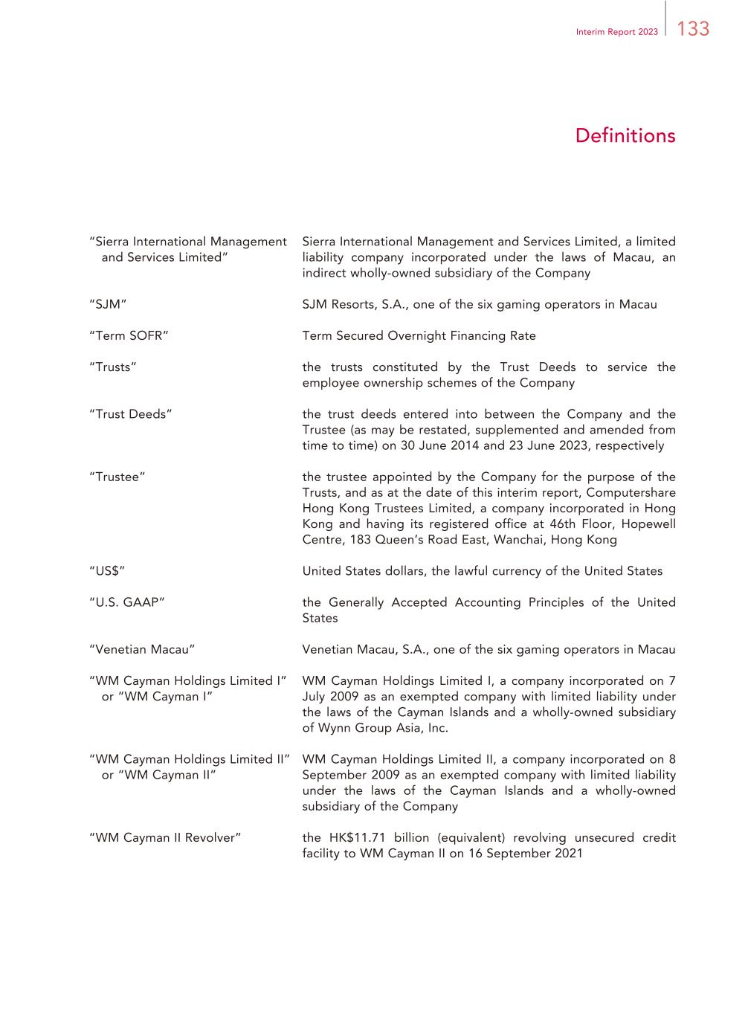
133Interim Report 2023 Definitions “Sierra International Management and Services Limited” Sierra International Management and Services Limited, a limited liability company incorporated under the laws of Macau, an indirect wholly-owned subsidiary of the Company “SJM” SJM Resorts, S.A., one of the six gaming operators in Macau “Term SOFR” Term Secured Overnight Financing Rate “Trusts” the trusts constituted by the Trust Deeds to service the employee ownership schemes of the Company “Trust Deeds” the trust deeds entered into between the Company and the Trustee (as may be restated, supplemented and amended from time to time) on 30 June 2014 and 23 June 2023, respectively “Trustee” the trustee appointed by the Company for the purpose of the Trusts, and as at the date of this interim report, Computershare Hong Kong Trustees Limited, a company incorporated in Hong Kong and having its registered office at 46th Floor, Hopewell Centre, 183 Queen’s Road East, Wanchai, Hong Kong “US$” United States dollars, the lawful currency of the United States “U.S. GAAP” the Generally Accepted Accounting Principles of the United States “Venetian Macau” Venetian Macau, S.A., one of the six gaming operators in Macau “WM Cayman Holdings Limited I” or “WM Cayman I” WM Cayman Holdings Limited I, a company incorporated on 7 July 2009 as an exempted company with limited liability under the laws of the Cayman Islands and a wholly-owned subsidiary of Wynn Group Asia, Inc. “WM Cayman Holdings Limited II” or “WM Cayman II” WM Cayman Holdings Limited II, a company incorporated on 8 September 2009 as an exempted company with limited liability under the laws of the Cayman Islands and a wholly-owned subsidiary of the Company “WM Cayman II Revolver” the HK$11.71 billion (equivalent) revolving unsecured credit facility to WM Cayman II on 16 September 2021

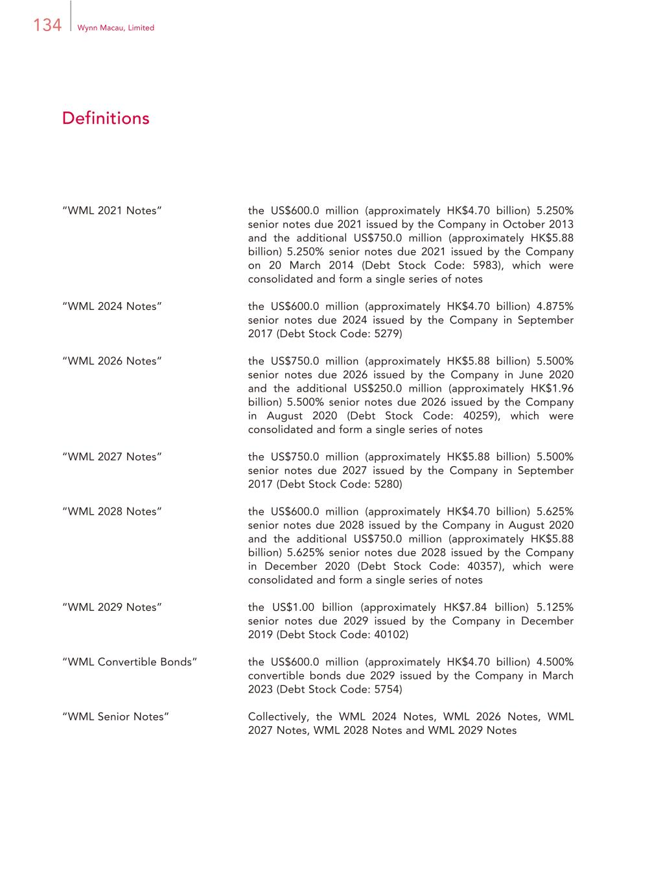
134 Wynn Macau, Limited Definitions “WML 2021 Notes” the US$600.0 million (approximately HK$4.70 billion) 5.250% senior notes due 2021 issued by the Company in October 2013 and the additional US$750.0 million (approximately HK$5.88 billion) 5.250% senior notes due 2021 issued by the Company on 20 March 2014 (Debt Stock Code: 5983), which were consolidated and form a single series of notes “WML 2024 Notes” the US$600.0 million (approximately HK$4.70 billion) 4.875% senior notes due 2024 issued by the Company in September 2017 (Debt Stock Code: 5279) “WML 2026 Notes” the US$750.0 million (approximately HK$5.88 billion) 5.500% senior notes due 2026 issued by the Company in June 2020 and the additional US$250.0 million (approximately HK$1.96 billion) 5.500% senior notes due 2026 issued by the Company in August 2020 (Debt Stock Code: 40259), which were consolidated and form a single series of notes “WML 2027 Notes” the US$750.0 million (approximately HK$5.88 billion) 5.500% senior notes due 2027 issued by the Company in September 2017 (Debt Stock Code: 5280) “WML 2028 Notes” the US$600.0 million (approximately HK$4.70 billion) 5.625% senior notes due 2028 issued by the Company in August 2020 and the additional US$750.0 million (approximately HK$5.88 billion) 5.625% senior notes due 2028 issued by the Company in December 2020 (Debt Stock Code: 40357), which were consolidated and form a single series of notes “WML 2029 Notes” the US$1.00 billion (approximately HK$7.84 billion) 5.125% senior notes due 2029 issued by the Company in December 2019 (Debt Stock Code: 40102) “WML Convertible Bonds” the US$600.0 million (approximately HK$4.70 billion) 4.500% convertible bonds due 2029 issued by the Company in March 2023 (Debt Stock Code: 5754) “WML Senior Notes” Collectively, the WML 2024 Notes, WML 2026 Notes, WML 2027 Notes, WML 2028 Notes and WML 2029 Notes

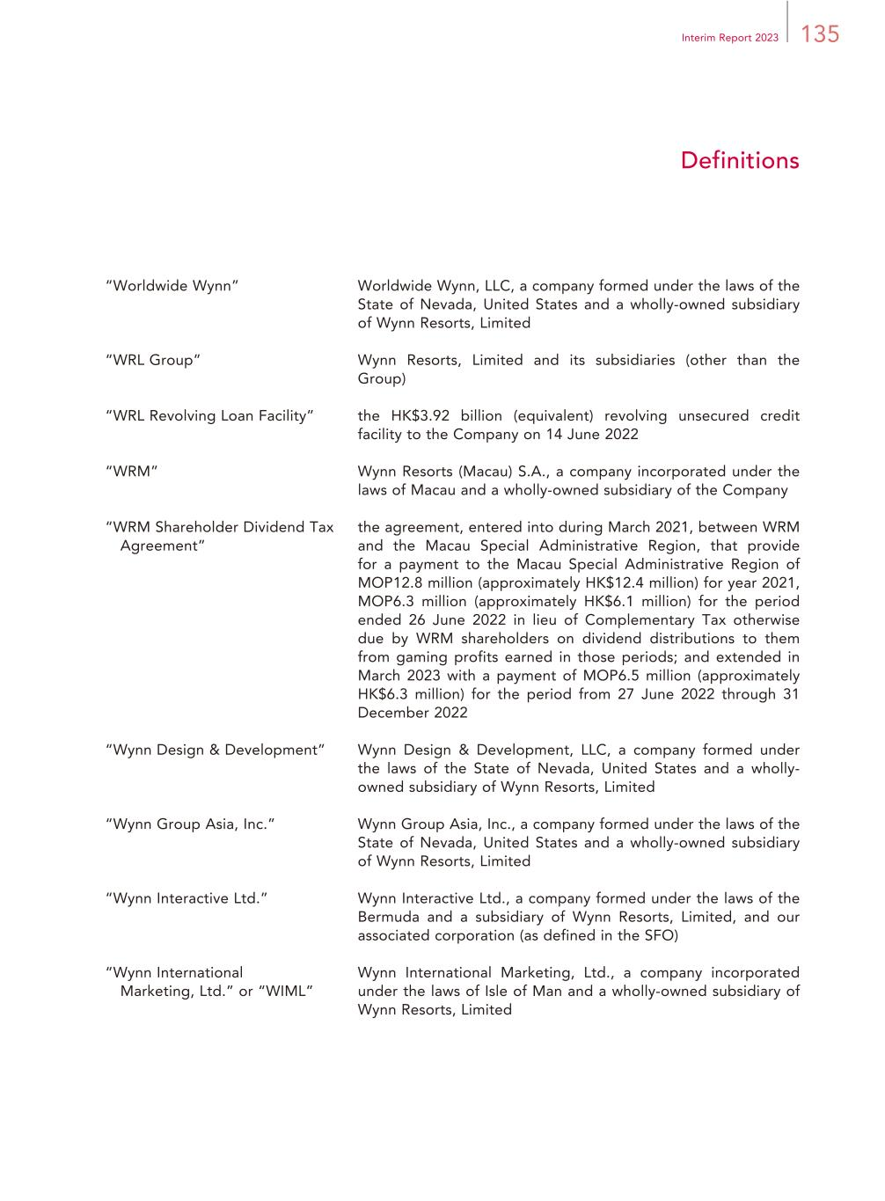
135Interim Report 2023 Definitions “Worldwide Wynn” Worldwide Wynn, LLC, a company formed under the laws of the State of Nevada, United States and a wholly-owned subsidiary of Wynn Resorts, Limited “WRL Group” Wynn Resorts, Limited and its subsidiaries (other than the Group) “WRL Revolving Loan Facility” the HK$3.92 billion (equivalent) revolving unsecured credit facility to the Company on 14 June 2022 “WRM” Wynn Resorts (Macau) S.A., a company incorporated under the laws of Macau and a wholly-owned subsidiary of the Company “WRM Shareholder Dividend Tax Agreement” the agreement, entered into during March 2021, between WRM and the Macau Special Administrative Region, that provide for a payment to the Macau Special Administrative Region of MOP12.8 million (approximately HK$12.4 million) for year 2021, MOP6.3 million (approximately HK$6.1 million) for the period ended 26 June 2022 in lieu of Complementary Tax otherwise due by WRM shareholders on dividend distributions to them from gaming profits earned in those periods; and extended in March 2023 with a payment of MOP6.5 million (approximately HK$6.3 million) for the period from 27 June 2022 through 31 December 2022 “Wynn Design & Development” Wynn Design & Development, LLC, a company formed under the laws of the State of Nevada, United States and a wholly- owned subsidiary of Wynn Resorts, Limited “Wynn Group Asia, Inc.” Wynn Group Asia, Inc., a company formed under the laws of the State of Nevada, United States and a wholly-owned subsidiary of Wynn Resorts, Limited “Wynn Interactive Ltd.” Wynn Interactive Ltd., a company formed under the laws of the Bermuda and a subsidiary of Wynn Resorts, Limited, and our associated corporation (as defined in the SFO) “Wynn International Marketing, Ltd.” or “WIML” Wynn International Marketing, Ltd., a company incorporated under the laws of Isle of Man and a wholly-owned subsidiary of Wynn Resorts, Limited

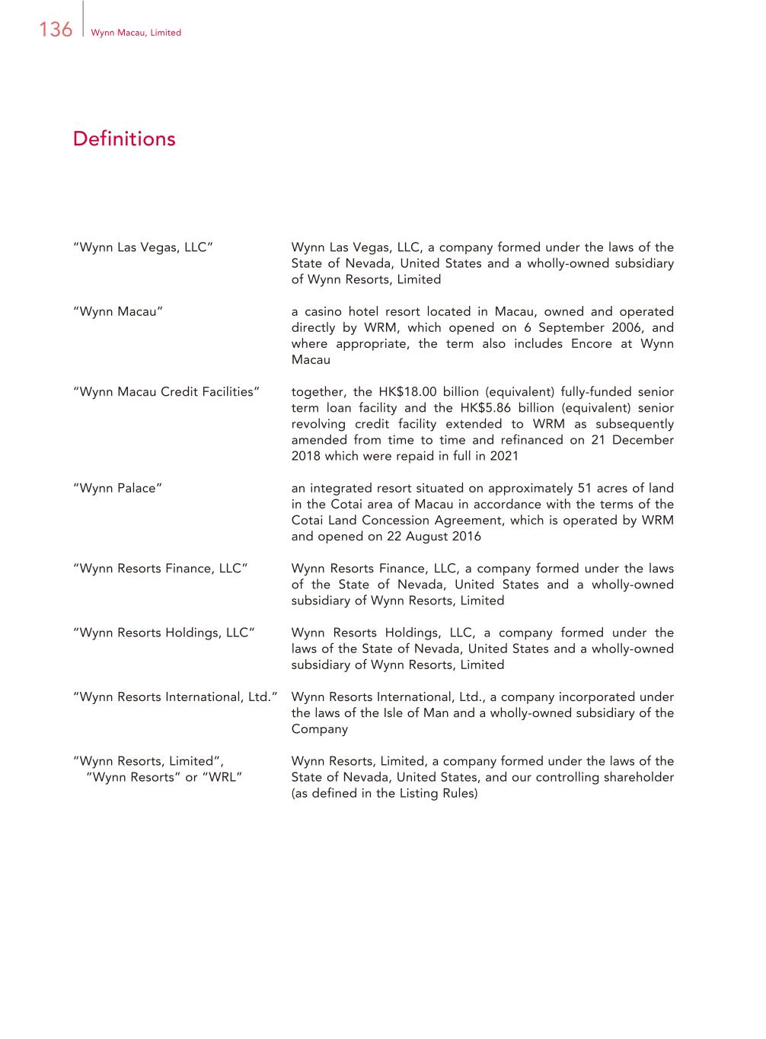
136 Wynn Macau, Limited Definitions “Wynn Las Vegas, LLC” Wynn Las Vegas, LLC, a company formed under the laws of the State of Nevada, United States and a wholly-owned subsidiary of Wynn Resorts, Limited “Wynn Macau” a casino hotel resort located in Macau, owned and operated directly by WRM, which opened on 6 September 2006, and where appropriate, the term also includes Encore at Wynn Macau “Wynn Macau Credit Facilities” together, the HK$18.00 billion (equivalent) fully-funded senior term loan facility and the HK$5.86 billion (equivalent) senior revolving credit facility extended to WRM as subsequently amended from time to time and refinanced on 21 December 2018 which were repaid in full in 2021 “Wynn Palace” an integrated resort situated on approximately 51 acres of land in the Cotai area of Macau in accordance with the terms of the Cotai Land Concession Agreement, which is operated by WRM and opened on 22 August 2016 “Wynn Resorts Finance, LLC” Wynn Resorts Finance, LLC, a company formed under the laws of the State of Nevada, United States and a wholly-owned subsidiary of Wynn Resorts, Limited “Wynn Resorts Holdings, LLC” Wynn Resorts Holdings, LLC, a company formed under the laws of the State of Nevada, United States and a wholly-owned subsidiary of Wynn Resorts, Limited “Wynn Resorts International, Ltd.” Wynn Resorts International, Ltd., a company incorporated under the laws of the Isle of Man and a wholly-owned subsidiary of the Company “Wynn Resorts, Limited”, “Wynn Resorts” or “WRL” Wynn Resorts, Limited, a company formed under the laws of the State of Nevada, United States, and our controlling shareholder (as defined in the Listing Rules)

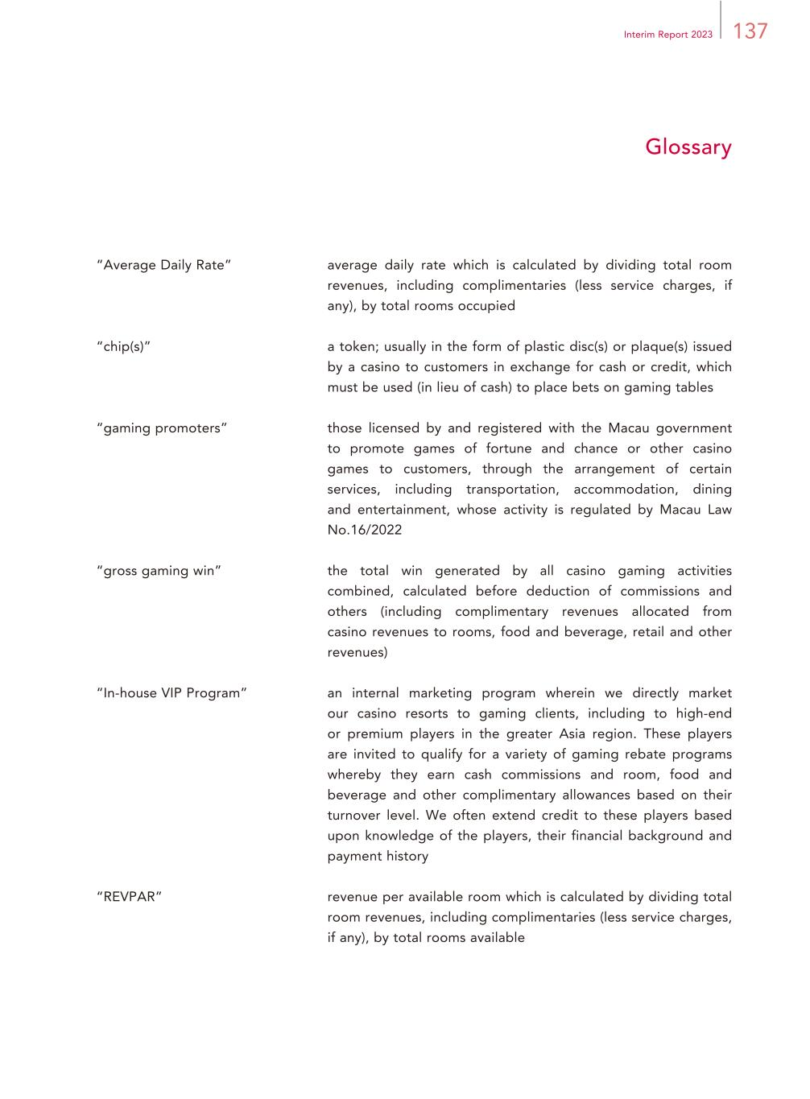
137Interim Report 2023 Glossary “Average Daily Rate” average daily rate which is calculated by dividing total room revenues, including complimentaries (less service charges, if any), by total rooms occupied “chip(s)” a token; usually in the form of plastic disc(s) or plaque(s) issued by a casino to customers in exchange for cash or credit, which must be used (in lieu of cash) to place bets on gaming tables “gaming promoters” those licensed by and registered with the Macau government to promote games of fortune and chance or other casino games to customers, through the arrangement of certain services, including transportation, accommodation, dining and entertainment, whose activity is regulated by Macau Law No.16/2022 “gross gaming win” the total win generated by all casino gaming activities combined, calculated before deduction of commissions and others (including complimentary revenues allocated from casino revenues to rooms, food and beverage, retail and other revenues) “In-house VIP Program” an internal marketing program wherein we directly market our casino resorts to gaming clients, including to high-end or premium players in the greater Asia region. These players are invited to qualify for a variety of gaming rebate programs whereby they earn cash commissions and room, food and beverage and other complimentary allowances based on their turnover level. We often extend credit to these players based upon knowledge of the players, their financial background and payment history “REVPAR” revenue per available room which is calculated by dividing total room revenues, including complimentaries (less service charges, if any), by total rooms available

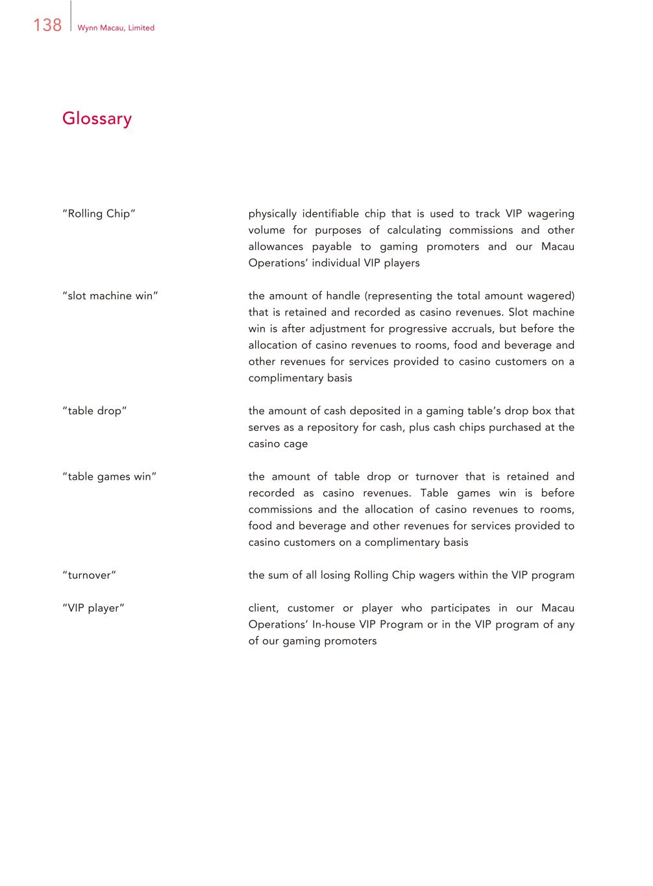
138 Wynn Macau, Limited Glossary “Rolling Chip” physically identifiable chip that is used to track VIP wagering volume for purposes of calculating commissions and other allowances payable to gaming promoters and our Macau Operations’ individual VIP players “slot machine win” the amount of handle (representing the total amount wagered) that is retained and recorded as casino revenues. Slot machine win is after adjustment for progressive accruals, but before the allocation of casino revenues to rooms, food and beverage and other revenues for services provided to casino customers on a complimentary basis “table drop” the amount of cash deposited in a gaming table’s drop box that serves as a repository for cash, plus cash chips purchased at the casino cage “table games win” the amount of table drop or turnover that is retained and recorded as casino revenues. Table games win is before commissions and the allocation of casino revenues to rooms, food and beverage and other revenues for services provided to casino customers on a complimentary basis “turnover” the sum of all losing Rolling Chip wagers within the VIP program “VIP player” client, customer or player who participates in our Macau Operations’ In-house VIP Program or in the VIP program of any of our gaming promoters


Wynn Macau, Limited Avenida da Nave Desportiva, Wynn Palace, COTAI, Macau SAR (853) 2888-9966 www.wynnmacau.com

