UNITED STATES

SECURITIES AND EXCHANGE COMMISSION
Washington, D.C. 20549

FORM 8-K

CURRENT REPORT

Pursuant to Section 13 or 15(d)
of the Securities Exchange Act of 1934, as Amended

Date of Report (Date of earliest event reported): October 11, 2013

WYNN RESORTS, LIMITED

(Exact name of registrant as specified in its charter)

Nevada | 000-50028 | 46-0484987
(State or other jurisdiction | (Commission | (IRS Employer
of incorporation | File Number) | Identification No.)
3131 Las Vegas Boulevard South
Las Vegas, Nevada |  | 89109
(Address of principal executive offices) |  | (Zip Code)

(702) 770-7555

(Registrant’s telephone number, including area code)

Not Applicable

(Former name or former address, if changed since last report.)

Check the appropriate box below if the Form 8-K filing is intended to simultaneously satisfy the filing obligation of the registrant under any of the following provisions:

- Written communications pursuant to Rule 425 under the Securities Act (17 CFR 230.425)

- Soliciting material pursuant to Rule 14a-12 under the Exchange Act (17 CFR 240.14a-12)

- Pre-commencement communications pursuant to Rule 14d-2(b) under the Exchange Act (17 CFR 240.14d-2(b))

- Pre-commencement communications pursuant to Rule 13e-4(c) under the Exchange Act (17 CFR 240.13e-4(c))

Item 7.01. Regulation FD Disclosure.

On October 11, 2013, Wynn Macau, Limited (“WML”), an indirect subsidiary of Wynn Resorts, Limited (the “Registrant”) with its ordinary shares listed on The Stock Exchange of Hong Kong Limited (the “HKSE”), filed with the HKSE, as required by HKSE listing rules, an announcement that WML has entered into a purchase agreement with certain Initial Purchasers, as defined in the purchase agreement, in connection with the issuance by WML of $600 million aggregate principal amount of 5.25% senior notes due 2021, which issuance is expected to occur on October 16, 2013 (the “Pricing Announcement”). The Registrant owns approximately 72.3% of WML’s ordinary shares. The Pricing Announcement and a copy of the associated press release are furnished herewith as Exhibits 99.1 and 99.2, respectively. The information in this Form 8-K and the exhibits attached hereto shall not be deemed “filed” for purposes of Section 18 of the Securities Exchange Act of 1934, as amended, nor shall it be deemed incorporated by reference in any filing under the Securities Act of 1933, as amended, except as shall be expressly set forth by specific reference in such filing.

Item 9.01. Financial Statements and Exhibits

- Exhibits.

Exhibit

No. Description

99.1 Pricing Announcement of Wynn Macau, Limited, dated October 11, 2013.

99.2 Press Release of Wynn Resorts, Limited, dated October 10, 2013.

2

SIGNATURES

Pursuant to the requirements of the Securities Exchange Act of 1934, as amended, the Registrant has duly caused this report to be signed on its behalf by the undersigned hereunto duly authorized.

 | WYNN RESORTS, LIMITED
Date: October 11, 2013 | By: | /s/ Matt Maddox
 | Name: | Matt Maddox
 | Title: | Chief Financial Officer and Treasurer

EXHIBIT INDEX

Exhibit

No. Description

99.1 Pricing Announcement of Wynn Macau, Limited, dated October 11, 2013.

99.2 Press Release of Wynn Resorts, Limited, dated October 10, 2013.

Exhibit 99.1
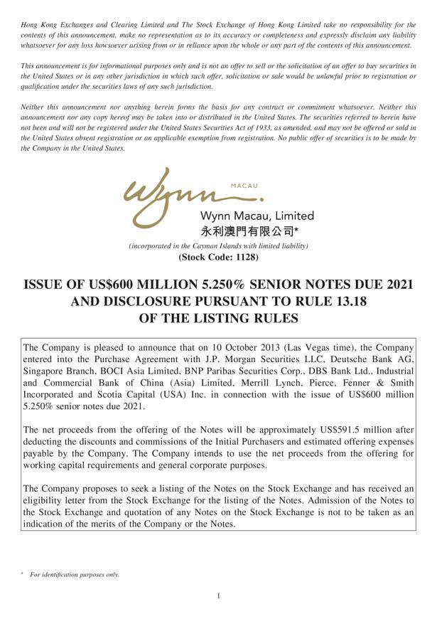

 |  |  | Exhibit 99.1
Hong Kong Exchanges and Clearing Limited and The Stock Exchange of Hong Kong Limited take no responsibility for the contents of this announcement, make no representation as to its accuracy or
completeness and expressly disclaim any liability whatsoever for any loss howsoever arising from or in reliance upon the whole or any part of the contents of this announcement.
This announcement is for informational purposes only and is not an offer to sell or the solicitation of an offer to buy securities in the United States or in any other jurisdiction in which such offer, solicitation or
sale would be unlawful prior to registration or qualification under the securities laws of any such juri diction. |  | may be taken into or distributed in the United States.
Neither this announcement nor anything herein forms the basis for any contract or commitment whatsoever. Neither this announcement nor any copy
The securities referred to herein have not been and will not be | under the United States Securities Act of 1933, as amended, and may not be hereoffered or sold in the United States absent registration or an
applicable exemption from registration. No public offer of securitiesregisteredto be made by the Company in the United States.
[Graphic Appears Here]
^{( tock}
_{ISSUE}incorporatedCode: 1128)inthe Cayman Islands with limited liability)
OF US$600 MILLION 5.250% SENIOR NOTES DUE 2021 AND DISCLOSURE PURSUANT TO RULE 13.18 OF THE LISTING RULES
The Company is pleased to_{Paribas}nnounce that on 10 October 2013 (Las Vegas time), the Company entered into the Purchase Agreement with J.P. Morgan Securities LLC, Deutsche Bank AG, Singapore Branch,
BOCI Asia Lim^{with}ed, BNP Securities Corp., DBS Bank Ltd., Industrial and Commercial Bank of China (Asia) Limited, Merrill Lynch, Pierce, Fenner & Smith Incorporated and Scotia Capital (USA) Inc.
in connection the issue of US$600 million 5.250% senior notes due 2021.

The net proceeds from the offering of the Notes will be approximately US$591.5 million after deducting the discounts and commissions of the Initial Purchasers and estimated offering expenses payable by the Company. The Company intends to use the net proceeds from the offering for working capital requirements and general corporate purposes.

The Company proposes to seek a listing of the Notes on the Stock Exchange and has received an eligibility letter from the Stock Exchange for the listing of the Notes. Admission of the Notes to the Stock Exchange and quotation of any Notes on the Stock Exchange is not to be taken as an indication of the merits of the Company or the Notes.

1* For identification purposes only.

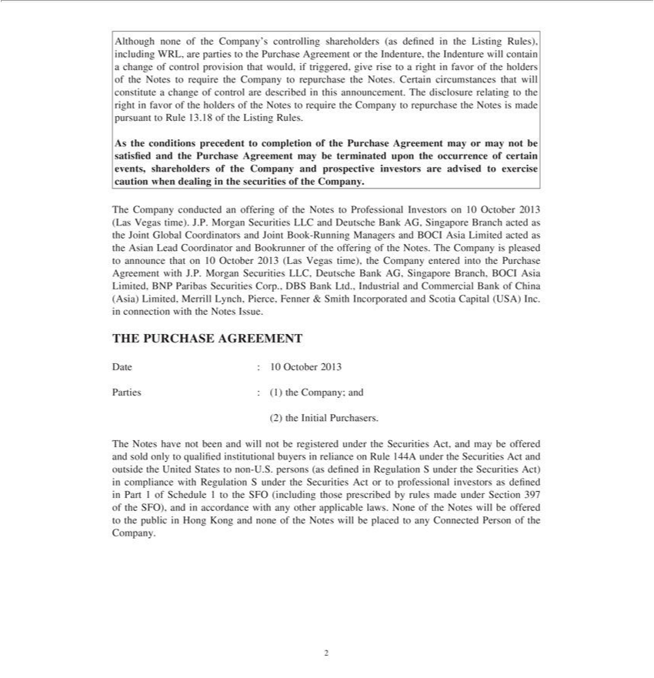

Although none of the Company’s controlling |  | (as defined in the Listing Rules), including WRL, are parties to the Purchase Agreement or the Indenture, the Indenture will contain a change of control
provision that would, if triggered, give rise to shareholdersrightfavor of the holders of the Notes to require the Company to repurchase the Notes. Certain circumstances that will constitute a change of control are
described in this announcement. The disclosure relating to the right in favor of the holders of the Notes to require the Company to repurchase the Notes is made pursuant to Rule 13.18 of the Listing Rules.
As the conditions precedent completion of the Purchase Agreement may or may not be satisfied and the Purchase Agreement may be terminated upon the occurrence of certain events, shareholders of the
Company and prospective investors are advised to exercise caution when dealing in the securities of the Company.
The Company conduc ed an offering of the Notes to Professional Investors on 10 October 2013 (Las Vegas time). J.P. Morgan Securities LLC and Deutsche Bank AG, Singapore Branch acted as the Joint Global
Coordinators and Joint Book-Running Managers and BOCI Asia Limited acted as the Asian Lead Coordinator and Bookrunner of the offering of the Notes. The Company is pleased to announce that on
10 October 2013 ( as Vegas time), the Company entered into the Purchase Agreement with J.P. Morgan Securities LLC, Deutsche Bank AG, Singapore Branch, BOCI Asia Limited, BNP Paribas Securities
Corp., DBS Bank Ltd., Industrial and Commercial Bank of China (Asia) Limited, Merrill Lynch, Pierce, Fenner & Smith Incorporated and Scotia Capital (USA) Inc. in connection with the Notes Issue.
THE PURCHASE AGREEMENT
Date : 10 October 2013
Parties : (1) the Company; and
(2) | the Initial Purchasers. |  | Rule 144A under the Securities Act and outside the
The Notes have not been and will not be registered under the Securities Act, and may be offered and sold only to qualified institutional buyers in reliance
United States to non-U.S. persons (as defined in Regulation under the Securities Act) in compliance with Regulation S under the Securities Act or to |  |  | as | in Part 1 of Schedule 1 to
 | SFO (including those prescribed by rules made under Section 397 of the SFO), and in accordance with any other applicable laws. None of the Notesprofessionalwillbeferedinvestorsthe publicdefinedHong Kong and none of
the Notes will be placed to any Connected Person of the Company.
2

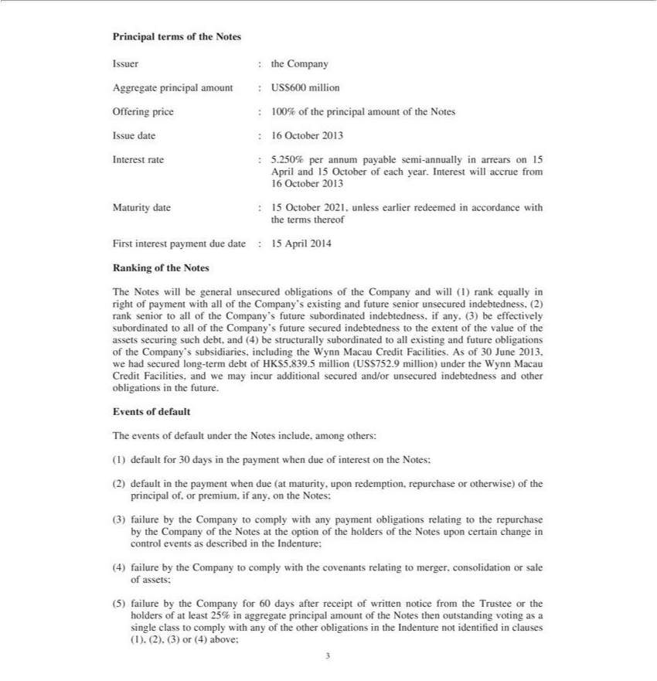

Principal terms of the Notes
Issuer : the Company
Aggregate principal amount : US$600 million
Offering price : 100% of the principal amount of the Notes
ssue date : 16 October 2013
Interest rate : 5.250% per annum payable semi-annually in arrears on 15
April and 15 October of each year. Interest will accrue from
16 October 2013
Maturity date : 15 October 2021, unless earlier redeemed in accordance with
the terms thereof
First interest payment due date : 15 April 2014
Ranking of the Notes
The Notes will be general unsecured obligations of the Company and will (1) rank equally in right of payment with all of the Company’ existing and future senior uns cured indebtedness, (2) rank senior to all
of the Company’ |  | future subordinated indebtedness, if any, (3) be effectively |  | to all of the Company’s future secured indebtedness to the extent of the value of the assets securing such debt, and
(4) be structurally subordinated to all existing and future obligations of the Company’subordinatedsubsidiaries, including the Wynn Macau Credit Facilities. As of 30 June 2013, we had secured long-term debt of
HK$5,839.5 million (US$752.9 million) under the Wynn Macau Credit Facilities, and we may incur additional secured and/or unsecured indebtedness and other obligations in the future.
Ev nts of default
The events of default under the Notes include, among others:
1) | for 30 days in the payment when due of interest the Notes;
2) default in the payment when due (at maturity, upon redemption, repurchase or otherwise) of the principal of, or premium, if any, the Notes;
(3) failure by the Company to comply with any payment obligations relating to the repurchase by the Company of the Notes at the option of the holders of the Notes upon certain change in control events as
described in the Indenture; |  |  | to comply with the covenants relating to merger, consolidation or sale of assets;
4)
(5) failure by the Company for 60 days after receipt of written notice from the Trustee or the holders of at least 25% in aggregate principal amount of the Notes then outstanding voting as a single class to comply with any of the other obligations in the Indenture not identified in clauses (1), (2), (3) or (4) above;

3

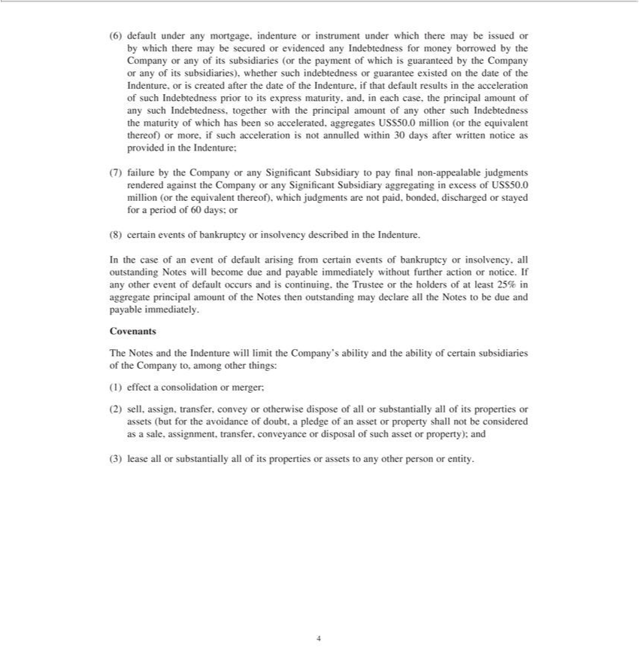

(6) default under any mortgage, indenture or instrument under which there may be issued or by which there may be secured or evidenced any Indebtedness for money |  |  |  |  | by the Company or any of its
subsidiaries (or the payment of which is guaranteed by the Company or any of its subsidiaries), whether such indebtedness or guarantee existed on the date of the Indenture,borrowedis created after the date of the
Indenture, if that default results in the acceleration of such Indebtedness prior to its express maturity, and, in each case, |  |  | principal amount of any such Indebtedness, together with the principal amount of any
other such Indebtedness the maturity of which has been so accelerated, aggregates US$50.0 million (or the equivalent thereof) or more, if such acceleration is not annulled within 30 days after written notice as
provided in the Indenture;
(7) failure by | Company or any Significant Subsidiary to pay final non-appealable judgments rendered against the Company or any Significant Subsidiary aggregating in excess of US$50.0 million (or the
equivalent thereof), which judgments are not paid, bonded, discharged or stayed for a period of 60 days; or
(8) c rtain events of bankruptcy or nsolvency described in the Indenture. |  |  |  | payable immediately without further action or notice. If any other event of
In the case of an event of default arising from certain events of bankruptcy or insolvency, all outstanding Notes will become due
default occurs and is continuing, the Trustee or the holders of at least 25% in aggregate principal amount of the Notes then outstanding may declare all the Notes to be due and payable immediately.
Covenants
The Notes and the Indenture will limit the Company’s ability and the ability of certain subsidiaries of the Company to, among other things:
1) effect consolidation or merger;
(2) sell, assign, transfer, |  | or otherwise dispose of all or substantially all of its properties or assets (but for the avoidance of doubt, a pledge of an asset or property shall not be considered as a sale,
assignment, transfer, conveyance or disposal of such asset or property); and
(3) lease all or substantially all of its properties or assets to any other person or entity.
4

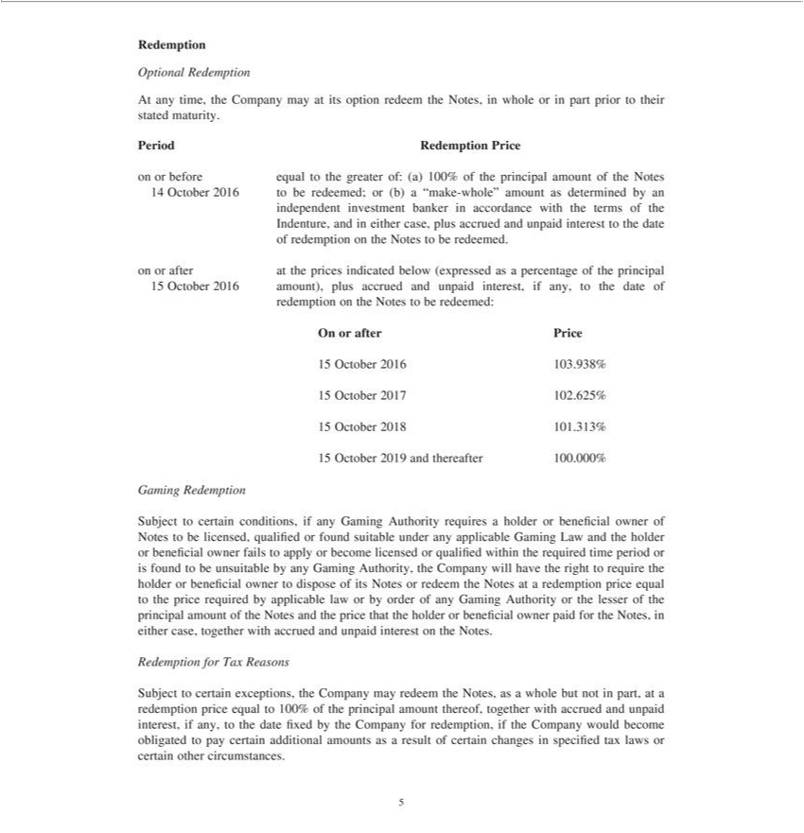

Redemption
Optional Redemption
At any time, the Company may at its option redeem the Notes, in whole or in part prior to their stated maturity.
Period Redemption Price
on or before equal to the greater of: (a) 100% of the principal amount of the Notes
14 October 2016 to be redeemed; or (b) “make-whole” amount as determined by an
independent | banker in accordance with the terms of the
Indenture, andinvestment case, plus accrued and unpaid interest to the date
f redemption on eitherNotes to be redeemed.
on or after at the prices indicated below (expressed as a percentage of the principal
15 October 2016 amount), plus accrued and unpaid interest, if any, to the date of
redemption on the Notes to be redeemed:
On or after Price | 3 938%
6 | 3 938%
7 | 2 625%
8 101.313%
15 October 2019
Gaming Redemptionand thereafter 100.000%

Subject to certain conditions, if any Gaming Authority requires a holder or beneficial owner of Notes to be licensed, qualified or found suitable under any applicable Gaming Law and the holder or beneficial ^{owner} fails to apply or become licensed or qualified within the required time period or is found to be unsuitable by any Gaming Authority, the Company will have the right to require the holder or beneficial
to dispose of its Notes or redeem the Notes at a redemption price equal _{together}theprice required by applicable law or by order of any Gaming Authority or the lesser of the principal amount of the Notes and
RedemptionthepricethatfortheTaxholderReasonsorbeneficial owner paid for the Notes, in either case, with accrued and unpaid interest on the Notes.

Subject to certain exceptions, the Company may redeem the Notes, as a whole but not in part, at a redemption price equal to 100% of the principal amount thereof, together with accrued and unpaid interest, if any, to the date fixed by the Company for redemption, if the Company would become obligated to pay certain additional amounts as a result of certain changes in specifid tax laws or certain other circumstances. 5

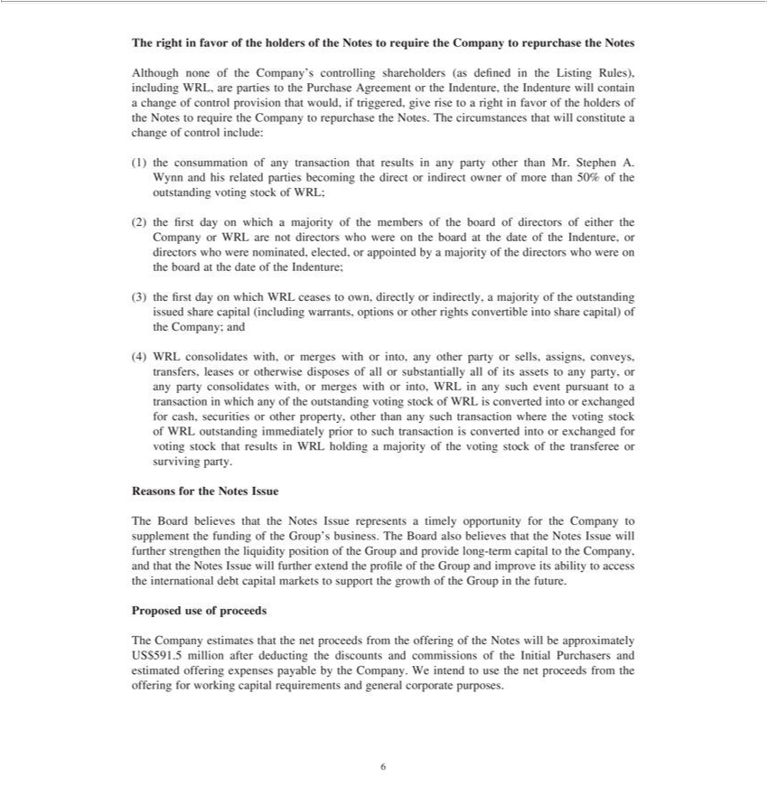

The right in favor of the holders of the Notes to require the Company to repurchase the Notes
Although none of the Company’s controlling |  | (as defined in the Listing Rules), including WRL, are parties to the Purchase Agreement or he Indenture, the Indenture will contain a change of control
provision that would, if triggered, give rise to shareholdersrightinfavor of the holders of the Notes to require the Company to repurchase the Notes. The circumstances that will constitute a change of control include:
(1) the consummation of any transaction that results in any party other than Mr. Stephen A. Wynn and his related parties becoming the direct or indirect owner of more than 50% of the outstanding voting stock
of WRL;
(2) the first day on which majority of the members of the board of directors of either the Company or WRL are not directors who were on the board at the date of the Indenture, or directors who were
nominated, elected, or appointed by | majority of the |  | who were on the board at the date of the Indenture;
(3) the first day on which WRL ceases to own, directlydirectorsindirectly, a majority of the outstanding issued share capital (including warrants, options or other rights convertible into share capital) of the Company;
and |  |  | or sells, assigns, conveys, transfers, leases or otherwise disposes of all or substantially all of its assets to any party, | any party consolidates
(4) WRL consolidates with, or merges with or into, any other |  |  |  | any party consolidates
any such transaction where the voting stock of WRL outstanding immediately prior to such transaction is converted into or exchanged for voting stock that results in WRL holding a majority of the voting stock
with, or merges with or into, WRL | any such event pursuantpartytotransaction in which any of the outstanding voting stock of WRL is converted into or exchanged for cash, securities |  |  | other property, other than
ReasonsofthetransfereefortheNotesorsurvivingIssue party.

The Board believes that the Notes Issue represents a timely opportunity for the Company to supplement the funding of the Group’s business. The Board also believes that the Notes Issue will further strengthen the liquidity position of the Group and provide long-term capital to the Company, and that the Notes Issue will further extend the profile of the Group and improve its ability to access the international debt capital markets to support the growth of the Group in the future.
Proposed use of proceeds

The Company estimates that the net proceeds from the offering of the Notes will be approximately US$591.5 million after deducting the discounts and commissions of the Initial Purchasers and estimated offering expenses payable by the Company. We intend to use the net proceeds from the offering for working capital requirements and general corporate purposes.

6

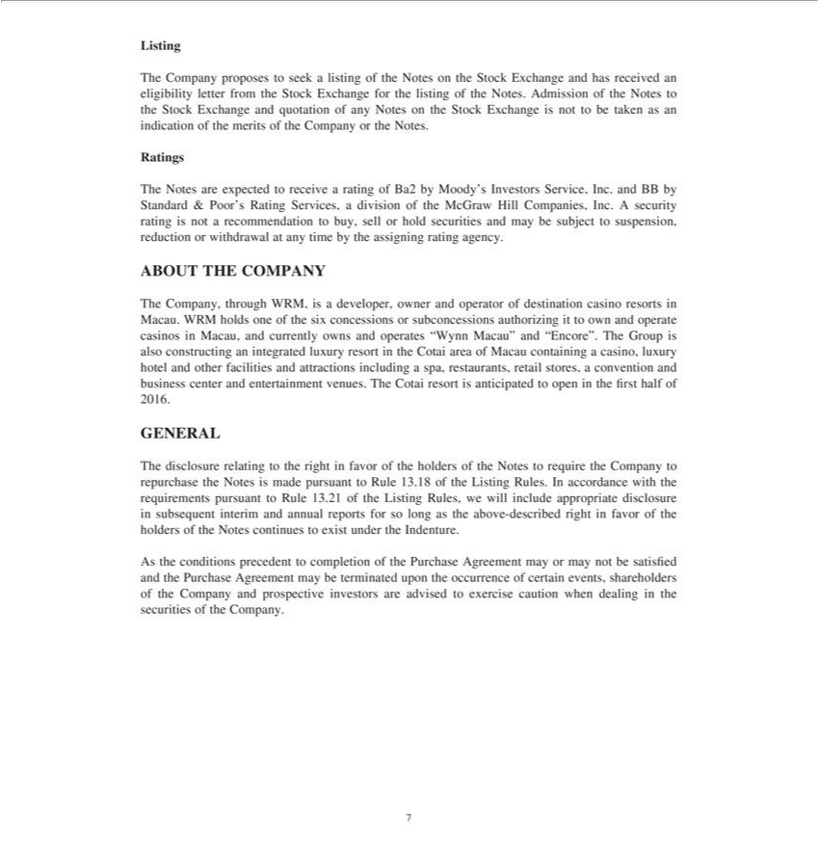

Listing
The Company proposes to seek a listing of the Notes on the Stock Exchange and has received an eligibility letter from the Stock Exchange for the listing of the Notes. Admission of the Notes to the Stock
Exchange and quotation of any Notes on the Stock Exchange is not to be taken as an indication of the merits of the Company or the Notes.
Ratings |  | Service, Inc. and BB by Standard & Poor’s Rating Services, a division of the McGraw Hill Companies, Inc. A security rating is not a
The Notes are expected to receive a rating of Ba2 by Moody’
recommendation to buy, sell or hold securities and may be subjectInvestorssuspension, reduction or withdrawal at any time by the assigning rating agency.
ABOUT THE COMPANY
The Company, through WRM, is developer, owner and operator of destination casino resorts Macau. WRM holds one of the six concessions or subconcessions authorizing it to own and operate casinos in
Macau, and currently owns and operates “Wynn Macau” and “Encore”. The Group is also constructing an integrated luxury resort in the Cotai area of Macau containing casino, luxury hotel and other facilities
and attractions including a spa, restaurants, retail stores, a convention and business center and entertainment venues. The Cotai resort is anticipated to open in the first half of 2016.
GENERAL | right in favor of the holders of the Notes to require the Company to repurchase the Notes is made pursuant to Rule 13.18 of the Listing Rules. In accordance with the requirements
The disclosure relating to
pursuant to Rule 13.21 of the Listing Rules, we will include appropriate disclosure in subsequent interim and annual reports for so long as the above-described right in favor of the holders of the Notes continues
to exist under the Indenture. | completion of the Purchase Agreement may or may not be satisfied and the Purchase Agreement may be terminated upon the occurrence of certain events, shareholders of the
As the conditions precedent
investors
7Company and prospective are advised to exercise caution when dealing in the securities of the Company.

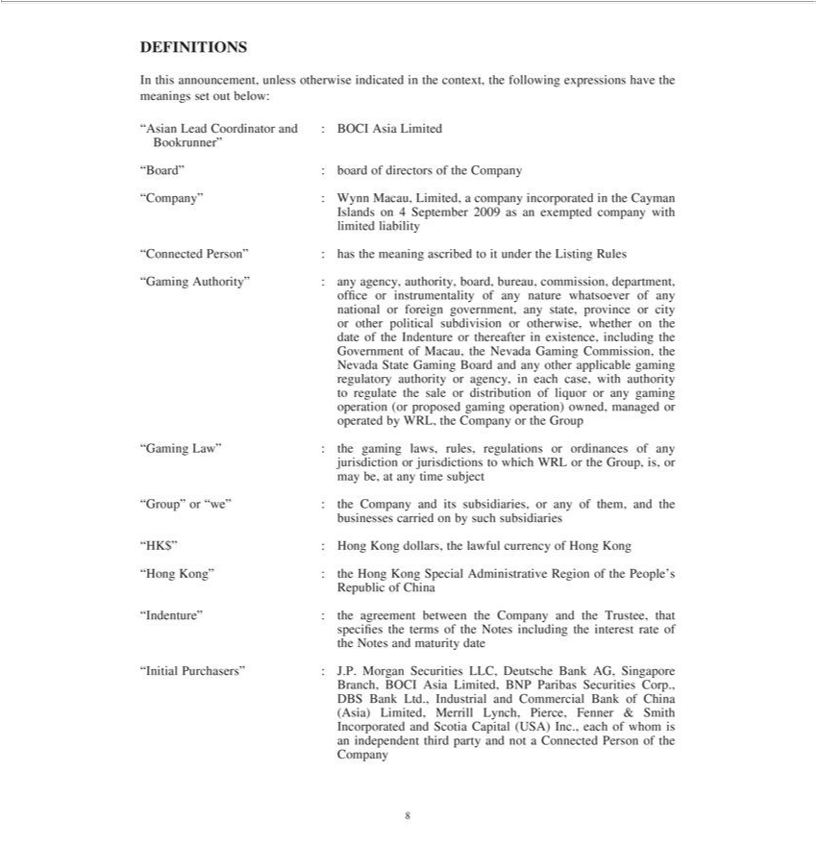

DEFINITIONS
In this announcement, unless otherwise indicated in the context, the following expressions have the meanings set out below:
“Asian Lead Coordinator and : BOCI Asia Limited
Bookrunner”ard” : board of directors of the
“Company” : Wynn Macau, Limited,Companycompany incorporated in the Cayman
Islands on 4 September 2009 as an exempted company with
limited liability
Connected Person” : has the meaning ascribed to it under the Listing Rules
“Gaming Authority” : any agency, authority, board, bureau, commission, department,
office or instrumentality of any nature whatsoever of any
national or foreign government, any state, province or city
or other political subdivision or otherwise, whether on the
date of the Indenture or thereafter in existence, including the
Government of Macau, the Nevada Gaming Commission, the
Nevada State Gaming Board and any other applicable gaming
authority or agency, in each case, with authority
regulatoryregulate the sale or distribution of liquor or any gaming
ion (or proposed ga ing operation) owned, managed or
operated by WRL, the Company or the Group | of any
“Gaming Law” : the gaming laws, rules, regulations or | of any
ordinances
mayjurisdictionbe,atanyor jurisdictionstimesubject to which WRL or the Group, is,
businesses“Group”orcarried“we”: onthebyCompanysuchsubsidiariesanditssubsidiaries, or any of them, and the
_{“Hong}K$” : Hong Kong dollars, the lawful currency of Hong Kong
Kong” : the Hong Kong Special Administrative Region of the People’s
Republic of China
specifies“Indenture”the:termstheagreementoftheNotesbetweenincludingtheCompanytheinterestandratetheofTrustee, that
the Notes and maturity date
“Initial Purchasers” : J.P. Morgan Securities LLC, Deutsche Bank AG, Singapore
Branch, BOCI Asia Limited, BNP Paribas Securities Corp.,
DBS Bank Ltd., Industrial and Commercial Bank of China
(Asia) Limited, Merrill Lynch, Pierce, Fenner & Smith
_{Company}IncorporatedindependentandthirdScotiapartyCapitalandnot(USA)aConnectedInc.,eachPersonofwhomoftheis
8

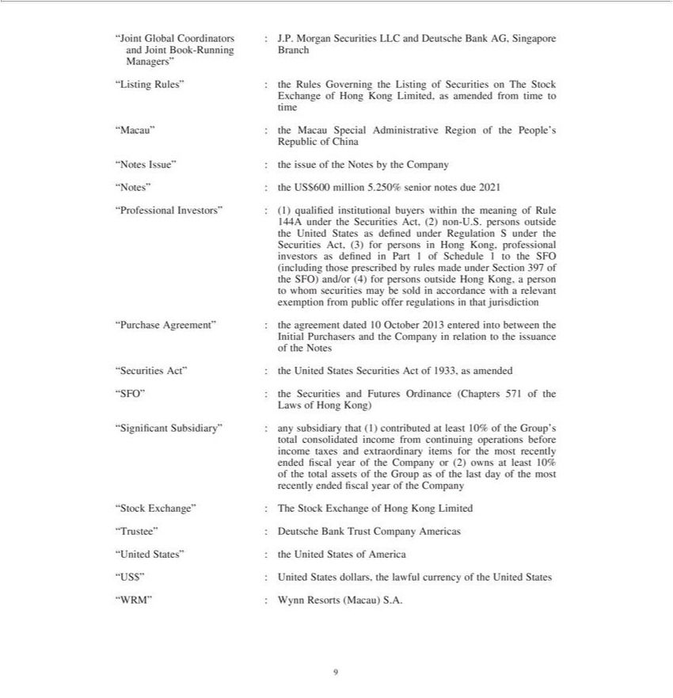

and“JointJointGlobalBookCoordinators-RunningBranch:J.P. Morgan Securities LLC and Deutsche Bank AG, Singapore
Managers”
Exchange“ListingRules”ofHong:theKongRulesLimited,GoverningasamendedtheListingfromof timeSecuritiesto on The Stock
time
Republic“Macau” :oftheChinaMacau Special Administrative Region of the People’s
_{“ProfessionalNotes”}Issue”:theUS:the$600issuemillionofthe5.250%NotesbyseniortheCompanynotesdue 2021
144A under_{States}heInvestors”Securities: (1)Act,qualified(2)non-institutionalU.S.personsbuyersoutsidewithin the meaning of Rule
the United as defined under Regulation S under the
investorsSecuritiesasAct,defined(3)forinpersonsPart1ofinScheduleHongKong,1to professionaltheSFO
^{to}(includingheSFO)and/orthose (4)prescribedforpersonsbyrulesoutsidemadeHongunderKong,Sectionaperson397of
exemptionwhomsecuritiesfrompublicmayofferbesoldregulationsinaccordanceinthatwithjurisdictionarelevant
Initial“PurchasePurchasersAgreement”andthe:theCompanyagreementinrelationdated10toOctobertheissuance2013 entered into between the
of the Notes
_{“SFO”}ecurities Act”_{Securities}:theUnited States Securities Act of 1933, as amended
Laws of: Hongthe Kong) and Futures Ordinance (Chapters 571 of the
total“SignificantconsolidatedSubsidiary”income: fromanysubsidiarycontinuingthatoperations(1)contributedbefore at least 10% of the Group’s
income taxes and extraordinary items for the most recently
ofendedthe totalfiscalassetsyear ofof thethe_{year}CompanyGroupas ofor the(2) lastownsdayat ofleastthe10%most
recently ended fiscal of the Company
^{T}
Stockrustee”^{nited}Exchange”:Deutsche:TheBankStockTrustExchangeCompanyofAmericasHongKong Limited
^{US$”} States” : the United States of America
^{“WRM”}: United States dollars, the lawful currency of the United States
₉ : Wynn Resorts (Macau) S.A.

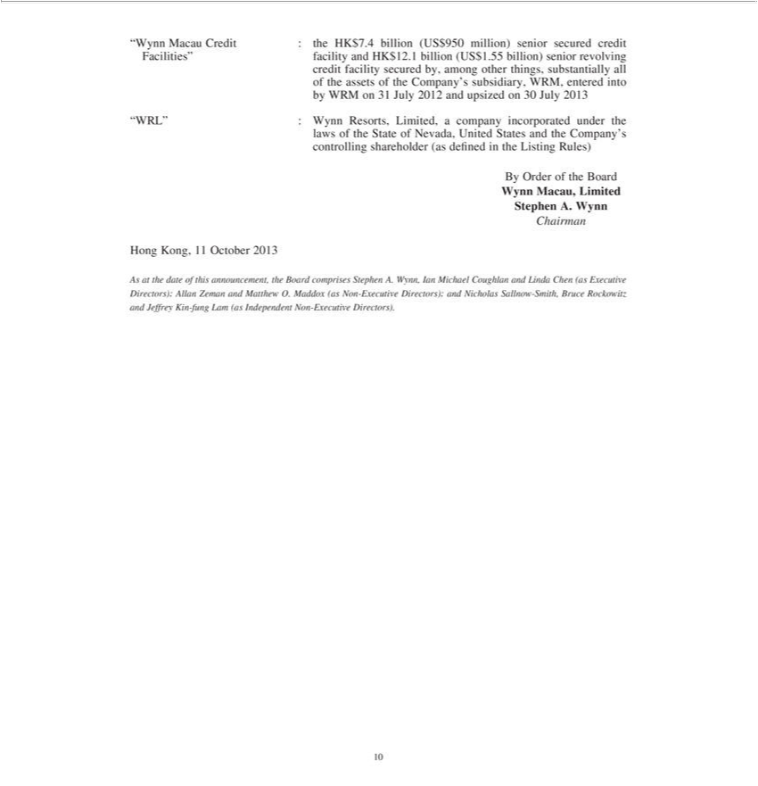

“Wynn Macau Credit : the HK$7.4 billion (US$950 million) senior secured credit
creditFacilities”facilityfacilitysecuredand by,HKamong$12.1 billionother_{things,}(US$1.55substantiallybillion)seniorall revolving
byof theWRMassetson of31theJulyCompany’s2012and upsizedsubsidiaryon 30WRM,July entered2013 into
“WRL” : Wynn Resorts, Limited, a company incorporated under the
controllinglawsofthe StateshareholderofNevada,(asdefinedUnitedinStatestheListingandtheRules)Company’s
By Order of the Board
Wynn Macau, Limited
Stephen A. Wynn
Chairman
Hong Kong, 11 October 2013
As at the date of this announcement, the Board comprises Stephen A. Wynn, Ian Michael Coughlan and Linda Chen (as Executive Directors); Allan Zeman and Matthew O. Maddox (as Non-Executive Directors); and Nicholas Sallnow-Smith, Bruce Rockowitz and Jeffrey Kin-fung Lam (as Independent Non-Executive Directors).
10

Exhibit 99.2

Wynn Resorts Announces Pricing of Private Offering of $600.0 Million Aggregate Principal Amount of Wynn Macau, Limited 5.25% Senior Notes Due 2021

LAS VEGAS – October 10, 2013 – Wynn Resorts, Limited (NASDAQ: WYNN) announced today the pricing by Wynn Macau, Limited (the “Issuer”), a majority-owned subsidiary of Wynn Resorts, Limited, of $600.0 million aggregate principal amount of 5.25% Senior Notes due 2021 (the “Notes”). The Notes will be issued at par. Wynn Macau, Limited plans to use the net proceeds from the offering for working capital requirements and general corporate purposes.

The Issuer will make the offering pursuant to an exemption under the Securities Act of 1933, as amended (the “Securities Act”). The initial purchasers of the Notes will offer the Notes only to qualified institutional buyers in reliance on Rule 144A under the Securities Act or outside the United States to certain persons in reliance on Regulation S under the Securities Act. The Notes have not been and will not be registered under the Securities Act or under any state securities laws. Therefore, the Issuer may not offer or sell the Notes within the United States to, or for the account or benefit of, any United States person unless the offer or sale would qualify for a registration exemption from the Securities Act and applicable state securities laws.

This press release does not constitute an offer to sell or a solicitation of an offer to buy the Notes described in this press release, nor shall there be any sale of the Notes in any state or jurisdiction in which such an offer, sale or solicitation would be unlawful prior to registration or qualification under the securities laws of any such jurisdiction.

Forward-Looking Statements

This release contains forward-looking statements, including those related to the offering of Notes and whether or not the Issuer will consummate the offering. Forward-looking information involves important risks and uncertainties that could significantly affect anticipated results in the future and, accordingly, such results may differ from those expressed in any forward-looking statements. These risks and uncertainties include, but are not limited to, competition in the casino/hotel and resorts industries, the Issuer’s dependence on existing management, levels of travel, leisure and casino spending, general domestic or international economic conditions, and changes in gaming laws or regulations. Additional information concerning potential factors that could affect the Issuer’s financial results is included in Wynn Macau, Limited’s annual report for the year ended December 31, 2012, interim report for the six months ended June 30, 2013 and its other reports filed with the Stock Exchange of Hong Kong Limited, and Wynn Resorts, Limited’s periodic reports filed with the Securities and Exchange Commission. Neither Wynn Resorts, Limited nor the Issuer are under any obligation to (and expressly disclaim any such obligation to) update their forward-looking statements as a result of new information, future events or otherwise, except as required by law.

Source: Wynn Resorts, Limited

Wynn Resorts, Limited

Lewis Fanger, Vice President

702-770-7555

investorrelations@wynnresorts.com

