UNITED STATES
SECURITIES AND EXCHANGE COMMISSION
Washington, D.C. 20549

FORM 8-K

CURRENT REPORT
PURSUANT TO SECTION 13 OR 15(d)
OF THE SECURITIES EXCHANGE ACT OF 1934
Date of Report (Date of earliest event reported): July 21, 2026

WYNN RESORTS, LIMITED
(Exact name of registrant as specified in its charter)

Nevada |  |  |  |  |  | 000-50028 |  |  | 46-0484987
(State or other jurisdiction  of incorporation) |  |  |  |  |  | (Commission  File Number) |  |  | (I.R.S. Employer  Identification No.)
3131 Las Vegas Boulevard South
Las Vegas, |  |  | Nevada |  |  |  |  |  | 89109
(Address of principal executive offices) |  |  |  |  |  |  |  |  | (Zip Code)

(702) 770-7555
(Registrant’s telephone number, including area code)
Not Applicable
(Former name or former address, if changed since last report)

Securities registered pursuant to Section 12(b) of the Act:
Title of each class |  |  |  |  |  | Trading Symbol(s) |  |  |  |  |  | Name of each exchange on which registered
Common stock, par value $0.01 |  |  |  |  |  | WYNN |  |  |  |  |  | Nasdaq Global Select Market

Check the appropriate box below if the Form 8-K filing is intended to simultaneously satisfy the filing obligation of the registrant under any of the following provisions:
☐ Written communications pursuant to Rule 425 under the Securities Act (17 CFR 230.425)
☐ Soliciting material pursuant to Rule 14a-12 under the Exchange Act (17 CFR 240.14a-12)
☐ Pre-commencement communications pursuant to Rule 14d-2(b) under the Exchange Act (17 CFR 240.14d-2(b))
☐ Pre-commencement communications pursuant to Rule 13e-4(c) under the Exchange Act (17 CFR 240.13e-4(c))
Indicate by check mark whether the registrant is an emerging growth company as defined in Rule 405 of the Securities Act of 1933 (§230.405 of this chapter) or Rule 12b-2 of the Securities Exchange Act of 1934 (§240.12b-2 of this chapter).
Emerging growth company ☐
If an emerging growth company, indicate by check mark if the registrant has elected not to use the extended transition period for complying with any new or revised financial accounting standards provided pursuant to Section 13(a) of the Exchange Act. ☐

Item 1.01 |  |  | Entry into a Material Definitive Agreement.

On July 21, 2026 (July 22, 2026 Hong Kong time), the Macau Special Administrative Region of the People’s Republic of China (the “Macau Government”) published in the Official Gazette of Macau an amended and restated land concession contract accepted by Palo Real Estate Company Limited ("Palo") and Wynn Resorts (Macau) S.A. ("Wynn Macau"), each an indirect subsidiary of Wynn Resorts, Limited (the "Registrant") (the “Amended Land Concession Contract”). The Amended Land Concession Contract amends and restates the original land concession contract among Palo, Wynn Macau and the Macau Government published in the Official Gazette of Macau on May 2, 2012 (the “Land Concession Contract”).

Pursuant to the Land Concession Contract, Palo leases 51 acres of land in the Cotai area of Macau (the “Cotai Land”) from the Macau Government for an initial term of 25 years from May 2, 2012 until May 1, 2037, with the right to renew for additional periods, subject to applicable legislation. The Land Concession Contract also requires that Wynn Macau, as a gaming concessionaire, operate and manage gaming operations on the Cotai Land.

The Amended Land Concession Contract permits Palo and Wynn Macau to expand Wynn Palace to develop a new five-star hotel, a theater and an event and entertainment center on the Cotai Land (the “Expanded Resort”). The Macau Government has allocated Palo a maximum of 60 months from the date of publication of the Amended Land Concession Contract to complete development of the Expanded Resort on the Cotai Land. Palo is required to pay the Macau Government an additional land premium of MOP652.3 million (approximately $80.8 million) as a one-time lump sum payment upon Palo’s acceptance of the conditions of the Amended Land Concession Contract. Palo is also required to pay an additional annual rent to the Macau Government, resulting in a total annual rent of MOP9.5 million (approximately $1.2 million) for the Expanded Resort. The rent for the Expanded Resort may be reviewed by the Macau Government every five years since the date of publication of the Amended Land Concession Contract. Palo must also provide the Macau Government with an additional guarantee by means of a deposit or bank guarantee for an amount equal to the annual rent payable under the Amended Land Concession Contract.

Item 7.01 |  |  | Regulation FD Disclosure.

On July 21, 2026 (July 22, 2026 Hong Kong time), Wynn Macau, Limited ("WML"), an indirect subsidiary of the Registrant with its ordinary shares of common stock listed on The Stock Exchange of Hong Kong Limited (the "HKSE"), filed with the HKSE an announcement that the Macau Government published the Amended Land Concession Contract in the Official Gazette of Macau (the "Announcement"). The Announcement is furnished herewith as Exhibit 99.1.

The information furnished pursuant to this Item 7.01 (including Exhibit 99.1) shall not be deemed "filed" for purposes of Section 18 of the Securities Exchange Act of 1934, as amended (the “Exchange Act”), or otherwise subject to liabilities of that section, nor shall it be deemed incorporated by reference in any filing under the Securities Act of 1933, as amended, or the Exchange Act, except as shall be expressly set forth by specific reference in such filing.

Item 9.01 |  |  | Financial Statements and Exhibits.

(d)Exhibits.
Exhibit No. |  |  | Description
10.1 |  |  | First Amendment to the Land Concession Contract, published on July 22, 2026, by and among Palo Real Estate Company Limited, Wynn Resorts (Macau), S.A. and the Macau Special Administrative Region of the People's Republic of China (translated to English from traditional Chinese and Portuguese).
99.1 |  |  | Announcement of Wynn Macau, Limited with respect to the Amended Land Concession Contract.
104 |  |  | Cover Page Interactive Data File - the cover page XBRL tags are embedded within the Inline XBRL document

SIGNATURES
Pursuant to the requirements of the Securities Exchange Act of 1934, the Registrant has duly caused this report to be signed on its behalf by the undersigned hereunto duly authorized.
 |  |  |  |  |  |  |  |  |  |  |  | WYNN RESORTS, LIMITED
Dated: July 22, 2026 |  |  |  |  |  | By: |  |  |  |  |  | /s/ Craig J. Fullalove
 |  |  |  |  |  |  |  |  |  |  |  | Craig J. Fullalove
 |  |  |  |  |  |  |  |  |  |  |  | Chief Financial Officer

Exhibit 10.1

(English Translation)
(File no. 6463.05 of the Land and Urban Construction Bureau and
File no. 12/2026 of the Lands Committee)

Contract agreed between:
The Macau Special Administrative Region, as first signatory ("Party A");
Palo Real Estate Company Limited, as second signatory ("Party B"); and
Wynn Resorts (Macau) S.A., as third signatory ("Party C").
Whereas:
1.By Order of the Secretary for Transport and Public Works no. 16/2012, published in the Official Gazette of the Macau Special Administrative Region No. 18, Series II, of May 2, 2012, the contract for the concession, by lease and with exemption of public tender, of a plot of land with an area of 205,797 m², situated in the reclaimed zone of Cotai, at Avenida do Aeroporto Nos. 1163 to 1409, Avenida da Nave Desportiva Nos. 858 to 1160, Rua da Patinagem Nos. 791 to 1021, and Avenida Dr. Henry Fok Nos. 640 to 730, described at the Land Registry under No. 23305, was granted to Palo Real Estate Company Limited, a subsidiary of Wynn Resorts (Macau) S.A., the holder of a concession for the operations of casino games of fortune in the Macau Special Administrative Region, with its registered office at Ground Floor, Wynn Palace, Avenida da Nave Desportiva, Cotai, Macau, and registered at the Commercial and Movable Property Registry under No. 27319 (SO), whose rights deriving from the concession are registered under No. 33218F.

2.Given that the contract for the concession for the operations of casino games of fortune initially entered into between Wynn Resorts (Macau) S.A. and the Macau Special Administrative Region expired on December 31, 2022, and for the purpose of complying with the provisions of Law No. 16/2001 (Legal Framework for the Operations of Casino Games of Fortune), as amended by Law No. 7/2022, the Macau Special Administrative Region acquired, by reversion, a share of 83.9/1000 of the aforesaid urban property, whose right is registered at the Land Registry under No. 398158G.

3.Given that Palo Real Estate Company Limited intends, jointly with Wynn Resorts (Macau) S.A., to construct a theater and an event center in the vacant areas of the concessioned land, it submitted, on October 6, 2023, to the Land and Urban Construction Bureau, hereinafter referred to as the DSSCU, an application for authorization to partially amend the concession and modify the use of the land, together with the development plan and the preliminary study.

4.Subsequently, on January 17, 2025, a new preliminary study was submitted, providing for the expansion of the Wynn Palace complex and the construction of a new hotel tower.

1

5.The preliminary studies were submitted for consultation to the competent subunits of the DSSCU and to the competent entities of the Macau Special Administrative Region, in particular the Financial Services Bureau and the Gaming Inspection and Coordination Bureau. These entities indicated that they had no objection to the application, provided that the casino area remains unchanged.

6.In view of the opinions issued, the DSSCU considered that the application satisfies the conditions for approval, since the proposed expansion project does not conflict with the grounds upon which the exemption from public tender was originally granted and is conducive to the development of the Macau Special Administrative Region's diversified tourism offerings.

7.Given that the Macau Special Administrative Region is also a holder of rights deriving from the land concession, it is exempt from payment of the respective portion of the premium payable for the revision of the concession.

8.After all documents required for the processing of the case had been received, the DSSCU calculated the compensation due and prepared the draft contract for the revision of the concession.

9.The plot of land that is the object of this contract, with an area of 205,797 m², is demarcated and identified in cadastral plan No. 6958/2011, issued by the Cartography and Cadastre Bureau, hereinafter referred to as the DSCC, on November 27, 2025.

10.Following its normal procedure, the case file was submitted to the Lands Committee, which, at its meeting held on June 25, 2026, issued a favorable opinion approving the application.

11.By an order dated June 26, 2026, issued by the Secretary for Transport and Public Works in the exercise of the executive powers delegated under paragraph 1 of Executive Order No. 95/2024, the application for the revision of the concession was approved in accordance with the suggestions set out in the opinion of the Lands Committee.

12.The conditions of the contract for the revision of the concession titled by this order were notified to the applicant companies and were expressly accepted by them through declarations submitted on July 8, 2026, signed by Chen Chih Ling Linda, with professional address in Macau, at Avenida da Nave Desportiva, Wynn Palace, Cotai, in the capacity of director and representing Palo Real Estate Company Limited and Wynn Resorts (Macau) S.A., whose capacity and powers were verified by the private notary Nuno Simões, in accordance with the recognition endorsed on those declarations.

13.The concessionaire has paid the additional premium stipulated in Clause Seven of the contract titled by this order.

Clause One – Object of the contract

1.By reason of the alteration of the development of the Land, consisting of the extension of the building, the object of the present contract is to revise the concession of a plot of Land, granted by lease, titled by Order of the Secretary for Transport and Public Works No. 16/2012,
2

published in Series II of the Official Gazette of the Macau Special Administrative Region No. 18 of May 2, 2012, with an area of 205,797 (two hundred and five thousand, seven hundred and ninety-seven) square meters, situated in the reclaimed zone of Cotai, at Avenida do Aeroporto Nos. 1163 to 1409, Avenida da Nave Desportiva Nos. 858 to 1160, Rua da Patinagem Nos. 791 to 1021, and Avenida Dr. Henry Fok Nos. 640 to 730, demarcated and indicated in cadastral plan No. 6958/2011, issued by the Cartography and Cadastre Bureau on November 27, 2025, and registered at the Land Registry under No. 23305, and the rights arising from the concession thereof are registered in the names of Party A and Party B under Nos. 398158G and 33218F, respectively.

2.In view of this revision, the Land referred to in the preceding paragraph, hereinafter referred to simply as the Land, shall be governed by the clauses of the present contract.

Clause Two – Term of the lease

1.The lease is valid until May 1, 2037.

2.The term of the lease fixed in the preceding paragraph may, pursuant to the applicable legislation, be successively renewed.

Clause Three – Development and purpose of the concession

1.In accordance with the permitted uses of the Land, in particular the tourism and entertainment use, the Land is developed with the construction of a complex comprising a five-star hotel (including gaming areas, convention center, commercial areas, food and beverage areas, SPA, nightclub, theater, and events center), car park, and open area, with the following gross construction areas:
1)Five-star hotel ................................................ 534,105 square meters;
2)Car park ......................................................... 69,467 square meters;
3)International Spectacle Theater ..................... 8,787 square meters;
4)Events and Activities Centre ......................... 23,738 square meters;
5)Open area ...................................................... 93,904 square meters.

2.The areas referred to in the preceding paragraph may be modified at the time of the application for the inspection of the works, for the purpose of issuing the utilization permit.

3.The second signatory shall comply with the urban planning regulations in force in the zone where the Land is located.

4.Given the particular characteristics of the development of the Land, the gross construction areas allocated to the gaming areas, integrated within the gross construction area designated for the purpose of "Five-star hotel", shall be operated by Wynn Resorts (Macau) S.A. in its capacity as third signatory of this contract and as holder of a concession for the operation of games of fortune or chance or other games in casinos in the Macau Special Administrative Region.
3

Clause Four – Rent
1.The second signatory pays an annual rent in the following manner:
1)Five-star hotel (excluding the casino with an area of 43,519.39 square meters): MOP$15.00 (fifteen patacas) per square meter of gross construction area;
2)Car park: MOP$10.00 (ten patacas) per square meter of gross construction area;
3)International Spectacle Theater: MOP$15.00 (fifteen patacas) per square meter of gross construction area;
4)Events and Activities Centre: MOP$15.00 (fifteen patacas) per square meter of gross construction area;
5)Open area: MOP$10.00 (ten patacas) per square meter of area.

2.Rent shall be revised every five years, counted from the date of publication in the Official Gazette of the Macau Special Administrative Region of the order that titles this revision, without prejudice to the immediate application of new rent amounts established by legislation that may be published during the term of the contract.

Clause Five – Period of development

1.The total period for the alteration of the development of the Land is 60 (sixty) months, counted from the date of publication in the Official Gazette of the Macau Special Administrative Region of the order that titles this revision.

2.The period referred to in the preceding paragraph includes the time for the submission by the second signatory, and the time for the assessment by the first signatory, of the construction project and for the issuance of the respective permits.

3.The second signatory shall observe the following periods:
1)Within 180 (one hundred and eighty) days counted from the date of publication of the order referred to in paragraph 1, prepare and submit the construction project (foundations, structures, water supply, drainage, electricity supply, and other specialty projects);
2)Within 60 (sixty) days counted from the date of notification of the approval of the construction project, submit the application for the issuance of the works permit;
3)Commence works within 30 (thirty) days after the issuance of the works permit.

4.For the purposes of the preceding paragraph, projects shall only be deemed effectively submitted when completely and properly accompanied by all requisite documentation.

5.Where, for reasons not attributable to the second signatory and considered sufficient by the first signatory, upon application by the second signatory, the first signatory may approve the suspension or extension of any of the periods referred to in this clause.

6.The application referred to in the preceding paragraph must be submitted before the expiry of the relevant period.

4

Clause Six – Penalties

1.For failure by the second signatory to comply with any of the periods established in Clause Five, a penalty shall be imposed for each day of delay in an amount equivalent to 0.1% (zero point one percent) of the additional premium established in Clause Seven of the present contract, up to a maximum of 150 (one hundred and fifty) days.

2.Where the suspension or extension of the period of development is approved for reasons not attributable to the second signatory and considered sufficient by the first signatory, the second signatory shall be exonerated from the liability referred to in the preceding paragraph.

Clause Seven – Additional premium

By reason of the present revision of the concession contract, when the second signatory accepts the conditions of the present contract in accordance with Article 125 of Law No. 10/2013, it shall pay to the first signatory, in a single lump sum, an additional contract premium in the amount of MOP$652,305,500.00 (six hundred and fifty-two million, three hundred and five thousand, five hundred patacas).

Clause Eight – Security deposit

1.Without prejudice to the payment of MOP$6,173,910.00 (six million, one hundred and seventy-three thousand, nine hundred and ten patacas) in accordance with the conditions established in Clause Seven of the concession contract titled by Order of the Secretary for Transport and Public Works No. 16/2012, published in Series II of the Official Gazette of the Macau Special Administrative Region No. 18 of May 2, 2012, pursuant to Article 126 of Law No. 10/2013, the second signatory shall provide an additional security deposit in the amount of MOP$ 9,480,370.00 (nine million, four hundred and eighty thousand, three hundred and seventy patacas), by means of deposit or bank guarantee accepted by the first signatory.

2.The amount of the security deposit referred to in the preceding paragraph shall accompany the value of the respective annual rent.

3.The security deposit referred to in paragraph 1 shall be returned to the second signatory by the Financial Services Bureau, upon its request, after presentation of the utilization permit issued by the Land and Urban Construction Bureau.

Clause Nine – Transfer

1.Given the nature of the concession, the transfer of any situation arising from this concession requires prior authorization from the first signatory, failing which the transfer shall be null and void and of no effect, without prejudice to the provisions of Clause Thirteen.

5

2.For the purposes of the preceding paragraph, the following shall also be deemed a transfer of the situations arising from the concession:
1)The transfer, in one or more transactions cumulatively, of more than 50% (fifty percent) of the share capital of the second signatory or of its controlling shareholder;
2)The granting of irrevocable powers of attorney or sub-powers of attorney, pursuant to Article 258(3) of the Civil Code, without the consent of the interested parties, where such powers of attorney confer upon the attorney the power to dispose of the situations arising from the concession or to carry out all acts in the proceedings.

3.Without prejudice to the provisions of the preceding paragraph, if the second signatory transfers more than 10% (ten percent) of its share capital or that of its controlling shareholder, it shall notify the Land and Urban Construction Bureau within 30 (thirty) days after the occurrence of such transfer, failing which, upon the first breach, a penalty equivalent to 1% (one percent) of the total premium amount of MOP$2,091,081,810.00 (two billion, ninety-one million, eighty-one thousand, eight hundred and ten patacas), determined by the concession contract titled by Order of the Secretary for Transport and Public Works No. 16/2012, published in Series II of the Official Gazette of the Macau Special Administrative Region No. 18 of May 2, 2012, as set out in Clause Nine thereof, together with the additional premium established in Clause Seven of the present contract, shall be imposed, and upon the second breach, the concession shall be rescinded.

4.The transferee shall be bound by the conditions of this contract as revised, in particular regarding the period of development and the payment of the additional premium.

5.Prior to the completion of the alteration of the development, pursuant to Article 42(5) of Law No. 10/2013, the second signatory may only create a voluntary mortgage over the rights arising from the concession in favor of credit institutions duly authorized to operate in the Macau Special Administrative Region.

6.Any mortgage created in breach of the preceding paragraph shall be null and void.

Clause Ten – Utilization permit

The utilization permit shall only be issued upon fulfilment of the obligations established in Clause Three, as well as upon payment of any outstanding penalties.

Clause Eleven – Supervision

During the period of development of the Land granted, the second signatory is obliged to allow access to the Land and to the works by representatives of the relevant government departments in the performance of their supervisory functions, and to provide them with all necessary assistance for the effective performance of their duties.

Clause Twelve – Lapse

1.The present concession shall lapse in the following cases:
6

1)Failure to complete the alteration of the development works (extension works) after the expiry of the 150 (one hundred and fifty) day period established in paragraph 1 of Clause Six, regardless of whether penalties have previously been imposed;
2)Interruption of the alteration of the development of the Land for more than 90 (ninety) days, whether continuous or intermittent, except for reasons not attributable to the second signatory and considered sufficient by the first signatory.

2.The lapse of the concession shall be declared by order of the Chief Executive, to be published in the Official Gazette of the Macau Special Administrative Region.

3.The lapse of the concession shall result in the reversion to the first signatory of all premiums paid and of all improvements made on the Land by any means, without any right on the part of the second signatory to any compensation or indemnity, and without prejudice to the right of the first signatory to collect any outstanding rent or penalties.

Clause Thirteen – Rescission

1.The present concession may be rescinded upon the occurrence of any of the following facts:
1)Alteration of the purpose of the concession or alteration of the development of the Land without prior approval;
2)Transfer of situations arising from the concession without prior authorization, in breach of paragraph 1 of Clause Nine;
3)A second breach of paragraph 3 of Clause Nine;
4)Use of the Land for purposes other than the purpose of the concession, or where such purposes have never been achieved;
5)Where, following a change in urban planning, it becomes impossible to commence or continue the development of the Land, and any of the situations referred to in Article 140(2) of Law No. 10/2013 arises;
6)Sub-lease.

2.The rescission of the concession shall be declared by order of the Chief Executive, to be published in the Official Gazette of the Macau Special Administrative Region.

3.Upon rescission of the concession, all premiums paid and all improvements made on the Land by any means shall revert to the first signatory, without any right on the part of the second signatory to any compensation or indemnity, except in the situations referred to in paragraphs 5 and 6 of Article 140 of Law No. 10/2013 where such rescission arises from a change in urban planning.

Clause Fourteen – Competent court

For the purposes of the resolution of any dispute arising from the present contract, the competent court is the Court of the Macau Special Administrative Region.

7

Clause Fifteen – Applicable legislation

The present contract is governed, in matters not provided for herein, by Law No. 10/2013 and other applicable legislation.
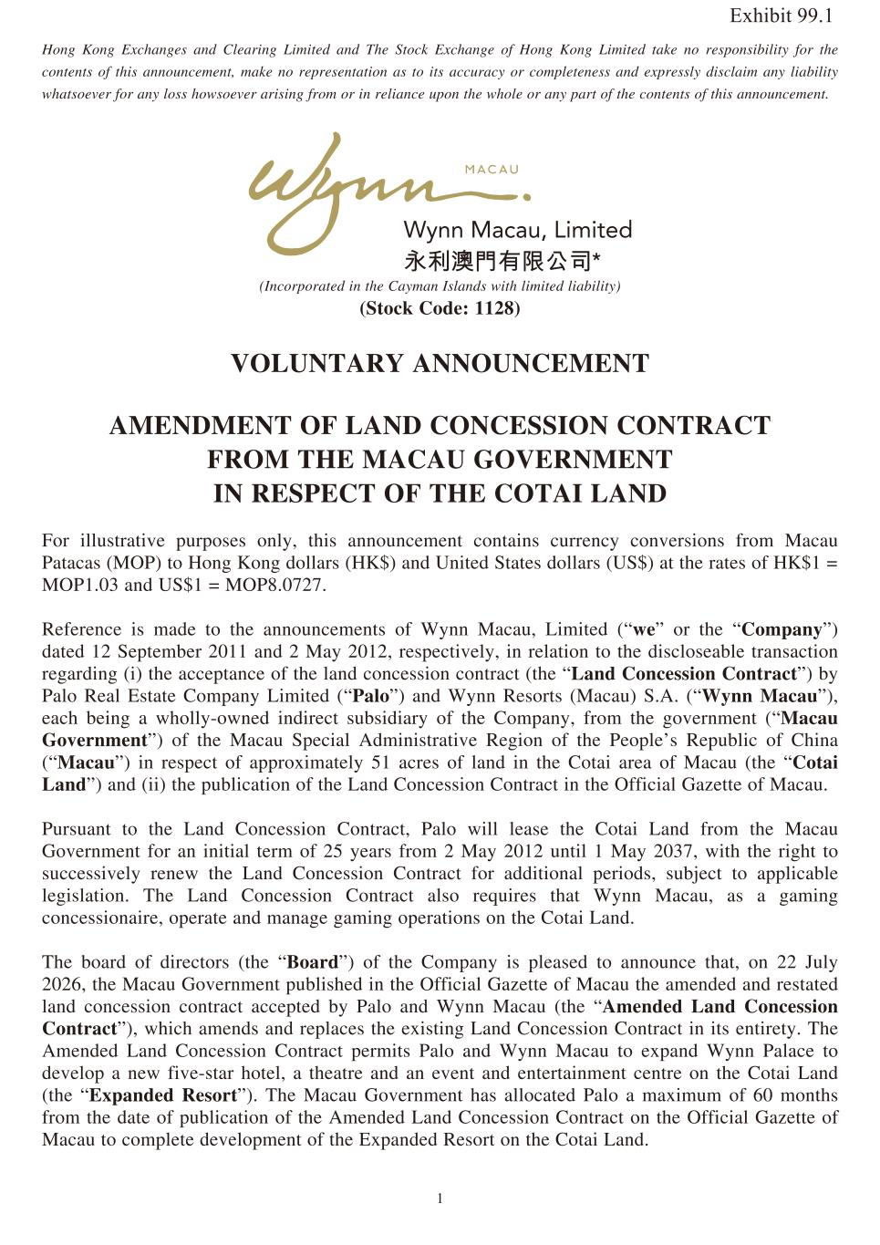
8

1 Hong Kong Exchanges and Clearing Limited and The Stock Exchange of Hong Kong Limited take no responsibility for the contents of this announcement, make no representation as to its accuracy or completeness and expressly disclaim any liability whatsoever for any loss howsoever arising from or in reliance upon the whole or any part of the contents of this announcement. (Incorporated in the Cayman Islands with limited liability) (Stock Code: 1128) VOLUNTARY ANNOUNCEMENT AMENDMENT OF LAND CONCESSION CONTRACT FROM THE MACAU GOVERNMENT IN RESPECT OF THE COTAI LAND For illustrative purposes only, this announcement contains currency conversions from Macau Patacas (MOP) to Hong Kong dollars (HK$) and United States dollars (US$) at the rates of HK$1 = MOP1.03 and US$1 = MOP8.0727. Reference is made to the announcements of Wynn Macau, Limited (“we” or the “Company”) dated 12 September 2011 and 2 May 2012, respectively, in relation to the discloseable transaction regarding (i) the acceptance of the land concession contract (the “Land Concession Contract”) by Palo Real Estate Company Limited (“Palo”) and Wynn Resorts (Macau) S.A. (“Wynn Macau”), each being a wholly-owned indirect subsidiary of the Company, from the government (“Macau Government”) of the Macau Special Administrative Region of the People’s Republic of China (“Macau”) in respect of approximately 51 acres of land in the Cotai area of Macau (the “Cotai Land”) and (ii) the publication of the Land Concession Contract in the Official Gazette of Macau. Pursuant to the Land Concession Contract, Palo will lease the Cotai Land from the Macau Government for an initial term of 25 years from 2 May 2012 until 1 May 2037, with the right to successively renew the Land Concession Contract for additional periods, subject to applicable legislation. The Land Concession Contract also requires that Wynn Macau, as a gaming concessionaire, operate and manage gaming operations on the Cotai Land. The board of directors (the “Board”) of the Company is pleased to announce that, on 22 July 2026, the Macau Government published in the Official Gazette of Macau the amended and restated land concession contract accepted by Palo and Wynn Macau (the “Amended Land Concession Contract”), which amends and replaces the existing Land Concession Contract in its entirety. The Amended Land Concession Contract permits Palo and Wynn Macau to expand Wynn Palace to develop a new five-star hotel, a theatre and an event and entertainment centre on the Cotai Land (the “Expanded Resort”). The Macau Government has allocated Palo a maximum of 60 months from the date of publication of the Amended Land Concession Contract on the Official Gazette of Macau to complete development of the Expanded Resort on the Cotai Land. Exhibit 99.1

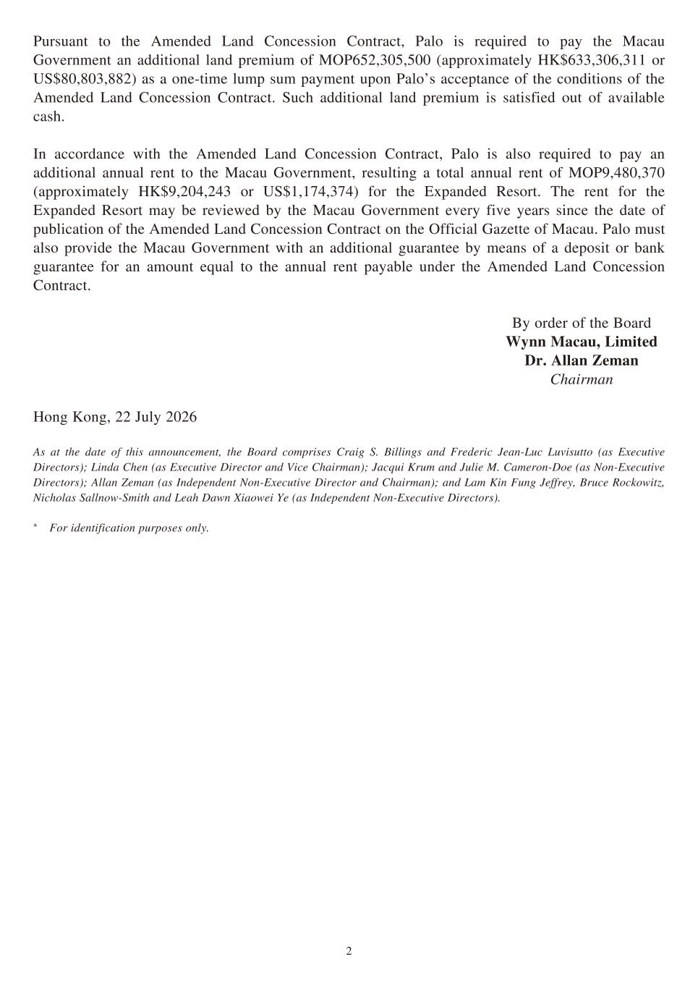
2 Pursuant to the Amended Land Concession Contract, Palo is required to pay the Macau Government an additional land premium of MOP652,305,500 (approximately HK$633,306,311 or US$80,803,882) as a one-time lump sum payment upon Palo’s acceptance of the conditions of the Amended Land Concession Contract. Such additional land premium is satisfied out of available cash. In accordance with the Amended Land Concession Contract, Palo is also required to pay an additional annual rent to the Macau Government, resulting a total annual rent of MOP9,480,370 (approximately HK$9,204,243 or US$1,174,374) for the Expanded Resort. The rent for the Expanded Resort may be reviewed by the Macau Government every five years since the date of publication of the Amended Land Concession Contract on the Official Gazette of Macau. Palo must also provide the Macau Government with an additional guarantee by means of a deposit or bank guarantee for an amount equal to the annual rent payable under the Amended Land Concession Contract. By order of the Board Wynn Macau, Limited Dr. Allan Zeman Chairman Hong Kong, 22 July 2026 As at the date of this announcement, the Board comprises Craig S. Billings and Frederic Jean-Luc Luvisutto (as Executive Directors); Linda Chen (as Executive Director and Vice Chairman); Jacqui Krum and Julie M. Cameron-Doe (as Non-Executive Directors); Allan Zeman (as Independent Non-Executive Director and Chairman); and Lam Kin Fung Jeffrey, Bruce Rockowitz, Nicholas Sallnow-Smith and Leah Dawn Xiaowei Ye (as Independent Non-Executive Directors). * For identification purposes only.

