 |  |  |  |  | UNITED STATES
 |  | SECURITIES AND EXCHANGE COMMISSION
 |  |  |  |  | Washington, D.C. 20549
 |  |  |  |  | SCHEDULE 13D
 |  | Under the Securities Exchange Act of 1934
 |  |  |  |  | (Amendment No. 15)*
 |  |  |  |  | WYNN RESORTS, LIMITED
 |  |  |  |  | (Name of Issuer)
 |  |  | Common Stock, $0.01 par value per share
 |  |  |  |  | (Title of Class of Securities)
 |  |  |  |  |  |  | 983134107
 |  |  |  |  | (CUSIP Number)
Kai Haakon E. Liekefett |  |  |  |  |  |  |  |  |  |  |  |  |  | James Cole
Sidley Austin LLP |  |  |  |  |  |  |  |  |  |  |  |  | Sidley Austin LLP
787 Seventh Avenue |  |  |  |  |  |  |  |  |  |  |  |  | 1501 K Street NW
New York, NY 10019 |  |  |  |  |  |  |  |  |  |  |  |  | Washington, DC 20005
(212) 839-5300 |  |  |  |  |  |  |  |  |  |  |  |  | (202) 736-8000
 |  | (Name, Address and Telephone Number of Person
 |  | Authorized to Receive Notices and Communications)
 |  |  |  |  |  | April 23, 2018
 |  | (Date of Event which Requires Filing of this Statement)
If the filing person has previously filed a statement on Schedule 13G to report the acquisition that is the subject of this Schedule 13D, and is filing this schedule because of §§240.13d-1(e), 240.13d-1(f) or 240.13d-1(g), check the following box. ☐

Note: Schedules filed in paper format shall include a signed original and five copies of the schedule, including all exhibits. See Rule 13d-7 for other parties to whom copies are to be sent.

- The remainder of this cover page shall be filled out for a reporting person’s initial filing on this form with respect to the subject class of securities, and for any subsequent amendment containing information which would alter the disclosures provided in a prior cover page.

The information required in the remainder of this cover page shall not be deemed to be “filed” for the purpose of Section 18 of the Securities Exchange Act of 1934 (“Act”) or otherwise subject to the liabilities of that section of the Act but shall be subject to all other provisions of the Act (however, see the Notes).

CUSIP NO. 983134107 SCHEDULE 13D Page 2 of 5 Pages

- Names of Reporting Persons.

ELAINE P. WYNN

- Check the Appropriate Box if a Member of a Group (See Instructions)

  - ☐

  - ☒

- SEC Use Only

- Source of Funds (See Instructions) N/A
- Check if Disclosure of Legal Proceedings is Required Pursuant to Items 2(d) or 2(e)

☐

- Citizenship or Place of Organization United States of America

    - Sole Voting Power


Number of |  | 9,539,077
Number of | 8. | Shared Voting Power
Shares
Beneficially |  | 0
Owned by Each | 9. | Sole Dispositive Power
Reporting
Persons With |  | 9,539,077
  - Shared Dispositive Power 0

- Aggregate Amount Beneficially Owned by Each Reporting Person 9,539,077

- Check if the Aggregate Amount in Row (11) Excludes Certain Shares (See Instructions)

☐

- Percent of Class Represented by Amount in Row (11) 9.24%

- Type of Reporting Person:

IN

SCHEDULE 13D Page 3 of 5 Pages

This Amendment No. 15 hereby amends and supplements the Schedule 13D filed with the Securities and Exchange Commission (the “Commission”) on November 13, 2002, as amended to date (the “Schedule 13D”) relating to the common stock, par value $0.01 (the “Common Stock”) of Wynn Resorts, Limited (the “Company”). Capitalized terms used but not defined herein shall have the respective meanings set forth in the Schedule 13D.

Item 4. Purpose of Transaction

Item 4 of the Schedule 13D is hereby amended and supplemented as follows:

On April 23, 2018, Ms. Wynn filed a preliminary proxy statement (the “Preliminary Proxy Statement”) and accompanying form of proxy card with the Commission to solicit proxies to vote “WITHHOLD” on the re-election of director John J. Hagenbuch at the Company’s upcoming 2018 annual meeting (the “Annual Meeting”).

Also on April 23, 2018, Ms. Wynn sent a letter to shareholders of the Company. A copy of this letter is included in the press release attached hereto as Exhibit 15.

Also on April 23, 2018, Ms. Wynn sent a letter to the Company, dated April 20, 2018, demanding the inspection of certain records pursuant to the Nevada Revised Statutes Section 78.105. A copy of this letter is attached hereto as Exhibit 16.

Also on April 23, 2018, Ms. Wynn sent a letter to the Company demanding the Company’s shareholder list for the purpose of disseminating solicitation materials to the Company’s shareholders pursuant to Rule 14a-7 promulgated under the Securities Exchange Act of 1934, as amended (the “Exchange Act”). A copy of the form of this letter is attached hereto as Exhibit 17.

Also on April 23, 2018, Sidley Austin LLP, Ms. Wynn’s outside counsel, submitted a letter to the Commission requesting that the Commission shorten the regular ten-day review period for the Preliminary Proxy Statement for good cause because the Company compressed the solicitation period from 41-42 days in the previous three years to 28 days for the upcoming Annual Meeting. A copy of this letter is attached hereto as Exhibit 18.

Ms. Wynn may engage in discussions with the Company’s shareholders, management and the Board regarding a variety of matters relating to the Company, including, among other things, the Company’s strategy, business, management, capital structure and allocation, corporate governance, and Board composition. Ms. Wynn may take steps seeking to bring about changes to increase shareholder value, including, but not limited to, pursuing any of the plans or proposals referred to in paragraphs (a) through (j) of Item 4 of Schedule 13D.

Item 6. Contracts, Arrangements, Understandings or Relationships with Respect to Securities of the Issuer.

Item 6 of the Schedule 13D is hereby amended and supplemented as follows:

The response to Item 4 of this Amendment No. 15 is incorporated by reference herein.

Except as set forth herein, Ms. Wynn has no contracts, arrangements, understandings or relationships (legal or otherwise) with any person with respect to any securities of the Company, including but not limited to, any contracts, arrangements, understandings or relationships concerning the transfer or voting of such securities, finder’s fees, joint ventures, loan or option arrangements, puts or calls, guarantees of profits, division of profits or losses, or the giving or withholding of proxies.

SCHEDULE 13D Page 4 of 5 Pages

Item 7. Material to be Filed as Exhibits.

Item 7 of the Schedule 13D is hereby amended and supplemented as follows:

Exhibit 15 Press release containing letter from Ms. Wynn to Company shareholders dated April 23, 2018


Exhibit 16 Letter from Ms. Wynn to the Company dated April 20, 2018 demanding the inspection of certain records pursuant to the Nevada Revised Statutes Section 78.105

Exhibit 17 Form of the letter from Ms. Wynn to the Company dated April 23, 2018 demanding the Company’s shareholder list for the purpose of disseminating solicitation materials to the Company’s shareholders pursuant to Rule 14a-7 under the Exchange Act

Exhibit 18 Letter from Sidley Austin LLP to the Commission dated April 23, 2018

SCHEDULE 13D Page 5 of 5 Pages

SIGNATURE

After reasonable inquiry and to the best of my knowledge and belief, I certify that the information set forth in this statement is true, complete and

correct.

Dated: April 23, 2018

ELAINE P. WYNN

/s/ Elaine P. Wynn

Elaine P. Wynn

Exhibit 15

Wynn Resorts Co-Founder and Largest Shareholder Elaine P. Wynn Urges Shareholders to

Withhold Votes from Legacy Director Nominee John J. Hagenbuch

Re-election of Legacy Director Hagenbuch Jeopardizes the Company’s Professed

Desire for a “New Wynn”

Board Should Not Make Any Decisions Regarding Wynn Boston Harbor Until

Majority of Board Is Reconstituted

LAS VEGAS – April 23, 2018 – Elaine Wynn, co-founder and the largest shareholder of Wynn Resorts, Limited (NASDAQ: WYNN) (“Wynn Resorts,” “Wynn,” the “Company”), today filed preliminary proxy materials with the Securities and Exchange Commission and released a letter addressed to all shareholders urging that they join her in WITHHOLDING votes from Wynn director candidate John J. Hagenbuch, who is up for re-election at Wynn’s Annual Meeting scheduled for Wednesday, May 16, 2018, in Las Vegas, Nevada.

A copy of the letter follows:

April 23, 2018

Dear Fellow Wynn Resorts Shareholders,

I am the co-founder and the largest shareholder of Wynn Resorts, Limited, owning 9,539,077 shares of Wynn common stock, which represents approximately 9.24% of the outstanding shares. I am deeply concerned by what I view as the lack of independence and responsible oversight demonstrated by the current board of directors. Given my significant interest in the Company, and my concerns about its most senior leadership, I am seeking to reconstitute the board and reform the Company’s corporate governance. I believe that this is the only path to restoring the Company’s reputation, improving its standing with regulators and maximizing shareholder value. To be clear, I am not looking for a board seat for myself or anyone who is closely associated with me. My focus is solely on enhancing and protecting our investment in the Company.

To achieve these goals, we need a new era at Wynn Resorts. Although the board recently unilaterally appointed three new directors and indicated its intention to add more new directors in the coming months, I do not believe these steps go far enough toward changing “business as usual” in Wynn’s boardroom. In particular, they do not address the number of longstanding legacy directors who will remain on the board.

This is largely the same board that announced only two months ago, “with a collective heavy heart” the resignation of “our founder, CEO and friend Steve Wynn.” Several longstanding legacy directors still wield significant influence at the Company. This is especially true of Mr. Hagenbuch, who serves on the special committee responsible for overseeing the investigation into allegations of Mr. Wynn’s sexual harassment and on the compensation committee, which is responsible for the Company’s executive compensation practices that proxy advisory firms have viewed as highly problematic.

1

This is why today I am launching a “Withhold-the-Vote” campaign against John J. Hagenbuch. I urge you to join me in this effort.

Mr. Hagenbuch has served on the board since 2012. I believe it is time for Mr. Hagenbuch’s departure from the board, so that new board members can seek change, free of holdovers from the past. My opposition to Mr. Hagenbuch’s re-election serves as a referendum on ALL of the longstanding legacy directors, including those who are not up for re-election because the incumbent directors refuse to declassify the board. A WITHHOLD vote with respect to Mr. Hagenbuch is a first step towards a “New Wynn.”

The Company’s Corporate Governance Guidelines require any director in an uncontested election who fails to receive over 50% of the votes cast “for” his or her election to tender his or her resignation to the board within five days of the election. If my proxy solicitation results in Mr. Hagenbuch’s failure to receive over 50% of the votes cast for his election, then I believe the failure of the board to accept his resignation would be an egregious violation of proper corporate governance and in direct opposition to a clear shareholder directive.

I am troubled by Mr. Hagenbuch’s service on the special committee

investigating the allegations of sexual harassment by Mr. Wynn.

The Company has been hit with allegations of sexual harassment by former Chairman of the Board and Chief Executive Officer Stephen A. Wynn. It is the responsibility of the board to fully investigate the actions of the past, including the extent to which the general “tone at the top” and long-standing personal relationships contributed to an unhealthy environment, and to ensure the implementation of policies and procedures to safeguard the future. Forming a special committee to investigate the allegations against Mr. Wynn was necessary.

However, given that Mr. Hagenbuch is a longtime close friend of Mr. Wynn’s, Mr. Hagenbuch’s service on the special committee is disconcerting. I find this obvious conflict deeply troubling. If you share my concerns about the independence of the investigation, I urge you to WITHHOLD your vote from Mr. Hagenbuch at this year’s annual meeting.

I am troubled by the Company’s executive compensation practices.

In recent years, shareholders and proxy advisors have repeatedly criticized the Company’s executive pay practices for not being correlated to performance.

Mr. Hagenbuch has served on the compensation committee since 2013. He was on the compensation committee when Mr. Wynn's pay was called into question in 2015. The Company did not hold a say-on-pay vote in 2015 or 2016, and at last year’s annual meeting, the say-on-pay proposal received only 59% support. This puts the Company in the lowest 10% of Russell 3000 companies holding say-on-pay votes in 2017.

2

Mr. Maddox’s recently approved $24 million pay package, which is exorbitant for a first-time untested public company CEO, demonstrates that very little has changed. It is puzzling to me that the compensation committee continues to repeat the same mistakes that have been decried in past ISS and Glass Lewis reports—large stock grants, discretionary pay and failure to disclose the metrics for performance awards. As a member of the compensation committee, Mr. Hagenbuch should be held responsible for these continuing failures.

Voting WITHHOLD Mr. Hagenbuch will send a strong signal to the entire compensation committee that the Company’s executive pay practices must change.

The board’s summary rejection of my shareholder-friendly requests raises serious concerns.

On April 17, 2018, I wrote to the board, seeking to restore the Company’s reputation by reforming its corporate governance and reconstituting a majority of the board of directors. I requested that the board reopen the window during which shareholders can nominate directors, given the profound change in circumstances since the nomination window closed in January. I also requested that the board take steps to allow for a majority of the board to be comprised of new independent qualified directors effective at the 2018 annual meeting.

Less than 24 hours later, the board responded by filing the Company’s proxy statement for the 2018 annual meeting, effectively precluding a reopening of the advance notice window and contemplating the election of just three of the 11 members of the board. This rushed response resulted in an extremely short solicitation period, with an annual meeting date only 28 days after the filing of the Company’s proxy statement—a significantly shorter period of time than in past years (42 days in 2017 and 41 days in each of 2016 and 2015). The day after the Company filed its proxy statement, Chairman D. Boone Wayson, a childhood friend and former business partner of Mr. Wynn, communicated the board’s outright rejection of my request to reopen the nomination window as neither “appropriate [n]or justified,” without any further explanation.

The board made no effort whatsoever to engage in dialogue on these critical issues for all shareholders prior to responding. Reacting in such a short timeframe, the board could not possibly have seriously considered the concerns raised.

If you are concerned about the Company’s governance practices, I urge you to WITHHOLD your vote from Mr. Hagenbuch at this year’s annual meeting.

I believe that any major decisions, including those regarding Wynn Boston Harbor, should be made by a board comprised of a majority of new independent directors.

3

The Company has invested over $1.1 billion in building the Wynn Boston Harbor, which is scheduled to open next year. In January 2018, the Massachusetts Gaming Commission launched an investigation into both Mr. Wynn’s alleged sexual harassment and the role of the board and other management in responding to the allegations of misconduct, both before and after the January 26, 2018 article in The Wall Street Journal detailing several sexual harassment allegations against Mr. Wynn. On April 12, 2018, The Boston Globe reported that Matt Maddox, the Company’s President and Chief Executive Officer, stated that he is open to a potential sale of the entire project to “maximize the value of our assets and mitigate risk.”

I am concerned that the board would consider selling Wynn Boston Harbor at all given the unique and strategic nature of the property. The Company sought and achieved this market leading position and has considered the property a core strategic asset. Moreover, the possibility that the Company might sell Wynn Boston Harbor for less than its full long-term value in an attempt to “mitigate risk” by limiting the investigation is of even greater concern. I fear that longstanding legacy directors such as Mr. Hagenbuch, who have close personal ties to Mr. Wynn, will endorse just such short-sighted action.

I believe that before any decisions about Wynn Boston Harbor are made, or any other material actions are taken that could have an adverse impact on long-term shareholder value, a reconstituted board must be in place. In my opinion, regulators would look favorably upon a change in a majority of the board.

If you share my concerns about Wynn Boston Harbor and other decisions that could have an adverse impact on long-term shareholder value, I urge you to WITHHOLD your vote from Mr. Hagenbuch at this year’s annual meeting.

***

My focus is on taking the steps required to enhance the Company’s long-term value, eliminate the risk of longtime directors making short-term decisions, restore the Company’s reputation and transform it from a corporate governance laggard into a corporate governance leader.

I look forward to discussing these issues with you over the coming weeks and hope that you will agree with me that the Company needs and deserves a new board that is truly independent and wholeheartedly committed to the Company’s long-term success.

Please join me in bringing about a new era at Wynn Resorts by supporting my campaign to WITHHOLD votes with respect to legacy director nominee John J. Hagenbuch.

Sincerely,

Elaine Wynn

4

Important Additional Information

Elaine P. Wynn is a participant in the solicitation of proxies from the stockholders of Wynn Resorts, Limited (the “Company”) in connection with the Company’s 2018 annual meeting of stockholders (the “Annual Meeting”). Ms. Wynn has filed a preliminary proxy statement (the “Preliminary Proxy Statement”) and form of proxy card with the U.S. Securities and Exchange Commission (the “SEC”) in connection with such solicitation of proxies from the Company’s stockholders. A description of Ms. Wynn’s direct or indirect interests, by security holdings or otherwise, is contained in the Preliminary Proxy Statement. MS. WYNN STRONGLY ENCOURAGES THE COMPANY’S STOCKHOLDERS TO READ ANY DEFINITIVE PROXY

STATEMENTS AND OTHER PROXY MATERIALS WHEN THEY BECOME AVAILABLE BECAUSE THEY WILL CONTAIN IMPORTANT INFORMATION. Stockholders may obtain any definitive proxy statement and any other relevant documents at no charge from the SEC’s website at www.sec.gov or by contacting Ms. Wynn’s proxy solicitor MacKenzie Partners, Inc. at wynn@mackenziepartners.com or by calling toll-free (800) 322-2885 or collect (212) 929-5500.

5

Exhibit 16

Elaine P. Wynn

3800 Howard Hughes Parkway, Suite 960, Las Vegas, Nevada, 89169

Wynn Resorts, Limited

Attn: Kim Sinatra, Executive Vice President, General Counsel and Secretary

3131 Las Vegas Boulevard South

Las Vegas, NV 89109

Re: Request for Records

Dear Ms. Sinatra:

Elaine P. Wynn (the “Requesting Stockholder”) is the holder of at least 5% of all outstanding shares of Common Stock, par value $0.01 per share, of Wynn Resorts, Limited, a Nevada corporation (the “Company”). Attached hereto as Exhibit A is documentary evidence of the Requesting Stockholder’s holding of greater than 5% of all outstanding shares of the Company as of April 20, 2018, and such documentary evidence is a true and correct copy of what it purports to be. The Requesting Stockholder continues to own the shares reflected on Exhibit A.

Pursuant to the Nevada Revised Statutes (“NRS”) 78.105, the Requesting Stockholder hereby demands, during the Company’s usual business hours, to inspect, and to make copies and extracts from:

- the Company’s articles of incorporation and all amendments thereto, certified by the Secretary of State (collectively, the “Articles”);

- the Company’s bylaws and all amendments thereto, certified by an officer of the Company (collectively, the “Bylaws”); and

- the Company’s stock ledger, and “all other information in the [Company’s] possession for the purpose of contacting and communicating with its stockholders,”¹ including the following information:

1. A complete record or list of the holders of (a) shares of the Company’s common stock (“Stock”) and (b) warrants, rights and options entitling the holders thereof to purchase from the Company shares of Stock (“Rights”), in each case of (a) and (b), certified by the Company or its transfer agent and showing in respect of each such holder (i) the name, last known business, residence or mailing address, and telephone number of each such holder; (ii) the number of shares of Stock and Rights held by each such holder; (iii) the name of such holder on each certificate; (iv) all existing certificate numbers for such holder; (v) the date each certificate was issued to each such holder; (vi) the amount of each such holder’s shares of Stock or Rights represented by each certificate number; and (vii) any indications that any such holder’s certificate is restricted in any way, including any transfer restrictions on such certificate.

¹ Cenergy Corp. v. Bryson Oil & Gas PLC, 662 F. Supp. 1144 (D. Nev. 1987); see also Wynnefield Partners Small Cap Value LP I v. Omega Protein Corp., A-16-737863-B (Nev. Dist. Ct. 2016).

- A complete record or list of the holders of Stock and Rights who are participants in any employee stock ownership, stock purchase, stock option, retirement, restricted stock, incentive, profit sharing, dividend reinvestment or any similar plan of the Company in which voting of shares under the plan is controlled, directly or indirectly, individually or collectively, by such plan’s participants, showing in respect of each such holder (a) the name, last known business, residence or mailing address and telephone number of each such holder; (b) the number of shares of Stock and Rights attributable to each such participant in any such plan; and (c) the name, business address and telephone number of the trustee or administrator of any such plan, and a detailed explanation of the voting treatment not only of shares of Stock for which the trustee or administrator receives instructions from participants, but also shares of Stock for which either they do not receive instructions or shares of Stock which are outstanding in any such plan but are unallocated to any participant.

- A complete record or list of the holders of Stock and Rights and respondent banks who have elected to receive electronic copies of proxy materials with respect to meetings of stockholders of the Company pursuant to Rule 14a-16(j)(2) under the Securities Exchange Act of 1934, as amended (the “Exchange Act”).

- All transfer journals and daily transfer sheets showing changes in the names, addresses and number of shares of holders of Stock or Rights, commencing the first business day after the record date for the 2018 Annual Meeting forward, which are in or come into the possession of the Company or any of its transfer agents or registrars, or which can reasonably be obtained from brokers, dealers, banks, clearing agencies, voting trustees or their respective nominees.

- All information in or which comes into possession or control of the Company or any of its transfer agents or registrars, or which can reasonably be obtained from brokers, dealers, banks, clearing agencies, voting trustees or their respective nominee, concerning the names, addresses and number of shares of Stock and Rights held by the participating brokers and banks named in the individual nominee names of Cede & Co. or other similar depositories or nominees, including respondent bank lists. These materials should be provided as of March 21 and March 30, 2018, as well as, the dates specified below.

- All information in or that comes into the Company’s possession, or that can reasonably be obtained from brokers, dealers, banks, clearing agencies, voting trustees or their respective nominee (including Broadridge Financial Services), relating to the names of the beneficial owners of Stock or Rights pursuant to Rule 14b-1(c) or Rule 14b-2(c) under the Exchange Act, including a Non Objecting Beneficial Owners or “NOBO” list.

- In respect of all information referred to in paragraphs (1) through (6) above, (a) electronic media containing such information in Excel format, (b) the computer processing data necessary for the Requesting Stockholder to make use of such information on electronic media and (c) a hard copy printout of such information for verification purposes (all information referred to in paragraphs (1) through (7) above, collectively, the Stock Ledger Materials” and, together with the Articles and Bylaws, the “Records”).

-2-

The Requesting Stockholder demands that the Stock Ledger Materials be made available (i) as of the most recent date available and (ii) as of the record date (the “Record Date”) in respect of the 2018 annual meeting of the stockholders of the Company (the “Annual Meeting”) and from time to time thereafter. In addition, the Requesting Stockholder demands that any updates, changes, modifications, corrections, additions or deletions to any of the Stock Ledger Materials be immediately furnished to the Requesting Stockholder as such updates, modifications, additions or deletions become available to the Company, its agents or other representatives. Moreover, the Requesting Stockholder demands that any and all changes whatsoever to the Bylaws made hereafter through the Annual Meeting, including, without limitation, any amendment to the existing Bylaws, any adoption of any new Bylaws or deletions of any of the existing Bylaws, be immediately furnished to the Requesting Stockholder.

The purpose of this demand is to enable the Requesting Stockholder to communicate with fellow stockholders of the Company regarding the business of the Company, including the solicitation of proxies regarding the Company’s proposals to be considered at the Annual Meeting. The inspection is not desired for a purpose which is in the interest of a business or object other than the business of the Company and the Requesting Stockholder has not at any time sold or offered for sale any list of stockholders of any domestic or foreign corporation or aided or abetted any person in procuring any such record of stockholders for any such purpose. An affidavit of the Requesting Stockholder in accordance with NRS 78.107 is attached hereto as Exhibit B.

The Requesting Stockholder has designated to conduct the inspection of the Records requested herein: (i) Sidley Austin LLP and its partners, associates, employees and any other persons designated by Sidley Austin LLP and (ii) MacKenzie Partners, Inc., and its directors, officers, employees and any other persons designated by MacKenzie Partners, Inc. A copy of the power-of-attorney granted to such designees is attached hereto as Exhibit C. The Requesting Stockholder will pay the reasonable costs of obtaining the Records and agrees to keep the Stock Ledger Materials confidential pursuant to a customary confidentiality agreement attached hereto as Exhibit D.

Pursuant to NRS 78.105(2), the Company is required to respond to this demand within five days from the date hereof by April 25, 2018. Accordingly, please advise the Requesting Stockholder’s counsel Kai Haakon E. Liekefett, Esq. (Sidley Austin LLP, 787 Seventh Avenue, New York, NY 10019, telephone number (212) 839-8744, and email kliekefett@sidley.com), as promptly as practicable within the requisite timeframe, when and where the Records will be made available to the Requesting Stockholder and/or its designees, and provide an estimate of the reasonable costs of providing the Stock Ledger Materials, the Articles and the Bylaws. If the Company contends that this demand is incomplete or is otherwise deficient in any respect, please notify the Requesting Stockholder immediately in writing, with a copy to the aforementioned Mr. Liekefett, setting forth the facts or law that the Company contends support its position and specifying any additional information believed to be required. In the absence of such prompt notice, the Requesting Stockholder will assume that the Company agrees that this demand complies in all respects with the requirements of NRS 78.105. Please be aware that pursuant to NRS 78.105(3), if the Company neglects or refuses to permit an inspection of the Records or refuses to permit copies to be made therefrom, the Company will be is liable to the Requesting Stockholder injured for all damages resulting to the Requesting Stockholder therefrom.

[Remainder of page intentionally left blank.]

-3-

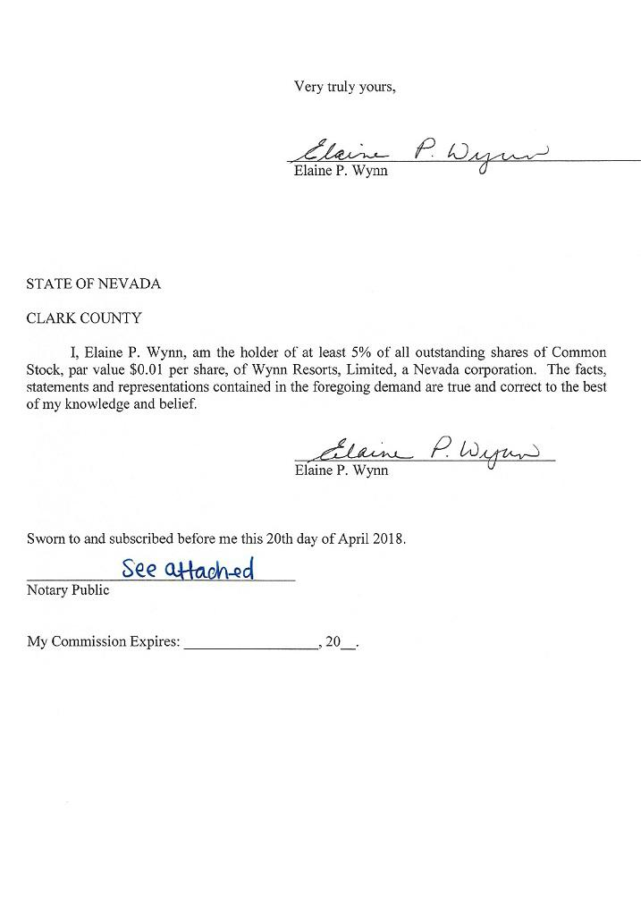

-4-

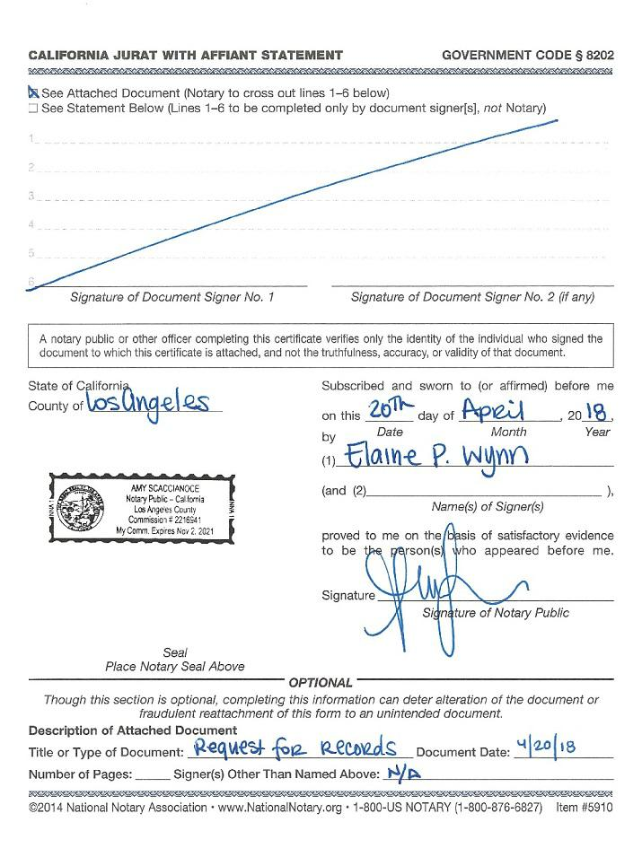

-5-

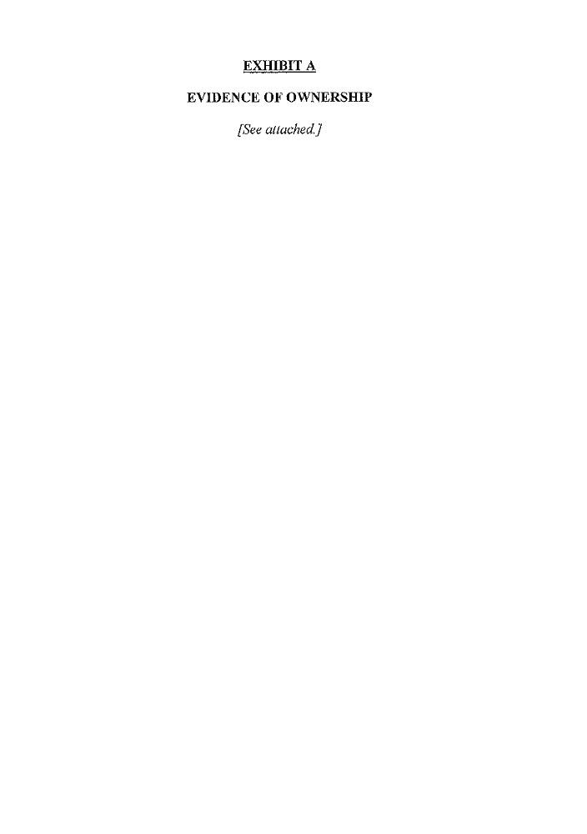

-6-

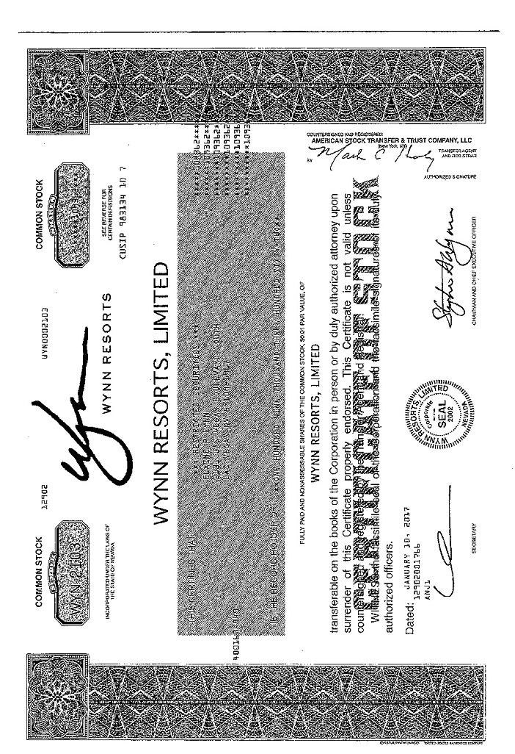

-7-

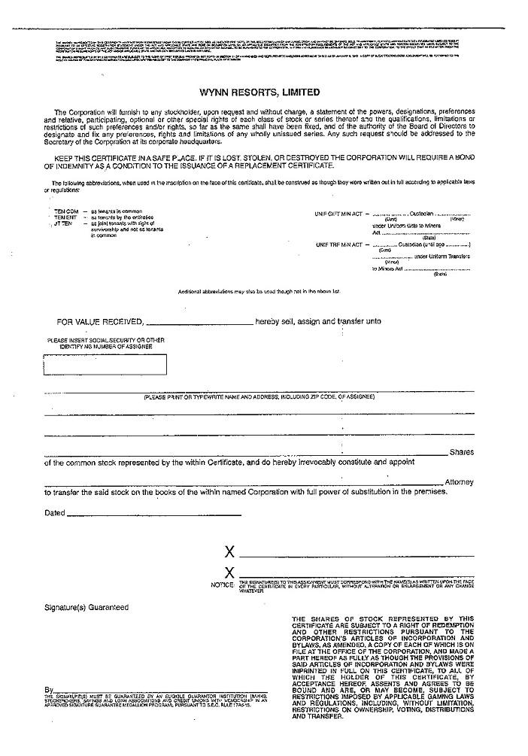

-8-

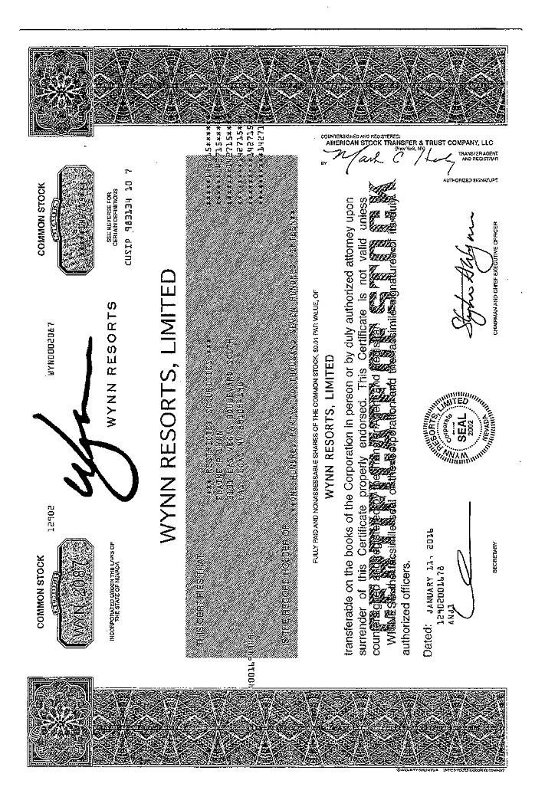

-9-

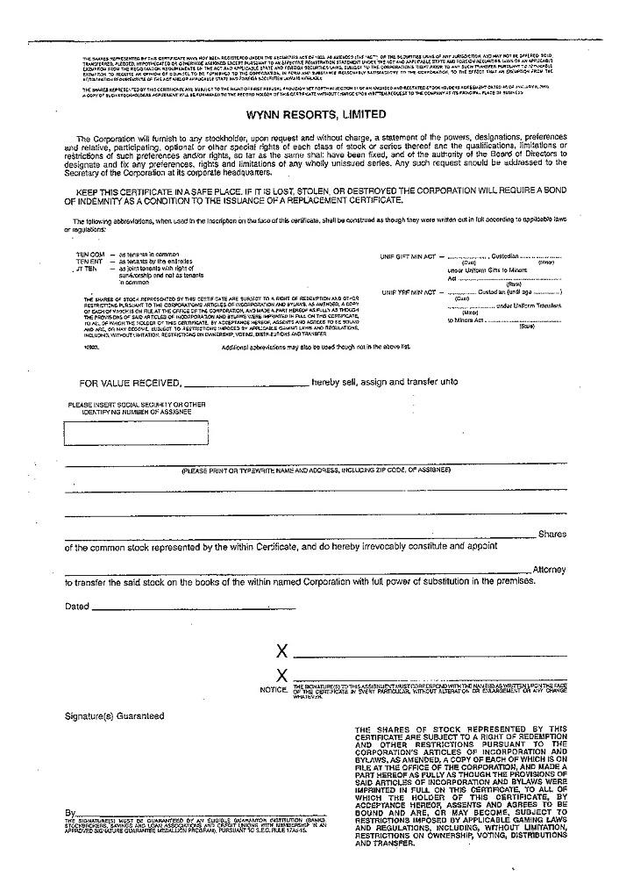

-10-

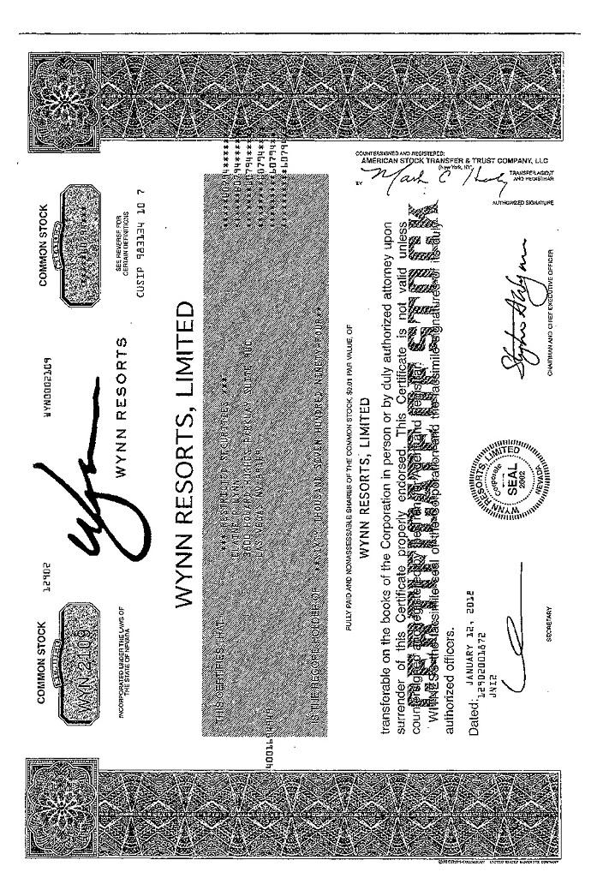

-11-

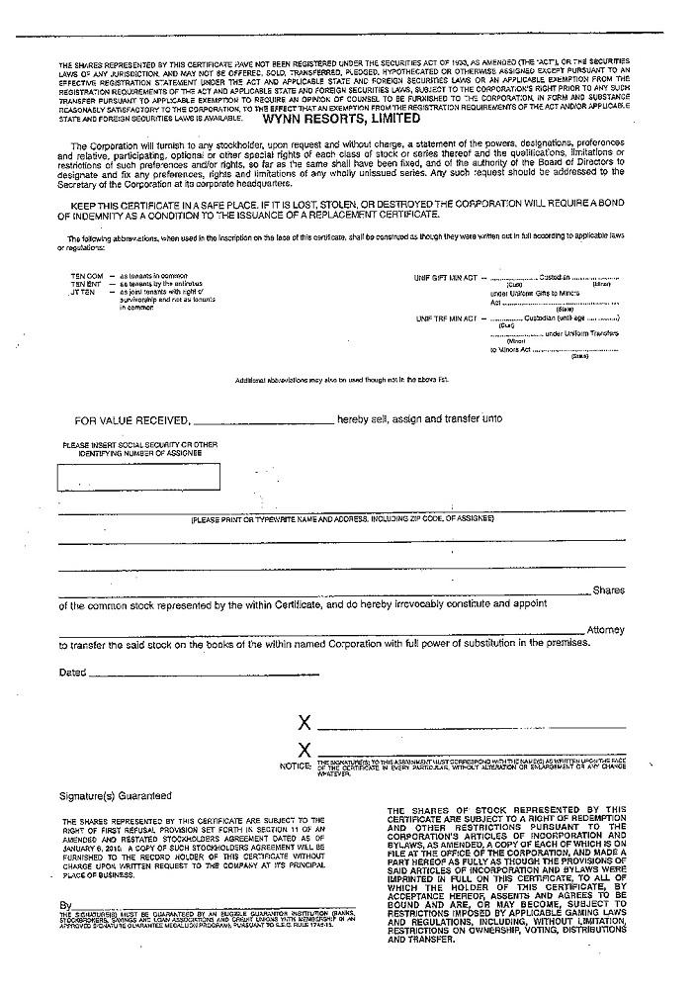

-12-

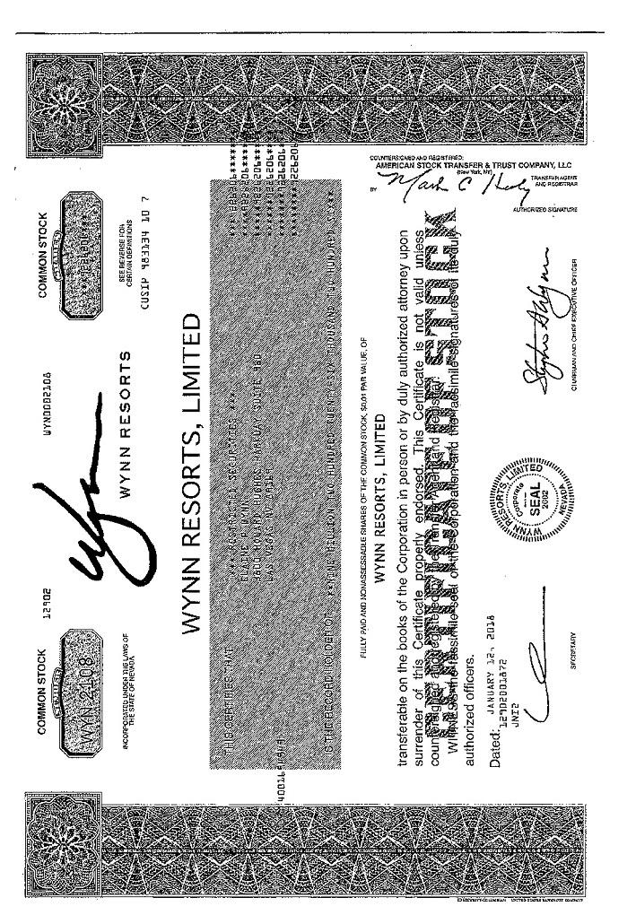

-13-

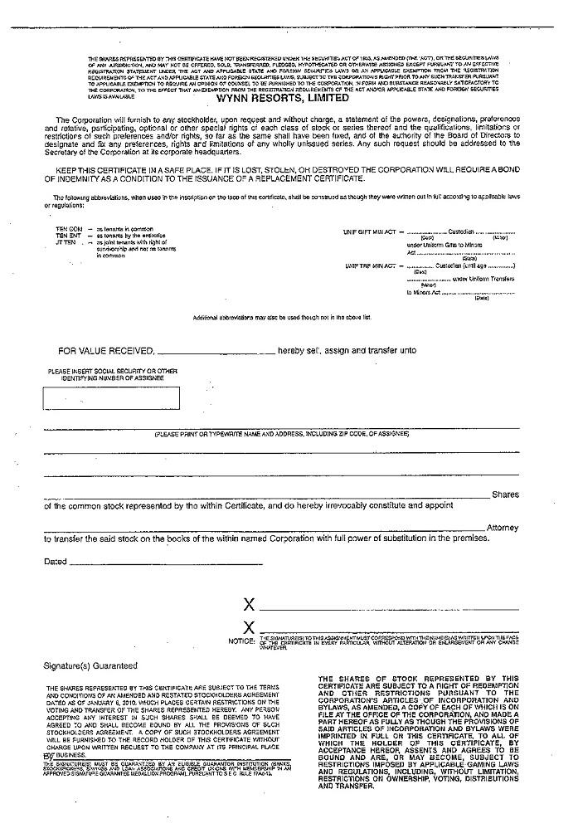

-14-



-15-

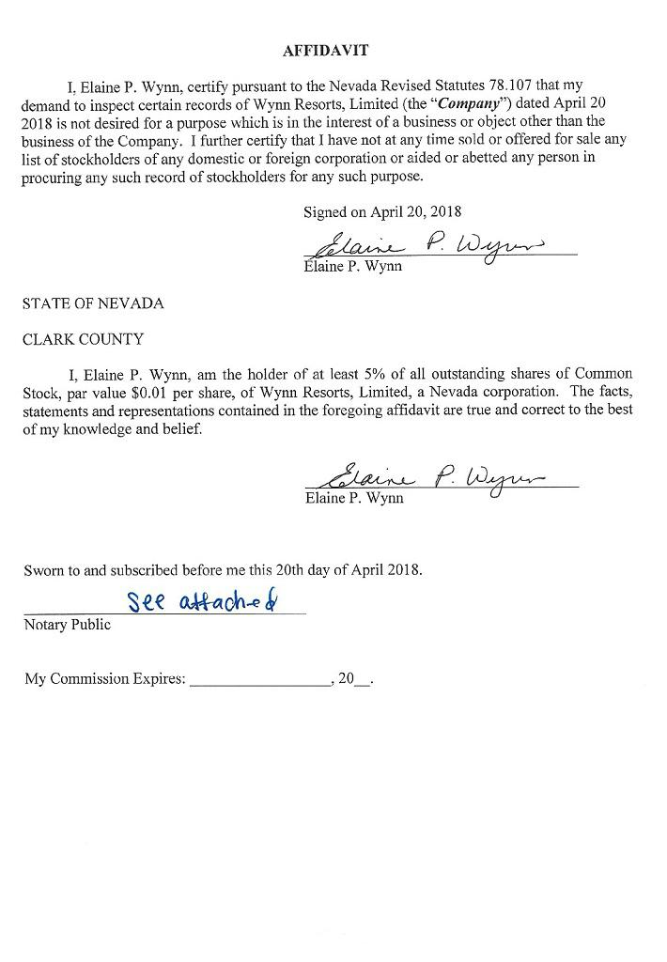

-16-

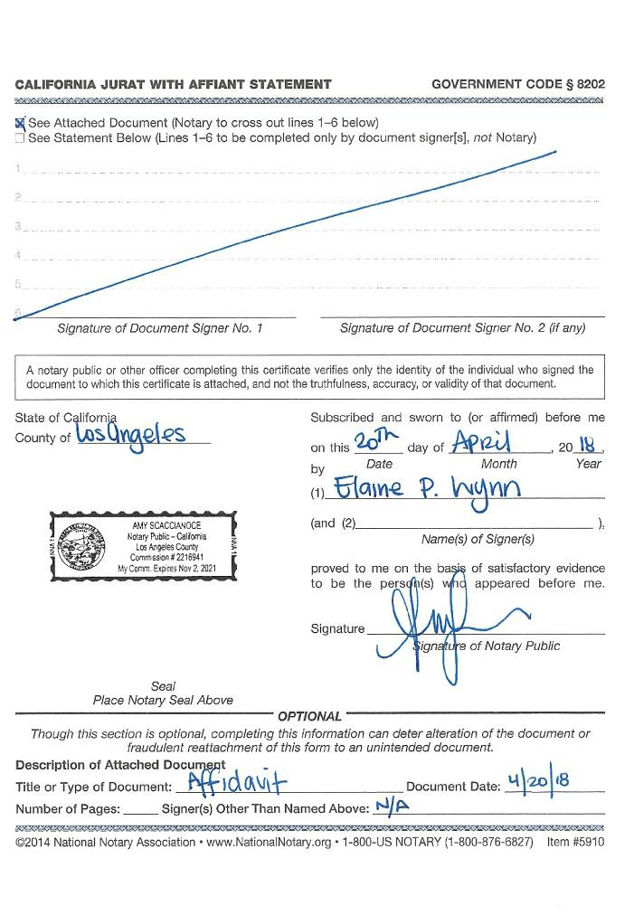

-17-



-18-

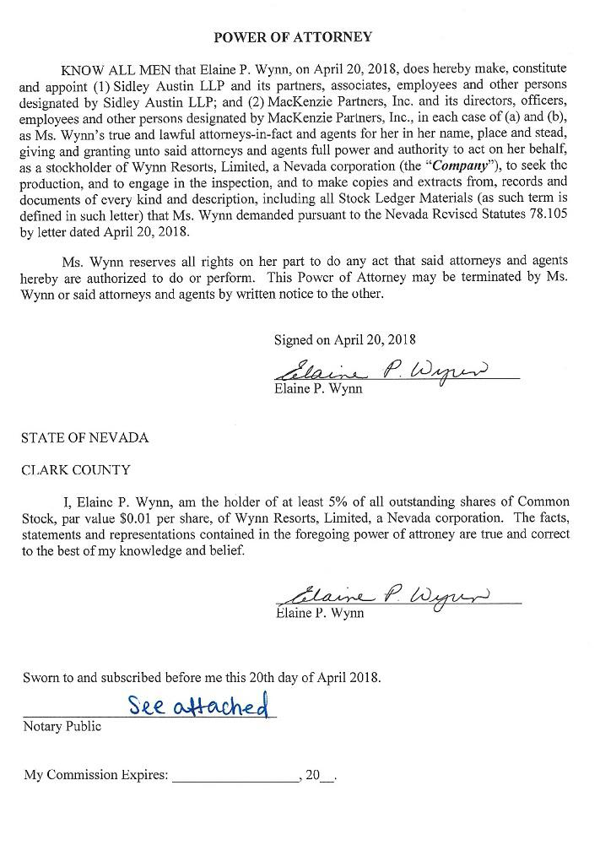

-19-

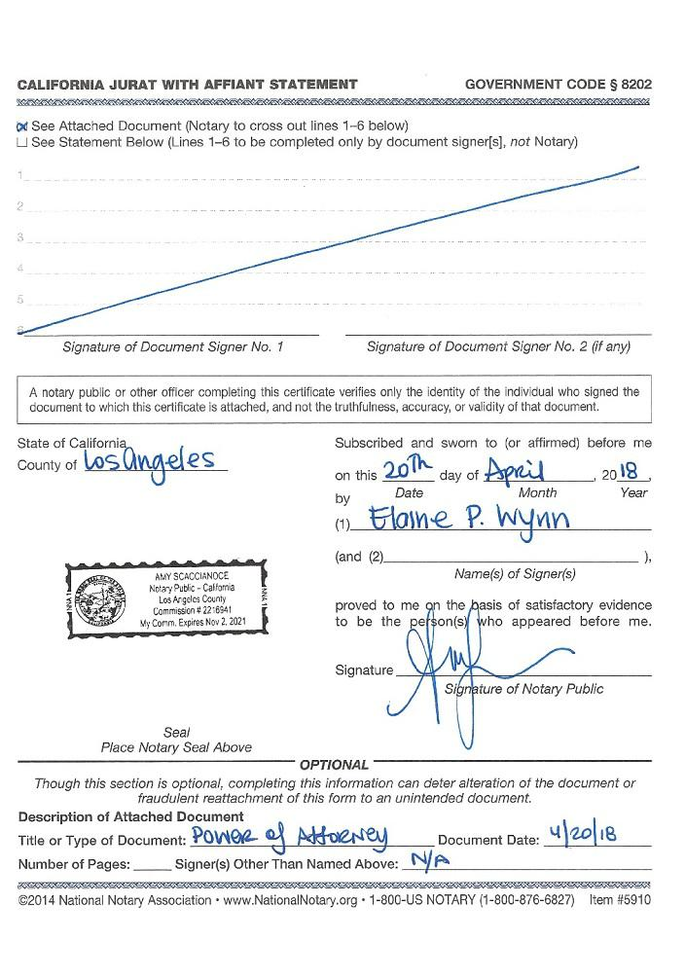

-20-



-21-

CONFIDENTIALITY AGREEMENT

CONFIDENTIALITY AGREEMENT (this “Agreement”), dated as of April 20, 2018, by and between Elaine P. Wynn (the “Requesting Stockholder”) and Wynn Resorts, Limited, a Nevada corporation (the “Company”).

WHEREAS, the Requesting Stockholder hereby represents that she is the beneficial owner of 9,539,077 shares of common stock of the Company, $0.01 par value per share;

WHEREAS, by letter to the Company dated April 20, 2018, the Requesting Stockholder has made a demand (the “Demand”) to inspect and make and/or receive copies or abstracts from certain records of the Company (the “Records”) pursuant to Nevada Revised Statutes 78.105; and

WHEREAS, subject to the execution of this Agreement and payment by the Requesting Stockholder for the production of the Records, the Company will make the Records available for inspection by the Requesting Stockholder in response to the Demand and any future demands by the Requesting Stockholder, subject to the provisions contained in this Agreement.

NOW THEREFORE, for good and valuable consideration, the receipt and sufficiency of which are hereby acknowledged, the parties do hereby agree as follows:

- Confidentiality and Purpose. The Company shall make the Records available for inspection by the Requesting Stockholder in response to the Demand and any future demands by the Requesting Stockholder. The Requesting Stockholder shall hold the Records (as defined in the Demand) in strict confidence and shall not, and shall direct her Representatives (as defined below) not to, publish, communicate or otherwise disclose the Records to anyone, either directly or indirectly, other than as permitted by Section 3 of this Agreement. The Requesting Stockholder expressly agrees and represents, consistent with her Demand, that the Records shall be utilized solely for the purpose set forth in the Demand (the “Permitted Purpose”).

The confidentiality obligations set forth in this Agreement shall not apply to any of the Records that (a) were already properly in the Requesting Stockholder’s or her Representatives’ possession as of the date hereof, provided that such Records were not subject to any legal, contractual or fiduciary obligation of confidentiality owed to the Company or any subsidiary thereof, (b) properly came into the Requesting Stockholder’s or her Representatives’ possession after the date hereof, provided that such Information was not subject to any legal, contractual or fiduciary obligation of confidentiality owed to the Company or any subsidiary thereof, or (c) are, on the date hereof, or subsequently become, publicly available, other than as a result of a breach of this Agreement by the Requesting Stockholder or her Representatives.

- Confidentiality Designation. The Company hereby designates the Records as confidential on the grounds that the Company in good faith believes that the Records constitute or reveals confidential information that requires the protection provided in this Agreement.

-22-

- Permitted Disclosure. The Requesting Stockholder shall be permitted to disclose the Records only on a need-to-know basis for the Permitted Purpose (a) to the employees, officers, attorneys, consultants, agents or other representatives of the Requesting Stockholder or any of her affiliates or associates (collectively, “Representatives”) or (b) as required by law, regulation or legal process, including as required by the Securities and Exchange Commission or any applicable stock exchange; provided, however, that the Requesting Stockholder shall, to the extent legally permissible, (i) provide reasonable notice to the Company of any such requirement, so that the Company may seek a protective order or other appropriate remedy and/or waive compliance with this Agreement; (ii) furnish only such Records as are legally required to be disclosed and (iii) exercise reasonable efforts to obtain assurance that confidential treatment will be accorded to any Records that are required to be disclosed. The Requesting Stockholder shall be responsible for any breach of this Agreement by her Representatives and agrees to advise her Representatives against prohibited or unauthorized disclosure or use of the Records (including litigation).

- Return or Destruction of Information. The parties agree that, within ten business days following the conclusion of the Company’s 2018 annual meeting of stockholders (including any postponements and/or adjournments thereof), the Requesting Stockholder shall, and shall direct her Representatives to, destroy the Records.

- Enforcement. The parties agree that money damages would not be a sufficient remedy for any breach of this Agreement by any of the parties hereto and that the other party shall be entitled to equitable relief, including injunctive relief and specific performance, in the event of any breach or threatened breach of this Agreement, without proof of actual damages or any requirement to post a bond, in addition to all other remedies available at law or in equity. If any action, suit or proceeding is initiated by a party to enforce the provisions hereof, the prevailing party in such action, suit or proceeding shall be entitled to reimbursement of all costs and expenses, including attorneys’ fees, incurred by such prevailing party in connection therewith.

- Governing Law; Venue and Jurisdiction. This Agreement shall be governed by the laws of the State of Nevada without regard to principles of conflict of laws thereof. The parties agree that the Courts of the State of Nevada shall have exclusive jurisdiction for purposes of any action, suit or proceeding arising hereunder, and the parties hereby consent to such venue and submit to such exclusive jurisdiction. Each of the Requesting Stockholder and the Company agrees that it will not bring any action, suit or proceeding relating to this Agreement in any court other than the Courts of the State of Nevada.

- General Provisions. Captions and section headings used herein are for convenience of reference only, are not part of this Agreement and shall not affect the construction of, or to be taken into consideration in, interpreting, this Agreement. This Agreement may be amended, changed, modified, altered or terminated only by written instruments signed by the parties hereto, and no waiver of compliance with any provision or condition of this Agreement shall be effective unless evidenced by a written instrument executed by the party against whom such waiver is to be effective. In the event any provision of this Agreement is held invalid or unenforceable by any court of competent jurisdiction, such holding shall not invalidate or render unenforceable any other provision hereof. This Agreement may be executed in multiple counterparts, each of which will be deemed an original for all purposes and all of which shall constitute a single instrument. Delivery of an executed signature page of this Agreement by email, facsimile or other customary means of electronic transmission (e.g., “pdf’) shall be effective as delivery of a manually executed counterpart hereof.

[Remainder of page intentionally left blank]

-23-

IN WITNESS WHEREOF, the undersigned have caused this Agreement to be executed on the date first written above.

WYNN RESORTS, LIMITED

By:

Name:

Title:

ELAINE P. WYNN
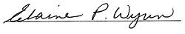

Signed:

-24-

Exhibit 17


April 23, 2018

By Hand Delivery

Wynn Resorts, Limited

Attn: Kim Sinatra, Executive Vice President, General Counsel and Secretary

3131 Las Vegas Boulevard South

Las Vegas, NV 89109

Re: Stockholder List Use Request Pursuant to Rule 14a-7 under the Securities Exchange Act of 1934, as amended

Dear Ms. Sinatra:

The undersigned stockholder, Elaine P. Wynn (the “Stockholder”), with a business address of 3800 Howard Hughes Parkway, Suite 960, Las Vegas, Nevada 89169, is the record owner of 9,539,077 shares (the “Shares”) of the Common Stock, par value $0.01 per share (the “Common Stock”), of Wynn Resorts, Limited, a Nevada corporation (the “Company”). The Stockholder intends to conduct a solicitation of proxies (the “Proxy Solicitation”) from the Company’s stockholders in connection with the 2018 Annual Meeting of Stockholders of the Company and at any adjournments, postponements and continuations thereof or at any other meeting of stockholders held in lieu thereof (the “Annual Meeting”).

Pursuant to Rule 14a-7 under the Securities Exchange Act of 1934, as amended (the “Exchange Act”), the Stockholder hereby requests that the Company provide to her the Company’s stockholder list and security position listings for the purpose of disseminating solicitation materials to the holders of the Common Stock. Unless specifically indicated otherwise, all references to “Rule” in this letter shall refer to the applicable “rule” promulgated under the Exchange Act.

For purposes of communicating the Company’s election under Rule 14a-7(b)(2) to comply with either paragraph (a)(2)(i) or paragraph (a)(2)(ii) of Rule 14a-7, please contact Kai Haakon E. Liekefett of Sidley Austin LLP, by hand delivery or mail at 787 Seventh Avenue, New York, New York 10019, by electronic mail to kliekefett@sidley.com, by telephone at (212) 839-8744, or by facsimile at (212) 839-5599. If the Company believes that this request is incomplete or otherwise deficient in any respect, please contact Mr. Liekefett immediately so that the Stockholder may promptly address any alleged deficiencies.

The Company is required by Rule 14a-7(a)(1) to deliver to the Stockholder within five (5) business days after receipt of this letter the following information:

- Notification of the Company’s election under Rule 14a-7(b)(2) as to whether the Company has elected to mail the solicitation materials or furnish the Stockholder with a stockholder list;

- A statement of the approximate number of record holders and beneficial holders of the Common Stock, separated by type of holder; and

Wynn Resorts, Limited

April 23, 2018

Page 2

- The estimated cost of mailing a proxy statement, form of proxy or other communication to such holders, including to the extent known or reasonably available, the estimated costs of any bank, broker and similar person through whom the registrant has solicited or intends to solicit beneficial owners in connection with the 2018 Annual Meeting.

If the Company elects to mail the solicitation materials pursuant to Rule 14a-7(a)(2)(i), the Company is required to, among other things, send copies of any proxy statement, form of proxy, or other soliciting material, furnished by the Stockholder to the record holders of the Common Stock, including banks, brokers, and similar entities. A sufficient number of copies must be sent to banks, brokers and similar entities for distribution to all beneficial owners of the Common Stock. The Company shall send the aforementioned solicitation materials with reasonable promptness after the Stockholder’s tender of such materials to be sent, envelopes or other containers therefor, postage or payment for postage and other reasonable expenses of effecting such distribution.

If the Company elects to provide the Stockholder with a stockholder list pursuant to Rule 14a-7 (a)(2)(ii), the Company is required to deliver the following information to the Stockholder no later than five (5) business days after receipt of this letter:

- A reasonably current list of the names, addresses and security positions of the record holders of the Common Stock, including banks, brokers and similar entities;

- The most recent list of names, addresses and security positions of beneficial owners as specified in Rule 14a-13(b), in the possession, or which subsequently comes into the possession, of the Company;

- The names of stockholders at a shared address that have consented to delivery of a single copy of proxy materials to a shared address, if the Company has received written or implied consent in accordance with Rule 14a-3(e)(1); and

- If the Company has relied on Rule 14a-16, the names of the stockholders who have requested paper copies of the proxy materials for all meetings and the names of stockholders who, as of the date that the Company receives the request, have requested paper copies of the proxy materials only for the meeting to which the solicitation relates.

This information should be in the format normally used by the Company for providing such information to its proxy solicitor, accompanied by a printout of the information and any instructions as are necessary to make use of such information. The Company shall furnish the Stockholder with updated record holder information on a daily basis or, if not available on a daily basis, at the shortest reasonable intervals. However, the Company need not provide beneficial or record holder information more current than the record date for the Annual Meeting.

Pursuant to Rule 14a-7(c)(1), the Stockholder is the record holder of 9,539,077 shares of Common Stock, representing approximately 9.24% of the outstanding shares of Common Stock. Enclosed as Exhibit A please find copies of her share certificates. The Stockholder is aware of and will comply with her obligations under Rules 14a-7(d) and 14a-(7)(e).

Wynn Resorts, Limited

April 23, 2018

Page 3

Attached hereto as Exhibit B is the declaration required by Rule 14a-7(c)(2) of the Exchange Act containing the attestations required by Rule 14a-7(c)(2)(i) and Rule 14a-7(c)(2)(ii).

Please acknowledge receipt of this letter and the enclosures by signing and dated the enclosed copy of this letter and returning it to the Stockholder in the enclosed envelope.

Very truly yours,

/s/ Elaine P. Wynn

Elaine P. Wynn

- Kai H. Liekefett, Esq. Sidley Austin LLP

EXHIBIT A

A-1

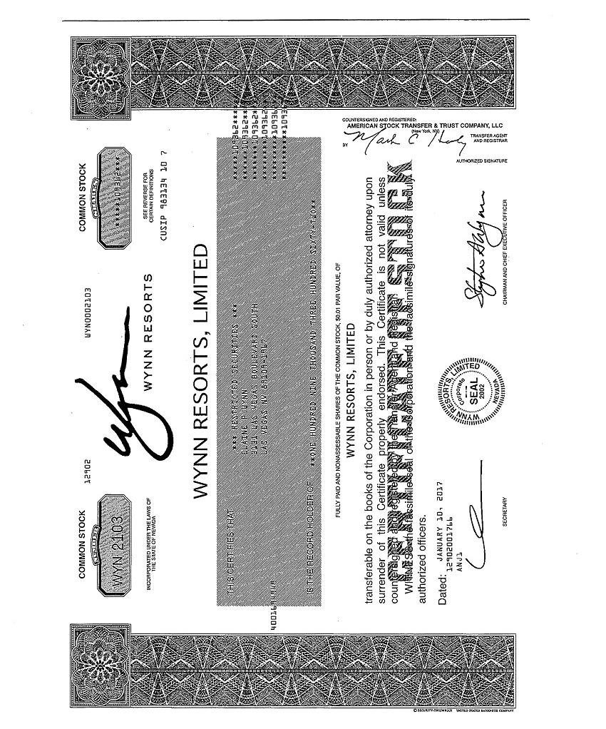

A-2

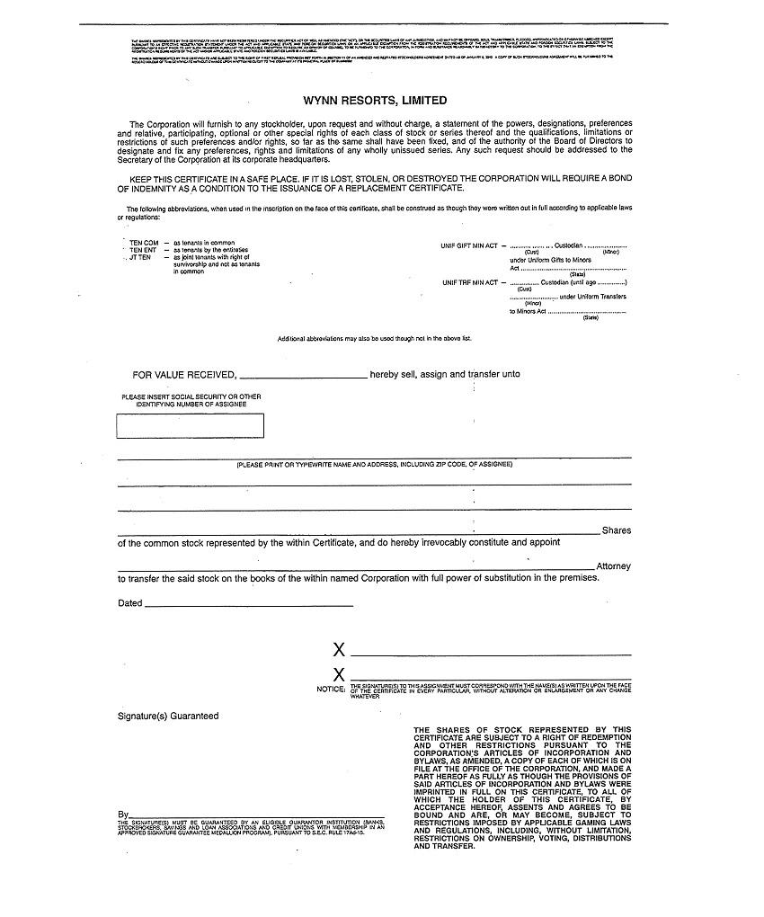

A-3

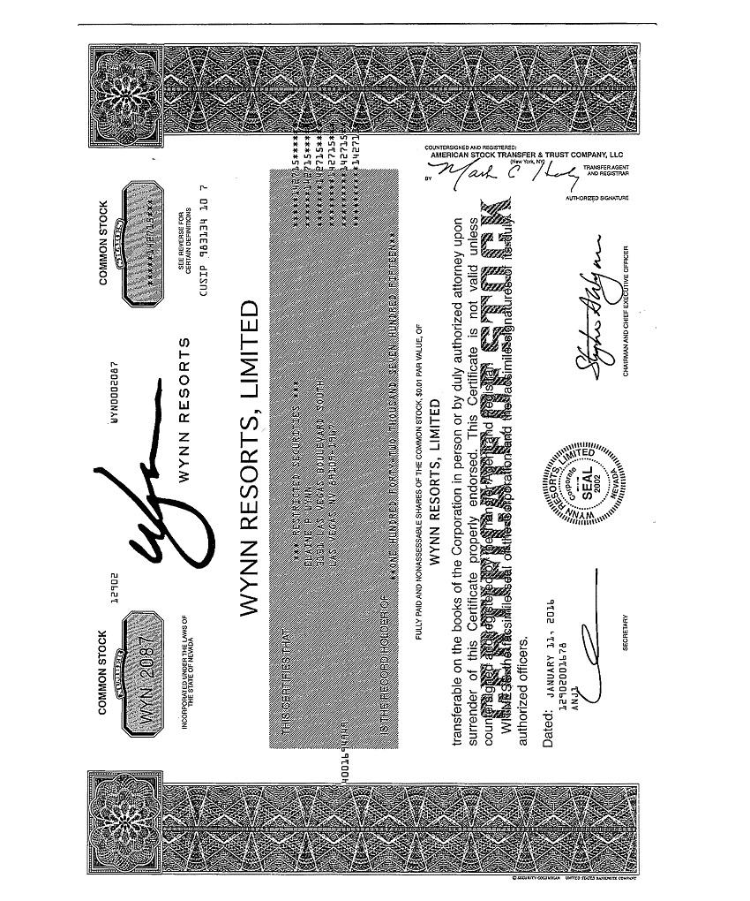

A-4

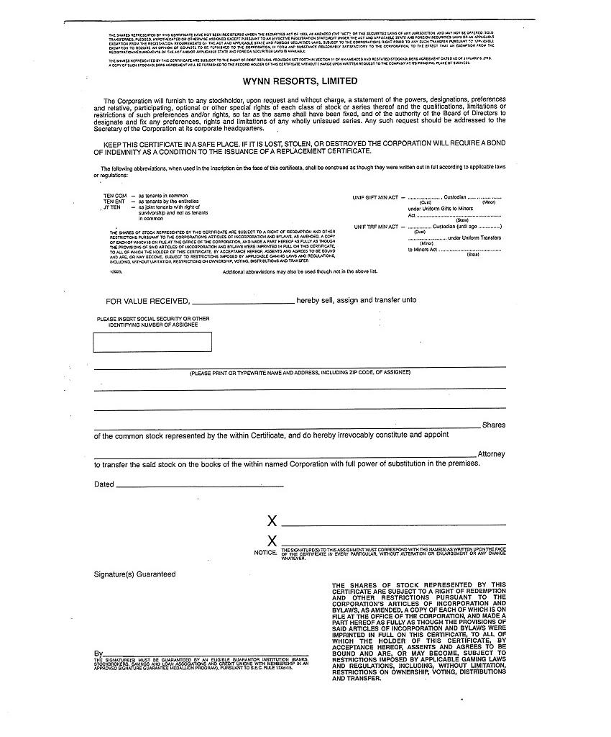

A-5

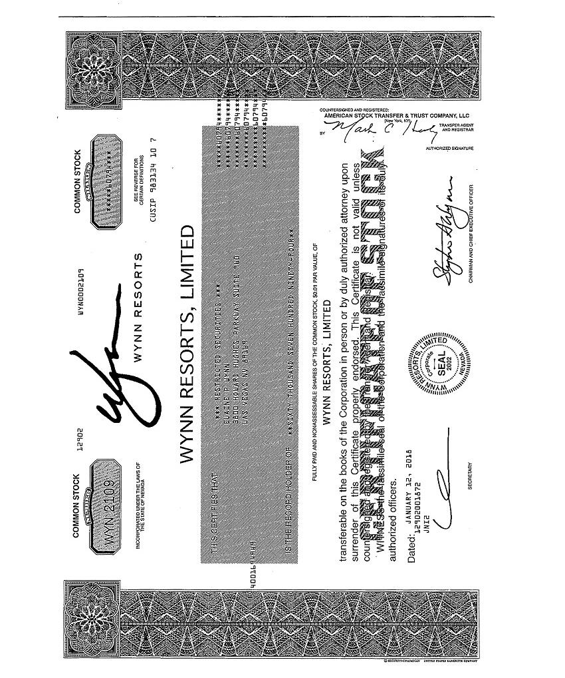

A-6

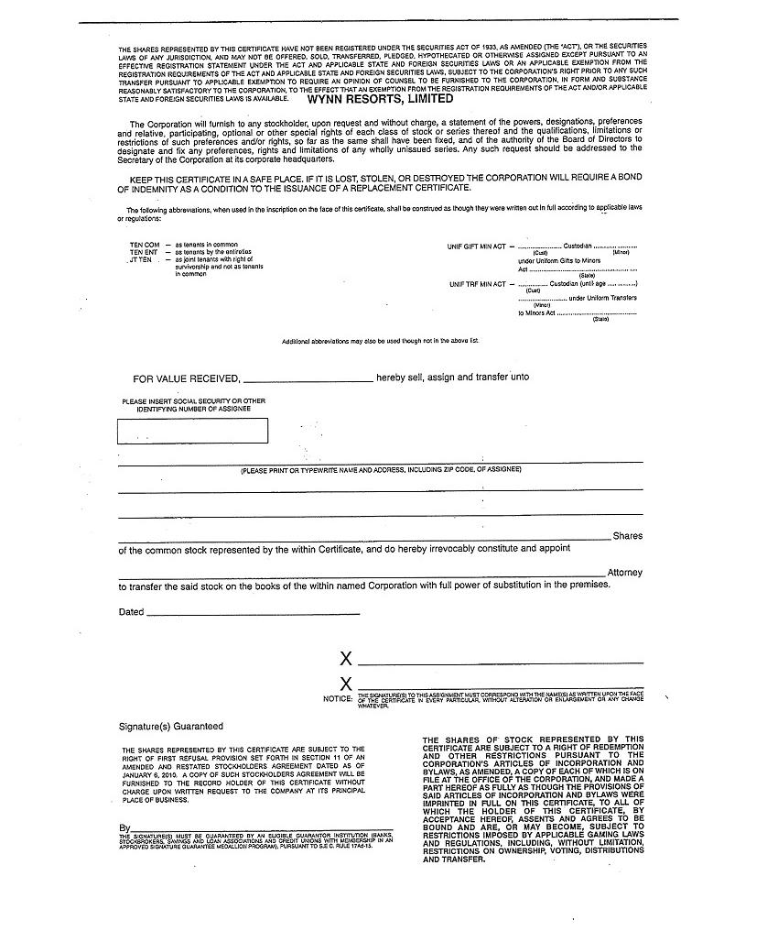

A-7

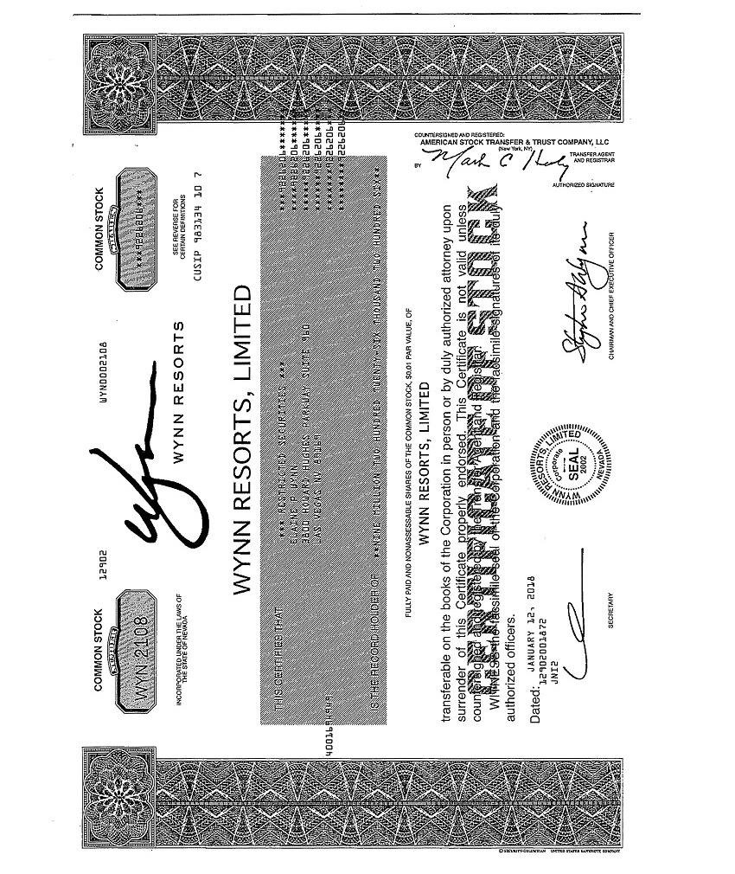

A-8

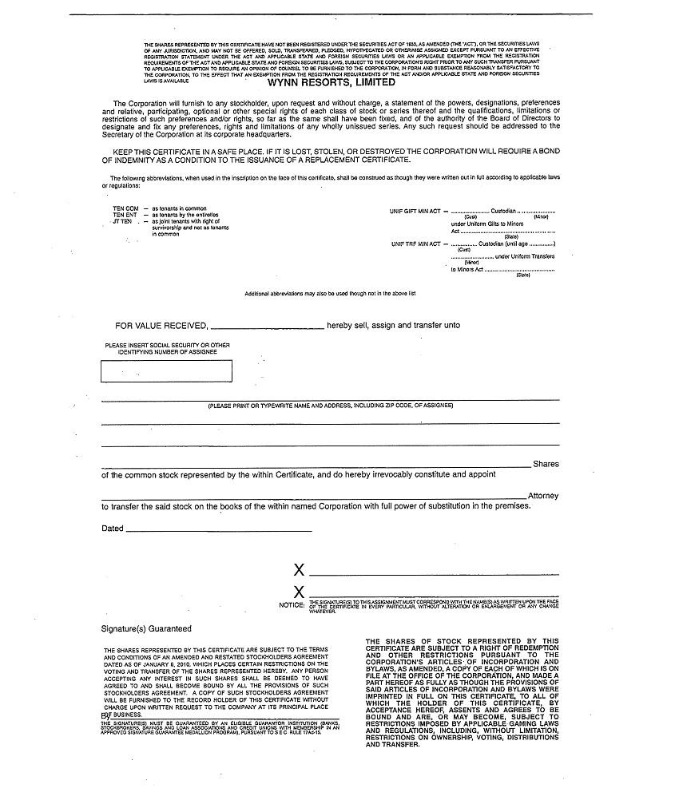

A-9

EXHIBIT B

DECLARATION

STATE OF NEVADA COUNTY OF CLARK

)

) ss:

)

Elaine P. Wynn (the “Stockholder”), being duly sworn, deposes and says under oath:

- The Stockholder intends to solicit proxies (the “Proxy Solicitation”) from the holders of shares of common stock, $0.01 par value per share, of Wynn Resorts, Limited, a Nevada corporation (the “Company”), with respect to the proposals to be voted on at the 2018 Annual Meeting of Stockholders of the Company and any adjournments, postponements, reschedulings or continuations thereof or any meeting of stockholders held in lieu thereof (the “Annual Meeting”);

- The Stockholder further states that the security holder list information (the “List Information”) that will be provided by the Company to the Stockholder pursuant to the Stockholder’s letter of request dated April 23, 2018 and made pursuant to Rule 14a-7 of the Securities Exchange Act of 1934, as amended (the “Exchange Act”), will not be used for any purpose other than to solicit the Company’ stockholders with respect to the Annual Meeting or action by written consent or authorization for which the Company is soliciting or intends to solicit or to communicate with stockholders with respect to a solicitation commenced by the Company; and

- The Stockholder will not disclose the List Information to any person other than an employee or agent of the Stockholder to the extent necessary to effectuate the communication or Proxy Solicitation.

B-1

This declaration is being made pursuant to Rule 14a-7(c)(2) under the Exchange Act.

/s/ Elaine P. Wynn

Elaine P. Wynn

SWORN TO AND SUBSCRIBED before me

this 23rd day of April, 2018.

Notary Public

B-2

Exhibit 18

SIDLEY AUSTIN LLP
787 SEVENTH AVENUE
NEW YORK, NY 10019
+1 | 212 839 5300
+1 | 212 839 5599 FAX | KLIEKEFETT@SIDLEY.COM
AMERICA ● ASIA PACIFIC ● EUROPE |  | +1 212 839 8744


Via EDGAR and Federal Express

April 23, 2018

U.S. Securities and Exchange Commission

Division of Corporate Finance

100 F Street, N.E.

Washington, DC 20549

Re:

Wynn Resorts, Limited

Request to Shorten Preliminary Proxy Statement Review Period for Good Cause

Ladies and Gentlemen:

Our client, Elaine P. Wynn, filed this morning a preliminary proxy statement in respect of the 2018 Annual Meeting (the “Annual Meeting”) of Wynn Resorts, Limited (the “Company”). We respectfully request that the staff (the “Staff”) of the Division of Corporation Finance of the Securities and Exchange Commission (the “Commission”) shorten the ten-day review period for a preliminary proxy statement provided for by Rule 14a-6 of Regulation 14A promulgated under the Section 14 of the Securities Exchange Act of 1934, as amended.

Rule 14a-6 allows the Commission to authorize a shorter review period upon a showing of good cause. Good cause exists because the Company’s compressed annual meeting timeline forces shareholders to vote in accordance with the Company’s position without an opportunity to consider Ms. Wynn’s proposals.

Ms. Wynn wrote to the Company’s board on April 17, 2018 to express her concerns about the board composition and request that the Company reopen the director nomination window so that she could nominate an alternate slate of directors for the Annual Meeting. One day later the Company filed its definitive proxy statement for the Annual Meeting. In its proxy statement, the Company disregarded Ms. Wynn’s stated intent to nominate an alternative slate of directors and disclosed May 16, 2018 as the date for the Annual Meeting—only 28 days later. In the past, the Company has given its shareholders notice of its annual meeting 42 days (in 2017) and 41 days (in 2016 and 2015) in advance. This significantly shortened timeframe severely curtails Ms. Wynn’s ability solicit proxies from her fellow shareholders as well as limits shareholders’ ability to make an informed voting decision at the Annual Meeting. The Staff would mitigate this issue by allowing Ms. Wynn to file a definitive proxy statement as soon as possible.

Ms. Wynn thanks the Commission for its time and consideration.

Please direct any questions that you may have with respect to the foregoing or any requests for supplemental information to Kai Haakon E. Liekefett at (212) 839-8744 or kliekefett@sidley.com.

Sincerely,

/s/ Kai Haakon E. Liekefett

Kai Haakon E. Liekefett

- Elaine P. Wynn

Sidley Austin (NY) LLP is a Delaware limited liability partnership doing business as Sidley Austin LLP and practicing in affiliation with other Sidley Austin partnerships.

