UNITED STATES

SECURITIES AND EXCHANGE COMMISSION
Washington, D.C. 20549

FORM 8-K

CURRENT REPORT

Pursuant to Section 13 or 15(d) of the

Securities Exchange Act of 1934, as Amended

Date of Report (Date of earliest event reported): September 8, 2013

WYNN RESORTS, LIMITED

(Exact name of registrant as specified in its charter)

Nevada | 000-50028 | 46-0484987
(State or other jurisdiction of | (Commission | (IRS Employer
incorporation | File Number) | Identification No.)
3131 Las Vegas Boulevard South
Las Vegas, Nevada |  | 89109
(Address of principal executive offices) |  | (Zip Code)

(702) 770-7555

(Registrant’s telephone number, including area code)

Not Applicable

(Former name or former address, if changed since last report.)

Check the appropriate box below if the Form 8-K filing is intended to simultaneously satisfy the filing obligation of the registrant under any of the following provisions:

- Written communications pursuant to Rule 425 under the Securities Act (17 CFR 230.425)

- Soliciting material pursuant to Rule 14a-12 under the Exchange Act (17 CFR 240.14a-12)

- Pre-commencement communications pursuant to Rule 14d-2(b) under the Exchange Act (17 CFR 240.14d-2(b))

- Pre-commencement communications pursuant to Rule 13e-4(c) under the Exchange Act (17 CFR 240.13e-4(c))

Item 7.01. Regulation FD Disclosure.

On September 8, 2013, Wynn Macau, Limited (“WML”), an indirect subsidiary of Wynn Resorts, Limited (the “Registrant”) with its ordinary shares listed on The Stock Exchange of Hong Kong Limited (the “HKSE”), filed its interim report in respect of the six months ended June 30, 2013 (the “Interim Report”) with the HKSE, as required by HKSE listing rules. The Registrant owns approximately 72.3% of WML’s ordinary shares. The Interim Report is furnished herewith as Exhibit 99.1. The information in this Form 8-K and Exhibit 99.1 attached hereto shall not be deemed “filed” for purposes of Section 18 of the Securities Exchange Act of 1934, as amended, nor shall it be deemed incorporated by reference in any filing under the Securities Act of 1933, as amended, except as shall be expressly set forth by specific reference in such filing.

Item 9.01. Financial Statements and Exhibits

- Exhibits.

Exhibit No. |  | Description
99.1 |  | Interim Report of Wynn Macau, Limited in respect of the six months ended June 30, 2013.
 | 2

SIGNATURES

Pursuant to the requirements of the Securities Exchange Act of 1934, as amended, the Registrant has duly caused this report to be signed on its behalf by the undersigned hereunto duly authorized.

 | WYNN RESORTS, LIMITED
Date: September 9, 2013 | By: | /s/ Matt Maddox
 | Name: | Matt Maddox
 | Title: | Chief Financial Officer and Treasurer

 |  |  | EXHIBIT INDEX
Exhibit No. |  | Description
99.1 |  | Interim Report of Wynn Macau, Limited in respect of the six months ended June 30, 2013.

Exhibit 99.1
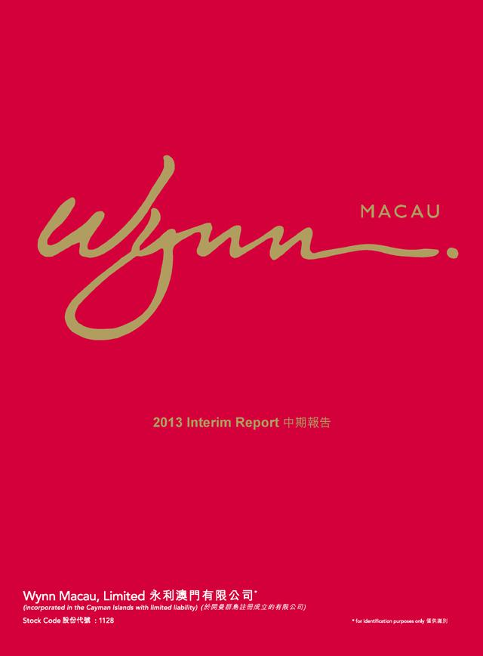

2013 Interim Report



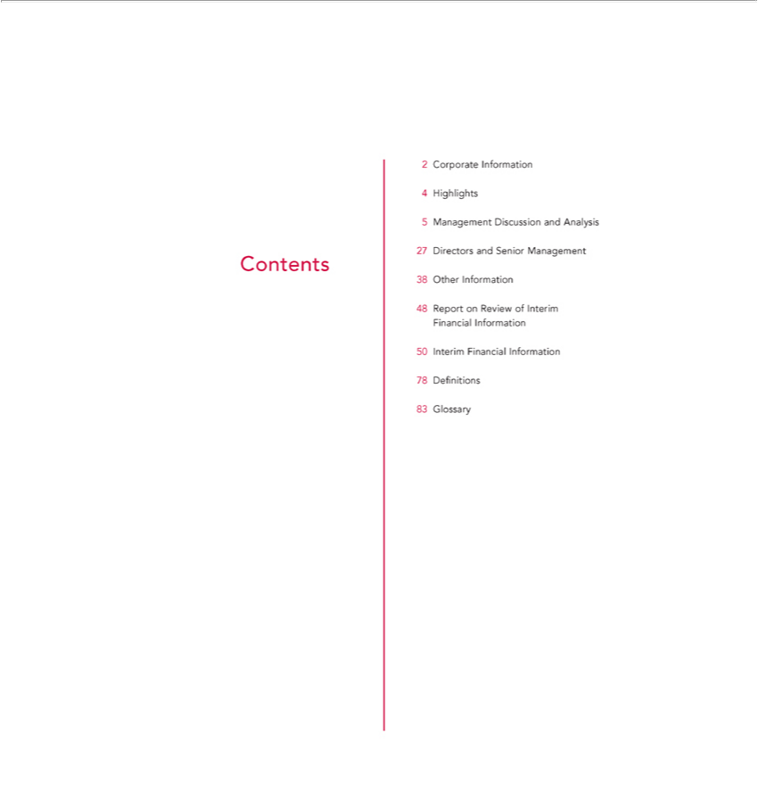

Contents
2 | Corporate Information
4 | Highlights
5 | Management Discussion and Analysis
27 | Directors and Senior Management
38 | Other
48 | ReportInformationReview of Interim Financial Information
50 | Interim Financial Information
78 | Definitions
83 | Glossary

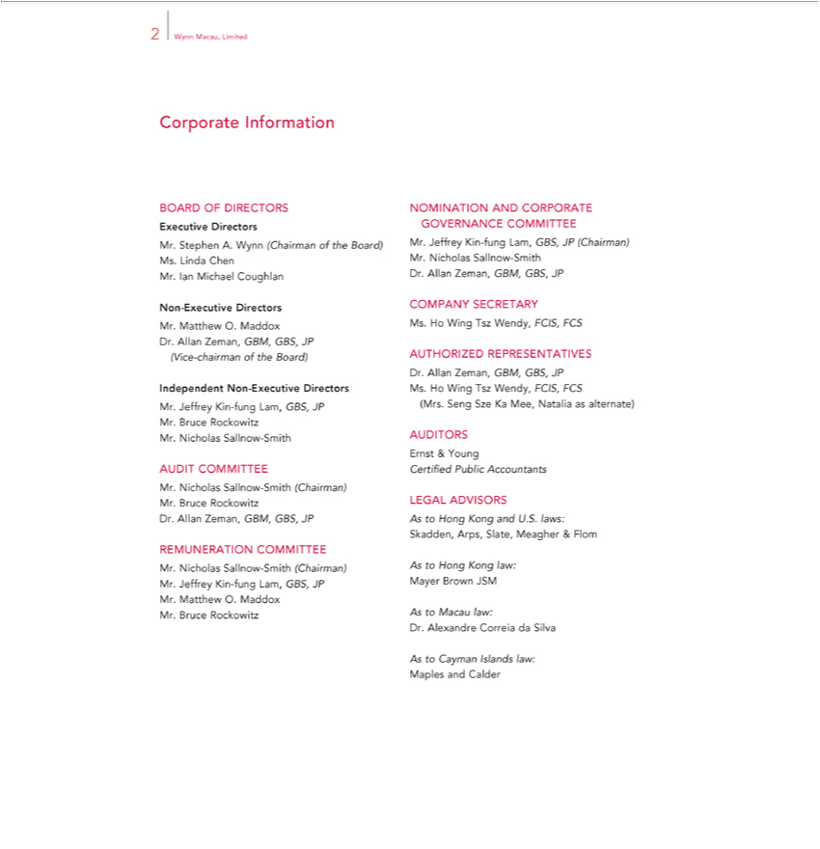

Corporate2WynnInformationMacau, Limited
ExecutiveBOARDOFDirectorsDIRECTORS
^{Mrs}. Stephen A. Wynn (Chairman of the Board)
. Linda Chen
Non.Ian-ExecutiveMichaelDirectorsCoughlan
IndependentMr.MatthewNonO.Maddox-ExecutiveDr.DirectorsAllanZeman, GBM, GBS, JP (Vice-chairman of the Board)
Mr. Jeffrey Kin-fung Lam, GBS, JP Mr. Bruce Rockowitz Mr. Nicholas Sallnow-Smith
AUDIT COMMITTEE

Mr. Nicholas Sallnow-Smith (Chairman) Mr. Bruce Rockowitz Dr. Allan Zeman, GBM, GBS, JP REMUNERATION COMMITTEE
Mr. Nicholas Sallnow-Smith (Chairman) Mr. Jeffrey Kin-fung Lam, GBS, JP Mr. Matthew O. Maddox Mr. Bruce Rockowitz
NOMINATION AND CORPORATE GOVERNANCE COMMITTEE
Mr. Jeffrey Kin-fung Lam, GBS, JP (Chairman) Mr. Nicholas Sallnow-Smith Dr. Allan Zeman, GBM, GBS, JP
Ms. Ho WingSECRETszWendy, FCIS, FCS
COMPANY ARY
AUTHORIZED REPRESENTATIVES
(Mrs.Dr.AllanSengZeman,SzeKaGBM,Mee, GBS,NataliaJPasMs.alternate)HoWing Tsz Wendy, FCIS, FCS
AUDITORS
Ernst & Young
Certified Public Accountants
LEGAL ADVISORS
As to Hong Kong and U.S. laws:
Skadden, Arps, Slate, Meagher & Flom
As to Hong Kong law:
Mayer Brown JSM
As to Macau law:
Dr. Alexandre Correia da Silva
As to Cayman Islands law:
Maples and Calder

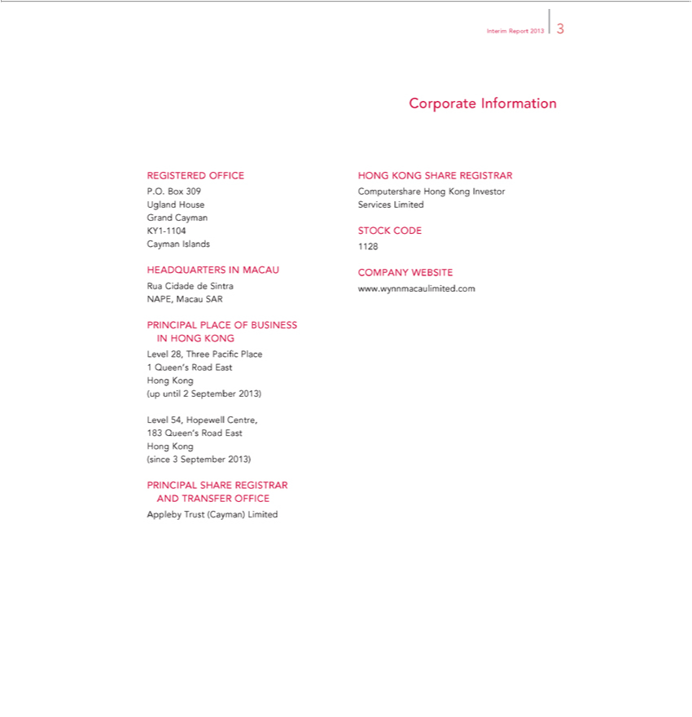

Interim Report 2013 3
Corporate Information
REGISTERED OFFICE
P.O. Box 309 Ugland House Grand Cayman KY1-1104 Cayman Islands
HEADQUARTERS IN MACAU
Rua Cidade de Sintra NAPE, Macau SAR
LevelPRINCIPAL28,ThreePLACEPacificOFPlaceBUSINESS IN HONG KONG
1 Queen’s Road East Hong Kong (up until 2 September 2013)
Level 54, Hopewell Centre, 183 Queen’s Road East Hong Kong (since 3 September 2013)
ApplebyPRINCIPALTrustSHARE(Cayman)REGISTRARLimited AND TRANSFER OFFICE
ComputershareHONGKONG SHAREHongKongREGISTRARInvestorServices Limited
1128STOCK CODE

COMPANY WEBSITE www.wynnmacaulimited.com

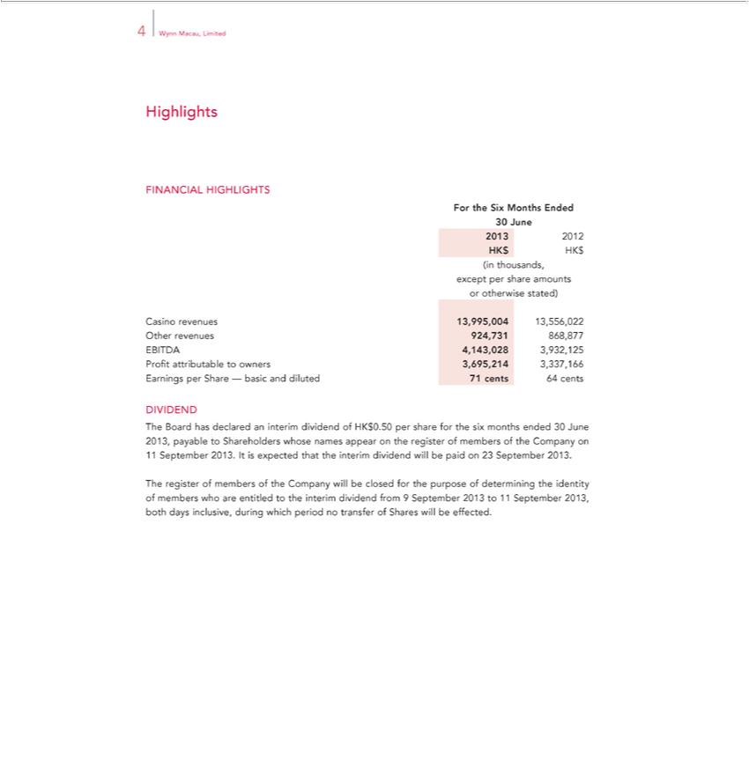

Highlights4Wynn Macau, Limited
^{For}INANCIAL HIGHLIGHTS
₂₀₁₃30Junethe Six Months Ended
2012 HK$ HK$ (in thousands, except per share amounts or otherwise stated)

Casino revenues 13,995,004 13,556,022 Other revenues 924,731 868,877 EBITDA 4,143,028 3,932,125 Profit attributable to owners 3,695,214 3,337,166 Earnings per Share — basic and diluted 71 cents 64 cents
DIVIDEND

The Board has declared an interim dividend of HK$0.50 per share for the six months ended 30 June 2013, payable to Shareholders whose names appear on the register of members of the Company on 11 September 2013. It is expected that the interim dividend will be paid on 23 September 2013.
The register of members of the Company will be closed for the purpose of determining the identity of members who are entitled to the interim dividend from 9 September 2013 to 11 September 2013, both days inclusive, during which period no transfer of Shares will be effected.

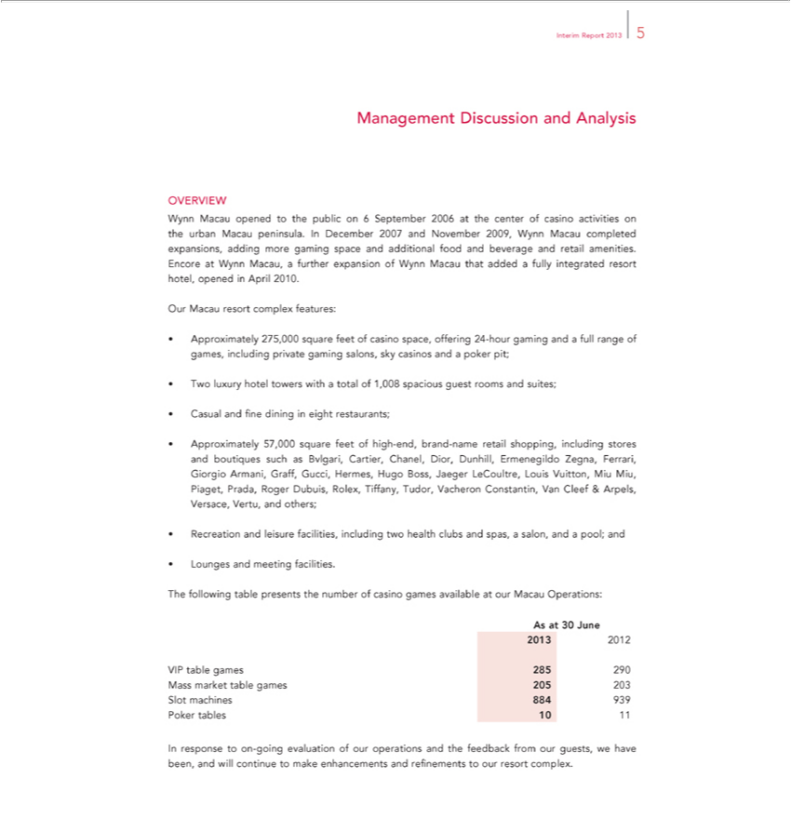

Interim Report 2013 5
Management Discussion and Analysis
OVERVIEW |  | Macau peninsula. In December 2007 and November 2009, Wynn Macau completed expansions, adding
Wynn Macau opened to the public on 6 September 2006 at the center of casino activities on the
more gaming space and additional food and beverage and retail amenities. Encore at Wynn Macau,urbanfurther expansion of Wynn Macau that added a fully integrated resort hotel, opened in April 2010.
Our Macau resort complex features:
• Approximately 275,000 square feet of casino space, offering 24-hour gaming and a full range of games, including private gaming salons, sky casinos and a poker pit;
• Two luxury hotel towers with a total of 1,008 spacious guest rooms and suites;
• Casual and fine dining in eight restaurants; |  |  | Cartier, Chanel, Dior Dunhill, Ermenegildo Zegna, Ferrari, Giorgio Armani,
• Approximately 57,000 square feet of high-end, brand-name retail shopping, including stores and boutiques such as
Graff, Gucci, Hermes, Hugo Boss, Jaeger LeCoultre, Louis Vuitton, Miu Miu, | Prada, Roger Dubuis, Rolex, Bvlgari,Tiffany Tudor, Vacheron Constantin, Van Cleef & Arpels, Versace, Vertu, and others;
• Recreation and leisure facilities, including two health clubs and spas, a salon, andPiaget,pool; and
• Lounges and meeting facilities.
AsTheatfollowing30June2013table 2012presents the number of casino games available at our Macau Operations:
VIP table games 285 290 Mass market table games 205 203 Slot machines 884 939 Poker tables 10 11
In response to on-going evaluation of our operations and the feedback from our guests, we have been, and will continue to make enhancements and refinements to our resort complex.

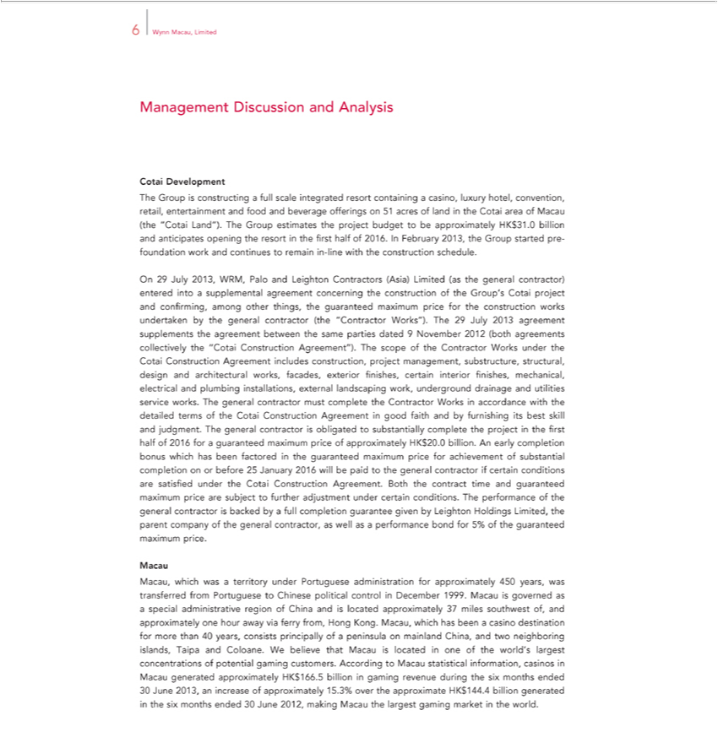

6 | Wynn Macau, Limited
Management Discussion and Analysis
Cotai Development
The Group is constructing a full scale integrated resort c ntaining casino, luxury hotel, convention, retail, entertainment and food and beverage offerings on 51 acres of land in the Cotai area of Macau (the
“Cotai Land”). The Group estimates the project budget to be approximately HK$31.0 billion and anticipates opening the resort in the first half of 2016. In February 2013, the Group started pre-foundation work
and continues to remain in-line with the construction schedule.
On 29 July 2013, WRM, P lo and Leighton Contractors (Asia) Limited (as the general contractor) entered into supplemental agreement concerning the construction of the Group’ Cotai project and confirming,
among other things, the guaranteed maximum price for the construction works undertaken by the general contractor (the “Contractor Works”). The 29 July 2013 agreement supplements the agreement between
the same parties dated 9 November 2012 (both agreements collectively the “Cotai Construction Agreement”). The scope of the Contractor Works under the Cotai Construction Agreement includes construction,
project management, substructure, structural, design and architectural works, facades, exterior finishes, certain interior finishes, mechanical, electrical and plumbing installations, external landscaping work,
underground drainage and utilities service works. The general contractor must complete the Contractor Works in accordance with the |  |  |  | terms of the Cotai Construction Agreement in good faith and by
furnishing its best skill and judgment. The general contractor is obligated to substantially complete the project in the first half of 2016detailedguaranteed maximum price of approximately HK$20.0 billion. An
early completion bonus which has been factored in the guaranteed maximum price for achievement of substantial completion on or before 25 Jan ary 2016 will be paid to the general contractor if certain
 | ditions are satisfied under the Cotai Construction Agreement. Both the contract time and guaranteed maximum price are subject further |  |  | under certain conditions. The performance of the general
contractor is backed by a full completion guarantee given by Leighton Holdings Limited, the parent company of the general contractor, as welladjustmentasperformance bond for 5% of the guaranteed maximum price.
Macau, which was a territory under Portuguese administration for approximately 450 years, was transferred from Portuguese to Chinese political control in December 1999. Macau is governed as a special
administrative region of |  | and is located approximately 37 miles southwest of, | approximately one hour away via ferry from, Hong Kong. Macau, which has been a casino destination for more than 40
years, consists principallyChinaof peninsula on mainland China, and two neighboring islands, Taipa and Coloane. We believe that Macau is located in one of the world’s largest concentrations of potential gaming customers. According to Macau_{approximately}statsticalinformation, casinos in Macau generated approximately HK$166.5 billion in gaming revenue during the six months ended
30 June 2013, an increase of 15.3% over the approximate HK$144.4 billion generated in the six months ended 30 June 2012, making Macau the largest gaming market in the world.

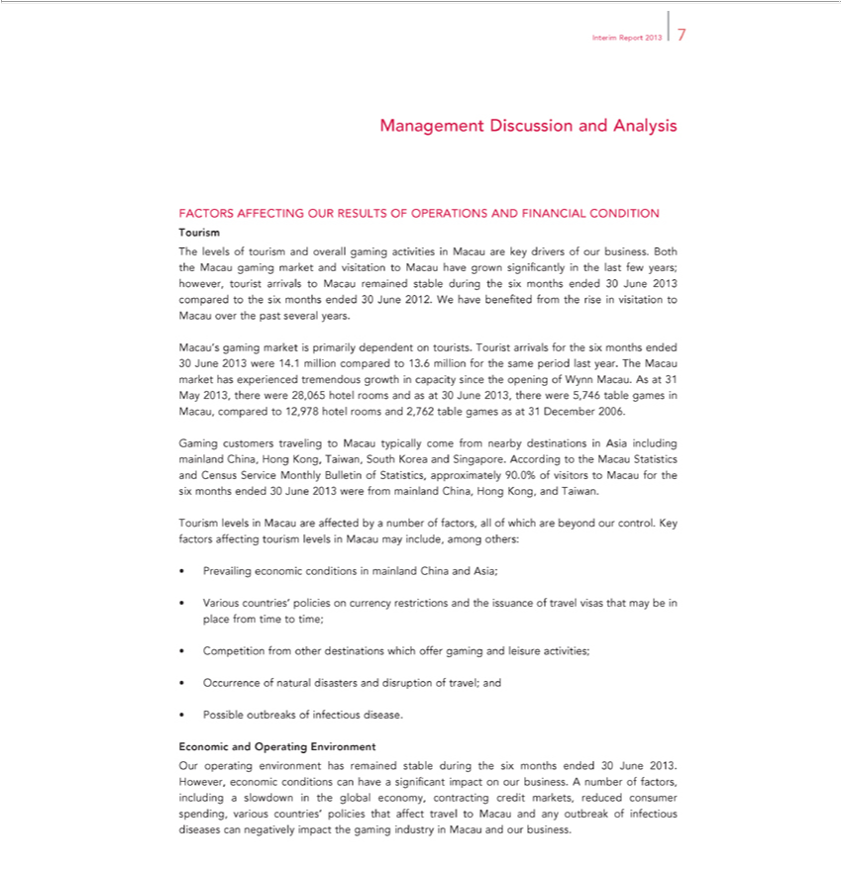

Interim Report 2013 7
Management Discussion and Analysis
FACTORS AFFECTING OUR RESULTS OF OPERATIONS AND FINANCIAL CONDITION
ourism | and overall gaming activities in Macau are key drivers of our business. Both the Macau gaming market and visitation to Macau have grown significantly in the last few years; howev ,
The levels of
tourist arrivalstourismMacau remained stable during the six months ended 30 June 2013 compared to the six months ended 30 June 2012. We have benefited from the rise in visitation to Macau over the past several
years.
Macau’s gaming market is primarily dependent on tourists. Tourist arrivals for the six months ended
30 June 2013 were 14.1 million compared to 13.6 million for the same period last year. The Ma au market has experienced tremendous growth in capacity since the opening of Wynn Macau. As at 31 May 2013,
there were 28,065 hotel rooms and as at 30 June 2013, there were 5,746 table games in Macau, compared to 12,978 hotel rooms and 2,762 table games as at 31 December 2006.
Gaming customers traveling to Macau typically come from nearby destinations in Asia including mainland China, Hong Kong, Taiwan, South Korea and Singapore. According to the Macau Statistics and Census
Service Monthly Bulletin of Statistics, approximately 90.0% of visitors to Macau for the six months ended 30 June 2013 were from |  | China, Hong Kong, and Taiwan.
Tourism levels in Macau are affected by number of factors, all of which are beyond our control. Key factors affecting tourism levelsmainlandMacau may include, among others:
• Prevailing economic conditions in mainland China and Asia;
• Various countries’ policies on currency restrictions and the issuance of travel visas that may be in place from time to time;
• Competition from other destinations which offer gaming and leisure activities;
• Occurrence of natural disasters and disruption of travel; and
• Possible outbreaks of infectious disease.
Economic and Operating Environment |  | significant impact on our business. A number of factors, including
Our | environment has remained stable during the six months ended 30 June 2013. However, economic conditions can have
slowdownoperatingthe global economy, contracting credit markets, reduced consumer spending, various countries’ policies that affect travel to Macau and any outbreak of infectious diseases can negatively impact the gaming industry in Macau and our business.

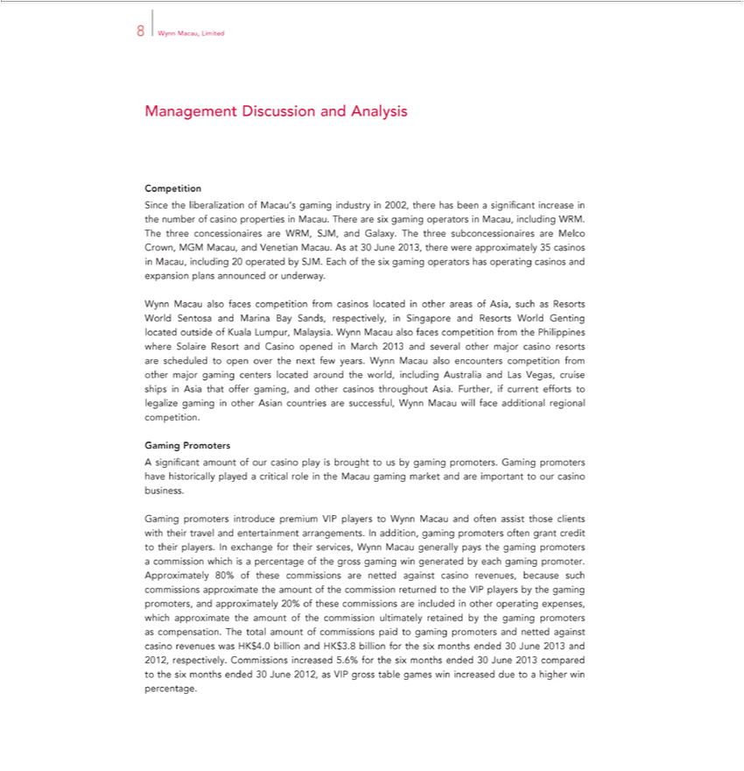

8 | Wynn Macau, Limited
Management Discussion and Analysis
Competition |  | increase in the number of casino properties in Macau. There are six gaming operators in Macau, including WRM. The
Since the liberalization of Macau’s gaming industry in 2002, there has been significant
three concessionaires are WRM, SJM, and Galaxy. The three subconcessionaires are Melco Crown, MGM Macau, and Venetian Macau. As at 30 June 2013, there were approximately 35 casinos in Macau,
including 20 operated by SJM. Each of the six gaming operators has operating casinos |  | and expansion plans announced or underway.
Wynn Macau also faces competition from casinos located in other areas of Asia, such |  | as Resorts World Sentosa and Marina Bay Sands, respectively, in Singapore and Resorts World Genting located outside of
Kuala Lumpur, Malaysia. Wynn Macau also faces competition from the Philippines where Solaire Resort and Casino opened March 2013 and several other major |  |  |  | resorts are scheduled to open over the
next few years. Wynn Macau also encounters competition from other major gaming centers located around the world, including Australia and Las Vegas, cruise shipscasinoAsia that offer gaming, and other casinos
throughout Asia. Further, if current efforts to legalize gaming in other Asian countries |  | are successful, Wynn Macau will face additional regional competition.
Gaming Promoters |  | promoters have historically played critical role in the Macau gaming market and are important to our casino business.
A significant amount of our casino play is brought to us by gaming promoters. Gaming
Gaming promoters introduce premium VIP players to Wynn Macau and often assist those clients with their travel |  |  | entertainment arrangements. In addition, gaming promoters often grant credit to their
players. In exchange for their services, Wynn Macau generally pays the gaming |  | promoters commission which is andpercentage of the gross gaming win generated by each gaming promoter. Approximately 80%
of these commissions are netted against casino revenues, because such commissions approximate the amount of the commission returned to the VIP players by the gaming promoters, and approximately 20% of
these commissions are included in other operating expenses, which approximate the amount of the commission ultimately retained by the gaming promoters as compensation. The total amount of commissions
paid to gaming promoters and netted against casino revenues was HK$4. billion and |  | HK$3.8 billion for the six months ended 30 June 2013 and 2012, respectively. Commissions increased 5.6% for the six
months ended 30 June 2013 compared to the six months ended 30 June 2012, as VIP gross table games win increased due to a higher win percentage.

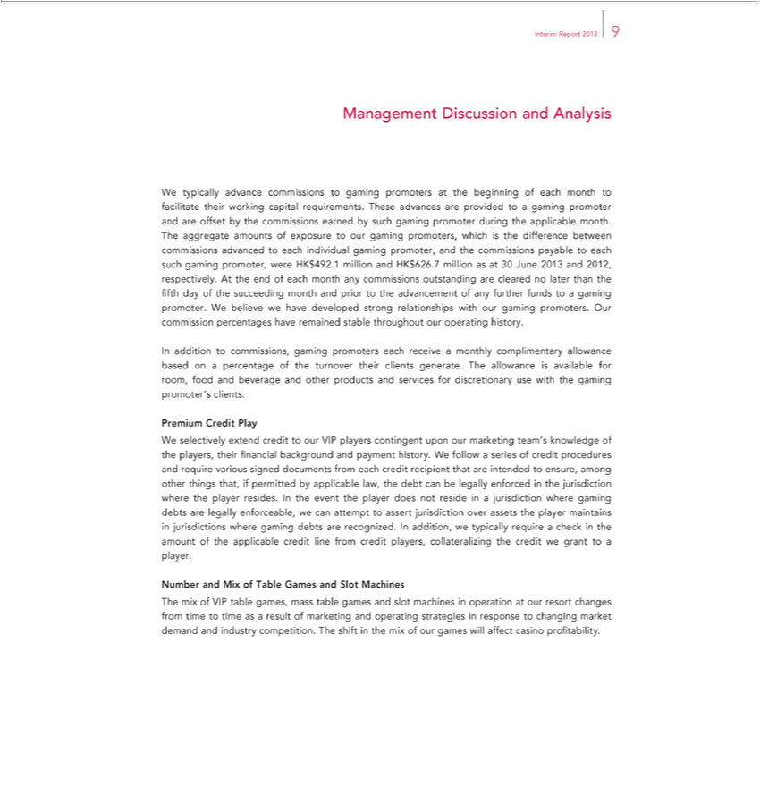

InterimManagementReportDiscussion20139 and Analysis
commissionsWtypically advanceearnedbycommissionssuchgamingtopromotergamingpromotersduringtheatapplicablethebeginningmonth.of Theeachaggregatemonthto amountsfacilitate oftheirexposureworkingto capitalourgamingrequirements.promoters,Thesewhichadvancesisthedifferenceareprovidedbetweentoagamingcommissionspromoteradvancedandaretooffseteach by the individual gaming promoter, and the commissions payable to each such gaming promoter, were HK$492.1 million and HK$626.7 million as at 30 June 2013 and 2012, respectively. At the end of each month any
commissions outstanding are cleared no later than the fifth day of the succeeding month and prior to the advanceme of any further funds to gaming promoter. We believe we have developed strong
Inrelationshipsadditiontowithcommissions,ourgaminggamingpromoters.promotersOurcommissioneachreceivepercentagesmonthly complimentaryhaveremained allowancestablethroughoutbasedonoura percentageoperatinghistory.ofthe turnover their clients generate. The allowance is available for room, food and
beverage and other products and services for discretionary use with the gaming promoter’s clients.
WPremiumselectivelyCreditextendPlay credit to our VIP players contingent upon our marketing team’ensure,knowledge of the players, their financial background and payment historylegally.Wfollow a series of credit procedures and
playerrequireresides.variousInsignedtheeventdocumentstheplayerfromdoeseachnotcreditresiderecipientinajurisdictionthatareintendwheredgamingto debtsamongarelegallyother thingsenforceable,that,ifwepermittedcanattemptbyapplicabletoassert jurisdictionlaw,thedebtovercan assetsbe the enforcedmaintainsthejurisdictioninjurisdictionswherewherethe
gaming debts are recognized. In addition, we typically require a check in the amount of the applicable credit line from credit players, collateralizing the credit we grantplayertoplayer. Number and Mix of Table Games and Slot Machines

The mix of VIP table games, mass table games and slot machines in operation at our resort changes from time to time as a result of marketing and operating strategies in response to changing market demand and industry competition. The shift in the mix of our games will affect casino profitability.

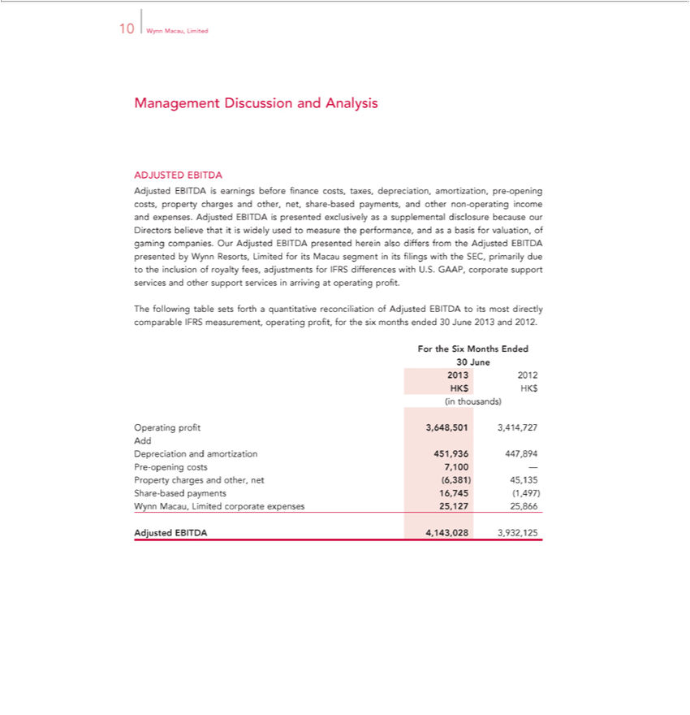

10 Wynn Macau, Limited
Management Discussion and Analysis
DJUSTED EBITDA | other non-operating income and expenses.
earnings before finance costs, taxes, depreciation, amortization, pre-opening costs, property charges and other, net, share-based payments, | other non-operating income and expenses.
_{Adjusted EBITDA} is presented exclusively as a supplemental disclosure because our Directors believe that_{Limited}iswidely used to measure the performance, and as andbasis for valuation, of gaming companies. Our
presented herein also differs from the Adjusted EBITDA presented by Wynn Resorts, for its Macau segment in its filings with the SEC, primarily due to the inclusion of royalty fees, adjustments for IFRS differences with U.S. GAAP, corporate support services and other support services in arriving at operating profit.

The following table sets forth a quantitative reconciliation of Adjusted EBITDA to its most directly comparable IFRS measurement, operating profit, for the six months ended 30 June 2013 and 2012. For the Six Months Ended
₂₀₁₃30June
2012 HK$ HK$ (in thousands)

Operating profit 3,648,501 3,414,727 Add Depreciation and amortization 451,936 447,894 Pre-opening costs 7,100 —Property charges and other, net (6,381) 45,135 Share-based payments 16,745 (1,497) Wynn Macau, Limited corporate expenses 25,127 25,866
Adjusted EBITDA 4,143,028 3,932,125

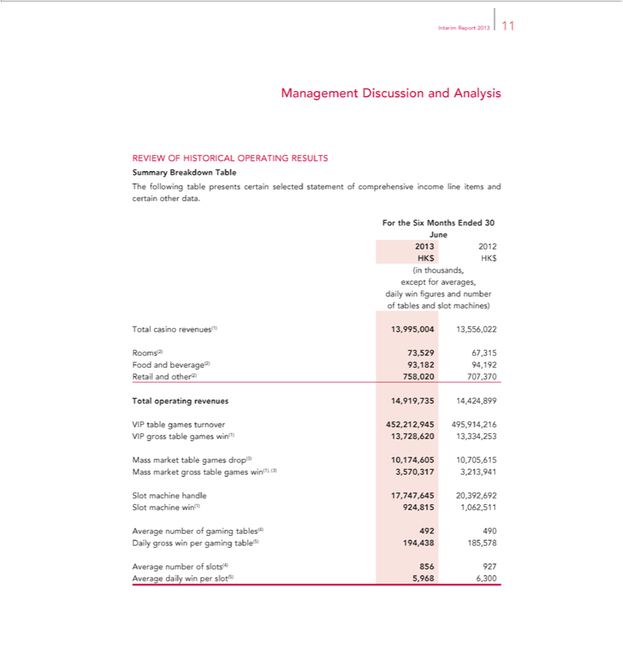

Interim Report 2013 11
Management Discussion and Analysis
SummaryREVIEW OFBreakdownHISTORICALTable OPERATING RESULTS
The following table presents certain selected statement of comprehensive income line items and certain other data.
TotalForthecasinoSixMonthsrevenues(1)Ended13,995,00430June201313,556,0222012HK$ HK$ (in thousands, except for averages, daily win figures and number of tables and slot machines)

Rooms(2) 73,529 67,315 Food and beverage(2) 93,182 94,192 Retail and other(2) 758,020 707,370 Total operating revenues 14,919,735 14,424,899
VIP table games turnover 452,212,945 495,914,216 VIP gross table games win(1) 13,728,620 13,334,253

Mass market table games drop(3) 10,174,605 10,705,615 Mass market gross table games win(1), (3) 3,570,317 3,213,941 Slot machine handle 17,747,645 20,392,692 Slot machine win(1) 924,815 1,062,51^{194,438}

_{Average number of} slots(4)gaming 856tables(4)927Average492490 dailyDailywingrossperwinslot(5)per gaming5,9686,300table(5) 185,578

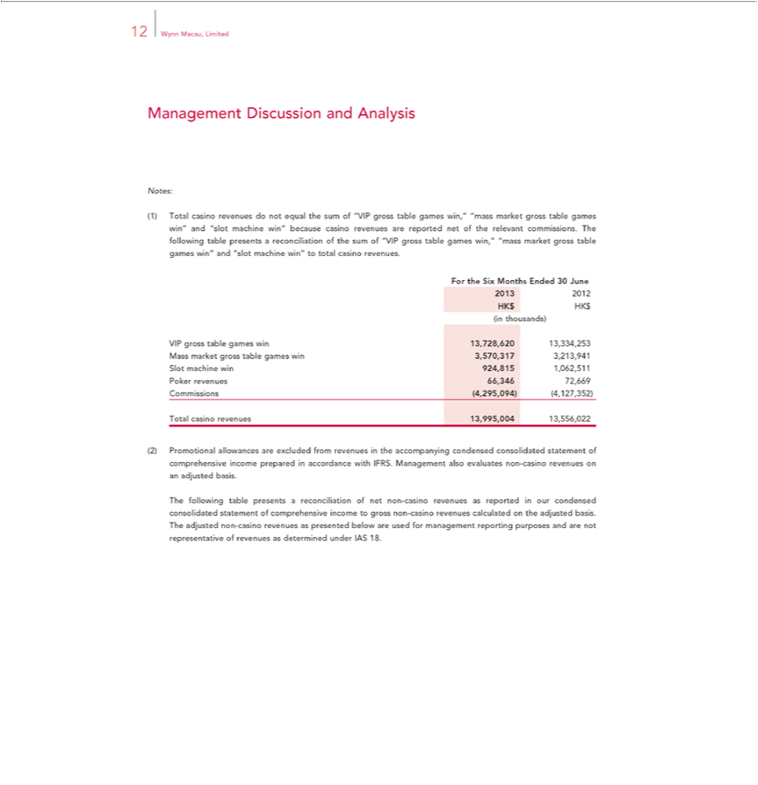

12 Wynn Macau, Limited
Management Discussion and Analysis
Notes:
(1) Total casino revenues do not equal the sum of “VIP gross table games win,” “mass market gross table games win” and “slot machine win” because casino revenues are reported net of the relevant
commissions. The following table presents a reconciliation of the sum of “VIP gross table games win,” “mass market gross table games win” and “slot machine win” to total casino revenues.
For the Six Months Ended 30 June 2013 2012 HK$ HK$ (in thousands)
VIP gross table games win 13,728,620 13,334,253 Mass market gross table games win 3,570,317 3,213,941 Slot machine win 924,815 1,062,511 Poker revenues 66,346 72,669 Commissions
(4,295,094) (4,127,352)
Total casino revenues 13,995,004 13,556,022
(2) Promotional | are excluded from revenues in the accompanying condensed consolidated statement of comprehensive income prepared in accordance with IFRS. Management also evaluates non-
casino revenues onallowances | basis.
The following table presentsadjustedreconciliation of net non-casino revenues as reported in our condensed consolidated statement of comprehensive income to gross non-casino revenues calculated on the adjusted basis. The adjusted non-casino revenues as presented below are used for management reporting purposes and are not representative of revenues as determined under IAS 18.

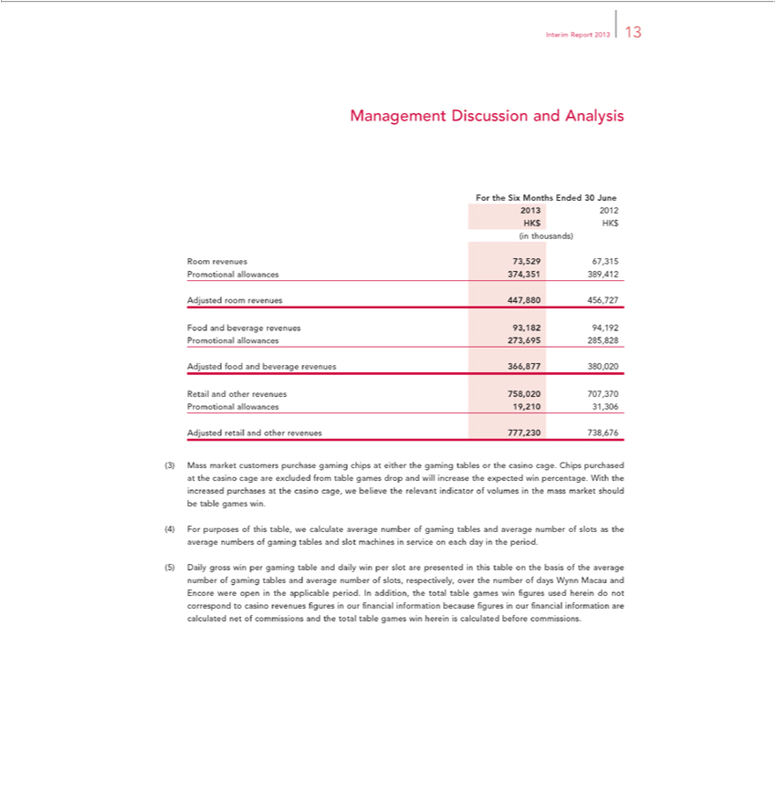

Interim Report 2013 13
Management Discussion and Analysis
For the Six Months Ended 30 June 2013 2012 HK$ HK$ (in thousands)
AdjustedRoomrevenuesroomrevenues73,52967,315447,880Promotional456,727 allowances 374,351 389,412
AdjustedFoodand foodbeverageand beveragerevenues revenues93,18294,192366,877Promotional380,020 allowances 273,695 285,828
AdjustedRetailandretailotherandrevenuesotherrevenues758,020 707,370777,230 Promotional738,676 allowances 19,210 31,306

(3) Mass market customers purchase gaming chips at either the gaming tables or the casino cage. Chips purchased at the casino cage are excluded from table games drop and will increase the expected win percentage. With the increased purchases at the casino cage, we believe the relevant indicator of volumes in the mass market should be table games win.

⁽⁵⁾4) For purposes of this table, we calculate average number of gaming tables and average number of slots as the average numbers of gaming tables and slot machines in service on each day in the period. Daily gross win per gaming table and daily win per slot are presented in this table on the basis of the average number of gaming tables and average number of slots, respectively, over the number of days

Wynn Macau and Encore were open in the applicable period. In addition, the total table games win figures used herein do not correspond to casino revenues figures in our financial information because figures in our financial information are calculated net of commissions and the total table games win herein is calculated before commissions.

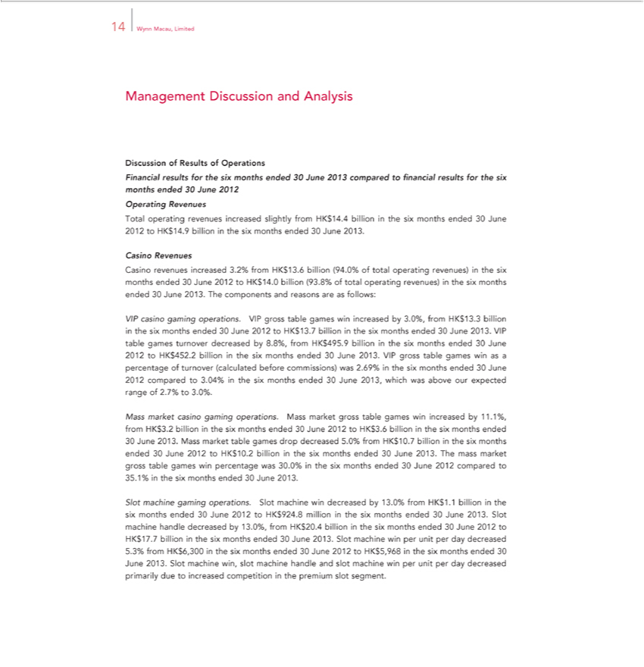

14 Wynn Macau, Limited
Management Discussion and Analysis
Discussion of Results of Operations
Financ al results for the six months ended 30 June 2013 compared to financial results for the six months ended 30 June 2012
Operating Revenues
Total operating revenues increased slightly from HK$14.4 billion in the six months ended 30 June 2012 to HK$14.9 billion in the six months ended 30 June 2013.
Revenues
Casino revenues increased 3.2% from HK$13.6 billion (94.0% of total operating revenues) in the six months ended 30 June 2012 to HK$14.0 billion (93.8% of total operating revenues) in the six months ended
30 June 2013. The components and reasons are as follows: | by 3.0%, from HK$13.3 billion in the six months ended 30 June 2012 to HK$13.7 billion in the six months ended 30 June 2013. VIP table
VIP casino gaming operations. VIP gross table games win
games turnover decreased by 8.8%, from HK$495. billionincreasedthesix months ended 30 June 2012 to HK$452.2 billion in the six months ended 30 June 2013. VIP gross table games win as a percentage of
turnover (calculated before commissions) was 2.69% in the six months ended 30 June |  | compared to .04% in the six months ended 30 June 2013, which was above our expected range of 2.7% to 3.0%.
Mass market casino gaming operations. Mass ma ket gross table games win increased 2012by1.1%, from HK$3.2 billion in the six months ended 30 June 2012 to HK$3.6 billion in the six months ended
30 June 2013. Mass market table games drop decreased 5.0% from HK$10.7 billion in the six months ended 30 June 2 12 to HK$10.2 billion in the six months ended 30 June 2013. The mass market gross table
games win percentage was 30.0% in the six months ended 30 June 2 12 compared to 35.1% in the six months ended 30 June 2013.
Slot machine gaming operations. Slot machine win decreased by 13.0% from HK$1. |  | billion in the six months ended 30 June 2012 to HK$924.8 million the six months ended 30 June 2013. Slot machine
handle decreased by 13.0%, from HK$20.4 billion in the six months ended 30 June 2012 to HK$17.7 billion_{machine}the six months ended 30 June 2013. Slot machine win per unit per day decreased 5.3% from
HK$6,300_{competition}inthesixmonths ended 30 June 2012 to HK$5,968 in the six months ended 30 June 2013. Slot win, slot machine handle and slot machine win per unit per day decreased primarily due to
increased in the premium slot segment.

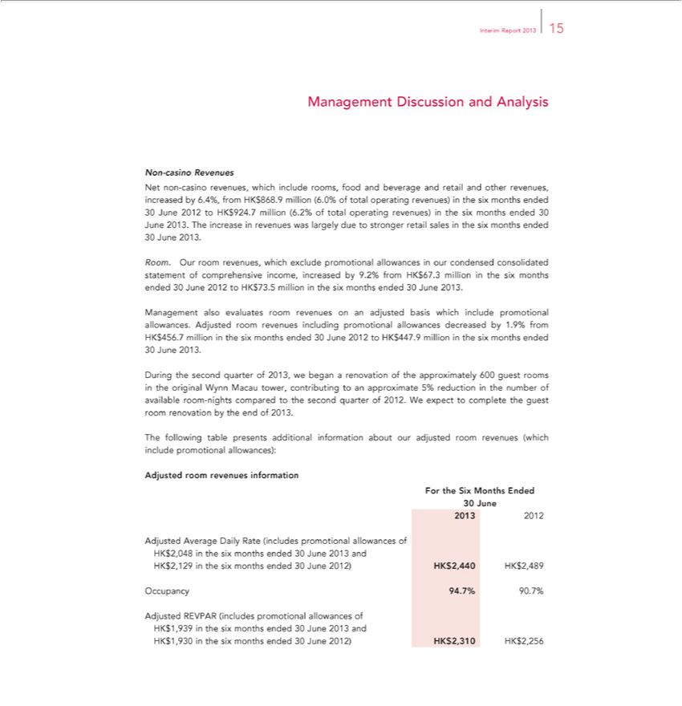

Interim Report 2013 15
^{Net}Managementon-casinoRevenuesDiscussion and Analysis
non-casino revenues, which include rooms, food and beverage and retail and other revenues, increased by 6.4%, from HK$868.9 million (6.0% of ^{total} operating revenues) in the six months ended ^{30 June} ²⁰¹³.to HK$924.7 million (6.2% of total operating revenues) in the six months ended 30 June 2013. The increase in revenues was largely due stronger retail sales in the six months ended

Room. Our room revenues, which exclude promotional allowances in our condensed consolidated statement of comprehensive income, increased by 9.2% from HK$67.3 million in the six months ended 30 June 2012 to HK$73.5 million in the six months ended 30 June 2013.
Management also evaluates room revenues on an adjusted basis which include promotional allowances. Adjusted room revenues including promotional allowances decreased by 1.9% from HK$456.7 million in the six months ended 30 June 2012 to HK$447.9 million in the six months ended
30 June 2013.

During the second quarter of 2013, we began a _{renovation} of the approximately 600 guest rooms in the original Wynn Macau tower, contributing to an approximate 5% reduction in the number of available room-nights compared to the second quarter of 2012. W expect to complete the guest room renovation by the end of 2013.
AdjustedThefollowingroomtablerevenuespresentsinformationadditional information about our adjusted room revenues (which include promotional allowances):
For the Six Months Ended
₂₀₁₃30June
2012

Adjusted Average Daily Rate (includes promotional allowances of HK$2,048 in the six months ended 30 June 2013 and HK$2,129 in the six months ended 30 June 2012) HK$2,440 HK$2,489

Occupancy 94.7% 90.7%

Adjusted REVPAR (includes promotional allowances of HK$1,939 in the six months ended 30 June 2013 and HK$1,930 in the six months ended 30 June 2012) HK$2,310 HK$2,256

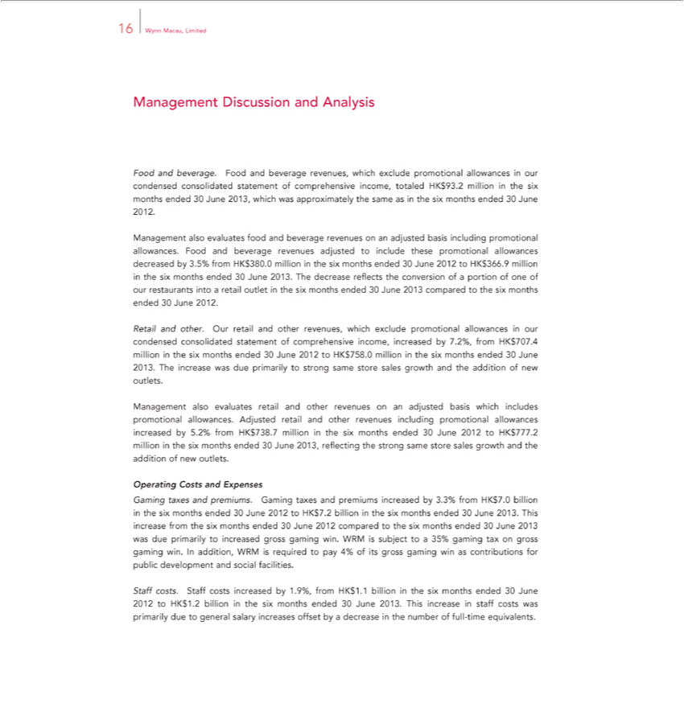

16 Wynn Macau, Limited
FoodManagementandbeverage.DiscussionFoodandandAnalysisbeverage revenues, which exclude promotional allowances in our condensed consolidated statement of comprehensive income, totaled HK$93.2 million in the six months ended
Management30June2013,alsowhichevaluateswasapproximatelyfoodandbeveragethesamerevenuesasintheonsixan monthsadjustedendedbasis 30 June 2012.promotional allowances. Food and beverage revenues adjusted to include these promotional allowances decreased by 3.5%
from HK$380.0 million in the six months ended 30 June 2012 to HK$366.9 millionincludingthe six months ended 30 June 2013. The decrease reflects the conversion of a portion of one of our restaurants into a retail outlet in the six months ended 30 June 2013 compared to the six months ended 30 June 2012.

Retail and other. Our retail and other revenues, which exclude promotional allowances in our condensed consolidated statement of comprehensive income, increased by 7.2%, from HK$707.4 million in the six months ended 30 June 2012 to HK$758.0 million in the six months ended 30 June 2013. The increase was due primarily to strong same store sales growth and the addition of new outlets.

Management also evaluates retail and other revenues on an adjusted basis which includes promotional allowances. Adjusted retail and other revenues including promotional allowances increased by 5.2% from HK$738.7 million in the six months ended 30 June 2012 to HK$777.2 million in the six months ended 30 June 2013, reflecting the strong same store sales growth and the addition of new outlets.
_{Operating} Costs and Expenses
^{from}Ga taxes and premiums. Gaming taxes and premiums increased by 3.3% from HK$7.0 billion in the six months ended 30 June 2012 to HK$7.2 billion in the six months ended 30 June 2013. This increase
the six months ended 30 June 2012 compared to the six months ended 30 June 2013 was due primarily to increased gross gaming win. WRM is subject to a 35% gaming tax on gross gaming win. In addition, WRM is required to pay 4% of its gross gaming win as contributions for public development and social facilities.

Staff costs. Staff costs increased by 1.9%, from HK$1.1 billion in the six months ended 30 June 2012 to HK$1.2 billion in the six months ended 30 June 2013. This increase in staff costs was primarily due to general salary increases offset by a decrease in the number of full-time equivalents.

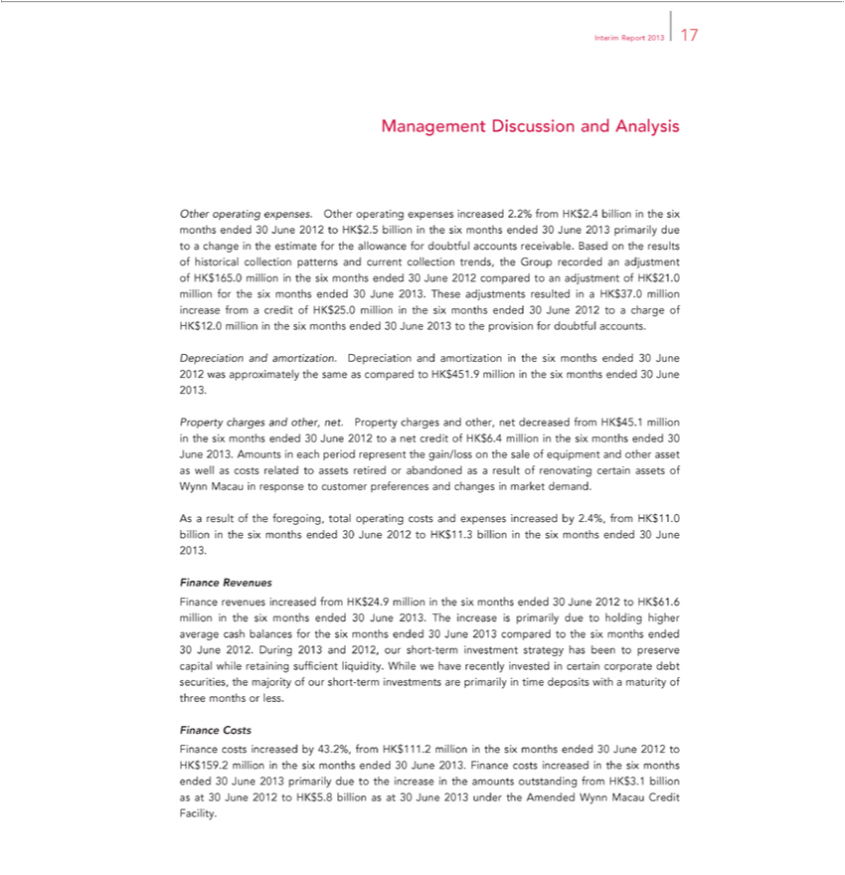

Interim Report 2013 17
Management Discussion and Analysis
Otherin | operating expenses. Other operating expenses increased 2.2% from HK$2.4 billion in the six months ended 30 June 2012 to HK$2.5 billion in the six months ended 30 June 2013 primarily due to a change
Otherin | estimate for the allowance for doubtful accounts receivable. Based |  | the results of historical collection patterns and current collection trends, the Group recorded an adjustment of HK$165.0 million in the
six months ended 30 June 2012 compared to an |  | of HK$21.0 million for the six months ended 30 June 2013. These adjustments resulted in HK$37.0 million increase from a credit of HK$25.0
million in the six months ended 30 June 2012 toadjustmentchargeof HK$12.0 million in the six months ended 30 June 2013 to the provision for doubtful accounts.
Depreciation and amortization. Depreciation and amortization in the six months ended 30 June 2012 was approximately the same as |  |  |  | to HK$451.9 million in the six months ended 30 June 2013.
Property charges and other, net. Property charges and other, net decreased from HK$45.1 million in the six months ended 30 June 2012comparedtonet credit of HK$6.4 million the six months ended 30 June 2013.
Amounts in each period represent the gain/loss on the sale of equipment and other asset as well as costs related to assets retired or abandoned as a result of renovating certain assets of Wynn Macau in response to
customer preferences and changes market demand.
As result of the foregoing, total operating costs and expenses increased by 2.4%, from HK$11.0 billion in the six months ended 30 June 2012 to HK$11.3 billion in the six months ended 30 June 2013.
 | Revenues
Finance revenues increased from HK$24.9 million in the six months ended 30 June 2012 to HK$61.6 million in the six months ended 30 June 2013. The increase is primarily due to holding higher average cash
balances for the six months ended 30 June 2013 compared to the six months ended
30 June 2012. During 2013 and 2012, our short-term investment strategy |  |  | been to preserve capital while retaining sufficient liquidity. While we have recently invested in certain corporate debt securities, the
majority of our short-term investments are primarily in time deposits withhasmaturity of three months or less.
 | Costs | the six months ended 30 June 2012 to HK$159.2 million in the six months ended 30 June 2013. Finance costs increased in the six months ended
Finance costs increased by 43.2%, from HK$111.2 million
30 June 2013 primarily due to the increase in the amounts outstanding from HK$3.1 billion as at 30 June 2012 to HK$5.8 billion as at 30 June 2013 under the Amended Wynn Macau Credit Facility.

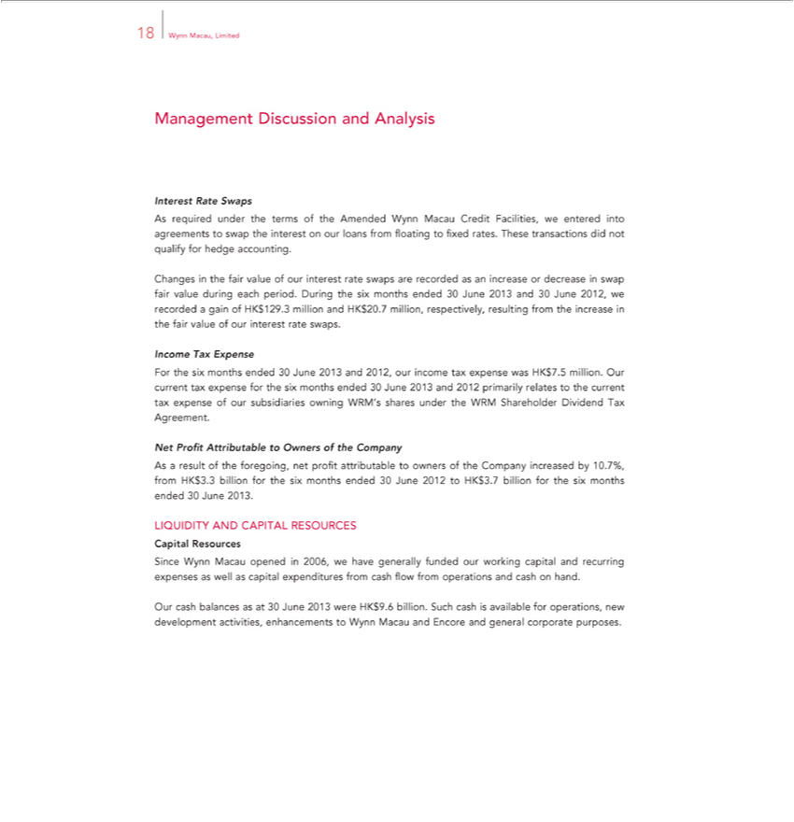

18 Wynn Macau, Limited
Management Discussion and Analysis
Interest Rate Swaps
As required under the terms of the Amended Wynn Macau Credit Facilities, we entered into agreements to swap the interest on our loans from floating to fixed rates. These transactions did not qualify for hedge accounting.
Changes in the fair value of our interest rate swaps are recorded as an increase or decrease in swap fair value during each period. During the six months ended 30 June 2013 and 30 June 2012, we recorded a gain of HK$129.3 million and HK$20.7 million, respectively, resulting from the increase in the fair value of our interest rate swaps.

Income Tax Expense

For the six months ended 30 June 2013 and 2012, our income tax expense was HK$7.5 million. Our current tax expense for the six months ended 30 June 2013 and 2012 primarily relates to the current tax expense of our subsidiaries owning WRM’s shares under the WRM Shareholder Dividend Tax Agreement.
Net Profit Attributable to Owners^{profit}the Company
As a result of the foregoing, net attributable to owners of the Company increased by 10.7%, from HK$3.3 billion for the six months ended 30 June 2012 to HK$3.7 billion for the six months ended 30 June 2013.
CapitalLIQUIDITYResourcesAND CAPITAL RESOURCES
Since Wynn Macau opened in 2006, we have generally funded our working capital and recurring expenses as well as capital expenditures from cash flow from operations and cash on hand.
Our cash balances as at 30 June 2013 were HK$9.6 billion. Such cash is available for operations, new development activities, enhancements to Wynn Macau and Encore and general corporate purposes.

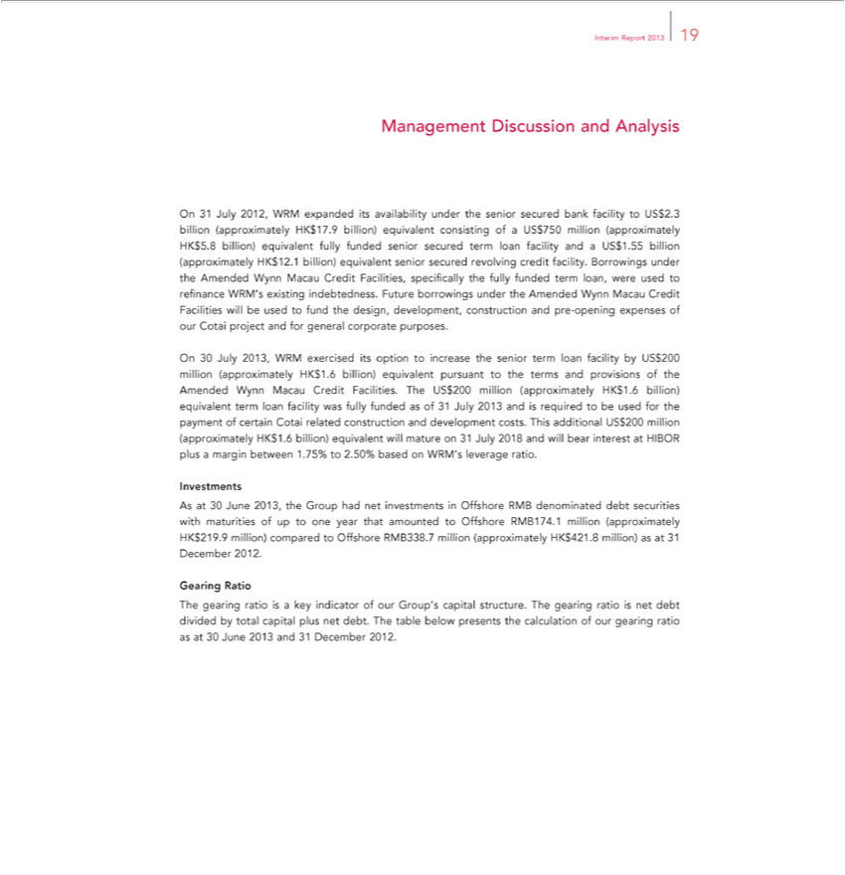

Interim Report 2013 19 | Analysis
Management Discussion | Analysis
On 31 July 2012, WRM expanded its availability under the senior secured bank facility to US$2.3 bi lion (approximately HK$17.9 billion) equivalent consisting of US$750 million (approximately HK$5.8
billion) equivalent fully funded senior secured term loan facility and a US$1.55 billion (approximately HK$12.1 billion) equivalent senior secured revolving credit facility. Borrowings under the Amended Wynn
Macau Credit Facilities, specifically the fully funded term loan, were used to refinance WRM’s existing indebtedness. Future borrowings under the Amended Wynn Macau Credit Facilities will be used to fund
the design, development, construct on and pre-opening expenses of our Cotai project and for general corporate purposes.
On 30 July 2013, WRM exercised its option to increase the senior term loan facility by US$200 million (approximately HK$1.6 billion) equivalent pursuant to the terms and provisions of the Amended Wynn
Macau Credit Facilities. The US$200 million (approximately HK$1.6 billion) equivalent term loan facility was fully funded as of 31 July 2013 and is required to be used for the |  | of certain Cotai related
construction and development costs. This additional US$200 million (approximately HK$1.6 billion) equivalent will mature on 31 July 2018 and will bear interest at HIBOR pluspaymentmargin between 1.75% to 2.50% based on WRM’s leverage ratio.
As at 30 June 2013, the Group had net investments in Offshore RMB denominated debt securities with maturities of up to one year that amounted to Offshore RMB174.1 million (approximately HK$219.9 million) compared to Offshore RMB338.7 million (approximately HK$421.8 million) as at 31 December 2012.
Gearing Ratio

The gearing ratio is a key indicator of our Group’s capital structure. The gearing ratio is net debt divided by total capital plus net debt. The table below presents the calculation of our gearing ratio as at 30 June 2013 and 31 December 2012.

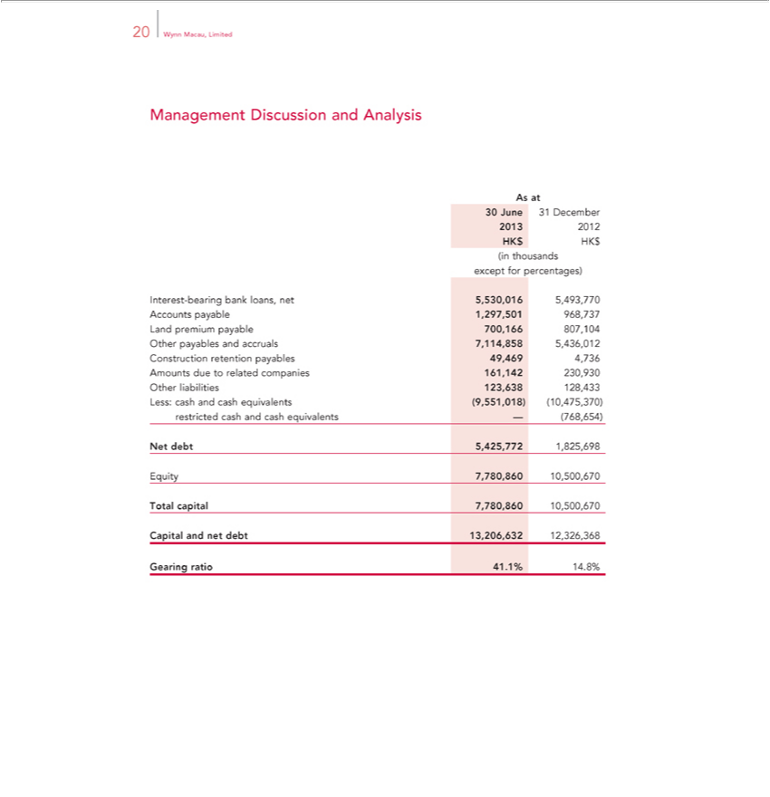

20 Wynn Macau, Limited
Management Discussion and Analysis
As at
²⁰¹³30June 31 December
2012 HK$ HK$ (in thousands except for percentages)

Interest-bearing bank loans, net 5,530,016 5,493,770 Accounts payable 1,297,501 968,737 Land premium payable 700,166 807,104 Other payables and accruals 7,114,858 5,436,012 Construction retention payables 49,469 4,736 Amounts due to related companies 161,142 230,930 Other liabilities 123,638 128,433 Less: cash and cash equivalents (9,551,018) (10,475,370) restricted cash and cash equivalents — (768,654)

EquityNetdebt7,780,8605,425,77210,500,6701,825,698

Total capital 7,780,860 10,500,670 Capital and net debt 13,206,632 12,326,368 Gearing ratio 41.1% 14.8%

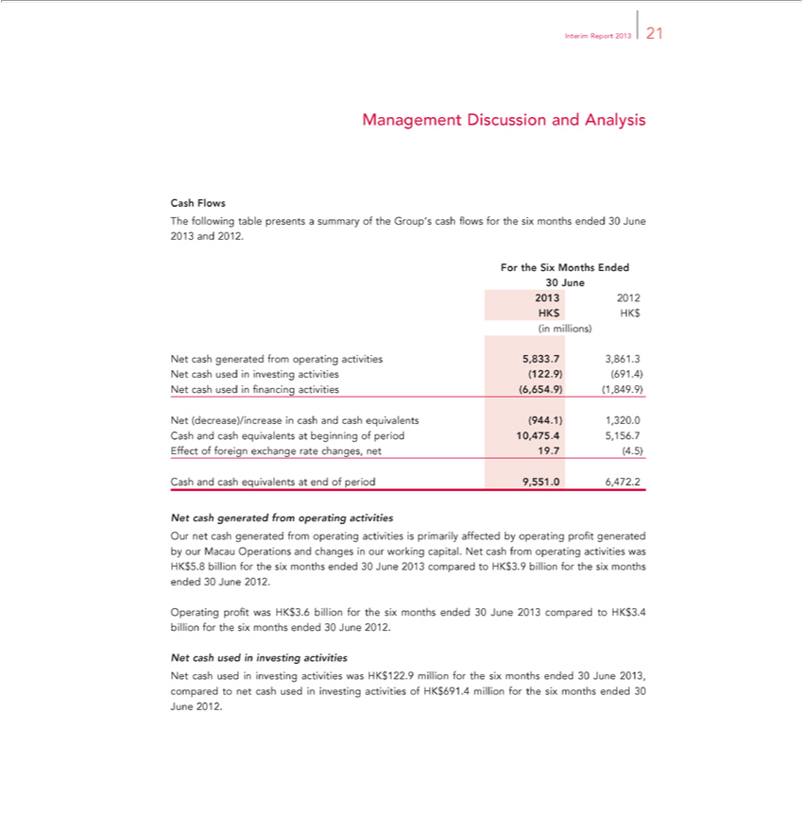

Interim Report 2013 21
CashManagementFlows Discussion and Analysis
ForThe thefollowingSixMonthstable Endedpresents a summary of the Group’s cash flows for the six months ended 30 June 2013 and 2012.
₂₀₁₃30June
2012 HK$ HK$ (in millions)
^{Net} cash generated from operating activities 5,833.7 3,861.3 Net cash used in investing activities (122.9) (691.4) Net cash used in financing activities (6,654.9) (1,849.9)
(decrease)/increase in cash and cash equivalents (944.1) 1,320.0 Cash and cash equivalents at beginning of period 10,475.4 5,156.7 Effect of foreign exchange rate changes, net 19.7 (4.5) Cash and cash equivalents_{operating}endof period 9,551.0 6,472.2
Net cash generated from activities

Our net cash^{the}generated from operating activities is primarily affected by operating profit generated by our Macau Operations and changes in our working capital. Net cash from operating activities was HK$5.8 billion for six months ended 30 June 2013 compared to HK$3.9 billion for the six months ended 30 June 2012.
Operating profit was HK$3.6 billion for the six months ended 30 June 2013 compared to HK$3.4 billion for the six months ended 30 June 2012.

Net cash used in investing activities was HK$122.9 million for the six months ended 30 June 2013, compared to net cash used in investing activities of HK$691.4 million for the six months ended 30 June 2012.

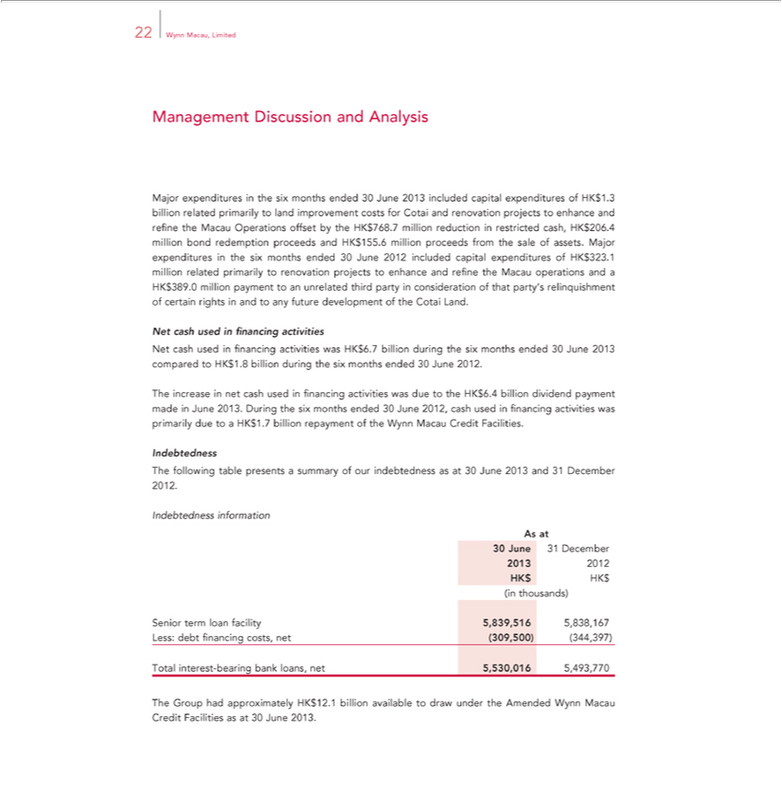

22 Wynn Macau, Limited
nagement Discussion and Analysis |  | capital expenditures of HK$1.3 billion related primarily to land improvement costs for Cotai and renovation projects to enhance and |  |  | the
jor expenditures in the six months ended 30 June 2013 |  |  |  |  | the
Macau Operations offset by the HK$768.7 million reductionincludedrestricted cash, HK$206.4 million bond redemption proceeds and HK$155.6 million proceeds from the |  |  |  | of assets. Major expendituresrefinethe six
months ended 30 June 2012 included capital |  | of HK$323.1 million related primarily to renovation projects to enhance | refine the Macau operations andsaleHK$389.0 million payment to an
unrelated third party consideration of that party’expendituresrelinquishment of certain rights in and to any future development of the Cotai Land.
Net cash used in financing activities was HK$6.7 billion during the six months ended 30 June 2013 compared to HK$1.8 billion during the six months ended 30 June 2012.
The increase in net cash used in financing activities was due to the HK$6.4 billion dividend payment made in June 2013. During the six months ended 30 June 2012, cash used in financing activities was
primarily due to a HK$1.7 billion repayment of the Wynn Macau Credit Facilities.
Indebtedness
The following table presents a summary of our indebtedness as at 30 June 2013 and 31 December 2012.
Indebtedness information
As at
30 June 31 December
2013 2012 HK$ HK$ (in thousands)
Senior term loan facility 5,839,516 5,838,167 Less: debt financing costs, net (309,500) (344,397)
otal interest-bearing bank loans, net | 5,493,770
The Group had approximately HK$12.5,530,016billion available to draw under the Amended Wynn Macau Credit Facilities as at 30 June 2013.

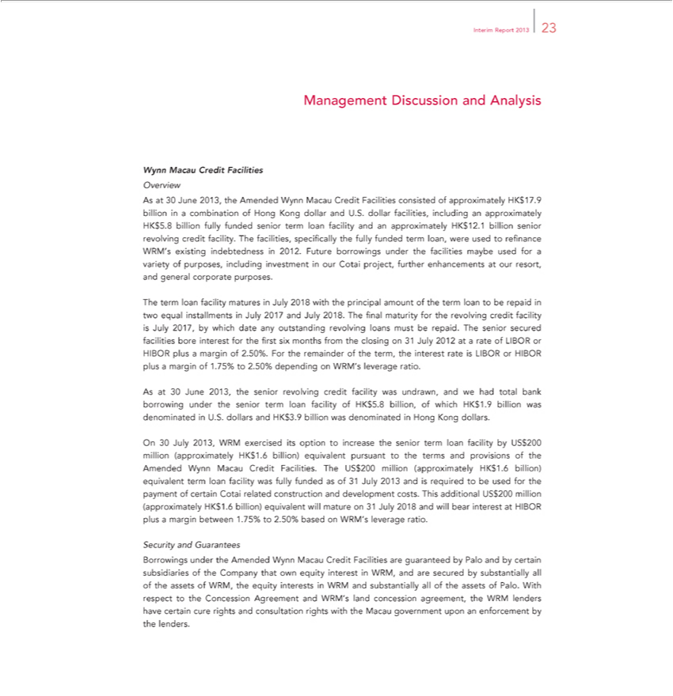

Interim Report 2013 23
Management Discussion and Analysis
Wynn Macau Credit Facilities
Overview |  |  |  |  |  |  |  | approximately HK$5.8
As at 30 June 2013, the Amended Wynn Macau Credit Facilities consisted of approximately HK$17.9 billion in combination of Hong Kong dollar and U.S. dollar facilities, including |  |  |  |  |  |  |  | approximately HK$5.8
billion fully funded senior term loan facility and an approximately HK$12.1 billion senior revolving cre |  |  |  | it facility. The facilities, specifically |  | fully funded term loan, were used to refinance WRM’ existing
indebtedness in 2012. Future | under the facilities maybe used for a variety of purposes, |  |  | investment our Cotai project, further enhancements |  |  | our resort, and general corporate purposes.
The term loan facility maturesborrowingsJuly2018 with the principal amount of the term loan to be repaid includingtwoequal installments in July 2017 and July 2018. The final |  |  |  |  |  |  | for the revolving credit facility is July
2017, by which date any outstanding revolving loans must be repaid. The |  | secured | bore interest for the first six |  | from the closing on 31 July 2012maturitya rate of LIBOR or HIBOR plus a
margin of 2.50%. For the remainder of the term, the interest rate is LIBORseniorHIBOR plusfacilitiesmargin of 1.75% to 2.50% dependingmonths WRM’s leverage ratio.
As at 30 June 2013, the senior revolving credit facility was undrawn, and we had total bank borrowing under the senior term loan facility of HK$5.8 billion, of which HK$1.9 billion was denominated in U.S.
dollars and HK$3.9 billion was denominated in Hong Kong dollars.
On 30 July 2013, WRM exercised its option to increase the senior term loan facility by US$200 million (approximately HK$1.6 billion) equivalent pursuant to the terms and provisions of the Amended Wynn
Macau Credit Facilities. The US$200 million (approximately HK$1.6 billion) equivalent term loan facility was fully funded as of 31 July 2013 and is required to be used for the |  |  |  |  |  |  |  | of certain Cotai related
construction and development costs. This additional US$200 million (approximately HK$1.6 billion) equivalent will mature on 31 July 2018 and will bear interest at HIBOR pluspaymentmargin between 1.75% to 2.50% based _{Guarantees}onWRM’ leverage ratio.

Security and
Borrowings under the Amended Wynn Macau Credit Facilities are guaranteed by Palo and by certain subsidiaries of the Company that own equity interest in WRM, and are secured by substantially all of the assets of WRM, the equity interests in WRM and substantially all of the assets of Palo. With respect to the Concession Agreement and WRM’s land concession agreement, the WRM lenders have certain cure rights and consultation rights with the Macau government upon an enforcement by the lenders.

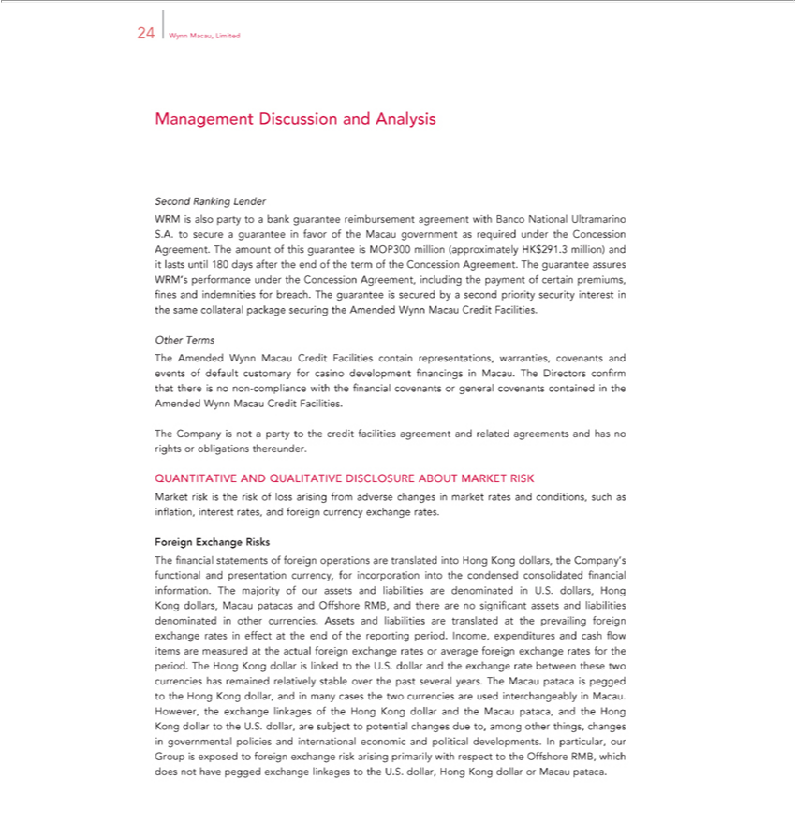

24 Wynn Macau, Limited
Management Discussion and Analysis
Second Ranking Lender
WRM is also party to bank guarantee reimbursement agreement with Banco National Ultramarino S.A. to secure a guarantee in favor of the Macau government as required under the Concession Agreement.
The amount of this guarantee is MOP300 million (approximately HK$291.3 million) and lasts until 180 days after the end of the term of the Concession Agreement. The guarantee assures WRM’s performance
under the Concession Agreement, including the payment of certain premiums, fines and indemnities for breach. The guarantee is secured by a second priority security interest in the same collateral package
securing the Amended Wynn Macau Credit Facilities.
Other Terms
The Amended Wynn Macau Credit Facilities contain representations, warranties, covenants and events of default customary for casino development financings in Macau. The Directors confirm that there is no
non-compliance with the financial covenants or general covenants contained in the Amended Wynn Macau Credit Facilities.
The Company is not a party to the credit facilities agreement and related agreements and has no rights or obligations thereunder.
QUANTITATIVE AND QUALITATIVE DISCLOSURE ABOUT MARKET RISK
Market risk is the risk of loss arising from adverse changes in market rates and conditions, such as inflation, interest rates, and foreign currency exchange rates.
Foreign Exchange Risks |  |  |  |  | information.
financial statements of foreign operations are translated into Hong Kong dollars, the Company’s functional and presentation currency, for incorporation into the condensed consolidated |  |  |  |  | information.
The majority of our assets and liabilities are |  | U.S. dollars, Hong Kong dollars, Macau patacas and Offshore RMB, and there are no significant assets and liabilities |  |  | financialother
currencies. Assets and liabilities are translateddenominatedprevailingthe |  |  | foreign exchange rates in effect at the end of the reporting period. Income, expenditures and cash flow items are measureddenominatedthe actual foreign
exchange rates or average foreign exchange rates for the period. The Hong Kong dollar is linked to the U.S. dollar and the exchange rate between these two currencies has remained relatively stable over the past
several years. The Macau pataca is pegged to the Hong Kong dollar, and in many cases the two currencies are used |  |  |  | in Macau. However, the exchange linkages of the Hong Kong dollar and the
Macau | and the Hong Kong dollar to the U.S. dollar, are subject to potential changes due to, among other things,interchangeablychangesgovernmental policies and international economic and political developments.
In particularpataca,our Group is exposed to foreign exchange risk arising primarily with respect to the Offshore RMB, which does not have pegged exchange linkages to the U.S. dollar, Hong Kong dollar or Macau pataca.

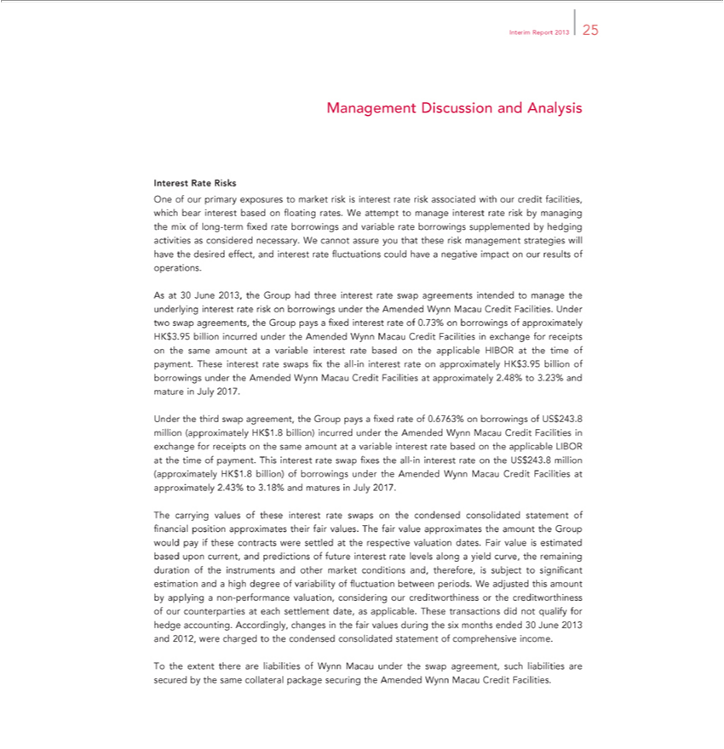

Interim Report 2013 25
Management Discussion and Analysis
Interest Rate Risks |  |  |  |  |  | risk by managing the mix of
One of our primary exposures to market risk is interest rate risk associated with our credit facilities, which bear intere t based on floating rates. We attempt to manage interest |  |  |  |  |  | risk by managing the mix of
long-term fixed rate borrowings and |  |  | rate borrowings supplemented by hedging activities as considered necessary. We cannot assure you that these risk management strategies will have the desired effect,
and interest rate fluctuations could havevariablenegative impact on our results of operations.
As at 30 June 2013, the Group had three interest rate swap agreements intended to manage the underlying interest rate risk on borrowings under the Amended Wynn Macau Credit Facilities. Under two swap
greements, the Group pays a fixed interest rate of 0.73% on borrowings of approximately HK$3.95 billion incurred under the Am nded Wynn Macau Credit Facilities in exchange for receipts on the same
amount at variable interest |  | based on the applicable HIBOR at the time of payment. These interest rate swaps fix the all-in interest rate on approximately HK$3.95 billion of borrowings under the Amended
Wynn Macau | Credit Facilitiesrate approximately 2.48% to 3.23% and mature |  |  | July 2017.
Under the third swap agreement, the Group |  |  | fixed rate of 0.6763% on borrowings of US$243.8 million (approximately HK$1.8 billion) incurred under the Amended Wynn Macau Credit Facilities in
exchange for receipts on the same amount atpaysvariable interest rate based on the applicable LIBOR at the time of payment. This interest rate swap fixes the all-in interest rate on the US$243.8 million
(approximately HK$1.8 billion) of borrowings under the Amended Wynn Macau Credit Facilities at approximately 2.43% to 3.18% and matures in July 2017.
The carrying values of |  | interest rate swaps on the condensed consolidated statement of financial position approximates their fair values. The fair value approximates the amount the Group would pay if these
cont acts were settled atthese respective valuation dates. Fair value is estimated based upon current, and predictions of future interest rate |  |  |  |  | along a yield curve, the | duration of the instruments and
other market conditions and, |  | is subject to significant estimation and |  | high degree of variability of fluctuation between periods.levelsWadjusted this amount by applyingremaining non-performance valuation,
considering our creditwort inesstherefore, creditworthiness of our counterparties at each settlement date, as applicable. These transactions did not qualify for hedge accounting. Accordingly, changes in the fair
values during | six months ended 30 June 2013 and 2012, were charged to the condensed consolidated statement of comprehensive income.
To the extent there are liabilities of Wynn Macau under the swap agreement, such liabilities are secured by the same collateral package securing the Amended Wynn Macau Credit Facilities.

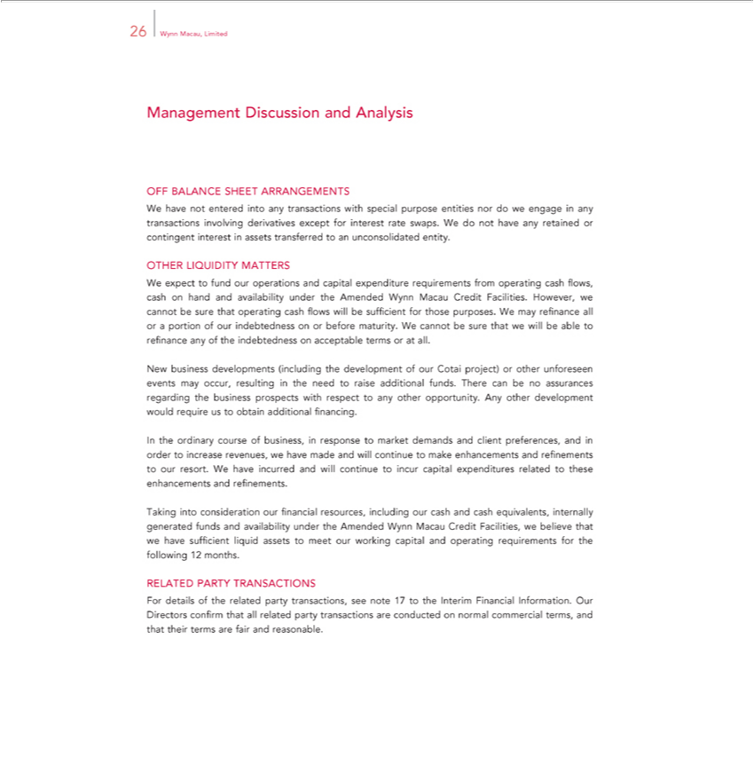

26 Wynn Macau, Limited
Management Discussion and Analysis
OFF BALANCE SHEET ARRANGEMENTS
W have not entered into any | with special purpose entities nor do we engage in any transactions involving derivatives except for interest rate swaps. We do not have any retained or contingent
interest in assets transferred totransactionsunconsolidated entity.
OTHER LIQUIDITY MATTERS |  | from operating | flows, cash on hand and availability under the | Wynn Macau Credit Facilities. However, we cannot be sure
We expect to fund our operations and capital expenditure |  | from operating | flows, cash on hand and availability under the | Wynn Macau Credit Facilities. However, we cannot be sure
that operating cash flows will be sufficient for those purposes.requirementsWmay refinance all or cashportion of our indebtedness on or before maturity.AmendedWcannot be sure that we will be able to refinance any of the
indebtedness on acce table terms or at all. | development of our Cotai project) or other unforeseen events may occur, resulting the need to raise additional funds. There can be no assurances regarding the
New business developments (including
business prospects with respect to any other opportunity. Any other development would require us to obtain additional financing.
WeInthehaveordinaryincurredcourseand willofbusiness,continueintoresponseincurcapitaltomarketexpendituresdemandsrelatedandclienttothesepreferences,enhancementsandinandorderrefinements.toincrease revenues, we have made and will continue to make enhancements and refinements to our resort.
Taking into consideration our financial resources, including our cash and cash equivalents, internally generated funds and availability under the Amended Wynn Macau Credit Facilities, we believe that we have sufficient liquid assets to meet our working capital and operating requirements for the following 12 months.
RELATED PARTY TRANSACTIONS

For details of the related party transactions, see note 17 to the Interim Financial Information. Our Directors confirm that all related party transactions are conducted on normal commercial terms, and that their terms are fair and reasonable.

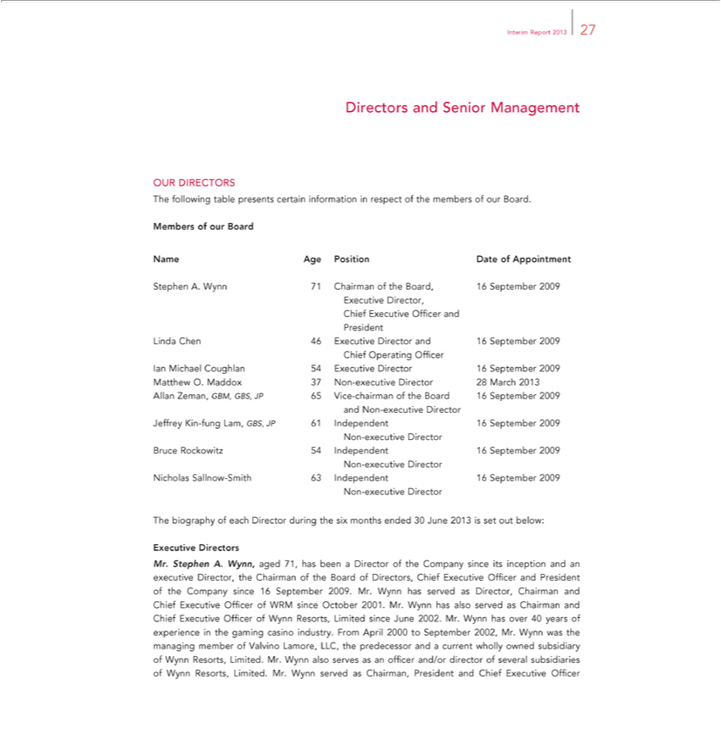

Interim Report 2013 27
Directors and Senior Management
OUR DIRECTORS
The following table presents certain information in respect of the members of our Board.
Members of ur Board
Name | Position Date of Appointment | ber | Executive Director, Chief Executive Officer and President Linda Chen 46 Executive Director and 16 September 2009 Chief Operating Officer
StephenAge. Wynn 71 Chairman of the Board, |  | ber
Ian Michael Coughlan 54 Executive Director |  | 16 September 2009 | Matthew O. Maddox 37 Non-executive Director 28 March 2013 Allan Zeman, GBM, GBS, JP 65 Vice-chairman of the Board 16 September
2009 and Non-executive Director Jeffrey Kin-fung Lam, GBS, JP 61 Independent 16 September 2009 Non-executive Director Bruce Rockowitz 54 Independent 16 September 2009 Non-executive Director Nicholas Sallnow-Smith 63 Independent 16 September 2009 Non-executive Director
The_{Executive}biographyDirectorsofeach Director during the six months ended 30 June 2013 is set out below:
Mr. Stephen A. Wynn, aged 71, has been a Director of the Company since its inception and an executive Director, the Chairman of the Board of Directors, Chief Executive Officer and President of the Company since 16 September 2009. Mr. Wynn has served as Director, Chairman and Chief Executive Officer of WRM since October 2001. Mr. Wynn has also served ^{was}Chairman and Chief Executive Officer of Wynn Resorts, Limited since June 2002. Mr. Wynn has over 40 years of experience in the gaming casino industry. From April 2000_{director}September 2002, Mr. Wynn the managing member of Valvino Lamore, LLC,
the predecessor and a current wholly owned subsidiary of Wynn Resorts, Limited. Mr. Wynn also serves as an officer and/or of several subsidiaries of Wynn Resorts, Limited. Mr. Wynn served as Chairman, President and Chief Executive Officer

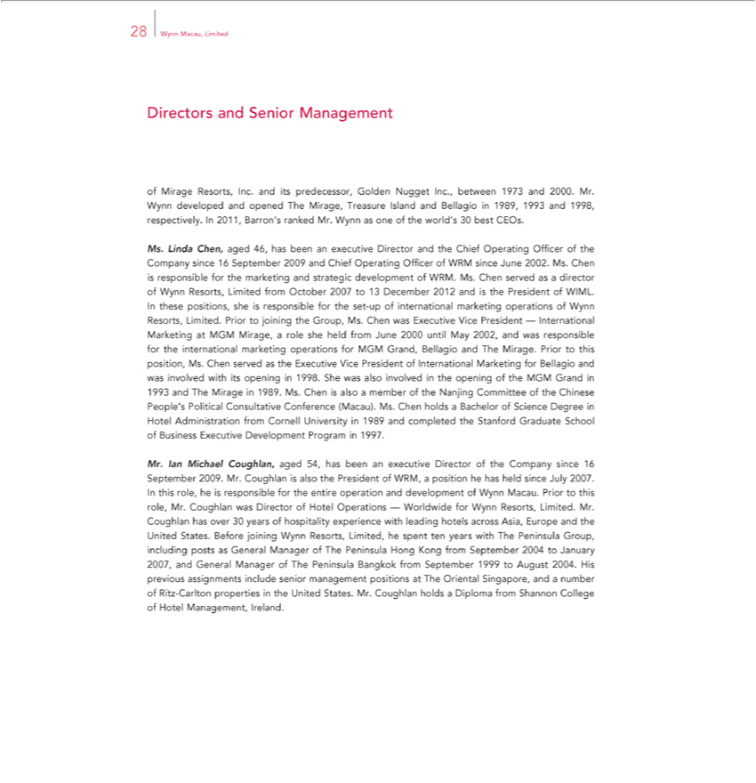

28 Wynn Macau, Limited
ofDirectorsMirageandResorts,SeniorInc.Managementanditspredecessor, Golden Nugget Inc., between 1973 and 2000. Mr. Wynn developed and opened The Mirage, Treasure Island and Bellagio in 1989, 1993 and 1998, respectively. In
Ms.2011,LindaBarron’Chen,rankedaged 46,Mr. hasWynnbeenas anoneexecutiveoftheworld’sDirector30 andbest theCEOs.Chief Operating Officer of the Company since 16 September 2009 and Chief Operating Officer of WRM since June 2002. Ms. Chen is responsible for the marketing and strategic development of WRM. Ms. Chen served as a director of Wynn Resorts, Limited from October 2007 to 13 December 2012 and is the President of WIML. In these
MGMpositions,Mirage,sheisa responsiblerolesheheldforfromthe setJune-up2000ofinternationaluntilMay2002,marketingandwasoperationsresponsibleofWynnfortheResorts,internationalLimited.marketingPriorto operationsjoiningthe forGroup,MGMMs.Grand,Chen BellagiowasExecutiveandTheViceMirage.PresidentPrior—to Internationalthisposition,MarketingMs.Chen servedat as the Executive Vice President of International Marketing for Bellagio and involved with its opening 1998. She was also involved in the opening of the MGM Grand in 1993 and The Mirage in 1989.

Ms. Chen is also a member of the Nanjing Committee of the Chinese People’wasPolitical Consultative Conference (Macau). Ms. Chen holds a Bachelor of Science Degree in Hotel Administration from Cornell University in 1989 and completed the Stanford Graduate School of Business Executive Development Program in 1997.

Mr. Ian Michael Coughlan, aged 54, has been an executive Director of the Company since 16 September 2009. Mr. Coughlan is also the President of WRM, a position he has held since July 2007. In this role, he is responsible for the_{experience}entireoperation and development of Wynn Macau. Prior to this role, Mr. Coughlan was Director of Hotel Operations — Worldwide for Wynn Resorts, Limited. Mr. Coughlan has over 30

years of hospitality with leading hotels across Asia, Europe and the United States. Before joining Wynn Resorts, Limited, he spent ten years with The Peninsula Group, including posts as General Manager of The Peninsula Hong Kong from September 2004 to January 2007, and General Manager of The Peninsula Bangkok from _{Diploma}Setember 1999 to August 2004. His previous assignments include senior
management positions at The Oriental Singapore, and a number of Ritz-Carlton properties in the United States. Mr. Coughlan holds a from Shannon College of Hotel Management, Ireland.

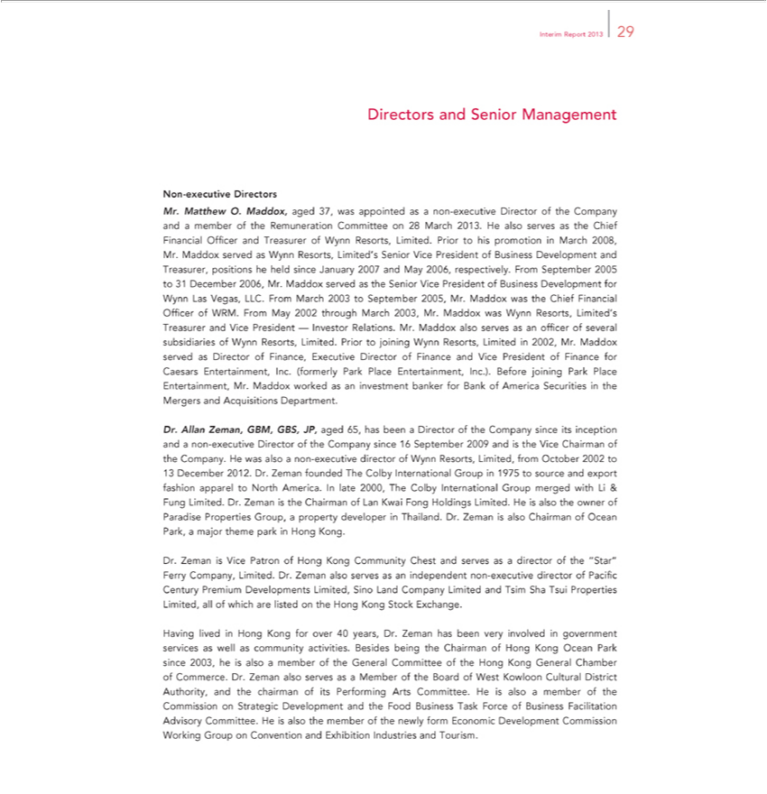

Interim Report 2013 29
Directors and Senior Management
Non-executive Directors
Mr. Matthew O. Maddox, aged 37, was appointed as a non-executive Director of the Company and a member of the Remuneration Committee on 28 March 2013. He also serves as the Chief Financial Officer
and Treasurer of Wynn Resorts, Limited. Prior to his promotion in March 2008, Mr. Maddox served as Wynn Resorts, Limited’s Senior Vice President of Business Development and Treasurer, positions he held
since January 2007 and May 2006, respectively. From September 2005 to 31 December 2006, Mr. Maddox served as the Senior Vice President of Business Development for Wynn Las Vegas, LLC. From March
2003 to September 2005, Mr. Maddox was the Chief Financial Offic of |  | . From May 2002 through March 2003, Mr. Maddox was Wynn Resorts, Limited’ T | and Vice President — Investor
Relations. Mr. Maddox also serves as officer of several subsidiaries of WRMynn Resorts, Limited. Prior to joining Wynn Resorts, Limited in 2002, Mr. Maddox servedreasurerDirector of |  |  |  | Executive Director
of Finance and Vice President of Finance for Caesars Entertainment, Inc. (formerly Park Place Entertainment, Inc.). Before joining Park Place Entertainment, Mr. Maddox worked as Finance,investment banker for
Bank of America Securities in the Mergers and Acquisitions Department.
Dr. Allan Zeman, GBM, GBS, JP, aged 65, has been a Director of the Company since its inception and a non-executive Director of the Company since 16 September 2009 and is the Vice Chairman of the
Company. He was also a non-executive director of Wynn Resorts, Limited, from October 2002 to
13 December 2012. Dr. Zeman founded The Colby International Group in 1975 to source and export fashion apparel to North America. In late 2000, The Colby International Group merged with Li & Fung
Limited. Dr. Zeman is the Chairman of Lan Kwai Fong Holdings Limited. He is also the owner of Paradise Properties Group, a property developer in Thailand. Dr. Zeman is also Chairman of Ocean Park, a
major theme park in Hong Kong.
Dr. Zeman is Vice Patron of Hong Kong Community Chest and serves as a director of the “Star” Ferry Company, Limited. Dr. Zeman also serves as an independent non-executive director of Pacific Century
Premium Developments Limited, Sino Land Company Limited and Tsim Sha Tsui Properties Limited, all of which are listed on the Hong Kong Stock Exchange.
 | lived in Hong Kong for over 40 years, Dr. Zeman has been very involved in government services as well as community activities. Besides being the Chairman of Hong Kong Ocean Park since 2003, he is
Havingalsomember of the General Committee of the Hong Kong General Chamber of Commerce. Dr. Zeman also serves as a Member of the Board of West Kowloon Cultural District Authority, and the chairman of
its | Arts Committee. He is also a member of the | Strategic Development and the Food Business Task Force of Business Facilitation Advisory Committee. He is also the member of the
newlyPerformingEconomic Development Commission Working GroupCommissionConvention and Exhibition Industries and Tourism.

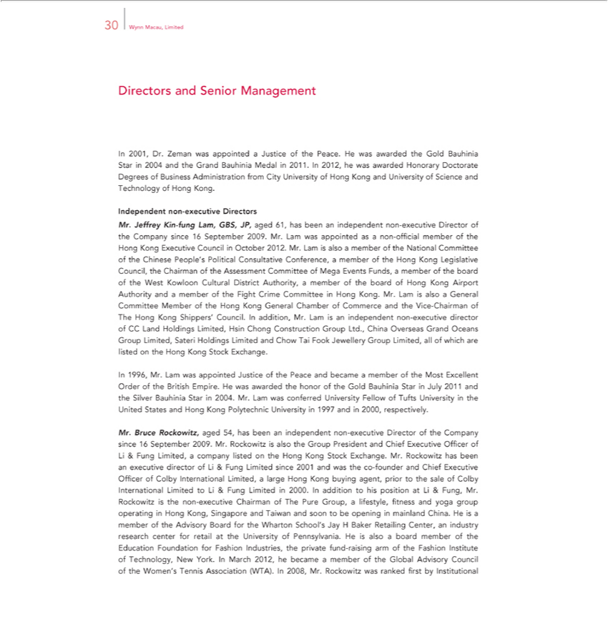

30 Wynn Macau, Limited
Directors and Senior Management
In 2001, Dr. Zeman was appointed a Justice of the Peace. He was awarded the Gold Bauhinia Star in 2004 and the Grand Bauhinia Medal in 2011. In 2012, he was awarded Honorary Doctorate Degrees of
Business Administration from City University of Hong Kong and University of Science and Technology of Hong Kong.
Independent non-executive Directors |  |  |  | 16 September 2009. Mr. Lam |  | appointed as a non-official member of the Hong Kong
Mr. Jeffrey Kin-fung Lam, GBS, JP, aged 61, has been an independent non-executive Director of the Company |  |  |  |  |  | appointed as a non-official member of the Hong Kong
Executive Council in October 2012. Mr. Lam is also a member of the National Committee of the Chinese People’sincePolitical Consultative Conference,was member of the Hong Kong Legislative Council, the
Chairman of the Assessment Committee of Mega Events Funds, member of the board of the West Kowloon Cultural District Authority, a member of the board of Hong Kong Airport Authority and a member of
the Fight Crime Committee Hong Kong. Mr. Lam is also a General Committee Member of the Hong Kong General Chamber of Commerce and the Vice-Chairman of The Hong Kong Shippers’ Council. In
addition, Mr. Lam is an independent non-executive director of CC Land Holdings Limited, Hsin Chong Construction Group Ltd., China Overseas Grand Oceans Group Limited, Sateri Holdings Limited and
Chow Tai Fook Jewellery Group Limited, all of which are listed on the Hong Kong Stock Exchange.
In 1996, Mr. Lam was appointed Justice of the Peace and became a member of the Most Excellent Order of the British Empire. He was awarded the honor of the Gold Bauhinia Star in July 2011 and the Silver
Bauhinia Star in 2004. Mr. Lam was co | ferred University Fellow of Tufts University in the United States and Hong Kong Polytechnic University in 1997 and in 2000, respectively.
Mr. Bruce Rockowitz, aged 54, has been an independent non-executive Director of the |  | since 16 September 2009. Mr. Rockowitz is also the Group President and Chief Executive Officer of Li & Fung
Limited, company listed on the Hong Kong Stock Exchange. Mr. Rockowitz has beenCompanyexecutive |  |  | of Li & Fung Limited since 2001 and was the co-founder and Chief Executive Officer of Colby
International Limited, a large Hong Kong buying agent, prior to the sale of Colby International LimiteddirectorLi & Fung Limited in 2000. In addition to his position at Li & Fung, Mr. Rockowitz the non-
executive Chairman of The Pure Group, | lifestyle, fitness and yoga group operating in Hong Kong, Singapore and Taiwan and soon to be opening in mainland China. He is member of the Advisory Board for
the Wharton School’s Jay H Baker Retailing Center, an industry research center for retail at the University of P nnsylvania. He |  |  |  |  | also a board member of the Education Foundation for Fashion Industries, the
private fund-raising arm of the Fashion Institute of Technology, New York. In March 2012, he became a member of the Global |  |  |  |  | Advisory Council of the Women’s Tennis Association (WTA). In 2008,
Mr. Rockowitz was ranked first by Institutional

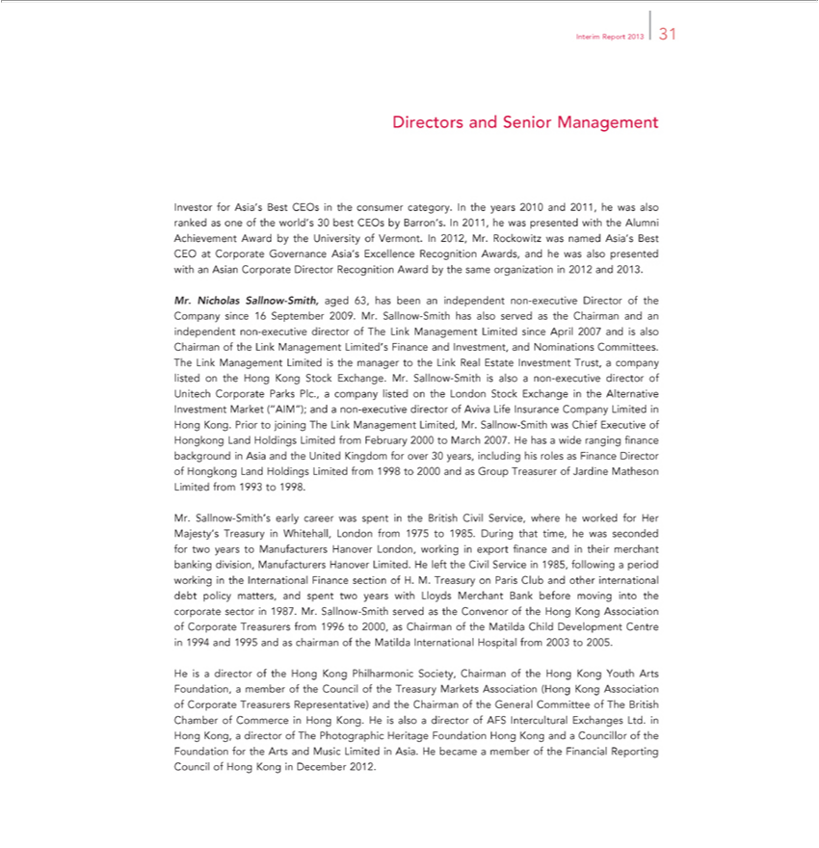

Interim Report 2013 31
Dir ctors and Senior Management
Investor for Asia’ Best CEOs in the consumer category. In the years 2010 and 2011, he was also ranked as one of the world’s 30 best CEOs by Barron’ . In 2011, he was presented with the Alumni Achievement
Award by the University of Vermont. In 2012, Mr. Rockowitz was named Asia’s Best CEO at Corporate Governance Asia’s Excellence Recognition Awards, and he was also presented with an Asian Corporate
Director Recognition Award by the same or | 2012 and 2013.
Mr. Nicholas Sallnow-Smith, aged 63, has beenganizationindependent non-executive Director of the Company since 16 September 2009. Mr. Sallnow-Smith has also served as the Chairman and an indepe dent non-
executive director of The Link Management Limited since April 2007 and is also Chairman of the Link Management Limited’s Finance and Investment, and Nominations Committees. The Link
Limited is the manager to the Link Real Estate Investment Trust, a company listed on the Hong Kong Stock Exchange. Mr. Sallnow-Smith is also |  |  | non-executive director of Unitech Corporate ParksManagementPlc.,
company listed on the London Stock Exchange in the Alternative Investment Market (“AIM”); and a non-executive director of Aviva Life |  |  | Company Limited in Hong Kong. Prior to joining The Link
Management Limited, Mr. Sallnow-Smith was Chief Executive of Hongkong Land Holdings Limited from February 2000 to March 2007. HeInsurancehaswide ranging finance background in Asia and the United
Kingdom for over 30 years, including his roles as Finance Director of Hongkong Land Holdings Limited from 1998 to 2000 and as Group Treasurer of Jardine Matheson Limited from 1993 to 1998.
. Sallnow-Smith’s early career was spent in the British Civil Service, where he worked for Her Majesty’ Treasury in Whitehall, London from 1975 to 1985. During that time, he was seconded for two years to
Manufacturers Hanover London, working in export finance and in their merchant banking division, Manufacturers Hanover Limited. He left the Civil Service in 1985, following a period working in the
International Finance section of H. M. Treasury on Paris Club and other international debt policy matters, and spent two years with Lloyds Merchant Bank before moving into the corporate sector in 1987.
Mr. Sallnow-Smith served as the Convenor of the Hong Kong Association of Corporate Treasurers from 1996 to 2000, as Chairman of the Matilda Child Development Centre in 1994 and 1995 and as chairman
of the Matilda International Hospital from 2003 to 2005. |  |  | Markets Association (Hong Kong Association of
He is director of the Hong Kong Philharmonic Society, Chairman of the Hong Kong Youth Arts Foundation, a member of the Council of the T |  |  | Markets Association (Hong Kong Association of
Treasurers Representative) and the Chairman of the |  | Committee of The British Chamber of Commerce in Hong Kong. He is alsoreasurydirector of AFS Intercultural Exchanges Ltd. in Hong Kong,
Corporatedirector of The Photographic Heritage Foundation Hong KongGeneraland Councillor of the Foundation for the Arts and Music Limited in Asia. He became a member of the Financial Reporting Council of Hong Kong in December 2012.

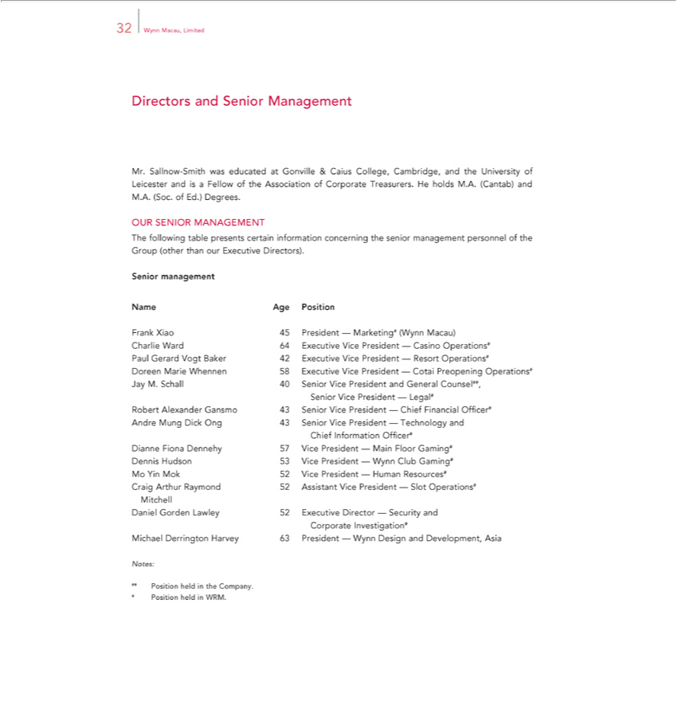

Directors32Wynn Macau,andSeniorLimitedManagement
Mr. Sallnow-Smith was educated at Gonville & Caius College, Cambridge, and the University of Leicester and is a Fellow of the Association of Corporate Treasurers. He holds M.A. (Cantab) and M.A. (Soc. of Ed.) Degrees.
OUR SENIOR MANAGEMENT
SeniorThefollowingmanagementtable presents certain information concerning the senior management personnel of the Group (other than our Executive Directors).
Name Age Position
Frank Xiao 45 President — Marketing# (Wynn Macau)
Charlie Ward 64 Executive Vice President — Casino Operations# Paul Gerard Vogt Baker 42 Executive Vice President — Resort Operations#
Doreen Marie Whennen _{President}58Excutive Vice President — Cotai Preopening Operations# Jay M. Schall 40 Senior Vice President and General Counsel##, Senior Vice President — Legal# Robert Alexander
Gansmo 43 Senior Vice — Chief Financial Officer# Andre Mung Dick Ong 43 Senior Vice President — Technology and Chief Information Officer# Dianne Fiona Dennehy 57 Vice President — Main Floor Gaming# Dennis Hudson 53 Vice President — Wynn Club Gaming# Mo Yin Mok 52 Vice President — Human Resources# Craig Arthur Raymond 52 Assistant Vice President — Slot Operations# Mitchell Daniel Gorden Lawley 52 Executive Director — Security and Corporate Investigation# Michael Derrington Harvey 63 President — Wynn Design and Development, Asia
Notes:
#
#PositionPositionheldheldininWRM.theCompany.

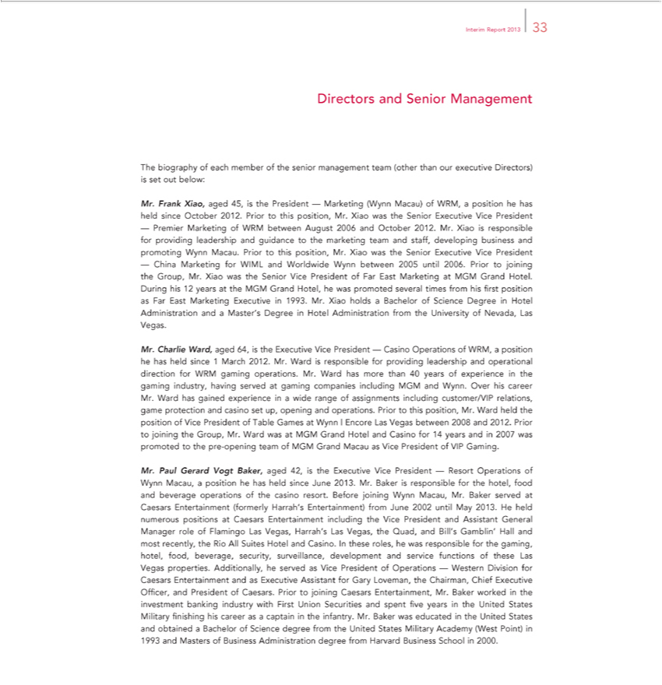

Interim Report 2013 33
Directors and Senior Management
The biography of each member of the senior management team (other than our executive Directors) is set out below:
Mr. Frank Xiao, aged 45, is the President — Marketing (Wynn Macau) of WRM, position he has held since October 2012. Prior to this position, Mr. Xiao was the Senior Executive Vice President
— Premier Marketing of WRM between August 2006 and October 2012. Mr. Xiao is responsible for providing leadership and guidance to the marketing team and staff, developing business and promoting Wynn
Macau. Prior to his position, Mr. Xiao was the Senior Executive Vice President
— China Marketing for WIML and Worldwide Wynn between 2005 until 2006. Prior to joining the Group, Mr. Xiao was the Senior Vice President of Far East Marketing at MGM Grand Hotel. During his 12
years at the MGM Grand Hotel, he was promoted several times from his first position as Far East Marketing Executive in 1993. Mr. Xiao holds a Bachelor of Science Degree in Hotel Administration and a
aster’s Degree in Hotel |  | from the University of Nevada, Las Vegas.
Mr. Charlie Ward, aged 64,AdministrationtheExecutive Vice President — Casino Operations of WRM, a position he has held since 1 March 2012. Mr. Ward is responsible for providing leadership and operational direction
for WRM | operations. Mr. Ward has more than 40 years of experience in the gaming industry, having served at gaming companies including MGM and Wynn. Over his career Mr. Ward has gained
experiencegamingwide range of assignments including customer/VIP relations, game protection and casino set up, opening and operations. Prior to this position, Mr. Ward held the position of Vice President of
Table Games at Wynn | Encore Las Vegas between 2008 and 2012. Prior to joining the Group, Mr. Ward was at MGM Grand Hotel and Casino for 14 years and in 2007 was promoted to the pre-opening team of
GM Grand Macau as Vice President of VIP Gaming.
Mr. Paul Gerard Vogt Baker, aged 42, is the Executive Vice President — Resort Operations of Wynn Macau, a position he has held since June 2013. Mr. Baker is responsible for the hotel, food and beverage
operations of the casino resort. Before joining Wynn Macau, Mr. Baker served at Caesars Entertainment (formerly Harrah’ Entertainment) from June 2002 until May 2013. He held numerous positions at
Caesars Entertainment including the Vice President and Assistant General Manager role of Flamingo Las Vegas, Harrah’s Las Vegas, the Quad, and Bill’ Gamblin’ Hall and most recently, the Rio All Suites
Hotel and Casino. In these roles, he was responsible for the gaming, hotel, food, beverage, security, surveillance, development and service functions of these Las Vegas properties. Additionally, he served as Vice
President of Operations — Western Division for Caesars Entertainment and as Executive Assistant for Gary Loveman, the Chairman, Chief Executive Officer, and President of Caesars. Prior to joining Caesars
educated | Mr. Baker worked | the investment banking industry with First Union Securities and spent five years in the United States Military finishing his career as captain in the infantry. Mr. Baker was
educated | the United States and obtained a Bachelor of Science degree from the United States Military Academy (West Point) in 1993 and Masters of Business Administration degree from Harvard Business
Entertainment,School2000.

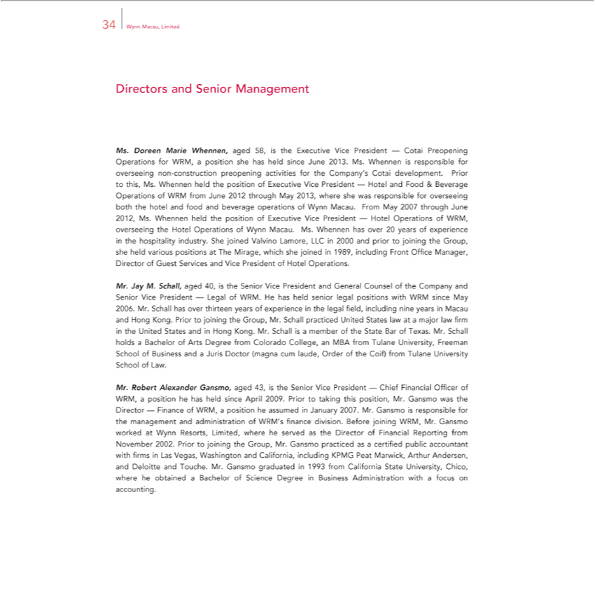

34 Wynn Macau, Limited
Direct s and Senior Management
Ms. Doreen Marie Whennen, aged 58, is the Executive Vice President — Cotai Preopening Operations for WRM, a position she has held since June 2013. Ms. Whennen is responsible for overseeing non-
construction preopening activities for the Company’s Cotai development. Prior to this, Ms. Whennen held the position of Executive Vice President — Hotel and Food & Beverage Operations of WRM from June
2012 through May 2013, where she was responsible for overseeing both the hotel and food and beverage operations of Wynn Macau. From May 2007 through June 2012, Ms. Whennen held the position of
Executive Vice President — Hotel Operations of WRM, overseeing the Hotel Operations of Wynn Macau. Ms. Whennen has over 20 years of experience in the hospitality industry. She joined Valvino Lamore,
LLC in 2000 and prior to joining the Group, she held various positions at The Mirage, which she joined in 1989, including Front Office Manager, Director of Guest Services and Vice President of Hotel
Operations.
Jay M. Schall, aged 40, is the Senior Vice President and General Counsel of the Company and Senior Vice President — Legal of WRM. He has held senior legal positions with WRM since May 2006.
Mr. Schall has over thirteen years of experience in the legal field, including nine years in Macau and Hong Kong. Prior to joining the Group, Mr. Schall practiced United States law at a major law firm in the
United St tes and in H ng Kong. Mr. Schall is a member of the State Bar of Texas. Mr. Schall holds a Bachelor of Arts Degree from Colorado College, an MBA from Tulane University, Freeman School of
Business and | Juris Doctor (magna cum laude, Order of the Coif) from Tulane University School of Law. |  |  | division. Before joining WRM, Mr. Gansmo worked at Wynn
Finance of WRM,Alexanderposition he |  | in January 2007. Mr. Gansmo is responsible for the management and administration of WRM’s finan |  | division. Before joining WRM, Mr. Gansmo worked at Wynn
Mr. Robert | Gansmo, aged 43, is the Senior Vice President — Chief Financial Officer of WRM, position he has held since April 2009. Prior to taking this position, Mr. Gansmo was the Director —
Resorts, Limited, where he servedassumedthe Director of Financial Reporting from November 2002. Prior to joining the Group, Mr. Gansmo practiced as certified public accountant with firms Las Vegas,
Washington and California, including KPMG |  |  | Marwick, Arthur Andersen, and Deloitte and Touche. Mr. Gansmo graduated in 1993 from | California State University, Chico, where he obtained a Bachelor of
Science Degree in Business Administration withPeat focus on accounting.

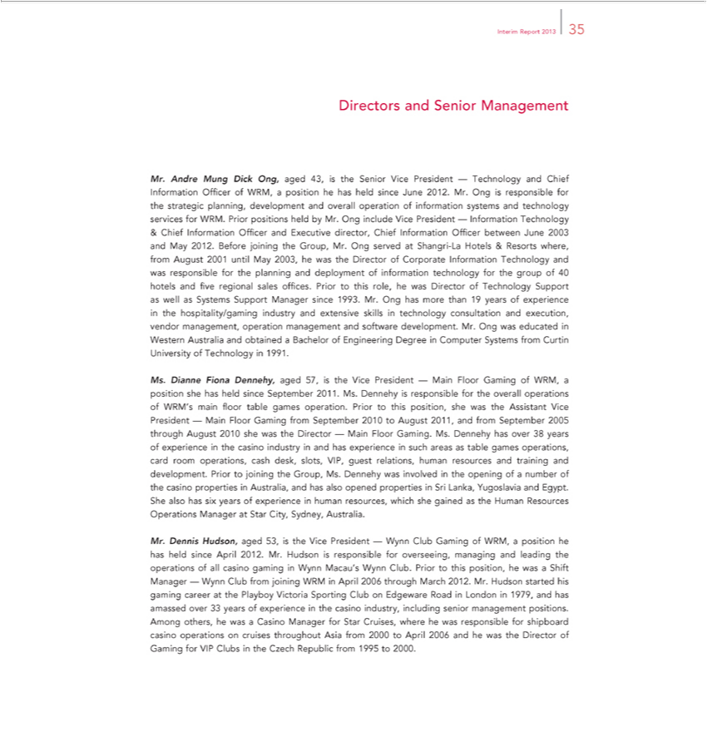

Interim Report 2013 35
Directors and Senior Management
Mr. Andre Mung Dick Ong, aged 43, is the Senior Vice President — Technology and Chief Information Officer of WRM, a position he has held since June 2012. Mr. Ong is responsible for the strategic planning,
development and overall operation of information systems and technology services for WRM. Prior positions held by Mr. Ong include Vice President — |  | Technology
& Chief Information Officer and Executive director, Chief Information Officer between June 2003 and May 2012. Before joining the Group, Mr. Ong served |  | Shangri-La Hotels & Resorts where, from August
2001 until May 2003, he was the Director of Corporate Information Technology and was responsible for the planning and deployment of information technologyInformationthe group of 40 hotels and five regional sales
offices. Prior to this role, he was Director of Technology Support as well as Systems Support Manager since 1993. Mr. Ong has more than 19 years of experience in the |  |  | industry and extensive
skills in technology consultation and execution, vendor management, operation management and software development. Mr. Ong was educated in Western Australia andhospitality/gamingobtainedBachelor of Engineering
Degree in Computer Systems from Curtin University of Technology in 1991. |  |  |  |  | main
Ms. Dianne Fiona Dennehy, aged 57, the Vice President — Main Floor Gaming of WRM, position she has held since September 2011. Ms. Dennehy is responsible for the overall operations of WRM’ |  |  |  |  | main
floor table games operation. Prior to this position, she was the Assistant Vice President — Main Floor Gaming from September 2010 to August 2011, and from September 2005 through August 2010 she was the
Director — Main Floor Gaming. Ms. Dennehy has over 38 years of experience in the casino industry in and has experience in such areas as table games operations, card room operations, cash desk, slots, VIP,
guest relations, human resources and training and development. Prior to joining the Group, Ms. Dennehy was involved | the opening of a number of the casino properties in |  | and has also opened
properties in Sri Lanka, Yugoslavia and Egypt. She also has six years of experience in human resources, which she gained as the Human Resources Operations Manager at StarAustralia,CitySydney, Australia. |  |  |  |  | of all
Mr. Dennis Hudson, aged 53, is the Vice President — Wynn Club Gaming of WRM, position he has held since April 2012. Mr. Hudson is responsible for overseeing, managing and leading the |  |  |  |  | of all
casino gaming in Wynn Macau’s Wynn Club. Prior to this position, he was a Shift Manager — Wynn Club from | WRM April 2006 through March 2012. Mr. Hudson started his gaming career |  |  | the
_{Casino}Playby Victoria Sporting Club on Edgeware Road in London in 1979, and has amassed over 33_{cruises}years of experiencejoiningthe casino industry, including senior management positions. Among others,operationshewas
Manager for Star Cruises, where he was responsible for shipboard casino operations on throughout Asia from 2000 to April 2006 and he was the Director of Gaming for VIP Clubs in the Czech Republic from 1995 to 2000.

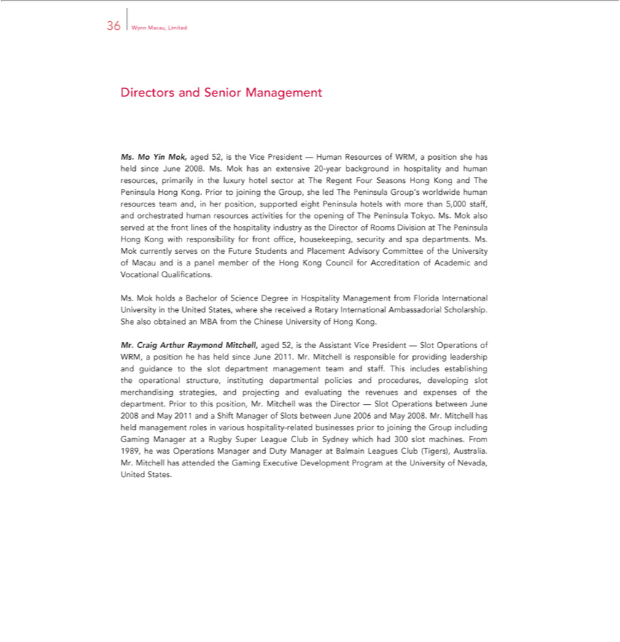

36 Wynn Macau, Limited
Directors and Senior Management
Ms. Mo Yin Mok, aged 52, is the Vice President — Human Resources of WRM, a position she has held since June 2008. Ms. Mok has an extensive 20-year background in hospitality and human resources,
primarily in the luxury hotel sector at The Regent Four Seasons Hong Kong and The Peninsula Hong Kong. Prior to joining the Group, she led The Peninsula Group’s worldwide human resources team and, in
er position, supported eight Peninsula hotels with more than 5,000 staff, and orchestrated human resources activities for the opening of The Peninsula Tokyo. Ms. Mok also served at the front lines of the
hospitality industry as the Director of Rooms Division at The Peninsula Hong Kong with responsibility for front office, housekeeping, security and spa departments. Ms. Mok currently serves on the Future
Students and | Advisory Committee of the University of Macau and is | panel member of the Hong Kong Council for Accreditation of |  | and Vocational Qualifications.
Ms. Mok holdsPlacementBachelor of Science Degree in Hospitality Management from |  | Florida International University in the United States, where she receivedAcademicRotary International Ambassadorial Scholarship. She
also obtained an MBA from the Chinese University of Hong Kong.
Mr. Craig Arthur Raymond Mitchell, aged 52, is the Assistant Vice President — Slot Operations of WRM, a position he has held since June 2011. Mr. Mitchell is responsible for providing leadership and
guidance to the slot department management team and staff. This includes establishing the operational structure, instituting departmental policies and procedures, developing slot |  |  |  |  | strategies, and
projecting and evaluating the revenues and expenses of the department. Prior to this position, Mr. Mitchell was the Director — Slot Operations between June 2008 and May 2011 merchandisingShiftManager of Slots
between June 2006 and May 2008. Mr. Mitchell has held management roles in various hospitality- |  |  | businesses prior to joining the Group including Gaming Manager at a Rugby Super League Club in
Sydney which had 300 slot machines. From 1989, he was Operations Manager and Duty Manager relatedBalmain Leagues Club (Tigers), Australia. Mr. Mitchell has attended the Gaming Executive Development Program at the University of Nevada, United States.

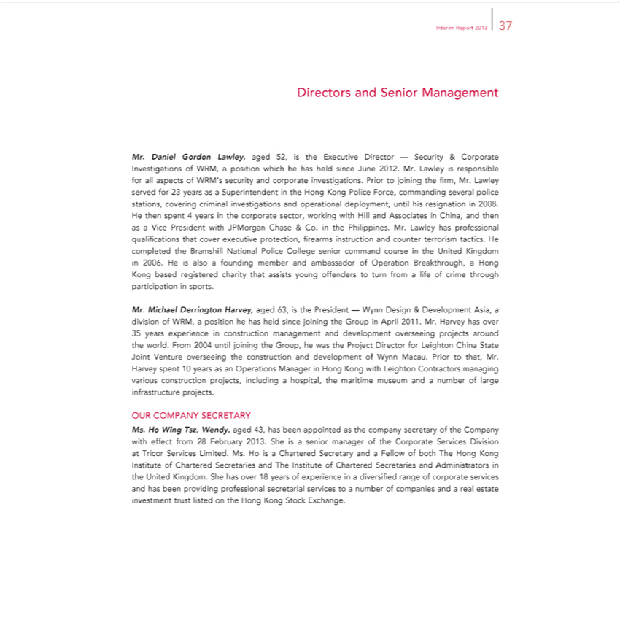

Interim Report 2013 37
Directors and Senior Management |  |  |  |  | of WRM, a position which he has held since June 2012. Mr. Lawley is responsible for all aspects of WRM’s
Mr. Daniel Gordon Lawley, aged 52, is the Executive Director — Security & Corporate
security and corporate investigations. Prior to joining the firm, Mr. Lawley served for 23InvestigationsasSuperintendent in the Hong Kong Police Force, |  |  |  |  |  | several police stations, covering criminal
investigations and operational deployment, until his resignation in 2008. He then spent 4 years in the corporate sector, working with Hill and AssociatescommandingChina, and then as a Vice President with JPMorgan
Chase & Co. in the | . Mr. Lawley has professional |  |  | that cover executive protection, fir arms instruction and counter terrorism tactics. He completed the Bramshill National Police College
senior command coursePhilippinestheUnited |  |  | in 2006. He isqualificationsalsofounding member and ambassador of Operation Breakthrough, a Hong Kong based registered charity that assists young offenders to turn
from life of crime through participationKingdomsports.
Mr. Michael Derrington Harvey, aged 63, is the President — Wynn Design & Development Asia, a division of WRM, a position he has held since joining the Group in April 2011. Mr. Harvey has over 35 years
experience in construction management and development overseeing projects around the world. From 2004 until joining the Group, he was the Project Director for Leighton China State Joint Venture overseeing
the construction and development of Wynn Macau. Prior to that, Mr. Harvey spent 10 years as an Operations Manager in Hong Kong with Leighton Contractors managing various construction projects, including
a hospital, the maritime museum and a number of large infrastructure projects.
OUR COMPANY SECRETARY
Ms. Ho Wing Tsz, Wendy, |  | 43, has been appointed as the company secretary of the Company with effect from 28 February 2013. She is a senior manager of the Corporate Services Division at Tricor
ervices Limited. Ms. Ho isaged |  |  | Secretary and Fellow of both The Hong Kong Institute of Chartered Secretaries and The Institute of Chartered Secretaries |  |  |  | Administrators the United Kingdom.
She has over 18 years of experienceCharteredin diversified range of corporate services and has been providing professional secretarial services to a number of companies andandreal estate investment trust listed on the Hong Kong Stock Exchange.

Other38WynnInformationMacau,Limited
DIVIDENDS
On 22 August 2013, the Board resolved to declare an interim dividend of HK$0.50 per Share to be paid in respect of the six months ended 30 June 2013.
DIRECTORS’ AND CHIEF EXECUTIVES’ INTEREST AND SHORT POSITIONS IN THE SHARES, UNDERLYING SHARES AND DEBENTURES OF THE COMPANY AND ANY ASSOCIATED CORPORATION
As at 30 June 2013, the interests and short positions of each Director and the chief executive of the Company (being Mr. Stephen A. Wynn) in the Shares, underlying Shares and debentures of the Company or any of its associated corporations within the meaning of Part XV of the SFO which (a) were required to be notified to the Company and the Hong Kong Stock Exchange pursuant to Divisions 7 and 8 of Part XV of the SFO (including interests and short positions which the _{Director} or chief executive is taken or deemed to have under such provisions of the SFO); (b) were required, pursuant to section 352 of the SFO, to be entered in the register maintained by the Company referred therein; (c) were required, pursuant to the Model Code contained in the Listing Rules, to be notified to the Company and the Hong Kong Stock Exchange; or (d) were disclosed according to the knowledge of the Directors of the Company were as follows:
(a) Interests in the Company
Total Approximate Personal Family Corporate Other Number of Percentage of Name of Director Interest Interest Interest Interest Shares Shareholding Allan Zeman 740,000 — — — 740,000 —(Long Position) (Long Position)
(Note 1) (Note 1)
(NoteNicholas2) (NoteSallnow2)-Smith — 10,000 — — 10,000 0.00% (Long Position) (Long Position)
(Note740,0002) —(Note— —2) 740,000 —(Long Position) (Long Position)
(NoteBruce 3)Rockowitz(Note3) 50,000 — — — 50,000 0.00% (Long Position) (Long Position)
(Note690,0003) —(Note— —3) 690,000 —(Long Position) (Long Position)

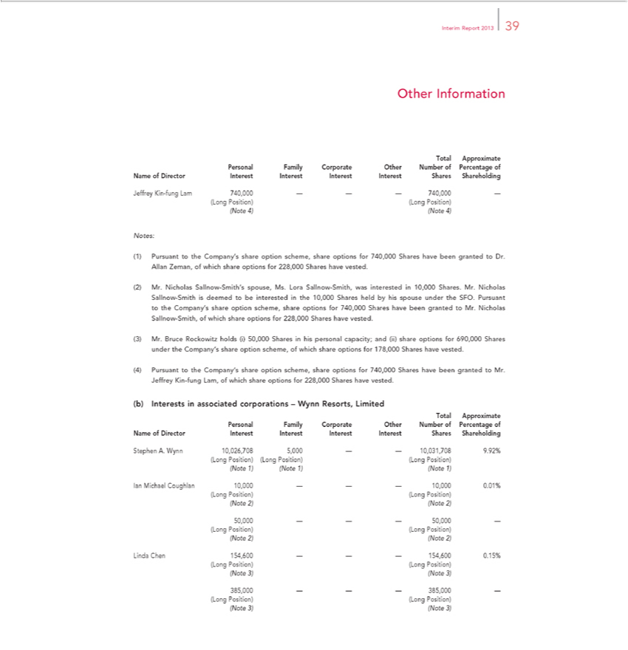

Interim Report 2013 39
Other Information
Total Approximate Personal Family Corporate Other Number of Percentage of Name of Director Interest Interest Interest Interest Shares Shareholding
Jeffrey Kin-fung Lam 740,000 — — — 740,000 —(Long Position) (Long Position)
(Note 4) (Note 4)
Notes: |  |  |  | option scheme, share options for 740,000 Shares have been granted to Dr. Allan Zeman, of which share options for 228,000 Shares have vested.
1) | Pursuant to the Company’s
(2) | Mr. Nicholas Sallnow-Smith’ |  |  | spouse, Ms. Lora Sallnow-Smith, was interested in 10,000 Shares. Mr. Nicholas Sallnow-Smith is deemed to be interested in the 10,000 Shares held by his spouse under the
SFO. Pursuant to the Company’shareshare option scheme, share options for 740,000 Shares have been granted to Mr. Nicholas Sallnow-Smith, of which share options for 228,000 Shares have vested.
(3) | Mr. Bruce Rockowitz holds (i) 50,000 Shares in his personal capacity; and (ii) share options for 690,000 Shares under the Company’s share option scheme, of which share options for 178,000 Shares have
vested.
4) | Pursuant to the Company’s share option scheme, share options for 740,000 Shares have been granted to Mr. Jeffrey Kin-fung Lam, of which share options for 228,000 Shares have vested.
(b) |  | Interests in associated corporations – Wynn Resorts, Limited
Total |  |  | Personal Family Corporate Other Number of Percentage of Name of Director Interest Interest Interest Interest Shares Shareholding
Approximate
(NoteStephen1) (Note.Wynn1) (Note10,026,7081) 5,000 — — 10,031,708 9.92% (Long Position) (Long Position) (Long Position)
(NoteIanMichael2)(NoteCoughlan2) 10,000 — — — 10,000 0.01% (Long Position) (Long Position)
(Note50,0002)—(Note——2)50,000 —(Long Position) (Long Position)
(NoteLinda 3)Chen(Note154,6003) — — — 154,600 0.15% (Long Position) (Long Position)
(Note385,0003) —(Note— —3) 385,000 —(Long Position) (Long Position)

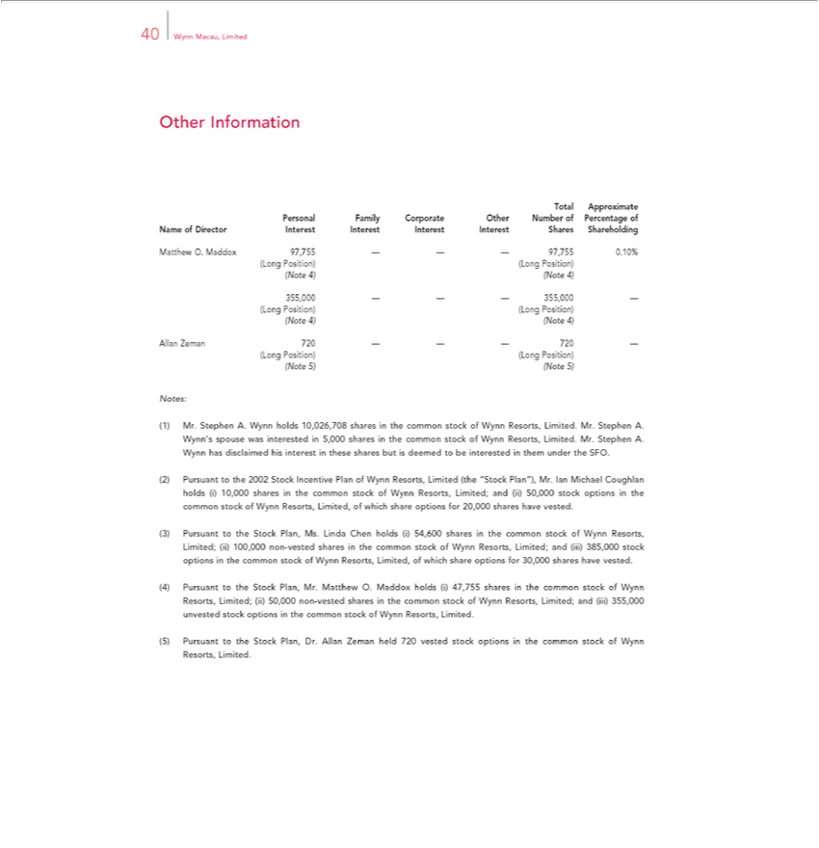

40 Wynn Macau, Limited
TotalOther ApproximateInformation Personal Family Corporate Other Number of Percentage of Name of Director Interest Interest Interest Interest Shares Shareholding Matthew O. Maddox 97,755 — — — 97,755 0.10% (Long Position) (Long Position)
(Note 4) (Note 4)
(Note355,0004) —(Note— —4) 355,000 —(Long Position) (Long Position)
Allan Zeman 720 — — — 720 —(Long Position) (Long Position)
Notes:(Note5) (Note 5)
(1) Mr. Stephen A. Wynn holds 10,026,708 shares in the common stock of Wynn Resorts, Limited. Mr. Stephen A. Wynn’s spouse was interested in 5,000 shares in the common stock of Wynn Resorts, Limited.
WynnMr.StephenhasdisclaimedA. his interest in these shares but is deemed to be interested in them under the SFO.
stock(2)PursuantoptionstointhetheStock2002mmonStockstockIncentiveofWynnPlanResorts,ofWynnLimited,Resorts,ofLimitedwhich share(the“StockoptionsPlan”),for20,000Mr. IansharesMichaelhave Coughlanvested. holds (i) 10,000 shares in the common stock of Wynn Resorts, Limited; and (ii) 50,000 3)iii)Pursuant to the Plan, Ms. Linda Chen holds (i) 54,600 shares in the common stock of Wynn Resorts, Limited; (ii) 100,000 non-vested shares in the common stock of Wynn Resorts, Limited; and
4) Pursuant385,000 tostockthe optionsStockPlan,intheMr.common stockO.MaddoxofWynnholdsResorts,(i)47,755Limited,sharesofwhichinthesharecommonoptionsstockforof30,000WynnsharesResorts,haveLimited;vested.(ii) 50,000 non-vested shares in the common stock of Wynn Resorts, Limited; and
iii) Matthew
⁽⁵⁾ 355,000 unvested stock options in common stock of Wynn Resorts, Limited.
Pursuant to the Stock Plan, Dr. Allan Zeman held 720 vested stock options in the common stock of Wynn Resorts, Limited.

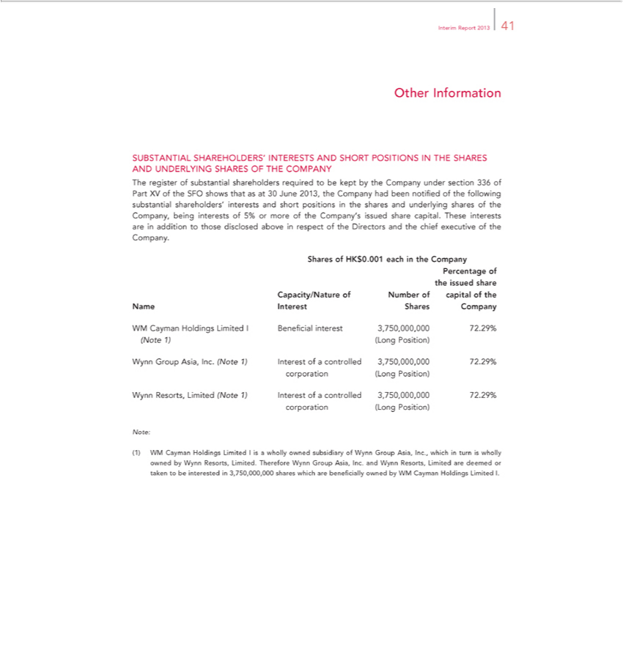

Interim Report 2013 41
Other Information
SUBSTANTIAL SHAREHOLDERS’ INTERESTS AND SHORT POSITIONS IN THE SHARES AND UNDERLYING SHARES OF THE COMPANY
The register of substantial shareholders required to be kept by the Company under section 336 of Part XV of the SFO shows that as at 30 June 2013, the Company had been notified of the following substantial
shareholders’ | and short positions in the shares and underlying shares of the Company, being interests of 5% or more of the Company’s issued share capital. These interests are in addition to those
disclosed aboveinterestsrespect of the Directors and the chief executive of the Company.
Shares of HK$0.001 each in the Company
Percentage of the issued share Capacity/Nature of Number of capital of the Name Interest Shares Company
M Cayman Holdings |  | Limited | I | Beneficial | interest | 3,750,000,000 | 72.29% (Note 1) (Long Position)
Group Asia, Inc. |  | Limited |  | Beneficial |  | 3,750,000,000 | .
Wynn Resorts, Limited |  | (Note 1) Interest of a controlled 3,750,000,000 72.29% corporation (Long Position)
Note:
(1) WM Cayman Holdings Limited I is a wholly owned subsidiary of Wynn Group Asia, Inc., which in turn is wholly owned by Wynn Resorts, Limited. Therefore Wynn Group Asia, Inc. and Wynn Resorts, Limited are deemed or taken to be interested in 3,750,000,000 shares which are beneficially owned by WM Cayman Holdings Limited I.

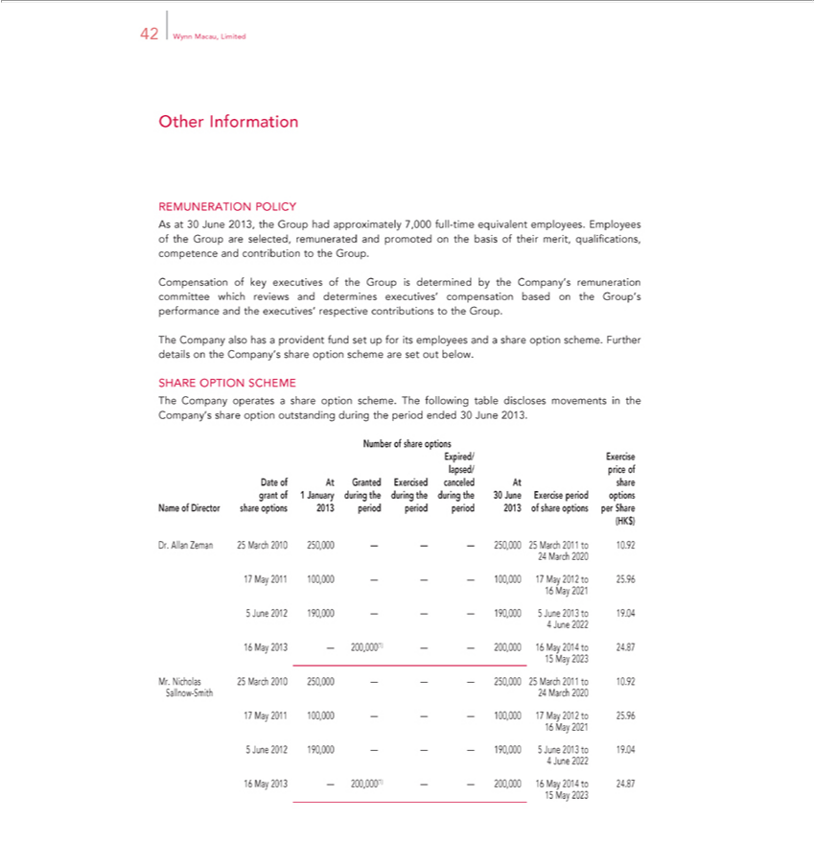

Other42WynnInformationMacau,Limited
REMUNERATION POLICY

As at 30 June 2013, the Group had approximately 7,000 full-time equivalent employees. Employees of the Group are selected, remunerated and promoted on the basis of their merit, qualifications, competence and contribution to the Group.
Compensation of key executives of the Group is determined by the Company’s remuneration committee which reviews and determines executives’ compensation based on the Group’s performance and the executives’ respective contributions to the ^{Group}.
The Company also has a provident fund set for its employees and a share option scheme. Further details on the Company’s share option scheme are set out below.
SHARE OPTION SCHEME
The Company operates a share option scheme. The following table discloses movements in the Company’s share option outstanding during the period ended 30 June 2013. Number of share options
Expired/ Exercise lapsed/ price of Date of At Granted Exercised canceled At share grant of 1 January during the during the during the 30 June Exercise period options Name of Director share options 2013 period period period 2013 of share options per Share (HK$)
24Dr. Allanrch Zeman2020 25 March 2010 250,000 — — — 250,000 25 March 2011 to 10.92
₁₆7 _{May} ₂₀₂₁1 100,000 — — — 100,000 17 May 2012 to 25.96
5 June 2012 190,000 — — — 190,000 5 June 2013 to 19.04
4 June 2022
₁₅6 _{May 2023}13 — 200,000(1) — — 200,000 16 May 2014 to 24.87
Mr. Nicholas 25 March 2010 250,000 — — — 250,000 25 March 2011 to 10.92 Sallnow-Smith 24 March 2020 ₁₆7 _{May} ₂₀₂₁1 100,000 — — — 100,000 17 May 2012 to 25.96
5 June 2012 190,000 — — — 190,000 5 June 2013 to 19.04
4 June 2022
₁₅6 _{May 2023}13 — 200,000(1) — — 200,000 16 May 2014 to 24.87

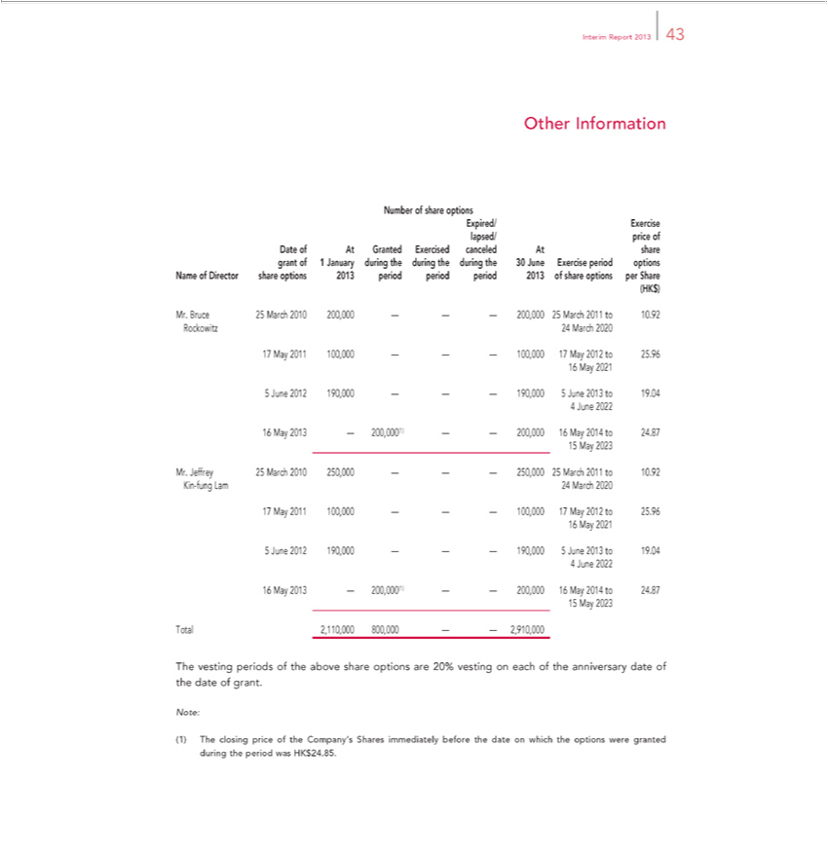

Interim Report 2013 43
NumberOtherInformationofshareoptions

Expired/ Exercise lapsed/ price of Date of At Granted Exercised canceled At share grant of 1 January during the during the during the 30 June Exercise period options Name of Director share options 2013 period period period 2013 of share options per Share (HK$)
₁₆Mr.7_{May}Bruce₂₀₂₁251 100,000March2010——200,000—100,000——17—May200,000201225to March25.96 2011 to 10.92 Rockowitz 24 March 2020
5 June 2012 190,000 — — — 190,000 5 June 2013 to 19.04
4 June 2022
₁₅6 _{May 2023}13 — 200,000(1) — — 200,000 16 May 2014 to 24.87
Mr. Jeffrey 25 March 2010 250,000 — — — 250,000 25 March 2011 to 10.92 Kin-fung Lam 24 March 2020 ₁₆7 _{May} ₂₀₂₁1 100,000 — — — 100,000 17 May 2012 to 25.96
5 June 2012 190,000 — — — 190,000 5 June 2013 to 19.04
4 June 2022
₁₅6 _{May 2023}13 Total—200,000(1)2,110,000—800,000—200,000——162,910,000May2014 to 24.87
Note:Thevesting periods of the above share options are 20% vesting on each of the anniversary date of the date of grant.

(1) The closing price of the Company’s Shares immediately before the date on which the options were granted during the period was HK$24.85.

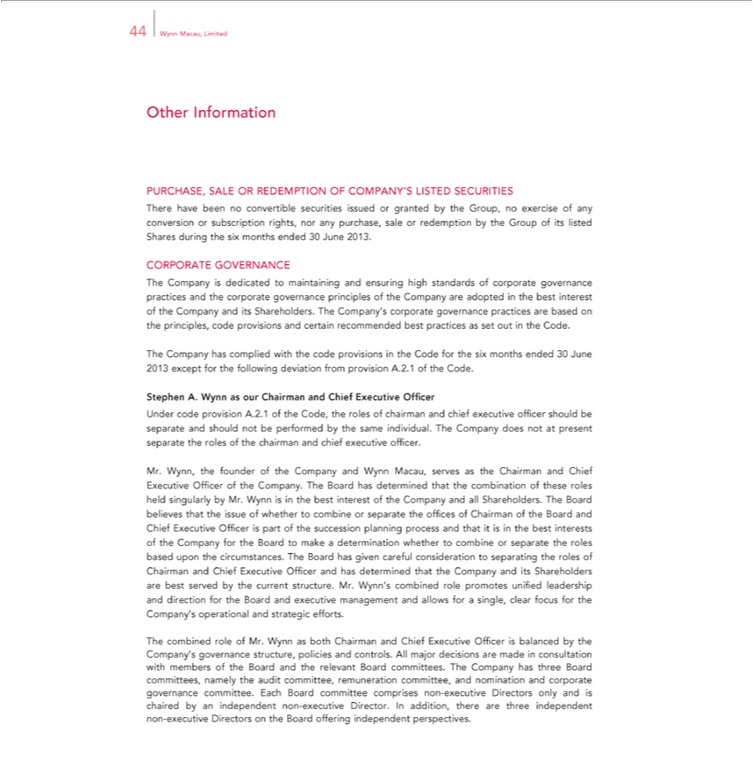

44 Wynn Macau, Limited
Other Information
PURCHASE, SALE OR REDEMPTION OF COMPANY’S LISTED SECURITIES
There have been no convertible securities issued or granted by the Group, no exercise of any conversion or subscription rights, nor any purchase, sale or redemption by the Group of its listed Shares during the
six months ended 30 June 2013.
CORPORATE GOVERNANCE
The Company is dedicated to maintaining and ensuring high standards of corporate governance practices and the corporate governance principles of the Company are adopted in the best interest of the Company
and its Shareholders. The Company’s corporate governance practices are based the principles, code provisions and certain recommended best practices as set out in the Code.
The Company has complied with the code provisions in the Code for the six months ended 30 June 2013 except for the following deviation from provision A.2.1 of the Code.
Stephen A. Wynn as our Chairman and Chief Executive Officer
Under code provision A.2.1 of the Code, the roles of chairman and chief executive officer should be separate and should not be performed by the same individual. The Company does not at present separate the
roles of the chairman and chief executive officer.
, the founder of the Company and Wynn Macau, serves as the Chairman and Chief Executive Officer of the Company. The Board has determined that the combination of these roles held singularly by
Mr. Wynn is in the best interest of the Company and all Shareholders. The Board believes that the issue of whether to combine or separate the offices of Chairman of the Board and Chief Executive Officer is part
of the succession planning process and that it is in the best interests of the Company for the Board to make a determination whether to combine or separate the roles based upon the circumstances. The Board has
given careful consideration to separating the roles of Chairman and Chief Executive Officer and has determined | the Company and its Shareholders are best served by the current structure. Mr. Wynn’s
combined role promotes unified leadership and direction for the Board and executive management and allows forthatsingle, clear focus for the Company’_{controls} operational and strategic efforts.
The combined role of Mr. Wynn as both Chairman and Chief Executive Officer is balanced by the Company’s governance structure, policies and . All major decisions are made in consultation with members of the Board and the relevant Board ^{non}cmmittees. The Company has three Board committees, namely the audit committee, remuneration committee, and nomination and corporate governance committee. Each Board committee comprises -executive Directors only and is chaired by an independent non-executive Director. In addition, there are three independent non-executive Directors on the Board offering independent perspectives.

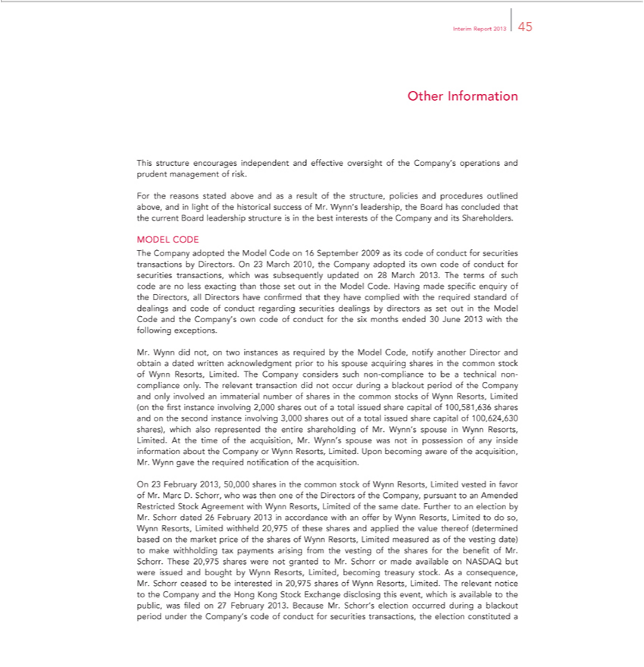

Interim Report 2013 45
Other Information
This structure encourages independent and effective oversight of the Company’ operations and prudent management of risk.
For the reasons stated above and as a result of the structure, policies and procedures outlined above, and in light of the historical success of Mr. Wynn’s leadership, the Board has concluded that the current Board
leadership structure is in the best interests of the Company and its Shareholders.
MODEL CODE
The Company adopted the Model Code on 16 September 2009 as its code of conduct for securities transactions by Directors. On 23 March 2010, the Company adopted its own code of conduct for securities
transactions, which was subsequently updated on 28 March 2013. The terms of such code are less exacting than those set out in the Model Code. |  |  | made specific enquiry of the | all Directors
have confirmed that they have complied with the required standard of dealings and code of conduct regarding securities dealings by directors as set outHavingthe Model Code and the Company’Directors,own code of
conduct for the six months ended 30 June 2013 with the following exceptions.
Mr. Wynn did not, on two instances as required by the Model Code, notify another Director and obtain a dated written acknowledgment prior to his spouse acquiring shares in the common stock of Wynn
Resorts, Limited. The Company considers such non-compliance to be a technical non-compliance only. The relevant transaction did not occur during |  |  | blackout period of the Company and only involved
mmaterial number of shares in the common stocks of Wynn Resorts, Limited (on the first instance involving 2,000 shares out of a total issued share capital of 100,581,636 shares and on the second instance
involving 3,000 shares out of a total issued share capital of 100,624,630 shares), which also represented the entire shareholding of Mr. Wynn’s spouse in Wynn Resorts, Limited. At the time of the acquisition,
Mr. Wynn’s spouse was not in possession of any inside information about the Company or Wynn Resorts, Limited. Upon becoming aware of the acquisition, Mr. Wynn gave the required notification of the
acquisition.
On 23 February 2013, 50,000 shares in the common stock of Wynn Resorts, Limited vested in favor of Mr. Marc D. Schorr, who was then one of the Directors of the Company pursuant to an Amended
tricted Stock Agreement with Wynn Resorts, Limited of the same date. Further to an election by Mr. Schorr dated 26 February 2013 in accordance with an offer by Wynn Resorts, Limited to do so, Wynn
Resorts, Limited withheld 20,975 of these shares and applied the value thereof (determined based on the market price of the shares of Wynn |  |  | Limited measured as of the vesting date) to make
withholding tax payments arising from the vesting of the shares for the benefit of Mr. Schorr. These 20,975 shares were not granted to Mr. SchorrResorts, made available on NASDAQ but were issued and bought by
Wynn Resorts, Limited, becoming treasury stock. As a consequence, Mr. Schorr ceased to be interested in 20,975 |  | of Wynn Resorts, Limited. The relevant notice to the Company and the Hong Kong Stock
Exchange disclosing this event, which is | to the public, was filed on 27 February 2013. Because Mr. Schorr’shareselection occurred during a blackout period under the Company’s code of conduct for
securities transactions, the election constitutedavailable

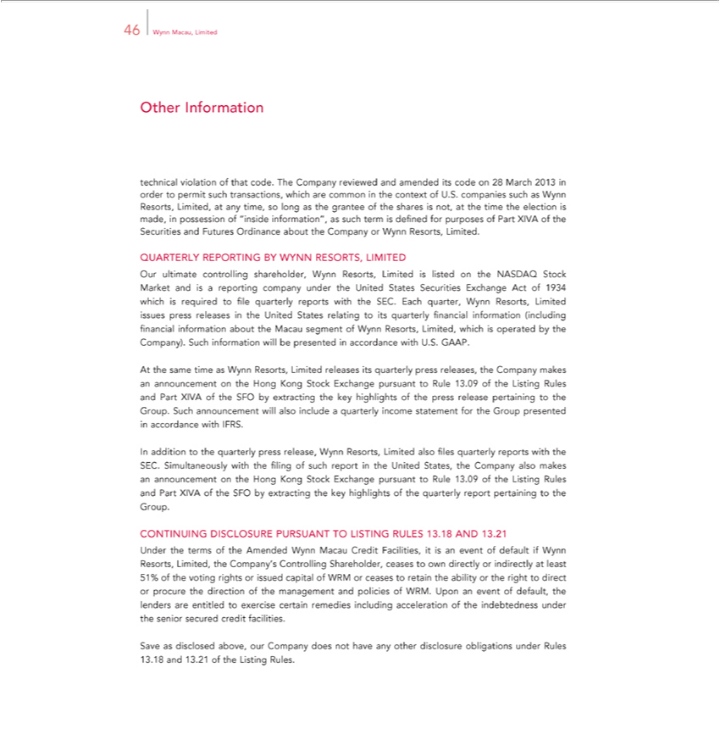

46 Wynn Macau, Limited
Other Information | of that code. The Company reviewed and amended its code 28 March 2013 in order to permit such transactions, which are common the context of U.S. companies such as Wynn Resorts,
technical
Limited, atviolationytime, so long as the grantee of the shares is not, at the time the election is made, in possession of “inside information”, as such term is defined for purposes of Part XIVA of the Securities and
Futures Ordinance about the Company or Wynn Resorts, Limited.
QUARTERLY REPORTING BY |  | RESORTS, LIMITED |  | reporting company under the United States Securities Exchange Act 1934 which is required to file
Our ultimate controlling shareholder,WYNNynn |  |  | Limited is listed on the NASDAQ Stock Market and is
quarterly reports with the SEC. Each quarterResorts,WynnResorts, Limited issues press releases in the United States relating to its quarterly financial information (including financial information about the Macau
segment of Wynn Resorts, Limited, which is operated by the Company). Such information will be presented in accordance with U.S. GAAP. |  |  |  |  | Rules and Part
At the same time as Wynn Resorts, Limited releases its quarterly press releases, the Company makes |  |  |  | on the Hong Kong Stock Exchange pursuant to Rule 13.09 of the | Rules and Part
XIVA of the SFO by extracting the key highlights of the press release pertaining to the Group. Such announcementwill also include a quarterly income statement for the Group presentedListingaccordance with
FRS.
In addition to the quarterly press release, Wynn Resorts, Limited also files quarterly reports with the SEC. Simultaneously with the filing of such report in the United States, the Company also makes an
announcement on the Hong Kong Stock Exchange pursuant to Rule 13.09 of the Listing Rules and Part XIVA of the SFO by extracting the key highlights of the quarterly report pertaining to the Group.
CONTINUING DISCLOSURE PURSUANT TO LISTING RULES 13.18 AND 13.21
Under the terms of the Amended |  | ynn Macau Credit Facilities, is an event of default if Wynn Resorts, Limited, the Company’s Controlling Shareholder, ceases to own directly or indirectly at least 51% of the
voting rights or issued capital of WRM or ceases to retain the ability or the right to direct or procure the direction of the management and policies of WRM. Upon an event of default, the lenders are entitled to exercise certain remedies including acceleration of the indebtedness under the senior secured credit facilities.

Save as disclosed above, our Company does not have any other disclosure obligations under Rules 13.18 and 13.21 of the Listing Rules.

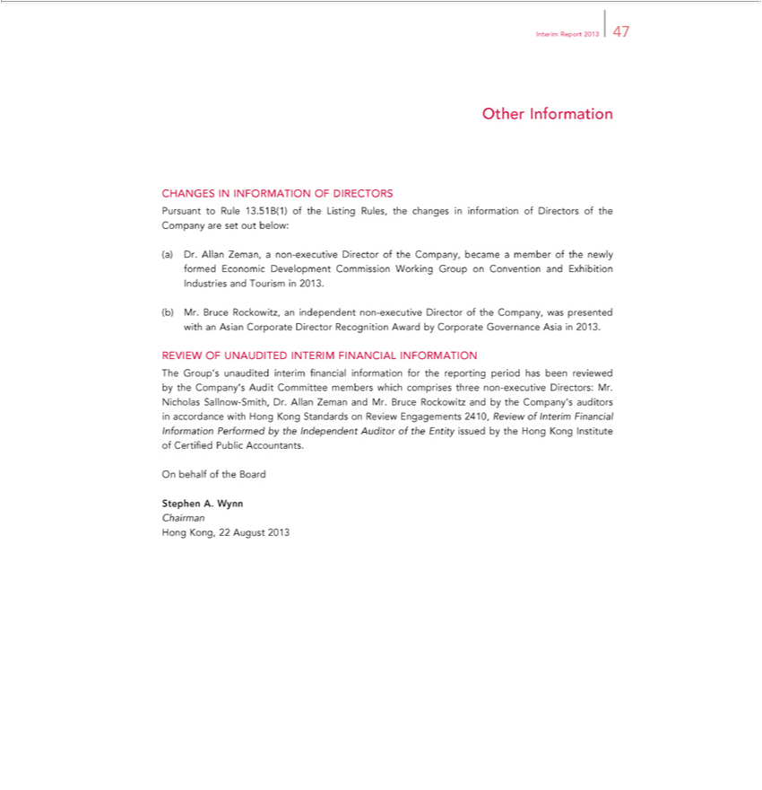

Interim Report 2013 47
Other Information
CHANGES IN INFORMATION OF DIRECTORS | of Directors of the Company are set out below:
Pursuant to Rule 13.51B(1) of the Listing Rules, the changes in | of Directors of the Company are set out below:
(a) Dr. Allan Zeman, a non-executive Director of the Company, becameinformationmember of the newly formed Economic Development Commission Working Group on Convention and Exhibition Industries and Tourism in 2013.

(b) Mr. Bruce Rockowitz, an independent non-executive Director of the Company, was presented with an Asian Corporate Director Recognition Award by Corporate Governance Asia in 2013. REVIEW OF UNAUDITED INTERIM FINANCIAL INFORMATION
The Group’s unaudited interim financial information for the reporting period has been reviewed by the Company’s Audit Committee members which comprises three non-executive Directors: Mr. Nicholas Sallnow-Smith, Dr. Allan Zeman and Mr. Bruce Rockowitz and by the Company’_{Institute}auditors in accordance with Hong Kong Standards on Review Engagements 2410, Review of Interim Financial Information
OnPerformedbehalfofbythetheBoardIndependent Auditor of the Entity issued by the Hong Kong of Certified Public Accountants.
ChairmanStephenA. Wynn

Hong Kong, 22 August 2013

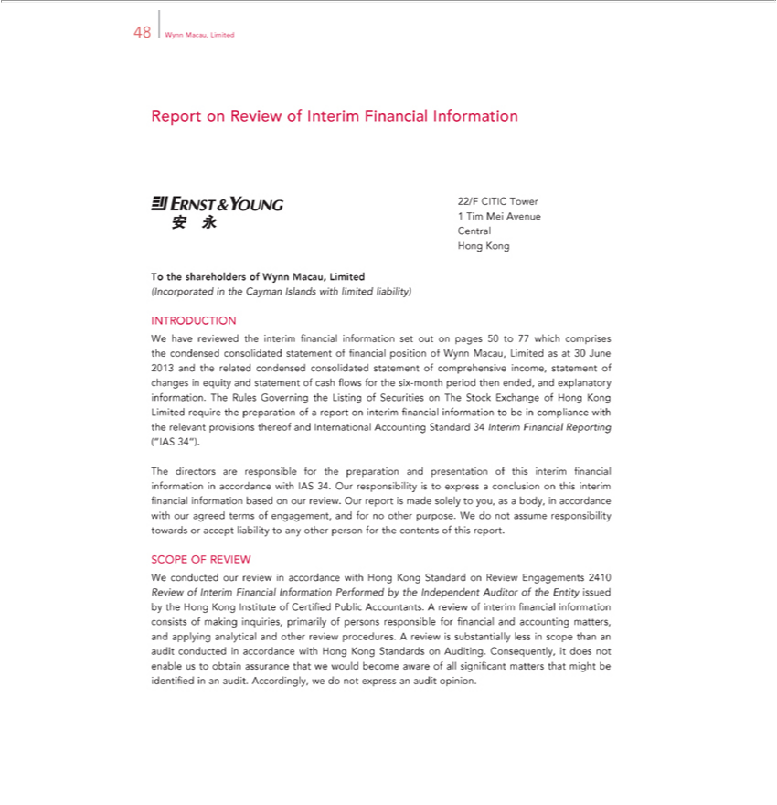

48 Wynn Macau, Limited
Report on Review of Interim Financial Information
22/F |  |  | Tower
1 |  | CITICim Mei Avenue Central Hong Kong
T the shareholders of Wynn Macau, Limited
(Incorporated in the Cayman Islands with limited liability)
INTRODUCTION |  |  |  |  |  |  |  |  | 30 June 2013 and the
W | have reviewed the interim financial information set out on pages 50 to 77 which comprises the condensed consolidated statement of financial position of Wynn Macau, Limited as |  |  |  |  |  |  |  | 30 June 2013 and the
related condensed consolidated statement of comprehensive income, statement of changes in equity and |  |  |  |  |  |  | of cash flows for the six- nth period then ended, and explanatory information. The Rules
Governing the Listing of Securities on The Stock Exchange of Hong Kong Limited require the preparationstatementofreport on interim financial information to be in compliance with the relevant provisions thereof and
Int rnational Accounting Standard 34 Interim Financial Reporting (“IAS 34”). |  |  |  |  |  | financial information in accordance with IAS 34. Our responsibility is to |  | a conclusion on this interim financial
The directors are |  |  |  | for the preparation and presentation of this
information basedresponsibleourreview. Our report is made solely to you, as a body,interim accordance with our agreed terms of engagement, and for no other purpose.expressWdo not assume responsibility towards or accept
liability to any other person for the contents of this report.
SCOPE OF REVIEW |  |  |  | accordance with Hong Kong Standard on Review Engagements 2410
W | conducted our review |  |  |  |  |  |  | . A review of interim fi | ancial information
Review of Interim Financial Information Performed by the Independent Auditor of the Entity issued by the Hong Kong Institute of Certified Public |  |  |  |  |  |  |  | . A review of interim fi | ancial information
 | sists of making inquiries, primarily of persons |  |  |  | for financial and accounting matters, and applying analytical and other review procedures.Accountantsreview is substantially less in scope than an audit
conducted |  |  | accordance with Hong Kong StandardsresponsibleAuditing. Consequently, it does not enable us to obtain assurance that we would become aware of all significant matters that might be identified in an
audit. Accordingly, we do not express an audit opinion.

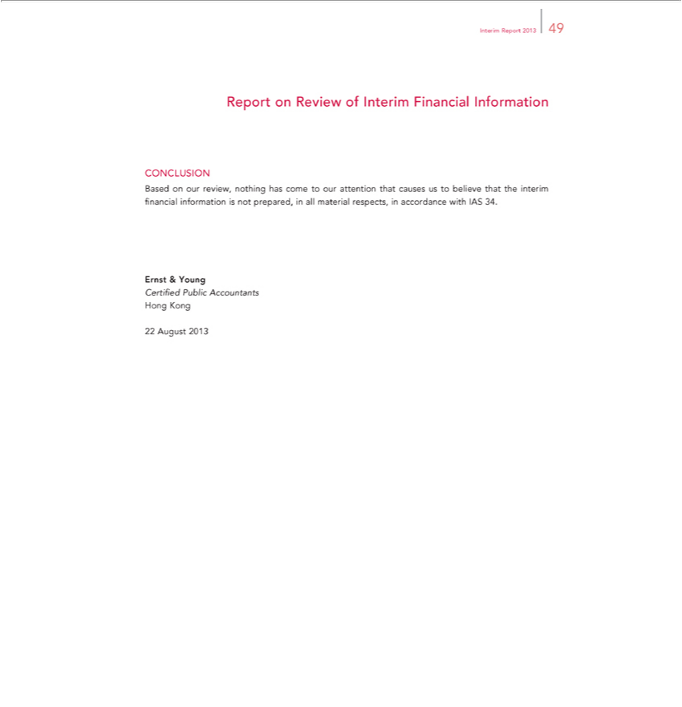

Interim Report 2013 49
Report on Review of Interim Financial Information
CONCLUSION
Based on our review, nothing has come to our attention that causes us to believe that the interim financial information is not prepared, in all material respects, in accordance with IAS 34. Ernst & Young
HongCertifiedKongPublic Accountants

22 August 2013

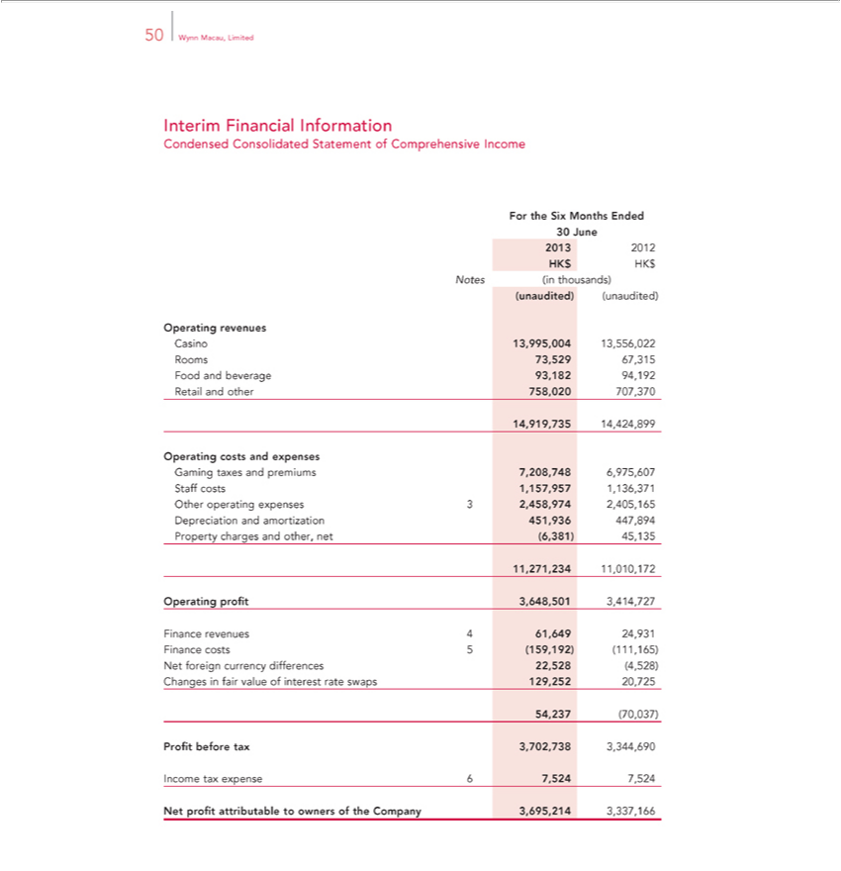

50 Wynn Macau, Limited
Interim Financial Information
Condensed Consolidated Statement of Comprehensive Income
For the Six Months Ended
30 June
2013 2012 HK$ HK$
Notes (in thousands)
(unaudited) (unaudited)
Operating revenues
Casino 13,995,004 13,556,022 Rooms 73,529 67,315 Food and beverage 93,182 94,192 Retail and other 758,020 707,370
14,919,735 14,424,899
Operating costs and expenses
Gaming taxes and premiums 7,208,748 6,975,607 Staff costs 1,157,957 1,136,371 Other operating expenses 3 2,458,974 2,405,165 Depreciation and amortization 451,936 447,894 Property charges and other,
net (6,381) | 45,1351,010,172
11,271,234 | 45,1351,010,172 | 501 3,414,727
Operating profit |  | 501 3,414,727
Finance revenues3,64861,649 24,931 Finance costs 5 (159,192) (111,165) Net foreign currency differences 22,528 (4,528) Changes in fair value of interest rate swaps 129,252 20,725 54,237 (70,037)
IncomeProfitbeforetaxexpensetax3,702,73867,5243,344,6907,524

Net profit attributable to owners of the Company 3,695,214 3,337,166

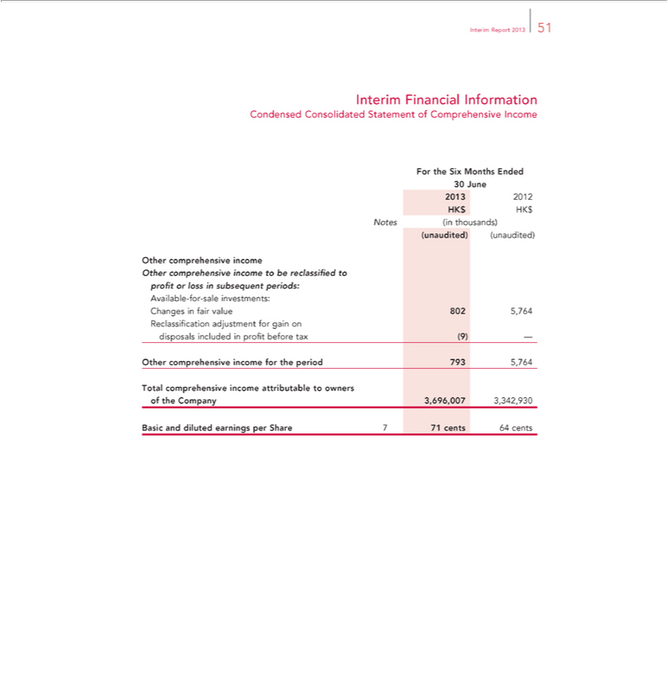

_{Interim} FinancialReport2013Information51
ForCondensedtheSix ConsolidatedMonthsEndedStatement of Comprehensive Income
₂₀₁₃30June
2012 HK$ HK$
(unaudited)Notes(inthousands)(unaudited)
Other comprehensive income
Available-for-sale investments:to be reclassified to profit or loss in subsequent periods:

Changes in fair value 802 5,764 Reclassification adjustment for gain on disposals included in profit before tax (9) — Other comprehensive income for the period 793 5,764

BasicTotal comprehensiveanddilutedearningsincomeperattributableShare771tocentsowners64centsofthe Company 3,696,007 3,342,930

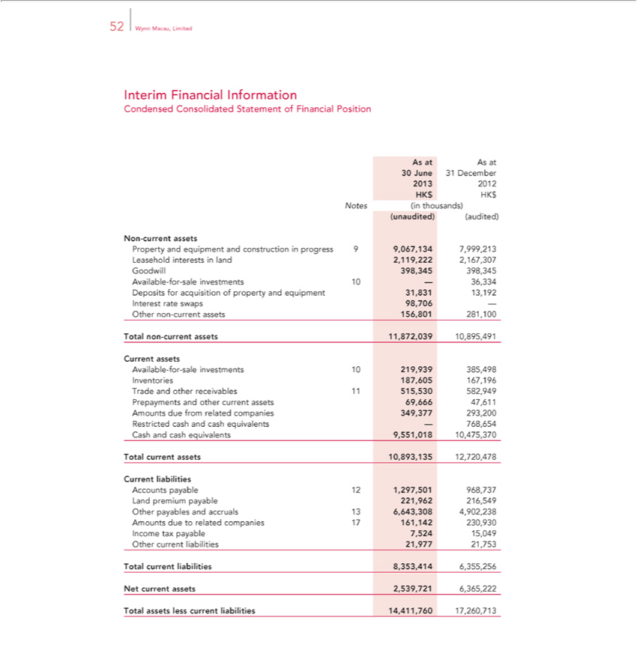

Interim52WynnFinancialMacau, LimitedInformation
AsCondensedatAsat Consolidated Statement of Financial Position
²⁰¹³30June 31 December
Notes2012(inthousands)HK$HK$
Non(unaudited)-current(audited)assets

Property and equipment and construction in progress 9 9,067,134 7,999,213 Leasehold interests in land 2,119,222 2,167,307 Goodwill 398,345 398,345 Available-for-sale investments 10 — 36,334 Deposits for acquisition of property and equipment 31,831 13,192 Interest rate swaps 98,706 — Other non-current assets 156,801 281,100
CurrentTotalnonassets-current assets 11,872,039 10,895,491
Available-for-sale investments 10 219,939 385,498 Inventories 187,605 167,196 Trade and other receivables_{9,551,018}1515,530 582,949 Prepayments and other current assets 69,666 47,611 Amounts due from related
companies 349,377 293,200 Restricted cash and cash equivalents — 768,654 Cash and cash equivalents 10,475,370 Total current assets 10,893,135 12,720,478
Current liabilities

Accounts payable 12 1,297,501 968,737 Land premium payable 221,962 216,549 Other payables and accruals 13 6,643,308 4,902,238 Amounts due to related companies 17 161,142 230,930 Income tax payable 7,524 15,049 Other current liabilities 21,977 21,753
Total current liabilities 8,353,414 6,355,256 Net current assets 2,539,721 6,365,222 Total assets less current liabilities 14,411,760 17,260,713

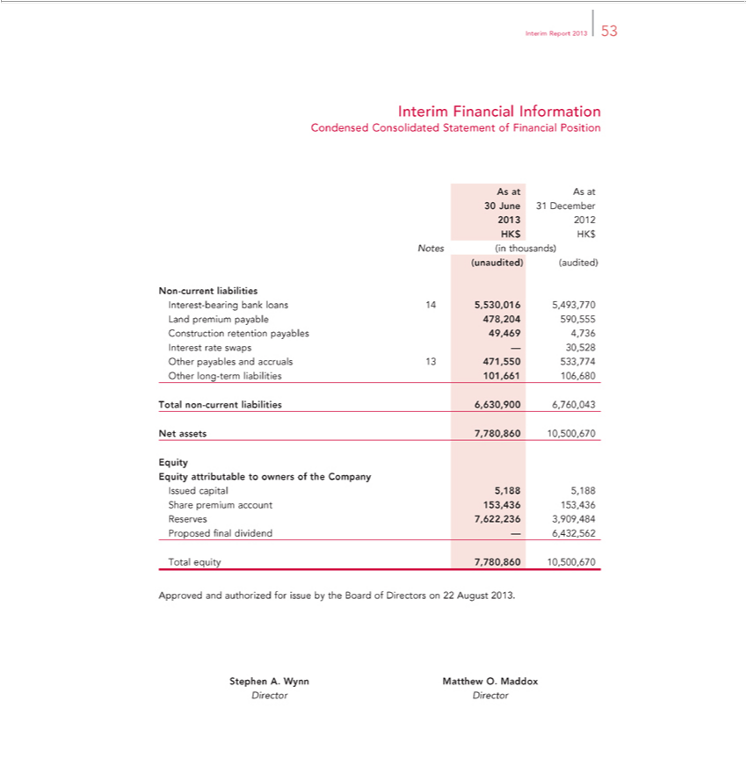

_{Interim} FinancialReport2013Information53
AsCondensedatAsat Consolidated Statement of Financial Position
²⁰¹³30June 31 December
Notes2012(inthousands)HK$HK$
Non(unaudited)-current(aud_{liabilities}ted)
Interest-bearing bank loans 14 5,530,016 5,493,770 Land premium payable 478,204 590,555 Construction retention payables 49,469 4,736 Interest rate swaps — 30,528 Other payables and accruals 13 471,550 533,774 Other long-term liabilities 101,661 106,680
NetTotalassetsnon-current7,780,860liabilities10,500,6706,630,900 6,760,043

Eq ity
^{Issued} attributable to owners of the Company
capital 5,188 5,188 Share premium account 153,436 153,436 Reserves 7,622,236 3,909,484 Proposed final dividend — 6,432,562 Total equity 7,780,860 10,500,670
StephenApprovedA.andWynnauthorizedMatthewforO.issueMaddoxbythe Board of Directors on 22 August 2013.
Director Director

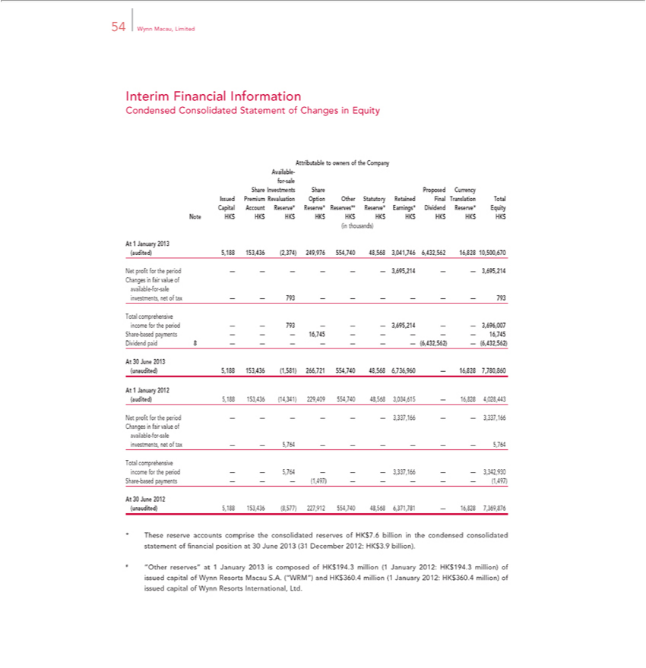

54 Wynn Macau, Limited
Interim Financial Information
Condensed C nsolidated Statement of Changes in Equity
Attributable to owners of the Company Available-for-sale
Share Investments Share Proposed Currency
Issued Premium Revaluation Option Other Statutory Retained Final Translation Total Capital Account Reserve* Reserve* Reserves*# Reserve* Earnings* Dividend Reserve* Equity Note HK$ HK$ HK$ HK$
HK$ HK$ HK$ HK$ HK$ HK$
(in thousands)
At 1 January 20 | 153,436 (2,374) 249,976 554,740 48,568 3,041,746 6,432,562 16,828 10,500,670
(audited) 5,188
Net profit for the period — — — — — — 3,695,214 — — 3,695,214
Changes in fair value of available-for-sale investments, net of tax — — 793 — — — — — — 793
Total comprehensive income for the period — — 793 — — — 3,695,214 — — 3,696,007
Share-based payments — — — 16,745 — — — — — 16,745
Dividend paid 8 — — — — — — — (6,432,562) — (6,432,562)
At 30 June 2013
(unaudited) 5,188 153,436 (1,581) 266,721 554,740 48,568 6,736,960 — 16,828 7,780,860
At 1 January 20 2
(audited) 5,188 | 153,436 (14,341) 229,409 554,740 48,568 3,034,615 — 16,828 4,028,443
Net profit for the period — — — — — — 3,337,166 — — 3,337,166 Changes in fair value of available-for-sale investments, net of tax — — 5,764 — — — — — — 5,764 Total comprehensive income for the period — — 5,764 — — — 3,337,166 — — 3,342,930 Share-based payments — — — (1,497) — — — — — (1,497)
(unaudited) 5,188 153,436 (8,577) 227,912 554,740 48,568 6,371,781 — 16,828 7,369,876
* ^{“Other}Thesereserve accounts comprise the consolidated reserves of HK$7.6 billion in the condensed consolidated statement of financial position at 30 June 2013 (31 December 2012: HK$3.9 billion).
HK#$360.4reserves”million) atof1issuedJanuarycapital2013ofis WynncomposedResortsofHKInternational,$194.3millionLtd. (1 January 2012: HK$194.3 million) of issued capital of Wynn Resorts Macau S.A. (“WRM”) and HK$360.4 million (1 January 2012:

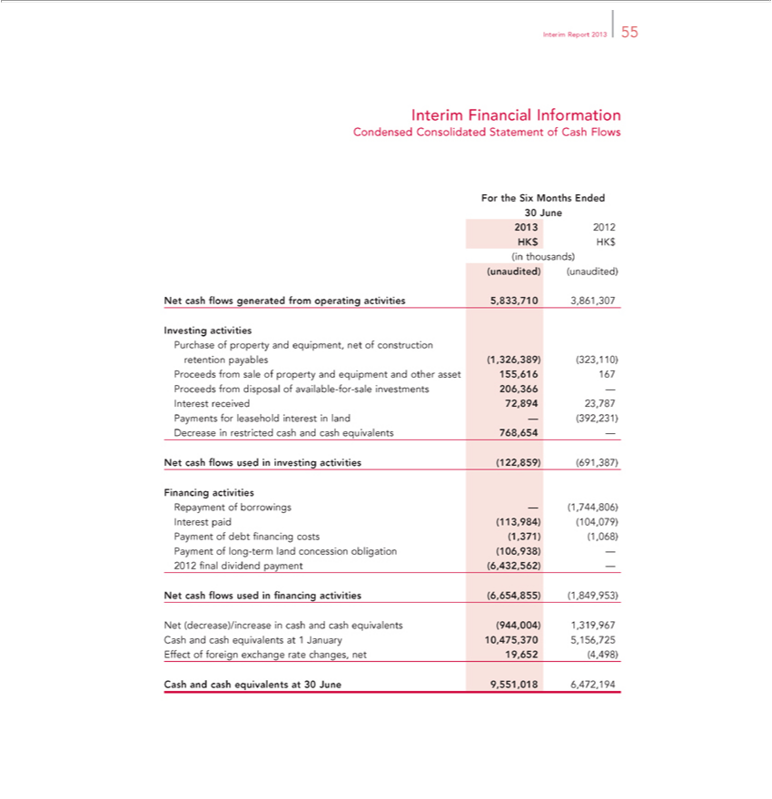

_{Interim} FinancialReport2013Information55
ForCondensedtheSix ConsolidatedMonthsEndedStatement of Cash Flows
₂₀₁₃30June
(unaudited)2012HK(unaudited)$HK$(in thousands)
InvestingNetcashflowsactivitiesgenerated from operating activities 5,833,710 3,861,307

Purchase of property and equipment, net of construction retention payables (1,326,389) (323,110) Proceeds from sale of property and equipment and other asset 155,616 167 Proceeds from disposal of available-for-sale investments 206,366 — Interest received 72,894 23,787 Payments for leasehold interest in land — (392,231) Decrease in restricted cash and cash equivalents 768,654 —
FinancingNetcashflowsactivitiesused in investing activities (122,859) (691,387)

_{Repayment} of borrowings — (1,744,806) Interest paid (113,984) (104,079) Payment of debt financing costs (1,371) (1,068) Payment of long-term land concession obligation (106,938) — 2012 final dividend (6,432,562) —
_{Net} _{(decrease)/increase}cashflowsused_{financing} activities (6,654,855) (1,849,953)
cash and cash equivalents (944,004) 1,319,967 Cash and cash equivalents at 1 January 10,475,370 5,156,725 Effect of foreign exchange rate changes, net 19,652 (4,498) Cash and cash equivalents at 30 June 9,551,018 6,472,194

56InterimWynnFinancialMacau, LimitedInformation
Notes to Interim Financial Information
1.ForCORPORATEthesixmonthsINFORMATIONended30June2013
ExchangeTheCompaony9 wasOctoberincorporated2009.Thein Company’stheCaymanregisteredIslandsasofficeanexemptedaddress companyisP.O.Boxwith309,limitedUglandliabilityHouse,onGrand4SeptemberCayman,2009.KY1The-1104,Company’sCayman SharesIslands,wereoratlistedsuch otherontheplaceMainasBoardtheDirectorsoftheHongmayKongfrom Stocktimeto time decide.
The 20Group-yearownsconcessionandoperatesperiodacommencedhotelandcasinoon27resort,June2002WynnandMacau,willexpirewhichonconducts26Junegaming2022. activities in casinos in Macau under a concession contract signed with the Macau Government on 24 June 2002. WM Cayman Holdings Limited I owns approximately 72.29% of the Company and approximately 27.71% of the Company is owned by public shareholders. The ultimate parent company of Wynn Macau,
Limited is Wynn Resorts, Limited, a publicly-traded company incorporated in the United States of America.
This2.1ACCOUNTINGinterimfinancialPOLICIESinformationANDhas BASISbeenpreparedOFPREPARATIONinaccordance with the applicable disclosure requirements of Appendix 16 to the Rules Governing the Listing of Securitiesinformationthe Hong Kong Stock
informationExchangeandandInternationaldisclosures Accountingrequired theStandardannual(“IAS”)financial34statements,InterimFinancialandshouldReportingbereadissuedconjunctionbytheIternationalwiththeGroup’sAccountingannualStandardsfinancial Board.statementsThe forinterimtheyearfinancialended 31 Decemberdoes2012.not includeTheaccountingallthe
policies and basis of preparation adopted in the preparation of the interim financial information are the same as those used in the annual financial statements for the year ended 31 December 2012.

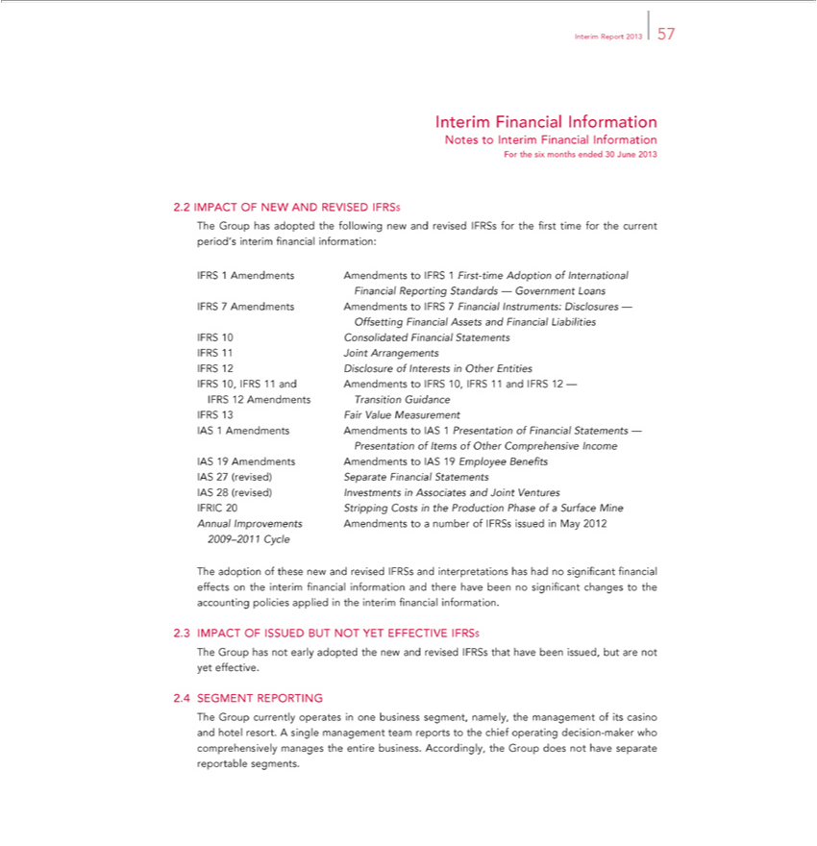

 | Report 2013 57
Interim Financial Information
Notes to Interim Financial Information
For the six months ended 30 June 2013
2.2 IMPACT OF NEW AND REVISED IFRSS
The Group has adopted the following new and revised IFRSs for the first time for the current period’s interim financial information:
1 |  | 1 rst-time Adoption of International Financial Reporting Standards — Government Loans
7 | Amendments Amendments to IFRS 7 Financial Instruments: Disclosures — Offsetting Financial Assets and Financial Liabilities IFRS 10 Consolidated Financial Statements IFRS 11 Joint Arrangements
 | 2 Disclosure of Interests in Other Entities
 | 0, IFRS 11 and Amendments to IFRS 10, IFRS 11 and IFRS 12 — IFRS 12 Amendments Transition Guidance
FRS 13 Fair Value Measurement
Amendments Amendments to IAS 1 Presentation of Financial Statements — Presentation of Items of Other Comprehensive Income
19 | Amendments Amendments to IAS 19 Employee Benefits
7 | Separate | Statements
AS 28 | (revised) InvestmentsFinancialAssociates and Joint Ventures
IFRIC | Stripping Costs in the Production Phase of a Surface Mine Annual Improvements Amendments to a number of IFRSs issued in May 2012
2009–2011 Cycle
The adoption of these new and revised IFRSs and interpretations has had no significant financial effects on the interim financial information and there have been no significant changes to the accounting policies
applied in the interim financial information.
2.3 IMPACT OF ISSUED BUT NOT YET EFFECTIVE IFRSS
The Group has not early adopted the new and revised IFRSs that have been issued, but are not yet effective.
2.4 SEGMENT REPORTING |  | one business segment, namely, the management of its casino and hotel resort. A single management team reports to the chief operating decision-maker who comprehensively
The Group currently operates
manages the entire business. Accordingly, the Group does not have separate reportable segments.

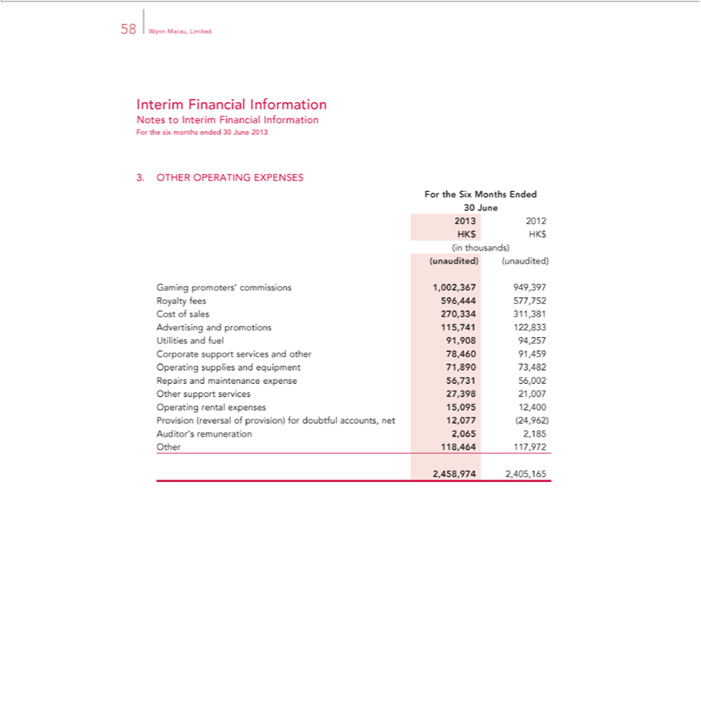

Interim58WynnFinancialMacau, LimitedInformation
ForNotesthetosixInterimmonthsFinancialended30InformationJune2013
For3.OTHERtheSix OPERATINGMonthsEndedEXPENSES
30₂₀₁₃June
(unaudited)2012HK(unaudited)$HK$(in thousands)

Gaming promoters’ commissions 1,002,367 949,397 Royalty fees 596,444 577,752 Cost of sales 270,334 311,381 Advertising and promotions 115,741 122,833 Utilities and fuel 91,908 94,257 Corporate support services and other 78,460 91,459 Operating supplies and equipment 71,890 73,482 Repairs and maintenance expense 56,731 56,002 Other support services 27,398 21,007 Operating rental expenses 15,095 12,400 Provision (reversal of provision) for doubtful accounts, net 12,077 (24,962) Auditor’s remuneration 2,065 2,185 Other 118,464 117,972
2,458,974 2,405,165

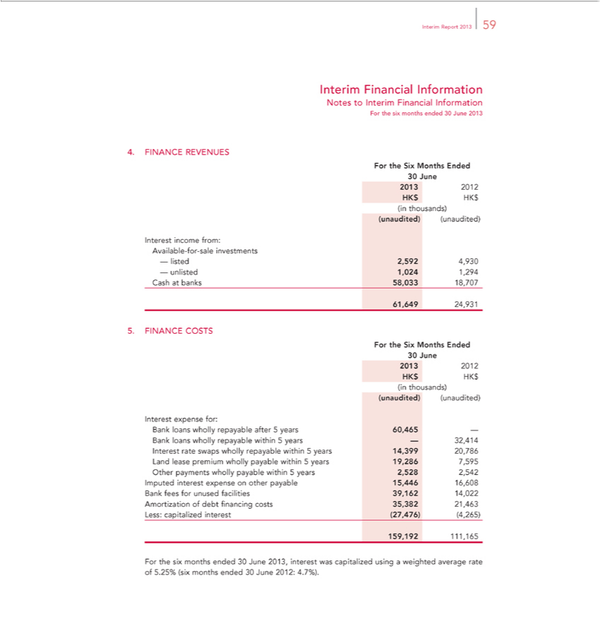

_{Interim} FinancialReport2013Information59
ForNotesthetosixInterimmonthsFinancialended30InformationJune2013
4. FINANCE REVENUES
For the Six Months Ended
30₂₀₁₃June
(unaudited)2012HK(unaudited)$HK$(in thousands)
AvailableInterestincome-for-salefrom:investments
61,649—listed24,9312,592 4,930 — unlisted 1,024 1,294 Cash at banks 58,033 18,707
For5.FINANCEtheSixMonthsCOSTSEnded
30₂₀₁₃June
(unaudited)2012HK(unaudited)$HK$(in thousands)
Interest expense for:
Bank loans wholly repayable after^{7,595} years 60,465 — Bank loans wholly repayable within 5 years — 32,414 Interest rate swaps wholly repayable within 5 years 14,399 20,786 Land lease premium wholly
payable within 5 years 19,286 Other payments wholly payable within 5 years 2,528 2,542 Imputed interest expense on other payable 15,446 16,608 Bank fees for unused facilities 39,162 14,022 Amortization of debt financing costs 35,382 21,463 Less: capitalized interest (27,476) (4,265)
159,192 111,165

For the six months ended 30 June 2013, interest was capitalized using a weighted average rate of 5.25% (six months ended 30 June 2012: 4.7%).

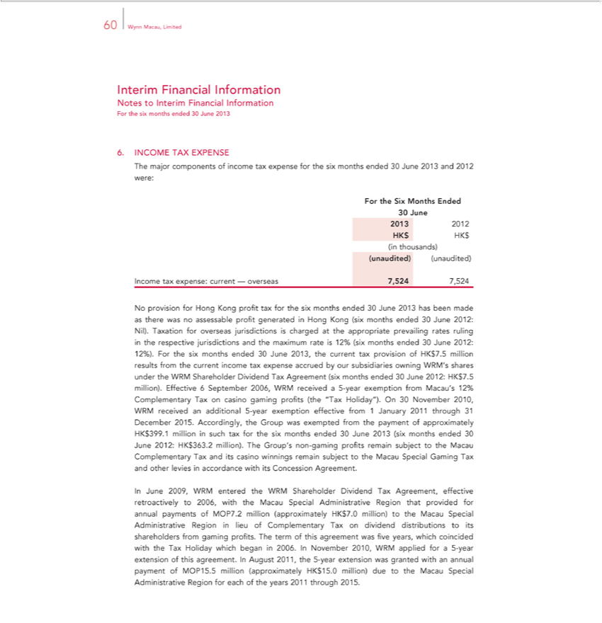

60 Wynn Macau, Limited
Interim Financial Information
Notes to Interim Financial Information
For the six months ended 30 June 2013
6. INCOME TAX EXPENSE
The major components of income tax expense for the six months ended 30 June 2013 and 2012 were:
For the Six Months Ended
30 June
2013 2012 HK$ HK$ (in thousands)
(unaudited) (unaudited)
Income tax expense: current — overseas 7,524 7,524
No provision for Hong Kong profit tax for the six months ended 30 June 2013 has been made as there was no assessable profit generated in Hong Kong (six months ended 30 June 2012: Nil). Taxation for
overseas jurisdictions charged at the appropriate prevailing rates ruling in the respective jurisdictions and the maximum rate is 12% (six months ended 30 June 2012: 12%). For the six months ended 30 June
2013, the current tax provision of HK$7.5 million results from the current income tax expense accrued by our subsidiaries owning WRM’s shares under the WRM Shareholder Dividend Tax Agreement (six
months ended 30 June 2012: HK$7.5 million). Effective 6 September 2006, WRM received a 5-year exemption from Macau’s 12% Complementary Tax on casino gaming profits (the “Tax Holiday”). On
30 November 2010, WRM received an additional 5-year exemption effective from 1 January 201 through 31 December 2015. Accordingly, the Group was exempted from the payment of approximately
HK$399.1 million in such tax for the six months ended 30 June 2013 (six months ended 30 June 2012: HK$363.2 million). The Group’s non-gaming profits remain subject to the Macau Complementary Tax and
its casino winnings remain subject to the Macau Special Gaming Tax and other levies in accordance with its Concession Agreement.
In June 2009, WRM entered the WRM Shareholder Dividend Tax Agreement, effective retroactively to 2006, with the Macau Special Administrative Region that provided for annual payments of MOP7.2
million (approximately HK$7.0 million) to the Macau Special | Region in lieu of Complementary T on dividend distributions to its shareholders from gaming profits. The term of this agreement
was five years, which coincided with the Tax Holiday which beganAdministrative2006.In November 2010, WRM applied forax 5-year extension of this agreement. In August 2011, the 5-year extension was granted with an annual payment of MOP15.5 million (approximately HK$15.0 million) due to the Macau Special Administrative Region for each of the years 2011 through 2015.

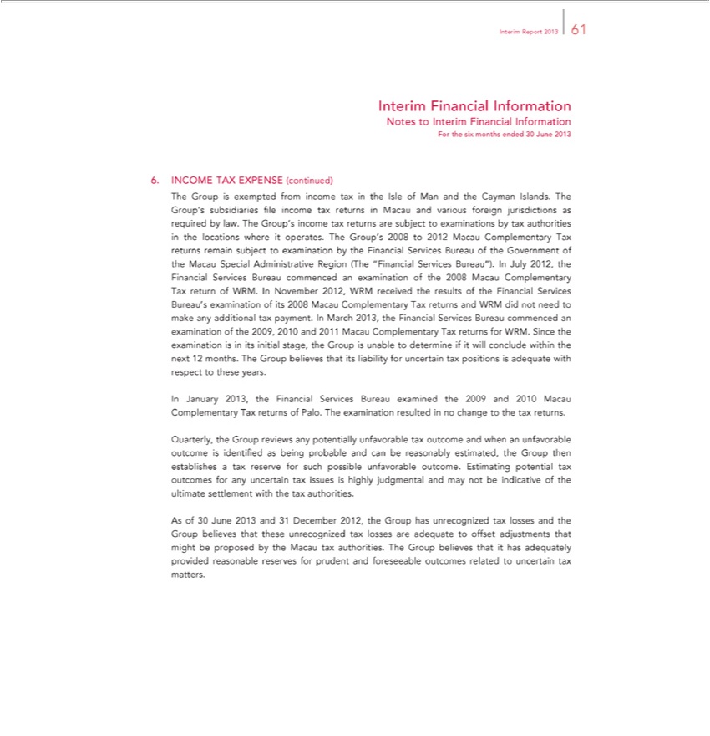

Report 2013 61
Interim Financial Information
Notes to Interim Financial Information
For the six months ended 30 June 2013
6. INCOME TAX EXPENSE (continued) | subsidiaries file income tax returns in Macau and various foreign jurisdictions as required by law. The Group’s
The Group is exempt d from income tax the Isle of Man and the Cayman Islands. The Group’
income tax returns are subject to examinations by tax authorities the locations where it operates. The Group’s 2008 to 2012 Macau Complementary Tax returns remain subject to examination by the Financial
Services Bureau of the Government of the Macau Special Administrative Region (The “Financial Services Bureau”). In July 2012, the Financial Services Bureau commenced an examination of the 2008 Macau
Complementary Tax return of WRM. In November 2012, WRM received the results of the | Services Bureau’s examination of its 2008 Macau Complementary Tax returns and WRM did not need to
make any additional tax payment. In March 2013, the Financial Services Bureau commencedFinancialexamination of the 2009, 2010 and 2011 Macau Complementary Tax returns for WRM. Since the examination is
in its initial stage, the Group is unable to determine if it will conclude within the next 12 months. The Group believes that its liability for uncertain tax positions is adequate with respect to these years.
In January 2013, the Financial Services Bureau examined the 2009 and 2010 Macau Complementary Tax returns of Palo. The examination resulted in no change to the tax returns. |  | establishes tax reserve
Quarterly, the Group reviews any potentially unfavorable tax outcome and when an unfavorable outcome is identified as being probable and can be reasonably estimated, the Group |  | establishes tax reserve
for such possible unfavorable outcome. Estimating potential tax outcomes for any uncertain tax issues is highly judgmental and may not be indicative of the ultimate settlement with thentax authorities.
As of 30 June 2013 and 31 December 2012, the Group has unrecognized tax losses and the Group believes that these unrecognized tax losses are adequate to offset adjustments that might be proposed by the Macau tax authorities. The Group believes that it has adequately provided reasonable reserves for prudent and foreseeable outcomes related to uncertain tax matters.

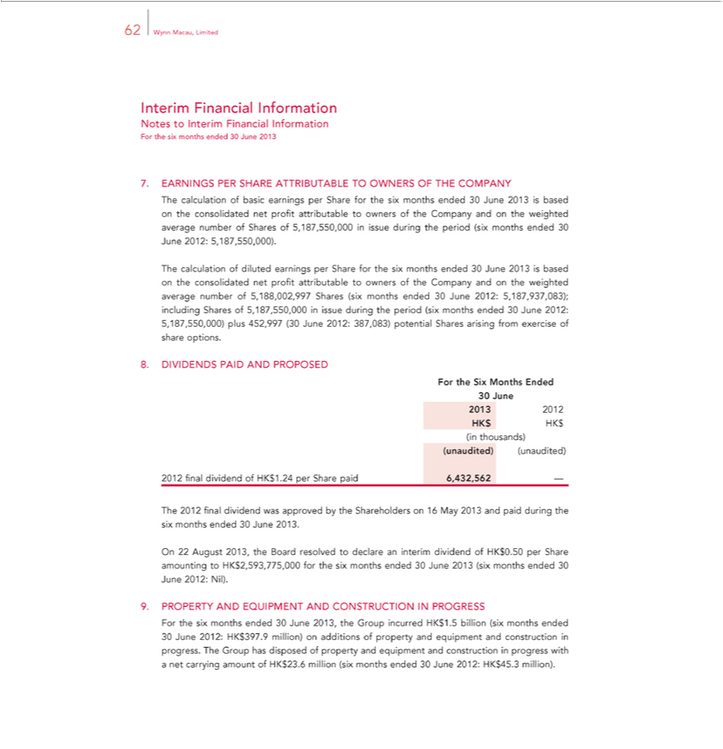

62 Wynn Macau, Limited
Interim Financial Information
Notes to Interim Financial Information
For the six months ended 30 June 2013
7. EARNINGS PER SHARE ATTRIBUTABLE TO OWNERS OF THE COMPANY
The calculation of basic earnings per Share for the six months ended 30 June 2013 is based on the consolidated net profit attributable to owners of the Company and on the weighted average number of Shares of
5,187,550,000 in issue during the | (six months ended 30 June 2012: 5,187,550,000).
The calculation of diluted earningsperiodShare for the six months ended 30 June 2013 is based on the consolidated net profit attributable to owners of the Company and on the weighted average number of
5,188,002,997 Shares (six months ended 30 June 2012: 5,187,937,083); including Shares of 5,187,550,000 in issue during the period (six months ended 30 June 2012: 5,187,550,000) plus 452,997 (30 June
2012: 387,083) potential Shares arising from exercise of share options.
8. DIVIDENDS PAID AND PROPOSED
For the Six Months Ended
30 June
2013 2012 HK$ HK$ (in thousands)
(unaudited) (unaudited)
2012 final dividend of HK$1.24 per Share paid 6,432,562 —
The 2012 final dividend was approved by the Shareholders on 16 May 2013 and paid during the six months ended 30 June 2013.
On 22 August 2013, the Board resolved to declare an interim dividend of HK$0.50 per Share amounting to HK$2,593,775,000 for the six months ended 30 June 2013 (six months ended 30 June 2012: Nil).
9. PROPERTY AND EQUIPMENT AND CONSTRUCTION IN PROGRESS
For the six months ended 30 June 2013, the Group incurred HK$1.5 billion (six months ended
30 June 2012: HK$397.9 million) | additions of property and equipment and construction in progress. The Group has disposed of property and equipment and construction in progress with a net carrying
amount of HK$23.6 million (six months ended 30 June 2012: HK$45.3 million).

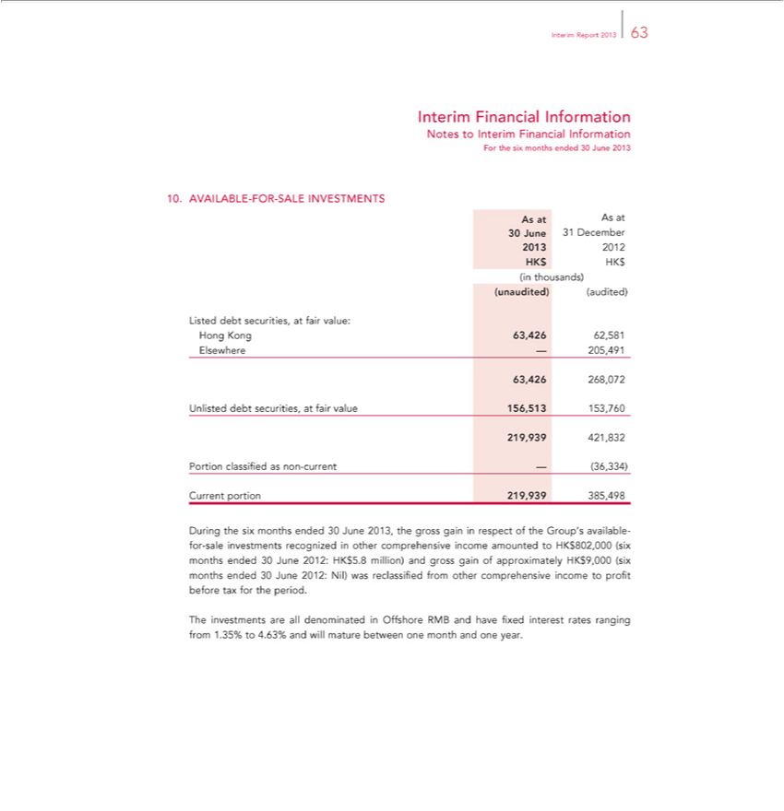

 | Report 2013 63
Interim Financial Information
Notes to Interim Financial Information
For the six months ended 30 June 2013
10. | AVAILABLE-FOR-SALE INVESTMENTS
As at As at
30 June 31 December
2013 | 2012 HK$ HK$ (in thousands)
(unaudited) (audited)
Listed debt securities, at fair value:
Hong Kong 63,426 62,581 Elsewhere — 205,491
63,426 268,072
Unlisted debt securities, at fair value 156,513 153,760
219,939 421,832 Portion classified as non-current — (36,334) Current portion 219,939 385,498 |  | income amounted to HK$802,000 (six months ended
During the six months ended 30 June 2013, the gross gain in respect of the Group’ available-for-sale investments recognized in other |  | income amounted to HK$802,000 (six months ended
months comprehensive
30 June 2012: HK$5.8 million) and gross gain of approximately HK$9,000 (six ended 30 June 2012: Nil) was reclassified from other _{month}prehensive income to profit before tax for the period.
The investments are all denominated in Offshore RMB and have fixed interest rates ranging from 1.35% to 4.63% and will mature between one and one year.

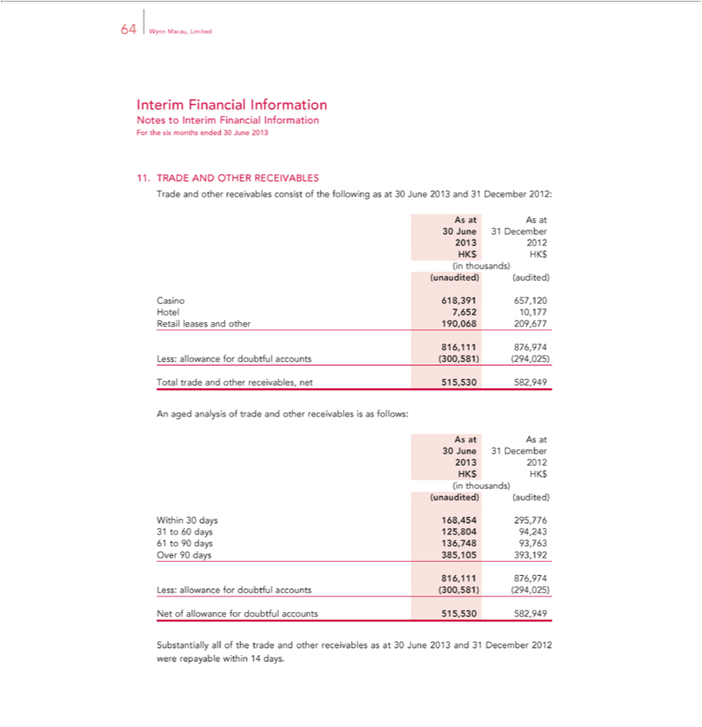

64 Wynn Macau, Limited
Interim Financial Information
Notes to Interim Financial Information
For the six months ended 30 June 2013
11. | TRADE AND OTHER RECEIVABLES
Trade and other receivables consist of the following as at 30 June 2013 and 31 December 2012:
As at As at
30 June 31 December
2013 | 2012 HK$ HK$ (in thousands)
(unaudited) (audited)
Casino 618,391 657,120 Hotel 7,652 10,177 Retail leases and other 190,068 209,677
816,111 876,974 Less: allowance for doubtful accounts (300,581) (294,025)
Total trade and other receivables, net 515,530 582,949
n aged analysis of trade and other receivables is as follows:
As at As at
30 June 31 December
2013 | 2012 HK$ HK$ (in thousands)
(unaudited) (audited)
Within 30 days 168,454 295,776 31 to 60 days 125,804 94,243 61 to 90 days 136,748 93,763 Over 90 days 385,105 393,192
816,111 876,974 Less: allowance for doubtful accounts (300,581) (294,025)
Net of |  | for doubtful accounts 515,530 582,949
Substantiallyallowanceof the trade and other receivables as at 30 June 2013 and 31 December 2012 were repayable within 14 days.

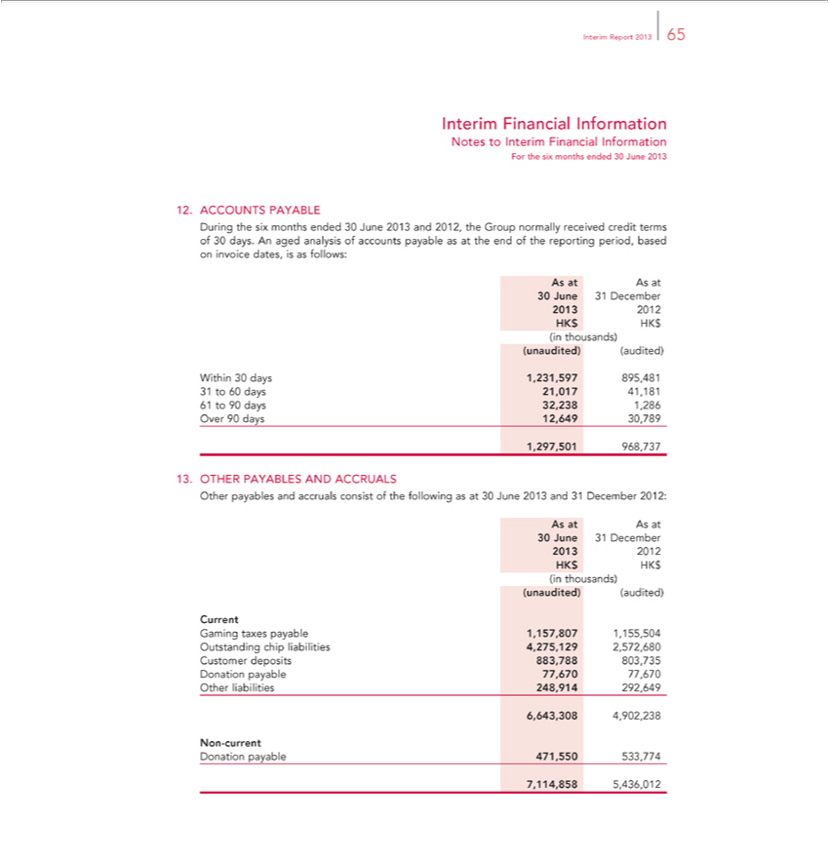

_{Interim} FinancialReport2013Information65
ForNotesthetosixInterimmonthsFinancialended30InformationJune2013
12. ACCOUNTS PAYABLE
During the six months ended 30 June 2013 and 2012, the Group normally received credit terms of 30 days. An aged analysis of accounts payable as at the end of the reporting period, based on invoice dates, is as follows:
As at As at
30²⁰¹³June 31 December
(unaudited)2012HK(audited)$HK$ (in thousands)

Within 30 days 1,231,597 895,481 31 to 60 days 21,017 41,181 61 to 90 days 32,238 1,286 Over 90 days 12,649 30,789 ¹³,297,501 968,737
. OTHER PAYABLES AND ACCRUALS
AsOtherat Aspayablesat and accruals consist of the following as at 30 June 2013 and 31 December 2012:
30²⁰¹³June 31 December
(unaudited)2012HK(audited)$HK$ (in thousands)
Current
Gaming taxes payable 1,157,807 1,155,504 Outstanding chip liabilities 4,275,129 2,572,680 Customer deposits 883,788 803,735 Donation payable 77,670 77,670 Other liabilities 248,914 292,649 6,643,308 4,902,238
N_{Donation}-current
payable 471,550 533,774

7,114,858 5,436,012

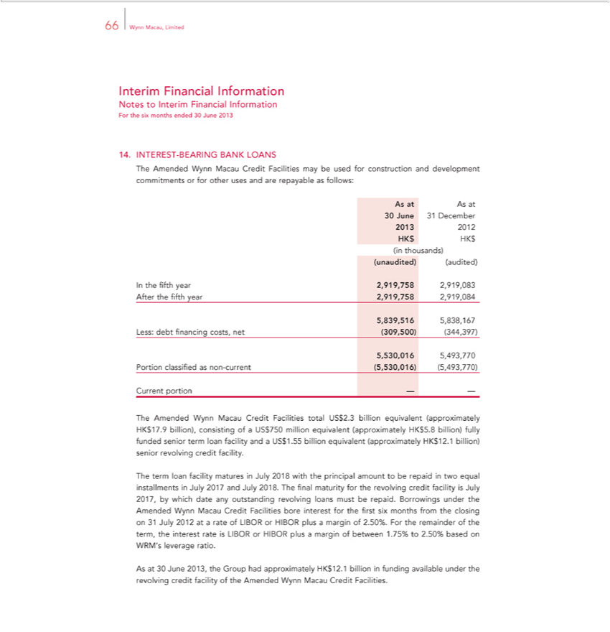

66 Wynn Macau, Limited
Interim Financial Information
Notes to Interim Financial Information
For the six months ended 30 June 2013
14. | INTEREST-BEARING BANK LOANS
The Amended Wynn Macau Credit Facilities may be used for construction and development commitments or for other uses and are repayable as follows:
As at As at
30 June 31 December
2013 | 2012 HK$ HK$ (in thousands)
(unaudited) (audited)
In the fifth year 2,919,758 2,919,083 After the fifth year 2,919,758 2,919,084
8 9 | 838 167 Less: debt financing c sts, net (309,500) (344,397)
5,530,016 5,493,770 |  | Portion classified as non-current (5,530,016) (5,493,770)
Current portion — —
The Amended Wynn Macau Credit Facilities total US$2.3 billion equivalent (approximately HK$17.9 billion), consisting of a US$750 million equivalent (approximately HK$5.8 billion) fully funded senior term
loan facility and US$1.55 billion equivalent (approximately HK$12.1 billion) senior revolving credit facility.
The term loan facility matures in July 2018 with the principal amount to be repaid in two equal installments in July 2017 and July 2018. The final maturity for the revolving credit facility is July 2017, by which
date any |  | revolving loans must be repaid. Borrowings under the Amended Wynn Macau Credit Facilities bore interest for the first six months from the closing on 31 July 2012 at a rate of LIBOR or
HIBOR plusoutstandingmargin of 2.50%. For the remainder of the term, the interest rate is LIBOR or HIBOR plus a margin of between 1.75% to 2.50% based on WRM’_{Facilities}leverage ratio.
As at 30 June 2013, the Group had approximately HK$12.1 billion in funding available under the revolving credit facility of the Amended Wynn Macau Credit .

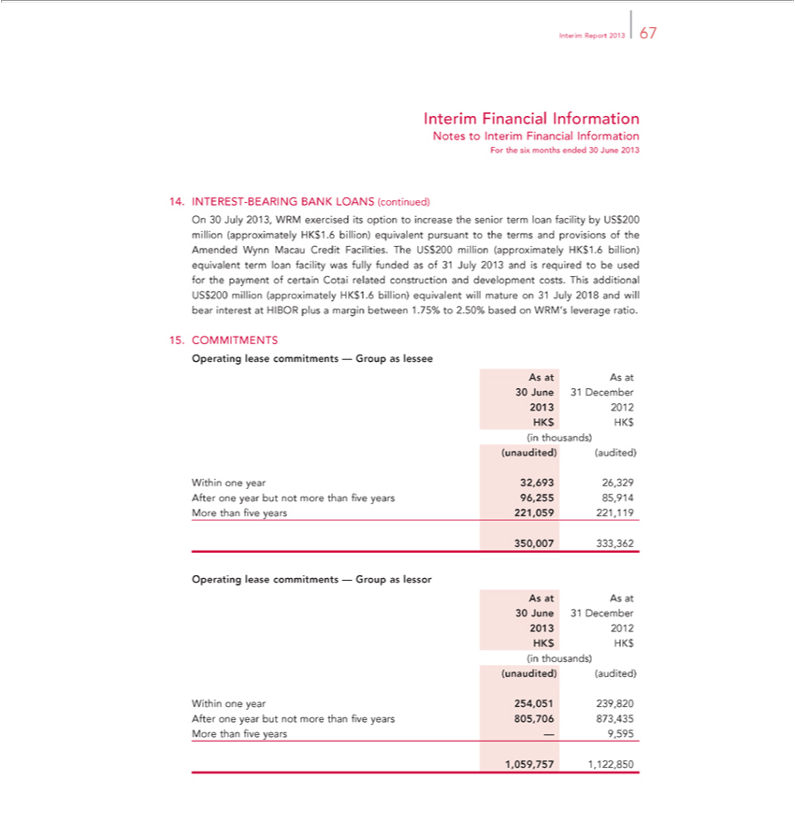

 | Report 2013 67
Interim Financial Information
Notes to Interim Financial Information
For the six months ended 30 June 2013
14. | INTEREST-BEARING BANK LOANS (continued)
On 30 July 2013, WRM exercised its option to increase the senior term loan facility by US$200 million (approximately HK$1.6 billion) equivalent pursuant to the terms and provisions of the Amended Wynn
Macau Credit Facilities. The US$200 million (approximately HK$1.6 billion) equivalent term loan facility was fully funded as of 31 July 2013 and is required to be used for the |  | of certain Cotai related
construction and development costs. This additional US$200 million (approximately HK$1.6 billion) equivalent will mature on 31 July 2018 and will bear interest at HIBOR pluspaymentmargin between 1.75% to
2.50% based on WRM’s leverage ratio.
15. | COMMITMENTS
_{OperatingAsAsat}lease commitments — Group as lessee
30 June 31 December
2013 | 2012 HK$ HK$ (in thousands)
(unaudited) (audited)
Within one year 32,693 26,329 After one year but not more than five years 96,255 85,914 More than five years 221,059 221,119
350,007 333,362
_{OperatingAsAsat}lease commitments — Group as lessor
30 June 31 December
2013 | 2012 HK$ HK$ (in thousands)
(unaudited) (audited)
Within one year 254,051 239,820 After one year but not more than five years 805,706 873,435 More than five years — 9,595 1,059,757 1,122,850

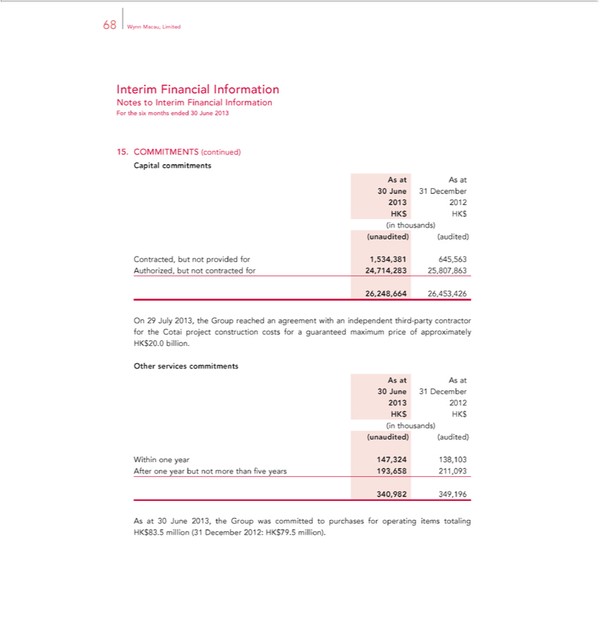

Interim68WynnFinancialMacau, LimitedInformation
NotesForthetosixInterimmonthsFinancialended30InformationJune2013
Capital15. commitmentsCOMMITMENTS (continued)
As at As at
30²⁰¹³June 31 December
(unaudited)2012HK(audited)$HK$ (in thousands)

Contracted, but not provided for 1,534,381 645,563 Authorized, but not contracted for 24,714,283 25,807,863 26,248,664 26,453,426
^{Other}n29 July 2013, the Group reached an agreement with an independent third-party contractor for the Cotai project construction costs for a guaranteed maximum price of approximately HK$20.0 billion. services commitments
As at As at
30²⁰¹³June 31 December
(unaudited)2012HK(audited)$HK$ (in thousands)
340,982Withinone349,196year147,324 138,103 After one year but not more than five years 193,658 211,093

As at 30 June 2013, the Group was committed to purchases for operating items totaling HK$83.5 million (31 December 2012: HK$79.5 million).

 | Report 2013 69
Interim Financial Information
Notes to Interim Financial Information
For the six months ended 30 June 2013
16. | LITIGATION
 | not have any material litigation outstanding as at 30 June 2013 and 31 December 2012.
The Group’doesaffiliates are involved in litigation in addition to the actions noted below, arising in the normal course of business. In the opinion of management, such litigation will not have a material effect on the
Group’s financial condition, results of operations or cash flows.
Determination of unsuitability and redemption of Aruze USA, Inc. and affiliates
On 18 | 2012, the Gaming Compliance Committee of Wynn Resorts, Limited concluded an investigation after receiving an independent report by Freeh, Sporkin & Sullivan, LLP (the “Freeh Report”)
detailingFebruarypattern of misconduct by Aruze USA, Inc., at the ime a stockholder of Wynn Resorts, Universal Entertainment Corporation, Aruze USA, Inc.’ parent company, and Kazuo Okada, the majority
shareholder of Universal Entertainment Corporation, who at the time was a |  |  | of Wynn Resorts and two of its subsidiaries (collectively, the “Okada Parties”). The factual record presented in the Freeh
Report included evidence |  | the Okada Parties had provided valuable itemsdirectorcertain foreign gaming officials who were responsible for regulating gaming in a jurisdiction in which entities controlled by
Mr. Okada were developingthat gaming resort. Mr. Okada denied the impropriety of such conduct to members of the board of directors of Wynn Resorts, refused to acknowledge or abide by Wynn Resorts’ anti-
bribery policies and refused to participate in the training all other directors received concerning these policies.
Based on the Freeh Report, the board of directors of Wynn Resorts determined that each of the Okada Parties is an “unsuitable person” under Article VII of Wynn Resorts’ articles of incorporation. The board of
directors of Wynn Resorts was unanimous (other than Mr. Okada) in its |  |  | . The board of directors of Wynn Resorts also requested that Mr. Okada resign as a director of Wynn Resorts (under Nevada
corporation law_{2012,}a board of directors does not have the power to remove determinationdirector)and recommended that Mr. Okada be removed as _{subsidiary}member of the Board of Directors of Wynn Macau, Limited. On
18 February Mr. Okada was removed from the board of directors of Wynn Las Vegas Capital Corp., an indirect wholly owned of Wynn Resorts, and on 24 February 2012, he was removed from the Board of Directors of Wynn Macau, Limited. On 22 February 2013, Mr. Okada was removed from the board of directors of Wynn Resorts by a stockholder vote in which 99.6% of the over 86 million shares voted were cast in favor of removal. Additionally, Mr. Okada resigned from the board of directors of Wynn Resorts on 21 February 2013.

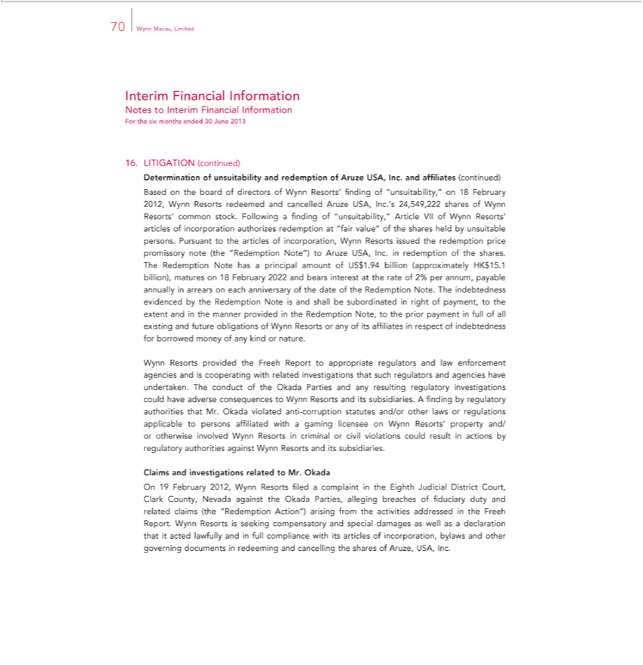

70 Wynn Macau, Limited
Interim Financial Information
Notes to Interim Financial Information
For the six months ended 30 June 2013
16. | LITIGATION (continued)
Based | of unsuitability and redemption of Aruze USA, Inc. and affiliates (continued) |  |  |  |  | 24,549,222 shares of Wynn Resorts’ common stock.
Based | the board of directors of Wynn Resorts’ finding of “unsuitability,” on 18 February 2012, Wynn Resorts redeemed and cancelled Aruze USA, Inc.’ |  |  |  |  | 24,549,222 shares of Wynn Resorts’ common stock.
DeterminationFollowingfinding of “unsuitability,” Article VII of Wynn Resorts’ articles of incorporation authorizes redemption at “fair value” of the shares held by unsuitable persons. Pursuant to the articles of
incorporation, Wynn Resorts issued the redemption price promissory note (the |  |  |  | Note”) to Aruze USA, Inc. in redemption of the shares. The Redemption Note has principal amount of US$1.94
billion (approximately HK$15.1 billion), matures on 18 February 2022 and bears“Redemptioninterestthe rate of 2% per annum, payable annually in arrears |  |  |  |  | each anniversary of the date of the Redemption Note. The
indebtedness evidenced by the Redemption Note is and shall be subordinated |  |  | right of payment, to the extent and in the manner provided in the Redemption Note, to the prior payment in full of all existing and
future obligations of Wynn Resorts any of its affiliates in respect of indebtedness |  |  |  | borrowed money of any kind or nature.
Wynn Resorts provided the Freeh Report |  | appropriate regulators and law enforcement agencies and is cooperating with related investigations that such regulators and agencies have undertaken. The conduct of
the Okada Parties and any resulting regulatory investigations could have |  |  | consequences to Wynn Resorts and its subsidiaries. A finding by regulatory authorities that Mr. Okada violated anti-corruption
statutes and/or other laws regulations applicable to persons affiliated withadversegaming licensee on Wynn Resorts’ property and/ or otherwise involved Wynn Resorts in criminal or civil violations could result in
actions by regulatory authorities against Wynn Resorts and its subsidiaries.
Claims and investigations related to Mr. |  |  |  |  |  | of fiduciary duty and related claims (the
On 19 February 2012, Wynn Resorts filedOkadacomplaint in the Eighth Judicial District Court, Clark County, Nevada against the Okada Parties, alleging |  |  |  |  |  | of fiduciary duty and related claims (the
“Redemption Action”) arising from the activities addressed in the Freeh Report. Wynn Resorts is seeking compensatory and special damages as well asbreachesdeclaration that it acted lawfully and in full compliance with its articles of incorporation, bylaws and other governing documents in redeeming and cancelling the shares of Aruze, USA, Inc.

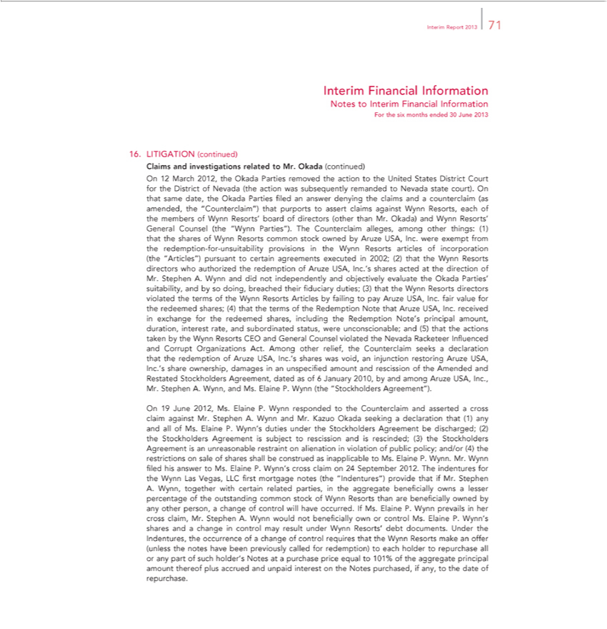

 | Report 2013 71
Interim Financial Information
Notes to Interim Financial Information
For the six months ended 30 June 2013
16. | LITIGATION (continued)
Claims and investigations related to Mr. Okada (continued)
n 12 March 2012, the Okada Parties removed the |  | to he United States District Court for the District of Nevada (the action was subsequently remanded to Nevada state court). On that same date, the
Okada Parties filed an answer denying the claims andactioncounterclaim (as amended, the “Counterclaim”) that purports to assert claims against Wynn Resorts, each of the members of Wynn Resorts’ board of
directors (other than Mr. Okada) and Wynn Resorts’ General Counsel (the “Wynn Parties”). The Counterclaim alleges, among other things: (1) that the shares of Wynn Resorts common stock owned by Aruze
USA, Inc. were exempt from the redemption-for-unsuitability provisions in the Wynn Resorts articles of incorporation (the “Articles”) pursuant to certain agreements executed in 2002; (2) that the Wynn
irectors who authorized the redemption of Aruze USA, Inc.’ shares acted the direction of Mr. Stephen A. Wynn and did not independently and objectively evaluate the Okada Parties’ suitability, and byResorts
doing, breached their fiduciary duties; (3) that the Wynn Resorts directors violated the terms of the Wynn Resorts Articles by failing to pay Aruze USA, Inc. fair value for the redeemed shares; (4) that the terms
of the Redemption Note that Aruze USA, Inc. received in exchange for the redeemed shares, including the Redemption Note’s principal amount, duration, interest rate, and subordinated status, were
 | and (5) that the actions taken by the Wynn Resorts CEO and General Counsel violated the Nevada Racketeer Influenced and Corrupt Organizations Act. Among other relief, the Counterclaim
unconscionable;seeksdeclaration that the redemption of Aruze USA, Inc.’s shares was void, an injunction restoring Aruze |  |  | Inc.’s share ownership, damages in an unspecified amount and rescission of the Amended and
Restated Stockholders Agreement, dated as of 6 January 2010, by and among Aruze USA, Inc., Mr. Stephen USA,.Wy n, and Ms. Elaine P. Wynn (the “Stockholders Agreement”).
On 19 June 2012, Ms. Elaine P. Wynn respond d to the Counterclaim and asserted a cross claim against Mr. Stephen A. Wynn and Mr. Kazuo Okada seeking a declaration that (1) any and all of Ms. Elaine P.
Wynn’s duties under the Stockholders Agreement be discharged; (2) the Stockholders Agreement is subject to rescission and is rescinded; (3) the Stockholders Agreement is an unreasonable |  |  |  | on
alienation in violation of public policy; and/or (4) the restrictions on sale of shares shall be construed as inapplicable to Ms. Elaine P. Wynn. Mr. Wynn filed his answer to Ms. Elaine P. Wynn’restraintcrossclaim on
24 September 2012. The indentures for the Wynn Las Vegas, LLC first mortgage notes (the “Indentures”) provide that if Mr. Stephen A. Wynn, together with certain related parties, in the aggregate beneficially
owns a lesser percentage of the outstanding common stock of Wynn Resorts than are beneficially owned by any other person, a change of control will have occurred. If Ms. Elaine P. Wynn prevails in her cross
 | Mr. Stephen A. Wynn would not beneficially own or control Ms. Elaine P. Wynn’s shares and a change in control may result under Wynn Resorts’ debt documents. Under the |  |  | the occurrence of
claim,change of control requires that the Wynn Resorts make an offer (unless the notes have been previously called for redemption) to each holder to repurchase all or any part of such holder’Indentures,Notes at a purchase price equal to 101% of the aggregate principal amount thereof plus accrued and unpaid interest on the Notes purchased, if any, to the date of repurchase.

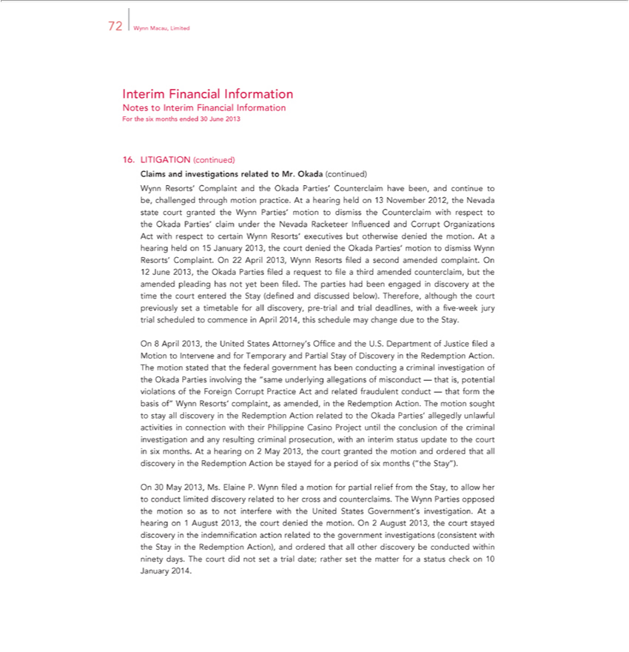

72 Wynn Macau, Limited
Interim Financial Information
Notes to Interim Financial Information
For the six months ended 30 June 2013
16. | LITIGATION (continued)
Claims and investigations related to Mr. Okada (continued) |  |  |  |  |  |  |  | 13 November 2012, the Nevada state court granted the
 | Resorts’ Complaint and the Okada Parties’ Counterclaim have been, and continue to be, challenged through motion practice. At a hearing held
Wynn Parties’ motion to dismiss the |  |  | with respect to the Okada Parties’ claim under the Nevada Racketeer Influenced and Corrupt Organizations Act with respect to certain Wynn Resorts’
executives but otherwise denied the motion.CounterclaimAthearing held on 15 January 2013, the court denied the Okada Parties’ motion to dismiss Wynn Resorts’ Complaint. On 22 April 2013, Wynn Resorts filed a
second amended complaint. On |  |  |  | third amended | but the amended pleading has not yet been filed. The |  | had been engaged in discovery at the time the court entered the
12 June 2013, the Okada Parties filed a request to file |  |  |  | third amended
Stay (defined and discussed below). Therefore, although the court previouslycounterclaim,settimetable for all discovery, pre-trial and trial deadlines, withpartiesfive-week jury trial scheduled to commence in April 2014, this
schedule may change due to the Stay.
On 8 April 2013, the United States Attorney’s Office and the U.S. Department of Justice filed a Motion to Intervene and for Temporary and Partial Stay of Discovery in the Redemption Action. The motion stated
that the federal government has been conducting |  |  | criminal investigation of the Okada Parties involving the “same underlying allegations of misconduct — that is, potential violations of the Foreign Corrupt
Practice Act and related fraudulent conduct — that form the basis of” Wynn Resorts’ complaint, as amended, in the Redemption Action. The motion sought to stay all discovery in the Redemption Action related
to the Okada Parti s’ allegedly unlawful |  |  |  | with their Philippine Casino Project until the conclusion of the |  | investigation and any resulting |  |  | prosecution, with an interim
status update to the court six months. At |  | hearing connection2May2013, the court granted the motion and ordered that all discoverycriminaltheRedemption Action be stayed forcriminalperiod of six months |  |  |  |  |  |  |  | Stay”).
On 30 May 2013, Ms. Elaine P. Wynn filedactivitiesmotion for partial relief from the Stay, to allow her to conduct limited discovery related to her cross and counterclaims. The Wynn Parties opposed (“themotion so as
not interfere with the United States Government’s |  |  |  | . At a hearing | 1 August 2013, the court denied the motion. On 2 August 2013, the court stayed discovery in the indemnification action related
to the government investigations (consistent with the investigationStaytheRedemption Action), and ordered that all other discovery be conducted within ninety days. The court did not set a trial date; rather set the matter for a status check on 10 January 2014.

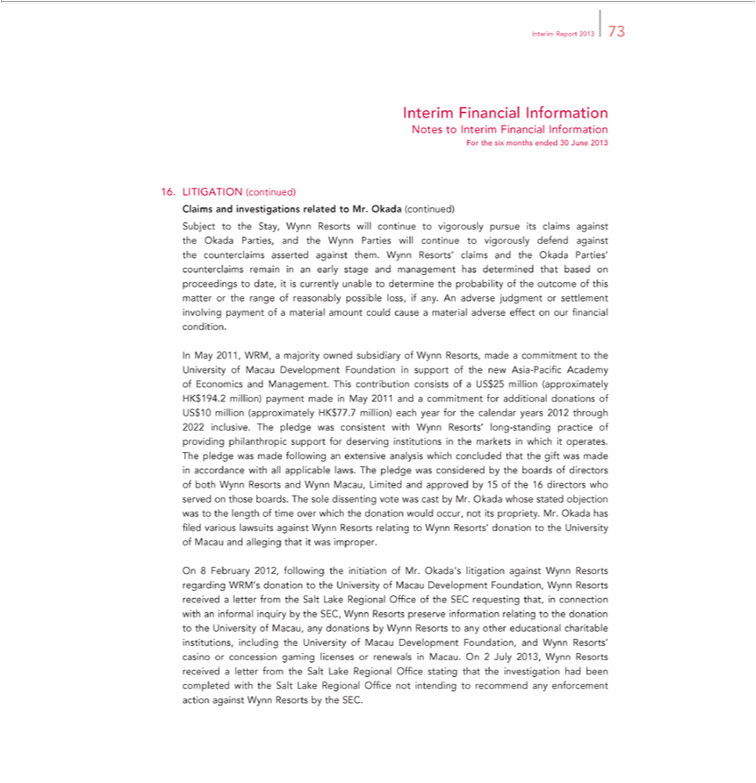

 | Report 2013 73
Interim Financial Information
Notes to Interim Financial Information
For the six months ended 30 June 2013
16. | LITIGATION (continued)
Claims and investigations related to Mr. Okada (continued) |  |  | to vigorously defend against the counterclaims asserted against
Subject to the Stay, Wynn Resorts will continue to vigorously pursue its claims against the Okada Parties, and the Wynn Parties will
m. Wynn Resorts’ claims and the Okada Parties’ counterclaims remain in an early stage and management has determined that |  |  | continueproceedings to date, it is currently unable to determine the probability of
the outcome of this matter or the range of reasonably possible loss, if any. An adverse judgment or settlement involving payment basedofmaterial amount could cause a material adverse effect on our financial
condition. |  | of Wynn Resorts, made commitment to the University of Macau Development Foundation in support of the new Asia-Pacific Academy of Economics and
In May 2011, WRM, a majority owned
Management. This contribution consistssubsidiaryofUS$25 million (approximately HK$194.2 million) payment made in May 2011 and a commitment for additional donations of US$10 million (approximately
HK$77.7 million) each year for the calendar years 2012 through 2022 inclusive. The pledge was consistent with Wynn Resorts’ long-standing practice of providing philanthropic support for deserving
institutions in the markets in which it operates. The pledge was made following an extensive analysis which concluded that the gift was made in accordance with all applicable laws. The pledge was considered
by the boards of directors of both Wynn Resorts and Wynn Macau, Limited and approved by 15 of the 16 directors who served on those boards. The sole dissenting vote was cast by Mr. Okada whose stated
objection was to the length of time over which the donation would occur, not its propriety. Mr. Okada has filed various lawsuits against Wynn Resorts relating to Wynn Resorts’ donation to the University of
Macau and alleging that it was improper.
On 8 February 2012, following the initiation of Mr. Okada’s litigation against Wynn Resorts regarding WRM’s donation to the University of Macau Development Foundation, Wynn Resorts received letter
from the Salt Lake Regional Office of the SEC requesting that, connection with an informal inquiry by the SEC, Wynn Resorts preserve information relating to the donation to the University of Macau, any
donations by Wynn Resorts to any ther |  | charitable institutions, including the University of Macau Development Foundation, and Wynn Resorts’ casino or concession gaming licenses or renewals in
Macau. On 2 July 2013, Wynn Resorts receivededucationalletter from the Salt Lake Regional Office stating that the investigation had been completed with the Salt Lake Regional Office not intending to recommend any enforcement action against Wynn Resorts by the SEC.

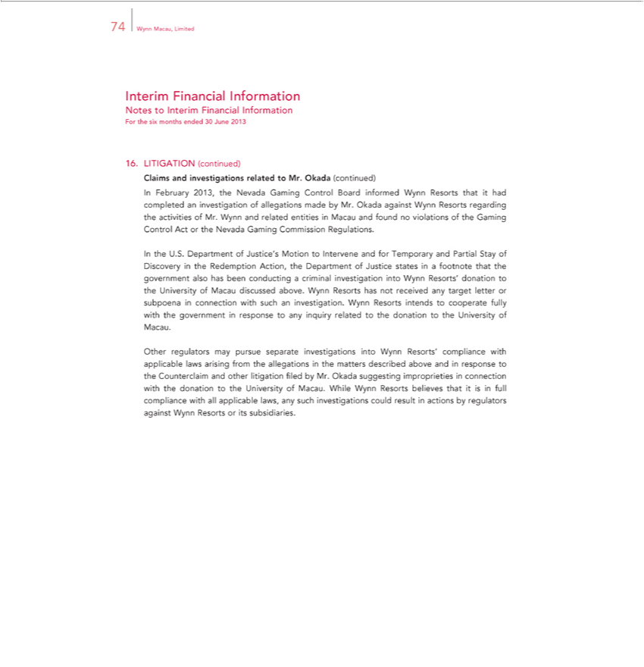

74 Wynn Macau, Limited
Interim Financial Information
ForNotesthetosixInterimmonthsFinancialended30InformationJune2013
16. LITIGATION (continued)
InClaimsFebruaryand investigations2013,theNevadarelatedGamingtoMr.ControlOkada Board(continued)informed Wynn Resorts that it had completed an investigation of allegations made by Mr. Okada against Wynn Resorts regarding the activities of Mr. Wynn
InandtherelatedU.S. entities in MacauofJustice’andfoundMotionno violatoInterveneionsof andthe GamingforTemporaryControlandActPartialortheStayNevadaofDiscoveryGamingCommissionintheRedemptionRegulations.Action, the Department of Justice states in footnote that the government also has
been conductingDepartmentcriminal investigation into Wynn Resorts’ donation to the University of Macau discussed above. Wynn Resorts has not received any target letter or subpoena in connection with such an investigation. Wynn Resorts intends to cooperate fully with the government in response to any inquiry related to the donation to the University of Macau.
Other regulators may pursue separate investigations into Wynn Resorts’ compliance with applicable laws arising from the allegations in the matters described above and in response to the Counterclaim and other litigation filed by Mr. Okada suggesting improprieties_{against}connection with the donation to the University of Macau. While Wynn Resorts believes that it is in full compliance with all applicable laws, any such
investigations could result in actions by regulators Wynn Resorts or its subsidiaries.

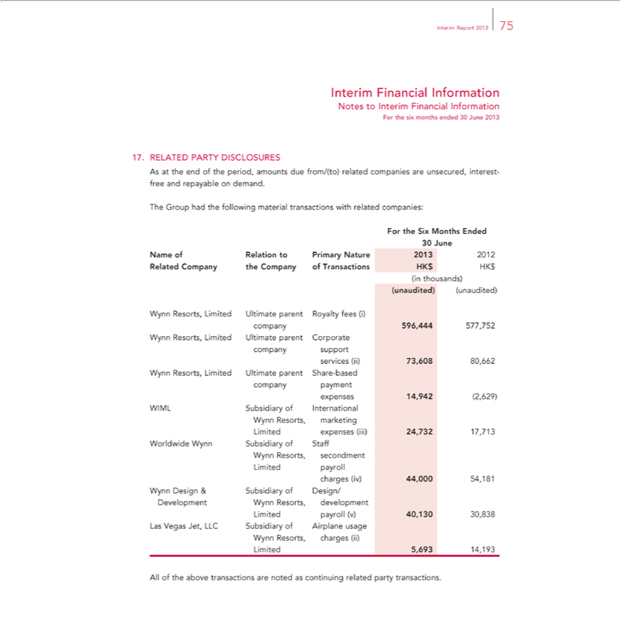

_{Interim} FinancialReport2013Information75
ForNotesthetosixInterimmonthsFinancialended30InformationJune2013
17. RELATED PARTY DISCLOSURES
TheAsatGrouptheendhadofthethefollowingperiod,amountsmaterialduetransactionsfrom/(to) relatedwithrelatedcompaniescompanies:areunsecured, interest-free and repayable on demand.
30ForJunethe Six Months Ended
(unaudited)NameofRelation(unaudited)toPrimary Nature 2013 2012 Related Company the Company of Transactions HK$ HK$ (in thousands)

Wynn Resorts, Limited Ultimate parent Royalty fees (i) company 596,444 577,752 Wynn Resorts, Limited Ultimate parent Corporate company support services (ii) 73,608 80,662 Wynn Resorts, Limited Ultimate parent Share-based company payment expenses 14,942 (2,629) WIML Subsidiary of International Wynn Resorts, marketing Limited expenses (iii) 24,732 17,713 Worldwide Wynn Subsidiary of Staff Wynn Resorts, secondment Limited payroll charges (iv) 44,000 54,181 Wynn Design & Subsidiary of Design/ Development Wynn Resorts, development Limited payroll (v) 40,130 30,838 Las Vegas Jet, LLC Subsidiary of Airplane usage Wynn Resorts, charges (ii) Limited 5,693 14,193
All of the above transactions are noted as continuing related party transactions.

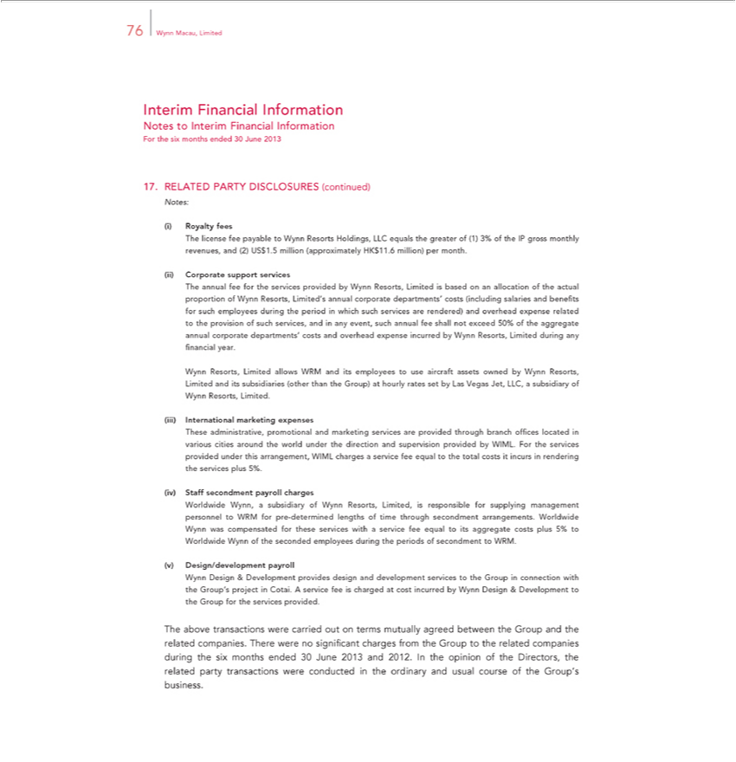

76 Wynn Macau, Limited
Interim Financial Information
Notes to Interim Financial Information
For the six months ended 30 June 2013
17. | RELATED PARTY DISCLOSURES (continued)
Notes: | Royalty fees
(i) | Royalty fees
The license fee payable to Wynn Resorts Holdings, LLC equals the greater of (1) 3% of the IP gross monthly revenues, and (2) US$1.5 million (approximately HK$11.6 million) per month.
(ii) Corporate support services
The annual fee for the services provided by Wynn Resorts, Limited is based on an allocation of the actual proportion of Wynn Resorts, Limited’ annual corporate departments’ costs (including salaries and
benefits for such employees during the period in which such services are rendered) and overhead expense related to the provision of such services, and in any event, such annual fee shall not exceed 50% of the
aggregate annual corporate departments’ costs and ov rhead expense incurred by Wynn Resorts, Limited during any financial year.
_{Wynn Resorts, Limited.}allows WRM and its employees to use aircraft assets owned by Wynn Resorts, Limited and its subsidiaries (other than the Group) at hourly rates set by Las Vegas Jet, LLC, a subsidiary of
(iii) International marketing expenses
These administrative, promotional and marketing services are provided through branch offices located various cities around the world under the direction and supervision provided by WIML. For the services
provided under this arrangement, WIML charges a service fee equal to the total costs it incurs in rendering the services plus 5%.
(iv) Staff secondment payroll charges
Worldwide Wynn, a subsidiary of Wynn Resorts, Limited, is responsible for supplying management personnel to WRM for pre-determined lengths of time through secondment arrangements. Worldwide Wynn
was compensated for these services with a service fee equal to its aggregate costs plus 5% to Worldwide Wynn of the seconded employees during the periods of secondment to WRM.
(v) | Design/development payroll
Wynn Design & Development provides design and development services to the Group in connection with the Group’s project in Cotai. A service fee is charged at cost incurred by Wynn Design & Development
to the Group for the services provided. |  | terms mutually agreed between the Group and the related companies. There were no significant charges from the Group to the related companies during the six months
The above transactions were carried out
ended 30 June 2013 and 2012. In the opinion of the Directors, the related party transactions were conducted in the ordinary and usual course of the Group’s business.

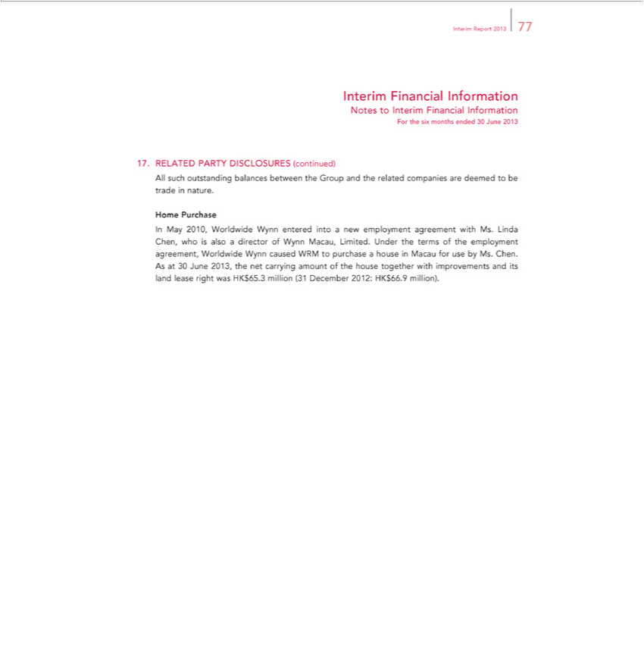

_{Interim} FinancialReport2013Information77
ForNotesthetosixInterimmonthsFinancialended30InformationJune2013
17. RELATED PARTY DISCLOSURES (continued)
HomeAllsuchPurchaseoutstanding balances between the Group and the related companies are deemed to be trade in nature.
In May 2010, _{WRM}orldwide Wynn entered _{intoMacau}new employment agreement with Ms. Linda Chen, who is also _{amount}director of Wynn Macau, Limited. Under the terms of the employment agreement, Worldwide
Wynn caused to purchase a house for use by Ms. Chen. As at 30 June 2013, the net carrying of the house together with improvements and its land lease right was HK$65.3 million (31 December 2012: HK$66.9 million).

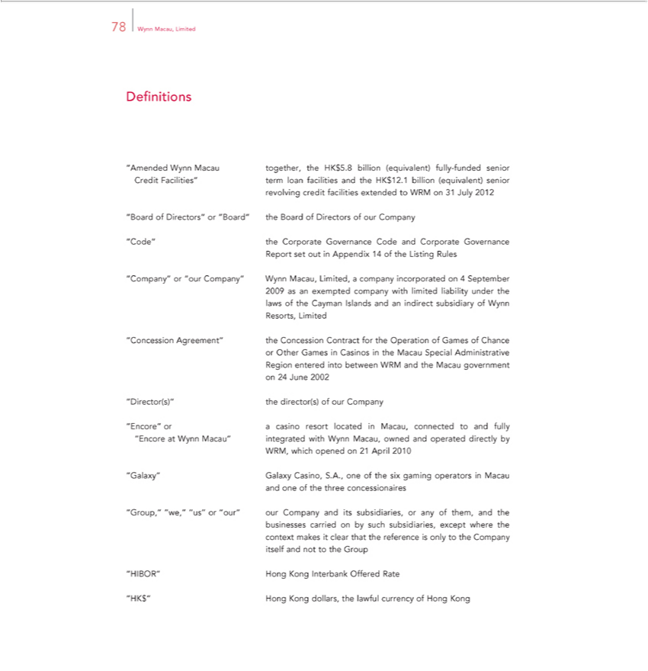

78 Wynn Macau, Limited
Definitions
“Amended Wynn Macau together, the HK$5.8 billion (equivalent) fully-funded senior Credit Facilities” term loan facilities and the HK$12.1 billion (equivalent) senior revolving credit facilities extended to
WRM on 31 July 2012
B ard of Direct s” or “Board” the Board of Directors of our Company
de” the | Governance Code and Corporate Governance Report set out in Appendix 14 of the Listing Rules
“Company”Corporate“ourCompany” Wynn Macau, Limited, a company incorporated on 4 September 2009 as an exempted company with limited liability under the laws of the Cayman Islands and an indirect
subsidiary of Wynn Resorts, Limited
“Concession Agreement” the Concession Contract for the Operation of Games of Chance or Other Games in Casinos in the Macau Special Administrative Region entered into between WRM and the Macau
government on 24 June 2002
Encore”Director(s)” | the director(s) of our Company
Encore”Director(s)” | casino resort located in Macau, connected and fully “Encore at Wynn Macau” integrated with Wynn Macau, owned and operated directly by WRM, which opened on 21 April 2010
alaxy” Galaxy operators
_{“Group,”} Casino, S.A., one of the six gaming in Macau and one of the three _{concessionaires}
“we,” “us” or “our” our Company and its subsidiaries, or any of them, and the businesses carried by such subsidiaries, except where the context makes it clear that the reference is only to the Company itself and not to the Group
^{“HK}IBOR”$” Hong Kong Interbank Offered Rate
Hong Kong dollars, the lawful currency of Hong Kong

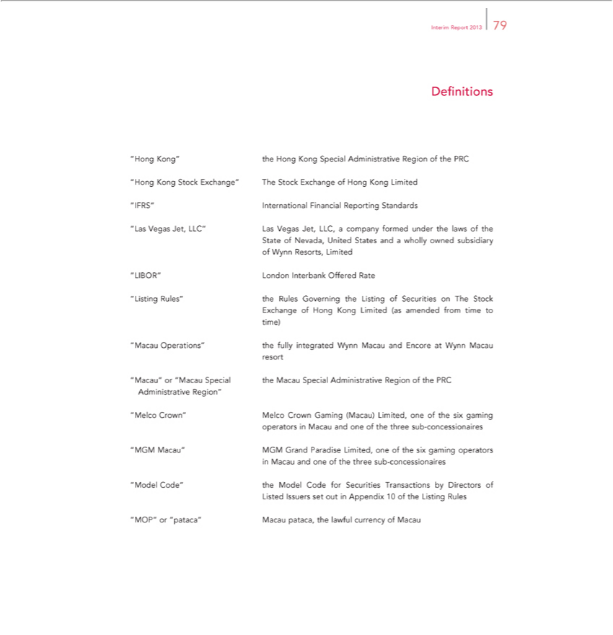

Interim Report 2013 79
Definitions | Region of the PRC “Hong Kong Stock Exchange” The Stock |  | of Hong Kong Limited “IFRS” International Financial Reporting Standards
Hong Kong” the Hong Kong Special
as Vegas Jet, LLC” Las Vegas Jet, LLC,Administrativecompany formed under the laws of the State of Nevada, United States andExchangewholly owned subsidiary of Wynn Resorts, Limited
IBOR” London Interbank Offered Rate
Listing Rules” the Rules Governing the Listing of Securities on The Stock Exchange of Hong Kong Limited (as amended from time to time)
Operations” the fully integrated Wynn Macau and Encore at Wynn Macau resort |  | Region”
acau” or “Macau Special the Macau Special Administrative Region of the PRC |  | Region”
elco Administrative
GM Crown” Melco CrownParadiseGamng (Macau) Limited, one of the six gaming operators Macau and one of the three sub-concessionaires

^{odel} Macau” MGM Grand Limited, one of the six gaming operators in Macau and one of the three sub-concessionaires ^{“MOP”} Code” the Model Code for Securities Transactions by Directors of Listed Issuers set out in Appendix 10 of the Listing Rules
or “pataca” Macau pataca, the lawful currency of Macau

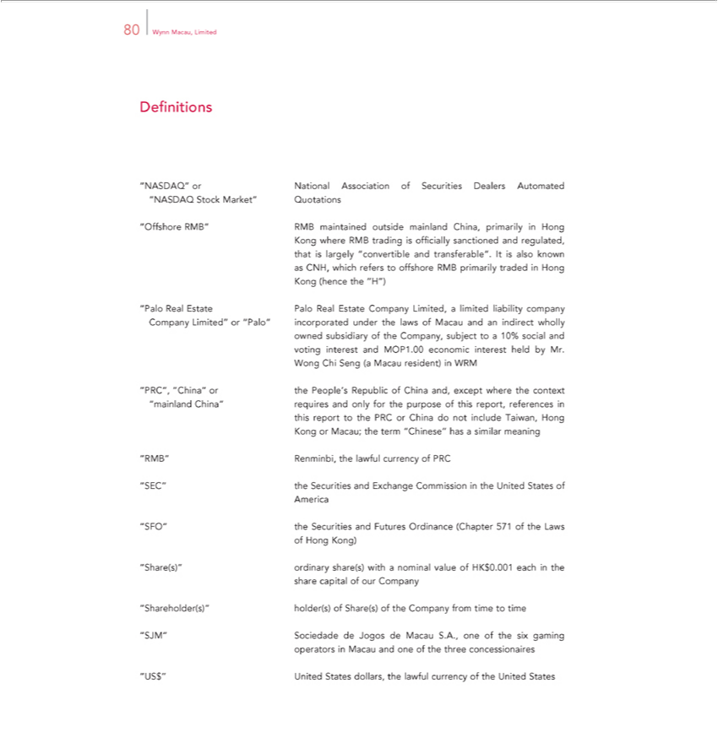

80 Wynn Macau, Limited
“OfDefinitionsNASDAQ” or National Association of Securities Dealers Automated “NASDAQ Stock Market” Quotations
CNH,fshorewhichRMB”refersRMBtooffshoremaintainedRMBoutsideprimarilymainlandtraded China,HongprimarilyKong(henceinHongthe Kong“H”) where RMB trading is officially sanctioned and regulated, that is largely “convertible and transferable”. It is also known as “Palo Real Estate Palo Real Estate Company Limited, limited liability company Company Limited” or “Palo” incorporated under the laws of Macau and an indirect wholly owned subsidiary of the Company,
subject to a 10% social and voting and MOP1.00 economic interest held by Mr.
“PRC”,WongChi“China”Seng (aorMacauthePeople’resident)RepublicinterestWRMof China and, except where the context “mainland China” requires and only for the purpose of this report, references in this report to the PRC or China do not include
Taiwan, Hong Kong or Macau; the term “Chinese” has a similar meaning
RMB”FO”EC”theRenminbi,SecuritiestheandlawfulExchangecurrencyCommissionofPRC in the United States of America
Futures Ordinance (Chapter 571 of the Laws of Hong Kong)

hareholder(s)”ordinary share(s)ofwithShare(s)nominalofthevalueCompanyofHKfrom$0.001timeeachtimeinthe share capital of our Company

SJM” holder(s) operators
^{“US$”} Sociedade Jogos de Macau S.A., one of the six gaming in Macau and one of the three concessionaires United States dollars, the lawful currency of the United States

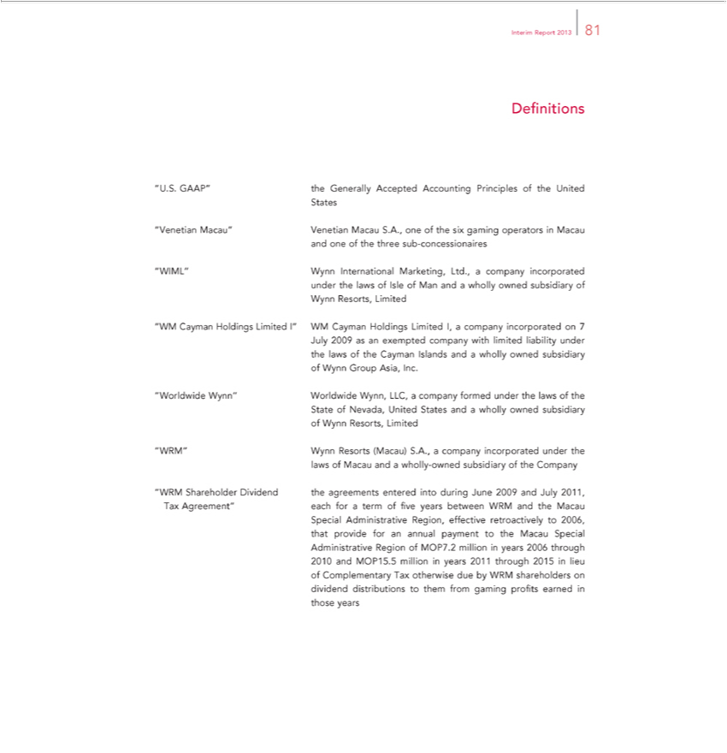

Interim Report 2013 81
Definitions
U.S. GAAP” the Generally Accepted Accounting Principles of the United States
Venetian Macau” Venetian Macau S.A., one of the six gaming operators in Macau and one of the three sub-concessionaires
IML” Wynn International Marketing, Ltd., |  | company incorporated under the laws of Isle of Man and a wholly owned subsidiary of Wynn Resorts, Limited
“WM Cayman Holdings Limited I” WM Cayman Holdings Limited I, a company incorporated on 7 July 2009 as an exempted company with limited liability under the laws of the Cayman Islands and a wholly
owned subsidiary of Wynn Group Asia, Inc. |  | company formed under the laws of the State of Nevada, United States and a wholly owned subsidiary of Wynn Resorts, Limited
orldwide Wynn” Worldwide W | LLC,
” Wynn Resorts (Macau) S.ynn,A. | company incorporated under the laws of Macau and a wholly-owned |  | of the Company
“WRM Shareholder Dividend the agreements entered into during June 2009 and July 2011, Tax Agreement” eachsubsidiaryforterm of five years between WRM and the Macau Special Administrative Region, effective retroactively to 2006, that provide for an annual payment to the Macau Special Administrative Region of MOP7.2 million in years 2006 through 2010 and MOP15.5 million in years 2011 through 2015 in lieu of Complementary Tax otherwise due by WRM shareholders on dividend distributions to them from gaming profits earned in those years

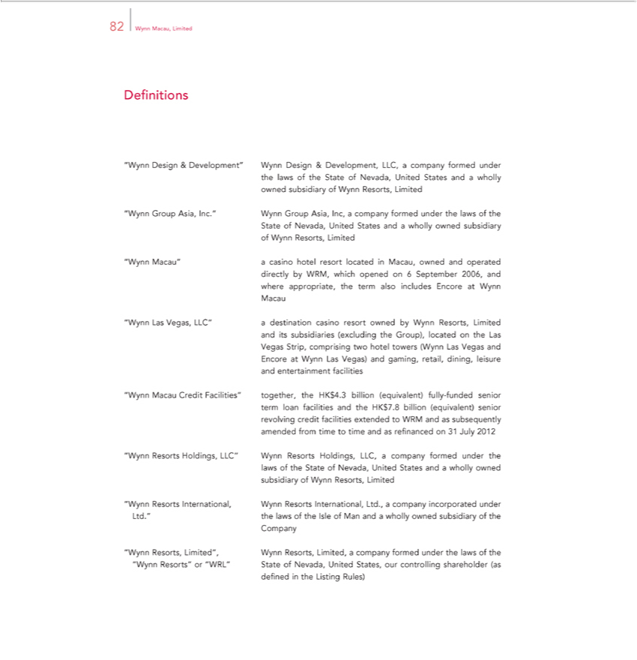

82 Wynn Macau, Limited
Definitions |  |  | Wynn Design & Development, LLC, a company formed under the laws of the State of |  |  | United States and wholly owned subsidiary of Wynn Resorts, Limited
Design &
Group |  | Development”Inc.Wynn Group Asia, Inc, company formed under the laws of the State of Nevada, United StatesNevada,andwholly owned subsidiary of Wynn Resorts, Limited
Macau”Asia,casino hotel resort located in Macau, owned and operated directly by WRM, which opened on 6 September 2006, and where appropriate, the term also includes Encore at Wynn Macau
“Wynn Las Vegas, LLC” a destination casino resort owned by Wynn Resorts, Limited and its subsidiaries (excluding the Group), located on the Las Vegas Strip, comprising two hotel towers (Wynn Las Vegas
and Encore at Wynn Las Vegas) and |  |  |  |  | retail, dining, leisure and entertainment facilities
“Wynn Macau Credit Facilities” |  |  |  | gaming,the HK$4.3 billion (equivalent) fully-funded senior term loan facilities and the HK$7.8 billion (equivalent) senior revolving credit facilities extended to WRM and as
subsequently amended from timetogethertime and as refinanced on 31 July 2012 |  |  |  |  |  | and a wholly owned subsidiary of Wynn Resorts, Limited
 | Holdings, LLC” Wynn Resorts Holdings, LLC, a company formed under the laws of the State of Nevada, United |  |  |  |  | and a wholly owned subsidiary of Wynn Resorts, Limited
 | International, Wynn Resorts |  |  |  | Ltd., a company incorporated under Ltd.” the laws of the Isle of Man andStateswholly owned subsidiary of the Company
“Wynn Resorts, Limited”, Wynn Resorts, Limited,International,company formed under the laws of the “Wynn Resorts” or “WRL” State of Nevada, United States, our controlling shareholder (as defined in the Listing Rules)

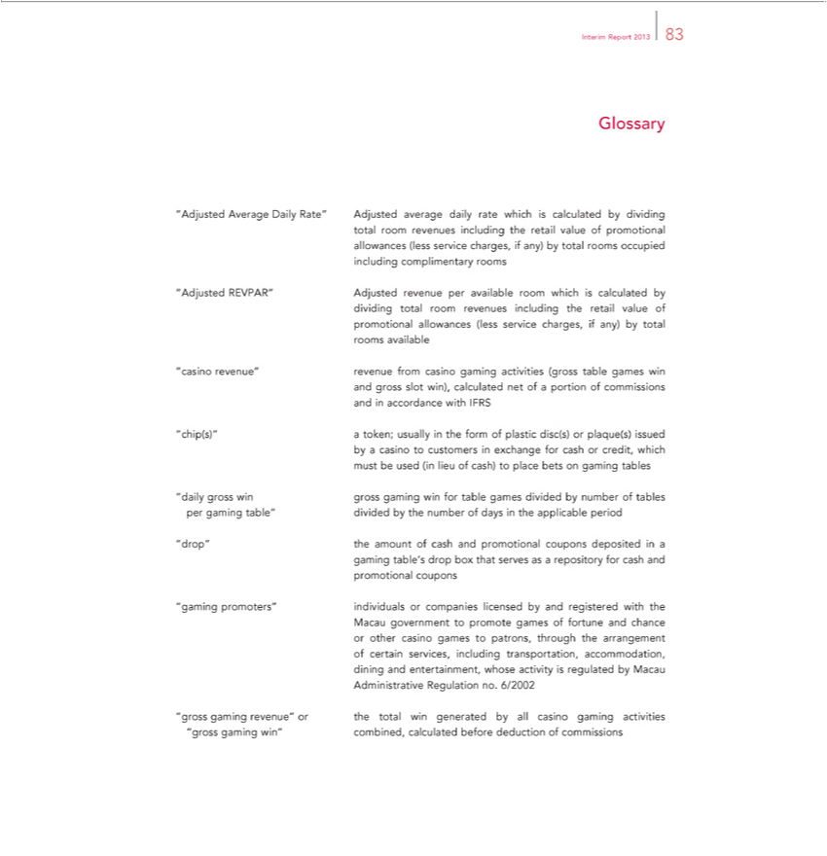

Interim Report 2013 83
Glossary
“Adjusted Average Daily Rate” Adjusted average daily rate which is calculated by dividing total room revenues including the retail value of promotional allowances (less service charges, if any) by total rooms
occupied including complimentary rooms
“Adjusted REVPAR” Adjusted revenue per available room which is calculated by dividing total room revenues including the retail value of promotional allowances (less service charges, if any) by total rooms
available | of commissions and in accordance with IFRS
asino revenue” revenue from casino gaming activities (gross table games win and gross slot win), calculated net of | of commissions and in accordance with IFRS
ch p(s)” cashportion
_{aily} a token; usually_{gaming}the form of plastic disc(s) or plaque(s) issued_{tables}bycasino to customers in exchange for credit, which must be used (in lieu of cash) to place bets on gaming tables
^{drop”}gross win gross win for table games divided by number of per gaming table” divided by the number of days in the applicable period _{“gaming}the amount of cash and promotional coupons deposited in a gaming table’s drop box that serves as a repository for cash and promotional coupons
promoters” individuals_{transportation,}companies licensed by and registered with the Macau government to promote games of fortune and chance or other casino games to patrons, through the arrangement of
certain services, including accommodation,_{casino}diing and enterta_{activities}nment, whose activity is regulated by Macau Administrative Regulation no. 6/2002
“gross gaming revenue” or the total win generated by all gaming “gross gaming win” combined, calculated before deduction of commissions

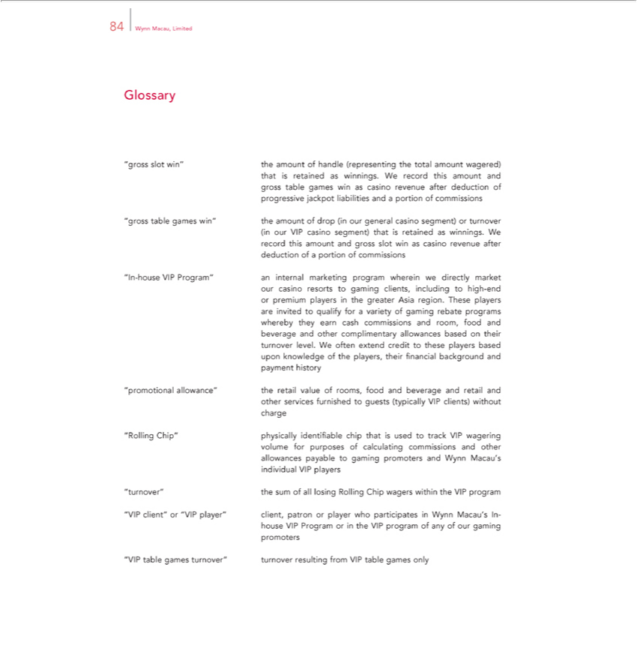

84 Wynn Macau, Limited |  |  | of handle (representing the total amount wagered) that is retained as winnings. We record this amount and gross table games win as casino revenue after deduction of progressive
Glossary“grossot win” the
jackpot liabilities andamountportion |  |  |  | f commissions
“gross table | win” the a |  |  | ount of drop (in our general casino segment) or turnover (in our VIP casino segment) that is retained as winnings. We record this amount and gross slot win as casino revenue after
deduction ofgamesportion of commissions
“In-house VIP |  | an internal marketing program wherein we directly market our casino resorts to gaming clients, including to high-end or premium players in the greater Asia region. These players are
invited to qualifyProgram”forvariety of gaming rebate programs whereby they earn cash commissions and room, food and beverage and other complimentary allowances based on their turnover level. We often extend credit to these players based upon knowledge of the players, their financial background and payment history
_{“Rolling}promotional allowance” the retail value of rooms, food and beverage and retail and other services furnished to guests (typically VIP clients) without charge
Chip” physically identifiable chip that is used to track VIP wagering volume for purposes of calculating commissions and other allowances payable to gaming promoters and Wynn Macau’s individual VIP players
turnover” the sum of all losing Rolling Chip wagers within the VIP program

^{“VIP} client” or “VIP player” client, patron or player who participates in Wynn Macau’s In-house VIP Program or in the VIP program of any of our gaming promoters table games turnover” turnover resulting from VIP table games only

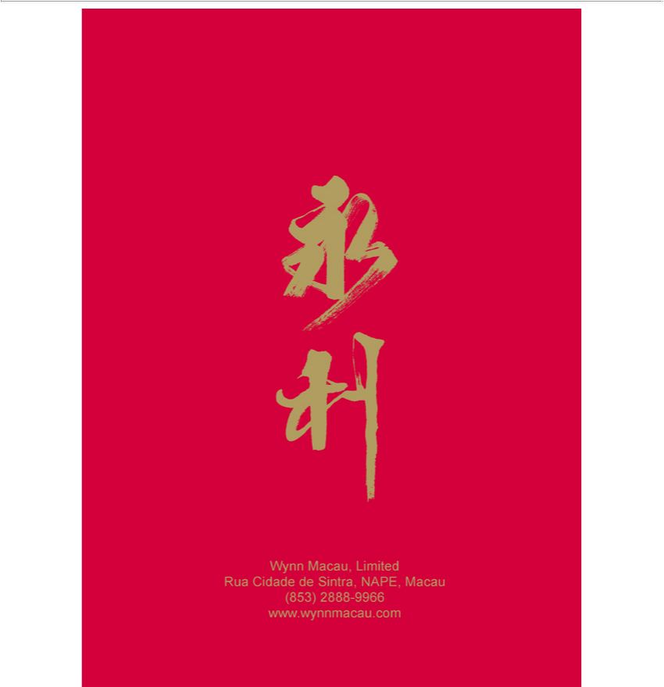

Wynn Macau, Limited Rua Cidade de Sintra, NAPE, Macau (853) 2888-9966 www.wynnmacau.com

