UNITED STATES

SECURITIES AND EXCHANGE COMMISSION

Washington, D.C. 20549

FORM 8-K

CURRENT REPORT

PURSUANT TO SECTION 13 OR 15(d)

OF THE SECURITIES EXCHANGE ACT OF 1934

Date of Report (Date of earliest event reported): December 14, 2020

WYNN RESORTS, LIMITED

(Exact name of registrant as specified in its charter)

 |  | Nevada |  | 000-50028 |  | 46-0484987
 |  | (State or other jurisdiction |  |  | (Commission |  | (I.R.S. Employer
 |  | of incorporation) |  |  | File Number) |  | Identification No.)
 |  | 3131 Las Vegas Boulevard South
 |  | Las Vegas, Nevada |  |  |  | 89109
 |  | (Address of principal executive offices) |  |  |  |  | (Zip Code)
 |  |  |  | (702) 770-7555
 |  |  |  | (Registrant’s telephone number, including area code)
 |  |  |  |  | Not Applicable
 |  |  |  | (Former name or former address, if changed since last report)
Securities registered pursuant to Section 12(b) of the Act:
 | Title of each class |  |  | Trading Symbol(s) |  |  | Name of each exchange on which registered
Common stock, par value $0.01 |  |  |  | WYNN |  |  | Nasdaq Global Select Market

Check the appropriate box below if the Form 8-K filing is intended to simultaneously satisfy the filing obligation of the registrant under any of the following provisions:

- Written communications pursuant to Rule 425 under the Securities Act (17 CFR 230.425)

- Soliciting material pursuant to Rule 14a-12 under the Exchange Act (17 CFR 240.14a-12)

- Pre-commencement communications pursuant to Rule 14d-2(b) under the Exchange Act (17 CFR 240.14d-2(b))

- Pre-commencement communications pursuant to Rule 13e-4(c) under the Exchange Act (17 CFR 240.13e-4(c))

Indicate by check mark whether the registrant is an emerging growth company as defined in Rule 405 of the Securities Act of 1933 (§230.405 of this chapter) or Rule 12b-2 of the Securities Exchange Act of 1934 (§240.12b-2 of this chapter).

Emerging growth company ☐

If an emerging growth company, indicate by check mark if the registrant has elected not to use the extended transition period or complying with any new or revised financial accounting standards provided pursuant to Section 13(a) of the Exchange Act. ☐

Item 7.01 Regulation FD Disclosure.

On December 14, 2020, Wynn Macau, Limited (“Wynn Macau”), an indirect subsidiary of Wynn Resorts, Limited (“Wynn Resorts” or the “Company”) with its ordinary shares of common stock listed on The Stock Exchange of Hong Kong Limited (the “HKSE”), filed with the HKSE an announcement (the “Announcement”) of Wynn Macau’s proposed issuance of senior notes (the “Offering”). Wynn Resorts owns approximately 72% of Wynn Macau’s ordinary shares of common stock. The Announcement is furnished herewith as Exhibit 99.1.

In connection with the Offering, Wynn Macau intends to provide potential investors with preliminary financial information for the Macau operations of Wynn Resorts for the two month period ended November 30, 2020, and certain other information. A summary of this information is attached to this report as Exhibit 99.2 and is incorporated herein by reference.

The information furnished pursuant to this Item 7.01 (including Exhibits 99.1 and 99.2 hereto) shall not be deemed to be “filed” for purposes of Section 18 of the Securities Exchange Act of 1934, as amended (the “Exchange Act”), or otherwise subject to the liabilities of that section, nor shall it be deemed incorporated by reference in any filing under the Securities Act of 1933, as amended (the “Securities Act”), or the Exchange Act, except as shall be expressly set forth by specific reference in such a filing.

This Current Report on Form 8-K contains forward-looking statements within the meaning of Section 27A of the Securities Act and Section 21E of the Exchange Act. Such forward-looking statements are subject to numerous assumptions, risks and uncertainties that could cause actual results to differ materially from those described in such statements. Such forward-looking statements are based on management’s expectations or beliefs as of December 14, 2020. Factors that might cause such differences include, but are not limited to, a variety of economic, competitive, and regulatory factors, many of which are beyond the Company’s control and are described in Wynn Resorts’ Annual Report on Form 10-K filed by Wynn Resorts, Limited on February 28, 2020 with the Securities and Exchange Commission (the “SEC”) and the other reports Wynn Resorts files from time to time with the SEC. Wynn Resorts undertakes no obligation to revise or publicly release any updates to such statements based on future information or actual results.

 | Item 9.01 |  | Financial Statements and Exhibits.
 | (d) Exhibits.
 | Exhibit No. |  | Description
99.1 |  |  | Announcement of Wynn Macau, Limited, dated December 14, 2020
99.2 |  |  | Investor Materials

SIGNATURES

Pursuant to the requirements of the Securities Exchange Act of 1934, the Registrant has duly caused this report to be signed on its behalf by the undersigned hereunto duly authorized.

WYNN RESORTS, LIMITED

Dated: December 14, 2020

By: /s/ Craig S. Billings

Craig S. Billings
President and Chief Financial Officer

(Principal Financial and Accounting Officer)

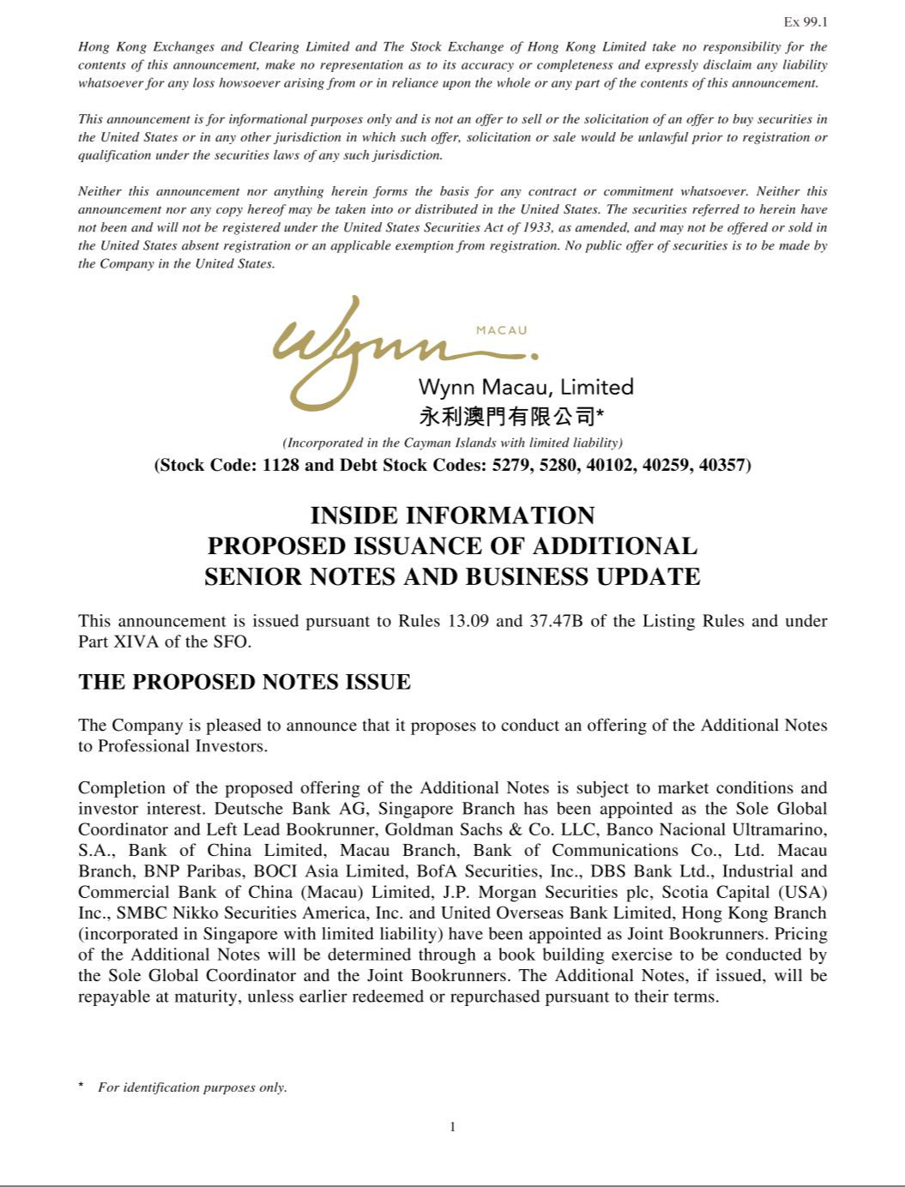

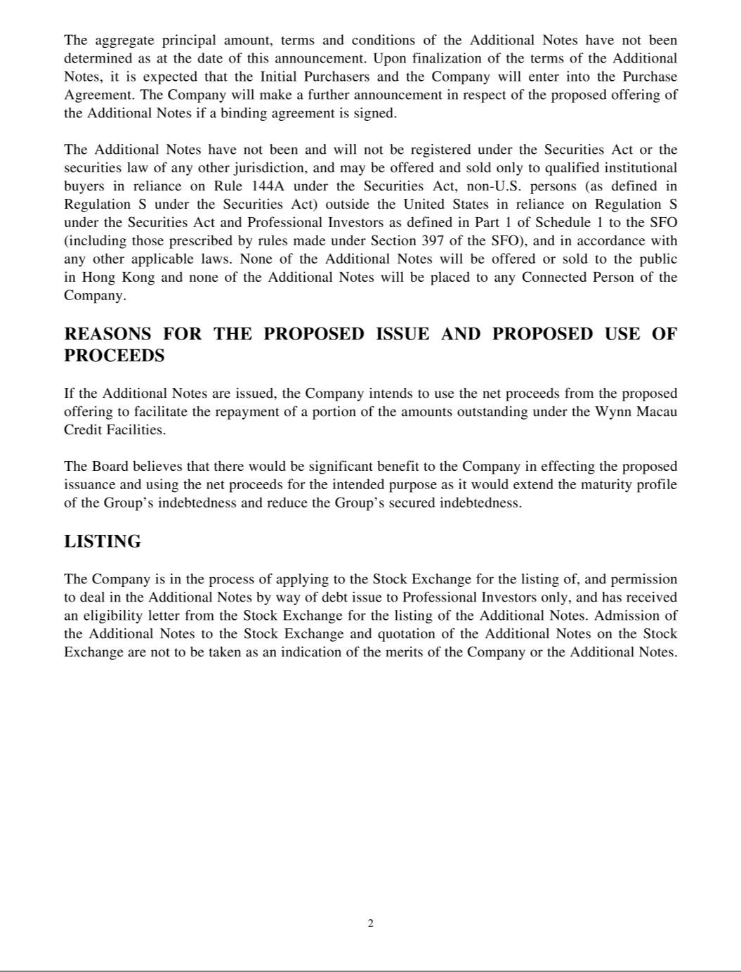

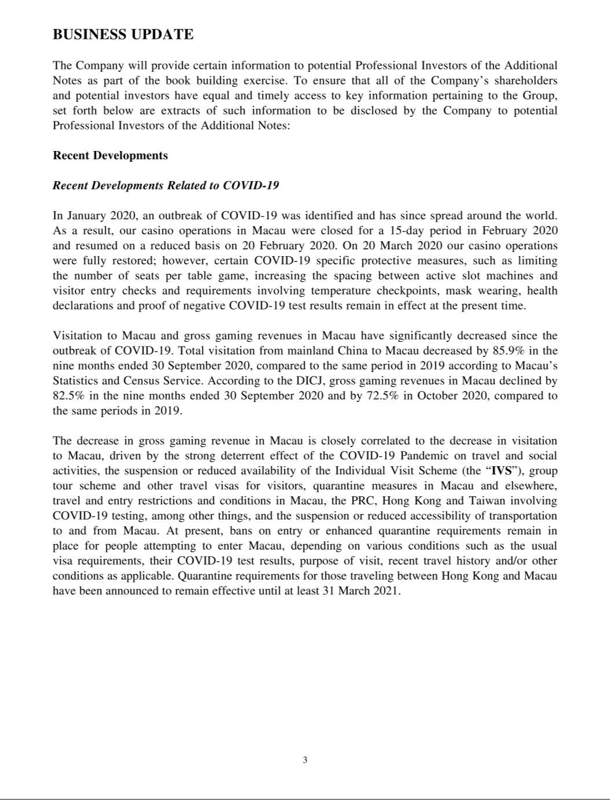

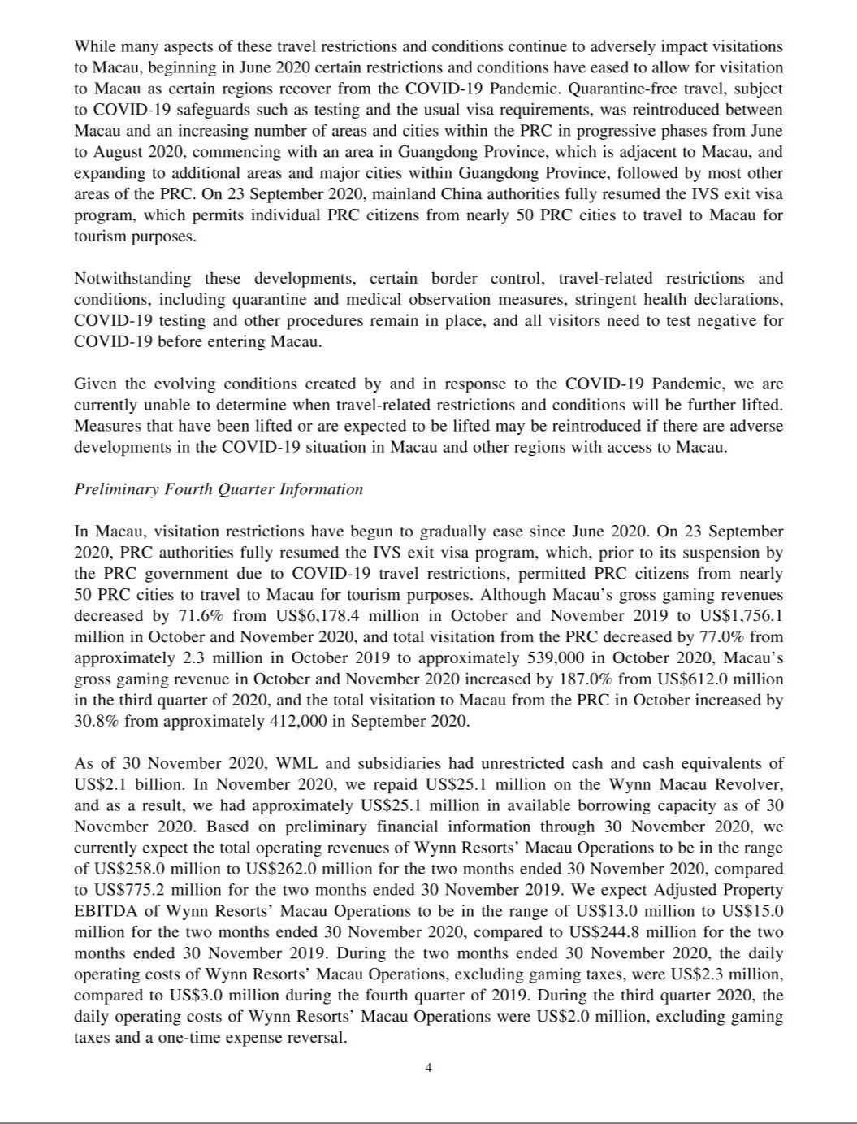

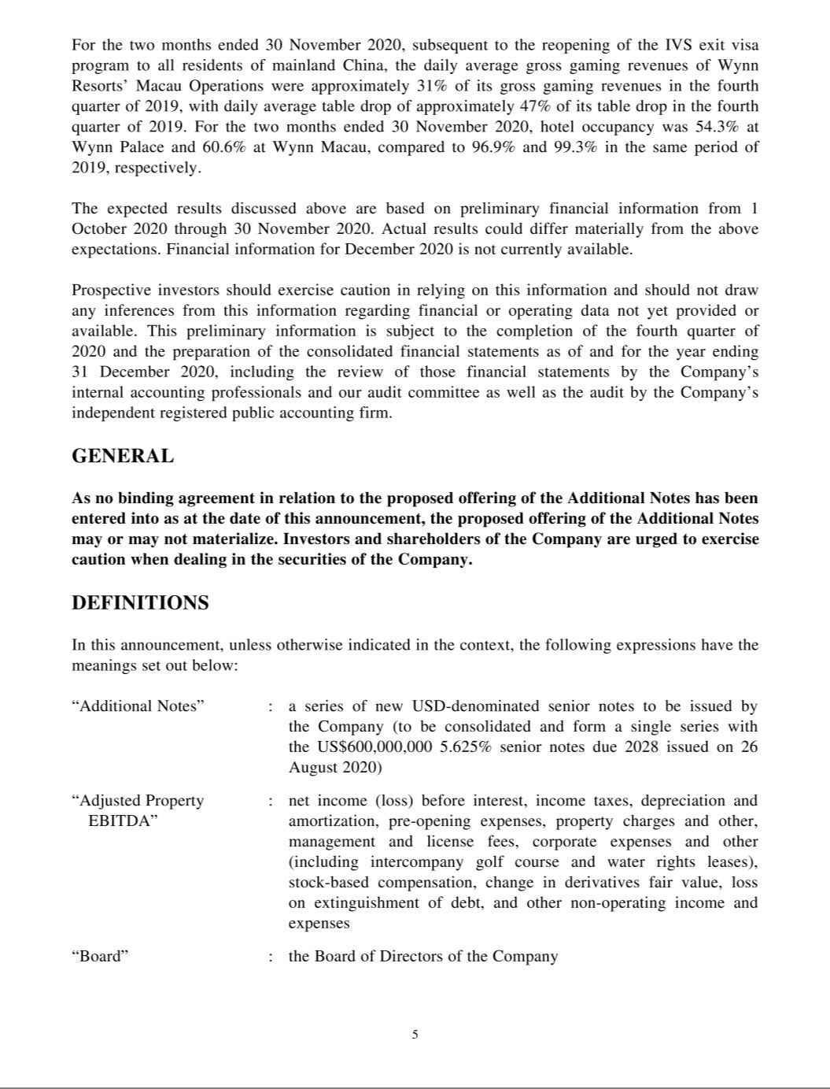

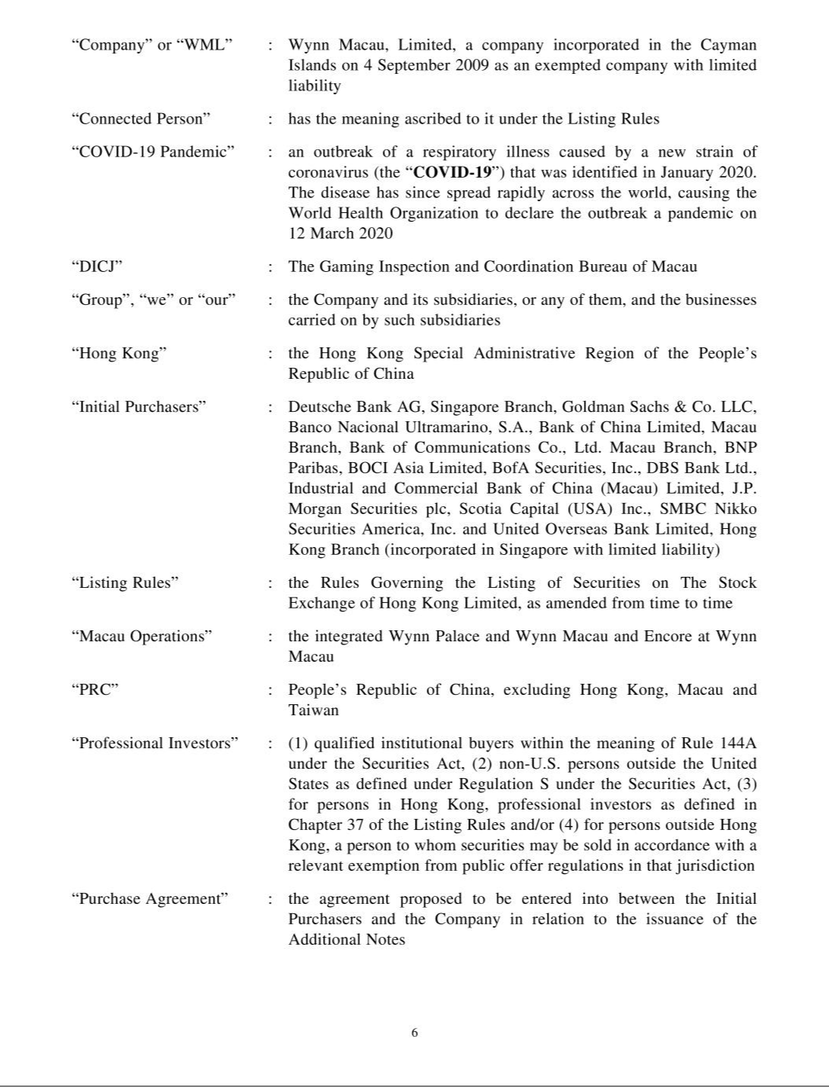

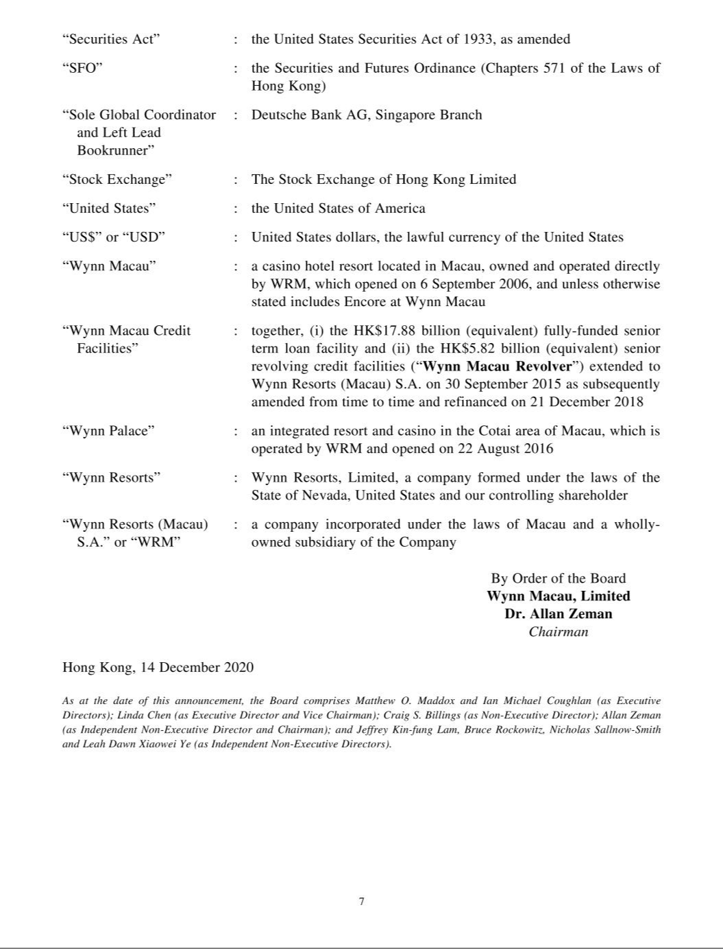

Exhibit 99.2

Recent Developments Related to COVID-19

In January 2020, an outbreak of COVID-19 was identified and has since spread around the world. As a result, our casino operations in Macau were closed for a 15-day period in February 2020 and resumed on a reduced basis on February 20, 2020. On March 20, 2020 our casino operations were fully restored; however, certain COVID-19 specific protective measures, such as limiting the number of seats per table game, increasing the spacing between active slot machines and visitor entry checks and requirements involving temperature checkpoints, mask wearing, health declarations and proof of negative COVID-19 test results remain in effect at the present time.

Visitation to Macau and gross gaming revenues in Macau have significantly decreased since the outbreak of COVID-19. Total visitation from mainland China to Macau decreased by 85.9% in the nine months ended September 30, 2020, compared to the same period in 2019 according to Macau’s Statistics and Census Service. According to the DICJ, gross gaming revenues in Macau declined by 82.5% in the nine months ended September 30, 2020 and by 72.5% in October 2020, compared to the same periods in 2019.

The decrease in gross gaming revenue in Macau is closely correlated to the decrease in visitation to Macau, driven by the strong deterrent effect of the COVID-19 Pandemic on travel and social activities, the suspension or reduced availability of the Individual Visit Scheme (the “IVS”), group tour scheme and other travel visas for visitors, quarantine measures in Macau and elsewhere, travel and entry restrictions and conditions in Macau, the PRC, Hong Kong and Taiwan involving COVID-19 testing, among other things, and the suspension or reduced accessibility of transportation to and from Macau. At present, bans on entry or enhanced quarantine requirements remain in place for people attempting to enter Macau, depending on various conditions such as the usual visa requirements, their COVID-19 test results, purpose of visit, recent travel history and/or other conditions as applicable. Quarantine requirements for those traveling between Hong Kong and Macau have been announced to remain effective until at least March 31, 2021.

While many aspects of these travel restrictions and conditions continue to adversely impact visitations to Macau, beginning in June 2020 certain restrictions and conditions have eased to allow for visitation to Macau as certain regions recover from the COVID-19 Pandemic. Quarantine-free travel, subject to COVID-19 safeguards such as testing and the usual visa requirements, was reintroduced between Macau and an increasing number of areas and cities within the PRC in progressive phases from June to August 2020, commencing with an area in Guangdong Province, which is adjacent to Macau, and expanding to additional areas and major cities within Guangdong Province, followed by most other areas of the PRC. On September 23, 2020, mainland China authorities fully resumed the IVS exit visa program, which permits individual PRC citizens from nearly 50 PRC cities to travel to Macau for tourism purposes.

Notwithstanding these developments, certain border control, travel-related restrictions and conditions, including quarantine and medical observation measures, stringent health declarations, COVID-19 testing and other procedures remain in place, and all visitors need to test negative for COVID-19 before entering Macau.

Given the evolving conditions created by and in response to the COVID-19 Pandemic, we are currently unable to determine when travel-related restrictions and conditions will be further lifted.

Measures that have been lifted or are expected to be lifted may be reintroduced if there are adverse developments in the COVID-19 situation in Macau and other regions with access to Macau.

Preliminary Fourth Quarter Information

In Macau, visitation restrictions have begun to gradually ease since June 2020. On September 23, 2020, PRC authorities fully resumed the IVS exit visa program, which, prior to its suspension by the PRC government due to COVID-19 travel restrictions, permitted PRC citizens from nearly 50 PRC cities to travel to Macau for tourism purposes. Although Macau’s gross gaming revenues decreased by 71.6% from US$6,178.4 million in October and November 2019 to US$1,756.1 million in October and November 2020, and total visitation from the PRC decreased by 77.0% from approximately 2.3 million in October 2019 to approximately 539,000 in October 2020, Macau’s gross gaming revenue in October and November 2020 increased by 187.0% from US$612.0 million in the third quarter of 2020, and the total visitation to Macau from the PRC in October increased by 30.8% from approximately 412,000 in September 2020.

As of November 30, 2020, Wynn Macau, Limited and subsidiaries had unrestricted cash and cash equivalents of US$2.1 billion. In November 2020, we repaid US$25.1 million on the Wynn Macau Revolver, and as a result, we had approximately US$25.1 million in available borrowing capacity as of November 30, 2020. Based on preliminary financial information through

November 30, 2020, we currently expect the total operating revenues of Wynn Resorts’ Macau Operations to be in the range of US$258.0 million to US$262.0 million for the two months ended November 30, 2020, compared to US$775.2 million for the two months ended November 30, 2019. We expect Adjusted Property EBITDA of Wynn Resorts’ Macau Operations to be in the range of US$13.0 million to US$15.0 million for the two months ended November 30, 2020, compared to US$244.8 million for the two months ended November 30, 2019. During the two months ended November 30, 2020, the daily operating costs of Wynn Resorts’ Macau Operations, excluding gaming taxes, were US$2.3 million, compared to US$3.0 million during the fourth quarter of 2019. During the third quarter 2020, the daily operating costs of Wynn Resorts’ Macau Operations were US$2.0 million, excluding gaming taxes and a one-time expense reversal.

For the two months ended November 30, 2020, subsequent to the reopening of the IVS exit visa program to all residents of mainland China, the daily average gross gaming revenues of Wynn Resorts’ Macau Operations were approximately 31% of its gross gaming revenues in the fourth quarter of 2019, with daily average table drop of approximately 47% of its table drop in the fourth quarter of 2019. For the two months ended November 30, 2020, hotel occupancy was 54.3% at Wynn Palace and 60.6% at Wynn Macau, compared to 96.9% and 99.3% in the same period of 2019, respectively.

Wynn Resorts uses Adjusted Property EBITDA to manage the operating results of its segments. Adjusted Property EBITDA of Wynn Resorts is net income (loss) before interest, income taxes, depreciation and amortization, pre-opening expenses, property charges and other, management and license fees, corporate expenses and other (including intercompany golf course and water rights leases), stock-based compensation, change in derivatives fair value, loss on extinguishment of debt, and other non-operating income and expenses. Adjusted Property EBITDA is presented exclusively as a supplemental disclosure because Wynn Resorts believes that it is widely used to measure the performance, and as a basis for valuation, of gaming companies. Wynn Resorts uses Adjusted Property EBITDA as a measure of the operating performance of its segments and to compare the operating performance of its properties with those of its competitors, as well as a basis for determining certain incentive compensation. Wynn Resorts also presents Adjusted Property EBITDA because it is used by some investors to measure a company’s ability to incur and service debt, make capital expenditures and meet working capital requirements. Gaming companies have historically reported EBITDA as a supplement to GAAP. In order to view the operations of their casinos on a more stand-alone basis, gaming companies, including Wynn Resorts, have historically excluded from their EBITDA calculations pre-opening expenses, property charges, corporate expenses and stock-based compensation, that do not relate to the management of specific casino properties. However, Adjusted Property EBITDA should not be considered as an alternative to operating income as an indicator of Wynn Resorts’ performance, as an alternative to cash flows from operating activities as a measure of liquidity, or as an alternative to any other measure determined in accordance with GAAP. Unlike net income, Adjusted Property EBITDA does not include depreciation or interest expense and therefore does not reflect current or future capital expenditures or the cost of capital. Wynn Resorts has significant uses of cash flows, including capital expenditures, interest payments, debt principal repayments, income taxes and other non-recurring charges, which are not reflected in Adjusted Property EBITDA. Also, Wynn Resorts’ calculation of Adjusted Property EBITDA may be different from the calculation methods used by other companies and, therefore, comparability may be limited.

The expected results discussed above are based on preliminary financial information from October 1, 2020 through November 30, 2020. Actual results could differ materially from the above expectations. Financial information for December 2020 is not currently available.

Prospective investors should exercise caution in relying on this information and should not draw any inferences from this information regarding financial or operating data not yet provided or available. This preliminary information is subject to the completion of the fourth quarter of 2020 and the preparation of the consolidated financial statements as of and for the year ending December 31, 2020, including the review of those financial statements by the Company’s internal accounting professionals and our audit committee as well as the audit by the Company’s independent registered public accounting firm.

