UNITED STATES SECURITIES AND EXCHANGE COMMISSION

Washington, D.C. 20549

SCHEDULE 14A INFORMATION

Proxy Statement Pursuant to Section 14(a) of

the Securities Exchange Act of 1934

Filed by the Registrant ☒

Filed by a Party other than the Registrant ☐

Check the appropriate box:

☐

☐

Preliminary Proxy Statement

Definitive Proxy Statement

☐ Confidential, for Use of the Commission Only (as permitted by Rule 14a-6(e)(2))

- Definitive Additional Materials

- Soliciting Material Pursuant to §240.14a-11(c) or §240.14a-12

WYNN RESORTS, LIMITED

(Name of Registrant as Specified In Its Charter)

(Name of Person(s) Filing Proxy Statement, if other than the Registrant)

Payment of Filing Fee (Check the appropriate box):

- No fee required.

- Fee computed on table below per Exchange Act Rules 14a-6(i)(1) and 0-11.

  - Title of each class of securities to which transaction applies:

  - Aggregate number of securities to which transaction applies:

  - Per unit price or other underlying value of transaction computed pursuant to Exchange Act Rule 0-11 (set forth the amount on which the filing fee is calculated and state how it was determined):

  - Proposed maximum aggregate value of transaction:

  - Total fee paid:

- Fee paid previously with preliminary materials.

- Check box if any part of the fee is offset as provided by Exchange Act Rule 0-11(a)(2) and identify the filing for which the offsetting fee was paid previously. Identify the previous filing by registration statement number, or the Form or Schedule and the date of its filing.

  - Amount Previously Paid:

  - Form, Schedule or Registration Statement No.:

  - Filing Party:

  - Date Filed:

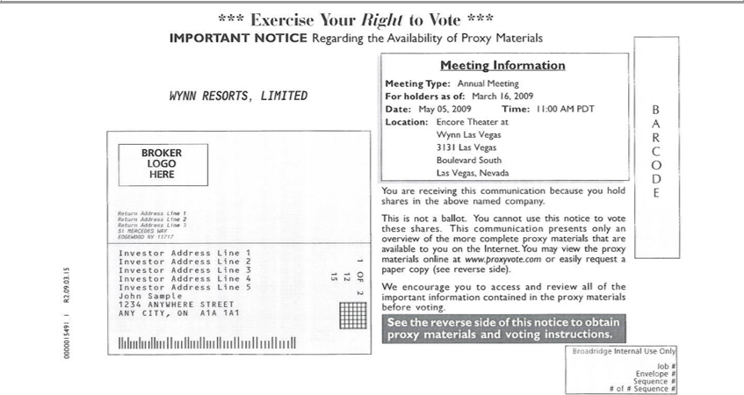

*** Exercise Your Right to Vote ***
IMPORTANT NOTICE Regarding the Availability of Proxy Materials
WYNN RESORTS, LIMITED
BROKER LOGO HERE
 |  | 1
Return Address Line |  | 2
 |  | 3
51 MERCEDES WAY
EDGEWOOD NY 1₁₇₁₇
 |  | 2
 |  | 3
 |  | 4
Investor Address Line 5
John Sample
1234 ANYWHERE STREET
ANY CITY, ON A1A 1A1
₂OF 2 | Information
15 | Information
Meeting Type: Annual Meeting
For holders as of: March 2009
Date: May 05, 2009 |  | ime:16,1:00 AM PDT
Theater
WynnLocation:Las EncoreVegas at

Las Vegas, Nevada
You are receiving this communication because you hold shares in the above named company.
This is not_{materials}ballot. You cannot use this notice to vote these shares. This communication presents only an overview of the more complete proxy materials that are available to you on the Internet. You may view
the proxy online_{access}at www.proxyvote.com_{important}easily request_{information}paper copy (see reverse side).
^{See}
W encouragethereverseyousidetoof this noticeandreviewtoobtainall proxyofthe materials and voting instructions.containedin the proxy materials before voting.
JobBroadridge# Internal Use Only
Envelope #
Sequence #
# of # Sequence #
BARCODE

0000015491_1 R2.09.03.15

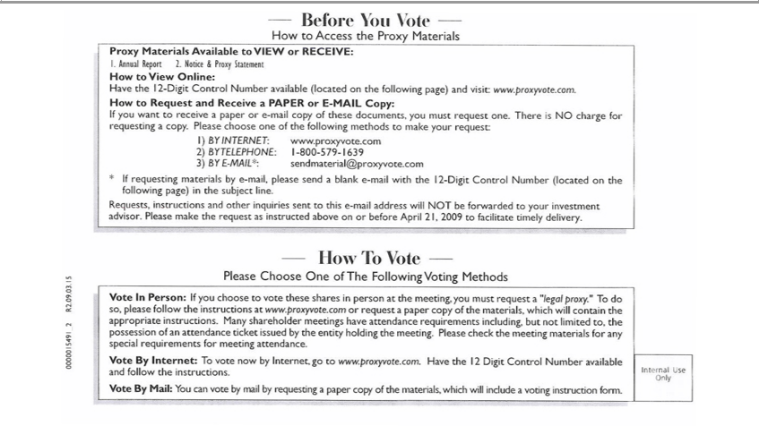

Before You Vote
How to Access the Proxy Materials
Proxy Materials Available to VIEW or RECEIVED:
1 Annual Report
2. | Notice & Proxy Statement
 | to View Online:
ave the 12-Digit Control Number available (located on the following page) and visit www.proxyvote.com.
How to Request and Receive a PAPER or E-MAIL Copy:
If you want to receive a paper or |  |  | -mail copy of these documents, you must request one. There is NO charge for requesting a copy. Please choose one of the following methods to make your request:
1) | INTERNET www.proxyvote.com
2) |  | 1-800-579-1639 |  | .com
3) BY TELEPHONE:-MAIL*: |  |  |  | .com
* If requesting materialssendmaterial@proxyvoteby-mail,pleasesend a blank e-mail with the 12-Digit Control Number (located on the following page) in the subject line.
Requests, instructions and other inquiries sent to this e-mail address will NOT be forwarded to your investment advisor. Please make the request as instructed above on or before April 21, 2009 to facilitate
timely delivery.
How To Vote
Please Choose One of The Following Voting Methods
Vote In Person: If you choose to vote these shares person at the meeting, you must request “legal proxy.” To do so, please follow the instructions at www.proxyvote.com or request a paper copy of the
materials, which will contain the appropriate instructions. |  |  |  |  | shareholder meetings have attend | requirements including, but not limited to, the possession of an attendance ticket issued by the entity
holding the meeting. Please check the meeting materials forMany special requirements for meeting attendance.
^{Vote}
byBy Mail:Internet:YouTocanvotevotebybyInternet,mailbygorequestingtowww.proxyvote.com.apapercopyof Havethematerials,the12DigitwhichControlwillincludeNumbera availablevotinginstructionandfollowform.the instructions.
0000015491_2 R2.09.03.15

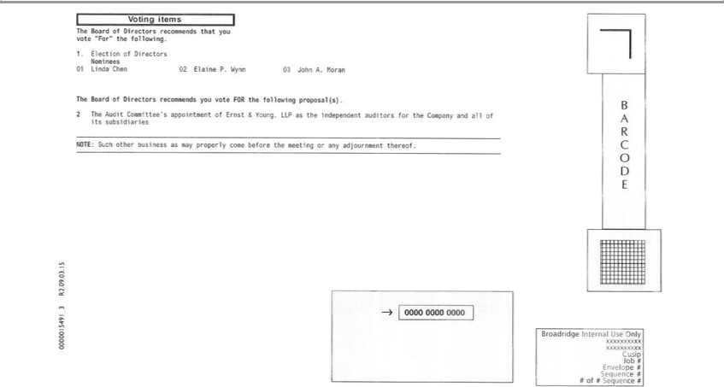

Voting items
1.TheElectionBoard ofof DirectorsDirectors recommends that you vote “For” the following
Nominees
01 Linda Chen 02 Elaine P. Wynn 03 John A. Moran
The Board of Directors _{recommends} you vote FOR the following proposal(s).
2. The Audit Committee’ appointment of Ernst & Young, LLP as the independent auditors for the Company and all of its subsidiaries NOTE: Such other business as may properly come before the meeting or any adjournment thereof.

BARCODE
⁰⁰⁰⁰015491_3 R2.09.03.15
0000 0000
xxxxxxxxxxBroadridgeInternal Use Only
Cusip
Job #
Envelope #
Sequence #
# of # Sequence #

VotingReservedInstructionsforBroadridge Internal Control Information
THIS SPACE RESERVED FOR LANGUAGE PERTAINING TO BANKS AND BROKERS AS REQUIRED BY THE NEW YORK STOCK EXCHANGE 0000015491_4 R2.09.03.15
BroadridgeTHISSPACEInternalRESERVEDUseOnlyFOR SIGNATURES IF APPLICABLE
Job #
Envelope #
Sequence #

# of # Sequence #

