Table of Contents

UNITED STATES

SECURITIES AND EXCHANGE COMMISSION
Washington, D.C. 20549

SCHEDULE 14A

Proxy Statement Pursuant to Section 14(a) of the

Securities Exchange Act of 1934

Filed by the Registrant ☒ Filed by a Party other than the Registrant ☐

Check the appropriate box:

- Preliminary Proxy Statement

- Confidential, For Use of the Commission Only (as permitted by Rule 14a-6(e)(2)) ☒ Definitive Proxy Statement

- Definitive Additional Materials

- Soliciting Material under § 240.14a-12

WYNN RESORTS, LIMITED

(Name of Registrant as Specified in Its Charter)

(Name of Person(s) Filing Proxy Statement, if Other Than the Registrant)

Payment of Filing Fee (Check the appropriate box):

- No fee required.

- Fee computed on table below per Exchange Act Rules 14a-6(i)(1) and 0-11.

  - Title of each class of securities to which transaction applies:

  - Aggregate number of securities to which transaction applies:

  - Per unit price or other underlying value of transaction computed pursuant to Exchange Act Rule 0-11 (set forth the amount on which the filing fee is calculated and state how it was determined):

  - Proposed maximum aggregate value of transaction:

  - Total fee paid:

- Fee paid previously with preliminary materials.

- Check box if any part of the fee is offset as provided by Exchange Act Rule 0-11(a)(2) and identify the filing for which the offsetting fee was paid previously. Identify the previous filing by registration statement number, or the Form or Schedule and the date of its filing.

  - Amount previously paid:

  - Form, Schedule or Registration Statement No.:

  - Filing Party:

  - Date Filed:

Table of Contents


Table of Contents


Table of Contents

Dear Shareholders,

In his letter to you, Craig Billings, our newly appointed Chief Executive Officer, discusses the plans and opportunities he envisions for growing the enterprise in both the near- and long-term.

These growth opportunities should not come as a surprise. As we reported in last year’s proxy, we committed to ensuring the Company would be well positioned to take advantage of anticipated strong consumer demand for our products and services when the pandemic subsided.

The correct allocation of our financial resources by management, with the approval of the Board, is central to that growth plan. The strong financial results we are seeing in Boston make our planned multi-phase development there a solid investment. Our partnership with Marjan and operating agreement with RAK Hospitality Holdings in Ras Al Khaimah to develop a new beachside casino resort in the United Arab Emirates will give us access to two billion travelers within a four-hour plane fight. This is the first instance of our company being compensated for the quality of our brand and operating experience.

The new Las Vegas entertainment experience Craig cites is created with a new, younger customer in mind. New dining experiences targeting the high-frequency guest at Encore Boston Harbor, as well as new capital planned for the evolving customer base in Macau, are proof that this management team is focused on our future customers.

We believe our single greatest asset is our people. That means all growth truly begins with our 27,000 employees at our resorts in Las Vegas, Boston, Macau, and Cotai, as well as our management team. That also includes our Board, whose succession planning for CEO resulted in a seamless transition with zero business interruption when Craig Billings assumed the role following Matt Maddox’s departure.

Likewise, it spoke well of management’s own succession planning when former Encore Boston Harbor President Brian Gullbrants was appointed President of Wynn Las Vegas, and Jenny Holaday, who had worked shoulder-to-shoulder with Brian in Boston and played a key role in creating outstanding results there, was in-turn appointed President of Encore Boston Harbor.

Finally, understanding that a diversity of experience is essential for the Company to be strong and competitive, the Board recruited Darnell Strom to join its ranks. As I previously reported to you, Darnell adds a young and fresh voice to the Board, and his professional experience in entertainment is of great benefit to the Company. Craig Billings also cultivated and recruited seasoned gaming financial executive Julie Cameron-Doe to fill the Chief Financial Officer opening created by his appointment as CEO.

Growth ultimately requires the right focus, strategy and people to be sustainable. As Chair of Wynn Resorts, I have great confidence in all three of these elements and look forward to reporting back to you next year on our continued success.
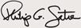

Sincerely,

Philip P. Satre

Chair of the Board of Directors

Table of Contents
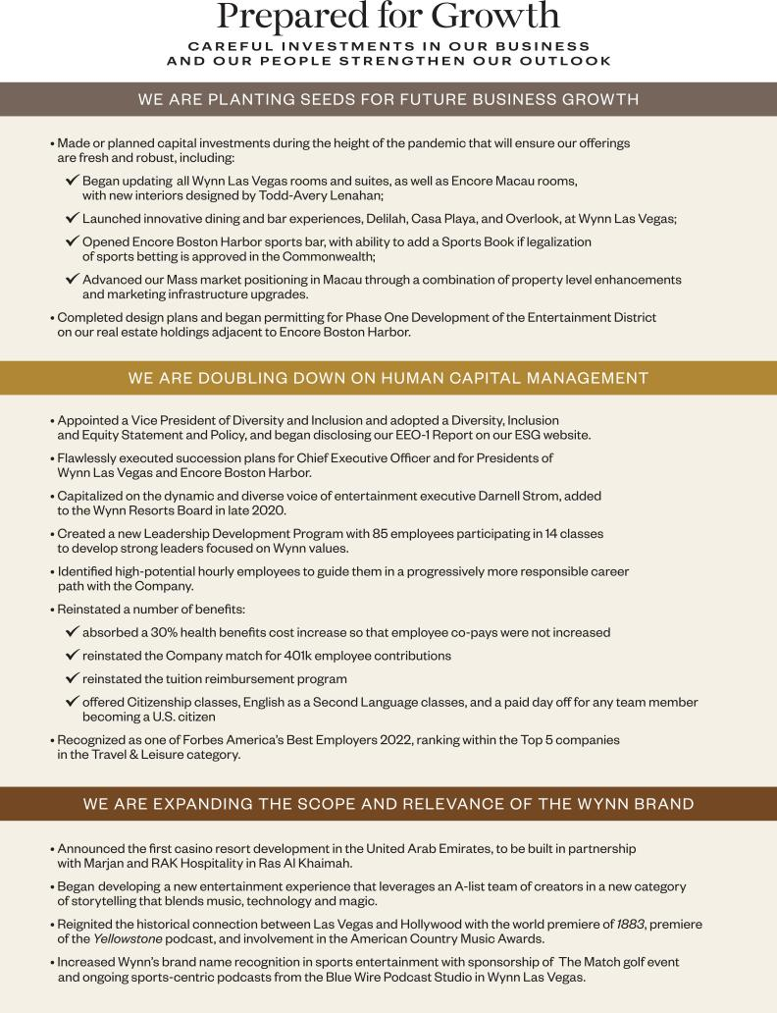

Table of Contents


Dear Shareholders,

Following the extended period of significant challenges created by the pandemic, 2021 proved to be an incredible, dynamic year for Wynn Resorts. Significant portions of our business reemerged stronger than ever; others are still experiencing the impact of pandemic-related restrictions.

Overall, the heart of our business – our employees and the tremendous sense of ownership they take in creating singular guest experiences – is unwavering. It is their sense of proprietorship which results in our strong performance.

We concluded last year on a wave of strength and success in North America. Our exceptional resort offerings and focus on service resonated well with guests who felt they had spent the whole of 2020 and early 2021 isolated and at home. Our Las Vegas team learned new ways to operate in a changed environment, one in which interest from convention and meetings groups was limited but featured roaring demand for our product from gaming and leisure travelers. Our Encore Boston Harbor team’s recalibration toward the casino side of the business began to show strong results with more to come.

Travel remains constrained in the Macau market due to the pandemic. We believe consumer demand will continue to build and the changes we have continuously made since the opening of Wynn Palace to increase our appeal to premium mass and direct VIP customers will be rewarded when travelers return to the market. Looking forward, the Macau concession renewal process continues to move ahead as anticipated in a very logical and methodical manner.

This year also looks bright for our resorts in North America with new room product for Wynn Las Vegas and a new entertainment offering and programming that will expand our audience of guests and deepen our relevance to them. New dining offerings and database growth at Encore Boston Harbor will further solidify our market position in the Northeast.

The closure of our sale-leaseback transaction of Encore Boston Harbor with Realty Income will, in part, facilitate the ground-breaking on Phase One of development of the significant real estate holdings we have across Lower Broadway, adjacent to Encore Boston Harbor. We will further diversify our business and meaningfully extend our brand into the Middle East and Europe with our recently announced resort in Ras Al-Khaimah in the United Arab Emirates. Design and development on that project will continue throughout 2022.

In such a pivotal year, no team is better positioned to gain advantage than Wynn Resorts.

Sincerely,

Craig Billings

Chief Executive Officer

Table of Contents


Table of Contents

Notice of Annual Meeting

Our 2022 Annual Meeting will be held online.

PURPOSE OF THE MEETING

THE ANNUAL MEETING WILL BE HELD FOR THE FOLLOWING PURPOSES:
- To elect three Class II directors to serve until the 2025 Annual Meeting of Shareholders;

- To ratify the appointment of Ernst & Young LLP as our independent registered public accounting firm for the fiscal year ending December 31, 2022;

- To approve, on a non-binding advisory basis, the compensation of our named executive officers as described in the Proxy Statement;

- To consider and transact such other business as may properly come before the Annual Meeting, or at any adjournments or postponements thereof.

The foregoing items of business are more fully described in the Proxy Statement accompanying this Notice. Only the Company’s shareholders of record at the close of business on March 11, 2022, the record date fixed by the Board of Directors, are entitled to notice of, and to vote at, the Annual Meeting, and at any adjournments or postponements thereof. Only such shareholders, their proxy holders, and our invited guests may attend the Annual Meeting.

IMPORTANT NOTICE REGARDING AVAILABILITY OF PROXY MATERIALS FOR THE SHAREHOLDER MEETING TO BE HELD ON MAY 5, 2022
This Proxy Statement and our Annual Report for the fiscal year ended December 31, 2021, are available at http://www.wynnresorts.com on the Company Information page under the “Annual Meeting” heading. On or about March 24, 2022, we mailed to our shareholders (other than those who previously requested electronic or paper delivery) a notice containing instructions on how to access our Annual Meeting materials (including the Proxy Statement and our Annual Report for the fiscal year ended December 31, 2021) and how to vote.

PARTICIPATING IN THE VIRTUAL ANNUAL MEETING
To participate in the virtual Annual Meeting, visit http://www.virtualshareholdermeeting.com/WYNN2022, and log in using the 16-digit control number printed in the box marked by the arrow on your Notice of Internet Availability, proxy card or voter instruction form.

YOUR VOTE IS IMPORTANT
You are encouraged to read the attached Proxy Statement and then cast your vote as promptly as possible by following the instructions on the proxy card you receive. Even if you have given your proxy, you may still vote electronically during the virtual Annual Meeting by visiting http://www.virtualshareholdermeeting.com/WYNN2022, logging in using the 16-digit control number printed in the box marked by the arrow on your Notice of Internet Availability, proxy card or voter instruction form, clicking on the vote button on the screen and following the instructions provided. If your shares are held through an intermediary, such as a bank, broker or other nominee, unless you provide voting instructions to such person, your shares will not be voted on most matters being considered at the Annual Meeting and, therefore, it is especially important you return the proxy card with your vote or vote via the internet or by telephone as further explained in the accompanying proxy materials.

By Order of the Board of Directors,
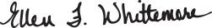

Ellen F. Whittemore

Secretary

Las Vegas, Nevada

March 24, 2022

DATE AND TIME |  | PLACE
May 5, 2022 |  | Virtual meeting conducted via live webcast accessed at this website:
9:00 am PT |  | http://www.virtualshareholdermeeting.com/WYNN2022

This Proxy Statement and our 2021 Annual Report on Form 10-K are available at http://www.wynnresorts.com on the Company Information page under the “Annual Meeting” heading.

Table of Contents


Table of Contents

OUR BOARD AND CORPORATE GOVERNANCE |  |  |  |  |  |  |  |  |  |  |  |  |  |  |  |  |  | 1
Board Composition and Diversity |  |  |  |  |  |  |  |  |  |  |  |  |  |  |  |  |  | 1
Director Skills and Experience |  |  |  |  |  |  |  |  |  |  |  |  |  |  |  |  |  | 2
Director Biographies |  |  |  |  |  |  |  |  |  |  |  |  |  |  |  |  |  | 3
Why Our Board Governance is Effective |  |  |  |  |  |  |  |  |  |  |  |  |  |  |  |  |  | 12
Board Committees |  |  |  |  |  |  |  |  |  |  |  |  |  |  |  |  |  | 12
Board Role in Risk Oversight |  |  |  |  |  |  |  |  |  |  |  |  |  |  |  |  |  | 16
Board Meetings/Annual Meeting |  |  |  |  |  |  |  |  |  |  |  |  |  |  |  |  |  | 17
Board Communication and Engagement |  |  |  |  |  |  |  |  |  |  |  |  |  |  |  |  |  | 17
Shareholder Engagement |  |  |  |  |  |  |  |  |  |  |  |  |  |  |  |  |  | 17
Board Compensation |  |  |  |  |  |  |  |  |  |  |  |  |  |  |  |  |  | 18
Non-Employee Director Compensation Table |  |  |  |  |  |  |  |  |  |  |  |  |  |  |  |  |  | 19
OUR PEOPLE AND OUR STEWARDSHIP |  |  |  |  |  |  |  |  |  |  |  |  |  |  |  |  |  | 23
Introduction |  |  |  |  |  |  |  |  |  |  |  |  |  |  |  |  |  | 23
Our People |  |  |  |  |  |  |  |  |  |  |  |  |  |  |  |  |  | 24
Our Communities |  |  |  |  |  |  |  |  |  |  |  |  |  |  |  |  |  | 24
Our Planet |  |  |  |  |  |  |  |  |  |  |  |  |  |  |  |  |  | 25
EXECUTIVE OFFICERS |  |  |  |  |  |  |  |  |  |  |  |  |  |  |  |  |  | 26

Table of Contents


COMPENSATION DISCUSSION AND ANALYSIS |  |  |  |  |  |  |  |  |  |  |  |  |  |  |  |  |  |  |  |  |  |  |  |  |  |  |  |  |  |  |  |  |  |  | 33
Why You Should Vote for the 2021 Say-on-Pay |  |  |  |  |  |  |  |  |  |  |  |  |  |  |  |  |  |  |  |  |  |  |  |  |  |  |  |  |  |  |  |  |  |  | 33
How We Approach Executive Compensation |  |  |  |  |  |  |  |  |  |  |  |  |  |  |  |  |  |  |  |  |  |  |  |  |  |  |  |  |  |  |  |  |  |  | 34
How the Company Has Performed |  |  |  |  |  |  |  |  |  |  |  |  |  |  |  |  |  |  |  |  |  |  |  |  |  |  |  |  |  |  |  |  |  |  | 36
How We Designed Incentives in 2021 |  |  |  |  |  |  |  |  |  |  |  |  |  |  |  |  |  |  |  |  |  |  |  |  |  |  |  |  |  |  |  |  |  |  | 37
Other Aspects of Our Executive Compensation |  |  |  |  |  |  |  |  |  |  |  |  |  |  |  |  |  |  |  |  |  |  |  |  |  |  |  |  |  |  |  |  |  |  | 42
Compensation Committee Report |  |  |  |  |  |  |  |  |  |  |  |  |  |  |  |  |  |  |  |  |  |  |  |  |  |  |  |  |  |  |  |  |  |  | 43
EXECUTIVE COMPENSATION TABLES AND OTHER INFORMATION |  |  |  |  |  |  |  |  |  |  |  |  |  |  |  |  |  |  |  |  |  |  |  |  |  |  |  |  |  |  |  |  |  |  | 47
Summary Compensation Table |  |  |  |  |  |  |  |  |  |  |  |  |  |  |  |  |  |  |  |  |  |  |  |  |  |  |  |  |  |  |  |  |  |  | 47
Discussion of Summary Compensation Table |  |  |  |  |  |  |  |  |  |  |  |  |  |  |  |  |  |  |  |  |  |  |  |  |  |  |  |  |  |  |  |  |  |  | 48
2021 Grants of Plan-Based Awards Table |  |  |  |  |  |  |  |  |  |  |  |  |  |  |  |  |  |  |  |  |  |  |  |  |  |  |  |  |  |  |  |  |  |  | 49
Outstanding Equity Awards at Fiscal Year-end |  |  |  |  |  |  |  |  |  |  |  |  |  |  |  |  |  |  |  |  |  |  |  |  |  |  |  |  |  |  |  |  |  |  | 50
Option Exercises and Stock Vested in 2021 |  |  |  |  |  |  |  |  |  |  |  |  |  |  |  |  |  |  |  |  |  |  |  |  |  |  |  |  |  |  |  |  |  |  | 51
Potential Payments Upon Termination or Change in Control |  |  |  |  |  |  |  |  |  |  |  |  |  |  |  |  |  |  |  |  |  |  |  |  |  |  |  |  |  |  |  |  |  |  | 51
CERTAIN RELATIONSHIPS AND TRANSACTIONS |  |  |  |  |  |  |  |  |  |  |  |  |  |  |  |  |  |  |  |  |  |  |  |  |  |  |  |  |  |  |  |  |  |  | 55
PAY RATIO DISCLOSURE |  |  |  |  |  |  |  |  |  |  |  |  |  |  |  |  |  |  |  |  |  |  |  |  |  |  |  |  |  |  |  |  |  |  | 56
SECURITY OWNERSHIP |  |  |  |  |  |  |  |  |  |  |  |  |  |  |  |  |  |  |  |  |  |  |  |  |  |  |  |  |  |  |  |  |  |  | 57
Certain Beneficial Ownership and Management |  |  |  |  |  |  |  |  |  |  |  |  |  |  |  |  |  |  |  |  |  |  |  |  |  |  |  |  |  |  |  |  |  |  | 57
Section 16(a) Beneficial Ownership Reporting Compliance |  |  |  |  |  |  |  |  |  |  |  |  |  |  |  |  |  |  |  |  |  |  |  |  |  |  |  |  |  |  |  |  |  |  | 58
ITEMS TO BE VOTED ON |  |  |  |  |  |  |  |  |  |  |  |  |  |  |  |  |  |  |  |  |  |  |  |  |  |  |  |  |  |  |  |  |  |  | 63
Proposal 1: Election of Directors |  |  |  |  |  |  |  |  |  |  |  |  |  |  |  |  |  |  |  |  |  |  |  |  |  |  |  |  |  |  |  |  |  |  | 63
Proposal 2: Ratification of Appointment of Independent Auditors |  |  |  |  |  |  |  |  |  |  |  |  |  |  |  |  |  |  |  |  |  |  |  |  |  |  |  |  |  |  |  |  |  |  | 63
Proposal 3: Advisory Vote to Approve the Compensation of Named
Executive Officers |  |  |  |  |  |  |  |  |  |  |  |  |  |  |  |  |  |  |  |  |  |  |  |  |  |  |  |  |  |  |  |  |  |  | 66
GENERAL INFORMATION |  |  |  |  |  |  |  |  |  |  |  |  |  |  |  |  |  |  |  |  |  |  |  |  |  |  |  |  |  |  |  |  |  |  | 67
Our 2022 Annual Meeting of Shareholders |  |  |  |  |  |  |  |  |  |  |  |  |  |  |  |  |  |  |  |  |  |  |  |  |  |  |  |  |  |  |  |  |  |  | 67
Voting and Solicitation |  |  |  |  |  |  |  |  |  |  |  |  |  |  |  |  |  |  |  |  |  |  |  |  |  |  |  |  |  |  |  |  |  |  | 67
How You Can Vote |  |  |  |  |  |  |  |  |  |  |  |  |  |  |  |  |  |  |  |  |  |  |  |  |  |  |  |  |  |  |  |  |  |  | 68
Revocability of Proxies |  |  |  |  |  |  |  |  |  |  |  |  |  |  |  |  |  |  |  |  |  |  |  |  |  |  |  |  |  |  |  |  |  |  | 68
Participating in the Annual Meeting |  |  |  |  |  |  |  |  |  |  |  |  |  |  |  |  |  |  |  |  |  |  |  |  |  |  |  |  |  |  |  |  |  |  | 68
Proxy Procedure and Expenses of Solicitation |  |  |  |  |  |  |  |  |  |  |  |  |  |  |  |  |  |  |  |  |  |  |  |  |  |  |  |  |  |  |  |  |  |  | 69
Shareholder Proposals |  |  |  |  |  |  |  |  |  |  |  |  |  |  |  |  |  |  |  |  |  |  |  |  |  |  |  |  |  |  |  |  |  |  | 69
Annual Report |  |  |  |  |  |  |  |  |  |  |  |  |  |  |  |  |  |  |  |  |  |  |  |  |  |  |  |  |  |  |  |  |  |  | 70
Householding |  |  |  |  |  |  |  |  |  |  |  |  |  |  |  |  |  |  |  |  |  |  |  |  |  |  |  |  |  |  |  |  |  |  | 70
Other Business |  |  |  |  |  |  |  |  |  |  |  |  |  |  |  |  |  |  |  |  |  |  |  |  |  |  |  |  |  |  |  |  |  |  | 70

Table of Contents


Table of Contents


Table of Contents


Table of Contents

Introduction

In this section, Wynn Resorts, Limited (the “Company,” “Wynn Resorts,” or “we”) will tell you about:

– Board Composition and Diversity
– Director Skills and Experience
– Director Biographies
– Why Our Board Governance is Effective
– Board Committees
– Board Governance
– Board Role in Risk Oversight
– Board Meetings/Annual Meeting
– Board Communication and Engagement
– Shareholder Engagement
– Board Compensation

Board composition and diversity


AVERAGE

DIRECTOR
TENURE:

3.7 YEARS

Compared with

7.7 years average tenure for the S&P
500⁽¹⁾

63%

(5 OF 8)
INDEPENDENT
DIRECTORS

ARE DIVERSE

Compared with 30% gender and 21% ethnic diversity for the S&P 500

100%

BOARD

COMMITTEE CHAIRS

ARE WOMEN

Compared with 30% for the S&P 500

INDEPENDENT

CHAIR

Prevalent at less than 37% of the S&P 500

* All figures are as of the day of the 2022 Annual Meeting.

Our Nominating and Corporate Governance Committee is committed to maintaining a Board of Directors (“Board”) with a broad spectrum of experience and expertise that will promote the presentation and consideration of different points of view, meet the Company’s evolving needs and strengthen our diversity.

In 2019, the Nominating and Corporate Governance Committee reinforced the Board’s commitment to diversity of experiences and perspectives among its members. The Nominating and Corporate Governance Committee amended the Company’s Corporate Governance Guidelines to adopt a policy that requires diverse candidates be included in the pool when recruiting, and have any search firm that it engages to include, candidates with a diverse – race, gender, and ethnicity – background when evaluating new candidates for the Board. At that time, the Nominating and Corporate Governance Committee had also established a goal of achieving 50% diversity among Board members. These considerations have been important factors in recent additions to the Board, including the appointment of Mr. Strom to the Board.

As of the 2022 Annual Meeting, our independent board is 63% diverse, with four female directors and one racially diverse director.

- Comparisons are based on information contained in the 2021 US Spencer Stuart Board Index.

// 1 //

Table of Contents
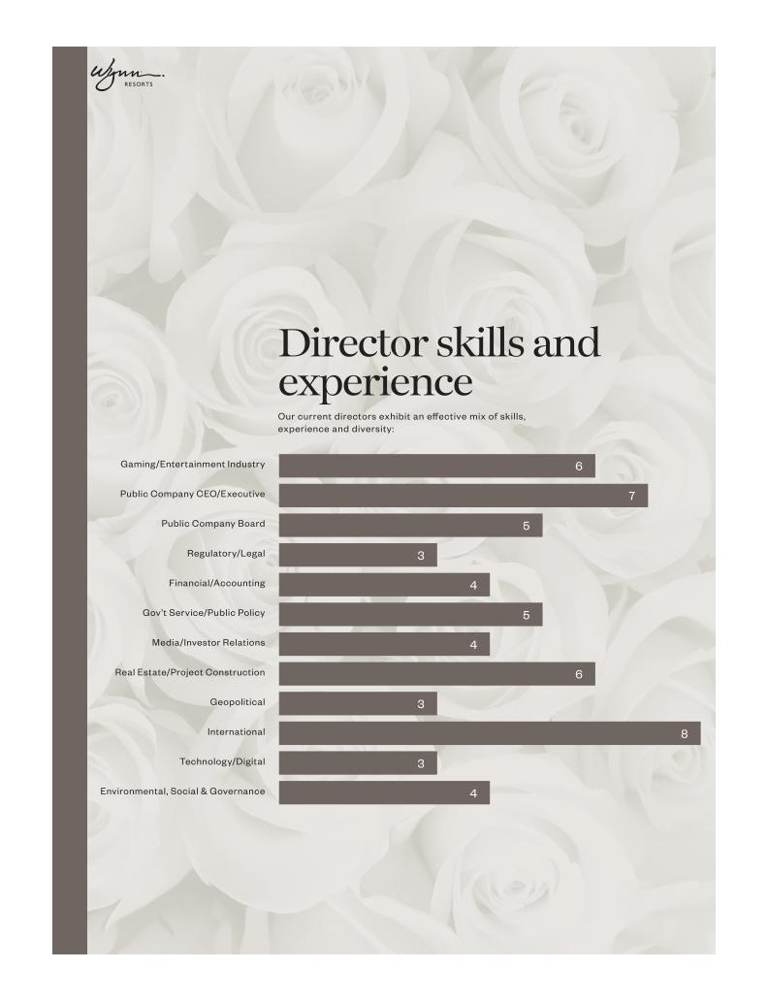

2022 PROXY STATEMENT _{// 2 //}

Table of Contents

Director Biographies Biographical and other information for our directors is provided below.

Betsy S. Atkins Chief Executive Officer and Founder, Baja Corporation

Ms. Atkins has been the Chief Executive Officer of Baja Corporation, an independent venture capital firm focused on technology, renewable energy and life sciences, since 1994. Ms. Atkins currently serves on the Board of SL Green Realty (since April 2015), and other private companies.

Director Since | April 2018
Term Expires | 2024 Annual Meeting
Age | 68
Board Committees: | Compensation,
 | Chair Nominating and
 | Corporate Governance


PREVIOUS EXPERIENCE

– 2016 to October 2018: Director, Cognizant Technology Solutions

– 2013 to 2016: Chair, APX Labs (a Google Glass enterprise software company)

– February 2009 to August 2009: Chair and Chief Executive Officer, Clear Standards (until acquired by SAP)

– 1991 to 1993: Chair and Chief Executive Officer, NCI

– 1989 to 1999: Co-founder, Director, Executive Vice President Sales, Marketing, International Operations, Ascend Communications (until acquired by Lucent Technologies)

– Previously served on the boards of Schneider Electric, HD Supply Holdings, Polycom, SunPower, Chico’s FAS, Ciber, Darden Restaurants

– Formerly Chair, Executive Advisory Board, SAP, AG, an advisor to British Telecom and presidential-appointee to the Pension Benefit Guaranty Corporation advisory committee

EDUCATION

Ms. Atkins graduated with a B.A. from the University of Massachusetts.

EXPERTISE

Ms. Atkins brings to our Board executive leadership and operational experience in various technology, food & beverage and retail industries, as well as significant public board experience and executive compensation, sustainability and enterprise risk management expertise.

Gaming/Entertainment Industry experience

Public Company CEO/Executive experience

Public Company Board experience

Gov’t Service/Public Policy experience

Media/Investor Relations experience

Real Estate/Project Construction experience

International experience

Technology/Digital experience

Environmental, Social & Governance experience

// 3 //

Table of Contents
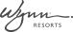

Craig S. Billings Chief Executive Officer, Wynn Resorts, Limited

Mr. Billings has served as the Company’s CEO since February 1, 2022, and as President from March 2019 until May 2020. Mr. Billings joined the Company in March 2017 as Chief Financial Officer. Mr. Billings also served as CEO of Wynn Interactive. On August 17, 2018, Mr. Billings was appointed as a Non-Executive Director of Wynn Macau, Limited, a majority owned subsidiary of the Company. Mr. Billings serves as a Director of Applovin Corporation.

Director Since | February 2022
Term Expires | 2022 Annual Meeting
Age | 49


PREVIOUS EXPERIENCE

– 2015 to 2017: Gaming industry independent advisor and investor

– 2012 to 2015: Chief Digital Officer, Strategy & Business Development Managing Director, various roles, Aristocrat Leisure Ltd.

– Previously Vice President in the Investment Banking Division of Goldman Sachs in both New York and London, covering the gaming industry

– Previously Manager in the Audit Division of Deloitte & Touche in Las Vegas, NV

– 2015 to 2018: Director and Non-Executive Chair, NYX Gaming Group

EDUCATION

Mr. Billings graduated with a B.S. (cum laude) in Accounting from the University of Nevada, Las Vegas, and received an M.B.A. from Columbia Business School. Mr. Billings is a Certified Public Accountant.

EXPERTISE

Mr. Billings has extensive leadership and innovation in the gaming industry, both domestically and internationally, as well experience in the investment banking and financial services industries.

Gaming/Entertainment Industry experience

Public Company CEO/Executive experience

Public Company Board experience

Financial/Accounting experience

Real Estate/Project Construction experience

International experience

Gov’t Service/Public Policy Experience

2022 PROXY STATEMENT _{// 4 //}

Table of Contents

Richard J. Byrne President, Benefit Street Partners

Mr. Byrne has been the President of Benefit Street Partners since 2013. He also serves as Chairman and Chief Executive Officer of Benefit Street Partners. Mr. Byrne is also the Chairman and Chief Executive Officer of Franklin BSP Lending Corporation, Franklin BSP Capital Corporation, Franklin BSP Realty Trust, Inc., and Benefit Street Partners Multifamily Trust. He currently serves on the Board of New York Road Runners (since 2009). He is also the Founder and Chief Executive Officer of Kasai Elite Grappling Championships.

Director Since | August 2018
Term Expires | 2023 Annual Meeting
Age | 61
Board Committees: | Audit (Financial Expert)
 | Compensation
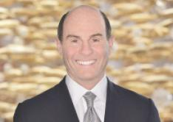

PREVIOUS EXPERIENCE

– 1999 to 2013: Chief Executive Officer, Deutsche Bank Securities, Inc. (2008-2013); Global Co-Head of Capital Markets at Deutsche Bank (2006-2013); member of the Global Banking Executive Committee and the Global Markets Executive Committee (2001-2010)

– 1985 to 1999: Global Co-Head of the Leveraged Finance Group and Global Head of Credit Research at Merrill Lynch & Co.

– Highly-ranked credit research analyst, principally in the gaming, lodging and leisure sector

EDUCATION

Mr. Byrne graduated with a B.A. from Binghamton University and a Masters of Business Administration (M.B.A.) from the Kellogg School of Management at Northwestern University.

EXPERTISE

Mr. Byrne has extensive high-level experience in the investment banking and financial services industries, adding expertise in corporate finance and substantial knowledge of the public and private capital markets to our Board. Mr. Byrne also has a deep background in the casino resort industry.

Gaming/Entertainment Industry experience

Public Company CEO/Executive experience

Public Company Board experience

Financial/Accounting experience

Real Estate/Project Construction experience

International experience

// 5 //

Table of Contents

Patricia Mulroy Non-Resident Senior Fellow for Climate Adaptation & Environmental Policy, Practitioner in Residence, Saltman Center for Conflict Resolution, William S. Boyd School of Law, University of Nevada, Las Vegas

Ms. Mulroy is currently a Non-Resident Senior Fellow for Climate Adaptation and Environmental Policy and Practitioner in Residence at the Saltman Center for Conflict Resolution at the William S. Boyd School of Law at the University of Nevada, Las Vegas. Ms. Mulroy operates a consulting firm representing both corporate and government clients in water matters. Ms. Mulroy is a recognized expert in climate related adaptation strategies for both governments and corporations. Ms. Mulroy recently completed her term as a member of the Global Agenda Council on Water of the World Economic Forum.

Director Since | October 2015
Term Expires | 2023 Annual Meeting
Age | 69
Board Committees: | Audit
 | Nominating and Corporate
 | Governance


PREVIOUS EXPERIENCE

– July 2014 through October 2015: served on the Nevada Gaming Commission

– 1995 to 2014: Nevada’s representative on Colorado River Basin issues, serving as the lead negotiator from 2007 to 2014

– 1993 to 2014: General Manager of the Southern Nevada Water Authority

– 1989 to 2014: General Manager of the Las Vegas Valley Water District

EDUCATION

Ms. Mulroy graduated with a B.A. and M.A. from the University of Nevada, Las Vegas.

EXPERTISE

Ms. Mulroy brings more than 30 years of government experience to the Board, serving in numerous leadership roles focusing on Nevada’s public infrastructure. Additionally, Ms. Mulroy’s experience on the Nevada Gaming Commission brings experience and insight into state regulatory and public policy issues impacting the Company’s operations.

Regulatory/Legal experience

Gov’t Service/Public Policy experience

Real Estate/Project Construction experience

International experience

Environmental, Social & Governance experience

2022 PROXY STATEMENT _{// 6 //}

Table of Contents

Margaret J. Myers Senior Advisor to the Governor of California and Director of the Governor’s Office of Business and Economic Development

Ms. Myers is currently Senior Advisor to the Governor of California and Director of the Governor’s Office of Business and Economic Development. From September 2014 to April 2020, Ms. Myers was Executive Vice President, Worldwide Corporate Communications and Public Affairs for Warner Bros. Entertainment, a broad-based entertainment company.

Director Since | April 2018
Term Expires | 2022 Annual Meeting
Age | 60
Board Committees: | Compensation
 | Nominating and Corporate
 | Governance


PREVIOUS EXPERIENCE

– September 2010 to June 2014: Managing Director, Strategic Communications and Public Affairs Practice, Glover Park Group

– 1994 to 2010: Political analyst, commentator and writer

– January 1993 to December 1994: White House Press Secretary

– Ms. Myers is the author of the 2008 New York Times best-selling book, “Why Women Should Rule the World”

EDUCATION

Ms. Myers graduated with a B.S. from Santa Clara University.

EXPERTISE

Ms. Myers has extensive experience in both the public and private sectors, as a C-Suite executive, senior government official and board member. She brings to our Board expertise in strategic growth, policy and governance and corporate communications strategies, including media relations, crisis and reputation management, executive communications, corporate responsibility, and philanthropy.

Public Company CEO/Executive experience

Gov’t Service/Public Policy experience

Media/Investor Relations experience

Geopolitical experience

International experience

// 7 //

Table of Contents

Clark T. Randt Jr. President, Randt & Co. LLC

Ambassador Randt is currently President of Randt & Co. LLC, which advises firms with interests in China. Ambassador Randt has been a Director of Valmont Industries since February 2009. Ambassador Randt is also a member of the Council on Foreign Relations. Ambassador Randt is a member of the New York State Bar Association, was admitted to the Hong Kong Bar Association, and has over 25 years of experience in cross-border corporate and finance transactions.

Director Since |  | October 2015
 | Term Expires | 2023 Annual Meeting
Age |  | 76
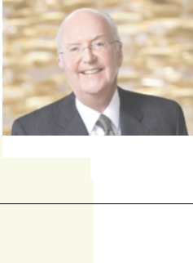

PREVIOUS EXPERIENCE

– 2001 to 2009: United States Ambassador to the People’s Republic of China

– Previously, partner at Shearman & Sterling, head of China practice

EDUCATION

Ambassador Randt graduated with a B.A. from Yale University, and has a J.D. from the University of Michigan Law School.

EXPERTISE

Ambassador Randt’s service as the U.S. Ambassador to the People’s Republic of China and his ongoing expertise regarding China give him a unique perspective on international business and foreign policy issues. Additionally, his fluency in Mandarin Chinese and extensive China experience make him well-suited to meaningfully contribute to the Board’s oversight of the Company’s operations in Macau.

Public Company Board experience

Regulatory/Legal experience

Gov’t Service/Public Policy experience

International experience

Geopolitical experience

Environmental, Social & Governance experience

Board Committees | Compensation
2022 PROXY STATEMENT _{// 8 //}

Table of Contents

Philip G. Satre Retired

Mr. Satre has served as the Non-Executive Chair of the Board since November 2018 and joined the Board as Vice-Chair in August 2018. In the not-for-profit sector, Mr. Satre is President Emeritus of the International Center for Responsible Gaming; a Trustee of The National World War II Museum; serves on the Board of the National Automobile Museum – The Harrah Collection in Reno, Nevada; and serves on the Stanford Alumni Association Board of Directors.

Director Since | August 2018
Term Expires | 2024 Annual Meeting
Age | 72
Board Committees | Nominating and Corporate
 | Governance


PREVIOUS EXPERIENCE

– 1980 to 2005: Various roles at Harrah’s Entertainment, Inc. with increasing responsibility, including Vice President, General Counsel and Secretary; President and Chief Executive Officer of its gaming division; culminating in service as CEO and Chair

– Previously served on the boards of Nordstrom, Inc., International Game Technology PLC, NV Energy, Tabcorp Holdings Ltd. (Australia), and Rite Aid Corporation

– Various roles in non-profits, including as Chair of the Guinn Center for Policy Priorities and Emeritus Member of the Stanford University Board of Trustees (2005 to 2010).

EDUCATION

Mr. Satre graduated with a B.A. from Stanford University and a J.D. from the University of California, Davis.

EXPERTISE

Mr. Satre’s prior experience as an executive in our industry brings the Board extensive understanding of the complex financial, regulatory, operational, and strategic challenges we face, while his prior experience as a director across a diversity of industries adds additional expertise in matters of good corporate governance and effective Board oversight.

Gaming/Entertainment Industry experience

Public Company CEO/Executive experience

Public Company Board experience

Regulatory/Legal experience

Financial/Accounting experience

Media/Investor Relations experience

Real Estate/Project Construction experience

International experience

// 9 //

Table of Contents

Darnell O. Strom Partner & Head of Culture and Leadership, UTA

Mr. Strom is a Partner & Head of the Culture and Leadership Division at premiere entertainment agency, UTA. Mr. Strom represents transformative talent, brands, and organizations across entertainment, media, sports, fashion, the arts, entrepreneurship, politics, and thought leadership.

Director Since | October 2020
Term Expires | 2024 Annual Meeting
Age | 40
Board Committees: | Audit
 | Nominating and Corporate
 | Governance
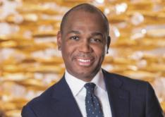

PREVIOUS EXPERIENCE

– 2012 to 2019: Agent, Creative Artists Agency

– 2010 to 2012: Executive, Creative Artists Agency Foundation

– 2006 to 2010: Deputy Director of Development, William J. Clinton Foundation

– 2005 to 2006: Deputy Director of Scheduling & Advance, Office of President William J. Clinton

EDUCATION

Mr. Strom graduated with a B.S. (with honors) from Florida A&M University.

EXPERTISE

Mr. Strom’s decades of experience in entertainment, media, and sports, along with the relationships he has established, will be a significant benefit to the Board. Mr. Strom brings to our Board significant industry expertise in media, sports, entertainment, music, fashion, the arts, branding and thought leadership.

Gaming/Entertainment Industry experience

Gov’t Service/Public Policy experience

Geopolitical experience

Technology/Digital experience

2022 PROXY STATEMENT _{// 10 //}

Table of Contents

Winifred M. Webb Founder, Kestrel Corporate Advisors

Ms. Webb founded Kestrel Corporate Advisors, an advisory services firm, and has served as its Chief Executive Officer since 2013. Ms. Webb currently serves on the Board of Trustees of American Homes 4 Rent (since January 2019), the Boards of AppFolio, Inc. (since December 2019) and ABM Industries (since 2014).

Director Since | April 2018
Term Expires | 2025 Annual Meeting
Age | 64
Board Committees: | Audit, Chair (Financial Expert)


PREVIOUS EXPERIENCE

– 2010 to 2013: Managing Director, Tennenbaum Capital Partners, now part of BlackRock

– 2008 to 2010: Member of the Corporate Executive team and senior advisor, Ticketmaster

– 1988 to 2008: Various senior positions, including as Senior Vice President of Investor Relations and Shareholder Services, and governance outreach, The Walt Disney Company; Executive Director, The Walt Disney Company Foundation

– Previously held various investment banking positions

– Prior service on the boards of TiVo, Jack in the Box, 9 Spokes, and nonprofit PetSmart Charities

EDUCATION

Ms. Webb graduated with a B.A. (with honors) from Smith College and received her M.B.A. from Harvard University.

EXPERTISE

Ms. Webb brings to our Board significant industry expertise in travel and tourism, hospitality, food and beverage, media and entertainment, retailing, and facilities services. Ms. Webb’s experience developing award-winning investor relations, strategic communications, brand-building programs and extensive, public company board service contribute to the Board’s ability to provide creative solutions in strategic planning and board governance.

Gaming/Entertainment Industry experience

Public Company CEO/Executive experience

Public Company Board experience

Financial/Accounting experience

Media/Investor Relations experience

Real Estate/Project Construction experience

International experience

Technology/Digital experience

Environmental, Social & Governance experience

// 11 //

Table of Contents

Why our board governance is effective


ROBUST INDEPENDENCE | ACCOUNTABILITY AND ALIGNMENT | EFFECTIVE OVERSIGHT
ROBUST INDEPENDENCE | WITH SHAREHOLDERS | EFFECTIVE OVERSIGHT

Separate Independent Chair and CEO roles | Strong stock ownership guidelines | Compliance Committee composed of four
enshrined in Bylaws | -3x annual retainer for directors | individuals who are independent of the Company
(1) | -6x base salary for CEO | and the Board
(2) | -3x base salary for our Chief Financial Officer and
All non-executive directors are independent and | Executive Vice Presidents
empowered to propose agenda items | Executive Vice Presidents | Regular director education and compliance training
Independent directors meeting in executive sessions | Anti-hedging and pledging policies | including mandatory preventing sexual harassment
Independent directors meeting in executive sessions | Anti-hedging and pledging policies | and workplace compliance training conducted by
 | (4) | Company’s outside counsel
at each regular Board meeting | Mandatory director retirement threshold at age 75 | Company’s outside counsel
 | Mandatory director retirement threshold at age 75 | Executive sessions of the Audit Committee with:
Fully Independent Audit, Compensation, and | (5) | Executive sessions of the Audit Committee with:
Nominating and Corporate Governance Committees | (5) | -Independent Auditors
Nominating and Corporate Governance Committees | 10b5-1 Plans | -General Counsel
(3) | Commitment to Diversity | -Chief Audit Executive
Third party review of compensation | Commitment to Diversity | -Chief Financial Officer
 | -In 2019, adopted policy requiring diverse pool for | -Chief Financial Officer
 | -In 2019, adopted policy requiring diverse pool for | -Chief Global Compliance Officer
 | new directors | -Chief Global Compliance Officer
 | -Support for NASDAQ rule to require director
 | diversity and disclosure

- The responsibilities of the Board chair are disclosed in our Corporate Governance Guidelines available on our website. This Proxy Statement contains hyperlinks to information on our website. The information on our website is not incorporated by reference into this Proxy Statement.

- All of our non-executive Board members qualify as “independent” under NASDAQ listing rules. All members of the Audit and Compensation Committees satisfy the independence requirements under the Securities Exchange Act of 1934, as amended (the “Exchange Act”).

- Our CEO’s compensation is established and reviewed by the Compensation Committee, all of whose members are independent. The Compensation Committee engages an independent third party to evaluate the level of the compensation provided to our NEOs. This evaluation was last completed in 2021 by Radford as described in the “Compensation Discussion and Analysis”.

- Pursuant to the Company’s Trading Policy, our directors and executive officers are prohibited from engaging in speculative transactions in the Company’s securities, such as trading in puts and calls, or selling securities short, and from all hedging and prospective pledging of Company securities as collateral for any loan, including holding securities in a margin account and obtaining a loan or other margin credit under such account, unless approved in advance by the Board.

- Our Trading Policy requires any executive who, at the time of the transaction owns more than $15 million of Company stock, and all directors to enter into a 10b5-1 plan for transactions related to our securities.

Board committees

The Board of Directors has three standing committees, each comprised solely of independent directors: the Audit Committee, the Compensation Committee, and the Nominating and Corporate Governance Committee. The written charters for these committees are available on our website at http://www.wynnresorts.com under the heading “Corporate Governance” on the Company Information page.

 | INDEPENDENT | AUDIT | COMPENSATION | NOMINATING
DIRECTOR | INDEPENDENT | AUDIT | COMPENSATION | AND CORPORATE
DIRECTOR | DIRECTOR | COMMITTEE | COMMITTEE | AND CORPORATE
 |  |  |  | GOVERNANCE COMMITTEE
Betsy S. Atkins | • |  | C | •
Richard J. Byrne | • | F | •
Jay L. Johnson | • | F |  | •
Patricia Mulroy | • | • |  | C*
Margaret J. Myers | • |  | • | •
Clark T. Randt, Jr. | • |  | •
Philip G. Satre | • |  |  | •
Darnell O. Strom | • | • |  | •
Winifred M. Webb | • | C,F
Committee Meetings in 2021 |  | 6 | 6 | 4

C Chair; F Financial Expert within the meaning of SEC regulations; *Following Director Johnson’s retirement from the Board effective at the 2022 annual meeting, the board has selected Patricia Mulroy as the Chair of the Nominating and Corporate Governance Committee, with such appointment effective at the Board meeting immediately following the 2022 annual meeting.

2022 PROXY STATEMENT _{// 12 //}

Table of Contents

AUDIT COMMITTEE

At each regular meeting, the Audit Committee meets in executive session with the Company’s independent auditors, General Counsel, Chief Audit Executive, Chief Financial Officer, and Chief Global Compliance Officer to discuss accounting principles, financial and accounting controls, the scope of the annual audit, internal controls, regulatory compliance, and other matters. As part of its program of regular oversight, the Audit Committee is responsible for overseeing cybersecurity risk and information security. The Audit Committee receives regular reports from the Company’s Chief Information Security Officer on the Company’s cybersecurity risk profile and enterprise cybersecurity program, which are communicated to the full Board. The independent auditors have complete access to the Audit Committee without management present to discuss the results of their audits and their opinions on the adequacy of internal controls, quality of financial reporting, and other accounting and auditing matters.

KEY RESPONSIBILITIES

- Appointing, retaining, overseeing, and approving the compensation of the independent auditors

- Reviewing and discussing with the independent auditors and management the Company’s earnings releases and quarterly and annual reports to be filed with the SEC

- Reviewing the adequacy, effectiveness, scope, and results of the Company’s internal auditing procedures and practices

- Overseeing the Company’s legal and regulatory compliance programs and its policies and procedures for monitoring compliance

- Overseeing cybersecurity risk and information security

- Meeting periodically with management to review the Company’s major risk exposures and the steps management has taken to monitor and control such exposures

- Reviewing and approving the Company’s decision to enter into certain swaps and other derivative transactions

COMPENSATION COMMITTEE

The Compensation Committee sets all elements of compensation for our named executive officers (“NEOs”) based upon consideration of our NEO’s contributions to the development and operating performance of the Company, and is primarily responsible for monitoring risks relating to the Company’s compensation policies and practices to determine whether they create risks that are reasonably likely to have a material adverse effect on the Company.

The Compensation Committee considers the recommendations of the CEO in establishing compensation for all NEOs, other than the CEO. In addition, the CEO performs annual reviews of all of our senior management and makes recommendations to the Compensation Committee concerning their compensation. The Compensation Committee reviews the recommendations and makes final decisions regarding compensation for members of our senior management.

The Compensation Committee has the authority to retain compensation consulting firms exclusively to assist it in the evaluation of executive officer and employee compensation and benefit programs. In 2021, the Compensation Committee retained Radford, a unit of Aon plc’s Human Capital Solutions (“Radford”), a nationally recognized independent compensation consulting firm, to assist in performing its duties. Radford does not provide services to the Company other than the advice on director and executive compensation that it may provide the Compensation Committee when requested. In 2021, Radford provided the Compensation Committee with a peer group review and competitive compensation analysis, in connection with the Compensation Committee’s review of compensation levels of our NEOs. The Compensation Committee retains sole responsibility for engaging advisors and meets with advisors, as needed, in the Compensation Committee’s sole discretion. Each of the members of the Compensation Committee brings a wealth of experience from their public and private board experience and their respective executive roles, which enables the Committee to effectively oversee the design and practice of linking executive compensation to company performance.

// 13 //

Table of Contents

KEY RESPONSIBILITIES

- Reviewing the goals and objectives of the Company’s executive compensation plans, and, as appropriate, recommending that the Board adopt new plans or amend existing plans

- Assessing the Company’s most recent advisory vote on executive compensation

- Appointing advisors retained by the Committee and assessing any potential conflicts of interest, overseeing and approving the compensation of any advisors the Committee retains

- Annually evaluating the performance of the CEO, overseeing the evaluation of performance of the other officers of the Company and its operating subsidiaries, and setting compensation for the CEO, other NEOs, and other members of senior management

- Reviewing and approving equity awards and supervising administrative functions pursuant to the Company’s equity plans

- Reviewing and approving compensation arrangements for officers and other key employees in accordance with policies adopted by the Committee from time to time

- Reviewing and recommending to the full Board the type and amount of compensation for Board and Committee service by non-management members of the Board

- Reviewing and discussing with management the Compensation Discussion and Analysis and related disclosures in the Company’s Proxy Statement

COMPENSATION COMMITTEE INTERLOCKS AND INSIDER PARTICIPATION

The members of the Compensation Committee are appointed by the Board each year. The members of the Compensation Committee that served in 2021 were Ms. Atkins, Mr. Byrne, Ms. Myers and Amb. Randt. No member of the Compensation Committee is, or was formerly, one of our officers or employees. No interlocking relationship exists between the Board or Compensation Committee and the board of directors or compensation committee of any other company, nor has any interlocking relationship existed in the past.

Nominating and corporate governance committee

The Nominating and Corporate Governance Committee seeks to have the Board represent a diversity of backgrounds and experience and assesses potential nominees in light of the Board’s current size and composition.

The Nominating and Corporate Governance Committee believes that the minimum qualifications for serving as a director of the Company are that a nominee demonstrate, by significant accomplishment in his or her field, an ability to make a meaningful contribution to the Board’s oversight of the business and affairs of the Company and robust engagement in the strategic planning process, and have a reputation for honest and ethical conduct in both his or her professional and personal activities. The Nominating and Corporate Governance Committee may, from time to time, develop and recommend additional criteria for identifying and evaluating director candidates. In addition, the Nominating and Corporate Governance Committee examines a candidate’s other commitments, potential conflicts of interest, and independence from management and the Company. The Nominating and Corporate Governance Committee and Board believe that differences of viewpoint, professional experience, individual characteristics, personal background, qualities, skills, qualifications, gender, ethnicity, and race help generate varying perspectives and that those varying perspectives are important to the effectiveness of the Board’s oversight of the Company. The Nominating and Corporate Governance Committee proactively considers diversity by annually reviewing with the Board the Board’s composition as a whole and recommending, if appropriate, measures to be taken so that the Board reflects the appropriate balance of knowledge, depth, diversity of backgrounds and experience, and the skills and expertise required for the Board as a whole. The Nominating and Corporate Governance Committee assesses the effectiveness of this policy by periodically reviewing the Board membership criteria with the Board. This assessment enables the Board to update the skills and experience it seeks in the Board as a whole and in individual directors, as the Company’s needs evolve and change over time.

2022 PROXY STATEMENT _{// 14 //}

Table of Contents

In 2019, the Nominating and Corporate Governance Committee amended the Company’s Corporate Governance Guidelines to establish a policy requiring the inclusion of candidates with diverse backgrounds when evaluating new candidates for the Board. This change was implemented to ensure that any initial slate of candidates includes those with a diversity of ethnicity, race and gender. Additionally, the Nominating and Corporate Governance Committee established a goal of 50% diversity among Board members, which we have exceeded since 2020.

In 2019, the Nominating and Corporate Governance Committee revised the annual Board self-evaluation process. Beginning with the 2019 self-evaluation, the Board conducts a three-part evaluation process coordinated by the General Counsel. Each Board member participated in an evaluation of the full Board, each of the Committees on which he or she serves, and individual Board member performance. A summary report of the results was prepared by the General Counsel and presented to the full Board and to each Committee. The Board uses the results in preparing action items as necessary.

KEY RESPONSIBILITIES

- Identifying, evaluating and recommending qualified director candidates, including candidates recommended by shareholders or management

- Assessing the qualifications, attributes, skills, experience, diversity and independence of Board members, taking into account appropriate considerations such as the Company’s current and planned business, current and potential composition considerations, any planned director successions, and the qualifications required of directors under the gaming laws of jurisdictions where the Company operates

- Reviewing the composition of the Board and its committees and recommending, as appropriate, measures to be taken for Board refreshment and Board succession planning

- Reviewing and making recommendations regarding the Board’s leadership structure

- Overseeing corporate governance matters generally and developing and recommending to the Board Company-appropriate corporate governance guidelines

- Overseeing and, as it determines appropriate, designating directors to participate in the Company’s engagement with shareholders

- Overseeing the annual evaluation of the Board and its standing committees

CONSIDERATION OF CANDIDATES RECOMMENDED BY SHAREHOLDERS

Our Nominating and Corporate Governance Committee is pleased to consider director candidates recommended by shareholders. In considering such candidates, the Nominating and Corporate Governance Committee will take into consideration the Board’s current size and composition; the needs of the Board, including the skills and experience of existing directors; and the qualifications of the candidate. To have a candidate considered by the Nominating and Corporate Governance Committee, a shareholder must submit the recommendation in writing and include the following information:

- The name of the shareholder and evidence of the shareholder’s ownership of Company stock, including the number of shares owned and the length of time of ownership; and

- The name of the candidate, the candidate’s resume or a listing of his or her qualifications to be a director of the Company, and the candidate’s consent to being considered for nomination as a director if selected by the Nominating and Corporate Governance Committee.

The shareholder recommendation and information described above must be sent to Wynn Resorts, Limited, c/o Secretary at 3131 Las Vegas Boulevard South, Las Vegas, Nevada 89109.

If the Nominating and Corporate Governance Committee determines to pursue consideration of a person who has been identified as a potential candidate, the Nominating and Corporate Governance Committee may take any or all of the following steps: collect and review publicly available information regarding the candidate, contact and request information from the

// 15 //

Table of Contents

candidate, vet the candidate’s credentials, conduct one or more interviews with the candidate and contact one or more references provided by the candidate or other persons that may have greater first-hand knowledge of the candidate’s accomplishments. The Nominating and Corporate Governance Committee’s evaluation process takes into account the candidate’s accomplishments and qualifications, including in comparison to any other candidates that the Nominating and Corporate Governance Committee might be considering, and does not vary based on whether or not a candidate is recommended by a shareholder.

Board role in risk oversight

The Board’s goals are to build value for the Company’s shareholders and to promote the vitality and sustainability of the Company for its customers, employees, jurisdictions in which it does business, our planet, and the other individuals and organizations that depend on the Company.

To achieve these goals, the Board monitors the performance of the Company (in relation to its goals, strategy, risks and competitors); reviews the Company’s compliance efforts; and, through the Compensation Committee, evaluates and addresses the performance of management, including the Chief Executive Officer.

The Board has an active role in overseeing the Company’s areas of risk.

- The Board and its Committees, in consultation with management and the Company’s independent auditors, regularly review the Company’s risk profile and have identified specific areas of risk including: regulatory compliance; legal and human resource matters; legislative and political conditions; capital availability and liquidity; gaming credit extension and collection; cybersecurity, including protection of customer and employee data; construction; catastrophic events; and succession planning.

- The Board assesses risks to the Company’s long-term strategic objectives, including threats related to our people, our communities and our planet (including climate change). The Company addresses these risks through our ESG initiatives.

- The Board (as a whole and through its Committees) has reviewed and approved management’s process for identifying, managing and mitigating these risks. While the full Board has overall responsibility for risk oversight, the Board has assigned certain areas of risk oversight to its Committees as well as to the Company’s Compliance Committee.

- Throughout the year, the Board, its Committees and the Company’s Compliance Committee receive reports from management that include information regarding major risks and exposures facing the Company and the steps management has taken to monitor and control such risks and exposures. In 2018, the Board also implemented a process to allow for direct communication of risks and issues from employees to the Board of Directors.

- In addition, throughout the year, the Board, its Committees and the Company’s Compliance Committee dedicate a portion of their meetings to review and discuss specific risk topics in greater detail.

- The Audit Committee is primarily responsible for the oversight of credit, related party, information security, construction and general financial risks.

- The Company’s Compliance Committee primarily oversees risks relating to regulatory, security, workplace conduct, and political compliance.

- For the 2021 fiscal year, management completed a review of the Company’s compensation policies and practices and presented its analysis to the Compensation Committee. The Compensation Committee concurred with management’s conclusion that such policies and practices do not present risks that are reasonably likely to have a material adverse effect on the Company.

2022 PROXY STATEMENT _{// 16 //}

Table of Contents

COMPLIANCE COMMITTEE

The Company maintains a Compliance Program that features a completely-independent Compliance Committee comprised of individuals with extensive familiarity with law enforcement, regulated businesses, ethics, and/or gaming compliance who are not otherwise affiliated with the Company, to oversee and promote the Company’s compliance and to ensure that the Company meets the Company’s strict policy to conduct business at the highest levels of honesty and integrity: Thomas Peterman, former Senior Vice President and Chief Compliance Officer for MGM Resorts International (Chair); Michelle Chatigny, former Vice President, Global Regulatory and Product Compliance for International Game Technology; Edward Davis, former Commissioner of the Boston Police Department; and Alison A. Quirk, former Executive Vice President and Chief Human Resources and Citizenship Officer at State Street Corporation. Chair Satre and Ms. Mulroy serve as ex officio members of the Committee and representatives of the Board. Ms. Webb also attends the meetings of the Compliance Committee. The Compliance Program is subject to review and approval of the Nevada Gaming Control Board and the Massachusetts Gaming Commission.

Board meetings/annual meeting

The Board met 5 times during 2021. All of our Board attended at least 80% of the meetings of the Board and 100% of the Committees on which they served. In accordance with our Corporate Governance Guidelines, each of our directors is expected to participate in the Annual Meeting. All of our directors attended the 2021 Annual Meeting.

Board communication and engagement

Our Board believes in listening to and communicating with shareholders. We believe our work should be informed by input from those who share a financial stake in our success.

We provide a number of ways for shareholders to communicate with the Board and management:

- Shareholders may speak with us when we reach out to engage both via governance communications and investor relations communications.

- Shareholders who wish to communicate in writing with the Board or any director, or with any Committee of the Board, including the chair of any Committee, may do so by writing to the following address: Wynn Resorts, Limited, c/o Secretary, 3131 Las Vegas Boulevard South, Las Vegas, Nevada 89109. All communications received will be opened by the office of our General Counsel for the purpose of assessing the nature of the communications. With the exception of advertising, promotions of a product or service, and patently offensive material, communications will be forwarded promptly to the addressee. In the case of communications addressed to more than one director, the General Counsel’s office will make sure each addressee receives the communication, which may be done by e-mail.

Shareholder engagement

We regularly engage with shareholders and other stakeholders to receive their insights on significant issues, including company performance and strategy, corporate governance, executive compensation, and environmental, social, and governance topics. Management provides the Board with extensive analysis of shareholder feedback and shareholder voting results. As a result of this review, over the last several years, the Board has made significant changes to compensation practices, governance matters and ESG reporting.

The Board and Company management remain committed to frequent and robust shareholder engagement. We have made important updates to our pay plans and corporate governance documents and policies based on our changing needs and the input we have received from engagements with our shareholders. For a detailed discussion of the feedback received, please see the Board responsiveness section included in the Compensation Discussion & Analysis below.

The Board is proud of its track record of broad engagement with investors and the actions it has taken – governance, compensation, and ESG – over the years that it believes provide greater transparency and a heightened accountability to our shareholders and stakeholders.

// 17 //

Table of Contents

Board compensation

For the 2021 Board service year, Directors who are not employees of the Company received fees for service on the Board and

Committees as follows:

Board Service

Audit Committee Service

Compensation Committee Service

Nominating and Corporate Governance Committee Service

- Member monthly fee of $5,000

- Member monthly fee of $1,250

- Chair monthly fee of $2,500

- Member monthly fee of $1,000

- Chair monthly fee of $2,000

- Member monthly fee of $1,000

- Chair monthly fee of $2,000

Each non-employee director also received a $1,500 meeting fee for each Board or Committee meeting he or she attended. In addition, non-employee directors were granted annual equity awards in the form of stock options or restricted stock determined annually at a meeting of the Board. For 2021, each non-employee director received a grant of restricted stock equal in value to $250,000 (determined as of the 2021 grant date) that vests 100% on the first anniversary of the date of grant, subject to continued service through each vesting date. Ex officio members of the Compliance Committee receive an annual retainer of $75,000. The Chair of the Audit Committee receives an attendance fee of $1,500 for telephonic meetings and $2,500 for in-person meetings of the Compliance Committee. The Chair of the Board receives an annual retainer of $ 100,000. All directors are provided complimentary room, food and beverage privileges at our properties and are reimbursed for any other out-of-pocket expenses related to their attendance at Board or Committee meetings or other corporate events. Directors from time to time may receive other benefits as discussed in the table below under “All Other Compensation.” The Company does not provide non-equity incentive plan awards or deferred compensation or retirement plans for non-employee directors.

For the 2022 Board service year that commences with our Annual Meeting in May 2022, the Compensation Committee has eliminated meeting fees for Directors who are not employees of the Company for service on the Board and each of the Committees. Fees for service on the Compliance Committee remain unchanged. Fees for service on the Board and Committees in 2022 for Directors who are not employees of the Company will be as follows:

Board Service

Audit Committee Service

Compensation Committee Service

Nominating and Corporate Governance Committee Service

2022 PROXY STATEMENT

  - Member annual fee of $100,000

  - Chair annual fee of $100,000

  - Member monthly fee of $1,250

  - Chair monthly fee of $2,500

  - Member monthly fee of $1,000

  - Chair monthly fee of $2,000

  - Member monthly fee of $1,000

  - Chair monthly fee of $2,000

- 18 //

Table of Contents

NON-EMPLOYEE DIRECTOR COMPENSATION TABLE

The table below summarizes the total compensation awarded to, earned by or paid to each of the non-employee directors for the fiscal year ended December 31, 2021. Mr. Maddox received no compensation for his service as a director and, therefore, is not included in this table.


 | FEES EARNED OR | STOCK | OPTION | ALL OTHER
NAME | FEES EARNED OR | STOCK | AWARDS | COMPENSATION | TOTAL($)
NAME | PAID IN CASH($) (1) | AWARDS($) (1)(2) | AWARDS | COMPENSATION | TOTAL($)
 | PAID IN CASH($) (1) | AWARDS($) (1)(2) | ($) (3) | ($)
Betsy S. Atkins | $118,500 | $249,944 | $ - | $ - | $368,444
Richard J. Byrne | $111,000 | $249,944 | $ - | $ - | $360,944
Jay L. Johnson | $121,500 | $249,944 | $ - | $ - | $371,444
Patricia Mulroy | $184,500 | $249,944 | $ - | $ - | $434,444
Margaret J. Myers | $106,500 | $249,944 | $ - | $ - | $356,444
Clark T. Randt, Jr. | $ 88,500 | $249,944 | $ - | $ - | $338,444
Philip G. Satre | $260,500 | $249,944 | $ - | $ - | $510,444
Darnell Strom | $109,500 | $249,944 | $ - | $ - | $359,444
Winifred M. Webb | $114,000 | $249,944 | $ - | $ - | $363,944

- The amounts set forth in this column reflects each non-employee director’s total annual fees, inclusive of their respective total annual retainer fees.

- The amounts set forth in this column reflect the aggregate grant date fair value of 2,010 restricted stock awards granted to each director on May 11, 2021. The aggregate number of unvested stock awards held by each director at December 31, 2021, is as follows: Ms. Atkins, Admiral Johnson, Ms. Mulroy, Ms. Myers, Ambassador Randt, and Ms. Webb, 3,222 each; Mr. Satre and Mr. Byrne, 2,894, each; and Mr. Strom, 2,010.

- The aggregate number of outstanding option awards held by each director at December 31, 2021, is as follows: Admiral Johnson 10,000 vested; Ambassador Randt 7,000 vested; and
Ms. Mulroy 6,700 vested.

// 19 //

Table of Contents


Table of Contents


Table of Contents


Table of Contents

Introduction

In this section we will tell you about:
–Our People

–Our Communities

–Our Planet

BEING SOCIALLY RESPONSIBLE IS NOT SIMPLY A CATCH-PHRASE AT WYNN RESORTS.
IT IS AN ESSENTIAL MINDSET THAT IS BUILT INTO ALL OUR OPERATIONS AND BUSINESS PLANS.

Under the direction and oversight of the Board, our executive team has set forth a strong set of values that supports our employees and their families, our communities and our planet. Our Board and executive team understand that being socially responsible is not only the right thing to do, it is a business imperative. Long-term value is only possible if all the Company’s stakeholders thrive, including our shareholders, employees, suppliers, the communities in which we operate and the environment.

We provide extensive disclosure of recent accomplishments, our progress toward and metrics for these and other such objectives, and our roadmap for the future throughout our annual ESG Report. Utilizing the Sustainability Accounting Standards Board (SASB) and Global Reporting Initiative (GRI) frameworks and aligning with the United Nation’s Sustainable Development Goals (UNSDGs), our ESG Report details our management of greenhouse gas emissions, renewable energy, waste diversion, responsible water consumption, and other social and governance topics. The annual Wynn Resorts ESG Reports are available online at http://wynnresponsibility.com/.

The foundation of our ESG approach is our best-in-the-business corporate governance, discussed throughout this Proxy Statement.

 |  | OUR VALUES
OUR PEOPLE |  | OUR COMMUNITIES | OUR PLANET
• Human Capital Management |  | OUR COMMUNITIES | OUR PLANET
 |  | • Giving and Volunteerism | • Net-Zero by 2050
• | Employee Benefits | • Giving and Volunteerism | • Net-Zero by 2050
• | Employee Benefits | • Responsible Gaming | • Carbon peak 2030
• | Diversity and Inclusion | • Responsible Gaming | • Carbon peak 2030
• | Diversity and Inclusion | • Human Rights | • Renewable Energy Procurement 2030
• Training and Development |  | • Human Rights | • Renewable Energy Procurement 2030

Our overarching commitment to social responsibility includes:
- Creating a five-star workplace

- Fostering a diverse and inclusive workforce

- Investing in the training and development of our employees and others in our community

- Furthering social impact initiatives in our communities

- Minimizing the harm and maximizing the benefit that we have on our community and environment by using and sourcing energy and materials responsibly
- Elevating our corporate governance practices to ensure they appropriately support the long-term interests of our stakeholders

  - 23 //

Table of Contents

Our People

We believe that we are the employer of choice in our industry because we provide exceptional benefits, are committed to diversity and inclusion, and present opportunities for advancement through growth and development opportunities. We foster the growth and development of our employees to ensure that they remain best-equipped to deliver the singular customer service at each of our resorts. Our incentive compensation and benefit plans contribute to employee engagement and motivation. For mid -level executives and above, our bonus and equity incentive programs are designed to encourage long-term employment and alignment with shareholder interests.

Diversity and inclusion are the cornerstone of our human capital management efforts, and fully supported by the Board and senior management. The Company discloses its EEO-1 Report on our ESG website, at www.wynnresponsibility.com. Our diversity and inclusion efforts Company-wide are overseen at an executive level by our Vice President of Diversity and Inclusion. In 2021, the Company adopted a Diversity, Inclusion and Equity Statement and Policy reflecting its commitment to these efforts. We are proud that over 70% of our line level employees are ethnically diverse and over 50% of our managers are ethnically diverse.

During 2020, the Company made many difficult decisions to ensure that the Company would not only survive the pandemic but thrive on the other side. In 2021 the Company determined that the reductions in 2020 were no longer necessary and the Company provided a cost of living increase of 2%, absorbed a 30% health cost increase so that employee co-pays for health benefits were not increased, and reinstated the Company match for the 2021 401K program employee contributions. It also announced that in 2022, the Company would reinstate the tuition reimbursement program for employees, again offer Citizenship classes and English as a Second Language classes and provide a paid day off for any team member becoming a U.S. citizen.

Each month, we have also identified resources for those employees who wish to develop their leadership, offering articles, podcasts, and videos with topics such as the key skills required to perform at the highest levels and creating a workplace environment where employees matter. These resources are available on demand, through access to our online learning site. The Company also offers “Conversations with Leaders,” a series spotlighting executives’ inspirational stories of success.

Our communities

Wynn’s legacy as an agent of change is supported and extended by the collective spirit of service in the hearts of our approximately 27,000 global employees. Our employees volunteered over 37,000 hours globally in 2021. Together, they have inspired our corporate culture of giving that builds resilience in our home communities. Our employees in North America led in 2021 by contributing over $620,000 to the community through the Wynn Employee Foundation. We promoted this culture as a Company by matching those contributions, and additionally donating over $2.9 million in 2021.

Combining philanthropy with citywide economic and infrastructure development has become our community relations calling card. And because each community we operate in functions with its own unique framework, we design transformative customized community-development projects to solve specific social challenges. To ensure these projects work better for more people and drive long-term inclusive growth, we partner with a spectrum of local civic leaders to identify financial, supply chain, and operational gaps for Wynn Resorts to fill where it matters the most. We continue to rely on these essential relationships with community leaders to guide our extensive nonprofit work as we strengthen infrastructure that provides for the underserved, as well as mobilize immediate relief efforts during times of crisis or natural disaster.

As a further commitment to our communities and to our customers, we follow the American Gaming Association’s Gaming Code of Conduct and support the efforts of the International Center for Responsible Gaming. We firmly believe that it is our responsibility to offer information to our guests about responsible gaming and resources for assistance, and to prevent underage gaming.

Our commitment to international human rights is expressed in our Human Rights Statement and Policy which expresses our support for diversity, freedom of association and collective bargaining, compliance with labor laws, preventing harassment and discrimination, elimination of forced labor and human trafficking and child labor, commitment to workplace health and safety, and the Company’s sustainability efforts. This year, the Company rolled out the Watch for Red Flags Stop Human Trafficking Program including a training video introduced by our CEO.

2022 PROXY STATEMENT _{// 24 //}

Table of Contents

Our planet

Being progressive is one of our four core company values. Our commitment to environmental sustainability gives us ample opportunity to demonstrate our leadership and vision in preserving our planet. This means providing award-winning service in our resorts worldwide, in a manner that respects communities, people, and our environment. Our sustainability program focuses on four global goals that will lead Wynn in a responsible and progressive future.

We believe it is our duty to help alleviate the negative impacts on our world, and have made public commitments to several significant initiatives designed to confront the global threat of climate change, including:


Net-Zero by 2050

To reduce or offset all carbon dioxide (CO2) produced by our operations no later than 2050.

Carbon Dioxide Emissions peak by 2030

To stop and reverse year-over-year growth of operational carbon dioxide (CO2) emissions by 2030.

50% renewable energy procurement by 2030

To increase Wynn’s supply of renewable energy produced or procured to at least 50 percent of total consumption by 2030.

We have made discernible progress towards ecosystem and water system resilience.

Wynn Las Vegas and Encore Boston Harbor have replaced the most common single-use plastic guest items with environmentally responsible alternative materials, in a global effort to reduce waste and support industry advancement in compostable material technology.

Wynn Las Vegas’ investment in renewable energy has resulted in the installation of 20 MW of solar capacity at Stillwater, which serves Wynn Las Vegas and offsets up to 75% of summer peak demand. At Encore Boston Harbor, the largest LEED Platinum certified new construction project in New England, achieved clean peak standard energy with its rooftop solar generation and battery storage system.

Wynn Las Vegas continues to improve the single-stream recycling system to underpin our efforts to reduce waste sent to landfill. Encore Boston Harbor achieved 100-percent landfill diversion in the past two years of operations.

Wynn Las Vegas and Encore Boston Harbor minimize water use and mitigate evaporation using artificial turf, efficient in-room faucets, weather and soil sensitive drip irrigation systems. By paying attention to the amount of shade, type of plant, and subsurface water measurements, Encore Boston Harbor reduced average daily watering time to just three minutes, compared to 25 minutes or more for conventional systems. Water consumption, regional water stress, and the latest conservation practices are detailed in the annual ESG Report.

// 25 //

Table of Contents

EXECUTIVE OFFICERS

Our Executive Officers as of March 11, 2022 are:

NAME | AGE | POSITION
Craig S. Billings | 49 | Director and Chief Executive Officer
Ellen F. Whittemore | 65 | Executive Vice President, General Counsel and Secretary

Executive transition

On November 9, 2021, Matt Maddox announced that he would be leaving as CEO of Wynn Resorts effective January 31, 2022. Based on Mr. Maddox’s performance as CEO and deep knowledge of our Company, following a unanimous request by the Board of Directors, Mr. Maddox agreed to remain on the Wynn Macau Limited and Wynn Interactive Limited Boards through the end of calendar year 2022.

Craig Billings, former CEO of Wynn Interactive and who had served as President and CFO of Wynn Resorts, was unanimously selected by the Board to become CEO of Wynn Resorts and a member of the Board effective February 1, 2022, based on his successful five-year tenure with the company in the various roles he has held. Mr. Billings has a history of leadership and innovation in the gaming industry, both domestically and internationally. He has held executive and board positions at Goldman Sachs, where he covered the industry globally, Aristocrat Leisure Limited, NYX Gaming Group, and International Game Technology.

On December 7, 2021, the Company announced it will appoint Julie Cameron-Doe as its Chief Financial Officer, effective in the second quarter of calendar year 2022 following completion of her notice period with her current employer.

NON-DIRECTOR EXECUTIVE OFFICER

Ellen F. Whittemore Executive Vice President, General Counsel and Secretary

Ms. Whittemore is the Company’s Executive Vice President, General Counsel and Secretary, a position she has held since July 2018.

PREVIOUS EXPERIENCE

- 2016 to 2018: Shareholder of Brownstein Hyatt Farber Schreck LLP

- 2014 to 2016: Sole manager of the Whittemore Gaming Group, LLC

- Previously owner and President of Las Vegas Sports Consultants, a sports information service for Nevada sports pools

- Previously Of Counsel in the Las Vegas office of the law firm Lionel Sawyer & Collins for more than 20 years

EDUCATION

Ms. Whittemore graduated with a B.A. from the University of Nevada, Reno and received her J.D. from the University of San Diego School of Law. She is admitted to practice before the United States Supreme Court.

Joined Wynn | July 2018
Age | 65
2022 PROXY STATEMENT | // 26 //

Table of Contents

Table of Contents
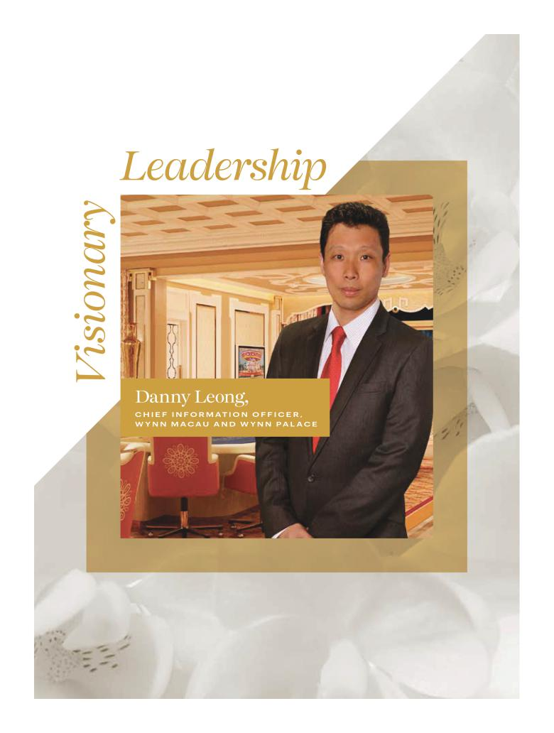

Table of Contents


Table of Contents
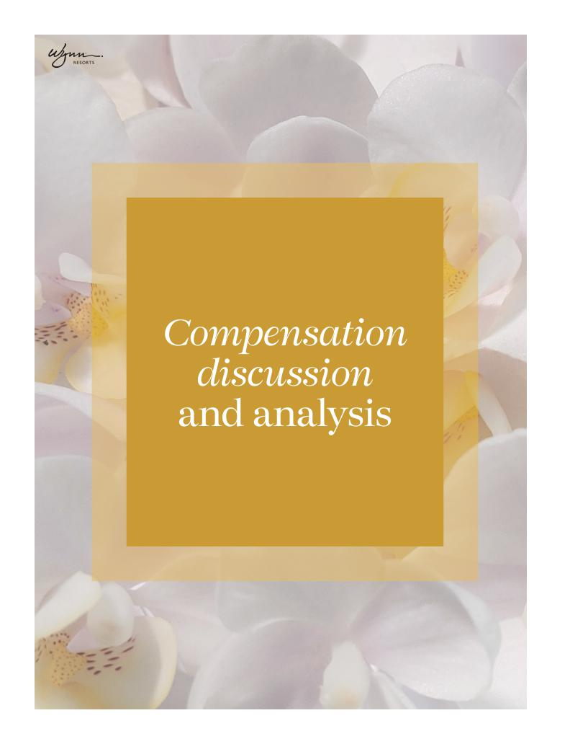

Table of Contents

We believe Wynn Resorts is the world’s preeminent designer, developer, and operator of integrated resorts. The Company’s business model integrates luxury hotel rooms, high-end retail, an array of dining and entertainment options, meeting space, and gaming, all supported by superior levels of customer service provided by our approximately 27,000 employees. Our operations in Las Vegas, Macau and Boston are designed to attract a wide range of domestic and international customers.

The Compensation Committee relies on best-in-class practices to incentivize and reward executives and all employees for actions that create long-term shareholder value. As a result, our executive compensation practices promote accountability for performance and align incentives with long-term shareholder value. In addition, the Compensation Committee has designed our executive compensation program to attract and retain the best-in-class talent across our business. In this compensation discussion and analysis, or CD&A, we describe our philosophy and approach to executive compensation.

FOR FISCAL 2021, OUR NEOs WERE:

NAME | TITLE
Matt Maddox | Chief Executive Officer
Craig S. Billings | Chief Financial Officer
Ellen F. Whittemore | Executive Vice President, General Counsel and Secretary

// 31 //

Table of Contents

Responding to shareholder feedback

Our Board recognizes the importance of shareholder engagement, both in terms of frequency and quality of dialogue, and has always been committed to engaging with shareholders on all topics including company performance and strategy, corporate governance, executive compensation, and environmental, social, and governance topics. We value shareholder feedback and consider it an essential part of Board discussions and decisions.

The Company sought shareholder feedback on key issues throughout 2021, including with respect to executive retention and compensation.

We listened to our shareholders and reaffirmed our philosophy with respect to executive retention and compensation, as described below. We are encouraged by the overwhelming support shareholders have expressed for our past Say-on-Pay proposals and believe the Company’s shareholder engagement efforts during 2021 will only strengthen that support.

SHAREHOLDER OUTREACH AND DESIGN

In 2021, the Company had calls and/or meetings with several shareholders of the Company’s Common Stock. Our Chair of the Board and Chair of the Compensation Committee participated in several meetings during the outreach. As a direct result of shareholder feedback, we now disclose our EEO-1 reports on our website at www.wynnresponsiblity.com.

SHAREHOLDER FEEDBACK AND BOARD RESPONSE

Feedback Themes | Specific Feedback | Actions Taken in Response | Impact of Action
Overall Executive Compensation | Strong preference for consistent | The Board remains committed to the | Continue to ensure that a significant
Philosophy and Practices | annual equity awards that encourage | pre-pandemic compensation structure | percentage of total direct pay is
 | long-term performance | which was focused on significant | at-risk and is aligned with Company
 |  | performance-based and at-risk cash | performance
 |  | and equity incentives
Pay-for-Performance Linkage | Broad support for at-risk | For 2021, CEO restricted stock | Strengthen executive focus on long-
 | compensation design | awards consisted of 50% | term actions, with long-term pay
 |  | performance-based and 50% time- | outcomes being in line with the
 |  | based equity | creation of sustainable shareholder
 |  |  | value
Employee Diversity Disclosure | Requested Wynn to publicly disclose | Our EEO-1 Report is publicly available | Enhance transparency of U.S.
 | employee diversity data where | on our website | workforce diversity
 | available

OVERALL EXECUTIVE COMPENSATION PHILOSOPHY AND PRACTICES: Shareholders we engaged with, in general expressed support for our compensation philosophy and the design of our executive compensation incentives. Overall, shareholders demonstrated support for our compensation structure with a 63% vote in favor of the 2021 Say on Pay proposal.

Board Response: The Board reiterates its commitment to our executive compensation philosophy that is focused on creating a strong alignment of the interests of executives with those of shareholders by designing incentives that are directly tied to actions which create sustainable long-term shareholder value. As a result, we believe that our executive compensation program is designed to attract, reward, and retain executive officers who create continual near- and long-term shareholder value by achieving the Company’s strategic goals.

2022 PROXY STATEMENT _{// 32 //}

Table of Contents

PAY-FOR- PERFORMANCE LINKAGE: Shareholders across the board expressed a strong preference for performance-based incentives including performance-based equity incentives.

Board Response: The Board is committed to ensuring a significant percentage of incentives being performance-based including at least a majority of equity incentives being performance-based. For 2021, 85% of CEO total direct pay was structured as cash and equity incentives, with 65% of equity being performance-based.

Overview of our executive compensation program

WHY YOU SHOULD VOTE FOR THE 2022 SAY-ON-PAY

RIGOROUS DESIGN, ACCOUNTABILITY AND ALIGNMENT
- Annual and long-term incentive compensation remains aligned with long-term shareholder value creation
- The Compensation Committee set rigorous metrics for annual incentives despite the uncertainty around a rebound from COVID-19, and maintained strong focus on performance-based long-term incentives

- To further enhance the alignment of executives’ interest with those of long-term shareholders, the annual incentive, based on pre-set goals, is paid out 50% in equity

- In line with our focus on performance-based pay, 86% of NEO compensation remained at-risk with over half of incentives being focused on long-term performance

- Our executive compensation framework reflects feedback received over the past several years from shareholders

CONTINUED RESPONSIVENESS TO EFFECTS OF COVID-19
- To preserve liquidity given the ongoing effects of COVID, all NEOs voluntarily agreed to reduce their base salaries by 20%, effective January 1, 2021 through March 31, 2021, without a corresponding stock grant

- The salary reductions in 2021 were in addition to the cash salary reductions ranging from 35% to 100% that the Company implemented for NEOs in 2020 at the outset of the pandemic

KEY LEADERSHIP TRANSITION
- With the announcement that CEO Matt Maddox will be leaving the Company as of January 31, 2022, the Board, after full consideration of alternatives, selected then-current CFO Craig S. Billings to serve as the Company’s CEO, effective February 1, 2022

- The Compensation Committee successfully negotiated new employment contracts in connection with the appointment of Craig S. Billings to CEO (effective February 1, 2022), hiring Julie Cameron-Doe as incoming CFO (effective in the second quarter of 2022), and the retention of Ellen F. Whittemore as Executive Vice President, General Counsel and Secretary (effective January 12, 2022)

As disclosed in the sections below, the executive compensation program is predicated on sound principles that clearly link compensation with performance. A significant percentage of CEO compensation is at-risk, with over half of pay being long term. This coupled with robust stock ownership guidelines ensure that the interests of executives and long-term shareholders are aligned.

We continue to make efforts to design and implement a world-class compensation structure that rewards executives for actions that create sustainable returns and shareholder value. Our annual incentives are focused on operational excellence and initiatives that align with our long-term strategy; paying 50% of earned annual incentives in equity sharpens the alignment of interests of executives with long-term shareholders. Our annual long-term incentives—including performance-based equity—reward executives in tandem with the creation of long-term value. The annual grants coupled with robust stock ownership guidelines ensure that executives are invested in ensuring the long-term viability of shareholder value.

We frequently engage with our shareholders to ensure that their feedback is reflected in our corporate governance approach, particularly with respect to executive compensation. Based in part on this feedback, the Compensation Committee continued to evaluate and implement meaningful changes in our executive compensation program, which, we believe, contributed to strong support from shareholders approving our Say-on-Pay proposal at the 2021 Annual Meeting.

// 33 //

Table of Contents

How we approach executive compensation

Our executive compensation philosophy is to align the interests of executives with those of shareholders by designing incentives that are directly tied to actions which create sustainable long-term shareholder value.

We, the Compensation Committee, believe that our ability to oversee the delivery of operational excellence and sustainable long-term returns to shareholders is inexorably linked to attracting and retaining a high-performing management team.

Hence, the executive compensation program must be designed to attract, reward, and retain executive officers who create continual near-and long-term shareholder value by achieving the Company’s strategic goals, as established by the Compensation Committee. We

also believe that stability at the executive level is key to the strength of the Company, particularly given the relatively small pool of executives with gaming experience for whom we compete.

To achieve this, we rely on the following principles:

PAY-FOR-SUSTAINABLE PERFORMANCE: The majority of our executives’ total compensation is tied to achieving annual and long-term goals that enhance the value of our reputation and brand, sustain the performance and attractiveness of our resorts and drive long-term shareholder value. The Compensation Committee retains discretion to reduce amounts earned and payable when doing so will further these goals. Further, 50% of annual incentive is paid in equity (rather than all cash), and equity is subject to our robust holding requirements.

SHAREHOLDER ALIGNMENT: Our long-term equity incentives align executives’ interests with those of shareholders and other stakeholders. Our executive compensation focuses on key metrics that are critical drivers for realizing our strategic objectives and achieving long-term results. By focusing on regular equity grants that vest over three years and on performance-based awards, we believe that the alignment of interest is strengthened, especially when coupled with robust stock holding requirements for executives (6x base salary for our CEO) and 3x base salary for our other NEOs.

FOCUS ON COMPENSATION TOTALS AND PARITY: We evaluate the total amounts of executives’ compensation for parity purposes and assess them relative to the pay practices of major gaming companies and other competitors for talent. The Compensation Committee reaffirmed its commitment to right-sized executive compensation by benchmarking total compensation at the median of our peer group and making adjustments for specific skills and experience.

SIMPLICITY AND CLARITY: We value pay structures that are simple and clear. We believe pay simplicity promotes transparency, avoids incentivizing focus on pay goals at the expense of ongoing excellence and performance, and promotes teamwork.

ATTRACT AND RETAIN TOP TALENT: Our business spans continents, can be subject to meaningful volatility, requires tight coordination with regulators, depends on knowledge of numerous types of complex operations, requires diligent investment over many years and across business cycles, and is highly dependent on a reputation for excellence, so finding and retaining top talent is a critical element of our compensation.

2022 PROXY STATEMENT _{// 34 //}

Table of Contents

Executive compensation components

ELEMENT


Base salary

Annual incentives


Long-term incentives: Performance-based restricted stock

Long-term incentives: Time-based restricted stock

% OF TOTAL | AT-
ANNUAL | AT- | FEATURES | 2021 RESULTS
ANNUAL | RISK? | FEATURES | 2021 RESULTS
COMPENSATION | RISK?
14% | No | Attract and retain top employees and recognize | In December 2020, the NEOs voluntarily agreed to
 |  | sustained performance, job scope and experience | reduce their base salaries by 20%, respectively,
 |  |  | January 1, 2021, through March 31, 2021
 |  |  | Otherwise, base salary remained unchanged in 2021
33% | Yes | Utilize multiple metrics with pre-set goals | Payout based on pre-set robust Financial and
 |  | Incentivize executives, enforce accountability and | Operational objectives as discussed under “2021
 |  | Incentivize executives, enforce accountability and | Compensation design & decisions”
 |  | motivate and reward achievement of annual goals | Compensation design & decisions”
 |  | 50% of annual incentive awards paid in stock and
 |  | subject to NEO holding requirements, further aligning
 |  | executive and long-term shareholder interests
17% | Yes | Performance-based stock vests solely based on | Performance-based restricted stock linked to the
 |  | company performance on preset goals over a three- | achievement of “fair share” metrics
 |  | year performance period, linking the creation of
 |  | shareholder value to incentives earned
36% | Yes | Ensure focus on long-term value creation, align | Retention, alignment of interests with those of long-
 |  | executive and long-term shareholder interests, and | term shareholders and includes a one-time grant for
 |  | promote retention | Craig Billings in connection with the execution of an
 |  |  | employment contract amendment in relation to his
 |  |  | promotion to Chief Executive Officer effective
 |  |  | February 1, 2022

HOW OUR EXECUTIVE COMPENSATION PHILOSOPHY DRIVES CEO PAY DESIGN


 |  | PAY FOR |  | FOCUS ON |  | ATTRACT AND
 |  | PAY FOR | SHAREHOLDER | COMPENSATION | SIMPLICITY | ATTRACT AND
 |  | SUSTAINABLE | SHAREHOLDER | COMPENSATION | SIMPLICITY | RETAIN TOP
 |  | SUSTAINABLE | ALIGNMENT | TOTALS AND | AND CLARITY | RETAIN TOP
 |  | PERFORMANCE | ALIGNMENT | TOTALS AND | AND CLARITY | TALENT
 |  | PERFORMANCE |  | PARITY |  | TALENT
❑ | Benchmarking CEO at Median of Peer |  | ● | ● |  | ●
 | Group |  | ● | ● |  | ●
❑ | 86% of total direct NEO compensation is | ● | ● |  | ●
 | at-risk (1) | ● | ● |  | ●
❑ | Annual incentives are 100% performance | ● | ● | ● | ● | ●
 | based
❑ | Performance-based stock units comprise | ● | ● | ● | ● | ●
 | majority of long-term incentives (2)


- Annual incentives subject to negative
 | Board discretion | ● | ● | ●
❑ | Stock Ownership Guidelines for all NEOs |  | ● | ● | ●

- Based on 2021 Total Direct Compensation for NEOs.

- Excluding equity grant to Mr. Billings in connection with his promotion to CEO.

// 35 //

Table of Contents

How the company has performed

Our year-to-year performance can be significantly impacted by market factors, geopolitical events and investor sentiment. Since our initial public offering in October 2002, the Company has averaged a 14% annual Total Shareholder Return (“TSR”), (including reinvestment of dividends), which is above the TSR of both the S&P 500 (approximately 11% average annual TSR) and the S&P Consumer Discretionary Index (approximately 13% average annual TSR) over the same time period. We have also delivered an average annual TSR nearly four times our closest industry peers.(1) We believe these results are driven by our focused, long-term investment in our properties and by our relentless dedication to delivering the industry’s best customer experience.
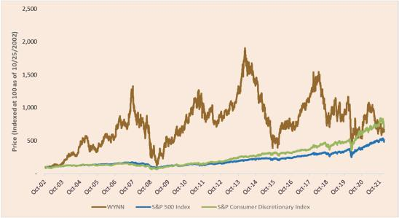

- Industry peers reflect Las Vegas Sands and MGM Resorts. Las Vegas Sands’ TSR is measured from the market close on the day of their IPO on 12/15/2004 (average annual TSR of approximately 1%). MGM Resorts’ TSR is measured from the close on the date of Wynn Resorts’ IPO on 10/25/2002 (average annual TSR of approximately 6%).

Our key accomplishments in 2021 include:

- ACHIEVED RECORD-SETTING RESULTS IN LAS VEGAS. Our Las Vegas Operations achieved its highest Adjusted Property EBITDA in the history of the resort at $530.9 million (previous record was $522.4 million of Adjusted Property EBITDA for 2017), despite continued COVID-19 health and safety restrictions during 2021. In addition, we continued to advance our strategy of delighting our guests with world-class amenities, which included opening two new restaurants and beginning a full remodel of our 2,674 hotel rooms in the Wynn Tower (expected completion in mid-2022) and Le Rêve Theater to a new and exciting performance concept (expected completion in Fall 2022).

- ACCELERATED GROWTH OF BOSTON OPERATIONS. Encore Boston Harbor achieved a record $210.1 million of Adjusted Property EBITDA during 2021 despite ongoing pandemic related challenges. We continued to execute on our operating strategy during 2021, opening new fast casual food and beverage offerings and a new sports bar with the infrastructure to function as a retail sports book positioning us to be ready for a ‘Day 1’ launch in the event enabling legislation is approved by the Commonwealth of Massachusetts.

- GROWING OUR MASS GGR IN MACAU. As visitation continues to fluctuate due to COVID-19-related travel restrictions, our team has remained focused on growing our mass table and slot gaming business through a combination of property level changes and marketing system upgrades, positioning the Company well to serve this valuable customer segment. Overall, these enhancements contributed to a 66% year over year increase in our mass table and slot gross gaming revenue in 2021.

2022 PROXY STATEMENT _{// 36 //}

Table of Contents

- MAINTAINED HEALTHY LIQUIDITY AND FINANCIAL FLEXIBILITY. Since the beginning of the COVID-19 pandemic, we have taken proactive steps to fortify our liquidity position and balance sheet. Those efforts continued into 2021, as the Company successfully raised approximately $860 million of equity to repay its U.S. revolving credit facility and assure funding for its growth pipeline and refinanced its Wynn Macau credit facility, extending the maturity date to 2025.

- CONTINUED RECOGNITION AS THE WORLD’S PREEMINENT LUXURY INTEGRATED RESORT COMPANY. With a combined 22 Forbes Travel Guide Five-Star Awards in 2021, Wynn Resorts remains the most decorated independent hotel company in the world. Our Macau operations were awarded 15 FTG Five-Star Awards, with Wynn Macau the only resort in the world to receive eight FTG Five-Star Awards and Wynn Palace receiving seven. In the US, Wynn Las Vegas and Encore Las Vegas hold the most FTG Five-Star awards of any resorts in North America, collectively receiving seven Five-Star Awards. In addition, Wynn Resorts was once again honored to be included on FORTUNE Magazine’s 2022 World’s Most Admired Companies list in the hotel, casino, and resort category and ranked first overall in the category of Quality of Products/ Services among all international hotel companies.

- CONTINUED LEADERSHIP IN OUR RESPONSE TO THE COVID-19 PANDEMIC. We remained focused on protecting our customers, our partners, and our employees in response to the COVID-19 pandemic, while still providing the world-class service and unique experiences guests have come to expect from Wynn.

How we designed incentives in 2021

2021 HIGHLIGHTS:

In 2021, the Compensation Committee:

- Set rigorous and meaningful financial metrics for annual incentives for 2021, despite significant uncertainty stemming from the COVID-19 pandemic at the point at which such targets were established.

- Continued to pay 50% of annual incentive executive compensation in equity.

- Maintained a policy that at least 50% of long-term incentive grants would be performance-based, including performance-based stock awards that vest upon achievement of pre-established financial performance goals that are based on the Company’s ability to achieve a premium revenue “fair share” relative to its peers (see discussion of this metric below), on a one-, two- and three-year basis.

- Reaffirmed its commitment to compensate executives around the median with regard to total compensation and conducted an overall analysis of all NEO total compensation to confirm compliance.

ROLE OF THE COMPENSATION COMMITTEE AND MANAGEMENT IN SETTING COMPENSATION: The Compensation Committee sets all elements of compensation for our NEOs based upon consideration of an NEO’s contributions to the operating and strategic performance of the Company. The Compensation Committee considers the recommendations of the CEO in establishing compensation for all other NEOs. In addition, the CEO performs annual reviews of our senior executive officers and makes recommendations to the Compensation Committee. The Compensation Committee reviews the recommendations and makes final decisions regarding compensation for our senior executive officers.

// 37 //

Table of Contents

COMPENSATION MIX

We take a multi-year investment approach to our business that focuses on rewarding strong near-term performance and the creation of long-term shareholder value. Because product quality and service excellence are at the core of our strategy, we use annually focused, operations-based pay to highlight the critical importance of performing well each year for each customer. We supplement that with a set of long-term incentives and holding requirements to support the sustainability of our reputation and our ongoing returns. The charts below highlight the focus on equity and at-risk mix of the total direct compensation for our current NEOs based on 2021 compensation outcomes(1):
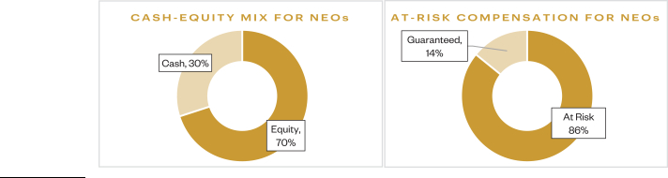

- Based on 2021 Total Direct Compensation for NEOs

2021 Compensation design & decisions

Base Salary: Negotiated employment agreements establish our NEOs’ initial base salaries. We review and adjust their base salaries periodically to stay competitive, reflect improvements in performance, capabilities, and experience, and reward expansions of responsibility or other extraordinary circumstances.

In December 2020, each of the NEOs voluntarily elected to reduce their base salary by 20% for the period of January 1, 2021 through March 31, 2021, after which each NEO’s base salary would be reinstated to the amount of their initial base salaries. The NEOs did not receive an equity grant in connection with the reduction in their base salaries.

The table below presents the base salary for each of our NEOs in 2021, which represents a blend of the reduced base salary each NEO received from January 1, 2021, through March 31, 2021, and the reinstated initial base salary each NEO received for the remainder of the year. The amount of each NEO’s salary reduction is described in the “Voluntary Reduction” column.

EXECUTIVE | 2021 BASE |  | 2020 BASE |  | VOLUNTARY
EXECUTIVE |  | SALARY |  | SALARY | REDUCTION
Matt Maddox | $ | 1,900,000 | $ | 2,000,000 | $ | 100,000
Craig S. Billings | $ | 1,140,000 | $ | 1,200,000 | $ | 60,000
Ellen F. Whittemore | $ | 665,000 | $ | 700,000 | $ | 35,000

Annual Incentives: For the 2021 annual incentive awards granted under our Omnibus Plan, the Compensation Committee selected the following four performance goals:

Goal 1 – Encore Boston Harbor, 2021 Adjusted Property EBITDA (weighted 25%): This is used to measure the operating performance of our Boston property compared to that of our competitors. Adjusted Property EBITDA is an important measure of a property’s performance within its respective market, a key driver of return on equity and essential element to the valuation of our Company and our stock price.

The Committee, based on the ongoing effect of the COVID-19 pandemic on the operating conditions in Boston, set a threshold performance level of at least $130 million, a target level of $140 million, and maximum performance level of $155 million.

No incentive payout would be earned in respect of this metric if the Company did not achieve the threshold performance level.

2022 PROXY STATEMENT _{// 38 //}

Table of Contents

Goal 2 – Wynn Las Vegas, Market Share of Gross Gaming Revenues (weighted 25%): Although Wynn Las Vegas remained open throughout 2021, many of its non-gaming offerings, including entertainment and group events, remained impacted by the COVID-19 pandemic. As such, the Compensation Committee established market share goals with respect to gross gaming revenues, a metric that largely reflects the state of the business under continued challenging and unusual conditions.

The Committee set a threshold performance level of 10% market share, a target level of 12% market share, and a maximum performance level of 14% market share.

No incentive payout would be earned in respect of this metric if the Company did not achieve the threshold performance level.

Goal 3 – Macau Operations, Market Share of Gross Gaming Revenues on Mass Table Games and Slot Machines (weighted 25%): Despite the reopening of the Company’s properties in Macau, visitation volumes remained suppressed due to travel restrictions related to the COVID-19 pandemic. In line with the performance goals set for Wynn Las Vegas above, the Compensation Committee established market share goals with respect to gross gaming revenues on mass table games and slot machines for its Macau operations.

The Committee set a threshold performance level of 10.5% market share, a target level of 11.5% market share, and a maximum performance level of 13% market share.

No incentive payout would be earned in respect of this metric if the Company did not achieve the threshold performance level.

Goal 4 – Wynn Interactive, Successful Scaling and Capitalization (weighted 25%): Having established its online gaming division in 2020, the Committee sought to incentivize management to grow that business during 2021. As such, this performance goal supports the Company’s strategic deployment of capital expenditures and return on capital, as well as increased brand awareness.

These awards were subject to (i) the limitations set forth in the Omnibus Plan, including the cash and stock grant limits and requirement of continued employment through the end of the calendar year performance period, and (ii) the Compensation Committee’s right, in its discretion, to reduce actual bonus amounts paid, taking into account other performance considerations, including corporate, property level and individual performance, as well as general macroeconomic conditions.

2021 Annual incentive payout:

In 2021, Actual Adjusted Property EBITDA for Encore Boston Harbor was $55.1 million above the maximum performance level. Wynn Las Vegas achieved 12.1% market share in gross gaming revenues. Our Macau Operations achieved 15.6% market share in gross gaming revenues on mass table games and slot machines, above the maximum threshold. And, while the Company materially expanded the business of Wynn Interactive, the division did not achieve certain capitalization milestones and, as such, the Committee used negative discretion and did not pay an award based on this goal.

Based on the 2021 results, in January 2022, the Compensation Committee determined the actual award payouts as set forth below, with the award being split equally in cash and stock:

 |  |  |  |  |  |  |  | ACTUAL AWARD(5)
NAMED EXECUTIVE OFFICER |  | THRESHOLD (1) |  | TARGET (2) |  | MAXIMUM (3) |  | CASH |  | EQUITY (4)
Matt Maddox |  | 200% |  | 250% |  | 300% | $ | 2,500,000 | $ | 2,500,000
Craig S. Billings |  | 160% |  | 200% |  | 240% | $ | 1,200,000 | $ | 1,200,000
Ellen F. Whittemore |  | 160% |  | 200% |  | 240% | $ | 700,000 | $ | 700,000

(1) Percentages of the base salaries in the Threshold column reflect potential awards for achievement of (i) 2021 Encore Boston Harbor Adjusted Property EBITDA greater than or equal to
$130 million but less than $140 million, (ii) Macau operations mass table and slots GGR market share above or equal to 10.5% but below 11.5%, (iii) Wynn Las Vegas GGR market share above or equal to 10.0% but below 12.0% and (iv) Successfully capitalize Wynn Interactive. No awards would have been payable if the (i) 2021 Encore Boston Harbor

// 39 //

Table of Contents

Adjusted Property EBITDA was below $130 million, (ii) Macau operations mass table and slots GGR market share was below 10.5%, (iii) Wynn Las Vegas GGR market share was below 10.0% and
- Wynn Interactive is not successfully capitalized. Adjusted Property EBITDA is net income/loss before interest, income taxes, depreciation and amortization, pre-opening expenses, property charges and other, management and license fees, corporate expenses and other (including intercompany golf course and water rights leases), stock-based compensation, loss on extinguishment of debt, change in derivatives value, and other non-operating income and expenses. See our Annual Report on Form 10-K for the year ended December 31, 2021 (Item 8, Note 20—“Segment Information” to our Consolidated Financial Statements) for the definition of “Adjusted Property EBITDA,” a reconciliation of Adjusted Property EBITDA to net income/loss attributable to Wynn Resorts, and other information regarding this non-GAAP financial measure.

- Percentages of the base salaries in the Target column reflect potential awards for achievement of (i) 2021 Encore Boston Harbor Adjusted Property EBITDA greater than or equal to $140 million but less than $155 million, (ii) Macau operations mass table and slots GGR market share above or equal to 11.5% but below 13.0%, (iii) Wynn Las Vegas GGR market share above or equal to 12.0% but below 14.0% and (iv) Successfully capitalize Wynn Interactive.

- Percentages of the base salaries in the Maximum column reflect potential awards for achievement of (i) 2021 Encore Boston Harbor Adjusted Property EBITDA greater than or equal to
$155 million, (ii) Macau operations mass table and slots GGR market share above or equal to 13.0%, (iii) Wynn Las Vegas GGR market share above or equal to 14.0% and (iv) Successfully capitalize Wynn Interactive.

- The amounts set forth in this column reflect the aggregate grant date fair value of stock awards granted. These stock awards are fully vested.

- For 2021, the actual award paid to each NEO totaled the target percentage and was calculated based on achieving maximum performance with respect to goals one and three, achieving target performance with respect to goal two, and not achieving goal four.

LONG-TERM INCENTIVES: In the past, the Company made periodic—not annual—equity grants to executives, including our NEOs. Those periodic grants were typically made with long-term vesting dates of up to ten years and such awards were not subject to performance conditions.

Beginning in 2018, the Compensation Committee moved from periodic grants to annual grants with three-year cliff vesting and implemented a policy of subjecting a portion (in 2021 no less than 50%) of grants made to NEOs to performance conditions in order to ensure a superior focus on operational excellence as well as better align executives’ interests with those of long-term shareholders. For 2021, the Compensation Committee set the vesting schedule on annual restricted stock grants to equal annual installment vesting on a pro rata basis over three-years to allow executives to realize incentives over time.

In 2021, management proposed, and the Compensation Committee approved, the use of “fair share” metrics for performance conditions over one-, two-, and three-year performance periods that take into consideration uncertainty from continued COVID-19 restrictions, most notably in Macau. These fair share metrics were generally calculated as follows:

- In Las Vegas, the Company’s share of total revenue relative to selected peers divided by the Company’s share of hotel rooms among such peers; and

- In Macau, the Company’s share of gaming revenue relative to selected peers divided by the Company’s share of gaming tables among such peers.

The decision to select these metrics was based on careful consideration of the following factors:

- The Company’s exposure to Macau provides sizeable opportunities over the mid and long-term, but can create meaningful volatility over short periods, significantly skewing short-term TSR and creating opportunities for management to benefit from outsized market growth, irrespective of their performance; and

- The Company’s strategy is to attract and retain premium consumers in each market in which the Company operates. We believe the results of this strategy provide outsized operating results, relative to peers, and create meaningful shareholder returns over the long-term. Consistently achieving such premium fair share requires diligent and consistent investment in facilities and people across the business cycle.

- The Company’s near-term operating results may be subject to significant volatility stemming from the COVID-19 Pandemic. This volatility, when coupled with the Company’s stated position of retaining employees despite temporary fluctuations in operating results, may cause material fluctuations in the Company’s EBITDA results, relative to certain peers who do not maintain comparable employee retention policies, rendering the Company’s historical measure of “fair share” of EBITDA incomparable for the performance periods in question.

Equity Grants:

On January 11, 2021, Mr. Maddox received a grant of 55,542 shares of restricted stock. Except as otherwise described in the section titled “Potential Payments Upon Termination or Change in Control”, such restricted stock award is subject to both
2022 PROXY STATEMENT _{// 40 //}

Table of Contents

time- and performance-based vesting conditions, whereby 50% of the award vests ratably over three years on each of the dates of February 28, 2022, 2023 and 2024, based on achievement of pre-established financial performance goals, and the remaining 50% of the award time vests ratably over three years on each anniversary of the grant date, subject to Mr. Maddox’s continued employment through such vesting date.

On January 11, 2021, Mr. Billings received a grant of 20,366 shares of restricted stock. Except as otherwise described in the section titled “Potential Payments Upon Termination or Change in Control”, such restricted stock award is subject to both time- and performance-based vesting conditions, whereby 50% of the award vests ratably over three years on each of the dates of February 28, 2022, 2023 and 2024 based on achievement of pre-established financial performance goals, and the remaining 50% of the award vests ratably over three years on each anniversary of the grant date, subject to Mr. Billings’ continued employment through such date.

On November 9, 2021, the Company announced that Mr. Billings had been appointed to serve as the Company’s CEO and member of the Board, effective February 1, 2022. In connection with the appointment, Mr. Billings and the Company entered into a new employment contract, under which Mr. Billings received a grant of 52,715 shares of restricted stock upon execution of the employment contract. Except as otherwise described in the section titled “Potential Payments Upon Termination or Change in Control”, such restricted stock award is subject to time-based vesting conditions, whereby the award vests ratably over three years on each anniversary of the grant date, subject to Mr. Billings’ continued employment through such date.

On January 12, 2022, Mr. Billings received a grant of 78,672 shares of restricted stock. Except as otherwise described in the section titled “Potential Payments Upon Termination or Change in Control”, such restricted stock award is subject to both time- and performance-based vesting conditions, whereby 33.3% of the award vests ratably over three years on each of the dates of February 28, 2023, 2024 and 2025, based on achievement of pre-established financial performance goals, and the remaining 67.7% of the award time vests ratably over three years on each anniversary of the grant date, subject to Mr. Billings’ continued employment through such vesting date.

On January 11, 2021, Ms. Whittemore received a grant of 9,952 shares of restricted stock. Except as otherwise described in the section titled “Potential Payments Upon Termination or Change in Control”, Ms. Whittemore’s award is subject to both time-and performance-based vesting conditions, whereby 50% of the award vests ratably over three years on each of the dates of February 28, 2022, 2023 and 2024 based on achievement of pre-established financial performance goals, and the remaining 50% of the award vests ratably over three years on each anniversary of the grant date, subject to Ms. Whittemore’s continued employment through such vesting date.

On January 12, 2022, Ms. Whittemore received a grant of 18,357 shares of restricted stock. Except as otherwise described in the section titled “Potential Payments Upon Termination or Change in Control”, such restricted stock award is subject to both time- and performance-based vesting conditions, whereby 33.3% of the award vests ratably over three years on each of the dates of February 28, 2023, 2024 and 2025, based on achievement of pre-established financial performance goals, and the remaining 67.7% of the award time vests ratably over three years on each anniversary of the grant date, subject to Ms. Whittemore’s continued employment through such vesting date.

On January 14, 2022, the Company announced that Ms. Whittemore and the Company had agreed to extend her employment contract through January 31, 2025.

EXECUTIVE BENEFITS: We provide our NEOs with benefits that we believe are reasonable, competitive and consistent with our overall executive compensation program. Our primary executive benefits are certain health insurance coverage, life insurance premiums, discounts and complimentary privileges with respect to the Company’s resorts, which are described in the footnotes to the “Summary Compensation Table.” For 2021, we paid nonresident state income taxes imposed on our executives who were required by us to travel on Company business and perform services in states other than their states of employment. This primarily arose as a result of travel to and work in Massachusetts in connection with our Encore Boston Harbor resort. Our reimbursement covers the incremental cost of the nonresident taxes and puts the executives in the same economic position as though they had worked in their normal places of business. The Company does not gross-up or pay any state income taxes that the employees incur on account of work in their normal work locations. In addition, certain executives, including NEOs, have access to the Company’s aircraft pursuant to time-sharing agreements described in “Certain relationships and transactions—Aircraft Arrangements.”

// 41 //

Table of Contents

PEER GROUP BENCHMARKING: The Compensation Committee believes that it is appropriate to offer competitive total compensation packages to senior executive officers in order to attract and retain top executive talent. The compensation peer group allows the Compensation Committee to monitor the compensation practices of our primary competitors for executive talent. The Compensation Committee targets the 50th percentile for the Company’s senior executive officers’ total compensation to ensure that executives are appropriately compensated as we operate in a highly competitive industry.

In 2021, as part of our regular review of our compensation programs, as well as in connection with new employment contracts for our NEOs, the Compensation Committee considered peer group data from gaming and other related industries that the Compensation Committee believes reflect the competitive market for executive talent similar to that required by the Company. Our peer group is updated for 2021.

Wynn Resorts 2021 executive compensation peer group

GAMING & RESORTS | TRAVEL, HOSPITALITY & RESORTS | LIFESTYLE PRODUCTS
Caesars Entertainment Corporation | Hilton Worldwide Holdings Inc. | Capri Holdings Limited
Las Vegas Sands Corp. | Hyatt Hotels Corporation | PVH Corp.
MGM Resorts International | Marriott International, Inc. | Ralph Lauren Corporation
Penn National Gaming, Inc. | Norwegian Cruise Line Holdings Ltd | Tapestry, Inc.
 | Royal Caribbean Cruises Ltd | The Estée Lauder Companies Inc.
 | Wyndham Hotels & Resorts, Inc. | V.F. Corporation

The 16 companies in the peer group generally had revenue, market capitalization and total enterprise value (as of December 31, 2021) in a relevant range around those of the Company as set forth below.

 | WYNN RESORTS |  | PEER GROUP
Revenue | $3.4 billion | Range: | $0.2 billion–$17.7 billion
 |  | Median: | $5.9 billion
Market Capitalization | $9.8 billion | Range: | $7.5 billion–$133.3 billion
 |  | Median: | $15.4 billion
Enterprise Value | $18.7 billion | Range: | $9.2 billion–$137.5billion
 |  | Median: | $26.7 billion

Data source: Bloomberg.

Non-disclosure of certain metrics and targets

The Company believes in transparency and strives to disclose as much information to shareholders as possible except in situations where we believe that providing full, or even limited, disclosure would be detrimental to the interests of shareholders. We believe certain disclosure could provide our competitors with insight regarding confidential business strategies without meaningfully adding to shareholders’ understanding of the metric.

Other aspects of our executive compensation

ROLE OF THE COMPENSATION CONSULTANT: The Compensation Committee has the authority to retain compensation consulting firms exclusively to assist it in the evaluation of senior executive officer and employee compensation and benefit programs. In 2021, the Compensation Committee retained Radford a nationally recognized independent compensation consulting firm, to assist in performing its duties. Radford does not provide services to the Company other than the advice on director and executive compensation that it may provide the Compensation Committee when requested. In 2021, Radford, at the direction of the Compensation Committee, completed a peer group review and competitive compensation analysis, in connection with the Compensation Committee’s review of compensation levels of our NEOs. The Compensation Committee retains sole responsibility for engaging its advisors.

2022 PROXY STATEMENT _{// 42 //}

Table of Contents

INDEPENDENCE OF THE COMPENSATION CONSULTANT: The Compensation Committee has determined that Radford is independent, and the services provided by Radford currently do not and during 2021 did not raise any conflict of interests. In reaching these conclusions, the Compensation Committee considered the factors set forth in Rule 10C-1 of the Exchange Act and applicable listing standards.

EMPLOYMENT CONTRACTS: We have a longstanding practice of entering into multi-year employment contracts with our senior executive officers and senior management. We believe that employment contracts provide greater assurance of continuity and retention of critical creative and operating talent in a highly competitive industry. Employment contracts for our NEOs are approved by the Compensation Committee in consultation with the Compensation Committee’s independent compensation advisors, as needed. The employment contracts for the NEOs currently employed by the Company specify their base salary and provide that if the executive’s employment (i) terminates without cause at the Company’s election, (ii) is terminated by the executive following the Company’s material breach of the agreement or (iii) is terminated by the executive for good reason after a change in control, the executive will receive a separation payment as described in more detail under the heading “Potential Payments Upon Termination or Change in Control.” The employment contracts and the terms of equity awards also provide that vesting of some or all of an executive’s equity awards will accelerate upon certain events. Current employment contracts do not provide for any excise tax gross ups. We believe that providing for these benefits in these situations enhances the value of the business by preserving the continuity of management during potential change in control situations and by focusing our senior executives on our long-term priorities. Additional information regarding payments under these provisions is provided under the heading “Potential Payments Upon Termination or Change in Control.”

Compensation committee report

We have reviewed and discussed the Compensation Discussion and Analysis required by Item 402(b) of Regulation S-K with the Company’s management. Based on such review and discussion, we have recommended to the Board that the Compensation Discussion and Analysis be included in this Proxy Statement.

Compensation Committee

Betsy S. Atkins, Chair
Richard J. Byrne
Margaret J. Myers

Clark T. Randt, Jr.

// 43 //

Table of Contents
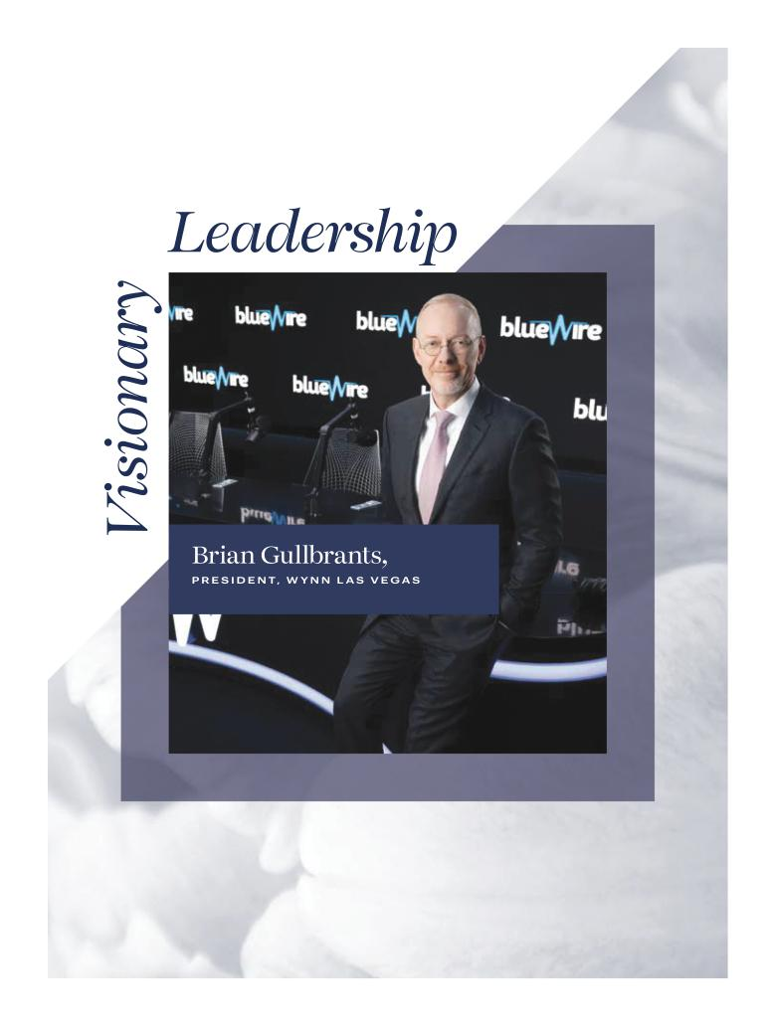

Table of Contents
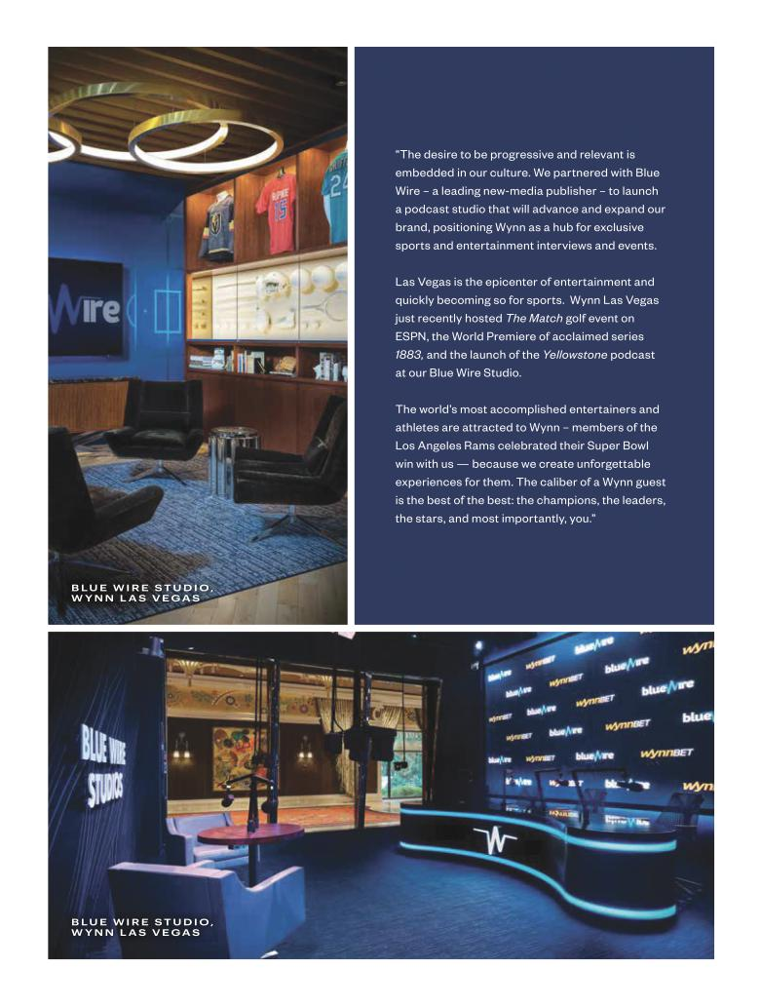

Table of Contents
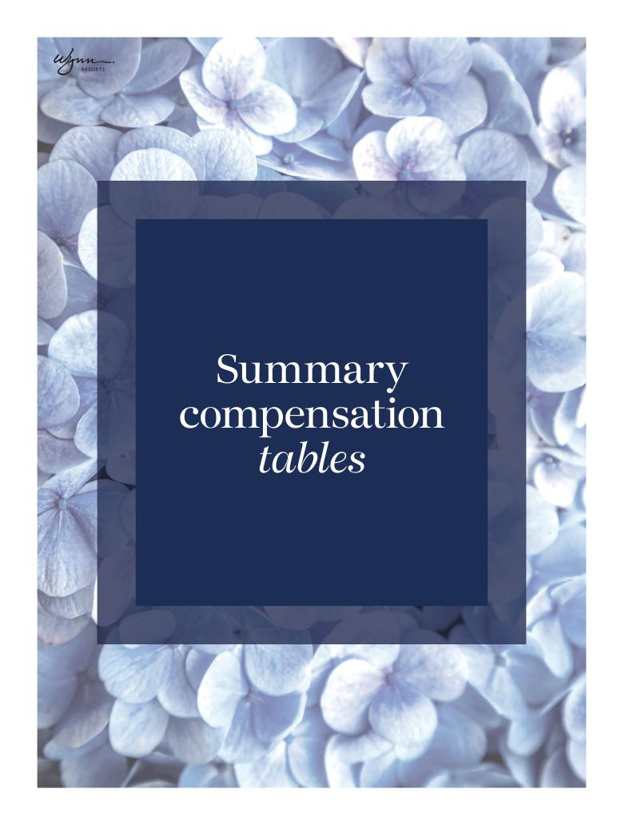

Table of Contents

The table below summarizes the total compensation awarded to, earned by, or paid to, each of our NEOs for the fiscal years ended December 31, 2021, 2020 and 2019.

The table below is presented in a manner consistent with Regulation S-K. As discussed in the Compensation Discussion and Analysis section of this proxy, in response to the effects of the COVID-19 pandemic, each of the NEOs voluntarily elected to reduce their base salary by 20% for the period of January 1, 2021 through March 31, 2021, after which each NEO’s base salary was reinstated to the amount of their contractual base salaries. The NEOs did not receive an equity grant in connection with the reduction of their base salaries.


 |  |  |  |  | NON-EQUITY
NAME AND |  | SALARY ($) | STOCK | OPTION | INCENTIVE | ALL OTHER
NAME AND | YEAR | SALARY ($) | AWARDS ($) | AWARDS ($) | PLAN | COMPENSATION | TOTAL ($)
PRINCIPAL POSITION | YEAR | (1)
PRINCIPAL POSITION |  | (1) | (2)(3) | (3)(4) | COMPENSATION | ($) (6)
 |  |  |  |  | ($) (5)

MATT MADDOX | 2021 |  | $1,900,000 | $8,500,202 | $- | $2,500,000 | $28,545 | $12,928,747
MATT MADDOX |  | 2020 | $2,000,000 | $20,283,231 | $699,218 | $1,100,000 | $489,531 | $24,571,980
Former Director and
Chief Executive Officer |  | 2019 | $2,000,000 | $8,000,209 | $- | $2,000,000 | $1,851,089 | $13,851,298
CRAIG BILLINGS | 2021 |  | $1,140,000 | $8,361,675 | $- | $1,200,000 | $11,671 | $10,713,346
Director and |  | 2020 | $1,200,000 | $3,678,581 | $1,673,207 | $528,000 | $70,997 | $7,150,785
Chief Executive Officer;
Former Chief Financial Officer |  | 2019 | $1,053,750 | $2,560,147 | $- | $960,000 | $217,382 | $4,791,279
ELLEN F. WHITTEMORE | 2021 |  | $665,000 | $1,775,115 | $- | $700,000 | $19,318 | $3,159,433
ELLEN F. WHITTEMORE |  | 2020 | $700,000 | $1,985,303 | $249,824 | $308,000 | $27,484 | $3,270,611
Executive Vice President,
General Counsel and Secretary |  | 2019 | $655,000 | $1,310,111 | $- | $560,000 | $67,184 | $2,592,295

- The amounts set forth in this column reflects each Named Executive Officer’s annual base salary approved by the Compensation Committee. On January 1, 2021, each NEO entered into amendments to their respective employment agreement to temporarily reduce the annual base salary compensation by 20% for the first three months of 2021. As result, the 2021 annual base salary was reduced to $1,900,000, $1,140,000 and $665,000 for Mr. Maddox, Mr. Billings and Ms. Whittemore, respectively.

- Stock awards granted as a component of the 2021, 2020 and 2019 annual incentive awards are reported in this column as 2021, 2020 and 2019 compensation, respectively, to reflect the applicable service period for such awards; however, stock grants for 2021, 2020 and 2019 were approved by the Compensation Committee in January of the following calendar year. See annual incentive award payouts as described in “Compensation Discussion and Analysis-How We Designed Incentives for 2021 Annual incentive payout” for a description of the 2021 annual incentive awards. The amounts reported in 2021 reflect a portion from restricted stock grants which are not related to the annual incentive awards and were reported in the year of grant. Except as otherwise noted, certain grants in this column vest based on specified performance criteria and are reflected in this column at 100% of the aggregate grant date fair value.

- The amounts set forth in this column reflect the aggregate grant date fair value of stock awards computed in accordance with FASB ASC Topic 718. Performance-based restricted share awards in this column are reflected based on the probable outcome of such conditions as of the applicable grant date in accordance with accounting standards for stock-based compensation. Except as otherwise described in the footnotes to this table, all performance-based restricted share awards were deemed probable of vesting on the grant date. See our Annual Report on Form 10-K for the year ended December 31, 2021, Item 8, Note 12 -“Stock-Based Compensation” to our Consolidated Financial Statements for assumptions used in computing fair value.

- The amounts set forth in this column represent stock options of a subsidiary, granted to Messrs. Maddox and Billings and Ms. Whittemore in 2020.

- As described above under “Compensation Discussion and Analysis-How We Designed Incentives for 2021 Annual incentive payout,” in January 2022, the Compensation Committee exercised its discretion to pay 50% of the actual earned annual incentive for all NEO’s in stock.

- The following amounts for 2021 are included in “All Other Compensation” for Mr. Maddox:
- insurance premiums and benefits including executive life and medical insurance of $18,980;
- reimbursement of taxes related to work performed in Massachusetts of $865; and
- matching contributions made under the Company’s §401(k) Plan, which is generally available to our eligible employees, of $8,700. The following amounts for 2021 are included in “All Other Compensation” for Mr. Billings:
- insurance premiums and benefits including executive life and medical insurance of $1,962;
- reimbursement of taxes related to work performed in Massachusetts of $466; and
- matching contributions made under the Company’s §401(k) Plan, which is generally available to our eligible employees, of $8,700.

  - 47 //

Table of Contents

The following amounts for 2021 are included in “All Other Compensation” for Ms. Whittemore:
- insurance premiums and benefits including executive life and medical insurance of $10,328;
- reimbursement of taxes related to work performed in Massachusetts of $290; and
- matching contributions made under the Company’s §401(k) Plan, which is generally available to our eligible employees, of $8,700.

Discussion of summary compensation table

In 2021, each of the NEOs received a base salary in accordance with the terms of his or her employment agreement, as approved by the
Compensation Committee. Key terms of the agreements, as in effect on December 31, 2021, were as follows:

NAME EXECUTIVE OFFICER | CONTRACT EXPIRATION |  |  | BASE
 |  |  |  | SALARY
MATT MADDOX (1) | January 31, 2022 |  | $ | 2,000,000
CRAIG BILLINGS (2) | February 15, | 2025 | $ | 1,200,000
ELLEN F. WHITTEMORE (3) | July 16, | 2022 | $ | 700,000


- On November 9, 2021, the Company entered into an agreement with Mr. Maddox (the “Maddox Agreement”) to finalize the term of his transition and departure. The Maddox Agreement terminates Mr. Maddox’s existing employment agreement with the Company as of January 31, 2022 and provides that through January 31, 2022, Mr. Maddox will continue to serve as a Director and as the CEO of the Company, and he will continue to receive compensation per the terms of his existing employment agreement. In addition, Mr. Maddox will continue to serve as a non-executive director of Wynn Macau, Limited and Wynn Interactive, Limited through December 31, 2022.

- On November 9, 2021, the Company entered into an agreement with Mr. Billings (the “Billings Agreement”). Mr. Billings will become CEO of the Company and a member of the Board effective February 1, 2022, at which time Mr. Billings’ base salary will increase to $1.8 million per year.

- On January 12, 2022, the Company entered into an agreement with Ms. Whittemore (the “Whittemore Agreement”). The Whittemore Agreement extends the term of Ms. Whittemore’s employment to January 31, 2025 and provides for a base salary of $900,000 per year.

Each of the employment agreements provides that the executive will participate in Company profit sharing and retirement plans if offered, disability or life insurance plans, medical and/or hospitalization plans, vacation and expense reimbursement programs. In addition, the agreements provide for severance payments and benefits upon certain terminations of employment, including termination following a change in control, as discussed in the section below entitled “Potential Payments Upon Termination or Change in Control.”

2022 PROXY STATEMENT _{// 48 //}

Table of Contents

2021 Grants of plan-based awards table

The Omnibus Plan rewards management for creation of superior return to shareholders, measured by the operating performance of our resorts. The amounts shown in the table below reflect potential payments and/or values of the awards, as required under Regulation S-K. Actual payouts are reflected in the “Stock Awards” and “Non-Equity Incentive Plan Compensation” columns of the Summary Compensation table.


 |  |  | ESTIMATED FUTURE PAYOUTS |  |  | ALL OTHER
 |  |  |  |  |  | STOCK | GRANT DATE
 |  |  | UNDER NON-EQUITY INCENTIVE PLAN |  |  | STOCK | GRANT DATE
 |  |  |  |  |  | AWARDS: | FAIR VALUE
 |  |  |  | AWARDS ($) (1) |  | AWARDS: | FAIR VALUE
NAMED EXECUTIVE OFFICER | GRANT DATE |  |  | AWARDS ($) (1) |  | NUMBER OF | OF STOCK
 |  |  | THRESHOLD | TARGET | MAXIMUM | SHARES OF | AND OPTION
 |  |  | THRESHOLD | TARGET | MAXIMUM | STOCK OR | AWARDS ($) (2)
 |  |  | ($) (3) | ($) (4) | ($) (5) | UNITS (#)

MATT MADDOX |  | N/A | $4,000,000 | $5,000,000 | $6,000,000 | - |  | -
MATT MADDOX |  | 1/11/2021 | - | - | - | 55,542⁽⁶⁾ | $ | 6,000,202
 |  | N/A | $1,920,000 | $2,400,000 | $2,880,000 | - |  | -
CRAIG BILLINGS |  | 1/11/2021 | - | - | - | 20,366⁽⁷⁾ | $ | 2,200,139
 |  | 11/9/2021 | - | - | - | 52,715⁽⁸⁾ | $ | 4,961,536
ELLEN F. WHITTEMORE |  | N/A | $1,120,000 | $1,400,000 | $1,680,000 | - |  | -
ELLEN F. WHITTEMORE |  | 1/11/2021 | - | - | - | 9,952⁽⁷⁾ | $ | 1,075,115

- The potential 2021 performance-based annual incentive awards that could have been earned for 2021 are subject to (a) the limitations set forth in the Omnibus Plan, including the cash and stock grant limits and continued employment through the end of the performance period, (b) the Compensation Committee’s ability to reduce awards in its discretion and (c) the Compensation Committee’s discretion to pay a portion of the awards in shares of Common Stock. Actual awards were based upon achievement of the 2021 performance criteria: (i) achievement of a 2021 Encore Boston Harbor Adjusted Property EBITDA goal, (ii) achievement of Macau operations mass table and slots GGR market share goal, (iii) achievement of Wynn Las Vegas GGR market share goal and

(iv) successfully capitalize Wynn Interactive. Actual payouts are described in “Compensation Discussion and Analysis-How We Designed Incentives for 2021 Annual incentive payout.”

- The amounts set forth in this column reflect the aggregate grant date fair value of stock awards computed in accordance with FASB ASC Topic 718. Performance-based restricted share awards in this column are reflected based on the probable outcome of such conditions as of the applicable grant date in accordance with accounting standards for stock-based compensation. Except as otherwise described in the footnotes to this table, all performance-based restricted share awards were deemed probable of vesting on the grant date. See our Annual Report on Form 10-K for the year ended December 31, 2021, Item 8, Note 12 -“Stock-Based Compensation” to our Consolidated Financial Statements for assumptions used in computing fair value.

- Amounts in the Threshold column reflect potential awards for achievement of (i) 2021 Encore Boston Harbor Adjusted Property EBITDA greater than or equal to $130 million but less than
$140 million, (ii) Macau operations mass table and slots GGR market share above or equal to 10.5% but below 11.5%, (iii) Wynn Las Vegas GGR market share above or equal to 10.0% but below 12.0% and (iv) successfully capitalize Wynn Interactive. No awards would have been payable under if the (i) 2021 Encore Boston Harbor Adjusted Property EBITDA was below $130 million,

(ii) Macau operations mass table and slots GGR market share was below 10.5%, (iii) Wynn Las Vegas GGR market share was below 10.0% and (iv) Wynn Interactive is not successfully capitalized.

(4) Amounts in the Target column reflect potential awards for achievement of (i) 2021 Encore Boston Harbor Adjusted Property EBITDA greater than or equal to $140 million but less than
$155 million, (ii) Macau operations mass table and slots GGR market share above or equal to 11.5% but below 13.0%, (iii) Wynn Las Vegas GGR market share above or equal to 12.0% but below 14.0% and (iv) Successfully capitalize Wynn Interactive.

- Amounts in the Maximum column reflect potential awards for achievement of (i) 2021 Encore Boston Harbor Adjusted Property EBITDA greater than or equal to $155 million, (ii) Macau operations mass table and slots GGR market share above or equal to 13.0%, (iii) Wynn Las Vegas GGR market share above or equal to 14.0%, and (iv) Successfully capitalize Wynn Interactive.

- On January 11, 2021, Mr. Maddox was granted 55,542 shares of restricted stock, provided that 50% of the shares would vest ratably on each of the three anniversary dates from the date of the grant, subject to continued employment. The other 50% of the shares would vest ratably on February 28th of 2022, 2023 and 2024, which are subject to the achievement of pre-established property-level revenue performance goals and continued employment. On November 9, 2021, Mr. Maddox entered into a Transition Agreement, effective January 31, 2022, and as such, Mr. Maddox will receive pro-rata shares of 9,007 for his January 11, 2021 grant in connection with his transition and departure.

- On January 11, 2021, Mr. Billings and Ms. Whittemore were granted 20,366 and 9,952 shares of restricted stock, respectively. The restricted stock awards provided that 50% of the shares would vest ratably on each of the three anniversary dates from the date of the grant, subject to continued employment. The other 50% of the shares would vest ratably on February 28th of 2022, 2023, and 2024, which are subject to the achievement of pre-established property-level revenue performance goals and continued employment.

- In connection with an employment agreement executed on November 9, 2021, Mr. Billings received an initial grant of 52,715 shares of restricted stock with 1/3 of the shares vesting on each of the three anniversary dates from the date of the grant, subject to continued employment.

  - 49 //

Table of Contents

Outstanding equity awards at fiscal year-end


 |  |  | OPTION AWARDS |  |  | STOCK AWARDS
 |  | NUMBER OF | NUMBER OF |  |  | NUMBER OF | MARKET VALUE
 |  | NUMBER OF | NUMBER OF |  |  | SHARES OR |  | OF SHARES
 |  | SECURITIES | SECURITIES |  |  | SHARES OR |  | OF SHARES
 |  | SECURITIES | SECURITIES | OPTION | OPTION | UNITS OF |  | OR UNITS
NAME |  | UNDERLYING | UNDERLYING | OPTION | OPTION | UNITS OF |  | OR UNITS
NAME |  | UNDERLYING | UNDERLYING | EXERCISE | EXPIRATION | STOCK THAT |  | OF STOCK
 |  | UNEXERCISED | UNEXERCISED | EXERCISE | EXPIRATION | STOCK THAT |  | OF STOCK
 |  | UNEXERCISED | UNEXERCISED | PRICE ($) | DATE | HAVE NOT |  | THAT HAVE
 |  | OPTIONS (#) | OPTIONS (#) | PRICE ($) | DATE | HAVE NOT |  | THAT HAVE
 |  | OPTIONS (#) | OPTIONS (#) |  |  | VESTED | NOT VESTED
 |  | EXERCISABLE | UNEXERCISABLE |  |  | VESTED
 |  | EXERCISABLE | UNEXERCISABLE |  |  | (#) |  | ($) (5)
MATT MADDOX | 967 |  | 2,901 | $760.79 | 12/11/2030⁽¹⁾ | 193,378⁽²⁾ | $ | 16,444,865
CRAIG BILLINGS | 2,314 |  | 6,942 | $760.79 | 12/11/2030⁽¹⁾ | 117,837⁽³⁾ | $ | 10,020,858
ELLEN F. WHITTEMORE | 346 |  | 1,036 | $760.79 | 12/11/2030⁽¹⁾ | 25,849⁽⁴⁾ | $ | 2,198,199

- On December 11, 2020, Messrs. Maddox and Billings and Ms. Whittemore were granted options to acquire shares of Wynn Interactive, subject to vesting conditions and continued employment. The options vest 25% each year on the anniversary date for four years. The strike price of these options were granted at a premium when compared to the current share price of Wynn Interactive Ltd. as determined by an independent valuation performed in accordance with Internal Revenue Code § 409A.

- 35,678 shares will vest on January 11, 2022, subject to continued employment. Of the remaining 157,700 shares, in connection with Mr. Maddox’s Transition Agreement and pursuant to his existing restricted stock agreements, 82,238 unvested shares granted to Mr. Maddox vested on January 31, 2022, representing a pro rata share of restricted stock previously granted to Mr. Maddox in connection with his transition and departure. The remaining 75,462 shares were forfeited on January 31, 2022. See “Executive Compensation Tables-Potential payments upon termination or change in control” section for more detail.

- 7,332 shares will vest if certain performance conditions are met related to company-specific gaming licensure in certain jurisdictions and subject to continued employment. 3,394 shares will vest on February 28, 2022 and 2023; 3,395 shares will vest on February 28, 2024; and 7,046 shares and 7,332 shares will vest on March 1, 2022 and March 1, 2023, respectively, all of which are subject to continued employment and the achievement of pre-established property-level revenue and/or Adjusted Property EBITDA performance goals. 7,046 shares will vest on January 11, 2022; 3,394 shares will vest on January 11, 2022 and 2023; 3,395 shares will vest on January 11, 2024; 11,000 shares will vest on March 1, 2022; 5,000 shares will vest on March 1, 2023; 17,571 shares will vest on November 9, 2022; and 17,572 shares will vest on November 9, 2023 and 2024, respectively, all of which are subject to continued employment.

- 1,658 shares will vest on February 28, 2022 and 2023; 1,660 shares will vest on February 28, 2024; 1,125 shares will vest on March 1, 2022; 3,303 shares will vest on March 1, 2022; and 3,583 shares will vest on March 1, 2023, all of which are subject to continued employment and the achievement of pre-established property-level revenue and/or Adjusted Property EBITDA performance goals. 3,303 shares will vest on January 11, 2022; 1,658 shares will vest on January 11, 2022 and 2023; 1,660 shares will vest on January 11, 2024; 1,000 shares will vest on July 15, 2022; and 3,583 shares will vest on January 14, 2023, all of which are subject to continued employment.

- Amounts in this column are based upon the closing price of the Company’s stock at December 31, 2021, which was $85.04.

2022 PROXY STATEMENT _{// 50 //}

Table of Contents

Option exercises and stock vested in 2021


 | OPTION AWARDS |  | STOCK AWARDS
 | NUMBER OF | VALUE | NUMBER OF |  | VALUE
 | SHARES | VALUE | NUMBER OF |  | VALUE
NAME | SHARES | REALIZED | SHARES |  | REALIZED
NAME | ACQUIRED | REALIZED | SHARES |  | REALIZED
NAME | ACQUIRED | ON EXERCISE | ACQUIRED | ON VESTING
 | ON EXERCISE | ON EXERCISE | ACQUIRED
 | (#) | ($) | ON VESTING (#) |  | ($)
MATT MADDOX | - | $- | 79,501 | $ | 7,599,117⁽¹⁾
CRAIG BILLINGS | - | $- | 19,476 | $ | 2,035,249⁽²⁾
ELLEN F. WHITTEMORE | - | $- | 7,585 | $ | 716,355⁽³⁾

- 15,000 shares that were acquired on vesting were as a result of achievement of certain pre-established performance goals. 64,501 shares vested based on service conditions.

- 19,476 shares vested based on service conditions.

- 7,585 shares vested based on service conditions.

The amounts reported in the table above are based on the closing price of the Company’s Common Stock on the date the stock award vested. Upon vesting of the stock award, the executive also was paid an amount equal to the dividends that had accrued on the shares prior to their vesting.

Potential payments upon termination or change in control

PAYMENTS MADE UPON TERMINATION DUE TO DEATH, COMPLETE DISABILITY OR LICENSE REVOCATION. The Company’s employment agreements with its current NEOs provide that such agreements terminate automatically upon death or complete disability of the employee, as well as upon failure of the employee to obtain or maintain any required gaming licenses. Upon such termination, such NEO is entitled to a lump sum payment of accrued and unpaid base salary and vacation pay through the termination date. Pursuant to the terms of the applicable stock option agreements and restricted stock grant agreements, all of the unvested options and restricted stock held by such NEOs would vest upon termination as a result of such NEO’s death or complete disability.

PAYMENTS MADE UPON TERMINATION WITHOUT CAUSE AT EMPLOYER’S ELECTION OR AT EMPLOYEE’S ELECTION UPON COMPANY MATERIAL BREACH DURING THE TERM. The Company’s employment agreements with its current NEOs provide that such agreements are terminable by the Company without cause upon notice to the employee, so long as a “separation payment” is paid as provided in such contracts, or by the employee upon written notice to the Company of the Company’s uncured material breach of the agreement. Cause is generally defined to include (i) inability or failure to secure and/or maintain any licenses or permits required by government agencies with jurisdiction over the business of the Company or its affiliates; (ii) willful destruction of property of the Company or an affiliate having a material value to the Company or such affiliate; (iii) fraud, embezzlement, theft, or comparable dishonest activity (excluding acts involving a de minimis dollar value and not related in any manner to the Company, its affiliates or their business); (iv) conviction of or entering a plea of guilty or nolo contendere to any crime constituting a felony; (v) material breach of employment agreement; (vi) neglect, refusal, or knowing failure to materially discharge duties (other than due to physical or mental illness) commensurate with title and function, or failure to comply with the lawful directions of the Company or its board; (vii) knowing material misrepresentation to the Company or its Board of Directors; (viii) failure to follow a material policy or procedure of the Company or an affiliate; or (ix) material breach of a statutory or common law duty of loyalty or fiduciary duty to the Company or an affiliate. Material breach is defined as (i) the Company’s failure to pay the employee’s base salary when due, (ii) the Company’s material reduction in the scope in the employee’s duties and responsibilities such that the employee’s remaining duties and responsibilities are materially inconsistent with duties and responsibilities generally associated with the employee’s position with the Company, or (iii) a material reduction in the employee’s base salary.

// 51 //

Table of Contents

The “separation payment” for all current NEOs equals the sum of (a) base salary for the remainder of the term of the employment agreement, but not less than 12 months (except for Mr. Maddox which is not less than 18 months); (b) bonus projected for all bonus periods through the end of the term of the employment agreement (based upon the last bonus paid pursuant to the employment agreement), but not less than the preceding bonus that was paid; and (c) any accrued but unpaid vacation pay.

If Mr. Maddox, Mr. Billings or Ms. Whittemore is terminated by the Company without cause or resigns following the Company’s material breach of his or her employment agreement, then as a condition to receiving such separation payment, he/she must execute a written release-severance agreement that (1) releases the Company, its affiliates, and their officers, directors, agents and employees, from any claims or causes of action, and (2) provides that the terminated employee may not disclose either the terms of the release-severance agreement or the compensation paid. In addition, the NEOs are entitled to health benefits coverage under the same plan or arrangement as such NEO was covered immediately prior to termination. Health benefits are to be provided until the earlier of the remainder of the original employment agreement term, or until the employee is covered by a plan of another employer. Pursuant to the terms of the applicable restricted stock grant agreements, all of the unvested restricted stock held by such NEOs would vest pro rata based on the number of months served since the grant date upon a termination of the NEO’s employment by the Company without “cause” or by the employee upon the Company’s material breach.

PAYMENTS MADE UPON TERMINATION BY EMPLOYEE FOR GOOD REASON AFTER CHANGE IN CONTROL. The Company’s employment agreements with its current NEOs provide that such agreements are terminable by the employee for good reason after a change of control. A change of control is generally defined as (a) any person or group becomes the beneficial owner of more than 50% of the Company’s outstanding securities, (b) the existing directors of the Company (including those elected in the normal course and not including those elected as a result of an actual or threatened election contest) cease to constitute a majority of the Board of the Company, or (c) the consummation of a merger, consolidation or reorganization to which the Company is a party or the sale or disposition of substantially all of the assets of the Company. Good reason is defined as: (i) reduction of employee’s base salary; (ii) discontinuation of employer’s bonus plan without immediately replacing such bonus plan with a plan that is the substantial economic equivalent of such bonus plan, or amending such bonus plan so as to materially reduce employee’s potential bonus at any given level of economic performance of employer or its successor entity; (iii) material reduction in the aggregate benefits and perquisites to employee;

- requirement that such employee change the location of his or her job or office by a distance of more than 25 miles; (v) reduction of responsibilities or required reporting to a person of lower rank or responsibilities; or (vi) a successor’s failure to expressly assume in writing the employment agreement.

Upon termination by the employee pursuant to this provision, the employee is entitled to the “separation payment” described under “Payments Made Upon Termination Without Cause at Employer’s Election During the Term” above. Pursuant to the terms of the applicable stock option agreements, some or all of the unvested options held by the applicable current NEOs would immediately vest upon termination by the Company without cause or upon termination by the employee for good reason after a change of control. Pursuant to the terms of the applicable restricted stock grant agreements, all of the unvested restricted stock held by such NEOs would vest upon termination for “good reason” following a “change of control”.

PAYMENTS MADE UPON TERMINATION. The tables below reflect the amount of compensation that would become payable to each of our current NEOs under existing agreements and arrangements if the NEO’s employment had terminated on December 31, 2021, based on the NEO’s compensation as of such date and, if applicable, the Company’s closing stock price on that date. These benefits are in addition to benefits available prior to the occurrence of any termination of employment, including benefits generally available to all salaried employees, such as distributions under the Company’s 401(k) plan. In addition, in connection with any actual termination of employment, the Compensation Committee may determine to enter into an agreement or to establish an arrangement providing additional benefits or amounts, or altering the terms of benefits described below, as the Compensation Committee determines appropriate. The actual amounts that would be paid upon an NEO’s termination of employment can only be determined at the time of such executive’s separation from the Company. Due to the number of factors that affect the nature and amount of any benefits provided upon the events discussed below, any actual amounts paid or distributed may be higher or lower than reported below. Factors that could affect these amounts include the timing during the year of any such event and the Company’s stock price.

2022 PROXY STATEMENT _{// 52 //}

Table of Contents

MATT MADDOX


 | TERMINATION UPON | TERMINATION WITHOUT | TERMINATION BY EMPLOYEE
 | TERMINATION UPON | CAUSE OR UPON | TERMINATION BY EMPLOYEE
 | DEATH OR COMPLETE | CAUSE OR UPON | FOR GOOD REASON AFTER
 | DEATH OR COMPLETE | COMPANY’S | FOR GOOD REASON AFTER
 | DISABILITY | COMPANY’S | CHANGE IN CONTROL
 | DISABILITY | MATERIAL BREACH | CHANGE IN CONTROL
 | Amounts earned and | $3,000,000 | $3,000,000
Base Salary | unpaid through the | $3,000,000 | $3,000,000
 | date of termination
Bonus | $- | $4,583,333 | $4,583,333
Restricted Stock (1)(2) | $18,028,150 | $10,125,944 | $18,028,150
Company Paid Life Insurance | $2,000,000 | $- | $-
Benefits (3) | $- | $20,502 | $20,502

- Upon death, complete disability or a termination by employee for good reason after a change in control, 193,378 shares of restricted stock would vest in full immediately. Using the closing stock price on December 31, 2021, the value of such 193,378 shares would have been $16,444,866 plus accrued dividends of $455,994. Upon death, complete disability or a termination by employee for good reason after a change in control, 967 shares of vested and 2,901 shares of unvested Wynn Interactive options are exercisable and in the money. The value of such 3,868 options would have been $1,127,290.

- Upon termination without cause or upon the Company’s material breach, 111,846 shares of restricted stock would vest on a prorated basis based on the number of months since the grant date. Using the closing stock price on December 31, 2021, the value of such 111,846 shares would have been $9,511,382, plus accrued dividends of $332,740. Upon termination without cause or upon the Company’s material breach, 967 shares of Wynn Interactive options are exercisable and in the money. The value of such 967 options would have been $281,822.

- Continued health benefits for remainder of the term or until covered by another plan.

CRAIG S. BILLINGS

 | TERMINATION UPON | TERMINATION WITHOUT | TERMINATION BY EMPLOYEE
 | TERMINATION UPON | CAUSE OR UPON | TERMINATION BY EMPLOYEE
 | DEATH OR COMPLETE | CAUSE OR UPON | FOR GOOD REASON AFTER
 | DEATH OR COMPLETE | COMPANY’S | FOR GOOD REASON AFTER
 | DISABILITY | COMPANY’S | CHANGE IN CONTROL
 | DISABILITY | MATERIAL BREACH | CHANGE IN CONTROL
 | Amounts earned and | $1,200,000 | $1,200,000
Base Salary | unpaid through the | $1,200,000 | $1,200,000
 | date of termination
Bonus | $- | $2,400,000 | $2,400,000
Restricted Stock (1)(2) | $12,925,971 | $4,340,540 | $12,925,971
Company Paid Life Insurance | $1,200,000 | $- | $-
Benefits (3) | $- | $1,841 | $1,841

- Upon death, complete disability or a termination by employee for good reason after a change in control, 117,837 shares of restricted stock would vest in full immediately. Using the closing stock price on December 31, 2021, the value of such 117,837 shares would have been $10,020,858 plus accrued dividends of $205,601. Upon death, complete disability or a termination by employee for good reason after a change in control, 2,314 shares of vested and 6,942 shares of unvested Wynn Interactive options are exercisable and in the money. The value of such 9,256 shares would have been $2,699,512.

- Upon termination without cause or upon the Company’s material breach, 41,362 shares of restricted stock would vest on a prorated basis based on the number of months since the grant date. Using the closing stock price on December 31, 2021, the value of such 41,362 shares would have been $3,517,425, plus accrued dividends of $148,237. Upon termination without cause or upon the Company’s material breach, 2,314 shares of Wynn Interactive options are exercisable and in the money. The value of such 2,314 shares would have been $674,878.

- Continued health benefits for remainder of the term or until covered by another plan.

  - 53 //

Table of Contents

ELLEN F. WHITTEMORE

 | TERMINATION UPON | TERMINATION WITHOUT | TERMINATION BY EMPLOYEE
 | TERMINATION UPON | CAUSE OR UPON | TERMINATION BY EMPLOYEE
 | DEATH OR COMPLETE | CAUSE OR UPON | FOR GOOD REASON AFTER
 | DEATH OR COMPLETE | COMPANY’S | FOR GOOD REASON AFTER
 | DISABILITY | COMPANY’S | CHANGE IN CONTROL
 | DISABILITY | MATERIAL BREACH | CHANGE IN CONTROL
 | Amounts earned and | $ 700,000 | $ 700,000
Base Salary | unpaid through the | $ 700,000 | $ 700,000
 | date of termination
Bonus | $- | $1,400,000 | $1,400,000
Restricted Stock (1)(2) | $2,653,085 | $1,405,342 | $2,653,085
Company Paid Life Insurance | $700,000 | $- | $-
Benefits (3) | $- | $11,113 | $11,113

- Upon death, complete disability or a termination by employee for good reason after a change in control, 25,849 shares of restricted stock would vest in full immediately. Using the closing stock price on December 31, 2021, the value of such 25,849 shares would have been $2,198,199 plus accrued dividends of $51,826. Upon death, complete disability or a termination by employee for good reason after a change in control, 346 shares of vested and 1,036 shares of unvested Wynn Interactive options are exercisable and in the money. The value of such 1,382 shares would have been $403,060.

- Upon termination without cause or upon the Company’s material breach, 14,858 shares of restricted stock would vest on a prorated basis based on the number of months since the grant date. Using the closing stock price on December 31, 2021, the value of such 14,858 shares would have been $1,263,524, plus accrued dividends of $40,907. Upon termination without cause or upon the Company’s material breach, 346 shares of Wynn Interactive options are exercisable and in the money. The value of such 346 shares would have been $100,911.

- Continued health benefits for remainder of the term or until covered by another plan.

MADDOX TRANSITION AGREEMENT

On November 9, 2021, the Company entered into an agreement with Mr. Maddox (the “Maddox Agreement”) to finalize the term of his transition and departure. In consideration of the terms set forth in the Maddox Agreement, consistent with the separation terms in

Mr. Maddox’s existing employment agreement, the Maddox Agreement provided to Mr. Maddox the following: (1) a cash payment equal to $3.0 million, which is equivalent to eighteen months’ salary; (2) continued participation in the Company’s senior executive health program through December 31, 2022; (3) a cash payment equal to $4.6 million, representing 11/12ths of Mr. Maddox’s annual bonus for 2021, and

- health care benefits coverage for Mr. Maddox and his dependents which shall be paid for by the Company until the expiration of Mr. Maddox’s continuation coverage under the Consolidated Omnibus Budget Reconciliation Act of 1985. In addition, pursuant to

Mr. Maddox’s existing restricted stock agreements, 82,238 unvested shares granted to Mr. Maddox vested on January 31, 2022 (with a fair value of $7.0 million on the date of vesting), representing a pro rata share of restricted stock previously granted to Mr. Maddox. Pursuant to the Maddox Agreement, Mr. Maddox will continue to serve on the boards of Wynn Interactive Ltd. and Wynn Macau, Limited, each subsidiaries of the Company, until December 31, 2022, and will remain available to the CEO of the Company for the remainder of 2022 on an as needed basis. Under the Maddox Agreement, Mr. Maddox has granted a waiver and release of claims to the Company and has agreed to certain non-competition, non-solicitation and confidentiality provisions.

BILLINGS EMPLOYMENT AGREEMENT

On November 9, 2021, the Company entered into an agreement with Mr. Billings (the “Billings Agreement”).

Pursuant to the Billings Agreement, upon transition to the role of CEO effective February 1, 2022, Mr. Billings will receive: (1) a base salary of $1,800,000, (2) an annual target bonus under the Company’s incentive plan of not less than 200% of the base salary, (3) an annual target equity grant of restricted stock equal to 375% of Mr. Billings’ base salary ($6.8 million in 2022), and (4) an initial grant of restricted stock equal to $5.0 million, vesting ratably over three years on each anniversary of the service commencement date as CEO. Equity awards granted to Mr. Billings previously under his existing agreement with the Company pursuant to the 2014 Omnibus Incentive Plan remain unchanged. The Billings Agreement provides the same severance benefits that were provided under Mr. Billings’ prior employment agreement, except that the portion attributable to base salary severance payments will be an amount equal to Mr. Billings’ base salary for the remainder of the term of the Billings Agreement, but not less than 18 months. The Billings Agreement also contains certain non-competition, non-solicitation and confidentiality provisions and has a term that ends on February 15, 2025.

2022 PROXY STATEMENT _{// 54 //}

Table of Contents

Certain relationships and transactions

Pursuant to written Company policy, the Audit Committee reviews for approval or ratification all transactions with any related person, which SEC rules define to include directors, director nominees, executive officers, beneficial owners of in excess of 5% of the outstanding shares of the Company’s Common Stock, and their respective immediate family members. The policy classifies as pre-approved: (a) employment of executive officers and director compensation if the compensation is required to be reported under Item 402 of Regulation S-K;

- transactions with another company or charitable contributions if the related person’s only relationship is as an employee (other than executive officer), director or beneficial owner of less than 10% of that company’s or donee’s shares if the aggregate amount does not exceed the greater of $200,000 or 5% of that company’s or donee’s total annual revenues; (c) transactions where the related person’s interest arises solely from the ownership of the Company’s stock and all shareholders benefit on a pro rata basis; (d) transactions involving competitive bids; (e) regulated transactions involving services as a common carrier or public utility at rates fixed in conformity with law or governmental authority; and (f) transactions with related parties involving a bank as depositary of funds, transfer agent, registrar, trustee under a trust indenture or similar services. The Audit Committee receives notice of the occurrence of all pre-approved transactions. All other transactions with related persons are subject to approval or ratification by the Audit Committee. In determining whether to approve or ratify a transaction, the Audit Committee will take into account, among other factors it deems appropriate, whether the transaction is on terms no less favorable than terms generally available to an unaffiliated third-party under the same or similar circumstances and the extent of the related person’s interest in the transaction.

The following are the material transactions or agreements that occurred or were in effect at any time after January 1, 2021, between the Company and related persons. The Audit Committee has approved or ratified all of these transactions that occurred after the date of the adoption of the policy.

COOPERATION AGREEMENT. On August 3, 2018, the Company entered into a Cooperation Agreement (the “Cooperation Agreement”) with Elaine P. Wynn (“Ms. Wynn”) regarding the composition of the Company’s Board and certain other matters, including, among other things, the appointment of Mr. Satre to the Board, standstill restrictions, releases, non-disparagement, reimbursement of expenses, and the grant of certain complimentary privileges. The term of the Cooperation Agreement expires on the date that Phil Satre no longer serves as Chair of the Board, unless earlier terminated pursuant to the circumstances described in the Cooperation Agreement.

REIMBURSABLE COSTS. The Company periodically provides services to certain executive officers, directors, or former directors of the Company, including the personal use of employees, construction work and other personal services, for which the officers, directors, or former directors reimburse the Company. The Company requires prepayment for any such services, which amounts are replenished on an ongoing basis as needed. As of December 31, 2021, these net deposit balances with the Company were immaterial, as were the services provided.

AIRCRAFT ARRANGEMENTS. Named Executive Officers, among other executives, may periodically use the Company’s aircraft for business or personal travel. Should an executive use the Company’s aircraft for personal reasons, they are required to enter into a time-sharing arrangement with the Company, whereby the executive would reimburse the Company for the direct, incremental cost associated with the flight. Additionally, the Company is required to include as taxable compensation of an executive, the direct costs that the Company incurs in operating the aircraft where personal passengers accompany the executive on business flights, up to an amount determined by using the Internal Revenue Service Standard Industry Fare Level (SIFL) tables. During 2021, $10,382 was included in

Mr. Maddox’s taxable compensation for business flights with personal accompaniment, and Mr. Maddox reimbursed the Company $42,659 through his deposit account described above for personal use of the aircraft. The Company does not provide tax gross ups related to the value of aircraft usage that is imputed into compensation. Neither Mr. Billings nor Ms. Whittemore used the Company’s aircraft for personal travel during 2021.

OTHER. In addition to the above, the Company (or its subsidiaries) employs Maryann Pascal, the sister-in-law of Ms. Wynn (who is a beneficial owner of in excess of 5% of the outstanding shares of the Company’s Common Stock), as Vice President – Player Development at Wynn Las Vegas. The Audit Committee of the Company approved the employment arrangement and determined that compensation was at (or below) levels paid to non-family members. Total compensation paid to Ms. Pascal for 2021 included the following amounts calculated in the same manner as the Summary Compensation Table values presented for NEOs: salary of $274,942, stock awards of $29,855, bonus of $4,175, and other compensation of $0.

// 55 //

Table of Contents

Pay ratio disclosure

The SEC’s rules for identifying the median compensated employee and calculating the pay ratio based on that employee’s annual total compensation allow companies to adopt a variety of methodologies, to apply certain exclusions, and to make reasonable estimates and assumptions that reflect their employee populations and compensation practices. As a result, the pay ratio reported by other companies may not be comparable to the pay ratio reported below, as other companies may have different employee populations and compensation practices and may utilize different methodologies, exclusions, estimates and assumptions in calculating their own pay ratios.

The pay ratio reported below is a reasonable estimate calculated in a manner consistent with SEC rules based on our payroll records and the methodology described below. For these purposes, we determined the median compensated employee using taxable income for 2021, which we annualized for any employee who did not work for the entire year unless designated as a temporary employee. We determined that, as of December 31, 2021, our employee population consisted of approximately 27,000 employees, with approximately 45% working in Macau as an employee of Wynn Macau, Limited or one of its subsidiaries. In identifying the median employee, we made a cost-of-living adjustment using the International Monetary Fund’s implied purchasing power conversion rate of 5.00 with respect to employees located in Macau. Using this methodology, we determined that the median employee in 2021 was a full-time, hourly employee located in Massachusetts. We recomputed our median employee for 2021 as a result of changes in our employee population due to ongoing recovery from the effects of the COVID-19 Pandemic, particularly in our domestic operations.

The 2021 annual total compensation of our median compensated employee, other than our CEO, was $ 44,048; the 2021 annual total compensation of our CEO, Mr. Maddox, was $12,928,747; and the ratio of these amounts was 1-to-294. The decrease in the ratio when compared to 2020 is a result of the Compensation Committee awarding a one-time grant of restricted stock to Mr. Maddox in connection with the extension of his employment agreement in 2020.

To identify the median employee without a cost-of-living adjustment, we converted the compensation paid in Macau currency to U.S. dollars by applying a Macau patacas to U.S. dollars exchange rate using the noon buying rate of exchange of Macau patacas to U.S. dollars of 8.03 on December 31, 2021. For 2021, we identified a new median employee for the reason described above. The 2021 annual total compensation of our median compensated employee, other than our CEO serving as of December 31, 2021, without the cost-of-living adjustment was $34,799; and the ratio of this amount to Mr. Maddox’s 2021 annual total compensation was 1-to-372.

We believe the employee population for gaming and hospitality industries includes a large percentage of “steady extra workers.” These are permanent workers who are paid hourly and obtain hours based on business volumes (e.g., coverage during peak times such as when large conventions are in town) and personal needs of the employee. As of December 31, 2021, approximately 17% of our employee population of approximately 27,000 consisted of steady extra workers, most of whom are eligible for medical and other benefits. Based on SEC’s rules, these permanent workers are included in the employee population used in calculating the median employee compensation and may impact comparability of our median employee compensation amount with that in other industries.

Our talented and dedicated employees play an integral role in our overall success and we place great emphasis on creating an environment for our employees to excel and advance. We are committed to the development, health and well-being of our workforce through various programs, benefits and amenities. Please refer to “Our People and Our Stewardship” for additional information.

2022 PROXY STATEMENT _{// 56 //}

Table of Contents

Security ownership

CERTAIN BENEFICIAL OWNERSHIP AND MANAGEMENT

The following table sets forth, as of March 11, 2022, (unless otherwise indicated), certain information regarding the shares of the Company’s Common Stock beneficially owned by: (i) each director; (ii) each shareholder who is known by the Company to beneficially own in excess of 5% of the outstanding shares of the Company’s Common Stock; (iii) each of the Company’s NEOs; and (iv) all executive officers and directors as a group. Each shareholder’s percentage is based on 115,918,364 shares of Common Stock outstanding as of March 11, 2022, and treating as outstanding all options held by that shareholder and exercisable within 60 days March 11, 2022.


 | BENEFICIAL OWNERSHIP OF SHARES (1)
NAME AND ADDRESS OF BENEFICIAL OWNER (2) | NUMBER | PERCENTAGE
5% Shareholders:
The Vanguard Group (3)
100 Vanguard Blvd.
Malvern, PA 19355 | 10,940,868 | 9.44%
T-Rowe Price Associates Inc. (4)
100 East Pratt St.
Baltimore, MD 21202 | 10,330,316 | 8.91%
Elaine P. Wynn (5)
c/o Elaine P. Wynn and Family Foundation
3800 Howard Hughes Parkway
Suite 960
Las Vegas, Nevada 89169 | 9,539,077 | 8.23%
Blackrock Inc. (6)
55 East 52nd St.
New York, NY 10055 | 6,816,265 | 5.88%
Capital International Investors (7)
333 South Hope St
Los Angeles, CA 90071 | 5,902,114 | 5.09%
Named Executive Officers and Directors:
Philip G. Satre (8) | 21,577 | *
Betsy S. Atkins (9) | 7,246 | *
Richard J. Byrne (10) | 10,032 | *
Margaret J. Myers (11) | 11,341 | *
Winifred M. Webb (12) | 11,341 | *
Jay L. Johnson (13) | 21,493 | *
Patricia Mulroy (14) | 17,089 | *
Clark T. Randt, Jr. (15) | 20,467 | *
Darnell Strom (16) | 5,010 | *
Craig S. Billings (17) | 220,926 | *
Ellen F. Whittemore (18) | 53,068 | *
All current directors and executive officers as a group (11 persons) (19) | 399,590 | *

* Less than one percent

- This table is based upon information supplied by officers, directors, and nominees for director, and contained in Schedules 13D and 13G filed with the SEC. Unless otherwise indicated in the footnotes to this table and subject to community property laws, where applicable, the Company believes each of the shareholders named in this table has sole voting and investment power with respect to the shares indicated as beneficially owned. Executives and directors have voting power over shares of restricted stock but cannot transfer such shares unless and until they vest.

  - 57 //

Table of Contents

- Unless otherwise indicated, the address of each of the named parties in this table is: c/o Wynn Resorts, Limited, 3131 Las Vegas Boulevard South, Las Vegas, Nevada 89109.

- The Vanguard Group (“Vanguard”) has beneficial ownership of these shares as of December 31, 2021. Vanguard has sole dispositive power as to 10,517,143 shares, shared voting power as to 173,007 shares and shared dispositive power as to 423,725 shares. The information provided is based upon a Schedule 13G/A filed on February 10, 2022 by Vanguard. The number of common shares beneficially owned by the Vanguard Group may have changed since the filing of the Schedule 13G/A.

- T. Rowe Price Associates, Inc. (“Price Associates”) has beneficial ownership of these shares as of December 31, 2021. Price Associates has sole dispositive power as to 10,330,316 shares, and sole voting power as to 4,803,020 shares. The information provided is based upon a Schedule 13G/A filed on February 14, 2022 by Price Associates. The number of common shares beneficially owned by Price Associates may have changed since the filing of the Schedule 13G/A.

- The information provided is based upon a Schedule 13D/A, dated August 6, 2018, filed by Elaine P. Wynn.

- Blackrock, Inc. (“Blackrock”) has beneficial ownership of these shares as of December 31, 2021. Blackrock has sole dispositive power as to 6,816,265 shares, and sole voting power as to 6,037,852 shares. The information provided is based upon a Schedule 13G/A filed on February 3, 2022 by Blackrock. The number of common shares beneficially owned by Blackrock may have changed since the filing of the Schedule 13G/A.

- Capital International Investors, a division of Capital Research and Management Company, has beneficial ownership of these shares as of December 31, 2021. Capital International Investors has sole dispositive power as to 5,902,114 shares, and sole voting power as to 5,902,108 shares. The information provided is based upon a Schedule 13G/A filed on February 11, 2022 by Capital International Investors. The number of common shares beneficially owned by Capital International Investors may have changed since the filing of the Schedule 13G/A.

- Includes (i) 2,894 shares of unvested restricted stock subject to vesting in accordance with Restricted Stock Agreements and (ii) 11,995 shares held indirectly through a family trust.

- Includes 3,222 shares of unvested restricted stock subject to vesting in accordance with Restricted Stock Agreements.

- Includes 2,894 shares of unvested restricted stock subject to vesting in accordance with a Restricted Stock Agreement.

- Includes 3,222 shares of unvested restricted stock subject to vesting in accordance with Restricted Stock Agreements.

- Includes 3,222 shares of unvested restricted stock subject to vesting in accordance with Restricted Stock Agreements.

- Includes (i) 3,222 shares of unvested restricted stock subject to vesting in accordance with Restricted Stock Agreements, (ii) 10,000 shares subject to immediately exercisable options to purchase Wynn Resorts’ Common Stock, and (iii) 1,403 shares held indirectly through a family trust.

- Includes (i) 3,222 shares of unvested restricted stock subject to vesting in accordance with Restricted Stock Agreements, (ii) 6,700 shares subject to immediately exercisable options to purchase Wynn Resorts’ Common Stock and (iii) 3,082 shares held indirectly through a family trust.

- Includes (i) 3,222 shares of unvested restricted stock subject to vesting in accordance with Restricted Stock Agreements and (ii) 7,000 shares subject to immediately exercisable options to purchase Wynn Resorts’ Common Stock.

- Includes 2,010 shares of unvested restricted stock subject to vesting in accordance with Restricted Stock Agreements.

- Includes 117,837 shares of unvested restricted stock subject to vesting in accordance with Restricted Stock Agreements.

- Includes 25,849 shares of unvested restricted stock subject to vesting in accordance with Restricted Stock Agreements.

- Includes 23,700 shares subject to immediately exercisable stock options to purchase Wynn Resorts’ Common Stock.

Section 16(a) beneficial ownership reporting compliance

Section 16(a) of the Exchange Act requires the Company’s executive officers and directors and persons who own more than 10% of the Company’s Common Stock to file reports of ownership on Forms 3, 4 and 5 with the SEC. Executive officers, directors and greater than 10% beneficial owners are also required to furnish the Company with copies of all Forms 3, 4 and 5 they file. Based solely on the Company’s review of the copies of such forms it has received, the Company believes that all its executive officers, directors and greater than 10% beneficial owners complied with all the filing requirements applicable to them with respect to transactions during 2021.

2022 PROXY STATEMENT _{// 58 //}

Table of Contents

Table of Contents


Table of Contents


Table of Contents


Table of Contents

Proposal 1: Election of directors

At the recommendation of the Company’s Nominating and Corporate Governance Committee, the Board is nominating the following individuals for election as Class II directors:

- Craig S. Billings

- Margaret J. Myers

- Winifred M. Webb

The Board has nominated the three individuals listed above to serve as Class II directors for terms that commence upon election at the 2022 Annual Meeting. If elected at the 2022 Annual Meeting, each nominee would serve until the 2025 Annual Meeting and until his or her successor has been duly elected and qualified, or until his or her earlier death, resignation, removal or retirement. The persons designated as proxies will have discretion to cast votes for other persons in the event any nominee for director is unable to serve, or the Board may choose to reduce the size of the Board. At present, it is not anticipated that any nominee will be unable to serve. If any director nominee is not elected at the 2022 Annual Meeting, the remaining members of the Board may fill the resulting vacancy, or the Board may choose to reduce the size of the Board. Biographical and other information for our nominees and our current directors is provided in the “Director Biographies” section.

OUR BOARD OF DIRECTORS RECOMMENDS THAT YOU VOTE FOR THE ELECTION OF THE NOMINEES LISTED ABOVE.

Proposal 2: Ratification of appointment

of independent auditors

The Audit Committee of the Board has selected Ernst & Young LLP, a registered public accounting firm, as our independent auditors to examine and report to our shareholders on the consolidated financial statements of our Company and its subsidiaries for the fiscal year ending December 31, 2022. Representatives of Ernst & Young LLP will participate in the virtual Annual Meeting and will be given an opportunity to make a statement. They also will be available to respond to appropriate questions.

As a matter of good corporate governance, the Audit Committee has determined to seek shareholder ratification of its selection of Ernst & Young LLP as the Company’s independent auditors, although this is not required under Nevada law, the Company’s Articles or Bylaws, SEC rules or applicable listing standards. If the shareholders do not ratify the selection of Ernst & Young LLP as the Company’s independent auditors for 2022, the Audit Committee will evaluate what would be in the best interests of the Company and its shareholders and consider whether to select new independent auditors. Even if the shareholders ratify the selection of Ernst & Young LLP, the Audit Committee, in its discretion, may direct the appointment of a different independent public accounting firm at any time during the year if the Audit Committee determines that such a change would be in the best interests of the Company and its shareholders.

// 63 //

Table of Contents

AUDIT AND OTHER FEES

The following table presents the aggregate fees billed (or expected to be billed) to the Company for audit and other services provided by
Ernst & Young LLP, the Company’s independent auditor, for each of the fiscal years ended December 31, 2021, and December 31, 2020:

 |  | AGGREGATE FEES
CATEGORY |  | 2021 |  | 2020
Audit fees | $ | 5,520,862 | $ | 4,468,680
Audit-related fees | $ | 492,129 | $ | 35,000
Tax fees | $ | 5,000 | $ | 10,000
All other fees |  | - |  | -

“Audit fees” includes the aggregate fees for professional services rendered for the reviews of our consolidated financial statements for the quarterly periods ended March 31, June 30 and September 30, for the audit of our consolidated financial statements and the consolidated financial statements of certain of our subsidiaries for the years ended December 31, 2021 and 2020, and for the audit of our internal controls over financial reporting as of December 31, 2021 and 2020. “Audit fees” also include fees for services provided in connection with securities offerings, audit-related accounting consultations and statutory audits of certain subsidiaries of the Company. “Audit-related fees” include the aggregate fees for the audit of the Company’s defined contribution employee benefit plan, and fees for pre-acquisition audits of an acquired company. “Tax fees” include fees for domestic tax planning and other research.

PRE-APPROVAL POLICY

The Audit Committee’s policy is to pre-approve all audit and non-audit services provided by the independent registered public accountants by pre-approving certain types of services at usual and customary rates. These services may include audit services, audit-related services, tax services and other permissible non-audit services. The pre-approval authority details the particular service or category of service that the independent registered public accountants will perform. Management reports to the Audit Committee on the actual fees charged by the independent registered public accountants for each category of service.

During the year, circumstances may arise when it becomes necessary to engage the independent registered public accountants for additional services not contemplated in the original pre-approval authority. In those instances, management submits a request to the Audit Committee describing a specific project at a specific fee or rate and, if deemed appropriate and necessary, the Audit Committee approves the services before we engage the independent registered public accountants.

The Audit Committee pre-approved all fees related to services provided by Ernst & Young LLP in 2021.

REPORT OF THE AUDIT COMMITTEE

The Audit Committee is comprised of the five members named below. As required by our committee charter, each member of the Audit Committee has been determined to be an independent director, as defined under the NASDAQ listing rules and the rules of SEC. In addition, the Board has determined that three of the five committee members (Mr. Byrne, Adm. Johnson and Ms. Webb) are Audit Committee financial experts, as defined by SEC rules.

During 2021, we held six full committee meetings.

Our purpose and responsibilities are set forth in our committee charter, which is approved and adopted by the Board and is available on the Company’s website at http://www.wynnresorts.com under the heading “Corporate Governance” on the Company Information page. The Audit Committee charter is reviewed and updated, as appropriate, to address changes in regulatory requirements, authoritative guidance, evolving oversight practices and investor feedback.

2022 PROXY STATEMENT _{// 64 //}

Table of Contents

Our role is to oversee, on behalf of the Board, the accounting and financial reporting processes of the Company and the audits of the Company’s financial statements, including review of the Company’s guidelines and policies with respect to risk assessment and risk management related to financial reporting and internal controls, major financial risk exposures of the Company and the steps the Company’s management has taken to monitor and control such exposures. The Company’s management is responsible for the preparation, presentation and integrity of our financial statements, and for maintaining appropriate accounting and financial reporting principles and policies, and internal controls and procedures that are reasonably designed to assure compliance with accounting standards and applicable laws and regulations. The independent auditors are responsible for auditing our financial statements and expressing an opinion as to their conformity with generally accepted accounting principles in the United States of America and for auditing and providing an attestation report on the effectiveness of our internal control over financial reporting.

In fulfilling our oversight duties, at each regular quarterly meeting of the Audit Committee, we met separately in executive session with Ernst & Young LLP, our independent registered public accountants, as well with each of the Company’s General Counsel, Chief Audit Executive (who heads internal audit), Chief Financial Officer, and Global Chief Compliance Officer. During these meetings, we discussed the quality of the Company’s accounting and financial reporting processes and the adequacy and effectiveness of its internal controls and procedures; reviewed significant audit findings prepared by each of the independent registered public accountants and internal audit department, together with management’s responses; reviewed the overall scope and plans for the audits by the internal audit department and the independent registered public accountants; reviewed critical accounting policies and the significant estimates and judgments management used in preparing the financial statements and their appropriateness for the Company’s business and current circumstances; and reviewed each Company press release concerning Company earnings prior to its release.

Ernst & Young LLP has served as the Company’s independent registered public accountants since 2006. In evaluating and selecting the Company’s independent registered public accounting firm, we consider, among other things, the historical and recent performance of our current firm, the firm’s global reach, external data on audit quality and performance, including Public Company Accounting Oversight Board (“PCAOB”) reports, industry experience, audit fee revenues, firm capabilities and audit approach, and the independence and tenure of the accounting firm. As discussed above, we have engaged Ernst & Young LLP to serve as our independent registered public accountants for the year ending December 31, 2022.

In addition to the activities discussed above, prior to the Company’s filing of its Annual Report on Form 10-K for the year ended December 31, 2021 with the SEC, we reviewed and discussed with management the Company’s audited financial statements for the year ended December 31, 2021. We discussed with the independent registered public accounting firm the matters required to be discussed by the applicable standards of the PCAOB, including the quality, not just the acceptability, of the accounting principles, the reasonableness of significant judgments and the clarity of the disclosures in the financial statements. We received the written disclosures and the letter from the independent auditors required by applicable requirements of the PCAOB regarding the independent auditors’ communications with the audit committee concerning independence and have discussed with the independent auditors their firm’s independence. Based on the review and discussions described in this report, we recommended to the Board that the audited financial statements referred to above be included in the Company’s Annual Report on Form 10-K for the year ended December 31, 2021, filed with the SEC.

Audit Committee

Winifred M. Webb, Chair
Richard J. Byrne
Jay L. Johnson
Patricia Mulroy
Darnell O. Strom

OUR BOARD OF DIRECTORS RECOMMENDS THAT YOU VOTE FOR THE RATIFICATION OF THE APPOINTMENT OF ERNST & YOUNG LLP AS THE COMPANY’S INDEPENDENT AUDITORS FOR THE YEAR 2022.

// 65 //

Table of Contents

Proposal 3: Advisory vote to approve the compensation of named executive officers

In accordance with Section 14A of the Exchange Act (which was added by the Dodd-Frank Wall Street Reform and Consumer Protection Act (the “Dodd Frank Act”)) and the related rules of the SEC, the Company will present a resolution at the Annual Meeting to enable our shareholders to approve, on an advisory and non-binding basis, the compensation of our NEOs as disclosed in the Compensation Discussion and Analysis, the accompanying compensation tables and the related narrative disclosure in this Proxy Statement.

This proposal, commonly known as a “Say-on-Pay” proposal, allows our shareholders the opportunity to express their views on our NEOs’ compensation. In considering this proposal, we urge shareholders to read the Compensation Discussion and Analysis, the accompanying compensation tables and the related narrative disclosure. Although this vote is advisory only, and therefore non-binding, the Board and the Compensation Committee will review and evaluate the voting result when considering future executive compensation decisions.

As the Company continues its transition from a compensation program oriented around a founder whose long-term focus was aligned with shareholders through his extensive stock ownership, to a more traditional compensation program, the Board determined to move from a triannual to an annual Say-on-Pay vote to provide for additional input from and further engagement with our shareholders. The Compensation Committee determined to right-size executive pay, to revamp our long-term incentive program to eliminate periodic grants and transition to annual grants, and to ensure that a majority of equity awards will be granted in performance-based stock to ensure a superior focus on operational excellence and better align executives’ interests with those of long-term shareholders.

As described in detail in the Compensation Discussion and Analysis, the majority of our executives’ total compensation is at-risk, tied to achieving annual and long-term goals that enhance the value of our reputation and brand, sustain the performance and attractiveness of our resorts and drive long-term shareholder value. In 2018, the Compensation Committee committed to right-sizing executive compensation by benchmarking total compensation at the median of our peer group. Because product quality and service excellence are at the core of our strategy, we use annually focused, operations-based pay to reflect the critical importance of performing well each year for each customer. The design of our long-term incentives coupled with robust stock ownership guidelines ensure that our executives’ interests are aligned with those of long-term shareholders.

Therefore, in accordance with Section 14A of the Exchange Act and as a matter of good corporate governance, we are asking shareholders to approve the following advisory resolution at the Annual Meeting:

“RESOLVED, that the shareholders of Wynn Resorts, Limited (the “Company”) approve, on an advisory basis, the compensation of the Company’s named executive officers as disclosed in the Compensation Discussion and Analysis and the tabular disclosure regarding each named executive officer’s compensation (together with the accompanying narrative disclosure) in the Proxy Statement, as disclosed pursuant to Item 402 of Regulation S-K, for the 2022 Annual Meeting of Shareholders.”

OUR BOARD OF DIRECTORS RECOMMENDS THAT YOU VOTE FOR THE APPROVAL OF THE ADVISORY RESOLUTION ON OUR NAMED EXECUTIVE OFFICE COMPENSATION.

2022 PROXY STATEMENT _{// 66 //}

Table of Contents

General Information

OUR 2022 ANNUAL MEETING OF SHAREHOLDERS

This Proxy Statement is furnished to the shareholders of Wynn Resorts in connection with the solicitation by the Board of proxies for its 2022 Annual Meeting of Shareholders (the “Annual Meeting”) that will be held online. Our 2022 Annual Meeting will be held on May 5, 2022, via live webcast accessed at this website: http://www.virtualshareholdermeeting.com/WYNN2022, at 9:00 am (local time), and at any adjournments or postponements thereof. Our principal executive offices are 3131 Las Vegas Boulevard South, Las Vegas, Nevada 89109. Matters to be considered and acted upon at the Annual Meeting are set forth in the Notice of Annual Meeting of Shareholders accompanying this Proxy Statement and are more fully described herein.

THE BOARD RECOMMENDS A VOTE AS FOLLOWS:

PROPOSAL | PROPOSAL | BOARD
NUMBER | PROPOSAL | RECOMMENDATION
1 | Election of the three Class II director nominees named in this Proxy Statement to serve until the 2025 Annual | “FOR” each nominee
 | Meeting of Shareholders
2 | Ratification of the appointment of Ernst & Young LLP as our independent registered public accounting firm for | “FOR”
 | the fiscal year ending December 31, 2022
3 | Approval, on a non-binding advisory basis, of the compensation of our named executive officers as described | “FOR”
 | in this Proxy Statement

VOTING AND SOLICITATION

Only holders of record of shares of the Company’s common stock, par value $0.01 (“Common Stock”), as of the close of business on March 11, 2022, the record date fixed by the Board (the “Record Date”), are entitled to notice of, and to vote at, the Annual Meeting and at any adjournments or postponements thereof. As of the Record Date, there were 115,918,364 shares of Common Stock outstanding. Each shareholder is entitled to one vote for each share of Common Stock held as of the Record Date on all matters presented at the Annual Meeting.

At least a majority of the outstanding shares of Common Stock must be represented at the Annual Meeting, in person or by proxy, to constitute a quorum and to transact business at the Annual Meeting. Abstentions and broker non-votes are counted for purposes determining whether there is a quorum.

For each item to be acted upon at the Annual Meeting, the item will be approved if the number of votes cast in favor of the item by the shareholders entitled to vote exceeds the number of votes cast in opposition to the item. You may vote “for,” “against” or abstain from voting on these proposals, and in the case of Proposal 1, you may vote “for,” “against” or abstain from voting on each director nominee. Abstentions will not be counted as votes cast on an item and, therefore, will not affect the outcome of these proposals. Broker non-votes will not be counted as votes cast on Proposals 1 and 3 and, therefore, will not affect the outcome of these proposals. Shares represented by properly executed and unrevoked proxies will be voted at the Annual Meeting in accordance with the directions of shareholders indicated in their proxies. If no specification is made, shares represented by properly executed and unrevoked proxies will be voted in accordance with the specific recommendations of the Board set forth above. If any other matter properly comes before the Annual Meeting, the shares will be voted in the discretion of the persons voting pursuant to the respective proxies.

For a shareholder who holds his or her shares through an intermediary, such as a broker, bank or other nominee (referred to as “beneficial owners”), such intermediary will not be permitted to vote on Proposal 1 (the election of directors) or Proposal 3 (approval of the compensation of our named executive officers (known as a “Say-on-Pay” vote)) (this situation is called a “broker non-vote”).

ACCORDINGLY, WE ENCOURAGE YOU TO VOTE YOUR SHARES ON ALL MATTERS BEING CONSIDERED AT THE ANNUAL MEETING. Notwithstanding the occurrence of a broker non-vote, the intermediary may still vote the shareholder’s shares on Proposal 2 (ratification of Ernst & Young LLP as our independent auditor).

// 67 //

Table of Contents

The following table summarizes the voting requirements to elect directors and to approve each of the proposals in this Proxy Statement:

PROPOSAL | PROPOSAL | VOTE REQUIRED | BROKER DISCRETIONARY
NUMBER | PROPOSAL | VOTE REQUIRED | VOTING ALLOWED
1 | Election of the three Class II directors | Number of votes cast in favor exceeds number | No
 |  | of votes cast in opposition
2 | Ratification of Ernst & Young LLP | Number of votes cast in favor exceeds number | Yes
 |  | of votes cast in opposition
3 | Advisory Vote to Approve the Compensation of | Number of votes cast in favor exceeds number | No
 | Named Executive Officers | of votes cast in opposition

HOW YOU CAN VOTE

SHAREHOLDERS OF RECORD. For shareholders of record, there are four different ways you can vote:

- By Internet. To vote via the Internet, use the website on the enclosed proxy card.

- By Telephone. To vote by telephone, call the toll-free number on the enclosed proxy card.

- By Mail. To vote by mail, follow the instructions on the enclosed proxy card.

- By Participating in the Virtual Annual Meeting. To vote electronically during the virtual Annual Meeting, visit http://www.virtualshareholdermeeting.com/WYNN2022, log in using the 16-digit control number printed in the box marked by the arrow on your Notice of Internet Availability or proxy card, click on the vote button on the screen and follow the instructions provided.

The Internet and telephone voting procedures are designed to authenticate your identity, to allow you to vote your shares and to confirm that your voting instructions have been properly recorded. Specific instructions are set forth on the enclosed proxy card. In order to be timely processed, an Internet or telephone vote must be received by 11:59 P.M. EASTERN TIME ON MAY 4, 2022. Regardless of the method you choose, your vote is important. Please vote by following the specific instructions on your proxy card.

BENEFICIAL SHAREHOLDERS. For shareholders who own shares of the Company’s Common Stock through an intermediary, such as a broker, bank or other nominee, the ultimate intermediary is the shareholder of record but will vote your shares in accordance with your instructions. In order to have your shares voted, you will need to follow the instructions for voting provided by your broker, bank or other nominee.

REVOCABILITY OF PROXIES

SHAREHOLDERS OF RECORD. If you are a shareholder of record and you deliver a proxy pursuant to this solicitation, you may revoke that proxy at any time before it is voted by (a) giving written notice to our Secretary at the address set forth below, (b) delivering to our Secretary a later dated proxy, (c) submitting another proxy by telephone or over the Internet (your latest telephone or Internet voting instructions are followed), or (d) voting electronically during the Annual Meeting. Written notice of revocation or subsequent proxy should be sent to:

Wynn Resorts, Limited
c/o Secretary
3131 Las Vegas Boulevard South

Las Vegas, Nevada 89109

BENEFICIAL SHAREHOLDERS. If your shares are held through an intermediary, such as a bank, broker or other nominee, you must contact that person if you wish to revoke previously given voting instructions. In this case, attendance at the Annual Meeting, in and of itself, does not revoke a prior proxy.

PARTICIPATING IN THE ANNUAL MEETING

CONTROL NUMBER. You will need the 16-digit control number that is printed in the box marked by the arrow on your Notice of Internet Availability, proxy card or voter instruction form to attend the virtual Annual Meeting, vote and ask questions.
2022 PROXY STATEMENT _{// 68 //}

Table of Contents

NOTICE OF INTERNET AVAILABILITY OF PROXY MATERIALS. Under rules adopted by the U.S. Securities and Exchange Commission (the “SEC”), we are furnishing proxy materials to some shareholders via the Internet, instead of mailing printed copies of those materials to each shareholder. On or about March 24, 2022, we mailed to shareholders either a printed copy of our Annual Meeting materials or a Notice of Internet Availability containing instructions on how to access our Annual Meeting materials, including this Proxy Statement and our Annual Report for the fiscal year ending December 31, 2021. The Notice of Internet Availability also explains how to vote through the Internet, by telephone or electronically at the Annual Meeting.

This electronic access process expedites shareholders’ receipt of our Annual Meeting materials, lowers the cost of our Annual Meeting and conserves natural resources. However, if you would prefer to receive a printed copy of our Annual Meeting materials, a paper proxy card or voting instructions card, please follow the instructions included in the Notice of Internet Availability. If you have previously elected to receive our Annual Meeting materials electronically or by mail, you will continue to receive these materials in that format unless you elect otherwise.

PROXY PROCEDURE AND EXPENSES OF SOLICITATION

We have retained Broadridge Financial Solutions, an independent tabulator, to receive and tabulate the proxies, to serve as an inspector of elections, and to certify the results. In addition, we have engaged Innisfree M&A Incorporated (“Innisfree”), a professional proxy solicitation firm, to assist in the solicitation of proxies for the Annual Meeting. The Company has agreed to pay Innisfree a fee of $17,500, plus reimbursement for out-of-pocket expenses. The address of Innisfree is 501 Madison Avenue, 20th Floor, New York, New York 10022. If you need assistance in completing your proxy card or have questions regarding the Annual Meeting, please contact Innisfree toll-free at (888) 750-5834.

All expenses incurred in connection with the solicitation of proxies will be borne by us. We will also reimburse banks, brokers and other nominees for their expenses in forwarding proxy materials to beneficial owners of Common Stock held in their names.

Solicitation may be undertaken by mail, telephone, personal contact or other similar means by directors, officers and employees without additional compensation.

SHAREHOLDER PROPOSALS

Shareholders intending to present a proposal at the 2023 Annual Meeting of Shareholders for inclusion in our proxy statement for that meeting pursuant to Rule 14a-8 of the Exchange Act must submit the proposal in writing to Wynn Resorts, Limited, Attention: Secretary, 3131 Las Vegas Boulevard South, Las Vegas, Nevada 89109. Such proposals must comply with the requirements of Rule 14a-8 of the Exchange Act and must be received by the Company no later than December 31, 2022.

In addition, our Bylaws provide notice procedures for shareholders to nominate a person as a director and to propose business to be considered by shareholders at a meeting when nomination and/or the other business are not submitted for inclusion in the Company’s proxy statement. Generally, notice of a nomination or proposal not submitted pursuant to Rule 14a-8 must be delivered to us not later than the close of business on the 90th day, nor earlier than the close of business on the 120th day, prior to the first anniversary of the preceding year’s annual meeting. However, if the date of the annual meeting is more than 30 days before or more than 70 days after such anniversary date, notice must be delivered to us not earlier than the close of business on the 120th day prior to such annual meeting date and not later than the close of business on the later of the 90th day prior to such annual meeting or the 10th day following the day on which public announcement of the date of such meeting is first made.

Accordingly, for our 2023 Annual Meeting, notice of a nomination or proposal must be delivered to us no later than February 3, 2023 and no earlier than January 4, 2023. Nominations and proposals also must satisfy other requirements set forth in the Bylaws. If a shareholder complies with the forgoing notice provisions and with certain additional procedural requirements in the Bylaws and SEC rules, the Company will have authority to vote shares under proxies we solicit when and if the nomination or proposal is raised at the Annual Meeting. The Chair of the Board may refuse to acknowledge the introduction of any shareholder proposal not made in compliance with the foregoing procedures.

// 69 //

Table of Contents

ANNUAL REPORT

Our financial statements for the year ended December 31, 2021, are included in our 2021 Annual Report to Shareholders, which we are providing to our shareholders at the same time as this Proxy Statement. Our Annual Report and this Proxy Statement are also posted on the Internet at http://www.wynnresorts.com on the Company Information page under the “Annual Meeting” heading. If you would like to receive a printed copy of these materials, please call our Investor Relations department at (702) 770-7555 or send a written request to the Company at Wynn Resorts, Limited, c/o Investor Relations, 3131 Las Vegas Boulevard South, Las Vegas, Nevada 89109, and we will send a copy to you without charge.

HOUSEHOLDING

Shareholders who are beneficial owners, but not the record holders, of the Company’s securities and share a single address may receive only one copy of the Company’s proxy materials, unless the broker, bank or other nominee delivering the materials has received contrary instructions from one or more of the shareholders. The Company will deliver promptly, upon written or oral request, a separate copy of the proxy materials to a shareholder at a shared address to which a single copy of the document was delivered. A shareholder who wishes to receive a separate copy of the proxy materials, now or in the future, should submit his or her request to the Company by telephone at

- 770-7555 or by submitting a written request to Wynn Resorts, Limited, c/o Investor Relations, 3131 Las Vegas Boulevard South, Las Vegas, Nevada 89109. Beneficial owners sharing an address who are receiving multiple copies of the proxy materials and wish to receive a single copy of such materials in the future will need to contact their broker, bank or other nominee to request that only a single copy be mailed to all shareholders at the shared address in the future.

OTHER BUSINESS

The Company is not aware of any other matters to be presented at the Annual Meeting. If any other matters should properly come before the Annual Meeting, the persons named in the proxy will vote the executed proxies on such matters as they determine appropriate in their discretion.

2022 PROXY STATEMENT _{// 70 //}

Table of Contents
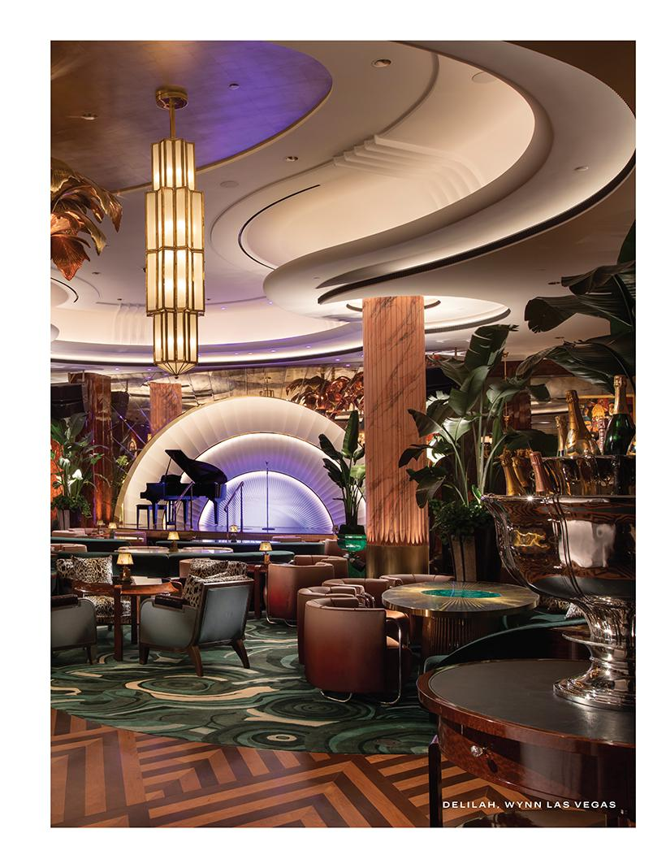

Table of Contents
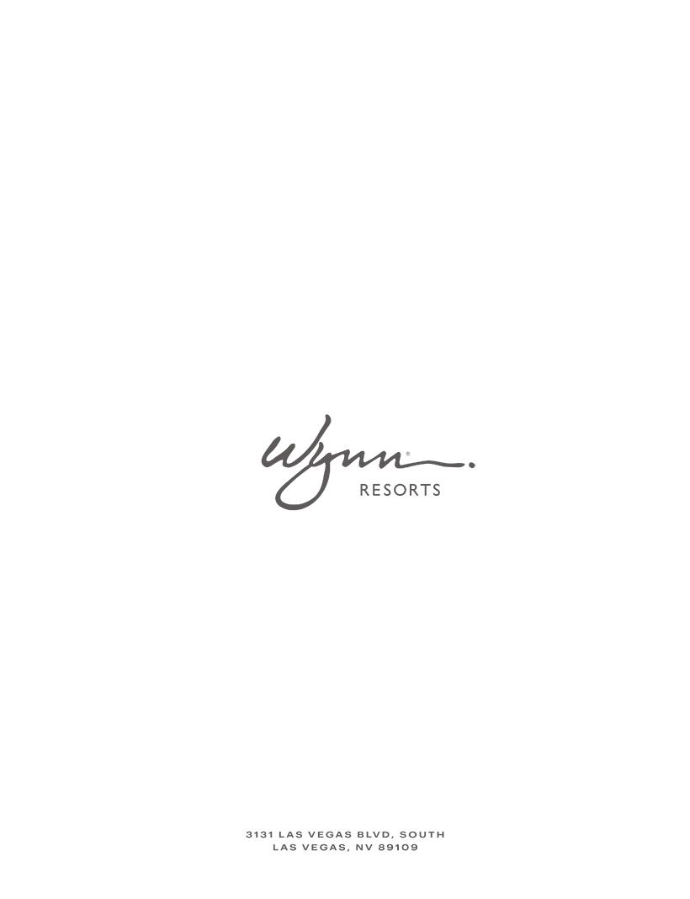

Table of Contents


WYNN RESORTS, LIMITED

ATTN: CORPORATE SECRETARY

3131 LAS VEGAS BLVD. SOUTH
LAS VEGAS, NV 89109

VOTE BY INTERNET - www.proxyvote.com or scan the QR Barcode above

Use the Internet to transmit your voting instructions and for electronic delivery of information up until 11:59 p.m. Eastern Time on May 4, 2022. Have your proxy card in hand when you access the web site and follow the instructions to obtain your records and to create an electronic voting instruction form.
During The Meeting - Go to www.virtualshareholdermeeting.com/WYNN2022
You may attend the meeting via the Internet and vote during the meeting. Have the information that is printed in the box marked by the arrow available and follow the instructions.
VOTE BY PHONE - 1-800-690-6903
Use any touch-tone telephone to transmit your voting instructions up until 11:59 p.m. Eastern Time on May 4, 2022. Have your proxy card in hand when you call and then follow the instructions.
VOTE BY MAIL
Mark, sign and date your proxy card and return it in the postage-paid envelope we have provided or return it to Vote Processing, c/o Broadridge, 51 Mercedes Way, Edgewood, NY 11717.

TO VOTE, MARK BLOCKS BELOW IN BLUE OR BLACK INK AS FOLLOWS:
KEEP THIS PORTION FOR YOUR RECORDS

— — — — — — — — — — — — — — — — — — — — — — — — — — — — — — — — — — — — — — — — — — — — — — — —

DETACH AND RETURN THIS PORTION ONLY

THIS PROXY CARD IS VALID ONLY WHEN SIGNED AND DATED.


For | Withhold | For All | To withhold authority to vote for any individual
For | Withhold | For All | nominee(s), mark “For All Except” and write the
All | All | Except | number(s) of the nominee(s) on the line below.
The Board of Directors recommends you vote FOR the following:

- Election of Directors

Nominees

01) Craig S. Billings 02) Margaret J. Myers 03) Winifred M. Webb

The Board of Directors recommends you vote FOR proposals 2 and 3. For Against Abstain

2. To ratify the appointment of Ernst & Young LLP as our independent registered public accounting firm for 2022.

3. To approve, on a non-binding advisory basis, the compensation of our named executive officers as described in the proxy statement.

NOTE: To consider and transact such other business as may properly come before the Annual Meeting or any adjournment or postponement thereof.

Please sign exactly as your name(s) appear(s) hereon. When signing as attorney, executor, administrator, or other fiduciary, please give full title as such. Joint owners should each sign personally. All holders must sign. If a corporation or partnership, please sign in full corporate or partnership name by authorized officer.

Signature [PLEASE SIGN WITHIN BOX] Date Signature (Joint Owners) Date

Table of Contents

Important Notice Regarding the Availability of Proxy Materials for the Annual Meeting:

The Notice and Proxy Statement and Annual Report are available at www.proxyvote.com

— — — — — — — — — — — — — — — — — — — — — — — — — — — — — — — — — —
— — — — — — — — — — — — — — — —


WYNN RESORTS, LIMITED

Proxy for Annual Meeting of Shareholders
To Be Held on May 5, 2022

This proxy is solicited by the Board of Directors

The undersigned shareholder of Wynn Resorts, Limited, a Nevada corporation (the “Company”), hereby appoints Craig S. Billings or Ellen F. Whittemore, and each of them, as proxies for the undersigned, each with full power of substitution, to attend the Annual Meeting of Shareholders of the Company to be held virtually at www.virtualshareholdermeeting.com/WYNN2022 on May 5, 2022, at 9:00 a.m., local time, (the “Annual Meeting”), and at any adjournment(s) or postponement(s) thereof, to cast on behalf of the undersigned all votes that the undersigned is entitled to cast at such Annual Meeting and otherwise to represent the undersigned at the Annual Meeting, with the same effect as if the undersigned were present. The undersigned instructs such proxies or their substitutes to act on the following matters as specified by the undersigned, and to vote in such manner as such proxies or their substitutes may determine on any other matters that may properly come before the Annual Meeting. The undersigned hereby acknowledges receipt of the Notice of Annual Meeting of Shareholders and the accompanying Proxy Statement and revokes any proxy previously given with respect to such shares.

THE VOTES ENTITLED TO BE CAST BY THE UNDERSIGNED WILL BE CAST IN ACCORDANCE WITH THE SPECIFICATIONS MADE. IF THIS PROXY IS EXECUTED BUT NO SPECIFICATION IS MADE, THE VOTES ENTITLED TO BE CAST BY THE UNDERSIGNED WILL BE CAST “FOR” ALL NOMINEES LISTED ON PROPOSAL NO. 1, “FOR” PROPOSAL NO. 2 AND “FOR” PROPOSAL NO. 3 AND THEY WILL BE VOTED IN THE DISCRETION OF THE PROXIES OR THEIR SUBSTITUTES ON ANY OTHER MATTER AT THE ANNUAL MEETING OR ANY ADJOURNMENT(S) OR POSTPONEMENT(S) THEREOF.


Continued and to be signed on reverse side

