UNITED STATES

SECURITIES AND EXCHANGE COMMISSION
Washington, D.C. 20549

FORM 8-K

CURRENT REPORT

Pursuant to Section 13 or 15(d) of the
Securities Exchange Act of 1934

Date of Report (Date of earliest event reported): February 19, 2012

WYNN RESORTS, LIMITED

(Exact name of registrant as specified in its charter)

Nevada

000-50028

46-0484987

(State or other jurisdiction

of incorporation)

(Commission File Number)

(I.R.S. Employer

Identification No.)

3131 Las Vegas Boulevard South

Las Vegas, Nevada

89109

(Address of principal executive offices of the registrant)

(Zip Code)

(702) 770-7555

(Registrant’s telephone number, including area code)

Not Applicable

(Former name or former address, if changed since last report)

Check the appropriate box below if the Form 8-K filing is intended to simultaneously satisfy the filing obligation of the registrant under any of the following provisions:

- Written communications pursuant to Rule 425 under the Securities Act (17 CFR 230.425)

- Soliciting material pursuant to Rule 14a-12 under the Exchange Act (17 CFR 240.14a-12)

- Pre-commencement communications pursuant to Rule 14d-2(b) under the Exchange Act (17 CFR 240.14d-2(b))

- Pre-commencement communications pursuant to Rule 13e-4(c) under the Exchange Act (17 CFR 240.13e-4(c))

Item 8.01. Other Events.

On February 19, 2012, Wynn Resorts, Limited (the “Company”) filed a complaint in the District Court of Clark County, Nevada against Mr. Kazuo Okada, a member of the Board of Directors of the Company, and certain of his affiliates, alleging breaches of fiduciary duty and related claims (the “Complaint”). The Complaint included as an exhibit a report on the results of an independent investigation by Freeh Sporkin & Sullivan, LLP to the Company’s Gaming Compliance Committee (the “Freeh Report”). The Complaint and the Freeh Report are attached as Exhibits 99.1 and 99.2, respectively, to this Current Report on Form 8-K and incorporated herein by reference.

Item 9.01. Financial Statements and Exhibits.

- Exhibits:

 | Exhibit
Number |  |  | Description
99.1 |  |  | Complaint, Wynn Resorts, Ltd. v. Kazuo Okada, et al., No. A-12-656710-B (Nev. Dist. Ct., Clark Cnty., Feb. 19, 2012).
99.2 |  |  | Report by Freeh, Sporkin & Sullivan, LLP to the Gaming Compliance Committee of Wynn Resorts, Limited.

SIGNATURES

Pursuant to the requirements of the Securities Exchange Act of 1934, the registrant has duly caused this report to be signed on its behalf by the undersigned hereunto duly authorized.

Dated: February 22, 2012

WYNN RESORTS, LIMITED

By: /s/ Matt Maddox

Matt Maddox

Chief Financial Officer and Treasurer

Exhibit 99.1
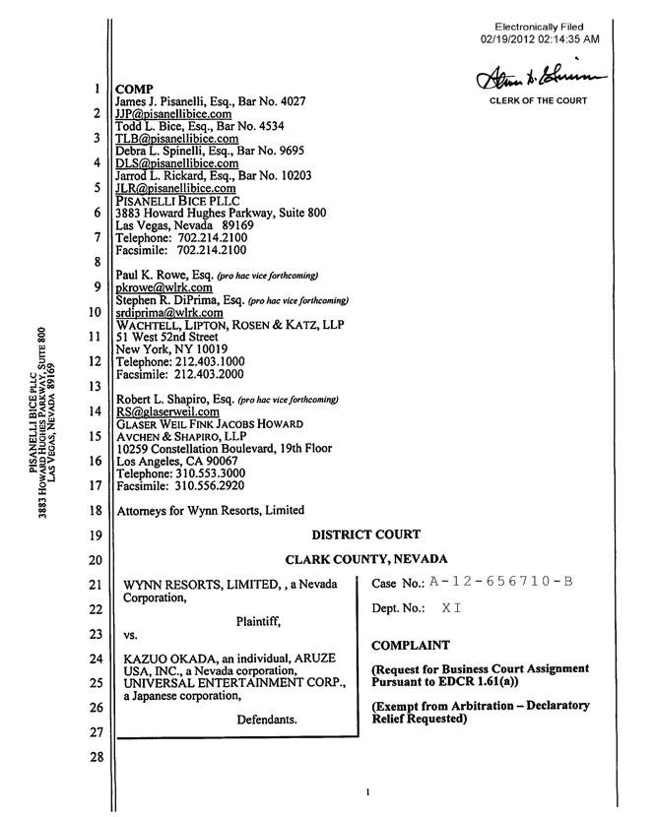

Electronically Filed 02/19/2012 02:14:35 AM
_{COMP}LERK OF THE COURT
_{JJP@pisanellibice}ames.Pisanelli, Esq., Bar No. 4027
.com
_{TLB@pisanellibice}odd.Bice,Esq., Bar No. 4534
.com
_{DLS@pisanellibice}ebra.Spinelli,Esq., Bar No. 9695
.com
arrod . Rickard, Esq., Bar No. 10203
Pisanelli_{JLR@pisanellibice}Bicepllc^{.com}
3883 Howard Hughes Parkway, Suite 800 Las Vegas, Nevada 89169 Telephone: 702.214.2100 Facsimile: 702.214.2100 Paul K. Rowe, Esq. (pro hac vice forthcoming)
pkrowe@wlrk.com
srdiprima@wlrk.comStephenR.DiPrima,Esq. (pro hac vice forthcoming)
51Wachtell,West52ndLipton,StreetRosen & Katz, LLP
New York, NY 10019
Telephone: 212.403.1000
Facsimile: 212.403.2000
_{RS@glaserweil}obertL.Shapiro, Esq. (pro hoc vice forthcoming)
.com
AvchenGlaserW& Shapiro,FinkJacobsLLP Howard
Los10259Angeles,ConstellationCA90067Boulevard, 19th Floor
Telephone: 310.553.3000
Facsimile: 310.556.2920
Attorneys for Wynn Resorts, Limited
DISTRICT COURT CLARK COUNTY, NEVADA
WYNN RESORTS, LIMITED,, a Nevada Corporation,
Plaintiff,
VS.Case No.: A-12-656710-B Dept. No.: XI

KAZUO OKADA, an individual, ARUZE USA, INC., a Nevada corporation, UNIVERSAL ENTERTAINMENT CORP., a Japanese corporation, Defendants. COMPLAINT
_{(Exempt}Request fromforBusinessArbitration—DeclaratoryCourtAssignmentReliefPursuantRequested)toEDCR 1.61 (a))
PISANELLI1234567 8BICE910 PLLC1112 13 14 15 16 17 18 19 20 21 22 23 24 25 26 27 28
LAS3883 VEGAS,HOWARDNEVADAHUGHES89169PARKWAY, SUIT 800

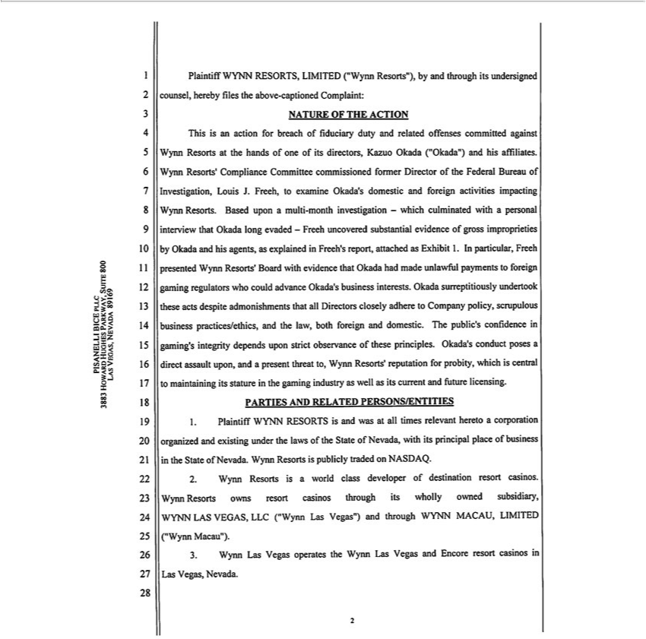

Plaintiff WYNN RESORTS, LIMITED (“Wynn Resorts”), by and through its undersigned counsel, hereby files the above-captioned Complaint:
NATURE OF THE ACTION
This is an action for breach of fiduciary duty and related offenses committed against Wynn Resorts at the hands of one of its directors, Kazuo Okada (“Okada”) and his affiliates. Wynn Resorts’ Compliance
Committee commissioned former Director of the Federal Bureau of Investigation, Louis J. Freeh, to examine Okada’s domestic and foreign activities impacting Wynn Resorts. Based upon a multi-month
investigation—which culminated with a personal interview that Okada long evaded—Freeh uncovered substantial evidence of gross improprieties by Okada and his agents, as explained in Freeh’ report,
attached as Exhibit 1. In particular, Freeh presented Wynn Resorts’ Board with evidence that Okada had made unlawful payments to foreign gaming regulators who could advance Okada’s business interests.
Okada surreptitiously undertook these acts despite admonishments that all Directors closely adhere to |  |  | policy, scrupulous business practices/ethics, and the law, both foreign and domestic. The public’s
confide ce in gaming’s integrity depends upon strict observance of these principles. Okada’s conduct posesCompanydirect assault upon, and a present threat to, Wynn Resorts’ reputation for probity, which is central to
maintaining its stature in the gaming industry as well as its current |  | future licensing. PARTIES AND RELATED PERSONS/ENTITIES
1. Plaintiff WYNN RESORTS is and was at all times relevant heretoand corporation organized and existing under the laws of the State of Nevada, with its principal place of business in the State of Nevada. Wynn
Resorts is publicly | on NASDAQ.
^{WYNN}2.ynn Resorts is tradedworld class developer of destination resort casinos. Wynn Resorts owns resort casinos through its wholly owned subsidiary, WYNN LAS VEGAS, LLC (“Wynn Las Vegas”) and through MACAU, LIMITED (“Wynn Macau”).
3. ynn Las Vegas operates the Wynn Las Vegas and Encore resort casinos in Las Vegas, Nevada.
PISANELLI1234567 8BICE910 PLLC1112 13 14 15 16 17 18 19 20 21 22 23 24 25 26 27 28
LAS3883 VEGAS,HOWARDNEVADAHUGHES89169PARKWAY, SUIT 800

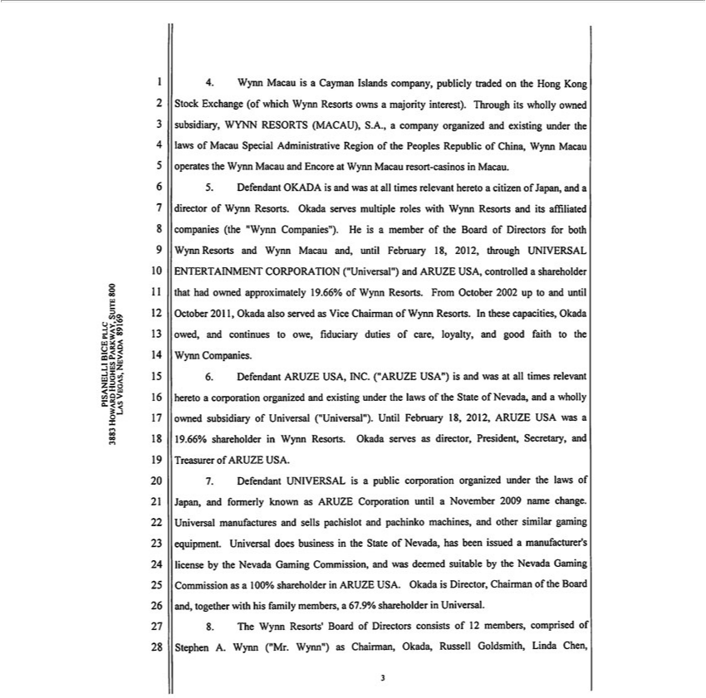

4. | Wynn Macau is a Cayman Islands company, publicly traded on the Hong Kong Stock Exchange (of which Wynn Resorts owns a majority interest). Through its wholly owned subsidiary, WYNN RESORTS
(MACAU), S.A., company organized and existing under the laws of Macau Special Administrative Region of the Peoples Republic of China, Wynn Macau operates the Wynn Macau and Encore at Wynn
Macau resort-casinos in Macau.
5. | Defendant OKADA is and was at all times relevant hereto a citizen of Japan, and a director of Wynn Resorts. Okada serves multiple roles with Wynn Resorts and its affiliated companies (the “Wynn
Companies”). He is a member of the Board of Directors for both Wynn Resorts and Wynn Macau and, until February 18, 2012, through UNIVERSAL ENTERTAINMENT CORPORATION (“Universal”) and
ARUZE USA, controlled shareholder that had owned approximately 19.66% of Wynn Resorts. From October 2002 up to and until October 2011, Okada also served as Vice Chairman of Wynn Resorts. In these
capacities, Okada owed, and continues to owe, fiduciary duties of care, loyalty, and good |  |  | to the Wynn Companies.
6. | nt ARUZE USA, INC. (“ARUZE USA”) is and | at all times relevant heretofaithcorporation organized and existing under the laws of the State of Nevada, and a wholly owned subsidiary of Universal
(“Univers l”). Until February 18, 2012, ARUZE USA was was19.66% shareholder in Wynn Resorts. Okada serves as director, President, |  |  |  |  | , and Treasurer of ARUZE USA.
7. | Defendant UNIVERSAL is public corporation organized under the laws of Japan, and formerly known as ARUZE Corporation until |  |  |  | November 2009 name change. Universal manufactures and sells
pachislot and pachinko machines, and other similar |  | equipment. Universal does business in the State of |  | has been issued Secretarymanufacturer’s license by the Nevada |  | Commission, and was
deemed suitable by the Nevada Gaming Commissiongamingas100% shareholder in ARUZE |  |  | . Okada is DirectorNevada,Chairman of the Board and, together with his family members,Gaming67.9% shareholder in Universal.
8. | The Wynn Resorts’ Board of Directors consists of 12 members, comprised of Stephen USA.Wynn (“Mr. Wynn”) as Chairman, Okada, Russell Goldsmith, Linda Chen,
1 2 3 4 5 6 7 8 9 10 11 12 13 14 15 16 17 18 19 20 21 22 23 24 25 26 27 28
PISANELLI BICE PLLC

LAS3883 VEGAS,HOWARDNEVADAHUGHES89169PARKWAY, SUIT 800

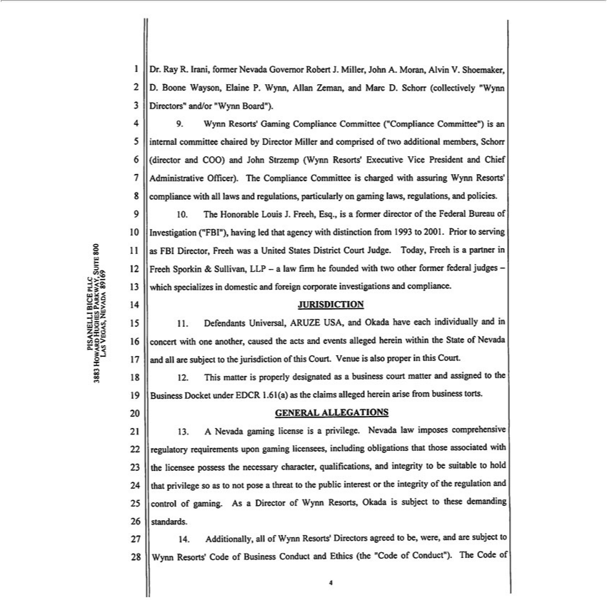

Dr. Ray R. Irani, former Nevada Governor Robert J. Miller, John A. Moran, Alvin V. Shoemaker, D. Boone Wayson, Elaine P. Wynn, Allan Zeman, and Marc D. Schorr (collectively “Wynn Directors” and/or
“Wynn Board”).
9. Wynn Resorts’ Gaming Compliance Committee (“Compliance Committee”) is an internal committee chaired by Director Miller and comprised of two additional mbers, Schorr (director and COO) and John
Strzemp (Wynn Resorts’ Executive Vice President and Chief Administrative Officer). The Compliance Committee is charged with assuring Wynn Resorts’ compliance with all laws and regulations, particularly
on gaming laws, regulations, and policies. |  |  |  | as FBI Director, Freeh was
10. The Honorable Louis J. Freeh, Esq., is a former director of the Federal Bureau of Investigation (“FBI”), having led that agency with distinction from 1993 to 2001. Prior to |  |  |  | as FBI Director, Freeh was
 | United States District Court Judge. Today, Freeh is a partner in Freeh Sporkin & Sullivan, LLP—a law firm he founded with two other former federal judges -which specializesservingdomestic and foreign
corporate investigations and compliance.
JURISDICTION
11. Defendants Universal, ARUZE USA, and Okada have each individually and in concert with one another, caused the acts and events alleged herein within the State of Nevada and all are subject to the
jurisdiction of |  | Court. Venue is also proper this Court.
12. This matterthisproperly designated as a business court matter and assigned to the Business Docket under EDCR 1.61 (a) as the claims alleged herein arise from business torts.
 | ALLEGATIONS
GENERAL13.Nevada gaming license is privilege. Nevada law imposes comprehensive regulatory requirements upon gaming licensees, including obligations that those associated with the licensee possess the
necessary character, qualifications, |  |  | integrity to be suitable to hold that privilege so as to not pose a threat to the public interest or the integrity of the regulation and control of gaming. As a Director of Wynn
Resorts, Okada is subject to these demanding standards.
1 | 4. Additionally, all of Wynn Resorts’ Directors agreed to be, were, and are subject to Wynn Resorts’ Code of Business Conduct and Ethics (the “Code of Conduct”). The Code of
1 | 2 3 4 5 6 7 8 9 10 11 12 13 14 15 16 17 18 19 20 21 22 23 24 25 26 27 28
PISANELLI BICE PLLC
3883 HOWARD HUGHES PARKWAY, SUIT 800
LAS VEGAS, NEVADA 89169

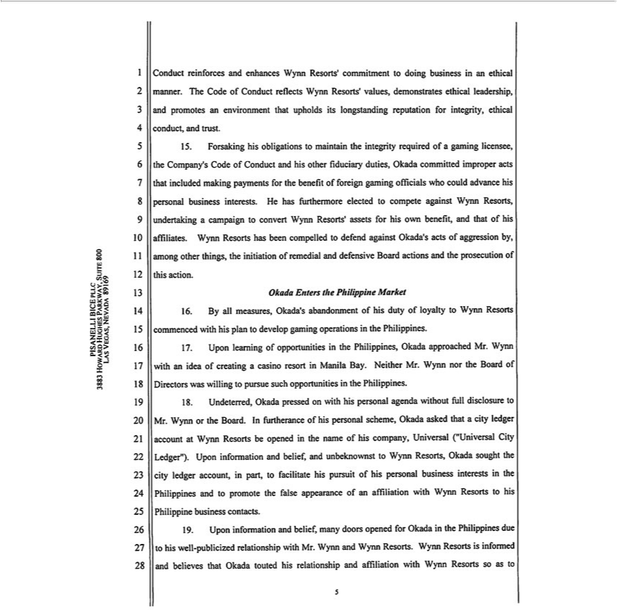

Conduct reinforces and enhances Wynn |  |  | commitment to doing business in ethical manner. The Code of Conduct reflects Wynn Resorts’ values, demonstrates ethical leadership, and promotes an
envir nment that upholds its longstandingResorts’putation for integrity, ethical conduct, and trust. |  |  |  |  |  | that included making
15. | Forsaking his obligations to maintain the integrity required of gaming licensee, the Company’ Code of Conduct and his other fiduciary duties, Okada committed improper |  |  |  |  | that included making
payments for the benefit of foreign gaming officials who could advance his personal business interests. He has furthermore elected to compete against Wynn Resorts, undertakingactsca paign to convert Wynn
Resorts’ assets for his own benefit, and that of his affiliates. Wynn Resorts has been compelled to defend against Okada’s acts of aggression by, among other things, the initiation of remedial and defensive Board
actions and the prosecution of this action.
Okada Enters the Philippine Market |  |  |  | operations in | Philippines.
6 | By all measures, Okada’ abandonment of his duty of loyalty to Wynn Resorts commenced with his plan to develop |  |  | operations in | Philippines.
17. | Upon | of opportunities in the Philippines, Okada approached Mr. Wynn with an idea of creating a casino resortgamingManila Bay. Neither Mr. Wynn nor the Board of Directors was willing to pursue such
opportunitieslearningthe Philippines.
18. | Undeterred, Okada pressed on with his personal agenda without full disclosure to Mr. Wynn or the Board. In furtherance of his personal scheme, Okada asked that a city ledger account at Wynn Resorts be
pened in the name of his company, Universal (“Universal City Ledger”). Upon information and belief, and unbeknownst to Wynn Resorts, Okada sought the city ledger account, in part, to facilitate his pursuit
of his personal business interests in the Philippines and to promote the false appearance of an affiliation with Wynn Resorts to his Philippine business contacts.
19. | Upon information and belief, many doors opened for Okada in the Philippines due to his well-publicized relationship with Mr. Wynn and Wynn Resorts. Wynn Resorts is informed and believes that Okada
touted his relationship and affiliation with Wynn Resorts so as to
1 2 | 3 4 5 6 7 8 9 10 11 12 13 14 15 16 17 18 19 20 21 22 23 24 25 26 27 28
PISANELLI BICE PLLC
LAS3883 VEGAS,HOWARDNEVADAHUGHES89169PARKWAY, SUIT 800

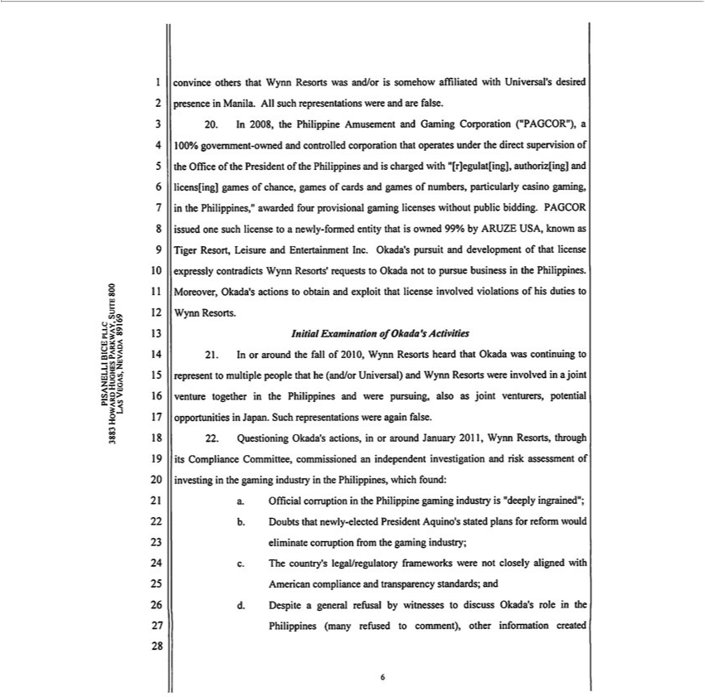

convince | that Wynn Resorts was |  | is somehow affiliated with |  | s desired presence in Manila. All such representations were and are false.
20. In 2008,others | Philippine Amusement and/orGaming Corporation (“PAGCOR”),Universal’100% government-owned and controlled corporation that operates under the direct supervision of the Office of the President of
the Philippines and is charged with “[r]egulat[ing], authoriz[ing] and licens[ing] games of chance, games of cards and games of numbers, particularly casino gaming, in the Philippines,” awarded four
gaming licenses without public bidding. PAGCOR issued one such license to a newly-formed entity that is owned 99% by ARUZE USA, known as Tiger Resort, Leisure and Entertainment Inc. Okada’provisionalpursuit
and development of that license expressly contradicts Wynn Resorts’ requests to Okada not to pursue business in the Philippines. Moreover, Okada’s actions to obtain and exploit that license involved violations
of his duties to Wynn Resorts.
Examination of Okada’s Activities |  |  |  |  | to represent to multiple people that he (and/or Universal) and Wynn Resorts were involved in a joint venture together in the
Initial21. or around the fall of 2010, Wynn Resorts heard that Okada was
Philippines and were |  | also as joint venturers, potential opportunitiescontinuingJapan. Such representations were again false.
22. | Okada’pursuing,actions, in or around January 2011, Wynn Resorts, through its Compliance Committee, commissioned an independent investigation and risk assessment of investing in the gaming
industryQuestioningthe |  | which found: |  | is “deeply ingrained”;
a. Official corruptionPhilippines,the Philippine gaming |  |  |  | is “deeply ingrained”;
b. Doubts that newly-elected President Aquino’industrystated plans for reform would eliminate corruption from the gaming industry;
c. The country’s legal/regulatory frameworks were not |  |  |  | aligned with American compliance and transparency standards; and
d. Despite a general refusal by witnesses to discuss Okada’closelyrole in the Philippines (many refused to comment), other information created 1 2 3 4 5 6 7 8 9 10 11 12 13 14 15 16 17 18 19 20 21 22 23 24 25 26 27 28

LAS3883 VEGAS,HOWARDNEVADAHUGHES89169PARKWAY, SUIT 800

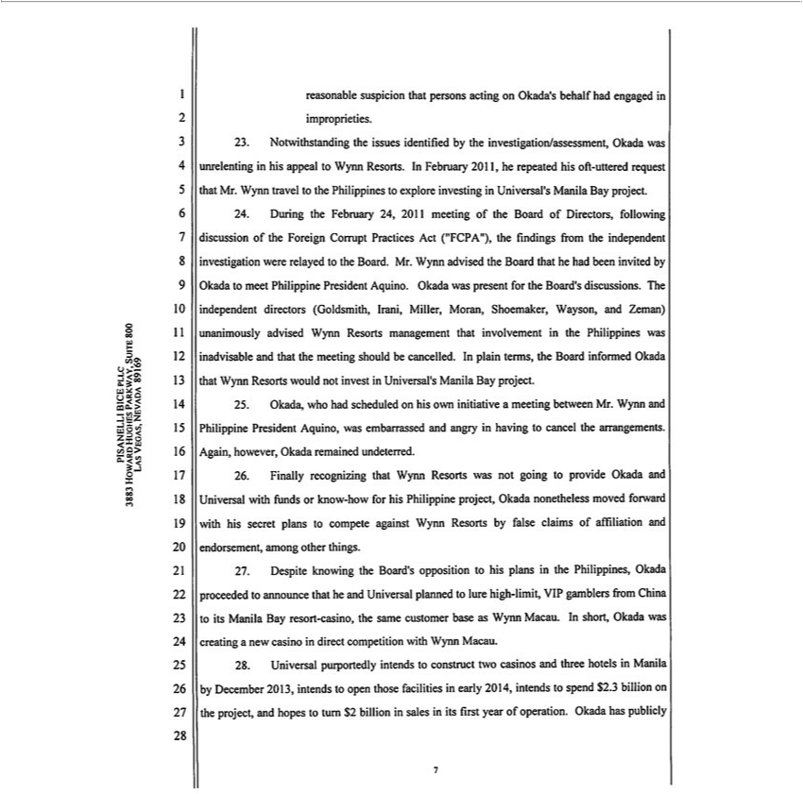

reasonable suspicion that persons acting on Okada’ behalf had engaged in improprieties,
23. | Notwithstanding the issues identified by the investigation/assessment, Okada was unrelenting in his appeal to Wynn Resorts. In February 2011, he repeated his oft-uttered request that Mr. Wynn travel to the
Philippines to explore investing in Universal’s Manila Bay project. |  |  |  | from the independent investigation were relayed to the
24. | During the February 24, 2011 meeting of the Board of Directors, following discussion of the Foreign Corrupt Practices Act (“FCPA”), the |  |  | from the independent investigation were relayed to the
Board. Mr. Wynn advised the Board that he had been invited by Okada to meet Philippine President Aquino. Okada was present for the Board’findingsdiscussions. The independent directors (Goldsmith, Irani, Miller,
Moran, Shoemaker, Wayson, and Zeman) unanimously advised Wynn Resorts management that involvement in the Philippines was inadvisable and that the meeting should be cancelled. In plain terms, the Board
informed Okada that Wynn Resorts would not invest in Universal’s Manila Bay project.
25. | Okada, who had scheduled on his own initiative a meeting between Mr. Wynn and Philippine President Aquino, was embarrassed and angry in having to cancel the arrangements. Again, however, Okada
remained undeterred.
26. | Finally recognizing that Wynn Resorts was not going to provide Okada and Universal with funds or know-how for his Philippine project, Okada nonetheless moved forward with his secret plans to compete
against Wynn Resorts by false |  | of affiliation and endorsement, among other things.
27. | Despite knowing the Board’claimsopposition to his plans in the Philippines, |  | proceeded to announce that he and Universal planned to lure high-limit, VIP gamblers from China to its Manila Bay resort-
casino, the same customer base as Wynn Macau. In short, Okada was |  |  | Okadanew casino in direct competition with Wynn Macau.
28. | Universal purportedly intends to construct two casinos and three hotelscreating Manila by December 2013, intends to open those facilities in early 2014, intends to spend $2.3 billion on the project, and hopes to
turn $2 billion in sales in its first year of operation. Okada has publicly
1 2 | 3 4 5 6 7 8 9 10 11 12 13 14 15 16 17 18 19 20 21 22 23 24 25 26 27 28
PISANELLI BICE PLLC
LAS3883 VEGAS,HOWARDNEVADAHUGHES89169PARKWAY, SUIT 800

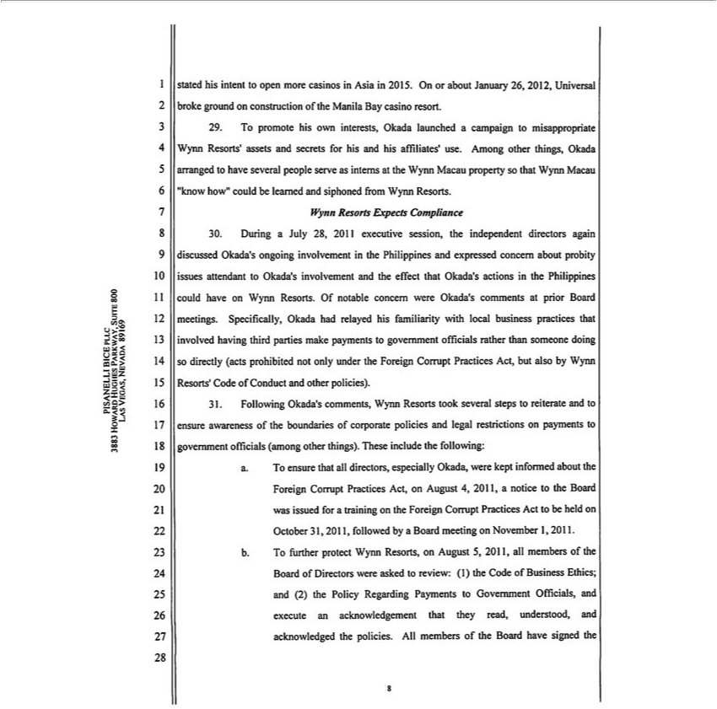

stated his intent to open more casinos in Asia in 2015. On or about January 26, 2012, Universal broke ground on construction of the Manila Bay casino resort.
29. To promote his own interests, Okada launched a campaign to misappropriate Wynn Resorts’ assets and secrets for his and his affiliates’ use. Among other things, Okada arranged to have several people serve as interns at the Wynn Macau property so that Wynn Macau “know how” could be learned and siphoned from Wynn Resorts.

Wynn Resorts Expects Compliance

30. During a July 28, 2011 executive _{session,} the independent directors again discussed Okada’s ongoing involvement in the _{Philippines} and expressed concern about probity issues attendant to Okada’_{his} involvement and the effect that Okada’ actions_{involved}the Philippines could have on Wynn Resorts. Of notable concern were Okada’ comments at prior Board meetings. Specifically, Okada had relayed

familiarity with local business practices that having third parties make payments to government officials rather than someone doing so directly (acts prohibited not only under the Foreign Corrupt Practices Act, but also by Wynn Resorts’ Code of Conduct and other policies).
31. Following Okada’s comments, Wynn Resorts took several steps to reiterate and to ensure awareness of the boundaries of corporate policies and legal restrictions on payments to government officials (among ^{other} things). These include the following:
a. T ensure that all directors, especially Okada, were kept informed about the Foreign Corrupt Practices Act, on August 4, 2011, a notice to the Board was issued for a training on the Foreign Corrupt Practices Act to be held on October 31, 2011, followed by a Board meeting on November 1, 2011.
b. To further protect Wynn Resorts, on August 5, 2011, all members of the Board of Directors were asked to review: (1) the Code of Business Ethics; and (2) the Policy Regarding Payments to Government Officials, and execute an acknowledgement that they read, understood, and acknowledged the policies. All members of the Board have signed the
PISANELLI1234567 8BICE910 PLLC1112 13 14 15 16 17 18 19 20 21 22 23 24 25 26 27 28
LAS3883 VEGAS,HOWARDNEVADAHUGHES89169PARKWAY, SUIT 800

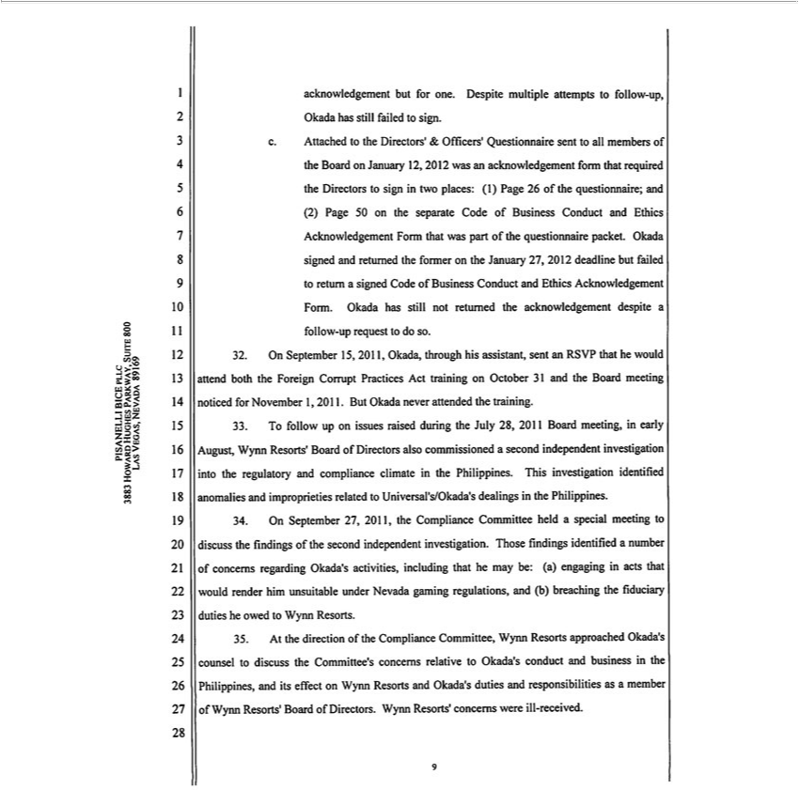

 | but for one. Despite multiple attempts to follow-up, Okada has still failed to sign.
acknowledgement.Attachedtothe Directors’ & Officers’ Questionnaire sent to all members of the Board on January 12,2012 was an acknowledgement form that required the Directors to sign in two places: (1) Page 26 of the
questionnaire; and (2) Page 50 on the separate Code of Business Conduct and Ethics Acknowledgement Form that was part of the questionnaire packet. Okada signed and returned the former on the January 27,
2012 deadline but failed to return signed Code of Business Conduct and Ethics Acknowledgement Form. Okada has still not returned the acknowledgement despite follow-up request to do so.
32. | On September 15, 2011, Okada, through his assistant, sent an RSVP that he would attend both the Foreign Corrupt Practices Act training on October 31 and the Board meeting noticed for November 1,2011.
But Okada never attended the training.
33. | T follow up on issues raised during the July 28, 2011 Board meeting, in early August, Wynn Resorts’ Board of Directors also commissioned a second independent investigation into the regulatory and
compliance climate in the Philippines. This investigation identified anomalies and improprieties related to Universal’s/Okada’s dealings the Philippines.
34. | On September 27, 2011, the Compliance Committee held a special meeting to discuss the findings of the second independent investigation. Those findings identified a number of concerns regarding Okada’s
activi ies, including that he may be: (a) engaging in acts that would render him |  | under Nevada gaming |  | and (b) breaching the fiduciary duties he owed to Wynn Resorts.
35. | At the direction of the Compliance Committee, Wynn Resorts approached Okada’unsuitablecounsel |  | discuss the Committee’regulations,concerns relative to Okada’s conduct and business in the Philippines, and its effect on
Wynn Resorts and Okada’s duties and responsibilities as a member of Wynn Resorts’ Board of |  |  | Directors. Wynn Resorts’ concerns were ill-received.
1 2 | 3 4 5 6 7 8 9 10 11 12 13 14 15 16 17 18 19 20 21 22 23 24 25 26 27 28
PISANELLI BICE PLLC
3883 HOWARD HUGHES PARKWAY, SUIT 800
LAS VEGAS, NEVADA 89169

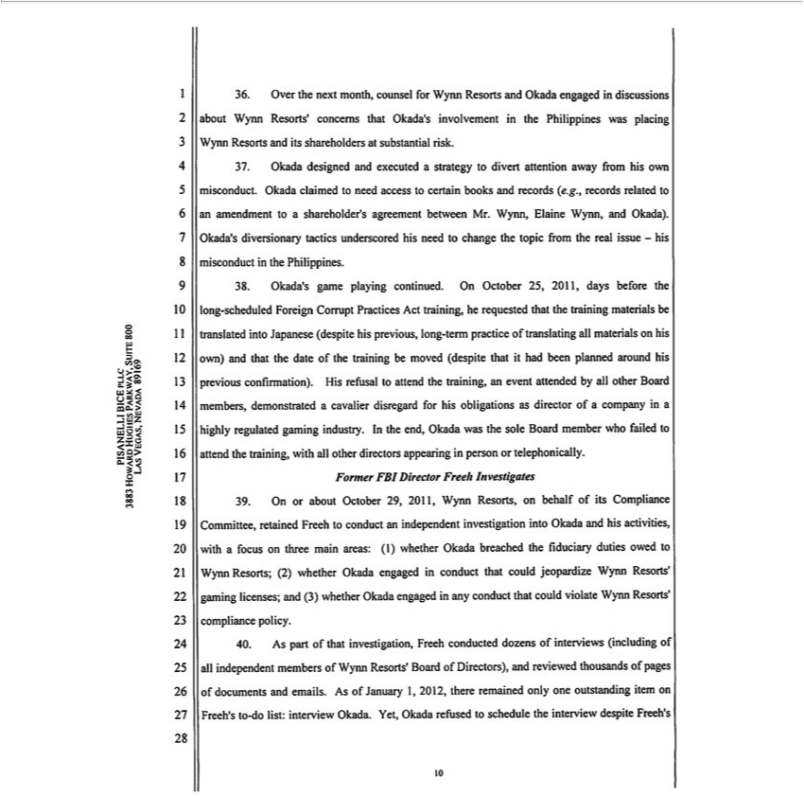

36. | Over the next month, counsel for Wynn Resorts and Okada engaged in discussions about Wynn Resorts’ concerns that Okada’s involvement in the Philippines was placing Wynn Resorts and its shareholders
at substantial risk. |  | and executed a strategy to divert attention away from his own misconduct. Okada claimed to need access to certain books and records (e.g., records related to an amendment to a
37. | Okada
38. | Okada’designedgameplaying continued. On October 25, 2011, days before the long-scheduled Foreign Corrupt Practices Act training, he requested that the training materials be translated into Japanese (despite his
shareholder’ agreement between Mr. Wynn, Elaine Wynn, and Okada). Okada’s diversionary tactics underscored his need to change the topic from the real issue - his misconduct in the Philippines.
previous, long-term practice of translating all aterials on his own) |  |  |  | that the date of the training be moved (despite that it had been | around his previous confirmation). His refusal to attend the
training, an event attended by all other Board members, demonstratedand cavalier disregard for his obligations as director of a company inplannedhighly regulated gaming industry. In the end, Okada was the sole Board
member who failed to attend the training, with all other directors appearing in person or telephonically.
Former FBI Director Freeh Investigates |  |  |  |  |  |  | areas:
39. | On or about October 29, 2011, Wynn Resorts, on behalf of its Compliance Committee, retained Freeh to conduct an independent investigation into Okada and his activities, with a focus on three |  |  |  |  |  | areas:
(1) whether Okada breached the fiduciary duties owed to Wynn Resorts; (2) whether Okada engaged in conduct that could jeopardize Wynn Resorts’ gaming licenses; and (3) whether Okada engagedmainany
conduct that could violate Wynn Resorts’ compliance policy. |  |  |  |  |  | of pages of documents and emails.
40. | As part of that investigation, Freeh conducted dozens of nterviews (including of all independent members of Wynn Resorts’ Board of Directors), and reviewed
As of January 1, |  |  | there remained only one outstanding item on Freeh’s to-do list: interview Okada. Yet, Okada refused to schedule the interview despite Freeh’thousands
1 2 | 3 4 5 6 7 8 9 102012, |  | 12 13 14 15 16 17 18 19 20 21 22 23 24 25 26 27 28
PISANELLI BICE PLLC
3883 HOWARD HUGHES PARKWAY, SUIT 800 |  |  |  | 10
LAS VEGAS, NEVADA 89169 |  |  |  | 10

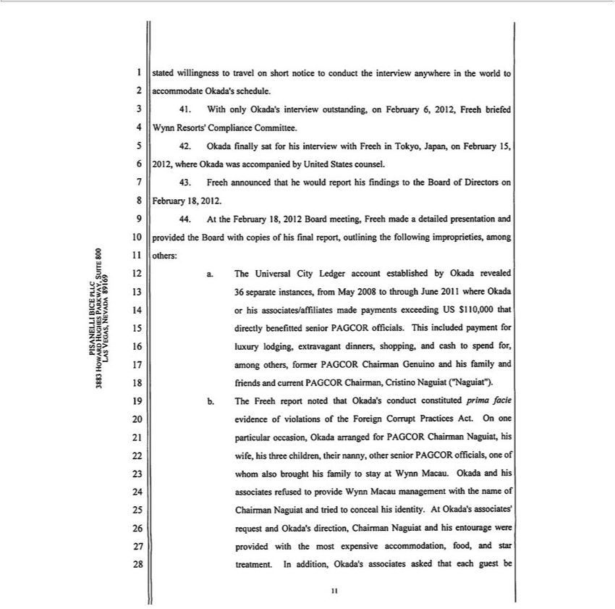

stated willingness to travel on short notice to |  | the interview anywhere in the world to accommodate Okada’s schedule.
1 | With only Okada’s interview outstanding,conductFebruary 6, 2012, Freeh briefed Wynn Resorts’ Compliance C mittee.
2 | Okada fi ally sat for his interview with Freeh | Tokyo, Japan, on February 15, 2012, where Okada was accompanied by United States counsel.
3 | Freeh announced that he would report his findings to the Board of Directors on February 18, 2012.
44. | At the February 18, 2012 Board m eting, Freeh made detailed presentation and provided the Board with copies of his final report, outlining the following improprieties, among others:
. The Universal Ci y Ledger account established by Okada revealed 36 separate instances, from May 2008 to through June 2011 where Okada or his associates/affiliates made payments exceeding US $110,000
that directly benefitted senior PAGCOR officials. This included payment for luxury lodging, extravagant dinners, shopping, and cash to spend for, among others, former PAGCOR Chairman Genuino and his
family and friends and current PAGCOR Chairman, Cristino Naguiat (“Naguiat”).
b. The Freeh report noted that Okada’s conduct constituted prima facie evidence of violations of the Foreign Corrupt Practices Act. On one particular occasion, Okada arranged for PAGCOR Chairman Naguiat,
his wife, his three children, their nanny, other senior PAGCOR officials, one of whom also brought his family to stay at Wynn Macau. Okada and his associates refused to provide Wynn Macau management with
the name of Chairman Naguiat and tri d to conceal his identity. At Okada’ associates’ request and Okada’s direction, Chairman Naguiat and his entourage were provided with the most expensive
accommodation, food, and star treatment. In addition, Okada’s associates asked that each guest be
1 2 | 3 4 5 6 7 8 9 10 11 12 13 14 15 16 17 18 19 20 21 22 23 24 25 26 27 28
PISANELLI BICE PLLC
3883 HOWARD HUGHES PARKWAY, SUIT 800 |  | 11
LAS VEGAS, NEVADA 89169 |  | 11

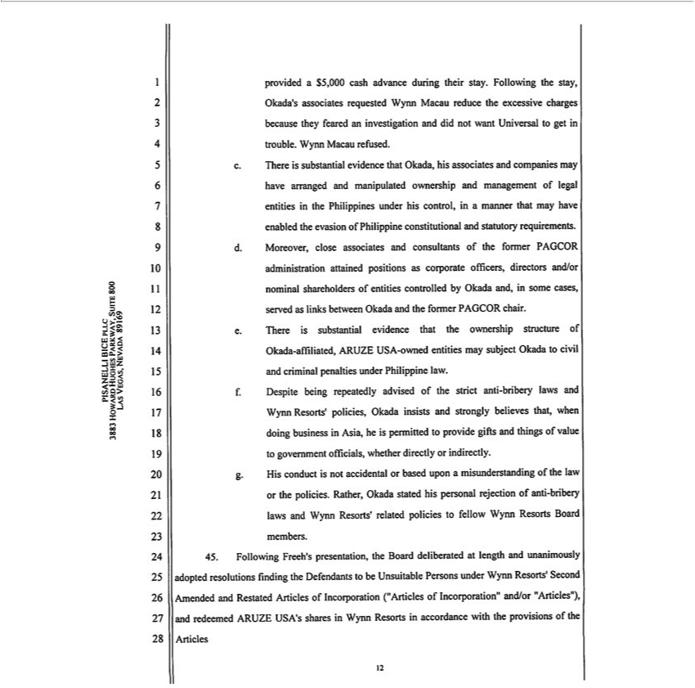

provided a $5,000 cash advance during their stay. Following the stay, Okada’s associates requested Wynn Macau reduce the excessive charges because they feared an investigation and did not want Universal to
get in trouble. Wynn Macau refused.
c. There is substantial evidence that Okada, his associates and companies may have arranged and manipulated ownership and management of legal entities in the Philippines under his control, in a manner that
may have enabled the evasion of Philippine constitutional and statutory requirements.
d. Moreover, close associates and consultants of the former PAGCOR administration attained positions as corporate officers, directors and/or nominal shareholders of entities controlled by Okada and, in some
served as links betw |  | Ok da and the former PAGCOR chair.
cases,.There is substantial evidence that the ownership structure of Okada-affiliated, ARUZE USA-owned entities may subject Okada to civil and criminal penalties under Philippine law.
f. Despite being repeatedly advised of the strict anti-bribery laws and Wynn Resorts’ policies, Okada insists and strongly believes that, when doing business in Asia, he is permitted to provide gifts and things of
value to government officials, whether directly or indirectly.
g. His conduct is not accidental or based upon a misunderstanding of the law or the policies. Rather, Okada stated his personal rejection of anti-bribery laws and Wynn Resorts’ related policies to fellow Wynn
Resorts Board | . |  | the Defendants to be Unsuitable Persons under Wynn Resorts’ Second Amended and Restated
45. Following Freeh’memberspresentation, the Board deliberated at length and unanimously adopted
Articles of Incorporation (“Articles of Incorporation” and/or “Articles”), and redeemed ARUZEresolutionsUSA’sharesfinding Wynn Resorts in accordance with the provisions of the Articles
1 2 3 4 5 6 7 8 9 10 11 12 13 14 15 16 17 18 19 20 21 22 23 24 25 26 27 28
PISANELLI BICE PLLC
3883 HOWARD HUGHES PARKWAY, SUIT 800 |  |  | 12
LAS VEGAS, NEVADA 89169 |  |  | 12

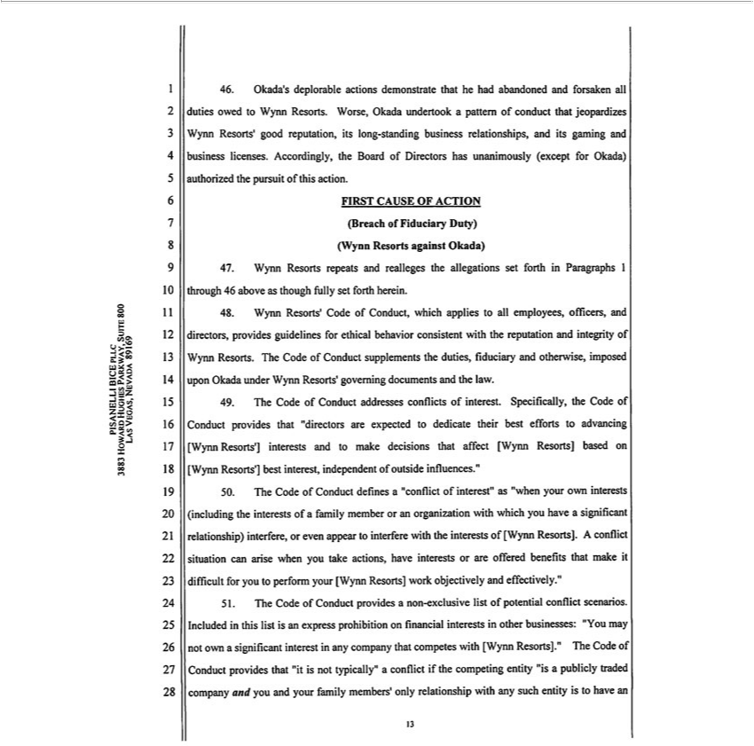

46. | Okada’ deplorable actions demonstrate that he had abandoned and forsaken all duties owed to Wynn Resorts. Worse, Okada undertook a pattern of conduct that jeopard zes Wynn Resorts’ good reputation,
its long-standing business relationships, and its gaming and business licenses. Accordingly, the Board of Directors has unanimously (except for Okada) authorized the pursuit of this action.
FIRST CAUSE OF ACTION
Breach of Fiduciary Duty)
(Wynn Resorts against Okada)
7 |  | repeats and realleges the allegations set forth in Paragraphs 1 through 46 above as though fully set forth herein.
48. Wynn Resorts’ Code of Conduct, which applies to all employees, officers, and directors, provides guidelines for ethical behavior consistent with the reputation and integrity of Wynn Resorts. The Code of
Conduct supplements the duties, fiduciary and otherwise, imposed upon Okada under Wynn Resorts’ governing documents and the law.
49. | The Code | Conduct addresses conflicts of interest. Specifically the Code of Conduct provides that “directors are expected to dedicate their best efforts to advancing [Wynn Resorts’] interests and to make
decisions that affect [Wynn Resorts] based on [Wynn Resorts’] best interest, independent of outside fluences.”
50. | The Code of | Conduct defines a “conflict of interest” as “when your own interests (including the interests of family member or an organization with which you have a significant relationship) interfere, or
even appear to interfere with the interests of [Wynn Resorts]. A conflict situation can arise when you take actions, have interests or are offered benefits that make it difficult for you to perform your [Wynn
Resorts] work objectively and effectively.”
51. | The Code of Conduct provides a non-exclusive list of potential conflict scenarios. Included in this list is an express prohibition on financial interests in other businesses: “You may not own significant
interest in any company that competes with [Wynn Resorts].” The Code of Conduct provides that “it is not typically” a conflict if the competing entity “is a publicly traded company and you and your family
members’ only relationship with any such entity is to have an
1 2 | 3 4 5 6 7 8 9 10 11 12 13 14 15 16 17 18 19 20 21 22 23 24 25 26 27 28
PISANELLI BICE PLLC

LAS3883 VEGAS,HOWARDNEVADAHUGHES89169PARKWAY, SUIT 800

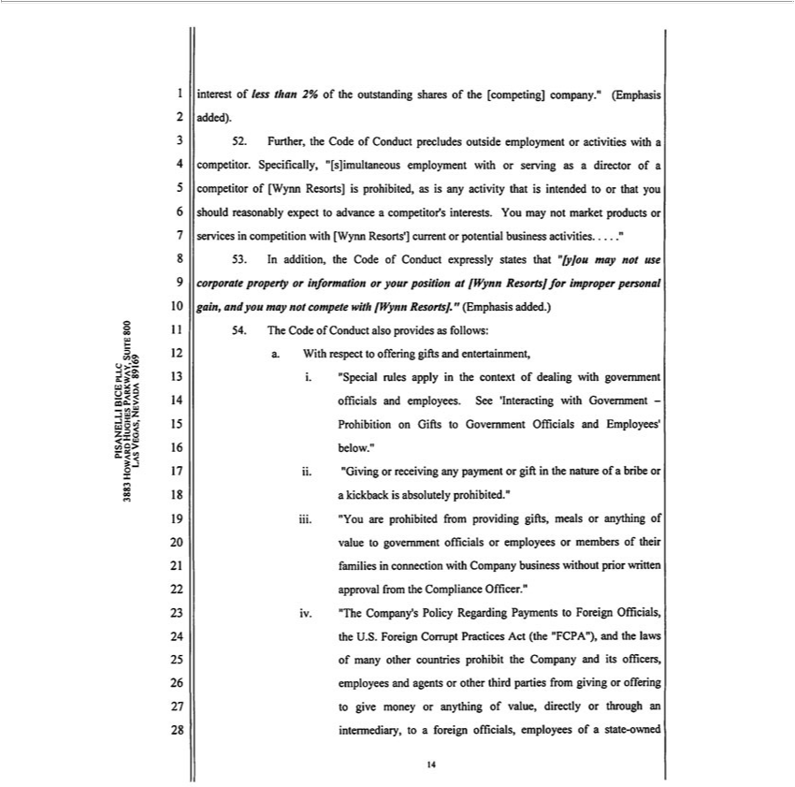

interest of less than 2% of the outstanding shares of the [competing] company.” |  |  |  | added). | , | employment with or serving as a director of a competitor of [Wynn Resorts] is
52. Fur her, the Code of Conduct precludes outside employment or activities with(Emphasis |  |  |  | . | ,
rohibited, as is any activity that is intended to or that you should reasonably expectcompetitoradvance Specificallycompetitor’“[s]imultaneousinterests.Y may not market products or services in competition with [Wynn Resorts’] current or
potential business activities.....”
53. In addition, the Code of Conduct expressly states that “[y]ou may not use corporate property or information or your position at [ Wynn Resorts] for improper personal gain, and you may not compete with
[Wynn Resorts].” (Emphasis added.)
54. The Code of Conduct also provides as follows:
a. With respect to of | gifts and entertainment, |  | and employees. See ‘Interacting with Government -Prohibition on Gifts to Government Officials and Employees’ below.”
. “Special rules applyferingthe context of |  | with government of
dealing ficials
_{iii}. “Giving or receiving any payment or _{gifts,} the nature_{anything}ofbribe or kickback is absolutely prohibited.”
. “You are prohibited from providing meals or of value to government officials or employees or members of their families in connection with Company business without prior written approval from the Compliance Officer.”
iv. “The Company’s Policy Regarding Payments to Foreign Officials, the U.S. Foreign Corrupt Practices Act (the “FCPA”), and the laws of many other countries prohibit the Company and its officers, employees and agents or other third parties from giving or offering to give money or anything of value, directly or through an intermediary, to a foreign officials, employees of a state-owned
PISANELLI1234567 8BICE910 PLLC1112 13 14 15 16 17 18 19 20 21 22 23 24 25 26 27 28
LAS3883 VEGAS,HOWARDNEVADAHUGHES89169PARKWAY, SUIT 800

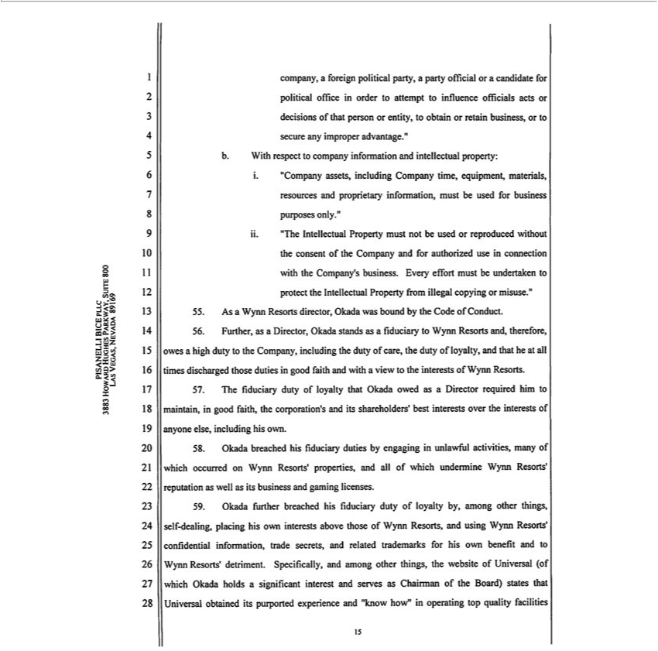

company, foreign political party, a party official or candidate for political office in order to attempt to influence officials acts or decisions of that person or entity, to obtain or retain business, or to secure any
mpr per adv |  | ntage.” b. With respect to company information and intellectual property: |  |  | must be | for business purposes only.”
. “Company assets, including Company time, equipment, materials, resources and proprietary |  |  |  |  | must be | for business purposes only.”
ii. “The Intellectual Property must not be used or reproduced without the consent of the Companyinformation,andauthorizedused in connection with the Company’s business. Every effort must be undertaken to protect
the |  | Property from illegal copying or misuse.”
56. | IntellectualAsWynn Resorts director, Okada |  |  | bound by the Code of Conduct.
56. | Further, as | Director, | stands wasa fiduciary to Wynn Resorts and, therefore, owes a high duty to the Company, including the duty of care, the duty of loyalty, and that he at all times discharged those
duties in good faith and withOkadaview to the interests of Wynn Resorts. |  |  |  |  |  | and its shareholders’ best interests over the interests of anyone else, including his own.
7 | The fiduci ry duty of loyalty that Okada owed as a Director required him to maintain, in good faith, the corporation’
58. | Okada breached his fiduciary duties by engaging in unlawful activities, many of which occurred on Wynn Resorts’ properties, and all of which undermine Wynn Resorts’ reputation as well as its business and
gaming licenses.
59. | Okada further breached his fiduciary duty of loyalty by, among other things, self-dealing, placing his own interests above those of Wynn Resorts, and using Wynn Resorts’ confidential information, trade
secrets, and related trademarks for his own benefit and to Wynn Resorts’ detriment. Specifically, and among other things, the website of Universal (of which Okada holds a significant interest and serves as
Chairman of the Board) states that Universal obtained its purported experience and “know how” in operating top quality facilities
1 2 | 3 4 5 6 7 8 9 10 11 12 13 14 15 16 17 18 19 20 21 22 23 24 25 26 27 28
PISANELLI BICE PLLC
LAS3883 VEGAS,HOWARDNEVADAHUGHES89169PARKWAY, SUIT 800

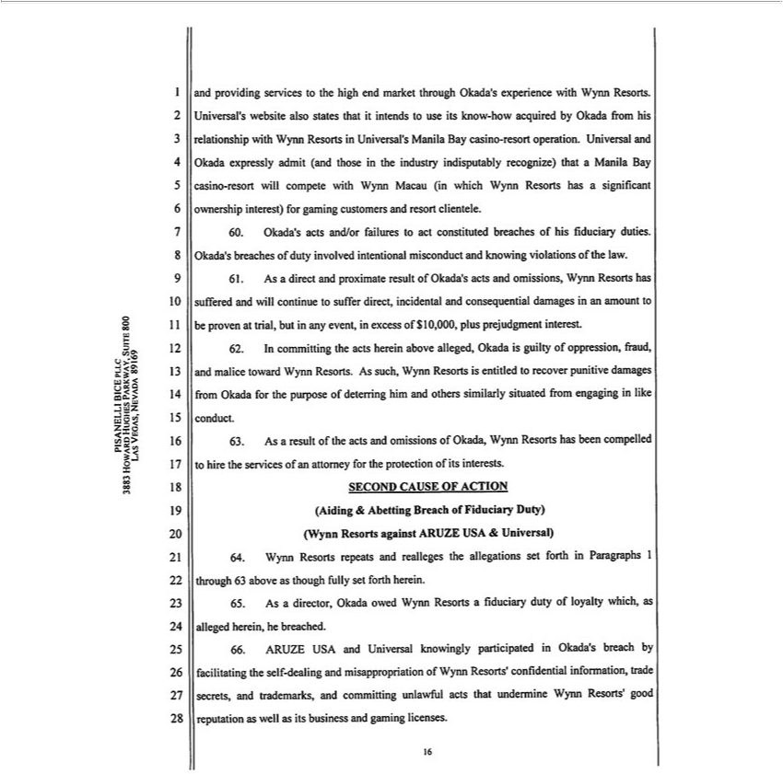

and providing services to the high end market through Okada’s experience with Wynn Resorts. Universal’s website also states that it intends to use its know-how acquired by Okada fr m his relationship with
Wynn Resorts in Universal’ Manila Bay casino-resort operation. Univers l and Okada expressly admit (and those in the industry indisputably recognize) that a Manila Bay casino-resort will compete with Wynn
Macau (in which Wynn Resorts has significant ownership interest) for gaming |  |  |  |  | and resort clientele.
0 | s acts and/or failures to act |  | breaches of his fiduciary duties.customersOkada’ breaches of duty involved intentional misconduct and knowing violations of the law.
61. Okada’Asdirect and proximate result ofconstitutedOkada’acts and omissions, Wynn Resorts has suffered and will continue to suffer direct, incidental and consequential damages in an amount to be proven at trial, but in
any event, excess of $10,000, plus prejud |  | ment interest.
62. In committing the acts herein above alleged, Okada is guilty of oppression, fraud, and malice toward Wynn Resorts. As such, Wynn Resorts is entitled to recover punitive damages from Okada for the
purpose of deterring him and others similarly situated from engaging in like conduct.
63. As a result of the acts and omissions of Okada, Wynn Resorts has been compelled to hire the services of an attorney for the protection of its interests.
SECOND CAUSE OF ACTION
Aiding & Abetting Breach of Fiduciary Duty)
(Wynn Resorts against ARUZE USA & Universal) |  |  |  | set forth in Paragraphs 1 through 63 above as though fully set forth herein.
4 | Wynn Resorts repeats and realleges the
5 | s a director, Okada owed Wynn Resortsallegationsfiduciary duty of loyalty which, as alleged herein, he breached.
66. ARUZE USA and Universal knowingly participated in Okada’s breach by facilitating the self-dealing and misappropriation of Wynn Resorts’ confidential information, trade secrets, and trademarks, and committing unlawful acts that undermine Wynn Resorts’ good reputation as well as its business and gaming licenses.
PISANELLI1234567 8BICE910 PLLC1112 13 14 15 16 17 18 19 20 21 22 23 24 25 26 27 28
LAS3883 VEGAS,HOWARDNEVADAHUGHES89169PARKWAY, SUIT 800

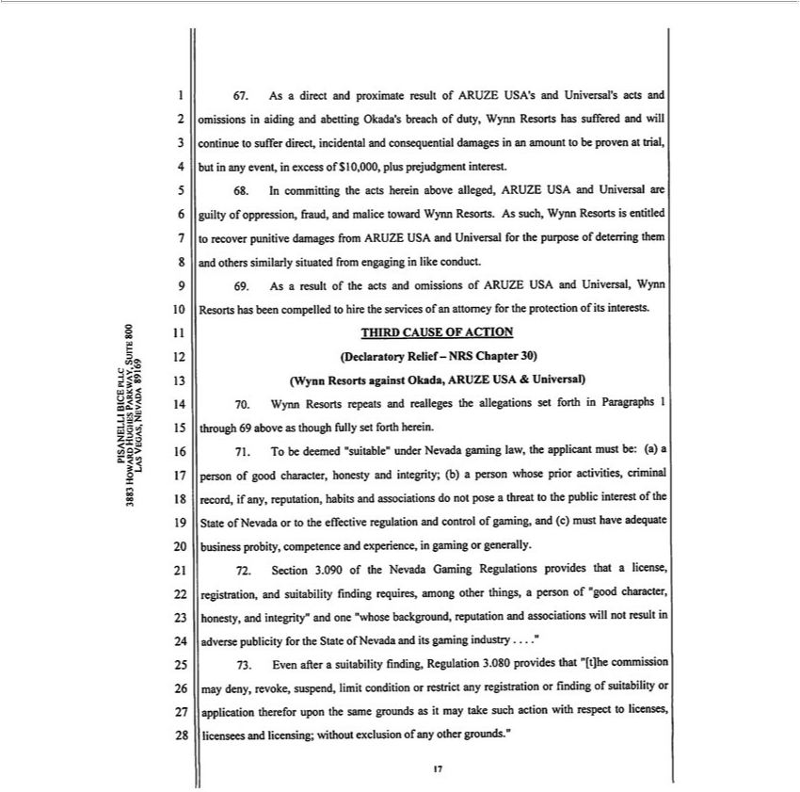

67. | As | direct and proximate result of ARUZE USA’s and Universal’s acts and omissions in aiding and abetting Okada’ breach of duty, Wynn Resorts has suffered and will continue to suffer direct, incidental
and consequential damages an amount to be proven at trial, but in any event, in excess of $10,000, plus prejudgment interest.
68. | In committing the acts herein above alleged, ARUZE USA and Universal are guilty of oppression, fraud, and malice toward Wynn Resorts. As such, Wynn Resorts is entitled to recover punitive damages
from ARUZE USA and Universal for the purpose of deterring them and others similarly situated from engaging in like conduct.
69. | As a result of the acts and omissions of ARUZE USA and Universal, Wynn Resorts has been compelled to hire the services of an attorney for the protection of its interests.
THIRD CAUSE OF ACTION
Declaratory Relief- NRS Chapter 30)
(Wynn Resorts against Okada, ARUZE USA & Universal)
0 | Wynn Resorts repeats and realleges the allegations set forth in Paragraphs 1 through 69 above as though fully set forth herein. |  |  | if any, reputation, habits
71. | T | be deemed “suitable” under Nevada gaming law, the applicant must be: (a) a person of good character, honesty and integrity; (b) person whose prior activities, criminal |  | if any, reputation, habits
and associations do not pose a threat to the public interest of the State of Nevada or to the effective regulation and control of gaming, and (c) must have adequate business probityrecord,competence and experience, in
gaming or generally.
72. | Section 3.090 of the Nevada Gaming Regulations provides that a license, registration, and suitability finding requires, among other things, a person of “good character, honesty, and integrity” and one “whose
background, |  |  | and associations will ot result in adverse publicity for the State of Nevada and its gaming industry .”
73. | Even afterreputation |  | finding, Regulation 3.080 provides that “[t]he commission may deny, revoke, suspend, limit condition or restrict any registration or finding of suitability or application therefor upon
the same groundssuitabilityasmay take such action with respect to licenses, licensees and licensing; without exclusion of any other grounds.”
1 2 | 3 4 5 6 7 8 9 10 11 12 13 14 15 16 17 18 19 20 21 22 23 24 25 26 27 28
PISANELLI BICE PLLC
3883 HOWARD HUGHES PARKWAY, SUIT 800
LAS VEGAS, NEVADA 89169

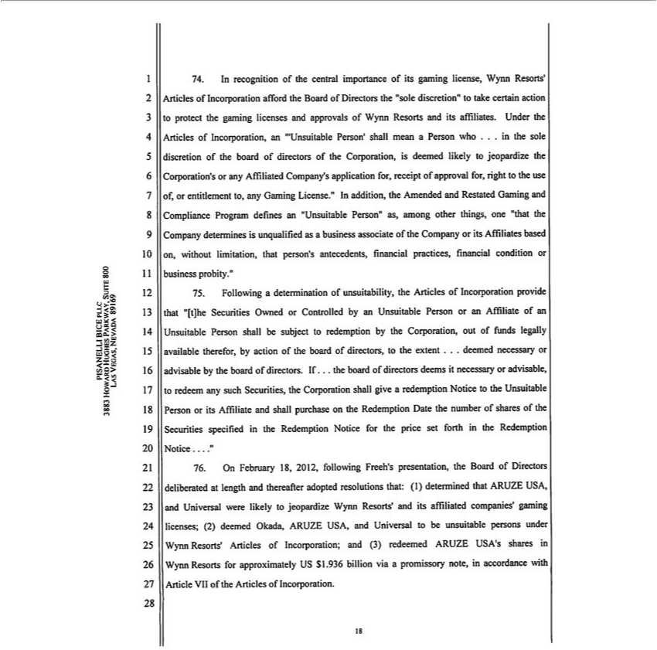

74. | In recognition of the central importance of its gaming license, Wynn Resorts’ Articles of Incorporation afford the |  |  |  |  | of Directors the “sole discretion” to take certain action protect the gaming licenses
and approvals of Wynn Resorts and its af |  |  |  | . Under the Articles of Incorporation, an ‘“Unsuitable Person’ shall meanBoardPerson who . in the sole discretion of the board of directors of the Corporation, is
deemed likely to jeopardize the Corporation’filiatesor any Affiliated Company’ application for, receipt of approval for, right to the use of, or entitlement to, |  |  |  |  |  |  | Gaming License.” In addition, the Amended and
Restated Gaming and Compliance Program defines “Unsuitable Person” as, among other things, one “ hat the Company determines is unqualified as anybusiness associate of the Company or its Affiliates based
on, without |  | that person’ |  | financial practices, financial condition or business probity.”
75. | Followinglimitation,determination of unsuitabilityantecedents,the Articles of Incorporation provide that “[t]he Securities Owned or Controlled by an Unsuitable Person or an Affiliate of an Unsuitable Person shall be subject to
redemption by the |  | out of funds legally available ther for, by action of the |  |  | of directors, to the extent . . . deemed necessary or advisable by the board of directors. If. the board of directors
deems it necessary Corporation,advisabl, to redeem any such Securities, the Corporation shall giveboardredemption Notice to the Unsuitable Person or its Affiliate and shall purchase on the Redemption Date the number of
shares of the Securities specified |  |  | the Redemption Notice for the price set forth in the Redemption Notice....”
76. | On February 18, 2012, following Freeh’ |  |  | presentation, the Board of Directors deliberated at length and thereafter adopted resolutions that: (1) determined that ARUZE USA, and Universal were likely to
jeopardize Wynn Resorts’ and its affiliated companies’ gaming licenses; (2) deemed Okada, ARUZE USA, and Universal to be unsuitable persons under Wynn Resorts’ Articles of Incorporation; and
(3) redeemed ARUZE USA’s shares in Wynn Resorts for approximately US $1,936 billion via a promissory note, in accordance with Article VII of the Articles of Incorporation.
1 2 | 3 4 5 6 7 8 9 10 11 12 13 14 15 16 17 18 19 20 21 22 23 24 25 26 27 28
PISANELLI BICE PLLC
3883 HOWARD HUGHES PARKWAY, SUIT 800
LAS VEGAS, NEVADA 89169

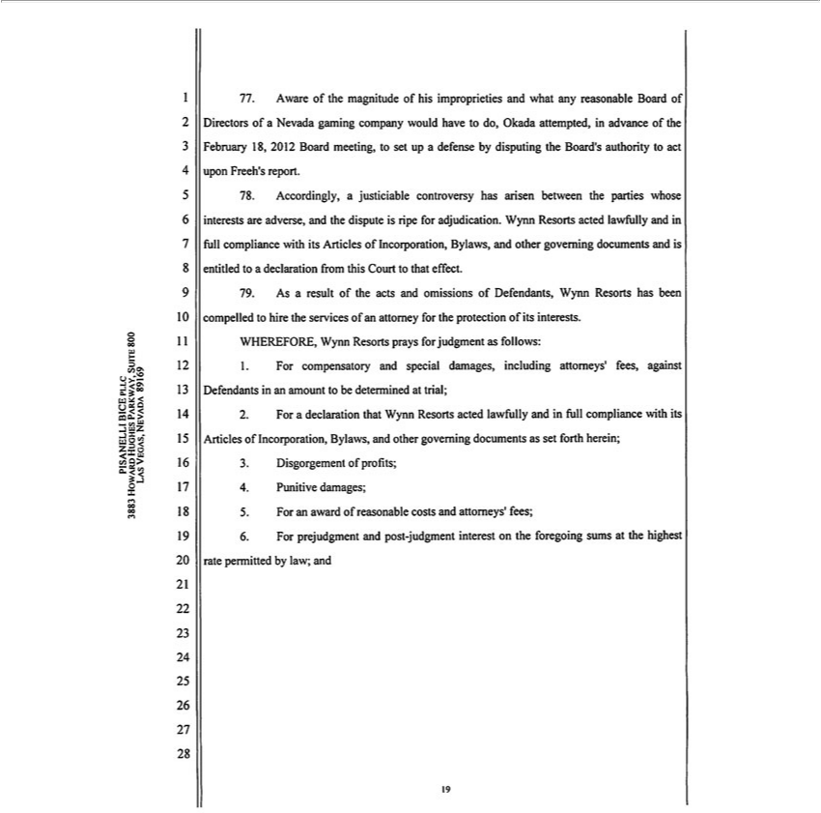

77. Aware of the |  | of his improprieties and what any reasonable Board of Directors of a Nevada gaming company would have to do, Okada attempted, in advance of the February 18, 2012 Board
meeting, to set up defense by disputing the Board’s authority to act upon Freeh’ report.
78. Accordingly |  | magnitudejusticiable controversy has arisen between the parties whose interests are adverse, and the dispute is ripe for adjudication. Wynn Resorts acted lawfully and in full compliance with its Articles
of |  | Bylaws, and other governing documents and is entitled to a declaration from this Court to that effect.
AsIncorporation,resultofthe acts and omissions of Defendants, Wynn Resorts has been compelled to hire the services of an attorney for the protection of its interests.
WHEREFORE, Wynn Resorts prays for judgment as follows:
1 |  | and special damages, including attorneys’ fees, against Defendants in an amount to be determined at trial;
2 | For compensatorydeclarationthat Wynn Resorts acted lawfully and in full compliance with its Articles of Incorporation, Bylaws, and other governing documents as set forth herein;
3 | Disgorgemenl of profits;
4 | Punitive damages;
5 | an award of reasonable costs and attorneys’ fees;
. For
16 2 3 4prejudgment5678910 and1112post13-judgment141516 17interest1819on20the21 foregoing22232425sums26 27at the28 highest rate permitted by law; and
LAS3883 VEGAS,HOWARDNEVADAHUGHES89169PARKWAY, SUIT 800

7. Any additional relief this Cour te deems just, and proper on the evidence presented at trial.
DATED this 18th day of February, 2012.
PlSANELLlBlCEP^C
Jmaaes J. Pisanelli, Esq., Bar No. 4027
Todd L. Bice, Esq., Bar |  |  | . 4534
Debra L. Spinelli Esq., |  |  | . 9696
Jarrod L. Rickard, Esq.,BarNoNo. 10203
3883 Howard Hughes Parkway, Suite 800
Las Vegas, Nevada 89169
and | ESq. (pro hac vice forthcoming)
Paul K.
Stephen Rowe,DiPrima,. |  | Esq. (pro hac vice forthcoming)
andWACHTBELL, LIPTON, ROSEN & KATZ, LLP 51 West 52nd Street New York, NY 10019
Robert L. Shapiro, Esq. (pro hac vice forthcoming)
Glaser Weil Fink Jacobs Howard Avchen & Shapiro, LLP 10259 Constellation Boulevard, 19th Floor Los Angeles, CA 90067 Attorneys for Wynn Resorts, limited
PISANELLI1234567 8BICE910 PLLC1112 13 14 15 16 17 18 19 20 21 22 23 24 25 26 27 28
LAS3883 VEGAS,HOWARDNEVADAHUGHES89169PARKWAY, SUIT 800



EXHIBIT 1
See Exhibit 99.2, which is incorporated herein by reference.

Exhibit 99.2

REPORT

Attorney – Client / Work Product / Privileged and Confidential

- Introduction

Wynn Resorts, Limited (“Wynn Resorts”), a publicly traded company incorporated in the State of Nevada, on behalf of its Compliance Committee, retained Freeh Sporkin & Sullivan, LLP (“FSS”) on November 2, 2011 to conduct an independent investigation. That independent investigation has been conducted under the sole direction of the Compliance Committee. The purpose of the investigation was to determine whether there is evidence that Mr. Kazuo Okada, a member of the Wynn Resorts Board of Directors, may have: (i) breached his fiduciary duties to Wynn Resorts; (ii) engaged in conduct that potentially could jeopardize the gaming licenses of Wynn Resorts; and/or, (iii) violated the Wynn Resorts compliance policy. Specifically, FSS has been asked to examine Mr. Okada’s efforts in connection with the creation of a gaming establishment in the Republic of the Philippines.

This is the Report to the Compliance Committee Chairman on the results of FSS’ investigation. As set forth with greater detail in the attached appendix, FSS has performed its investigation by interviewing dozens of individuals and by reviewing thousands of documents, electronic emails, corporate and public records.

- Summary

The investigation has produced substantial evidence that:

- Despite being advised by the Wynn Resorts Board of Directors and Wynn Resorts attorneys on the strict US anti-bribery laws which govern Wynn Resorts and its board, Mr. Okada strongly believes and asserts that when doing business in Asia, he should be able to provide gifts and things of value to foreign government officials, whether directly or by the use of third party intermediaries or consultants.

- Mr. Okada, his associates and companies have arranged and designed his corporate gaming business and operations in the Philippines in a manner which appears to contravene Philippine Constitutional provisions and statutes that require 60% ownership by Philippine nationals, as well as a Philippine criminal statute.

- Mr. Okada, his associates and companies appear to have engaged in a longstanding practice of making payments and gifts to his two (2) chief gaming regulators at the Philippines Amusement and Gaming Corporation (“PAGCOR”), who directly oversee and regulate Mr. Okada’s Provisional Licensing Agreement to operate in that country. Since 2008, Mr. Okada and his associates have made multiple payments to and on behalf of these chief regulators, former PAGCOR Chairman Efraim Genuino and Chairman Cristino Naguiat (his current chief regulator), their families and PAGCOR associates, in an amount exceeding US 110,000. At times, Mr. Okada, his

1

REPORT

Attorney – Client / Work Product / Privileged and Confidential

associates and companies have consciously taken active measures to conceal both the nature and amount of these payments, which appear to be prima facie violations of the United States Foreign Corrupt Practices Act (“FCPA”). In one such instance in September 2010, Mr. Okada, his associates and companies, paid the expenses for a luxury stay at Wynn Macau by Chairman Naguiat, Chairman Naguiat’s wife, their three children and nanny, along with other senior PAGCOR officials, one of whom also brought his family. Mr. Okada and his staff intentionally attempted to disguise this particular visit by Chairman Naguiat by keeping his identity “Incognito” and attempting to get Wynn Resorts to pay for the excessive costs of the chief regulator’s stay, fearing an investigation. Wynn Resorts rejected the request by Mr. Okada and his associates to disguise and to conceal the actual expenditures made on behalf of Chairman Naguiat.

- Additionally, Mr. Okada, his associates and companies appear to have engaged in a pattern of such prima facie violations of the FCPA. For example, in 2010 it also is possible that Mr. Okada, his associates and companies made similar payments to a Korean government official who oversees Mr. Okada’s initial gaming investment in that country. Additional investigation is needed to develop and confirm these possible FCPA violations.

- The prima facie FCPA violations by Mr. Okada, his associates and companies constitute a substantial, ongoing risk to Wynn Resorts and to its Board of Directors, creating regulatory risk, conflicts of interest and potential violations of his fiduciary duty to Wynn Resorts. Finally, Mr. Okada’s documented refusal to receive Wynn Resorts requisite FCPA training provided to other Directors, as well as his failure to sign an acknowledgment of understanding of Wynn Resorts Code of Conduct, increase this risk going forward.

- Mr. Okada insisted in his interview that all of his gaming efforts in the Philippines prior to the change of the presidential administration in the summer of 2010 were undertaken on behalf of and for the benefit of Steve Wynn and Wynn Resorts. This assertion is contradicted by press releases dating back to 2007 on his website, which announce an independent effort by Universal; his real estate investments; and the ownership of his corporations in the Philippines.

- (7) Mr. Okada has stated that Universal paid expenses related to then-PAGCOR Chairman Genuino’s trip to Beijing during the 2008 Olympics.

2

REPORT

Attorney – Client / Work Product / Privileged and Confidential

- Kazuo Okada’s Relevant Corporate Affiliations

- Wynn Resorts

After an initial public offering which closed in October 2002, Aruze USA, Inc., controlled by Mr. Okada, became a 24.5% shareholder of Wynn Resorts. Mr. Okada’s current ownership of Wynn Resorts through his control of Aruze USA, Inc. is 19.66%.

Mr. Okada became a member of the Wynn Resorts Board of Directors on October 21, 2002, and remains on the Board of Directors as of the date of this Report. In the past, Mr. Okada has used the title of Vice Chairman of Wynn Resorts. In October 2011, the Wynn Resorts Board of Directors eliminated the position of Vice Chairman.

As a Director of Wynn Resorts, Mr. Okada is entitled to receive the courtesy of what is called a “City Ledger Account.” Such accounts were originally instituted as a result of Sarbanes Oxley’s prohibition of extensions of credit, in the form of a personal loan from an issuer to an officer or director. The accounts were funded by deposits from the director or his company. Such an account exists for billing conveniences related to charges incurred at various Wynn Resorts locales. Mr. Okada has availed himself of this courtesy and established such a City Ledger Account.1 Within Wynn Resorts, this Okada City Ledger Account is referred to either as the “Universal City Ledger Account” or as the “Aruze City Ledger Account.” Accordingly, the phrases Universal City Ledger Account and Aruze City Ledger Account will be referred to interchangeably within this report despite the fact that Aruze Corp.’s name was changed to Universal Entertainment Corporation in November of 2009.

Mr. Okada has been found to be suitable by the Nevada Gaming Commission.2

- Universal Entertainment Corporation of Japan

Mr. Okada currently serves as Director and Chairman of the Board of Universal Entertainment Corporation (“Universal Entertainment”), registered in Tokyo, Japan. Universal Entertainment Corporation is the current trade name of a company which was incorporated in 1969 as Universal Lease Co. Ltd. and which became Aruze Corp. in 1998. Aruze changed its

- The initial wire to establish the Aruze Corp. City Ledger Account was dated February 15, 2008.

- Mr. Okada was originally found to be suitable as a shareholder of Aruze Corp. as part of An Order of Registration issued jointly by the State Gaming Control Board and the Nevada Gaming Commission on June 4, 2004. On June 5, 2005, in a similar order, the Nevada Commission and the State Gaming Control Board found Aruze Corp. to be (1) suitable as a controlling shareholder of Wynn Resorts, Limited, (2) suitable as the sole shareholder of Aruze USA, Inc., (3) that Aruze USA, Inc. is registered as an intermediary company and is found suitable as a shareholder of Wynn Resorts, Limited, and (4) that Mr. Okada is suitable as a shareholder and controlling shareholder of Aruze Corp. [See Appendix]

3

REPORT

Attorney – Client / Work Product / Privileged and Confidential

name to Universal Entertainment Corporation in November 2009. Universal is listed on the JASDAQ stock exchange and is engaged in the manufacture and sale of pachinko and gaming machines and related business activities. As of September 2011, Okada Holdings Godokaisha was Universal Entertainment’s major shareholder, with 67.90% of the issued shares.

The Nevada Gaming Commission has approved Universal Entertainment’s suitability as the 100% shareholder for a subsidiary, Aruze USA, Inc.

- Aruze USA, Inc.

Aruze USA, Inc. (“Aruze USA”) is a wholly owned subsidiary of Universal Entertainment. Aruze USA is a US company and was incorporated in the State of Nevada on June 9, 1999. Mr. Okada is a Director of Aruze USA and serves as its President, Secretary, and Treasurer.

Aruze USA has been found suitable by the Nevada Gaming Commission as a major shareholder of Wynn Resorts.

- Aruze Gaming America, Inc.

Aruze Gaming America, Inc. is a private company that is 100% personally owned by Mr. Okada. He currently serves as a Director, Secretary, and Treasurer of the company. Aruze Gaming America, Inc. is a US company and was incorporated on February 7, 1983. The company changed its name from Universal Distributing of Nevada, Inc. to Aruze Gaming America, Inc. on January 6, 2006. Aruze Gaming America, Inc. shares a common business address with Aruze USA, Inc. in Las Vegas, Nevada.

- Business Interests in the Republic of the Philippines

Since 2008, Mr. Okada has been involved with a variety of corporate entities and with various business associates in the creation of a gaming establishment in an area of the Philippines known as Entertainment City Manila.3 In furtherance of this endeavor, Mr. Okada and his associates have procured land and a provisional gaming license in the Philippines. A more detailed review of Mr. Okada’s corporate entities and business associates in the Philippines is set forth in Section V(2)(A) below.

- Business Interests in the Republic of Korea

Mr. Okada has recently pursued development of a casino resort complex in the Incheon Free Economic Zone in the Republic of Korea. A more detailed review of Mr. Okada’s activities in Korea is set forth in Section V(4) below.

- On the Universal Entertainment website (viewed January 30, 2012) this project is referenced as “Manila Bay Resorts.” [See Appendix] 4

REPORT

Attorney – Client / Work Product / Privileged and Confidential

IV. Relevant Legal and Policy Standards

- FCPA

The United States Foreign Corrupt Practices Act (“FCPA”) contains two primary categories of violations: (i) a books and records provision, and (ii) a bribery provision. Based upon available information, it seems clear that Aruze USA fits the definition of domestic concern4 and United States person5 provided in the FCPA, and that the FCPA applies both to Aruze USA and to Mr. Okada personally, in his capacity as an officer and director of Aruze USA.

Under the definitions of domestic concern and United States person, the statute applies to a corporation, partnership, unincorporated organization and other enumerated entities that have their principal place of business in the United States or which are organized under the laws of a State of the United States. It also applies to officers and directors of such concerns.6

In 1998, the FCPA was amended and added an alternative basis to interstate commerce for jurisdiction. As the United States District Court for the Southern District of New York wrote: “…. The amendments expanded FCPA coverage to ‘any person’

— not just ‘issuers’ or ‘domestic concerns’…. [A]ny United States person or entity violating the Act outside of the United States is subject to prosecution, regardless of whether any means of interstate commerce were used. Citing 15 USC 78dd-1, 78dd-2…. (Emphasis added.)7

Under this definition, Aruze USA is a covered party under the FCPA.

The FCPA provides that “[i]t shall be unlawful for any domestic concern, other than an issuer which is subject to section 78dd–1 of this title, or for any officer, director, employee, or agent of such domestic concern or any stockholder thereof acting on behalf of such domestic concern, to make use of the mails or any means or instrumentality of interstate commerce corruptly in furtherance of an offer, payment, promise to pay, or authorization of the payment of any money, or offer, gift, promise to give, or authorization of the giving of anything of value to—

- any foreign official for purposes of—

(A)

- 15U.S.C. 78 dd – 2(a),(h).

5 15U.S.C. 78 dd – 2(i).

6 15U.S.C. 78 dd – 2(g).

7 Inre Grand Jury Subpoena, 218 F. Supp. 2d 544, 550 (S.D.N.Y 2002).

5

REPORT

Attorney – Client / Work Product / Privileged and Confidential

- influencing any act or decision of such foreign official in his official capacity,

- inducing such foreign official to do or omit to do any act in violation of the lawful duty of such official, or

- securing any improper advantage; or

- inducing such foreign official to use his influence with a foreign government or instrumentality thereof to affect or influence any act or decision of such government or instrumentality, in order to assist such domestic concern in obtaining or retaining business for or with, or directing business to, any person;…”8

The head of PAGCOR fits within the definition of foreign official as used in the FCPA.

According to PAGCOR’s website, it “is a 100 percent government-owned and controlled corporation that runs under the direct supervision of the Office of the President of the Republic of the Philippines.”9 In addition to prescribing mandates to generate revenue for certain government programs and promote tourism in the Philippines, PAGCOR’s charter states that the entity will “… [r]egulate, authorize and license games of chance, games of cards and games of numbers, particularly casino gaming, in the Philippines….”10 (Emphasis added.)

As set forth above, there is still the interstate commerce basis for jurisdiction, but there is also an alternative. The alternative would require the same elements for an offense, but a showing of interstate commerce would not be required. If the interstate commerce basis for jurisdiction were used, the analysis set forth below would be of significance.

With regard to means or instrumentality of interstate commerce, some of the facts referred to in this report pertain to

Mr. Okada utilizing the Universal City Ledger Account to confer financial benefits upon Philippine gambling regulators who could

affect the business interests of Aruze USA, Inc. in the Philippines. Some of those benefits were conferred at Wynn Macau. The

following facts concerning the Universal City Ledger Account, which bear upon use of means or instrumentalities of interstate

commerce, were established during the investigation:

- The account is maintained at the corporate offices of Wynn Resorts, Limited in Las Vegas, Nevada where periodic deposits are made from Universal into the Wynn Resorts, Limited operating account at Bank of America in Las Vegas, Nevada to ensure that the amount on deposit remains at or about US 100,000. Bank documents reflect that the deposits are received from a Universal Entertainment account located in Japan.11

- 15 U.S.C. Section 78dd – 2(a).

- http://www.pagcor.ph/pagcor-faqs-profile.php, viewed January 18, 2012. [See Appendix]

10 Ibid., viewed January 18, 2012. [See Appendix]

11 See, e.g. wire transfer documents from Sumitomo Mitsumi Bank to Bank of America. [See Appendix]

6

REPORT

Attorney – Client / Work Product / Privileged and Confidential

- When charges are incurred at Wynn Macau, Wynn Macau tracks all charges for the Universal City Ledger Account on its books, and then the accounting department transfers the charges to accounting at Wynn Resorts, Limited in Las Vegas via a journal entry. Wynn Macau sends a pdf file to a staff accountant at Wynn Resorts, Limited in Las Vegas with all the backup documentation. Invoices issued by Wynn Resorts, Limited are periodically sent to a Universal Entertainment email address.12

- Nevada Gaming Regulations and Wynn Resorts Policies

The question of whether or not a gaming licensee or licensee applicant is deemed “suitable” in Nevada is answered by reviewing the Nevada Revised Statutes (“NRS”) in conjunction with the regulations promulgated by the Nevada Gaming Commission (“NGC”), which is empowered by the NRS.13

- Legislative Authority

The standard for determining suitability is found in Section 463.170 of the NRS. Paragraph (2) of the NRS 463.170, entitled Qualifications for license, finding of suitability or approval; regulations, provides that the person seeking a license or a suitability determination is subject to the following considerations: “[a]n application to receive a license or be found suitable must not be granted unless the Commission is satisfied that the applicant is: (a) A person of good character, honesty and integrity; (b) A person whose prior activities, criminal record, if any, reputation, habits and associations do not pose a threat to the public interest of this State or to the effective regulation and control of gaming….” In addition, paragraph (3) provides in pertinent part “[a] license

to operate a gaming establishment or an inter-casino linked system must not be granted unless the applicant has satisfied the Commission that: (a) [t]he applicant has adequate business probity, competence and experience, in gaming or generally….”

The Nevada Gaming Commission Regulations (“Nevada Gaming Regulations”) are also relevant to the conditions placed upon suitability. According to Section 3.080 of the Nevada Gaming Regulations, entitled Unsuitable affiliates, “[t]he commission may deny, revoke, suspend, limit, condition or restrict any registration or finding of suitability or application therefor upon the same grounds as it may take such action with respect to licenses, licensees and licensing; without exclusion of any other grounds.” Paragraph (1) of Section 3.090, entitled

- In a Wynn Resorts Memorandum to File from the Corporate Accounting department, dated January 10, 2012, the “invoice[s] and all support documentation are emailed to kimiko.okamura@hq.universal-777.com, takashi.usami@hq.universal-777.com and iwayama.hidetsugu@hq.universal-777.com on the 5th of each month for the prior month [sic] activity.” [See Appendix]
- For further advice regarding suitability, please consult directly with David Arrajj, Esq. and/or see Memo dated December 9, 2011 from Kate Lowenhar-Fisher, Esq. and Jamie L. Thalgott, Esq. to David Arrajj, Esq. re Associations and the Suitability Analysis. [See Appendix]

7

REPORT

Attorney – Client / Work Product / Privileged and Confidential

Standards for commission action, provides in pertinent part that “[n]o license, registration, finding of suitability, or approval shall be granted unless and until the applicant has satisfied the commission that the applicant: (a) Is a person of good character, honesty, and integrity; (b) Is a person whose background, reputation and associations will not result in adverse publicity for the State of Nevada and its gaming industry; and (c) Has adequate business competence and experience for the role or position for which application is made.”

- Underlying Corporate Documents of Wynn Resorts

The Second Amended and Restated Articles of Incorporation of Wynn Resorts, Limited (filed September 16, 2002) also provide for standards that seek to define an “Unsuitable Person.” As set forth on page 8 of the Articles of Incorporation, the phrase Unsuitable Person “shall mean a Person who . . . in the sole discretion of the board of directors of the Corporation, is deemed likely to jeopardize the Corporation’s or any Affiliated Company’s application for, receipt of approval for, right to the use of, or entitlement to, any Gaming License.” (Emphasis added.)

Finally, the Amended and Restated Gaming and Compliance Program of Wynn Resorts, Limited (adopted as of July 29, 2010) defines an Unsuitable person as a “[p]erson (i) who has been denied licensing or other related approvals by a Gaming Authority on the grounds of unsuitability or who has been determined to be unsuitable to be associated with a gaming enterprise by a Gaming Authority; or (ii) that the Company determines is unqualified as a business associate of the Company or its Affiliates based on, without limitation, that Person’s antecedents, associations, financial practices, financial condition or business probity.”

In the event of a finding of unsuitability, there are provisions within the aforementioned corporate documents that provide for a resolution post determination. Specifically, on page 6 of the Second Amended and Restated Articles of Incorporation of Wynn Resorts, Limited, the Articles state in pertinent part, “[t]he Securities Owned or Controlled by an Unsuitable Person or an Affiliate of an Unsuitable Person shall be subject to redemption by the Corporation, out of funds legally available therefor, by action of the board of directors, to the extent required by the Gaming Authority making the determination of unsuitability or to the extent deemed necessary or advisable by the board of directors. If a Gaming Authority requires the Corporation, or the board of directors deems it necessary or advisable, to redeem any such Securities, the Corporation shall give a Redemption Notice to the Unsuitable Person or its Affiliate and shall purchase on the Redemption Date the number of shares of the Securities specified in the Redemption Notice for the Price set forth in the Redemption Notice….” The Articles provide further guidance as to the terms of the redemption.

In addition, according to Section 3.6 of the Fourth Amended and Restated Bylaws, effective as of November 13, 2006, the removal of a director is premised upon “. . . the

8

REPORT

Attorney – Client / Work Product / Privileged and Confidential

affirmative vote of the holders of not less than two-thirds (2/3) of the voting power of the issued and outstanding stock of the Corporation entitled to vote generally in the election of directors (voting as a single class)….” Resignation is also listed as an

option “upon giving written notice, unless the notice specifies a later time for effectiveness of such resignation, to the chairman of the board, if any, the president or secretary, or in the absence of all of them, any other officer.”

- Wynn Resorts Code of Business Ethics

Wynn Resorts first adopted a Code of Business Conduct and Ethics on May 4, 2004. The document defines itself as “a statement of policies for the individual and business conduct of the Company’s employees and Directors….”14 There are two

sections of the Code that are relevant to this investigation: (i) conflict of interest and (ii) interaction with government officials. The sections are included below for reference purposes.

- Conflict of Interest:

“A Conflict of interest occurs when your private interests interfere, or even appear to interfere, with the interests of the Company. A conflict situation can arise when you take actions or have interests that make it difficult for you to perform your Company work objectively and effectively. Your obligation to conduct the Company’s business in an honest and ethical manner includes the ethical handling of actual, apparent and potential conflicts of interest between personal and business relationships. This includes full disclosure of any actual, apparent or potential conflicts of interest as set forth below.

Special rules apply to executive officers and Directors who engage in conduct that creates an actual, apparent or potential conflict of interest. Before engaging in any such conduct, executive officers and Directors must make full disclosure of all facts and circumstances to the Corporate Secretary, who shall inform and seek the prior approval of the Audit Committee of the Board of Directors.”

- Interacting with Government:

Prohibition on Gifts to Government Officials and Employees

“Different governments have different laws restricting gifts, including meals, entertainment, transportation and lodging, that may be provided to government officials and government employees. You are prohibited from providing gifts, meals or anything of value to government officials or employees or members of their families in connection with Company business without prior written approval from the Compliance Officer.”

- Wynn Resorts Code of Business Conduct and Ethics dated May 4, 2004, page 7. [See Appendix] 9

REPORT

Attorney – Client / Work Product / Privileged and Confidential

Bribery of Government Officials

“The Company’s Policy Regarding Payments to Foreign Officials, the U.S. Foreign Corrupt Practices Act (the “FCPA”), and the laws of many other countries prohibit the Company and its officers, employees and agents from giving or offering to give money or anything of value to a foreign official, a foreign political party, a party official or a candidate for political office in order to influence official acts or decisions of that person or entity, to obtain or retain business, or to secure any improper advantage. Please refer to the Company’s Policy Regarding Payments to Foreign Officials for more details regarding prohibited payments to foreign government officials.”

Discipline for Violations:

“The Company intends to use every reasonable effort to prevent the occurrence of conduct not in compliance with its Code and to halt any such conduct that may occur as soon as reasonably possible after its discovery. Subject to applicable laws and agreements, Company personnel who violate this Code and other Company policies and procedures may be subject to disciplinary action, up to and including discharge.” (Emphasis added.)

The Code has since been revised twice, once in 2009 and then again on November 1, 2011. Although the above sections have been expanded in these later editions, for the purpose of this investigation and the dates in question the substance has remained basically the same and the FCPA has continued to be a point of emphasis.

- Report of Investigation

  - Mr. Okada’s Attitude Toward Wynn Resorts Compliance Requirements

Mr. Okada’s prima facie violations of FCPA, involving both his government regulators in the Philippines and possibly in Korea, do not appear to be accidental or based upon a misunderstanding of anti-bribery laws. Conversely, despite being advised by fellow Wynn Resorts Board members and Wynn Resorts counsel that payments and gifts to foreign government officials are strictly prohibited, Mr. Okada has insisted that there is nothing wrong with this practice in Asian countries. Mr. Okada has stated his personal rejection of Wynn Resorts anti-bribery rules and regulations, as well as legal prohibitions against making such payments to government officials, to fellow Wynn Resorts Board members.

In a February 24, 2011 Wynn Resorts Board of Directors (“Board”) meeting at which Mr. Okada was present, after a lengthy discussion by the Board of the FCPA,15 including specifically the Universal project in the Philippines and potential Wynn Resorts’ involvement, “[t]he

- In an email from Kim Sinatra to Michiaki Tanaka, dated February 26, 2011, Ms. Sinatra referenced a meeting with Mr. Okada in which she furnished FCPA policy and training materials and reiterated the importance of strict compliance with the FCPA. [See Appendix]

10

REPORT

Attorney – Client / Work Product / Privileged and Confidential

independent members of the board unanimously advised management that any involvement [by Wynn Resorts] in the Philippines under the current circumstances was inadvisable.”16 During this discussion, Mr. Okada challenged the other board members over statements regarding the impermissibility under the FCPA of giving gifts abroad in return for favorable treatment, and made statements about hiring “third party consultants” to give gifts to officials.17

One board member recalled Mr. Okada stating that, in Asia, one must follow the local culture, and that is why one should hire “consultants” to give the gifts.18 This board member understood Mr. Okada to mean that such use of consultants would help avoid prosecution under the FCPA. Another board member who was present recalled Mr. Okada stating that conducting business in the Philippines was all a matter of “hiring the right people” to pay other people.19 Yet another board member recalled Mr. Okada being “adamant” during the FCPA discussion that it is not corrupt to give “gifts.”20 A board member who participated in the meeting by phone recalled Mr. Okada claiming that, in the Philippines, “business is done in a different manner, and sometimes you have an ‘intermediary’ that will do whatever he has to do,” or words to that effect.21 A different board member recalled being “shocked” by the contradiction between two of Mr. Okada’s statements during this discussion.22 Early in the discussion, Mr. Okada explained that there were no longer corruption issues in the Philippines with the new administration. However, Mr. Okada subsequently stated, in effect, that while he himself would not pay bribes, he would “hire someone else” to bribe the necessary person.

Pursuant to a chain of emails reviewed by FSS, commencing with an email on August 4, 2011 from Roxane Peper, Director of Intellectual Property and Corporate Records, to each of the board members (or their representatives), and ending with an email from Ms. Peper to Kevin Tourek, Senior Vice President and Corporate Counsel, on October 26, 2011, the following is clear:23

- All board members were notified of upcoming FCPA training/board meeting set for October 31 – November 1, 2011 and asked to confirm attendance by August 31, 2011.

- Mr. Okada, through two of his representatives, was emailed at least three (3) separate times before Shinobu Noda, his assistant, sent an email on September 15, 2011 confirming that Mr. Okada would attend.

- Minutes of Wynn Resorts Board of Directors meeting, February 24, 2011, p.3. [See Appendix]

- Interview of Steve Wynn, November 7, 2011.

- Interview of Robert J. Miller, December 16, 2011.

- Interview of Alvin V. Shoemaker, December 20, 2011.

- Interview of Marc D. Schorr, December 20, 2011.

- Interview of Allan Zeman, December 21, 2011.

- Interview of D. Boone Wayson, December 20, 2011.

- See emails from Roxane Peper to Kevin Tourek on October 26, 2011. [See Appendix]

11

REPORT

Attorney – Client / Work Product / Privileged and Confidential

Subsequent to the confirmation, Ms. Peper received an email from Ms. Noda on October 25, 2011. Ms. Noda stated that the email contained a message to Kim Sinatra, Senior Vice President and General Counsel of Wynn Resorts, from Mr. Okada.24 This part of the message was entirely in Japanese and had to be translated. Mr. Okada asked for the FCPA training materials to be provided in Japanese. He also stated that he would be arriving on “Monday [October 31]”, which was the day the FCPA training was to commence. He asked if the training could be held after the board meeting or rescheduled. Kim Sinatra sent a response to Ms. Noda via email on October 25, 2011 thanking Mr. Okada for the note and stating further that the FCPA training materials had been translated and would be provided to him via email and that Wynn Resorts had made further arrangements to have the FCPA live training translated to Japanese via simultaneous translation.25 She also stated that the date of the training could not be rescheduled because it had been planned around his previous confirmation and that outside counsel was coming to Las Vegas to provide the training.

Mr. Okada failed to attend the training on October 31, 2011. He was the only member of the board not in attendance (all others attended in person or via telephone dial-in as evidenced via a sign-in sheet).26

- Gaming Establishment in the Philippines

Evidence obtained in the course of the investigation establishes that Mr. Okada, his associates and companies, may have arranged and manipulated the ownership and management of legal entities in the Philippines under his control, in a manner that may have enabled the evasion of Philippine constitutional and statutory requirements. It is also noted that Mr. Okada’s two principal Philippine corporations, Eagle I Landholdings, Inc. and Eagle II Holdco, Inc., which may have been purposefully created to circumvent Philippine constitutional restrictions on foreign ownership of land, appear to be closely intertwined with Rodolfo Soriano, Paolo Bombase and Manuel M. Camacho, who have numerous common ties to former PAGCOR Chairman Efraim Genuino. For example, with regard to Eagle II Holdco, Inc., as late as 2010, Platinum Gaming and Entertainment (“Platinum”) had acquired 60% of its shares. According to a dated filing by Platinum on file with the Philippine SEC, Rodolfo Soriano controlled 20% of Platinum at the time of its incorporation. Mr. Soriano, referred to by attorney Camacho as a “bag man” for then-Chairman Genuino, is a former PAGCOR consultant and respondent in PAGCOR corruption referrals (see page 15 infra). Similarly, Paolo Bombase, an officer, director and nominal shareholder of Eagle I Landholding, Inc. and Eagle II Holdco., Inc. has a 1.25% share of Ophiuchus Real Properties Corp. This Ophiuchus entity is 15% owned by a Philippine company named SEAA Corp. In turn, SEAA is the family-controlled company of former PAGCOR Chairman Efraim Genuino. At this time, the significance of this interlocking shareholder link

- See email from Shinobu Noda to Roxane Peper dated October 25, 2011. [See Appendix]

- See email from Kim Sinatra to Shinobu Noda dated October 25, 2011. [See Appendix]

- See FCPA Training Sign-In sheet dated October 31, 2011. [See Appendix]

12

REPORT

Attorney – Client / Work Product / Privileged and Confidential

between Mr. Okada, his former Philippine gaming regulator, and the regulator’s associates is not known.

A. Corporate Links between Mr. Okada’s Business Interests and Those of Philippine Government Officials

Close associates and consultants of the former Genuino PAGCOR administration eventually attained positions as corporate officers, directors and/or nominal shareholders in legal entities controlled by Mr. Okada, and, in some cases, served as links between the business interests of Mr. Okada and those of former PAGCOR chairman Efraim Genuino and members of Genuino’s immediate family.

In order to better understand the interrelationships among corporate entities in the Philippines controlled by Mr. Okada and those controlled by PAGCOR officials and their associates, FSS requested the Philippines law firm of M. M. Lazaro & Associates (“Lazaro”) to produce a study of this issue.27 Drawing upon official records obtained from the Philippines Securities and Exchange Commission, Lazaro produced an analysis of the relationships created by the ownership and control structures of these entities.28 The chart below, extracted from that analysis, illustrates these relationships in schematic form.

- Manuel Lazaro was formerly a government corporate counsel with the rank and privileges of a Philippine presiding justice, court of appeals, who FSS retained to assist in the investigation and to advise on certain aspects of Philippine law. [See Appendix]
- The complete Lazaro PPT is attached to this report. [See Appendix]

13

REPORT

Attorney – Client / Work Product / Privileged and Confidential
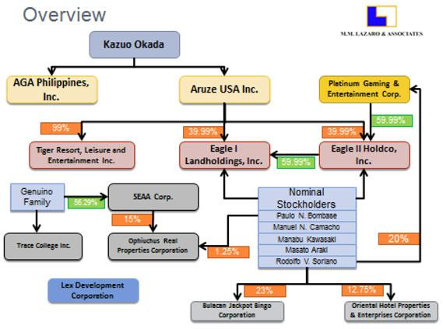

Tiger Resorts, Leisure and Entertainment, Inc. (“Tiger”) was incorporated in the Philippines on June 13, 2008.29 Its primary purpose was stated as:

To acquire, own, maintain, operate and/or manage hotels (city and resort), inns, apartments, private clubs, pension houses, convention halls, lodging houses, restaurants, cocktail bars, and any and all services and facilities related or incident thereto.30

Tiger is predominantly owned by Aruze USA, Inc.31 In August 2008, PAGCOR granted Tiger a Provisional Licensing Agreement to operate a gaming establishment in the Entertainment City Manila Zone. An official of the current PAGCOR administration told FSS in December 2011 that PAGCOR was currently reexamining this license.32

- Articles of Incorporation of Tiger. [See Appendix]

- Ibid. [See Appendix]

- GIS of Tiger, 2010. [See Appendix]

- Combined interview of Jay Daniel R. Santiago and Thadeo Francis P. Hernando, on December 12, 2011. It should be noted that after the interview with Santiago and Hernando, FSS along with its Philippine counsel, for purposes of this investigation, formally requested a copy of the Provisional Licensing Agreement from PAGCOR, as well as other related documents. On the same date that the formal request was made, PAGCOR refused to supply a

14

REPORT

Attorney – Client / Work Product / Privileged and Confidential

Eagle I Landholdings, Inc. (“Eagle I”) was incorporated in the Philippines on May 16, 2008 with 5 partners of the Philippines law firm Sycip Salazar Gatmaitan (“Sycip”) as the shareholders, directors and officers.33 By certification on September 5, 2008, the original shareholders were all replaced by, among others, Eagle II Holdco, Inc. (“Eagle II”), with approximately 60% ownership. Eagle II maintained this percentage of ownership of Eagle I through the filing of the latest available General Information Statement (“GIS”) for the year 2010.34 Eagle I’s 2009 GIS, filed September 17, 2009, indicates that Paolo Bombase, Manuel N. Camacho and Rodolfo V. Soriano (whose associations with PAGCOR and Mr. Genuino are explained below) all had become officers/directors and nominal stockholders of Eagle I; they retained this status through the filing of the latest GIS for Eagle I.35 Aruze USA, Inc. first appears as the owner of approximately 40% of Eagle I as of the 2010 GIS, owning the share previously owned by Molly Investments Cooperative UA (“Molly”).36

Eagle II’s filings with the Philippines Securities and Exchange Commission indicate a history similar to that of Eagle I. Incorporated on May 19, 2008 by the same 5 Sycip partners,37 Eagle II reflected the acquisition of approximately 60% of its shares by Platinum Gaming & Entertainment Corp. (“Platinum”) on its GIS filed September 17, 2009, with Platinum owning the same percentage as of the 2010 GIS.38 The same filings reflect the appearance--in 2009 and continuing through the 2010 filing--of Messrs. Camacho, Soriano and Bombase as officers/directors and nominal shareholders. In 2010 Aruze USA, Inc. appears with the 40% shareholding that was attributed to Molly in 2009.39

Platinum was incorporated in the Philippines on November 21, 2001, with a Certificate of Filing of Amended Articles of Incorporation (“AOI”) issued by the Philippines Securities and Exchange Commission on June 10, 2002.40 Platinum has no GIS on file with the Philippines Securities and Exchange Commission, and the only corporate document filed besides the Articles of Incorporation is the 2004 Financial Statement. The latest information on file lists Mr.

copy of Tiger’s Provisional Licensing Agreement, saying that they were bound by a non-disclosure clause. That refusal was signed by Francis P. Hernando, who is identified below as a PAGCOR employee, who stayed in Wynn Macau in June 2011 and had US 709.72 of expenses paid for by the Aruze City Ledger account. See Letter of Request and Letter of Refusal. [See Appendix]
- Articles of Incorporation of Eagle I. [See Appendix]

- GIS of Eagle I for years 2009 and 2010. [See Appendix] A GIS is required to be filed on an annual basis according to Section 141 of the Corporation Code of the Philippines. [See Appendix]
- Ibid. [See Appendix]

- Ibid. [See Appendix]; FSS has determined Molly to be a wholly owned subsidiary of Aruze Corp. See http://www.universal-

777.com/en/ir/ir_lib/material/annual_20081119.pdf, page 32.

- Articles of Incorporation of Eagle II. [See Appendix]

- GIS of Eagle II, years 2009-2010. [See Appendix]

- GIS of Eagle II, 2010. [See Appendix]

- Articles of Incorporation of Platinum, as amended June 10, 2002. [See Appendix]

15

REPORT

Attorney – Client / Work Product / Privileged and Confidential

Soriano, a former PAGCOR consultant, as a director/officer and a 20% shareholder in Platinum.41

Messrs. Camacho, Bombase and Soriano are all directly associated with former PAGCOR Chairman Genuino in significant ways. Mr. Camacho is an attorney and a principal of the Manila law firm Camacho & Associates. He was for a time in a law partnership with Mr. Genuino’s son, Erwin Genuino.42 Mr. Camacho traveled to Japan with Mr. Soriano at then PAGCOR Chairman Genuino’s behest, to meet with Mr. Okada and other representatives of Aruze. This meeting resulted in Mr. Camacho’s firm replacing Sycip in representing Aruze with respect to the development of the project in Entertainment City Manila.43

Sometime subsequent to this meeting, Aruze wired retainer funds to the bank account of Mr. Camacho’s firm, an account controlled jointly by Mr. Camacho and Erwin Genuino. Later, Mr. Camacho discovered that all or most of these funds had been withdrawn by Erwin Genuino. When he questioned this withdrawal, he was eventually told by Mr. Soriano and/or then PAGCOR Chairman Genuino that the funds had been withdrawn to be used as a “cash payoff” to the mayor of the municipality in which the Entertainment City Manila project is located, in order to facilitate approval of the use of some plots of land to build roads needed for Mr. Okada’s casino project. Mr. Camacho claims to have had a falling out with Erwin Genuino and Mr. Soriano, and to be involved currently in a lawsuit against Erwin Genuino over the dissolution of their law partnership.44 Erwin Genuino is named as a respondent, along with former PAGCOR Chairman Genuino, in two sworn corruption referrals (“PAGCOR Referrals”) filed with the Republic of the Philippines Department of Justice (“DOJ”) in the summer of 2011 by the current PAGCOR Administration.45

Mr. Bombase, also an attorney, is an officer/director and shareholder of Ophiuchus Real Properties Corporation (“Ophiuchus”), incorporated in April 2011.46 According to its 2011 GIS, Ophiuchus was 15% owned by SEAA Corporation (“SEAA”).47 SEAA, which was registered with the Philippine SEC on December 3, 1997, is, according to its 2011 GIS, 100% owned by members of former PAGCOR Chairman Genuino’s immediate family.48 The Articles of

- M. M. Lazaro & Associates, “Aruze Corporations in the Philippines and ‘Related’ Corporations”, p. 18. [See Appendix]

- Interview of M. Camacho, December 13, 2011.

- In his discussion with FSS, Mr. Camacho referred to the firm only as “Aruze,” not further defined.

- Although Mr. Camacho, who is in his seventies, failed to recall some details of his dealings with Mr. Genuino and Mr. Soriano, FSS credits the general account given by him during the December 13, 2011 interview.
- See PAGCOR Referrals. [See Appendix]

- Articles of Incorporation of Ophiuchus. [See Appendix]

- GIS of Ophiuchus, 2011. [See Appendix]

- GIS of SEAA, 2011. [See Appendix]

16

REPORT

Attorney – Client / Work Product / Privileged and Confidential

Incorporation of Ophiuchus also list Emilio Marcelo as an officer/director and shareholder.49 Mr. Marcelo is named as a respondent in the PAGCOR Referrals.50

Mr. Soriano is a former PAGCOR consultant, named by Mr. Camacho as a close business associate and “bag man” for Mr. Genuino.51 Mr. Soriano is also named as a respondent in the PAGCOR Referrals.52 As of the latest information filed with the Philippines Securities and Exchange Commission in 2002, Mr. Soriano was a 20% shareholder and an officer/director of Platinum,53 identified above as a 60% shareholder in Eagle II. If Mr. Soriano still held the same stake in Platinum when it acquired its share of Eagle II in 2009, then he became an effective owner of 12% of Eagle II and approximately 7% in Eagle I.

B. Apparent Evasion of Republic of Philippines Legal Requirements

As described in the preceding section, Mr. Okada caused various legal entities to be incorporated in the Philippines, in order to develop his casino resort project there, over time replacing the original incorporating Filipino shareholders with combinations of foreign shareholders affiliated with or controlled by him and associates of then-PAGCOR Chairman Genuino. As discussed below, there are constitutional and statutory requirements in the Republic of the Philippines requiring that purchasers of land be Philippines citizens or Filipino-owned legal entities, and that legal entities conducting business in the Philippines, with certain exceptions, be at least 60% Filipino owned.

In 2008, Eagle I purchased various tracts of land near Manila Bay totaling approximately 30 hectares at a total price of PHP 13,527,637,941.00 (approximately US 314,953,000.00) for the development of the project in Entertainment City Manila.54

At FSS’ request, Lazaro prepared an analysis and opinion on the validity of Eagle I’s ownership of these properties, in light of the aforementioned provisions of the Philippines Constitution and applicable statutes.55 The analysis included a detailed review of the ownership and capitalization of Eagle I and associated entities described in the preceding section. The following is a summary of pertinent findings of the Lazaro analysis.

- Articles of Incorporation of Ophiuchus. [See Appendix]

- See PAGCOR Referrals. [See Appendix]

- Interview of M. Camacho, Dec 13, 2011.

- See PAGCOR Referrals. [See Appendix]

- Articles of Incorporation of Platinum, as amended June 10, 2002. The 2001 Articles of Incorporation list four (4) additional 20% shareholders, identified as Filipino nationals. Because Platinum has not filed a GIS since 2002, the current ownership and control of Platinum is unknown. [See Appendix]

- Numbered Transfer Certificates of Title (“TCT”) for Eagle I purchase of land tracts in Parañaque City, Philippines, dated August 19, 2008. [See Appendix]

- M. M. Lazaro & Associates. Memo re “Validity of Eagle I’s Ownership of Real Estate Properties” (“Ownership Memo”), Jan 2012. [See Appendix]

17

REPORT

Attorney – Client / Work Product / Privileged and Confidential

A review of the 2009 Financial Statement of Eagle I disclosed that the funds used to purchase the land tracts appear to have been advanced by Molly.56

Platinum, the 59.99% owner of Eagle II, has filed no records with the Philippines Securities and Exchange Commission indicating that its paid-in capital ever increased beyond the original PHP 62,500, despite its amended Articles of Incorporation indicating that its authorized capital stock was increased from the initial PHP 1,000,000.00 to PHP 24,000,000.00.57 Nor is it known today what person(s) or entities have controlled Platinum since incorporation in 2001.

The 1987 Constitution of the Philippines requires that only Philippines citizens or corporations with at least 60% of their capital stock owned by Filipinos are qualified to acquire land in the Philippines.58 The Philippines Foreign Investment Act further requires that for a corporation to be considered a Philippines national, at least 60% of its capital stock outstanding and entitled to vote must be owned and held by citizens of the Philippines.59

Whenever facts or circumstances create doubt as to whether the ownership of 60% of a corporation is truly Filipino, Philippines Securities and Exchange Commission case law has held that a stringent examination of the true ownership of the voting stock of the subject corporation and of the true ownership of the voting stock of all successive layers of corporate ownership should be conducted. The application of this stringent standard is known as the “Grandfather Rule.”60

Serious doubts are therefore raised about the actual Filipino equity of Eagle I, because of the appearance that Eagle I and Eagle II were created purposely to “...circumvent the constitutional restriction on foreign ownership of land.”61 Lazaro bases this assertion on its conclusion that “…Platinum appears to be merely a shell corporation used to satisfy the Filipino equity requirement.”62 Application of the Grandfather Rule would therefore be appropriate.

Applying the Grandfather Rule, Lazaro calculates the true percentage of Filipino versus foreign equity in Eagle I as illustrated in the following table:63

- Ibid, p. 2. [See Appendix]

- Ibid, pp. 5-6. [See Appendix]

- Ibid, p. 8. [See Appendix]

- Ibid, pp. 9-10. [See Appendix]

- Ibid, pp. 11-14. [See Appendix]

- Ibid, p. 14. [See Appendix]

- Ibid, pp. 14-15. [See Appendix]

- Ibid, p. 15. [See Appendix]

18

REPORT

Attorney – Client / Work Product / Privileged and Confidential

 |  |  | Total | Total
 |  |  | Filipino | Foreign
Shareholder | Direct | Indirect | investment | investment
 |  |  | in Eagle I | in Eagle I
 |  | 24%
 | 40% of | (40% of 60% total
Aruze USA | 40% of | holdings of Eagle II |  | 64%
Aruze USA | Eagle I | holdings of Eagle II |  | 64%
 | Eagle I | in Eagle I)
 |  | 36%
 |  | (60% of 60% total
Platinum* |  | holdings of Eagle II | 36%
 |  | in Eagle I)

*As noted above, Platinum has failed to file its annually required GIS with the Philippine SEC since its inception in 2001. The calculations in the above table prepared by Lazaro assume the “best case” scenario (for Platinum), i.e., that it is a truly 100% Filipino-owned corporation. If Platinum’s actual Filipino ownership is less than 100%, then the percentage of Filipino investment in Eagle I would be correspondingly even less than calculated in the table.

Lazaro concludes that “...the foregoing shareholder structure appears to have been formulated by the parties as a legal scheme to justify the qualification of Eagle I to own real estate properties. The scheme employed...gives Aruze USA, Inc....a

convenient vehicle to justify its ownership...in circumvention of the constitutional restriction on the foreign ownership of land.”64 Lazaro goes on to conclude that the apparent shareholder structuring scheme outlined above may also constitute a violation of Commonwealth Act No. 108, commonly known in the Philippines as the “Anti-Dummy Law.”65 If convicted of a violation of this law, stockholders of Platinum and of Aruze USA, Inc. who profited from the scheme would face a sentence of imprisonment of not less than five years nor more than fifteen years.66

From the foregoing discussion, there is substantial evidence and credible legal opinion indicating that the ownership structure of Eagle I and Eagle II may subject Mr. Okada, along with his associates and companies, to civil as well as criminal sanctions under Philippine law.

- Ibid, p. 16. [See Appendix]

- Ibid, pp. 16-17. [See Appendix]

- Ibid, p. 17. [See Appendix]

19

REPORT

Attorney – Client / Work Product / Privileged and Confidential

- Apparent FCPA Violations Regarding Philippine PAGCOR Officials at Wynn Resort Properties

FSS has reviewed records of the Aruze City Ledger Account, through which Mr. Okada and Universal charge expenses for lodging, entertainment and other incidentals incurred at Wynn Resorts facilities against funds deposited into the account by Universal, and available underlying documentation furnished by Wynn Resorts management. The table below highlights thirty-six

- separate instances, from May, 2008, through June 2011 (more than a three (3) year period), when Mr. Okada, his associates and companies made payments exceeding US 110,000, which directly benefitted senior PAGCOR officials, including two chairmen and their family members.

Name | Relationship to | Location(s) and | Total Charged to
 | PAGCOR/Phil. | Date(s) of Stay(s) | Aruze City Ledger
 | Gov’t. |  | Account (in US)
Efraim C. Genuino | Former PAGCOR | WM June 6-9 2010 | 1,870.64
 | Chairman (February 2001
 | to June 30, 2010)
Cristino L. Naguiat Jr. | PAGCOR Chairman | WM Sep 22-26 2010 | See Suzzanne
 | (July 2, 2010 to |  | Bangsil67
 | Present)
 |  | WLV Nov 15-20 2010 | 5,380.86
 |  | WM June 6-10 2011 | 3,909.80
Dinner (Naguiat Party) | Chairman (PAGCOR) | WM Sep 24 2010 | 1,673.07
 |  | (Hosted by and
 |  | charged to Kazuo
 |  | Okada)
Maria Teresa | Wife of PAGCOR | WM June 6-10 2011 | 1,039.31
Socorro Naguiat | Chairman Cristino
 | L. Naguiat Jr.
Suzzanne | Wife of Rogelio Bangsil, | WM Sep 22-26 2010 | 50,523.22
Bangsil68 | PAGCOR
Jose Miguel | Husband of former | WLV Nov 12-17 | 4,642.40

- Chairman Naguiat did not identify himself and Mr. Okada’s representatives insisted that his stay there be “Incognito.” Accordingly, the bulk of the charges for the trip are reflected on the City Ledger Account as attributable to “Suzzanne Bangsil,” the wife of Rogelio Bangsil, a senior PAGCOR official and Chairman Naguiat’s employee. However, interviews, photo identifications and documentary evidence clearly establish that Chairman Naguiat was the “Incognito” guest and the direct beneficiary of these payments.

- Investigation has in fact determined that Chairman Naguiat was registered as an “Incognito” VIP guest under Suzzanne Bangsil’s reservation. Therefore, this US 50,523.22 was paid for Chairman Naguiat’s benefit.

20

REPORT

Attorney – Client / Work Product / Privileged and Confidential

“Mike” Arroyo | Philippines | 2009
 | President Gloria M.
 | Arroyo (Jan 20 2001
 | – June 20 2010)
Imelda Dimaporo | PAGCOR Board Member | WM June 8-10 2010 | 891.44
Philip Lo | PAGCOR Board Member | WLV April 29 | 1,755.25
 |  | 2009 – May 3
 |  | 2009
Manuel Roxas | PAGCOR Board Member | WLV April 200969 | 253.75
 |  | WLV April 29 | 1,686.95
 |  | 2009 – May 3
 |  | 2009
Susan Vargas | PAGCOR Board Member | WM June 8-10 2010 | 480.17
Jose Tanjuatco | PAGCOR Board Member | WLV Nov 15-18 2010 | 2,148.57
 | (July 19 2010 to Present)
Rogelio J. B. Bangsil | Officer in Charge of | WM Sep 24-26 2010 | 1,149.04
 | PAGCOR Gaming
 | Department
 |  | WM June 6-12 2011 | 2,955.23
Rodolfo Soriano | PAGCOR Consultant | WM June 3-7 2008 | 1,186.08
 |  | WLV Nov 12-17 2009 | 4,228.00
 |  | WM June 7-10 2010 | 1,104.06
 |  | WM Aug 18 2010 | 368.06
Olivia Soriano | Relative of Rodolfo | WLV May 2008 | 975.55
 | Soriano
Anthony F. | Son of Efraim C. | WLV Sep. 2008 | 2,386.26
“Ton” Genuino70 | Genuino; Mayor of
 | Los Baños (2010 to
 | Present)
 |  | WLV Oct 2008 | 2,326.49
Rafael Francisco | PAGCOR COO and | WLV Nov 12-17 2009 | 4,360.16
 | President
 |  | WM June 7-11 2010 | 935.21

- When the “Dates of Stay” in this table were not readily available, the month and year that the charges were entered in the City Ledger Account are used.

- See PAGCOR Referrals (Anthony Genuino is named as a respondent). [See Appendix]

21

REPORT

Attorney – Client / Work Product / Privileged and Confidential

Emelio Marcello | PAGCOR Consultant | WLV Nov 12-17 2009 | 1,181.60
 |  | WM June 7-9 2010 | 471.51
Carlos Bautista | PAGCOR VP Legal | WM June 6-10 2010 | 1,049.69
Mario Cornista | PAGCOR Consultant | WM June 7-9 2010 | 600.02
Rene Figueroa | PAGCOR Executive VP | WM June 7-10 2010 | 646.76
Ernesto Francisco | PAGCOR Executive | WM June 7-10 2010 | 797.17
 | Committee and
 | Casino General
 | Manager
Edward King | PAGCOR VP | WM June 7-10 2010 | 767.71
 | Corporate
 | Communications
Transportation | PAGCOR Delegation | WM Aug 2010 | 462.42
Jeffrey Opinion | Member of Naguiat Party | WM Sep 24-26 2010 | 906.61
Ed de Guzman | PAGCOR Executive | WM Jun 6-12 2011 | 3,421.79
 | Committee, AVP
 | Slots
Gabriel Guzman | Probable relative of | WM Jun 6-12 2011 | 1,391.71
 | Ed de Guzman (had
 | adjoining room)
(Thadeo) Francis P. | PAGCOR VP, | WM Jun 8-10 2011 | 709.72
Hernando71 | Licensed Casino
 | Development Dept.
TOTAL |  |  | 110,636.36

The total in the above table represents charges from the Aruze City Ledger Account that are readily identifiable as incurred directly by officials and consultants of PAGCOR,72 their family members and close associates, including Jose Miguel Arroyo, the then-First Gentleman of the Republic of the Philippines, husband of Philippine President Gloria Arroyo. Through a review of the Aruze City Ledger Account for statement periods March 2008 through November 2011, FSS has calculated that total charges to the account for that period, attributable to

- This is the same PAGCOR official who denied the FSS request for documents in December 2011, including a copy of the Provisional License Agreement. See footnote 31.
- In order to establish the PAGCOR affiliation of some of the individuals listed in this chart, various sources were consulted, including the PAGCOR website, internet news articles and the PAGCOR Referrals.

22

REPORT

Attorney – Client / Work Product / Privileged and Confidential

PAGCOR officials, employees, consultants, their associates and family members, exceed USD 110,000.73

FSS investigators interviewed members of the Wynn Macau management team, who furnished the following relevant information regarding a visit to that property in September 2010 by then and current PAGCOR Chairman and CEO Cristino L. Naguiat, Jr., his wife, three children, nanny and other PAGCOR officials, whose four-day stay at Wynn Macau was paid for via the Aruze City Ledger Account:

- September 20, 2010: Yoshiyuki Shoji of Universal, in an e-mail to Angela Lai of Wynn Macau, requests reservations for “Rogelio Bangsil (Guest Representative) & Others.” Mr. Shoji requests Encore Suite or “more gorgeous room, such as Villa,” and “the best butler” for unnamed person in group, who is “VIP for Universal.” Mr. Shoji states that guests other than Bangsil should not be registered, that all charges should be posted to Universal’s City Ledger,74 and that “Mr. Okada would like them to experience the best accommodations and services at Wynn Macau.”75 The communication makes no reference to PAGCOR or the government affiliation of the guests.

- September 20, 2010: In an e-mail to Wynn Macau President Ian Coughlan and others, Ms. Lai informs

Mr. Coughlan of the reservation and that checks of websites indicate that Mr. Bangsil is in charge of PAGCOR’s gaming department.76

- September 20, 2010: In an e-mail to Mr. Shoji, Ms. Lai advises that Wynn Macau is checking on availability of the requested upgrade and that Macau law requires that all room occupants be registered, and requests that all guest names be furnished in advance of or at the time of registration.77

- September 22, 2010: In an e-mail to Wynn Macau President Ian Coughlan, Wynn Macau Senior Vice-President – Legal Jay M. Schall advises Mr. Coughlan of

- See City Ledger Account. [See Appendix]

- When Mr. Shoji set up the City Ledger Account for Mr. Okada in 2008, he asked whether the customer name and amount paid would be made public. He was advised that such information would not become public. Email response from Kim Sinatra to Shoji, dated February 8, 2008. [See Appendix]

- E-mail from Y. Shoji to A. Lai, September 20, 2010 [See Appendix]; interview of A. Lai, January 4, 2012.

- E-mail from A. Lai to I. Coughlan, September 20, 2011 [See Appendix]; interview of A. Lai, January 4, 2012; interview of I. Coughlan, December 29, 2011. It should be noted that according to an article in Manilatimes.net, published February 2, 2012, Rogelio Bangsil has recently been transferred to the PAGCOR international marketing department after a probe that found the government losing PHP 160 million in government run casinos to a Mr. Liu. [See Appendix]

- E-mail from A. Lai to Y. Shoji, September 20, 2010 [See Appendix]; interview of A. Lai, January 4, 2012.

23

REPORT

Attorney – Client / Work Product / Privileged and Confidential

PAGCOR’s 100% government ownership and of Mr. Bangsil’s position there. He writes “Bangsil, the guest of Mr. Okada, is a top five (if not 3) officer.”78

- September 22, 2010 (14:00): Wynn Macau sends 1 Rolls Royce and 1 Elgrand to the airport, along with Masato Araki, Special Assistant to Mr. Okada; and Kenichiro Watanabe, another Universal associate, to meet arriving party, who arrived on Philippine Airline Flight 352 from Manila. They return with Chairman Cristino L. Naguiat, Rogelio Bangsil and Jeffrey Opinion at 14:45.79 Only Mr. Bangsil furnishes his name upon registration. Ms. Lai and Wynn Macau VIP Services Manager Beatrice Yeung thereafter checks PAGCOR website and identifies Chairman Naguiat’s name from his picture there.80 Ms. Yeung’s log and ongoing entries refer to “[I]ncognito (Mr. Naguiat, Cristino L.).”81

- Chairman Naguiat occupies Villa 81, the most expensive accommodation at Wynn Resorts Macau (about 7,000 square feet in size, which then cost about US 6,000 per day and is mostly reserved for “high rollers”).

- September 22, 2010: the Wynn Encore log book reflects “Incognito (Mr. Naguiat) stayed in Villa 81 Master Bedroom l.”82

- September 23, 2010 (10:00): Mr. Araki advises Ms. Yeung that Chairman Naguiat plans to have lunch with Miss Pansy Ho at MGM.83

- September 23, 2010 (14:04): Jay Schall sends an email to Wynn Macau corporate security to check Worldcheck, as a rush job, for Cristino L. Naguiat Jr., Chairman and Chief Executive Officer of PAGCOR.84

- E-mail from J. Schall to I. Coughlan, September 22, 2010 [See Appendix]; interview of J. Schall, January 3, 2012; interview of I. Coughlan, December 29, 2011.
- Wynn Macau Manager – Encore Logbook, September 22, 2010. [See Appendix]

- Interviews of Beatrice Yeung, January 4, 2012 and February 1, 2012; interviews of Angela Lai January 4, 2012 and February 2, 2012.

- Wynn Macau Manager – Encore Logbook, September 22, 2010. [See Appendix]

- Ibid. [See Appendix] During subsequent visits, Chairman Naguiat was identified as “Naguiat,” though he was identified during his initial visit as “incognito.” The negative inference to be drawn is an attempt to hide the payment of extremely costly expenses by a corporation connected with a regulated entity. The fact that he had only recently become chairman may have been a factor in his desire to keep his identity secret.

- Miss Ho is the daughter of Hong-Kong and Macau-based businessman Stanley Ho. Though Nevada gaming regulators found Miss Ho to be a suitable business partner for MGM Mirage, see
http://www.lvrj.com/business/45462797.html, New Jersey regulators recommended that she be found unsuitable as MGM Mirage’s joint venture partner in Macau. See http://www.newjerseynewsroom.com/state/mgm-mirage-chooses-pansy-ho-over-atlantic-city. [See Appendix]

- Email from Jay Schall to Peter Barnes of Wynn Macau Corporate Security, dated September 23, 2010. [See Appendix]

24

REPORT

Attorney – Client / Work Product / Privileged and Confidential

- September 23, 2010: In an e-mail to Ms. Lai, with a copy to Mr. Okada, Mr. Shoji requests that a credit of US 5,000 be extended to each person now staying at the Villa for shopping and gaming, up to a total of US 50,000. According to Mr. Shoji’s email, the funds are to be advanced by Wynn Macau and charged to the Universal City Ledger account.85

- September 24, 2010 (13:45): MOP 80,00086 (approximately US 10,000) is advanced from the Wynn Macau main cage to a Wynn Macau VIP Services employee (no longer employed at Wynn Macau), who in turn hands the money to Masato Araki, special assistant to president of Aruze USA, based upon instructions in the above referenced e-mail to Ms. Lai. The handover of funds is witnessed by Wynn Encore manager Alex Kong. The funds are charged to the Universal City Ledger Account. 87 MOP 15,000 of this sum is used to pay for a Chanel bag that Chairman Naguiat requested be purchased for his wife.88

- September 24, 2010 (Approximately 14:00): Mrs. Naguiat, her three children, Mrs. Bangsil and her daughter arrive at Wynn Macau.

- September 24, 2010 (15:45): Wynn Macau employees meet Mr. Okada and his assistant, Jun Yoshie, at the airport, transport them to Wynn Macau and escort Mr. Okada to room 5688.89

- September 24, 2010 (late afternoon): Mr. Coughlan receives a phone message from Mr. Yoshie that Mr. Okada would like to speak to him. Mr. Coughlan proceeds to an area near the Wynn Encore reception desk, where he meets Mr. Yoshie and Mr. Okada. They step into the Cristal Bar to talk, whereupon Mr. Okada, with Mr. Yoshie interpreting into English, tells Mr. Coughlan that the guests [referring to

- E-mail from Y. Shoji to A. Lai, September 23, 2010 [See Appendix]; e-mail from B. Yeung to I. Coughlan, September 27, 2010 [See Appendix]; interview of B. Yeung, January 4, 2012; Wynn Macau Manager – Encore Logbook, September 24, 2010.
- MOP 80,000 was worth approximately US 9,816 at that time.

- Wynn Macau Manager – Encore Logbook, September 24, 2010 [See Appendix]; Wynn Macau “Miscellaneous Disbursement” record #013014, dated September 24, 2010 [See Appendix]; e-mail from B. Yeung to I. Coughlan, September 27, 2010 [See Appendix]; interview of B. Yeung, January 4, 2012; interview of Alex Kong, February 1, 2012.

- Wynn Macau Manager – Encore Logbook, September 24, 2010. [See Appendix]. The Chanel bag was purchased by a Wynn Macau employee as per instructions by Mr. Araki, who works for Mr. Okada. The Wynn Macau employee gave the bag, store receipt and change to Mr. Araki to deliver to Mrs. Naguiat. Later, Mr. Araki stated that Mrs. Naguiat did not like the bag so he would give it to his own wife.

- Wynn Macau Manager – Encore Logbook, September 24, 2010 [See Appendix]; interview of B. Yeung, January 4, 2012.

25

REPORT

Attorney – Client / Work Product / Privileged and Confidential

Chairman Naguiat’s party] are very important to Universal, and that Mr. Okada wants Mr. Couglan to insure that they are well cared for during their stay.90

- September 24, 2010 (17:00): Mr. Okada meets Chairman Naguiat (and approximately thirteen (13)) others in his party) for dinner at Okada Restaurant.91 Mr. Okada hosts the dinner and the bill for $1,673.07 is charged to his room.

- September 25, 2010 (05:45): Wynn Macau employees meet Mr. Okada outside his room and escort him to a limousine, which transports him to the Macau Ferry Terminal for 07:00 scheduled ferry departure to Hong Kong International Airport.92

- September 25, 2010: Beatrice Yeung describes in her log book “Movements – Incognito (Mr. Naguiat, Cristino L) / Mr. Bangsil, Rogelio / Mr. Opinion, Jeffrey (Mr. Okada’s guests, Villa 81).”93

- September 25, 2010: Mr. Araki requests a second advance of MOP 80,000 for guests in Villa 81. Ms. Yeung accompanies Mr. Araki to the Main Cage and obtains the advance for him.94 [This makes a total of MOP 160,000 advanced for the use of Chairman Naguiat and his party and charged to the Universal City Ledger Account per Mr. Okada’s orders, as relayed in Mr. Shoji’s e-mail.]

- September 26, 2010 (11:10): Mr. Araki departs the Wynn Macau Encore main entrance. He hands Ms. Yeung MOP 4100, returning what he says is the remainder of the two cash advances for Chairman Naguiat’s party.95

- September 26, 2010 (13:15): Chairman Naguiat’s party departs via Wynn Macau limousine to pick up Mrs. Naguiat from shopping and proceeds to the airport.96

- Interviews of Ian Coughlan, January 5, 2012 and February 2, 2012.

- Interview of B. Yeung, January 4, 2012; Wynn Macau Manager – Encore Logbook, September 24, 2010. [See Appendix]

- Interview of B. Yeung, January 4, 2012; Wynn Macau Manager – Encore Logbook, September 25, 2010. [See Appendix]

- Wynn Macau Manager – Encore Logbook, September 25, 2010. [See Appendix]

- Interview of B. Yeung, January 4, 2012; Wynn Macau Manager – Encore Logbook, September 25, 2010 [See Appendix]; Wynn Macau “Miscellaneous Disbursement” record #013066, dated September 25, 2010. [See Appendix]
- E-mail from B. Yeung to I. Coughlan, September 27, 2010 [See Appendix]; Wynn Macau Manager – Encore Logbook, September 26, 2010 [See Appendix]; handwritten and signed note dated “9/26/10” with notation “MOP 4.100”. [See Appendix]. The returned funds were equal to approximately US 503.07 returned out of a total of approximately US 19,632 provided.

- Interview of B. Yeung, January 4, 2012; Wynn Macau Manager – Encore Logbook, September 26, 2010. [See Appendix]

26

REPORT

Attorney – Client / Work Product / Privileged and Confidential

- November 10, 2010: Mr. Shoji advises Mr. Coughlan in an e-mail of receipt of Wynn Macau’s invoice for the late September 2010 visit, in which the Villa [for Chairman Naguiat] was charged at the amount of MOP 48,000.

Mr. Shoji states that “I understand that Mr. Okada explained to you in Macau that they were our business guests and we made reservations for them and all charges are billed to our company. While some of charges [sic] will be reimbursed by them, room charges were planned to be borne by us as ordinary business expenses. Since the amount charged is too much and beyond the ordinary room charge, our company will be put in a very difficult position to give reasonable explanations if we are inquired by someone. I would appreciate if you would reconsider this matter and charge us the original rate (free upgrade to Villa) since the party directly dealing with [sic] on this matter is our company rather than the each [sic] individual guest.”(Emphasis added.)97

- On or about December 10, 2010: After e-mails and phone messages following Mr. Shoji’s September 20, 2010 e-mail, Mr. Coughlan has a phone conversation with Mr. Shoji, in which he advises Mr. Shoji that, after internal Wynn Macau discussions, the final decision was that Wynn Macau would not provide the requested free upgrade for the Villa occupied during the September 2010 visit.98

The foregoing recitation of facts surrounding the September 2010 visit of Chairman Naguiat and his party to Wynn Macau demonstrates several significant elements of that visit:

- Mr. Okada considered these guests to be very important to his company.

- An effort was made from the outset to conceal Chairman Naguiat’s identity and official status, to the point of not even wanting to advise Wynn Macau management and staff.

- With Mr. Okada’s knowledge, Chairman Naguiat and his family were provided with approximately US 20,000 cash to use for gaming and also shopping

- Mr. Okada’s representative sought to have Wynn Resorts fund a portion of the expenses incurred by Chairman Naguiat and his party, i.e., the free upgrade to a Villa.

- E-mail from Y. Shoji to I. Coughlan, November 10, 2010 [See Appendix]; interviews of I. Coughlan, December 29, 2011 and January 5, 2012.

- Interviews of I. Coughlan, December 29, 2011 and January 5, 2012; e-mail string between I. Coughlan and Y. Shoji and others, September 20 to December 9, 2010, subject: “Invoice and Statement for September Stay.” [See Appendix]

27

REPORT

Attorney – Client / Work Product / Privileged and Confidential

- Mr. Okada’s representative expressed apprehension about Universal being able to justify the level of expenditures in the event of future inquiries.

There is evidence that Mr. Okada personally directed the payments and gifts provided to Chairman Naguiat and his family during their luxury stay at Wynn Macau’s most expensive accommodation in September 2010. On October 5, 2010, Mr. Araki sent an email to Wynn Macau in order to arrange for a “second group of PAGCOR” checking into Wynn Macau on October 8, 2010.

Clearly referring back to Chairman Naguiat’s stay less than two weeks earlier, Mr. Araki writes: “Our Chairman Okada once again instructed us to take care of the group, but not like last time meaning that we will not take care of their room charges and others.” (Emphasis added). Mr. Araki, who worked for Mr. Okada and personally supervised Chairman Naguiat’s luxury stay at Wynn Macau, appears to confirm Mr. Okada’s personal knowledge and control of the payments for Chairman Naguiat.99

It is significant to note that the leadership of PAGCOR, which is appointed by the President of the Republic of the Philippines, changed effective June 30, 2010, when Benigno S. Aquino III assumed office as President of the Republic of the Philippines, succeeding Gloria M. Arroyo. Former PAGCOR Chairman Efraim C. Genuino, an Arroyo appointee, left office effective June 30, 2010, and Cristino L. Naguiat, Jr., President Aquino’s appointee, assumed the position of Chairman and CEO of PAGCOR on July 2, 2010.

A review of the Aruze City Ledger Account records reveals that, after June 30, 2010, there are no charges attributed to Mr. Genuino or any of his family members who collectively had three (3) separate stays at Wynn resorts (Macau or Las Vegas) while Mr. Genuino was PAGCOR Chairman.100 Conversely, the Aruze City Ledger Account reflects charges for Chairman Naguiat, his family, and key PAGCOR staff from Chairman Naguiat’s “new” administration only after Naguiat became PAGCOR Chairman. This sequence is evidence that the hosting of these persons at Wynn Resorts, and payments made for them through the Aruze City Ledger Account, are solely related to PAGCOR, the Philippines government agency in charge of licensing and regulating Mr. Okada’s business interests.

It is also clear that, having already received approval from PAGCOR in 2008 for a Provisional Licensing Agreement to develop a gaming business in the Philippines, Mr. Okada had a strong and continuing motive through 2010 and beyond to maintain favorable relations with the Chairmen and senior officials of PAGCOR. As previously noted, PAGCOR’s primary governmental mission is regulating gaming businesses in the Philippines. Mr. Okada’s project in Entertainment City Manila was prominently featured in PAGCOR’s annual reports for

- Email from Matt Araki to Beatrice Yeung dated October 5, 2010. [See Appendix]

- The sole exception identified, Rodolfo Soriano, Jr., is listed on the Aruze City Ledger Account as having a single room charge on August 18, 2010. [See Appendix]

28

REPORT

Attorney – Client / Work Product / Privileged and Confidential

2008,101 2009102 and 2010.103 The 2010 Annual report features photos and messages from Chairman Naguiat, and several other members of the new PAGCOR leadership. The 2010 Annual report makes it clear that two of the proponents, Bloomsbury and the SM Consortium, are constructing their resorts and are expected to complete their first phase within 2014. The other two proponents (one of which is Tiger, the provisional licensee for Mr. Okada’s casino project) are in the initial design stages and are expected to break ground in 2012.

The continuing coverage of Mr. Okada’s Manila Bay Resorts project in PAGCOR’s annual reports indicates that PAGCOR’s interest in and oversight of this project did not stop with the granting of the Provisional Licensing Agreement in 2008. Indeed, the very nature of the Provisional Licensing Agreement requires continued oversight by PAGCOR officials. As Lazaro advised, the Provisional Licensing Agreement was issued in relation to the “Bagong Nayong Philipino Manila Bay Tourism City” project, which is also referred to as “PAGCOR City.” PAGCOR City is envisioned to be a Las Vegas-style gaming and entertainment complex. The project was designed to attract proponents with established experience in the hotel and gaming business. PAGCOR released the “Terms of Reference,” which detailed a list of requirements to which project proponents must conform in order to qualify for a PAGCOR license to operate within PAGCOR City.

The “Terms of Reference” section provides, in pertinent part, a mandatory Minimum Investment of US 1 Billion, consisting of both equity and debt, and the submission of an associated Project Implementation Plan within 120 days from signing of the Provisional License and approval by PAGCOR (Paragraph 4, Section II, Terms of Reference). Furthermore, within 30 days of signing of the Provisional License, proponents are required to submit a Performance Assurance Bond in the amount of PHP 100 Million to guarantee the completion of the project (Paragraph 8, Section II, Terms of Reference). Within 15 days of signing of the Provisional License, proponents are also required to open an Escrow Account (with an initial deposit of at least US 100 Million) through which funds for the project will pass. This Escrow Account must maintain a balance of at least US 50 Million. (Paragraph 9, Section II, Terms of Reference).

Specifically, paragraph 13 of the Terms of Reference states the following in relation to achieving a regular, non-provisional, Casino Gaming license:

- PAGCOR 2008 Annual Report, pp. 12-18, viewed January 25, 2012 at http://www.pagcor.ph/annual- reports/annual-2008/pagcor-annual-report-2008.html. [See Appendix]
- PAGCOR 2009 Annual Report, pp. 16-19, viewed January 25, 2012 at http://www.pagcor.ph/annual- reports/annual-2009/pagcor-annual-report-2009.html. [See Appendix]
- PAGCOR 2010 Annual Report, pp. 24-26, viewed January 25, 2012 at http://www.pagcor.ph/annual- reports/annual-2010/pagcor-annual-report-2010.html. [See Appendix]

29

REPORT

Attorney – Client / Work Product / Privileged and Confidential

“13. Issuance of License

A Provisional License will be issued to the winning proponent effective for the duration of the project development period and shall not exceed the approved completion date of the whole project.

The Regular Casino Gaming License will be issued upon completion of the Project and upon approval by PAGCOR of the report detailing the actual total cost of the Project to ensure the proponent’s compliance with the approved project cost based on the Project Implementation Plan. The term of the License shall not exceed the term of PAGCOR as specified in RA 9487.

No sub-license will be issued nor allowed.” (Emphasis added.)

Thus, a Regular Casino Gaming License will be issued by PAGCOR upon (1) completion of the Project and (2) compliance with the approved project cost as approved by PAGCOR, based on the previously submitted Project Implementation Plan, including all other conditions as may be stipulated in the Provisional License Agreement.104 Clearly, PAGCOR maintains an active regulatory role over gaming businesses after the issuance of a provisional gaming license. An operator who has already been granted a provisional license, therefore, would have a powerful business incentive to maintain favorable relations with PAGCOR’s Chairman and senior leadership.105

Finally, the PAGCOR officials with whom FSS spoke in December 2011 indicated that, upon “taking over” from the Genuino Administration in 2010, they conducted a review of previously granted gaming licenses to ensure that all issuance decisions had been done properly, indicating that the Naguiat Administration was exercising close review in monitoring of all licensees, including Mr. Okada.

- See research of Michelle Lazaro as expressed in her email dated January 30, 2012 to Mike McCall; See also “Terms of Reference” that were attached to the email. [See Appendix]
- A recent example of the extent of PAGCOR’s continuing oversight of gaming operators can be found in the August 2011 issue of Inside Asian Gaming magazine. An article therein reported on claims by gaming operator Thunderbird Resorts, Inc. (“Thunderbird”) that PAGCOR had unlawfully attempted to force Thunderbird, through various allegedly selective enforcement actions, to renegotiate the revenue sharing agreement it had signed with the previous PAGCOR leadership under Mr. Genuino. See “Ball of Confusion,” dated August 10, 2011, Inside Asian Gaming, online edition, viewed January 26, 2011 at http://www.asgam.com/features/item/1238-ball-of-confusion.html. In the September 2011 issue, PAGCOR responded by making reference to various regulatory or enforcement functions it had been carrying out with regard to Thunderbird’s casinos, up through the time that the dispute became heated. Among the functions mentioned were “resident monitoring teams” in Thunderbird casinos to “...guarantee the fair conduct of games...” as well as PAGCOR’s serving of a notice of closure to Thunderbird in response to the disputed issues. See “Philippines Gaming Regulation—The Untold Story”, dated 23 September 2011, Inside Asian Gaming, online edition, viewed January 26, 2011. [See Appendix]. These statements by PAGCOR clearly indicate that PAGCOR maintains active regulatory monitoring of licensed gaming businesses in the Philippines and claims the authority to close down licensed operators.

30

REPORT

Attorney – Client / Work Product / Privileged and Confidential

Mr. Okada’s hosting and payments on behalf of PAGCOR Chairman Naguiat and his family at Wynn Macau, was most likely related to Mr. Okada’s business interests in the Philippines, and would therefore constitute a prima facie violation of the FCPA both by Mr. Okada as well as by Aruze USA, Inc.

- Possible Pattern of FCPA Violations Regarding Korean Government Officials

As stated previously, in recent years, Mr. Okada has been pursuing development of a resort complex in the Incheon Free Economic Zone in the Republic of Korea. Jong Cheol Lee, the Commissioner of the Incheon Free Economic Zone Authority, and apparently an Incheon government official, announced the signing of a Memorandum of Understanding on approximately October 27, 2011, between the Incheon Free Economic Zone (“IFEZ”) and Okada Holdings Korea to develop a casino resort near the Incheon International Airport.106

A review of the Aruze City Ledger Account disclosed charges paid for Jong Cheol Lee and other guests of his party at Wynn Las Vegas and Wynn Macau for the period November 2010 to June 2011. Registration documents provided by Wynn Resorts disclosed annotations for Mr. Lee and three other guests, indicating: “Share with Incheon Free Economic Zone.” According to the Aruze City Ledger Account, the following amounts were paid for government Lee and his party:

Name | Relationship to |  | Total Charged to
 | Incheon Free | Location and Date of | Aruze City Ledger
 | Economic Zone | Stay | Account
Jong Cheol Lee | Commissioner | WLV Nov 16-18 | 1,597.16
 |  | 2010
 |  | WM June 2011 | 1,134.55
Woo Hyeung Lee | Unknown | WLV Nov 16-18 | 843.89
 |  | 2010
 |  | WM June | 1,083.22
 |  | 2011
Min Yong Choi | Unknown | WLV Nov 16-18 | 507.50
 |  | 2010
Ki Dong Hur | Unknown | WLV Nov 16-18 | 779.20
 |  | 2010
TOTAL PAID |  |  | 5,945.52

These payments made for and on behalf of possible Korean government officials may be part of a continuing pattern by Mr. Okada and his associates to commit prima facie violations of the

- http://english.visitkorea.or.kr/enu/bs/tour_investment_support/pds/content/cms_view_1516066.jsp?gotoPage=&item=&keyword=, viewed January 14, 2012 [See Appendix]. http://blog.daum.net/ikoreatimes/60, viewed January 14, 2012. [See Appendix]

31

REPORT

Attorney – Client / Work Product / Privileged and Confidential

FCPA. However, further investigation is required in order to determine (i) the nature of Mr. Okada’s relationship with these guests;

- whether these guests actually had a government affiliation at the time of their 2010 visits to Wynn Las Vegas and Wynn Macau; and, (iii) the status of Mr. Okada’s gaming initiative in Korea.

- Mr. Okada’s Continuing Refusal to Receive Wynn Resorts mandated FCPA Orientation Training and to Acknowledge Wynn Resorts Code of Conduct

Mr. Okada’s apparent practice and pattern of committing prima facie violations of the FCPA must also be reviewed in the context of his ongoing and likely future conduct as a majority shareholder and director of Wynn Resorts. Since August, 2011, Mr. Okada has failed to make himself available for requisite Wynn Resorts Board of Directors training regarding the FCPA and compliance. Not only has every other board member accepted and received such training, but attempts to accommodate Mr. Okada (including Japanese translation of the FCPA training materials and telephonic availability for the training) have failed.

Moreover, since August 2011, Mr. Okada has also failed even to acknowledge in writing Wynn Resorts Code of Business Ethics and Wynn Resorts Policy regarding Payments to Government Officials. Mr. Okada’s continuing failure to perform this requisite review and agreement to comply with Wynn Resorts Ethics and anti-bribery rules and regulations create risk to Wynn Resorts and its board. Such non-compliance by Mr. Okada also suggests that he intends to continue his apparent practice and pattern of making FCPA prohibited payments on a going-forward basis. Any such future conduct would substantially enhance the risks to Wynn Resorts and compromise Mr. Okada’s fiduciary duties to Wynn Resorts.

On August 5, 2011, Cheryl Palmer, the executive assistant to Kevin Tourek, sent out an email memorandum on Mr. Tourek’s behalf to all board members stating that per compliance policy requirements, all members must acknowledge in writing on an annual basis having reviewed (and agreeing to comply with) two separate documents: (1) the Company’s Code of Business Ethics and (2) Policy Regarding Payments to Government Officials.107 A copy of the form was attached to the email, as was a copy of both the Code and the Policy. The email asked for the executed form to be returned prior to August 26, 2011. All of the members of the board, except for Mr. Okada, returned a signed copy of the acknowledgement. Mr. Okada was reminded, via emails to his representatives on a number of occasions,108 as well as via a letter from Kevin Tourek, dated November 2, 2011, to provide an executed copy of the

- See email from Cheryl Palmer dated August 5, 2011. [See Appendix]

- See emails contained in email from Kevin Tourek to Robert Shapiro, Esq., dated October 24, 2011. [See Appendix]

32

REPORT

Attorney – Client / Work Product / Privileged and Confidential

acknowledgement form no later than November 15, 2011.109 Mr. Okada failed to meet this deadline and, as of the date of this report, has yet to provide a signed copy of the form.110

In addition to his failure to return the fully executed Code of Business Conduct and Ethics and the Policy Regarding Payments to Government Officials Acknowledgment Form, which, as previously indicated, was sent out in August of 2011, Mr. Okada has yet to return a secondary acknowledgement form that was attached to the annual Directors’ & Officers’ Questionnaire (“D&O Questionnaire”). This form was sent out to each member of the board of directors on January 9, 2012, as part of the overall D&O Questionnaire packet.111 The packet contained instructions to “sign where indicated by the sign here tabs” and asked that the 2012 D&O Questionnaire be returned in its entirety on or before January 27, 2012. The two places that required Mr. Okada’s signature were (1) on page 26 of the D/O Questionnaire itself, and (2) on page 50 on the separate Code of Business Conduct and Ethics Acknowledgement Form that was part of the overall D&O Questionnaire packet. Though Mr. Okada returned the signature page (page 26) of the D&O Questionnaire itself on January 27, 2012,112 (which was confirmed to FSS on February 7, 2012), the fact that he has yet to return the separate Code of Business Conduct and Ethics Acknowledgement Form (which he has unequivocally pledged to do by virtue of signing on the signature page of the D&O Questionnaire) is telling and is consistent with his refusal to provide an executed copy of the Code of Business Conduct and Ethics and the Policy Regarding Payments to Government Officials Acknowledgment Form that was sent to him in August of 2011. Though Wynn Resorts did not send to

Mr. Okada the Code of Business Conduct and Ethics and the Policy Regarding Payments to Government Officials attached to the D

- O Questionnaire in Japanese language versions, which they did previously with respect to the code and policy sent out in August of 2011 after a request by Mr. Okada’s attorney, Mr. Okada has never previously requested that the D & O Questionnaire itself be translated into Japanese. Mr. Okada was again reminded of his obligation to return the separate Code of Business Conduct and Ethics Acknowledgment Form (page 50 of the D&O Questionnaire packet) in an email from Roxane Peper to Mr. Okada’s assistant, Takashi Matsui, on January 31, 2012.113 A copy of the form was attached to the email for Mr. Okada’s convenience. This form remains outstanding.

- See letter from Kevin Tourek to Mr. Okada, dated November 2, 2011. [See Appendix]

- In a letter dated December 1, 2011 to Robert Shapiro, Esq., outside counsel for Wynn Resorts, Gidon Caine, Esq., counsel for Mr. Okada, explained that the

reason Mr. Okada did not sign the acknowledgment form was due to the fact that the materials had not been translated into Japanese. As of the date of submission of this Report, Mr. Okada has not yet submitted a signed copy of the acknowledgment form despite being provided with the requested translations, which were attached to a letter sent via email dated December 27, 2011 from Jeffrey Soza to Gidon Caine. [See Appendix]

- See Memorandum from Kim Sinatra to Board of Directors and Officers of Wynn Resorts, Limited, dated January 9, 2012, and 2012 Director’s & Officers Questionnaire attached thereto. [See Appendix]
- See email from Takashi Matsui to Roxane Peper, dated January 27, 2012. [See Appendix]

- See email from Roxane Peper to Takashi Matsui, dated January 31, 2012. [See Appendix]

33

REPORT

Attorney – Client / Work Product / Privileged and Confidential

On February 1, 2012, Barry Brooks, one of Mr. Okada’s attorneys, contacted Kevin Tourek, senior vice president and general counsel with Wynn Resorts, via email regarding “address[ing] the request, forwarded to Mr. Okada under cover of a memorandum from Mr. Wynn, that Mr. Okada execute and return to Wynn Resorts, Ltd. (“Wynn Resorts”) a form of acknowledgment (“Acknowledgment”) in regard to the Wynn Resorts Code of Business Conduct and Ethics (the “Code”). Most importantly, I wanted to emphasize that Mr. Okada agrees, with a deep sense of commitment, with the principles set out in the Code and agrees that it is in the best interest of Wynn Resorts and its shareholders that he, as a director, be a leader in observing and advocating for those principles. Also, and in any case, Mr. Okada believes that the requirements of the Code, and the spirit of those requirements, are keys to the future success of Wynn Resorts.”114 In a follow-up phone call to that email, Mr. Brooks and

Mr. Tourek discussed the ramifications of Mr. Okada not signing the policy, the possibility of interpretation issues, and concerns over whether Mr. Okada may have any conflict of interest issues. Mr. Brooks also asked for a copy of the D & O Questionnaire.115

- Mr. Okada, his associates and companies, Universal have pursued independently a casino gambling development in the Philippines since 2008.

FSS interviewed Mr. Okada on February 15, 2012 and the results of that interview are set forth more fully in Section VI.116 In this interview, Mr. Okada asserted that all his efforts in the Philippines prior to the change of presidential administration in the summer of 2010 were undertaken on behalf of and for the benefit of Steve Wynn and Wynn Resorts, and that he only undertook to develop a gaming business in the Philippines independently subsequent to the change of presidential administrations.

On December 20, 2007, Aruze Corp. issued a press release entitled “Business Realignment and Future Business Development.” The press release stated the following:

“The Company looks to acquire the licenses necessary to operate a casino resort in the Asian region, including Macau, and to commence operation of a casino resort on its own over the next business year. . . . For this know-how, which is vital from a management perspective, the Company intends to enlist the full cooperation of Wynn Resorts, Limited’s Steve Wynn in its future pursuits regarding this project. For the purpose of successfully operating a casino resort in the Asian Region on an independent basis, the Company has received agreement from Steve Wynn that he will supply all necessary support, including active personal exchange with Wynn Resorts, Limited.…”117 (Emphasis added.)

- See email from Barry Brooks to Kevin Tourek, dated February 1, 2012. [See Appendix]

- See email from Kevin Tourek to Kim Sinatra, dated February 2, 2012. [See Appendix]

- Statements attributed to Okada during the February 15, 2012 interview are based on FSS’ contemporaneous notes.

- See JASDAQ press release for Aruze Corp., dated December 20, 2007, entitled “Business Realignment and Future Business,” available at: http://www.universal-777.com/en/ir/releases/2007/20071220 e.pdf. [See Appendix]

34

REPORT

Attorney – Client / Work Product / Privileged and Confidential

On April 25, 2008, Aruze Corp. issued another press release entitled “Casino Project in the Philippines.” This press release stated the following:

“As announced in its ‘Business Realignment and Future Business Development’ press release issued December 20, 2007, ARUZE GROUP seeks to commence the operation of a casino resort in the Asian region, which shall be conducted independently by ARUZE CORP. . . . Out of the above mentioned elements, where essential management-based know-how is concerned, the Company intends to proceed with the project under the full guidance of Wynn Resorts, Limited’s Steve Wynn.”118 (Emphasis added.)

The press release identifies the location of the planned casino as a plot of land adjacent to “Bagong Nayong Pilipino Manila Bay Tourism City.”

The language in the press releases suggest that Universal’s intentions from the inception of the project were to develop a gaming business independently, and not for the benefit of Steve Wynn or Wynn Resorts.

- Mr. Okada has stated that Universal paid expenses related to then-PAGCOR Chairman Genuino’s trip to Beijing during the 2008 Olympics.119

Mr. Okada was asked during his interview whether he met then-PAGCOR Chairman Genuino in Beijing during the 2008 Olympics. Mr. Okada stated that Universal’s President Tokuda made the arrangements for Chairman Genuino to travel to the Olympics. Mr. Okada explained that Mr. Tokuda was involved with the setting of the travel itinerary. When Mr. Okada was asked if the travel arrangements were “paid by Universal,” Mr. Okada responded “not 100% perhaps there were people certainly not all but I’m not familiar with the details.” Mr. Okada was then asked “To your knowledge, did Universal pay any of the associated costs of any of the travel of Mr. Genuino?” Mr. Okada answered “I don’t know whether or not the travel expense was paid by them. My understanding is that there was a certain amount of personal monies being spent from the attendees and participants including Chairman Genuino but I do not know details regarding this.” Mr. Okada was then asked “But is it your knowledge that some of those expenses were paid by Universal?” Mr. Okada answered: “Regarding the individual payment of personal monies, whether before or after, it was Universal that put together all of the expenses.”

Mr. Okada then explained that since Mr. Okada was previously invited to “one of the islands in the Philippines so in return well we decided that we would decide to do this in turn so I too would invite them as well. There was a time from where we had that understanding now that I recall. So I may have asked Mr. Tokuda to include this person [Genuino] as well.” The

- See JASDAQ press release for Aruze Corp., dated April 25, 2008, entitled “Casino Project in the Philippines,” available at: http://www.universal-777.com/en/ir/releases/2008/20080425 e pr2.pdf. [See Appendix]
- Attributions from Mr. Okada’s interview are based on FSS contemporaneous notes.

35

REPORT

Attorney – Client / Work Product / Privileged and Confidential

following question was then asked: “If there was a time that Genuino has invited you to the Philippines and in return for that you may have invited him or had some knowledge that Universal paid some of his expenses when he came to Beijing?” Mr. Okada responded: “I don’t like to be invited more than what is necessary because that would mean that I am vulnerable and I don’t like that. I was told that it was paid for and he insisted so I remember he had to be paid for in this way. So I remember that Mr. Tokuda said he should be included as well. I remember thinking that I had to return this in some way so I may have made that decision based on that memory.” (Emphasis Added).

Later in the interview, Mr. Okada stated that Chairman Genuino appeared to have a “few people” with him at the Olympics and, “I asked my staff why wasn’t he around and then my people said Mr. Genuino had a few people accompany him and he met with them to go shopping and once I heard that I do not recall now but again I don’t have a clear recollection of his whereabouts.”

VI. Summary of Mr. Okada’s February 15, 2012 Interview120

Mr. Okada had four lawyers present over the course of the interview, including a Japanese interpreter/associate. Mr. Okada was given a full opportunity to answer all questions. He attended the interview voluntarily and at the end he was asked whether he wanted to explain anything else.

- Apparent FCPA Violations regarding Philippine PAGCOR officials.

- Mr. Okada admitted going to Macau on or about September 24 2010 to meet with PAGCOR chairman Naguiat at Wynn Macau. Mr. Araki called Mr. Okada on either September 24 or 23 to advise that Chairman Naguiat was at Wynn Macau.

- Mr. Okada stated he flew to Macau from Japan for the sole reason of meeting Chairman Naguiat.

- Mr. Okada stated the purpose of Chairman Naguiat’s visit to Wynn Macau was for business – as a new PAGCOR Chairman, Naguiat wanted to better understand the casino business. Mr. Okada stated that a number of his Universal employees, including Araki, were at Wynn Macau in order to assist Chairman Naguiat in this regard.

- Mr. Okada stated that when he got to Wynn Macau he asked to see Ian Coughlan, Wynn Macau CEO.

- Mr. Okada asked to see and met with Ian Coughlan at Wynn Macau but denied telling Coughlan that the guests were Universal VIPs and that they should be treated well.

- Certain sections of the report below are presented in an abbreviated form. See the attached notes of Mr. Okada’s interview for a more expansive description. [See Appendix]

36

REPORT

Attorney – Client / Work Product / Privileged and Confidential

- Mr. Okada emphatically denied saying this and related that there is no way he would have said something to that extent regarding special care: “I would have said this is a person with a position with PAGCOR, I would have said be normal and don’t do anything out of the ordinary.”

- Mr. Okada stated he attended a dinner for approximately ten (10) people at Wynn Macau and that Chairman Naguiat also attended.

- Mr. Okada stated that either Araki, Shoji or Universal paid for the dinner
- Mr. Okada said that he did not know whether any other PAGCOR officials attended the dinner.

- Mr. Okada stated that he and Naguiat did not discuss any business at the dinner which would have been rude.

- Mr. Okada stated that he believed Naguiat’s wife was present at the dinner but that he was not introduced to her.

- Mr. Okada stated he left early the next morning.

- Mr. Okada’s Knowledge of and Response to Chairman Naguiat’s September 2010 stay

- Mr. Okada stated that sometime after September 2010 he learned from Universal President Tokuda that the cost of Chairman Naguiat’s stay at Wynn Macau exceeded reasonable entertainment expenses.

- Mr. Okada learned about the excessive September 2010 expenses from Takuda about three or four months after the events when the bills would come up.

- Mr. Okada stated that he was never told the cost of Chairman Naguiat’s Wynn Macau stay nor did he ask anybody that question.

- Mr. Okada stated that he understood that Chairman Naguiat had stayed in the most expensive accommodation at Wynn Macau. But he said “I heard later on that he was in one of the more expensive rooms. I heard this in the context of it would be a problem regarding our corporate policy.…”
- Mr. Okada stated that Chairman Naguiat’s wife was present at Wynn Macau. Mr. Okada did not know if his children were present.

- Mr. Okada stated that he did not know that any cash had been provided to Chairman Naguiat.

- Mr. Okada stated that he did not know that Universal employees had tried to hide the identity of Chairman Naguiat as a guest.

- Mr. Okada stated that he did not know how long Chairman Naguiat had stayed at Wynn Macau.

- Mr. Okada denied seeing two (2) emails from Shoji to Angela Lai at Wynn Macau, dated September 20th and 23rd 2010 respectively, which requested

37

REPORT

Attorney – Client / Work Product / Privileged and Confidential

reservations for a Universal VIP guest, “who would not be registered,” and arrangements to provide up to 5,000 US credit for each person staying at Naguiat’s Villa. Mr. Okada explained that although he saw his name in the email cc’s, he would not have seen either email because for the most part he does not use his PC.

- Mr. Okada stated that internal Universal rules do not permit the payment of cash to government officials. Mr. Okada stated that no stay in the Villa in Wynn Macau could cost US 50,000
- Mr. Okada stated that internal Universal rules permitted the payment of reasonable entertainment expense for government officials but did not know what amount was permitted.
- Mr. Okada stated that the cost of Chairman Naguiat’s stay at Wynn Macau caused a “problem” for Universal and that as a result Araki was fired, and Shoji resigned after having been scolded by Mr. Okada.

- Mr. Okada stated that he did not make any changes at his company or give anyone new instructions as a result of finding out about Naguiat’s stay in September 2010.

- Mr. Okada said that it was possible that Chairman Naguiat would be billed for the cost of the stay.

- Mr. Okada said, when he was asked about a reference in a Shoji email to posting all expenses to the Universal City Ledger Account, that he lacked any knowledge of such an account and said “I wonder if the City Ledger is in reference to our internal policy, as long as it is under that ceiling.…”

C. Mr. Okada stated that he was aware of only one other guest stay at Wynn Macau that he believed was improperly paid by Universal.

- Mr. Okada stated only a few weeks ago he learned from President Tokuda that Anthony Genuino, son of former PAGCOR Chairman Genuino, had stayed at Wynn Las Vegas in September of 2008 and that Universal had paid US 2300 for his stay.

- Mr. Okada stated that Genuino would be sent the bill for this cost
- Mr. Okada denied any knowledge of other PAGCOR officials staying at Wynn Resorts from 2008 through June 2011 with Universal paying for their expenses.

- Mr. Okada stated that he had just instructed President Tokuda of Universal to conduct an investigation into Universal’s payment of entertainment expenses.

- Mr. Okada blamed Shoji as the responsible party for these payments.
- Mr. Okada stated that he yelled at Shoji for not reporting these matters to him and would have fired Shoji except that Shoji resigned. Mr. Okada stated that Tokuda

38

REPORT

Attorney – Client / Work Product / Privileged and Confidential

did report these matters and Mr. Okada believed that Shoji was also in a position to know all about what had happened but had failed to report it to him.
- Mr. Okada stated that Shoji was a trusted employee who had worked closely with him since 2002 and should have reported these matters to him.

- Mr. Okada stated that they were just starting this investigation and that bills may be sent to certain of these guests for the expenses which Universal paid.

- Mr. Okada especially blamed Mr. Shoji since he was the head of the company’s compliance committee from 2002-2010.

- Mr. Okada stated that he last met with Chairman Naguiat in the Philippines during January 2012 in order to seek land leasing approval from PAGCOR.

- Mr. Okada stated that Universal had an expense policy but he didn’t know what the amounts were. Mr. Okada stated that he was unfamiliar with the specific details of his compliance policy because he was too high within the company. He left it to others to handle the details of the policies.
- Mr. Okada was asked a series of questions regarding about a dozen other PAGCOR officials who stayed at Wynn Macau or Wynn Las Vegas during 2010 and 2011 for whom Universal paid their expenses.
- Mr. Okada denied having authorized any of these payments and said that he would not have authorized such payments if the guests were PAGCOR officials.

- Mr. Okada stated that on one occasion he met Jose Miguel Arroyo, husband of Former Philippine President Gloria Arroyo, but did not know that Jose Arroyo had stayed at Wynn Las Vegas in November 2009, with Universal paying for his expenses totaling US 4,642.

- Mr. Okada stated that he met Chairman Naguiat approximately 4 or 5 times since Naguiat’s Chairmanship in June 2010 and that these meetings always involved official matters.
- Mr. Okada stated that he told Tokuda in December of 2011 to investigate these matters.
- Mr. Okada stated that December was the first time he asked Mr. Tokuda investigate these charges for Universal.

- Mr. Okada stated further that Shoji was a trusted employee whom he had met with “very frequently.” During the time period in September 2010 when Shoji was setting up the Naguiat visit, Shoji told Mr. Okada nothing about Naguiat.

- Okada statements to the Board of Directors Regarding doing business in Asia

- Mr. Okada stated that he could not specifically remember attending a Wynn Resorts Board of Directors meeting in February 2011.

39

REPORT

Attorney – Client / Work Product / Privileged and Confidential

- Mr. Okada stated that he did not remember attending a Wynn Resorts Board of Directors meeting where bribery was discussed.
- Mr. Okada denied ever stating to Wynn Resort Directors words to the effect that “it was a matter of hiring the right people and that you must pay other people.” He responded “absolutely not, that’s a lie.”
- Mr. Okada denied telling fellow board members words to the effect that “you have to follow local customs and that’s why you have consultants.”

- Mr. Okada also denied ever stating to fellow board members words to the effect “I wouldn’t bribe someone but would have someone else bribe that person.”

- As to bribing someone in the Philippines, Mr. Okada stated that “there is no need to do that in the Philippines even because we are in the position to invest.”

- Mr. Okada also denied ever stating words to the effect that “in Asia, it is okay to give gifts to government officials.” His response was “absolutely not.”

- Mr. Okada stated that he had been a member of the Wynn Resorts Board of Directors since 2005 or 2006. When asked about his duties or responsibilities as a director of Wynn Resorts, Okada stated that he had to “ensure socially just company, there should be no illegal activities, and that I have to help them be successful and grow as a company.”

- Mr. Okada was asked if he had ever read the Wynn Resorts Code of Conduct to which he responded, “No because it is in English, no I cannot.”

- Mr. Okada was asked if he had accepted Wynn Resorts Board of Director FCPA training in 2011, to which he replied that he had received some documents but sent them to his lawyers.

- Doing Business in the Philippines

- Mr. Okada stated that prior to the new Philippine administration taking over in 2010, his efforts to conduct a gambling business in the Philippines were being done for Wynn Resorts and that he was reporting to Steve Wynn about these activities.

- Mr. Okada said before the new Philippine administration in 2010 “All of the conversation between myself and Genuino was for the sake of explaining to Mr. Wynn.”

- Mr. Okada stated that a press release from Aruze Corp. dated April 25, 2008, that announced Aruze would independently operate a casino project in the Philippines, had not been presented to him for approval.

- Mr. Okada stated that neither Steve Wynn nor Wynn Resorts had invested any money in the Philippine business initiative which he had been conducting since 2008.

40

REPORT

Attorney – Client / Work Product / Privileged and Confidential

- Okada stated that Universal had invested between US 300-400 million in 2008 to acquire the land for the Manila Bay project.
- When asked whether Mr. Wynn or Wynn Resorts invested any money in the US 300-400 million purchase, Mr. Okada stated that “Wynn Resorts had no involvement whatsoever.”

- Mr. Okada stated that it was only after the new Aquino presidency in June of 2010 that he decided to pursue a Philippine gaming project independently.

- Mr. Okada stated that this land had been acquired by a company called Eagle I Land Holdings in which Aruze USA had an ownership interest.

- Mr. Okada stated that at the time of the land acquisition in 2008, Eagle I Land Holdings was 60% owned by Filipino nationals. However, when asked to identify the 60% ownership today, he responded “I know of them I know who they are but I don’t remember their names.”

- Mr. Okada stated that he was aware of the Philippine legal requirement that land be 60% owned by Filipinos.

- Mr. Okada stated that neither Tiger or Aruze had a provisional gaming license for the Philippines.

- Mr. Okada does not know whether a deposit was made by Universal in order to pursue the Filipino gaming initiative.

- It was his understanding that to get a gaming license in the Philippines you needed to do certain things beforehand and that he asked questions on Wynn’s behalf as to what had to be done.
- Mr. Okada stated that Platinum Gaming and Entertainment was a Philippine company run by Soriano.

- Mr. Okada stated that he did not know Paolo Bombase or Manuel Camacho as shareholders of Eagle I and Eagle II.

- Mr. Okada stated that Masato Araki may have lent his name as a stockholder to Eagle I and Eagle II but that Mr. Okada did not know the details. Mr. Okada stated that he did not know whether Manabu Kawasaki, who was another Universal employee, was a stockholder of Eagle I or Eagle II.

- Possible Payments by Universal to Korean Government Officials.

Mr. Okada stated that he is interested in the IFEZ for possible investment. Mr. Okada stated that he personally set up arrangements in 2009 or 2010 for a Korean delegation from the IFEZ to visit Las Vegas. According to Mr. Okada, this delegation was led by a Mr. Lee, who was “seconded” to IFEZ by the Korean government. Mr. Okada invited this delegation to see the Venetian.

41

REPORT

Attorney – Client / Work Product / Privileged and Confidential

Mr. Okada stated that “at the very beginning” he discussed the “issue of expense” and the Korean side said they had to pay for their own expenses as government officials. Mr. Okada stated that the Korean delegation stayed at Wynn Las Vegas and paid for their rooms. When told that Universal in fact paid for the Koreans’ rooms, Mr. Okada stated “It’s possible we paid in advance the first time but then they paid later. I am personally in charge of the Koreans.” When Mr. Okada was then asked if he knew that was done he responded “I am certain it was done.”

Mr. Okada later repeated that the Koreans paid for their own travel. When advised that Universal paid for Commissioner Lee and others to stay at Wynn Macau in 2011, and Wynn Las Vegas in 2010, Mr. Okada stated that “It may have been that we made a temporary payment to be reimbursed later but in any case for Korea all trips must be applied for with the City Hall and they need to get prior approval.”

Mr. Okada later repeated that he did not authorize Universal to pay approximately US 6,000 worth of room charges for Commissioner Lee and other IFEZ officials for stays at Wynn Resorts. When asked if it would be against “Universal’s policy” to pay such travel expenses, Mr. Okada repeated that the Koreans would pay for their own expenses. He added that “Maybe it was the case where Universal made a temporary payment to be reimbursed later and all this would be paid by ‘admin official.’”

- Mr. Okada Instructs Mr. Tokuda to Conduct an Investigation

Mr. Okada stated that since about 2008-2009, Universal has had both “ordinary” and “extraordinary” rules about paying entertainment expenses regarding government officials. However, he stated that he did not know the “specific details.” Mr. Okada stated that “cash” could not be given but that he did not know the dollar amount limit for providing government officials with meals.

Mr. Okada stated that after learning from Mr. Tokuda about the excessive expenses paid by Universal for Chairman Naguiat’s September 2010 stay at Wynn Macau, Mr. Okada did not take any steps or give instructions to prevent a recurrence. Indeed, Mr. Okada stated his belief that Universal’s corporate policy as it exists today is “plenty on its own.”

Mr. Okada stated that “within the last week or so” he learned from Mr. Tokuda that the son of then-PAGCOR Chairman Genuino stayed at Wynn Las Vegas in 2008 and that Universal had paid US 2,800 for his expenses. Mr. Okada said this was “inexcusable” and that he had given instructions to have him [Genuino] billed directly. Mr. Okada further stated that Mr. Tokuda had found “several more” of these instances but that Mr. Okada did not “know the details.” Mr. Okada stated that in regard to Chairman Naguiat’s stay at Wynn Macau, perhaps an invoice should also be sent to him as the customer.

Mr. Okada stated that “it was just yesterday” that he heard from Tokuda about “these issues being raised.” After being asked what he knew about a list of PAGCOR officials whose

42

REPORT

Attorney – Client / Work Product / Privileged and Confidential

stays at Wynn Macau and Wynn Las Vegas were paid by Universal from 2008 – 2011, Mr. Okada denied any knowledge of these events. However, Mr. Okada stated that “everything I believe [FSS] mentioned matches with what Mr. Tokuda is investigating right now. And I will have him write a paper that lists all the countermeasures and a progress report and what has been wrapped up and so forth.”

Mr. Okada stated that in approximately December 2011, he “clearly instructed” Mr. Tokuda to conduct an investigation about these matters. At the end of the interview, Mr. Okada stated that “I will look into all the expense that you have asked about and if it is someone who has an existing relationship I will for sure bill that person.”

VII. Conclusions

The investigation has produced substantial evidence that directly relates to Mr. Okada’s suitability under Nevada law as both a major shareholder and director of Wynn Resorts.

Nevada Gaming Commission Regulations regarding individual suitability issues encompass, among other things, a person’s “good character, honesty and integrity,” and whether a person’s “background, reputation and associations will not result in adverse publicity for the State of Nevada and its gaming industry” (Section 3.090 of the NRS). The NRS also require that a covered person satisfy the Commission that such person has “adequate business probity” (Section 463.170, paragraph 3).

Both Aruze USA , a Nevada corporation, and Mr. Okada personally, as a Director, President, Secretary and Treasurer of Aruze Inc., are covered parties under the jurisdiction of the FCPA.

As set forth above, the investigation has produced substantial evidence that Mr. Okada, his associates and companies have apparently been engaging in a longstanding practice and pattern of committing prima facie violations of anti-bribery laws, particularly the FCPA.

The testimonial and documentary evidence appear to prove that, since at least 2008, Mr. Okada, his associates and companies have made over US 110,000 in payments to his chief gaming regulators (2) in the Philippines (PAGCOR), their families and associates. Mr. Okada is building a multi-billion dollar gaming business and operation in the Philippines.

The practice and means of making these payments varied slightly but were regularly and repeatedly arranged in the same manner. For example, between June 2008 and August 2010, former PAGCOR Chairman Efraim Genuino (February 2001 – June 30, 2010), his son and other PAGCOR government officials, were hosted by Mr. Okada, his associates and companies at either Wynn Resorts Las Vegas or Wynn Resorts Macau. Mr. Okada, his associates and companies would arrange and pay thousands of dollars to cover the expenses of Chairman

43

REPORT

Attorney – Client / Work Product / Privileged and Confidential

Genuino, his son and other then-current PAGCOR officials in his party. These payments were made by Mr. Okada, his associates and companies, using the City Ledger Account, which contained an average balance of US 100,000 funded and replenished by Universal. International money transfers and the facilities of interstate commerce were used to make these payments.

There is substantial evidence to show that Chairman Genuino’s June 2010 stay at Wynn Macau was due to the fact that he was then Mr. Okada’s principal Philippine gaming regulator. This is also demonstrated by the fact that after Chairman Genuino left his PAGCOR office in June 2010, he and his family were no longer the beneficiaries of such payments at Wynn Resorts facilities.

However, as set forth above in greater detail, Mr. Okada’s current chief Philippine gaming regulator, Chairman Cristino Naguiat (July 2, 2010 – present) and his family quickly succeeded Chairman Genuino as the beneficiaries of payments by Universal for stays at Wynn Resorts Las Vegas and Wynn Resorts Macau (September 2010 in Macau; November 2010 in Las Vegas; and June 2011 in Macau, just over seven (7) months ago).

These payments were made using Mr. Okada’s City Ledger Account, as was done regarding payments on behalf of the former PAGCOR Chairman. The evidence further suggests that Chairman Naguiat’s luxury stays at Wynn Resorts facilities were fully known to Mr. Okada, who actively involved himself in some of the arrangements. For example, Chairman Naguiat’s September 22-26, 2010 stay at Wynn Resorts Macau luxury Villa 81, the most expensive accommodation at Wynn Resorts Macau (about 7,000 square feet in size, which then cost about US 6,000 per day), was intended by Mr. Okada and his associates to be kept secret and concealed within Wynn Resorts Macau records. Initially, Mr. Okada’s associates arranging for Chairman Naguiat’s September 2010 stay at Wynn Resorts Macau purposefully withheld Naguiat’s name and had him registered as an “Incognito” VIP guest of Universal, utilizing the named reservation of “Rogelio Bangsil” (another then-senior PAGCOR official). Chairman Naguiat then stayed at the Wynn Resorts Macau for four days, together with his wife, three children and a nanny, without ever once introducing himself to the constantly attending Wynn Resorts Macau VIP service managers.

Mr. Okada’s associate, who made this reservation for Chairman Naguiat, requested a “more gorgeous room, such as “Villa” and “the best butler,” for this unnamed “VIP for Universal,” who turned out to be the chief gaming regulator for the Philippines. The evidence also shows that on September 24, 2010, Mr. Okada personally made clear (via an interpreter) to Ian Coughlan, the Wynn Resorts Macau Executive Director and President, that Chairman Naguiat and his party were important guests and that Mr. Coughlan should make sure that his staff took good care of them. The evidence further shows that on the evening of September 24, 2010, Mr. Okada hosted a dinner at Wynn Macau for Chairman Naguiat (and approximately 13 others). The US 1,673.07 cost of this dinner was charged to Mr. Okada’s room.

44

REPORT

Attorney – Client / Work Product / Privileged and Confidential

The testimonial and documentary evidence also shows that despite deliberate attempts to conceal Chairman Naguiat’s identity while a guest at Wynn Resorts Macau in September 2010, hotel staff, acting on their own, soon identified Chairman Naguiat by means of a photo from the PAGCOR website. Their interest in doing so was sparked by the fact that the senior PAGCOR guest known to them, Mr. Bangsil, exercised great deference to Chairman Naguiat, who the staff determined must be the ‘boss’. Nevertheless, the VIP service providers continued to refer to Chairman Naguiat only as “sir,” thereby following the wishes and directions of Chairman Naguiat and Mr. Okada’s associates. The evidence also shows that several weeks after Chairman Naguiat’s intended “Incognito” stay at Villa 81, Mr. Okada’s associates became concerned about the high cost of Chairman Naguiat’s luxury stay at Wynn Resorts Macau. Specifically, Mr. Okada’s associate advised Wynn Resorts Macau that the amount being charged for Chairman Naguiat’s stay was too much over an ordinary business expense. Mr. Okada’s associate then asked if Wynn Resorts Macau “could reconsider the matter [Chairman Naguiat’s stay] and charge us [Mr. Okada’s company] the original rate [and free upgrade to a Villa] since the party directly dealing with on this matter is our company [Mr. Okada’s company] rather than each individual guest [Chairman Naguiat].” Mr. Okada’s associate further stated that “since the amount charged [for Chairman Naguiat] is too much beyond the ordinary room charge, our company [Mr. Okada’s company] will be put in a very difficult position to give reasonable explanations if we are inquired by someone.” (Emphasis added).

Despite Mr. Okada’s associate’s efforts to have Wynn Resorts Macau reduce these payments and assist in covering up the beneficial amounts received by Chairman Naguiat, Wynn Resorts Macau denied this request.

Mr. Araki’s later email (“Our Chairman Okada once again instructed us to take care of the group [PAGCOR], but not like the last time.…”) to Wynn Macau, dated October 5, 2010, also tends to confirm Mr. Okada’s personal knowledge and direction of the payments made on behalf of Chairman Naguiat and his family for their luxury stay at Wynn Macau for September 22-26, 2010.

The evidence also shows that on September 24-25, 2010, Mr. Okada’s associates obtained a total of US 20,000 cash from Wynn Resorts Macau’s main cage as “cash advances” for Chairman Naguiat, his family and party. This same associate of

Mr. Okada returned approximately US 503 of this advance on September 26, 2010 as the remainder from Chairman Naguiat’s party.

Mr. Okada’s City Ledger Account was again used to pay for this advance.

The evidence also shows that the PAGCOR-related payments made by Mr. Okada and his associates are not the result of any misunderstanding of the applicable anti-bribery laws, including the FCPA. Conversely, by his own statements and declarations to fellow Wynn Resorts Board members, Mr. Okada apparently believes that there is nothing wrong with making payments and gifts to government officials when doing business in Asia. When advised by fellow directors and Wynn Resorts lawyers that such payments are bribes strictly prohibited by

45

REPORT

Attorney – Client / Work Product / Privileged and Confidential

the FCPA and other laws, Mr. Okada responded that third party intermediaries or “consultants” can be used to make the payments.

The best evidence of Mr. Okada’s belief that it is permissible to make payments to government officials is his admission that Universal paid expenses for then-PAGCOR Chairman Genuino’s trip to the 2008 Beijing Olympics. Mr. Okada explained that since Mr. Genuino had previously invited Mr. Okada to “one of the islands in the Philippines,” Mr. Okada and Universal’s President Tokuda in turn had Universal pay for expenses related to Genuino’s trip to Beijing, which Mr. Okada stated was arranged by President Tokuda. This admission by Mr. Okada is consistent with his February 24, 2011 statements to board members that there is nothing wrong with making payments and gifts to government officials.

The evidence about the corporate structures utilized by Mr. Okada and his associates to initiate his multibillion dollar gaming business in the Philippines also appears to demonstrate Mr. Okada’s intent to do business as he desires, regardless of the applicable laws and regulations. FSS’s examination of the corporate documents relating to Mr. Okada’s gaming initiative in the Philippines appears to show that he has used a complex web of corporate structures and companies to evade laws which require Philippine nationals to own 60% interest in all real estate. A separate legal analysis by a Philippine attorney confirms this finding and suggests that Mr. Okada’s Philippine gaming initiative has been set up in violation of applicable law.

Additionally, the preliminary evidence also shows that in connection with Mr. Okada’s efforts to develop a gaming business in IFEZ, Mr. Okada and his associates may be engaging in the same pattern of proscribed payments to government officials. The preliminary evidence shows that in October 2011, Mr. Okada’s company signed a Memorandum of Understanding with IFEZ to develop a casino resort near the Incheon International Airport. Preliminary information indicates that IFEZ is overseen by the Incheon Free Economic Zone Authority, apparently part of the City of Incheon government. Mr. Okada’s City Ledger account reflects that from November 2010 through June 2011, four (4) individuals, including IFEZ Commissioner Jong Cheol Lee, had two stays at Wynn Resorts Las Vegas and Wynn Resorts Macau, where payments totaling US 5,945.52 were made on their behalf through Mr. Okada’s City Ledger account. Preliminary internet research identifies Jong Cheol Lee as the current IFEZ Commissioner, a position he has held since July 2010. It is not clear at this preliminary stage i) whether Mr. Okada’s announced gaming investment and operation within IFEZ has received any gaming licensing, and ii) whether the three (3) guests who accompanied Commissioner Lee were then Korean government officials.

The investigation has established that despite requests by Wynn Resorts since August 2011 that Mr. Okada acknowledge in writing that he has reviewed (and agreed to comply with) Wynn Resort’s “Code of Business Ethics” and “Policy Regarding Payments to Government Officials,” Mr. Okada has failed to do so.

46

REPORT

Attorney – Client / Work Product / Privileged and Confidential

Finally, Mr. Okada was interviewed by FSS on February 15, 2012 by FSS and was given the opportunity to present his version of the facts. Mr. Okada denied knowledge of Chairman Naguiat staying “incognito” at Wynn Macau in September 2010. He also denied knowledge that Mr. Shoji was actively involved in arranging for Chairman Naguiat’s stay. Although Mr. Shoji’s emails asking that Chairman Naguiat’s identity be kept secret, and that Chairman Naguiat be provided with cash in connection with his visit, were copied directly to Mr. Okada, the latter stated that because he rarely uses his personal computer, he would not have seen such emails. Mr. Okada acknowledged flying to Macau on September 24, 2010 in order to visit Chairman Naguiat but denied telling Ian Coughlan that Chairman Naguiat was an important Universal guest who should be treated well. Conversely, Mr. Okada stated that there is “no way” he would have said something like that, but would have said “be normal and don’t do anything out of the ordinary.” The substantial evidence relating to Chairman Naguiat’s September 2010 stay at Wynn Macau, including emails, Coughlan’s statements, and the facts and reasonable inferences regarding this evidence, cast substantial doubt on Mr. Okada’s credibility.

Mr. Okada also vehemently denied making statements to fellow board members to the effect that doing business in Asia requires and permits bribes to be made to government officials. Mr. Okada’s denials are directly contradicted by many of his fellow board members.

Similarly, Mr. Okada insists that all of his efforts to establish a gambling business in the Philippines prior to 2010 were undertaken solely on behalf of Wynn Resorts. His insistence is largely contradicted by the actions which he undertook. First, Mr. Okada and Universal invested US 300-400 million to buy property in the Manila Bay Entertainment Zone, which was to be used for his gaming operation. Mr. Okada admitted that Wynn Resorts had “no money involved in this investment.” Secondly, Mr. Okada and Universal set up an elaborate corporate structure in order to initiate, and operate in the future, a multimillion dollar casino operation. Wynn Resorts had no participation in any of these corporate initiatives or structures, all of which were controlled by Universal and Mr. Okada. Third, the provisional gaming license, which is required in order to establish a gaming business in the Philippines, was procured by Mr. Okada and his companies, without any relation to Wynn Resorts. Finally, when shown an

April 25, 2008 Aruze Corp. press release, which states that the Aruze casino operation will be independently developed by Aruze with the mere intent that Wynn Resorts help guide its project, Mr. Okada denied any knowledge of this press release.

In sum, the substantial evidence developed by this investigation and set forth above, based on witness interviews, public information, documentary and electronic data, provide the Compliance Committee and Board of Directors a factual basis to review Mr. Okada’s continued suitability to be a major shareholder and director of Wynn Resorts.

47

