UNITED STATES
SECURITIES AND EXCHANGE COMMISSION
Washington, D.C. 20549

FORM 8-K

CURRENT REPORT
PURSUANT TO SECTION 13 OR 15(d)
OF THE SECURITIES EXCHANGE ACT OF 1934
Date of Report (Date of earliest event reported): June 2, 2025

WYNN RESORTS, LIMITED
(Exact name of registrant as specified in its charter)

Nevada |  |  |  |  |  | 000-50028 |  |  | 46-0484987
(State or other jurisdiction  of incorporation) |  |  |  |  |  | (Commission  File Number) |  |  | (I.R.S. Employer  Identification No.)
3131 Las Vegas Boulevard South
Las Vegas, |  |  | Nevada |  |  |  |  |  | 89109
(Address of principal executive offices) |  |  |  |  |  |  |  |  | (Zip Code)

(702) 770-7555
(Registrant’s telephone number, including area code)
Not Applicable
(Former name or former address, if changed since last report)

Securities registered pursuant to Section 12(b) of the Act:
Title of each class |  |  |  |  |  | Trading Symbol(s) |  |  |  |  |  | Name of each exchange on which registered
Common stock, par value $0.01 |  |  |  |  |  | WYNN |  |  |  |  |  | Nasdaq Global Select Market

Check the appropriate box below if the Form 8-K filing is intended to simultaneously satisfy the filing obligation of the registrant under any of the following provisions:
☐ Written communications pursuant to Rule 425 under the Securities Act (17 CFR 230.425)
☐ Soliciting material pursuant to Rule 14a-12 under the Exchange Act (17 CFR 240.14a-12)
☐ Pre-commencement communications pursuant to Rule 14d-2(b) under the Exchange Act (17 CFR 240.14d-2(b))
☐ Pre-commencement communications pursuant to Rule 13e-4(c) under the Exchange Act (17 CFR 240.13e-4(c))
Indicate by check mark whether the registrant is an emerging growth company as defined in Rule 405 of the Securities Act of 1933 (§230.405 of this chapter) or Rule 12b-2 of the Securities Exchange Act of 1934 (§240.12b-2 of this chapter).
Emerging growth company ☐
If an emerging growth company, indicate by check mark if the registrant has elected not to use the extended transition period for complying with any new or revised financial accounting standards provided pursuant to Section 13(a) of the Exchange Act. ☐

Item 7.01 |  |  | Regulation FD Disclosure.
On June 2, 2025, Wynn Macau, Limited ("WML"), an indirect subsidiary of Wynn Resorts, Limited (the "Registrant") with its ordinary shares of common stock listed on The Stock Exchange of Hong Kong Limited (the "HKSE"), filed with the HKSE an announcement (the "Announcement") in relation to an adjustment to the conversion price of its 4.50% convertible bonds due 2029 (the “Convertible Bonds”) as provided under the terms and conditions of the Convertible Bonds. Such terms and conditions provide, among others, that an adjustment be made to the conversion price of the Convertible Bonds if and whenever WML pays or makes any capital distributions, including cash dividends, to its shareholders. Accordingly, effective on June 3, 2025, the conversion price of the Convertible Bonds will be adjusted from HK$10.01212 to HK$9.66905, as a result of the payment by WML of a final dividend of HK$0.185 per share to the shareholders of record as of June 2, 2025. Other than the conversion price adjustment, all other terms and conditions of the Convertible Bonds remain unchanged.

The Registrant owns approximately 72% of WML's ordinary shares of common stock. A copy of the Announcement is furnished herewith as Exhibit 99.1 and incorporated herein by reference.

The information furnished under Item 7.01 of this Current Report on Form 8-K, including Exhibit 99.1 attached hereto, shall not be deemed "filed" for purposes of Section 18 of the Securities Exchange Act of 1934, as amended, nor shall it be deemed incorporated by reference in any filing under the Securities Act of 1933, as amended, except as shall be expressly set forth by specific reference in such filing.

Item 9.01 |  |  | Financial Statements and Exhibits.

(d)Exhibits.
Exhibit No. |  |  | Description
99.1 |  |  | Announcement of Wynn Macau, Limited, dated June 2, 2025
104 |  |  | Cover Page Interactive Data File - the cover page XBRL tags are embedded within the Inline XBRL document

SIGNATURES
Pursuant to the requirements of the Securities Exchange Act of 1934, the Registrant has duly caused this report to be signed on its behalf by the undersigned hereunto duly authorized.
 |  |  |  |  |  |  |  |  |  |  |  | WYNN RESORTS, LIMITED
Dated: June 3, 2025 |  |  |  |  |  | By: |  |  |  |  |  | /s/ Julie Cameron-Doe
 |  |  |  |  |  |  |  |  |  |  |  | Julie Cameron-Doe
 |  |  |  |  |  |  |  |  |  |  |  | Chief Financial Officer

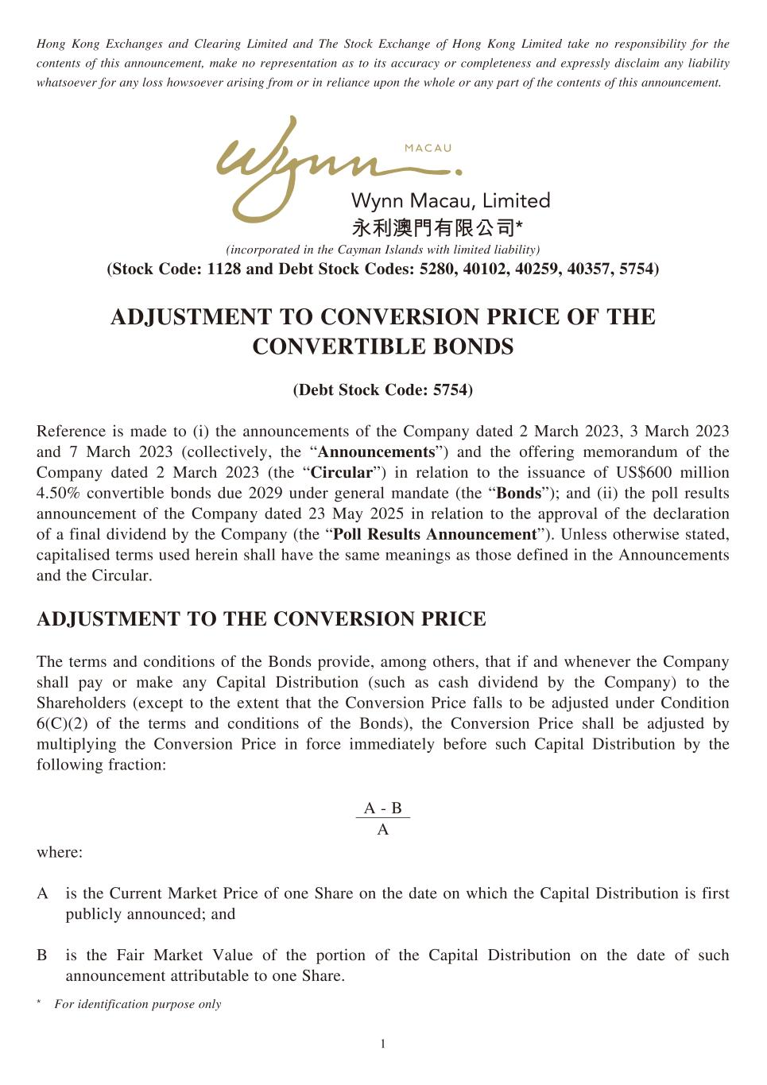

1 Hong Kong Exchanges and Clearing Limited and The Stock Exchange of Hong Kong Limited take no responsibility for the contents of this announcement, make no representation as to its accuracy or completeness and expressly disclaim any liability whatsoever for any loss howsoever arising from or in reliance upon the whole or any part of the contents of this announcement. (incorporated in the Cayman Islands with limited liability) (Stock Code: 1128 and Debt Stock Codes: 5280, 40102, 40259, 40357, 5754) ADJUSTMENT TO CONVERSION PRICE OF THE CONVERTIBLE BONDS (Debt Stock Code: 5754) Reference is made to (i) the announcements of the Company dated 2 March 2023, 3 March 2023 and 7 March 2023 (collectively, the “Announcements”) and the offering memorandum of the Company dated 2 March 2023 (the “Circular”) in relation to the issuance of US$600 million 4.50% convertible bonds due 2029 under general mandate (the “Bonds”); and (ii) the poll results announcement of the Company dated 23 May 2025 in relation to the approval of the declaration of a final dividend by the Company (the “Poll Results Announcement”). Unless otherwise stated, capitalised terms used herein shall have the same meanings as those defined in the Announcements and the Circular. ADJUSTMENT TO THE CONVERSION PRICE The terms and conditions of the Bonds provide, among others, that if and whenever the Company shall pay or make any Capital Distribution (such as cash dividend by the Company) to the Shareholders (except to the extent that the Conversion Price falls to be adjusted under Condition 6(C)(2) of the terms and conditions of the Bonds), the Conversion Price shall be adjusted by multiplying the Conversion Price in force immediately before such Capital Distribution by the following fraction: A - B A where: A is the Current Market Price of one Share on the date on which the Capital Distribution is first publicly announced; and B is the Fair Market Value of the portion of the Capital Distribution on the date of such announcement attributable to one Share. * For identification purpose only

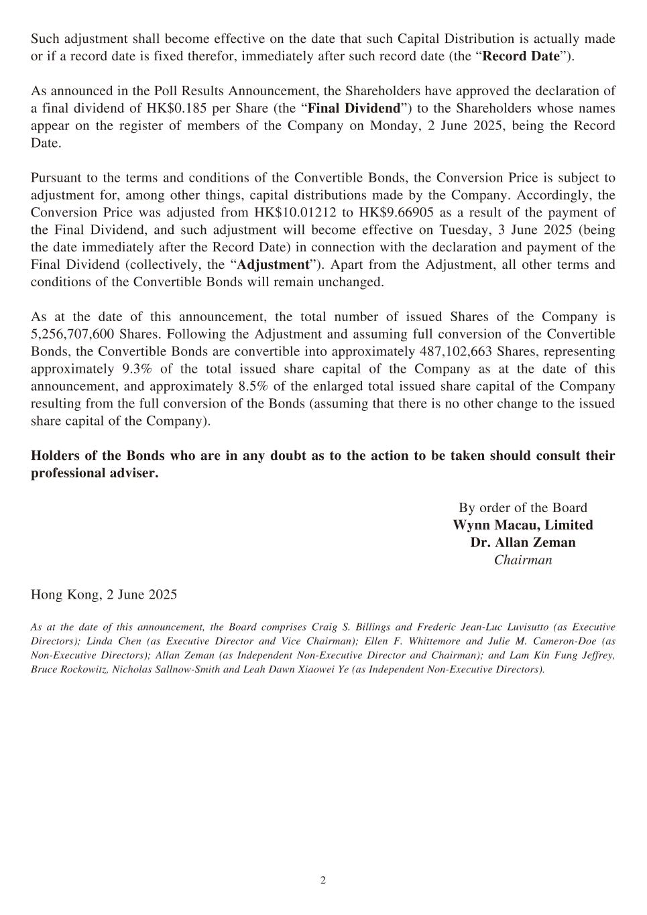
2 Such adjustment shall become effective on the date that such Capital Distribution is actually made or if a record date is fixed therefor, immediately after such record date (the “Record Date”). As announced in the Poll Results Announcement, the Shareholders have approved the declaration of a final dividend of HK$0.185 per Share (the “Final Dividend”) to the Shareholders whose names appear on the register of members of the Company on Monday, 2 June 2025, being the Record Date. Pursuant to the terms and conditions of the Convertible Bonds, the Conversion Price is subject to adjustment for, among other things, capital distributions made by the Company. Accordingly, the Conversion Price was adjusted from HK$10.01212 to HK$9.66905 as a result of the payment of the Final Dividend, and such adjustment will become effective on Tuesday, 3 June 2025 (being the date immediately after the Record Date) in connection with the declaration and payment of the Final Dividend (collectively, the “Adjustment”). Apart from the Adjustment, all other terms and conditions of the Convertible Bonds will remain unchanged. As at the date of this announcement, the total number of issued Shares of the Company is 5,256,707,600 Shares. Following the Adjustment and assuming full conversion of the Convertible Bonds, the Convertible Bonds are convertible into approximately 487,102,663 Shares, representing approximately 9.3% of the total issued share capital of the Company as at the date of this announcement, and approximately 8.5% of the enlarged total issued share capital of the Company resulting from the full conversion of the Bonds (assuming that there is no other change to the issued share capital of the Company). Holders of the Bonds who are in any doubt as to the action to be taken should consult their professional adviser. By order of the Board Wynn Macau, Limited Dr. Allan Zeman Chairman Hong Kong, 2 June 2025 As at the date of this announcement, the Board comprises Craig S. Billings and Frederic Jean-Luc Luvisutto (as Executive Directors); Linda Chen (as Executive Director and Vice Chairman); Ellen F. Whittemore and Julie M. Cameron-Doe (as Non-Executive Directors); Allan Zeman (as Independent Non-Executive Director and Chairman); and Lam Kin Fung Jeffrey, Bruce Rockowitz, Nicholas Sallnow-Smith and Leah Dawn Xiaowei Ye (as Independent Non-Executive Directors).

