UNITED STATES

SECURITIES AND EXCHANGE COMMISSION

Washington, D.C. 20549

FORM 8-K

CURRENT REPORT

PURSUANT TO SECTION 13 OR 15(d)

OF THE SECURITIES EXCHANGE ACT OF 1934

Date of Report (Date of earliest event reported): June 11, 2020

WYNN RESORTS, LIMITED

(Exact name of registrant as specified in its charter)

 |  | Nevada |  | 000-50028 |  | 46-0484987
 |  | (State or other jurisdiction |  |  | (Commission |  | (I.R.S. Employer
 |  | of incorporation) |  |  | File Number) |  | Identification No.)
 | 3131 Las Vegas Boulevard South
 |  | Las Vegas, Nevada |  |  |  | 89109
 | (Address of principal executive offices) |  |  |  |  |  |  | (Zip Code)
 |  |  |  | (702) 770-7555
 |  |  |  | (Registrant’s telephone number, including area code)
 |  |  |  | Not Applicable
 |  |  |  | (Former name or former address, if changed since last report)
Securities registered pursuant to Section 12(b) of the Act:
 | Title of each class |  |  | Trading Symbol(s) |  | Name of each exchange on which registered
Common stock, par value $0.01 |  |  |  | WYNN |  |  | Nasdaq Global Select Market

Check the appropriate box below if the Form 8-K filing is intended to simultaneously satisfy the filing obligation of the registrant under any of the following provisions:

- Written communications pursuant to Rule 425 under the Securities Act (17 CFR 230.425)

- Soliciting material pursuant to Rule 14a-12 under the Exchange Act (17 CFR 240.14a-12)

- Pre-commencement communications pursuant to Rule 14d-2(b) under the Exchange Act (17 CFR 240.14d-2(b))

- Pre-commencement communications pursuant to Rule 13e-4(c) under the Exchange Act (17 CFR 240.13e-4(c))

Indicate by check mark whether the registrant is an emerging growth company as defined in Rule 405 of the Securities Act of 1933 (§230.405 of this chapter) or Rule 12b-2 of the Securities Exchange Act of 1934 (§240.12b-2 of this chapter).

Emerging growth company ☐

If an emerging growth company, indicate by check mark if the registrant has elected not to use the extended transition period or complying with any new or revised financial accounting standards provided pursuant to Section 13(a) of the Exchange Act. ☐

Item 7.01 Regulation FD Disclosure.

On June 11, 2020, Wynn Macau, Limited (“Wynn Macau”), an indirect subsidiary of Wynn Resorts, Limited (the “Wynn Resorts” or the “Company”) with its ordinary shares of common stock listed on The Stock Exchange of Hong Kong Limited (the “HKSE”), filed with the HKSE an announcement (the “Announcement”) of Wynn Macau’s proposed issuance of senior notes (the “Offering”). Wynn Resorts owns approximately 72% of Wynn Macau’s ordinary shares of common stock. The Announcement is furnished herewith as Exhibit 99.1.

In connection with the Offering, Wynn Macau intends to provide potential investors with preliminary financial information for the Macau operations of Wynn Resorts for the two months ended May 31, 2020, and certain other information. A summary of this information is attached to this report as Exhibit 99.2 and is incorporated herein by reference.

The information furnished pursuant to this Item 7.01 (including Exhibits 99.1 and 99.2 hereto) shall not be deemed to be “filed” for purposes of Section 18 of the Securities Exchange Act of 1934, as amended (the “Exchange Act”), or otherwise subject to the liabilities of that section, nor shall it be deemed incorporated by reference in any filing under the Securities Act of 1933, as amended (the “Securities Act”), or the Exchange Act, except as shall be expressly set forth by specific reference in such a filing.

This Current Report on Form 8-K contains forward-looking statements within the meaning of Section 27A of the Securities Act and Section 21E of the Exchange Act. Such forward-looking statements are subject to numerous assumptions, risks and uncertainties that could cause actual results to differ materially from those described in such statements. Such forward-looking statements are based on management’s expectations or beliefs as of June 11, 2020. Factors that might cause such differences include, but are not limited to, a variety of economic, competitive, and regulatory factors, many of which are beyond the Company’s control and are described in Wynn Resorts’ Annual Report on Form 10-K filed by Wynn Resorts, Limited on February 28, 2020 with the Securities and Exchange Commission (the “SEC”) and the other reports Wynn Resorts files from time to time with the SEC. Wynn Resorts undertakes no obligation to revise or publicly release any updates to such statements based on future information or actual results.

Item 9.01 Financial Statements and Exhibits.

- Exhibits.

Exhibit No. |  | Description
99.1 |  | Announcement of Wynn Macau, Limited, dated June 11, 2020
99.2 |  | Investor Materials

SIGNATURES

Pursuant to the requirements of the Securities Exchange Act of 1934, the Registrant has duly caused this report to be signed on its behalf by the undersigned hereunto duly authorized.

WYNN RESORTS, LIMITED

Dated: June 11, 2020

By: /s/ Craig S. Billings

Craig S. Billings

President, Chief Financial Officer and Treasurer

(Principal Financial and Accounting Officer)

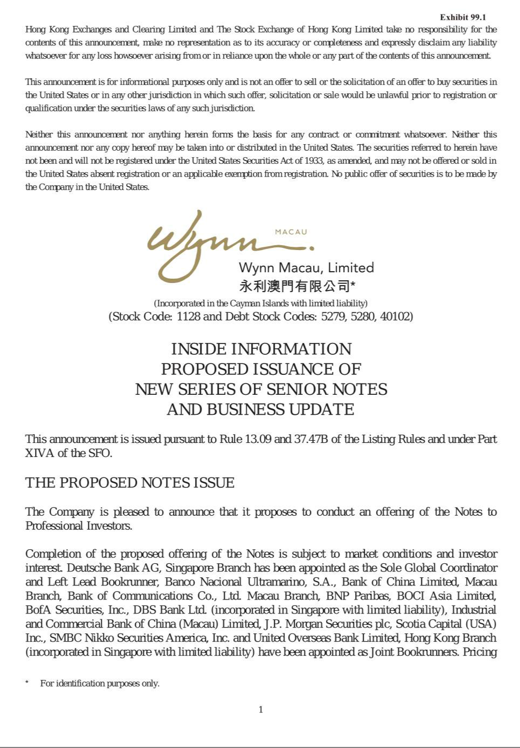

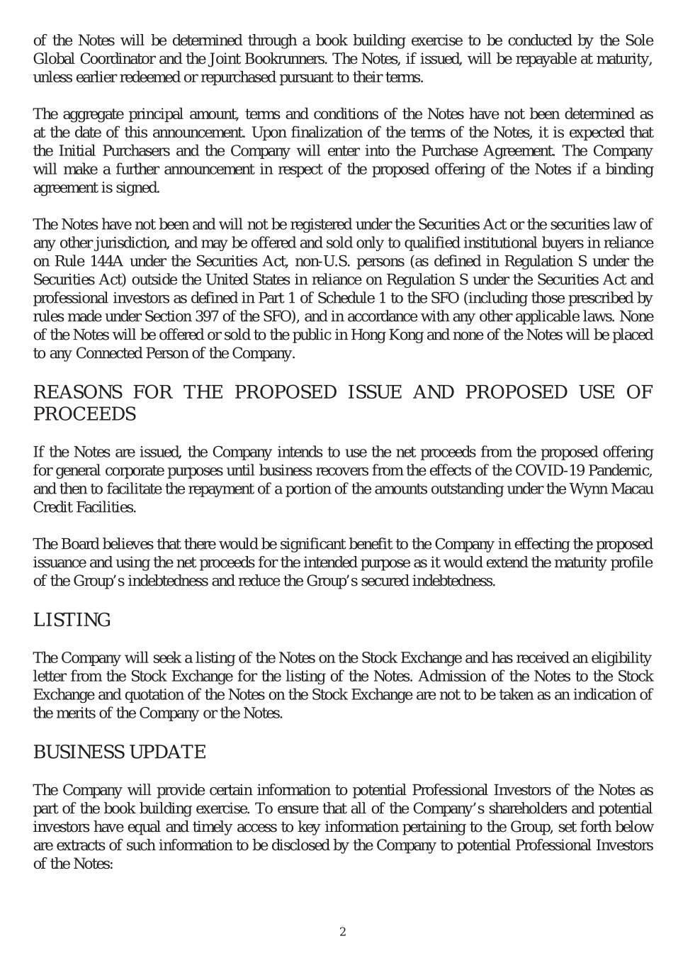

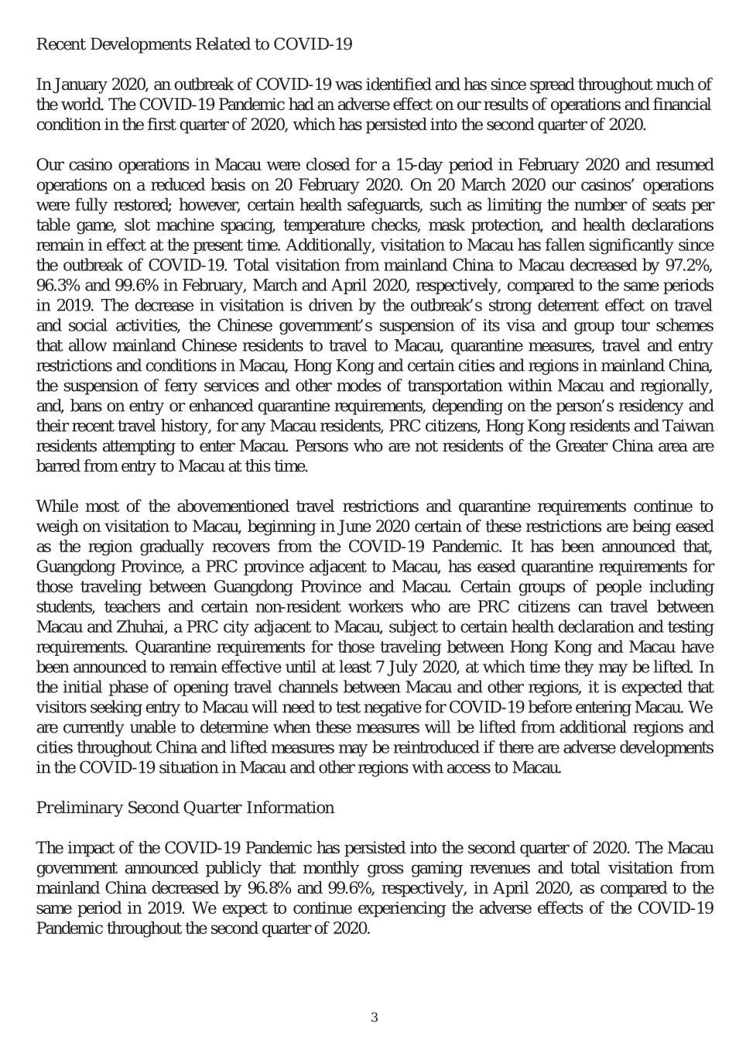

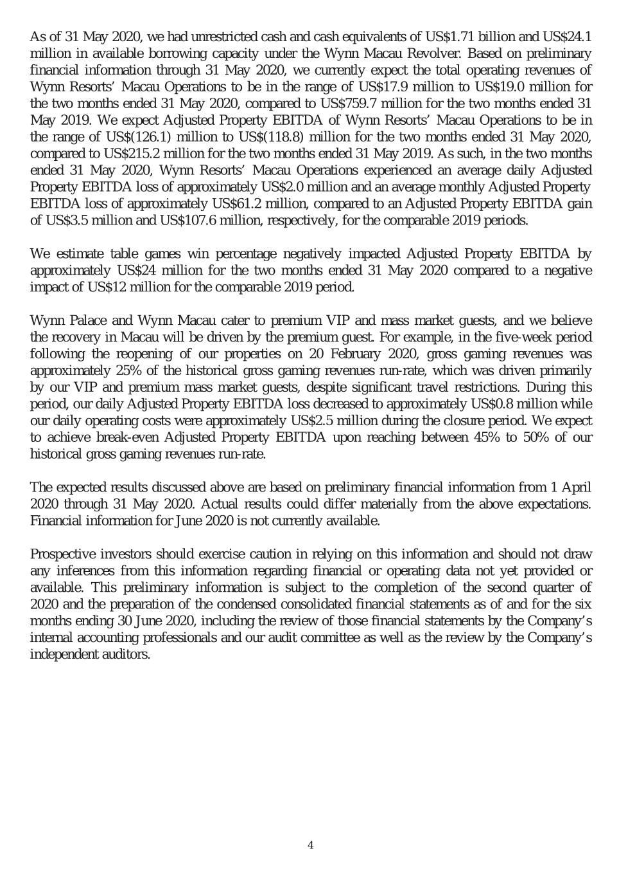

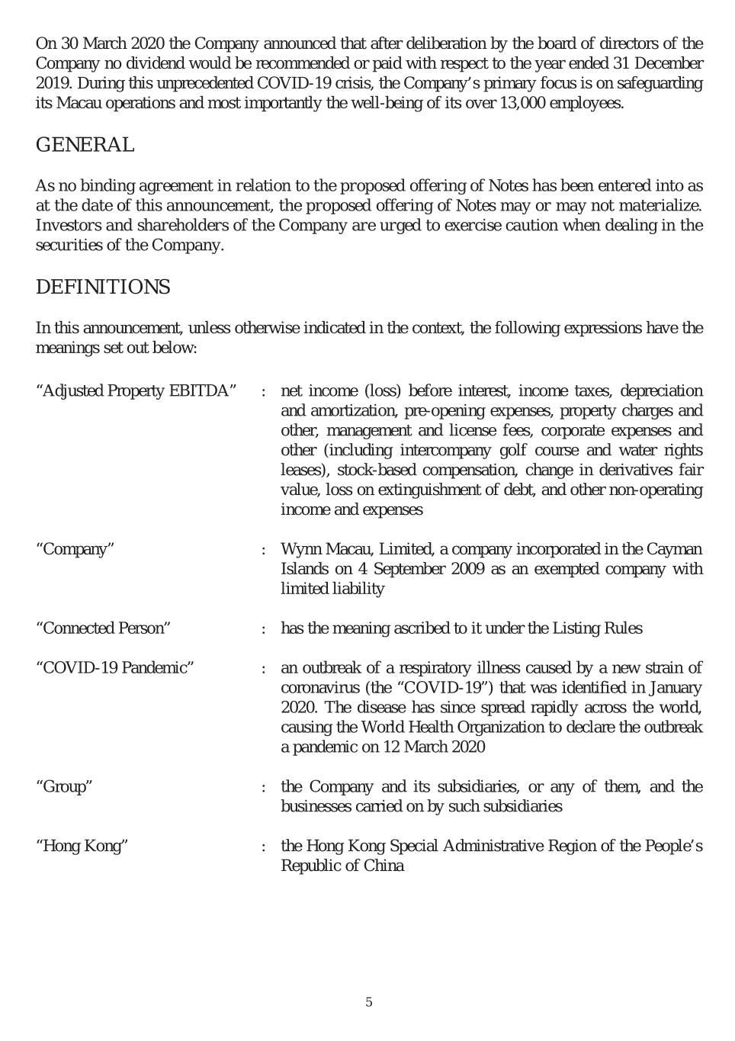

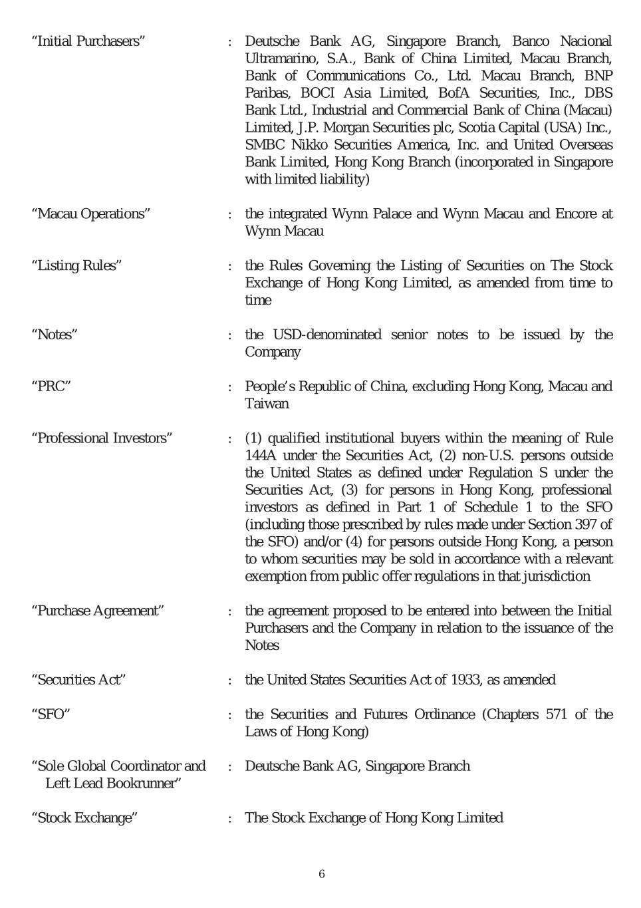

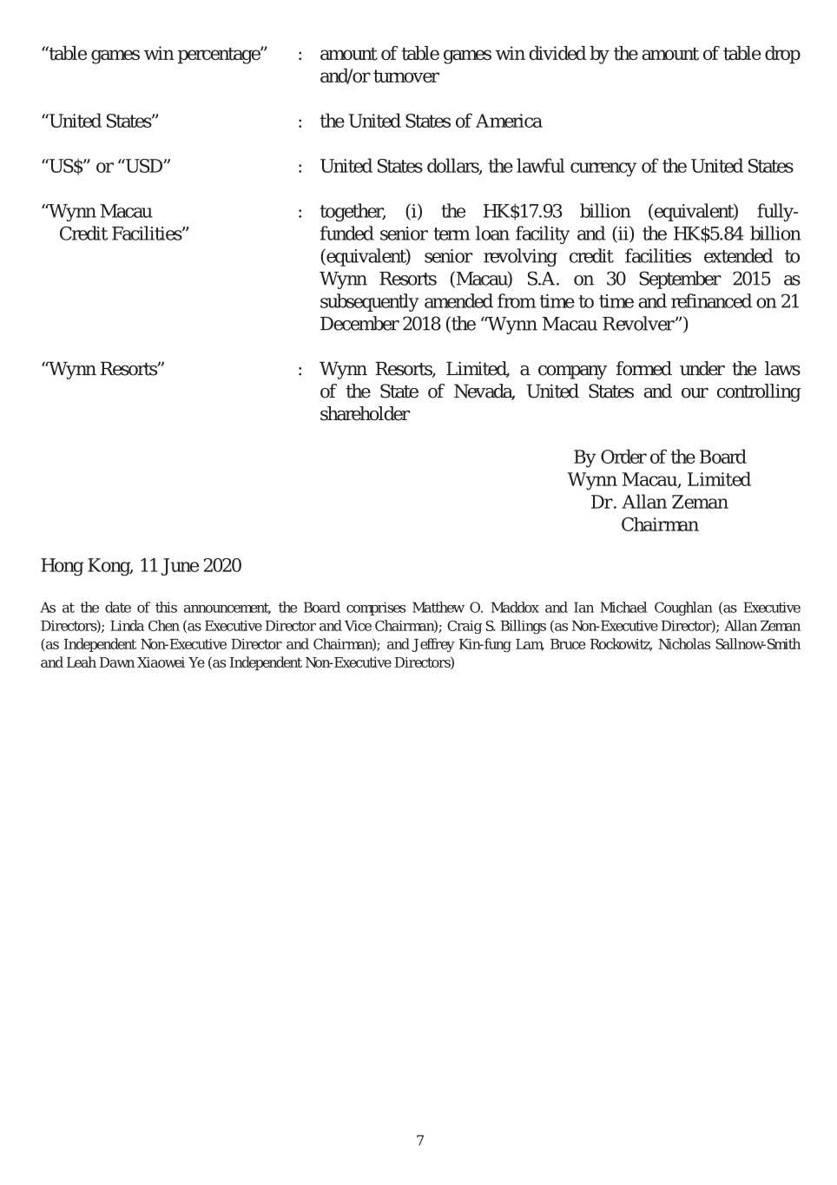

Exhibit 99.2

Recent Developments Related to COVID-19

In January 2020, an outbreak of COVID-19 was identified and has since spread throughout much of the world. The COVID-19 Pandemic had an adverse effect on our results of operations and financial condition in the first quarter of 2020, which has persisted into the second quarter of 2020.

Our casino operations in Macau were closed for a 15-day period in February 2020 and resumed operations on a reduced basis on February 20, 2020. On March 20, 2020 our casinos’ operations were fully restored; however, certain health safeguards, such as limiting the number of seats per table game, slot machine spacing, temperature checks, mask protection, and health declarations remain in effect at the present time. Additionally, visitation to Macau has fallen significantly since the outbreak of COVID-19. Total visitation from mainland China to Macau decreased by 97.2%, 96.3% and 99.6% in February, March and April 2020, respectively, compared to the same periods in 2019. The decrease in visitation is driven by the outbreak’s strong deterrent effect on travel and social activities, the Chinese government’s suspension of its visa and group tour schemes that allow mainland Chinese residents to travel to Macau, quarantine measures, travel and entry restrictions and conditions in Macau, Hong Kong and certain cities and regions in mainland China, the suspension of ferry services and other modes of transportation within Macau and regionally, and, bans on entry or enhanced quarantine requirements, depending on the person’s residency and their recent travel history, for any Macau residents, PRC citizens, Hong Kong residents and Taiwan residents attempting to enter Macau. Persons who are not residents of the Greater China area are barred from entry to Macau at this time.

While most of the abovementioned travel restrictions and quarantine requirements continue to weigh on visitation to Macau, beginning in June 2020 certain of these restrictions are being eased as the region gradually recovers from the COVID-19 Pandemic. It has been announced that, Guangdong Province, a PRC province adjacent to Macau, has eased quarantine requirements for those traveling between Guangdong Province and Macau. Certain groups of people including students, teachers and certain non-resident workers who are PRC citizens can travel between Macau and Zhuhai, a PRC city adjacent to Macau, subject to certain health declaration and testing requirements. Quarantine requirements for those traveling between Hong Kong and Macau have been announced to remain effective until at least July 7, 2020, at which time they may be lifted. In the initial phase of opening travel channels between Macau and other regions, it is expected that visitors seeking entry to Macau will need to test negative for COVID-19 before entering Macau. We are currently unable to determine when these measures will be lifted from additional regions and cities throughout China and lifted measures may be reintroduced if there are adverse developments in the COVID-19 situation in Macau and other regions with access to Macau.

Preliminary Second Quarter Information

The impact of the COVID-19 Pandemic has persisted into the second quarter of 2020. The Macau government announced publicly that monthly gross gaming revenues and total visitation from mainland China decreased by 96.8% and 99.6%, respectively, in April 2020, as compared to the same period in 2019. We expect to continue experiencing the adverse effects of the COVID-19 Pandemic throughout the second quarter of 2020.

As of May 31, 2020, Wynn Macau, Limited and its consolidated subsidiaries had unrestricted cash and cash equivalents of US$1.71 billion and US$24.1 million in available borrowing capacity under the Wynn Macau Revolver. Based on preliminary financial information through May 31, 2020, we currently expect the total operating revenues of the integrated Wynn Palace resort and casino and the Wynn Macau casino hotel resort and Encore at the Wynn Macau casino hotel resort (“Wynn Resorts’ Macau Operations”) to be in the range of US$17.9 million to US$19.0 million for the two months ended May 31, 2020, compared to US$759.7 million for the two months ended May 31, 2019. We expect Adjusted Property EBITDA of Wynn Resorts’ Macau Operations to be in the range of US$(126.1) million to US$(118.8) million for the two months ended May 31, 2020, compared to US$215.2 million for the two months ended May 31, 2019. As such, in the two months ended May 31, 2020, Wynn Resorts’ Macau Operations experienced an average daily Adjusted Property EBITDA loss of approximately US$2.0 million and an average monthly Adjusted Property EBITDA loss of approximately US$61.2 million, compared to an Adjusted Property EBITDA gain of US$3.5 million and US$107.6 million, respectively, for the comparable 2019 periods.

We estimate table games win percentage negatively impacted Adjusted Property EBITDA of Wynn Resorts’ Macau Operations by approximately US$24 million for the two months ended May 31, 2020 compared to a negative impact of US$12 million for the comparable 2019 period.

Wynn Palace and Wynn Macau cater to premium VIP and mass market guests, and we believe the recovery in Macau will be driven by the premium guest. For example, in the five-week period following the reopening of our properties on February 20, 2020, gross gaming revenues was approximately 25% of the historical gross gaming revenues run-rate, which was driven

primarily by our VIP and premium mass market guests, despite significant travel restrictions. During this period, our daily Adjusted Property EBITDA loss decreased to approximately US$0.8 million while our daily operating costs were approximately US$2.5 million during the closure period. We expect to achieve break-even Adjusted Property EBITDA upon reaching between 45% to 50% of our historical gross gaming revenues run-rate.

Wynn Resorts uses Adjusted Property EBITDA to manage the operating results of its segments. Adjusted Property EBITDA of Wynn Resorts is net income (loss) before interest, income taxes, depreciation and amortization, pre-opening expenses, property charges and other, management and license fees, corporate expenses and other (including intercompany golf course and water rights leases), stock-based compensation, change in derivatives fair value, loss on extinguishment of debt, and other non-operating income and expenses. Adjusted Property EBITDA is presented exclusively as a supplemental disclosure because Wynn Resorts believes that it is widely used to measure the performance, and as a basis for valuation, of gaming companies. Wynn Resorts uses Adjusted Property EBITDA as a measure of the operating performance of its segments and to compare the operating performance of its properties with those of its competitors, as well as a basis for determining certain incentive compensation. Wynn Resorts also presents Adjusted Property EBITDA because it is used by some investors to measure a company’s ability to incur and service debt, make capital expenditures and meet working capital requirements. Gaming companies have historically reported EBITDA as a supplement to GAAP. In order to view the operations of their casinos on a more stand-alone basis, gaming companies, including Wynn Resorts, have historically excluded from their EBITDA calculations pre-opening expenses, property charges, corporate expenses and stock-based compensation, that do not relate to the management of specific casino properties. However, Adjusted Property EBITDA should not be considered as an alternative to operating income as an indicator of Wynn Resorts’ performance, as an alternative to cash flows from operating activities as a measure of liquidity, or as an alternative to any other measure determined in accordance with GAAP. Unlike net income, Adjusted Property EBITDA does not include depreciation or interest expense and therefore does not reflect current or future capital expenditures or the cost of capital. Wynn Resorts has significant uses of cash flows, including capital expenditures, interest payments, debt principal repayments, income taxes and other non-recurring charges, which are not reflected in Adjusted Property EBITDA. Also, Wynn Resorts’ calculation of Adjusted Property EBITDA may be different from the calculation methods used by other companies and, therefore, comparability may be limited.

The expected results discussed above are based on preliminary financial information from April 1, 2020 through May 31, 2020. Actual results could differ materially from the above expectations. Financial information for June 2020 is not currently available, and there can be no assurance that the results for the month will not show a decline from the corresponding period in 2019 or the month of May 2020. Our results could be materially adversely affected by any of the risks set forth in Wynn Resorts’ SEC filings. Prospective investors should exercise caution in relying on this information and should not draw any inferences from this information regarding financial or operating data not yet provided or available. This preliminary information is subject to the completion of the second quarter of 2020 and the preparation of the condensed consolidated financial statements as of and for the six months ending June 30, 2020, including the review of those financial statements by Wynn Resorts’ and Wynn Macau’s internal accounting professionals and audit committees as well as the review by Wynn Resorts’ and Wynn Macau’s independent auditors.

On March 30, 2020, Wynn Macau, Limited announced that after deliberation by its board of directors no dividend would be recommended or paid with respect to the year ended December 31, 2019. During this unprecedented COVID-19 crisis, the Company’s primary focus is on safeguarding its Macau operations and most importantly the well-being of its over 13,000 employees.

