UNITED STATES

SECURITIES AND EXCHANGE COMMISSION
Washington, D.C. 20549

SCHEDULE 14A

Proxy Statement Pursuant to Section 14(a) of

The Securities Exchange Act of 1934

Filed by the Registrant ☒ Filed by a Party other than the Registrant ☐

Check the appropriate box:

- Preliminary Proxy Statement

- Confidential, for Use of the Commission Only (as permitted by Rule 14a-6(e)(2))

- Definitive Proxy Statement

- Definitive Additional Materials

- Soliciting Material Pursuant to §240.14a-12

WYNN RESORTS, LIMITED

(Name of Registrant as Specified In Its Charter)

(Name of Person(s) Filing Proxy Statement, if other than the Registrant)

Payment of Filing Fee (Check the appropriate box):

- No fee required.

- Fee computed on table below per Exchange Act Rules 14a-6(i)(1) and 0-11.

  - Title of each class of securities to which transaction applies:

  - Aggregate number of securities to which transaction applies:

  - Per unit price or other underlying value of transaction computed pursuant to Exchange Act Rule 0-11 (set forth the amount on which the filing fee is calculated and state how it was determined):

  - Proposed maximum aggregate value of transaction:

  - Total fee paid:

- Fee paid previously with preliminary materials.

- Check box if any part of the fee is offset as provided by Exchange Act Rule 0-11(a)(2) and identify the filing for which the offsetting fee was paid previously. Identify the previous filing by registration statement number, or the Form or Schedule and the date of its filing.
  - Amount Previously Paid:

  - Form, Schedule or Registration Statement No.:

  - Filing Party:

  - Date Filed:

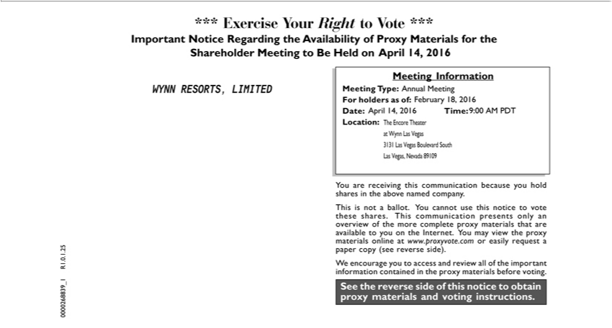

*** Exercise Your Right to Vote ***Important Notice Regarding the Availability of Proxy Materials for the Shareholder Meeting to Be Held on April 14, 2016
WYNN RESORTS, LIMITED
Meeting Information Meeting Type: For holders as of:
^{Date:} Time: Location: Annual Meeting April 14, 2016 9:00 AM PDT February 18, 2016 The Encore Theater Wynn Las Vegas 3131 Las Vegas Boulevard South Las Vegas, Nevada 89109
See the reverse side of this notice to obtain proxy materials and voting instructions.
You are receiving this communication because you hold shares in the above named company.
This is not a ballot. You cannot use this notice to vote these shares. This communication presents only an overview of the more complete proxy materials that are
available to you_{contained}the Internet. You may view the proxy materials online at www.proxyvote.com or easily request a paper copy (see reverse side). We encourage you to access and review all of the important
information in the proxy materials before voting. 0000268839_1 R1.0.1.25

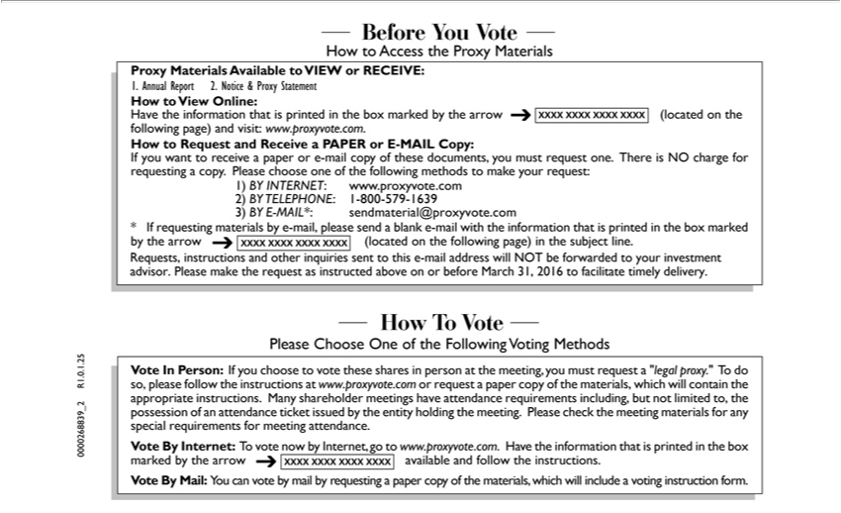

Shareholder***ExerciseMeetingYourRighttoBeto HeldVote ***ImportantonApril14,2016NoticeWYNNRegardingRESORTS,theAvailabilityLIMITEDof Proxy Materials for the Meeting Information Meeting Type: For holders as of: Date: Time: Location: Annual Meeting
atAprilWynn14,Las2016Vegas9:00 3131AM PDTLasVegasFebruaryBoulevard18,2016SouthThe LasEncoreVegas,TheaterNevada 89109 See the reverse side of this notice to obtain proxy materials and voting instructions.

ofYouthearemorereceivingcompletethis proxycommunicationmaterials thatbecauseareavailableyouholdtosharesyouonin thethe Internet.abovenamedYou maycompany.view theThisproxyisnot a ballot. You cannot use this notice to vote these shares. This communication presents only an overview materials online at www.proxyvote.com or easily request a paper copy (see reverse side). W encourage you to access and review all of the important
0000268839informationcontained_1R1.0.1.25inthe materials before voting.

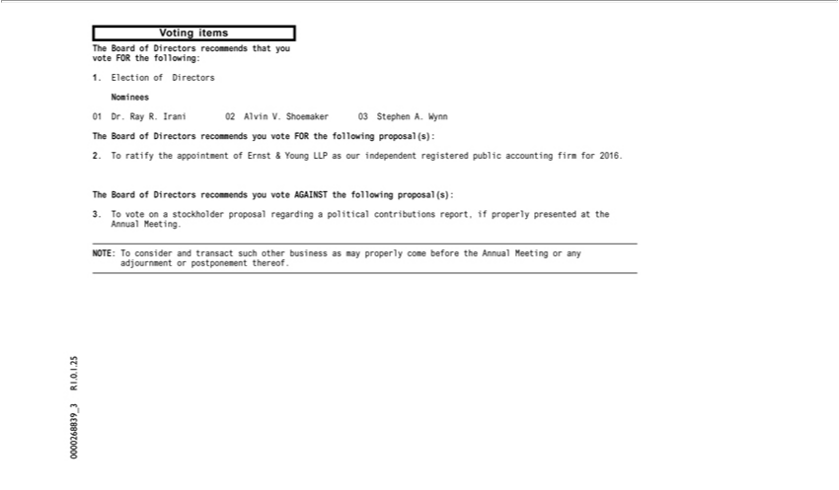

Voting items
The Board of Directors recommends that you
vote FOR the following: 1. Election of Directors Nominees
01 Dr. Ray R. Irani 02 Alvin V. Shoemaker 03 Stephen A. Wynn
The Board of Directors recommends you vote FOR the following proposal(s):
The2.ToBoardratify oftheDirectorsappointmentrecommendsofErnst &youYoungvote AGAINSTLLPasour theindependentfollowingregisteredproposal(s):public accounting firm for 2016.
3._{adjournment}Tvoteon a stockholder pr_{consider}posalregarding_{transact}political contributions report, if properly presented at the
Ann al Meeting_{postponement}.NOTE:T and such other business as may properly come before the Annual Meeting or any
or thereof.

0000268839_3 R1.0.1.25

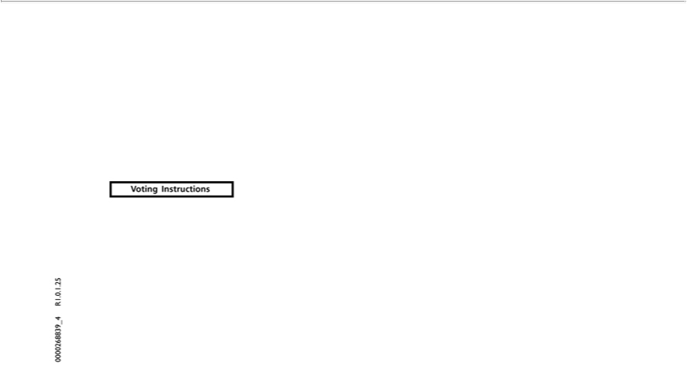

Voting Instructions 0000268839_4 R1.0.1.25

