UNITED STATES

SECURITIES AND EXCHANGE COMMISSION
Washington, D.C. 20549

SCHEDULE 14A

Proxy Statement Pursuant to Section 14(a) of

The Securities Exchange Act of 1934

Filed by the Registrant ☒ Filed by a Party other than the Registrant ☐

Check the appropriate box:

- Preliminary Proxy Statement

- Confidential, for Use of the Commission Only (as permitted by Rule 14a-6(e)(2))

- Definitive Proxy Statement

- Definitive Additional Materials

- Soliciting Material Pursuant to §240.14a-12

WYNN RESORTS, LIMITED

(Name of Registrant as Specified In Its Charter)

(Name of Person(s) Filing Proxy Statement, if other than the Registrant)

Payment of Filing Fee (Check the appropriate box):

- No fee required.

- Fee computed on table below per Exchange Act Rules 14a-6(i)(1) and 0-11.

  - Title of each class of securities to which transaction applies:

  - Aggregate number of securities to which transaction applies:

  - Per unit price or other underlying value of transaction computed pursuant to Exchange Act Rule 0-11 (set forth the amount on which the filing fee is calculated and state how it was determined):

  - Proposed maximum aggregate value of transaction:

  - Total fee paid:

- Fee paid previously with preliminary materials.

- Check box if any part of the fee is offset as provided by Exchange Act Rule 0-11(a)(2) and identify the filing for which the offsetting fee was paid previously. Identify the previous filing by registration statement number, or the Form or Schedule and the date of its filing.

  - Amount Previously Paid:

  - Form, Schedule or Registration Statement No.:

  - Filing Party:

  - Date Filed:

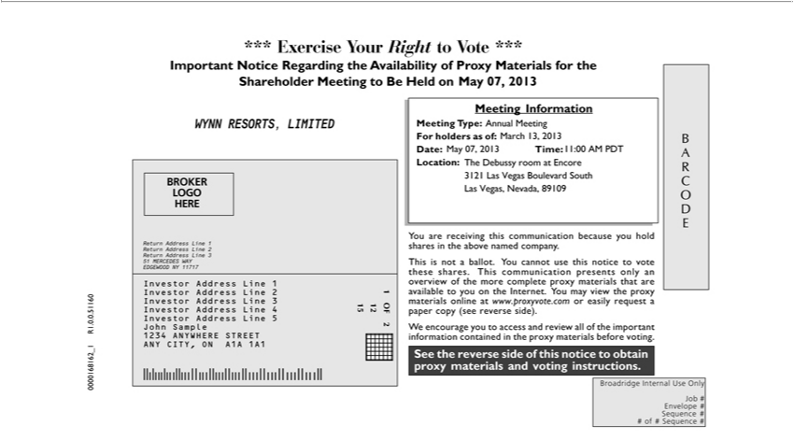

ARCODE See the reverse side of this notice to obtain proxy materials and voting instructions. BROKER LOGO HERE 1 OF 2 12 15 1234567 1234567 1234567 1234567 1234567 1234567 1234567
Broadridge I ternal Use Only Job # Envelope # Sequence # # f # Sequence # *** Exercise Your Right to Vote *** Important Notice Regarding the Availability of Proxy Materials for the Shareholder Meeting
to Be Held on <mtgdate>. You are receiving this communication because you hold shares in the above named company. This is not ballot. You cannot use this notice to vote these shares. This communication
presents only an overview of the more complete proxy materials that are available to you the Internet. You may view the proxy materials online www.proxyvote.com or easily request a paper copy (see
reverse side). W encourage you to access and review all of the important information contained in the proxy materials before voting. Meeting Information Meeting Type: <mtgtype> For holders as of: <recdate>
Date: Time: <mtgtime> Location: 0000168162_1 R1.0.0.51160 WYNN RESORTS, LIMITED Annual Meeting May 07, | May 07, 2013 11:00 AM PDT March 13, 2013 The Debussy room at Encore 3121
Las Vegas Boulevard South_{Address}LasVegas, Ne_{Investor}ada,89109 Return Address Line 1 Return Address Line 2 Return Address Line201351 MERCEDES WAY EDGEWOOD NY 11717 Investor Address Line 1 Investor
Address Line 2 Investor Line 3 Address Line 4 Investor Address Line 5 John Sample 1234 ANYWHERE STREET ANY CITY, ON A1A 1A1

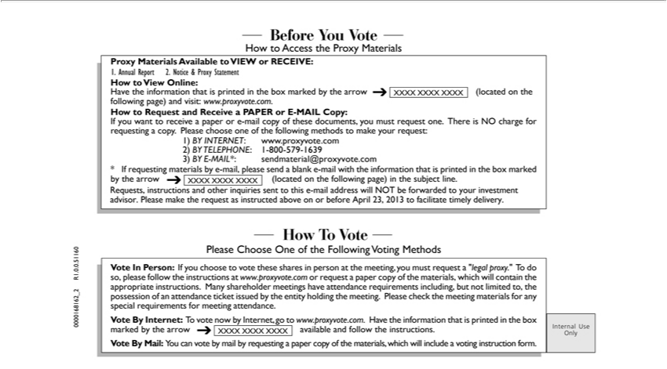

How To Vote Please Choose One of the |  |  | Voting Methods Internal Use Only Before You Vote How to Access the Proxy Materials Proxy Materials Available to VIEW or |  |  | How to View
Online: | the | that is printedFollowingthe box marked by the arrow (located on the following page) and visit: www.proxyvote.com. How to Request and Receive PAPERRECEIVE:or-MAIL Copy: If you want
to receiveHavepaper informatione-mailcopy of these documents, you must request one. There is NO charge for requesting a copy. Please choose one of the following methods to make your request: 1) BY INTERNET:
www.proxyvote.com 2) BY TELEPHONE: 1-800-579-1639 3) BY E-MAIL*: sendmaterial@proxyvote.com * If requesting materials by -mail, please send a blank -mail with the |  |  |  |  |  | that is printed in
the box | by the arrow | on the | page) | the subject line. XXXX XXXX XXXX XXXX XXXX XXXX Vote In Person: If you choose to vote these shares personinformationthe meeting, you
must requestmarked“legal proxy.” (locatedTdoso, pleasefollowingthe instructions at www.proxyvote.com or request a paper copy of the materials, which will contain the appropriate instructions. Many shareholder meetings
have attendance requirements including, but not limited to, the possession of an attendance ticket issued by the entity holding the meeting. Please check the meeting materials for any special requirements for
meeting attendance. Vote By Internet: To vote now by Internet, go to www.proxyvote.com. |  |  |  |  | the information that is printed in the box marked by the arrow available and follow the instructions. Vote By
Mail: You can vote by mail by requesting a paper copy of the |  |  |  | which will include | Havevoting instruction form. XXXX XXXX XXXX 0000168162_2 R1.0.0.51160 1. Annual Report 2. Notice & Proxy
Statement Requests, instructions and other inquiries sent to thismaterials,-mailaddress will NOT be forwarded to your investment advisor. Please make the request as instructed above on or before April 23, 2013 to facilitate timely delivery.

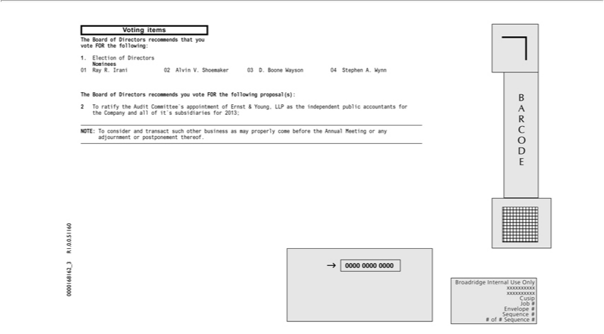

^{Broadridge}ARCODE 123456789012 123456789012 123456789012 123456789012 123456789012 123456789012 123456789012 123456789012 123456789012 ¹²³⁴⁵⁶⁷⁸⁹⁰¹² 123456789012 123456789012 Internal Use Only xxxxxxxxxx xxxxxxxxxx Cusip Job # Envelope # Sequence # # of # Sequence #0000 0000 0000 Voting items 0000168162 R1. . .51160 The Board of Directors recommends
that you vote FOR the _{following:} 1. Election of _{Directors} Nominees 01 Ray R. Irani 02 Alvin V. Shoemaker 03 D. Boone Wayson 04 Stephen A. Wynn The Board of Directors recommends you _{vote} FOR the
following proposal(s): 2 T ratify the Audit Committee’ appointment of Ernst & Young, LLP as the independent public accountants for the Company and all of it’s subsidiaries for 2013; NOTE: T consider and transact such other business as may properly come before the Annual Meeting or any adjournment or postponement thereof.

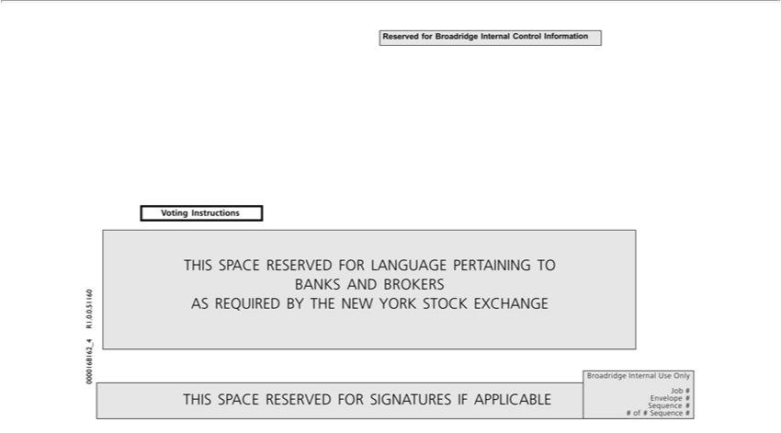

THIS SPACE RESERVED FOR LANGUAGE PERTAINING TO BANKS AND BROKERS AS REQUIRED BY THE NEW YORK STOCK EXCHANGE Voting Instructions THIS SPACE RESERVED FOR SIGNATURES IF APPLICABLE P99999-010 12 15 # OF # Broadridge Internal Use Only Job # Envelope # Sequence # # of # Sequence # Reserved for Broadridge Internal Control Information 0000168162_4 R1.0.0.51160

