UNITED STATES

SECURITIES AND EXCHANGE COMMISSION
Washington, D.C. 20549

FORM 8-K

CURRENT REPORT

Pursuant to Section 13 or 15(d) of

The Securities Exchange Act of 1934

Date of Report (Date of earliest event reported): September 5, 2011

Wynn Resorts, Limited

(Exact name of registrant as specified in its Charter)

Nevada | 000-50028 | 46-0484987
(State or other jurisdiction | (Commission | (I.R.S. Employer
of incorporation) | File Number) | Identification No.)

3131 Las Vegas Boulevard South

Las Vegas, Nevada

89109

(Address of principal executive offices)

(Zip Code)

(702) 770-7555

(Registrant’s telephone number, including area code)

Not applicable.

(Former name or former address, if changed since last report)

Check the appropriate box below if the Form 8-K filing is intended to simultaneously satisfy the filing obligation of the registrant under any of the following provisions:

- Written communications pursuant to Rule 425 under the Securities Act (17 CFR 230.425)

- Soliciting material pursuant to Rule 14a-12 under the Exchange Act (17 CFR 240.14a-12)

- Pre-commencement communications pursuant to Rule 14d-2(b) under the Exchange Act (17 CFR 240.14d-2(b))

- Pre-commencement communications pursuant to Rule 13e-4(c) under the Exchange Act (17 CFR 240.13e-4(c))

Item 7.01 Regulation FD Disclosure.

On September 5, 2011, Wynn Macau, Limited (“WML”), an indirect subsidiary of Wynn Resorts, Limited (the “Registrant”) with ordinary shares of its common stock listed on The Stock Exchange of Hong Kong Limited, filed its interim report in respect of the six months ended June 30, 2011 (the “Interim Report”) with The Stock Exchange of Hong Kong Limited. The Registrant owns approximately 72.3% of WML’s ordinary shares of common stock. The Interim Report is furnished herewith as Exhibit 99.1. The information in this Form 8-K and Exhibit 99.1 attached hereto shall not be deemed “filed” for purposes of Section 18 of the Securities Exchange Act of 1934, as amended, nor shall it be deemed incorporated by reference in any filing under the Securities Act of 1933, as amended, except as shall be expressly set forth by specific reference in such filing.

Item 9.01. Financial Statements and Exhibits.

- Exhibits.

Exhibit No. Description

99.1 Interim Report of Wynn Macau, Limited in respect of the six months ended June 30, 2011

SIGNATURES

Pursuant to the requirements of the Securities Exchange Act of 1934, the Registrant has duly caused this report to be signed on its behalf by the undersigned thereunto duly authorized.

Date: September 6, 2011

WYNN RESORTS, LIMITED

By: /s/ Matt Maddox

Matt Maddox

Chief Financial Officer and Treasurer

Exhibit 99.1
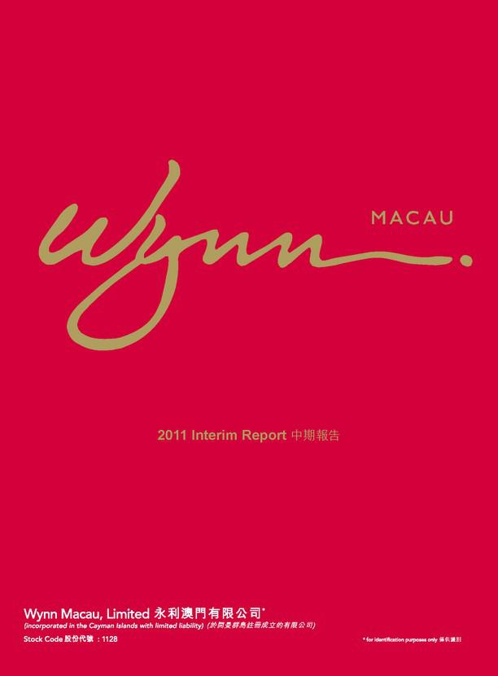

2011 Interim Report

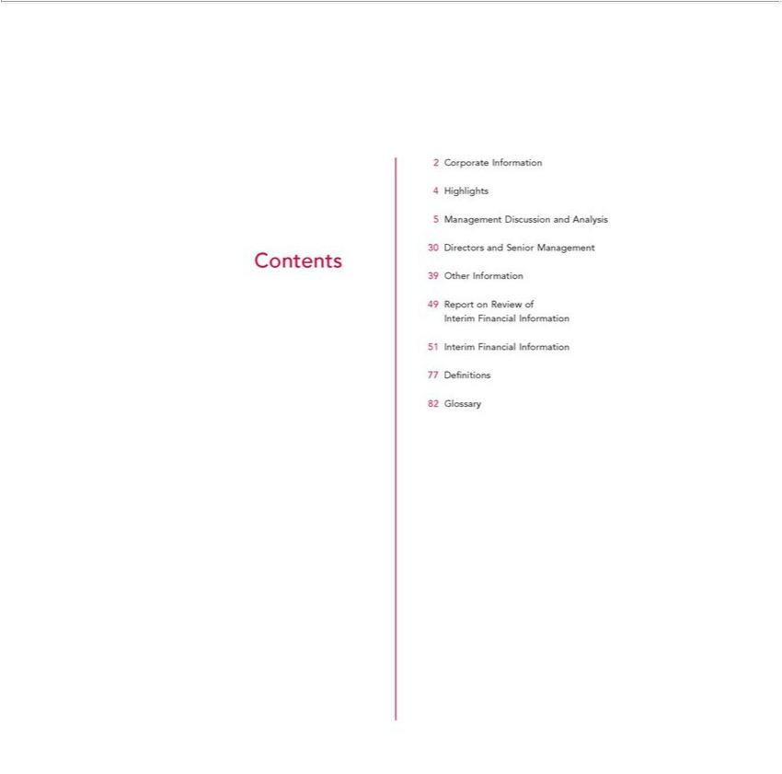

2 | Corporate Information
4 | Highlights
5 | Management Discussion and Analysis
30 | Directors and Senior Management
Contents
39 | Other
49 | ReportInformationReview of
Interim Financial Information
51 | Interim Financial Information
77 | Defi nitions
82 | Glossary

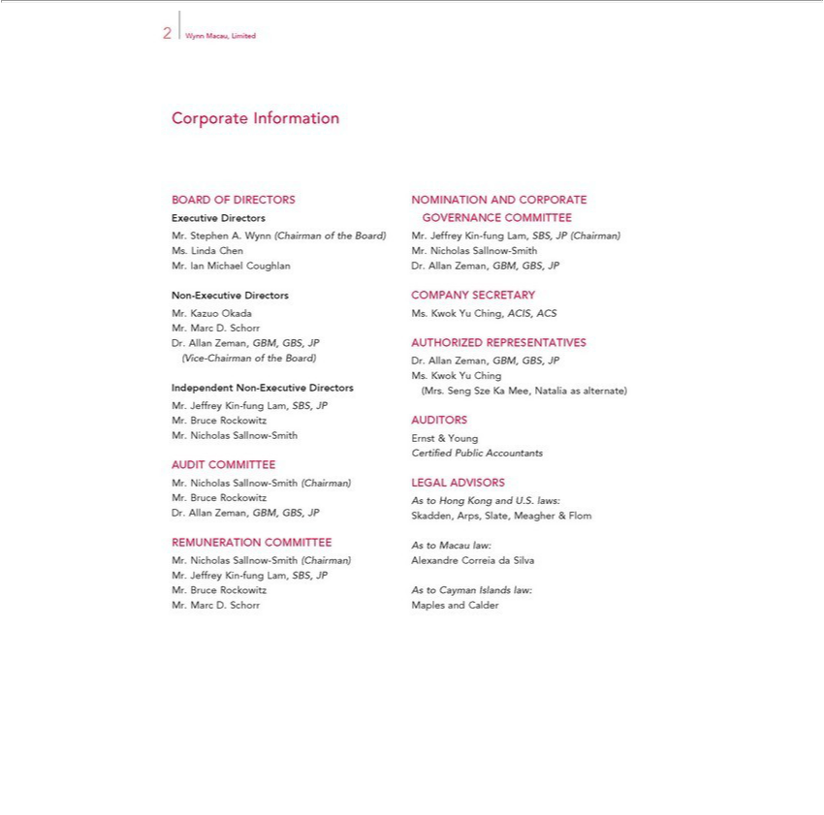

2 Wynn Macau, Limited
Corporate Information
ExecutiveBOARDOFDirectorsDIRECTORSGOVERNANCENOMINATIONCOMMITTEEANDCORPORATE
^{Mrs}. Stephen A. Wynn (Chairman of the Board) Mr. Jeffrey Kin-fung Lam, SBS, JP (Chairman)
. Linda Chen Mr. Nicholas Sallnow-Smith
Non.Ian-ExecutiveMichaelDirectorsCoughlanCOMPANYDr.AllanZeman,SECRETARYGBM,GBS, JP
^{Mr.}
MarcKazuoD.OkadaSchorrMs. Kwok Yu Ching, ACIS, ACS
(ViceDr.Allan-ChairmanZeman,ofGBM,theBoard)GBS, Dr.JP AUTHORIZEDAllanZeman,GBM,REPRESENTATIVESGBS,JP
Ms. Kwok Yu Ching
IndependentJeffreyKinNon-fung-ExecutiveLam,SBS,DirectorsJP (Mrs. Seng Sze Ka Mee, Natalia as alternate)
^{Mr.}
NicholasBruceRockowitzSallnow-AUDITORSSmithErnst & Young
AUDIT COMMITTEE Certifi ed Public Accountants
^{Mr.}
BruceNicholasRockowitzSallnow-AsSmithtoHong(Chairman)KongandLEGALU.S. laws:ADVISORS
REMUNERATIONDr.AllanZeman,GBM,COMMITTEEGBS,JPSkadden,AstoMacauArps,law:Slate, Meagher & Flom
JeffreyNicholasKinSallnow-fungLam,-SmithSBS,(Chairman)JP Alexandre Correia da Silva
^{Mr.}
MarcBruceD.RockowitzSchorrMaplesAsto CaymanandCalderIslands law:

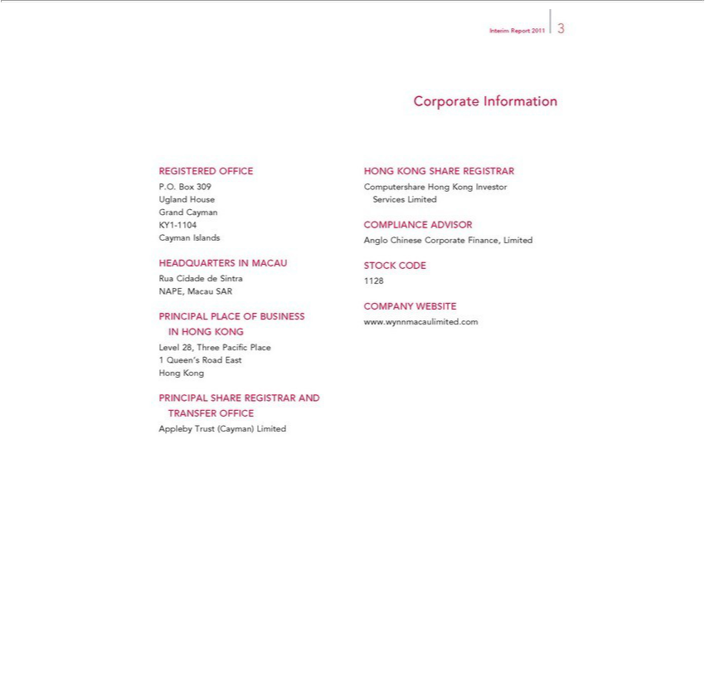

P.O.REGISTEREDBox309 OFFICE
Ugland House
Grand Cayman
KY1-1104
Cayman Islands
RuaHEADQUARTERSCidadedeSintraIN MACAU
NAPE, Macau SAR
LevelPRINCIPAL28,ThreePLACEPacifiOFcPlaceBUSINESS IN HONG KONG
Hong1 KongQueen’s Road East
TRANSFERPRINCIPAL SHARE^{OFFICE} REGISTRAR AND
Appleby rust (Cayman) Limited
CorporateInterimReportInformation20113
HONG KONG SHARE REGISTRAR
ServicesComputershareLimitedHong Kong Investor
COMPLIANCE ADVISOR
Anglo Chinese Corporate Finance, Limited
1128STOCK CODE
www.wynnmacaulimited.comCOMPANYWEBSITE

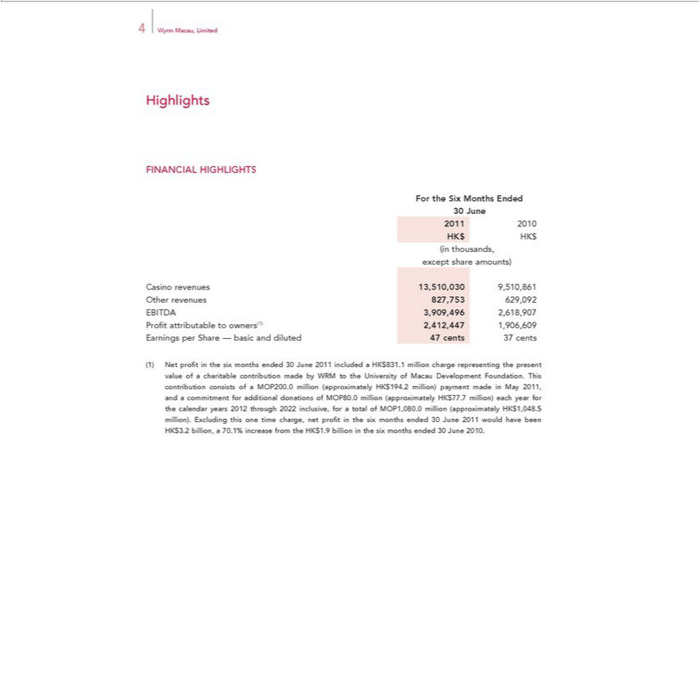

4 Wynn Macau, Limited
ForHighlightsINANCIAL HIGHLIGHTS
the Six Months Ended
20130June12010
HK$ HK$
except(inthousands,shareamounts)
Casino revenues 13 510,030 9,510,861
EBITDAOtherrevenues3,909,496827,7532,618,907629,092
Profi t attributable to owners(1) 2,412,447 1,906,609
NetFoundationEarningsprofiperin Sharethesix—monthsbasic andendeddiluted30June47 cents2011 37includedcents a HK$831.1 million charge representing the present value Mayof charitable contribution made by WRM to the University of Macau Development
HK$77.7 million).ThiscontributioneachyearforconsiststhecalendarofMOP200years. millionthrough(approximately2022inclusive,HKfor$194.2atotalmillion)ofMOP1,080.0paymentmillionmadein(approximately2011,andHKacommitment$1,048.5million)foradditional.ExcludingdonationsthisoneoftimeMOP80.0charge,millionnetprofi(approximatelyinthesix
months ended 30 June 2011 would have been HK$3.2012billion, a 70.1% increase from the HK$1.9 billion in the six months ended 30 June 2010.

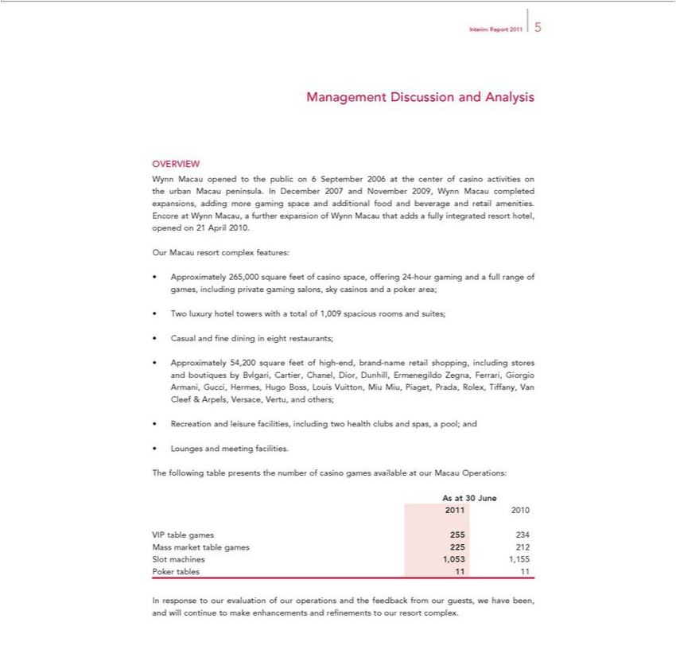

Interim Report 2011 5
Management Discussion and Analysis
OVERVIEW
Wynn Macau opened to the public on 6 September 2006 at the center of casino activities on the ^{urban} Macau peninsula. In December 2007 and November 2009, Wynn Macau completed expansions, adding more gaming space and additional food and beverage and retail amenities. Encore at Wynn Macau, further expansion of Wynn Macau that adds a fully integrated resort hotel, opened on 21 April 2010. Our Macau resort complex features:
Approximately 265,000 square feet of casino space, offering 24-hour gaming and a full range of games, including private gaming salons, sky casinos and a poker area; Two luxury hotel towers with a total of 1,009 spacious rooms and suites;
Casual and fi ne dining in eight restaurants;

Approximately 54,200 square feet of high-end, brand-name retail shopping, including stores and boutiques by Bvlgari, Cartier, Chanel, Dior, Dunhill, Ermenegildo Zegna, Ferrari, Giorgio Armani, Gucci, Hermes, Hugo Boss, Louis Vuitton, Miu Miu, Piaget, Prada, Rolex, Tiffany, V^{and} Cleef & Arpels, Versace, Vertu, and others;
LoungesRecreationandandmeetingleisurefacilities.facilities, including two health clubs and spas, a pool;
AsTheatfollowing30June table presents the number of casino games available at our Macau Operations:
2011 2010
VIP table games 255 234
Mass market table^{1,053}games 225 212
PokerSlotmachinestables11 1,155

In response to our evaluation of our operations and the feedback from our guests, we have been, and will continue to make enhancements and refi nements to our resort complex.

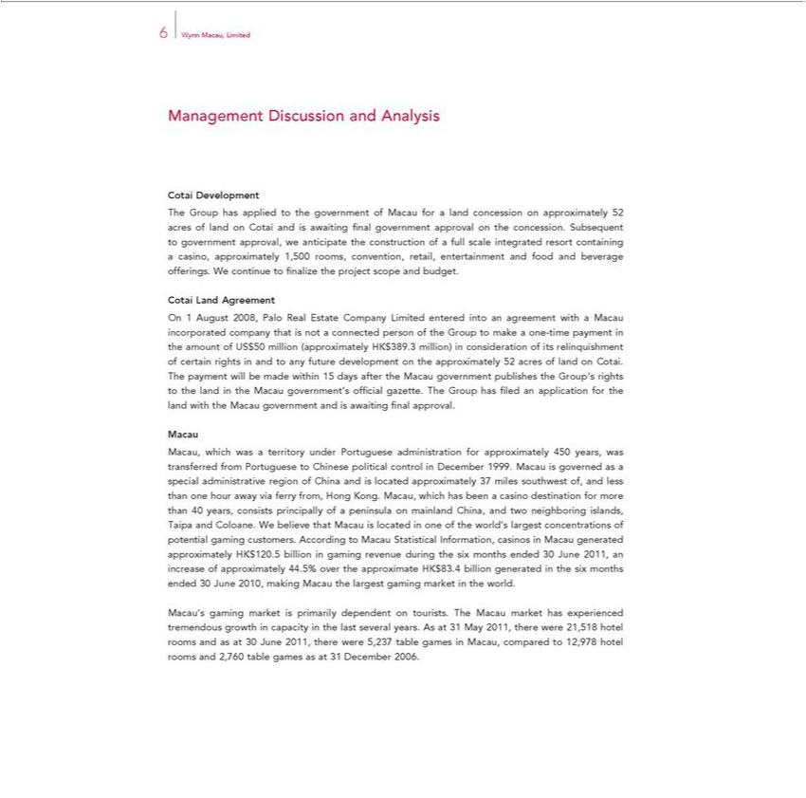

6 | Wynn Macau, Limited
Management Discussion and Analysis
Cotai Development |  | land concession |  | 52 acres of land on Cotai and is awaiting fi nal government approval on the concession. |  |  |  | to government
The Group has applied to the government of Macau for |  |  |  |  |  |  |  | to government
approval, we anticipate the construction of a full scale integrated resort containingapproximatelycasino, approximately 1,500 rooms, convention, retail, entertainment and food and beverage offerings.SubsequentWcontinue to fi
nalize the project scope and budget.
Cotai Land Agreement |  |  |  |  | that is not a connected person of the Group to make a one-time payment in the amount of
On 1 August 2008, Palo Real Estate Company Limited entered into an agreement with a Macau
US$50 million (approximately HK$389.3 million) in consideration of relinquishment of certainincorporatedrightsandcompanyto |  |  |  |  | future development on the approximately 52 acres of land on Cotai. The payment will be
made within 15 days after the Macau government publishes the Group’itsrights to the land in the Macau government’s offi cial gazette. The Group has fi led an application for the land with the Macau government
and is awaiting fi nal approval.
Macau, which was a territory under Portuguese administration for approximately 450 years, was transferred from Portuguese to Chinese political control in December 1999. Macau is governed as special
admini trative region of China and is located approximately 37 miles southwest of, and less than one hour away via ferry from, Hong Kong. Macau, which |  |  |  |  |  |  | been a casino destination for more than 40 years,
onsists principally of a peninsula on mainland China, and two |  |  |  | islands, Taipa and Coloane. We believe that Macau is located |  | one of the world’has largest concentrations of potential gaming
customers. According to Macau Statistical Information, |  |  | neighboringMacaugenerated approximately HK$120.5 billion in gaming revenue |  |  | the six months ended 30 June 2011, an increase of approximately
44.5% over the approximate HK$83.4 billion generated casinosthesix months ended 30 June 2010, making Macau the largest gaming market duringthe world.
Macau’s gaming market is primarily dependent on tourists. The Macau market has experienced tremendous growth in capacity in the last several years. As at 31 May 2011, there were 21,518 hotel rooms and as at 30 June 2011, there were 5,237 table games in Macau, compared to 12,978 hotel rooms and 2,760 table games as at 31 December 2006.

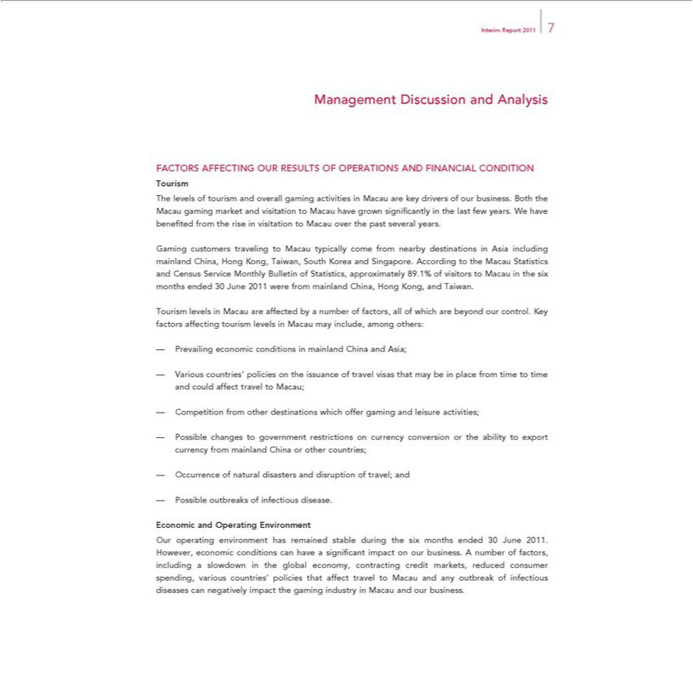

Interim Report 2011 7
Management Discussion and Analysis
FACTORS AFFECTING OUR RESULTS OF OPERATIONS AND FINANCIAL CONDITION
ourism
The lev ls of tourism and overall gaming activities in Macau are key drivers of our business. Both the Macau gaming market and visitation to Macau have grown signifi cantly in the last few years. We have
benefi ted from the rise |  | visitation to Macau over the past several years.
Gaming customers traveling to Macau typically come from nearby destinations in Asia including mainland China, Hong Kong, Taiwan, South Korea and Singapore. According to the Macau Statistics and Census
Service Monthly Bulletin of Statistics, |  |  | 89.1% of visitors to Macau in the six months ended 30 June 2011 were from | China, Hong Kong, and Taiwan.
Tourism levels in Macau are affected byapproximatelynumberof factors, all of which are beyond our control. Key factors affecting tourism levelsmainlandMacau may include, among others:
Prevailing economic |  | in mainland China and Asia;
Various countries’ policiesconditionsthe issuance of travel visas that may be in place from time to time and could affect travel to Macau;
Competition from other destina ions which offer gaming and leisure activities;
Possible changes to government restrictions on currency conversion or the ability to export currency from mainland China or other countries;
Occurrence of natural disasters and disruption of travel; and
— Possible outbreaks of infectious disease.
Economic and Operating Environment |  |  |  | signifi cant impact on our business. A number of factors, including
Our | environment has remained stable during the six months ended 30 June 2011. However, economic conditions can have
slowdownoperatingthe global economy, contracting credit markets, reduced consumer spending, various countries’ policies that affect travel to Macau and any outbreak of infectious diseases can negatively impact the gaming industry in Macau and our business.

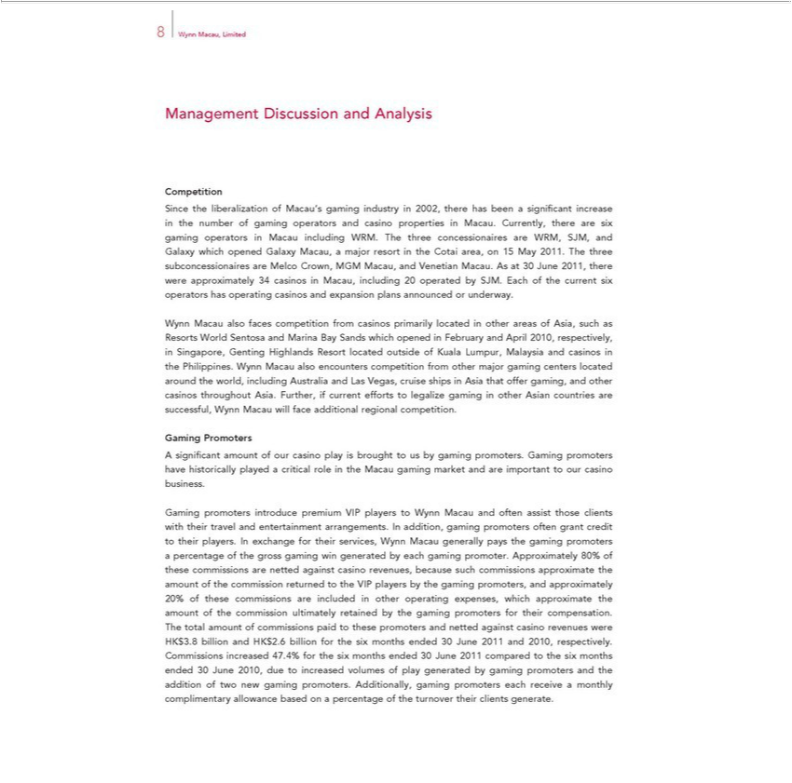

8 | Wynn Macau, Limited
Management Discussion and Analysis
CompetitionSintheliberalization of Macau’s gaming industry in 2002, there has been signifi cant increase in the number of gaming operators and casino properties in Macau. Currently, there are six gaming operators in
 | acau including WRM. The three concessionaires are WRM, SJM, and Galaxy which opened Galaxy Macau, a major resort in the Cotai area, on 15 May 2011. The three subconcessionaires are Melco Crown,
MGM Macau, and Venetian Macau. As at 30 June 2011, there were approximately 34 casinos in Macau, including 20 operated by SJM. Each of the current six operators has operating casinos and expansion
plans announced or underway.
Wynn Macau also faces competition from casinos primarily located in other areas of Asia, such as Resorts World Sentosa and Marina Bay Sands which opened in February and April 2010, respectively, in
Singapore, Genting Highlands Resort located outside of Kuala Lumpur, Malaysia and casinos the Philippines. Wynn Macau also encounters competition from other major gaming centers located around the
world, including Australia and Las Vegas, cruise ships in Asia that offer gaming, and other casinos throughout Asia. Further, if current efforts to legalize gaming in other Asian countries are successful, Wynn
Macau will face additional regional competition.
Gaming Promoters
A signifi cant amount of our casino play is brought us by gaming promoters. Gaming promoters have historically played critical role in the Macau gaming market and are important to our casino business.
Gaming promoters introduce premium VIP players to Wynn Macau and often assist those clients with their travel and entertainment arrangements. In addition, gaming promoters often grant credit to their
players. In exchange for their services, Wynn Macau generally pays the gaming promoters a percentage of the gross gaming win generated by each gaming promoter. Approximately 80% of these commissions
are netted against casino revenues, because such commissions approximate the amount of the commission returned to the VIP players by |  | gaming promoters, and approximately 20% of these commissions are
included in other operating expenses, which approximate the amount of the commission ultimately retained by the gaming promoters for their compensation. The total amount of commissions paid to these promoters and netted against casino revenues were HK$3.8 billion and HK$2.6 billion for the six months ended 30 June 2011 and 2010, respectively. Commissions increased 47.4% for the six months ended

30 June 2011 compared to the six months ended 30 June 2010, due to increased volumes of play generated by gaming promoters and the addition of two new gaming promoters. Additionally, gaming promoters each receive a monthly complimentary allowance based on a percentage of the turnover their clients generate.

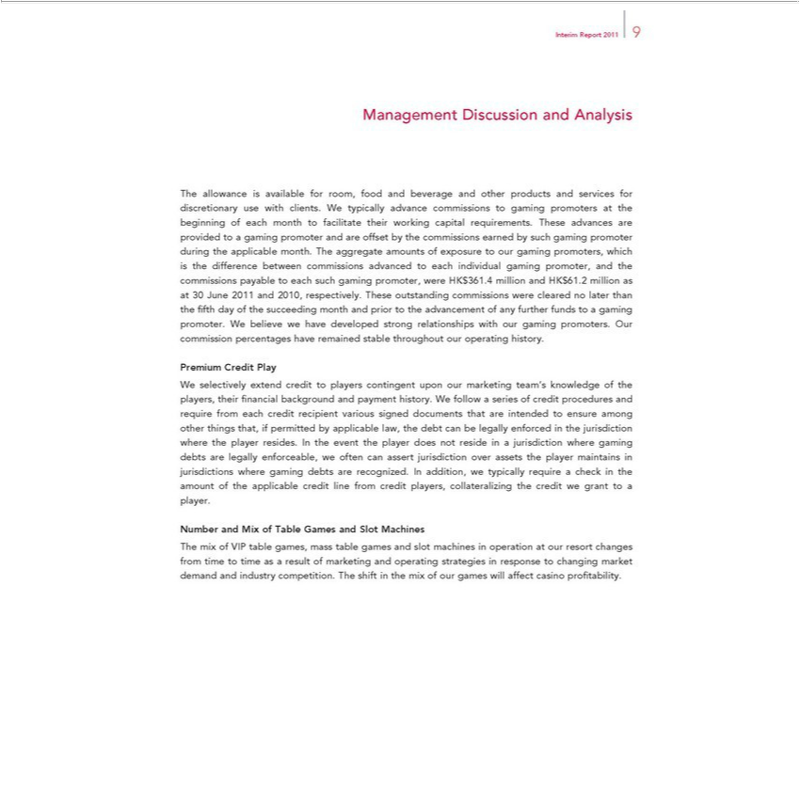

Interim Report 2011 9 | and Analysis
Management | and Analysis
The al owanceDiscussionavailable for room, food and beverage and other products and services for discretionary use with clients. We typically advance commissions to gaming promoters at the beginning of each month
to facilitate their working capital requirements. These advances are provided to a gaming promoter and are offset by the commissions earned by such gaming promoter during the applicable month. The
aggregate amounts of exposure to our gaming promoters, which is the difference between commissions advanced to each individual gaming promoter, and the commissions payable to each such gaming
promoter, were HK$361.4 million and HK$61.2 million as at 30 June 2011 and 2010, respectively. These outstanding commissions were cleared no later than the fi fth day of the succeeding month and prior to
the advancement of any further funds to a gaming promoter. We believe we have developed strong relationships with our gaming promoters. Our commission percentages have remained stable throughout our
operating history.
Credit Play |  | follow a series of credit procedures and require from
PremiumWselectively extend credit to players contingent upon our marketing team’s knowledge of the players, their fi nancial background and payment history. W
each credit recipient various signed documents that are intended to ensure among other things that, if permitted by applicable law, the debt can be legally enforced in the jurisdiction where the player resides. In
the event the player does not reside in a jurisdiction where gaming debts are legally enforceable, we often can assert jurisdiction over assets the player |  |  | in jurisdictions where gaming debts are
recognized. In addition, we typically require check in the amount of the applicable credit line from credit players, collateralizing the credit we grant tomaintainsplayer.
Number and Mix of Table Games and Slot Machines
The mix of VIP table games, mass table games and slot machines in operation at our resort changes from time to time as a result of marketing and operating strategies in response to changing market demand and industry competition. The shift in the mix of our games will affect casino profi tability.

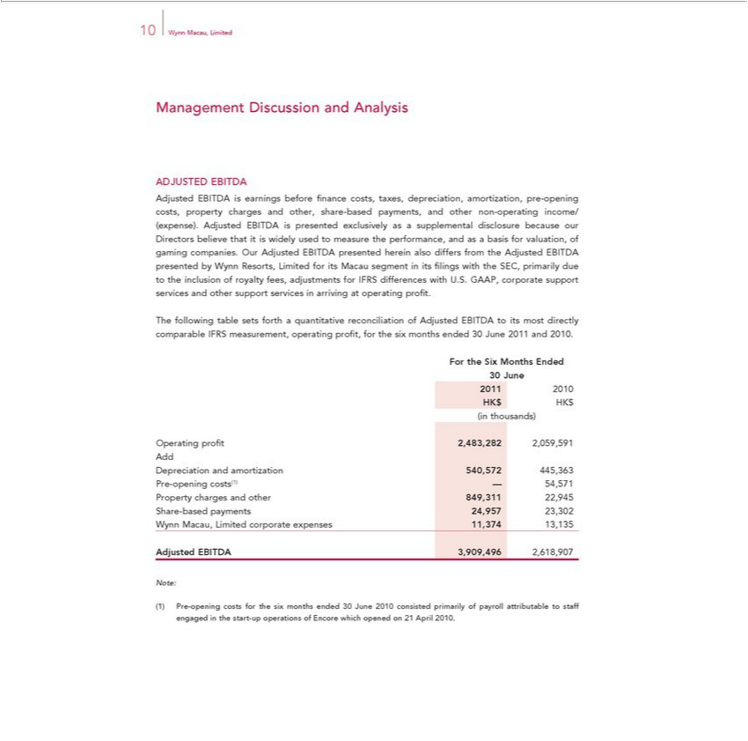

10 Wynn Macau, Limited
Management Discussion and Analysis
DJUSTED EBITDA |  | and other non-operating income/ (expense). Adjusted
Adjusted EBITDA is earnings before fi nance costs, taxes, depreciation, amortization, pre-opening costs, property charges and other share-based |  | and other non-operating income/ (expense). Adjusted
is presented exclusively as a supplemental disclosure because our Directors believe that is widely used to measure the performance, andpayments,asbasis for valuation, of gaming companies. Our Adjusted
EBITDA presented herein also differs from the Adjusted EBITDA presented by Wynn Resorts, Limited for its Macau segment in its fi lings with the SEC, primarily due to the inclusion of royalty fees,
adjustments for IFRS differences with U.S. GAAP, corporate support services and other support services in arriving at operating profi .
The following table sets forth a quantitative reconciliation of Adjusted EBITDA to its most directly comparable IFRS measurement, operating profi t, for the six months ended 30 June 2011 and 2010.
For the Six Months Ended
30 June
2011 2010
HK$ HK$
(in thousands)
Operating profi t 2,483,282 2,059,591
Add | and amortization 540,572 445,363
Depreciation-openingcosts(1) — 54,571
Property charges and other 849,311 22,945
Share-based payments 24,957 23,302
Wynn Macau, Limited corporate expenses 11,374 13,135
Adjusted EBITDA 3,909,496 2,618,907
Note:
Pre-opening costs for the six months ended 30 June 2010 consisted primarily of payroll attributable to staff engaged in the start-up operations of Encore which opened on 21 April 2010.

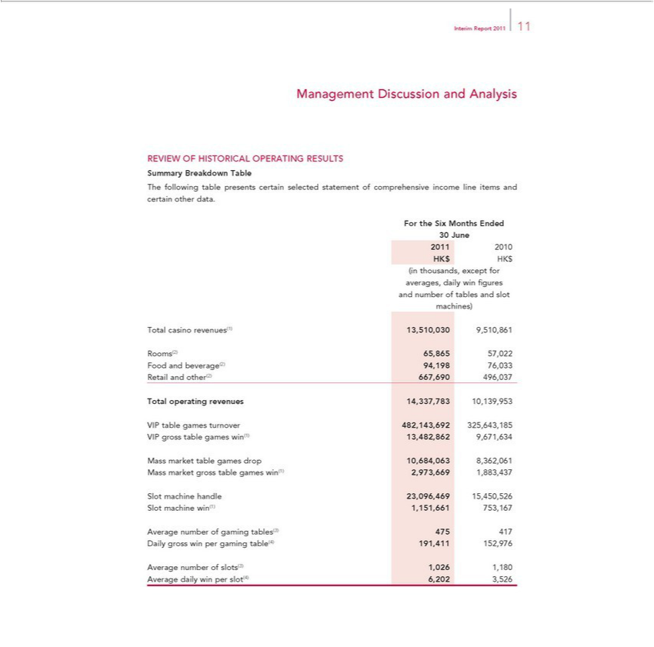

Interim Report 2011 11
Management Discussion and Analysis
SummaryREVIEW OFBreakdownHISTORICALTable OPERATING RESULTS
ForThe thefollowingSixMonthstable Endedpresents certain selected statement of comprehensive income line items and certain other data.
30₂₀₁June
HK$1 HK2010$
^{and}(inverages,thousands,dailyexceptwinfi forgures
machines)number of tables and slot
Rooms(2)Totalcasino65,865revenues(1)57,022 13,510,030 9,510,861
RetailFoodandandbeverage(2)other(2)667,69094,198496,03776,033
^{VIP}Totaltableoperatinggamesrevenuesturnover14,337,783482,143,69210,139,953325,643,185
_{Mass}gross_{market}tabletablegamesgameswin(1)drop13,482,86210,684,0639,671,6348,362,061
_{Slot machine} grosshandletable23,096,469games_{753,167}win(1)15450,5262,973,669 1,883,437
win(1) 1,151,661
Average number of gaming tables(3) 475 ⁴¹⁷
_{Average}Dailygrossnumberwinperof slots(3)gaming 1,026table(4)1,180191,41 152,976
daily win per slot(4) 6,202 3,526

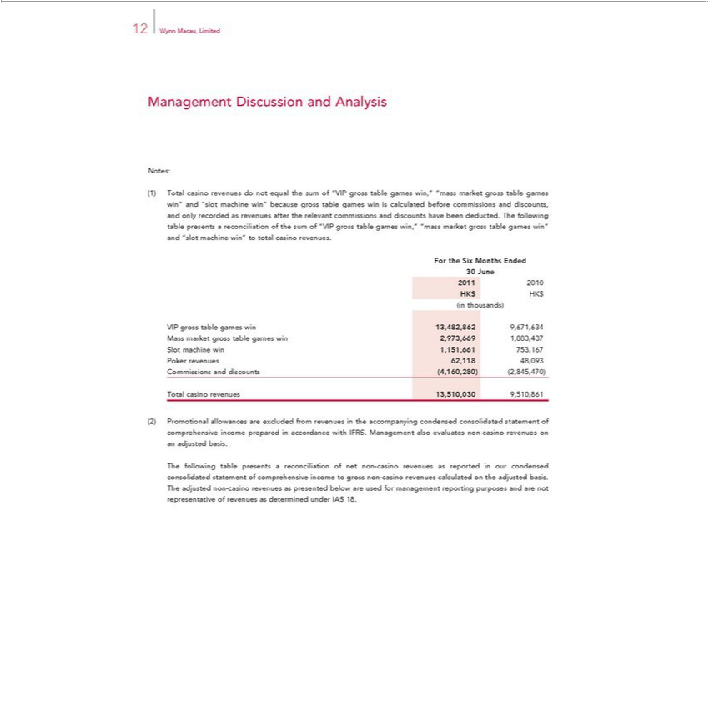

12 Wynn Macau, Limited
Management Discussion and Analysis
Notes:
Total casino revenues do not equal the sum of “VIP gross table games win,” “mass market gross table games win” and “slot machine win” because gross table games win is calculated before commissions and discounts, and only recorded as revenues after the relevant commissions and discounts have been deducted. The following table presents a reconciliation of the sum of “VIP gross table games win,” “mass market gross table games win” and “slot machine win” to total casino revenues.
For the Six Months Ended
₂₀₁30June
1 2010
(inHKthousands)$HK$
VIP gross table games win 13,482,862 9,671,634
SlotMassmachimarket_{revenues}grosswin1,151,661tablegames753,167win2,973,669 1,883,437
Poker 62,118 48,093
TotalCommissionscasinorevenuesanddiscounts13,510,030(4,160,280)9,510,861(2,845,470)

_{Promotional} allowances are excluded from revenues in the accompanying condensed consolidated statement of comprehensive income prepared in accordance with IFRS. Management also evaluates non-casino revenues an adjusted basis.
The following table presents^{casino} reconciliation of net non-casino revenues as reported in our condensed consolidated statement of comprehensive income to gross non-casino revenues calculated on the adjusted
basis. The adjusted non- revenues as presented below are used for management reporting purposes and are not representative of revenues as determined under IAS 18.

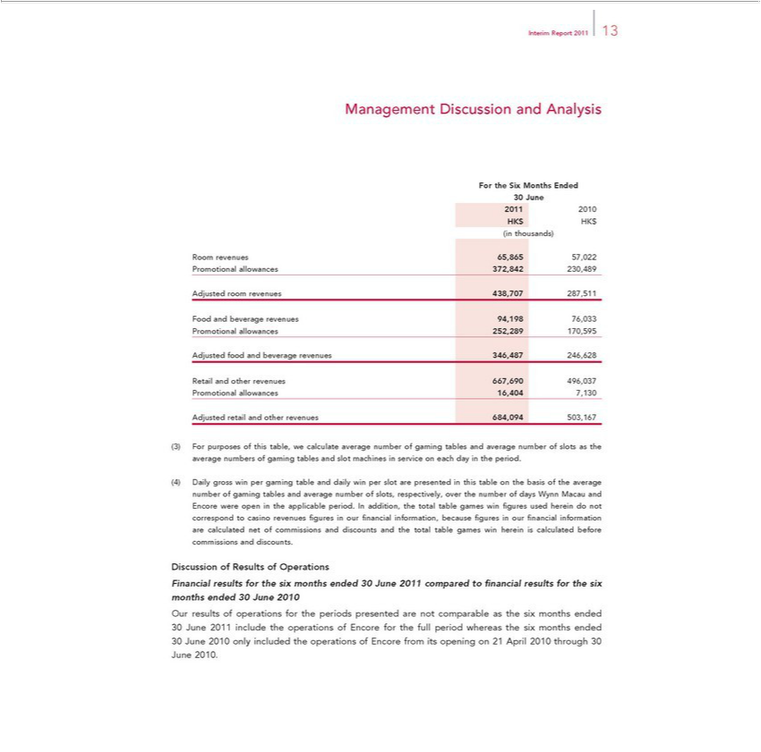

InterimManagementReportDiscussion201113 and Analysis
For the Six Months Ended
30201June12010
(inHKthousands)$HK$
Room revenues 65,865 57,022
AdjustedPromotionalroomallowancesrevenues 372,842438,707 230,489287,511
Food and beverage revenues 94,198 76,033
AdjustedPromotionalfoodallowancesandbeverage252,289revenues170,595346,487 246,628
Retail and other revenues 667,690 496,037
AdjustedPromotionalretaillowancesandother16,404revenues7,130684,094 503,167
DailyForpurposesgrosswinof thisper gamingtable,wetablecalculateanddailyaveragewin numberslot areofgamingpresentedtablesinthisandtableaverageonthenumberbasis ofof slotstheaverageastheaveragenumber numbersofgamingof tablesgamingandtablesaverageand numberslotmachinesofslots,in respectivelyserviceoneachoverdaytheinnumbertheperiod.ofdays Wynn
Macau and Encore were open in the applicable period. In addition, the total table games win fi gures used herein do not correspond to casino revenues fi gures in our fi nancial information, because fi gures in our fi nancial information are calculated net of commissions and discounts and the total table games win herein is calculated before commissions and discounts.

Financial results for the six months ended 30 June 2011 compared to fi nancial results for the six months ended 30 June 2010

Our results of operations for the periods presented are not comparable as the six months ended 30 June 2011 include the operations of Encore for the full period whereas the six months ended 30 June 2010 only included the operations of Encore from its opening on 21 April 2010 through 30 June 2010.

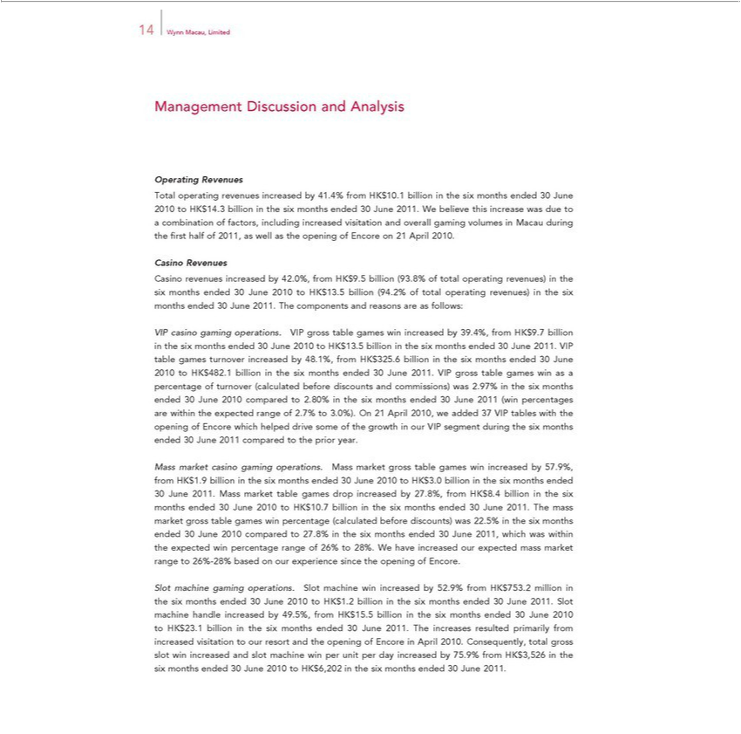

14 Wynn Macau, Limited
Management Discussion and Analysis
Operating Revenues |  |  | the six months ended 30 June 2010 to HK$14.3 billion in the six months ended 30 June 2011. We believe this increase was due to a
Total operating revenues increased by 41.4% from HK$10.1 billion
combination of factors, including increased visitation and overall gaming volumes in Macau during the fi rst half of 2011, as well as the opening of Encore on 21 April 2010.
Revenues
Casino revenues increased by 42.0%, from HK$9.5 billion (93.8% of total operating revenues) in the six months ended 30 June 2010 to HK$13.5 billion (94.2% of total operating revenues) in the six months
ended 30 June 2011. The components and reasons are as follows: |  |  | by 39.4%, from HK$9.7 billion in the six months ended 30 June 2010 to HK$13.5 billion in the six months ended 30 June 2011. VIP table
VIP casino gaming operations. VIP gross table games win
games turnover increased by 48.1%, from HK$325.6 billionincreasedthesix months ended 30 June 2010 to HK$482.1 billion in the six months ended 30 June 2011. VIP gross table games win as a percentage of
turnover (calculated before discounts and commissions) was 2.97% in the six months ended 30 June 2010 compared to 2.80% in the six months ended 30 June 2011 (win percentages are within the expected
range of 2.7% to 3.0%). On 21 April 2010, we added 37 VIP tables with the opening of Encore which helped drive some of the growth in our VIP segment during the six months ended 30 June 2011 compared to
the prior year. |  |  |  | by 57.9%, from HK$1.9 billion in the six months ended 30 June 2010 to HK$3.0 billion in the six months ended 30 June
Mass market casino gaming operations. Mass market gross table games win
2011. Mass market table games drop increased by 27.8%, from HK$8.4 billionincreasedthesix months ended 30 June 2010 to HK$10.7 billion in the six months ended 30 June 2011. The mass market gross table
games win percentage | before discounts) was 22.5% in the six months ended 30 June 2010 compared to 27.8% the six months ended 30 June 2011, which was within the expected win percentage
range of 26% to 28%. W(calculatedhaveincreased our expected mass market range to 26%-28% based on our experience since the opening of Encore.
Slot machine gaming operations. Slot machine win increased by 52.9% from HK$753. million in the six months ended 30 June 2010 to HK$1.2 billion the six months ended 30 June 2011. Slot machine
handle increased by 49.5%, from HK$15.5 billion in the six months ended 30 June 2010 to HK$23.1 billion the six months ended 30 June 2011. The increases resulted primarily from increased visitation to
our resort and the opening of Encore in April |  | . Consequently, total gross slot win increased and slot machine win per unit per day increased by 75.9% from HK$3,526 in the six months ended 30 June 2010
to HK$6,202 in the six months ended 30 June20101.

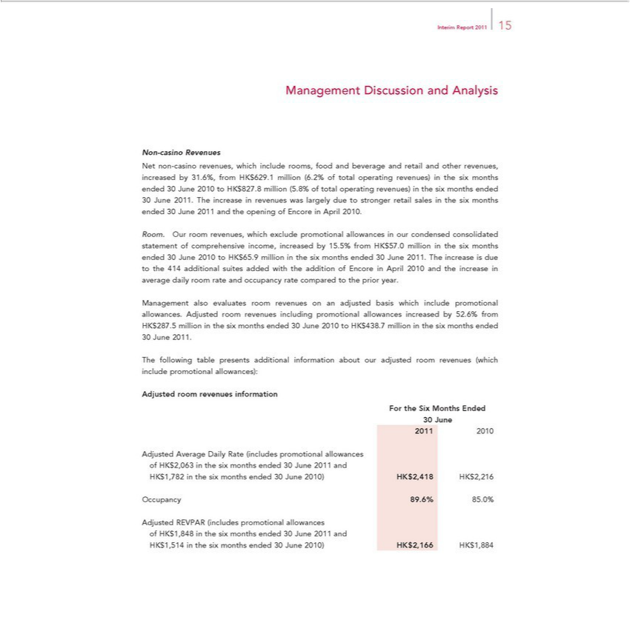

Interim Report 2011 15
^{Net}Managementon-casinoRevenuesDiscussion and Analysis
non-casino revenues, which include rooms, food and beverage and retail and other revenues, increased by 31.6%, from HK$629.1 million (6.2% of total operating revenues) in the six months ended 30 June 2010 to HK$827.8 million (5.8% of total operating revenues) in the six months ended 30 June 2011. The increase in revenues was largely due to stronger retail sales in the six months ended 30 June 2011 and the opening of Encore in April 2010.
Room. Our room revenues, which exclude promotional allowances in our condensed consolidated statement of comprehensive income, increased by 15.5% from HK$57.0 million_{increase}the six months ended
30 June 2010 to HK$65.9 million in the six months ended 30 June 2011. The increase is due to the 414 additional suites added with the addition of Encore in April 2010 and the in average daily room rate and occupancy rate compared to the prior year.
Management also evaluates room revenues on an adjusted basis which include promotional allowances. Adjusted room revenues including promotional allowances increased by 52.6% from HK$287.5 million in the six months ended 30 June 2010 to HK$438.7 million in the six months ended 30 June 2011.
AdjustedThefollowingroomtablerevenuespresentsinformationadditional information about our adjusted room revenues (which include promotional allowances):
For the Six Months Ended
₂₀₁30June
1 2010
ofAdjustedHK$2,063AverageintheDailysixmonthsRate(includesended30promotionalJune2011 andallowances
OccupancyHK$1,782in89.6%thesix85.0%months ended 30 June 2010) HK$2,418 HK$2,216
ofAdjustedHK$1,848REVPARinthe (includessixmonthspromotionalended30Juneallowances2011and

HK$1,514 in the six months ended 30 June 2010) HK$2,166 HK$1,884

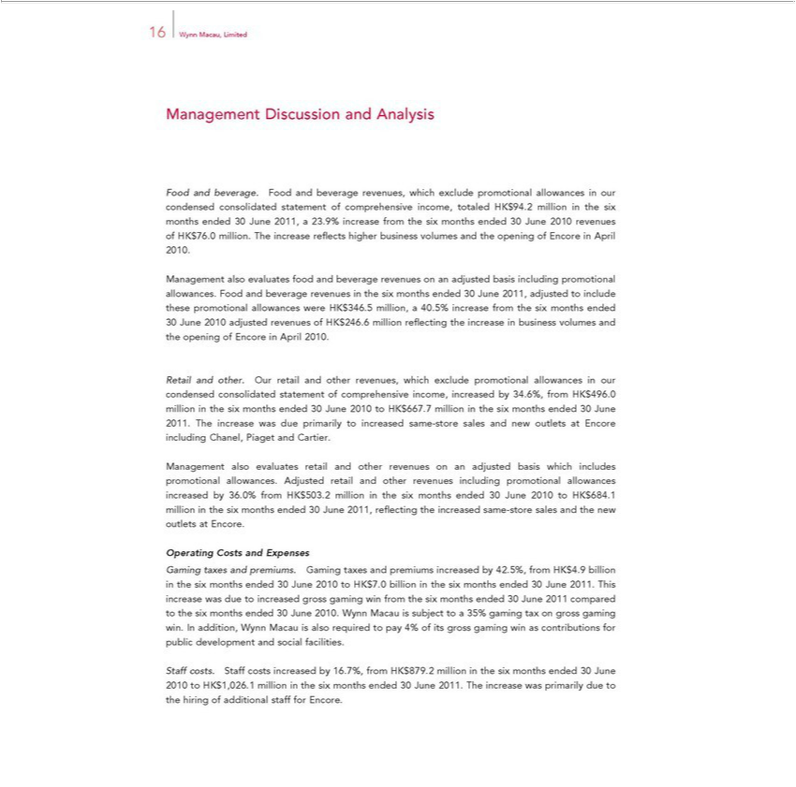

Management16WynnMacau,DiscussionLimitedand Analysis
Food and _{beverage}. Food and beverage revenues, which exclude promotional allowances in our condensed consolidated statement of comprehensive income, totaled HK$94.2 million in the six months ended 30 June 2011, 23.9% increase from the six months ended 30 June 2010 revenues of HK$76.0 million. The increase refl ects higher business volumes and the opening of Encore in April 2010.

Management also evaluates food and beverage revenues on an adjusted basis including promotional allowances. Food and beverage revenues in the six months ended 30 June 2011, adjusted to include these promotional allowances were HK$346.5 million, a 40.5% increase from the six months ended 30 June 2010 adjusted revenues of HK$246.6 million refl ecting the increase in business volumes and the opening of Encore in April 2010.
Retail and other. Our retail and other revenues, which exclude promotional allowances in our condensed consolidated statement of comprehensive income, increased by 34.6%, from HK$496.0 million in the six months ended 30 June 2010 to HK$667.7 million in the six months ended 30 June 2011. The increase was due primarily to increased same-store sales and new outlets at Encore including Chanel, Piaget and Cartier.
Management also evaluates retail and other revenues on an adjusted basis which includes promotional allowances. Adjusted retail and other revenues including promotional allowances increased by 36.0% from HK$503.2 million in the six months ended 30 June 2010 to HK$684.1 million in the six months ended 30 June 2011, refl ecting the increased same-store sales and the new outlets at Encore.
Operating Costs and Expenses
^{was}Gming taxes and premiums. Gaming taxes and premiums increased by 42.5%, from HK$4.9 billion in the six months ended 30 June 2010 to HK$7.0 billion in the six months ended 30 June 2011. This increase due to increased gross gaming win from the six months ended 30 June 2011 compared to the six months ended 30 June 2010. Wynn Macau is subject to a 35% gaming tax on gross gaming win. In addition,

Wynn Macau is also required to pay 4% of its gross gaming win as contributions for public development and social facilities.

Staff costs. Staff costs increased by 16.7%, from HK$879.2 million in the six months ended 30 June 2010 to HK$1,026.1 million in the six months ended 30 June 2011. The increase was primarily due to the hiring of additional staff for Encore.

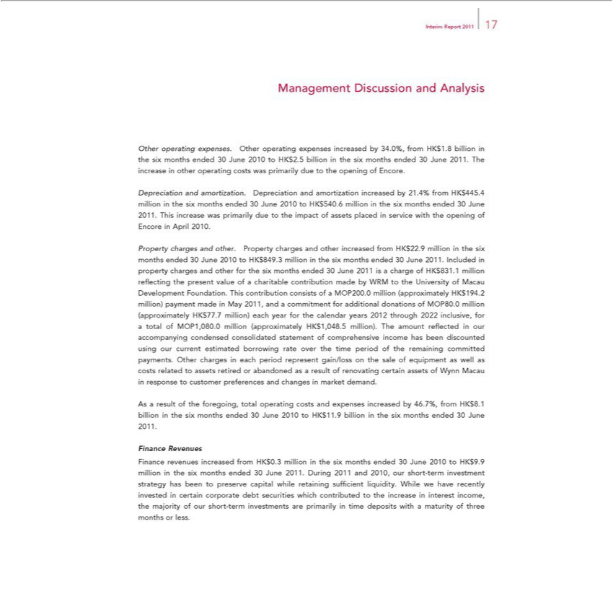

Interim Report 2011 17
OtherManagementoperatingDiscussionexpenses.andOtherAnalysisoperating expenses increased by 34.0%, from HK$1.8 billion in the six months ended 30 June 2010 to HK$2.5 billion in the six months ended 30 June 2011. The increase in
Depreciationotheroperatingandcostsamortization.wasprimarilyDepreciationduetotheandopeningamortizationofEncore.increased by 21.4% from HK$445.4 million in the six months ended 30 June 2010 to HK$540.6 million in the six months ended 30 June 2011. This increase was primarily due to the impact of assets placed service with the opening of Encore in April 2010.
chargesPropertyandchargesotherandfor othersix.Propertymonths endedcharges30andJuneother201increased1ischargefromof HKHK$$22.9831HK.millionmillion$194inreflthe ectingsixmonthsthepresentended value30Juneof 2010acharitabletoHK$contribution849.3millionmadeinthebysixWRMmonthstotheendedUniversity30Juneof2011.MacauIncludedDevelopmentinproperty Foundation. This contribution consistscalendarofMOP200. million (approximately .2 million) payment made in May 2011, and a commitment for additional donations of MOP80.0 million (approximately
consolidatedHK$77.7million)statementeach ofyearcomprehensiveforthe incomeyearshas2012beenthroughdiscounted2022 inclusive,usingour currentforatotalestimatedofMOP1,080.0borrowingmillionrateover(approximatelythetimeperiodHK$of1,048.5theremainingmillion)committed.Theamountpayments.reflectedOtherinourchargesaccompanyingeachperiodcondensed represent gain/loss on the sale of equipment as well as costs related to assets retired or abandoned as a result of renovating certain assets of Wynn Macau in response to customer preferences and changes in
Asmarketresultdemand.ofthe foregoing, total operating costs and expenses increased by 46.7%, from HK$8.1 billion in the six months ended 30 June 2010 to HK$11.9 billion in the six months ended 30 June 2011. Finance Revenues

been to preserverevenuescapitalincreasedwhilefromretainingHK$0.3suffimillioncient inliquidity.thesix monthsWhileweendedhave30recentlyJune2010investedtoHKin$9.9certainmillioncorporateinthe debtsixmonthssecuritiesendedwhich30 Junecontributed2011.Duringtothe increase2011andin2010,interestourincome,short-termthe investmentmajorityof strategyourshorthas-term investments are primarily time deposits with a maturity of three months or less.

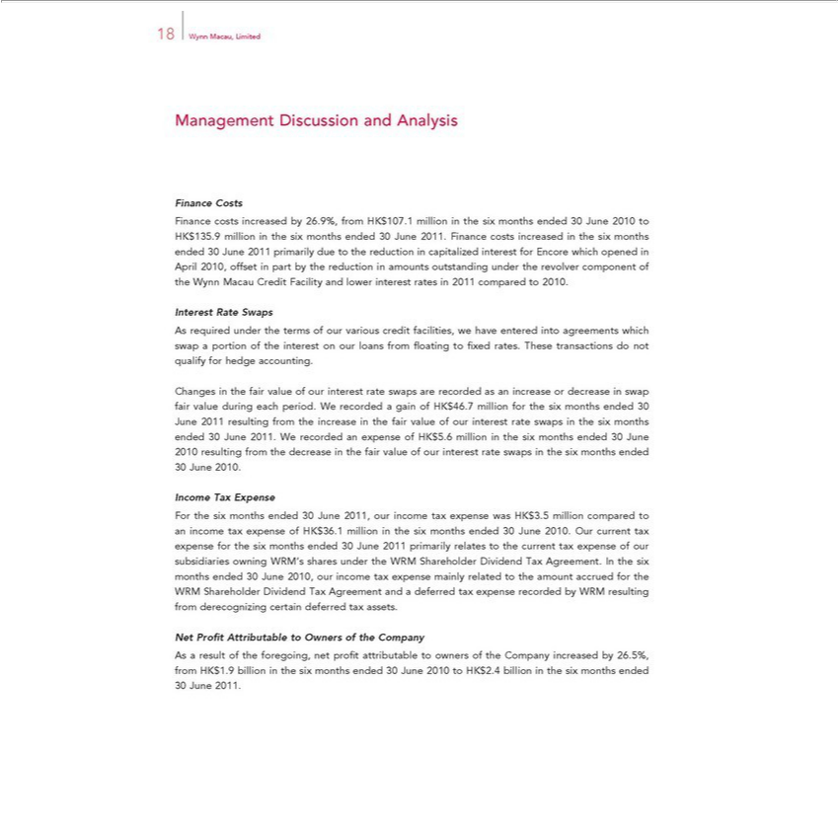

18 Wynn Macau, Limited
Management Discussion and Analysis
 | Costs
Finance costs increased by 26.9%, from HK$107.1 million the six months ended 30 June 2010 to HK$135.9 million in the six months ended 30 June 2011. Finance costs increased in the six months ended
30 June 2011 primarily due to the reduction in capitalized interest for Encore which opened in April 2010, offset in part by the reduction in amounts outstanding under the revolver component of the Wynn
Macau Credit Facility and lower interest rates in 2011 compared to 2010.
Interest Rate Swaps
As required under the terms of our various credit facilities, we have entered into agreements which swap a portion of the interest on our loans from fl oating to fi xed rates. These transactions do not qualify for
hedge | .
Changesaccountingthefair value of our interest rate swaps are recorded as an increase or decrease in swap fair value during each period. W recorded a gain of HK$46.7 million for the six months ended 30 June 2011
resulting from the increase in the fair value of our |  |  | rate swaps in the six months ended 30 June 2011. We recorded an expense of HK$5.6 million in the six months ended 30 June 2010 resulting from the
decrease in the fair value of our interest rate swapsinterestthesix months ended 30 June 2010.
Income Tax Expense
For the six months ended 30 June 2011, our income tax expense was HK$3.5 million compared to an income tax expense of HK$36.1 million in the six months ended 30 June 2010. Our current tax expense for
the six months ended 30 June 2011 primarily relates to the current tax expense of our subsidiaries owning WRM’s shares under the WRM Shareholder Dividend Tax Agreement. In the six months ended 30 June
2010, our income tax expense mainly related to the amount accrued for the WRM Shareholder Dividend Tax Agreement and a deferred tax expense recorded by WRM resulting from derecognizing certain
deferred | assets. | Company
Net ProfitaxAttributable to Owners |  | Company
As a result of the foregoing, net profi theattributable to owners of the Company increased by 26.5%, from HK$1.9 billion in the six months ended 30 June 2010 to HK$2.4 billion in the six months ended 30 June 2011.

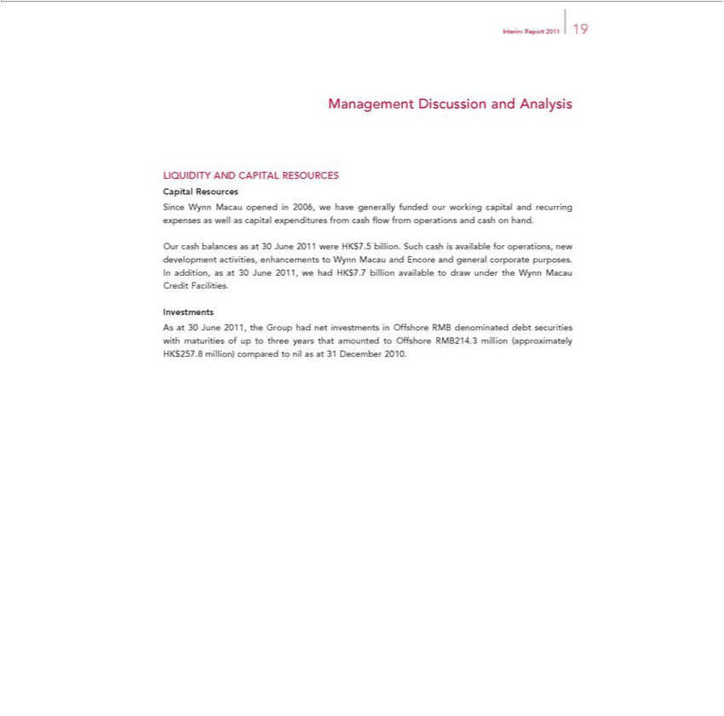

Interim Report 2011 19
Management Discussion and Analysis
CapitalLIQUIDITYResourcesAND CAPITAL RESOURCES
Since Wynn Macau opened in 2006, we have generally funded our working capital and recurring expenses as well as capital expenditures from cash fl ow from operations and cash on hand.
^{HK$7}
_{Investments}Ouraddition,cashbalancesasat30asJuneat302011,June we2011hadwereHK$7. billion.5billion.availableSuch tocashdrawis availableundertheforWynnoperations,Macau CreditnewdevelopmentFacilities. activities, enhancements to Wynn Macau and Encore and general corporate purposes.
As at 30 June 2011, the Group had net investments in Offshore RMB denominated debt securities with maturities of up to three years that amounted to Offshore RMB214.3 million (approximately HK$257.8 million) compared to nil as at 31 December 2010.

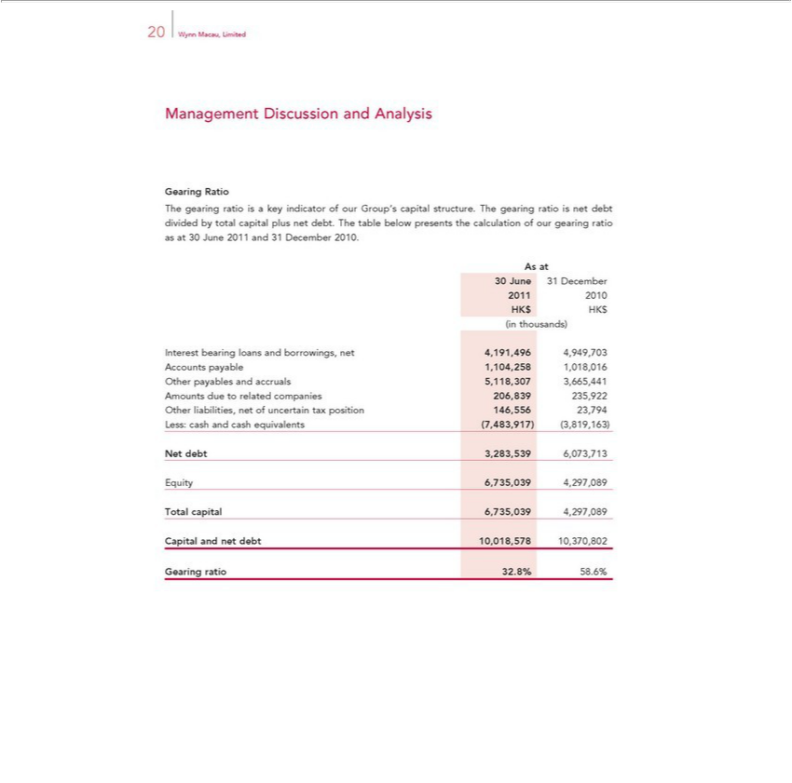

20 Wynn Macau, Limited
Management Discussion and Analysis
Gearing Ratio
The gearing ratio is a key indicator of our Group’s capital structure. The gearing ratio is net debt divided by total capital plus net debt. The table below presents the calculation of our gearing ratio as at 30 June 2011 and 31 December 2010.
As at
30²⁰¹June 31 December
1 2010
(inHKthousands)$HK$
AccountsInterestbearingpayableloans1,104,258andborrowings,1,018,016net 4,191,496 4,949,703
AmountsOtherpayablesduetoandrelatedaccrualscompanies5,118,307206,8393,665,441235,922
Less:Other cashliabilities,andcashnet equivalentsofuncertain(7,483,917)taxposition(3,819,163)146,55623,794
Net debt 3,283,539 6,073,713
TotalEquitycapital6,735,0396,735,0394,297,0894,297,089
GearingCapitalandrationet32.8%debt 10,018,57858.6% 10,370,802

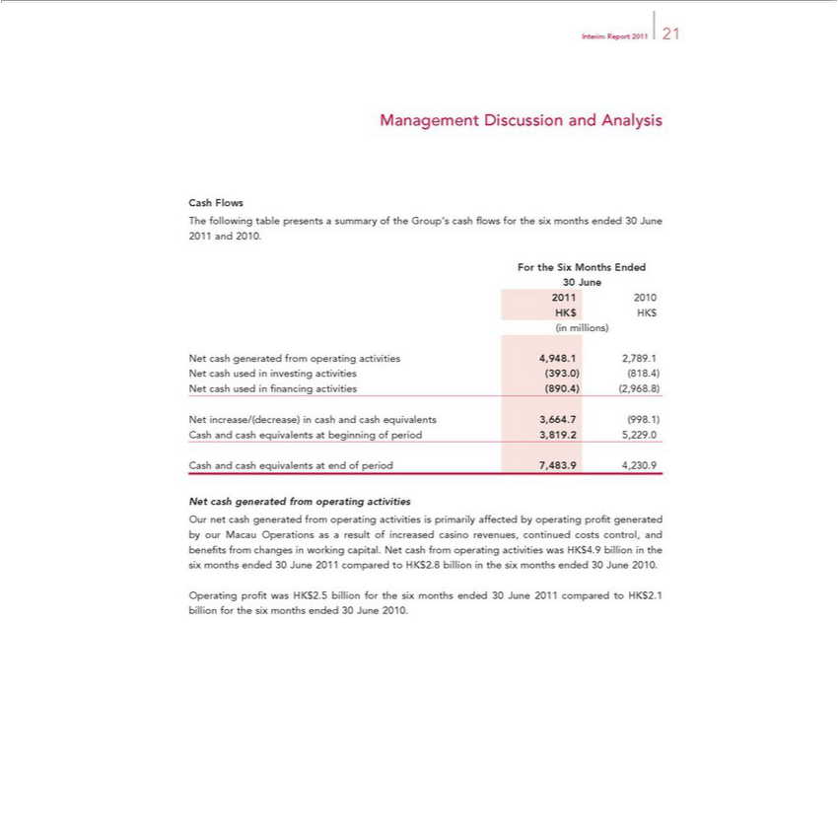

Interim Report 2011 21
Management Discussion and Analysis
Cash Flows
The following table presents a summary of the Group’s cash fl ows for the six months ended 30 June 2011 and 2010.
For the Six Months Ended
30 June
2011 2010
HK$ HK$
(in millions)
generated from operating activities 4,948.1 2,789.1
investing activities (393.0) (818.4)
cash used in fi | activities (890.4) (2,968.8)
Net increase/(decrease)nancingcash and cash equivalents 3,664.7 (998.1)
 | beginning of period 3,819.2 5,229.0
Cash and cash equivalents at end of period 7,483.9 4,230.9
Net cash generated from operating activities |  | revenues, continued costs
Our net cash generated from operating activities is primarily affected by operating profi t generated by our Macau Operations as result of increased |  | revenues, continued costs
changes in working capital. Net cash from operating activities was HK$4.9 billion in the six months ended 30 June 2011 compared to HK$2.8 billion casinothe six months ended 30 June Operating profi t was HK$2.5 billion for the six months ended 30 June 2011 compared to HK$2.1 billion for the six months ended 30 June 2010.

control, and benefi ts from 2010.

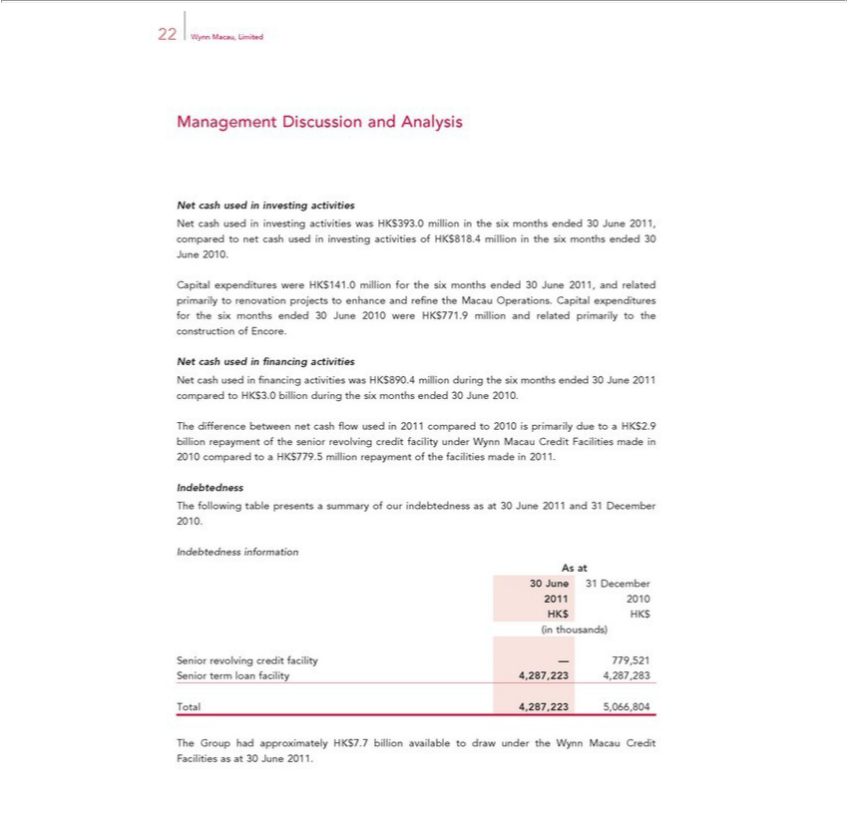

Management22WynnMacau,DiscussionLimitedand Analysis

Net cash used in investing activities was HK$393.0 million in the six months ended 30 June 2011, compared to net cash used in investing activities of HK$818.4 million in the six months ended 30 June 2010. Capital expenditures were HK$141.0 million for the six months ended 30 June 2011, and related primarily to renovation projects to enhance and refi ne the Macau Operations. Capital expenditures for the six months ended 30 June 2010 were HK$771.9 million and related primarily to the construction of Encore.
Net cash used in fi nancing activities was HK$890.4 million during the six months ended 30 June 2011 compared to HK$3.0 billion during the six months ended 30 June 2010.
The difference between net cash fl ow used in 2011 compared to 2010 is primarily due to a HK$2.9 billion repayment of the senior revolving credit facility under Wynn Macau Credit Facilities made in 2010 compared to a HK$779.5 million repayment of the facilities made in 2011.
Indebtedness
IndebtednessThefollowinginformationtablepresents a summary of our indebtedness as at 30 June 2011 and 31 December 2010.
As at
30²⁰¹June 31 December
1 2010
(inHKthousands)$HK$
^{Senior}
termrevolvingloan facilitycreditfacility4,287,223—779,5214,287,283
^{The}otal 4,287,223 5,066,804
Group had approximately HK$7.7 billion available to draw under the Wynn Macau Credit Facilities as at 30 June 2011.

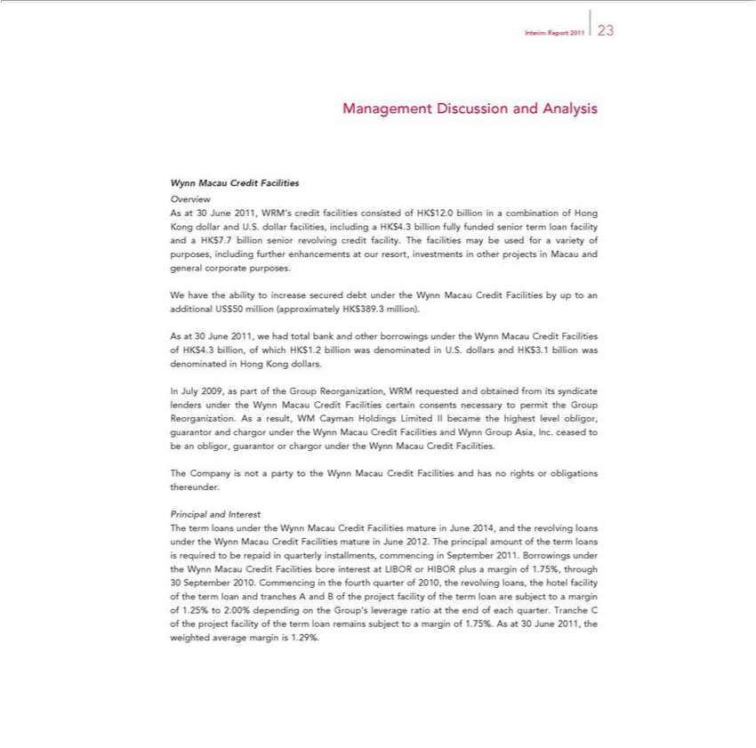

Interim Report 2011 23
Management Discussion and Analysis
Wynn Macau Credit Facilities
Overview
As at 30 June 2011, WRM’s credit facilities consisted of HK$12.0 billion in a combination of Hong Kong dollar and U.S. dollar facilities, including a HK$4.3 billion fully funded senior term loan facility and a
HK$7.7 billion senior revolving credit facility. The facilities may be used for a variety of purposes, including further enhancements at our resort, investments in other projects in Macau and general corporate
purposesWhave.the ability to increase secured debt under the Wynn Macau Credit Facilities by up to an additional US$50 million (approximately HK$389.3 million).
As 30 June 2011, we had total bank and other borrowings under the Wynn Macau Credit Facilities of HK$4.3 billion, of which HK$1.2 billion was denominated in U.S. dollars and HK$3.1 billion was
denominated in Hong Kong dollars.
In July 2009, as part of the Group Reorganization, WRM requested and obtained from its syndicate lenders under the Wynn Macau Credit Facilities certain consents necessary to permit the Group
Reorganization. As a result, WM Cayman Holdings Limited II became the highest level obligor, guarantor and chargor under the Wynn Macau Credit Facilities and Wynn Group Asia, Inc. ceased to be an
obligor, guarantor or chargor under the Wynn Macau Credit Facilities.
The Company is not a party to the Wynn Macau Credit Facilities and has no rights or obligations thereunder.
Principal and Interest |  | in June 2012. The | amount of the term loans is
The term loans under the Wynn Macau Credit Facilities mature in June 2014, and the revolving loans under the Wynn Macau Credit Facilities |  | in June 2012. The | amount of the term loans is
required to be repaid quarterly | commencing in September 2011. Borrowings under the Wynn Macau Credit Facilities bore interestmatureLIBOR or HIBOR plusprincipalmargin of 1.75%, through
30 September 2010. Commencing | the fourth quarter of 2010, the revolving loans, the hotel facility of the term loan and tranches A and B of the project facility of the term loan are subject to a margin of 1.25%
to 2.00% depending on the Group’installments,leverageratio at the end of each quarter. Tranche C of the project facility of the term loan remains subject to a margin of 1.75%. As at 30 June 2011, the weighted average margin is 1.29%.

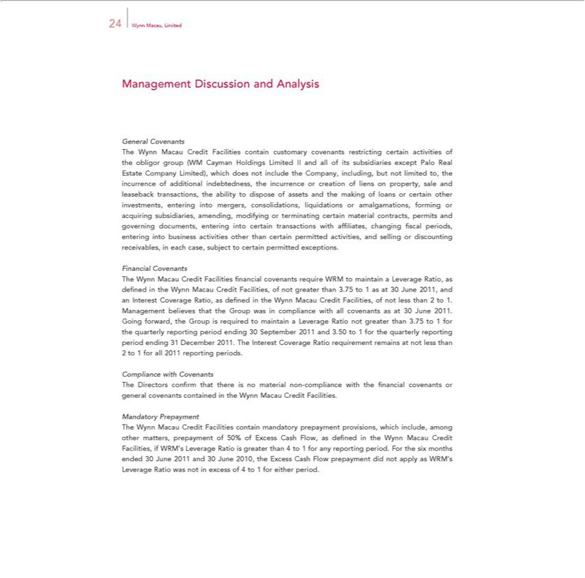

24 Wynn Macau, Limited
Management Discussion and Analysis
General Covenants
The Wynn Macau Credit Facilities contain customary covenants restricting certain activities of the obligor group (WM Cayman Holdings Limited II and all of its subsidiaries except Palo Real Estate Company Limited), which does not include the Company, including, but not limited to, the incurrence of additional indebtedness, the incurrence or creation of liens on property_{subsidiaries,}saleandleaseback transactions, the ability

_{terminating}odisposeof assets and the making of loans or certain other investments, entering into mergers, consolidations, liquidations or amalgamations, forming or acquiring amending, modifying or certain material contracts, permits and governing documents, entering into certain transactions with affi liates, changing fi scal periods, entering into business activities other than certain permitted
Financialactivities, Covenantsandselling or discounting receivables, in each case, subject to certain permitted exceptions.
_{Interest}TheWynn Macau Credit Facilities fi nancial covenants require WRM to mai_{not}tain a Leverage Ratio,_{Management}asdefied in the Wynn Macau Credit Facilities, of not greater than 3.75 to 1 as at 30 June 2011, and an
Coverage Ratio, as defi _{Leverage}ndinthe Wynn Macau Credit Facilities, of less than 2 to 1. believes that the Group was in compliance with all covenants as at 30 June 2011. Going forward, the
TheGroupInterestisrequiredCoveragetomaintainRatiorequirementa remainsRationotatgreaternotlessthanthan3.752toto1 1forforallthe2011quarterlyreportingreportingperiods.period ending 30 September 2011 and 3.50 to 1 for the quarterly reporting period ending 31 December 2011.
Compliance with Covenants
MandatoryTheDirectorsPrepaymentconfirm that there is no material non-compliance with the fi nancial covenants or general covenants contained in the Wynn Macau Credit Facilities.

^{WRM’}Theynn Macau Credit Facilities contain mandatory prepayment provisions, which include, among other matters, prepayment of 50% of Excess Cash Flow, as defi ned in the Wynn Macau Credit Facilities, if _{excess}Leverage Ratio is greater than 4 to 1 for any reporting period. For the six months ended 30 June 2011 and 30 June 2010, the Excess Cash Flow prepayment did not apply as WRM’s Leverage Ratio was
not in of 4 to 1 for either period.

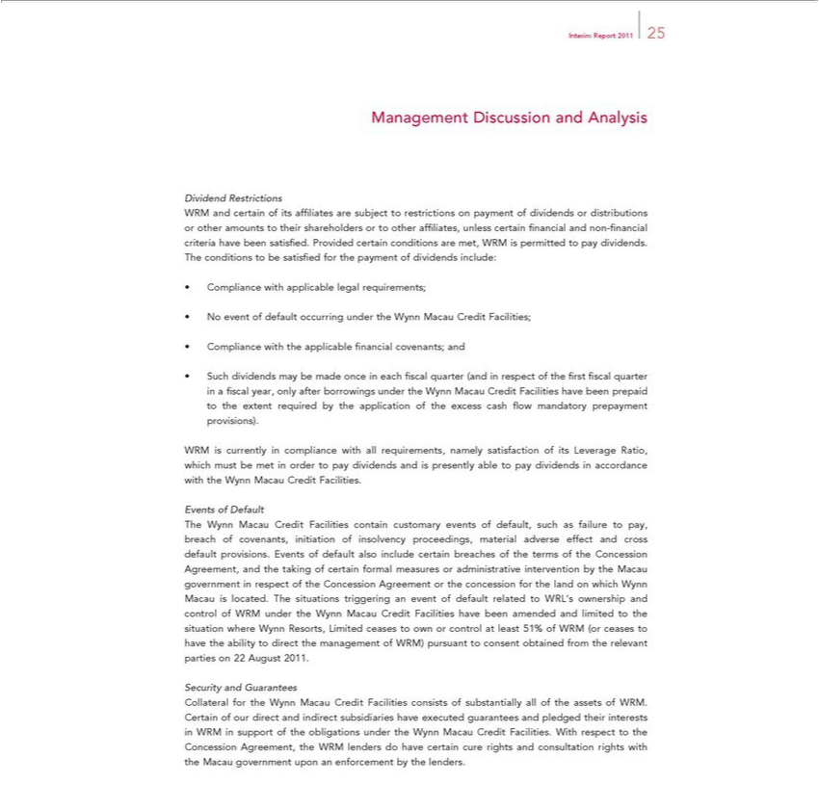

Interim Report 2011 25
DividendManagementRestrictionsDiscussion and Analysis

WRM and certain of its affi liates are subject to restrictions on payment of dividends or distributions or other amounts to their shareholders or to other affi liates, unless certain fi nancial and non-fi nancial criteria have been satisfi ed. Provided certain conditions are met, WRM is permitted to pay dividends. The conditions to be satisfi ed for the payment of dividends include:
Compliance with applicable legal requirements;
ComplianceNoeventof defaultwiththeoccurringapplicableunderfinancialtheWynncovenants;Macau andCredit Facilities;

Such dividends may be made once in each fi scal quarter (and in respect of the fi rst fi scal quarter in a fi scal year, only after borrowings under the Wynn Macau Credit Facilities have been prepaid to the extent required by the application of the excess cash fl ow mandatory prepayment provisions).
WRM is currently in compliance with all requirements, namely satisfaction of its Leverage Ratio, which must be met in order to pay dividends and is presently able to pay dividends in accordance with the Wynn Macau Credit Facilities.
The_{Events}^{nts of Default}
Wynn Macau Credit Facilities contain customary events of default, such as failure to pay, breach of covenants, initiation of insolvency proceedings, material adverse effect and cross default provisions. of default also include certain breaches of the terms of the Concession Agreement, and the taking of certain formal measures or administrative intervention by the Macau government in respect of the _{Credit}oncession Agreement or the concession for the land on which Wynn Macau is located. The situations triggering an event of default related to WRL’_{ceases}ownership and control of WRM under the Wynn Macau
Facilities have been amended and limited to the situation where Wynn Resorts, Limited ceases to own or control at least 51% of WRM (or to have the ability to direct the management of WRM) pursuant to consent obtained from the relevant parties on 22 August 2011.
Security and Guarantees

Collateral for the Wynn Macau Credit Facilities consists of substantially all of the assets of WRM. Certain of our direct and indirect subsidiaries have executed guarantees and pledged their interests in WRM in support of the obligations under the Wynn Macau Credit Facilities. With respect to the Concession Agreement, the WRM lenders do have certain cure rights and consultation rights with the Macau government upon an enforcement by the lenders.

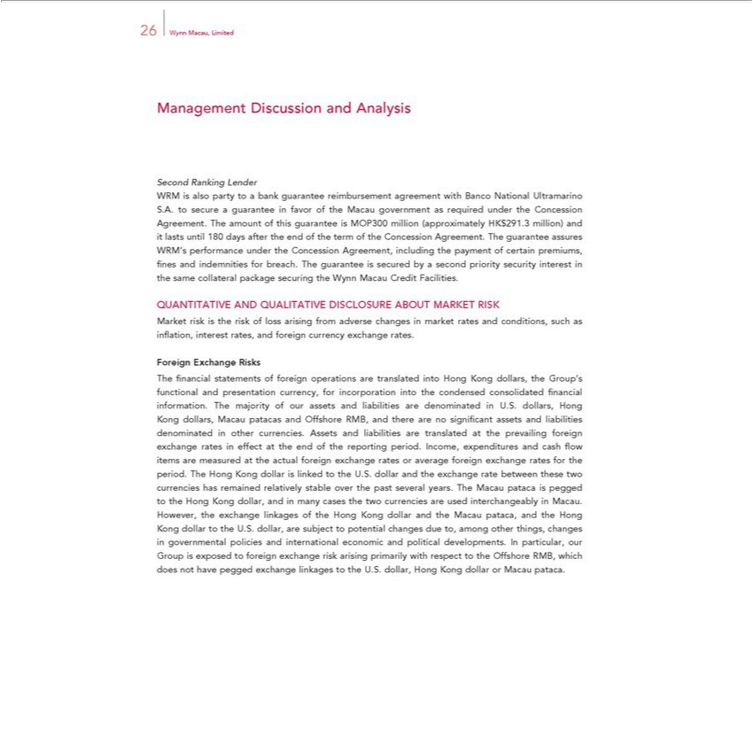

26 Wynn Macau, Limited
Management Discussion and Analysis
Second Ranking Lender
WRM is also party to bank guarantee reimbursement agreement with Banco National Ultramarino S.A. to secure a guarantee in favor of the Macau government as required under the Concession Agreement.
The amount of this guarantee is MOP300 million (approximately HK$291.3 million) and lasts until 180 days after the end of the term of the Concession Agreement. The guarantee assures WRM’s performance
under the Concession Agreement, including the payment of certain premiums, fi nes and indemnities for breach. The guarantee is secured by a second priority security interest in the same collateral package
securing the Wynn Macau Credit Facilities.
QUANTITATIVE AND QUALITATIVE DISCLOSURE ABOUT MARKET RISK
Market risk is the risk of loss arising from adverse changes in market rates and conditions, such as infl ation, interest rates, and foreign currency exchange rates.
Foreign Exchange Risks
fi nancial statements of foreign operations are translated into Hong Kong dollars, the Group’s functional and presentation currency, for incorporation into the condensed consolidated fi nancial information.
The majority of our assets and liabilities are |  | U.S. dollars, Hong Kong dollars, Macau patacas and Offshore RMB, and there are no signifi cant assets and liabilities |  |  | in other
currencies. Assets and liabilities are translateddenominatedprevailingthe |  |  | foreign exchange rates in effect at the end of the reporting period. Income, expenditures and cash fl ow items are measureddenominatedthe actual foreign
exchange rates or average foreign exchange rates for the period. The Hong Kong dollar is linked to the U.S. dollar and the exchange rate between these two currencies has remained relatively stable over the past
several years. The Macau pataca is pegged to the Hong Kong dollar, and in many cases the two currencies are used |  |  |  | in Macau. However, the exchange linkages of the Hong Kong dollar and the
Macau | and the Hong Kong dollar to the U.S. dollar, are subject to potential changes due to, among other things,interchangeablychangesgovernmental policies and international economic and political developments.
In particularpataca,our Group is exposed to foreign exchange risk arising primarily with respect to the Offshore RMB, which does not have pegged exchange linkages to the U.S. dollar, Hong Kong dollar or Macau pataca.

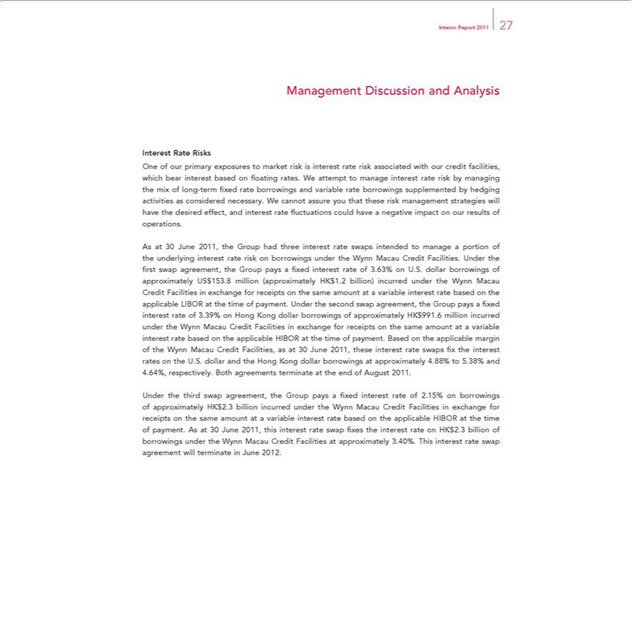

Interim Report 2011 27
Management Discussion and Analysis
Interest Rate Risks |  |  |  |  | risk by managing the mix of
One of our primary exposures to market risk is interest rate risk associated with our credit facilities, which bear interest based on fl oating rates. We attempt to manage interest
long-term fi xed rate borrowings and variable |  | borrowings supplemented by hedging activities as considered necessary. We cannot assure you that these risk management strategies will have the desired
effect, and interest rate fl uctuations could haveratenegative impact on our results of operations.
As at 30 June 2011, the Group had three interest rate swaps intended to manage a portion of the underlying interest rate risk on borrowings under the Wynn Macau Credit Facilities. Under the fi rst swap
agreement, the Group pays a fi xed interest |  | of 3.63% on U.S. dollar borrowings of approximately US$153.8 million (approximately HK$1.2 billion) incurred under the Wynn Macau Credit Facilities in
exchange for receipts on the same amount ratevariable interest rate based on the applicable LIBOR at the time of payment. Under the second swap agreement, the Group pays a fi xed interest rate of 3.39% on
ong Kong dollar borrowings of approximately HK$991.6 million incurred under the Wynn Macau Credit Facilities in exchange for receipts on the same amount a variable interest rate based |  |  |  |  |  | the applicable
HIBOR at the time of payment. Based on the applicable margin of the Wynn Macau Credit Facilities, as at 30 June 2011, these interest rate swaps fi x the interest rates on the U.S. dollar and the |  |  |  |  |  | Hong Kong
dollar borrowings at approximately 4.88% to 5.38% and 4.64%, respectively. Both agreements terminate |  |  | the end of August 2011.
same amount at swapvariable interest rate based on the applicable HIBOR at the time of payment. Asapproximately30June2011, this interest rate swap fi xes the interest rate on HK$2.3 billion of borrowings under the Wynn
Under the third | agreement, the Group pays a fi xed interest rate of 2.15% on borrowings of |  |  | HK$2.3 billion incurred under the Wynn Macau Credit Facilities in exchange for receipts on the
Macau Credit Facilities at approximately 3.40%. This interest rate swap agreement will terminate in June 2012.

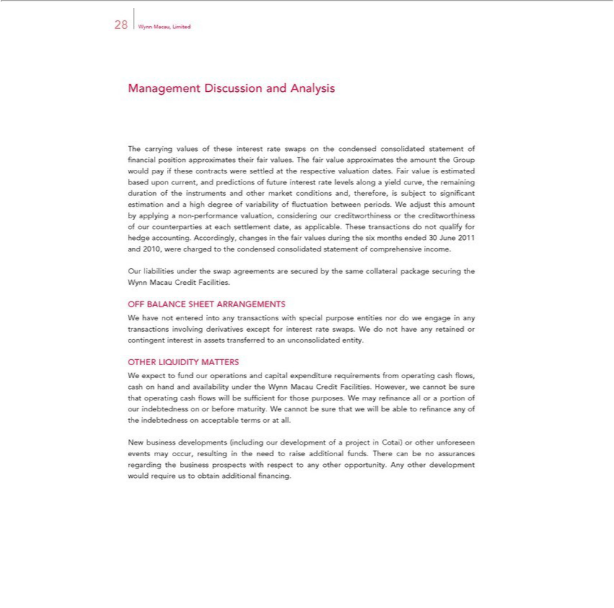

28 Wynn Macau, Limited
Management Discussion and Analysis |  | the condensed consolidated statement of fi nancial position approximates their fair values. The fair value approximates the amount the Group would pay if
The carrying values of these interest rate swaps
these contracts were settled at the respective valuation dates. Fair value is estimated based upon current, and predictions of future interest rate |  |  |  |  | along a yield curve, the | duration of the instruments
and other market conditions and, | is subject to signifi cant estimation and |  |  | high degree of variability of fl uctuation between periods.levelsWadjust this amount by applyingremainingnon-performance valuation,
considering our creditwort iness ortherefore,creditworthiness of our counterpar ies at each settlement date, as applicable. These transactions do not qualify for hedge accounting. Accordingly, changes in the fair
values during the six months ended 30 June 2011 and 2010, were charged to the condensed consolidated statement of comprehensive income.
ur liabilities under the swap agreements are secured by the same collateral package securing the Wynn Macau Credit Facilities.
OFF BALANCE SHEET ARRANGEMENTS
W have not entered into any | with special purpose entities nor do we engage in any transactions involving derivatives except for interest rate swaps. We do not have any retained or contingent
interest in assets transferred totransactionsunconsolidated entity.
OTHER LIQUIDITY MATTERS |  |  | from | cash fl ows, cash on hand and availability under the Wynn Macau Credit Facilities. However, we cannot be sure that
W expect to fund our operations and capital expenditure |  |  | from
opera requirements operating
_{indebtedness}ingcash fl ows will be suffi cient for those purposes. W may refi nance all or portion of our indebtedness on or before maturity. We cannot be sure that we will be able to refi nance any of the on_{developments}accetableterms or at all.
New business (including our development of a project in Cotai) or other unforeseen events may occur, resulting_{nancing} the need to raise additional funds. There can be no assurances regarding the
business prospects with respect to any other opportunity. Any other development would require us to obtain additional fi .

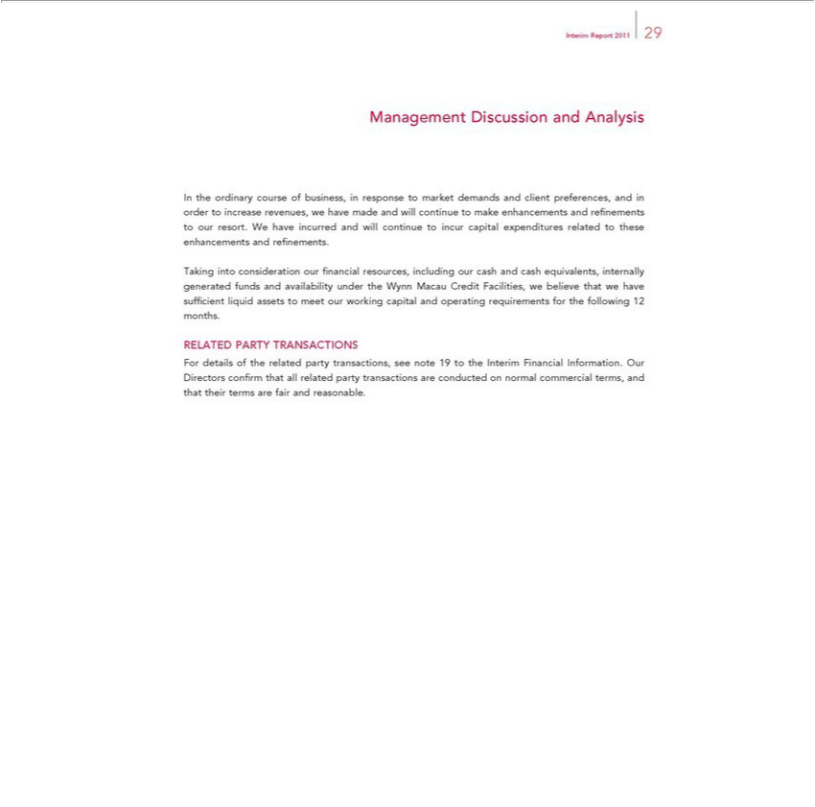

Interim Report 2011 29
Management Discussion and Analysis
WeInthehaveordinaryincurredcourseand willofbusiness,continueintoresponseincurcapitaltomarketexpendituresdemandsrelatedandclienttothesepreferences,enhancementsandinandorderrefitonements.increase revenues, we have made and will continue to make enhancements and refi nements to our resort.

Taking into consideration our fi nancial resources, including our cash and cash equivalents, internally generated funds and availability under the Wynn Macau Credit Facilities, we believe that we have suffi cient liquid assets to meet our working capital and operating requirements for the following 12 months.
RELATED PARTY TRANSACTIONS

For details of the related party transactions, see note 19 to the Interim Financial Information. Our Directors confi rm that all related party transactions are conducted on normal commercial terms, and that their terms are fair and reasonable.

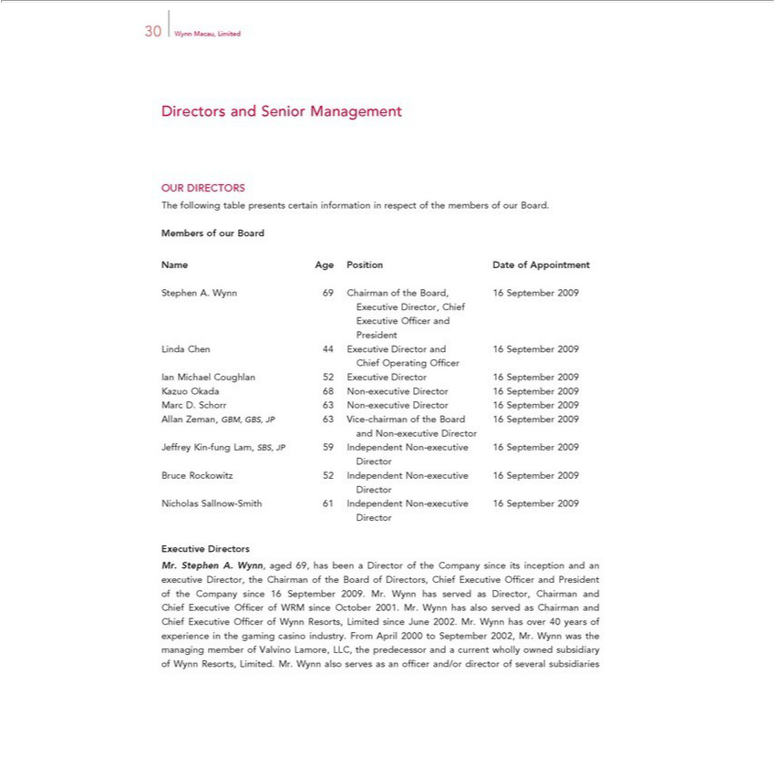

30 Wynn Macau, Limited
Directors and Senior Management
OUR DIRECTORS
The following table presents certain information in respect of the members of our Board.
Members of ur Board
Name | Position Date of Appointment
StephenAge. Wynn 69 Chairman of the Board, 16 September 2009
 | Director, Chief
Executive Offi cer and
President
Linda Chen 44 Executive Director and 16 September 2009
Chief Operating Offi cer
Ian Michael Coughlan 52 Executive Director 16 September 2009
Kazuo Okada 68 Non-executive Director 16 September 2009
Marc D. Schorr 63 Non-executive Director 16 September 2009
Allan Zeman, GBM, GBS, JP 63 Vice-chairman of the Board 16 September 2009
and Non-executive Director
Jeffrey Kin-fung Lam, SBS, JP 59 Independent Non-executive 16 September 2009
Director
Bruce Rockowitz 52 Independent Non-executive 16 September 2009
N cholas^{rector} | Sallnow-Smith 61 Independent Non-executive 16 September 2009
Director

Executive Directors
Mr. Stephen A. Wynn, aged 69, has been a Director of the Company since its inception and an executive Director, the Chairman of the Board of Directors, Chief Executive Offi cer and President of the Company since 16 September 2009. Mr. Wynn has served as Director, Chairman and Chief Executive Offi cer of WRM since October 2001. Mr. Wynn has also served^{was}Chairman and Chief Executive Offi cer of Wynn Resorts, Limited since June 2002. Mr. Wynn has over 40 years of experience in the gaming casino industry. From April 2000 _{director}September 2002, Mr. Wynn the managing member of Valvino Lamore, LLC,
the predecessor and a current wholly owned subsidiary of Wynn Resorts, Limited. Mr. Wynn also serves as an offi cer and/or of several subsidiaries

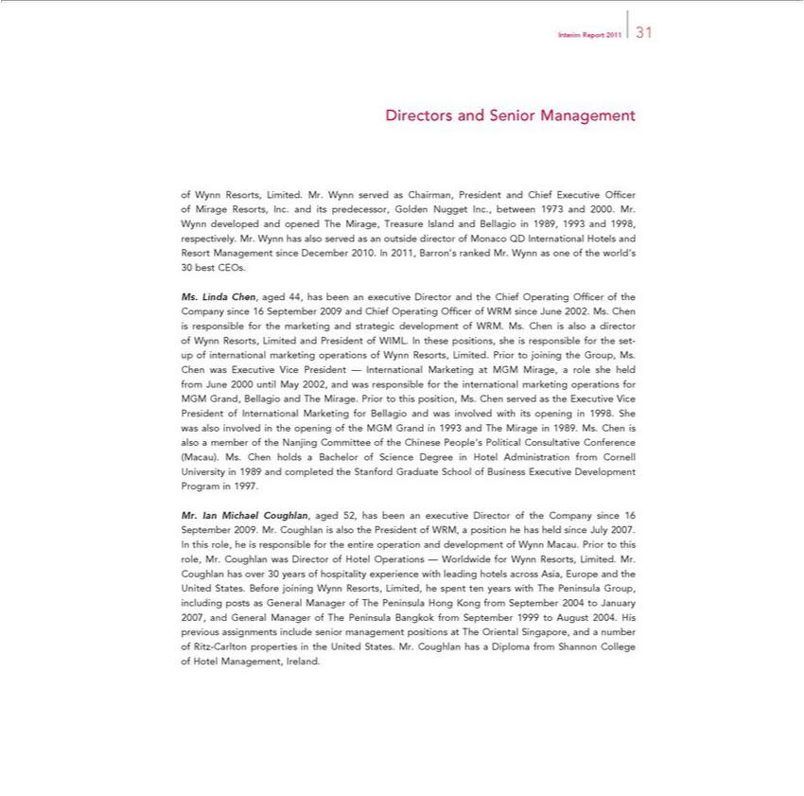

Interim Report 2011 31
ofDirectorsWynnResorts,andSeniorLimited.ManagementMr.Wynn served as Chairman, President and Chief Executive Offi cer of Mirage Resorts, Inc. and its predecessor, Golden Nugget Inc., between 1973 and 2000. Mr. Wynn developed
Decemberandopened2010.The Mirage,In2011,TreasureBarron’sIslandrankedandMr.BellagioWynnasinone1989,of the1993world’sand1998,30bestrespectively.CEOs. Mr. Wynn has also served as an outside director of Monaco QD International Hotels and Resort Management since Ms. Linda Chen, aged 44, has been executive Director and the Chief Operating Offi cer of the Company since 16 September 2009 and Chief Operating Offi cer of WRM since June 2002. Ms. Chen is
internationalresponsbleformarketingthemarketingoperationsandstrategicofWynndevelopmentResorts,Limited.ofWRM.PriorMs.tojoiningChenisthealsoGroup,adirectorMs. ChenofWynnwas Resorts,ExecutiveLimitedVicePresidentandPresident—InternationalofWIML. InMarketingthesepositions,atMGMsheMirage,isresponsiblearolesheforheldthe setfrom-upJuneof 2000 until May 2002, and was responsible for the international marketing operations for MGM Grand, Bellagio and The Mirage. Prior to this position, Ms. Chen served as the Executive Vice President of International
CommitteeMarketingforof theBellagioChineseandPeople’wasinvolvedPoliticalwithConsultativeitsopening Conference1998.She(Macau)wasalso.Ms.involvedChen inholdsthe aopeningBachelorof oftheScienceMGM GrandDegreeinin1993HotelandAdministrationTheMirageinfrom1989.CornellMs.ChenUniversityisalso ina member1989andofcompletedtheNanjingthe
Stanford Graduate School of Business Executive Development Program in 1997.
Mr. Ian Michael Coughlan, aged 52, has been an executive Director of the Company since 16 September 2009. Mr. Coughlan is also the President of WRM, a position he has held since July 2007. In this role, he is responsible for the_{experience}entireoperation and development of Wynn Macau. Prior to this role, Mr. Coughlan was Director of Hotel Operations — Worldwide for Wynn Resorts, Limited. Mr. Coughlan has over 30

years of hospitality with leading hotels across Asia, Europe and the United States. Before joining Wynn Resorts, Limited, he spent ten years with The Peninsula Group, including posts as General Manager of The Peninsula Hong Kong from September 2004 to January 2007, and General Manager of The Peninsula Bangkok from September 1999 to August 2004. His previous assignments include senior management positions at The Oriental Singapore, and a number of Ritz-Carlton properties in the United States. Mr. Coughlan has a Diploma from Shannon College of Hotel Management, Ireland.

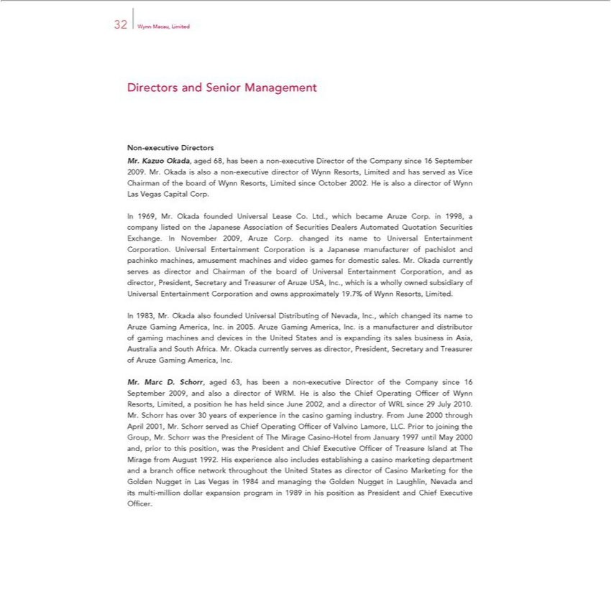

32 Wynn Macau, Limited
Directors and Senior Management
Non-executive Directors |  |  | since 16 September 2009. Mr. Okada is also a non-executive director of Wynn Resorts, Limited and has served as Vice Chairman
Mr. Kazuo Okada, aged 68, has been a non-executive Director of the
of the board of Wynn Resorts, Limited since October 2002. He is alsoCompanydirector of Wynn |  |  |  | Vegas Capital Corp.
In 1969, Mr. Okada founded Universal Lease Co. Ltd., which became Aruze Corp. 1998,Las company listed on the Japanese Association of Securities Dealers Automated Quotation Securities
Exchange. In November 2009, Aruze Corp. changed its name to Universal Entertainment |  |  |  | Corporation. Universal Entertainment Corporation is Japanese manufacturer of pachislot and pachinko machines,
amusement machines and video games for domestic sales. Mr. Okada currently serves as director and Chairman of the board of Universal Entertainment Corporation, and as director, President, Secretary and
Treasurer of Aruze USA, Inc., which is |  | wholly owned subsidiary of Universal Entertainment Corporation and owns approximately 19.7% of Wynn Resorts, Limited.
In 1983, Mr. Okada also founded Universal Distributing of Nevada, Inc., which changed its name to Aruze Gaming America, Inc. in 2005. Aruze Gaming |  |  |  |  |  | Inc. is a manufacturer and distributor of
gaming machines and devices in the United States and is expanding its sales business in Asia, Australia and South Africa. Mr. Okada currently serves as directorAmerica,President, Secretary and Treasurer of Aruze
Gaming America, Inc. | non-executive Director of the Company since 16 September 2009, and also a director of WRM. He is also the Chief Operating Offi cer of Wynn Resorts, Limited, a
Mr. Marc D. Sc orr, aged 63, has been
position he has held since June 2002, and |  | director of WRL since 29 July 2010. Mr. Schorr has over 30 years of experience in the casino gaming industry. From June 2000 through April 2001, Mr. Schorr served
as Chief Operating Offi cer of Valvino Lamore, LLC. Prior to joining the Group, Mr. Schorr was the President of The Mirage Casino-Hotel from January 1997 until May 2000 and, prior to this position, was the
President and Chief Executive Offi cer of Treasure Island at The Mirage from August 1992. His exper ence also includes |  |  |  |  | casino marketing department and branch offi ce network throughout the
United States as director of Casino Marketing for the Golden Nugget in Las Vegas in 1984 and managing the Golden NuggetestablishingLaughlin, Nevada and its multi-million dollar expansion program in 1989 in his position as President and Chief Executive Offi cer.

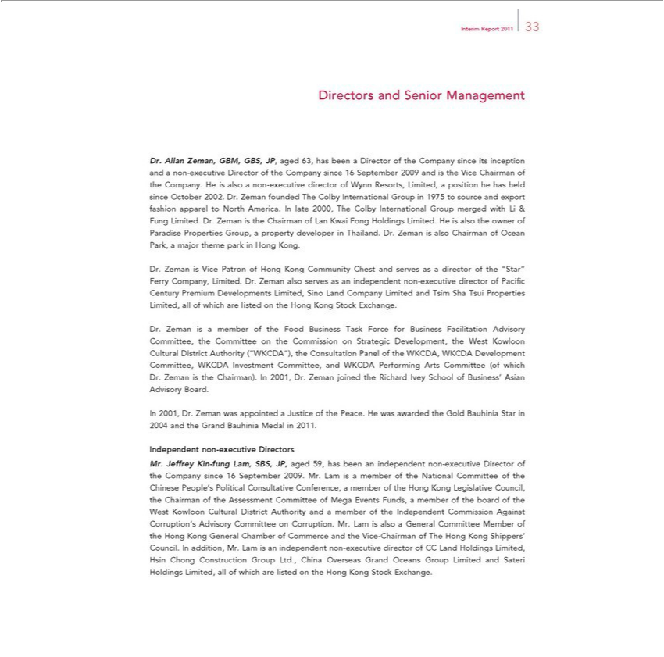

Interim Report 2011 33
irectors and Senior Management |  | since its inception and a non-executive Director of the Company since 16 September 2009 and is the Vice Chairman of the
Dr. Allan Zeman, GBM, GBS, JP, aged 63, has been a Director of the
Company. He is also | non-executive director of Wynn Resorts, Limited,Companyposition he has held since October 2002. Dr. Zeman founded The Colby International Group in 1975 to source and export fashion
apparel to North | . In late 2000, The Colby International Group merged with Li & Fung Limited. Dr. Zeman is the Chairman of Lan Kwai Fong Holdings Limited. He is also the owner of Paradise
Properties Group,Americaproperty developer in Thailand. Dr. Zeman is also |  | f Ocean Park, a major theme park in Hong Kong.
Dr. Zeman is Vice Patron of Hong Kong Community Chest and serves Chairmanasdirector of the “Star” Ferry Company, Limited. Dr. Zeman also serves as an independent non-executive director of Pacifi c Century
Premium Developments Limited, Sino Land Company Limited and Tsim Sha Tsui Properties Limited, all of which are listed on the Hong |  |  | Stock Exchange.
Dr. Zeman is a member of the Food Business Task Force for Business Facilitation Advisory Committee, the Committee on the CommissionKongStrategic Development, the West Kowloon Cultural _{District} Authority (“WKCDA”), the Consultation Panel of the WKCDA, WKCDA Development Committee, WKCDA Investment Committee, and WKCDA Performing Arts Committee (of which Dr. Zeman the Chairman). In 2001, Dr. Zeman_{appointed}joined the Richard Ivey School of Business’ Asian Advisory Board.
_{Independent}2001,Dr. Zemannon-executivewas DirectorsaJustice of the Peace. He was awarded the Gold Bauhinia Star in 2004 and the Grand Bauhinia Medal in 2011.
Mr. Jeffrey Kin-fung Lam, SBS, JP, aged 59, has been an independent non-executive Director of the Company since 16 September 2009. Mr. Lam is a member of the National Committee of the Chinese People’s Political Consultative Conference, a member of the Hong Kong Legislative Council, the Chairman of the Assessment Committee of Mega Events Funds, a member of the board of the West Kowloon Cultural District Authority and a member of the Independent Commission Against Corruption’s Advisory Committee on Corruption. Mr. Lam is also a General Committee Member of the Hong Kong General Chamber of Commerce and the Vice-Chairman of The Hong Kong Shippers’ Council. In addition, Mr. Lam is an independent non-executive director of CC Land Holdings Limited,

Hsin Chong Construction Group Ltd., China Overseas Grand Oceans Group Limited and Sateri Holdings Limited, all of which are listed on the Hong Kong Stock Exchange.

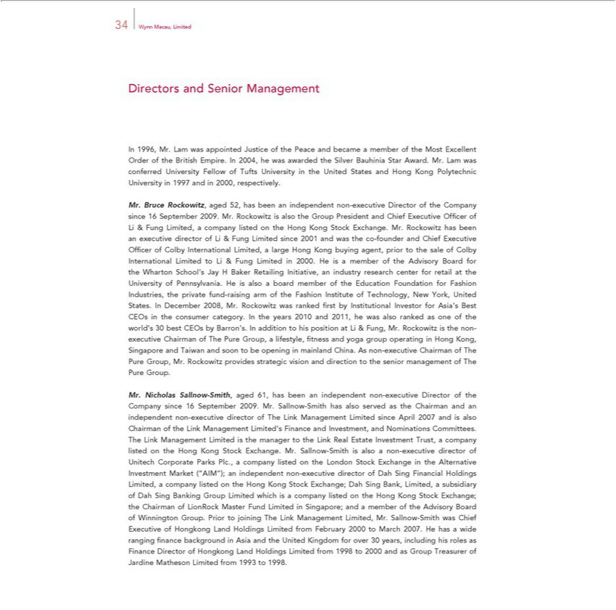

34 Wynn Macau, Limited
InDirectors1996,Mr.andLamSeniorwasManagementappointedJustice of the Peace and became a member of the Most Excellent Order of the British Empire. In 2004, he was awarded the Silver Bauhinia Star Award. Mr. Lam was conferred University Fellow of Tufts University in the United States and Hong Kong Polytechnic Universitysince1997 and in 2000, respectively.
Limited,InternationalMr.BruceRockowitz,companylistedagedon52,thehasHongbeenKonganindependentStockExchange.non-executiveMr.RockowitzDirectorhasof beentheCompanyexecutive director16SeptemberofLi& 2009.Fung LimitedMr.Rockowitzsince2001isalsoandthewasGroupthecoPresident-founder andand ChiefChief ExecutiveExecutive OffiOffi cercer ofof LiColby&Fung Limited,Initiative,large Hong Kong buying agent, prior to the sale of Colby International Limited Li & Fung Limited in 2000. He is a member of the Advisory Board for the Wharton School’raisingJay H
theBakerFashionRetailingInstitute of Technology,anindustryNewresearchYork,centerUnitedforStates.retailInat DecembertheUniversity2008,ofMr.Pennsylvania.Rockowitz Hewasisrankedalsoa fiboardrstbymemberInstitutionalofthe InvestorEducationforFoundationAsia’sBestforCEOsFashionintheIndustries,consumerthe private. Infundthe- years 2010arm ofand
2011, he was also ranked as one of the world’s 30 best CEOs by Barron’s. In addition to his position at Li & Fung, Mr. Rockowitz is the non-executive Chairman of The Pure Group,categorylifestyle, fi tness and yoga group operating in Hong Kong, Singapore and Taiwan and soon to be opening in mainland China. As non-executive Chairman of The Pure Group, Mr. Rockowitz provides strategic vision and direction to the senior manageme_{Sallnow}tof The Pure Group.

Mr. Nicholas -Smith, aged 61, has been an independent non-executive Director of the Company since 16 September 2009. Mr. Sallnow-Smith has also served as the Chairman and an indepe_{Management}dentnon-executive director of The Link Management Limited since April 2007 and is also Chairman of the Link Management Limited’s Finance and Investment, and Nominations Committees. The Link

Limited is the manager to the Link Real Estate Investment Trust, a company listed on the Hong Kong Stock Exchange. Mr. Sallnow-Smith is also a non-executive director of Unitech Corporate Parks Plc., company listed on the London Stock Exchange in the Alternative Investment Market (“AIM”); an independent non-executive director of Dah Sing Financial Holdings Limited, a company listed on the Hong Kong Stock Exchange; Dah Sing Bank, Limited, a subsidiary of Dah Sing Banking Group Limited which is a company listed on the Hong Kong Stock Exchange; the Chairman of LionRock Master Fund Limited in Singapore; and^{March}member of the Advisory Board of Winnington Group. Prior to joining The Link Management Limited, Mr. Sallnow-Smith was Chief Executive of Hongkong Land Holdings Limited

^{from} February 2000 to 2007. He has a wide ranging fi nance background in Asia and the United Kingdom for over 30 years, including his roles as Finance Director of Hongkong Land Holdings Limited 1998 to 2000 and as Group Treasurer of Jardine Matheson Limited from 1993 to 1998.

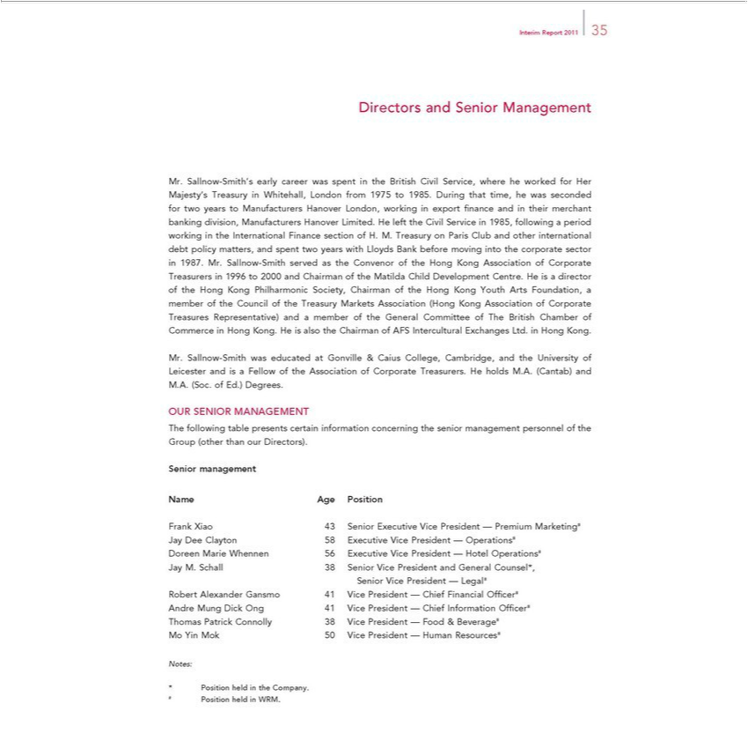

Interim Report 2011 35
 |  | and Senior Management | Treasury in Whitehall, London from 1975 to 1985. During that time, he was seconded for wo years to
Directors.Sallnow-Smith’s early career was spent in the British Civil Service, where he worked for Her Majesty’
Manufacturers Hanover London, working in export fi nance and in their merchant banking division, Manufacturers Hanover Limited. He left the Civil Service in 1985, following a period working in the
International Finance section of H. M. Treasury on Paris Club and other international debt policy matters, and spent two y ars with Lloy s Bank before moving into the corporate sector in 1987. Mr. Sallnow-
 | mith served as the Convenor of the Hong Kong Association of Corporate Treasurers in 1996 to 2000 and Chairman of he Matilda Child Development Centre. He is director of the Hong Kong Philharmonic
Society, Chairman of the Hong Kong Youth Arts Foundation, a member of the Council of the Treasury Markets Association (Hong Kong Association of Corporate Treasures Representative) and a member of the
General Committee of The British Chamber of Commerce in Hong Kong. He is also the Chairman of AFS |  |  | Exchanges Ltd. in Hong Kong.
Mr. Sallnow-Smith was educated at Gonville & Caius College, Cambridge, and the University of Leicester InterculturalandisFellow of the Association of Corporate Treasurers. He holds M.A. (Cantab) and M.A. (Soc. of
Ed.) Degrees.
OUR SENIOR MANAGEMENT
The following table presents certain information concerning the senior management personnel of the Group (other than our Directors).
Senior management
Name Age Position
Frank Xiao 43 Senior Executive Vice President — Premium Marketing#
Jay Dee Clayton 58 Executive Vice President — Operations#
Doreen Marie Whennen 56 Executive Vice President — Hotel Operations#
Jay M. Schall 38 Senior Vice President and General Counsel*,
Senior Vice President — Legal#
Robert Alexander Gansmo 41 Vice President — Chief Financial Offi cer#
Andre Mung Dick Ong 41 Vice President — Chief Information Offi cer#
Thomas Patrick Connolly 38 Vice President — Food & Beverage#
Mo Yin Mok 50 Vice President — Human Resources#
Notes: |  | Position held in the Company.
* |  | Position held in the Company.
# Position held in WRM.

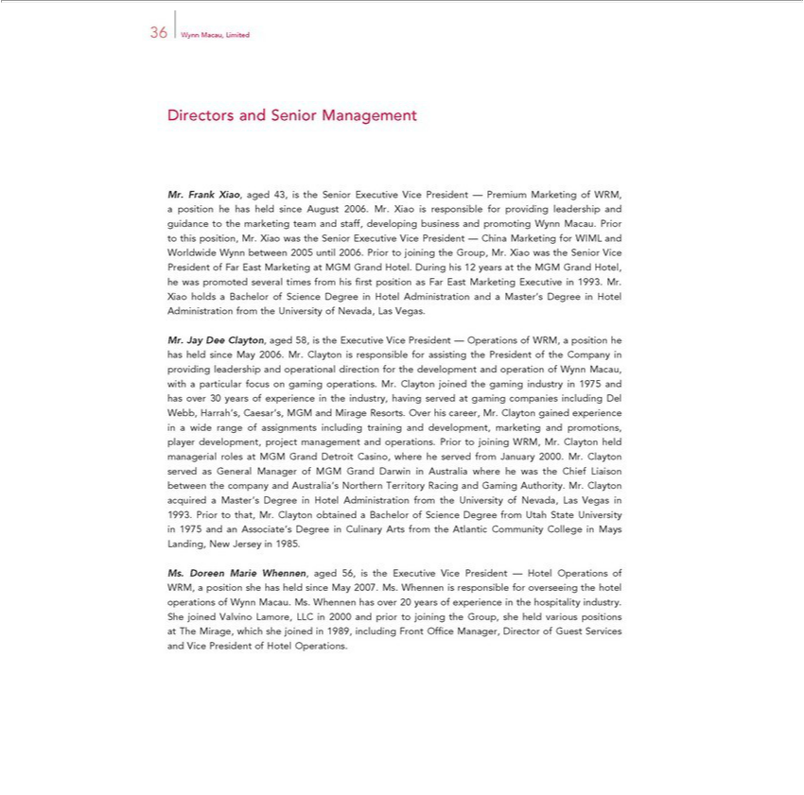

36 Wynn Macau, Limited
Directors and Senior Management
Mr. Frank Xiao, aged 43, is the Senior Executive Vice President — Premium Marketing of WRM, a position he has held since August 2006. Mr. Xiao is responsible for providing leadership and guidance to the
marketing team and staff, developing business and promoting Wynn Macau. Prior to this position, Mr. Xiao was the Senior Executive Vice President — China Marketing for WIML and Worldwide Wynn
between 2005 until 2006. Prior to joining the Group, Mr. Xiao was the Senior Vice President of Far East Marketing at MGM Grand Hotel. During his 12 |  |  |  | at the MGM Grand Hotel, he was promoted several
times from his fi rst position as Far East Marketing Executive in 1993. Mr. Xiao holds a Bachelor of Science Degree in Hotel Administration and a Master’yearsDegree in Hotel Administration from the University
of Nevada, Las Vegas.
Mr. Jay Dee Clayton, aged 58, is the Executive Vice President — Operations of WRM, a position he has held since May 2006. Mr. Clayton is responsible for assisting the President of the Company in providing
leadership and operational direction for the development and operation of Wynn Macau, with a particular focus on gaming operations. Mr. Clayton joined the gaming industry in 1975 and has over 30 years of
experience the industry having served at gaming companies including Del Webb, Harrah’s, Caesar’s, MGM and Mirage Resorts. Over his career, Mr. Clayton gained experience in a wide range of assignments
including training and development, marketing and promotions, player development, project management and operations. Prior to joining WRM, Mr. Clayton held managerial roles at MGM Grand Detroit
Casino, where he served from January 2000. Mr. Clayton served |  | General Manager of MGM Grand Darwin in Australia where he was the Chief Liaison between the company and Australia’s Northern
Science Degree from Utah State University in 1975 and an Associate’MasterDegree in |  |  | Culinary Arts from the Atlantic Community College in Mays Landing, | New Jersey in 1985.
Territory Racing and Gaming Authority. Mr. Clayton acquired |  | ’s Degree | Hotel Administration from the University of Nevada, Las Vegas 1993. Prior to that, Mr. Clayton obtained a Bachelor of
Ms. Doreen Marie | aged 56, is the Executive Vice President — Hotel Operations of WRM, position she has held since May 2007. Ms. Whennen is responsible for overseeing the hotel operations of
Wynn Macau. Ms. | Whennen, has over 20 years of experience in the hospitality industry. She joined Valvino Lamore, LLC in 2000 and prior to joining the Group, she held various positions at The Mirage, which
she joined in 1989, including Front Offi ce Manager, Director of Guest Services and Vice President of Hotel Operations.

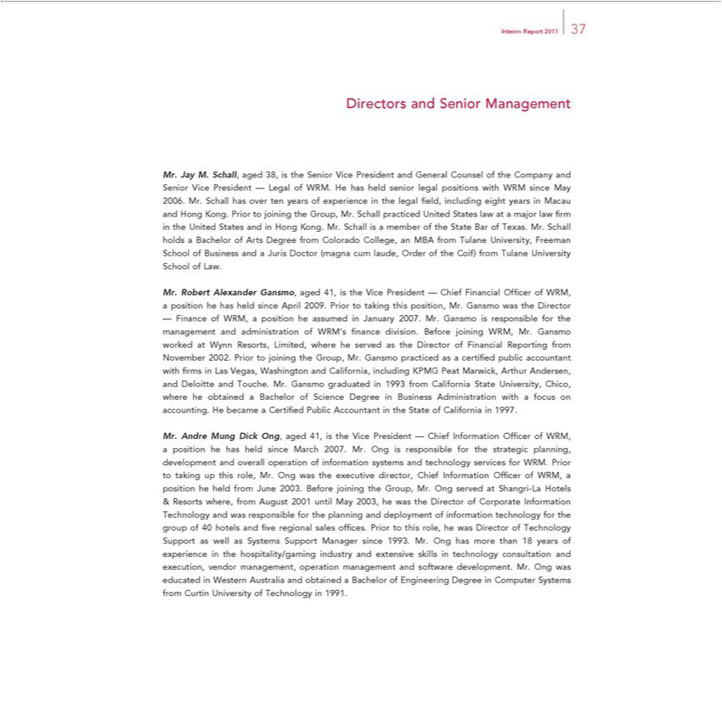

Interim Report 2011 37
Directors and Senior Management
Jay M. Schall, aged 38, is the Senior Vice President and General Counsel of the Company and Senior Vice President — Legal of WRM. He has held senior legal positions with WRM since May 2006.
Mr. Schall has over ten years of experience in the legal fi eld, including eight years in Macau and Hong Kong. Prior to joining the Group, Mr. Schall practiced United States law at |  |  |  | major law fi rm in the United
and in Hong Kong. Mr. Schall is a member of the State Bar of Texas. Mr. Schall holds Bachelor of Arts Degree from Colorado College, an MBA from Tulane University, Freeman School of Business
StatesandJuris Doctor (magna cum laude, Order of the Coif) from Tulane University School of Law.
Mr. Robert Alexander Gansmo, aged 41, is the Vice President — Chief Financial Offi cer of WRM, position he has held since April 2009. Prior to taking this position, Mr. Gansmo was the Director
— Finance of WRM, a position he assumed in January 2007. Mr. Gansmo is responsible for the management and administration of WRM’s fi nance division. Before joining WRM, Mr. Gansmo worked at Wynn
Resorts, Limited, where he served as the Director of Financial Reporting from November 2002. Prior to joining the Group, Mr. Gansmo practiced as certifi ed public accountant with fi rms Las Vegas,
Washington and California, including KPMG |  | Marwick, Arthur Andersen, and Deloitte and Touche. Mr. Gansmo graduated in 1993 from California State University, Chico, where he obtained a Bachelor of
Science Degree in Business | withPeat focus on accounting. He became a Certifi ed Public Accountant in the State of California in 1997. |  |  | planning, development and
Mr. Andre Mung Dick Ong, Administrationaged41,the Vice President — Chief Information Offi cer of WRM, a position he has held since March 2007. Mr. Ong is responsible for the |  |  |  | planning, development and
overall operation of information systems and technology services for WRM. Prior to taking up this role, Mr. Ong was the executive director, Chief Information Offi cer of WRM,strategic position he held from June
2003. Before joining the Group, Mr. Ong served at Shangri-La Hotels & Resorts where, from August 2001 until May 2003, he was the Director of Corporate Information Technology and was responsible for the
planning and deployment of information technology for the group of 40 hotels and fi ve regional sales offi ces. Prior to this role, he was Director of Technology Support as well as Systems Support Manager
ince 1993. Mr. Ong has more than 18 years of experience in the |  |  | industry and extensive skills in technology consultation and execution, vendor management, operation management and
software development. Mr. Ong was educated in Western Australiahospitality/gamingandobtainedBachelor of Engineering Degree in Computer Systems from Curtin University of Technology in 1991.

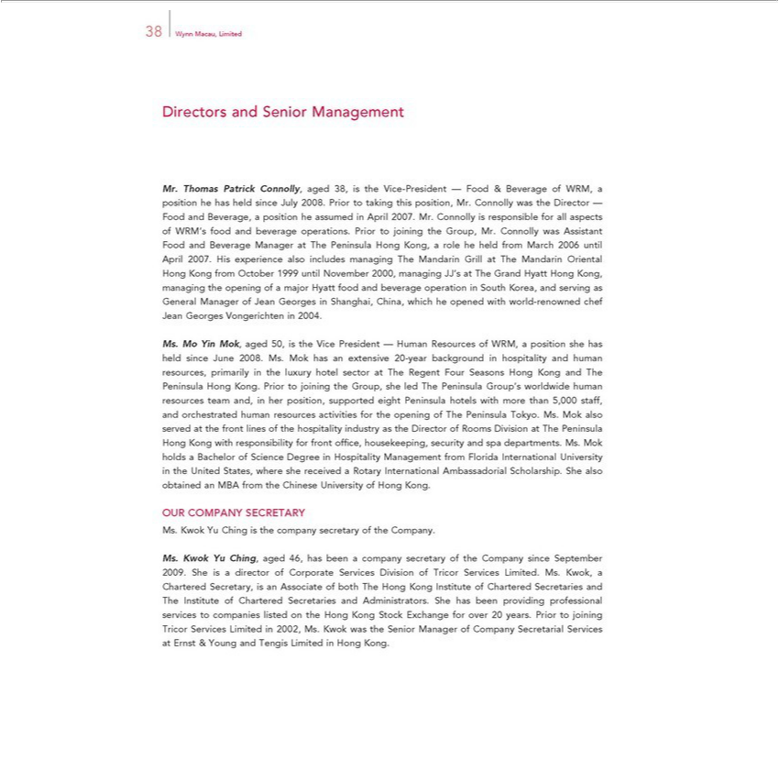

38 Wynn Macau, Limited
Directors and Senior Management |  |  |  | he has held since July 2008. Prior to taking this position, Mr. Connolly was the Director — Food and
Mr. | Patrick Connolly, aged 38, is the Vice-President — Food & Beverage of WRM, a
Beverage,Thomas position he assumed in April 2007. Mr. Connolly is responsible for all aspects of WRM’positionfood and beverage operations. Prior to joining the Group, Mr. Connolly was Assistant Food and Beverage
Manager at The Peninsula Hong Kong, a role he held from March 2006 until April 2007. His experience also includes managing The |  |  |  |  | Grill at The Mandarin Oriental Hong Kong from October 1999
until November 2000, managing JJ’s at The Grand Hyatt Hong Kong, managing the |  |  | of a major Hyatt food and beverage operationMandarinSouth Korea, and serving as General Manager of Jean Georges in
Shanghai, China, which he opened with world-renowned chef Jean Georges Vongerichtenopening 2004.
Ms. Mo Yin Mok, aged 50, is the Vice President — Human Resources of WRM, a position she has held since June 2008. Ms. Mok has an extensive 20-year background in hospitality and human resources,
primarily in the luxury hotel sector at The Regent Four Seasons Hong Kong and The Peninsula Hong Kong. Prior to joining the Group, she led The Peninsula Group’s worldwide human resources team and, in
er position, supported eight Peninsula hotels with more than 5,000 staff, and orchestrated human resources activities for the opening of The Peninsula Tokyo. Ms. Mok also served at the front lines of the
hospitality industry as the Director of Rooms Division The Peninsula Hong Kong with responsibility for front offi ce, housekeeping, security and spa departments. Ms. Mok holds Bachelor of Science
Degr | in Hospitality Management from Florida International University in the United States, where she received a Rotary International Ambassadorial Scholarship. She also obtained an MBA from the Chinese
University of Hong Kong.
OUR COMPANY SECRETARY |  | of the Company.
 | is the company | of the Company.
Ms. Kwok Yu Ching, aged 46, has beensecretarycompany secretary of the Company since September 2009. She_{Chartered}isdirector of Corporate Services Division of Tricor Services Limited. Ms. Kwok, a Chartered
Secretary, is an Associate of both The Hong Kong Institute of Chartered Secretaries and The Institute of Secretaries and Administrators. She has been providing professional services to companies listed on the Hong Kong Stock Exchange for over 20 years. Prior to joining Tricor Services Limited in 2002, Ms. Kwok was the Senior Manager of Company Secretarial Services at Ernst & Young and Tengis Limited in Hong Kong.

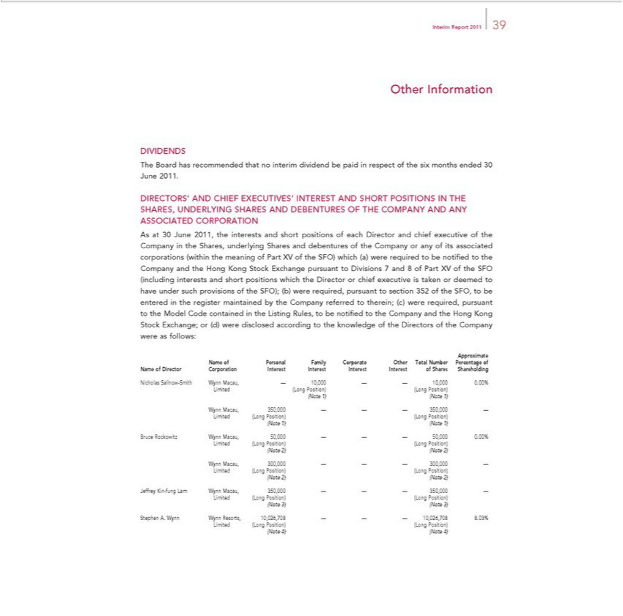

Interim Report 2011 39
Other Information
DIVIDENDS
The Board has recommended that no interim dividend be paid in respect of the six months ended 30 June 2011.
DIRECTORS’ AND CHIEF EXECUTIVES’ INTEREST AND SHORT POSITIONS IN THE SHARES, UNDERLYING SHARES AND DEBENTURES OF THE COMPANY AND ANY ASSOCIATED
CORPORATION
As at 30 June 2011, the interests and short positions of each Director and chief executive of the Company in the Shares, underlying Shares and debentures of the Company or any of its associated corporations
(within the meaning of Part XV of the SFO) which (a) were required to be notifi ed to the Company and the Hong Kong Stock Exchange pursuant to Divisions 7 and 8 of Part XV of the SFO (including interests
and short positions which the Director or chief executive is taken or deemed to have under such provisions of the SFO); (b) were r quired, pursuant to section 352 of the SFO, to be entered in the register
maintained by the Company referred to | ( ) were required, pursuant to the Model Code contained in the Listing Rules, to be notifi ed to the Company and the Hong Kong Stock Exchange; or (d) were
therein;Directors
Approximatedisclosedaccording to the knowledge of of the Company were as follows:
_{ame of Director}Pesonal Family Corporate Other Total Number Percentage of

(NoteLimited1) (Long(Note Position)1) (Long Position)
Wynn Macau, 350,000 — — — 350,000 —
(NoteLimited1) (Long(Note Position)1) (Long Position)
Bruce Rockowitz Wynn Macau, 50,000 — — — 50,000 0.00%
Limited (Long Position) (Long Position)
(Note 2) (Note 2)
Wynn Macau, 300,000 — — — 300,000 —
(NoteLimited2) (Long(Note Position)2) (Long Position)
Jeffrey Kin-fung Lam Wynn Macau, 350,000 — — — 350,000 —
Limited (Long Position) (Long Position)
(Note 3) (Note 3)
Stephen A. Wynn Wynn Resorts, 10,026,708 — — — 10,026,708 8.03%
Limited (Long Position) (Long Position)
(Note 4) (Note 4)

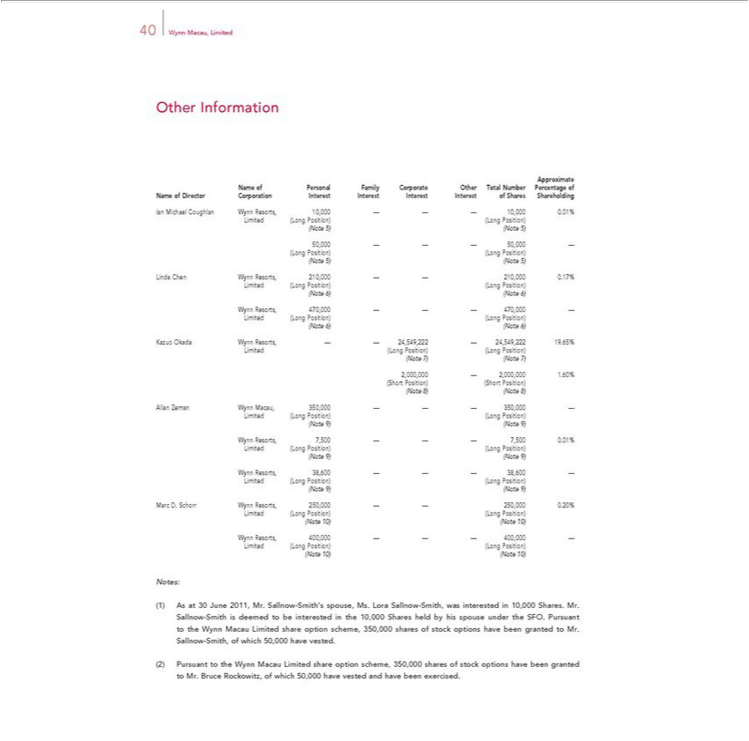

40 Wynn Macau, Limited
Other Information
Approximate
_{Name of} Pe_{Director}sonal CorporationFamilyCorporateInterestOtherInterestTotalInterestNumberInterestPercentageofSharesof Shareholding
LimitedIanMichael(LongCoughlanPosition)Wynn(LongResorts,Position)10,000 — — — 10,000 0.01%
(Note 5) (Note 5)
^{(Note}50,000LongPosition)——— (Long50,000Position)—
5) (Note 5)
_{Limited}ndaChen(LongWynnPosition)Resorts,(Long210,000Position)—— 210,000 0.17%
(Note 6) (Note 6)
Wynn Resorts, 470,000 — — — 470,000 —
(NoteLimited6) (Long(Note Position)6) (Long Position)
LimitedKazuoOkada(LongWynnPosition)Resorts,(Long—Position)—24,549,222 — 24,549,222 19.65%
(Note 7) (Note 7)
^{(Note}2,000,000ShortPosition)—2,000,000(ShortPosition)1.60%
8) (Note 8)
LimitedAllanZeman(LongWynnPosition)Macau,(Long350,000Position)—— — 350,000 —
(Note 9) (Note 9)
Wynn Resorts, 7,500 — — — 7,500 0.01%
(NoteLimited9) (Long(Note Position)9) (Long Position)
Wynn Resorts, 38,600 — — — 38,600 —
(NoteLimited9) (Long(Note Position)9) (Long Position)
LimitedMarcD. (LongSchorrPosition)WynnResorts,(Long 250,000Position)— — 250,000 0.20%
(Note 10) (Note 10)
Wynn Resorts, 400,000 — — — 400,000 —
(NoteLimited10)(Long(NotePosition)10) (Long Position)
Notes:
As at 30 June 2011, Mr. Sallnow-Smith’^{share}spouse, Ms. Lora Sallnow-Smith, was interested in 10,000 Shares. Mr. Sallnow-Smith is deemed to be interested in the 10,000 Shares held by his spouse under the SFO.
Pursuant to the Wynn Macau Limited option scheme, 350,000 shares of stock options have been granted to Mr. Sallnow-Smith, of which 50,000 have vested.
Bruce Rockowitz, of which 50,000 have vested and have been exercised.

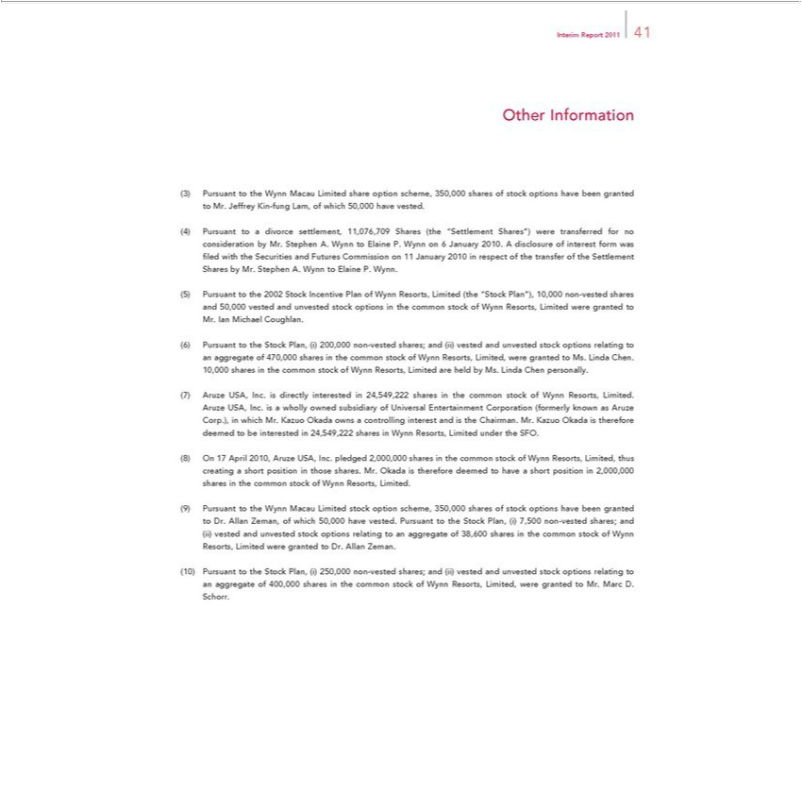

Interim Report 2011 41
Other Information
the Wynn Macau Limited share option scheme, 350,000 shares of stock options have been granted to Mr. Jeffrey Kin-fung Lam, of which 50,000 have vested.
Pursuant to a divorce settlement, 11,076,709 Shares (the “Settlement Shares”) were transferred for no consideration by Mr. Stephen A. Wynn to Elaine P. Wynn on 6 January 2010. A disclosure of interest form
was fi led with the Securities and Futures Commission on 11 January 2010 in respect of the transfer of the Settlement Shares by Mr. Stephen A. Wynn to Elaine P. Wynn.
Pursuant to the 2002 Stock Incentive Plan of Wynn Resorts, Limited (the “Stock Plan”), 10,000 non-vested shares and 50,000 vested and unvested stock options in the common stock of Wynn Resorts, Limited
were granted to Mr. Ian Michael Coughlan.
Pursuant to the Stock Plan, (i) 200,000 non-vested shares; and (ii) vested and unvested stock options relating to an aggregate of 470,000 shares in the common stock of Wynn Resorts, Limited, were granted to
Ms. Linda Chen. 10,000 shares the common stock of Wynn Resorts, Limited are held by Ms. Linda Chen personally. | Corporation (formerly
Aruze USA, Inc. is directly interested in 24,549,222 shares in the common stock of Wynn Resorts, Limited. Aruze USA, Inc. is a wholly owned subsidiary of Universal | Corporation (formerly
known as Aruze Corp.), in which Mr. Kazuo Okada owns a controlling interest and is the Chairman. Mr. Kazuo Okada is therefore deemed to be interested in 24,549,222EntertainmentsharesWynn Resorts, Limited under the SFO.

On 17 April 2010, Aruze USA, Inc. pledged 2,000,000 shares in the common stock of Wynn Resorts, Limited, thus creating a short position in those shares. Mr. Okada is therefore deemed to have a short _{Pursuant}positionin 2,000,000 shares in the common stock of Wynn Resorts, Limited.
to the Wynn Macau Limited stock option scheme, 350,000 shares of stock options have been granted to Dr. Allan Zeman, of which 50,000 have vested. Pursuant to the Stock Plan, (i) 7,500 non-vested shares; and
vested and unvested stock options relating to an aggregate of 38,600 shares in the common stock of Wynn Resorts, Limited were granted to Dr. Allan Zeman.

Pursuant to the Stock Plan, (i) 250,000 non-vested shares; and (ii) vested and unvested stock options relating to an aggregate of 400,000 shares in the common stock of Wynn Resorts, Limited, were granted to Mr. Marc D. Schorr.

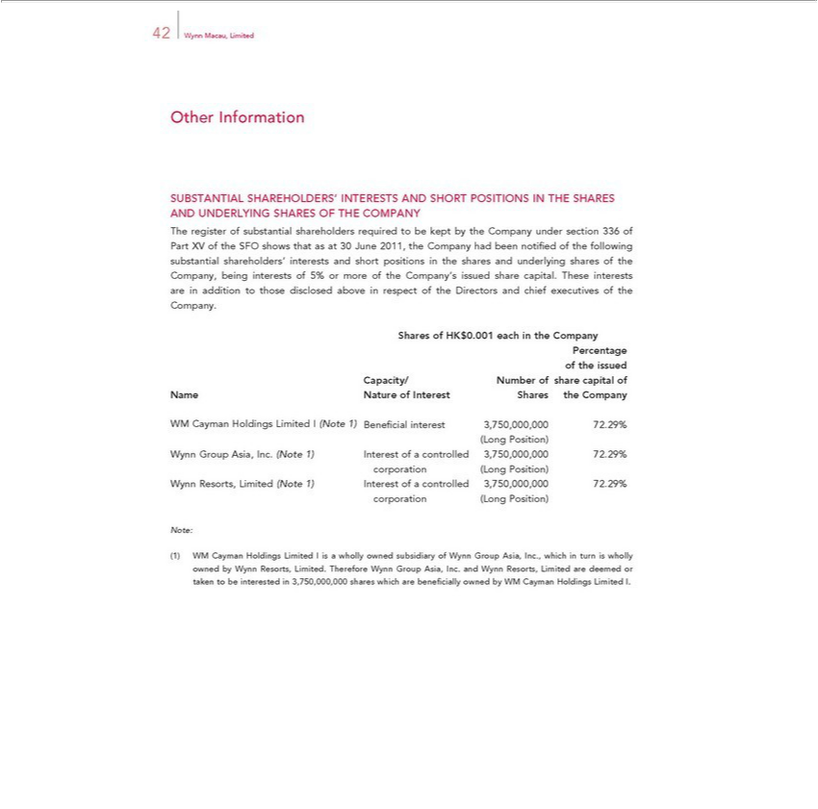

42 Wynn Macau, Limited
SUBSTANTIALOtherInformationSHAREHOLDERS’ INTERESTS AND SHORT POSITIONS IN THE SHARES AND UNDERLYING SHARES OF THE COMPANY
shareholders’Theregisterof substantialand shareholdersshortpositionsrequiredinthe sharestobekeptand byunderlyingtheCompanysharesunderofthesectionCompany,336 ofbeingPartinterestsXVoftheof SFO5%orshowsmorethatoftheas atCompany’s30June2011,issuedtheshareCompanycapital.hadThesebeeninterestsnotifiedareof intheadditionfollowingto thosesubstantial
interests
Company.disclosedabove respect of the Directors and chief executives of the
PercentageSharesofHK$0.001 each in the Company
of the issued
Capacity/ Number of share capital of
Name Nature of Interest Shares the Company
(LongWMCaymanPosition)Holdings Limited I (Note 1) Benefi cial interest 3,750,000,000 72.29%
corporationWynnGroup(LongAsia, Position)Inc.(Note 1) Interest of a controlled 3,750,000,000 72.29%
corporationWynnResorts,(LongLimitedPosition)(Note 1) Interest of a controlled 3,750,000,000 72.29%
Note:
WM Cayman Holdings Limited I is a wholly owned subsidiary of Wynn Group Asia, Inc., which in turn is wholly owned by Wynn Resorts, Limited. Therefore Wynn Group Asia, Inc. and Wynn Resorts, Limited are deemed or taken to be interested in 3,750,000,000 shares which are benefi cially owned by WM Cayman Holdings Limited I.

OtherInterimInformationReport2011 43
REMUNERATION POLICY

As at 30 June 2011, the Group had approximately 7,200 full-time equivalent employees. Employees of the Group are selected, remunerated and promoted on the basis of their merit, qualifi cations, competence and contribution to the Group.
Compensation of key executives of the Group is determined by the Company’s remuneration committee which reviews and determines executives’ compensation based on the Group’s performance and the executives’ respective contributions to the ^{Group}.
The Company also has a provident fund set for its employees and a share options scheme. Further details on the Company’s share options scheme are set out below.
SHARE OPTION SCHEME
_{The} Compa_{following}y tableoperatesdisclosesasharemovementsoptionscheme.intheFurtherCompany’_{details}shareoftheoptionschemeoutstandingaredisclosedduringin thenoteyear:16to the interim fi nancial information.
Expired/Number of share options
lapsed/
At Granted Exercised canceled At Exercise
1 January during during during 30 June Date of grant of Exercise period price of
Name of Director 2011 the period the period the period 2011 share options of share options share options (HK$
per share)
24Dr.MarchAllan Zeman2020 250,000 — — — 250,000 25 March 2010 25 March 2011 to 10.92
16— May100,000(₂₀₂₁) — — 100,000 17 May 2011 17 May 2012 to 25.96
250,000 100,000 — — 350,000
24Mr.MarchNicholas2020Sallnow-Smith 250,000 — — — 250,000 25 March 2010 25 March 2011 to 10.92
16— May100,000(₂₀₂₁) — — 100,000 17 May 2011 17 May 2012 to 25.96
250,000 100,000 — — 350,000

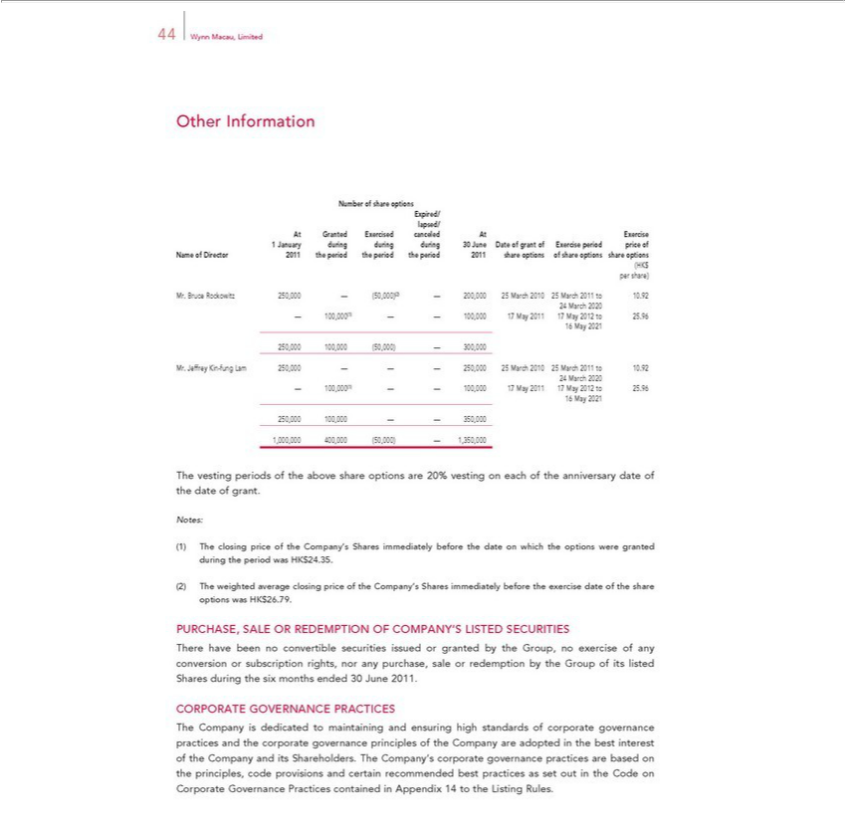

44OtherWynnInformationMacau,Limited
Expired/Number of share options
lapsed/
At Granted Exercised canceled At Exercise
1 January during during during 30 June Date of grant of Exercise period price of
Name of Director 2011 the period the period the period 2011 share options of share options share options (HK$
per share)
24Mr.MarchBruce 2020Rockowitz 250,000 — (50,000)(2) — 200,000 25 March 2010 25 March 2011 to 10.92
16— May100,000(₂₀₂₁) — — 100,000 17 May 2011 17 May 2012 to 25.96
250,000 100,000 (50,000) — 300,000
24Mr.MarchJeffrey2020Kin-fung Lam 250,000 — — — 250,000 25 March 2010 25 March 2011 to 10.92
16— May100,000(₂₀₂₁) — — 100,000 17 May 2011 17 May 2012 to 25.96
_{1,000,000}250,100,_{400,000}—(50,000)—350,000—1,350,000
Notes:Thevesting periods of the above share options are 20% vesting on each of the anniversary date of the date of grant.
^{The}
weightedclosingpriceaverageoftheclosingCompany’sprice ofSharestheCompany’simmediatelySharesbeforeimmediatelythedateon beforewhich thethe exerciseoptionsweredate ofgrantedtheshareduringoptionstheperiodwasHKwas$26.79.HK$24.35.
PURCHASE, SALE OR REDEMPTION OF COMPANY’S LISTED SECURITIES
There have been no convertible securities issued or granted by the Group, no exercise of any conversion or subscription rights, nor any purchase, sale or redemption by the Group of its listed Shares during the six months ended 30 June 2011.
CORPORATE GOVERNANCE PRACTICES
The Company is dedicated to maintaining and ensuring high standards of corporate governance practices and the corporate governance_{recommended}principles of the Company are adopted in the best interest of the Company
and its Shareholders. The Company’s corporate governance practices are based on the principles, code provisions and certain best practices as set out in the Code on Corporate Governance Practices contained in Appendix 14 to the Listing Rules.

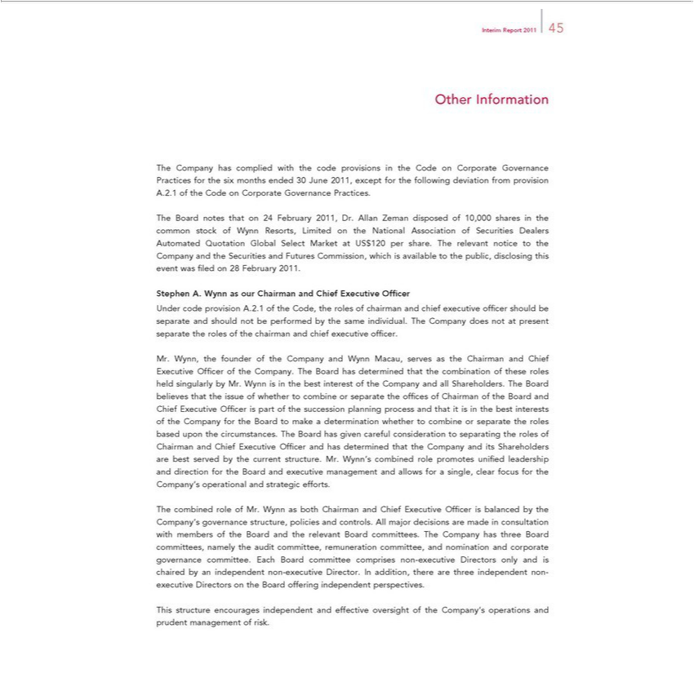

Interim Report 2011 45
Other Information
The Company has complied with the code provisions in the Code on Corporate Governance Practices for the six months ended 30 June 2011, except for the following deviation from provision A.2.1 of the Code
on Corporate Governance Practices.
The Board notes that on 24 February 2011, Dr. Allan Zeman disposed of 10,000 shares in the common stock of Wynn Resorts, Limited on the National Association of Securities Dealers Automated Quotation
Global Select Market at US$120 per share. The relevant notice to the Company and the Securities and Futures Commission, which is available to the public, disclosing this event was fi led on 28 February 2011.
Stephen A. Wynn as our Chairman and Chief Executive Offi cer
Under code provision A.2.1 of the Code, the roles of chairman and chief executive offi cer should be separate and should not be performed by the same individual. The Company does not at present separate the
roles of the chairman and chief executive offi cer.
, the founder of the Company and Wynn Macau, serves as the Chairman and Chief Executive Offi cer of the Company. The Board has determined that the combination of these roles held singularly by
Mr. Wynn is in the best interest of the Company and all Shareholders. The Board believes that the issue of whether to combine or separate the offi ces of Chairman of the Board and Chief Executive Offi cer is
p rt of the succession planning process and that it is in the best interests of the Company for the Board to make a determination whether to combine or separate the roles based upon the circumstances. The Board
has given careful consideration to separating the roles of Chairman and Chief Executive Offi cer and has determined that the Company and its | are best served by the current structure. Mr. Wynn’s
combined role promotes unifi ed leadership and direction for the Board and executive management and allows for_{governance}single, clear focus for the Company’Shareholdersoperational and strategic efforts.
The combined role of Mr. Wynn as both Chairman and Chief Executive Offi cer is balanced by the Company’s structure, policies and controls. All major decisions are made in consultation with members of the Board and the relevant Board ^{non}cmmittees. The Company has three Board committees, namely the audit committee, remuneration committee, and nomination and corporate governance committee. Each Board committee comprises -executive Directors only and is chaired by an independent non-executive Director. In addition, there are three independent non-executive Directors on the Board offering independent perspectives.
This structure encourages independent and effective oversight of the Company’s operations and prudent management of risk.

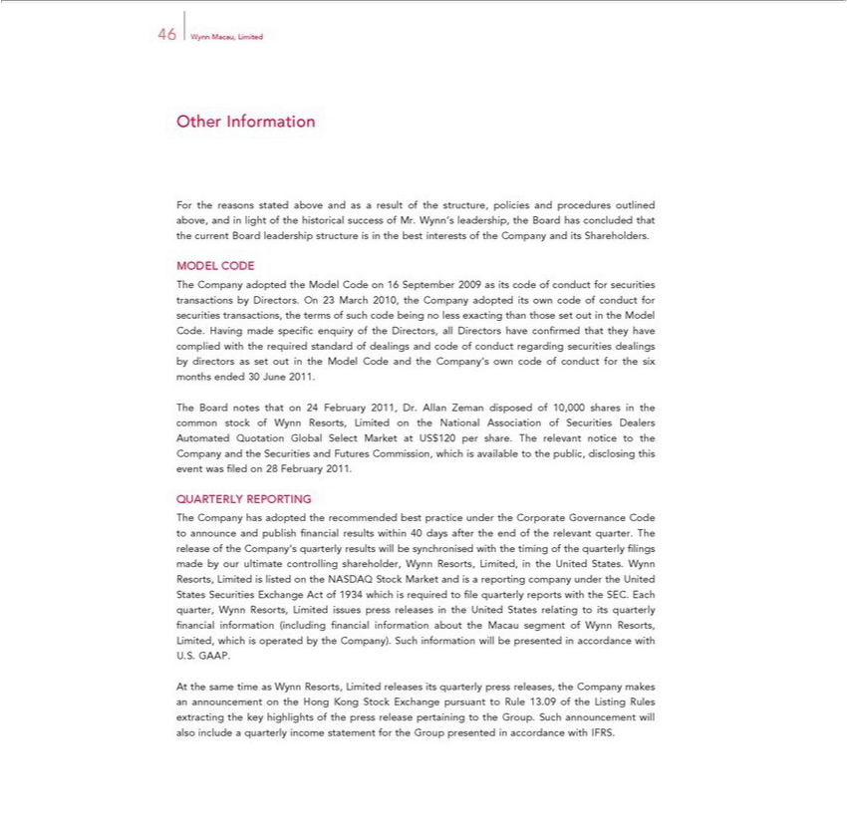

46 Wynn Macau, Limited
Other Information
For the reasons stated above and as a result of the structure, policies and procedures outlined above, and in light of the historical success of Mr. Wynn’s leadership, the Board has concluded that the current Board
leadership structure is in the best interests of the Company and its Shareholders.
MODEL CODE
The Company adopted the Model Code on 16 September 2009 as its code of conduct for securities transactions by Directors. On 23 March 2010, the Company adopted its own code of conduct for securities
transactions, the terms of |  | code being no less exacting than those set out in the Model
Code. | made specifisuchenquiry of the |  | all Directors have confi rmed that they have complied with the required standard of dealings and code of conduct regarding securities dealings by directors
as set outHavingthe Model Code and the Company’Directors,owncode of conduct for the six months ended 30 June 2011.
The Board notes that on 24 February 2011, Dr. Allan Zeman disposed of 10,000 shares in the common stock of Wynn Resorts, Limited on the National Association of Securities Dealers Automated Quotation
Global Select Market at US$120 per share. The relevant notice to the Company and the Securities and Futures Commission, which is available to the public, disclosing this event was fi led on 28 February 2011.
QUARTERLY REPORTING
The Company has adopted the recommended best practice under the Corporate Governance Code to announce and publish fi nancial results within 40 days after the end of the relevant quarter. The release of the
Company’s quarterly results will be |  |  | d with the timing of the quarterly fi lings made by our ultimate controlling shareholder, Wynn Resorts, Limited, in the United States. Wynn | Limited is
synchronisreporting Resorts,
listed on the NASDAQ Stock Market and _{States} company under the _{nancial}Uited States Securities Exchange Act of 1934 which is required to fi le quarterly reports with the SEC. Each quarter Wynn Resorts,
Limited issues press releases in the United relating to its quarterly fi information (including fi nancial information about the Macau segment of Wynn Resorts, Limited, which is operated by the Company). Such information will be presented in accordance with U.S. GAAP.
At the same time as Wynn Resorts, Limited releases its quarterly press releases, the Company makes an announcement on the Hong Kong Stock Exchange pursuant to Rule 13.09 of the Listing Rules extracting the key highlights of the press release pertaining to the Group. Such announcement will also include a quarterly income statement for the Group presented in accordance with IFRS.

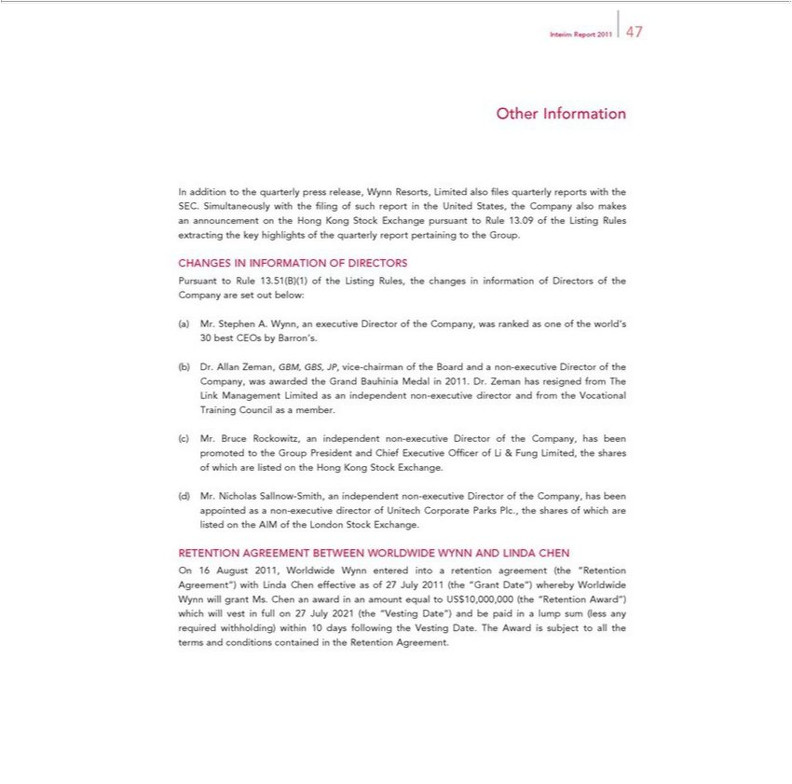

Interim Report 2011 47
Other Information |  | the United States, the Company also makes an
In addition to the quarterly press release, Wynn Resorts, Limited also fi les quarterly reports with the SEC. Simultaneously with the fi ling of such report |  | the United States, the Company also makes an
announcement on the Hong Kong Stock Exchange pursuant to Rule 13.09 of the Listing Rules extracting the key highlights of the quarterly report pertaining to the Group.
CHANGES IN INFORMATION OF DIRECTORS
Pursuant to Rule 13.51(B)(1) of the Listing Rules, the changes in information of Directors of the Company are set out below:
Mr. Stephen A. Wynn, an executive Director of the Company, was ranked as one of the world’s 30 best CEOs by Barron’s.
Dr. Allan Zeman, GBM, GBS, JP, vice-chairman of the Board and a non-executive Director of the Company, was awarded the Grand Bauhinia Medal in 2011. Dr. Zeman has resigned from The Link
anagement Limited as an independent non-executive director and from the Vocational Training Council as a member.
Mr. Bruce Rockowitz, independent non-executive Director of the Company, has been promoted to the Group President and Chief Executive Offi cer of Li & Fung Limited, the shares of which are listed on the
Hong Kong Stock Exchange.
Mr. Nicholas Sallnow-Smith, an independent non-executive Director of the Company, has been appointed as a non-executive director of Unitech Corporate Parks Plc., the shares of which are listed on the AIM
of the London Stock Exchange. | WORLDWIDE WYNN AND LINDA CHEN
RETENTION AGREEMENT | WORLDWIDE WYNN AND LINDA CHEN | Date”) whereby Worldwide Wynn will grant
On 16 August 2011, WorldwideBETWEENynnentered into a retention agreement (the “Retention Agreement”) with Linda Chen effective as of 27 July 2011 (the |  | Date”) whereby Worldwide Wynn will grant
Ms. Chen an award in an amount equal to US$10,000,000 (the “Retention Award”) which will vest in full_{Retention}27July 2021 (the “Vesting Date”) and be paid“Grantin lump sum (less any required withholding) within
10 days following the Vesting Date. The Award is subject to all the terms and conditions contained in the Agreement.

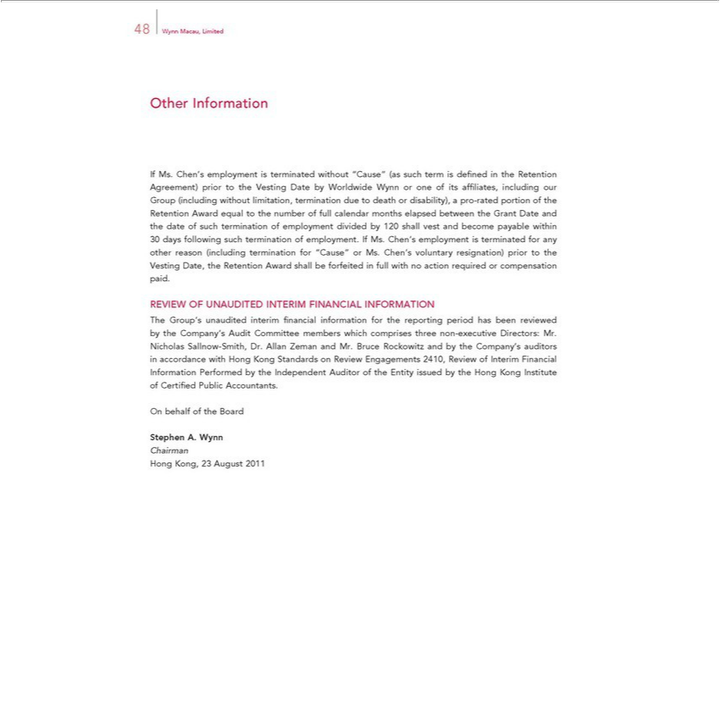

48 Wynn Macau, Limited
Other Information | prior to the Vesting Date by Worldwide Wynn or one of its affi liates, including our Group
If Ms. Chen’s employment is terminated without “Cause” (as such term is defi ned in the Retention
(including without_{employment}imitation, termination due to death or disability),_{payable}pro-rated portion of the RetentionAgreement)ward equal to the number of full calendar months elapsed between the Grant Date and the date of such
_{termination} of divided by 120 shall vest and become within 30 days following such termination of employment. If Ms. Chen’s employment is terminated for any other reason (including for “Cause” or Ms. Chen’s voluntary resignation) prior to the Vesting Date, the Retention Award shall be forfeited in full with no action required or compensation paid.
REVIEW OF UNAUDITED INTERIM FINANCIAL INFORMATION

The Group’s unaudited interim fi nancial information for the reporting period has been reviewed by the Company’s Audit Committee members which comprises three non-executive Directors: Mr. Nicholas Sallnow-Smith, Dr. Allan Zeman and Mr. Bruce Rockowitz and by the Company’_{Institute}auditors in accordance with Hong Kong Standards on Review Engagements 2410, Review of Interim Financial Information
OnPerformedbehalfofbythetheBoardIndependent Auditor of the Entity issued by the Hong Kong of Certifi ed Public Accountants.
ChairmanStephenA. Wynn

Hong Kong, 23 August 2011

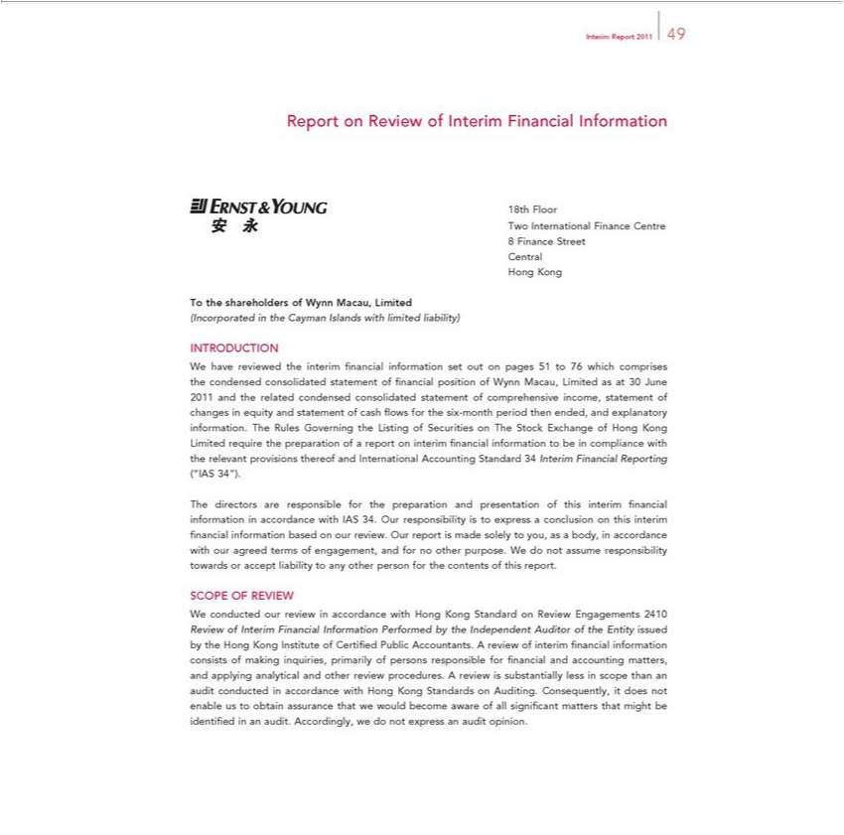

Interim Report 2011 49
Report on Review of Interim Financial Information
18th Floor
Two International Finance Centre
8 | Finance Street
Central
 | Kong
HongTthe shareholders of Wynn Macau, Limited
(Incorporated in the Cayman Islands with limited liability)
INTRODUCTION
W | have reviewed the interim fi nancial information set out on pages 51 to 76 which comprises the condensed consolidated statement of fi nancial position of Wynn Macau, Limited as 30 June 2011 and the
related condensed consolidated statement of comprehensive income, statement of changes in equity and |  |  |  |  |  | of cash fl ows for the six- nth period then ended, and explanatory information. The Rules
Governing |  | he Listing of Securities on The Stock Exchange of Hong Kong Limited require the preparationstatementofreport on interim fi nancial information to be in compliance with the relevant provisions thereof
and International Accounting Standard 34 Interim Financial Reporting (“IAS 34”). |  |  |  |  |  |  | a conclusion | this interim fi nancial
The directors are |  |  | for the preparation and presentation of this |  | fi nancial information in accordance with IAS 34. Our responsibility is to |  | a conclusion | this interim fi nancial
information basedresponsibleourreview. Our report is made solely to you, as a body,interim accordance with our agreed terms of engagement, and for no other purpose.expressWdo not assume responsibility towards or accept
liability to any other person for the contents of this report.
SCOPE OF REVIEW |  |  | accordance with Hong Kong Standard on Review Engagements 2410
W | conducted our review |  |  |  |  |  | . A review of interim fi nancial information
Review of Interim Financial Information Performed by the Independent Auditor of the Entity issued by the Hong Kong Institute of Certifi ed Public
 | sists of making inquiries, primarily of persons |  |  | for fi nancial and accounting matters, and applying analytical and other review procedures.Accountantsreview is substantially less in scope than an audit
conducted |  | accordance with Hong Kong StandardsresponsibleAuditing. Consequently, it does not enable us to obtain assurance that we would become aware of all signifi cant matters that might be identifi ed in an
audit. Accordingly, we do not express an audit opinion.

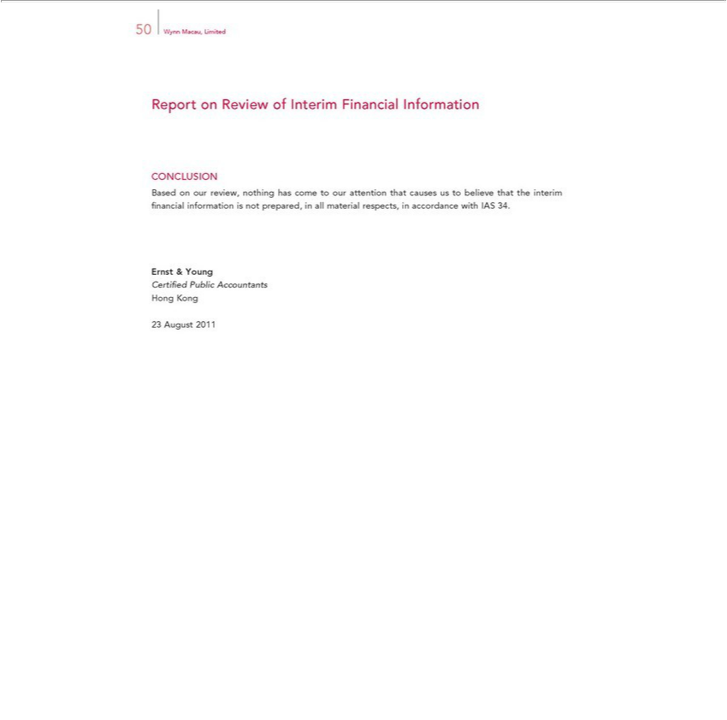

50 Wynn Macau, Limited
Report on Review of Interim Financial Information
CONCLUSION
Based on our review, nothing has come to our attention that causes us to believe that the interim fi nancial information is not prepared, in all material respects, in accordance with IAS 34. Ernst & Young
HongCertifiKongedPublic Accountants

23 August 2011

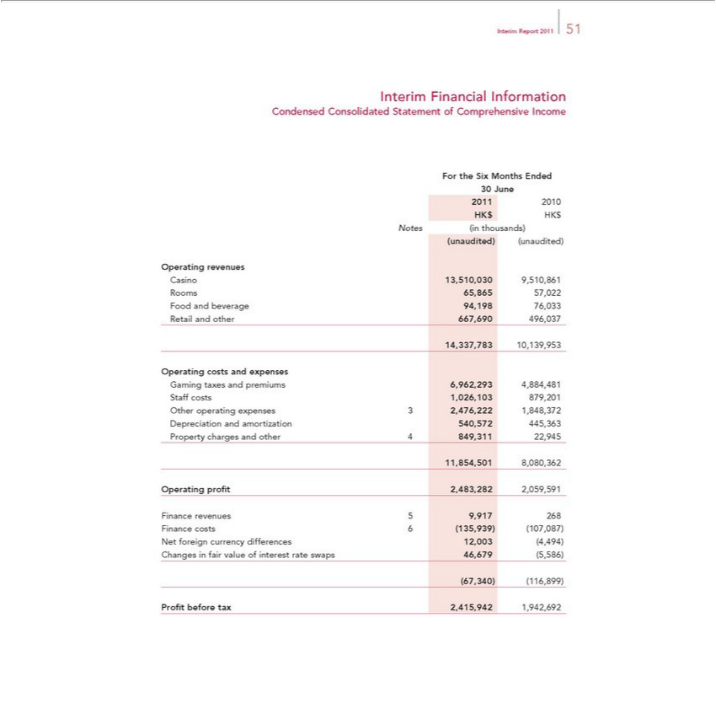

Report 2011 51
Interim Financial Information
Condensed Consolidated Statement of Comprehensive Income
For the Six Months Ended
30 June
2011 2010
HK$ HK$
Notes (in thousands)
(unaudited) (unaudited)
Operating revenues
Casino 13,510,030 9,510,861
Rooms 65,865 57,022
Food and beverage 94,198 76,033
Retail and other 667,690 496,037
14,337,783 10,139,953
Operating costs and expenses
Gaming taxes and premiums 6,962,293 4,884,481
Staff costs 1,026,103 879,201
Other operating expenses 3 2,476,222 1,848,372
Depreciation and amortization 540,572 445,363
Property charges and other 4 849,311 22,945
11,854,501 8,080,362
Operating profi t 2,483,282 2,059,591
revenues 9,917 | 268
Finance costs 6 (135,939) | (107,087)
Net foreign ^{fair}curency differences 12,003 (4,494)
(67,340)Changes (116,899)invalue of interest rate swaps 46,679 (5,586)

Profi t before tax 2,415,942 1,942,692

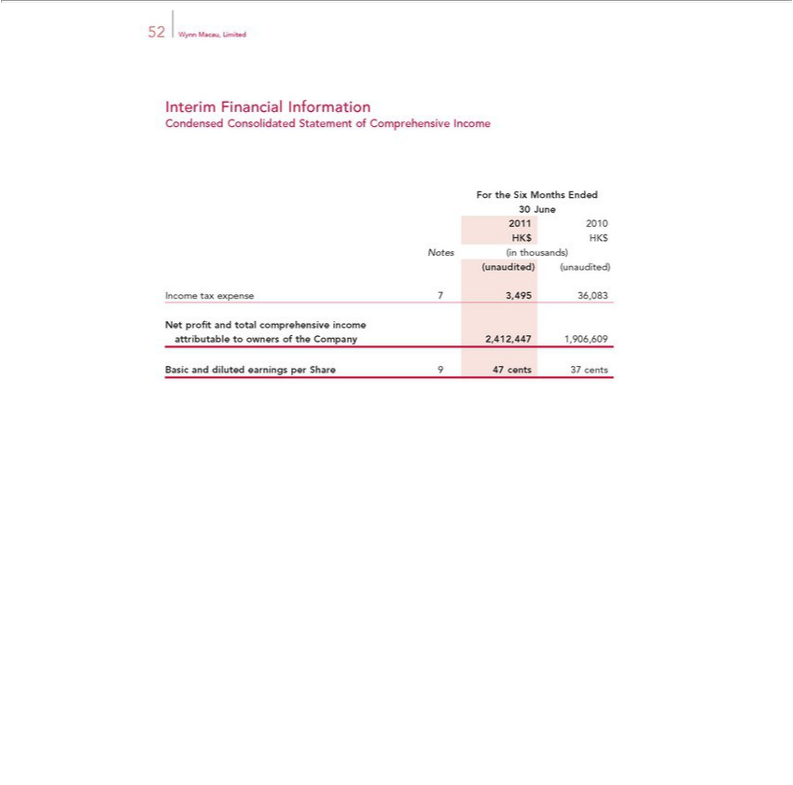

Interim52WynnFinancialMacau, LimitedInformation
ForCondensedtheSix ConsolidatedMonthsEndedStatement of Comprehensive Income
30₂₀₁June
HK$1 HK2010$
(unaudited)Notes(inthousands)(unaudited)
Income ^{tax} expense 7 3,495 36,083
Net profi and total comprehensive income
BasicattributableanddilutedtoownersearningsoftheperCompanyShare9 472,412,447cents371,906,609cents

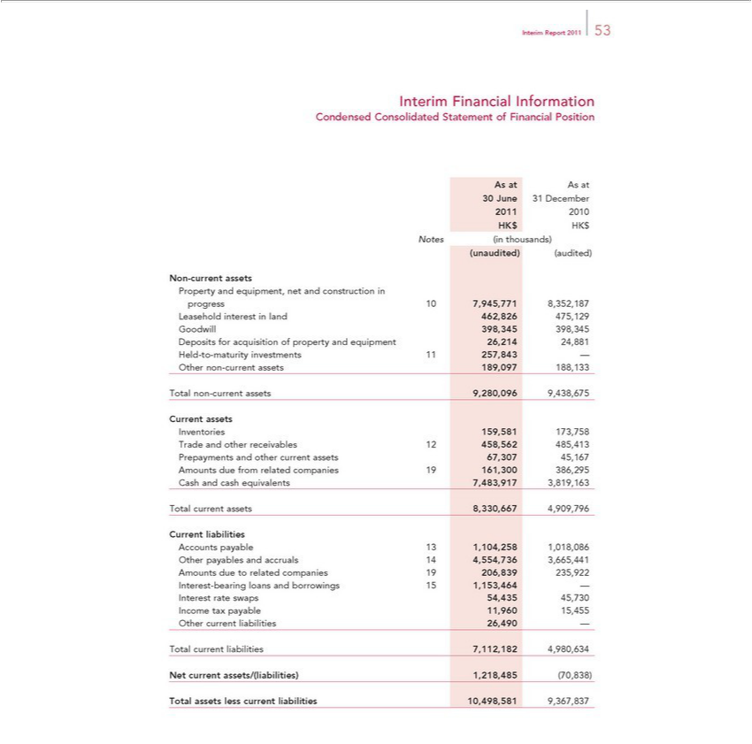

Report 2011 53
Interim Financial Information
Condensed Consolidated Statement of Financial Position
As at As at
30 June 31 December
2011 2010
HK$ HK$
Notes (in thousands)
(unaudited) (audited)
Non-current assets
Property and equipment, net and construction in
progress 10 7,945,771 8,352,187
Leasehold interest in land 462,826 475,129
Goodwill 398,345 398,345
D posits for acquisition of property and equipment 26,214 24,881
Held-to-maturity investments 1 257,843 —
Other non-current assets 189,097 188,133
Total non-current assets 9,280,096 9,438,675
Current assets
Inventories 159,581 173,758
Trade and other receivables 12 458,562 485,413
Prepayments and other current assets 67,307 45,167
Amounts due from related companies |  | 161,300 386,295
Cash and cash equivalents 7,483,917 3,819,163
Total current assets 8,330,667 4,909,796
Current liabilities
Accounts payable 13 1,104,258 1,018,086
Other payables and accruals 14 4,554,736 3,665,441
Amounts due to related companies 19 206,839 235,922
-bearing loans and borrowings 15 1,153,464 —
terest rate swaps 54,435 45,730
Income tax pay | le 11,960 15,455
Other current liabilities 26,490 —
Total current | 7,112,182 4,980,634
Net current assets/(liabilities) 1,218,485 (70,838)
Total assets less current liabilities 10,498,581 9,367,837

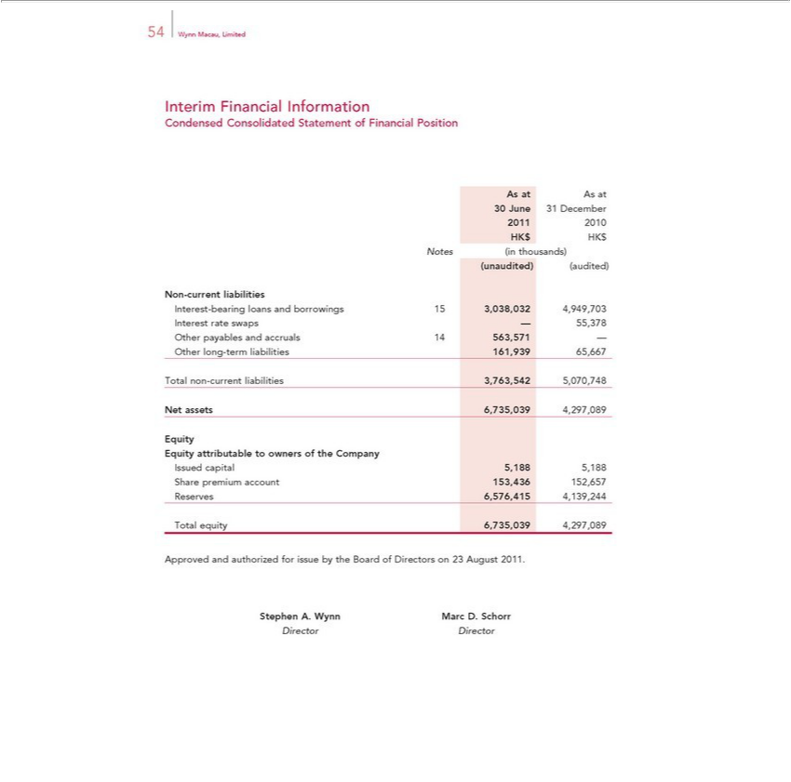

Interim54WynnFinancialMacau, LimitedInformation
AsCondensedatAsat Consolidated Statement of Financial Position
20130June 31 December
HK$1 HK2010$
Notes (in thousands)
Non(unaudited)-current(aud_{liabilities}ted)
_{Interest}-ratebearingswapsloans— 55,378andborrowings 15 3,038,032 4,949,703
^{Other}
longpayables-termandliabilitiesaccruals161,93914563,57165,667—

NetTotalassetsnon-current6,735,039liabilities4,297,0893,763,542 5,070,748
Eq ity
^{Issued}
capitalattributable5,188to5,188owners of the Company
ReservesSharepremium6,576,415account4,139,244153,436 152,657
Total equity 6,735,039 4,297,089
StephenApprovedA.andWynnauthorizedMarcD.forSchorrissue by the Board of Directors on 23 August 2011.

Director Director

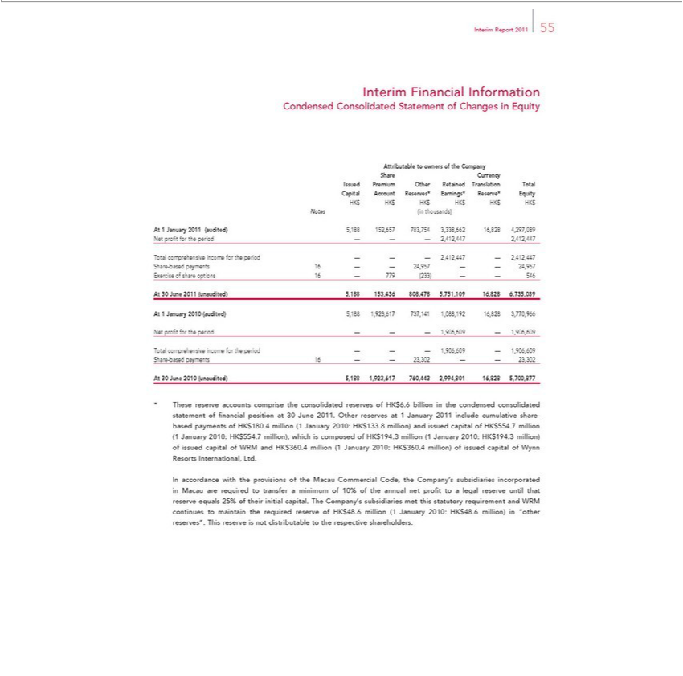

Report 2011 55
Interim Financial Information
Condensed C nsolidated Statement of Changes in Equity
Attributable to owners of the Company
Share Currency
Issued Premium Other Retained Translation Total
Capital Account Reserves* Earnings* Reserve* Equity
HK$ HK$ HK$ HK$ HK$ HK$
Notes (in thousands)
At 1 January 2011 (audited) 5,188 152,657 783,754 3,338,662 16,828 4,297,089
Net profi t for the period — — — 2,412,447 2,412,447
Total comprehensive income for the period — — — 2,412,447 — 2,412,447
Share-based payments 16 — — 24,957 — — 24,957
Exercise of share options 16 — 779 (233) — — 546
30 June 201 (unaudited) 5,188 153,436 808,478 5,751,109 16,828 6,735,039
At 1 January 2010 (audited) 5,188 1,923,617 737,141 1,088,192 16,828 3,770,966
Net profi t for the period — — — 1,906,609 — 1,906,609
Total comprehensive income for the period — — — 1,906,609 — 1,906,609
Share-based payments 16 — — 23,302 — — 23,302 | 5,700,877
At 30 June 2010 (unaudited) 5,188 1,923,617 760,443 2,994,801 | 5,700,877
share-based payments of HK$180.4 million (1 January 2010: HK$16,828133. million) and issued capital of HK$554.7 million (1 January 2010: HK$554.7 million), which is composed of HK$194.3 million (1
These reserve accounts comprise the consolidated reserves of HK$6. billion in the condensed consolidated statement of fi nancial position at 30 June 2011. Other reserves at 1 January 201 |  |  | include cumulative
January 2010: HK$194.3 million) of issued capital of WRM and HK$360.4 million (1 January 2010: HK$360.4 million) of issued capital of Wynn Resorts International, Ltd. |  |  | legal reserve until
In accordance with the provisions of the Macau Commercial Code, the Company’ subsidiaries incorporated in Macau are required to transfer a minimum of 10% of the annual net profi t to |  |  | legal reserve until
that reserve equals 25% of their initial capital. The Company’s subsidiaries met this statutory requirement and WRM continues to maintain the required reserve of HK$48.6 million (1 |  | January 2010: HK$48.6
million) in “other reserves”. This reserve is not distributable to the respective shareholders.

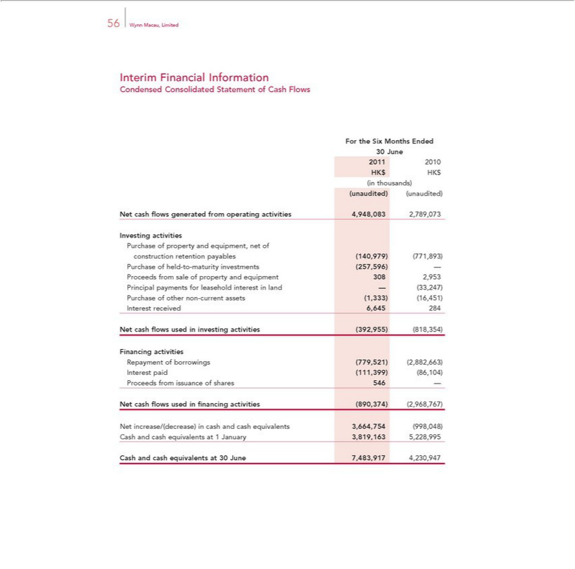

Interim56WynnFinancialMacau, LimitedInformation
ForCondensedtheSix ConsolidatedMonthsEndedStatement of Cash Flows
30₂₀₁June
1 2010
_{(unaudited)}HKinthousands)$HK$
(unaudited)
InvestingNetcashflactivitiesowsgenerated from operating activities 4,948,083 2,789,073
constructionPurchaseofpropertyretentionandpayablesequipment,(140,979)netof(771,893)

ur_{rincipaloceeds}hase offromheldsale-to-ofmaturitypropertyinvestmentsandequipment(257,596)3082,953—
_{Purchase} ofpaymentsothernonfor-currentleaseholdassetsinterest(1,333)inland(16,451)—(33,247)
Interest received 6,645 284
FinancingNetcashflactivitiesowsused in investing activities (392,955) (818,354)
InterestRepaymentpaidof(111,399)borrowings(86,104)(779,521) (2,882,663)
Proceeds from issuance of shares 546 —
_{Net} cash_{increase/(decrease)}flowsused fi nancing activities (890,374) (2,968,767)
in cash and cash equivalents 3,664,754 (998,048)
_{Cash and cash equivalents at} 301JanuaryJune7,483,9173,819,1634,230,9475,228,995

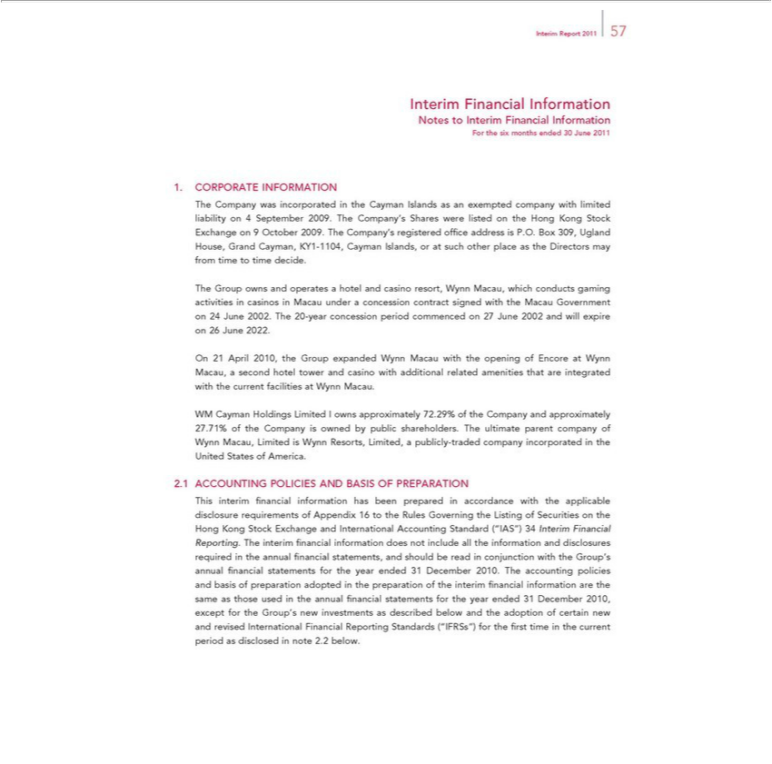

Report 2011 57
Interim Financial Information
Notes to Interim Financial Information
For the six months ended 30 June 2011
CORPORATE INFORMATION |  | Exchange on 9 October
The Company was incorporated in the Cayman Islands as an exempted company with limited liability on September 2009. The Company’s Shares were listed on the Hong Kong |  | Exchange on 9 October
2009. The Company’s registered offi ce address is P.O. Box 309, Ugland House, Grand Cayman, KY1-1104, Cayman Islands, or at such other place as the Directors may from timeStocktime decide.
Group owns and operates a hotel and casino resort, Wynn Macau, which conducts gaming activities in casinos in Macau under a concession contract signed with the Macau Government on 24 June 2002.
The 20-year concession period commenced on 27 June 2002 and will expire on 26 June 2022.
On 21 April 2010, the Group expanded Wynn Macau with the opening of Encore at Wynn Macau, a second hotel tower and casino with additional related amenities that are integrated with the current facilities at
ynn Macau.
WM Cayman Holdings Limited I owns approximately 72.29% of the Company and approximately 27.71% of the Company is owned by public shareholders. The ultimate parent company of Wynn Macau,
Limited is Wynn Resorts, Limited, a publicly-traded company incorporated in the United States of America.
ACCOUNTING POLICIES AND BASIS OF PREPARATION |  | the
This interim fi nancial information has been prepared | accordance with the applicable disclosure quirements of Appendix 16 to the Rules Governing the Listing of Securities | the
Hong Kong Stock Excha ge and International | Standard (“IAS”) 34 Interim Financial Reporting. The interim fi nancial information does not include all the information and disclosures required in the
statements, Accounting
annual fi nancial and should_{information}bereadconjunction with the Group’s annual fi nancial statements for the year ended 31 December 2010. The accounting policies and basis of preparation adopted in
the preparation of the interim fi nancial are the same as those used_{Reporting}the annual fi nancial statements for the year ended 31 December 2010, except for the Group’s new investments as described
below and the adoption of certain new and revised International Financial Standards (“IFRSs”) for the fi rst time in the current period as disclosed in note 2.2 below.

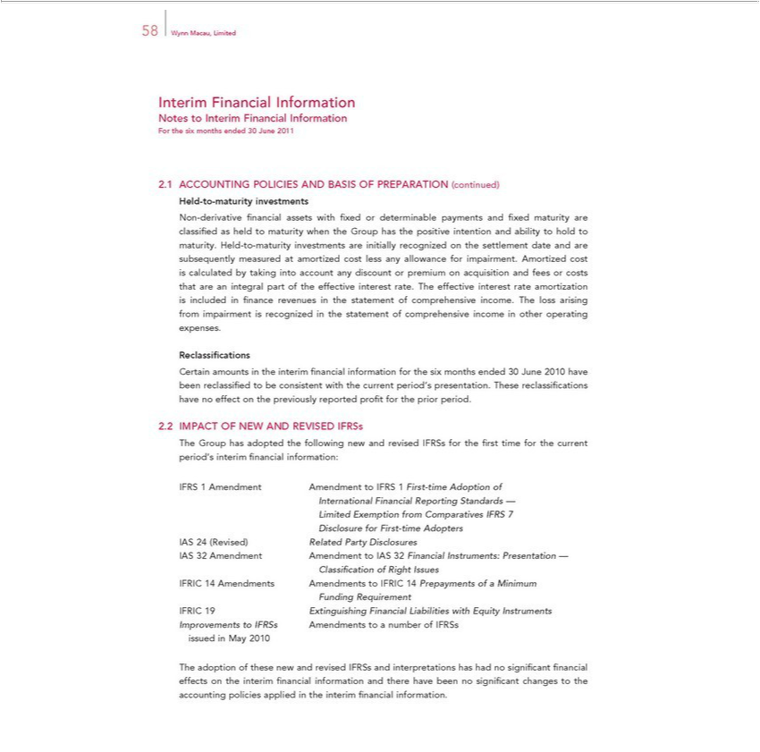

58 Wynn Macau, Limited
Interim Financial Information
Notes to Interim Financial Information
For the six months ended 30 June 2011
ACCOUNTING POLICIES AND BASIS OF PREPARATION (continued)
Held-to-maturity investments
Non-derivative fi nancial assets with fi xed or determinable payments and fi xed maturity are classifi ed as held to maturity when the Group has the positive intention and ability to hold to maturity. Held-to-
maturity investments are initially recogniz d on the settlement date and are subsequently measured at amortized cost less any allowance for impairment. Amortized cost is calculated by taking into account any
discount or premium on acquisition and fees or costs that are an integral part of the effective interest rate. The effective interest rate amortization is included in fi nance revenues in the statement of
comprehensive income. The loss arising from impairment is recognized in the statement of comprehensive income in other operating expenses.
R classifi cations
Certain amounts in the interim fi nancial information for the six months ended 30 June 2010 have been reclassifi ed to be consistent with the current period’s presentation. These reclassifi cations have no effect
on the previously reported profi t for the prior period.
IMPACT OF NEW AND REVISED IFRSs
The Group has adopted the following new and revised IFRSs for the fi rst time for the current period’s interim fi nancial information:
FRS 1 Amendment Amendment to IFRS 1 First-time Adoption of
International Financial Reporting Standards —
Limited Exemption from Comparatives IFRS 7
Disclosure for First-time Adopters
24 (Revised) Related Party Disclosures
IAS 32 Amendment Amendment to IAS 32 Financial Instruments: Presentation —
Classifi cation of Right Issues
IFRIC 14 Amendments Amendments to IFRIC 14 Prepayments of a Minimum
Funding Requirement | with Equity Instruments
FRIC 19 Extinguishing Financial | with Equity Instruments
Improvements Liabilities
issued in May 2010toIFRSs Amendments to number of IFRSs
The adoption of these new and revised IFRSs_{information}andterpretations has had no signifi cant fi nancial effects on the interim fi nancial information and there have been no signifi cant changes to the accounting
policies applied in the interim fi nancial .

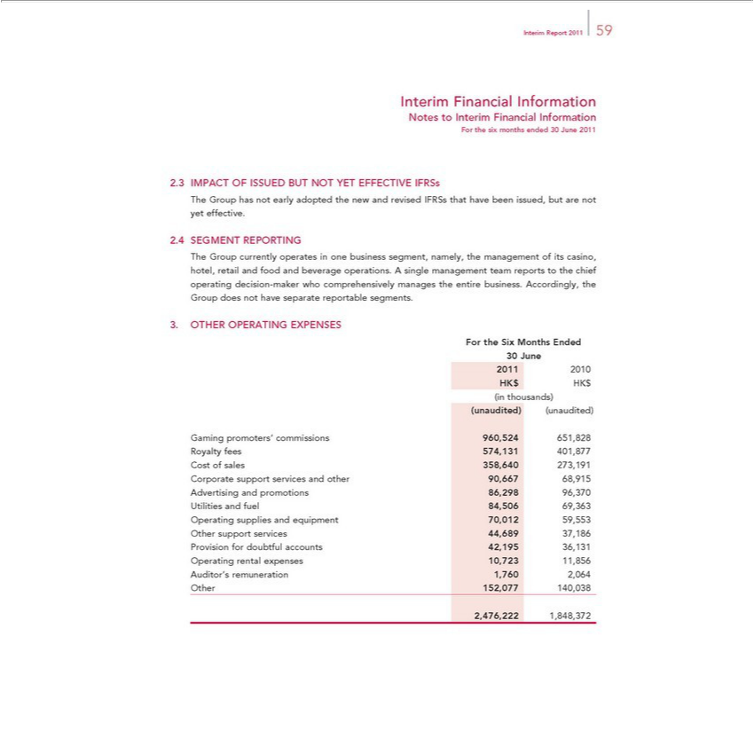

Report 2011 59
Interim Financial Information
Notes to Interim Financial Information
For the six months ended 30 June 2011
IMPACT OF ISSUED BUT NOT YET EFFECTIVE IFRSs
The Group has not early adopted the new and revised IFRSs that have been issued, but are not yet effective.
SEGMENT REPORTING
The Group currently operates in one business segment, namely, the management of its casino, hotel, retail and food and beverage operations. A single management team reports to the chief operating decision-
maker who comprehensively manages the entire business. Accordingly, the Group does not have separate reportable segments.
3. OTHER OPERATING EXPENSES
For the Six Months Ended
30 June
2011 2010
HK$ HK$
in thousands)
(unaudited) (unaudited)
Gaming promoters’ commissions 960,524 651,828
R yalty fees 574,131 401,877
st of sales 358,640 273,191
Corporate support services and other 90,667 68,915
Advertising and promotions 86,298 96,370
Utilities and fuel 84,506 69,363
perating supplies and equipment 70,012 59,553
Other supp t services 44,689 37,186 | 36,131
Provision for doubtful accounts | 36,131
42,195
Auditor’sOperating remunerationrentalexpenses1,76010,7232,0641,856
2,476,222 1,848,372

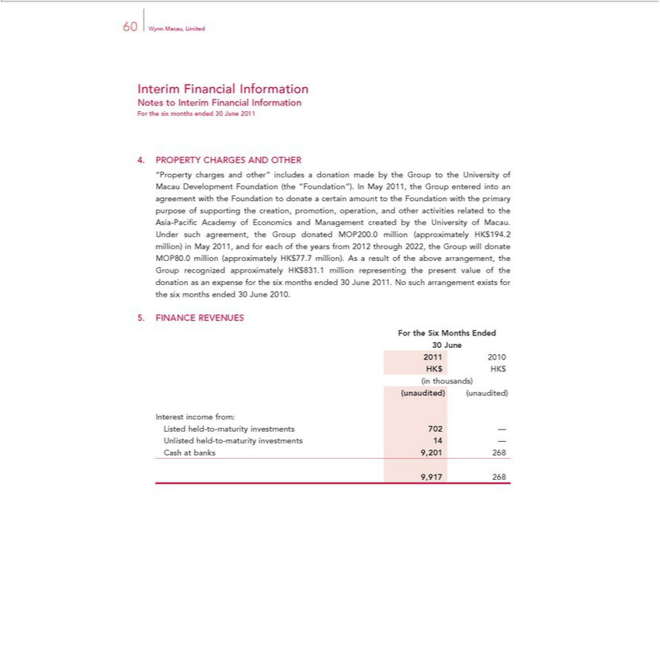

Interim60WynnFinancialMacau, LimitedInformation
ForNotesthetosixInterimmonthsFinancialended30InformationJune2011
PROPERTY CHARGES AND OTHER
“Property charges and other” includes a donation made by the Group to the University of Macau Development Foundation (the “Foundation”). In May 2011, the Group entered into an agreement with the Foundation to donate a certain amount to the Foundation with the primary purpose of supporting the creation, promotion, operation, and other activities related to the Asia-Pacifi c Academy of Economics and Management created by the University of Macau. Under such agreement, the Group _{donated} MOP200.0 million (approximately HK$194.2 million) in May 2011, and for each of the years from 2012 through 2022, the Group will donate MOP80.0 million (approximately HK$77.7 million). As result of the above arrangement, the Group recognized approximately HK$831.1 million representing the present value of the donation as an expense for the six months ended 30 June 2011. No such arrangement exists for the six months ended 30 June 2010.
^{For}
INANCEtheSix REVENUESMonthsEnded
30₂₀₁June
1 2010
_{(unaudited)}HKinthousands)$HK$
(unaudited)
Interest income from:
Listed held-to-maturity investments 702 —
CashUnlistedatbanksheld-to9,201-maturity268 investments 14 —

9,917 268

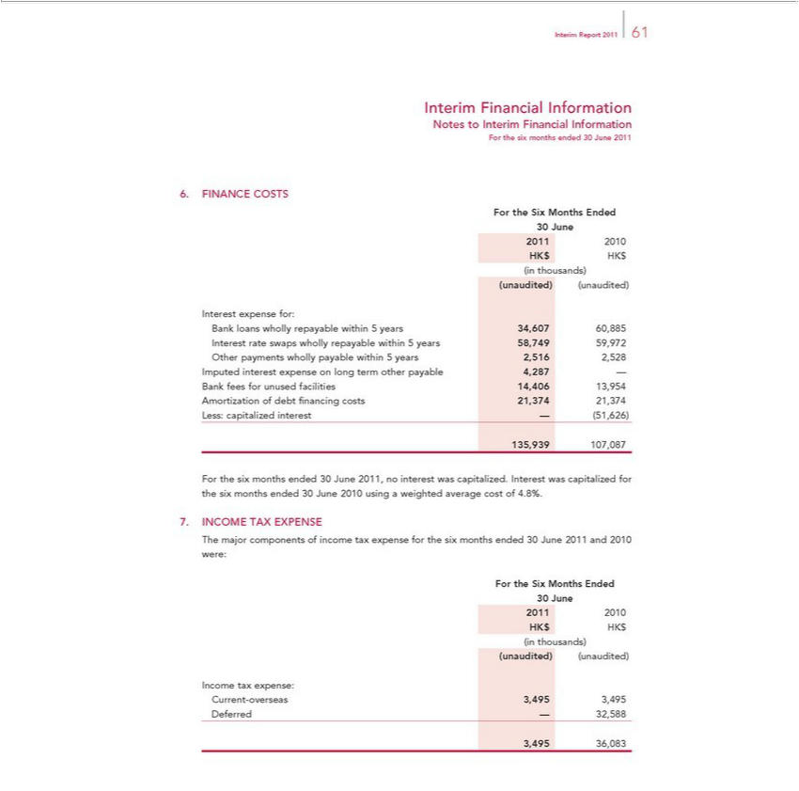

_{Interim} FinancialReport2011Information61
ForNotesthetosixInterimmonthsFinancialended30InformationJune2011
For6.FINANCEtheSixMonthsCOSTSEnded
30₂₀₁June
1 2010
_{(unaudited)}HKinthousands)$HK$
(unaudited)
Interest expense for:
Bank loans wholly repayable within 5 years 34,607 60,885
OtherInterestpaymentsrateswapswhollywhollypayablerepayablewithinwithin5years5years2,51658,7492,528 59,972
BankImputedfeesinterestforunusedexpensefacilitiesonlong14,406term 13,954otherpayable 4,287 —
Less:Amortizationcapitalizedofdebtinterestfinancing—(51,626)costs 21,374 21,374
135,939 107,087
For the six months ended 30 June 2011, no interest was capitalized. Interest was capitalized for the six months ended 30 June 2010 using a weighted average cost of 4.8%.
INCOME TAX EXPENSE
ForThe themajorSixcomponentsMonthsEndedofincome tax expense for the six months ended 30 June 2011 and 2010 were:
30₂₀₁June
1 2010
_{(unaudited)}HKinthousands)$HK$
(unaudited)
Income tax expense:
DeferredCurrent-overseas—32,5883,495 3,495

3,495 36,083

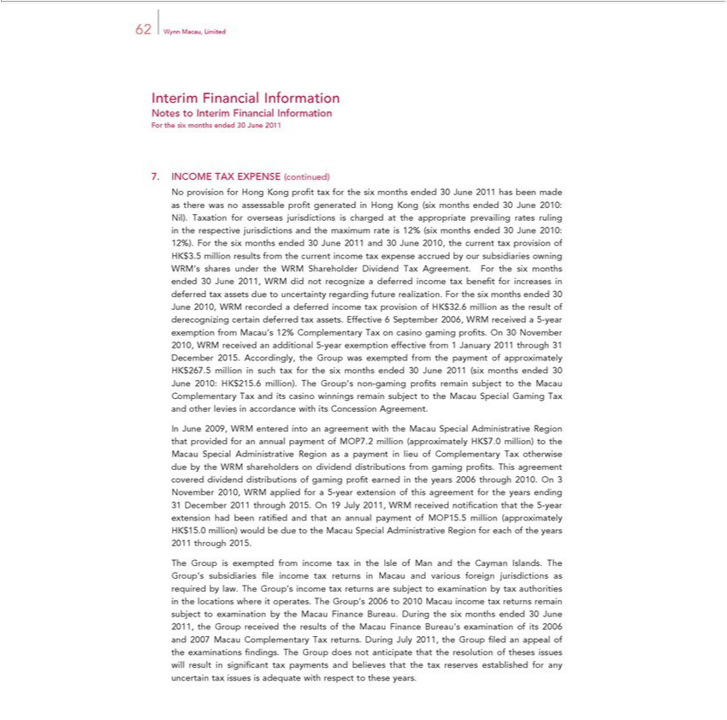

62 Wynn Macau, Limited
Interim Financial Information
Notes to Interim Financial Information
For the six months ended 30 June 2011
INCOME TAX EXPENSE
No provision for Hong Kong(continued)profitax for the six months ended 30 June 2011 has been made as there was no assessable profi t generated in Hong Kong (six months ended 30 June 2010: Nil). Taxation for
overseas jurisdictions is charged at the appropriate prevailing rates ruling in the respective jurisdictions and the maximum rate is 12% (six months ended 30 June 2010: 12%). For the six months ended 30 June
2011 and 30 June 2010, the current tax provision of HK$3.5 million results from the current income tax expense accrued by our |  | owning
WRM’s sha s under the WRM Shareholder Dividend Tax Agreement. For the six months ended 30 June 2011, WRM did not recognizesubsidiariesdeferred income tax benefi t for increases deferred tax assets due to
uncertainty regarding future realization. For the six months ended 30 June 2010, WRM recorded | deferred income tax provision of HK$32.6 million as the result of derecognizing certain deferred tax assets.
Effective 6 September 2006, WRM received a 5-year exemption from Macau’s 12% Complementary Tax on casino gaming profi ts. On 30 November 2010, WRM received an additional 5-year exemption
effective from 1 January 2011 through 31 December 2015. Accordingly, the Group was exempted from the payment of approximately HK$267.5 million such tax for the six months ended 30 June 2011 (six
months ended 30 June 2010: HK$215.6 million). The Group’s non-gaming profi ts remain subject to the Macau Complementary Tax and its casino winnings remain subject to the Macau Special Gaming Tax and
other levies in accordance with its Concession Agreement.
In June 2009, WRM entered into an agreement with the Macau Special Administrative Region that provided for an annual payment of MOP7.2 million (approximately HK$7.0 million) to the Macau Special
Region as a payment in lieu of Complementary Tax otherwise due by the WRM shareholders on dividend distributions from gaming profi ts. This agreement covered dividend distributions of
Administrativegamingprofiearned in the years 2006 through 2010. On 3 | 2011 through 2015. On 19 July 2011, WRM received notifi cation that the 5-year extension had been
November 2010, WRM applied for a 5-year extension of this agreement for the years ending 31
ratifi ed and that an annual payment of MOP15.5 million (approximately HK$15.0 million) wouldDecemberdueto the Macau Special |  | Region for each of the years 2011 through 2015.
The Group is exempt_{are}d from income_{examination}taxthe Isle of Man and the Cayman Islands. The Group’s subsidiaries fi le income tax returnsAdministrativeMacau and various foreign jurisdictions as required by law. The Group’s
income tax returns subject to by tax authorities in the locations where it operates. The Group’s 2006 to 2010 Macau income tax returns remain subject to examination by the Macau Finance Bureau. During the six months ended 30 June 2011, the Group received the results of the Macau Finance Bureau’_{issues}examination of its 2006 and 2007 Macau Complementary Tax returns. During July 2011, the

Group fi led an appeal of the examinations fi ndings. The Group does not anticipate that the resolution of theses will result in signifi cant tax payments and believes that the tax reserves established for any uncertain tax issues is adequate with respect to these years.

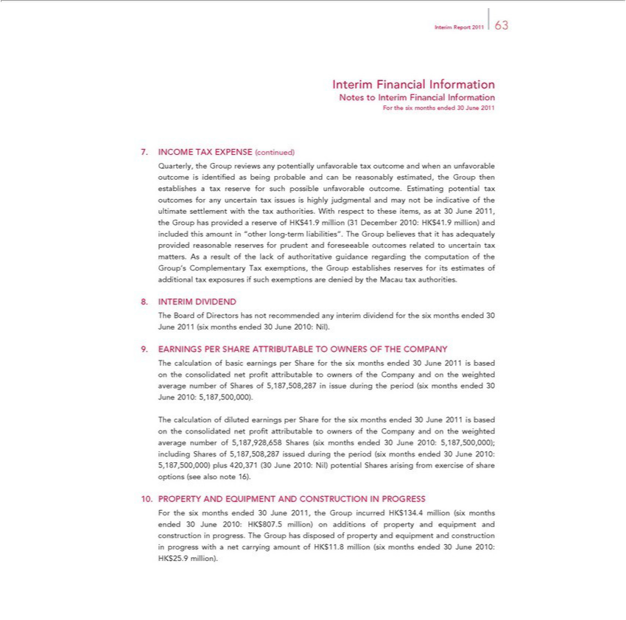

Report 2011 63
Interim Financial Information
Notes to Interim Financial Information
For the six months ended 30 June 2011
INCOME TAX EXPENSE (continued)
Quarterly, the Group reviews any potentially unfavorable tax outcome and when an unfavorable outcome is identifi ed as being probable and can be reasonably estimated, the Group then establishes tax reserve
for such possible unfavorable outcome. Estimating potential tax outcomes for any uncertain tax issues is highly judgmental and may not be indicative of the ultimate settlement with the tax authorities. With
respect to these items, as 30 June 2011, the Group has provided a reserve of HK$41.9 million (31 December 2010: HK$41.9 million) and included this amount in “other long-term liabilities”. The Group
believes that it has adequately provided reasonable reserves for prudent and |  | outcomes related to uncertain tax matters. As a result of the lack of authoritative guidance regarding the computation of
the Group’s Complementary Tax exemptions, the Group establishes reservesforeseeableitsestimates of additional tax exposures if such exemptions are denied by the Macau tax authorities.
INTERIM DIVIDEND
The Board of Directors has not recommended any interim dividend for the six months ended 30 June 2011 (six months ended 30 June 2010: Nil).
EARNINGS PER SHARE ATTRIBUTABLE TO OWNERS OF THE COMPANY
The calculation of basic earnings per Share for the six months ended 30 June 201 is based on the consolidated net profi t attributable to owners of the Company and on the weighted average number of Shares of
The calculation of diluted earningsperiodShare for the six months ended 30 June5,187,500,000)201isbased on the consolidated net profi |  |  |  | attributable to owners of the Company and on the weighted average number of
5,187,508,287 in issue during the | (six months ended 30 June 2010: | .
5,187,928,658 Shares (six months ended 30 June 2010: 5,187,500,000); including Shares of 5,187,508,287 issued during the period (six months ended 30 June 2010: 5,187,500,000) plus 420,371 (30 June 2010:
Nil) potential Shares arising from exercise of share options (see also note 16).
PROPERTY AND EQUIPMENT AND CONSTRUCTION IN PROGRESS |  |  | .5 million) additions of property and equipment and construction in progress. The
For the six months ended 30 June 2011, the Group incurred HK$134.4 million (six months ended 30 June 2010:
Group has disposed of property and equipment and construction in progress with a net carrying amount of HK$11.HK$million807 |  |  |  | (six months ended 30 June 2010: HK$25.9 million).

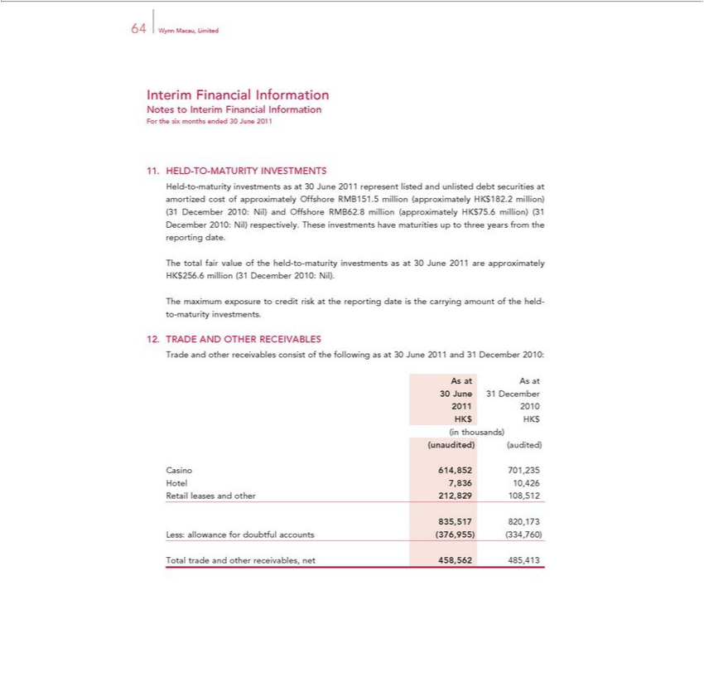

64 Wynn Macau, Limited
NotesInterimtoFinancialInterimFinancialInformationInformation
For the six months ended 30 June 2011
HeldELD-to-TO-maturity-MATURITYinvestmentsINVESTMENTSasat30June 2011 represent listed and unlisted debt securities at amortized cost of approximately Offshore RMB151.5 million (approximately HK$182.2 million) (31 December
2010:totalNil)fairandvalueOffshoreoftheRMB62.8held-to- million (approximatelyinvestmentsas atHK30$75.6June million)2011are(31approximatelyDecember2010:HK$256.6Nil)respectively.million(31 DecemberTheseinvestments2010:Nil)have. maturities up to three years from the reporting date.
he maturity

RADEmaximum exposure to credit risk the reporting date is the carrying amount of the held-to-maturity investments.
T AND OTHER RECEIVABLES
Asradeat Asandatother receivables consist of the following as at 30 June 2011 and 31 December 2010:
1 2010
_{(unaudited)}HKinthousands)$HK$
(audited)
Casino 614,852 701,235
Hotel 7,836 10,426
835,517Retailleases820,173and other 212,829 108,512
Less: allowance for doubtful accounts (376,955) (334,760)
Total trade and other receivables, net 458,562 485,413

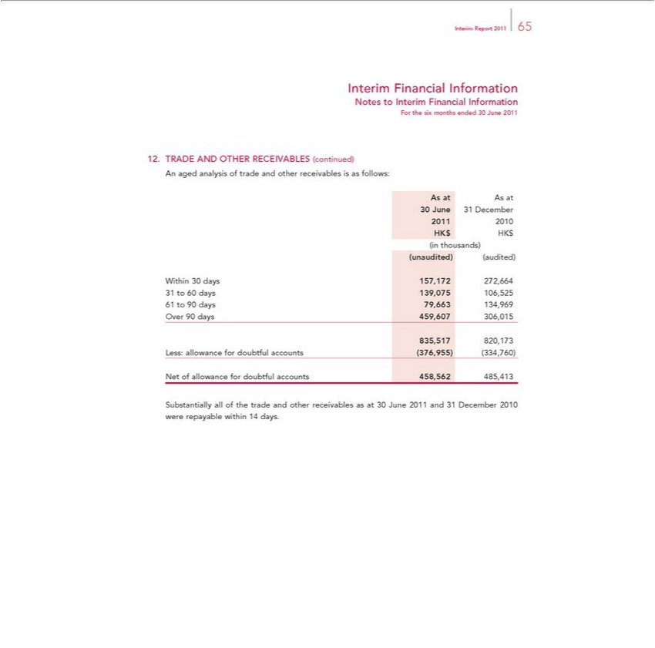

 | Report 2011 65
Interim Financial Information
Notes to Interim Financial Information
For the six months ended 30 June 2011
TRADE AND OTHER RECEIVABLES (continued)
n aged analysis of trade and other receivables is as follows:
As at As at
30 June 31 December
2011 2010
HK$ HK$
in thousands)
(unaudited) (audited)
Within 30 days 157,172 272,664
31 | 60 | 139,075 106,525
61 to 90 days 79,663 134,969
Over 90 days 459,607 306,015
835,517 820,173
Less: allowance for doubtful accounts (376,955) (334,760)
Net of |  |  | for doubtful accounts 458,562 485,413
Substantiallyallowanceof the trade and other receivables as at 30 June 2011 and 31 December 2010 were repayable within 14 days.

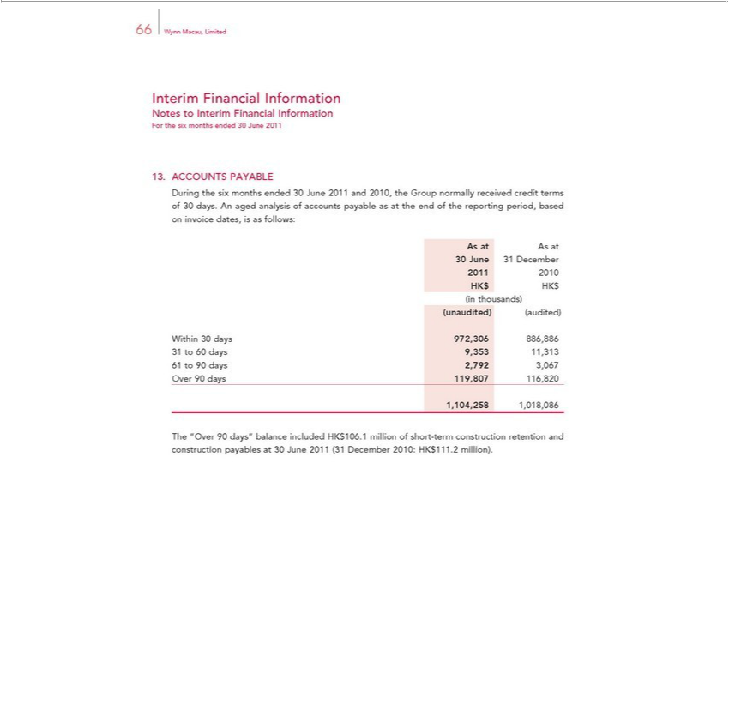

Interim66WynnFinancialMacau, LimitedInformation
ForNotesthetosixInterimmonthsFinancialended30InformationJune2011
ACCOUNTS PAYABLE
During the six months ended 30 June 2011 and 2010, the Group normally received credit terms of 30 days. An aged analysis of accounts payable as at the end of the reporting period, based on invoice dates, is as follows:
As at As at
²⁰¹30June 31 December
1 2010
_{(unaudited)}HKinthousands)$HK$
(audited)
Within 30 days 972,306 886,886
61³¹ to 90⁶⁰ days 2,792^{353 11,313}
3,067
1,104,258Over90days1, _{18,086}19,807 116,820

The “Over 90 days” balance included HK$106.1 million of short-term construction retention and construction payables at 30 June 2011 (31 December 2010: HK$111.2 million).

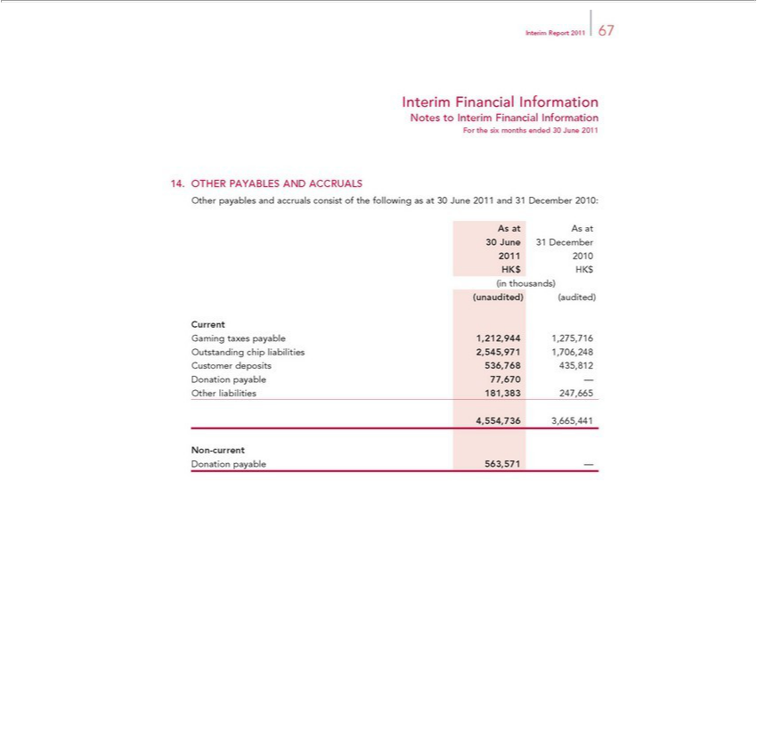

_{Interim} FinancialReport2011Information67
Notes to Interim Financial Information
_{Other}ForTHERthesixPAYABLESmonthsendedAND30ACCRUALSJune2011
As at Aspayablesat and accruals consist of the following as at 30 June 2011 and 31 December 2010:
²⁰¹30June 31 December
HK$1 HK2010$
in thousands)
_{Current(unaudited)} (audited)
GamingOutstandingtaxeschippayableliabilities1,212,9442,545,9711,275,7161,706,248
DonationCustomer payabledeposits77,670536,768—435,812
Other liabilities 181,383 247,665
N_{Donation}4,554,736-current3,665,441
payable 563,571 —

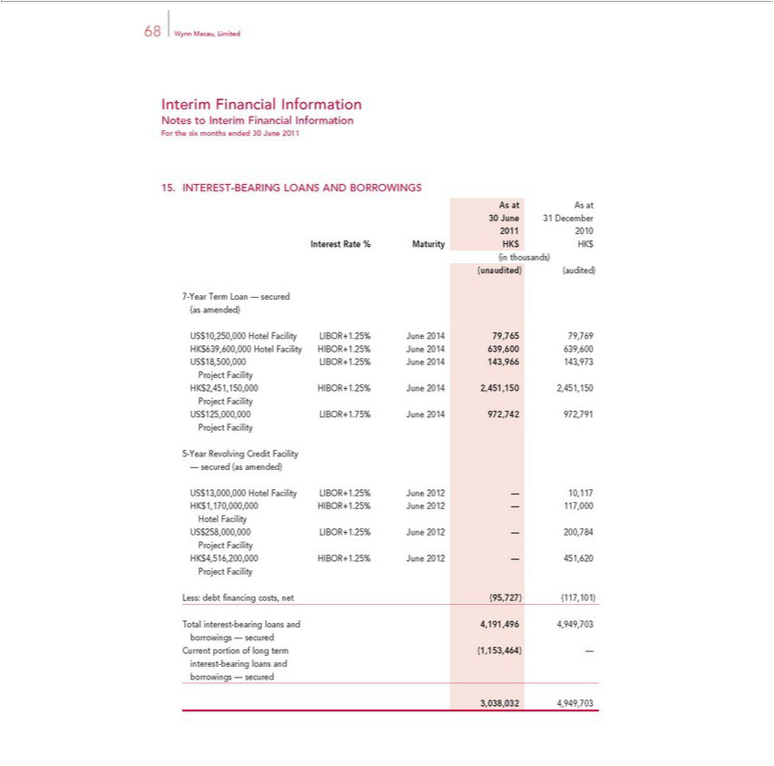

Interim68WynnFinancialMacau, LimitedInformation
ForNotesthetosixInterimmonthsFinancialended30InformationJune2011
As15. at AsINTERESTat-BEARING LOANS AND BORROWINGS
30²⁰¹June 31 December
1 2010
_{(unaudited)}Interestinthousands)Rate% Maturity HK$ HK$
(audited)
(as7-Yearamended)TermLoan — secured
US$10,250,000 Hotel Facility LIBOR+1.25% June 2014 79,765 79,769
USHK$$18,500,000639,600,000LIBOR+1.25%HotelFacility JuneHIBOR+1.25%2014143,966June143,9732014639,600 639,600
Project Facility
ProjectHK$2,451,150,000Facility HIBOR+1.25% June 2014 2,451,150 2,451,150
ProjectUS$125,000,000Facility LIBOR+1.75% June 2014 972,742 972,791
5-Year Revolving Credit Facility
— secured (as amended)
^{Hotel}USK$$13,000,0001,170,000,000HotelHIBOR+1.25%FacilityLIBOR+1.25%June2012 June—117,0002012— 10,117
Facility
ProjectUS$258,000,000Facility LIBOR+1.25% June 2012 — 200,784
ProjectHK$4,516,200,000Facility HIBOR+1.25% June 2012 — 451,620
Less: debt fi nancing costs, net (95,727) (117,101)
borrowingsTotalinterest—-bearingsecuredloans and 4,191,496 4,949,703
_{interest}Cur-bearingportion ofloanslongandterm (1,153,464) —
3,038,032borrowings4,949,703—secured

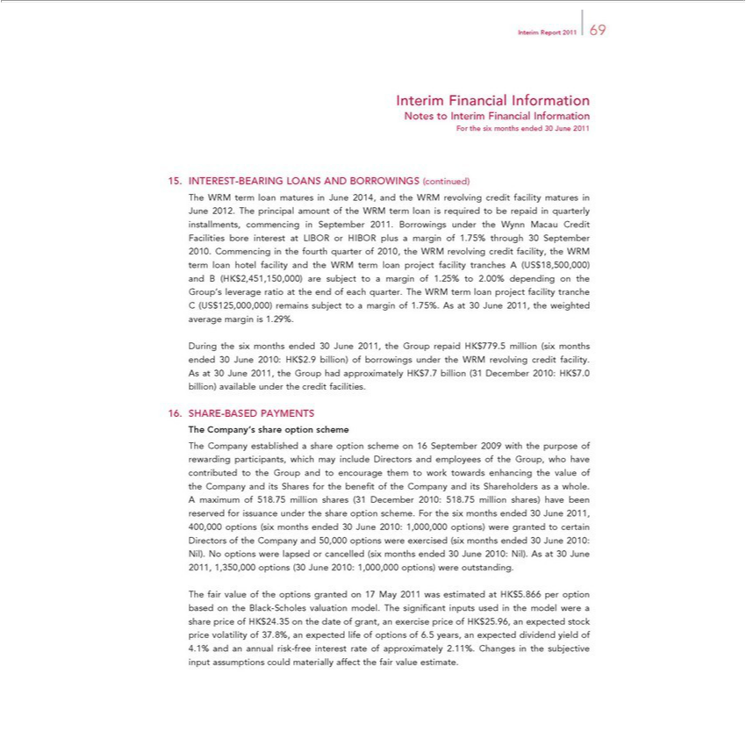

Report 2011 69
Interim Financial Information
Notes to Interim Financial Information
For the six months ended 30 June 2011
INTEREST-BEARING LOANS AND BORROWINGS (continued) |  |  |  |  | quarterly
The WRM term loan matures in June 2014, and the WRM revolving credit facility matures in June 2012. The principal amount of the WRM term loan is required to repaid |  |  |  |  | quarterly
commencing in September 2011. Borrowings under the Wynn Macau Credit Facilities bore interest at LIBOR or HIBOR plus a margin of .75% through 30 September 2010. |  |  |  |  | Commencing the fourth quarter
of 2010, the WRM revolving credit facility, the WRM term loan hotel facility and the WRM term loan project facility tranches A (US$18,500,000) and B |  |  |  |  | are subject installments,tomarginof 1.25% to
2.00% depending on the Group’s leverage ratio at the end of each quarter. The WRM term loan project facility tranche C (US$125,000,000) remains subject(HKto$a2,451,150,000)marginof.75%. As at 30 June 2011, the
weighted average margin is 1.29%. |  | .5 million (six months ended 30 June 2010: HK$2.9 billion) of borrowings under the WRM revolving credit facility. As at 30 June 2011, the
During the six months ended 30 June 2011, the Group repaid
Group had approximately HK$7.7 billion (31 December 2010:HK$779.0 billion) available under the credit facilities.
SHARE-BASED PAYMENTS
’ share option scheme |  |  | which may include Directors | employees of the Group, who have contributed to the Group
The Company established a share option scheme on 16 September 2009 with the purpose of rewarding |  |  | which may include Directors
and to encourage them to work towards enhancing the value of the Company and its Shares for the benefiparticipants,oftheCompany and its Shareholders asand whole. A maximum of 518.75 million shares (31 December
2010: 518.75 million shares) have been reserved for issuance under the share option scheme. For the six months ended 30 June 2011, 400,000 options (six months ended 30 June 2010: 1,000,000 options) were
granted to certain Directors of the Company and 50,000 options were exercised (six months ended 30 June 2010: Nil). No options were lapsed or cancelled (six months ended 30 June 2010: Nil). As at 30 June
2011, 1,350,000 options (30 June 2010: 1,000,000 options) were outstanding.
The fair value of the options | on 17 May 2011 was estimated at HK$5.866 per option based on the Black-Scholes valuation model. The signifi cant inputs used in the model were share price of
HK$24.35 on the date of grant,grantedexercise price of HK$25.96, an expected stock price volatility of 37.8%, an expected life of options of 6.5 years, an expected dividend yield of 4.1% and an annual risk-free interest rate of approximately 2.11%. Changes in the subjective input assumptions could materially affect the fair value estimate.

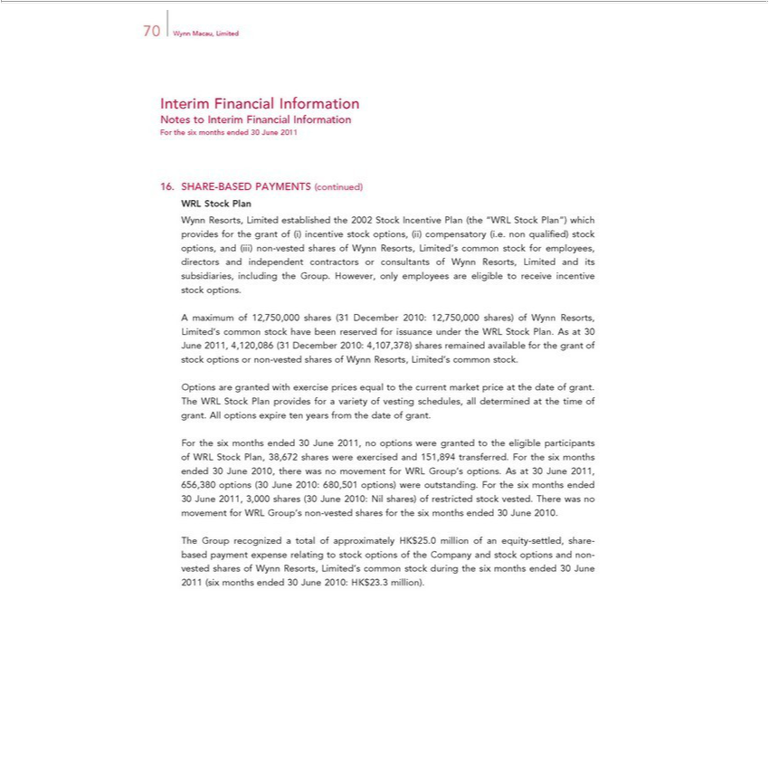

70 Wynn Macau, Limited
Interim Financial Information
Notes to Interim Financial Information
For the six months ended 30 June 2011
SHARE-BASED PAYMENTS (continued)
RL Stock Plan
Wynn Resorts, Limited established the 2002 Stock Incentive Plan (the “WRL Stock Plan”) which provides for the grant of (i) incentive stock options, (ii) compensatory (i. . non qualifi ed) stock options, and
(iii) non-vested shares of Wynn Resorts, Limited’s common stock for employees, directors and independent contractors or consultants of Wynn Resorts, Limited and its subsidiaries, including the Group.
However, only employees are eligible to receive incentive stock options. | Limited’s common stock have been | for issuance under the WRL Stock Plan. As at 30 June 2011, 4,120,086
A maximum of 12,750,000 shares (31 December 2010: 12,750,000 shares) of Wynn | Limited’s common stock have been
(31 December 2010: 4,107,378) shares remained available for the grant of stock optionsResorts,non-vested shares of Wynn Resorts, Limited’reservedcommon stock.
Options are granted with exercise prices equal to the current market price at the date of grant. The WRL Stock Plan provides for a variety of vesting schedules, all determined at the time of grant. All options
expire ten years from the date of grant. |  |  | June 2010,
For the six months ended 30 June 2011, no options were granted to the eligible participants of WRL Stock Plan, 38,672 shares were exercised and 151,894 transferred. For the six months ended |  |  | June 2010,
there was no movement for WRL Group’s options. As at 30 June 2011, 656,380 options (30 June 2010: 680,501 options) were outstanding. For the six months ended 30 June 2011, 3,000 shares |  |  | (30 June 2010:
Nil shares) of restricted stock vested. There was no movement for WRL Group’_{settled,}non-vested shares for the six months ended 30 June 2010.
The Group recognized a total of approximately HK$25.0 million of an equity- share-based payment expense relating to stock options of the Company and stock options and non-vested shares of Wynn Resorts, Limited’s common stock during the six months ended 30 June 2011 (six months ended 30 June 2010: HK$23.3 million).

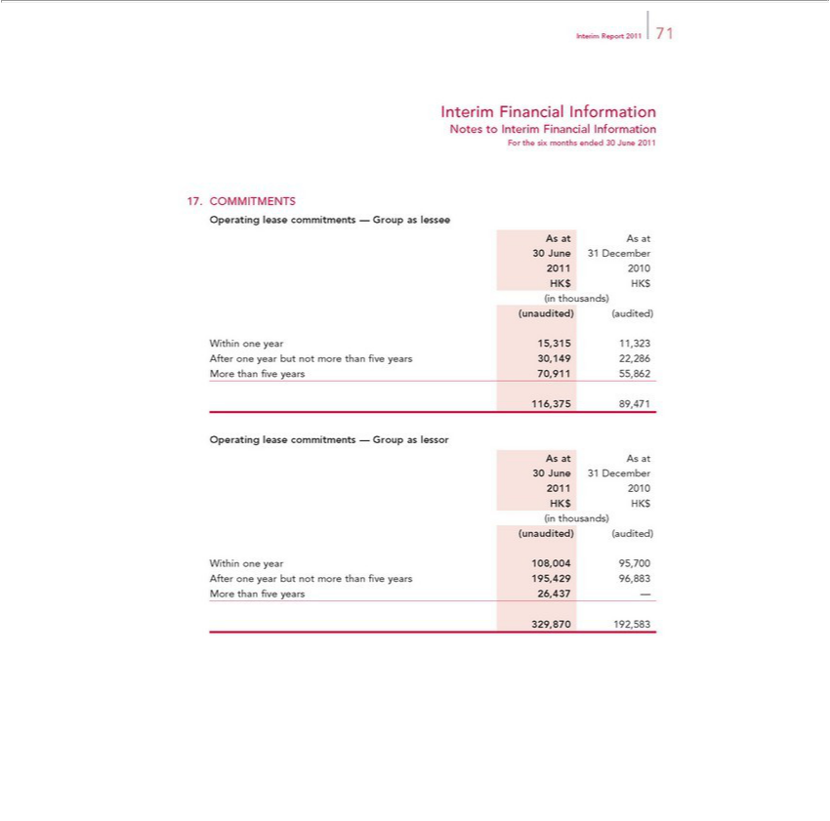

_{Interim} FinancialReport2011Information71
ForNotesthetosixInterimmonthsFinancialended30InformationJune2011
COMMITMENTS
_{OperatingAsAsat}lease commitments — Group as lessee
30²⁰¹June 31 December
1 2010
_{(unaudited)}HKinthousands)$HK$
(audited)
Within one year 15,315 11,323
MoreAfter onethanyearfivebutyearsnot70,911morethan55,862five years 30,149 22,286
116,375 89,471
_{OperatingAsAsat}lease commitments — Group as lessor
30²⁰¹June 31 December
1 2010
_{(unaudited)}HKinthousands)$HK$
(audited)
Within one year 108,004 95,700
MoreAfter onethanyearfivebutyearsnot26,437morethan— fi ve years 195,429 96,883

329,870 192,583

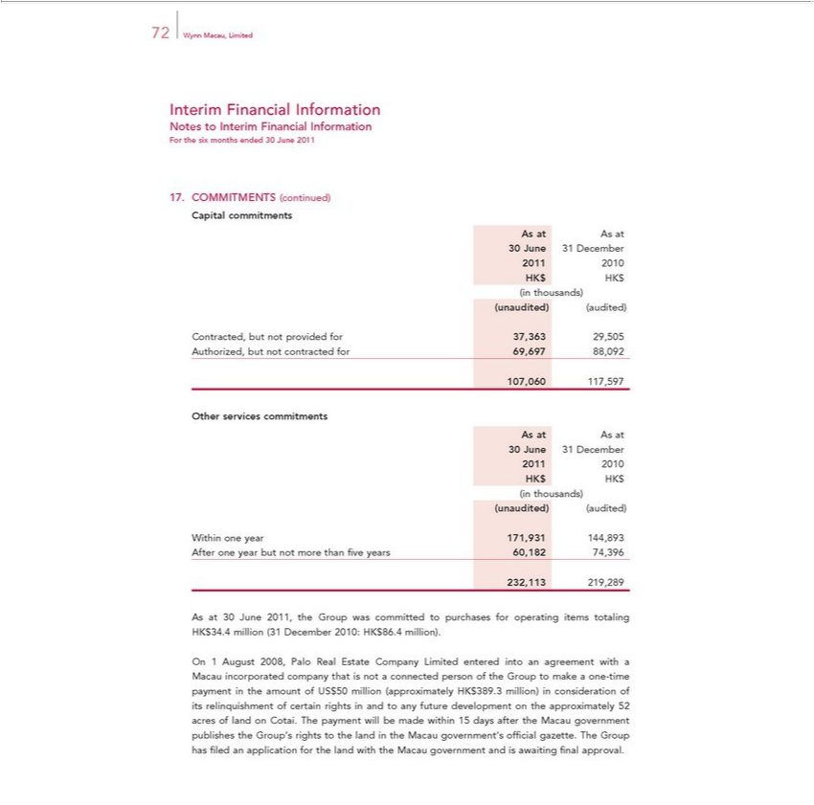

72 Wynn Macau, Limited
Interim Financial Information
Notes to Interim Financial Information
For the six months ended 30 June 2011
17. | COMMITMENTS (continued)
Capital commitments
As at As at
30 June 31 December
2011 2010
HK$ HK$
in thousands)
(unaudited) (audited)
Contracted, but not provided for 37,363 29,505
Authorized, but not contracted for 69,697 88,092
107,060 117,597
Other services commitments
As at As at
30 June 31 December
2011 2010
HK$ HK$
in thousands)
(unaudited) (audited)
Within one year 171,931 144,893
After one year but not more than fi ve years 60,182 74,396
232,113 219,289
As at 30 June 2011, the Group was committed to purchases for operating items totaling HK$34.4 million (31 December 2010: HK$86.4 million).
On 1 August 2008, Palo Real Estate |  |  | Limited entered into an agreement with a
Macau |  | that is Companynot | person of the Group to make a one-time payment in the amount of US$50 million (approximately HK$389.3 million) in consideration of its relinquishment
of certainincorporatedrightsandcompanyto |  | future developmentconnected the approximately 52 acres of land on Cotai. The payment will be made within 15 days after the Macau government publishes the Group’s rights to the land
in the Macau government’s offi cial gazette. The Group has fi led an application for the land with the Macau government and is awaiting fi nal approval.

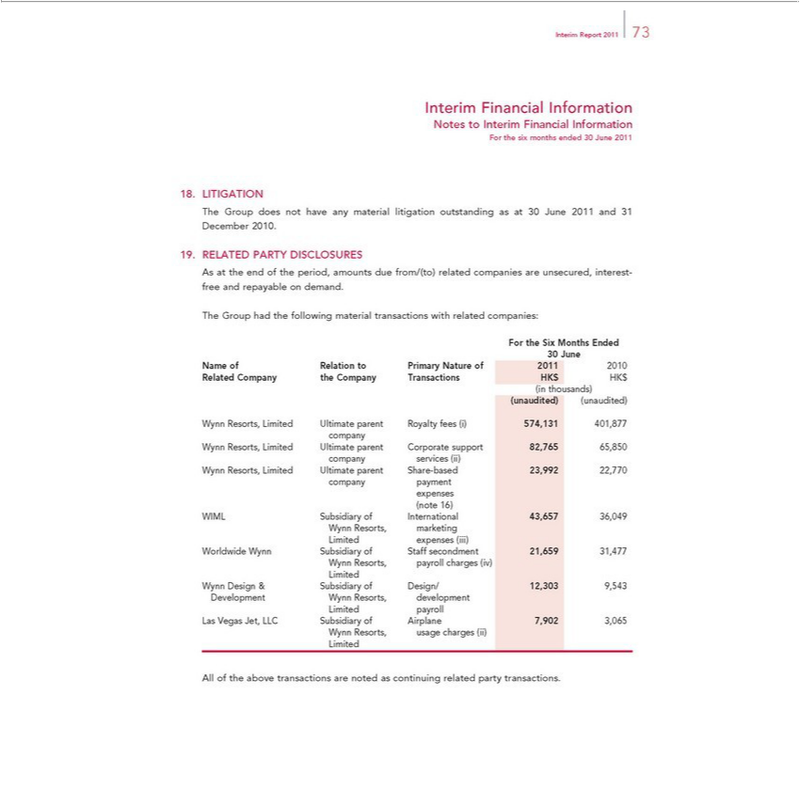

_{Interim} FinancialReport2011Information73
ForNotesthetosixInterimmonthsFinancialended30InformationJune2011
LITIGATION
The Group does not have any material litigation outstanding as at 30 June 2011 and 31 December 2010.
RELATED PARTY DISCLOSURES
TheAsatGrouptheendhadofthethefollowingperiod,amountsmaterialduetransactionsfrom/(to) relatedwithrelatedcompaniescompanies:areunsecured, interest-free and repayable on demand.
30ForJunethe Six Months Ended
Name of Relation to Primary Nature of 2011 2010
_{(unaudited)}Relatedinthousands)Company the Company Transactions HK$ HK$
(unaudited)
companyWynnResorts, Limited Ultimate parent Royalty fees (i) 574,131 401,877
companyWynnResorts,servicesLimited(ii) Ultimate parent Corporate support 82,765 65,850
companyWynnResorts,paymentLimited Ultimate parent Share-based 23,992 22,770
(noteexpenses16)
^{W}
ynnIMLResorts,SubsidiarymarketingofInternational 43,657 36,049
Limited expenses (iii)
^{W}
orldwideynnResorts,WynnpayrollSubsidiarychargesof(iv)Staff secondment 21,659 31,477
Limited
Wynn Design & Subsidiary of Design/ 12,303 9,543
^{Las}DevelopmentimitedpayrollWynn Resorts, development
WynnVegasResorts,Jet, LLCusageSubsidiarycharges(ii)of Airplane 7,902 3,065
Limited
All of the above transactions are noted as continuing related party transactions.

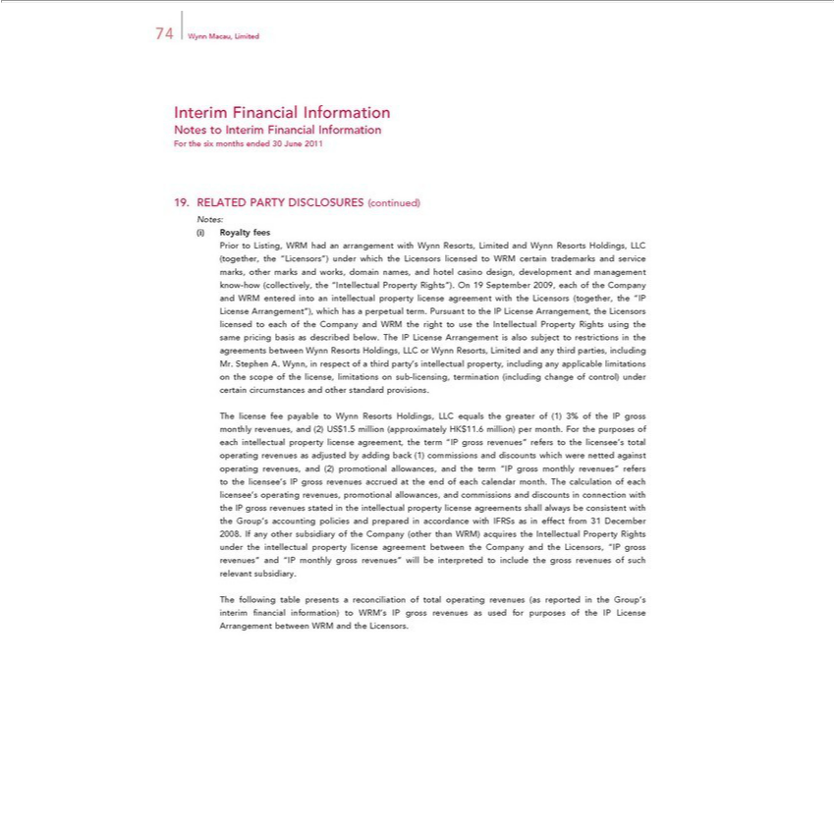

74 Wynn Macau, Limited
NotesInterimtoFinancialInterimFinancialInformationInformation
For the six months ended 30 June 2011
Notes:19. RELATED PARTY DISCLOSURES (continued)
PriorRoyaltyto Listing,fees WRM had an arrangement with Wynn Resorts, Limited and Wynn Resorts Holdings, LLC (together, the “Licensors”) under which the Licensors licensed to WRM certain trademarks and service marks, other marks and works,intellectualdomin names, and hotel casino design, development and management know-how (collectively, the “Intellectual Property Rights”). On 19 September 2009, each of the Company
licensedandWRMto enteredeachof intotheCompany and WRMpropertythelicenserighttoagreementusetheIntellectualwiththeLicensorsProperty Rights(together,usingthethe“IPsameLicensepricingArrangement”),basisasdescribedwhichbelow.hasperpetualTheIPLicenseterm.PursuantArrangementtotheisIPalsoLicensesubjectArrangement,torestrictionstheinLicensorsthe agreements between Wynn Resorts Holdings, LLC or Wynn Resorts, Limited and any third parties, including Mr. Stephen A. Wynn, in respect of a third party’provisionsintellectual property, including any applicable
Thelimitationsintellectualcenseonfeethepayablescope toof Wynnthelicense,ResortslimitationsHoldings,onLLCsub-equalslicensing,the greaterterminationof(1)(including3%ofthechangeIPgrossofmonthlycontrol) revenues,undercertainand circumstances(2)US$1.5millionandother(approximatelystandard HK$11.6. million) per month. For the purposes of each property license agreement, the term “IP gross revenues” refers to the licensee’ total operating as adjusted by adding back (1) commissions and discounts which were netted gainst
_{licensee’}oprating revenues, and (2) promotional allowances, and the term “IP gross monthly revenues” refers to the licensee’revenuesIPgross revenues accrued at the end of each calendar month. The calculation of each
s operating revenues, promotional allowances, and commissions and discounts in connection with the IP gross revenues stated in the intellectual property license agreements shall always be consistent with the Group’s accounting policies and prepared in accordance with IFRSs as in effect from 31 December 2008. If any other subsidiary of the Company (other than WRM) acquires the Intellectual Property Rights under the intellectual property license agreement between the Company and the Licensors, “IP gross revenues” and “IP monthly gross revenues” will be interpreted to include the gross revenues of such relevant subsidiary.

The following table presents a reconciliation of total operating revenues (as reported in the Group’s interim fi nancial information) to WRM’s IP gross revenues as used for purposes of the IP License Arrangement between WRM and the Licensors.

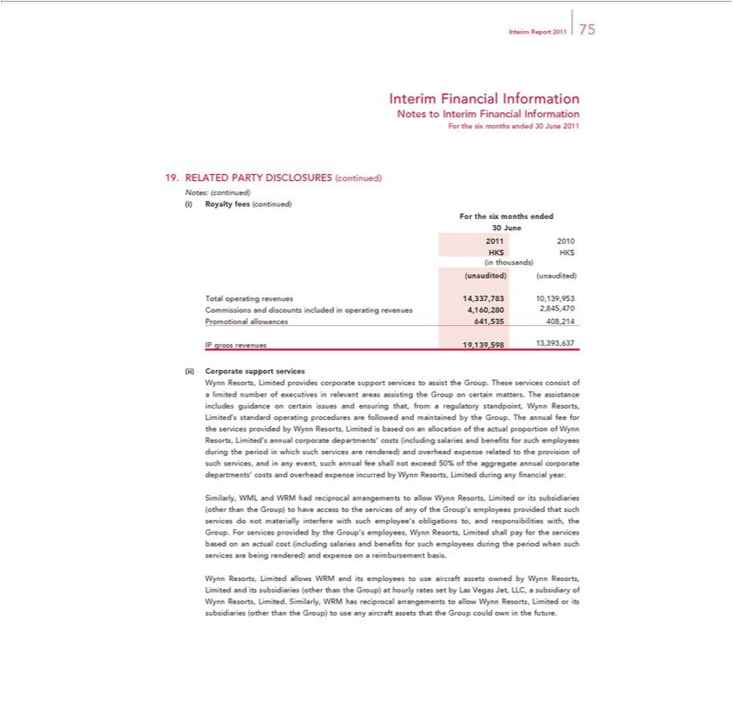

Interim | Report 2011 75
Interim | Financial Information
Notes to Interim Financial Information
For the six months ended 30 June 2011
19. | RELATED PARTY DISCLOSURES (continued)
Notes: (continued)
(i) | Royalty fees (continued)
For the six months ended
30 June
2011 2010
HK$ HK$
in thousands)
(unaudited) (unaudited)
Total operating revenues 14,337,783 10,139,953
Commissions and discounts included in operating revenues 4,160,280 2,845,470
Promotional allowances 641,535 408,214
IP gross revenues 19,139,598 13,393,637
Corporate support services
Wynn Resorts, Limited provides corporate support services to assist the Group. These services consist of a limited number of executives in relevant areas assisting the Group on certain matters. The assistance
includes guidance on certain issues and ensuring that, from a regulatory standpoint, Wynn Resorts, Limited’ standard operating procedures are followed and maintained by the Group. The annual fee for the
services provided by Wynn Resorts, Limited is based on an allocation of the actual proportion of Wynn Resorts, Limited’ annual corporate departments’ costs (including salaries and benefi ts for such
employees during the period in which such services are rendered) and overhead expense related to the provision of such services, and in any event, such annual fee shall not exceed 50% of the aggregate annual
corporate departments’ costs and overhead expense incurred by Wynn Resorts, Limited during any fi nancial year.
Similarly, WML and WRM had reciprocal arrangements to allow Wynn Resorts, Limited or its subsidiaries (other than the Group) to have access to the services of any of the Group’s employees provided that
uch services do not materially interfere with such employee’s obligations to, and responsibilities with, the Group. For services provided by the Group’ employees, Wynn Resorts, Limited shall pay for the
services based on an actual cost (including salaries and benefi ts for such employees during the period when such services are being rendered) and expense on a reimbursement basis.
 | allows WRM and its employees to use aircraft assets owned by Wynn Resorts, Limited and its subsidiaries | than the Group) at hourly rates set by Las Vegas Jet, LLC, a subsidiary of
Wynn Resorts, Limited. Similarly, WRM has reciprocal arrangements to allow Wynn Resorts, Limited or its subsidiaries (other than(otherGroup) to use any aircraft assets that the Group could own in the future.

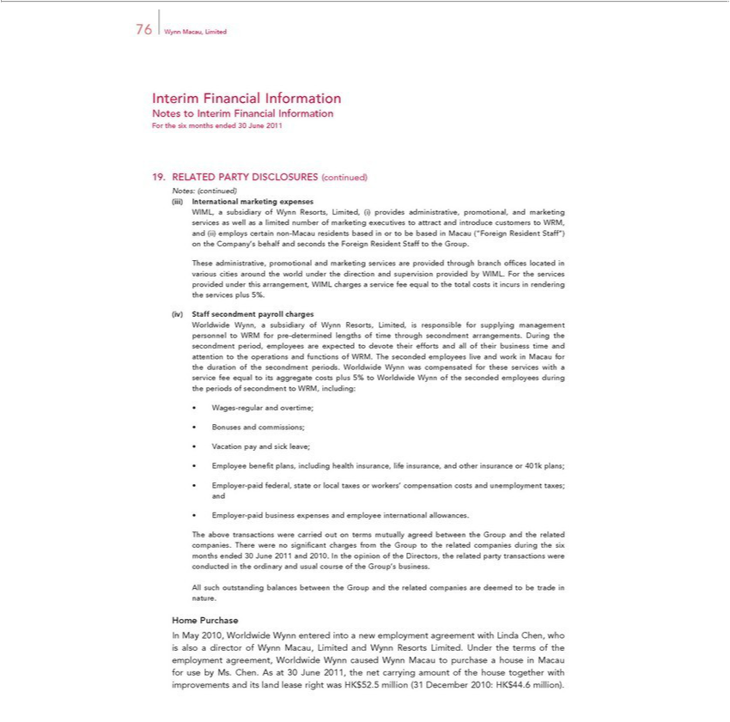

76 Wynn Macau, Limited
Interim Financial Information
Notes to Interim Financial Information
For the six months ended 30 June 2011
19. | RELATED PARTY DISCLOSURES (continued)
Notes: (continued)
 | marketing expenses |  | promotional, and marketing services as well as a limited number of marketing executives to attract and introduce customers to WRM,
InternationalWIML,subsidiary of Wynn Resorts, Limited, (i) provides
and (ii) employs certain non-Macau residents based in or to beadministrative,basedMacau (“Foreign Resident Staff”) on the Company’s behalf and seconds the Foreign Resident Staff to the Group.
These administrative, promotional and marketing services are provided through branch offi ces located various cities around the world under the direction and supervision provided by WIML. For the services
provided under this arrangement, WIML charges a service fee equal to the total costs it incurs in rendering the services plus 5%.
Staff secondment |  | charges |  | the
Worldwide Wynn,payrollsubsidiary of Wynn Resorts, Limited, is responsible for supplying management personnel to WRM for pre-determined lengths of time through secondment arrangements. |  |  |  | the
secondment period, employees are expected to devote their efforts and all of their business time and attention to the operations and functions of WRM. The seconded employees live and workDuringMacau for the duration of the secondment periods. Worldwide Wynn was compensated for these services with a service fee equal to its aggregate costs plus 5% to Worldwide Wynn of the seconded employees during the periods of secondment to WRM, including:
Wages-regular and overtime;

VacationBonuses andpay commissions;andsickleave;

e benefi t plans, including health insurance, life insurance, and other insurance or 401k plans; _{Employer-paid} federal, state or local taxes or workers’ compensation costs and unemployment taxes; and

business expenses and employee international allowances.

The above transactions were carried out on terms mutually agreed between the Group and the related companies. There were no signifi cant charges from the Group to the related companies during the six months ended 30 June 2011 and 2010. In the opinion of the Directors, the related party transactions were conducted in the ordinary and usual course of the Group’s business.
HomeAllsuchPurchaseoutstanding balances between the Group and the related companies are deemed to be trade in nature.
In May 2010, Worldwide Wynn entered into^{Macau}new employment agreement with Linda Chen, who is also a director of Wynn Macau, Limited and Wynn Resorts Limited. Under the terms of the employment
agreement, Worldwide Wynn caused Wynn to purchase a house in Macau for use by Ms. Chen. As at 30 June 2011, the net carrying amount of the house together with improvements and its land lease right was HK$52.5 million (31 December 2010: HK$44.6 million).

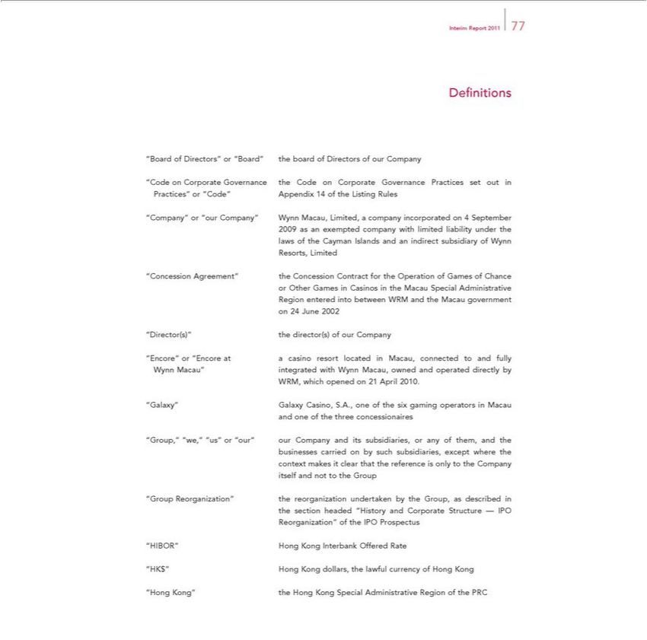

Interim Report 2011 77
Defi nitions

“CodeBardonof CorporateDiectors”GoverAppendixor“Board”ance thethe boardCode onof DirectorsCorporateofGovernanceurCompanyPractices set out in

“Company”Practices” “Code”“ourCompany” Wynn14of theMacau,ListingLimited,Rules a company incorporated on 4 September 2009 as exempted company with limited liability under the
laws of the Cayman Islands and an indirect subsidiary of Wynn
“ConcessionResorts,LimitedAgreement” the Concession Contract for the Operation of Games of Chance
or Other Games Casinos in the M cau Special Administrative
Region24Juneentered2002into between WRM and the Macau government
^{WRM,} integrated
ynn Macau”whichopened on 21withAprilWynn2010.Macau, owned and operated directly by
and“Galaxy”oneofGalaxythethreeCasino,concessionairesS.A.,oneof the six gaming operators in Macau
businesses“Group,”“we,”carried“us”on orby“our”such oursubsidiaries,Companyexceptanditswheresubsidiaries,the or any of them, and the
itselfcontextandmakesnottoittheclearGroupthat the reference is only to the Company
the“GroupsectionReorganization”headed“Historythe andreorganizationCorporate Structureundertaken— byIPOthe Group, as described in
Reorganization”IBOR”^{K$”}Hong Kongofthe InterbankIPOProspectusOffered Rate
_{“Hong} Hong Kong dollars, the lawful currency of Hong Kong
Kong” the Hong Kong Special Administrative Region of the PRC

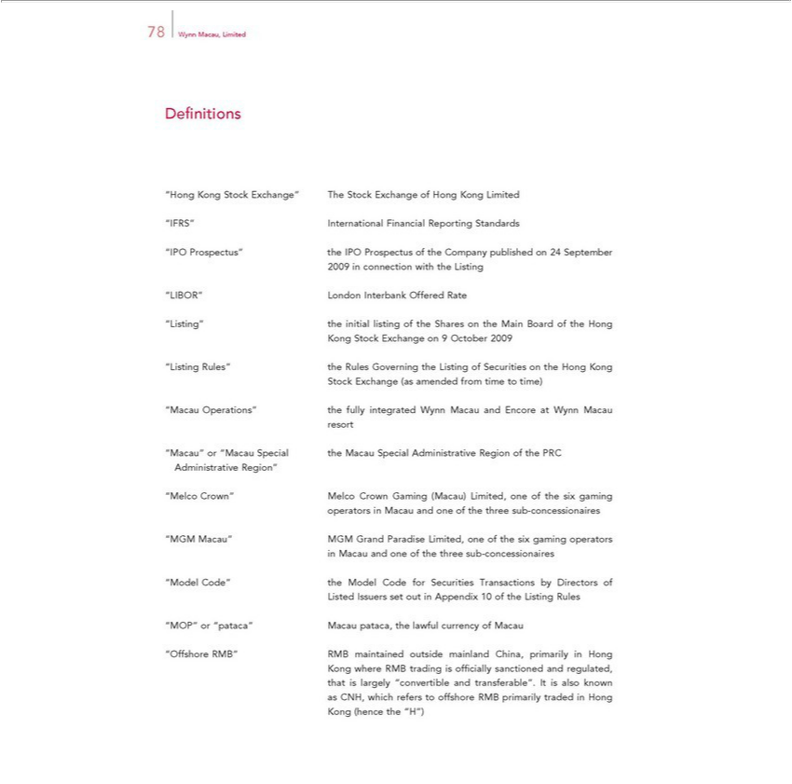

Defi78WynnnitionsMacau, Limited
^{FRS”}
^{“IPO}Hong KongInternationalStockExchange”Financial TheReportingStock StandardsExchange of Hong Kong Limited
2009_{“Listing”}Prospectus”connectionthewithIPOtheProspectusListing of the Company published on 24 September
IBOR” London Interbank Offered Rate
the_{Exchange}initillisting of the Shares on the Main Board of the Hong
Kong Stock on 9 October 2009
Stock“ListingExchangeRules” the(as RulesamendedGoverningfromtimethetoListingtime) of Securities on the Hong Kong
resort“Macau Operations” the fully integrated Wynn Macau and Encore at Wynn Macau
Administrative“Macau”or“MacauRegion”Special the Macau Special Administrative Region of the PRC
“Melco_{operators}Crown”inMacauMelcoand Crownoneof theGamingthree (Macau)sub-concessionairesLimited,one of the six gaming
in“MGMMacauMacau”andoneMGMoftheGrandthree Paradisesub-concessionairesLimited,one of the six gaming operators
Listed“ModelIssuersCode”settheoutModelinAppendixCodefor10SecuritiesoftheListingTransactionsRules by Directors of
^{“Of}MOP” or “pataca” Macau pataca, the lawful currency of Macau
KongfshorewhereRMB”RMBRMBtradingmaintainedisofficiallyoutsidesanctionedmainlandandChina,regulated,primarily in Hong
that is largely “convertible and transferable”. It is also known
KongasCNH,(hencewhichtherefers“H”) to offshore RMB primarily traded in Hong

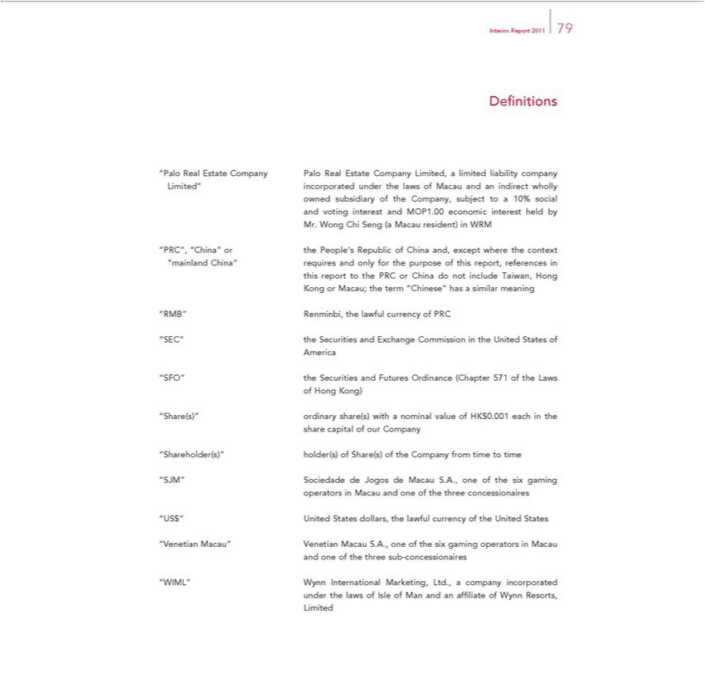

Interim Report 2011 79
Defi nitions |  |  |  |  | Limited, a limited liability company
“Palo Real Estate Company Palo Real Estate |  |  |  | Companyand | Limited, a limited liability company
Limited” incorporated under the laws of |  |  |  | Companyand | indirect wholly
owned subsidiary of the Company, subjectMacauto10% social
and voting interest and MOP1.00 economic interest held by
Mr. Wong | Seng (a Macau |  | in WRM
PRC”, “China” or the People’resident)Republic of China and, except where the context
“mainland China” requires and only for the purpose of this report, references in
this | to the PRC or China do not include Taiwan, Hong
KongreportMacau; the term “Chinese” has a similar meaning
RMB” Renminbi, the lawful currency of PRC
“SEC” the Securities and Exchange Commission in the United States of
America
“SFO” the Securities and Futures Ordinance (Chapter 571 of the Laws
of Hong Kong)
“Share(s)” ordinary share(s) with a nominal value of HK$0.001 each in the
share capital of our Company
hareholder(s)” |  | of Share(s) of the Company from time to time
“SJM” holder(s)
operatorsSociedadeinMacau andJogosonedeof MacauthethreeS.A.,concessionairesoneofthesix gaming
^{“V}US$” United States dollars, the lawful currency of the United States
andenetianoneofMacau”thethreeVenetiansub-concessionairesMacauS.A., one of the six gaming operators in Macau
“WIML” Wynn International Marketing, Ltd., a company incorporated
Limitedunderthe laws of Isle of Man and an affi liate of Wynn Resorts,

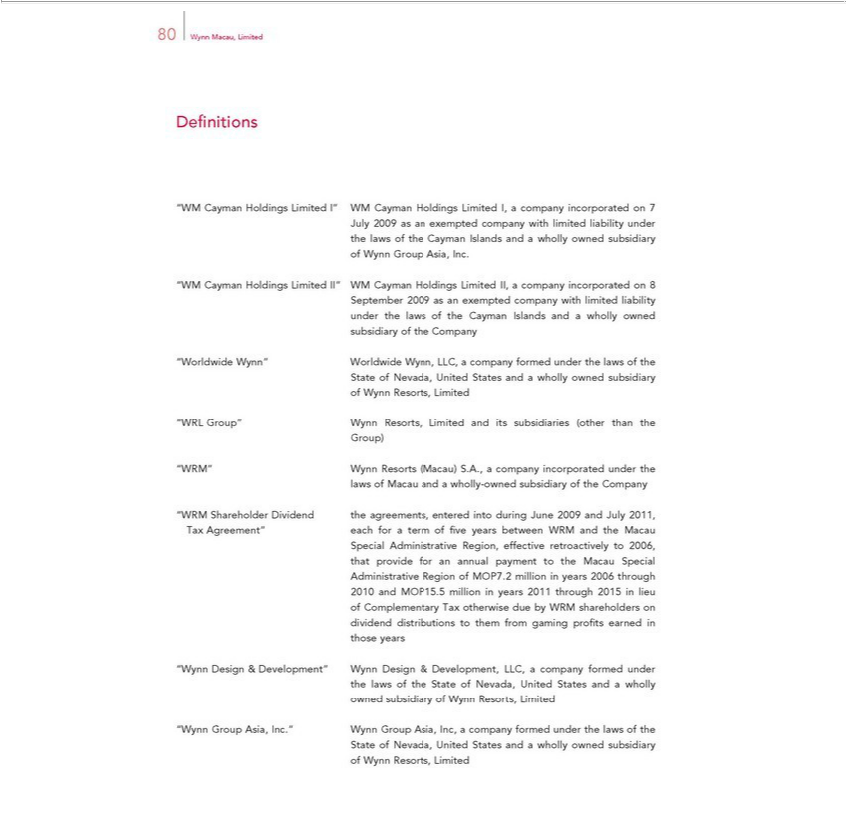

80 Wynn Macau, Limited
Defi nitions
“WM Cayman Holdings Limited I” WM Cayman Holdings Limited I, a company incorporated on 7
July 2009 as an exempted company with limited liability under
the laws of the Cayman Islands and a wholly owned subsidiary
of | ynn Group Asia, Inc.
“WM Cayman Holdings Limited II” WM Cayman Holdings Limited II, a company incorporated on 8
September 2009 as an exempted company with limited liability
under the laws of the Cayman Islands and a wholly owned
subsidiary of the Company
“Worldwide Wynn” Worldwide Wynn, LLC, a company formed under the laws of the
State of Nevada, United States and a wholly owned subsidiary
of | ynn Resorts, Limited
“WRL Group” Wynn Resorts, Limited and its subsidiaries (other than the
Group) |  | company incorporated under the
“WRM” Wynn Resorts (Macau) S.A., |  | company incorporated under the
laws of Macau and a wholly-owned subsidiary of the Company
“WRM Shareholder Dividend the agreements, entered into during June 2009 and July 2011,
Tax Agreement” each for a term of fi |  | years between WRM and the Macau
SpecialthatprovideAdministrativeforanannualRegion,paymenteffectivetothe retroactivelyMacauSpecialto 2006,
Administrative Region of MOP7.2 million in years 2006 through
of2010ComplementaryandMOP15.5Taxmillionotherwiseinyearsdue2011byWRMthroughshareholders2015inlieuon
thosedividendyearsdistributions to them from gaming profi ts earned in

“Wynn Design & Development” Wynn Design & Development, LLC, a company formed under the laws_{subsidiary}oftheState of Nevada, United States and a wholly
owned of Wynn Resorts, Limited
State“WynnofGroupNevada,Asia,UnitedInc.”StatesWynnandGroupawhollyAsia,ownedInc,a companysubsidiaryformed under the laws of the

of Wynn Resorts, Limited

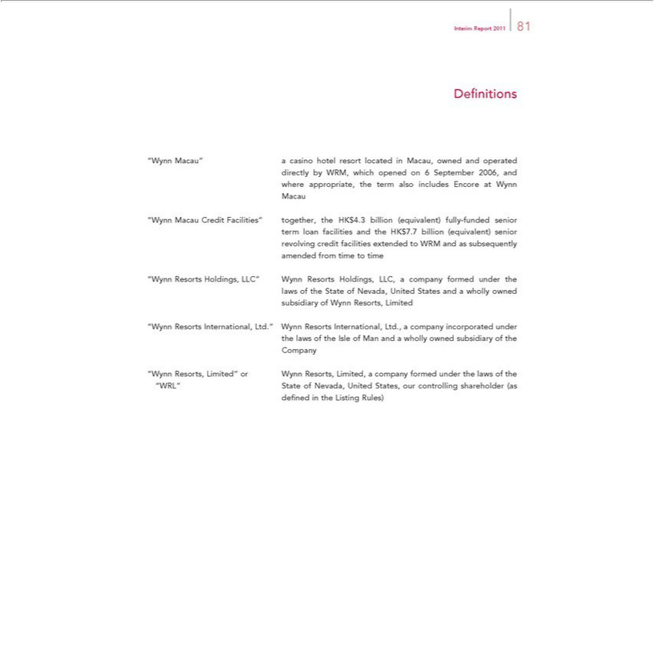

DefiInterimnitionsReport 2011 81
directly“Wynn Macau”byWRM,acasinowhichhotelopenedresorton 6locatedSeptemberinMacau,2006,ownedand and operated
Macauwhereappropriate, the term also includes Encore at Wynn
term“WynnloanMacaufacilitiesCreditandFacilities”theHK$7.7together,billionthe(equivalent)HK$4.3billionsenior(equivalent) fully-funded senior
amendedrevolving fromcredittimefacilitiestotimeextended to WRM and as subsequently
laws“Wynnof ResortstheStateHoldings,ofNevada,LLC”UnitedWynnStatesResortsand aHoldings,whollyownedLLC, a company formed under the
subsidiary of Wynn Resorts, Limited
“Wynn Resorts International, Ltd.” Wynn Resorts International, Ltd., a company incorporated under the laws of the Isle of Man and a wholly owned subsidiary of the

Company
^{“WRL”}
ynn Resorts,Stateof Limited”Nevada, UnitedorWynnStates,Resorts,our Limited,controllingacompanyshareholderformed(as under the laws of the

defi ned in the Listing Rules)

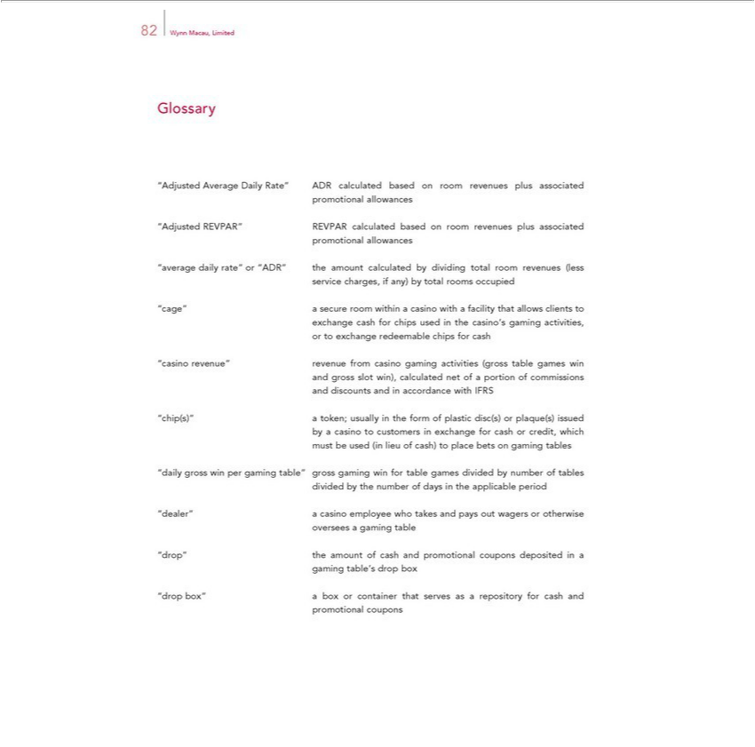

82 Wynn Macau, Limited
Glossary
“Adjusted Average Daily Rate” ADR calculated based on room revenues plus associated
promotional allowances
“Adjusted REVPAR” REVPAR calculated based on room revenues plus associated
promotional allowances
“average daily rate” or “ADR” the amount calculated by dividing total room revenues (less
service charges, if any) by |  | rooms occupied
“cage” secure room withintotalcasino with a facility that allows clients to
exchange cash for chips used in the casino’s gaming activities,
or to exchange redeemable chips for cash
“casino revenue” revenue from casino gaming activities (gross table games win
gross slot win), calculated net of a portion of commissions
and discounts and in accordance with IFRS
“chip(s)” | usually in the form of plastic disc(s) or plaque(s) issued
by a casino token;customers in exchange for cash or credit, which
must be used (in lieu of cash) to place bets on gaming tables
“daily gross win per gaming table” gross gaming win for table games divided by number of tables
divided by the number of days in the applicable period
“dealer” a casino employee who takes and pays out wagers or otherwise
oversees a gaming table
“drop” the amount of cash and promotional coupons deposited in a
gaming | s drop b x
table’ container
promotional“dropbox” couponsboxor that serves as a repository for cash and

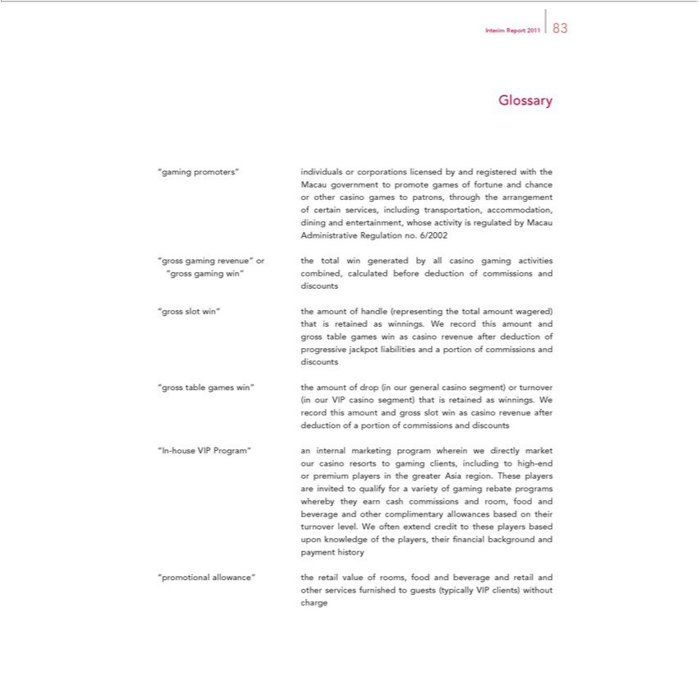

Interim Report 2011 83
Glossary
“gaming promoters” individuals or corporations licensed by and registered with the
Macau government to promote games of fortune and chance
r other casino games to patrons, through the arrangement
of certain services, including transportation, accommodation,
dining and entertainment, whose activity is regulated by Macau
Administrative Regulation no. 6/2002
 | revenue” or the total win generated by all casino gaming activities
“gross gaming win” combined, calculated before deduction of commissions and
discounts
“gross slot win” the amount of handle (representing the total amount wagered)
that is retained as |  | . We record this amount and
ss table games winningsascasino revenue after deduction of
progressive jackpot liabilities and a portion of commissions and
discounts
“gross table games win” the amount of drop (in our general casino segment) or turnover
(in our VIP casino segment) that is ret ined winnings. W
record this |  | and gross slot win as casino revenue after
deduction ofamountportion of commissions and discounts
“In-house VIP Program” an internal marketing program wherein we directly market
ur casino resorts to gaming cli nts, including to high-end
or premium players in the greater Asia region. These players
are invited to qualify for a variety of gaming rebate programs
whereby they earn cash commissions and room, food and
beverage and |  | allowances based on their
other complimentary
turnover level. W oft_{the players,}extnd credit to these players based
paymentuponknowledgehistory of their fi nancial background and
other“promotionalservices allowance”furnishedtotheguestsretail(typicallyvalueof rooms,VIPclients)food andwithoutbeverage and retail and

charge

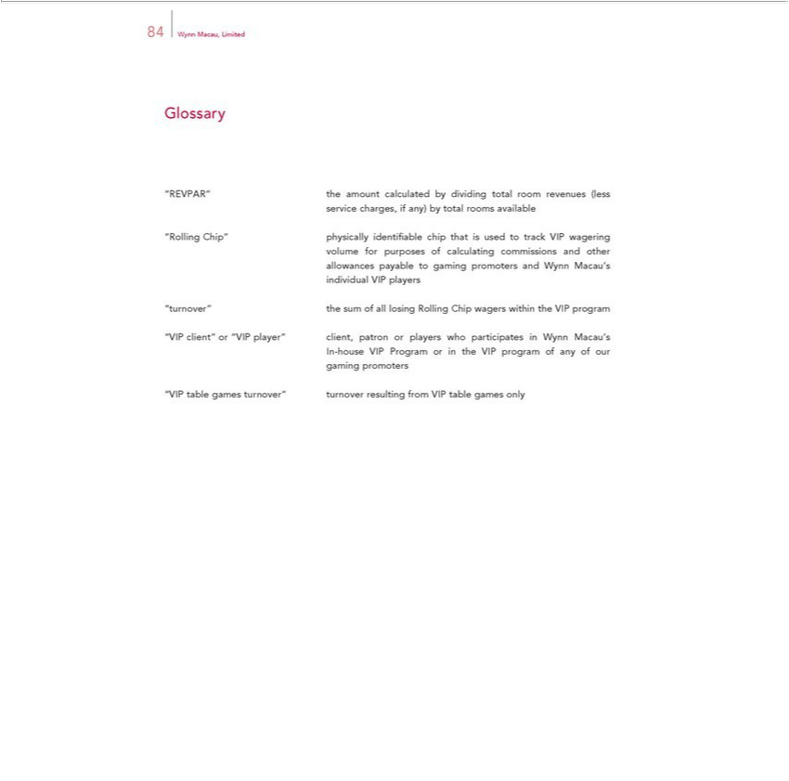

Glossary84Wynn Macau, Limited
service“REVPAR”charges,the amountifany) bycalculatedtotalroomsbydividingavailabletotal room revenues (less
volume“RollingforChip”purposesphysicallyofcalculatingidentifiablecommissionschipthat isandusedotherto track VIP wagering
individualallowancesVIPpayableplayersto gaming promoters and Wynn Macau’s
^{“VIP}turnover” the sum of all losing Rolling Chip wagers within the VIP program
In-houseclient”VIPorProgram“VIPplayer”orintheclient,VIP patronprogramor ofplayersanyofwhoourparticipates in Wynn Macau’s
gaming promoters
“VIP table games turnover” turnover resulting from VIP table games only

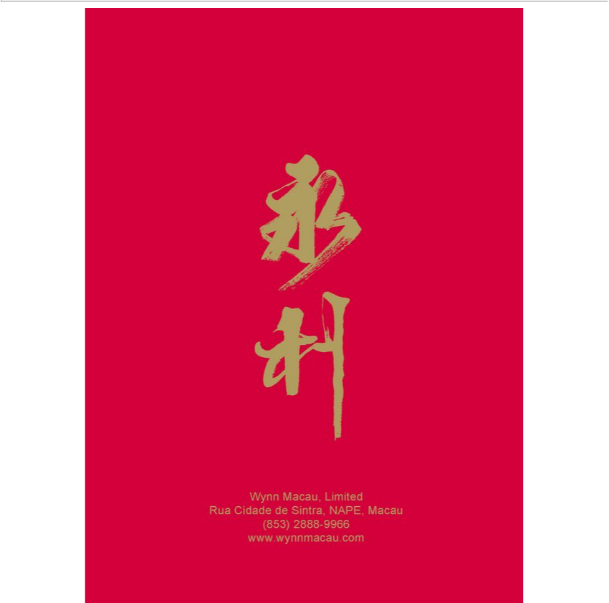

Wynn Macau, Limited
Rua Cidade de Sintra, NAPE, Macau (853) 2888-9966 www.wynnmacau.com

