SEC Form 3
FORM 3 | UNITED STATES SECURITIES AND EXCHANGE COMMISSION
 | Washington, D.C. 20549
 | Washington, D.C. 20549 |  | OMB APPROVAL
 | INITIAL STATEMENT OF BENEFICIAL OWNERSHIP OF
 | INITIAL STATEMENT OF BENEFICIAL OWNERSHIP OF |  | OMB Number: | 3235-0104
 | SECURITIES |  | Estimated average burden
 | SECURITIES |  | hours per response: | 0.5

Filed pursuant to Section 16(a) of the Securities Exchange Act of 1934
or Section 30(h) of the Investment Company Act of 1940
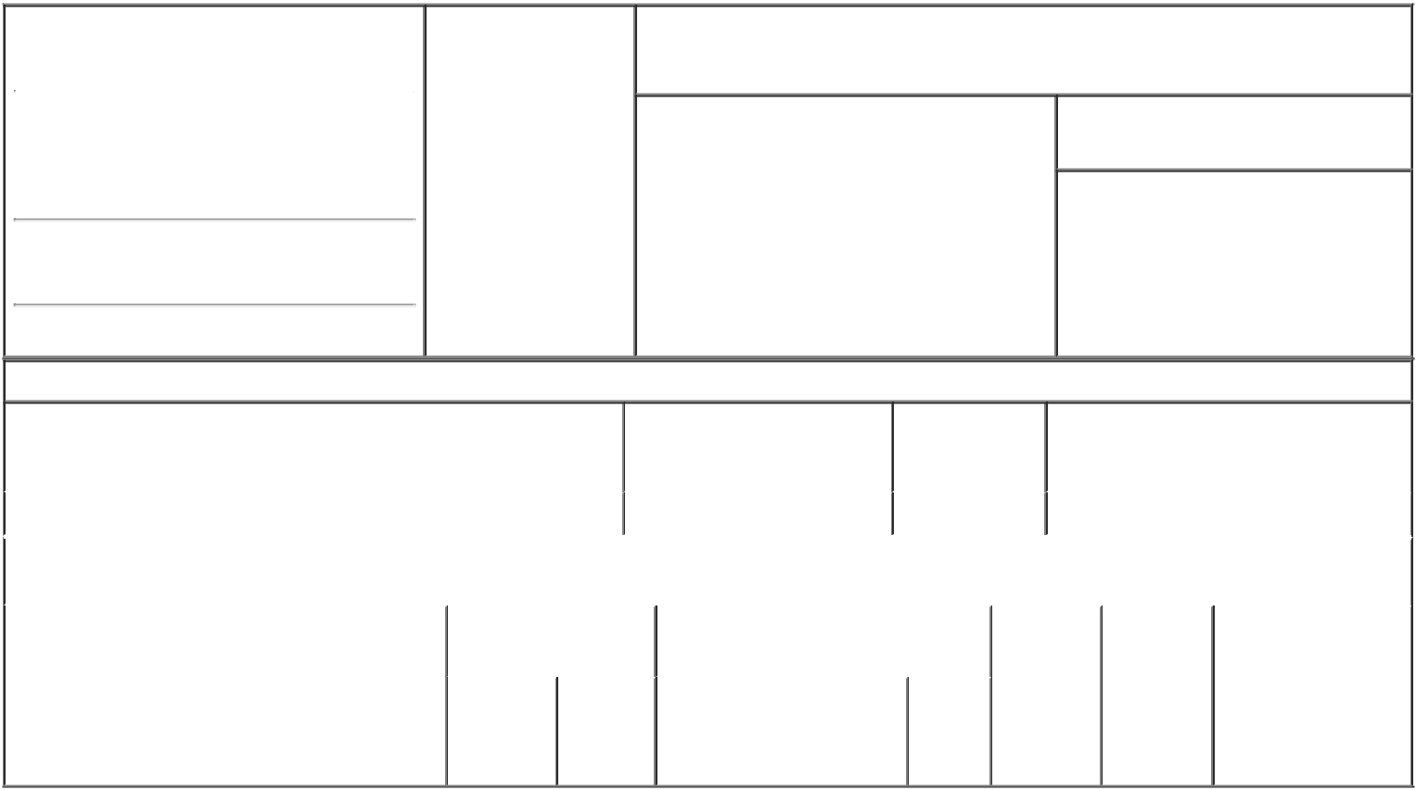

1. Name and Address of Reporting Person* |  |  |  | 2. Date of Event
 |  | JOHNSON JAY L |  | Requiring Statement
 |  |  |  | (Month/Day/Year)
 |  |  |  | 08/22/2016

3. Issuer Name and Ticker or Trading Symbol

WYNN RESORTS LTD [ WYNN ]

(Last) (First) (Middle)

C/O WYNN RESORTS, LIMITED

3131 LAS VEGAS BOULEVARD SOUTH

(Street)
LAS VEGAS NV | 89109

- Relationship of Reporting Person(s) to Issuer (Check all applicable)
X Director 10% Owner

Officer (give title Other (specify
below) below)

- If Amendment, Date of Original Filed (Month/Day/Year)

- Individual or Joint/Group Filing (Check Applicable Line)

- Form filed by One Reporting Person

Form filed by More than One Reporting Person

(City) (State) (Zip)

Table I - Non-Derivative Securities Beneficially Owned

1. Title of Security (Instr. 4) | 2. Amount of Securities | 3. Ownership | 4. Nature of Indirect Beneficial Ownership
 | Beneficially Owned (Instr. 4) | Form: Direct (D) | (Instr. 5)
 |  | or Indirect (I)
 |  | (Instr. 5)

 | No Securities Owned |  |  |  | 0 | D
 |  |  | Table II - Derivative Securities Beneficially Owned
 |  | (e.g., puts, calls, warrants, options, convertible securities)
 | 1. Title of Derivative Security (Instr. 4) |  | 2. Date Exercisable and |  | 3. Title and Amount of Securities |  | 4. | 5. | 6. Nature of Indirect
 |  |  | Expiration Date |  | Underlying Derivative Security (Instr. 4) |  | Conversion | Ownership | Beneficial Ownership
 |  |  | (Month/Day/Year) |  |  |  | or Exercise | Form: | (Instr. 5)
 |  |  |  |  |  |  | Price of | Direct (D)
 |  |  |  |  |  | Amount | Price of | Direct (D)
 |  |  |  |  |  | Amount | Derivative | or Indirect
 |  |  |  |  |  | or | Security | (I) (Instr. 5)
 |  |  |  |  |  | Number
 |  |  | Date | Expiration |  | of
 |  |  | Exercisable | Date | Title | Shares

Explanation of Responses:

Remarks:

Exhibit List: Exhibit 24 - Power of Attorney
/s/ Kimmarie Sinatra, attorney- _{08/23/2016}
in- fact for Jay L. Johnson

** Signature of Reporting Person Date

Reminder: Report on a separate line for each class of securities beneficially owned directly or indirectly.

* If the form is filed by more than one reporting person, see Instruction 5 (b)(v).

- Intentional misstatements or omissions of facts constitute Federal Criminal Violations See 18 U.S.C. 1001 and 15 U.S.C. 78ff(a). Note: File three copies of this Form, one of which must be manually signed. If space is insufficient, see Instruction 6 for procedure.
Persons who respond to the collection of information contained in this form are not required to respond unless the form displays a currently valid OMB Number.



