Table of Contents

UNITED STATES

SECURITIES AND EXCHANGE COMMISSION
Washington, D.C. 20549

SCHEDULE 14A

Proxy Statement Pursuant to Section 14(a) of the

Securities Exchange Act of 1934

Filed by the Registrant ☒ Filed by a Party other than the Registrant ☐

Check the appropriate box:

- Preliminary Proxy Statement

- Confidential, For Use of the Commission Only (as permitted by Rule 14a-6(e)(2))

☒Definitive Proxy Statement

- Definitive Additional Materials

- Soliciting Material Pursuant to § 240.14a-12

WYNN RESORTS, LIMITED

(Name of Registrant as Specified in Its Charter)

(Name of Person(s) Filing Proxy Statement, if Other Than the Registrant)

Payment of Filing Fee (Check the appropriate box):

- No fee required.

- Fee computed on table below per Exchange Act Rules 14a-6(i)(1) and 0-11.

  - Title of each class of securities to which transaction applies:

  - Aggregate number of securities to which transaction applies:

  - Per unit price or other underlying value of transaction computed pursuant to Exchange Act Rule 0-11 (set forth the amount on which the filing fee is calculated and state how it was determined):

  - Proposed maximum aggregate value of transaction:

  - Total fee paid:

- Fee paid previously with preliminary materials.

- Check box if any part of the fee is offset as provided by Exchange Act Rule 0-11(a)(2) and identify the filing for which the offsetting fee was paid previously. Identify the previous filing by registration statement number, or the Form or Schedule and the date of its filing.

  - Amount previously paid:

  - Form, Schedule or Registration Statement No.:

  - Filing Party:

  - Date Filed:

Table of Contents
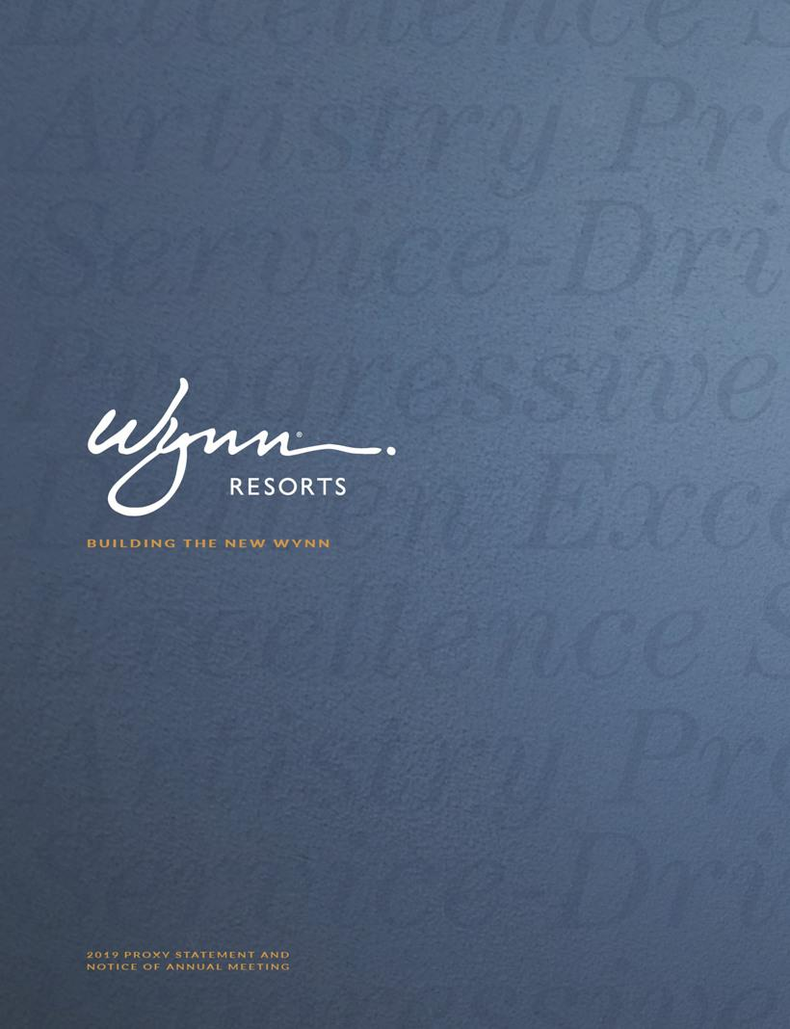

Table of Contents


Table of Contents

DEAR FELLOW SHAREHOLDERS,

I joined the Company as Vice Chairman in August 2018, and was elected Chairman of the refreshed Board in November. Like most of you, I watched many of the adverse developments which began to come to light in early 2018 from the outside.

In my forty-year career both in and out of gaming, I have never seen a company respond so quickly and decisively to adversity as this one. I joined a great Company in the process of transforming itself from a founder-led organization to a global enterprise, overseen by a refreshed, capable, independent and accountable Board of Directors. Despite the challenges we faced on numerous fronts, last year was a successful year for Wynn Resorts financially and, more importantly, culturally. I am confident we have found our way, and excited about the future of Wynn Resorts.

When I walked through the doors of Wynn Las Vegas that first day, I met our CEO Matt Maddox for the first time. I make that point to convey to you that there is no long-standing relationship between Matt and myself, or among any other board members. We are fully independent directors, without any personal connection to any Company executives which might impair our ability to hold management accountable. But I must tell you, I was impressed with what Matt, the refreshed Board and the remade executive team had done to address the cultural and governance challenges with which they were unexpectedly confronted.

Of the many goals for the “new” Wynn Resorts, two loom large:

- Achieve stability. A critical step in achieving stability was to rebuild our relationship with regulators, beginning with fully supporting their investigations of the Company. I believe that complete transparency and cooperation are essential to creating a relationship of trust with regulators. We are now on the road to rebuilding that trust.

- Listen. Listen to our employees. Listen to our regulators. Listen, extensively, to our shareholders. The Company began engaging with numerous shareholders immediately after the January news reports were published. We did not stop after the Annual Meeting concluded or after the Board had been fully refreshed or even as the calendar year came to a close. We heard your messages on executive compensation, on corporate governance, on board diversity and refreshment, and on sustainability. Then we took action. As a Board we take seriously our accountability to our fellow shareholders. Throughout this Proxy Statement, you will find steps we have taken in response to your input.

Although the Company has made tremendous progress, our mission is not completed. We will continue to listen, and we will continue to make headway on numerous fronts, including the issues our shareholders tell us are important to them.

One of our regulators recently praised us as “innovators” and spoke of his desire for Wynn Resorts to “build, grow and prosper.” I share that same desire, as I know do you. With a refreshed Board, engaged shareholders and a talented, experienced and focused management team, we are entering a new phase for Wynn Resorts even as we continue to draw on a legendary legacy of creativity and innovation. With your support, I am confident that Wynn Resorts will be an even greater company to work for, to partner with, and to invest in.

Sincerely,
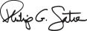

Philip G. Satre

Non-executive Chairman of the Board

Table of Contents
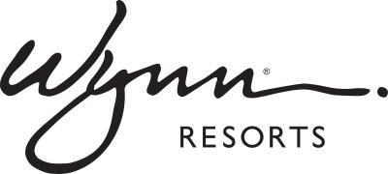

Table of Contents

Notice of annual meeting

B U I L D I N G T H E N E W W Y N N

PURPOSE OF THE MEETING

THE ANNUAL MEETING WILL BE HELD FOR THE FOLLOWING PURPOSES:

- To elect three Class II directors to serve until the 2022 Annual Meeting of Shareholders;

- To ratify the appointment of Ernst & Young LLP as our independent registered public accounting firm for the fiscal year ending December 31, 2019;

- To approve, on a non-binding advisory basis, the compensation of our named executive officers as described in the Proxy Statement;

- To consider and vote on the shareholder proposal requesting a political contributions report, if properly presented at the Annual Meeting; and

- To consider and transact such other business as may properly come before the Annual Meeting, or at any adjournments or postponements thereof.

The foregoing items of business are more fully described in the Proxy Statement accompanying this Notice. Only the Company’s shareholders of record at the close of business on March 11, 2019, the record date fixed by the Board of Directors, are entitled to notice of, and to vote at, the Annual Meeting, and at any adjournments or postponements thereof. Only such shareholders, their proxy holders, and our invited guests may attend the Annual Meeting.

NOTICE REGARDING AVAILABILITY OF PROXY MATERIALS

This Proxy Statement and our Annual Report for the fiscal year ended December 31, 2018, are available at http://www.wynnresorts.com on the Company Information page under the “Annual Meeting” heading. On or about March 27, 2019, we mailed to our shareholders (other than those who previously requested electronic or paper delivery) a notice containing instructions on how to access our Annual Meeting materials (including the Proxy Statement and our Annual Report for the fiscal year ended December 31, 2018) and how to vote.

YOUR VOTE IS IMPORTANT

Whether or not you plan to attend the Annual Meeting, you are encouraged to read the attached Proxy Statement and then cast your vote as promptly as possible by following the instructions on the proxy card you receive. Even if you have given your proxy, you may still vote in person if you attend the Annual Meeting. If your shares are held through an intermediary, such as a bank, broker or other nominee, unless you provide voting instructions to such person, your shares will not be voted on most matters being considered at the Annual Meeting and, therefore, it is especially important you return the proxy card with your vote.

By Order of the Board of Directors

Ellen F. Whittemore

Secretary

Las Vegas, Nevada
March 27, 2019

DATE AND TIME | PLACE
May 7, 2019 | Encore Theater at Wynn Las Vegas,
9:00 am PT | 3131 Las Vegas Boulevard South, Las Vegas, Nevada

This Proxy Statement and our 2018 Annual Report on Form 10-K are available at http://www.wynnresorts.com on the Company Information page under the “Annual Meeting” heading.

Table of Contents

Table of contents

B U I L D I N G T H E N E W W Y N N

OUR BOARD AND CORPORATE GOVERNANCE EXECUTIVE COMPENSATION TABLES

Board Composition and Refreshment |  |  |  |  |  |  |  |  |  |  |  |  |  |  |  |  |  |  |  |  |  |  | 1
Director Skills, Experience and Tenure |  |  |  |  |  |  |  |  |  |  |  |  |  |  |  |  |  |  |  |  |  |  | 2
Director Biographies |  |  |  |  |  |  |  |  |  |  |  |  |  |  |  |  |  |  |  |  |  |  | 3
Board Committees |  |  |  |  |  |  |  |  |  |  |  |  |  |  |  |  |  |  |  |  |  |  | 7
Why Our Board Governance is Effective |  |  |  |  |  |  |  |  |  |  |  |  |  |  |  |  |  |  |  |  |  |  | 11
Board Role in Risk Oversight |  |  |  |  |  |  |  |  |  |  |  |  |  |  |  |  |  |  |  |  |  |  | 12
Board Meetings/Annual Meeting |  |  |  |  |  |  |  |  |  |  |  |  |  |  |  |  |  |  |  |  |  |  | 12
Board Communication and Engagement |  |  |  |  |  |  |  |  |  |  |  |  |  |  |  |  |  |  |  |  |  |  | 12
Shareholder Engagement in 2018 |  |  |  |  |  |  |  |  |  |  |  |  |  |  |  |  |  |  |  |  |  |  | 13
Board Compensation |  |  |  |  |  |  |  |  |  |  |  |  |  |  |  |  |  |  |  |  |  |  | 13
Non-Employee Director Compensation Table |  |  |  |  |  |  |  |  |  |  |  |  |  |  |  |  |  |  |  |  |  |  | 14
OUR PEOPLE AND OUR STEWARDSHIP
Introduction |  |  |  |  |  |  |  |  |  |  |  |  |  |  |  |  |  |  |  |  |  |  | 17
Our People |  |  |  |  |  |  |  |  |  |  |  |  |  |  |  |  |  |  |  |  |  |  | 19
Our Communities |  |  |  |  |  |  |  |  |  |  |  |  |  |  |  |  |  |  |  |  |  |  | 21
Our Planet |  |  |  |  |  |  |  |  |  |  |  |  |  |  |  |  |  |  |  |  |  |  | 22
EXECUTIVE OFFICERS |  |  |  |  |  |  |  |  |  |  |  |  |  |  |  |  |  |  |  |  |  |  | 24
COMPENSATION DISCUSSION AND ANALYSIS
How We Solicited and Responded to Shareholder Feedback |  |  |  |  |  |  |  |  |  |  |  |  |  |  |  |  |  |  |  |  |  |  | 27
How We Approach Executive Compensation |  |  |  |  |  |  |  |  |  |  |  |  |  |  |  |  |  |  |  |  |  |  | 29
How the Company Has Performed |  |  |  |  |  |  |  |  |  |  |  |  |  |  |  |  |  |  |  |  |  |  | 30
How We Designed Incentives in 2018 |  |  |  |  |  |  |  |  |  |  |  |  |  |  |  |  |  |  |  |  |  |  | 31
Why You Should Vote for the 2019 Say on Pay |  |  |  |  |  |  |  |  |  |  |  |  |  |  |  |  |  |  |  |  |  |  | 36
Other Aspects of Our Executive Compensation |  |  |  |  |  |  |  |  |  |  |  |  |  |  |  |  |  |  |  |  |  |  | 37
Compensation Committee Report |  |  |  |  |  |  |  |  |  |  |  |  |  |  |  |  |  |  |  |  |  |  | 37

Summary Compensation Table |  |  |  |  |  |  |  |  |  |  |  |  |  |  |  |  |  |  |  |  |  |  |  |  | 39
Discussion of Summary Compensation Table |  |  |  |  |  |  |  |  |  |  |  |  |  |  |  |  |  |  |  |  |  |  |  |  | 40
2018 Grants of Plan-based Awards Table |  |  |  |  |  |  |  |  |  |  |  |  |  |  |  |  |  |  |  |  |  |  |  |  | 40
Outstanding Equity Awards at Fiscal Year-end |  |  |  |  |  |  |  |  |  |  |  |  |  |  |  |  |  |  |  |  |  |  |  |  | 41
Option Exercises and Stock Vested in 2018 |  |  |  |  |  |  |  |  |  |  |  |  |  |  |  |  |  |  |  |  |  |  |  |  | 41
Potential Payments Upon Termination or Change in Control |  |  |  |  |  |  |  |  |  |  |  |  |  |  |  |  |  |  |  |  |  |  |  |  | 42
CERTAIN RELATIONSHIPS AND TRANSACTIONS |  |  |  |  |  |  |  |  |  |  |  |  |  |  |  |  |  |  |  |  |  |  |  |  | 45
PAY RATIO DISCLOSURE |  |  |  |  |  |  |  |  |  |  |  |  |  |  |  |  |  |  |  |  |  |  |  |  | 47
SECURITY OWNERSHIP |  |  |  |  |  |  |  |  |  |  |  |  |  |  |  |  |  |  |  |  |  |  |  |  | 48
Certain Beneficial Ownership and Management |  |  |  |  |  |  |  |  |  |  |  |  |  |  |  |  |  |  |  |  |  |  |  |  | 48
Section 16(a) Beneficial Ownership Reporting Compliance |  |  |  |  |  |  |  |  |  |  |  |  |  |  |  |  |  |  |  |  |  |  |  |  | 49
ITEMS TO BE VOTED ON
Proposal 1: Election of Directors |  |  |  |  |  |  |  |  |  |  |  |  |  |  |  |  |  |  |  |  |  |  |  |  | 51
Proposal 2: Ratification of Appointment of Independent Auditors |  |  |  |  |  |  |  |  |  |  |  |  |  |  |  |  |  |  |  |  |  |  |  |  | 51
Proposal 3: Advisory Vote to Approve the |  |  |  |  |  |  |  |  |  |  |  |  |  |  |  |  |  |  |  |  |  |  |  |  | 53
Compensation of Named Executive Officers |  |  |  |  |  |  |  |  |  |  |  |  |  |  |  |  |  |  |  |  |  |  |  |  | 53
Proposal 4: Shareholder Proposal Requesting a |  |  |  |  |  |  |  |  |  |  |  |  |  |  |  |  |  |  |  |  |  |  |  |  | 54
Political Contributions Report |  |  |  |  |  |  |  |  |  |  |  |  |  |  |  |  |  |  |  |  |  |  |  |  | 54
GENERAL INFORMATION |  |  |  |  |  |  |  |  |  |  |  |  |  |  |  |  |  |  |  |  |  |  |  |  | 57
Our 2019 Annual Meeting of Shareholders |  |  |  |  |  |  |  |  |  |  |  |  |  |  |  |  |  |  |  |  |  |  |  |  | 57
Voting and Solicitation |  |  |  |  |  |  |  |  |  |  |  |  |  |  |  |  |  |  |  |  |  |  |  |  | 57
How You Can Vote |  |  |  |  |  |  |  |  |  |  |  |  |  |  |  |  |  |  |  |  |  |  |  |  | 58
Revocability of Proxies |  |  |  |  |  |  |  |  |  |  |  |  |  |  |  |  |  |  |  |  |  |  |  |  | 58
Attending the Annual Meeting |  |  |  |  |  |  |  |  |  |  |  |  |  |  |  |  |  |  |  |  |  |  |  |  | 58
Proxy Procedure and Expenses of Solicitation |  |  |  |  |  |  |  |  |  |  |  |  |  |  |  |  |  |  |  |  |  |  |  |  | 59
Shareholder Proposals |  |  |  |  |  |  |  |  |  |  |  |  |  |  |  |  |  |  |  |  |  |  |  |  | 59
Annual Report |  |  |  |  |  |  |  |  |  |  |  |  |  |  |  |  |  |  |  |  |  |  |  |  | 60
Householding |  |  |  |  |  |  |  |  |  |  |  |  |  |  |  |  |  |  |  |  |  |  |  |  | 60
Other Business |  |  |  |  |  |  |  |  |  |  |  |  |  |  |  |  |  |  |  |  |  |  |  |  | 60

Table of Contents


Table of Contents


Table of Contents
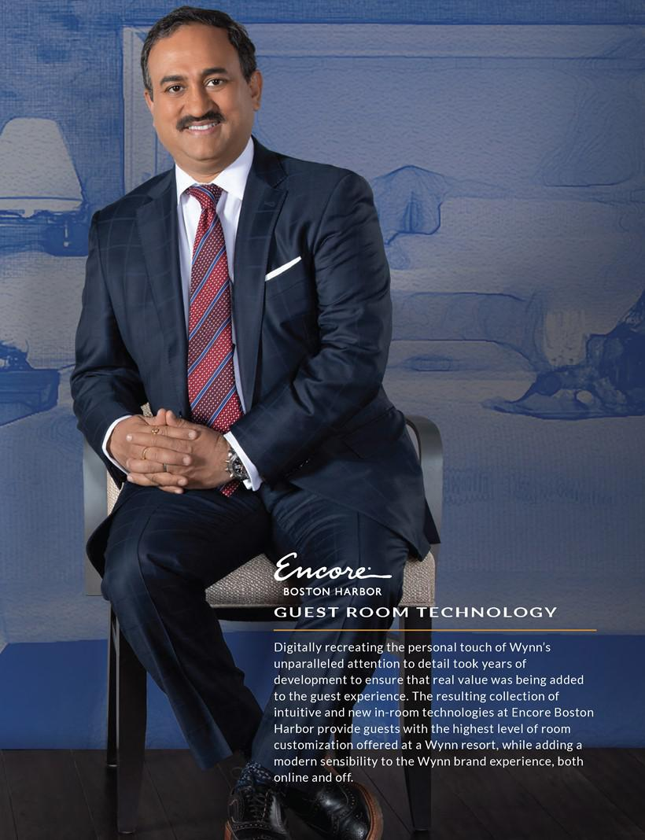

Table of Contents
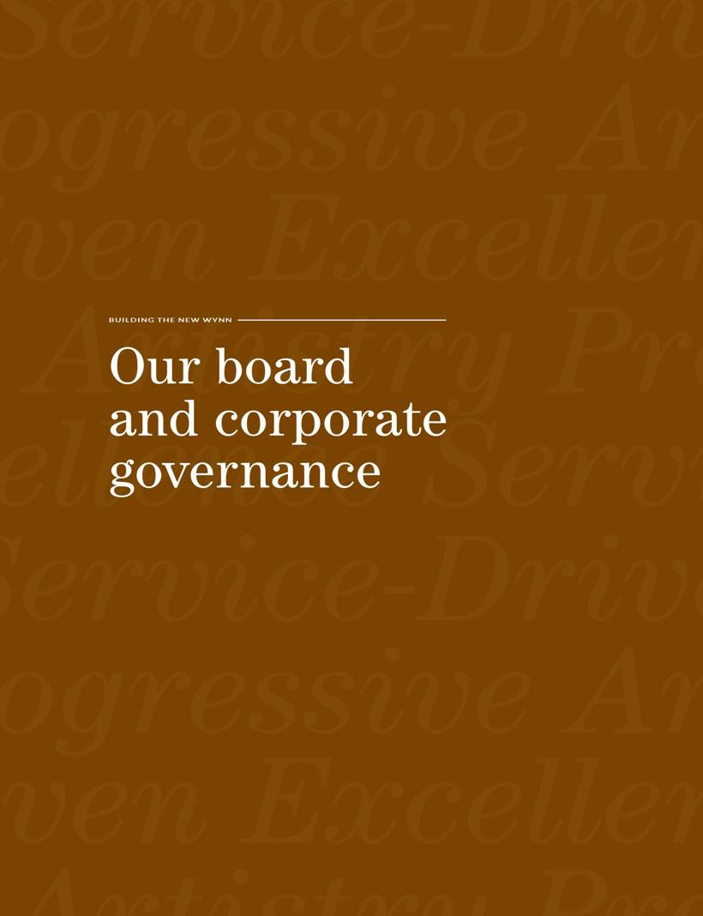

Table of Contents

In this section, Wynn Resorts, Limited (the “Company,” “Wynn Resorts,” or “we”) will tell you about:

– Board Composition and Refreshment |  | – Board Role in Risk Oversight
– Director Skills, Experience and Tenure |  | – | Board Meetings/Annual Meeting
– | Director Biographies | – Board Communication and Engagement
– | Board Committees | – Shareholder Engagement in 2018
– | Board Governance | – | Board Compensation

BOARD COMPOSITION AND REFRESHMENT

Beginning in February 2018, as part of our commitment to the refreshment and strengthening of our Board of Directors (“Board”), our Nominating and Corporate Governance Committee, assisted by an independent search firm, began a process of refreshing the Board with a broad spectrum of experience and expertise that will promote the presentation and consideration of different points of view, meet the Company’s evolving needs (particularly by adding Board expertise in corporate governance, communications and public affairs, technology, strategic positioning, and hospitality and branding), and strengthen our diversity.

That process has now resulted in substantial changes to the diversity, experience, skill mix and tenure of our Board. Six of the nine current directors have joined the Board since the Nominating and Corporate Governance Committee began its renewal initiative. The average tenure of directors as of the 2019 Annual Meeting is under two years, with no director having served longer than four years. Four of the eight independent directors (including the Chairpersons of the Audit and Compensation Committees) are women.

The Nominating and Corporate Governance Committee continues to investigate other potential candidates as part of its ongoing commitment to enhance the diversity, experience, and strength of the entire Board.
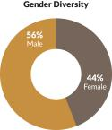
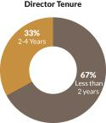

2019 PROXY STATEMENT | 1

Table of Contents

Our board and corporate governance

THE BOARD’S PATH TO REFRESHMENT
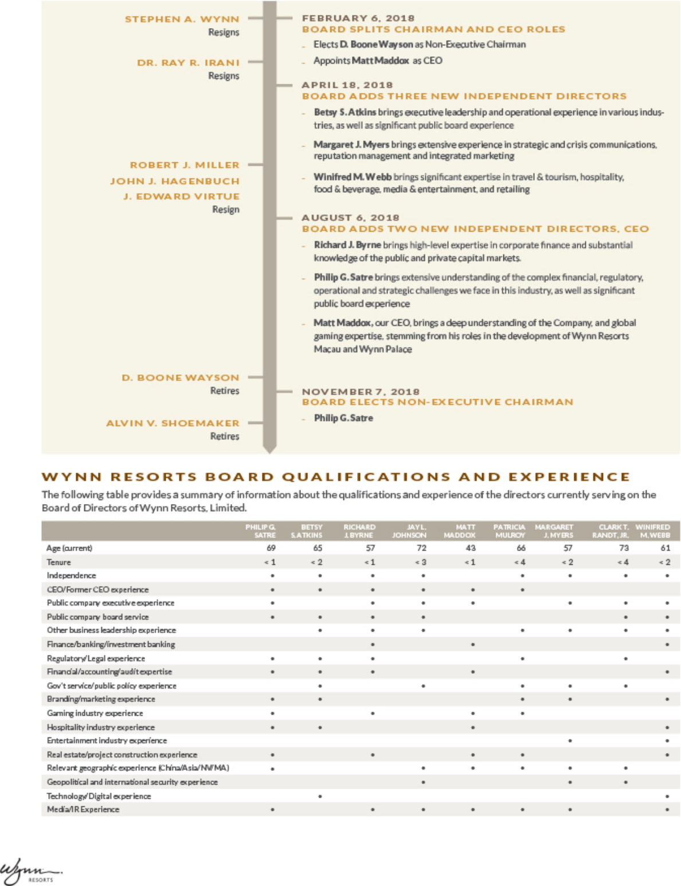

- |

Table of Contents

DIRECTOR BIOGRAPHIES

Biographical and other information for our directors is provided below.

Betsy S. Atkins

Chief Executive Officer and Founder, Baja Corporation

Ms. Atkins has been the Chief Executive Officer of Baja Corporation, an independent venture capital firm focused on technology, renewable energy and life sciences, since 1994.

Ms. Atkins currently serves on the Boards of Schneider Electric (since April 2011), SL Green Realty (since April 2015), as well as Volvo Car AB and several private companies.


PREVIOUS EXPERIENCE

– 2016 to October 2018: Board of Directors of Cognizant Technology Solutions

– 2013 to 2016: Chair, APX Labs (a Google Glass enterprise software company)

– February 2009 to August 2009: Chair and Chief Executive Officer, Clear Standards (until acquired by SAP)

– 1991 to 1993: Chair and Chief Executive Officer, NCI

– 1989 to 1999: Co-founder, Director, Executive Vice President Sales, Marketing, International Operations, Ascend Communications (until acquired by Lucent Technologies)

– Previously served on the boards of HD Supply Holdings, Polycom, SunPower, Chico’s FAS, Ciber, Darden Restaurants

– Formerly Chairman, Executive Advisory Board, SAP, AG, an advisor to British Telecom and presidential-appointee to the Pension Benefit Guaranty Corporation advisory committee

EDUCATION

Ms. Atkins graduated with a B.A. from the University of Massachusetts.

EXPERTISE

Ms. Atkins brings to our Board executive leadership and operational experience in various technology, food & beverage and retail industries, as well as significant public board experience and executive compensation, sustainability and enterprise risk management expertise.

Director Since | April 2018
Term Expires | 2021 Annual Meeting
Age | 65
Board | Compensation, Chair
Committees | Nominating and Corporate
 | Governance

Richard J. Byrne

President, Benefit Street Partners

Mr. Byrne has been the President of Benefit Street Partners since 2013. He also serves as Chairman and Chief Executive Officer of Development Corporation of America and Chairman and Chief Executive Officer of Benefit Street Partners Realty Trust, Inc., since 2016. Mr. Byrne currently serves on the Boards of MFA Financial, Inc. (since 2014) and New York Road Runners (since 2009). He is also the Founder and Chief Executive Officer of Kasai Elite Grappling Championships.


PREVIOUS EXPERIENCE

– 1999 to 2013: Chief Executive Officer, Deutsche Bank Securities, Inc. (2008-2013). He was also Global Co-Head of Capital Markets at Deutsche Bank (2006-2013) as well as a member of the Global Banking Executive Committee and the Global Markets Executive Committee (2001-2010)

– 1985 to 1999: Global Co-Head of the Leveraged Finance Group and Global Head of Credit Research at Merrill Lynch & Co.

EDUCATION

Mr. Byrne graduated with a B.A. from Binghamton University and a Masters of Management from the Kellogg School of Management at Northwestern University.

EXPERTISE

Mr. Byrne has extensive high-level experience in the investment banking and financial services industries, adding expertise in corporate finance and substantial knowledge of the public and private capital markets to our Board.

Director Since | August 2018
Term Expires | 2020 Annual Meeting
Age | 57
Board Committees | Audit
 | Compensation

2019 PROXY STATEMENT | 3

Table of Contents

Our board and corporate governance

Jay L. Johnson

Retired

Admiral Johnson retired as Chairman and Chief Executive Officer of General Dynamics Corporation, a publicly traded manufacturer of defense, aerospace, and other technology products, in December 2012. Admiral Johnson is a member of the Council on Foreign Relations and currently serves as a director of the U.S. Naval Academy Foundation and The Peregrine Fund.


PREVIOUS EXPERIENCE

– 2000 to 2008: various senior executive roles at Dominion Resources Inc., a publicly traded energy company, including as CEO of Dominion Virginia Power

– Prior to 2000: 32-year career in the U.S. Navy, serving as chief of naval operations and a member of the Joint Chiefs of Staff since 1996

EDUCATION

Admiral Johnson graduated with a B.S. from the United States Naval Academy.

EXPERTISE

Admiral Johnson’s experience as an executive and director of various public companies contributes to the Board’s ability to guide corporate strategy and oversee public company governance. Additionally, the Board benefits from Admiral Johnson’s distinguished 32-year military career, which provides valuable public policy and government relations experience as well as extensive leadership and strategic skills.

Director Since August 2016

Term Expires 2019 Annual Meeting

Age 72

Board Nominating and Corporate

Committees Governance, Chair

Matt Maddox

Chief Executive Officer and President, Wynn Resorts, Limited

Mr. Maddox has served as the Company’s President since November 2013 and its CEO since February 2018. He has been a member of the Board of Directors of Wynn Resorts, Limited since August 3, 2018. He was a non-executive Director of Wynn Macau, Limited from March 28, 2013, until he was re-designated as an Executive Director, upon his appointment as CEO of Wynn Macau, Limited, in February 2018. Mr. Maddox has served as the Company’s President since November 2013 and its CEO since February 2018. He has been a member of the Board of Directors of Wynn Resorts, Limited since August 3, 2018. He was a non-executive Director of Wynn Macau, Limited from March 28, 2013 until he was re-designated as an Executive Director, upon his appointment as CEO of Wynn Macau, Limited, in February 2018. Since joining Wynn Resorts in 2002, Mr. Maddox has served in various capacities at the Company, including Senior Vice President of Business Development and Chief Financial Officer of Wynn Resorts, Limited and Wynn Resorts (Macau), S.A.


PREVIOUS EXPERIENCE

– Previously, Corporate Finance, Caesars Entertainment, Inc. (formerly Park Place Entertainment, Inc.)

– Previously M&A banker, Bank of America Securities

EDUCATION

Mr. Maddox graduated with a B.B.A. in finance from Southern Methodist University.

EXPERTISE

Mr. Maddox contributes a deep understanding of the Company, global gaming expertise stemming from his roles in the development of Wynn Resorts (Macau), S.A. and Wynn Palace, and financial acumen developed being responsible for helping secure the financing to build Wynn Las Vegas and serving as the first Chief Financial Officer of Wynn Resorts (Macau), S.A.

Director Since | August 2018
Term Expires | 2021 Annual Meeting

Age 43

- |

Table of Contents

Patricia Mulroy

Non-Resident Senior Fellow for Climate Adaptation & Environmental Policy, Brookings Institution; Practitioner in Residence, Saltman Center for Conflict Resolution, William S. Boyd School of Law, University of Nevada, Las Vegas

Ms. Mulroy is currently a Non-Resident Senior Fellow for Climate Adaptation and Environmental Policy for the Brookings Institution and a Practitioner in Residence at the Saltman Center for Conflict Resolution at the William S. Boyd School of Law at University of Nevada, Las Vegas. Ms. Mulroy operates a consulting firm representing both corporate and government clients in water matters. Ms. Mulroy recently completed her term as a member of the Global Agenda Council on Water of the World Economic Forum.


PREVIOUS EXPERIENCE

– July 2014 through October 2015: served on the Nevada Gaming Commission

– 1995 to 2014: Nevada’s representative on Colorado River Basin issues, serving as the lead negotiator from 2007 to 2014

– 1993 to 2014: General Manager of the Southern Nevada Water Authority

– 1989 to 2014: General Manager of the Las Vegas Valley Water District

EDUCATION

Ms. Mulroy graduated with a B.A. and M.A. from the University of Nevada, Las Vegas.

EXPERTISE

Ms. Mulroy brings more than 30 years of government experience to the Board, serving in numerous leadership roles focusing on Nevada’s public infrastructure. Additionally, Ms. Mulroy’s experience on the Nevada Gaming Commission brings experience and insight into state regulatory and public policy issues impacting the Company’s operations.

Director since October 2015

Term Expires 2020 Annual Meeting

Age 66

Board Audit
Committees
Nominating and Corporate

Governance

Margaret J. Myers

Executive Vice President, Worldwide Corporate Communications and Public Affairs, Warner Bros. Entertainment

Ms. Myers has been Executive Vice President, Worldwide Corporate Communications and Public Affairs for Warner Bros. Entertainment, a broad-based entertainment company and division of TimeWarner, Inc., since September 2014.


PREVIOUS EXPERIENCE

– September 2010 to June 2014: Managing Director, Strategic Communications and Public Affairs Practice, Glover Park Group

– 1994 to 2010: Political analyst, commentator and writer

– January 1993 to December 1994: White House Press Secretary

– Ms. Myers is the author of the 2008 New York Times best-selling book, “Why Women Should Rule the World”

EDUCATION

Ms. Myers graduated with a B.S. from Santa Clara University.

EXPERTISE

Ms. Myers has extensive experience providing counsel on strategic and crisis communications, reputation management and integrated marketing, drawing on her years in politics and media. She brings to our Board expertise in global corporate communications strategies and activities, including media relations, public positioning, executive communications, corporate responsibility and philanthropy.

Director Since April 2018

Term Expires 2019 Annual Meeting

Age 57

Board Compensation
Committees
Nominating and Corporate

Governance

2019 PROXY STATEMENT | 5

Table of Contents

Our board and corporate governance

Clark T. Randt Jr.

President, Randt & Co. LLC

Ambassador Randt is currently President of Randt & Co. LLC, which advises firms with interests in China. Ambassador Randt has been a Director of Valmont Industries since February 2009, a Director of United Parcel Service since August 2010, and a Director of Qualcomm Inc. since October 2013. Ambassador Randt is also a member of the Council on Foreign Relations. Ambassador Randt is a member of the New York State Bar Association, was admitted to the Hong Kong Bar Association, has over 25 years of experience in cross-border corporate and finance transactions.


PREVIOUS EXPERIENCE

– 2001 to 2009: United States Ambassador to the People’s Republic of China

– Previously partner at Shearman & Sterling, head of China practice

EDUCATION

Ambassador Randt graduated with a B.A. from Yale University, and has a J.D. from the University of Michigan Law School.

EXPERTISE

Ambassador Randt’s service as the U.S. Ambassador to the People’s Republic of China and his ongoing expertise regarding China give him a unique perspective on international business and foreign policy issues. Additionally, his fluency in Mandarin Chinese and extensive China experience make him well-suited to meaningfully contribute to the Board’s oversight of the Company’s operations in Macau.

Director Since October 2015

Term Expires 2020 Annual Meeting

Age 73

Board Nominating and Corporate

Committees Governance

Philip G. Satre

Retired

Mr. Satre currently serves on the Board of fashion retailer, Nordstrom, Inc. (2006 to Present, Chairman from 2016 – 2018).


PREVIOUS EXPERIENCE

– 1980 to 2005: Various roles at Harrah’s Entertainment, Inc. with increasing responsibility, including Vice President, General Counsel and Secretary; President and Chief Executive Officer of its gaming division; culminating in service as CEO and Chairman

– Previously served on the boards of International Game Technology PLC, NV Energy, Tabcorp Holdings Ltd. (Australia) and Rite Aid Corporation

– Various roles in non-profits, including as a Trustee of The National World War II Museum, a Trustee of the National Automobile Museum – The Harrah Collection in Reno, NV, and an Emeritus Member of the Stanford University Board of Trustees

EDUCATION

Mr. Satre graduated with a B.A. from Stanford University and a J.D. from the University of California, Davis.

EXPERTISE

Mr. Satre’s prior experience as an executive in our industry brings the Board extensive understanding of the complex financial, regulatory, operational and strategic challenges we face, while his prior experience as a director across a diversity of industries adds additional expertise in matters of good corporate governance and effective Board oversight.

Director since August 2018


Term Expires 2021 Annual Meeting

Age 69

Board Nominating and Corporate

Committees Governance

- |

Table of Contents

Winifred M. Webb

Chief Executive Officer, Kestrel Corporate Advisors

Ms. Webb has been Chief Executive Officer of Kestrel Corporate Advisors, an advisory services firm, counseling organizations on strategic business issues, including growth initiatives, digital marketing, board governance and investor relations, since 2013. Ms. Webb currently serves on the Board of Trustees of American Homes 4 Rent (since January 2019) and the Board of Directors of ABM Industries (since 2014). She also serves as Co-Chair of non-profit WomenCorporateDirectors, Los Angeles/Orange County Chapter.


PREVIOUS EXPERIENCE

– 2010 to 2013: Managing Director, Tennenbaum Capital Partners, now part of BlackRock

– 2008 to 2010: Member of the Corporate Executive team and senior advisor, Ticketmaster

– 1988 to 2008: Various senior positions, including as Senior Vice President of Investor Relations and Shareholder Services, and governance outreach, The Walt Disney Company; Executive Director, The Walt Disney Company Foundation

– Previously held various investment banking positions

– Prior service on the boards of TiVo, Jack in the Box, 9 Spokes and nonprofit PetSmart Charities

EDUCATION

Ms. Webb graduated with a B.A. (with honors) from Smith College and received her M.B.A. from Harvard University.

EXPERTISE

Ms. Webb brings to our Board significant industry expertise in travel & tourism, hospitality, food & beverage, media & entertainment, retailing, and facilities services. Ms. Webb’s experience developing award-winning investor relations, strategic communications, brand-building programs and extensive, public company board service contribute to the Board’s ability to provide creative solutions in strategic planning and board governance.

Director Since April 2018

Term Expires 2019 Annual Meeting

Age 61

Board Audit, Chair

Committees

BOARD COMMITTEES

The Board of Directors has three standing committees, each comprised solely of independent directors: the Audit Committee, the Compensation Committee, and the Nominating and Corporate Governance Committee. The written charters for these Committees are available on our website at http://www.wynnresorts.com under the heading “Corporate Governance” on the Company Information page.

 |  |  |  | NOMINATING
 | INDEPENDENT | AUDIT | COMPENSATION | AND CORPORATE
DIRECTOR | DIRECTOR | COMMITTEE | COMMITTEE | GOVERNANCE COMMITTEE
Betsy S. Atkins | • |  | C | •
Richard J. Byrne | • | F | •
Jay L. Johnson | • |  |  | C
Patricia Mulroy | • | • |  | •
Margaret J. Myers | • |  | • | •
Clark T. Randt, Jr. | • |  |  | •
Philip G. Satre | • |  |  | •
Winifred M. Webb | • | C,F
Committee Meetings in 2018 |  | 9 | 14 | 8
C Chairperson; F Financial Expert within the meaning of SEC regulations

AUDIT COMMITTEE

At each regular meeting, the Audit Committee meets in executive session with the Company’s independent auditors, General Counsel, Chief Audit Executive, Chief Financial Officer, and Chief Compliance Officer to discuss accounting principles, financial and accounting controls, the scope of the annual audit, internal controls, regulatory compliance, and other matters. The independent auditors have complete access to the Audit Committee without management present to discuss the results of their audits and their opinions on the adequacy of internal controls, quality of financial reporting, and other accounting and auditing matters.

2019 PROXY STATEMENT | 7

Table of Contents

Our board and corporate governance

Key Responsibilities

– appointing, retaining, overseeing, and approving the compensation of the independent auditors
– reviewing and discussing with independent auditors and management the Company’s earnings releases and quarterly and annual reports to be filed with the SEC

– reviewing the adequacy, effectiveness, scope, and results of the Company’s internal auditing procedures and practices
– overseeing the Company’s legal and regulatory compliance programs and its policies and procedures for monitoring compliance
– meeting periodically with management to review the Company’s major risk exposures and the steps management has taken to monitor and control such exposures

– reviewing and approving the Company’s decision to enter into certain swaps and other derivative transactions

COMPENSATION COMMITTEE

The Compensation Committee sets all elements of compensation for our named executive officers (“NEOs”) based upon consideration of our NEO’s contributions to the development and operating performance of the Company, and is primarily responsible for monitoring risks relating to the Company’s compensation policies and practices to determine whether they create risks that are reasonably likely to have a material adverse effect on the Company.

The Compensation Committee considers the recommendations of the CEO in establishing compensation for all NEOs, other than the CEO. The CEO is not present during the voting or deliberations regarding his compensation. In addition, the CEO performs annual reviews of all of our senior management and makes recommendations to the Compensation Committee concerning their compensation. The Compensation Committee reviews the recommendations and makes final decisions regarding compensation for members of our senior management.

The Compensation Committee has the authority to retain compensation consulting firms exclusively to assist it in the evaluation of executive officer and employee compensation and benefit programs. In 2018, the Compensation Committee retained Radford, a business unit of AON plc (“Radford”), a nationally recognized independent compensation consulting firm, to assist in performing its duties. Radford does not provide services to the Company other than the advice on director and executive compensation that it may provide the Compensation Committee when requested. In 2018, Radford provided the Compensation Committee with a peer group review and competitive compensation analysis, in connection with the Compensation Committee’s review of compensation levels of our NEOs. The Compensation Committee retains sole responsibility for engaging advisors and meets with advisors, as needed, in the Compensation Committee’s sole discretion. Each of the members of the Compensation Committee bring a wealth of experience from their public and private board experience and their respective executive roles, which enables the Committee to effectively oversee the design and practice of linking executive compensation to company performance.

Key Responsibilities

– reviewing the goals and objectives of the Company’s executive compensation plans, and, as appropriate, recommending that the Board adopt new plans or amend existing plans

– assessing the Company’s most recent advisory vote on executive compensation
– appointing advisors retained by the Committee and assessing any potential conflicts of interest, overseeing and approving the compensation of any advisors the Committee retains

– annually evaluating the performance of the CEO, overseeing the evaluation of performance of the other officers of the Company and its operating subsidiaries, and setting compensation for the CEO, other NEOs, and other members of senior management

– reviewing and approving equity awards and supervising administrative functions pursuant to the Company’s equity plans
– reviewing and approving compensation arrangements for officers and other key employees in accordance with policies adopted by the Committee from time to time

– reviewing and recommending to the full Board the type and amount of compensation for Board and Committee service by non-management members of the Board

– reviewing and discussing with management the Compensation Discussion and Analysis and related disclosures in the Company’s proxy statement

- |

Table of Contents

Compensation Committee Interlocks and Insider Participation

The members of the Compensation Committee are appointed by the Board each year. The members of the Compensation Committee that served in 2018 were Ms. Atkins (as of May 16, 2018), Mr. Byrne (as of November 6, 2018), Ms. Myers (as of May 16, 2018), Ms. Webb (from May 16, 2018 until December 31, 2018), Admiral Johnson (until May 16, 2018), Mr. Hagenbuch (until May 16, 2018), Mr. Shoemaker (until May 16, 2018), and Mr. Virtue (until May 16, 2018). No member of the Compensation Committee is, or was formerly, one of our officers or employees. No interlocking relationship exists between the Board or Compensation Committee and the board of directors or compensation committee of any other company, nor has any interlocking relationship existed in the past.

NOMINATING AND CORPORATE GOVERNANCE COMMITTEE

The Nominating and Corporate Governance Committee seeks to have the Board represent a diversity of backgrounds and experience and assesses potential nominees in light of the Board’s current size and composition.

The Nominating and Corporate Governance Committee believes that the minimum qualifications for serving as a director of the Company are that a nominee demonstrate, by significant accomplishment in his or her field, an ability to make a meaningful contribution to the Board’s oversight of the business and affairs of the Company and robust engagement in the strategic planning process, and have a reputation for honest and ethical conduct in both his or her professional and personal activities. The Nominating and Corporate Governance Committee may, from time to time, develop and recommend additional criteria for identifying and evaluating director candidates. In addition, the Nominating and Corporate Governance Committee examines a candidate’s other commitments, potential conflicts of interest, and independence from management and the Company.

The Nominating and Corporate Governance Committee and Board believe that differences of viewpoint, professional experience, individual characteristics, personal background, qualities, skills, qualifications, gender, ethnicity, and race help generate varying perspectives and that those varying perspectives are important to the effectiveness of the Board’s oversight of the Company. The Nominating and Corporate Governance Committee proactively considers diversity by annually reviewing with the Board the Board’s composition as a whole and recommending, if appropriate, measures to be taken so that the Board reflects the appropriate balance of knowledge, depth, diversity of backgrounds and experience, and the skills and expertise required for the Board as a whole. The Nominating and Corporate Governance Committee assesses the effectiveness of this policy by periodically reviewing the Board membership criteria with the Board. This assessment enables the Board to update the skills and experience it seeks in the Board as a whole and in individual directors, as the Company’s needs evolve and change over time.

Key Responsibilities

– identifying, evaluating and recommending qualified director candidates, including candidates recommended by shareholders or management
– assessing the qualifications, attributes, skills, experience, diversity and independence of Board members, taking into account appropriate considerations such as the Company’s current and planned business, current and potential composition considerations, any planned director successions, and the qualifications required of directors under the gaming laws of jurisdictions where the Company operates

– reviewing the composition of the Board and its committees and recommending, as appropriate, measures to be taken for Board refreshment and Board succession planning

– reviewing and making recommendations regarding the Board’s leadership structure
– overseeing corporate governance matters generally and developing and recommending to the Board Company-appropriate corporate governance guidelines

– overseeing and, as it determines appropriate, designating directors to participate in the Company’s engagement with shareholders
– overseeing the annual evaluation of the Board and its standing committees

2019 PROXY STATEMENT | 9

Table of Contents

Our board and corporate governance

Consideration of Candidates Recommended by Shareholders

Our Nominating and Corporate Governance Committee is pleased to consider director candidates recommended by shareholders. In considering such candidates, the Nominating and Corporate Governance Committee will take into consideration the Board’s current size and composition; the needs of the Board, including the skills and experience of existing directors; and the qualifications of the candidate. To have a candidate considered by the Nominating and Corporate Governance Committee, a shareholder should submit the recommendation in writing and include the following information:

– The name of the shareholder and evidence of the shareholder’s ownership of Company stock, including the number of shares owned and the length of time of ownership; and

– The name of the candidate, the candidate’s resume or a listing of his or her qualifications to be a director of the Company, and the candidate’s consent to being considered for nomination as a director if selected by the Nominating and Corporate Governance Committee.

The shareholder recommendation and information described above should be sent to Wynn Resorts, Limited, c/o Corporate Secretary at 3131 Las Vegas Boulevard South, Las Vegas, Nevada 89109.

If the Nominating and Corporate Governance Committee determines to pursue consideration of a person who has been identified as a potential candidate, the Nominating and Corporate Governance Committee may take any or all of the following steps: collect and review publicly available information regarding the person, contact the person and request information from the candidate, vet the candidate’s credentials, conduct one or more interviews with the candidate and contact one or more references provided by the candidate or other persons that may have greater first-hand knowledge of the candidate’s accomplishments. The Nominating and Corporate Governance Committee’s evaluation process takes into account the person’s accomplishments and qualifications, including in comparison to any other candidates that the Nominating and Corporate Governance Committee might be considering, and does not vary based on whether or not a candidate is recommended by a shareholder.

10 |

Table of Contents

WHY OUR BOARD GOVERNANCE IS EFFECTIVE
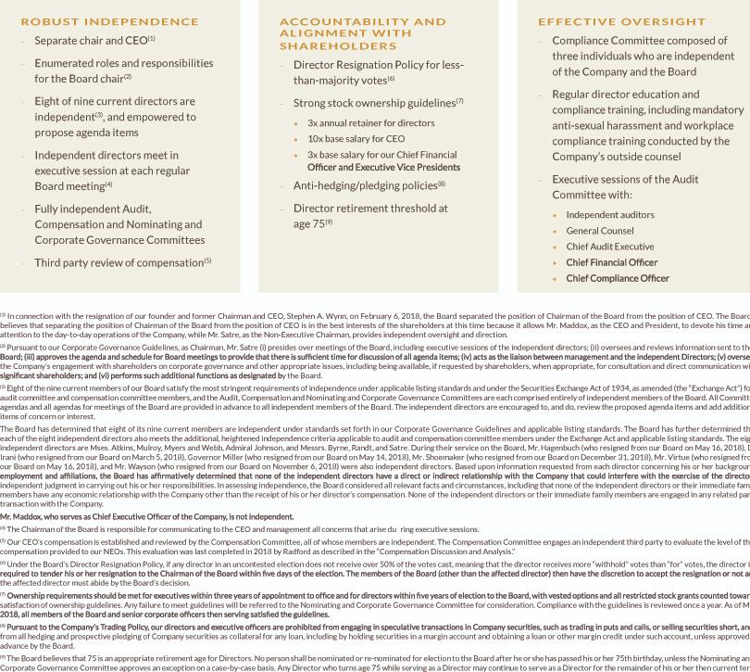

2019 PROXY STATEMENT | 11

Table of Contents

Our board and corporate governance

BOARD ROLE IN RISK OVERSIGHT

The Board has an active role in overseeing the Company’s areas of risk.

– The Board and its Committees, in consultation with management and the Company’s independent auditors, regularly review the Company’s risk profile and have identified specific areas of risk including: regulatory compliance; legal and human resources; legislative and political conditions; capital availability and liquidity; gaming credit extension and collection; construction; catastrophic events; and succession planning.

– The Board (as a whole and through its Committees) has reviewed and approved management’s process for identifying, managing and mitigating these risks. While the full Board has overall responsibility for risk oversight, the Board has assigned certain areas of risk oversight to its Committees as well as to the Company’s Compliance Committee.

– Throughout the year, the Board, its Committees and the Company’s Compliance Committee receive reports from management that include information regarding major risks and exposures facing the Company and the steps management has taken to monitor and control such risks and exposures. In 2018, the Board also implemented a process to allow for direct communication of risks and issues from employees to the Board of Directors.

– In addition, throughout the year, the Board, its Committees and the Company’s Compliance Committee dedicate a portion of their meetings to review and discuss specific risk topics in greater detail.

– The Audit Committee is primarily responsible for the oversight of credit, related party, information security, construction and general financial risks.
– The Company’s Compliance Committee primarily oversees risks relating to regulatory, security, workplace conduct, and political compliance.
– For the 2018 fiscal year, management completed a review of the Company’s compensation policies and practices and presented its analysis to the Compensation Committee. The Compensation Committee concurred with management’s conclusion that such policies and practices do not present risks that are reasonably likely to have a material adverse effect on the Company.

COMPLIANCE COMMITTEE

In August 2018, the Company adopted a new Compliance Program that features a completely-independent Compliance Committee comprised of individuals with extensive familiarity with law enforcement, regulated businesses, ethics, and/or gaming compliance who are not otherwise affiliated with the Company, to oversee and promote the Company’s compliance and to ensure that the Company meets the Company’s strict policy to conduct business at the highest levels of honesty and integrity: Michelle Chatigny, former Vice President, Global Regulatory and Product Compliance for International Game Technology; Thomas Peterman, former Senior Vice President and Chief Compliance Officer for MGM Resorts International (Chair); and Edward Davis, former Commissioner of the Boston Police Department. Chair Satre and Ms. Mulroy serve as ex officio members of the Committee and representatives of the Board.

BOARD MEETINGS/ANNUAL MEETING

The Board met 30 times during 2018. All of the current members of our Board attended at least 75% of the meetings held by the Board and the Committees on which they served during the periods in which they served. In accordance with our Corporate Governance Guidelines, each of our directors is invited and encouraged to attend the Annual Meeting. All of our then-serving directors attended the 2018 Annual Meeting.

BOARD COMMUNICATION AND ENGAGEMENT

Our Board believes in listening to and communicating with shareholders. We believe our work should be informed by input from those who share a financial stake in our success.

We provide a number of ways for shareholders to communicate with the Board and management:

– Shareholders may attend our annual meeting in person where our directors are in attendance.
– Shareholders may speak with us when we reach out to engage both via governance communications and investor relations communications.

12 |

Table of Contents

– Shareholders who wish to communicate in writing with the Board or any director, or with any Committee of the Board, including the chair of any Committee, may do so by writing to the following address: Wynn Resorts, Limited, c/o Corporate Secretary, 3131 Las Vegas Boulevard South, Las Vegas, Nevada 89109. All communications received will be opened by the office of our General Counsel for the purpose of assessing the nature of the communications. With the exception of advertising, promotions of a product or service, and patently offensive material, communications will be forwarded promptly to the addressee. In the case of communications addressed to more than one director, the General Counsel’s office will make sufficient copies of the contents to send to each addressee.

SHAREHOLDER ENGAGEMENT IN 2018

In 2018, the Board of Directors and Company management sought to meaningfully improve the Company’s shareholder engagement efforts, both in terms of frequency and quality of dialogue. In early 2018, subsequent to the publication of allegations against our former Chairman and CEO and associated volatility in our share price, we began a shareholder outreach program focused on transparency and direct requests for feedback.

In light of the on-going volatility in our share price and of the on-going media attention, we continued our extensive shareholder consultation through the 2018 Annual Meeting. Both before and after the 2018 Annual Meeting, the Board performed extensive analysis of shareholder feedback and shareholder voting results and made significant changes to governance and compensation practices. In the fourth quarter of 2018, we again solicited shareholder feedback on the Board and the Company’s 2018 transformation efforts.

The Board and Company management remain committed to frequent and robust shareholder engagement. We have made important updates to our pay plans and corporate governance documents and policies based on our changing needs and the input we have received from engagements with our shareholders. Each change supports our business model and the aligning of our compensation with our performance goals. These changes include:

– Separating the positions of Chairman of the Board and CEO, and electing an independent director as Board Chair
– Commencing a significant Board refreshment process to meet our evolving needs and strengthen our Board’s diversity, skills and experience
– Restructuring the Company’s long-term incentive program to eliminate multi-year, cliff-vested “mega grants”, to implement performance-based awards for a portion of NEO compensation and to extend equity to line-level management

– Meaningfully reducing CEO compensation to align with peers and eliminating substantially all CEO perquisites (other than those generally available to management of the Company)

– Implementing a director retirement age policy
– Eliminating all excise tax-gross ups

The Compensation Discussion & Analysis (CD&A) outlines specific feedback received during our 2018 outreach which was directly related to executive compensation, and details specific steps taken in response to this shareholder input.

BOARD COMPENSATION

Directors who are not employees of the Company currently receive fees for service on the Board and Committees as follows:

Board Service | • Member monthly fee of $5,000
Audit Committee Service | • Member monthly fee of $1,250
 | • Chairman monthly fee of $2,500
Compensation Committee Service | • Member monthly fee of $1,000
 | • Chairman monthly fee of $2,000
Nominating and Corporate Governance Committee Service | • Member monthly fee of $1,000
 | • Chairman monthly fee of $2,000

2019 PROXY STATEMENT | 13

Table of Contents

Our board and corporate governance

Each non-employee director also receives a $1,500 meeting fee for each Board or Committee meeting he or she attends. In addition, non-employee directors are granted annual equity awards in the form of stock options or restricted stock determined annually at a meeting of the Board. For 2018, each non-employee director received a grant of restricted stock equal in value to $250,000 (determined as of the May 15, 2018 grant date) that vests 25% per year on each of the first four anniversaries of the date of grant, subject to continued service through each vesting date. Ex officio members of the Compliance Committee receive an annual retainer of $75,000. The Chairman and Vice-Chairman, if any, of the Board each receive an annual retainer of $100,000. All directors are provided complimentary room, food and beverage privileges at our properties and are reimbursed for any other out of pocket expenses related to their attendance at Board or Committee meetings or other corporate events. Directors from time to time may receive other benefits as discussed in the table below under “All Other Compensation.” The Company does not provide non-equity incentive plan awards or deferred compensation or retirement plans for non-employee directors.

In January 2018, the Board formed a Special Committee comprised solely of independent directors to, among other things, investigate certain allegations regarding Stephen A. Wynn and to conduct a comprehensive review of the Company’s internal policies and procedures with the goal of employing best practices to maintain a safe and respectful workplace for all employees. Each director serving on the Special Committee received the following fees: $10,000 one-time retainer; $2,000 attendance fee for each meeting of the Special Committee attended by such director in his or her capacity as the Chair of the Special Committee; and $1,000 attendance fee for each meeting of the Special Committee attended by such director in his or her capacity as a member of the Special Committee. After it completed its review, the Special Committee was dissolved in February 2019.

In February 2018, the Board formed a Demand Review Committee comprised solely of independent directors to, among other things, review, investigate, and make recommendations to the Board concerning communications the Board or the Company receive from, or on behalf of shareholders, regarding allegations against Stephen A. Wynn or the Company, as well as any related facts, allegations or circumstances that came to the attention of the Demand Review Committee. The Demand Review Committee receives the following fees: $10,000 one-time retainer; $2,000 attendance fee for each meeting of the Demand Review Committee attended by such director in his or her capacity as the Chair of the Demand Review Committee; and $1,000 attendance fee for each meeting of the Demand Review Committee attended by such director in his or her capacity as a member of the Demand Review Committee. On December 17, 2018, the Board, upon the recommendation of the Demand Review Committee, suspended the work of the Demand Review Committee, pending the Special Litigation Committee’s investigation with respect to the plaintiffs’ derivative claims discussed under “Certain Legal Proceedings.”

In September 2018, the Board formed a Special Litigation Committee comprised solely of independent directors and a member of the Company’s Compliance Committee to, among other things, investigate the plaintiffs’ derivative claims discussed under “Certain Legal Proceedings” and determine whether it is in the Company’s best interest to pursue them. The Special Litigation Committee receives the following fees: $10,000 one-time retainer; $2,000 attendance fee for each meeting of the Special Litigation Committee attended by such director in his or her capacity as the Chair or member of the Special Litigation Committee.

NON-EMPLOYEE DIRECTOR COMPENSATION TABLE

The table below summarizes the total compensation awarded to, earned by or paid to each of the non-employee directors for the fiscal year ended December 31, 2018.

 |  | FEES
 | EARNED OR |  |  | STOCK |  | OPTION | ALL OTHER
 | PAID IN CASH |  |  | AWARDS |  | AWARDS | COMPENSATION |  |  | TOTAL
NAME |  | ($) |  | ($)(1) |  | ($)(2) |  | ($)(3) |  | ($)
Betsy S. Atkins(4) | $ | 93,382 | $ | 631,754 | $ | — | $ | 2,945 | $ | 728,081
Richard J. Byrne(5) | $ | 40,180 | $ | 298,380 | $ | — | $ | — | $ | 338,560
John J. Hagenbuch(6) | $ | 123,113 | $ | — | $ | — | $ | 833 | $ | 123,946
Dr. Ray R. Irani(7) | $ | 30,968 | $ | — | $ | — | $ | — | $ | 30,968
Jay L. Johnson | $ | 211,016 | $ | 249,914 | $ | — | $ | 9,733 | $ | 470,663
Robert J. Miller(8) | $ | 155,739 | $ | — | $ | — | $ | 833 | $ | 156,572
Patricia Mulroy | $ | 288,911 | $ | 249,914 | $ | — | $ 10,904 |  | $ | 549,729

14 |

Table of Contents

 |  | FEES
 | EARNED OR |  |  | STOCK |  | OPTION | ALL OTHER
 | PAID IN CASH |  |  | AWARDS |  | AWARDS | COMPENSATION |  |  | TOTAL
NAME |  | ($) |  | ($)(1) |  | ($)(2) |  | ($)(3) |  | ($)
Margaret J. Myers(9) | $ | 100,866 | $ | 631,754 | $ | — | $ 2,945 |  | $ | 735,565
Clark T. Randt, Jr. | $ | 103,833 | $ | 249,914 | $ | — | $10,904 |  | $ | 364,651
Philip G. Satre(10) | $ | 127,089 | $ | 298,380 | $ | — | $ | — | $ | 425,469
Alvin V. Shoemaker(11) | $ | 153,379 | $ | 88,987 | $ | — | $12,645 |  | $ | 255,011
J. Edward Virtue(12) | $ | 79,371 | $ | — | $ | — | $ | 833 | $ | 80,204
D. Boone Wayson(13) | $ | 202,926 | $ | 139,556 | $ | — | $15,446 |  | $ | 357,928
Winifred M. Webb(14) | $ | 89,245 | $ | 631,754 | $ | — | $ 2,945 |  | $ | 723,944

- The amounts set forth in this column reflect the aggregate grant date fair value of 1,309 restricted stock awards granted to each director other than Dr. Irani, Governor Miller, and Messrs. Satre, Byrne, Hagenbuch, and Virtue on May 15, 2018. In addition, 2,000 shares of fully vested stock were granted to Directors appointed to the Board in 2018: Ms. Atkins, Ms. Myers, Ms. Webb, Mr. Satre and Mr. Byrne. The amounts set forth in this column for Messrs. Wayson and Shoemaker include the effect of the revaluing of their unvested award balances of 4,691 each at the time of the accelerated vesting of such awards in connection with their respective departures from the Board. The aggregate number of unvested stock awards held by each director at December 31, 2018, is as follows: Ms. Atkins, Ms. Myers and Ms. Webb, 1,309 each; Ms. Mulroy and Ambassador Randt, 4,203 each; and Admiral Johnson, 2,923. Upon their respective departures from the Board, Dr. Irani, Governor Miller, and Messrs. Hagenbuch and Virtue each forfeited the unvested balances of their previously granted restricted stock awards of 5,048, 3,382, 3,382, and 3,382, respectively.

- The aggregate number of outstanding option awards held by each director at December 31, 2018, is as follows: Mr. Wayson 14,200 vested; Mr. Shoemaker 21,890 vested; Admiral Johnson 10,000 vested; Ambassador Randt 7,000 vested; and Ms. Mulroy 6,700 vested. Options not exercised within 90 days of a director’s departure are forfeited. On February 5, 2019, Mr. Wayson forfeited 14,200 stock options. Mr. Shoemaker has 90 days from his departure date to exercise his options or they will be forfeited.

- For each director other than Admiral Johnson, Mr. Shoemaker, and Mr. Wayson, “All Other Compensation” consists entirely of cash dividends accrued on unvested stock, which is paid if and when the stock vests.

The following amounts are included in “All Other Compensation” for Admiral Johnson:

- personal use of aircraft of $2,349;
- accrued cash dividends on unvested restricted stock of $7,384.

The following amounts are included in “All Other Compensation” for Mr. Shoemaker:

- personal use of aircraft of $399;
- accrued cash dividends on unvested restricted stock of $12,246.

The following amounts are included in “All Other Compensation” for Mr. Wayson:

  - personal use of aircraft of $3,200;
  - accrued cash dividends on unvested restricted stock of $12,246.

- Ms. Atkins was appointed to the Board effective April 17, 2018.

- Mr. Byrne was appointed to the Board effective August 3, 2018.

- Mr. Hagenbuch resigned from the Board effective May 16, 2018.

- Dr. Irani resigned from the Board effective March 5, 2018.

- Governor Miller resigned from the Board effective May 14, 2018.

- Ms. Myers was appointed to the Board effective April 17, 2018.

- Mr. Satre was appointed to the Board effective August 3, 2018, and was elected Non-Executive Chairman of the Board on November 6, 2018.

- Mr. Shoemaker retired from the Board effective December 31, 2018.

- Mr. Virtue resigned from the Board effective May 16, 2018.

- Mr. Wayson retired from the Board effective November 6, 2018.

- Ms. Webb was appointed to the Board effective April 17, 2018.

2019 PROXY STATEMENT | 15

Table of Contents

[THIS PAGE INTENTIONALLY LEFT BLANK]

16 |

Table of Contents
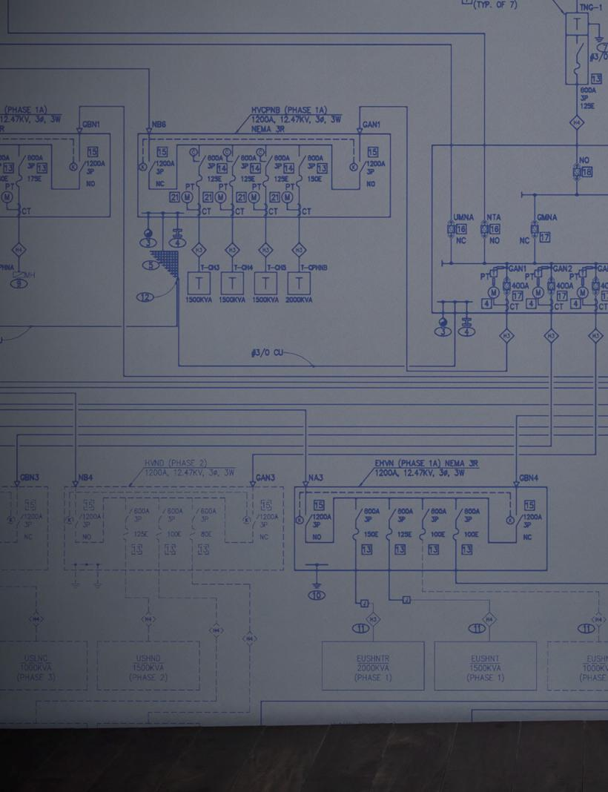

Table of Contents


Table of Contents
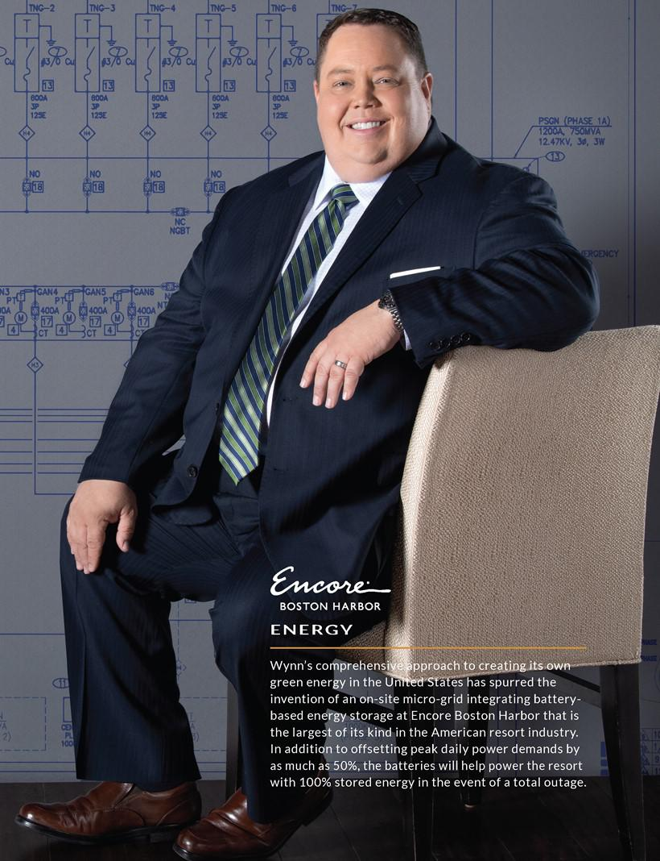

Table of Contents


Table of Contents

INTRODUCTION

In this section we will tell you about:

– Our Cultural Transformation
– Our People
  - Exceptional Employee Benefits

  - Employee Training, Talent Management

  - Employee Retention and Satisfaction

  - Employee and Supply Chain Diversity and Inclusion

– Our Communities
– Our Planet

Simply put, excellence is the keystone of the Wynn Resorts business model. Many companies talk about it, some aspire to it, but at Wynn Resorts the drive for excellence, and the absolute unwillingness to accept anything short of that, is in our DNA. Wynn Resorts is the preeminent designer, developer, and operator of integrated resorts. Our resorts combine exquisite hotel rooms, high-end retail, meeting space, and an array of dining and entertainment options, including gaming.

The legendary design and quality of our resorts serve as a platform for the most important thing we do: create outstanding guest experiences. Guest experience is everything to us. It is so essential to us that we incorporate achievement of Forbes Five-Star distinctions in hotel, food and beverage, and spa categories into our compensation metrics. Our desire to be best-in-class extends beyond integrated resorts to the global hospitality industry.



And we have delivered: We have developed three of the world’s most recognized integrated resorts, and collectively, Wynn Resorts has more Forbes Travel Guide Five-Star awards than any other independent hotel company in the world. Wynn Macau enjoys 8 Forbes Five Stars, making it one of the two highest rated resorts internationally. We were ranked as the highest casino resort on FORTUNE Magazine’s list of 2019 World’s Most Admired Companies, and ranked first overall for Quality of Products among all international hotel companies.

We are confident no company tries harder to show our more than 26,000 employees that each is essential to our reputation for excellence—our business is dependent on repeat visits from our guests and their experiences with our employees are a significant factor in their desire to return. Five-star service, in other words, depends on five-star employees feeling five-star valued by a company they can believe in.

Here are some of the things we do to be good stewards of human capital, good stewards of the environment, and good corporate citizens, beginning with changes to our corporate culture.

2019 PROXY STATEMENT | 17

Table of Contents

Our people and our stewardship

OUR CULTURAL TRANSFORMATION

Over the past 12 months, under the leadership of our newly organized Board of Directors and CEO Matt Maddox, Wynn Resorts has undergone a corporate transformation.

In the wake of allegations against and the departure of our founder, we embarked on a comprehensive self-examination of our Company, its management, and our workplace policies, procedures, and culture. We have examined each aspect of the way we work and made major changes at every level of key decision-making in the Company.

Any employee identified as having been aware of allegations of sexual assault against the Company’s former chairman and who did not investigate or report it is no longer with the Company. We have made meaningful changes to policies, practices, and procedures to ensure the Company has a safe, healthy and supportive workplace culture. Chief among these actions are that the Board:

– Immediately established a Special Committee to review who at the Company was aware of the allegations against Mr. Wynn as well as a sweeping review of the Company’s workplace policies and procedures.

– Changed the leadership of Wynn Resorts. The Company separated the roles of CEO and Chairman of the Board, consistent with best corporate practice. Matt Maddox was appointed CEO of Wynn Resorts and the Company fully separated from Mr. Wynn.

– Commenced a robust Board refreshment process that has brought the median tenure of our independent directors down to less than two years, even as it increased the corporate governance expertise on the Board. Half of the independent directors are women, and the Board is now chaired by an independent director with extensive industry and boardroom experience, Philip G. Satre, who joined subsequent to the last Annual Meeting.

– Appointed Ellen Whittemore, a recognized expert in gaming regulatory and gaming compliance matters, as General Counsel.
– Appointed Rose Huddleston, a seasoned human resources executive, to the newly created corporate position of Senior Vice President of Human Resources- North America.

– Appointed Marilyn Spiegel, an executive with significant hospitality and human resources experience, as President of Wynn Las Vegas.

Under the leadership of CEO Matt Maddox, the Company has taken additional steps to further transform its workplace environment, and reinforce in numerous ways that we value our employees, their diversity, and their contributions to the Company’s success:

– Refocused efforts on the Company’s workplace culture by making it a priority for the Company’s new Human Resources leadership.
– Launched enhanced Workplace Compliance and Prevention of Sexual Harassment training for all employees, designed by a third-party expert and delivered in-person to all employees.

– Launched a Women’s Leadership Council to promote equality within the workplace. The group’s first activity was to produce a speaker series, “Women Who Thrive,” to educate and inspire employees through powerful female role models.

– Commissioned pay and promotion equity studies to measure pay equality among men and women in the workforce.
– Launched a new Paid Parental Leave program that provides paid time off to new parents.
– Implemented new Diversity, Inclusion and Unconscious Bias training for all employees, including senior executives, taught by third-party experts.
– Launched the Great Places to Work survey and focus groups which measure employee engagement against the Fortune “100 Best Places to Work.”
– Launched a new Wynn Employee Foundation Scholarship Program, an annual grant each year to ten qualifying Wynn Las Vegas employees or family members of up to $7,500 (renewable for up to four academic years) to be used towards earning a degree in any field of study at any Nevada university or college. Encore Boston Harbor employees will be eligible for similar grants for public higher education in Massachusetts.

– By establishing new reporting requirements and investigation processes, increasing workplace oversight, and mandating updated training, including training around sexual harassment, we have reestablished a culture in which employees are encouraged to come forward and employees at all levels are held accountable. We are making clear, in both policy and action: every employee is entitled to a safe and respectful workplace and no employee, at any level of our Company, is above the rules.

18 |

Table of Contents

OUR PEOPLE

The impact of the investments we make in our people show up in some of the key drivers of sustainable success.

– Our voluntary employee turnover rates are significantly lower than the industry average – 18% in 2018 versus 22% across all consumer services globally, according to data from the 2018 US Mercer Turnover Survey – our employees consistently choose to stay with Wynn even in an era when job-hopping is common.

– We invest in our talent—51% of our jobs were filled with current employees in 2018.
– We were named among this year’s Best Employers for Diversity by Forbes Magazine, which recognizes the top employers in the United States for their commitment to diversity and workplace culture. Wynn Resorts was one of only 13 hotel companies to be recognized in these rankings.

EMPLOYEE BENEFITS

– Medical, prescription, dental and vision insurance for all full-time employees and their families, and all part-time employees who average 30 or more hours per week

– 401(k) plan with Company match incentive
– Paid time off for holidays, perfect attendance, floating holiday, and vacation
– On-site wellness facilities including health coaches and 24-hour wellness centers
– Six weeks paid parental leave and a Perfect Start program, giving $250 to new parents to help with early childhood expenses
– Employee Assistance Program with generous benefits and extensive work-life resources, including private counseling sessions
– Financial guidance, including free legal advice, relocation advice, and financial and tax information
– Employer paid life insurance benefits, which include added value benefits of identify theft protection and travel assistance plan
– Group discounts for supplemental coverage, including disability, auto/home, legal, pet, additional life, critical illness, etc.
– Free meals in our employee dining rooms, including healthy options
– We Save employee discount program, including child-care facilities discounts and fitness center memberships

EMPLOYEE EDUCATION AND TRAINING

– Tuition reimbursement program with a focus on continuing education
– Sponsorship of 12-week courses to prepare employees for US citizenship test
– English as a second language program
– On site leadership and self-development classes
– Compliance training
– Code of Business Conduct and Ethics training
– Responsible Gaming training

2019 PROXY STATEMENT | 19

Table of Contents

Our people and our stewardship

EMPLOYEE AND SUPPLY CHAIN DIVERSITY AND INCLUSION

– Recognizing that women are traditionally under-represented in the building trades, Wynn and Minuteman High School founded the Massachusetts “Girls in Trade” Advisory Group to work with developers, contractors, building trades unions and government officials to increase career opportunities for women in construction in Massachusetts

– Affinity groups for employees, including our Diversity Council and LGBT Focus Group
– Supplier diversity program and purchasing guidelines:
  - 248 minority, women or veteran owned business partners receive over $34 million in annual procurement spending from Wynn Las Vegas

  - Encore Boston Harbor has issued over $256 million in construction and design contracts to minority, women, or veteran-owned businesses, and exceeded its commitments to the Commonwealth of Massachusetts in the construction of Encore Boston Harbor regarding women, minority and veteran participation in its workforce and contracts.
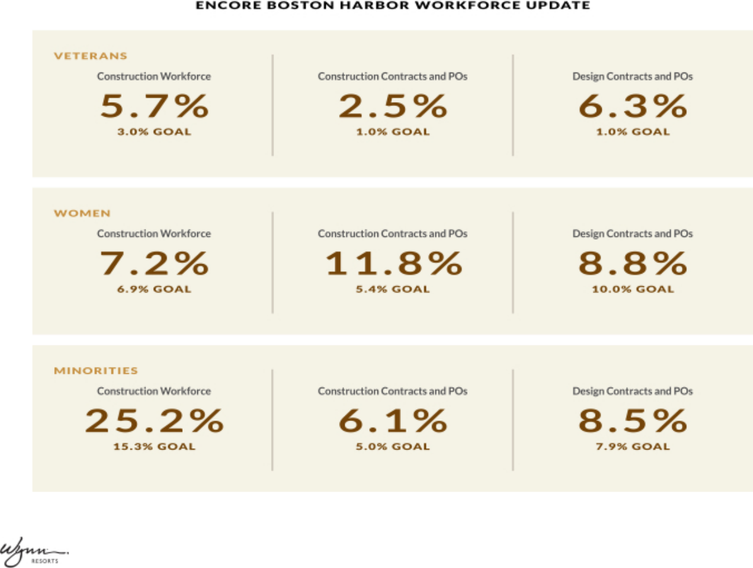

20 |

Table of Contents

OUR COMMUNITIES

Support for over 100 diverse community organizations including:

– Over 45,000 hours of community service at our resorts in Las Vegas, Macau, and Boston
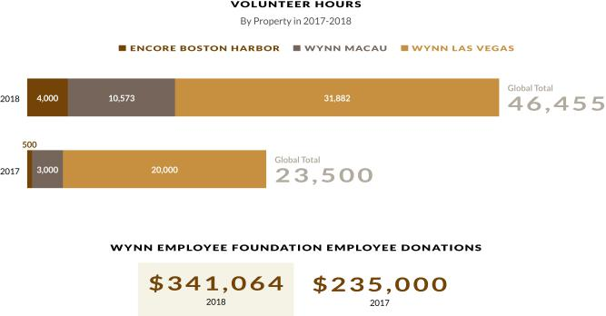

Wynn Las Vegas:

– Rallied over 80 local businesses and pledged $1.5 million for large-scale facility upgrades to The Shade Tree, a 24-hour crisis shelter which focuses on homeless and abused children in crisis, including victims of domestic violence and human trafficking. The unique ‘hybrid’ approach also included over 800 pro-bono volunteer hours by Wynn employees providing professional services in several areas including: Marketing/Advertising, Engineering/Construction, and Strategic Consulting.

– Since 2015, the innovative “Adopt-A-Classroom” program at Dean Petersen Elementary School has provided student and teacher support inside of the classroom, including: tutoring, literacy programs, translation service for English language learners, career days, and mentoring. In 2018, Wynn employees adopted 50+ classrooms and engaged weekly with the students.

Encore Boston Harbor:

– Launched a partnership with the highly regarded Connors Family Office to donate $10 million over the next four years to support a wide range of social programs and civic institutions that will help those in need and improve the lives of residents throughout the Boston area.

– Encore’s first official fundraiser in Boston raised more than $360,000 for the New England Center for Arts and Technology (NECAT), an organization that provides at-risk and resource-limited adults with a pathway to stable, long-term careers in the food services industry.

Wynn Macau:

– Support for the sixth consecutive year to the Welfare Shop Project of Macau Holy House of Mercy (SCMM), including a donation of MOP300,000 to finance the distribution of food hampers to over 360 underprivileged families. Wynn has donated an accumulated total of MOP1,700,000 since the founding of the project in 2013.

– Education engagement continues to increase, with scholarships totaling MOP300,000 distributed to 35 students attending classes at the Universidad de Macau, Institute for Tourism Studies, and the Polytechnic Institute.

2019 PROXY STATEMENT | 21

Table of Contents

Our people and our stewardship

Impact of Wynn Resorts Properties

Every new Wynn development has the potential to transform a local economy. When Wynn Las Vegas opened in 2005, it triggered the largest increase in non-gaming revenue in Las Vegas history. Encore Boston Harbor is also demonstrating how we develop shared goals with host cities to:

– Stimulate economic growth and create local jobs
– Fund local infrastructure improvements, including the transformation of unproductive and environmentally damaged local sites into productive city amenities

– Provide a financial boost to existing cultural and entertainment assets, including via cross marketing opportunities and enhanced local customer traffic
– Partner with national and local authorities to establish world-class regulatory frameworks

OUR PLANET

In 2018 Wynn Las Vegas was awarded Four Green Globes (equivalent to LEED Platinum) under the Green Globes for Existing Buildings criteria. Additionally, we

– Made significant investments in solar. The combined output of Wynn Resorts’ solar projects will offset approximately 34,000 metric tons of greenhouse gas emissions annually, which is equivalent to the annual energy use of approximately 4,113 residential homes. These projects include:

  - An agreement with Enel Green Power to purchase 20 megawatts of solar power from the 160-acre Wynn Solar Facility in Fallon, Nevada for the direct consumption at Wynn Las Vegas for a term of seven years. The output delivered from this facility is enough to offset 75% of the Wynn Las Vegas peak demand needs during the summer months, and greater during off-peak months.
  - Installed approximately 1 megawatt of behind-the-meter rooftop solar on Wynn Las Vegas to further offset the resort’s demand on the electrical grid, and provide clean reliable power for our facilities use.
  - Installing approximately 1 megawatt of rooftop solar at Encore Boston Harbor, that will be utilized on-site and integrated into the resort’s power supply.

– Commissioning 4MW/8MWh of battery storage used for peak demand reduction, back-up power and ancillary services at Encore Boston Harbor. This creates a behind-the-meter micro-grid for our Boston resort—an industry first.

– Installed 3 megawatts of combined heat and power (CHP) co-generation for energy production and building heating requirements.
– Established a full remediation program for the abandoned industrial site in Boston, that is now home to Encore Boston Harbor, including development of a living shoreline.

– Established eco-efficiency programs throughout Wynn Las Vegas, which have offset over 100,000 metric tons of greenhouse gas emissions. This is the equivalent to saving 9.9 million gallons of gasoline.

– Attributable to an ongoing investment in energy efficient measures, stabilization of energy demand, and equipment upgrades, reduced energy consumption per square meter at Wynn Macau by 27% from 2015 through 2017 (which is the last full year for which data is currently available), resulting in the reduction of Wynn Macau’s greenhouse gas emissions by over 13,000 metric tons.

22 |

Table of Contents
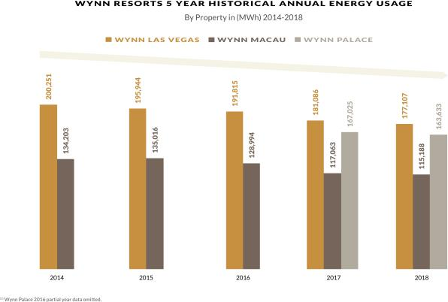

– Emissions- and waste-reductions programs throughout properties
– Energy and water use monitoring programs
– Single stream recycling at Wynn Las Vegas

2019 PROXY STATEMENT | 23

Table of Contents

Executive officers

B U I L D I N G T H E N E W W Y N N

Our Executive Officers and certain key management personnel as of March 11, 2019 are as follows:

NAME | AGE | POSITION
Matt Maddox | 43 | Director, Chief Executive Officer and President
Craig Billings | 46 | Chief Financial Officer and Treasurer
Ellen F. Whittemore | 62 | Executive Vice President, General Counsel and Secretary
Linda Chen | 52 | Vice Chairman and Executive Director—Wynn Macau, Limited
Ian Michael Coughlan | 59 | President and Executive Director—Wynn Macau, Limited

Our executive officers are appointed by the Board and serve at the discretion of the Board, subject to applicable employment agreements.

NON-DIRECTOR EXECUTIVE OFFICERS AND KEY MANAGEMENT

Craig Billings

Chief Financial Officer and Treasurer

Mr. Billings is the Company’s Chief Financial Officer and Treasurer, a position he has held since March 2017. On August 17, 2018, Mr. Billings was appointed a Non-Executive Director of Wynn Macau, Limited, a majority owned subsidiary of the Company.


PREVIOUS EXPERIENCE

– 2015 to 2017: Gaming industry independent advisor and investor

– 2012 to 2015: Chief Digital Officer, Strategy & Business Development Managing Director, various roles, Aristocrat Leisure Ltd

– Previously Vice President in the Investment Banking Division of Goldman Sachs in both New York and London, covering the gaming industry

– Previously Manager in the Audit Division of Deloitte & Touche in Las Vegas, NV

– 2015 to 2018: Director and Non-Executive Chairman, NYX Gaming Group (now part of Scientific Games)

EDUCATION

Mr. Billings graduated with a B.S. (Cum Laude) in Accounting from the University of Nevada, Las Vegas, and received an M.B.A. from Columbia Business School. Mr. Billings is a Certified Public Accountant.

Joined Wynn March 2017

Age 46

24 |

Table of Contents

Ellen F. Whittemore

Executive Vice President, General Counsel and Secretary

Ms. Whittemore is the Company’s Executive Vice President, General Counsel and Secretary, a position she has held since July 2018.


PREVIOUS EXPERIENCE

– 2016 to 2018: Shareholder of Brownstein Hyatt Farber Schreck LLP

– 2014 to 2016: Sole manager of the Whittemore Gaming Group, LLC

– Previously of counsel in the Las Vegas office of the law firm Lionel Sawyer & Collins for more than 20 years

EDUCATION

Ms. Whittemore graduated with a B.A. from the University of Nevada, Reno and received her J.D. from the University of San Diego School of Law. She is admitted to practice before the United States Supreme Court.

Joined Wynn July 2018

Age 62

Linda Chen

Vice Chairman and Executive Director—Wynn Macau, Limited, President—Wynn International Marketing, Limited

Ms. Chen serves as Vice Chairman and Executive Director of Wynn Macau, Limited and serves as the President of Wynn International Marketing, Limited, a position she has held since January 2005. She has also held the position of President and Executive Director of Wynn Resorts (Macau), S.A. since March 2017, and the position of Chief Operating Officer of Wynn Macau, Limited since 2009. She was appointed to serve as Vice Chairman of the Board of Wynn Macau, Limited in April 2018 and has been an Executive Director of Wynn Macau, Limited since 2009. In addition, Ms. Chen is a member of the Nanjing Committee of the Chinese People’s Political Consultative Conference (Macau). Ms. Chen served on the Board of Directors of Wynn Resorts from 2007 to 2012.


PREVIOUS EXPERIENCE

– 2000 to 2002: Executive Vice President, International Marketing, responsible for international marketing for the integrated resorts MGM Grand, Bellagio and The Mirage

– Previously Executive Vice President, International Marketing at Bellagio, including opening the resort in 1998

– Previously involved in the opening of the MGM Grand in 1993 and The Mirage in 1989

EDUCATION

Ms. Chen graduated with a B.S. in Hotel Administration from Cornell University.

Joined Wynn | June 2002
Appointed in Current
Position | January 2005
Age | 52
 | 2019 PROXY STATEMENT | 25

Table of Contents

Executive officers

Ian Michael Coughlan

President and Executive Director—Wynn Macau, Limited

Mr. Coughlan has been the President of Wynn Macau, Limited since September 2016 and oversees all operations and development activities for Wynn Macau and Wynn Palace. Mr. Coughlan is also an Executive Director of Wynn Macau, Limited, a position he has held since Wynn Macau, Limited’s formation in September 2009. He also served as President of Wynn Resorts (Macau), S.A. from July 2007 until March 2017 and relinquished this role after his appointment as President of Wynn Macau, Limited. Mr. Coughlan initially served as Director of Hotel Operations Worldwide for Wynn Resorts during 2007.


PREVIOUS EXPERIENCE

– 2004 to 2007: General Manager, The Peninsula Hong Kong

– 1999 to 2004: General Manager, The Peninsula Bangkok

– Previously held senior management positions with Mandarin Oriental Singapore, and the Ritz-Carlton Hotel Company in Hawaii, New York, Palm Springs, and Atlanta

EDUCATION

Mr. Coughlan received his Diploma in Hotel Management from Shannon College of Hotel Management, Ireland.

Joined Wynn | January 2007
Appointed in Current Position | September 2016
Age | 59

26 |

Table of Contents


Table of Contents


Table of Contents


Table of Contents
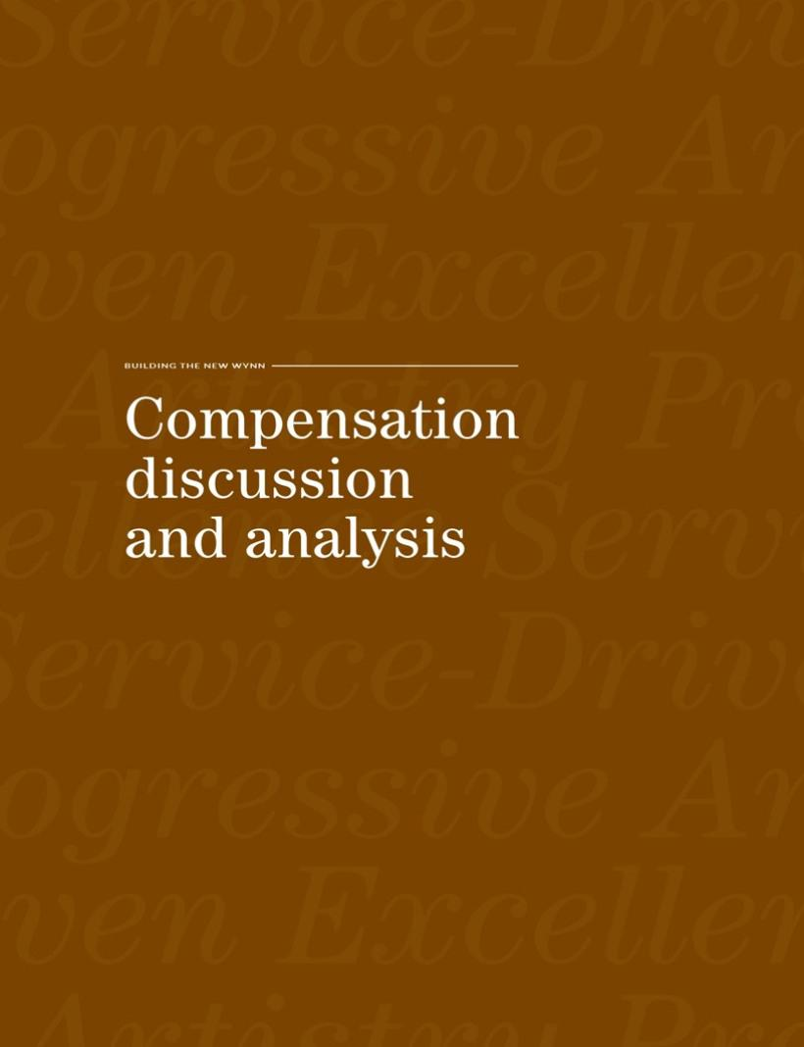

Table of Contents

We believe Wynn Resorts is the world’s preeminent designer, developer, and operator of integrated resorts. The Company’s business model integrates luxury hotel rooms, high-end retail, an array of dining and entertainment options, meeting space, and gaming, all supported by superior levels of customer service provided by our more than 26,000 employees. Our operations in Las Vegas and Macau (and at Encore Boston Harbor, which is expected to open in June 2019) are designed to attract a wide range of domestic and international customers.

As we continue our transition from a founder-led company, the Compensation Committee aims to transform executive compensation to incorporate best-in-class practices that reward executives and all employees for actions that create long-term shareholder value.

In this compensation discussion and analysis, or CD&A, we describe our philosophy and renewed approach to executive compensation, and discuss the changes we have made to our compensation program based on engagement with our shareholders during 2018.

We understand the importance of executive compensation decisions to our shareholders and that the annual proposal to approve the compensation of our named executive officers gives shareholders the opportunity to evaluate our compensation approach.

For fiscal 2018, our NEOs were:

NAME | TITLE
Matt Maddox | Chief Executive Officer (as of February 6, 2018) and President
Craig Billings | Chief Financial Officer and Treasurer
Ellen Whittemore | Executive Vice President, General Counsel and Secretary (as of July 16, 2018)
Stephen A. Wynn | Former Chairman and Chief Executive Officer (until February 6, 2018)
Kimmarie Sinatra | Former Executive Vice President, General Counsel and Secretary (until July 15, 2018)

HOW WE SOLICITED AND RESPONDED TO SHAREHOLDER FEEDBACK

In 2018, the Board and Company management sought to meaningfully improve our shareholder engagement efforts, both in terms of frequency and quality of dialogue. The Board remains deeply committed to frequent and robust shareholder engagement.

In early 2018, subsequent to the publication of allegations against our former Chairman and CEO and associated short-term volatility in our share price, we began a shareholder outreach program involving members of the Board and management that was focused on transparency and direct requests for feedback. We continued our extensive shareholder outreach through the 2018 Annual Meeting. Given the ongoing interest and substantive response from shareholders, we subsequently extended these engagement efforts through the remainder of 2018.

Over the course of the year, members of the Board and management engaged with holders of more than 50% of our outstanding shares. The Board performed extensive analysis of shareholder feedback and shareholder voting results, made significant changes to governance and compensation practices in response, then re-engaged with shareholders to provide updates and solicit feedback on the Board and the Company’s transformation efforts.

Prior to the 2018 Annual Meeting, as we noted in our 2018 Proxy Statement, the Board had already taken significant actions, including:

– eliminating excise tax gross-ups to NEOs,
– eliminating outsized change of control payments for the CEO, and
– adding pre-established financial performance conditions to previously-granted time-based equity awards.

2019 PROXY STATEMENT | 27

Table of Contents

Compensation discussion and analysis

Subsequent to the 2018 Annual Meeting, the Company continued to engage with shareholders. The following table highlights key compensation-related themes shareholders raised in those discussions, and actions taken by the Board in response:

FEEDBACK THEMES | ACTIONS TAKEN IN RESPONSE |  |  | IMPACT OF ACTION |  |  | WHEN
FEEDBACK THEMES |  |  |  |  |  |  | EFFECTIVE
 | – |  | Reduce CEO compensation | – Right-size pay while strengthening performance linkage |  |  | 2018 and
CEO Pay | – |  | Benchmark total compensation at median of peer group | – Institutes linkage to peer group to right-size pay |  |  | 2018 and
 |  |  |  |  |  |  | beyond
 | – |  | Eliminate CEO perquisites | – |  | Increases performance-based compensation | beyond
 |  | – Eliminate multi-year, cliff-vested “mega grants” |  | – Eliminate potential windfalls and variability of pay across years
Use of Equity |  | – Institute regular performance-based awards |  | – Continuously incentivize actions that create long-term shareholder value |  |  | 2019 and
Use of Equity |  | – Extend equity to line-level management |  |  | – Introduce broad-base ownership and accountability |  | beyond
 |  | – Eliminate annual performance periods for equity |  |  | – Ensure vesting of performance awards rewards long-term performance
At Risk Compensation | – Implement plans in which the majority of NEOs’ pay is “at risk.” |  |  | – |  | For 2018, approximately 85% of our CEO’s total compensation was at risk and tied 2018 and
At Risk Compensation |  |  |  |  |  | to the achievement of three performance goals | beyond

IMPACT ON 2018 CEO COMPENSATION

Certain of the changes outlined above occurred in 2018 and, as a direct result, CEO compensation decreased by 50% year-over-year when compared to 2017. However, certain of the changes outlined above were not implemented until early 2019 and thus we expect the impact of these changes on NEO compensation to become increasingly clear in future proxy statements when legacy practices and legacy executives are no longer included in our CD&A.

ADDITIONAL GOVERNANCE AND COMPENSATION UPDATES

We have made additional important updates to our pay plans and corporate governance documents and policies based on our changing needs and the input we have received from engagements with our shareholders. Each change supports our business model and better aligns our executives’ compensation with our performance goals. These changes include:

EXECUTIVE COMPENSATION

Creating multiple metrics for our annual incentive programs, consistent with best practices

Increasing previously set Minimum Adjusted Property EBITDA targets by 55% for 2018 performance awards

Shifting payments of annual incentive bonuses from all cash to 50% stock

Eliminating all excise tax-gross ups

Exercising negative discretion to reduce compensation payouts when warranted

GOVERNANCE AND BOARD STRUCTURE

Separating the positions of Chairman of the Board and CEO, and electing an independent director as Chairman

Commencing a significant board refreshment process to meet our evolving needs and strengthen the Board’s diversity, skills, and experience

Implementing a director retirement age policy

We believe in the value of shareholder engagement and will continue to reach out to our shareholders in 2019 and beyond, continuing our commitment to ongoing discussions and feedback from all shareholders.

28 |

Table of Contents

HOW WE APPROACH EXECUTIVE COMPENSATION

Our executive compensation philosophy is to align the interests of executives with those of shareholders by designing incentives that are directly tied to actions which create sustainable long-term shareholder value.


We, the Compensation Committee, believe that our ability to oversee the delivery of operational excellence and sustainable long-term returns to shareholders

is inexorably linked to attracting and retaining a high-performing management team.

Hence, the executive compensation program must be designed to attract, reward, and retain executive officers who create continual near- and long-term shareholder value by achieving the Company’s strategic goals. We also believe

that stability at the executive level is key to the strength of the Company, particularly given the relatively small pool of executives with gaming experience for whom we compete.

To achieve this, we rely on the following principles:

Pay-for-Sustainable Performance: The majority of our executives’ total compensation is tied to achieving annual and long-term goals that enhance the value of our reputation and brand, sustain the performance and attractiveness of our resorts and drive long-term shareholder value. The Compensation Committee retains discretion to reduce amounts earned and payable when doing so will further these goals. Further, 50% of annual incentive

is paid in equity (rather than all cash), and equity is subject to our robust holding requirements.

EXECUTIVE COMPENSATION PROGRAM HIGHLIGHTS

Annual Incentives:

– No guaranteed payouts

– Aligned with critical operating and excellence goals

– 50% of earned annual incentive is paid in equity

Equity Incentives:

– 50% of NEO grants are performance-based

– Minimum 3-year vesting

– Robust holding requirements (10X for CEO)

Additional Best Practices:

– No repricing

– No dividends on option awards

– No SERP or pension benefits to NEOs

– No excise tax gross-ups

– Change-in-control payments are double-trigger

– Pay plans discourage inappropriate risk

Shareholder Alignment: Our long-term equity incentives align executives’ interests with those of shareholders and stakeholders. In adopting regular equity grants that vest over 3 years, we believe that the alignment of interest is strengthened, especially when coupled with best-in-class stock holding requirements for executives (10X base salary for our CEO).

Focus on Compensation Totals and Parity: We evaluate the total amounts of executives’ compensation for parity purposes and assess them relative to the pay practices of major gaming companies and other competitors for talent. The Committee reaffirmed its commitment to right-sized executive compensation by benchmarking total compensation at the median of our peer group and making adjustments for specific skills and experience.

Simplicity and Clarity: We value pay structures that are simple and clear. We believe pay simplicity promotes transparency, avoids incentivizing focus on pay goals at the expense of ongoing excellence and performance, and promotes teamwork.

Attract and Retain Top Talent: Our business spans continents, can be subject to meaningful volatility, requires tight coordination with regulators, depends on knowledge of numerous types of complex operations, requires diligent investment over many years and across business cycles, and is highly dependent on a reputation for excellence, so finding and retaining top talent is a critical element of our compensation.

2019 PROXY STATEMENT | 29

Table of Contents

Compensation discussion and analysis

HOW THE COMPANY HAS PERFORMED

While our year to year performance can be significantly impacted by market factors, geopolitical events and investor sentiment, we have delivered significant outperformance since our initial public offering in 2002. Over that 16-year period, the Company has averaged a 17% annual Total Shareholder Return (“TSR”), (including reinvestment of dividends), which is substantially above the TSR of both the S&P 500 (approximately 9% average annual TSR) and the S&P Consumer Discretionary Index (approximately 10% average annual TSR) over the same time period. We have also delivered an average annual TSR greater than five times our closest industry peers.⁽¹⁾ We believe these results are driven by our focused, long-term investment in our properties and by our relentless dedication to delivering the industry’s best customer experience.
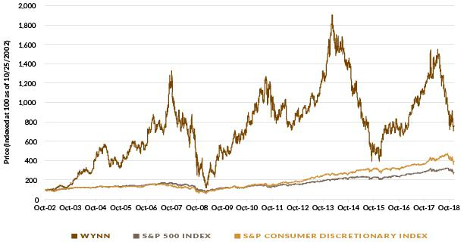

Our key accomplishments in 2018 include:

– Generating $467 million of Adjusted Property EBITDA at Wynn Las Vegas. Despite the challenges faced by the allegations against our founder and former CEO, Wynn Las Vegas performed well overall. The resort also achieved several property records, including our best year ever for hotel gross revenue and for restaurants revenue (excluding catering). Ongoing guest research and surveys indicate the strength of the Wynn brand and customer affinity for it, positioning Wynn Las Vegas well for the continued growth of the Las Vegas market.

– Solidifying Market Share Gains in Macau with the Continued Ramp-up of Wynn Palace. Wynn Palace, which opened in August of 2016, generated $844 million of Adjusted Property EBITDA and achieved 8.8% of gross gaming revenue market share in 2018, its second full fiscal year of operations. This contributed to very strong operating results from the Company’s Macau operations during the year. [See our Annual Report footnote Item 8, Note 16.]

– Making Substantial Progress at Encore Boston Harbor. Located on the Mystic River in Everett, Massachusetts, and adjacent to Boston, our newest resort will feature the premium amenities associated with all our resorts, including full casino amenities, hotel, fine and casual dining outlets, meeting and convention facilities, a spa, nightclub and a waterfront boardwalk and harbor for water transportation. We expect to open Encore Boston Harbor in June 2019, and as of December 2018 have incurred $2.03 billion in total project costs of an estimated total project budget of approximately $2.6 billion.

– Maintaining a Robust Capital Investment Program at Existing Properties. We continually enhance the guest experience at our resorts in Las Vegas and Macau through strategic capital investments. This includes the fourth quarter 2018 opening of Wynn Plaza at Wynn Las Vegas, a 74,000 square-foot luxury retail esplanade. We are constructing an approximately 400,000 square-foot meeting and convention facility at Wynn Las Vegas, slated to open in the first quarter of 2020. In Macau, we announced several initiatives including a meaningful room refreshment program and a reconfiguration of a portion of the casino floor at Wynn Macau and a meaningful, multi-year expansion project adjacent to Wynn Palace called the Crystal Pavilion.

- Industry peers reflect Las Vegas Sands and MGM Resorts. Las Vegas Sands’ TSR is measured from the market close on the day of their IPO on 12/15/2004 (average annual TSR of approximately 3%). MGM Resorts’ TSR is measured from the close on the date of Wynn Resorts’ IPO on 10/25/2002 (average annual TSR of approximately 3%).

30 |

Table of Contents

– Maintaining Healthy Liquidity and Financial Flexibility. As of December 31, 2018, the Company had approximately $2.2 billion of cash and cash equivalents and approximately $731 million of undrawn debt capacity to help fund its current and potential future development projects. During 2018, the Company continued to improve the maturity profile of its debt obligations by amending and extending the Wynn Macau Credit Facilities and continued to improve the Company’s liquidity profile by retiring the Redemption Note and issuing approximately $927.5 million of equity to a strategic investor.

– Continuing to Return Significant Capital to our Shareholders. During 2018, we raised our recurring quarterly dividend to $0.75 per share and returned approximately $295 million of cash to shareholders through dividend payments. Through the end of 2018, we have returned approximately $6.9 billion ($63.50 per share) since our initial public offering in 2002.

– Earned More Forbes Five-Star Awards than Any Independent Hotel Company In The World. Wynn Macau is the only resort in the world with eight Forbes Travel Guide Five-Star awards, and this year Wynn Palace won six Five Star awards. Collectively, the Company has 19 Five Star awards in its portfolio.

HOW WE DESIGNED INCENTIVES IN 2018

2018 HIGHLIGHTS:

In 2018, the Compensation Committee:

– Established financial and strategic goals to evaluate performance for the annual incentives, 50% of which was paid as equity.
– Overhauled the long-term incentive program to move from periodic grants to annual grants with three-year cliff vesting.
– Implemented a policy that at least 50% of long-term incentive grants would be performance-based.
– Implemented, on a going forward basis, performance-based stock awards that vest upon achievement of pre-established financial performance goals that are based on the Company’s ability to achieve a premium revenue and Adjusted Property EBITDA “fair share” relative to its peers (see discussion of this metric below), on a three-year basis.

– Reaffirmed its commitment to compensate executives at the median with regard to total compensation, and conducted an overall analysis of all NEO total compensation to confirm compliance.

Role of the Compensation Committee and Management in Setting Compensation: The Compensation Committee sets all elements of compensation for our NEOs based upon consideration of an NEO’s contributions to the operating and strategic performance of the Company. The Compensation Committee considers the recommendations of the CEO in establishing compensation for all other NEOs. In addition, the CEO performs annual reviews of our senior executive officers and makes recommendations to the Compensation Committee. The Compensation Committee reviews the recommendations and makes final decisions regarding compensation for our senior executive officers.

ELEMENTS OF PAY

We take a multi-year investment approach to our business that focuses on rewarding strong near-term performance and the creation of long-term shareholder value. Because product quality and service excellence are at the core of our strategy, we use annually focused, operations-based pay to highlight the critical importance of performing well each year for each customer. We supplement that with a set of long-term incentives and holding requirements to support the sustainability of our reputation and our ongoing returns. The charts below highlight the focus on equity and at-risk mix of the total direct compensation for our current NEOs based on 2018 compensation outcomes:
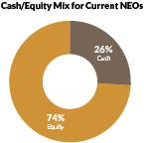
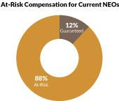

2019 PROXY STATEMENT | 31

Table of Contents

Compensation discussion and analysis

The key elements of our compensation program are:

ELEMENT | ROLE AND OBJECTIVE
Base salary | – Provide competitive, fixed, cash compensation to attract and retain top employees and recognize sustained performance, job
 | scope and experience
Annual incentives | – Incentivize executives, enforce accountability and motivate and reward achievement of annual and long-term goals
 | – 50% of annual incentive awards paid in stock and subject to NEO holding requirements, further aligning executive and long-term
 | shareholder interests
Long-term incentives: stock options & restricted stock | – Ensure focus on long-term value creation, align executive and long-term shareholder interests, and promote retention
 | – 50% of equity awards granted as performance-based stock that vest solely based on company performance on preset goals over
 | a three-year performance period, linking the creation of shareholder value to incentives earned
Executive benefits | – Promote executive and family well-being through health and insurance benefits, complimentary resort privileges and
 | merchandise discounts

Base Salary: Negotiated employment agreements establish our NEOs’ initial base salaries. We review and adjust their base salaries periodically to stay competitive, to reflect improvements in performance, capabilities, and experience, and reward expansions of responsibility or other extraordinary circumstances. Base salaries for the NEOs as of December 31, 2018 and 2017 were:

EXECUTIVE |  | 2018 BASE SALARY |  | 2017 BASE SALARY | INCREASE
Matt Maddox(1) | $ | 2,000,000 | $ | 1,500,000 | 33%
Craig Billings(2) | $ | 875,000 | $ | 750,000 | 17%
Ellen F. Whittemore(3) | $ | 600,000 |  | N/A | N/A
Stephen A. Wynn(4) | $ | 2,500,000 | $ | 2,500,000 | 0%
Kimmarie Sinatra(5) | $ | 1,000,000 | $ | 1,000,000 | 0%

- Mr. Maddox’s base salary was increased to $2,000,000, effective February 27, 2018, in connection with his promotion to Chief Executive Officer.

- Mr. Billings joined the Company on March 1, 2017. Mr. Billings’ base salary was increased to $875,000, effective March 1, 2018, in connection with the one-year extension of his employment agreement, and in recognition of his contributions to the performance of the Company.

- Ms. Whittemore joined the Company on July 16, 2018.

- Mr. Wynn left the Company effective February 6, 2018.

- Ms. Sinatra left the Company effective August 3, 2018.

Annual Incentives: For the 2018 annual incentive awards granted under our Omnibus Plan, the Compensation Committee selected three performance goals, one of which is comprised of our four strategic initiatives.

Goal 1 – 2018 Adjusted Property EBITDA (weighted 40%): This is used to measure the operating performance of our properties compared to those of our competitors. Adjusted Property EBITDA is an important measure of each property’s performance within its respective market, a key driver of return on equity and an essential element to the valuation of our Company and our stock price.

The Committee, based on the current operating conditions in Las Vegas and Macau and the Company’s operating and growth strategies, set a threshold performance level of at least $1.8 billion, a target level of $2.0 billion, and maximum performance level of $2.2 billion.

No incentive payout will be earned with respect to this metric if the Company does not achieve the threshold performance level.

Goal 2 – Maintain Forbes Five Star (weighted 20%): Our business requires superior customer experience and service. We believe such service allows us to attract customers with a higher spend per visit, increase the loyalty of those customers and meaningfully improve the likelihood of additional visits from those customers. Forbes 5-star status serves as external validation of this key aspect of our strategy. Achievement of this goal encourages long-term investment in our human capital and retention of talent because we believe human resources and staff training ensure our employees are prepared to provide the luxury service that our guests expect.

Goal 3 – Key Strategic Initiatives (weighted 40%): This goal is comprised of four discrete strategic initiatives, the execution of which were critical to the success of the Company. Each of these initiatives was weighted at 10%, reflecting the equal importance of success on all fronts.

32 |

Table of Contents

STRATEGIC & OPERATIONAL GOALS | WEIGHT | RATIONALE FOR INCLUSION | PERFORMANCE
Settlement of Long-standing | 10% | The settlement of complex, multi-year, multi-party litigation removed a critical overhang from the Company’s equity value and allowed | Achieved
Litigation |  | management to instead focus its time and attention on advancement of the Company’s strategic initiatives.
Implementation of Key | 10% | In light of the allegations made against our former Chairman and CEO and given the importance of attracting and retaining the best | Achieved
Cultural and Compliance |  | operational talent in our industry, the Board and the Compensation Committee believed that the immediate design and implementation of
Initiatives |  | certain culture and compliance initiatives in 2018 was critical to the Company’s future success.
Minimizing the Regulatory | 10% | Our ability to operate is conditioned upon our maintaining required gaming licenses. Our gaming regulators were concerned with the | Achieved
Risk Stemming from |  | allegations against our former Chairman and CEO, with understanding the Company’s response to the allegations, and with ensuring the
Allegations against our Former |  | Company’s full cooperation with associated regulatory reviews. The Board and Compensation Committee viewed the swiftness of
Chairman and CEO |  | management’s response to the allegations and its cooperation with the Company’s gaming regulators as minimizing regulatory risk and
 |  | being critical to the Company’s future success.
Successful Placement of | 10% | Key to the successful management and containment of the regulatory impacts of the allegations against our former Chairman and CEO | Achieved
Substantially All of Former |  | was the sale of his equity in our Company. The Board and Compensation Committee believed it to be in the best interest of all
CEO’s Shareholdings to Long- |  | shareholders to ensure that such shares were sold to stable, long-term (and in certain cases, strategic) shareholders.
Term and Strategic
Shareholders

These awards were subject to (i) the limitations set forth in the Omnibus Plan, including the cash and stock grant limits and requirement of continued employment through the end of the calendar year performance period, and (ii) the Compensation Committee’s right, in its discretion, to reduce actual bonus amounts paid, taking into account other performance considerations, including corporate, property level and individual performance, as well as general macroeconomic conditions.

Annual Incentive Payout: Actual Adjusted Property EBITDA for 2018 was $2.04 billion, the Company maintained its Forbes Five-Star distinction in both Las Vegas and Macau, and the Company achieved all of the additional qualitative performance metrics during the year. Accordingly, all performance metrics for maximum funding were attained, and in January 2019, the Compensation Committee determined the actual award payouts as set forth below.

 |  |  |  |  |  |  |  | ACTUAL AWARD
NAMED EXECUTIVE OFFICER |  | THRESHOLD(1) |  | TARGET(2) | MAXIMUM(3) |  |  | CASH |  | EQUITY(4)
Matt Maddox | $ | 4,000,000 | $ | 5,000,000 | $ | 6,000,000 | $ | 2,500,000 | $ | 2,500,000
Craig Billings | $ | 1,400,000 | $ | 1,750,000 | $ | 2,100,000 | $ | 875,000 | $ | 875,000
Ellen F. Whittemore | $ | 480,000 | $ | 600,000 | $ | 720,000 | $ | 300,000 | $ | 300,000
Stephen A. Wynn(5) |  | N/A |  | N/A |  | N/A |  | N/A |  | N/A
Kimmarie Sinatra(5) |  | N/A |  | N/A |  | N/A |  | N/A |  | N/A

- Amounts in the Threshold column reflect potential awards for achievement of 2018 Adjusted Property EBITDA between $1.8 billion to $2.0 billion, achievement of goals 2 and 3. No awards would have been payable under goal 1 if the 2018 Adjusted Property EBITDA were below $1.8 billion. Adjusted Property EBITDA is net income before interest, income taxes, depreciation and amortization, litigation settlement expense, pre-opening expenses, property charges and other, management and license fees, corporate expenses and other (including intercompany golf course and water rights leases), stock-based compensation, loss on extinguishment of debt, change in derivatives value, change in Redemption Note fair value, and other non-operating income and expenses. See our Annual Report on Form 10-K for the year ended December 31, 2018 (Item 8, Note 16—“Segment Information” to our Consolidated Financial Statements) for the definition of “Adjusted Property EBITDA,” a reconciliation of Adjusted Property EBITDA to net income attributable to Wynn Resorts, and other information regarding this non-GAAP financial measure.

- Amounts in the Target column reflect potential awards for achievement of 2018 Adjusted Property EBITDA between $2.0 billion to $2.2 billion and achievement of goals 2 and 3.

- Amounts in the Maximum column reflect potential awards for achievement of 2018 Adjusted Property EBITDA of over $2.2 billion and achievement of goals 2 and 3.

- The amounts set forth in this column reflect the aggregate grant date fair value of stock awards granted. These stock awards are fully vested.

- Mr. Wynn and Ms. Sinatra left the Company prior to the end of the fiscal year and were not eligible to receive any Annual Incentive payouts.

Long-Term Incentives: The Company historically made periodic—not annual—equity grants to executives, including our NEOs. Those periodic grants were typically made with long-term vesting dates of up to ten years and such awards were not subject to performance conditions.

In 2018, the Compensation Committee determined that moving from periodic grants to annual grants with three-year cliff vesting and implementing a policy of subjecting a portion (currently 50%) of grants made to NEOs to performance conditions would ensure a superior focus on operational excellence as well as better align executives’ interests with those of long-term shareholders.

These changes were implemented in two steps, with the inclusion of performance conditions implemented in April 2018 and the movement from periodic grants to annual grants implemented in January 2019. Accordingly, the information in this CD&A does not yet fully reflect the Compensation Committee’s meaningful changes to the Company’s long-term incentive structure. We expect our future proxies to fully reflect these shareholder-friendly structures as legacy compensation information and legacy executives are removed from future proxies.

2019 PROXY STATEMENT | 33

Table of Contents

Compensation discussion and analysis

In 2018, management proposed, and the Compensation Committee approved, the use of “fair share” metrics for performance conditions. The four fair share metrics selected by the Company are generally calculated as follows:

- In Las Vegas, the Company’s share of total revenue relative to selected peers divided by the Company’s share of hotel rooms among such peers and the Company’s share of Adjusted Property EBITDA relative to those selected peers divided by the Company’s share of hotel rooms among such peers; and

- In Macau, the Company’s share of gaming revenue relative to selected peers divided by the Company’s share of gaming tables among such peers and the Company’s share of Adjusted Property EBITDA relative to those selected peers divided by the Company’s share of gaming tables among such peers.

The decision to select these metrics was based on careful consideration of the following factors:

- The Company’s exposure to Macau provides sizeable opportunities over the mid and long-term, but can create meaningful volatility over short periods, significantly skewing short-term TSR and creating opportunities for management to benefit from outsized market growth, irrespective of their performance; and

- The Company’s strategy is to attract and retain premium consumers in each market in which the Company operates. We believe the results of this strategy provide outsized operating results, relative to peers, and create meaningful shareholder returns over the long-term. Consistently achieving such premium fair share requires diligent and consistent investment in facilities and people across the business cycle.

2018 Equity Grants: In connection with Mr. Maddox’s promotion as the Company’s Chief Executive Officer and prior to the transition from periodic grants to annual grants, he received a grant of 50,000 shares of restricted stock in April 2018. Except as otherwise described in the section titled “Potential Payments or Upon Termination or Change in Control”, Mr. Maddox’s award vests as follows: 10,000 shares vest on each of March 1, 2019, March 1, 2020 and March 1, 2021, based on the achievement of performance-based criteria set by the Compensation Committee, and 10,000 shares vest on each of March 1, 2022 and March 1, 2023, subject to continued employment.

On January 11, 2019, as part of the Company’s transition to annual grants, Mr. Maddox received a grant of 52,842 shares of restricted stock. Except as otherwise described in the section titled “Potential Payments or Upon Termination or Change in Control”, Mr. Maddox’s award vests as follows: 50% of the shares is based on achievement of pre-established financial performance goals during the three-year period ended December 31, 2021, and if met, will vest on March 1, 2022, and vesting of the remaining 50% is conditioned on continued service through January 11, 2022.

In connection with the extension of Mr. Billings’ employment agreement and prior to the transition from periodic grants to annual grants, he received a grant of 25,000 shares of restricted stock in April 2018. Except as otherwise described in the section titled “Potential Payments or Upon Termination or Change in Control”, Mr. Billings’ award vests as follows: 5,000 shares vest on each of March 1, 2019, March 1, 2020 and March 1, 2021, based on the achievement of fair share performance-based criteria set by the Compensation Committee, and 5,000 shares vest on each of March 1, 2022 and March 1, 2023, subject to continued employment.

On January 11, 2019, as part of the Company’s transition to annual grants, Mr. Billings received a grant of 14,092 shares of restricted stock. Except as otherwise described in the section titled “Potential Payments or Upon Termination or Change in Control”, Mr. Billings’ award vests as follows: 50% of the shares is based on achievement of pre-established financial performance goals during the three-year period ended December 31, 2021, and if met, will vest on March 1, 2022, and vesting of the remaining 50% is conditioned on continued service through January 11, 2022, subject to continued employment.

In connection with her initial employment and prior to the transition from periodic grants to annual grants, Ms. Whittemore received a grant of 7,500 shares of restricted stock in August 2018. Except as otherwise described in the section titled “Potential Payments or Upon Termination or Change in Control”,

Ms. Whittemore’s award vests as follows: 60% of the shares is based on achievement of pre-established financial performance goals over each of the next four years, and vesting of one-third of the remaining 40% is conditioned on continued service through July 15, 2020, July 15, 2021 and July 15, 2022, respectively.

34 |

Table of Contents

On January 11, 2019, as part of the Company’s transition to annual grants, Ms. Whittemore received a grant of 6,606 shares of restricted stock. Except as otherwise described in the section titled “Potential Payments or Upon Termination or Change in Control”, Ms. Whittemore’s award vests as follows: 50% of the shares is based on achievement of pre-established financial performance goals during the three-year period ended December 31, 2021, and if met, will vest on March 1, 2022, and vesting of the remaining 50% is conditioned on continued service through January 11, 2022.

Executive Benefits: We provide our NEOs with benefits that we believe are reasonable, competitive and consistent with our overall executive compensation program. Our primary executive benefits are certain health insurance coverage, life insurance premiums, discounts and complimentary privileges with respect to the Company’s resorts, which are described in the footnotes to the “Summary Compensation Table.” For 2018, we paid nonresident state income taxes imposed on our executives who were required by us to travel on Company business and perform services in states other than their states of employment. This primarily arose as a result of travel to and work in Massachusetts in connection with our Encore Boston Harbor resort. Our reimbursement covers the incremental cost of the nonresident taxes and puts the executives in the same economic position as though they had worked in their normal places of business. The Company does not gross-up or pay any state income taxes that the employees incur on account of work in their normal work locations.

In addition, prior to his resignation, Mr. Wynn had access to the Company’s aircraft for personal use pursuant to a time-sharing agreement described in “Certain Relationships and Related Transactions—Aircraft Arrangements.” Mr. Wynn was required to reimburse the Company for certain expenses for his personal use of Company aircraft, subject to a $250,000 credit per calendar year as approved by the Compensation Committee. For security purposes, the Board required Mr. Wynn to travel on Company aircraft for both personal and business travel, and the Company provided cars and a driver in Las Vegas for his business and personal use. We maintain a comprehensive security program for the Company. As a component of that program, we provided Mr. Wynn with personal security services, which we viewed as a necessary and appropriate business expense. In determining the level and form of protection, we considered both security risks faced by multinational corporations generally and security risks specific to our Company and Mr. Wynn. Subsequent to the resignation of Mr. Wynn, the Company does not provide aircraft related perquisites to any Company executives.

Peer Group Benchmarking: The Compensation Committee believes that it is appropriate to offer competitive total compensation packages to senior executive officers in order to attract and retain top executive talent. The compensation peer group allows the Compensation Committee to monitor the compensation practices of our primary competitors for executive talent. The Compensation Committee targets the 50th percentile for the Company’s senior executive officers’ total compensation to ensure that executives are appropriately compensated as we operate in a highly competitive industry.

In 2018, as part of our regular review of our compensation programs, the Compensation Committee considered peer group data from gaming and other related industries that the Compensation Committee believes reflect the competitive market for executive talent similar to that required by the Company. Our peer group was last updated in 2018.

WYNN RESORTS 2018 EXECUTIVE COMPENSATION PEER GROUP

GAMING & RESORTS | TRAVEL, HOSPITALITY & RESORTS | LIFESTYLE PRODUCTS
Caesars Entertainment Corporation | Hilton Worldwide Holdings Inc. | Michael Kors Holdings Limited
Las Vegas Sands Corp. | Hyatt Hotels Corporation | PVH Corp.
MGM Resorts International | Marriott International, Inc. | Ralph Lauren Corporation
Penn National Gaming, Inc. | Norwegian Cruise Line Holdings Ltd | Tapestry, Inc.
 | Royal Caribbean Cruises Ltd | The Estée Lauder Companies Inc.
 | Wyndham Hotels & Resorts, Inc. | Tiffany & Co.
 |  | V.F. Corporation

2019 PROXY STATEMENT | 35

Table of Contents

Compensation discussion and analysis

The 17 companies in the peer group generally had revenue, market capitalization and total enterprise value (as of December 31, 2018) in a relevant range around those of the Company as set forth below.

 | WYNN RESORTS |  | PEER GROUP
Revenue | $6.7 billion | Range: | $1.7 billion–$21.3 billion
 |  | Median: | $8.5 billion
Market Capitalization | $13.4 billion | Range: | $2.2 billion–$47.2 billion
 |  | Median: | $9.8 billion
Enterprise Value | $20.1 billion | Range: | $6.3 billion–$48.8 billion
 |  | Median: | $18.8 billion
Data source: Bloomberg.
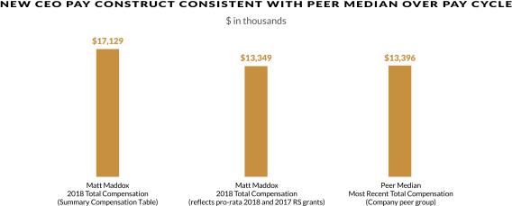

NON-DISCLOSURE OF CERTAIN METRICS AND TARGETS

The Company believes in transparency and strives to disclose as much information to shareholders as possible except in situations where we believe that providing full, or even limited, disclosure would be detrimental to the interests of shareholders. We believe certain disclosure could provide our competitors with insight regarding confidential business strategies without meaningfully adding to shareholders’ understanding of the metric.

WHY YOU SHOULD VOTE FOR THE 2019 SAY ON PAY

– Extensive shareholder outreach for feedback
– The Board’s response to 2018 Say-on-Pay, which included significant shareholder outreach and meaningful changes made in response to feedback
– CEO pay level consistent with peers and increased pay-for-performance linkage
– Re-set total compensation benchmark to median of peer group
– 85% of CEO compensation is at-risk; nearly two-thirds of incentives are long-term
– CEO stock ownership requirement is 10x annual base salary
– Annual incentive, based on pre-set goals, paid out 50% in equity
– Half of long-term equity is granted as PSUs, with vesting contingent on three-year performance period

Prior to the 2018 Annual Meeting, and again following the Company’s disappointing 2018 Say-on-Pay vote, members of the Board and management reached out to shareholders owning more than half of our outstanding shares to gather feedback. The Compensation Committee approved changes to the pay program that directly address the feedback received.

As a result of a reassessment of the executive compensation program, the Committee also confirmed its commitment to benchmark total compensation at median, and revamped the long-term incentive program to eliminate periodic grants and transition to annual grants, 50% of which will be granted as performance-based stock.

36 |

Table of Contents

As disclosed in the sections above, the executive compensation program is predicated on sound principles that clearly link compensation with performance. A significant percentage of CEO compensation is at risk, with nearly two-thirds of pay being long term. This coupled with robust stock ownership guidelines ensure that the interests of executives and long-term shareholders are aligned.

We believe the changes implemented this year represent significant strides toward designing a world-class compensation structure that rewards executives for actions that create sustainable returns and shareholder value. Our annual incentives are focused on operational excellence and initiatives that align with our long-term strategy; paying 50% of annual incentives earned in equity sharpen the alignment of interests of executives with long-term shareholders. Our long-term incentives – 50% of which are granted as performance-based stock – reward executives in tandem with the creation of long-term value. The annual grants coupled with robust stock ownership guidelines ensure that executives are invested in ensuring the long-term viability of shareholder value.

OTHER ASPECTS OF OUR EXECUTIVE COMPENSATION

Role of the Compensation Consultant: The Compensation Committee has the authority to retain compensation consulting firms exclusively to assist it in the evaluation of senior executive officer and employee compensation and benefit programs. In 2018, the Compensation Committee retained Radford a nationally recognized independent compensation consulting firm, to assist in performing its duties. Radford does not provide services to the Company other than the advice on director and executive compensation that it may provide the Compensation Committee when requested. In 2018, Radford provided the Compensation Committee with a peer group review and competitive compensation analysis, in connection with the Compensation Committee’s review of compensation levels of our NEOs. The Compensation Committee retains sole responsibility for engaging its advisors.

Independence of the Compensation Consultant: The Compensation Committee has determined that Radford is independent and the services provided by Radford currently do not and during 2018 did not raise any conflict of interests. In reaching these conclusions, the Compensation Committee considered the factors set forth in Rule 10C-1 of the Exchange Act and applicable listing standards.

Employment Agreements: We have a longstanding practice of entering into multi-year employment agreements with our senior executive officers and senior management. We believe that employment agreements provide greater assurance of continuity and retention of critical creative and operating talent in a highly competitive industry. Employment agreements for our NEOs are approved by the Compensation Committee in consultation with the Compensation Committee’s independent compensation advisors, as needed. The employment agreements for the NEOs currently employed by the Company specify their base salary and provide that if the executive’s employment (i) terminates without cause at the Company’s election, (ii) is terminated by the executive following the Company’s material breach of the agreement or (iii) is terminated by the executive for good reason after a change in control, the executive will receive a separation payment as described in more detail under the heading “Potential Payments Upon Termination or Change in Control.” The employment agreements and the terms of equity awards also provide that vesting of some or all of an executive’s equity awards will accelerate upon certain events. Current employment agreements do not provide for any excise tax gross ups. We believe that providing for these benefits in these situations enhances the value of the business by preserving the continuity of management during potential change in control situations and by focusing our senior executives on our long-term priorities. Additional information regarding payments under these provisions is provided under the heading “Potential Payments Upon Termination or Change in Control.”

COMPENSATION COMMITTEE REPORT

We have reviewed and discussed the Compensation Discussion and Analysis required by Item 402(b) of Regulation S-K with the Company’s management. Based on such review and discussion, we have recommended to the Board that the Compensation Discussion and Analysis be included in this Proxy Statement.

Compensation Committee

Betsy S. Atkins, Chairperson
Richard J. Byrne

Margaret J. Myers

2019 PROXY STATEMENT | 37

Table of Contents

[THIS PAGE INTENTIONALLY LEFT BLANK]

38 |

Table of Contents


Table of Contents


Table of Contents
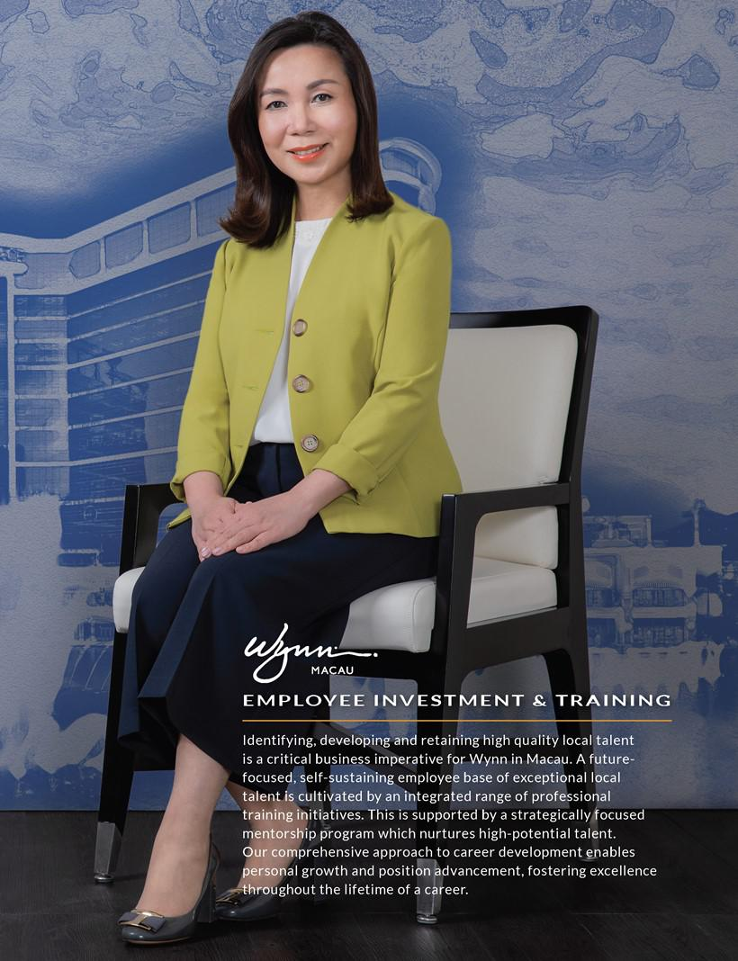

Table of Contents


Table of Contents

SUMMARY COMPENSATION TABLE

The table below summarizes the total compensation awarded to, earned by, or paid to, each of our NEOs for the fiscal years ended December 31, 2018, 2017 and 2016.

 |  |  |  |  |  |  |  |  | NON-EQUITY
 |  |  |  |  | STOCK |  | OPTION |  | INCENTIVE PLAN |  | ALL OTHER
NAME AND |  |  |  |  | AWARDS |  | AWARDS |  | COMPENSATION |  | COMPENSATION |  | TOTAL
PRINCIPAL POSITION | YEAR | SALARY ($) |  |  | ($)(1)(2) |  | ($)(2)(3) |  | ($)(4) |  | ($)(5) |  | ($)
Matt Maddox(6)
Chief Executive Officer and President | 2018 | $ | 1,901,923 | $ | 12,032,500 | $ | — | $ | 2,500,000 | $ | 694,760 | $ | 17,129,183
 | 2017 | $ | 1,500,000 | $ | 21,030,000 | $ | — | $ | 1,800,000 | $ | 486,633 | $ | 24,816,633
 | 2016 | $ | 1,500,000 | $ | 1,500,000 | $ | — | $ | 1,500,000 | $ | 114,703 | $ | 4,614,703
Craig Billings
Chief Financial Officer and Treasurer | 2018 | $ | 849,519 | $ | 5,641,250 | $ | — | $ | 875,000 | $ | 132,276 | $ | 7,498,045
 | 2017 | $ | 624,423 | $ | 3,981,300 | $ | — | $ | 900,000 | $ | 126,570 | $ | 5,632,293
Ellen F. Whittemore(7)
EVP, General Counsel and Secretary | 2018 | $ | 253,846 | $ | 1,421,550 | $ | — | $ | 300,000 | $ | 14,150 | $ | 1,989,546
Stephen A. Wynn(8)
Former Chief Executive Officer | 2018 | $ | 548,077 | $ | — | $ | — | $ | — | $ | 238,284 | $ | 786,361
 | 2017 | $ | 2,500,000 | $ | 15,000,000 | $ | — | $ | 15,000,000 | $ | 2,022,695 | $ | 34,522,695
 | 2016 | $ | 2,500,000 | $ | 12,500,000 | $ | — | $ | 12,500,000 | $ | 656,985 | $ | 28,156,985
Kimmarie Sinatra(9)
Former EVP, General Counsel and Secretary | 2018 | $ | 615,385 | $ | 568,323 | $ | 1,843,313 | $ | — | $ | 1,906,965 | $ | 4,933,986
 | 2017 | $ | 1,000,000 | $ | 10,815,000 | $ | — | $ | 1,200,000 | $ | 279,043 | $ | 13,294,043
 | 2016 | $ | 873,654 | $ | 850,000 | $ | — | $ | 850,000 | $ | 65,086 | $ | 2,638,740

- Stock awards granted as a component of the 2018, 2017 and 2016 annual incentive awards are reported in this column as 2018, 2017 and 2016 compensation, respectively, to reflect the applicable service period for such awards; however, stock grants for 2018 and 2016 were approved by the Compensation Committee in January of the following calendar year. Stock grants for 2017 were approved by the Compensation Committee in December 2017. See annual incentive award payouts as described in “Compensation Discussion and Analysis—How We Designed Incentives for 2018—Elements of Pay” for a description of the 2018 annual incentive awards. The amounts reported in 2018 for Mr. Maddox, Mr. Billings and Ms. Whittemore, reflect a portion from restricted stock grants which are not related to the annual incentive awards and were reported in the year of grant. 60% of the 2018 grants for Mr. Maddox, Mr. Billings and Ms. Whittemore vest based on specified performance criteria. The amounts for these performance-based awards reported in this column reflect the entire aggregate grant date fair value. The amount reported in 2018 for Ms. Sinatra relates to the incremental compensation from revaluing 10,715 shares of restricted stock that were accelerated and vested in full upon her separation from the Company.

- The amounts set forth in this column reflect the aggregate grant date fair value of stock awards computed in accordance with accounting standards for stock-based compensation. See our Annual Report on Form 10-K for the year ended December 31, 2018, Item 8, Note 11—“Stock-Based Compensation” to our Consolidated Financial Statements for assumptions used in computing fair value.

- The amount reported in 2018 for Ms. Sinatra relates to the incremental compensation from revaluing 25,000 stock options that were accelerated and vested in full upon her separation from the Company.

- As described above under “Compensation Discussion and Analysis—How We Designed Incentives for 2018—Elements of Pay,” in January 2019, the Compensation Committee exercised its discretion to pay 50% of the actual earned annual incentive for all NEOs in stock.

- The following amounts for 2018 are included in “All Other Compensation” for Mr. Maddox:

  - accrued cash dividends on unvested restricted stock of $662,500;

  - insurance premiums and benefits including executive life and medical insurance of $9,565;

  - reimbursement of taxes related to work performed in Massachusetts of $14,445; and

  - matching contributions made under the Company’s §401(k) Plan, which is generally available to our eligible employees, of $8,250.

The following amounts for 2018 are included in “All Other Compensation” for Mr. Billings:

- accrued cash dividends on unvested restricted stock of $122,250;

- insurance premiums for executive life insurance of $1,419;

- reimbursement of taxes related to work performed in Massachusetts of $357; and

- matching contributions made under the Company’s §401(k) Plan, which is generally available to our eligible employees, of $8,250. The following amounts for 2018 are included in “All Other Compensation” for Ms. Whittemore:
- accrued cash dividends on unvested restricted stock of $11,250;

- insurance premiums for executive life insurance of $907; and

- reimbursement of taxes related to work performed in Massachusetts of $1,993. The following amounts for 2018 are included in “All Other Compensation” for Mr. Wynn:
- personal use of Company aircraft of $87,725 (Mr. Wynn received no tax gross ups relating to the value of aircraft usage that is imputed to him as compensation);

- insurance premiums for executive life insurance of $5,150;

2019 PROXY STATEMENT | 39

Table of Contents

Executive compensation tables

- post-employment medical premiums of $51,942;

- allocated compensation and benefits for the personal use of a driver whom we employed for Mr. Wynn and the personal use of vehicles of $73,497;

- reimbursement of taxes related to work performed in Massachusetts of $19,553; and

- other compensation totaling $417.

The following amounts for 2018 are included in “All Other Compensation” for Ms. Sinatra:

  - accrued cash dividends on unvested restricted stock of $49,108;

  - insurance premiums for executive life insurance of $3,063;

  - post-employment medical premiums of $23,610;

  - reimbursement of taxes related to work performed in Massachusetts of $17,184; and

  - severance payments of $1,814,000.

- Mr. Maddox was appointed to serve as Chief Executive Officer effective February 6, 2018.

- Ms. Whittemore joined the Company as EVP, General Counsel and Secretary on July 16, 2018.

- Mr. Wynn resigned as Chairman of the Board and Chief Executive Officer effective February 6, 2018.

- Ms. Sinatra left the Company on August 3, 2018.

DISCUSSION OF SUMMARY COMPENSATION TABLE

In 2018, each of the NEOs received a base salary in accordance with the terms of his or her employment agreement, as approved by the Compensation Committee. Key terms of the agreements, as in effect on December 31, 2018, were as follows:

NAMED EXECUTIVE OFFICER

Matt Maddox

Craig Billings

Ellen F. Whittemore

Stephen A. Wynn

Kimmarie Sinatra

CONTRACT
EXPIRATION | BASE SALARY
2/27/21 | $ | 2,000,000
3/1/21 | $ | 875,000
7/16/22 | $ | 600,000
N/A(1) |  | N/A
N/A(2) |  | N/A

- Mr. Wynn left the Company on February 6, 2018.

- Ms. Sinatra left the Company on August 3, 2018.

Each of the employment agreements provide that the executive will participate in Company profit sharing and retirement plans if offered, disability or life insurance plans, medical and/or hospitalization plans, vacation and expense reimbursement programs. In addition, the agreements provide for severance payments and benefits upon certain terminations of employment, including termination following a change in control, as discussed in the section below entitled “Potential Payments Upon Termination or Change in Control.”

2018 GRANTS OF PLAN-BASED AWARDS TABLE

The Omnibus Plan rewards management for creation of superior return to shareholders, measured by the operating performance of our resorts. The amounts shown in the table below reflect potential payments. Actual payouts are reflected in the “Stock Awards” and “Non-Equity Incentive Plan” columns of the Summary Compensation table.

 |  |  |  |  |  |  |  | GRANT DATE
 |  |  |  |  |  | ALL OTHER STOCK |  | FAIR
 |  |  | ESTIMATED FUTURE PAYOUTS |  |  | AWARDS: |  | VALUE OF
 |  |  | UNDER NON-EQUITY |  |  | NUMBER OF |  | STOCK
 |  |  | INCENTIVE PLAN AWARDS ($)(1) |  |  | SHARES OF |  | AND OPTION
 | GRANT | THRESHOLD | TARGET |  | MAXIMUM | STOCK OR UNITS |  | AWARDS
NAMED EXECUTIVE OFFICER | DATE | ($)(3) | ($)(4) |  | ($)(5) |  | (#) | ($)(2)
Matt Maddox | N/A | $4,000,000 | $5,000,000 | $ | 6,000,000
 | 4/17/2018 |  |  |  |  | $ | 50,000(6) | $ 9,532,500
Craig Billings | N/A | $1,400,000 | $1,750,000 | $ | 2,100,000
 | 4/17/2018 |  |  |  |  | $ | 25,000(6) | $ 4,766,250
Ellen F. Whittemore | N/A | $ 480,000 | $ 600,000 | $ | 720,000
 | 8/2/2018 |  |  |  |  | $ | 7,500(7) | $ 1,121,550

40 |

Table of Contents

- The potential 2018 performance-based annual incentive awards that could have been earned for 2018 are subject to (a) the limitations set forth in the Omnibus Plan, including the cash and stock grant limits and continued employment through the end of the performance period, (b) the Compensation Committee’s ability to reduce awards in its discretion and (c) the Compensation Committee’s discretion to pay a portion of the awards in shares of Common Stock. Actual awards were based upon achievement of the 2018 performance criteria: (i) achievement of a 2018 Adjusted Property EBITDA goal; (ii) retention of specified third party recognition of quality and performance, and (iii) achievement of key strategic initiatives. Actual payouts are described in “Compensation Discussion and Analysis—How We Designed Incentives for 2018—Elements of Pay.”

- The amounts set forth in this column reflect the aggregate grant date fair value of stock awards computed in accordance with accounting standards for stock-based compensation. See our Annual Report on Form 10-K for the year ended December 31, 2018, Item 8, Note 11—“Stock-Based Compensation” to our Consolidated Financial Statements for assumptions used in computing fair value.

- Amounts in the Threshold column reflect potential awards for achievement of 2018 Adjusted Property EBITDA between $1.8 billion to $2.0 billion and achievement of goals 2 and 3. No awards would have been payable under goal 1 if the 2016 Adjusted Property EBITDA were below $1.0 billion.

- Amounts in the Target Column reflect potential awards for achievement of 2018 Adjustment Property EBITDA between $2.0 billion to $2.2 billion and achievement of goals 2 and 3.

- Amounts in the Maximum column reflect potential awards for achievement of 2018 Adjustment Property EBITDA of over $2.2 billion and achievement of goals 2 and 3.

- Mr. Maddox and Mr. Billings were granted 50,000 and 25,000 shares of restricted stock, respectively. The restricted stock awards provided that the shares would vest over each of the next five years ending March 1, 2023 subject to continued employment and 60% of which are subject to the achievement of pre-established property-level revenue and Adjusted Property EBITDA performance goals, provided that if the executive’s employment terminates before such date, certain accelerated vesting provisions may apply as described below under “Potential Payments upon Termination or Change in Control.”

- Ms. Whittemore was granted 7,500 shares of restricted stock. The restricted stock award provided that the shares would vest over each of the next four years ending July 15, 2022 subject to continued employment and 60% of which are subject to the achievement of pre-established property-level revenue and Adjusted Property EBITDA performance goals, provided that if the executive’s employment terminates before such date, certain accelerated vesting provisions may apply as described below under “Potential Payments upon Termination or Change in Control.”

OUTSTANDING EQUITY AWARDS AT FISCAL YEAR-END

 |  | OPTION AWARDS |  |  | STOCK AWARDS
 | NUMBER OF | NUMBER OF |  |  | NUMBER OF | MARKET VALUE
 | SECURITIES | SECURITIES |  |  | SHARES OR | OF SHARES OR
 | UNDERLYING | UNDERLYING |  |  | UNITS OF |  | UNITS OF
 | UNEXERCISED | UNEXERCISED | OPTION | OPTION | STOCK THAT |  | STOCK THAT
 | OPTIONS (#) | OPTIONS (#) | EXERCISE | EXPIRATION | HAVE NOT |  | HAVE NOT
NAME | EXERCISABLE | UNEXERCISABLE | PRICE ($) | DATE | VESTED (#) |  | VESTED ($)(5)
Matt Maddox(1) | 30,000 | 30,000 | $ 47.12 | 5/6/2019 | 250,000(2) | $ | 24,727,500
Craig Billings | — | — | — | — | 49,000(3) | $ | 4,846,590
Ellen F. Whittemore | — | — | — | — | 7,500(4) | $ | 741,825
Stephen A. Wynn | — | — | — | — | — | $ | —
Kimmarie Sinatra | — | — | — | — | — | $ | —

- 30,000 stock options will vest on May 6, 2019.

- 50,000 shares will vest on March 1, 2019, 2020 and 2021, subject to continued employment and the achievement of pre-established property-level revenue and Adjusted Property EBITDA performance goals. 40,000 shares will vest on November 4, 2020 and 2021 and 10,000 shares will vest on March 1, 2022 and 2023, all of which are subject to continued employment.

- 5,000 shares will vest on March 1, 2019, 2020 and 2021, subject to continued employment and the achievement of pre-established property-level revenue and Adjusted Property EBITDA performance goals. 6,000 shares will vest on March 1, 2019, 2020 and 2021; 11,000 shares will vest on March 1, 2022; and 5,000 shares will vest on March 1, 2023, all of which are subject to continued employment.

- 1,125 shares will vest on March 1, 2019, 2020, 2021 and 2022, subject to continued employment and the achievement of pre-established property-level revenue and Adjusted Property EBITDA performance goals. 1,000 shares will vest on July 15, 2020, 2021 and 2022 subject to continued employment.

- Amounts in this column are based upon the closing price of the Company’s stock at December 31, 2018, which was $98.91.

All vesting is conditioned upon such NEOs being an employee of the Company on the vesting date, except as discussed below under “Potential Payments Upon Termination or Change in Control.”

OPTION EXERCISES AND STOCK VESTED IN 2018

 | OPTION AWARDS |  |  | STOCK AWARDS
 | NUMBER OF SHARES | VALUE REALIZED |  | NUMBER OF SHARES | VALUE REALIZED
NAME | ACQUIRED ON EXERCISE (#) | ON EXERCISE ($) |  | ACQUIRED ON VESTING (#)(1) |  | ON VESTING ($)
Matt Maddox | 25,000 | $ | 2,083,417 | — | $ | —
Craig Billings | — |  | — | 6,000 | $ | 980,520
Kimmarie Sinatra | 75,000 | $ | 7,309,953 | 39,286 | $ | 5,861,078

- Ms. Sinatra’s shares represent the total shares that vested effective August 3, 2018 in connection with her separation from the Company. 6,000 of Mr. Billings 30,000 shares granted on March 1, 2017 vested on March 1, 2018.

The amounts reported in the table above are based on the closing price of the Company’s Common Stock on the date the stock award vested. Upon vesting of the stock award, the executive also was paid an amount equal to the dividends that had accrued on the shares prior to their vesting.

2019 PROXY STATEMENT | 41

Table of Contents

Executive compensation tables

POTENTIAL PAYMENTS UPON TERMINATION OR CHANGE IN CONTROL

Payments Made Upon Termination Due to Death, Complete Disability or License Revocation. The Company’s employment agreements with its current NEOs provide that such agreements terminate automatically upon death or complete disability of the employee, as well as upon failure of the employee to obtain or maintain any required gaming licenses. Upon such termination, such NEO is entitled to a lump sum payment of accrued and unpaid base salary and vacation pay through the termination date. Pursuant to the terms of the applicable stock option agreements and restricted stock grant agreements, all of the unvested options and restricted stock held by such NEOs would vest upon termination as a result of such NEO’s death or complete disability.

Payments Made Upon Termination Without Cause at Employer’s Election or at Employee’s Election Upon Material Breach During the Term. The Company’s employment agreements with its current NEOs provide that such agreements are terminable by the Company without cause upon notice to the employee, so long as a “separation payment” is paid as provided in such contracts, or by the employee upon written notice to the Company of the Company’s uncured material breach of the agreement. Cause is generally defined to include (i) inability or failure to secure and/or maintain any licenses or permits required by government agencies with jurisdiction over the business of the Company or its affiliates; (ii) willful destruction of property of the Company or an affiliate having a material value to the Company or such affiliate; (iii) fraud, embezzlement, theft, or comparable dishonest activity (excluding acts involving a de minimis dollar value and not related in any manner to the Company, its affiliates or their business); (iv) conviction of or entering a plea of guilty or nolo contendere to any crime constituting a felony; (v) material breach of employment agreement; (vi) neglect, refusal, or knowing failure to materially discharge duties (other than due to physical or mental illness) commensurate with title and function, or failure to comply with the lawful directions of the Company or its board; (vii) knowing material misrepresentation to the Company or its board of directors; (viii) failure to follow a material policy or procedure of the Company or an affiliate; or (ix) material breach of a statutory or common law duty of loyalty or fiduciary duty to the Company or an affiliate. Material breach is defined as

- the Company’s failure to pay the employee’s base salary when due, (ii) the Company’s material reduction in the scope in the employee’s duties and responsibilities such that the employee’s remaining duties and responsibilities are materially inconsistent with duties and responsibilities generally associated with the employee’s position with the Company, or (iii) a material reduction in the employee’s base salary.

The “separation payment” for all current NEOs equals the sum of (a) base salary for the remainder of the term of the employment agreement, but not less than 12 months (except for Mr. Maddox which is not less than 18 months); (b) bonus projected for all bonus periods through the end of the term of the employment agreement (based upon the last bonus paid pursuant to the employment agreement), but not less than the preceding bonus that was paid; and (c) any accrued but unpaid vacation pay.

If Mr. Maddox, Mr. Billings or Ms. Whittemore is terminated without cause or resigns following the Company’s material breach of his or her employment agreement, then as a condition to receiving such separation payment, he/she must execute a written release-severance agreement that (1) releases the Company, its affiliates, and their officers, directors, agents and employees, from any claims or causes of action, and (2) provides that the terminated employee may not disclose either the terms of the release-severance agreement or the compensation paid. In addition, the NEOs are entitled to health benefits coverage under the same plan or arrangement as such NEO was covered immediately prior to termination. Health benefits are to be provided until the earlier of the remainder of the original term, or until the employee is covered by a plan of another employer. Pursuant to the terms of the applicable restricted stock grant agreements, all of the unvested restricted stock held by such NEOs would vest pro rata for the number of months served since the grant date upon termination by the Company without “cause” or by the employee upon the Company’s material breach.

Payments Made Upon Termination by Employee for Good Reason after Change in Control. The Company’s employment agreements with its current NEOs provide that such agreements are terminable by the employee for good reason after a change of control. A change of control is defined as (a) any person or group becomes the beneficial owner of more than 50% of the Company’s outstanding securities, (b) the existing directors of the Company (including those elected in the normal course and not including those elected as a result of an actual or threatened election contest) cease to constitute a majority of the Board of the Company, or (c) the consummation of a merger, consolidation or reorganization to which the Company is a party or the sale or disposition of substantially all of the assets of the Company. Good reason is defined as: (i) reduction of employee’s base salary; (ii) discontinuation of employer’s bonus plan without immediately replacing such bonus plan with a plan that is the substantial economic equivalent of such bonus plan, or amends such bonus plan so as to materially reduce employee’s potential bonus at any given level of economic performance of employer or its successor entity; (iii) material reduction in the aggregate benefits and perquisites to employee; (iv) requirement that such employee change the location of his or her job or office by a distance of more than 25 miles; (v) reduction of responsibilities or required reporting to a person of lower rank or responsibilities; or (vi) a successor’s failure to expressly assume in writing the employment agreement.

42 |

Table of Contents

Upon termination by the employee pursuant to this provision, the employee is entitled to the “separation payment” described under “Payments Made Upon Termination Without Cause at Employer’s Election During the Term” above. Pursuant to the terms of the applicable stock option agreements, some or all of the unvested options held by the applicable current NEOs would immediately vest upon termination by the Company without cause or upon termination by the employee for good reason after a change of control. Pursuant to the terms of the applicable restricted stock grant agreements, all of the unvested restricted stock held by such NEOs would vest upon termination for “good reason” following a “change of control.”

Payments Made Upon Termination. The tables below reflect the amount of compensation that would become payable to each of our current NEOs under existing agreements and arrangements if the NEO’s employment had terminated on December 31, 2018, given the NEO’s compensation as of such date and, if applicable, based on the Company’s closing stock price on that date. These benefits are in addition to benefits available prior to the occurrence of any termination of employment, including benefits generally available to all salaried employees, such as distributions under the Company’s 401(k) plan. In addition, in connection with any actual termination of employment, the Compensation Committee may determine to enter into an agreement or to establish an arrangement providing additional benefits or amounts, or altering the terms of benefits described below, as the Compensation Committee determines appropriate. The actual amounts that would be paid upon an NEO’s termination of employment can only be determined at the time of such executive’s separation from the Company. Due to the number of factors that affect the nature and amount of any benefits provided upon the events discussed below, any actual amounts paid or distributed may be higher or lower than reported below. Factors that could affect these amounts include the timing during the year of any such event and the Company’s stock price.

Matt Maddox

 |  |  | TERMINATION |  | TERMINATION BY
 | TERMINATION UPON |  | WITHOUT CAUSE OR |  | EMPLOYEE FOR GOOD
 | DEATH OR COMPLETE |  | UPON MATERIAL |  | REASON AFTER
 |  | DISABILITY |  | BREACH | CHANGE IN CONTROL
Base Salary | Amounts earned and
 | unpaid through the
 | date of termination |  | $ | 4,333,333 | $ | 4,333,333
Bonus |  | — | $ | 10,833,333 | $ | 10,833,333
Stock Options/Restricted Stock(1)(2)(3) | $ | 28,797,400 | $ | 10,356,784 | $ | 27,243,700
Company Paid Life Insurance | $ | 2,000,000 |  | — |  | —
Benefits(4) |  | — | $ | 34,872 | $ | 34,872

- As of December 31, 2018, vested stock options of 30,000 were available for exercise. Using the closing price on December 31, 2018, the value of such vested shares would have been $1,553,700. Upon death or complete disability, unvested stock options of 30,000 would vest in full immediately. Using the closing price on December 31, 2018, the value of such stock options upon exercise would have been $1,533,700.

- Upon death, complete disability or change in control, 250,000 shares of restricted stock would vest in full immediately. Using the closing price on December 31, 2018, the value of such 250,000 shares would have been $24,727,500, plus accrued dividends of $962,500.

- Upon termination without cause or upon the Company’s material breach, 85,467 shares of restricted stock would vest on a prorated basis based on the number of months since the grant date. Using the closing price on December 31, 2018, the value of such 85,467 shares would have been $8,453,540, plus accrued dividends of $349,446.

- Continued health benefits for remainder of the term or until covered by another plan.

Craig Billings

 |  |  | TERMINATION |  | TERMINATION BY
 | TERMINATION UPON |  | WITHOUT CAUSE OR |  | EMPLOYEE FOR GOOD
 | DEATH OR COMPLETE |  | UPON MATERIAL |  | REASON AFTER
 | DISABILITY |  |  | BREACH | CHANGE IN CONTROL
Base Salary | Amounts earned and
 | unpaid through the
 | date of termination |  | $ | 1,895,833 | $ | 1,895,833
Bonus |  | — | $ | 3,791,667 | $ | 3,791,667
Stock Options/Restricted Stock(1)(2) | $ | 5,004,840 | $ | 1,256,636 | $ | 5,004,840
Company Paid Life Insurance | $ | 875,000 |  | — |  | —
Benefits(3) |  | — | $ | 34,872 | $ | 34,872

- Upon death, complete disability or change in control, 49,000 shares of restricted stock would vest in full immediately. Using the closing price on December 31, 2018, the value of such 49,000 shares would have been $4,846,590, plus accrued dividends of $158,250.

- Upon termination without cause or upon the Company’s material breach, 12,248 shares of restricted stock would vest on a prorated basis based on the number of months since the grant date. Using the closing price on December 31, 2018, the value of such 12,248 shares would have been $1,211,450, plus accrued dividends of $45,159.

- Continued health benefits for remainder of the term or until covered by another plan.

2019 PROXY STATEMENT | 43

Table of Contents

Executive compensation tables

Ellen F. Whittemore

 |  | TERMINATION |  |  | TERMINATION BY
 | TERMINATION UPON | WITHOUT CAUSE OR |  |  | EMPLOYEE FOR GOOD
 | DEATH OR COMPLETE | UPON MATERIAL |  |  | REASON AFTER
 | DISABILITY |  | BREACH |  | CHANGE IN CONTROL
Base Salary | Amounts earned and
 | unpaid through the
 | date of termination | $ | 2,125,000 | $ | 2,125,000
Bonus | — | $ | 2,125,000 | $ | 2,125,000
Stock Options/Restricted Stock(1)(2) | $753,075 | $ | 65,485 | $ | 753,075
Company Paid Life Insurance | $600,000 |  | — |  | —
Benefits(3) | — | $ | 58,205 | $ | 58,205

- Upon death, complete disability or change in control, 7,500 shares of restricted stock would vest in full immediately. Using the closing price on December 31, 2018, the value of such 7,500 shares would have been $741,825, plus accrued dividends of $11,250.

- Upon termination without cause or upon the Company’s material breach, 652 shares of restricted stock would vest on a prorated basis based on the number of months since the grant date. Using the closing price on December 31, 2018, the value of such 652 shares would have been $64,489, plus accrued dividends of $978.

- Continued health benefits for remainder of the term or until covered by another plan.

Stephen A. Wynn

On February 6, 2018, Mr. Wynn resigned from his position as the Company’s Chairman and Chief Executive Officer, effective immediately. Mr. Wynn did not receive any severance payment or other compensation in connection with his resignation. On February 15, 2018, the Company entered into a separation agreement among the Company, Mr. Wynn, and Wynn Resorts Holdings, LLC (the “Separation Agreement”) specifying the terms of Mr. Wynn’s termination of service with the Company and confirmed that Mr. Wynn was not entitled to any severance payment or other compensation from the Company. Under the Separation Agreement, Mr. Wynn agreed not to compete against the Company for a period of two years and to provide reasonable cooperation and assistance to the Company in connection with any private litigation or arbitration and to the Board of Directors of the Company or any committee of the Board in connection with any investigation by the Company related to his service with the Company. The Separation Agreement provided that (i) Mr. Wynn’s lease of his personal residence at Wynn Las Vegas would terminate not later than June 1, 2018 and until such date Mr. Wynn would continue to pay rent at the fair market value (Please refer to “Certain Relationships and Related Transactions”), unless Mr. Wynn elected to terminate the lease before such date,

- Mr. Wynn’s healthcare coverage would terminate on December 31, 2018 (for the related amount, please refer to “All Other Compensation” in the “Summary Compensation Table”), and (iii) administrative support for Mr. Wynn will terminate on May 31, 2018. Additionally, in order to conduct any sales of Company shares in an orderly fashion, with Mr. Wynn to reimburse the Company for its reasonable expenses, the Company entered into a registration rights agreement with Mr. Wynn. For related amounts, please refer to the section titled ‘Summary Compensation Table.

Kimmarie Sinatra

Kimmarie Sinatra ceased to serve as the Company’s Executive Vice President, General Counsel and Secretary, effective July 15, 2018. On August 3, 2018, the Company entered into an agreement with Ms. Sinatra (the “Agreement”) to finalize the terms of her transition and departure. The Agreement provided to Ms. Sinatra: (1) a cash payment of $1,814,000; (2) continued participation in the Company’s senior executive health program through December 31, 2018 (for the related amount, please refer to “All Other Compensation” in the “Summary Compensation Table”); and (3) health care benefits coverage for Ms. Sinatra and her dependents which shall be paid for by the Company until the expiration of Ms. Sinatra’s continuation coverage under the Consolidated Omnibus Budget Reconciliation Act of 1985, which is estimated to be $43,243. In addition, 39,286 unvested shares granted to Ms. Sinatra under a Restricted Stock Agreement with a total fair value of $5,861,078 and 25,000 unvested stock options granted to Ms. Sinatra under a Stock Option Agreement with a total intrinsic value of $2,551,750, respectively, vested on August 3, 2018; and the transfer restriction with respect to the vested shares granted to Ms. Sinatra in January 2016 was removed as of August 3, 2018. Pursuant to the Agreement, Ms. Sinatra granted a waiver and release of claims to the Company and agreed to certain non-competition and confidentiality provisions. For related amounts, please refer to the section titled ‘Summary Compensation Table.

44 |

Table of Contents

Certain relationships and transactions

B U I L D I N G T H E N E W W Y N N

Pursuant to written Company policy, the Audit Committee reviews for approval or ratification all transactions with any related person, which SEC rules define to include directors, director nominees, executive officers, beneficial owners of in excess of 5% of the outstanding shares of the Company’s Common Stock, and their respective immediate family members. The policy classifies as pre-approved: (a) employment of executive officers and director compensation if the compensation is required to be reported under Item 402 of Regulation S-K; (b) transactions with another company or charitable contributions if the related person’s only relationship is as an employee (other than executive officer), director or beneficial owner of less than 10% of that company’s or donee’s shares if the aggregate amount does not exceed the greater of $200,000 or 5% of that company’s or donee’s total annual revenues; (c) transactions where the related person’s interest arises solely from the ownership of the Company’s stock and all shareholders benefit on a pro rata basis; (d) transactions involving competitive bids; (e) regulated transactions involving services as a common carrier or public utility at rates fixed in conformity with law or governmental authority; and (f) transactions with related parties involving a bank as depositary of funds, transfer agent, registrar, trustee under a trust indenture or similar services. The Audit Committee receives notice of the occurrence of all pre-approved transactions. All other transactions with related persons are subject to approval or ratification by the Audit Committee. In determining whether to approve or ratify a transaction, the Audit Committee will take into account, among other factors it deems appropriate, whether the transaction is on terms no less favorable than terms generally available to an unaffiliated third-party under the same or similar circumstances and the extent of the related person’s interest in the transaction.

The following are the material transactions or agreements that occurred or were in effect at any time after January 1, 2018, between the Company and related persons. The Audit Committee has approved or ratified all of these transactions that occurred after the date of the adoption of the policy.

CURRENT

Cooperation Agreement. On August 3, 2018, the Company entered into a Cooperation Agreement (the “Cooperation Agreement”) with Elaine P. Wynn (“Ms. Wynn”) regarding the composition of the Company’s Board and certain other matters, including, among other things, the appointment of Mr. Satre to the Board, standstill restrictions, releases, non-disparagement, reimbursement of expenses, and the grant of certain complimentary privileges. The term of the Cooperation Agreement expires on the day after the conclusion of the 2020 annual meeting of the Company’s shareholders, unless earlier terminated pursuant to the circumstances described in the Cooperation Agreement.

Reimbursable Costs. The Company periodically provides services to certain executive officers, directors, or former directors of the Company, including the personal use of employees, construction work and other personal services, for which the officers, directors, or former directors reimburse the Company. The Company requires prepayment for any such services, which amounts are replenished on an ongoing basis as needed. As of December 31, 2018, these net deposit balances with the Company were immaterial, as were the services provided.

Other. In addition to the above, the Company (or its subsidiaries) employs Mary Ann Pascal, the sister-in-law of Ms. Wynn (who is a beneficial owner of in excess of 5% of the outstanding shares of the Company’s Common Stock), as Vice President—Player Development at Wynn Las Vegas. The Audit Committee of the Company approved the employment arrangement in advance and determined that compensation was at (or below) levels paid to non-family members. Total compensation paid to Ms. Pascal for 2018 included the following amounts calculated in the same manner as the Summary Compensation Table values presented for NEOs: salary (includes retroactive pay related to her salary increase from $200,000 to $250,000 in May 2017 which was not paid until 2018) of $281,731, bonus of $100,575, and other compensation of $7,609. Ms. Pascal’s annual base salary for 2019 is $250,000.

TERMINATED IN 2018

Shareholders Agreement. On January 6, 2010, Mr. Wynn, Ms. Wynn, and Aruze USA, Inc. (“Aruze”), each of whom were then greater than 5% shareholders of the Company, entered into an amended and restated shareholders agreement (the “Shareholders Agreement”), pursuant to which each of Mr. Wynn,
Ms. Wynn and Aruze agreed to vote all shares of the Company held by them and subject to the terms of the Amended and Restated Stockholders Agreement in a manner so as to elect to the Company’s Board of Directors each of the nominees contained on each and every slate of directors endorsed by Mr. Wynn, to include, subject to certain conditions, Ms. Wynn and, so long as such

2019 PROXY STATEMENT | 45

Table of Contents

Certain relationships and transactions

slate results in a majority of directors at all times being candidates endorsed by Mr. Wynn, nominees approved by Aruze. Pursuant to an agreement, dated March 8, 2018, settling certain litigation between the Company and Aruze, Aruze agreed not to claim that Aruze remains a party to the Shareholders Agreement. On March 14, 2018, Mr. Wynn and Ms. Wynn entered into a stipulation declaring the Shareholders Agreement invalid and unenforceable, and on April 16, 2018, the Company entered into a Settlement Agreement and Mutual Release by and between the Company, Mr. Wynn, Ms. Wynn and Ms. Sinatra, which, among other things, resolved and unconditionally released the parties from all claims and cross claims asserted among the parties in a legal proceeding involving the Shareholders Agreement.

As a result of Mr. Wynn’s resignation and the Separation Agreement described under Potential Payments Upon Termination or Change of Control, above, an aircraft purchase option that gave Mr. Wynn the right to purchase any or all of the aircraft owned by the Company or its direct wholly owned subsidiaries terminated on February 6, 2018. Further, under the parties’ Surname Rights Agreement, Mr. Wynn granted the Company an exclusive, fully paid-up, perpetual, worldwide license to use, and to own and register trademarks and service marks incorporating the “Wynn” surname for casino resorts and related businesses, together with the right to sublicense the name and marks to its affiliates. Pursuant to the Separation Agreement, if the Company ceases to use the “Wynn” surname and trademark, the Company will assign all of its right, title, and interest in the “Wynn” trademark to Mr. Wynn and terminate the Surname Rights Agreement. The lease of Mr. Wynn’s residence was terminated by agreement of the parties on April 10, 2018.

On March 20, 2018, the Company entered into a registration rights agreement with Mr. Wynn, the Wynn Family Limited Partnership, a Delaware limited partnership (together with Mr. Wynn, the “Selling Stockholder”) and each holder from time to time a party thereto (the “Registration Rights Agreement”), pursuant to the Separation Agreement. The Selling Stockholder subsequently sold all of its holdings of the Company’s common stock through open market transactions pursuant to Rule 144 under the Securities Act of 1933, as amended, and certain privately negotiated transactions. Pursuant to the Registration Rights Agreement, without the Company’s prior written consent, the Selling Stockholder was not permitted to sell more than an aggregate of 4,043,903 shares of Common Stock in any quarter. The Company provided written consent permitting the Selling Stockholder to undertake the registered sales.

46 |

Table of Contents

Pay ratio disclosure

B U I L D I N G T H E N E W W Y N N

The SEC’s rules for identifying the median compensated employee and calculating the pay ratio based on that employee’s annual total compensation allow companies to adopt a variety of methodologies, to apply certain exclusions, and to make reasonable estimates and assumptions that reflect their employee populations and compensation practices. As a result, the pay ratio reported by other companies may not be comparable to the pay ratio reported below, as other companies may have different employee populations and compensation practices and may utilize different methodologies, exclusions, estimates and assumptions in calculating their own pay ratios.

The pay ratio reported below is a reasonable estimate calculated in a manner consistent with SEC rules based on our payroll records and the methodology described below. For these purposes, in 2017, we determined the median compensated employee using taxable income for 2017, which we annualized for any employee who did not work for the entire year unless designated as a temporary employee. We determined that, as of December 31, 2017, our employee population consisted of approximately 25,200 employees, with approximately 52% working in Macau as an employee of Wynn Macau, Limited or one of its subsidiaries. In identifying the median employee, we made a cost-of-living adjustment using the International Monetary Fund’s implied purchasing power conversion rate of 5.49 with respect to employees located in Macau. Using this methodology, we determined that the median employee in 2017 was a full-time, salaried employee located in Las Vegas. As permitted by the SEC rules, we are using the same median employee for our 2018 ratio because we did not believe that this employee’s compensation had changed significantly or that our employee population had changed significantly in 2018.

The 2018 annual total compensation of our median compensated employee, other than our 2018 CEO, was $44,492; the 2018 annual total compensation of our CEO serving as of December 31, 2018, Mr. Maddox, was $17,227,260; and the ratio of these amounts was 1-to-387.

Because we had two non-concurrent CEOs serving during our fiscal year 2018, to calculate the annual total compensation of the CEO for the purposes of this disclosure, we looked to the CEO serving in that position as of December 31, 2018, Mr. Maddox, and annualized his compensation. To identify the median employee without a cost-of-living adjustment, we converted the compensation paid in Macau currency to U.S. dollars by applying a Macau patacas to U.S. dollars exchange rate using the noon buying rate of exchange of Macau patacas to U.S. dollars of 8.0664 on December 31, 2018. For 2018, we did not identify a new median employee for the reasons described above. The 2018 annual total compensation of our median compensated employee, other than our CEO serving as of December 31, 2018, without the cost-of-living adjustment was $40,503; and the ratio of this amount to Mr. Maddox’s 2018 annual total compensation was 1-to-425.

We believe the employee population for gaming and hospitality industries includes a large percentage of “steady extra workers”. These are permanent workers who are paid hourly and obtain hours based on business volumes (e.g., coverage during peak times such as when large conventions are in town) and personal needs of the employee. As of December 31, 2018, approximately 13% of our employee population of approximately 26,000 consisted of steady extra workers, most of whom are eligible for medical and other benefits. Based on SEC’s rules, these permanent workers are included in the employee population used in calculating the median employee compensation and may impact comparability of our median employee compensation amount with that in other industries.

Our talented and dedicated employees play an integral role in our overall success and we place great emphasis on creating an environment for our employees to excel and advance. We are committed to the development, health and well-being of our workforce through various programs, benefits and amenities. Please refer to “Our People and Our Stewardship” for additional information.

2019 PROXY STATEMENT | 47

Table of Contents

Security ownership

B U I L D I N G T H E N E W W Y N N

CERTAIN BENEFICIAL OWNERSHIP AND MANAGEMENT

The following table sets forth, as of March 11, 2019, (unless otherwise indicated), certain information regarding the shares of the Company’s Common Stock beneficially owned by: (i) each director; (ii) each shareholder who is known by the Company to beneficially own in excess of 5% of the outstanding shares of the Company’s Common Stock; (iii) each of the Company’s named executive officers; and (iv) all executive officers and directors as a group. Each shareholder’s percentage is based on 107,639,329 shares of Common Stock outstanding as of March 11, 2019, and treating as outstanding all options held by that shareholder and exercisable within 60 days of March 11, 2019.

 | BENEFICIAL OWNERSHIP OF SHARES(1)
NAME AND ADDRESS OF BENEFICIAL OWNER(2) | NUMBER | PERCENTAGE
5% Shareholders:
The Vanguard Group(3)
100 Vanguard Blvd.
Malvern, PA 19355 | 9,684,316 | 9.0%
Elaine P. Wynn(4)
c/o Elaine P. Wynn and Family Foundation
3800 Howard Hughes Parkway
Suite 960
Las Vegas, Nevada 89169 | 9,539,077 | 8.9%
Capital Group Companies Inc(5)
333 SO Hope St 55TH FL
Los Angeles, CA 90071 | 8,253,146 | 7.7%
T-Rowe Price Associates Inc.(6)
100 East Pratt St.
Baltimore, MD 21202 | 7,154,817 | 6.6%
Blackrock Inc.(7)
55 East 52nd St.
New York, NY 10055 | 6,187,633 | 5.7%
Lone Pine Capital LLC(8)
Two Greenwich Plaza
Greenwich, CT 06830 | 5,955,497 | 5.5%
Named Executive Officers and Directors:
Philip G. Satre | 11,995 | *
Betsy S. Atkins(9) | 3,309 | *
Richard J. Byrne | 2,000 | *
Margaret J. Myers(10) | 3,309 | *
Winifred M. Webb(11) | 3,309 | *
Jay L. Johnson(12) | 13,461 | *
Patricia Mulroy(13) | 13,794 | *
Clark T. Randt, Jr.(14) | 13,020 | *
Matt Maddox(15) | 478,824 | *
Craig Billings(16) | 70,201 | *
Ellen Whittemore(17) | 15,434 | *
Kimmarie Sinatra(18) | 149,620 | *
Stephen A. Wynn(19) | — | —
All current directors and executive officers as a group (11 persons)(20) | 628,656 | *

* Less than one percent

- This table is based upon information supplied by officers, directors, and nominees for director, and contained in Schedules 13D and 13G filed with the SEC. Unless otherwise indicated in the footnotes to this table and subject to community property laws, where applicable, the Company believes each of the shareholders named in this table has sole voting and investment power with respect to the shares indicated as beneficially owned. Executives and directors have voting power over shares of restricted stock, but cannot transfer such shares unless and until they vest.

- Unless otherwise indicated, the address of each of the named parties in this table is: c/o Wynn Resorts, Limited, 3131 Las Vegas Boulevard South, Las Vegas, Nevada 89109.

48 |

Table of Contents

- The Vanguard Group (“Vanguard”) has beneficial ownership of these shares as of December 31, 2018. Vanguard has sole dispositive power as to 9,541,856 shares, sole voting power as to 120,648 shares, shared voting power as to 23,987 shares and shared dispositive power as to 142,460 shares. The information provided is based upon a Schedule 13G/A filed on February 11, 2019 by Vanguard. The number of common shares beneficially owned by the Vanguard Group may have changed since the filing of the Schedule 13G/A.

- The information provided is based upon a Schedule 13D/A, dated August 6, 2018, filed by Elaine P. Wynn.

- Based on Schedules 13F filed on February 14, 2019 by Capital Research Global Investors, Capital World Investors, Capital International Inc, Capital Guardian Trust Co, Capital Bank & Trust Co, Capital International Investors, Capital International SARL, and Capital International Ltd. None of these related funds reported in any filed Schedule 13F beneficial ownership as aggregated with all other related funds, and may disclaim beneficial ownership of the shares held by some or all related funds. None of these related funds individually held in excess of 5% of the outstanding shares of the Company’s common stock.

- T. Rowe Price Associates, Inc. (“Price Associates”) has beneficial ownership of these shares as of December 31, 2018. Price Associates has sole dispositive power as to 7,154,817 shares, and sole voting power as to 2,679,781 shares. The information provided is based upon a Schedule 13G filed on February 14, 2019 by Price Associates. The number of common shares beneficially owned by Price Associates may have changed since the filing of the Schedule 13G.

- Blackrock, Inc. (“Blackrock”) has beneficial ownership of these shares as of December 31, 2018. Blackrock has sole dispositive power as to 6,187,633 shares, and sole voting power as to 5,495,530 shares. The information provided is based upon a Schedule 13G filed on February 8, 2019 by Blackrock. The number of common shares beneficially owned by Blackrock may have changed since the filing of the Schedule 13G.

- Lone Pine Capital LLC (“Lone Pine”) has beneficial ownership of these shares as of December 31, 2018. Lone Pine has sole dispositive power and sole voting power as to 5,955,497 shares. The information provided is based upon a Schedule 13G filed on September 10, 2018 by Lone Pine and a schedule 13F which indicated no changes as of December 31, 2018. The number of common shares beneficially owned by Lone Pine may have changed since the filing of the Schedule 13G.

- Includes 1,309 shares of unvested restricted stock subject to vesting in accordance with a Restricted Stock Agreement.

- Includes 1,309 shares of unvested restricted stock subject to vesting in accordance with a Restricted Stock Agreement.

- Includes 1,309 shares of unvested restricted stock subject to vesting in accordance with a Restricted Stock Agreement.

- Includes (i) 2,923 shares of unvested restricted stock subject to vesting in accordance with a Restricted Stock Agreement and (ii) 10,000 shares subject to immediately exercisable options to purchase Wynn Resorts’ Common Stock.

- Includes (i) 4,203 shares of unvested restricted stock subject to vesting in accordance with a Restricted Stock Agreement, (ii) 6,700 shares subject to immediately exercisable options to purchase Wynn Resorts’ Common Stock and (iii) 2,891 shares held indirectly through a family trust.

- Includes (i) 4,203 shares of unvested restricted stock subject to vesting in accordance with a Restricted Stock Agreement and (ii) 7,000 shares subject to immediately exercisable options to purchase Wynn Resorts’ Common Stock.

- Includes (i) 252,842 shares of unvested restricted stock subject to vesting in accordance with Restricted Stock Agreements and (ii) 30,000 shares subject to options to purchase Wynn Resorts’ Common Stock that become exercisable on May 6, 2019.

- Includes 52,092 shares of unvested restricted stock subject to vesting in accordance with a Restricted Stock Agreement.

- Includes 12,981 shares of unvested restricted stock subject to vesting in accordance with a Restricted Stock Agreement.

- Ms. Sinatra left the Company effective July 15, 2018. The information provided is based on the Company’s records as of July 15, 2018.

- The information provided is based upon a Schedule 13D/A, dated March 22, 2018, filed by Mr. Wynn and Wynn Family Limited Partnership (collectively, the “Selling Shareholder”). The Selling Shareholder reported that on March 21, 2018, it sold an aggregate of 4,104,999 shares of Common Stock at a price of $180.00 per share in open market transactions pursuant to Rule 144 under the Security Act of 1933, as amended. On or around March 28, 2018, the Selling Shareholder completed its sales of 3,026,708 shares of Common Stock at a price of $175.00 per share to T. Rowe Price Associates, Inc. and 5,000,000 shares of Common Stock at a price of $175.00 per share to certain funds managed or advised by Capital Research and Management Company. Upon completion of these sales, the Selling Shareholder had no remaining holdings of Common Stock.

- Includes (i) 23,700 shares subject to immediately exercisable stock options to purchase Wynn Resorts’ Common Stock and (ii) 30,000 shares subject to options to purchase Wynn Resorts’ Common Stock that become exercisable on May 6, 2019.

SECTION 16(A) BENEFICIAL OWNERSHIP REPORTING COMPLIANCE

Section 16(a) of the Exchange Act requires the Company’s executive officers and directors and persons who own more than 10% of the Company’s Common Stock to file reports of ownership on Forms 3, 4 and 5 with the SEC. Executive officers, directors and greater than 10% beneficial owners are also required to furnish the Company with copies of all Forms 3, 4 and 5 they file. Based solely on the Company’s review of the copies of such forms it has received, the Company believes that all its executive officers, directors and greater than 10% beneficial owners complied with all the filing requirements applicable to them with respect to transactions during 2018.

2019 PROXY STATEMENT | 49

Table of Contents

[THIS PAGE INTENTIONALLY LEFT BLANK]

50 |

Table of Contents


Table of Contents


Table of Contents


Table of Contents


Table of Contents

PROPOSAL 1: ELECTION OF DIRECTORS

At the recommendation of the Company’s Nominating and Corporate Governance Committee, the Board is nominating the following individuals for election as
Class II directors:

– Jay L. Johnson
– Margaret J. Myers
– Winifred M. Webb

The Board has nominated the three individuals listed above to serve as Class II directors for terms that commence upon election at the 2019 Annual Meeting. If elected at the 2019 Annual Meeting, each nominee would serve until the 2022 Annual Meeting and until his or her successor has been duly elected and qualified, or until his or her earlier death, resignation, removal or retirement. The persons designated as proxies will have discretion to cast votes for other persons in the event any nominee for director is unable to serve, or the Board may choose to reduce the size of the Board. At present, it is not anticipated that any nominee will be unable to serve. Biographical and other information for our nominees and our current directors is provided in the “Director Biographies” section.

OUR BOARD OF DIRECTORS RECOMMENDS THAT YOU VOTE FOR THE ELECTION OF THE NOMINEES LISTED ABOVE.

PROPOSAL 2: RATIFICATION OF APPOINTMENT OF INDEPENDENT AUDITORS

The Audit Committee of the Board has selected Ernst & Young LLP, a registered public accounting firm, as our independent auditors to examine and report to our shareholders on the consolidated financial statements of our Company and its subsidiaries for the fiscal year ending December 31, 2019. Representatives of Ernst & Young LLP will be present at the Annual Meeting and will be given an opportunity to make a statement. They also will be available to respond to appropriate questions.

As a matter of good corporate governance, the Audit Committee has determined to seek shareholder ratification of its selection of Ernst & Young LLP as the Company’s independent auditors, although this is not required under Nevada law the Company’s Articles or Bylaws, SEC rules or applicable listing standards. If the shareholders do not ratify the selection of Ernst & Young LLP as the Company’s independent auditors for 2019, the Audit Committee will evaluate what would be in the best interests of the Company and its shareholders and consider whether to select new independent auditors. Even if the shareholders ratify the selection of Ernst & Young LLP, the Audit Committee, in its discretion, may direct the appointment of a different independent public accounting firm at any time during the year if the Audit Committee determines that such a change would be in the best interests of the Company and its shareholders.

AUDIT AND OTHER FEES

The following table presents the aggregate fees billed (or expected to be billed) to the Company for audit and other services provided by Ernst & Young LLP, the Company’s independent auditor for each of the fiscal years ended December 31, 2018, and December 31, 2017:

 |  | AGGREGATE FEES
CATEGORY |  | 2018 |  | 2017
Audit fees | $ | 3,006,975 | $ | 2,912,000
Audit-related fees | $ | 43,980 | $ | 42,000
Tax fees | $ | 502,650 | $ | 323,000
All other fees |  | — |  | —

“Audit fees” includes the aggregate fees for professional services rendered for the reviews of our consolidated financial statements for the quarterly periods ended March 31, June 30 and September 30, for the audit of our consolidated financial statements and the consolidated financial statements of certain of our subsidiaries for the years ended December 31, 2018 and 2017, and for the audit of our internal controls over financial reporting as of December 31, 2018 and 2017. “Audit fees” also include fees for services provided in connection with securities

2019 PROXY STATEMENT | 51

Table of Contents

Items to be voted on

offerings, audit-related accounting consultations and statutory audits of certain subsidiaries of the Company. “Audit-related fees” include the aggregate fees for the audit of the Company’s defined contribution employee benefit plan. “Tax fees” include fees for domestic tax planning and other research.

PRE-APPROVAL POLICY

The Audit Committee’s policy is to pre-approve all audit and non-audit services provided by the independent registered public accountants by pre-approving certain types of services at usual and customary rates. These services may include audit services, audit-related services, tax services and other permissible non-audit services. The pre-approval authority details the particular service or category of service that the independent registered public accountants will perform. Management reports to the Audit Committee on the actual fees charged by the independent registered public accountants for each category of service.

During the year, circumstances may arise when it becomes necessary to engage the independent registered public accountants for additional services not contemplated in the original pre-approval authority. In those instances, management submits a request to the Audit Committee describing a specific project at a specific fee or rate and, if deemed appropriate and necessary, the Audit Committee approves the services before we engage the independent registered public accountants.

The Audit Committee pre-approved all fees related to services provided by Ernst & Young LLP in 2018.

REPORT OF THE AUDIT COMMITTEE

The Audit Committee is comprised of the three members named below. As required by our committee charter, each member of the Audit Committee has been determined to be an independent director, as defined under the NASDAQ listing rules and the rules of SEC. In addition, the Board has determined that two of the three committee members (Mr. Byrne and Ms. Webb) are Audit Committee financial experts, as defined by SEC rules.

During 2018, we held nine full committee meetings.

Our purpose and responsibilities are set forth in our committee charter, which is approved and adopted by the Board and is available on the Company’s website at http://www.wynnresorts.com under the heading “Corporate Governance” on the Company Information page. The Audit Committee charter is reviewed and updated, as appropriate, to address changes in regulatory requirements, authoritative guidance, evolving oversight practices and investor feedback.

Our role is to oversee, on behalf of the Board, the accounting and financial reporting processes of the Company and the audits of the Company’s financial statements, including review of the Company’s guidelines and policies with respect to risk assessment and risk management related to financial reporting and internal controls, major financial risk exposures of the Company and the steps the Company’s management has taken to monitor and control such exposures. The Company’s management is responsible for the preparation, presentation and integrity of our financial statements, and for maintaining appropriate accounting and financial reporting principles and policies, and internal controls and procedures that are reasonably designed to assure compliance with accounting standards and applicable laws and regulations. The independent auditors are responsible for auditing our financial statements and expressing an opinion as to their conformity with generally accepted accounting principles in the United States of America and for auditing and providing an attestation report on the effectiveness of our internal control over financial reporting.

In fulfilling our oversight duties, at each regular quarterly meeting of the Audit Committee, we met separately in executive session with Ernst & Young LLP, our independent registered public accountants, as well with each of the Company’s General Counsel, Chief Audit Executive (who heads internal audit), Chief Financial Officer, and Chief Compliance Officer. During these meetings, we discussed the quality of the Company’s accounting and financial reporting processes and the adequacy and effectiveness of its internal controls and procedures; reviewed significant audit findings prepared by each of the independent registered public accountants and internal audit department, together with management’s responses; reviewed the overall scope and plans for the audits by the internal audit department and the independent registered public accountants; reviewed critical accounting policies and the significant estimates and judgments management used in preparing the financial statements and their appropriateness for the Company’s business and current circumstances; and reviewed each Company press release concerning Company earnings prior to its release.

52 |

Table of Contents

Ernst & Young LLP has served as the Company’s independent registered public accountants since 2006. In evaluating and selecting the Company’s independent registered public accounting firm, we consider, among other things, the historical and recent performance of our current firm, the firm’s global reach, external data on audit quality and performance, including Public Company Accounting Oversight Board (“PCAOB”) reports, industry experience, audit fee revenues, firm capabilities and audit approach, and the independence and tenure of the accounting firm. As discussed above, we have engaged Ernst & Young LLP to serve as our independent registered public accountants for the year ending December 31, 2019.

In addition to the activities discussed above, prior to the Company’s filing of its Annual Report on Form 10-K for the year ended December 31, 2018 with the SEC, we reviewed and discussed with management the Company’s audited financial statements for the year ended December 31, 2018. We discussed with the independent registered public accounting firm the matters required to be discussed by the applicable standards of the PCAOB, including the quality, not just the acceptability, of the accounting principles, the reasonableness of significant judgments and the clarity of the disclosures in the financial statements.

We received the written disclosures and the letter from the independent auditors required by applicable requirements of the PCAOB regarding the independent auditors’ communications with the audit committee concerning independence and have discussed with the independent auditors their firm’s independence. Based on the review and discussions described in this report, we recommended to the Board that the audited financial statements referred to above be included in the Company’s Annual Report on Form 10-K for the year ended December 31, 2018, filed with the SEC.

Audit Committee

Winifred M. Webb, Chairperson
Richard J. Byrne

Patricia Mulroy

OUR BOARD OF DIRECTORS RECOMMENDS THAT YOU VOTE FOR THE RATIFICATION OF THE APPOINTMENT OF ERNST & YOUNG LLP AS THE COMPANY’S INDEPENDENT AUDITORS FOR THE YEAR 2019.

PROPOSAL 3: ADVISORY VOTE TO APPROVE THE COMPENSATION OF NAMED EXECUTIVE OFFICERS

In accordance with Section 14A of the Exchange Act (which was added by the Dodd-Frank Wall Street Reform and Consumer Protection Act (the “Dodd Frank Act”)) and the related rules of the SEC, the Company will present a resolution at the Annual Meeting to enable our shareholders to approve, on an advisory and non-binding basis, the compensation of our NEOs as disclosed in the Compensation Discussion and Analysis, the accompanying compensation tables and the related narrative disclosure in this Proxy Statement.

This proposal, commonly known as a “Say-on-Pay” proposal, allows our shareholders the opportunity to express their views on our NEOs’ compensation. In considering this proposal, we urge shareholders to read the Compensation Discussion and Analysis, the accompanying compensation tables and the related narrative disclosure. Although this vote is advisory only, and therefore non-binding, the Board and the Compensation Committee will review and evaluate the voting result when considering future executive compensation decisions.

As the Company continues its transition from a compensation program oriented around a founder whose long-term focus was aligned with shareholders through his extensive stock ownership, to a more traditional compensation program, the Board determined to move from a triannual to an annual Say-on-Pay vote to provide for additional input from and further engagement with our shareholders. The Compensation Committee determined to right-size executive pay, to revamp our long-term incentive program to eliminate periodic grants and transition to annual grants, and to ensure that a majority of equity awards will be granted in performance-based stock to ensure a superior focus on operational excellence and better align executives’ interests with those of long-term shareholders.

As described in detail in the Compensation Discussion and Analysis, the majority of our executives’ total compensation is at-risk, tied to achieving annual and long-term goals that enhance the value of our reputation and brand, sustain the performance and attractiveness of our resorts and drive long-term shareholder value. In 2018, the Compensation Committee committed to right-sizing executive compensation by benchmarking total compensation at the median of our peer group. Because product quality and service excellence are at the core of our

2019 PROXY STATEMENT | 53

Table of Contents

Items to be voted on

strategy, we use annually focused, operations-based pay to reflect the critical importance of performing well each year for each customer. The design of our long-term incentives coupled with robust stock ownership guidelines ensure that our executives’ interests are aligned with those of long-term shareholders.

Therefore, in accordance with Section 14A of the Exchange Act and as a matter of good corporate governance, we are asking shareholders to approve the following advisory resolution at the Annual Meeting:

“RESOLVED, that the shareholders of Wynn Resorts, Limited (the “Company”) approve, on an advisory basis, the compensation of the Company’s named executive officers as disclosed in the Compensation Discussion and Analysis and the tabular disclosure regarding each named executive officer’s compensation (together with the accompanying narrative disclosure) in the Proxy Statement for the 2019 Annual Meeting of Shareholders.”

OUR BOARD OF DIRECTORS RECOMMENDS THAT YOU VOTE FOR THE APPROVAL OF THE ADVISORY RESOLUTION ON OUR NAMED EXECUTIVE OFFICE COMPENSATION.

PROPOSAL 4: SHAREHOLDER PROPOSAL REQUESTING A POLITICAL CONTRIBUTIONS REPORT

The Company has been advised that the New York State Common Retirement Fund, 59 Maiden Lane, 30th Floor, New York, NY 10038, the beneficial owner of 210,500 shares as of October 30, 2018, intends to submit the following proposal for consideration at the Annual Meeting:

“Resolved, that the shareholders of Wynn Resorts, Limited (‘the Company’) hereby request that the Company provide a public report, updated semiannually, disclosing the Company’s:

- Policies and procedures for making, with corporate funds or assets, contributions and expenditures (direct or indirect) to (a) participate or intervene in any political campaign on behalf of (or in opposition to) any candidate for public office, or (b) influence the general public, or any segment thereof, with respect to an election or referendum.

- Monetary and non-monetary contributions and expenditures (direct and indirect) used in the manner described in section 1 above, including:

- The identity of the recipient as well as the amount paid to each; and

- The title(s) of the person(s) in the Company responsible for decision-making.

The report shall be presented to the board of directors or relevant board committee and posted on the Company’s website within 12 months from the date of the annual meeting. This proposal does not encompass lobbying spending.”

SUPPORTING STATEMENT OF THE NEW YORK STATE COMMON RETIREMENT FUND

“As long-term shareholders of Wynn Resorts, Limited, we support transparency and accountability in corporate spending on political activities. These include any activities considered intervention in any political campaign under the Internal Revenue Code, such as direct and indirect contributions to political candidates, parties, or organizations; independent expenditures; or electioneering communications on behalf of federal, state or local candidates.

Disclosure is in the best interest of the company and its shareholders. Moreover, the Supreme Court’s Citizens United decision recognized the importance of political spending disclosure for shareholders when it said, ‘[D]isclosure permits citizens and shareholders to react to the speech of corporate entities in a proper way. This transparency enables the electorate to make informed decisions and give proper weight to different speakers and messages.’ Gaps in transparency and accountability may expose the company to reputational and business ricks that could threaten long-term shareholder value.

54 |

Table of Contents

Relying on publicly available data does not provide a complete picture of the Company’s political spending. For example, the Company’s payments to trade associations used for political activities are undisclosed and unknown. In some cases, even management does not know how trade associations use their company’s money politically. The proposal asks the Company to disclose all of its political spending, including payments to trade associations and other tax-exempt organizations used for political purposes. This would bring our Company in line with a growing number of leading companies that support political disclosure and accountability and present this information on their websites.

The Company’s Board and its shareholders need comprehensive disclosure to be able to fully evaluate the political use of corporate assets. We urge your support for this critical governance reform.”

THE BOARD OF DIRECTORS’ STATEMENT IN OPPOSITION

After careful consideration, the Board of Directors recommends that shareholders vote AGAINST this proposal for the following reasons:

The very same proposal from the same proponent was defeated by the Company’s shareholders at the 2014, 2015, 2016, 2017, and 2018 annual meetings of shareholders. Each time, the Company’s shareholders rejected this proposal with 73.9%, 80.0%, 85.4%, 70.3% and 63.3%, respectively, of votes cast voting against the proposal.

The Company operates in a highly regulated industry, and the decisions of federal, state, and local governments can significantly impact the Company. Therefore, the Board believes that it is critical that the Company participate in the political process to protect its business interests and its shareholders’ interests. The Company is committed to participating in the political process as a good corporate citizen, in full compliance with applicable laws. Accordingly, the Company has adopted the Political Contributions Policy (the “Policy”), which is available on our investor relations website at https://wynnresortslimited.gcs-web.com/political-contributions-policy. In addition to the Company’s Code of Business Conduct and Ethics, the Policy governs the Company’s consideration of political activities, including the Company’s political contributions at the federal, state, and local levels, and the Company’s membership in trade associations.

Under the Policy, the Company’s political contributions at the federal, state, and local levels are subject to an extensive internal review process designed to confirm their compliance with applicable contribution limits and regulations, and that all political contributions are to promote the business interests of the Company. Recognizing that the Company likely will not agree with every position a candidate takes, the Company’s government affairs team meets with a candidate prior to making significant contributions to determine whether supporting the candidate is in the best interests of the Company and its shareholders. In addition, the Company reports to the Audit Committee on its political contributions on a periodic basis.

The Company also believes that it provides sufficient transparency with respect to its political contributions. The Company’s participation in political activities includes contributions to federal elections through Wynn Resorts, Limited Initiative for Public Policy, a separate, segregated fund for the purposes of soliciting and accepting political contributions (“Wynn PAC”). In compliance with federal law, Wynn PAC files regular reports with the Federal Election Commission (the “FEC”) to disclose political contributions by Wynn PAC. These reports are publicly available on the FEC website. In addition, reports regarding the Company’s specific political contributions in various jurisdictions are publicly available at each jurisdiction’s official website.

From time to time, the Company pays annual membership dues to industry trade associations. The trade associations in which the Company participates may engage in political activities, but such decisions are governed by those associations’ respective bylaws. Thus, even when the Company participates in trade associations, the Company does not control how they use membership dues. The Company expects these trade associations to comply with applicable laws with respect to their political activities. As such, the Board believes that additional disclosures regarding the specific payments made to these trade associations would not benefit shareholders.

Moreover, the Company believes that the adoption of this proposal could put our company at a disadvantage relative to our competitors, who are not only not required to disclose this information, but may also be able to discern the Company’s public policy and political strategies and implement strategies opposed to the Company’s public policy goals if we made the disclosures requested by the proposal. We believe that any additional political contribution reporting requirements that go beyond those required under existing law should be applicable to all participants engaged in the political process, rather than to us alone, as the proposal requests.

2019 PROXY STATEMENT | 55

Table of Contents

Items to be voted on

In sum, the Company already discloses sufficient information regarding its political contributions and already has an appropriate system of oversight in place, including the Policy, to confirm that the Company’s political contributions comply with applicable law and are in the best, long-term interests of the Company and its shareholders. Accordingly, the Board believes that preparing an additional report as requested by the proposal would be an unnecessary and imprudent use of the Company’s time and resources.

OUR BOARD OF DIRECTORS UNANIMOUSLY RECOMMENDS THAT YOU VOTE AGAINST THE SHAREHOLDER PROPOSAL REQUESTING A POLITICAL CONTRIBUTIONS REPORT.

56 |

Table of Contents

General information

B U I L D I N G T H E N E W W Y N N

OUR 2019 ANNUAL MEETING OF SHAREHOLDERS

This Proxy Statement is furnished to the shareholders of Wynn Resorts in connection with the solicitation by the Board of proxies for its 2019 Annual Meeting of Shareholders (the “Annual Meeting”) to be held on May 7, 2019, at the Encore Theater at Wynn Las Vegas, 3131 Las Vegas Boulevard South, Las Vegas, Nevada 89109, at 9:00 am (local time), and at any adjournments or postponements thereof. Our principal executive offices are 3131 Las Vegas Boulevard South, Las Vegas, Nevada 89109. Matters to be considered and acted upon at the Annual Meeting are set forth in the Notice of Annual Meeting of Shareholders accompanying this Proxy Statement and are more fully described herein.

The Board recommends a vote as follows:

PROPOSAL |  | BOARD
NUMBER | PROPOSAL | RECOMMENDATION
1 | Election of the three Class II director nominees named in this Proxy Statement to serve until the 2022 Annual Meeting of Shareholders | “FOR” each nominee
2 | Ratification of the appointment of Ernst & Young LLP as our independent registered public accounting firm for the fiscal year ending December 31, 2019 | “FOR”
3 | Approval, on a non-binding advisory basis, of the compensation of our named executive officers as described in this Proxy Statement | “FOR”
4 | Vote on a shareholder proposal requesting a political contributions report, if properly presented | “AGAINST”

VOTING AND SOLICITATION

Only holders of record of shares of the Company’s common stock, par value $0.01 (“Common Stock”), as of the close of business on March 11, 2019, the record date fixed by the Board (the “Record Date”), are entitled to notice of, and to vote at, the Annual Meeting and at any adjournments or postponements thereof. As of the Record Date, there were 107,639,329 shares of Common Stock outstanding. Each shareholder is entitled to one vote for each share of Common Stock held as of the Record Date on all matters presented at the Annual Meeting.

At least a majority of the outstanding shares of Common Stock must be represented at the Annual Meeting, in person or by proxy, to constitute a quorum and to transact business at the Annual Meeting. Abstentions, broker non-votes and “withhold” votes are counted for purposes determining whether there is a quorum.

A plurality of the votes cast in person or by proxy at the Annual Meeting is required for the election of the director nominees. Shares as to which a shareholder withholds voting authority and broker non-votes, which are described below, will not affect the outcome of the election.

For each other item to be acted upon at the Annual Meeting (Proposals 2, 3 and 4), the item will be approved if the number of votes cast in favor of the item by the shareholders entitled to vote exceeds the number of votes cast in opposition to the item. Abstentions and broker non-votes will not be counted as votes cast on an item and, therefore, will not affect the outcome of these proposals. Shares represented by properly executed and unrevoked proxies will be voted at the Annual Meeting in accordance with the directions of shareholders indicated in their proxies. If no specification is made, shares represented by properly executed and unrevoked proxies will be voted in accordance with the specific recommendations of the Board set forth above. If any other matter properly comes before the Annual Meeting, the shares will be voted in the discretion of the persons voting pursuant to the respective proxies.

For a shareholder who holds his or her shares through an intermediary, such as a broker, bank or other nominee (referred to as “beneficial owners”), such intermediary will not be permitted to vote on Proposal 1 (the election of directors), Proposal 3 (approval of the compensation of our named executive officers (known as a “Say-on-Pay” vote)) or Proposal 4 (the shareholder proposal) if the shareholder does not provide the intermediary with applicable voting instructions (this situation is called a “broker non-vote”). Accordingly, we encourage you to vote your shares on all matters being considered at the Annual Meeting. Notwithstanding the occurrence of a broker non-vote, the intermediary may still vote the shareholder’s shares on Proposal 2 (ratification of Ernst & Young LLP as our independent auditor).

2019 PROXY STATEMENT | 57

Table of Contents

General information

The following table summarizes the voting requirements to elect directors and to approve each of the proposals in this Proxy Statement:

PROPOSAL |  |  | BROKER DISCRETIONARY
NUMBER | PROPOSAL | VOTE REQUIRED | VOTING ALLOWED
1 | Election of the three Class II directors | Plurality of votes cast | No
2 | Ratification of Ernst & Young LLP | Majority of shares represented at meeting in person or by proxy and entitled to
 |  | vote | Yes
3 |  | Majority of shares represented at meeting in person or by proxy and entitled to
 | Advisory Vote to Approve the Compensation of Named Executive Officers | vote | No
4 | Vote on a shareholder proposal requesting a political contributions report, if | Majority of shares represented at meeting in person or by proxy and entitled to
 | properly presented | vote | No

HOW YOU CAN VOTE

Shareholders of Record. For shareholders of record, there are four different ways you can vote:

- By Internet. To vote via the Internet, use the website on the enclosed proxy card.

- By Telephone. To vote by telephone, call the toll-free number on the enclosed proxy card.

- By Mail. To vote by mail, follow the instructions on the enclosed proxy card.

- In Person. To vote in person, you must attend the Annual Meeting as instructed below and follow the procedures for voting announced at the Annual Meeting.

The Internet and telephone voting procedures are designed to authenticate your identity, to allow you to vote your shares and to confirm that your voting instructions have been properly recorded. Specific instructions are set forth on the enclosed proxy card. In order to be timely processed, an Internet or telephone vote must be received by 11:59 p.m. Eastern Time on May 6, 2019. Regardless of the method you choose, your vote is important. Please vote by following the specific instructions on your proxy card.

Beneficial Shareholders. For shareholders who own shares of the Company’s Common Stock through an intermediary, such as a broker, bank or other nominee, the ultimate intermediary is the shareholder of record but will vote your shares in accordance with your instructions. In order to have your shares voted, you will need to follow the instructions for voting provided by your broker, bank or other nominee.

REVOCABILITY OF PROXIES

Shareholders of Record. If you are a shareholder of record and you deliver a proxy pursuant to this solicitation, you may revoke that proxy at any time before it is voted by (a) giving written notice to our Corporate Secretary at the address set forth below, (b) delivering to our Corporate Secretary a later dated proxy, (c) submitting another proxy by telephone or over the Internet (your latest telephone or Internet voting instructions are followed), or (d) voting in person at the Annual Meeting. Written notice of revocation or subsequent proxy should be sent to:

Wynn Resorts, Limited
c/o Corporate Secretary
3131 Las Vegas Boulevard South

Las Vegas, Nevada 89109

Beneficial Shareholders. If your shares are held through an intermediary, such as a bank, broker or other nominee, you must contact that person if you wish to revoke previously given voting instructions. In this case, attendance at the Annual Meeting, in and of itself, does not revoke a prior proxy.

ATTENDING THE ANNUAL MEETING

Shareholders of Record. For shareholders of record, a government-issued photo identification that matches the shareholder’s name on the Company’s stock ledger as of the close of business on the Record Date must be presented to attend the Annual Meeting.

Beneficial Shareholders. For shareholders who own shares of the Company’s Common Stock through an intermediary, such as a broker, bank or other nominee, satisfactory proof of ownership of the Company’s Common Stock as of the close of business on the Record Date must be

58 |

Table of Contents

presented to attend the Annual Meeting. Satisfactory proof of ownership consists of a government-issued photo identification and a document that includes the shareholder’s name and confirms ownership as of the Record Date, such as (a) a copy of a voting instruction form that was mailed to the shareholder or (b) a valid, legal proxy signed by the record holder.

Persons who are not shareholders will be entitled to admission only if they have a valid legal proxy from a record holder and government-issued photo identification. Each shareholder may appoint only one proxyholder to attend on his or her behalf.

Notice of Internet Availability of Proxy Materials. Under rules adopted by the U.S. Securities and Exchange Commission (the “SEC”), we are furnishing proxy materials to some shareholders via the Internet, instead of mailing printed copies of those materials to each shareholder. On or about March 27, 2019, we mailed to shareholders either a printed copy of our Annual Meeting materials or a Notice of Internet Availability containing instructions on how to access our Annual Meeting materials, including this Proxy Statement and our Annual Report for the fiscal year ending December 31, 2018. The Notice of Internet Availability also explains how to vote through the Internet or by telephone.

This electronic access process expedites shareholders’ receipt of our Annual Meeting materials, lowers the cost of our Annual Meeting and conserves natural resources. However, if you would prefer to receive a printed copy of our Annual Meeting materials, a paper proxy card or voting instructions card, please follow the instructions included in the Notice of Internet Availability. If you have previously elected to receive our Annual Meeting materials electronically or by mail, you will continue to receive these materials in that format unless you elect otherwise.

PROXY PROCEDURE AND EXPENSES OF SOLICITATION

We will retain an independent tabulator to receive and tabulate the proxies and an inspector of elections will certify the results. In addition, we have engaged Innisfree M&A Incorporated (“Innisfree“), a professional proxy solicitation firm, to assist in the solicitation of proxies for the Annual Meeting. The Company has agreed to pay Innisfree a fee of $17,500, plus reimbursement for out of pocket expenses. The address of Innisfree is 501 Madison Avenue, 20th Floor, New York, New York 10022. If you need assistance in completing your proxy card or have questions regarding the Annual Meeting, please contact Innisfree toll-free at (888) 750-5834.

All expenses incurred in connection with the solicitation of proxies will be borne by us. We will also reimburse banks, brokers and other nominees for their expenses in forwarding proxy materials to beneficial owners of Common Stock held in their names.

Solicitation may be undertaken by mail, telephone, personal contact or other similar means by directors, officers and employees without additional compensation.

SHAREHOLDER PROPOSALS

Shareholders intending to present a proposal at the 2020 Annual Meeting of Shareholders for inclusion in our proxy statement for that meeting pursuant to Rule 14a-8 of the Exchange Act must submit the proposal in writing to Wynn Resorts, Limited, Attention: Corporate Secretary, 3131 Las Vegas Boulevard South, Las Vegas, Nevada 89109. Such proposals must comply with the requirements of Rule 14a-8 of the Exchange Act and must be received by the Company no later than November 28, 2019.

In addition, our Bylaws provide notice procedures for shareholders to nominate a person as a director and to propose business to be considered by shareholders at a meeting when nomination and/or the other business are not submitted for inclusion in the Company’s proxy statement. Generally, notice of a nomination or proposal not submitted pursuant to Rule 14a-8 must be delivered to us not later than the close of business on the 90th day, nor earlier than the close of business on the 120th day, prior to the first anniversary of the preceding year’s annual meeting. However, if the date of the annual meeting is more than 30 days before or more than 70 days after such anniversary date, notice must be delivered to us not earlier than the close of business on the 120th day prior to such annual meeting date and not later than the close of business on the later of the 90th day prior to such annual meeting or the 10th day following the day on which public announcement of the date of such meeting is first made.

Accordingly, for our 2020 Annual Meeting, notice of a nomination or proposal must be delivered to us no later than February 7, 2020 and no earlier than January 8, 2020. Nominations and proposals also must satisfy other requirements set forth in the Bylaws. If a shareholder complies with the forgoing notice provisions and with certain additional procedural requirements in the Bylaws and SEC rules, the Company will have authority to vote shares under proxies we solicit when and if the nomination or proposal is raised at the Annual Meeting. The Chairman of the Board may refuse to acknowledge the introduction of any shareholder proposal not made in compliance with the foregoing procedures.

2019 PROXY STATEMENT | 59

Table of Contents

General information

ANNUAL REPORT

Our financial statements for the year ended December 31, 2018, are included in our 2018 Annual Report to Shareholders, which we are providing to our shareholders at the same time as this Proxy Statement. Our Annual Report and this Proxy Statement are also posted on the Internet at http://www.wynnresorts.com on the Company Information page under the “Annual Meeting” heading. If you would like to receive a printed copy of these materials, please call our Investor Relations department at (702) 770-7555 or send a written request to the Company at Wynn Resorts, Limited, c/o Investor Relations, 3131 Las Vegas Boulevard South, Las Vegas, Nevada 89109, and we will send a copy to you without charge.

HOUSEHOLDING

Shareholders who are beneficial owners, but not the record holders, of the Company’s securities and share a single address may receive only one copy of the Company’s proxy materials, unless the broker, bank or other nominee delivering the materials has received contrary instructions from one or more of the shareholders. The Company will deliver promptly, upon written or oral request, a separate copy of the proxy materials to a shareholder at a shared address to which a single copy of the document was delivered. A shareholder who wishes to receive a separate copy of the proxy materials, now or in the future, should submit his or her request to the Company by telephone at (702) 770-7555 or by submitting a written request to Wynn Resorts, Limited, c/o Investor Relations, 3131 Las Vegas Boulevard South, Las Vegas, Nevada 89109. Beneficial owners sharing an address who are receiving multiple copies of the proxy materials and wish to receive a single copy of such materials in the future will need to contact their broker, bank or other nominee to request that only a single copy be mailed to all shareholders at the shared address in the future.

OTHER BUSINESS

The Company is not aware of any other matters to be presented at the Annual Meeting. If any other matters should properly come before the Annual Meeting, the persons named in the proxy will vote the executed proxies on such matters as they determine appropriate in their discretion.

60 |

Table of Contents


Table of Contents


Table of Contents
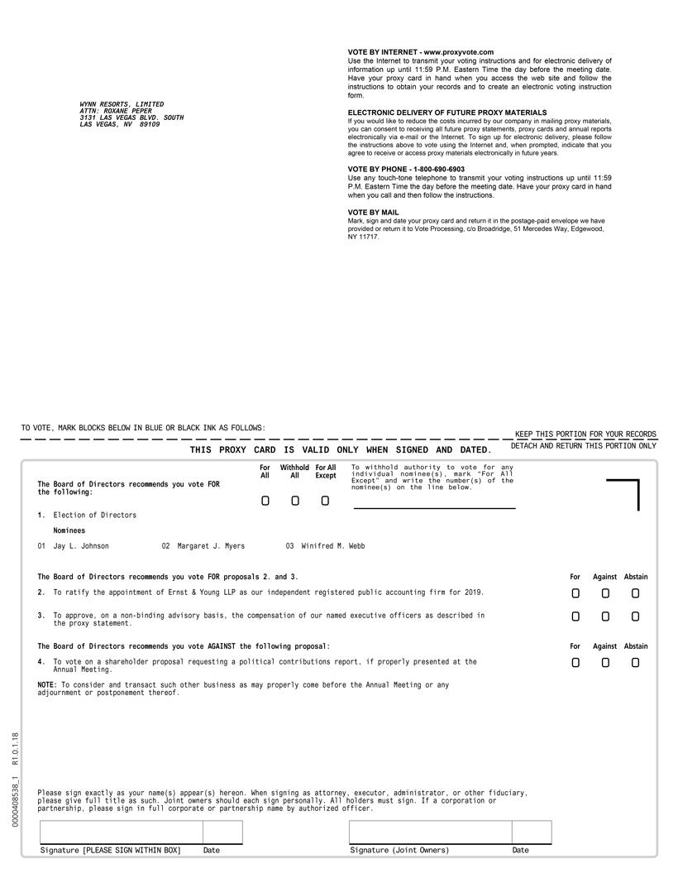

Table of Contents


