UNITED STATES
SECURITIES AND EXCHANGE COMMISSION
Washington, D.C. 20549

FORM 8-K

CURRENT REPORT
PURSUANT TO SECTION 13 OR 15(d)
OF THE SECURITIES EXCHANGE ACT OF 1934
Date of Report (Date of earliest event reported): October 23, 2026

WYNN RESORTS, LIMITED
(Exact name of registrant as specified in its charter)

Nevada |  |  |  |  |  | 000-50028 |  |  | 46-0484987
(State or other jurisdiction  of incorporation) |  |  |  |  |  | (Commission  File Number) |  |  | (I.R.S. Employer  Identification No.)
3131 Las Vegas Boulevard South
Las Vegas, |  |  | Nevada |  |  |  |  |  | 89109
(Address of principal executive offices) |  |  |  |  |  |  |  |  | (Zip Code)

(702) 770-7555
(Registrant’s telephone number, including area code)
Not Applicable
(Former name or former address, if changed since last report)

Securities registered pursuant to Section 12(b) of the Act:
Title of each class |  |  |  |  |  | Trading Symbol(s) |  |  |  |  |  | Name of each exchange on which registered
Common stock, par value $0.01 |  |  |  |  |  | WYNN |  |  |  |  |  | Nasdaq Global Select Market

Check the appropriate box below if the Form 8-K filing is intended to simultaneously satisfy the filing obligation of the registrant under any of the following provisions:
☐ Written communications pursuant to Rule 425 under the Securities Act (17 CFR 230.425)
☐ Soliciting material pursuant to Rule 14a-12 under the Exchange Act (17 CFR 240.14a-12)
☐ Pre-commencement communications pursuant to Rule 14d-2(b) under the Exchange Act (17 CFR 240.14d-2(b))
☐ Pre-commencement communications pursuant to Rule 13e-4(c) under the Exchange Act (17 CFR 240.13e-4(c))
Indicate by check mark whether the registrant is an emerging growth company as defined in Rule 405 of the Securities Act of 1933 (§230.405 of this chapter) or Rule 12b-2 of the Securities Exchange Act of 1934 (§240.12b-2 of this chapter).
Emerging growth company ☐
If an emerging growth company, indicate by check mark if the registrant has elected not to use the extended transition period for complying with any new or revised financial accounting standards provided pursuant to Section 13(a) of the Exchange Act. ☐

Item 7.01 |  |  | Regulation FD Disclosure.

On October 23, 2026, Wynn Macau, Limited ("WML"), an indirect subsidiary of Wynn Resorts, Limited (the "Registrant") with its ordinary shares of common stock listed on The Stock Exchange of Hong Kong Limited (the "HKSE"), filed with the HKSE an announcement that Wynn Resorts (Macau) S.A. ("Wynn Macau" or the "Subscriber"), an indirect subsidiary of Wynn Resorts, Limited (the "Registrant"), with Macau Project Management (No. 2) Limited (the "General Partner"), a limited liability company established by the Macau government entered into a subscription agreement (the "Subscription Agreement"), pursuant to which the Wynn Macau agrees to commit capital investment of up to MOP1,365,030,000 to Macau SAR Government Guidance Fund No. 2, Limited Partnership Fund (the "Fund") a limited partnership fund established by the General Partner (the "Subscription"). The amount of the Subscription, to be contributed to the Fund pursuant to the Subscription Agreement and the limited partnership agreement, will constitute non-gaming investment and be applied towards the Subscriber’s committed investment obligations under the gaming concession contract between Wynn Macau and the Macau government dated December 16, 2022. The announcement is furnished herewith as Exhibit 99.1.

The information furnished pursuant to this Item 7.01 (including Exhibit 99.1) shall not be deemed "filed" for purposes of Section 18 of the Securities Exchange Act of 1934, as amended (the “Exchange Act”), or otherwise subject to liabilities of that section, nor shall it be deemed incorporated by reference in any filing under the Securities Act of 1933, as amended, or the Exchange Act, except as shall be expressly set forth by specific reference in such filing.

Item 9.01 |  |  | Financial Statements and Exhibits.

(d)Exhibits.
Exhibit No. |  |  | Description
99.1 |  |  | Subscription of Fund Announcement of Wynn Macau, Limited, dated October 23, 2026.
104 |  |  | Cover Page Interactive Data File - the cover page XBRL tags are embedded within the Inline XBRL document

SIGNATURES
Pursuant to the requirements of the Securities Exchange Act of 1934, the Registrant has duly caused this report to be signed on its behalf by the undersigned hereunto duly authorized.
 |  |  |  |  |  |  |  |  |  |  |  | WYNN RESORTS, LIMITED
Dated: October 23, 2026 |  |  |  |  |  | By: |  |  |  |  |  | /s/ Craig J. Fullalove
 |  |  |  |  |  |  |  |  |  |  |  | Craig J. Fullalove
 |  |  |  |  |  |  |  |  |  |  |  | Chief Financial Officer

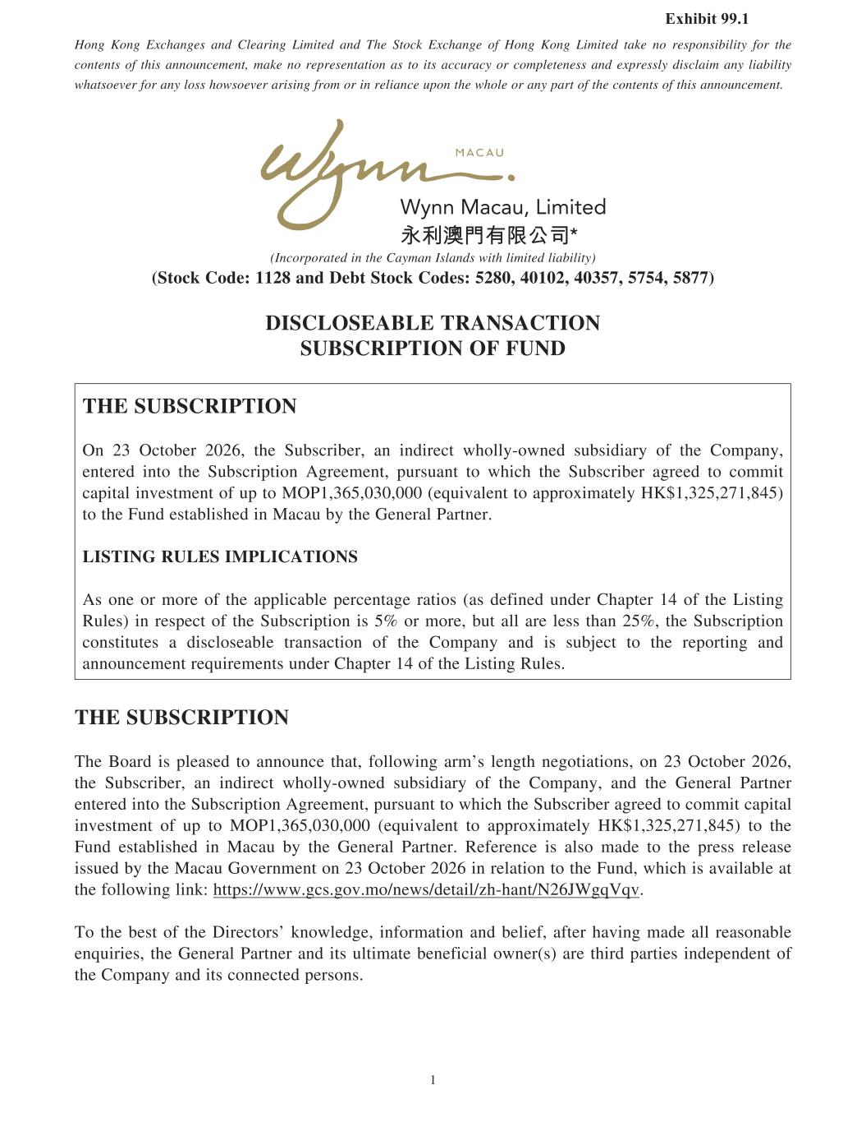

? ??????????? ???? ???????? ??????????? ???????? ???? ??? ???? ??????????????????? ????? ????? ??????????????????? ? ??? ?????????????????? ? ??????? ????? ?? ? ??????????????????? ??? ????? ???? ? ? ??????? ?? ???????? ??????????????????? ????? ! ????????????????? ?? ! ?????????????????????? ???? ???????? ? ??? ?????????????????? ? ??? ?????????????????? ? ??" #$? ??????? ??????? ????????$??????? ????????? ???????????%&'()*+?,)-./?0012?34-?5.6(?'()*+?,)-.7/?8129:?;9091:?;9<8=:?8=8;:?82==>5?',@A'BCD@B?EFCG'C,E?AG'HD',F?IE?AG?AJ?JHG5EKB?'HD',F?IE?AGLM?NO?LPQRSTU?NVNWX?QYT?Z[S\PU]STUX?̂M?]M_]UTPQ?̀YRabcR̀MT_?\[S\]_]̂Ub?Rd?QYT?eRfĝMbX?TMQTUT_?]MQR?QYT?Z[S\PU]gQ]RM?hiUTTfTMQX?g[U\[̂MQ?QR?̀Y]PY?QYT?Z[S\PU]STU?̂iUTT_?QR?PRff]Q?P̂g]Q̂a?]MjT\QfTMQ?Rd?[g?QR?kLl?XOWmXVOVXVVV?nTo[]ĵaTMQ?QR?̂ggURp]f̂QTab?qrs?XONmXNt?Xuvmw?QR?QYT?x[M_?T\Q̂Sa]\YT_?]M?k P̂̂[?Sb?QYT?yTMTÛa?l̂UQMTUz@?'E?G{?FH@B'??|I@?,CE?AG'h\?RMT?RU?fRUT?Rd?QYT?̂gga]P̂SaT?gTUPTMQ̂iT?ÛQ]R\?n̂\?_Td]MT_?[M_TU?eŶgQTU??v?Rd?QYT?}]\Q]Mi?~[aT\w?]M?UT\gTPQ?Rd?QYT?Z[S\PU]gQ]RM?]\?m?RU?fRUTX?S[Q?̂a?̂UT?aT\\?QŶM?NmX?QYT?Z[S\PU]gQ]RM?PRM\Q]Q[QT\?̂?_]\PaR\T̂SaT?QÛM\̂PQ]RM?Rd?QYT?eRfĝMb?̂M_?]\?\[STPQ?QR?QYT?UTgRUQ]Mi?̂M_?M̂MR[MPTfTMQ?UTo[]UTfTMQ\?[M_TU?eŶgQTU??v?Rd?QYT?}]\Q]Mi?~[aT\zEKB?'HD',F?IE?AGYT?R̂U_?]\?gaT̂\T_?QR?̂MMR[MPT?QŶQX?dRaR̀]Mi?̂Uf\?aTMiQY?MTiRQ]̂Q]RM\X?RM?NO?LPQRSTU?NVNWX?QYT?Z[S\PU]STUX?̂M?]M_]UTPQ?̀YRabcR̀MT_?\[S\]_]̂Ub?Rd?QYT?eRfĝMbX?̂M_?QYT?yTMTÛa?l̂UQMTU?TMQTUT_?]MQR?QYT?Z[S\PU]gQ]RM?hiUTTfTMQX?g[U\[̂MQ?QR?̀Y]PY?QYT?Z[S\PU]STU?̂iUTT_?QR?PRff]Q?P̂g]Q̂a?]MjT\QfTMQ?Rd?[g?QR?kLl?XOWmXVOVXVVV?nTo[]ĵaTMQ?QR?̂ggURp]f̂QTab?qrs?XONmXNt?Xuvmw?QR?QYT?x[M_?T\Q̂Sa]\YT_?]M?k P̂̂[?Sb?QYT?yTMTÛa?l̂UQMTUz?~TdTUTMPT?]\?̂a\R?f̂_T?QR?QYT?gUT\\?UTaT̂\T?]\\[T_?Sb?QYT?k P̂̂[?yRjTUMfTMQ?RM?NO?LPQRSTU?NVNW?]M?UTâQ]RM?QR?QYT?x[M_X?̀Y]PY?]\?̂ĵ]âSaT?̂Q?QYT?dRaR̀]Mi?a]M ?YQg\ ̀ `̀ ziP\ziRjzfRMT̀\_TQ̂]aYcŶMQNWioojzR?QYT?ST\Q?Rd?QYT?]UTPQRU\?MR̀aT_iTX?]MdRUf̂Q]RM?̂M_?STa]TdX?̂dQTU?Ŷj]Mi?f̂_T?̂a?UT̂\RM̂SaT?TMo[]U]T\X?QYT?yTMTÛa?l̂UQMTU?̂M_?]Q\?[aQ]f̂QT?STMTd]P]̂a?R̀MTUn\w?̂UT?QY]U_?ĝUQ]T\?]M_TgTM_TMQ?Rd?QYT?eRfĝMb?̂M_?]Q\?PRMMTPQT_?gTU\RM\z }~?vzmun?wRQT?m?QR}~?OzmN }~?Ozm?h }~?vzmunOw}~?vzmunvw }~?vzmunOw}~?vzmunvw}~?vzWVn?w}~?vzWVnNw ?

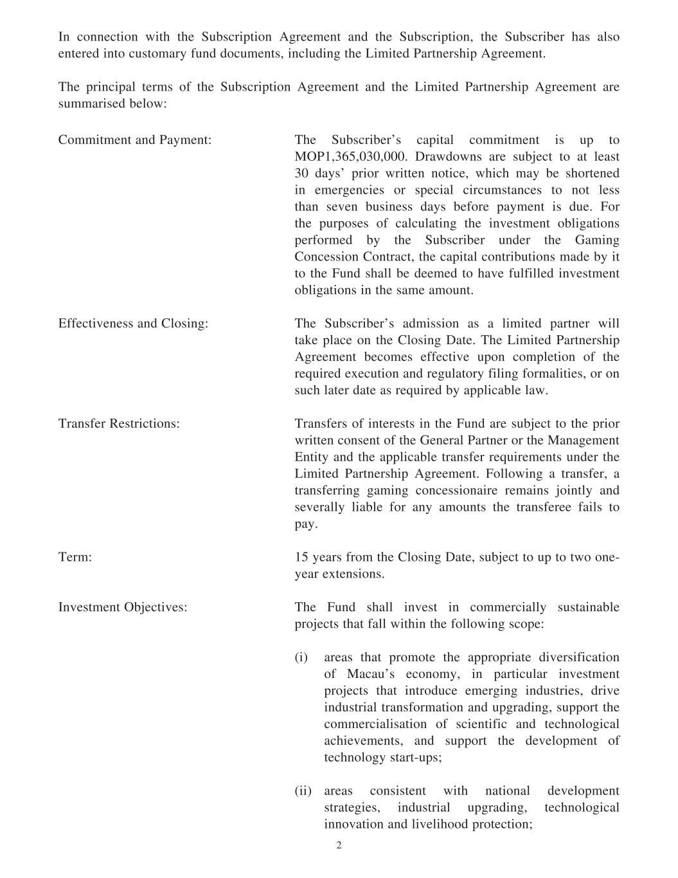
? ?????????? ??? ???????? ???? ?? ?????????????????????? ???? ?? ????????? ???? ????????????????????? ????? ????????? ?????? ??????? ??? ? ???????? ? ????????????? ?????????????????? ?? ?????????????????? ???? ?? ?????????????????????? ? ????????????? ????????????????? ???? ???????? ? ??? ?????????????????? ????? ???? ???!????? ???????? ?????? ?? ?????"#?$?%&'?(%(?(((??)?? ?? ???????? ?*????????????????%(?????!??? ??? ? ??????? ???? ? ???????????????????? ?????????? ?????????? ???? ?? ????????????????????????????+???? ? ????????????????????????? ??? ???,???????? ?????????????? ??? ??????? ?+??????????? ??? ?????????????????????? ???? ???? ?????????-?? ??? ?????? ??? ???????????????? ????????? ? ? ???????????? ?????????, ???????????????????????+??? ?? ???? ?+??????????? ??? ???? ?????????????? ???.????? +?????????? ??? ??? ????? ???? ???!????? ?? ????????? ? ???????????? ????/??????????????? ??? ???)?????????? ? ????????????? ?????????????????????????? +?? ??????????? ????????????0 ?????1?? ? ?????????? ???????? ? ????????? ? ??????????? ???????????????????0 ??????????? ???????? ??????????2???? ?? ???? ????????????? ????????? ??????, ???????? ?*????????????? ??? ? ???????????????????-??????????????????????"??????????.?? ??????????????? ?????????????????0 ???????? ?????????? ? ????????????? ?????????????,??? ?????????????????????????? ?????? ?????????? ??? ??????? ???*? ???????????+??????? ???????????????? ????????????????????? ??????????????? $'???????????????? ??? ???)?????? ?*??????? ?????? ?????3??????1???? ??????+????????#?*??? +??? ????, ???????? ?+???? ????????? ????? ??? ?????????*?????????????? ?? ?????????? ?????????4 5??????????????????????????????? ????? +??? ? ??? ??????"??? !??????????? ?????? ? ???? ?+???????????*?????????? ????? ???????? ??? ?? ??? ?????? +?? ?? ??? ?????????????? ??????? ????? ????? ????????????????? ?? ??? ???????? ??? ? ??????????????? ??????? ?+????????????? ????????????+????????????????????????????3 ??64 5??????????? ?????? ?????? ???????+???????????????? ???? ?? ??? ??? ????? ????????????? ???? ???+?? ???????? +?? ???????????? ??6 ?2$7?&(4$5?2$7?&(4?5

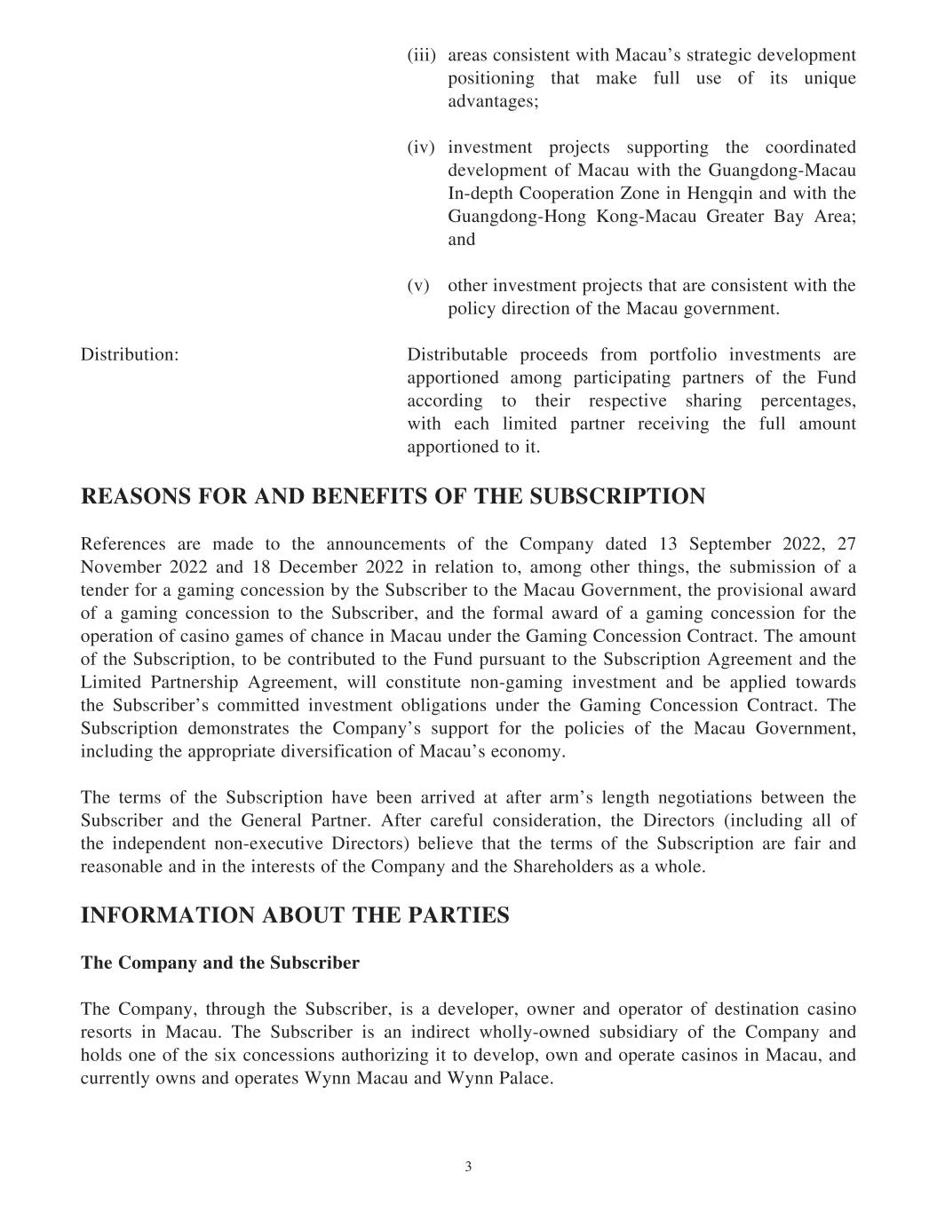
? ????????? ? ?? ? ?? ??? ???? ??? ? ?? ??? ??????????? ??? ? ??????? ?? ??????????? ?????? ????????????? ??? ?????????? ??? ?????? ? ????? ???? ??? ??????? ????????????? ?????? ????? ?? ??????????????? ??? ????? ??!?????? ????"???????#????????????? ?? ?????????????#????$?????? ??????? ???%?&?'????????????? ???????? ??? ?????? ? ?? ????? ?? ? ?? ??? ?? ??????? &????? ??????? ????? ???????????? ()? ??*? ???+ )? ??*? ?*?????? ??? ????????? ?????????? ??? ?????????? ??????????????? ? ??? ??????? ??? ???? ???,????? ??????? ?? ??????? ?? ???? ?????????? ?? ??? -??? ???? ?????? ?????? ?????? ??????? ???????????? ?????? ?????? ??? (./01231?42.?035?6/3/4781?24?89/?1:61;.7<8723=?????? ? ?????????? ?? ????????? ???? ???? ???!?????&??? ???>????? ??*???@A@@-?@B?C????*???@A@@?????>D?)? ??*???@A@@???????? ???? ?-???????? ???? ???? -? ??? ?*?? ????????? ??????????????????? ?? ? ????*&? ?????* ??*??? ?? ????? ???????????? -? ???????? ???????????????????????? ?? ? ???? ?? ?????* ??*??-????? ???????????????????????????? ?? ? ???????? ???????? ??????? ? ???????? ???? ??? ??????? ????????? ??????????!?? ? ????!?? ?? (?E???????? ???? ?????* ??? ???-? ??*?? ?? ??*? ??? ?? ???,??????? ??? ? ?? ?????* ??? ????'??????? ????? ???F??? ???G?? ??? ????'??????? -????? ?? ? ? ????????????????? ??? ?????*?????????? ????? ? ?????* ??*??? ? ???? ??????? ??? ??*???? ??? ??????? ??????????!?? ? ????!?? ?? (?E?????* ??? ????????? ?? ? ? ???!?????&? ? ????? ????? ??????? ?? ???? ????? ???????????? -??? ??????? ???????????? ??????? ??? ? ????????? ??? ?? ????&(E??? ??? ???? ?????* ??? ?????????*????????????? ??? ??????? ????? ?????? ?? ??? ?*? ????? ?????* ??*??????? ???????????G?? ???(?'? ??? ??????? ?? ????? ???-? ???)??? ?? ???? ????????????? ????????????? ??????H? ? ????)??? ?? ??*??????? ?? ? ??? ??? ???? ?????* ??? ???????????????????? ???*?????????? ????? ??? ???? ???!?????&????? ?????????????? ?? ????????(7342.I08723?062:8?89/?<0.87/18JK?;LMNOPQ?OPR?SJK?1TUVWXYUKXE???!?????&-? ??????? ?????* ??*??-?? ????????????-???????????????? ???????? ??? ???? ? ?????? ?? ?????? ??(?E?????* ??*???? ?????????? ?????&??????? ?* ?????&???? ???!?????&????????? ???????? ??? ?H? ?? ? ??? ??? ????Z????? ? ?????????-?????????????? ?? ? ??? ?????? ??-????? ????? ?&???? ?????????? ? ?[&????? ???????[&???G??? ?( F=>\(]D?]?F=>\(]D?D? F=>\(]D?@?

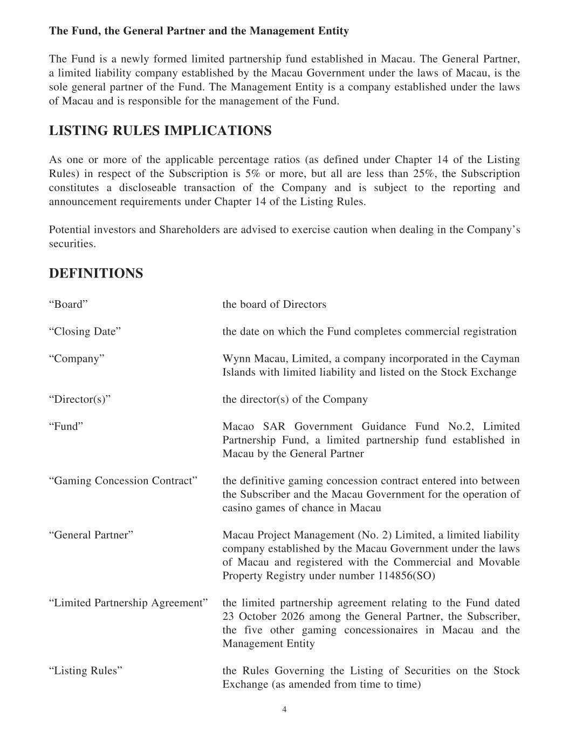
? ??????? ????????? ????? ??? ??? ?????????????????????????????????? ???!"#?$%&'???"?'?(???) &(??&???)?$??????( *"?????????+ , ?-?????.???& "?/ &(??&0? ?"?'?(???"? *?"?(#?,%') ?#???( *"??????*#?(???+ , ??.%1?&?'??(?????&?(???" !??%$?+ , ?0????(????%"??2???& "?) &(??&?%$?(???????-?????+ ? 2?'??(?3?(?(#???? ?,%') ?#???( *"??????????&?(???" !??%$?+ , ?? ??????&??)%???*"??$%&?(???' ? 2?'??(?%$?(???????-456?57??894?6?5??45:;?5<76=??%???%&?'%&??%$?(??? ))"?, *"??)?&,??( 2??& (?%??> ????$?????????&??? )(?&?@??%$?(???A??(??2?B?"??C????&??)?,(?%$?(???D?*?,&?)(?%?????EF?%&?'%&?0?*?(? "? &??"????(? ??GEF0?(???D?*?,&?)(?%??,%??(?(?(??? ????,"%?? *"??(& ?? ,(?%??%$?(????%') ?#? ????????*H?,(?(%?(???&?)%&(??2? ??? ??%??,?'??(?&?I??&?'??(??????&??? )(?&?@??%$?(???A??(??2?B?"??-/%(??(? "???1??(%&?? ???D? &??%"??&?? &?? ?1?????(%??J?&,????, ?(?%??!?????? "??2????(????%') ?#K????,?&?(???-L??575?5<76MN% &?O? (???*% &??%$?P?&?,(%&?M?"%???2?P (?O (???? (??%??!??,??(????????,%')"?(???,%''?&,? "?&?2??(& (?%?M?%') ?#O Q#???+ , ?0?A?'?(??0? ?,%') ?#???,%&)%& (??????(???? #' ??R?" ????!?(??"?'?(???"? *?"?(#? ???"??(???%??(???D(%,S?3J,? ?2?MP?&?,(%&>?CO (?????&?,(%&>?C?%$?(????%') ?#M????O + , %?D=B?.%1?&?'??(?.??? ?,???????T%-G0?A?'?(???/ &(??&???)?????0? ?"?'?(???) &(??&???)?$??????( *"?????????+ , ??*#?(???.???& "?/ &(??&M. '??2??%?,????%???%?(& ,(O (?????$???(?1??2 '??2?,%?,????%??,%?(& ,(???(?&?????(%?*?(!????(???D?*?,&?*?&? ???(???+ , ??.%1?&?'??(?$%&?(???%)?& (?%??%$?, ???%?2 '???%$?,? ?,?????+ , ?M.???& "?/ &(??&O + , ??/&%H?,(?+ ? 2?'??(?>T%-?GC?A?'?(??0? ?"?'?(???"? *?"?(#?,%') ?#???( *"??????*#?(???+ , ??.%1?&?'??(?????&?(???" !??%$?+ , ?? ???&?2??(?&???!?(??(????%''?&,? "? ???+%1 *"??/&%)?&(#?B?2??(&#?????&???'*?&?@@?UEV>DWCMA?'?(???/ &(??&???)?=2&??'??(O (???"?'?(???) &(??&???)? 2&??'??(?&?" (??2?(%?(????????? (???GX?W,(%*?&?GYGV? '%?2?(???.???& "?/ &(??&0?(???D?*?,&?*?&0?(???$?1??%(??&?2 '??2?,%?,????%? ?&??????+ , ?? ???(???+ ? 2?'??(?3?(?(#MA??(??2?B?"??O (???B?"???.%1?&???2?(???A??(??2?%$?D?,?&?(????%??(???D(%,S?3J,? ?2??> ?? '??????$&%'?(?'??(%?(?'?C AB@?-YV>GC

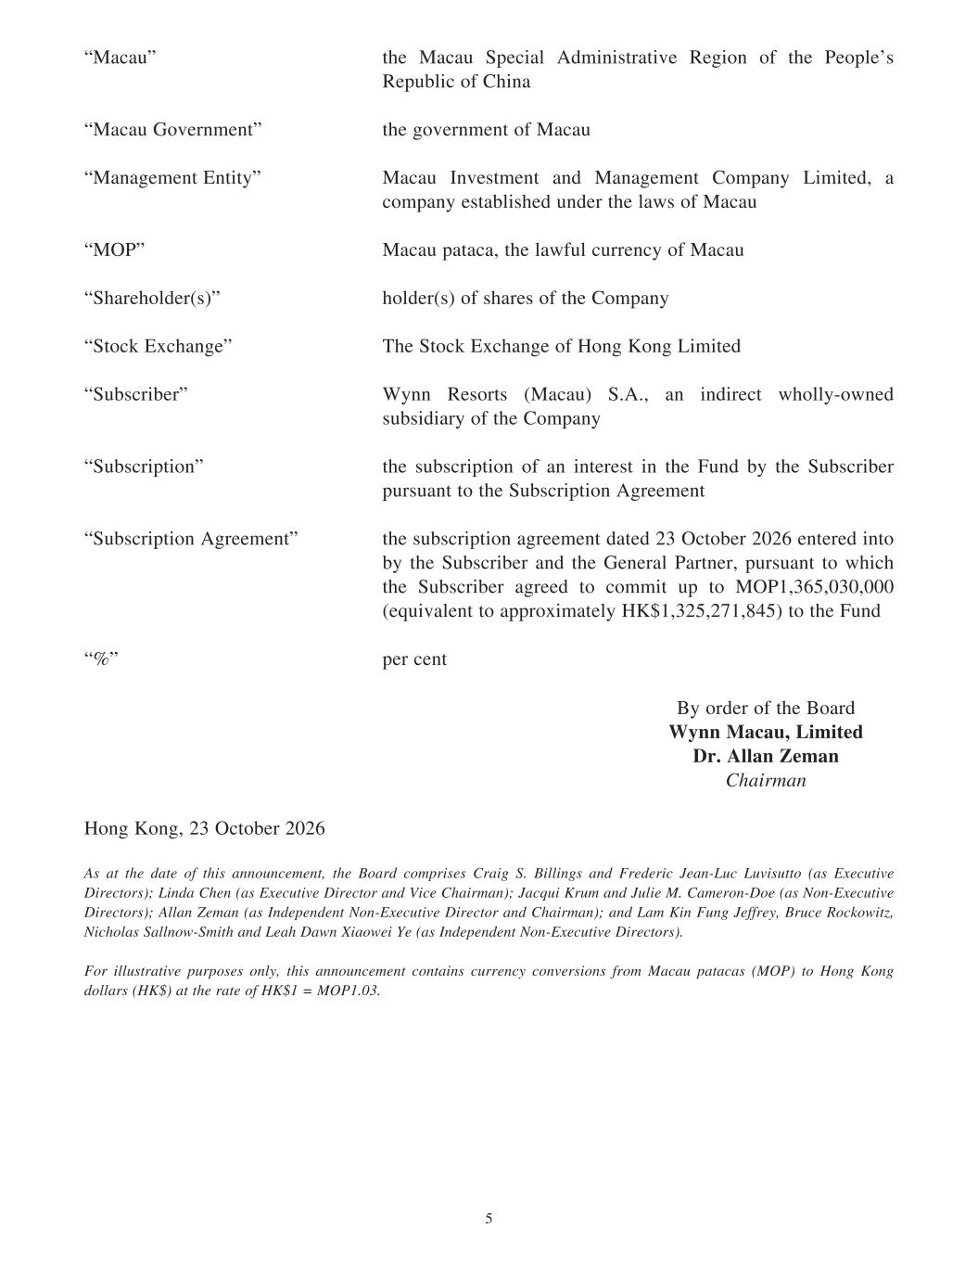
? ??????? ? ???????? ?????????????????? ?? ????????? ?? ? ? ???? ?????????? ????????????? ??? ??? ? ???? ??? ????????????????? ? ??? ????!? ??????"?? ??? ???????????? ? ?????? ??!?#???? ?$?????? ??!? ??????? ????? ??? ???%????????????&?? ?????? ?????$?? ???%???????? ??!??????????? ?? ??? ?'?(? ??? ?'?(????? ?? ?????? ???? ??!?????)? *? ??? ? + ?????)? *? ??? ????,????-????#???? ?????????? ?? .!???? ??????'?????(??/?/$????????? ???% ??!0?%? ???????????!????? ???? ??!???????? ????? ? ???????? ?????????????? ? ??????? ?1?????!?? ????????? ?? ???????????? ???????? ???????? ? ?????????? ???????? ? ??? ? ???????? ???????? ? ?????? ??23?&???? ??2425? ?? ? ????????!?? ????????? ??????? ?? ? ????????? ?$? ???????????% ?? ?? ????????? ????? ????????????? ?????&?6$35?$434$444?' 7????? ??????? ??*???? ?!?,-86$32?$296$:;?(????? ?1????<? ??? ?? =!???? ?????? ?=????>?@@?ABCBDE?FGHGIJKLMN?OPB@?QJHB@RSTUVWTX,????-???$?23?&???? ??2425YZ?T[?[S\?]T[\?̂_?[SUZ?TXX̂ X̀a\W\X[b?[S\?ĉTV]?âWdVUZ\Z?RVTUe?fg?cUhUXeZ?TX]?iV\]\VUa?j\TXkl̀a?l̀mUZ̀[̂?nTZ?op\à[Um\?qUV\a[̂VZrs?lUX]T?RS\X?nTZ?op\à[Um\?qUV\a[̂V?TX]?tUa\?RSTUVWTXrs?jTaùU?vV̀W?TX]?j̀hU\?wg?RTW\V̂Xkq̂\?nTZ?x̂Xkop\à[Um\?qUV\a[̂VZrs?YhTX?y\WTX?nTZ?zX]\d\X]\X[?x̂Xkop\à[Um\?qUV\a[̂V?TX]?RSTUVWTXrs?TX]?lTW?vUX?ìXe?j\_V\{b?cV̀a\?|̂a}̂~U[b?xUaŜhTZ?fThX̂~kfWU[S?TX]?l\TS?qT~X?UT̂~\U?\?nTZ?zX]\d\X]\X[?x̂Xkop\à[Um\?qUV\a[̂VZrgîV?Uh̀Z[VT[Um\?d̀Vd̂Z\Z?̂Xh{b?[SUZ?TXX̂ X̀a\W\X[?âX[TUXZ?àVV\Xa{?âXm\VZÛXZ?_V̂W?wTaT̀?dT[TaTZ?nwr?[̂?̂Xe?v̂Xe?]̂hTVZ?nv r?T[?[S\?VT[\?̂_?v ??wgg#?2/6;

