Table of Contents

UNITED STATES

SECURITIES AND EXCHANGE COMMISSION
Washington, D.C. 20549

SCHEDULE 14A

Proxy Statement Pursuant to Section 14(a) of the

Securities Exchange Act of 1934

Filed by the Registrant ☒ Filed by a Party other than the Registrant ☐

Check the appropriate box:

- Preliminary Proxy Statement

- Confidential, For Use of the Commission Only (as permitted by Rule 14a-6(e)(2))

☒Definitive Proxy Statement

- Definitive Additional Materials

- Soliciting Material Pursuant to § 240.14a-12

WYNN RESORTS, LIMITED

(Name of Registrant as Specified in Its Charter)

(Name of Person(s) Filing Proxy Statement, if Other Than the Registrant)

Payment of Filing Fee (Check the appropriate box):

- No fee required.

- Fee computed on table below per Exchange Act Rules 14a-6(i)(1) and 0-11.

  - Title of each class of securities to which transaction applies:

  - Aggregate number of securities to which transaction applies:

  - Per unit price or other underlying value of transaction computed pursuant to Exchange Act Rule 0-11 (set forth the amount on which the filing fee is calculated and state how it was determined):

  - Proposed maximum aggregate value of transaction:

  - Total fee paid:

- Fee paid previously with preliminary materials.

- Check box if any part of the fee is offset as provided by Exchange Act Rule 0-11(a)(2) and identify the filing for which the offsetting fee was paid previously. Identify the previous filing by registration statement number, or the Form or Schedule and the date of its filing.

  - Amount previously paid:

  - Form, Schedule or Registration Statement No.:

  - Filing Party:

  - Date Filed:

Table of Contents


Table of Contents

Table of Contents


Dear Shareholders,

One of the most important functions of your independent Board of Directors is to ensure we have a leadership team that builds confidence and gains the trust of its constituencies. We believe we have been exceptionally served by our leadership team in this regard in their individual capacities at the corporate and property levels.

If I’ve learned anything in my decades of experience in executive leadership, especially in the highly-regulated gaming industry, it is the importance of trust. To achieve any measure of success, a company must earn and then retain the trust of its shareholders, regulators, customers and employees. Without trust, little is possible. With it, everything is possible.

Over the course of the pandemic, Wynn Resorts built a reservoir of trust with key constituents even as we continued to build our brand. When the going gets tough, such as having to close our resorts worldwide for the safety of guests and employees, a company’s true colors show. At Wynn Resorts, I’m proud of the decisions we made and what that demonstrates about this Company, its Board of Directors and its executives.

We began by making the decision to pay all our employees their full wages, benefits and estimated tips throughout our closure, and safeguard as many jobs as possible upon re-opening. If you believe as we do that “Only People Make People Happy,” you will find the profound trust and gratitude between our employees and the Company deeply affirming. Next time you’re at a Wynn resort, ask any employee what they think of the Company. I do it myself. I know what you’ll hear.

We became a trusted source of information for our guests and created a successful health safety template for the broader political and business communities in which we operate. CEO Matt Maddox assembled a team of medical and public health experts to advise him on the path forward. The health safety protocols the Wynn team created set the standard in our industry and beyond. Matt is now one of the most trusted voices in how to lead the travel and hospitality sectors safely through this crisis.

Your independent Board of Directors, keenly aware of the trust and confidence you have placed in us, worked as active, prudent fiduciaries to reinforce that trust and confidence. As just one example, we completed a highly-successful equity offering to provide additional financial flexibility for the opportunities we anticipate in the post-pandemic economy. We continued to act on our commitment to expand both the Board’s skill set and its diversity of voices; adding Darnell Strom, whose experience in entertainment, communications and philanthropy the Board will leverage for years to come.

Finally, by clearly demonstrating that we will always step up, follow our values and do the right thing, we have continued to build strong trust with our regulators. This has always been one of my key goals as Chair, and this Board and executive team have now earned what I believe is a leadership position in that area. It is a position we must continue to earn every day.

Our actions over the past year speak for themselves. Perhaps more importantly, they set the tone for the integrity, diligence and commitment you can expect from us in the future.

Sincerely,

Philip G. Satre
Non-Executive Chair of the Board

Table of Contents


Table of Contents


Dear Shareholders,

A year ago, Wynn Resorts -- from Las Vegas to Boston to Macau -- was closed. It was, as I told you a year ago, “unimaginable.” It was stunning. And it was necessary.

We closed to keep our guests and employees safe from the rapid global spread of the COVID-19 pandemic. Working with some of the top medical and public health professionals in the world, we created a program that became the industry gold standard in health safety. Other companies requested copies so they could replicate “The Wynn Plan” in its entirety. Acting on our value to “care about everyone and everything,” we eagerly shared, and we continue to share, what we learned.

I also reminded you last year that “We Build Houses of Brick,” and we build them on solid foundations. We spent our closure, and the months immediately following our re-opening, reinforcing and extending the foundation of this house with the knowledge that, once the pandemic began to recede and the tourism and hospitality sectors came roaring back, we would return to building this house. As vaccination distribution expands, testing protocols become more sophisticated, and consumer confidence begins to return, we are prepared.

We’ve built trust in Wynn to offer secure leisure and business travel experiences. In partnership with University Medical Center, the Vaccination Center at Encore Las Vegas administers more than 800 COVID-19 vaccinations per day. Our recently-opened Testing Lab performs tests for convention and leisure customers at Wynn Las Vegas. We are helping to get our children safely back to school by providing the testing facility for student athletes in Clark County Schools. We continue to lead, locally and globally, on health safety planning in a post-pandemic recovery.

We’ve built new ways to entertain. We reimagined our Lake of Dreams show to offer an entertainment experience that is both one-of-a-kind and audience safe. Delilah is a modern, innovative take on the classic supper club experience, offering a fresh option in the Wynn Nightlife experience. Delilah’s spectacular design represents the new face of Wynn Resorts.

We’re building a new distribution platform for the Wynn Experience. WynnBET is our new online gaming platform, anchored by our mobile sports and casino betting app. We will use our strategic partnerships in sports and entertainment to create activations and content that will be distributed on social media platforms and from podcasts emanating from our studio at Wynn Las Vegas. WynnBET will bring the Wynn Experience to millions of guests who haven’t yet visited one of our resorts.

We’ve built a solid financial and operational base. Our team at Encore Boston Harbor is leading that business to greater financial success than we’ve seen before. Our team in Macau is attracting new guests through innovative marketing to the VIP mass consumer base. Our Las Vegas team maintained its Five Star ratings despite the challenges inherent in our rigorous pandemic safety procedures. Our resorts have never been in better hands.

A year after we closed, Wynn Resorts is revitalized, more innovative and more relevant to our customers than it has ever been before. We are leading the way into an era which, this time for all the best reasons, is equally “unimaginable.” I am proud of what we’ve done to make that possible.

Sincerely,

Matthew Maddox
CEO Wynn Resorts, Limited

Table of Contents


Table of Contents

Notice of Annual Meeting

Our 2021 Annual Meeting will be held entirely online due to the uncertain nature of travel and other restrictions that may be in place at the time of the meeting.

PURPOSE OF THE MEETING

THE ANNUAL MEETING WILL BE HELD FOR THE FOLLOWING PURPOSES:

- To elect four Class I directors to serve until the 2024 Annual Meeting of Shareholders;

- To ratify the appointment of Ernst & Young LLP as our independent registered public accounting firm for the fiscal year ending December 31, 2021;

- To approve, on a non-binding advisory basis, the compensation of our named executive officers as described in the Proxy Statement;

- To consider and transact such other business as may properly come before the Annual Meeting, or at any adjournments or postponements thereof.

The foregoing items of business are more fully described in the Proxy Statement accompanying this Notice. Only the Company’s shareholders of record

at the close of business on March 12, 2021, the record date fixed by the Board of Directors, are entitled to notice of, and to vote at, the Annual Meeting,

and at any adjournments or postponements thereof. Only such shareholders, their proxy holders, and our invited guests may attend the Annual Meeting.

NOTICE REGARDING AVAILABILITY OF PROXY MATERIALS

This Proxy Statement and our Annual Report for the fiscal year ended December 31, 2020, are available at http://www.wynnresorts.com on the Company Information page under the “Annual Meeting” heading. On or about March 25, 2021, we mailed to our shareholders (other than those who previously requested electronic or paper delivery) a notice containing instructions on how to access our Annual Meeting materials (including the Proxy Statement and our Annual Report for the fiscal year ended December 31, 2020) and how to vote.

PARTICIPATING IN THE VIRTUAL ANNUAL MEETING

To participate in the virtual Annual Meeting, visit http://www.virtualshareholdermeeting.com/WYNN2021, and log in using the 16-digit control number printed in the box marked by the arrow on your proxy card.

YOUR VOTE IS IMPORTANT

You are encouraged to read the attached Proxy Statement and then cast your vote as promptly as possible by following the instructions on the proxy card you receive. Even if you have given your proxy, you may still vote electronically during the virtual Annual Meeting by visiting http://www.virtualshareholdermeeting.com/WYNN2021, logging in using the 16-digit control number printed in the box marked by the arrow on your proxy card, clicking on the vote button on the screen and following the instructions provided. If your shares are held through an intermediary, such as a bank, broker or other nominee, unless you provide voting instructions to such person, your shares will not be voted on most matters being considered at the Annual Meeting and, therefore, it is especially important you return the proxy card with your vote.

By Order of the Board of Directors

Ellen F. Whittemore

Secretary

Las Vegas, Nevada

March 25, 2021


DATE AND TIME

May 5, 2021
9:00 am PT

PLACE

Virtual meeting conducted via live webcast accessed at this website:

http://www.virtualshareholdermeeting.com/WYNN2021

This Proxy Statement and our 2020 Annual Report on Form 10-K are available at http://www.wynnresorts.com on the Company Information page under the “Annual Meeting” heading.

Table of Contents

Table

of

Contents

OUR BOARD AND CORPORATE GOVERNANCE |  |  |  |  |  |  |  |  |  |  |  |  |  |  |  | 1
Board Composition and Diversity |  |  |  |  |  |  |  |  |  |  |  |  |  |  |  | 1
Director Skills and Experience |  |  |  |  |  |  |  |  |  |  |  |  |  |  |  | 2
Director Biographies |  |  |  |  |  |  |  |  |  |  |  |  |  |  |  | 3
Why Our Board Governance is Effective |  |  |  |  |  |  |  |  |  |  |  |  |  |  |  | 10
Board Committees |  |  |  |  |  |  |  |  |  |  |  |  |  |  |  | 10
Board Role in Risk Oversight |  |  |  |  |  |  |  |  |  |  |  |  |  |  |  | 14
Board Meetings/Annual Meeting |  |  |  |  |  |  |  |  |  |  |  |  |  |  |  | 15
Board Communication and Engagement |  |  |  |  |  |  |  |  |  |  |  |  |  |  |  | 15
Shareholder Engagement |  |  |  |  |  |  |  |  |  |  |  |  |  |  |  | 16
Board Compensation |  |  |  |  |  |  |  |  |  |  |  |  |  |  |  | 16
Non-Employee Director Compensation Table |  |  |  |  |  |  |  |  |  |  |  |  |  |  |  | 17
OUR PEOPLE AND OUR STEWARDSHIP |  |  |  |  |  |  |  |  |  |  |  |  |  |  |  | 21
Introduction |  |  |  |  |  |  |  |  |  |  |  |  |  |  |  | 21
Our People |  |  |  |  |  |  |  |  |  |  |  |  |  |  |  | 22
Our Communities |  |  |  |  |  |  |  |  |  |  |  |  |  |  |  | 24
Our Planet |  |  |  |  |  |  |  |  |  |  |  |  |  |  |  | 27
EXECUTIVE OFFICERS |  |  |  |  |  |  |  |  |  |  |  |  |  |  |  | 30

Table of Contents

COMPENSATION DISCUSSION AND ANALYSIS |  |  |  |  |  |  |  |  |  |  |  |  |  |  |  |  |  |  |  |  |  |  |  |  |  |  |  |  |  |  |  |  |  |  | 36
Why You Should Vote for the 2021 Say-on-Pay |  |  |  |  |  |  |  |  |  |  |  |  |  |  |  |  |  |  |  |  |  |  |  |  |  |  |  |  |  |  |  |  |  |  | 36
How We Approach Executive Compensation |  |  |  |  |  |  |  |  |  |  |  |  |  |  |  |  |  |  |  |  |  |  |  |  |  |  |  |  |  |  |  |  |  |  | 39
How the Company Has Performed |  |  |  |  |  |  |  |  |  |  |  |  |  |  |  |  |  |  |  |  |  |  |  |  |  |  |  |  |  |  |  |  |  |  | 40
How We Designed Incentives in 2020 |  |  |  |  |  |  |  |  |  |  |  |  |  |  |  |  |  |  |  |  |  |  |  |  |  |  |  |  |  |  |  |  |  |  | 41
Other Aspects of Our Executive Compensation |  |  |  |  |  |  |  |  |  |  |  |  |  |  |  |  |  |  |  |  |  |  |  |  |  |  |  |  |  |  |  |  |  |  | 48
Compensation Committee Report |  |  |  |  |  |  |  |  |  |  |  |  |  |  |  |  |  |  |  |  |  |  |  |  |  |  |  |  |  |  |  |  |  |  | 48
EXECUTIVE COMPENSATION TABLES AND OTHER INFORMATION |  |  |  |  |  |  |  |  |  |  |  |  |  |  |  |  |  |  |  |  |  |  |  |  |  |  |  |  |  |  |  |  |  |  | 54
Summary Compensation Table |  |  |  |  |  |  |  |  |  |  |  |  |  |  |  |  |  |  |  |  |  |  |  |  |  |  |  |  |  |  |  |  |  |  | 54
Discussion of Summary Compensation Table |  |  |  |  |  |  |  |  |  |  |  |  |  |  |  |  |  |  |  |  |  |  |  |  |  |  |  |  |  |  |  |  |  |  | 55
2020 Grants of Plan-Based Awards Table |  |  |  |  |  |  |  |  |  |  |  |  |  |  |  |  |  |  |  |  |  |  |  |  |  |  |  |  |  |  |  |  |  |  | 56
Outstanding Equity Awards at Fiscal Year-end |  |  |  |  |  |  |  |  |  |  |  |  |  |  |  |  |  |  |  |  |  |  |  |  |  |  |  |  |  |  |  |  |  |  | 57
Option Exercises and Stock Vested in 2020 |  |  |  |  |  |  |  |  |  |  |  |  |  |  |  |  |  |  |  |  |  |  |  |  |  |  |  |  |  |  |  |  |  |  | 58
Potential Payments Upon Termination or Change in Control |  |  |  |  |  |  |  |  |  |  |  |  |  |  |  |  |  |  |  |  |  |  |  |  |  |  |  |  |  |  |  |  |  |  | 58
CERTAIN RELATIONSHIPS AND TRANSACTIONS |  |  |  |  |  |  |  |  |  |  |  |  |  |  |  |  |  |  |  |  |  |  |  |  |  |  |  |  |  |  |  |  |  |  | 62
PAY RATIO DISCLOSURE |  |  |  |  |  |  |  |  |  |  |  |  |  |  |  |  |  |  |  |  |  |  |  |  |  |  |  |  |  |  |  |  |  |  | 63
SECURITY OWNERSHIP |  |  |  |  |  |  |  |  |  |  |  |  |  |  |  |  |  |  |  |  |  |  |  |  |  |  |  |  |  |  |  |  |  |  | 64
Certain Beneficial Ownership and Management |  |  |  |  |  |  |  |  |  |  |  |  |  |  |  |  |  |  |  |  |  |  |  |  |  |  |  |  |  |  |  |  |  |  | 64
Section 16(a) Beneficial Ownership Reporting Compliance |  |  |  |  |  |  |  |  |  |  |  |  |  |  |  |  |  |  |  |  |  |  |  |  |  |  |  |  |  |  |  |  |  |  | 65
ITEMS TO BE VOTED ON |  |  |  |  |  |  |  |  |  |  |  |  |  |  |  |  |  |  |  |  |  |  |  |  |  |  |  |  |  |  |  |  |  |  | 69
Proposal 1: Election of Directors |  |  |  |  |  |  |  |  |  |  |  |  |  |  |  |  |  |  |  |  |  |  |  |  |  |  |  |  |  |  |  |  |  |  | 69
Proposal 2: Ratification of Appointment of Independent Auditors |  |  |  |  |  |  |  |  |  |  |  |  |  |  |  |  |  |  |  |  |  |  |  |  |  |  |  |  |  |  |  |  |  |  | 69
Proposal 3: Advisory Vote to Approve the Compensation of Named Executive Officers |  |  |  |  |  |  |  |  |  |  |  |  |  |  |  |  |  |  |  |  |  |  |  |  |  |  |  |  |  |  |  |  |  |  | 72
GENERAL INFORMATION |  |  |  |  |  |  |  |  |  |  |  |  |  |  |  |  |  |  |  |  |  |  |  |  |  |  |  |  |  |  |  |  |  |  | 73
Our 2021 Annual Meeting of Shareholders |  |  |  |  |  |  |  |  |  |  |  |  |  |  |  |  |  |  |  |  |  |  |  |  |  |  |  |  |  |  |  |  |  |  | 73
Voting and Solicitation |  |  |  |  |  |  |  |  |  |  |  |  |  |  |  |  |  |  |  |  |  |  |  |  |  |  |  |  |  |  |  |  |  |  | 73
How You Can Vote |  |  |  |  |  |  |  |  |  |  |  |  |  |  |  |  |  |  |  |  |  |  |  |  |  |  |  |  |  |  |  |  |  |  | 74
Revocability of Proxies |  |  |  |  |  |  |  |  |  |  |  |  |  |  |  |  |  |  |  |  |  |  |  |  |  |  |  |  |  |  |  |  |  |  | 74
Attending the Annual Meeting |  |  |  |  |  |  |  |  |  |  |  |  |  |  |  |  |  |  |  |  |  |  |  |  |  |  |  |  |  |  |  |  |  |  | 74
Proxy Procedure and Expenses of Solicitation |  |  |  |  |  |  |  |  |  |  |  |  |  |  |  |  |  |  |  |  |  |  |  |  |  |  |  |  |  |  |  |  |  |  | 75
Shareholder Proposals |  |  |  |  |  |  |  |  |  |  |  |  |  |  |  |  |  |  |  |  |  |  |  |  |  |  |  |  |  |  |  |  |  |  | 75
Annual Report |  |  |  |  |  |  |  |  |  |  |  |  |  |  |  |  |  |  |  |  |  |  |  |  |  |  |  |  |  |  |  |  |  |  | 76
Householding |  |  |  |  |  |  |  |  |  |  |  |  |  |  |  |  |  |  |  |  |  |  |  |  |  |  |  |  |  |  |  |  |  |  | 76
Other Business |  |  |  |  |  |  |  |  |  |  |  |  |  |  |  |  |  |  |  |  |  |  |  |  |  |  |  |  |  |  |  |  |  |  | 76

Table of Contents
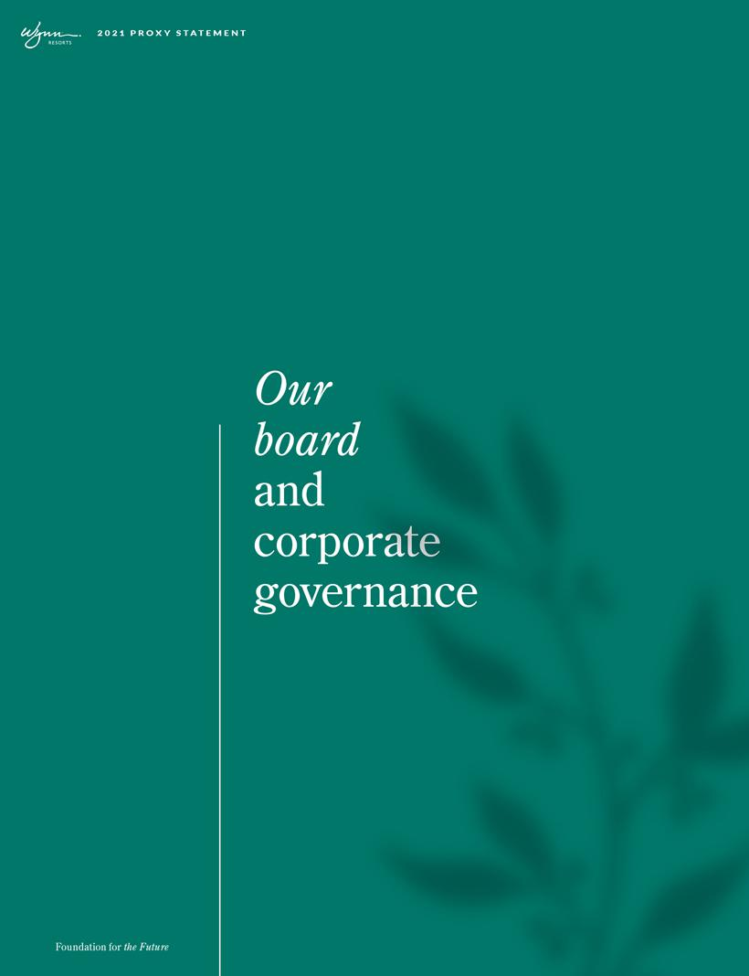

Table of Contents

Introduction

In this section, Wynn Resorts, Limited (the “Company,” “Wynn Resorts,” or “we”) will tell you about:

– Board Composition and Diversity
– Director Skills and Experience
– Director Biographies
– Why Our Board Governance is Effective
– Board Committees
– Board Governance
– Board Role in Risk Oversight
– Board Meetings/Annual Meeting
– Board Communication and Engagement
– Shareholder Engagement
– Board Compensation

Board composition and diversity
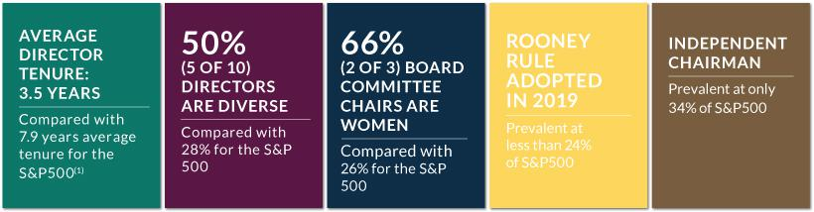

Our Nominating and Corporate Governance Committee is committed to maintaining a Board of Directors (“Board”) with a broad spectrum of experience and expertise that will promote the presentation and consideration of different points of view, meet the Company’s evolving needs and strengthen our diversity.

In 2019, the Nominating and Corporate Governance Committee reinforced the Board’s commitment to diversity of experiences and perspectives among its members. The Nominating and Corporate Governance Committee amended the Company’s Corporate Governance Guidelines to adopt an NFL-style “Rooney Rule” policy to include, and have any search firm that it engages to include, candidates with a diverse – race, gender, and ethnicity – background when evaluating new candidates for the Board. At that time, the Nominating and Corporate Governance Committee had also established a goal of achieving 50% diversity among Board members. These considerations have been important factors in recent additions to the Board, including the appointment of Mr. Strom to the Board.

As of the 2021 Annual Meeting, our board is 50% diverse, with four female directors and one racially diverse director.

- Comparisons are based on information contained in the 2020 US Spencer Stuart Board Index.

1

Table of Contents

2021 PROXY STATEMENT

Director skills and experience

Our current directors exhibit an effective mix of skills, experience and diversity:

Wynn Resorts

board qualifications

and experience
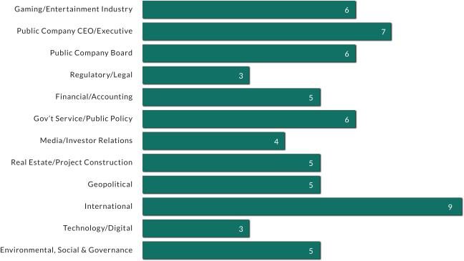

- Foundation for the Future

Table of Contents

Director biographies Biographical and other information for our directors is provided below.

Betsy S. Atkins Chief Executive Officer and Founder, Baja Corporation

Ms. Atkins has been the Chief Executive Officer of Baja Corporation, an independent venture capital firm focused on technology,

renewable energy and life sciences, since 1994. Ms. Atkins currently serves on the Board of SL Green Realty (since April 2015), and other private companies.

PREVIOUS EXPERIENCE
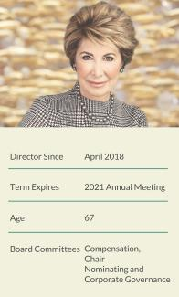
- 2016 to October 2018: Director, Cognizant Technology Solutions

- 2013 to 2016: Chair, APX Labs (a Google Glass enterprise software company)

- February 2009 to August 2009: Chair and Chief Executive Officer, Clear Standards (until acquired by SAP)

- 1991 to 1993: Chair and Chief Executive Officer, NCI

- 1989 to 1999: Co-founder, Director, Executive Vice President Sales, Marketing, International Operations, Ascend Communications (until acquired by Lucent Technologies)

- Previously served on the boards of Schneider Electric, HD Supply Holdings, Polycom, SunPower, Chico’s FAS, Ciber, Darden Restaurants

- Formerly Chairman, Executive Advisory Board, SAP, AG, an advisor to British Telecom and presidential-appointee to the Pension Benefit Guaranty Corporation advisory committee

EDUCATION

Ms. Atkins graduated with a B.A. from the University of Massachusetts.

EXPERTISE

Ms. Atkins brings to our Board executive leadership and operational experience in various technology, food & beverage and retail industries, as well as significant public board experience and executive compensation, sustainability and enterprise risk management expertise.

Gaming/Entertainment Industry experience

Public Company CEO/Executive experience

Public Company Board experience

Gov’t Service/Public Policy experience

Media/Investor Relations experience

Real Estate/Project Construction experience

International experience

Technology/Digital experience

Environmental, Social & Governance experience

3

Table of Contents

2021 PROXY STATEMENT

Richard J. Byrne President, Benefit Street Partners

Mr. Byrne has been the President of Benefit Street Partners since 2013. He also serves as Chairman and Chief Executive Officer of Business Development Corporation of America and Chairman and Chief Executive Officer of Benefit Street Partners Realty Trust, Inc. since 2016. Mr. Byrne is also the Chairman and Chief Executive Officer of Broadtree Residential, Inc. and Broadstone Real Estate Access Fund, since 2020. He currently serves on the Board of New York Road Runners (since 2009). He is also the Founder and Chief Executive Officer of Kasai Elite Grappling Championships.

PREVIOUS EXPERIENCE
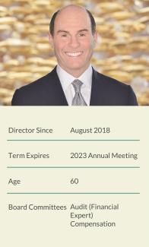
- 1999 to 2013: Chief Executive Officer, Deutsche Bank Securities, Inc. (2008-2013); Global Co-Head of Capital Markets at Deutsche Bank (2006-2013); member of the Global Banking Executive Committee and the Global Markets Executive Committee (2001-2010)

- 1985 to 1999: Global Co-Head of the Leveraged Finance Group and Global Head of Credit Research at Merrill Lynch & Co.

- Highly-ranked credit research analyst, principally in the gaming, lodging and leisure sector

EDUCATION

Mr. Byrne graduated with a B.A. from Binghamton University and a Masters of Business Administration (M.B.A.) from the Kellogg School of Management at Northwestern University.

EXPERTISE

Mr. Byrne has extensive high-level experience in the investment banking and financial services industries, adding expertise in corporate finance and substantial knowledge of the public and private capital markets to our Board. Mr. Byrne also has a deep background in the casino industry.

Gaming/Entertainment Industry experience

Public Company CEO/Executive experience

Public Company Board experience

Financial/Accounting experience

Real Estate/Project Construction experience

International experience

- Foundation for the Future

Table of Contents

Jay L. Johnson Retired

Admiral Johnson retired as Chairman and Chief Executive Officer of General Dynamics Corporation, a publicly traded manufacturer of defense, aerospace, and other technology products, in December 2012. Admiral Johnson is a member of the Council on Foreign Relations and currently serves as a director of the U.S. Naval Academy Foundation and The Peregrine Fund.

PREVIOUS EXPERIENCE
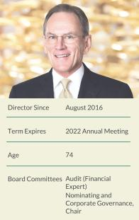
- 2000 to 2008: various senior executive roles at Dominion Resources Inc., a publicly traded energy company, including as CEO of Dominion Virginia Power

- Prior to 2000: 32-year career in the U.S. Navy, serving as Chief of Naval Operations and a member of the Joint Chiefs of Staff since 1996

- Previously served on the boards of International Paper and USAA

EDUCATION

Admiral Johnson graduated with a B.S. from the United States Naval Academy.

EXPERTISE

Admiral Johnson’s experience as an executive and director of various public companies contributes to the Board’s ability to guide corporate strategy and oversee public company governance. Additionally, the Board benefits from Admiral Johnson’s distinguished 32-year military career, which provides valuable public policy and government relations experience as well as extensive leadership and strategic skills.

Public Company CEO/Executive experience

Public Company Board experience

Financial/Accounting experience

Gov’t Service/Public Policy experience

International experience

Geopolitical experience

Environmental, Social & Governance experience

Matt Maddox Chief Executive Officer, Wynn Resorts, Limited

Mr. Maddox has served as the Company’s Chief Executive Officer since February 2018 and served as President from November 2013 to May 2019. He has been a member of the Board of Directors of Wynn Resorts, Limited since August 3, 2018. He was a non-executive Director of Wynn Macau, Limited from March 28, 2013 until he was re-designated as an Executive Director, upon his appointment as CEO of Wynn Macau, Limited, in February 2018. From March 2008 to May 2014, Mr. Maddox was the Company’s Chief Financial Officer. Since joining Wynn Resorts in 2002, Mr. Maddox has served as the Company’s Senior Vice President of Business Development and Treasurer, as the Senior Vice President of Business Development for Wynn Las Vegas, as the Chief Financial Officer of Wynn Resorts (Macau), S.A., and as the Company’s Treasurer and Vice President-Investor Relations. Mr. Maddox also serves as an officer of several of the Company’s subsidiaries.

PREVIOUS EXPERIENCE
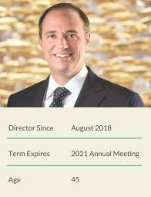
- Previously, Corporate Finance, Caesars Entertainment, Inc. (formerly Park Place Entertainment, Inc.)

- Previously M&A banker, Bank of America Securities

EDUCATION

Mr. Maddox graduated with a B.B.A. in finance from Southern Methodist University.

EXPERTISE

Mr. Maddox contributes a deep understanding of the Company, global gaming expertise stemming from his roles in the development of Wynn Resorts (Macau), S.A. and Wynn Palace, and financial acumen developed being responsible for helping secure the financing to build Wynn Las Vegas and serving as the first Chief Financial Officer of Wynn Resorts (Macau), S.A.

Gaming/Entertainment Industry experience

Public Company CEO/Executive experience

Financial/Accounting experience

Real Estate/Project Construction experience

International experience

5

Table of Contents

2021 PROXY STATEMENT

Patricia Mulroy Non-Resident Senior Fellow for Climate Adaptation & Environmental Policy, Brookings Institution; Practitioner in Residence, Saltman Center for Conflict Resolution, William S. Boyd School of Law, University of Nevada, Las Vegas

Ms. Mulroy is currently a Non-Resident Senior Fellow for Climate Adaptation and Environmental Policy for the Brookings Institution and a Practitioner in Residence at the Saltman Center for Conflict Resolution at the William S. Boyd School of Law at the University of Nevada, Las Vegas. Ms. Mulroy operates a consulting firm representing both corporate and government clients in water matters. Ms. Mulroy is a recognized expert in climate related adaptation strategies for both governments and corporations. Ms. Mulroy recently completed her term as a member of the Global Agenda Council on Water of the World Economic Forum.

PREVIOUS EXPERIENCE
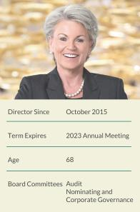
- July 2014 through October 2015: served on the Nevada Gaming Commission

- 1995 to 2014: Nevada’s representative on Colorado River Basin issues, serving as the lead negotiator from 2007 to 2014

- 1993 to 2014: General Manager of the Southern Nevada Water Authority

- 1989 to 2014: General Manager of the Las Vegas Valley Water District

EDUCATION

Ms. Mulroy graduated with a B.A. and M.A. from the University of Nevada, Las Vegas.

EXPERTISE

Ms. Mulroy brings more than 30 years of government experience to the Board, serving in numerous leadership roles focusing on Nevada’s public infrastructure. Additionally, Ms. Mulroy’s experience on the Nevada Gaming Commission brings experience and insight into state regulatory and public policy issues impacting the Company’s operations.

Regulatory/Legal experience

Gov’t Service/Public Policy experience

Real Estate/Project Construction experience

International experience

Environmental, Social & Governance experience

Margaret J. Myers Senior Advisor to the Governor of California and Director of the Governor’s Office of Business and Economic Development

Ms. Myers is currently Senior Advisor to the Governor of California and Director of the Governor’s Office of Business and Economic Development. From September 2014 to April 2020, Ms. Myers was Executive Vice President, Worldwide Corporate Communications and Public Affairs for Warner Bros. Entertainment, a broad-based entertainment company.

PREVIOUS EXPERIENCE
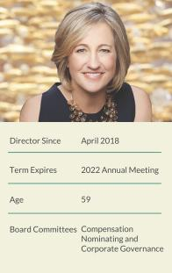
- September 2010 to June 2014: Managing Director, Strategic Communications and Public Affairs Practice, Glover Park Group

- 1994 to 2010: Political analyst, commentator and writer

- January 1993 to December 1994: White House Press Secretary

- Ms. Myers is the author of the 2008 New York Times best-selling book, “Why Women Should Rule the World”

EDUCATION

Ms. Myers graduated with a B.S. from Santa Clara University.

EXPERTISE

Ms. Myers has extensive experience providing counsel on strategic and crisis communications, reputation management and integrated marketing, drawing on her years in politics and media. She brings to our Board expertise in global corporate communications strategies and activities, including media relations, public positioning, executive communications, corporate responsibility, and philanthropy.

Public Company CEO/Executive experience

Gov’t Service/Public Policy experience

Media/Investor Relations experience

Geopolitical experience

International experience

- Foundation for the Future

Table of Contents

Clark T. Randt Jr. President, Randt & Co. LLC

Ambassador Randt is currently President of Randt & Co. LLC, which advises firms with interests in China. Ambassador Randt has been a Director of Valmont Industries since February 2009, a Director of United Parcel Service since August 2010, and a Director of Qualcomm Inc. since October 2013. Ambassador Randt is also a member of the Council on Foreign Relations. Ambassador Randt is a member of the New York State Bar Association, was admitted to the Hong Kong Bar Association, and has over 25 years of experience in cross-border corporate and finance transactions.

PREVIOUS EXPERIENCE
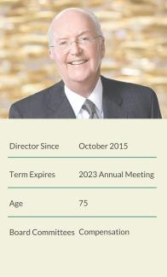
- 2001 to 2009: United States Ambassador to the People’s Republic of China

- Previously, partner at Shearman & Sterling, head of China practice

EDUCATION

Ambassador Randt graduated with a B.A. from Yale University, and has a J.D. from the University of Michigan Law School.

EXPERTISE

Ambassador Randt’s service as the U.S. Ambassador to the People’s Republic of China and his ongoing expertise regarding China give him a unique perspective on international business and foreign policy issues. Additionally, his fluency in Mandarin Chinese and extensive China experience make him well-suited to meaningfully contribute to the Board’s oversight of the Company’s operations in Macau.

Public Company Board experience

Regulatory/Legal experience

Gov’t Service/Public Policy experience

International experience

Geopolitical experience

Environmental, Social & Governance experience

7

Table of Contents

2021 PROXY STATEMENT

Philip G. Satre Retired

Mr. Satre has served as the Non-Executive Chair of the Board since November 2018 and joined the Board as Vice-Chairman in August 2018. In the not-for-profit sector, Mr. Satre is President of the National Center for Responsible Gaming; a Trustee of The National World War II Museum; serves on the Board of the National Automobile Museum – The Harrah Collection in Reno, Nevada; and serves on the Stanford Alumni Association Board of Directors.

PREVIOUS EXPERIENCE
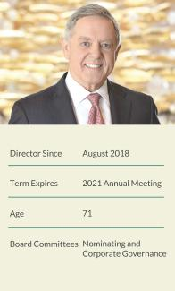
- 1980 to 2005: Various roles at Harrah’s Entertainment, Inc. with increasing responsibility, including Vice President, General Counsel and Secretary; President and Chief Executive Officer of its gaming division; culminating in service as CEO
and Chairman

- Previously served on the boards of Nordstrom, Inc., International Game Technology PLC, NV Energy, Tabcorp Holdings Ltd. (Australia), and Rite Aid Corporation

- Various roles in non-profits, including as Chairman of the Guinn Center for Policy Priorities (2013 to 2018) and Emeritus Member of the Stanford University Board of Trustees (2005 to 2010)

EDUCATION

Mr. Satre graduated with a B.A. from Stanford University and a J.D. from the University of California, Davis.

EXPERTISE

Mr. Satre’s prior experience as an executive in our industry brings the Board extensive understanding of the complex financial, regulatory, operational, and strategic challenges we face, while his prior experience as a director across a diversity of industries adds additional expertise in matters of good corporate governance and effective Board oversight.

Gaming/Entertainment Industry experience

Public Company CEO/Executive experience

Public Company Board experience

Regulatory/Legal experience

Financial/Accounting experience

Media/Investor Relations experience

Real Estate/Project Construction experience

International experience

Darnell O. Strom Partner & Head of Culture and Leadership, UTA

Mr. Strom is a Partner & Head of the Culture and Leadership Division at premiere entertainment agency, UTA. Strom represents transformative talent, brands, and organizations across entertainment, media, sports, fashion, the arts, entrepreneurship, politics, and thought leadership.

PREVIOUS EXPERIENCE
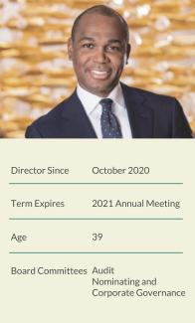
- 2012 to 2019: Agent, Creative Artists Agency

- 2010 to 2012: Executive, Creative Artists Agency Foundation

- 2006 to 2010: Deputy Director of Development, William J. Clinton Foundation

- 2005 to 2006: Deputy Director of Scheduling & Advance, Office of President William J. Clinton

EDUCATION

Mr. Strom graduated with a B.S. (with honors) from Florida A&M University.

EXPERTISE

Mr. Strom’s decades of experience in entertainment, media, and sports, along with the relationships he has established, will be a significant benefit to the Board. Mr. Strom brings to our Board significant industry expertise in media, sports, entertainment, music, fashion, the arts, branding and thought leadership.

Gaming/Entertainment Industry experience

Gov’t Service/Public Policy experience

Geopolitical experience

Technology/Digital experience

- Foundation for the Future

Table of Contents

Winifred M. Webb Chief Executive Officer, Kestrel Corporate Advisors

Ms. Webb has been Chief Executive Officer of Kestrel Corporate Advisors, an advisory services firm, since 2013. Ms. Webb currently serves on the Board of Trustees of American Homes 4 Rent (since January 2019) and the Boards of AppFolio, Inc. (since December 2019) and ABM Industries (since 2014).

PREVIOUS EXPERIENCE
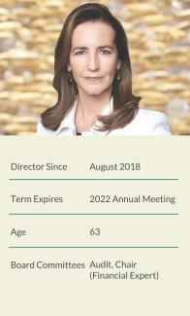
- 2010 to 2013: Managing Director, Tennenbaum Capital Partners, now part of BlackRock

- 2008 to 2010: Member of the Corporate Executive team and senior advisor, Ticketmaster

- 1988 to 2008: Various senior positions, including as Senior Vice President of Investor Relations and Shareholder Services, and governance outreach, The Walt Disney Company; Executive Director, The Walt Disney Company Foundation

- Previously held various investment banking positions

- Prior service on the boards of TiVo, Jack in the Box, 9 Spokes, and nonprofit PetSmart Charities

EDUCATION

Ms. Webb graduated with a B.A. (with honors) from Smith College and received her M.B.A. from Harvard University.

EXPERTISE

Ms. Webb brings to our Board significant industry expertise in travel and tourism, hospitality, food and beverage, media and entertainment, retailing, and facilities services. Ms. Webb’s experience developing award-winning investor relations, strategic communications, brand-building programs and extensive, public company board service contribute to the Board’s ability to provide creative solutions in strategic planning and board governance.

Gaming/Entertainment Industry experience

Public Company CEO/Executive experience

Public Company Board experience

Financial/Accounting experience

Media/Investor Relations experience

Real Estate/Project Construction experience

International experience

Technology/Digital experience

Environmental, Social & Governance experience

9

Table of Contents

2021 PROXY STATEMENT

Why our board governance is effective


ROBUST INDEPENDENCE | ACCOUNTABILITY AND ALIGNMENT | EFFECTIVE OVERSIGHT
ROBUST INDEPENDENCE | WITH SHAREHOLDERS | EFFECTIVE OVERSIGHT

Separate Independent Chair and CEO roles | Strong stock ownership guidelines | Compliance Committee composed of three
enshrined in Bylaws | -3x annual retainer for directors | individuals who are independent of the Company
(1) | -6x base salary for CEO | and the Board
(2) | -3x base salary for our President, Chief Financial
All non-executive directors are independent and | Officer and Executive Vice Presidents
empowered to propose agenda items | Officer and Executive Vice Presidents | Regular director education and compliance training
Independent directors meeting in executive | Anti-hedging and pledging policies | including mandatory preventing sexual harassment
Independent directors meeting in executive | Anti-hedging and pledging policies | and workplace compliance training conducted by
 | (4) | Company’s outside counsel
sessions at each regular Board meeting | Mandatory director retirement threshold at age 75 | Company’s outside counsel
 | Mandatory director retirement threshold at age 75 | Executive sessions of the Audit Committee with:
Fully Independent Audit, Compensation, and | (5) | Executive sessions of the Audit Committee with:
Nominating and Corporate Governance Committees | (5) | -Independent Auditors
Nominating and Corporate Governance Committees | 10b5-1 Plans | -General Counsel
(3) | Commitment to Diversity | -Chief Audit Executive
Third party review of compensation | Commitment to Diversity | -Chief Financial Officer
 | -Adopted NFL-style “Rooney Rule” in 2019 | -Chief Financial Officer
 | -Adopted NFL-style “Rooney Rule” in 2019 | -Chief Global Compliance Officer
 | -Support for NASDAQ rule to require director | -Chief Global Compliance Officer
 | diversity and disclosure

- The responsibilities for the Board chair are disclosed in our Corporate Governance Guidelines available on our website. This Proxy Statement contains hyperlinks to information on our website. The information on our website is not incorporated by reference into this Proxy Statement.

- All of our non-executive Board members qualify as “independent” under NASDAQ listing rules. All members of the Audit and Compensation Committees satisfy the independence requirements under the Securities Exchange Act of 1934, as amended (the “Exchange Act”).

- Our CEO’s compensation is established and reviewed by the Compensation Committee, all of whose members are independent. The Compensation Committee engages an independent third party to evaluate the level of the compensation provided to our NEOs. This evaluation was last completed in 2020 by Radford as described in the “Compensation Discussion and Analysis”.

- Pursuant to the Company’s Trading Policy, our directors and executive officers are prohibited from engaging in speculative transactions in the Company’s securities, such as trading in puts and calls, or selling securities short, and from all hedging and prospective pledging of Company securities as collateral for any loan, including holding securities in a margin account and obtaining a loan or other margin credit under such account, unless approved in advance by the Board.

- Our Trading Policy requires any executive who, at the time of the transaction owns more than $15 million of Company stock, and all directors to enter into a 10b5-1 plan for transactions related to our securities.

Board committees

The Board of Directors has three standing committees, each comprised solely of independent directors: the Audit Committee, the Compensation Committee, and the Nominating and Corporate Governance Committee. The written charters for these committees are available on our website at http://www.wynnresorts.com under the heading “Corporate Governance” on the Company Information page.

 |  |  |  | NOMINATING
 | INDEPENDENT | AUDIT | COMPENSATION | AND CORPORATE
DIRECTOR | DIRECTOR | COMMITTEE | COMMITTEE | GOVERNANCE COMMITTEE
Betsy S. Atkins | • |  | C | •
Richard J. Byrne | • | F | •
Jay L. Johnson | • | F |  | C
Patricia Mulroy | • | • |  | •
Margaret J. Myers | • |  | • | •
Clark T. Randt, Jr. | • |  | •
Philip G. Satre | • |  |  | •
Darnell O. Strom | • | • |  | •
Winifred M. Webb | • | C,F
Committee Meetings in 2020 |  | 7 | 9 | 5

C Chair; F Financial Expert within the meaning of SEC regulations

- Foundation for the Future

Table of Contents

AUDIT COMMITTEE

At each regular meeting, the Audit Committee meets in executive session with the Company’s independent auditors, General Counsel, Chief Audit Executive, President and Chief Financial Officer, and Chief Global Compliance Officer to discuss accounting principles, financial and accounting controls, the scope of the annual audit, internal controls, regulatory compliance, and other matters. As part of its program of regular oversight, the Audit Committee is responsible for overseeing cybersecurity risk and information security. The Audit Committee receives regular reports from the Company’s Chief Information Security Officer on the Company’s cybersecurity risk profile and enterprise cybersecurity program, which are communicated to the full Board. The independent auditors have complete access to the Audit Committee without management present to discuss the results of their audits and their opinions on the adequacy of internal controls, quality of financial reporting, and other accounting and auditing matters.

KEY RESPONSIBILITIES

- Appointing, retaining, overseeing, and approving the compensation of the independent auditors

- Reviewing and discussing with the independent auditors and management the Company’s earnings releases and quarterly and annual reports to be filed with the SEC

- Reviewing the adequacy, effectiveness, scope, and results of the Company’s internal auditing procedures and practices

- Overseeing the Company’s legal and regulatory compliance programs and its policies and procedures for monitoring compliance

- Overseeing cybersecurity risk and information security

- Meeting periodically with management to review the Company’s major risk exposures and the steps management has taken to monitor and control such exposures

- Reviewing and approving the Company’s decision to enter into certain swaps and other derivative transactions

COMPENSATION COMMITTEE

The Compensation Committee sets all elements of compensation for our named executive officers (“NEOs”) based upon consideration of our NEO’s contributions to the development and operating performance of the Company, and is primarily responsible for monitoring risks relating to the Company’s compensation policies and practices to determine whether they create risks that are reasonably likely to have a material adverse effect on the Company.

The Compensation Committee considers the recommendations of the CEO in establishing compensation for all NEOs, other than the CEO. The CEO is not present during the voting or deliberations regarding his compensation. In addition, the CEO performs annual reviews of all of our senior management and makes recommendations to the Compensation Committee concerning their compensation. The Compensation Committee reviews the recommendations and makes final decisions regarding compensation for members of our senior management.

The Compensation Committee has the authority to retain compensation consulting firms exclusively to assist it in the evaluation of executive officer and employee compensation and benefit programs. In 2020, the Compensation Committee retained Radford, a business unit of AON plc (“Radford”), a nationally recognized independent compensation consulting firm, to assist in performing its duties. Radford does not provide services to the Company other than the advice on director and executive compensation that it may provide the Compensation Committee when requested. In 2020, Radford provided the Compensation Committee with a peer group review and competitive compensation analysis, in connection with the Compensation Committee’s review of compensation levels of our NEOs. The Compensation Committee retains sole responsibility for engaging advisors and meets with advisors, as needed, in the Compensation Committee’s sole discretion. Each of the members of

11

Table of Contents

2021 PROXY STATEMENT

the Compensation Committee bring a wealth of experience from their public and private board experience and their respective executive roles, which enables the Committee to effectively oversee the design and practice of linking executive compensation to company performance.

KEY RESPONSIBILITIES

- Reviewing the goals and objectives of the Company’s executive compensation plans, and, as appropriate, recommending that the Board adopt new plans or amend existing plans

- Assessing the Company’s most recent advisory vote on executive compensation

- Appointing advisors retained by the Committee and assessing any potential conflicts of interest, overseeing and approving the compensation of any advisors the Committee retains

- Annually evaluating the performance of the CEO, overseeing the evaluation of performance of the other officers of the Company and its operating subsidiaries, and setting compensation for the CEO, other NEOs, and other members of senior management

- Reviewing and approving equity awards and supervising administrative functions pursuant to the Company’s equity plans

- Reviewing and approving compensation arrangements for officers and other key employees in accordance with policies adopted by the Committee from time to time

- Reviewing and recommending to the full Board the type and amount of compensation for Board and Committee service by non-management members of the Board

- Reviewing and discussing with management the Compensation Discussion and Analysis and related disclosures in the Company’s Proxy Statement

COMPENSATION COMMITTEE INTERLOCKS AND INSIDER PARTICIPATION

The members of the Compensation Committee are appointed by the Board each year. The members of the Compensation Committee that served in 2020 were Ms. Atkins, Mr. Byrne, Ms. Myers and Amb. Randt. No member of the Compensation Committee is, or was formerly, one of our officers or employees. No interlocking relationship exists between the Board or Compensation Committee and the board of directors or compensation committee of any other company, nor has any interlocking relationship existed in the past.

Nominating and corporate governance committee

The Nominating and Corporate Governance Committee seeks to have the Board represent a diversity of backgrounds and experience and assesses potential nominees in light of the Board’s current size and composition.

The Nominating and Corporate Governance Committee believes that the minimum qualifications for serving as a director of the Company are that a nominee demonstrate, by significant accomplishment in his or her field, an ability to make a meaningful contribution to the Board’s oversight of the business and affairs of the Company and robust engagement in the strategic planning process, and have a reputation for honest and ethical conduct in both his or her professional and personal activities. The Nominating and Corporate Governance Committee may, from time to time, develop and recommend additional criteria for identifying and evaluating director candidates. In addition, the Nominating and Corporate Governance Committee examines a candidate’s other commitments, potential conflicts of interest, and independence from management and the Company. The Nominating and Corporate Governance Committee and Board believe that differences of viewpoint, professional experience, individual characteristics, personal background, qualities, skills, qualifications, gender, ethnicity, and race help generate varying perspectives and that those varying perspectives are important to the effectiveness of the Board’s oversight of the Company. The Nominating and Corporate Governance Committee proactively considers

- Foundation for the Future

Table of Contents

diversity by annually reviewing with the Board the Board’s composition as a whole and recommending, if appropriate, measures to be taken so that the Board reflects the appropriate balance of knowledge, depth, diversity of backgrounds and experience, and the skills and expertise required for the Board as a whole. The Nominating and Corporate Governance Committee assesses the effectiveness of this policy by periodically reviewing the Board membership criteria with the Board. This assessment enables the Board to update the skills and experience it seeks in the Board as a whole and in individual directors, as the Company’s needs evolve and change over time.

In 2019, the Nominating and Corporate Governance Committee amended the Company’s Corporate Governance Guidelines to establish an NFL- style Rooney Rule policy to consider candidates with diverse backgrounds when evaluating new candidates for the Board. This change was implemented to ensure that any initial slate of candidates includes those with a diversity of race, gender and ethnicity.

Additionally, the Nominating and Corporate Governance Committee had established a goal of 50% diversity among Board members, which we have achieved this year.

In 2019, the Nominating and Corporate Governance Committee revised the annual Board self-evaluation process. Beginning with the 2019 self-evaluation, the Board conducts a three-part evaluation process coordinated by the General Counsel. Each Board member participated in an evaluation of the full Board, each of the Committees on which he or she serves, and individual Board member performance. A summary report of the results was prepared by the General Counsel and presented to the full Board and to each Committee. The Board uses the results in preparing action items as necessary.

KEY RESPONSIBILITIES

- Identifying, evaluating and recommending qualified director candidates, including candidates recommended by shareholders or management

- Assessing the qualifications, attributes, skills, experience, diversity and independence of Board members, taking into account appropriate considerations such as the Company’s current and planned business, current and potential composition considerations, any planned director successions, and the qualifications required of directors under the gaming laws of jurisdictions where the Company operates

- Reviewing the composition of the Board and its committees and recommending, as appropriate, measures to be taken for Board refreshment and Board succession planning

- Reviewing and making recommendations regarding the Board’s leadership structure

- Overseeing corporate governance matters generally and developing and recommending to the Board Company-appropriate corporate governance guidelines

- Overseeing and, as it determines appropriate, designating directors to participate in the Company’s engagement with shareholders

- Overseeing the annual evaluation of the Board and its standing committees

13

Table of Contents

2021 PROXY STATEMENT

CONSIDERATION OF CANDIDATES RECOMMENDED BY SHAREHOLDERS

Our Nominating and Corporate Governance Committee is pleased to consider director candidates recommended by shareholders. In considering such candidates, the Nominating and Corporate Governance Committee will take into consideration the Board’s current size and composition; the needs of the Board, including the skills and experience of existing directors; and the qualifications of the candidate. To have a candidate considered by the Nominating and Corporate Governance Committee, a shareholder must submit the recommendation in writing and include the following information:

- The name of the shareholder and evidence of the shareholder’s ownership of Company stock, including the number of shares owned and the length of time of ownership; and

- The name of the candidate, the candidate’s resume or a listing of his or her qualifications to be a director of the Company, and the candidate’s consent to being considered for nomination as a director if selected by the Nominating and Corporate Governance Committee.

The shareholder recommendation and information described above must be sent to Wynn Resorts, Limited, c/o Corporate Secretary at 3131 Las Vegas Boulevard South, Las Vegas, Nevada 89109.

If the Nominating and Corporate Governance Committee determines to pursue consideration of a person who has been identified as a potential candidate, the Nominating and Corporate Governance Committee may take any or all of the following steps: collect and review publicly available information regarding the candidate, contact and request information from the candidate, vet the candidate’s credentials, conduct one or more interviews with the candidate and contact one or more references provided by the candidate or other persons that may have greater first-hand knowledge of the candidate’s accomplishments. The Nominating and Corporate Governance Committee’s evaluation process takes into account the candidate’s accomplishments and qualifications, including in comparison to any other candidates that the Nominating and Corporate Governance Committee might be considering, and does not vary based on whether or not a candidate is recommended by a shareholder.

Board role in risk oversight

The Board’s goals are to build value for the Company’s shareholders and to promote the vitality and sustainability of the Company for its customers, employees, jurisdictions in which it does business, our planet, and the other individuals and organizations that depend on the Company.

To achieve these goals, the Board monitors the performance of the Company (in relation to its goals, strategy, risks and competitors); reviews the Company’s compliance efforts; and, through the Compensation Committee, evaluates and addresses the performance of management, including the Chief Executive Officer.

The Board has an active role in overseeing the Company’s areas of risk.

- The Board and its Committees, in consultation with management and the Company’s independent auditors, regularly review the Company’s risk profile and have identified specific areas of risk including: regulatory compliance; legal and human resource matters; legislative and political conditions; capital availability and liquidity; gaming credit extension and collection; cybersecurity, including protection of customer and employee data; construction; catastrophic events; and succession planning.

- The Board assesses risks to the Company’s long-term strategic objectives, including threats related to our people, our communities and our planet. The Company addresses these risks through our ESG initiatives.

- The Board (as a whole and through its Committees) has reviewed and approved management’s process for identifying, managing and mitigating these risks. While the full Board has overall responsibility for risk oversight, the Board has assigned certain areas of risk oversight to its Committees as well as to the Company’s Compliance Committee.

- Throughout the year, the Board, its Committees and the Company’s Compliance Committee receive reports from management that include information regarding major risks and exposures facing the Company and the steps management has taken to monitor and control such risks and exposures. In 2018, the Board also implemented a process to allow for direct communication of risks and issues from employees to the Board of Directors.

- Foundation for the Future

Table of Contents

- In addition, throughout the year, the Board, its Committees and the Company’s Compliance Committee dedicate a portion of their meetings to review and discuss specific risk topics in greater detail.

- The Audit Committee is primarily responsible for the oversight of credit, related party, information security, construction and general financial risks.

- The Company’s Compliance Committee primarily oversees risks relating to regulatory, security, workplace conduct, and political compliance.

- For the 2020 fiscal year, management completed a review of the Company’s compensation policies and practices and presented its analysis to the Compensation Committee. The Compensation Committee concurred with management’s conclusion that such policies and practices do not present risks that are reasonably likely to have a material adverse effect on the Company.

COMPLIANCE COMMITTEE

The Company maintains a Compliance Program that features a completely-independent Compliance Committee comprised of individuals with extensive familiarity with law enforcement, regulated businesses, ethics, and/or gaming compliance who are not otherwise affiliated with the Company, to oversee and promote the Company’s compliance and to ensure that the Company meets the Company’s strict policy to conduct business at the highest levels of honesty and integrity: Thomas Peterman, former Senior Vice President and Chief Compliance Officer for MGM Resorts International (Chair); Michelle Chatigny, former Vice President, Global Regulatory and Product Compliance for International Game Technology; and Edward Davis, former Commissioner of the Boston Police Department. Chair Satre and Ms. Mulroy serve as ex officio members of the Committee and representatives of the Board. Ms. Webb also attends the meetings of the Compliance Committee The Compliance Program is subject to review and approval of the Nevada Gaming Control Board and the Massachusetts Gaming Commission.

Board meetings/annual meeting

The Board met 18 times during 2020. All of our Board attended more than 90% of the meetings of the Board and of the Committees on which they served. In accordance with our Corporate Governance Guidelines, each of our directors is expected to participate in the Annual Meeting. All of our directors attended the 2020 Annual Meeting.

Board communication and engagement

Our Board believes in listening to and communicating with shareholders. We believe our work should be informed by input from those who share a financial stake in our success.

We provide a number of ways for shareholders to communicate with the Board and management:

- Shareholders may speak with us when we reach out to engage both via governance communications and investor relations communications.

- Shareholders who wish to communicate in writing with the Board or any director, or with any Committee of the Board, including the chair of any Committee, may do so by writing to the following address: Wynn Resorts, Limited, c/o Corporate Secretary, 3131 Las Vegas Boulevard South, Las Vegas, Nevada 89109. All communications received will be opened by the office of our General Counsel for the purpose of assessing the nature of the communications. With the exception of advertising, promotions of a product or service, and patently offensive material, communications will be forwarded promptly to the addressee. In the case of communications addressed to more than one director, the General Counsel’s office will make sure each addressee receives the communication, which may be done by e-mail.

15

Table of Contents

2021 PROXY STATEMENT

Shareholder engagement

We regularly engage with shareholders and other stakeholders to receive their insights on significant issues, including company performance and strategy, corporate governance, executive compensation, and environmental, social, and governance topics. Management provides the Board with extensive analysis of shareholder feedback and shareholder voting results. As a result of this review, over the last several years, the Board has made significant changes to compensation practices, governance matters and ESG reporting.

The Board and Company management remain committed to frequent and robust shareholder engagement. We have made important updates to our pay plans and corporate governance documents and policies based on our changing needs and the input we have received from engagements with our shareholders.

Based on specific feedback received, the Board adopted the SASB reporting metrics that were included in our 2019 ESG Report. The Board believes that these metrics provide greater transparency in our reporting as well as heightened accountability to our stakeholders.

Board compensation

Directors who are not employees of the Company currently receive fees for service on the Board and Committees as follows:

Board Service

Audit Committee Service

Compensation Committee Service

Nominating and Corporate Governance Committee Service

- Member monthly fee of $5,000

- Member monthly fee of $1,250

- Chair monthly fee of $2,500

- Member monthly fee of $1,000

- Chair monthly fee of $2,000

- Member monthly fee of $1,000

- Chair monthly fee of $2,000

Each non-employee director also receives a $1,500 meeting fee for each Board or Committee meeting he or she attends. In addition,
non-employee directors are granted annual equity awards in the form of stock options or restricted stock determined annually at a meeting

of the Board. In response to the COVID-19 pandemic and the financial impact on the Company, each non-employee director elected to
receive a certain amount of stock in lieu of the monthly fee for their Board service. For 2020, each non-employee director received a grant
of restricted stock equal in value to $250,000 (determined as of the June 24, 2020 grant date) that vests 25% per year on each of the first
four anniversaries of the date of grant, subject to continued service through each vesting date. Ex officio members of the Compliance
Committee receive an annual retainer of $75,000. The Chair of the Audit Committee receives an attendance fee of $1,500 for telephonic
meetings and $2,500 for in-person meetings of the Compliance Committee. The Chair of the Board receives an annual retainer of
$100,000. All directors are provided complimentary room, food and beverage privileges at our properties and are reimbursed for any other
out-of-pocket expenses related to their attendance at Board or Committee meetings or other corporate events. Directors from time to time
may receive other benefits as discussed in the table below under “All Other Compensation.” The Company does not provide non-equity
incentive plan awards or deferred compensation or retirement plans for non-employee directors.

- Foundation for the Future

Table of Contents

NON-EMPLOYEE DIRECTOR COMPENSATION TABLE

The table below summarizes the total compensation awarded to, earned by or paid to each of the non-employee directors for the fiscal year ended December 31, 2020. Mr. Maddox receives no compensation for his service as a director and, therefore, is not included in this table.


 |  |  | OPTION | ALL OTHER
 | FEES EARNED OR | STOCK | AWARDS | COMPENSATION
NAME | PAID IN CASH($) (1) | AWARDS($) (1)(2) | ($) (3) | ($) (4) |  | TOTAL($)
Betsy S. Atkins | $142,500 | $258,538 | $- | $2,750 |  | $403,788
Richard J. Byrne | $138,000 | $258,538 | $- | $1,768 |  | $398,306
Jay L. Johnson | $130,750 | $258,538 | $- | $3,826 |  | $393,114
Patricia Mulroy | $205,500 | $252,822 | $- | $4,466 |  | $462,788
Margaret J. Myers | $132,000 | $258,538 | $- | $2,750 |  | $393,288
Clark T. Randt, Jr. | $105,000 | $252,822 | $- | $4,466 |  | $362,288
Philip G. Satre | $281,500 | $272,772 | $- | $1,768 |  | $556,040
Darnell Strom | $ 21,904 | $228,360 | $- | $ | - | $250,264
Winifred M. Webb | $132,000 | $258,538 | $- | $2,750 |  | $393,288

- The amounts set forth in this column reflects each non-employee director’s total annual fees, inclusive of their respective total annual retainer fees. On March 23, 2020, in response to the COVID-19 pandemic, Ms. Atkins, Messrs. Byrne and Satre, Admiral Johnson, Ms. Myers, Ambassador Randt, and Ms. Webb each elected to receive 100% of the remainder of their respective annual retainer fees in the form of a restricted stock award, and Ms. Mulroy and Ambassador Randt each elected to receive 33% of the remainder of their respective annual retainer fees in the form of a restricted stock award. The full annual fees for each such non-employee director are reflected above in the Fees Earned or Paid in Cash column and the incremental value of such restricted stock awards, as computed in accordance with FASB ASC Topic 718, is included in the Stock Awards column. Such incremental amounts included in the Stock Awards column were: for Ms. Atkins, Mr. Byrne, Admiral Johnson, Ms. Myers, and Ms. Webb, $8,540 each; for Mr. Satre, $22,774; and for Ms. Mulroy and Ambassador Randt, $2,824 each. The number of shares each Non-employee Director was granted was determined based on each of their respective annual fees for the remainder of the year and the 3-day volume weighted average of the Company’s stock price ending March 20, 2020.

- The amounts set forth in this column reflect 1) the incremental value of restricted stock awards granted in exchange for a voluntary reduction of a portion of the non-employee director’s annual retainer fees for the remainder of 2020 in response to the COVID-19 pandemic, as described in the preceding footnote (1): for Ms. Atkins, Mr. Byrne, Admiral Johnson, Ms. Myers, and Ms. Webb, $8,540 each; for Mr. Satre, $22,774; and for Ms. Mulroy and Ambassador Randt, $2,824 each; 2) the aggregate grant date fair value of 3,324 restricted stock awards granted to each director on June 24, 2020, except for Mr. Strom; and 3) the aggregate grant date fair value of 3,000 shares of fully vested stock granted on November 4, 2020 to Mr. Strom, who was appointed to the Board of Directors effective October 14, 2020. The aggregate number of unvested stock awards held by each director at December 31, 2020, is as follows: Ms. Atkins, Ms. Myers and Ms. Webb, 5,305 each; Admiral Johnson, Ms. Mulroy, and Ambassador Randt, 5,843 each; Messrs. Byrne and Satre, 4,650 each; and Mr. Strom, none.

- The aggregate number of outstanding option awards held by each director at December 31, 2020, is as follows: Admiral Johnson 10,000 vested; Ambassador Randt 7,000 vested; and
Ms. Mulroy 6,700 vested.

(4) For each director “All Other Compensation” consists entirely of cash dividends accrued on unvested stock, which is paid if and when the stock vests.

17

Table of Contents
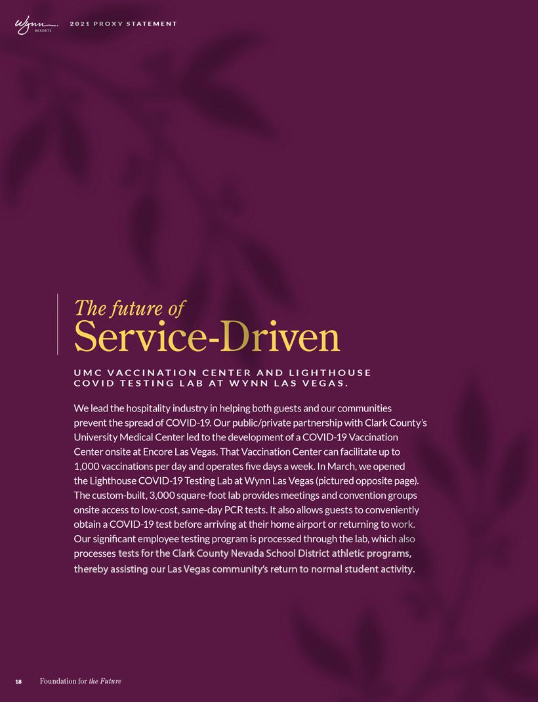

Table of Contents
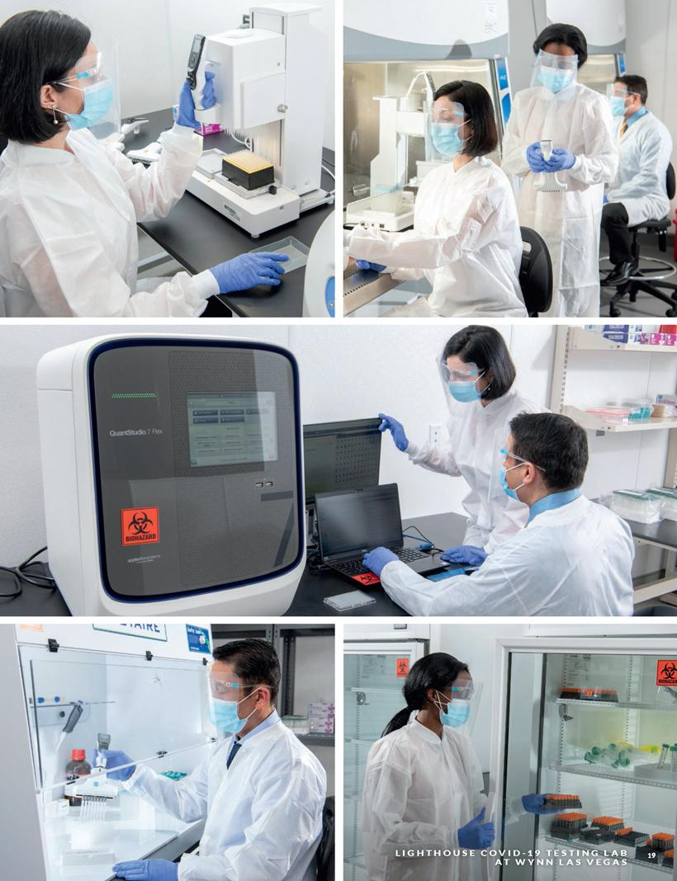

Table of Contents


Table of Contents

Introduction

In this section we will tell you about:

–Our People

–Our Communities

–Our Planet

Being socially responsible is not simply a catch-phrase at Wynn Resorts.

It is an essential mindset that is built into all our operations and business plans.

Under the direction of the Board, our executive team has set forth a strong set of values that supports our employees and their families, our communities and our planet. Our Board and executive team understand that being socially responsible is not only the right thing to do, it is a business imperative. Long-term value is only possible if all the Company’s stakeholders thrive, including our shareholders, employees, suppliers, the communities in which we operate and the environment. The Board has committed to a set of Environmental, Social and Governance (“ESG”) goals to drive long-term corporate value, and to measuring and reporting our progress toward our goals in each of these areas through certain Sustainability Accounting Standards Board (“SASB”) metrics.

The foundation of our ESG approach is our best-in-the-business corporate governance, discussed throughout this Proxy Statement.

 | CORPORATE GOVERNANCE
 | OUR VALUES
OUR PEOPLE | OUR COMMUNITIES | OUR PLANET
• Human Capital Management | • Giving and Volunteerism | • Net-Zero by 2050
• Employee Benefits | • Responsible Gaming | • Carbon peak 2030
• Diversity and Inclusion | • Human Trafficking Prevention Policy | • Renewable Energy Procurement 2030
• Training and Development

At a corporate level, our overarching commitment to social responsibility includes:

- Creating a five-star workplace

- Fostering a diverse and inclusive workforce

- Investing in the training and development of our employees and others in our community

- Furthering social impact initiatives in our communities

- Minimizing the harm and maximizing the benefit that we have on our community and environment by using and sourcing energy and materials responsibly
- Elevating our corporate governance practices to ensure they appropriately support the long-term interests of our stakeholders

In North America, we have taken a leading role in the hospitality industry’s transition to clean and sustainable sources of energy. Our investments in alternative energy, including on-site solar facilities and notably, a 160-acre solar facility in Northern Nevada, have earned us an invitation to join the U.S. Environmental Protection Agency’s Green Power Partnership and a top ranking among Fortune 500 companies that voluntarily use green power to reduce air pollution and other environmental impacts associated with electricity use.

We benefit from a diverse and inclusive workforce in which divergent perspectives create a thoughtful approach to solving business challenges. We encourage our employees to avail themselves of numerous leadership and development opportunities and use our resources to also assist in the education and development of the next generation of employees and leaders. In this extraordinary year, we have focused on the well-being of our employees and renewed our focus on diversity and inclusion.

We are also fully committed to supporting our communities in the Las Vegas and Boston areas, through our corporate giving program and through the Wynn Employee Foundation (“WEF”), which fosters charitable giving and volunteerism among Wynn employees and community partners.

21

Table of Contents

2021 PROXY STATEMENT

In Macau and across the Greater Bay Area (the region encompassing Macau, Hong Kong and southern Guangdong Province), we strive to drive reinvestment in our community, encourage volunteerism, and promote responsible gaming through our Wynn Care program. Since launching this program in Macau, we have centralized our community-focused initiatives under one umbrella and meaningfully increased our involvement in various volunteer activities and community events in Macau, the Greater Bay Area, and beyond. We are also fully committed to the sustainable development of Macau and endeavor to provide our guests with a premium experience while remaining environmentally conscious by monitoring and reducing inefficient consumption and embracing technologies that help us to responsibly use our resources. In addition, we provide our employees in Macau with numerous professional development and training opportunities to elevate core and leadership skills.

Our people

HUMAN CAPITAL MANAGEMENT

Our core philosophy that “Only People Can Make People Happy” has resulted in a culture focused on the engagement and happiness of our employees.

In the face of the COVID-19 pandemic, we began addressing the widespread and unexpected business challenges it created by focusing on the well-being of our greatest asset: our employees. In 2020, we:

- Committed to pay all employees, including part-time employees, full compensation including wages and an estimate of tips and full benefits while our resorts were closed, keeping 16,000 valued team members from joining the ranks of the unemployed.

- Made wellness and mental health of our employees a focus throughout the pandemic, offering emotional, financial and community health information and launched the Wellness Coach App for all employees for tools and resources to enhance their well-being.

- Launched a Virtual Volunteer program to provide team members with a digital platform to give back through national and local online volunteer opportunities.

- Voluntarily adopted an emergency leave policy to allow employees to take paid sick leave if they or a family member in their household is diagnosed with COVID-19.

- Partnered with University Medical Center to test our employees and exposed family members, with over 25,000 tests being administered in 2020.

- Offered Wynn Las Vegas employees, through a unique partnership with Boys and Girls Club of Southern Nevada, no-cost professionally supervised learning centers for their children attending public school “virtually”.

- Committed to $1 million in funding, increased the benefits, and relaxed the criteria for employees to take advantage of the Employee Lifeline Fund for those whose financial situation was affected by circumstances such as layoffs of their spouses.

- Continued to engage with our employees while our resorts were closed through virtual employee talent shows, TikTok challenges, virtual cooking classes and virtual family field trips to the Egyptian Pyramids, Buckingham Palace, the Louvre and other iconic locations.

- Gave retention grants of equity to over 400 key employees, made possible by the CEO’s request and the Compensation Committee’s agreement to cancel 140,000 CEO performance shares.

Beyond our responses to the pandemic, we remain committed to the success of each of our approximately 27,500 employees. We are leaders in the industry in employee retention because we provide exceptional benefits, are committed to diversity and inclusion, and create opportunities for advancement through extensive educational programs.

- Foundation for the Future

Table of Contents

EMPLOYEE BENEFITS

Contributing to our motivated workforce is a collection of employee programs and benefits that are the envy of our industry. We continue our work on pay and promotion equity, making changes as we find discrepancies. Some of our most popular benefits are voluntary ones such as home or even pet insurance. Each employee with a newborn is eligible for a $250 perfect start award and our Paid Parental Leave program is among the most generous programs in Las Vegas, as is our employee and family scholarship programs, both in North America and in Macau.

Our bonus and equity incentive programs for mid-level executives and above are designed to encourage long-term employment and alignment with shareholder interests. Our bonus and long-term incentive programs are overseen by the Compensation Committee.

DIVERSITY AND INCLUSION

Diversity and inclusion are the cornerstone of our human capital management efforts, and fully supported by the Board and senior management. Our CEO is a signatory to the CEO Action for Diversity and Inclusion Pledge, the largest CEO-driven business commitment to advance diversity and inclusion in the workplace. We are committed to standing up publicly for our beliefs and practices, with Matt Maddox issuing strong statements against racism and publicly confirming his commitment to diversity:

“Racism has no place in our society. The Wynn family is made up of every race, color and creed- representing the very best of Las Vegas and Boston. Now is the time for us to stand united, come together and work for change.”

“On this 155th anniversary of Juneteenth, we ask that each of us pause for a moment and decide what we will commit to do today to increase equality and eliminate racism in our community.”

EXCEPTIONALLY DIVERSE WORKFORCE
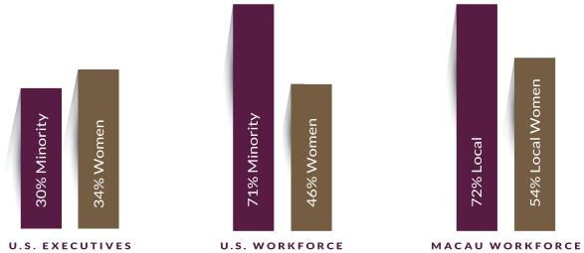

While these commitments and statements are recent, the evidence of our workforce demonstrates that the commitment is not: over 70% of our line level employees are ethnically diverse and over 50% of our managers are ethnically diverse.

We have also implemented or endorsed a number of different opportunities to encourage and support diversity in the workplace, including establishing affinity groups, sponsoring employees to participate in a U.S. citizenship program, with 84 employees taking advantage of the opportunity in 2020, training our employees on diversity, inclusion and implied biases and offering English as a second language. We also sponsored “Race and Racism in Nevada, Conversations to Better Understand our Diverse Community,” a five-part series on Nevada Public Radio.

23

Table of Contents

2021 PROXY STATEMENT

TRAINING AND DEVELOPMENT

We foster the growth and development of our employees to ensure that they remain best-equipped to deliver the singular customer service at each of our resorts. Across our resorts, we maintain an extensive program of training and development focused on skills development and career advancement. While large-scale in-person trainings were impossible due to the constraints of physical distancing requirements, we offered an online executive development series and encouraged team building and leadership skills with GIFT (Great Ideas From Teams) an operational improvement program. As our business returns to pre-COVID levels, we will relaunch our mentorship and leadership development programs.

MENTORSHIP PROGRAMS

Mentorship programs across Wynn Resorts properties are building a culture of internal mentorship, professional support, and personal development, pairing supervisors and managers with senior executives, including the resort presidents.

WE STRIVE

The WE Strive Program, through which we provide leadership development training to high-potential, line-level employees interested in pursuing a management career, is a three-month program covering leadership, team building, public speaking, emotional intelligence, conflict resolution, professional communication, and personal development.

SCHOLARSHIP AND TUITION REIMBURSEMENT

North American employees are eligible for WEF-sponsored scholarships awarded annually. Additionally, employees who are pursuing a college degree in an industry-related field are eligible for tuition reimbursement. We similarly fund scholarships for local talent in Macau.

Our communities

In the face of a global pandemic, which affected every aspect of our business, we continued to take care of our communities by:

- Developing and sharing our Health & Safety program, based on the advice of a team of leading medical and public health professionals which has become the gold standard for our and other industries and served as the foundation for the reopening of our resorts

- Assisting the Southern Nevada Health District with its ramped-up contact tracing efforts by allocating more than 100 team members from the Wynn Teleservices Call Center

- Establishing a round-the-clock, multi-department contact tracing team to ensure that each employee who tests positive for COVID-19 (which has been almost exclusively from community spread) receives detailed, thorough and personalized service to ensure that they and their families return to full health and that they do not spread it further throughout the community

- Establishing a first of its kind, PCR testing site at Wynn Las Vegas, which will allow us to test our employees and our guests on an expedited basis allowing return to more normal business activities

- Establishing a COVID-19 vaccination site for community members in partnership with University Medical Center allowing our health care partner to vaccinate more individuals than it was able to do at its own location

- Donating over $23 million in cash and in-kind donations to charitable organizations, $4.75 million of which was in-kind donations for COVID-19 relief efforts:

  - More than 245,000 N95-equivalent respirator masks, 1,775,000 surgical masks, and 640,000 pairs of medical gloves and hospital gowns to hospitals, nursing homes, and law enforcement agencies

  - More than $1 million in cash and food to local food banks

  - More than $100,000 in funds to domestic violence shelters

- Foundation for the Future

Table of Contents

  - 1.75 million MOP in pandemic supplies to more than 50 Macau organizations for use in residential homes and facilities for children and youth, temporary shelters, drug treatment centers and nurseries

- Raising more than $700,000 for the national ALL IN Challenge To Help Fight Food Insecurity, through a curated collection of the resort’s most exclusive luxuries, including some that money typically cannot buy

- Offering a complimentary one-night stay at the Wynn Las Vegas five-star resort to 10,000 hospital and medical workers, police, and fire fighters to show our appreciation. Additionally, we honored healthcare workers at nine hospitals during National Nurses and Hospital Weeks

- Creating two new initiatives to help our non-profit partners:

  - The Nonprofit Leadership Program, which is tailored for a small group of nonprofit leaders to help improve their strategic planning skills through interaction with and learning from Wynn executives

  - The Stronger Together Collective, which is intended to enhance resources for and to encourage collaboration among nonprofit partners

- Establishing the We Care Foundation in Macau to support and elevate community impact. The new foundation will fund education projects for youth and provide support to small and medium businesses and young entrepreneurs. The company aims to promote volunteerism, charitable and community activities, environment protection and sustainable development, sports, leisure, and culture

Wynn’s legacy as an agent of change is supported and extended by the collective spirit of service in the hearts of our approximately 27,500 global employees. Together, they have inspired our corporate culture of giving, bettering our home communities for generations to come For instance, our employees in North America contributed over $500,000 to the Wynn Employee Foundation. Along with matching contributions from the Company, these donations helped fund organizations dealing with food insecurity and domestic violence as a result of the COVID-19 pandemic.

WEF FUNDRAISING AND VOLUNTEERISM 2017-2020
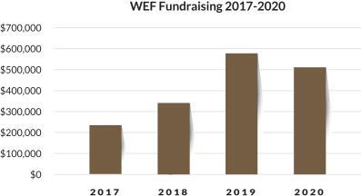

To help address physical distancing constraints on traditional forms of volunteerism, we launched a Virtual Volunteer program to provide team members with a digital platform to give back through national and local online volunteer opportunities. Leveraging that program, as well as traditional volunteer opportunities as they presented themselves, our employees volunteered almost 35,000 hours to community organizations by:

- Packing grocery bags for Three Square grocery giveaways

- Decorating and writing holiday cards for community partners

25

Table of Contents

2021 PROXY STATEMENT

- Donating food and hygiene items to homeless shelters for adults and teenagers

- Sewing face coverings donated to our Las Vegas community partners, including homeless shelters, legal aid society and health and public safety workers

- Organizing 5,400 Macau employees and family members to participate in an annual Walk-A-Million raising money for local charities We don’t just make a difference in our communities through our charitable efforts, we make a difference by being committed to building relationships with diverse vendors as part of our investment in our community, including partnership with small, minority-, women-, LGBT-, disabled-, and veteran-owned businesses. We are also committed to building partnerships with businesses focused on or located in historically disadvantaged communities.

RESPONSIBLE GAMING

As further commitment to our communities and to our customers, we follow the American Gaming Association’s Gaming Code of Conduct.

These practices include:

- Promoting Responsible Gaming, including providing information to our guests about responsible gaming and resources for assistance

- Preventing underage gaming and unattended minors at our resorts

- Training our employees on responsible gaming

- Responsible alcoholic beverage service practices

- Responsible advertising

- Providing financial resources to community organizations for preventing and treating problem gambling

HUMAN TRAFFICKING PREVENTION POLICY

We recognize the destructive effect of human trafficking on the global community as well as the potential intersection between human trafficking and the hospitality industry. We condemn all forms of human trafficking and are committed to implementing effective systems and controls to prevent human trafficking from taking place at our resorts. Essential to our commitment to combating human trafficking is our continued partnership with law enforcement agencies, as well as our community outreach efforts providing strong support for at risk youths, women, and children within our communities.

- Foundation for the Future

Table of Contents

Our planet

Being progressive is one of our four core company values. Our commitment to environmental sustainability gives us ample opportunity to demonstrate our leadership and vision in preserving our planet. This means providing award-winning service in our resorts worldwide, in a manner that respects communities, people, and our environment. Our sustainability program focuses on four global goals that will lead Wynn in a responsible and progressive future.

At Wynn Resorts we:

- Invent Solutions

- Add Value

- Take Action

- Scale Knowledge

In the same way the pandemic required a global response, we believe that the negative impacts of climate-change and environmental sustainability also requires bold commitments and even bolder actions, we have made public commitments to several significant initiatives that confront the global threat of climate-change including:


NET-ZERO BY 2050

CARBON PEAK 2030

RENEWABLE ENERGY PROCUREMENT

2030

Removing or offsetting an amount of carbon equal to the amount we produce from our resort operations no later than 2050.

Greenhouse Gas Emissions (GHGE) produced will not increase on a year over year basis past 2030.

Commitment to increased renewable energy production or procurement of at least 50% of energy consumed by 2030.

We provide extensive disclosure of recent accomplishments, our progress toward and metrics for these and other such objectives, and our roadmap for the future – including details on greenhouse gas emissions, renewable energy, and water intensity data – utilizing the Sustainability Accounting Standards Board (SASB) and Global Reporting Initiative (GRI) frameworks throughout our annual ESG Report available online at https://www.wynnresponsibility/2019_ESG_Report_Wynn_Resorts.pdf. Following are highlights of several long-term initiatives key to achieving these public environmental commitments.

27

Table of Contents

2021 PROXY STATEMENT

RENEWABLE ENERGY

Wynn Las Vegas’s investment in renewable energy has now installed 20 megawatts of solar capacity at Stillwater, which serves Wynn Las Vegas and offsets up to 75% of summer peak demand, and an additional 2 megawatts of rooftop solar which offsets 100% of the energy required for the south convention space expansion. Wynn Las Vegas has earned 4 Green Globes Certification for green buildings, and now offers Zero Carbon, Zero Waste event services, a compelling advantage for the event business.

The on-site micro-grid at Encore Boston Harbor provides 1 megawatt of rooftop solar generation, and 4 megawatts/8 megawatt hours of battery storage, supporting an additional 3 megawatts of combined heat and power (CHP) generation for the property as well as stability support for the New England Power Grid. This summer EBH, the largest LEED Platinum certified new construction project in New England, will achieve clean peak standard energy. We continue to invest in new energy efficiency measures and renewable energy generation to ensure year over year greenhouse gas emissions continue to decline.
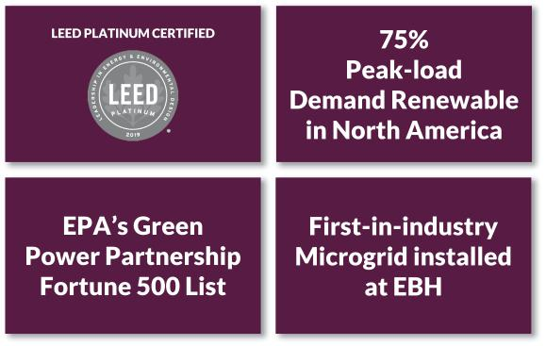

- Foundation for the Future

Table of Contents
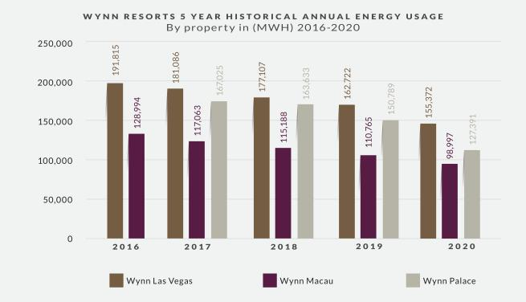

WASTE MANAGEMENT

Wynn Las Vegas implemented a single-stream recycling system to accelerate our efforts to reduce waste. As a proud partner of Clean the World, we reduce unnecessary waste by collecting the excess soap products from our resorts, which is then recycled and transformed into hygiene kits that will be distributed to underserved communities worldwide.

Wynn Macau, which continues to pioneer new approaches with tackling food waste, was the first in Macau to adopt the ‘Winnow Vision System’ across its properties. This system uses computer vision-based monitoring technology powered by AI and machine-learning to track and measure what food is being wasted, then delivers data-driven insights which enable an analytical approach to food production that enhances efficiency without compromising quality. Since its implementation in a number of Wynn restaurants, the initiative has already cut food waste by up to 35%, and reduced costs, while also ensuring a more responsible use of precious resources.

REDUCING SINGLE-USE PLASTICS

Wynn Las Vegas and Encore Boston Harbor have replaced the most common single-use plastic guest items such as straws, to-go packaging, and plastic bags with environmentally responsible alternative materials, in a global effort to reduce waste. As part of our Zero Carbon, Zero Waste event service, we have partnered with Proud Source water to eliminate all single-use water bottles from our Wynn Las Vegas meetings and convention space.

Wynn Macau became the first integrated resort in the world to install and use at significant scale an on-site Nordaq water bottling plant. This system enables high-quality filtered water to be produced locally and served in reusable glass bottles. As a result, Wynn Macau phased out the use of plastic water bottles in our food and beverage operations in 2020. We currently plan to have plastic bottles phased out of our hotel operations by year-end 2021.

29

Table of Contents

2021 PROXY STATEMENT

EXECUTIVE OFFICERS

Our Executive Officers as of March 12, 2021 are:

NAME | AGE | POSITION
Matt Maddox | 45 | Director and Chief Executive Officer
Craig S. Billings | 48 | President and Chief Financial Officer
Ellen F. Whittemore | 64 | Executive Vice President, General Counsel and Secretary

Our executive officers are appointed by the Board and serve at the discretion of the Board, subject to applicable employment agreements.

NON-DIRECTOR EXECUTIVE OFFICERS

Craig S. Billings President and Chief Financial Officer

Mr. Billings is the Company’s President and Chief Financial Officer, a position he has held since May 2019. On August 17, 2018, Mr. Billings was appointed a Non-Executive Director of Wynn Macau, Limited, a majority owned subsidiary of the Company. Mr. Billings joined the Company in March 2017 as the Company’s Chief Financial Officer and Treasurer.

PREVIOUS EXPERIENCE
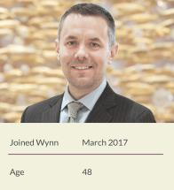
- 2015 to 2017: Gaming industry independent advisor and investor

- 2012 to 2015: Chief Digital Officer, Strategy & Business Development Managing Director, various roles, Aristocrat Leisure Ltd.

- Previously Vice President in the Investment Banking Division of Goldman Sachs in both New York and London, covering the gaming industry

- Previously Manager in the Audit Division of Deloitte & Touche in Las Vegas, NV

- 2015 to 2018: Director and Non-Executive Chairman, NYX Gaming Group (now part of Scientific Games)

EDUCATION

Mr. Billings graduated with a B.S. (cum laude) in Accounting from the University of Nevada, Las Vegas, and received an M.B.A. from Columbia Business School. Mr. Billings is a Certified Public Accountant.

Ellen F. Whittemore Executive Vice President, General Counsel and Secretary

Ms. Whittemore is the Company’s Executive Vice President, General Counsel and Secretary, a position she has held since July 2018.

PREVIOUS EXPERIENCE
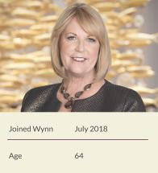
- 2016 to 2018: Shareholder of Brownstein Hyatt Farber Schreck LLP

- 2014 to 2016: Sole manager of the Whittemore Gaming Group, LLC

- Previously owner and President of Las Vegas Sports Consultants, a sports information service for Nevada sports pools

- Previously Of Counsel in the Las Vegas office of the law firm Lionel Sawyer & Collins for more than 20 years

EDUCATION

Ms. Whittemore graduated with a B.A. from the University of Nevada, Reno and received her J.D. from the University of San Diego School of Law. She is admitted to practice before the United States Supreme Court.

- Foundation for the Future

Table of Contents


Table of Contents

Table of Contents


Table of Contents
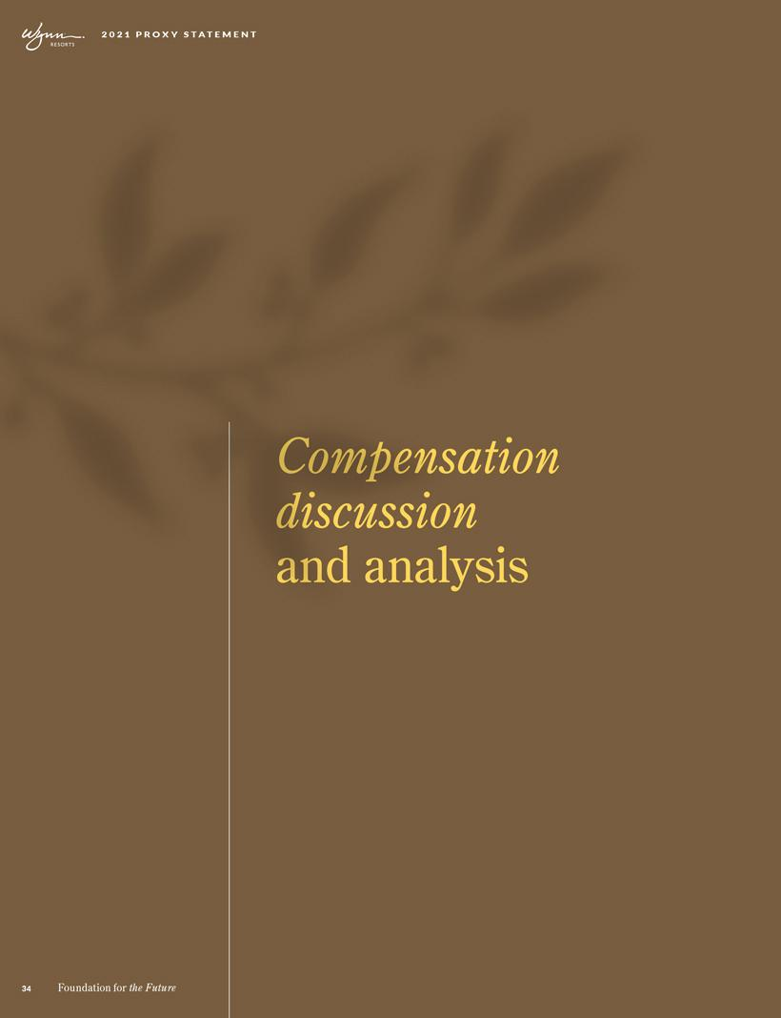

Table of Contents

We believe Wynn Resorts is the world’s preeminent designer, developer, and operator of integrated resorts. The Company’s business model integrates luxury hotel rooms, high-end retail, an array of dining and entertainment options, meeting space, and gaming, all supported by superior levels of customer service provided by our more than 27,500 employees. Our operations in Las Vegas, Macau and Boston are designed to attract a wide range of domestic and international customers.

The Compensation Committee relies on best-in-class practices to incentivize and reward executives and all employees for actions that create long-term shareholder value. As a result, our executive compensation practices promote accountability for performance and align incentives with long-term shareholder value. In addition, the Compensation Committee has designed our executive compensation program to attract and retain the best-in-class talent across our business. In this compensation discussion and analysis, or CD&A, we describe our philosophy and approach to executive compensation.

FOR FISCAL 2020, OUR NEOs WERE:

NAME | TITLE
Matt Maddox | Chief Executive Officer
Craig S. Billings | President and Chief Financial Officer
Ellen F. Whittemore | Executive Vice President, General Counsel and Secretary

35

Table of Contents

2021 PROXY STATEMENT

Overview of our executive compensation program

WHY YOU SHOULD VOTE FOR THE 2021 SAY-ON-PAY

Rigorous Design, Accountability and Alignment
- Annual and long-term incentive compensation remains aligned with long-term shareholder value creation
- The Compensation Committee set rigorous metrics for annual incentives despite the uncertainty around a rebound from COVID-19, and maintained strong focus on performance-based long-term incentives

- To further enhance the alignment of executives’ interest with those of long-term shareholders, the annual incentive, based on pre-set goals, is paid out 50% in equity

- In line with our focus on performance-based pay, 93% of NEO compensation remained at-risk with nearly two-thirds of incentives being focused on long-term performance

- Our executive compensation framework reflects feedback received over the past several years from shareholders

Responsiveness to COVID-19 Developments
- To preserve liquidity at the onset of COVID, all NEOs voluntarily agreed to receive a specified portion of base salary in the form of a restricted stock award, rather than in the form of cash, that vested on December 31, 2020 if the NEO remained continuously employed with the Company through such date

- To enable retention grants of equity to over 400 key employees, the CEO requested, and the Compensation Committee agreed, to cancel 140,000 of the CEO’s performance-based restricted share awards

As disclosed in the sections below, the executive compensation program is predicated on sound principles that clearly link compensation with performance. A significant percentage of CEO compensation is at-risk, with nearly two-thirds of pay being long term. This coupled with robust stock ownership guidelines ensure that the interests of executives and long-term shareholders are aligned.

We continue to make efforts to design and implement a world-class compensation structure that rewards executives for actions that create sustainable returns and shareholder value. Our annual incentives are focused on operational excellence and initiatives that align with our long-term strategy; paying 50% of annual incentives earned in equity sharpen the alignment of interests of executives with long-term shareholders. Our long-term incentives—at least 50% of which are granted as performance-based equity—reward executives in tandem with the creation of long-term value. The annual grants coupled with robust stock ownership guidelines ensure that executives are invested in ensuring the long-term viability of shareholder value.

We frequently engage with our shareholders to ensure that their feedback is reflected in our corporate governance approach, particularly with respect to executive compensation. Based in part on this feedback, the Compensation Committee has made considerable changes in our executive compensation program in recent years and, we believe, these changes contributed to 92.3% of voting shareholders approving our Say-on-Pay proposal at the 2020 Annual Meeting.

COMPENSATION CHANGES RESULTING FROM COVID-19

The COVID-19 pandemic significantly disrupted our operations at each of our properties. Our operations in Las Vegas and in Boston were closed entirely for several months to help slow the spread of COVID-19 in the U.S. and to ensure the safety of our employees, guests, and communities. Our Macau Operations were closed for two weeks and, upon reopening, experienced considerable reductions in visitation due to COVID-19-related regional travel restrictions. As a reflection of our core value to “care about everyone and everything,” we continued to pay our U.S. employees full wages, including estimated tips and full benefits, during the entire period that the applicable property was closed.

In January 2020, before the onset of COVID-19, the Compensation Committee approved annual long-term incentive grants to management consistent with those in prior years. In late Q1 2020, in the early stages of the COVID-19 pandemic, the Board, Compensation Committee and Management shifted its focus to the Company’s overall response to the pandemic and the well-being of all of our employees. During this period, the Company reduced NEO cash salaries by amounts ranging from 35% to 100% through December 31, 2020, as a measure of

- Foundation for the Future

Table of Contents

cash preservation and, in return, such NEO’s received stock compensation at a comparable amount. A reduction of NEO salaries of 20% was extended from January 1, 2021 to March 31, 2021 without a corresponding stock grant.

As our U.S. properties reopened in Q2 2020 and business operations became modestly predictable, the Compensation Committee addressed 2020 short-term incentives by setting rigorous goals for the second half of the year into considerable market uncertainty and set the target payout for such awards at 40% of historic targets. During Q3, as it became evident that the effects of COVID-19 would be protracted, the Compensation Committee approved a retention stock grant for over 250 U.S. employees to ensure continuity of management through late 2021. A similar grant was provided to over 150 employees in Macau during Q4 2020. The table below summarizes the changes and decisions made in direct response to the pandemic:

PAY ELEMENT |  | DETAIL/IMPACT
Base Salary | In March 2020, to preserve the Company’s cash position, each NEO voluntarily elected to receive all or a
 | significant portion of remaining base salary compensation for the remainder of the calendar year in the form
 | of a restricted stock award (in lieu of cash) that vested on December 31, 2020, and each Director voluntarily
 | received stock in lieu of cash retainer
Annual Incentives | The Compensation Committee
 | - | Set rigorous goals for the second part of 2020 once our U.S. properties reopened
 | - | Capped annual incentive at 40% of contractual targets
 | - | Evaluated performance against these preset goals to determine payouts
Long-term Incentives | The Compensation Committee
 | - | Maintained commitment to having at least 50% of long-term incentive grants being performance based
 | - | Granted broad-based retention stock grants to over 400 employees, including the NEOs, to ensure the
 |  | stability of management through the pandemic

CEO EMPLOYMENT CONTRACT EXTENSION AND RELATED PERFORMANCE SHARE GRANT

As disclosed in the 2020 Proxy Statement, CEO Matt Maddox and the Company agreed to extend his employment contract through Dec. 16, 2022. In connection with this extension, the amended contract provided for a restricted stock grant that contemplated the vesting of a total of 45,000 shares at threshold performance, 100,000 shares at target performance, and 180,000 shares at maximum performance, based entirely on the attainment of numerous strategic performance conditions, including, among others, the extension of the Company’s Macau gaming concession, attaining certain performance metrics at Encore Boston Harbor, attaining Great Places to Work certification at Wynn Las Vegas, and advancement of certain of the Company’s business development efforts and conditioned generally on his continued employment.

In August 2020, in order to provide equity incentives broadly throughout the Company as part of the aforementioned retention grant to over 400 employees in the U.S. and Macau, Mr. Maddox requested, and the Compensation Committee agreed to cancel the 140,000 of the maximum of 180,000 of such performance shares underlying Mr. Maddox’s restricted stock grant described above, valued at

$6.4 million. As a result, only 40,000 shares of the original 180,000 performance shares subject to such restricted stock grant in February 2020 remain outstanding as of December 31, 2020 and subject to the original performance conditions described above. As such, the effective value of such performance-based restricted stock grant following such forfeiture was valued at $4.4 million, compared with the original grant value of $10.8 million.

37

Table of Contents

2021 PROXY STATEMENT

The following chart depicts the impact of the forfeiture mentioned above on the CEO’s compensation in 2020.
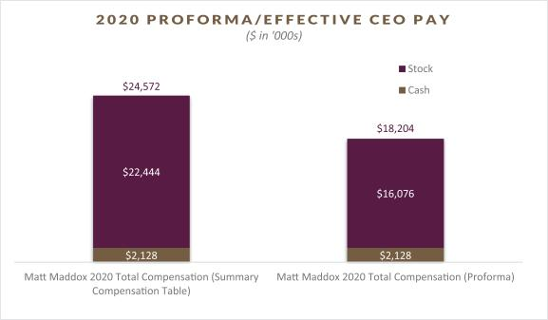

Executive compensation components

 | % OF TOTAL | AT-
 | ANNUAL | AT-
ELEMENT | COMPENSATION(1) | RISK? | FEATURES | 2020 RESULTS
Base salary | 13% | No | Attract and retain top employees and recognize | Base salary unchanged in 2020
 |  |  | sustained performance, job scope and experience | In March 2020, each NEO accepted a restricted
 |  |  |  | stock award in lieu of receiving their base salary
 |  |  |  | compensation in the form of cash for the
 |  |  |  | remainder of the calendar year to preserve the
 |  |  |  | Company’s cash position in response to the
 |  |  |  | pandemic
Annual incentives | 12% | Yes | Utilize multiple metrics with pre-set goals | 2020 Annual Incentive opportunity capped at 40%
 |  |  | Incentivize executives, enforce accountability and | of contractual targets
 |  |  | motivate and reward achievement of annual goals | Payout based on pre-set robust Financial and
 |  |  | 50% of annual incentive awards paid in stock and | Operational objectives for the second half of the
 |  |  | 50% of annual incentive awards paid in stock and | year
 |  |  | subject to NEO holding requirements, further | year
 |  |  | aligning executive and long-term shareholder
 |  |  | interests
Long-term incentives: | 46% | Yes | Performance-based stock vest solely based on | Performance-based restricted stock linked to the
Performance-based |  |  | company performance on preset goals over a | achievement of “fair share” metrics
restricted stock and |  |  | three-year performance period, linking the | Performance granted with exercise price
premium priced options |  |  | creation of shareholder value to incentives earned | Performance granted with exercise price
premium priced options |  |  | creation of shareholder value to incentives earned | representing a premium greater than 50% of grant
 |  |  |  | date price
Long-term incentives: | 28% | Yes | Ensure focus on long-term value creation, align | Retention, alignment of interests with those of
Time-based restricted |  |  | executive and long-term shareholder interests, | long-term shareholders and includes restricted
stock |  |  | and promote retention | stock received in lieu of cash as noted above

(1) % of 2020 Total Compensation (Proforma) for CEO Maddox as displayed in immediately prior chart, excluding Other Compensation. Percentages do not add up to 100% because of rounding.

- Foundation for the Future

Table of Contents

How we approach executive compensation

Our executive compensation philosophy is to align the interests of executives with those of shareholders by designing incentives that are directly tied to actions which create sustainable long-term shareholder value.

We, the Compensation Committee, believe that our ability to oversee the delivery of operational excellence and sustainable long-term returns to shareholders is inexorably linked to attracting and retaining a high-performing management team.

Hence, the executive compensation program must be designed to attract, reward, and retain executive officers who create continual near-and long-term shareholder value by achieving the Company’s strategic goals. We also believe that stability at the executive level is key to the strength of the Company, particularly given the relatively small pool of executives with gaming experience for whom we compete.

To achieve this, we rely on the following principles:

Pay-for-Sustainable Performance: The majority of our executives’ total compensation is tied to achieving annual and long-term goals that enhance the value of our reputation and brand, sustain the performance and attractiveness of our resorts and drive long-term shareholder value. The Compensation Committee retains discretion to reduce amounts earned and payable when doing so will further these goals. Further, 50% of annual incentive is paid in equity (rather than all cash), and equity is subject to our robust holding requirements.

Shareholder Alignment: Our long-term equity incentives align executives’ interests with those of shareholders and stakeholders. Our executive compensation focuses on key metrics that are critical drivers for realizing our strategic objectives and achieving long-term results. By focusing on regular equity grants that vest over three years and on performance-based awards, we believe that the alignment of interest is strengthened, especially when coupled with robust stock holding requirements for executives (6x base salary for our CEO).

Focus on Compensation Totals and Parity: We evaluate the total amounts of executives’ compensation for parity purposes and assess them relative to the pay practices of major gaming companies and other competitors for talent. The Committee reaffirmed its commitment to right-sized executive compensation by benchmarking total compensation at the median of our peer group and making adjustments for specific skills and experience.

Simplicity and Clarity: We value pay structures that are simple and clear. We believe pay simplicity promotes transparency, avoids incentivizing focus on pay goals at the expense of ongoing excellence and performance, and promotes teamwork.

Attract and Retain Top Talent: Our business spans continents, can be subject to meaningful volatility, requires tight coordination with regulators, depends on knowledge of numerous types of complex operations, requires diligent investment over many years and across business cycles, and is highly dependent on a reputation for excellence, so finding and retaining top talent is a critical element of our compensation.

39

Table of Contents

2021 PROXY STATEMENT

HOW OUR EXECUTIVE COMPENSATION PHILOSOPHY DRIVES CEO PAY DESIGN


 |  |  |  | FOCUS ON
 |  | PAY FOR |  | COMPENSATION |  | ATTRACT AND
 |  | SUSTAINABLE | SHAREHOLDER | TOTALS AND | SIMPLICITY | RETAIN TOP
 |  | PERFORMANCE | ALIGNMENT | PARITY | AND CLARITY | TALENT
❑ | Benchmarking CEO at Median of Peer |  | ● | ● |  | ●
 | Group |  | ● | ● |  | ●
❑ | 93% of total direct NEO compensation is | ● | ● |  | ●
 | at-risk⁽²⁾ | ● | ● |  | ●
❑ | Annual incentives are 100% performance | ● | ● | ● | ● | ●
 | based
❑ | Performance-based stock units comprise | ● | ● | ● | ● | ●
 | majority of long-term incentives


- Annual incentives subject to negative Board
 | discretion | ● | ● | ●
❑ | Stock Ownership Guidelines for all NEOs |  | ● | ● | ●

- Based on 2020 Total Direct Compensation for NEOs excluding the CEO’s employment contract extension grant

How the company has performed

While our year-to-year performance can be significantly impacted by market factors, geopolitical events and investor sentiment, we have delivered significant outperformance since our initial public offering in October 2002 through October 2020. Over that 18-year period, the Company has averaged a 16% annual Total Shareholder Return (“TSR”), (including reinvestment of dividends), which is substantially above the TSR of both the S&P 500 (approximately 10% average annual TSR) and the S&P Consumer Discretionary Index (approximately 12% average annual TSR) over the same time period. We have also delivered an average annual TSR nearly four times our closest industry peers.(1) We believe these results are driven by our focused, long-term investment in our properties and by our relentless dedication to delivering the industry’s best customer experience.
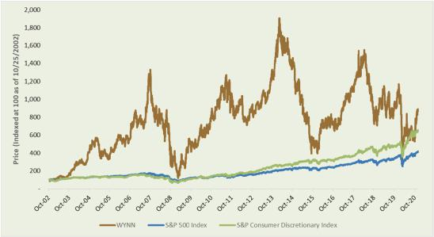

- Industry peers reflect Las Vegas Sands and MGM Resorts. Las Vegas Sands’ TSR is measured from the market close on the day of their IPO on 12/15/2004 (average annual TSR of approximately 4%). MGM Resorts’ TSR is measured from the close on the date of Wynn Resorts’ IPO on 10/25/2002 (average annual TSR of approximately 4%).

- Foundation for the Future

Table of Contents

Our key accomplishments in 2020 include:

- Industry-Leading Response to the COVID-19 Pandemic. We pre-emptively closed our Las Vegas Operations to protect our customers, our partners and our employees in response to the COVID-19 pandemic. We created and adopted the industry-leading approach to allow our resorts to reopen safely. We leveraged resources to assist local health services to broaden access to testing, which contributed to reopening our resorts earlier.

- Advanced our Digital Gaming Strategy. We accelerated our digital sports betting strategy by acquiring a controlling stake in BetBull in October 2020, and aggressively growing our domestic interactive business. By the end of 2020, a subsidiary of Wynn Interactive had secured market access in seven states and had agreements for additional market access pending legalization in other states. We launched our app, WynnBET, to pursue growth in the market.

- Growing Mass Gaming Share in Macau. Upon reopening in Macau, our team has focused on continuing to grow our mass table gaming market share, which increased approximately 160 basis points year over year in 4Q 2020.

- Targeted Capital Investment Program at Existing Properties. Although we halted many capital expenditure projects as a consequence of the COVID-19 pandemic, we executed on targeted property enhancements where capital had already been deployed or where we saw an opportunity for a meaningful upgrade as we reopened. In Las Vegas, we completed construction of an approximately 430,000 square foot meeting and convention facility that is ready to welcome guests when it is safe to do so. We have designed and are prepared to make a meaningful room refreshment for the Wynn Las Vegas tower in the near term.

- Maintaining Healthy Liquidity and Financial Flexibility. Despite the COVID-19 pandemic, we opportunistically preserved our liquidity and de-risked our Macau balance sheet. As of December 31, 2020, the Company had approximately $3.48 billion of cash and cash equivalents and $461.4 million of borrowing capacity available under our revolving credit facilities. During 2020, the Company continued to improve the maturity profile of its debt obligations in Macau by refinancing shorter tenor secured debt with longer tenor unsecured senior notes.

- Continued Recognition as a Preeminent Integrated Resort. For the second year in a row, Wynn Macau is the only resort in the world with eight Forbes Travel Guide Five-Star awards. Wynn Macau and Wynn Palace, which won seven Five-Star Awards, are the most decorated integrated resort brands in Asia, with 15 Five-Star Awards. In 2021, Wynn Las Vegas and Encore Las Vegas won seven Five Star awards. Collectively, the Company has 22 Five Star awards in its portfolio. In addition, Wynn Resorts was once again honored to be included on FORTUNE Magazine’s 2021 World’s Most Admired Companies list in the hotel, casino, and resort category and ranked first overall in the category of Quality of Products/ Services among all international hotel companies.

How we designed incentives in 2020

2020 HIGHLIGHTS:

In 2020, the Compensation Committee:

- Set rigorous and meaningful financial metrics for annual incentives for the second half of 2020, once our properties reopened, that reflected the operating condition of the properties. Continued to pay 50% of annual incentive executive compensation in equity.

- Maintained a policy that at least 50% of long-term incentive grants would be performance-based, including performance-based stock awards that vest upon achievement of pre-established financial performance goals that are based on the Company’s ability to achieve a premium revenue and Adjusted Property EBITDA “fair share” relative to its peers (see discussion of this metric below), on a three-year basis.

- Reaffirmed its commitment to compensate executives at the median with regard to total compensation, and conducted an overall analysis of all NEO total compensation to confirm compliance.

- Modified the vesting schedule to equal annual installment vesting over three-years for restricted stock awards to allow executives to realize incentives over time.

41

Table of Contents

2021 PROXY STATEMENT

Role of the Compensation Committee and Management in Setting Compensation: The Compensation Committee sets all elements of compensation for our NEOs based upon consideration of an NEO’s contributions to the operating and strategic performance of the Company. The Compensation Committee considers the recommendations of the CEO in establishing compensation for all other NEOs. In addition, the CEO performs annual reviews of our senior executive officers and makes recommendations to the Compensation Committee. The Compensation Committee reviews the recommendations and makes final decisions regarding compensation for our senior executive officers.

COMPENSATION MIX

We take a multi-year investment approach to our business that focuses on rewarding strong near-term performance and the creation of long-term shareholder value. Because product quality and service excellence are at the core of our strategy, we use annually focused, operations-based pay to highlight the critical importance of performing well each year for each customer. We supplement that with a set of long-term incentives and holding requirements to support the sustainability of our reputation and our ongoing returns. The charts below highlight the focus on equity and at-risk mix of the total direct compensation for our current NEOs based on 2020 compensation outcomes(1):
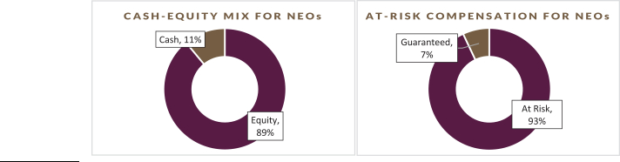

- Based on 2020 Total Direct Compensation for NEOs excluding the CEO’s employment contract extension grant and retention grants for all NEOs

2020 Compensation design & decisions

Base Salary: Negotiated employment agreements establish our NEOs’ initial base salaries. We review and adjust their base salaries periodically to stay competitive, to reflect improvements in performance, capabilities, and experience, and reward expansions of responsibility or other extraordinary circumstances. While contractual base salaries for the NEOs as of December 31, 2020 and 2019 were unchanged, cash base salaries for NEOs were reduced by 100%, 50%, and 35% for Mr. Maddox, Mr. Billings, and Ms. Whittemore, respectively, as part of our COVID-19 mitigation efforts as described below.

In March 2020, each of the NEOs elected to receive a portion of their remaining base salary compensation for the 2020 calendar year in the form of a restricted stock award (in lieu of cash) that vested on December 31, 2020 if the NEO remained continuously employed with the Company through such vesting date. The number of shares underlying each NEO’s restricted stock award was determined based on the three-day trailing closing price of the Company’s stock on March 20, 2020, equivalent to the amount of base salary compensation such NEO would have otherwise received. The table below presents the base salary our NEOs were contractually entitled to for 2020. The incremental value of the restricted stock award received in lieu of cash for base salary compensation is included in the “Stock Awards” column to the Summary Compensation Table below, and the applicable incremental amounts are described in the footnote to the “Base Salary” column thereto.

 |  |  |  |  |  | 2020 CASH |  | 2019 CASH
 |  |  | 2020 BASE |  | 2019 BASE | BASE |  | BASE
EXECUTIVE |  |  | SALARY⁽¹⁾ |  | SALARY⁽¹⁾ | SALARY⁽²⁾ |  | SALARY⁽²⁾
Matt Maddox |  | $ | 2,000,000 | $ | 2,000,000 | $ 538,462 | $ | 2,000,000
Craig S. Billings |  | $ | 1,200,000 | $ | 1,200,000 | $ 784,615 | $ | 1,200,000
Ellen F. Whittemore |  | $ | 700,000 | $ | 700,000 | $ 538,462 | $ | 700,000

- Reflects base salary per each respective NEO’s employment contract.

- Reflects the actual cash received by each respective NEO for calendar year 2020 as adjusted for an exchange of base salary for a stock compensation grant that vested on December 31, 2020 as previously discussed.

- Foundation for the Future

Table of Contents

Annual Incentives: In response to the pandemic, the Compensation Committee limited the annual incentive opportunity to 40% of contractual target awards. For the 2020 annual incentive awards granted under our Omnibus Plan, the Compensation Committee applied two performance goals, each related to the second half of the year given that the Company was able to begin opening certain properties at that time and due to the uncertainty surrounding COVID-19 during the first half of the year.

Goal 1 – 2020 Adjusted Property EBITDA in North America (weighted 50%): For the second half of 2020, Adjusted Property EBITDA was used as a proxy for operating cash flow during a period of intense focus on liquidity.

The Committee, based on the effect of the COVID-19 pandemic on the operating conditions in Las Vegas and Boston and the uncertainty of operating conditions as the properties reopened, set a threshold performance level of at most a loss of $7 million, a target level of break-even, and maximum performance level of $60 million, in order to encourage minimization of cash flow losses.

No incentive payout would be earned with respect to this metric if the Company did not achieve the threshold performance level.

Goal 2 – Macau Market Share (weighted 50%): As our Macau properties reopened, visitation volumes remained suppressed due to travel restrictions. The Compensation Committee established market share goals to evaluate performance in challenging and unusual conditions.

The Committee set a threshold performance level of 10% market share, a target level of 12% market share, and a maximum performance level of 16% market share.

No incentive payout would be earned in respect of this metric if the Company did not achieve the threshold performance level.

These awards were subject to (i) the limitations set forth in the Omnibus Plan, including the cash and stock grant limits and requirement of continued employment through the end of the calendar year performance period, and (ii) the Compensation Committee’s right, in its discretion, to reduce actual bonus amounts paid, taking into account other performance considerations, including corporate, property level and individual performance, as well as general macroeconomic conditions.

43

Table of Contents

2021 PROXY STATEMENT

2020 Annual incentive payout:

For the second half of 2020, Actual Adjusted Property EBITDA for our Las Vegas Operations and Encore Boston Harbor was $83.9 million
– above the maximum performance level. For the second half 2020, the Company’s market share in Macau was above the Threshold level, but below the maximum performance level. Based on the 2020 results, in January 2021, the Compensation Committee determined the actual award payouts as set forth below, with the award being split equally in cash and stock and the target level set at 40% of contractual target levels:

 |  |  |  |  |  |  |  | ACTUAL AWARD
NAMED EXECUTIVE OFFICER |  | THRESHOLD(1) |  | TARGET(2) |  | MAXIMUM(3) |  | CASH |  | EQUITY(4)
Matt Maddox |  | 80% |  | 100% |  | 120% | $ | 1,100,000 |  | $ | 1,100,000
Craig S. Billings |  | 64% |  | 80% |  | 96% | $ | 528,000 |  | $ | 528,000
Ellen F. Whittemore |  | 64% |  | 80% |  | 96% | $ | 308,000 |  | $ | 308,000

- Amounts in the Threshold column reflect potential awards for achievement of second half 2020 North America Adjusted Property EBITDA between $(7.0) million to $0 and achievement of second half 2020 Macau market share between 10% and 11.99%. No awards would have been payable under if the second half North America Adjusted Property EBITDA was below $(7.0) million and second half Macau market share was below 10%. Adjusted Property EBITDA is net income before interest, income taxes, depreciation and amortization, pre-opening expenses, property charges and other, management and license fees, corporate expenses and other (including intercompany golf course and water rights leases), stock-based compensation, loss on extinguishment of debt, change in derivatives value, change in Redemption Note fair value, and other non-operating income and expenses. See our Annual Report on Form 10-K for the year ended December 31, 2020 (Item 8, Note 20—“Segment Information” to our Consolidated Financial Statements) for the definition of “Adjusted Property EBITDA,” a reconciliation of Adjusted Property EBITDA to net income attributable to Wynn Resorts, and other information regarding this non-GAAP financial measure.

- Amounts in the Target column reflect potential awards for achievement of second half 2020 North America Adjusted Property EBITDA between $0 through $60 million and achievement of second half 2020 Macau market share between 12% and 15.99%.

- Amounts in the Maximum column reflect potential awards for achievement of second half 2020 North America Adjusted Property EBITDA above $60 million and achievement of second half 2020 Macau market share above 16%.

- The amounts set forth in this column reflect the aggregate grant date fair value of stock awards granted. These stock awards are fully vested.

Long-Term Incentives: In the past, the Company made periodic—not annual—equity grants to executives, including our NEOs. Those periodic grants were typically made with long-term vesting dates of up to ten years and such awards were not subject to performance conditions.

Beginning in 2018, the Compensation Committee moved from periodic grants to annual grants with three-year cliff vesting and implemented a policy of subjecting a portion (currently no less than 50%) of grants made to NEOs to performance conditions in order to ensure a superior focus on operational excellence as well as better align executives’ interests with those of long-term shareholders. The Compensation Committee maintained this approach in 2020.

In January 2020, before the onset of COVID 19, management proposed, and the Compensation Committee approved, the use of “fair share” metrics for performance conditions. The four fair share metrics selected by the Company are generally calculated as follows:

- In Las Vegas, the Company’s share of total revenue relative to selected peers divided by the Company’s share of hotel rooms among such peers and the Company’s share of Adjusted Property EBITDA relative to those selected peers divided by the Company’s share of hotel rooms among such peers; and

- In Macau, the Company’s share of gaming revenue relative to selected peers divided by the Company’s share of gaming tables among such peers and the Company’s share of Adjusted Property EBITDA relative to those selected peers divided by the Company’s share of gaming tables among such peers.

The decision to select these metrics was based on careful consideration of the following factors:

- The Company’s exposure to Macau provides sizeable opportunities over the mid and long-term, but can create meaningful volatility over short periods, significantly skewing short-term TSR and creating opportunities for management to benefit from outsized market growth, irrespective of their performance; and

- Foundation for the Future

Table of Contents

- The Company’s strategy is to attract and retain premium consumers in each market in which the Company operates. We believe the results of this strategy provide outsized operating results, relative to peers, and create meaningful shareholder returns over the long-term. Consistently achieving such premium fair share requires diligent and consistent investment in facilities and people across the business cycle.

2020 Equity Grants: On January 14, 2020, Mr. Maddox received a grant of 39,994 shares of restricted stock. Except as otherwise described in the section titled “Potential Payments or Upon Termination or Change in Control”, Mr. Maddox’s award vests as follows: 50% of the shares is based on achievement of pre-established financial performance goals during the three-year period ended December 31, 2022, and if met, will vest on March 1, 2023, and vesting of the remaining 50% is conditioned on continued service through January 14, 2023.

On December 17, 2019, the Company announced that Mr. Maddox and the Company had agreed to extend his employment contract through December 16, 2022. In connection with this extension, Mr. Maddox amended and restated employment contract provided for the grant of a target of 100,000 shares (45,000 threshold, 180,000 maximum), based entirely on the attainment of numerous performance conditions, including the extension of the Company’s Macau gaming concession, attaining certain Discretionary Free Cash Flow targets, attaining certain performance metrics at Encore Boston Harbor, attaining Great Places to Work certification at Wynn Las Vegas, and advancement of the Company’s business development efforts in Japan. Certain accelerated vesting provisions may apply if the reporting person’s employment with the Company is terminated prior to December 16, 2022. The terms of the grant were approved by the Compensation Committee and the award was made effective on February 26, 2020. In light of the pandemic, and in an effort to provide equity incentives to management broadly throughout the Company, on August 18, 2020, Mr. Maddox requested, and the Compensation Committee agreed, to cancel 140,000 shares of the February 2020 performance share grant.

On March 23, 2020, Mr. Maddox elected to receive of his remaining base salary compensation for 2020 in the form of a restricted stock award in lieu of cash, whereby he was granted 32,071 shares of restricted stock that was conditioned on his continued employment and vested on December 31, 2020.

On August 18, 2020, along with over 250 other key U.S. employees across the Company, in recognition of the Company’s efforts to respond to the pandemic, Mr. Maddox received a grant of 24,501 shares of restricted stock that vests on August 18, 2021, subject to his continued employment through such vesting date.

On December 11, 2020, Mr. Maddox was granted 3,868 options to acquire Wynn Interactive stock that vest ratably each year for four years ending on December 11, 2024.

On January 11, 2021, Mr. Maddox received a grant of 55,542 shares of restricted stock. Except as otherwise described in the section titled “Potential Payments or Upon Termination or Change in Control”, such restricted stock award is subject to both time- and performance-based vesting conditions, whereby 50% of the award vests on March 1, 2024 based on achievement of pre-established financial performance goals during the three-year period ending December 31, 2023, and the remaining 50% of the award time vests ratably over three-years on each anniversary of the grant date, subject to Mr. Maddox’s continued employment through such vesting date.

On January 14, 2020, Mr. Billings received a grant of 7,332 shares of restricted stock. Except as otherwise described in the section titled “Potential Payments or Upon Termination or Change in Control”, such restricted stock award vests 100% on March 1, 2023 based on achievement of pre-established financial performance goals during the three-year period ended December 31, 2022, subject to

Mr. Billings’ continued employment. On February 26, 2020, Mr. Billings received a grant of 7,332 shares of restricted stock that vests solely upon the achievement of an extension of the Company’s Macau gaming concession and continued employment.

On March 23, 2020, Mr. Billings elected to receive 50% of his remaining base salary compensation for 2020 in the form of a restricted stock award in lieu of cash, whereby he was granted 9,621 shares of restricted stock that was conditioned on Mr. Billings’ continued employment and vested on December 31, 2020.

On August 18, 2020, along with over 250 other key U.S. employees across the Company during 2020, in recognition of the Company’s efforts to respond to the pandemic, Mr. Billings received a grant of 13,476 shares

of restricted stock that vests on August 18, 2021, subject to his continued employment through such date.

45

Table of Contents

2021 PROXY STATEMENT

On December 11, 2020, Mr. Billings was granted 9,256 options to acquire Wynn Interactive stock that vests 25% each year for the four-year period ending on December 11, 2024.

On January 11, 2021, Mr. Billings received a grant of 20,366 shares of restricted stock. Except as otherwise described in the section titled “Potential Payments or Upon Termination or Change in Control”, such restricted stock award is subject to both time- and performance-based vesting conditions, whereby 50% of the award vests on March 31, 2024 based on achievement of pre-established financial performance goals during the three-year period ending December 31, 2023, and the remaining 50% of the award vests ratably over three-years on each anniversary of the grant date, subject to Mr. Billings’ continued employment through such date.

On January 14, 2020, Ms. Whittemore received a grant of 7,166 shares of restricted stock. Except as otherwise described in the section titled “Potential Payments or Upon Termination or Change in Control”, such restricted stock award is subject to both time- and performance-based vesting conditions, whereby 50% of the award vests on March 1, 2023 based on achievement of pre-established financial performance goals during the three-year period ending December 31, 2022, and the remaining 50% of the award vests on January 14, 2023, subject to Ms. Whittemore’s continued employment through such vesting date.

On March 23, 2020, Ms. Whittemore elected to receive 35% of her remaining base salary compensation for 2020 in the form of a restricted stock award in lieu of cash, whereby she was granted 3,929 shares of restricted stock that was conditioned on her continued employment and vested on December 31, 2020.

On August 18, 2020, along with over 250 other key U.S. employees across the Company, in recognition of the Company’s efforts to respond to the COVID-19 Pandemic, Ms. Whittemore received a grant of 6,585 shares of restricted stock that vests on August 18, 2021, subject to Ms. Whittemore’s continued employment through such vesting date.

On December 11, 2020, Ms. Whittemore was granted 1,382 options to acquire Wynn Interactive stock that vests ratably each year for the four-year period ending on December 11, 2024.

On January 11, 2021, Ms. Whittemore received a grant of 9,952 shares of restricted stock. Except as otherwise described in the section titled “Potential Payments or Upon Termination or Change in Control”, Ms. Whittemore’s award is subject to both time-and performance-based vesting conditions, whereby 50% of the award vests on March 1, 2024 based on achievement of pre-established financial performance goals during the three-year period ending December 31, 2023, and the remaining 50% of the award vests ratably over three-years on each anniversary of the grant date, subject to Ms. Whittemore’s continued employment through such vesting date.

Executive Benefits: We provide our NEOs with benefits that we believe are reasonable, competitive and consistent with our overall executive compensation program. Our primary executive benefits are certain health insurance coverage, life insurance premiums, discounts and complimentary privileges with respect to the Company’s resorts, which are described in the footnotes to the “Summary Compensation Table.” For 2020, we paid nonresident state income taxes imposed on our executives who were required by us to travel on Company business and perform services in states other than their states of employment. This primarily arose as a result of travel to and work in Massachusetts in connection with our Encore Boston Harbor resort. Our reimbursement covers the incremental cost of the nonresident taxes and puts the executives in the same economic position as though they had worked in their normal places of business. The Company does not gross-up or pay any state income taxes that the employees incur on account of work in their normal work locations. In addition, certain executives, including Named Executive Officers, have access to the Company’s aircraft pursuant to time-sharing agreements described in “Certain Relationships and Related Transactions—Aircraft Arrangements.”

Peer Group Benchmarking: The Compensation Committee believes that it is appropriate to offer competitive total compensation packages to senior executive officers in order to attract and retain top executive talent. The compensation peer group allows the Compensation Committee to monitor the compensation practices of our primary competitors for executive talent. The Compensation Committee targets the 50th percentile for the Company’s senior executive officers’ total compensation to ensure that executives are appropriately compensated as we operate in a highly competitive industry.

- Foundation for the Future

Table of Contents

In 2020, as part of our regular review of our compensation programs, the Compensation Committee considered peer group data from gaming and other related industries that the Compensation Committee believes reflect the competitive market for executive talent similar to that required by the Company. Our peer group was last updated in 2019.

Wynn Resorts 2020 executive compensation peer group

GAMING & RESORTS | TRAVEL, HOSPITALITY & RESORTS | LIFESTYLE PRODUCTS
Caesars Entertainment Corporation | Hilton Worldwide Holdings Inc. | Capri Holdings Limited
Las Vegas Sands Corp. | Hyatt Hotels Corporation | PVH Corp.
MGM Resorts International | Marriott International, Inc. | Ralph Lauren Corporation
Penn National Gaming, Inc. | Norwegian Cruise Line Holdings Ltd | Tapestry, Inc.
 | Royal Caribbean Cruises Ltd | The Estée Lauder Companies Inc.
 | Wyndham Hotels & Resorts, Inc. | Tiffany & Co.
 |  | V.F. Corporation

The 17 companies in the peer group generally had revenue, market capitalization and total enterprise value (as of December 31, 2020) in a relevant range around those of the Company as set forth below.

 | WYNN RESORTS |  | PEER GROUP
Revenue | $2.1 billion | Range: | $1.3 billion–$14.2 billion
 |  | Median: | $4.3 billion
Market Capitalization | $12.2 billion | Range: | $5.5 billion–$96.3 billion
 |  | Median: | $15.5 billion
Enterprise Value | $21.2 billion | Range: | $7.7 billion–$98.8 billion
 |  | Median: | $22.9 billion

Data source: Bloomberg.
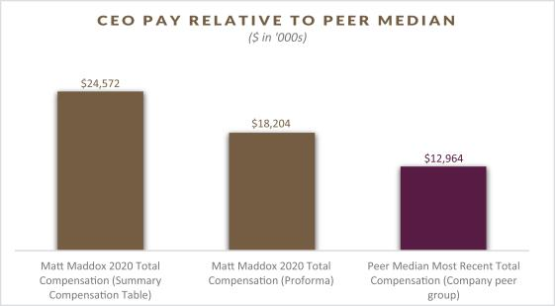

47

Table of Contents

2021 PROXY STATEMENT

Non-disclosure of certain metrics and targets

The Company believes in transparency and strives to disclose as much information to shareholders as possible except in situations where we believe that providing full, or even limited, disclosure would be detrimental to the interests of shareholders. We believe certain disclosure could provide our competitors with insight regarding confidential business strategies without meaningfully adding to shareholders’ understanding of the metric.

Other aspects of our executive compensation

Role of the Compensation Consultant: The Compensation Committee has the authority to retain compensation consulting firms exclusively to assist it in the evaluation of senior executive officer and employee compensation and benefit programs. In 2020, the Compensation Committee retained Radford a nationally recognized independent compensation consulting firm, to assist in performing its duties. Radford does not provide services to the Company other than the advice on director and executive compensation that it may provide the Compensation Committee when requested. In 2020, Radford, at the direction of the Compensation Committee, completed a peer group review and competitive compensation analysis, in connection with the Compensation Committee’s review of compensation levels of our NEOs. The Compensation Committee retains sole responsibility for engaging its advisors.

Independence of the Compensation Consultant: The Compensation Committee has determined that Radford is independent and the services provided by Radford currently do not and during 2020 did not raise any conflict of interests. In reaching these conclusions, the Compensation Committee considered the factors set forth in Rule 10C-1 of the Exchange Act and applicable listing standards.

Employment Agreements: We have a longstanding practice of entering into multi-year employment agreements with our senior executive officers and senior management. We believe that employment agreements provide greater assurance of continuity and retention of critical creative and operating talent in a highly competitive industry. Employment agreements for our NEOs are approved by the Compensation Committee in consultation with the Compensation Committee’s independent compensation advisors, as needed. The employment agreements for the NEOs currently employed by the Company specify their base salary and provide that if the executive’s employment (i) terminates without cause at the Company’s election, (ii) is terminated by the executive following the Company’s material breach of the agreement or (iii) is terminated by the executive for good reason after a change in control, the executive will receive a separation payment as described in more detail under the heading “Potential Payments Upon Termination or Change in Control.” The employment agreements and the terms of equity awards also provide that vesting of some or all of an executive’s equity awards will accelerate upon certain events. Current employment agreements do not provide for any excise tax gross ups. We believe that providing for these benefits in these situations enhances the value of the business by preserving the continuity of management during potential change in control situations and by focusing our senior executives on our long-term priorities. Additional information regarding payments under these provisions is provided under the heading “Potential Payments Upon Termination or Change in Control.”

Compensation committee report

We have reviewed and discussed the Compensation Discussion and Analysis required by Item 402(b) of Regulation S-K with the Company’s management. Based on such review and discussion, we have recommended to the Board that the Compensation Discussion and Analysis be included in this Proxy Statement.

Compensation Committee

Betsy S. Atkins, Chair
Richard J. Byrne
Margaret J. Myers

Clark T. Randt, Jr.

- Foundation for the Future

Table of Contents


Table of Contents


Table of Contents
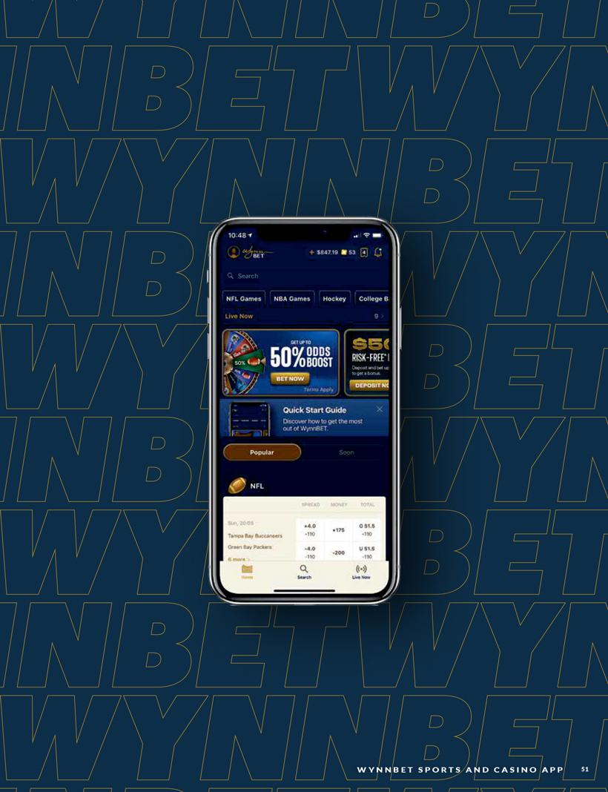

Table of Contents
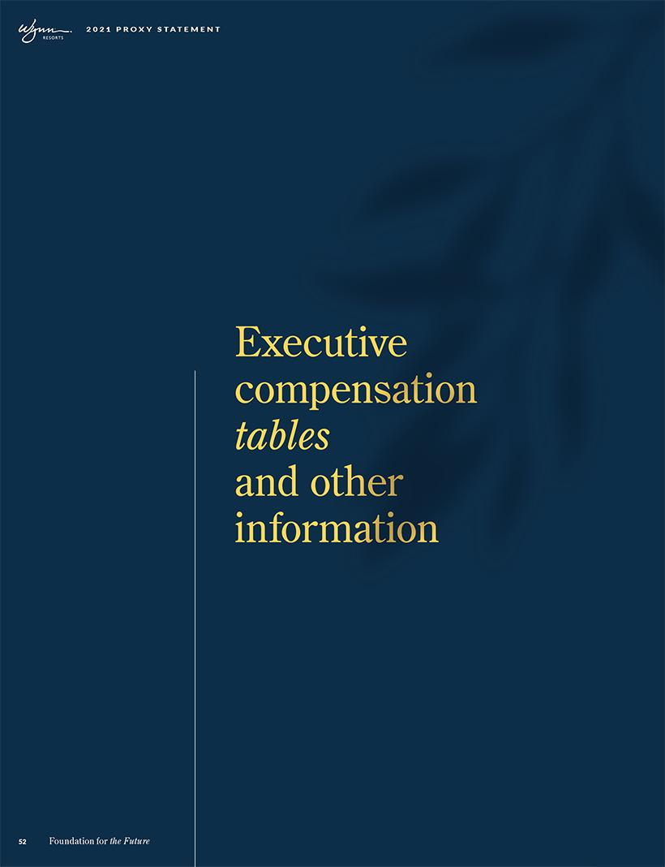

Table of Contents

2020 CEO COMPENSATION

As disclosed in the 2020 Proxy Statement, CEO Matt Maddox and the Company agreed to extend his employment contract through Dec. 16, 2022. In connection with this extension, the amended contract provided for a restricted stock grant that contemplated the vesting of a total of 45,000 shares at threshold performance, 100,000 shares at target performance, and 180,000 shares at maximum performance, based entirely on the attainment of numerous strategic performance conditions, including, among others, the extension of the Company’s Macau gaming concession, attaining certain performance metrics at Encore Boston Harbor, attaining Great Places to Work certification at Wynn Las Vegas, and advancement of certain of the Company’s business development efforts and conditioned generally on his continued employment.

In August 2020, in order to provide equity incentives broadly throughout the Company as part of the aforementioned retention grant to over 400 employees in the U.S. and Macau, Mr. Maddox requested, and the Compensation Committee agreed to cancel the 140,000 of the maximum of 180,000 of such performance shares underlying Mr. Maddox’s restricted stock grant described above, valued at $6.4 million. As a result, only 40,000 shares of the original 180,000 performance shares subject to such restricted stock grant in February 2020 remain outstanding as of December 31, 2020 and subject to the original performance conditions described above. As such, the effective value of such performance-based restricted stock grant following such forfeiture was valued at $4.4 million, compared with the original grant value of $10.8 million.

The following chart depicts the impact of the forfeiture mentioned above on the CEO’s compensation in 2020.

2020 Proforma/Effective CEO Pay ($ in '000s)Stock Cash $24,572 $18,204 $22,444 $2,128 $16,076 $2,128 Matt Maddox 2020 Total Compensation (Summary Compensation Table) Matt Maddox 2020 Total Compensation (Proforma)

53

Table of Contents

2021 PROXY STATEMENT

Summary compensation table

The table below summarizes the total compensation awarded to, earned by, or paid to, each of our NEOs for the fiscal years ended December 31, 2020, 2019 and 2018.

The table below is presented in a manner consistent with Regulation S-K. As discussed throughout the Compensation Discussion and Analysis section of our proxy, in response to the effects of the COVID-19 pandemic, significant modifications were made to executive compensation in 2020 that resulted in a reduction of cash compensation for NEOs and a reduction of stock compensation for our Chief Executive Officer. Such changes are not reflected in the table below. In March of 2020, each of the NEOs elected to receive a portion of their remaining base salary compensation for the 2020 calendar year in the form of a restricted stock award (in lieu of cash) that vested on December 31, 2020. These elections reduced cash compensation for Mr. Maddox by approximately $1 .5 million, Mr. Billings by approximately $ 0.4 million, and Ms. Whittemore by approximately $ 0.2 million. The stock received in lieu of these reductions is included in Salary for 2020 in the table below. Further, In light of the pandemic, and in effort to provide equity incentives to management broadly throughout the Company, on August 18, 2020, Mr. Maddox requested, and the Compensation Committee agreed, to cancel 140,000 shares ($6.4 million at grant date value) of Mr. Maddox’s February 2020 share grant. This forfeiture is not reflected in the table below.


 |  |  |  |  | NON-EQUITY
NAME AND |  | SALARY ($) | STOCK | OPTION | INCENTIVE | ALL OTHER
NAME AND | YEAR | SALARY ($) | AWARDS ($) | AWARDS ($) | PLAN | COMPENSATION | TOTAL ($)
PRINCIPAL POSITION | YEAR | (1)
PRINCIPAL POSITION |  | (1) | (2)(3) | (3)(4) | COMPENSATION | ($)(6)
 |  |  |  |  | ($ )(5)

MATT MADDOX |  | 2020 | $2,000,000 | $20,283,231 | $699,218 | $1,100,000 | $489,531 | $24,571,980
Director and |  | 2019 | $2,000,000 | $8,000,209 | $- | $2,000,000 | $1,851,089 | $13,851,298
Chief Executive Officer |  | 2018 | $1,901,923 | $12,032,500 | $- | $2,500,000 | $694,760 | $17,129,183
CRAIG BILLINGS |  | 2020 | $1,200,000 | $3,678,581 | $1,673,207 | $528,000 | $70,997 | $7,150,785
President and |  | 2019 | $1,053,750 | $2,560,147 | $- | $960,000 | $217,382 | $4,791,279
Chief Financial Officer |  | 2018 | $849,519 | $5,641,250 | $- | $875,000 | $132,276 | $7,498,045
ELLEN F. WHITTEMORE | 2020 |  | $700,000 | $1,985,303 | $249,824 | $308,000 | $27,484 | $3,270,611
Executive Vice President, |  | 2019 | $655,000 | $1,310,111 | $- | $560,000 | $67,184 | $2,592,295
General Counsel and
Secretary | 2018 |  | $253,846 | $1,421,550 | $- | $300,000 | $14,150 | $1,989,546

- The amounts set forth in this column reflects each Named Executive Officer’s annual base salary approved by the Compensation Committee. On March 23, 2020, in response to the COVID-19
pandemic, Mr. Maddox elected to receive 100% of the remainder of his annual salary in the form of a restricted stock award, Mr. Billings elected to receive 50% of the reminder of his annual salary in the form of a restricted stock award, and Ms. Whittemore elected to receive 35% of the remainder of her annual salary in the form of a restricted stock award. The full annual base salary for each such Named Executive Officer is reflected above and the incremental value of such restricted stock awards, as computed in accordance with FASB ASC Topic 718, are included in the Stock Awards column. Such incremental amounts included in the Stock Awards column for Mr. Maddox, Mr. Billings and Ms. Whittemore were $384,789, $138,496 and $64,655, respectively. The number of shares each Named Executive Officer was granted was determined based on the total amount of each of their respective base salaries for the remainder of the year and the 3-day volume weighted average of the Company’s stock price ending on March 20, 2020.

- Stock awards granted as a component of the 2020, 2019 and 2018 annual incentive awards are reported in this column as 2020, 2019 and 2018 compensation, respectively, to reflect the applicable service period for such awards; however, the stock grants were approved by the Compensation Committee in January of the following calendar year. See annual incentive award payouts as described in “Compensation Discussion and Analysis-How We Designed Incentives for 2020-Elements of Pay” for a description of the 2020 annual incentive awards. The amounts reported in this column reflect a portion from restricted stock grants which are not related to the annual incentive awards and were reported in the year of grant. Except as otherwise noted, certain grants in this column vest based on specified performance criteria and are reflected in this column at 100% of the aggregate grant date fair value. In February 2020, in connection with an extension of

Mr. Maddox’s employment agreement, the Compensation Committee approved a grant for Mr. Maddox totaling 180,000 restricted shares, assuming achievement at maximum performance, that all vest entirely based on the achievement of certain performance criteria as described under “2020 Grants of Plan-Based Awards”. This column reflects $10,798,125 of compensation for Mr. Maddox related to 97,500 restricted shares that were determined to be probable of vesting on the

- Foundation for the Future

Table of Contents

grant date or thereafter. This column does not reflect $9,136,875 of compensation for Mr. Maddox related to 82,500 of restricted shares that was determined not to be probable of vesting on the grant date (together with the probable portion of the award, the highest level of achievement is $19,935,000). In light of the pandemic, and in an effort to provide equity incentives to management broadly throughout the Company, on August 18, 2020, Mr. Maddox requested, and the Compensation Committee agreed, to cancel 140,000 shares of the February 2020 performance share grant ($6.4 million at grant date value).

- The amounts set forth in this column reflect the aggregate grant date fair value of stock awards and stock options computed in accordance with FASB ASC Topic 718, excluding estimated forfeitures. Performance-based restricted share awards in this column are reflected based on the probable outcome of such conditions as of the applicable grant date in accordance with accounting standards for stock-based compensation. Except as otherwise described in the footnotes to this table, all performance-based restricted share awards were deemed probable of vesting on the grant date. See our Annual Report on Form 10-K for the year ended December 31, 2020, Item 8, Note 12 -“Stock-Based Compensation” to our Consolidated Financial Statements for assumptions used in computing fair value.

- The amounts set forth in this column represent stock options of Wynn Interactive Ltd., an indirect 72% owned subsidiary of Wynn Resorts (“Wynn Interactive”), Limited, granted to Messrs. Maddox and Billings and Ms. Whittemore in 2020.

- As described above under “Compensation Discussion and Analysis-How We Designed Incentives for 2020-Elements of Pay,” in January 2021, the Compensation Committee exercised its discretion to pay 50% of the actual earned annual incentive for all NEO’s in stock that was fully vested at grant.

- The following amounts for 2020 are included in “All Other Compensation” for Mr. Maddox:
  - accrued cash dividends on unvested restricted stock of $472,836;
  - insurance premiums and benefits including executive life and medical insurance of $1,781; and
  - reimbursement of taxes related to work performed in Massachusetts of $14,638.

The following amounts for 2020 are included in “All Other Compensation” for Mr. Billings:
- accrued cash dividends on unvested restricted stock of $66,756;
- insurance premiums and benefits including executive life and medical insurance of $1,415; and
- reimbursement of taxes related to work performed in Massachusetts of $2,826.

The following amounts for 2020 are included in “All Other Compensation” for Ms. Whittemore:
- accrued cash dividends on unvested restricted stock of $20,147;
- insurance premiums and benefits including executive life and medical insurance of $4,226; and
- reimbursement of taxes related to work performed in Massachusetts of $3,111.

Discussion of summary compensation table

In 2020, each of the NEOs received a base salary in accordance with the terms of his or her employment agreement, as approved by the
Compensation Committee. Key terms of the agreements, as in effect on December 31, 2020, were as follows:


 |  |  |  | BASE
NAME EXECUTIVE OFFICER | CONTRACT EXPIRATION |  |  | SALARY
MATT MADDOX | December 16, 2022 |  | $ | 2,000,000
CRAIG BILLINGS | March 1, | 2022 | $ | 1,200,000
ELLEN F. WHITTEMORE | July 16, | 2022 | $ | 700,000

Each of the employment agreements provide that the executive will participate in Company profit sharing and retirement plans if offered, disability or life insurance plans, medical and/or hospitalization plans, vacation and expense reimbursement programs. In addition, the agreements provide for severance payments and benefits upon certain terminations of employment, including termination following a change in control, as discussed in the section below entitled “Potential Payments Upon Termination or Change in Control.”

55

Table of Contents

2021 PROXY STATEMENT

2020 Grants of plan-based awards table

The Omnibus Plan rewards management for creation of superior return to shareholders, measured by the operating performance of our resorts. The amounts shown in the table below reflect potential payments. Actual payouts are reflected in the “Stock Awards” and “Non-Equity Incentive Plan” columns of the Summary Compensation table.


 |  |  |  |  |  |  |  |  |  |  |  |  | ALL OTHER
 |  |  |  |  | ESTIMATED FUTURE PAYOUTS |  |  |  |  | ESTIMATED FUTURE PAYOUTS |  |  | STOCK
 |  |  |  |  |  |  |  |  |  |  |  |  | AWARDS:
 |  |  |  |  | UNDER NON-EQUITY INCENTIVE PLAN |  |  |  |  | UNDER EQUITY INCENTIVE PLAN |  |  |  |  | GRANT DATE
 |  |  |  |  |  | AWARDS($)(1) |  |  |  | AWARDS(#)(2)(7) |  |  | NUMBER OF |  | FAIR VALUE
 |  |  |  |  |  |  |  |  |  |  |  |  | SHARES OF |  | OF | STOCK
 |  |  |  | THRESHOLD |  |  | TARGET |  | MAXIMUM | THRESHOLD | TARGET | MAXIMUM | STOCK OR | AND |  | OPTION
NAMED EXECUTIVE OFFICER | GRANT DATE |  |  |  | ($)(4) |  | ($)(5) |  | ($)(6) | (#)(2) | (#)(2) | (#)(2) | UNITS(#) |  | AWARDS($)(3)
 |  | N/A |  | $ | 1,600,000 | $2,000,000 |  | $ | 2,400,000 |  |  |  |  |  |  | —
 |  | 1/14/2020 |  |  | - |  | - |  | - | - | - | - | 39,994⁽⁷⁾⁽⁸⁾ | $ | 6,000,300
MATT MADDOX |  | 2/26/2020 |  |  | - |  | - |  | - | 45,000 | 100,000 | 180,000 | - | $ 10,798,125⁽²⁾
MATT MADDOX |  | 3/23/2020 |  |  | - |  | - |  | - | - | - | - | _{32,071}(7)(10) | $ | 1,846,327
 |  | 8/18/2020 |  |  | - |  | - |  | - | - | - | - | _{24,501}(7)(11) | $ | 2,000,017
 |  | 12/11/2020 |  |  | - |  | - |  | - | - | - | - | _{3,868}(7)(12) | $ |  | 699,218
 |  | N/A |  | $ | 768,000 | $ | 960,000 | $ | 1,152,000 | - | - | - | - |  |  | -
 |  | 1/14/2020 |  |  | - |  | - |  | - | - | - | - | _{7,332}(7)(8) | $ | 1,100,020
CRAIG BILLINGS |  | 2/26/2020 |  |  | - |  | - |  | - | - | - | - | _{7,332}(7)(9) | $ |  | 812,019
CRAIG BILLINGS |  | 3/23/2020 |  |  | - |  | - |  | - | - | - | - | _{9,621}(7)(10) | $ |  | 553,881
 |  | 8/18/2020 |  |  | - |  | - |  | - | - | - | - | _{13,476}(7)(11) | $ | 1,100,046
 |  | 12/11/2020 |  |  | - |  | - |  | - | - | - | - | _{9,256}(7)(12) | $ | 1,673,207
 |  | N/A |  | $ | 448,000 | $ | 560,000 | $ | 672,000 | - | - | - | - |  |  | -
 |  | 1/14/2020 |  |  | - |  | - |  | - | - | - | - | _{7,166}(7)(8) | $ | 1,075,115
ELLEN F. WHITTEMORE |  | 3/23/2020 |  |  | - |  | - |  | - | - | - | - | _{3,929}(7)(10) | $ |  | 226,193
 |  | 8/18/2020 |  |  | - |  | - |  | - | - | - | - | _{6,585}(7)(11) | $ |  | 537,534
 |  | 12/11/2020 |  |  | - |  | - |  | - | - | - | - | _{1,382}(7)(12) | $ |  | 249,824

- The potential 2020 performance-based annual incentive awards that could have been earned for 2020 are subject to (a) the limitations set forth in the Omnibus Plan, including the cash and stock grant limits and continued employment through the end of the performance period, (b) the Compensation Committee’s ability to reduce awards in its discretion and (c) the Compensation Committee’s discretion to pay a portion of the awards in shares of Common Stock. Actual awards were based upon achievement of the 2020 performance criteria: (i) achievement of a second half 2020 North America Adjusted Property EBITDA goal and (ii) achievement of a second half 2020 Macau Market Share goal. In addition, the Compensation Committee exercised its discretion to reduce the potential 2020 annual incentive award to a potential target of 40% of contractual targets. The targets included in the table reflect 40% of contractual targets. Actual payouts are described in “Compensation Discussion and Analysis-How We Designed Incentives for 2020-Elements of Pay.”

- In connection with an extension of Mr. Maddox’s employment agreement, Mr. Maddox was awarded a potential of 180,000 shares that all vest based on the achievement of performance criteria, including criteria related to company-specific gaming licensure in certain jurisdictions, free cash flow targets, certain property-level gaming statistical targets, and certain corporate responsibility measures. The amounts in each Threshold, Target, and Maximum column represent the potential achievement of each of the performance criteria at each given level. It was determined that 97,500 shares were probable of vesting on the date of grant or thereafter, which totaled $10,798,125 of compensation. It was determined that 82,500 shares were not probable of vesting on the date of grant. The grant date fair value as presented does not reflect $9,136,875 of compensation related to the awards that were determined not to be probable of vesting (together with the probable portion of the award, the highest level of achievement is $19,935,000). In light of the pandemic, and in an effort to provide equity incentives to management broadly throughout the Company, on August 18, 2020, Mr. Maddox requested, and the Compensation Committee agreed, to cancel 140,000 shares of the February 2020 performance share grant ($6.4 million at grant date value).

- The amounts set forth in this column reflect the aggregate grant date fair value of stock awards and stock options computed in accordance with accounting standards for stock-based compensation. Performance-based restricted share awards in this column are reflected based on the probable outcome of such conditions as of the applicable grant date in accordance with accounting standards for stock-based compensation. See our Annual Report on Form 10-K for the year ended December 31, 2020, Item 8, Note 12 -“Stock-Based Compensation” to our Consolidated Financial Statements for assumptions used in computing fair value.

- Amounts in the Threshold column reflect potential awards for achievement of second half 2020 North America Adjusted Property EBITDA between $(7.0) million to $0 and achievement of second half 2020 Macau market share between 10% and 11.99%. No awards would have been payable under if the second half North America Adjusted Property EBITDA was below $(7.0) million and second half Macau market share was below 10%.

- Amounts in the Target column reflect potential awards for achievement of second half 2020 North America Adjusted Property EBITDA between $0 through $60 million and achievement of second half 2020 Macau market share between 12% and 15.99%.

- Amounts in the Maximum column reflect potential awards for achievement of second half 2020 North America Adjusted Property EBITDA above $60 million and achievement of second half 2020 Macau market share above 16%.

- Foundation for the Future

Table of Contents

- The shares granted may be subject to certain accelerated vesting provisions as described below under “Potential Payments upon Termination or Change in Control” if the executive’s employment is terminated prior to the vesting date.

- Mr. Maddox and Ms. Whittemore were granted 39,994 and 7,166 shares of restricted stock respectively. The restricted stock awards provided that 50% of the shares would vest on January 14, 2023 subject to continued employment and 50% of the shares would vest on March 1, 2023 which are subject to the achievement of pre-established property-level revenue and Adjusted Property EBITDA performance goals and continued employment. Mr. Billings was granted 7,332 shares of restricted stock and would vest on March 1, 2023 subject to the achievement of pre-established property-level revenue and Adjusted Property EBITDA performance goals and continued employment.

- Mr. Billings was granted 7,332 restricted shares that vest based the achievement of company-specific gaming licensure in certain jurisdictions and continued employment.

- On March 23, 2020, Mr. Maddox elected to receive 100% of the remainder of his contractual annual salary in the form of a restricted stock grant (in lieu of cash), Mr. Billings elected to receive 50% of the reminder of his contractual annual salary in the form of a restricted stock grant (in lieu of cash), and Ms. Whittemore elected to receive 35% of the remainder of her annual salary in the form of a restricted stock grant (in lieu of cash). The number of shares each Named Executive Officer received was determined based on the total amount of each of their respective base salaries for the remainder of the year and the 3-day volume weighted average of the Company’s stock price ending on March 20, 2020. As these shares were granted in lieu of cash for the calendar year 2020 base salary, the shares vested in full on December 31, 2020. The amount presented in this table represents the entire grant date fair value of the award in accordance with applicable accounting standards. The amount included in the Stock Awards column of the Summary Compensation Table for each of the Named Executive Officers includes only the incremental amount of the award that exceeds each NEO’s applicable base salary amount for which cash was not received.

- These shares vest on August 18, 2021 subject to continued employment.

- On December 11, 2020, Messrs. Maddox and Billings and Ms. Whittemore were granted options to acquire shares of Wynn Interactive that vest 25% each year for the four-year period ending on December 11, 2024, subject to continued employment.

Outstanding equity awards at fiscal year-end


 |  | OPTION AWARDS |  |  | STOCK AWARDS
 |  |  |  |  | NUMBER OF | MARKET VALUE
 | NUMBER OF | NUMBER OF |  |  | SHARES OR | OF SHARES
 | SECURITIES | SECURITIES |  |  | UNITS OF |  | OR UNITS
 | UNDERLYING | UNDERLYING |  |  | STOCK THAT | OF STOCK
 | UNEXERCISED | UNEXERCISED | OPTION | OPTION | HAVE NOT | THAT HAVE
 | OPTIONS(#) | OPTIONS(#) | EXERCISE | EXPIRATION | VESTED | NOT VESTED
NAME | EXERCSIABLE | UNEXERCISABLE | PRICE ($) | DATE | (#) |  | ($)(5)
MATT MADDOX | - | 3,868 | $760.79 | 12/11/2030⁽¹⁾ | 217,337⁽²⁾ | $24,522,134
CRAIG BILLINGS | - | 9,256 | $760.79 | 12/11/2030⁽¹⁾ | 64,232⁽³⁾ | $ | 7,247,297
ELLEN F. WHITTEMORE | - | 1,382 | $760.79 | 12/11/2030⁽¹⁾ | 23,482⁽⁴⁾ | $ | 2,649,474

- On December 11, 2020, Messrs. Maddox and Billings and Ms. Whittemore were granted options to acquire shares of Wynn Interactive that vest 25% each year for the four-year period ending on December 11, 2024 subject to continued employment.

- On January 1, 2021, 15,000 performance shares vested as a result of achieving certain performance conditions as of December 31, 2020. 25,000 shares will vest if certain performance conditions are met related to company-specific gaming licensure in certain jurisdictions and subject to continued employment. 26,421 shares and 19,997 shares vest on March 1, 2022 and March 1, 2023, respectively, subject to continued employment and the achievement of pre-established property-level revenue and Adjusted Property EBITDA performance goals. 24,501 shares will vest on August 18, 2021; 40,000 shares will vest on November 4, 2021; 26,421 shares will vest on January 11, 2022; 10,000 shares will vest on March 1, 2022; 19,997 shares will vest on January 14, 2023; and 10,000 shares will vest on March 1, 2023, all of which are subject to continued employment.

- 7,332 shares will vest if certain performance conditions are met related to company-specific gaming licensure in certain jurisdictions and subject to continued employment. 7,046 and 7,332 shares will vest on March 1, 2022 and March 1, 2023, respectively, subject to continued employment and the achievement of pre-established property-level revenue and Adjusted Property EBITDA performance goals. 6,000 shares will vest on March 1, 2021; 13,476 shares will vest on August 18, 2021; 7,046 shares will vest on January 11, 2022; 11,000 shares will vest on March 1, 2022; and 5,000 shares will vest on March 1, 2023, all of which are subject to continued employment.

- 1,125 shares will vest on March 1, 2022; 3,303 shares will vest on March 1, 2022; and 3,583 shares will vest on March 1, 2023, all of which are subject to continued employment and the achievement of pre-established property-level revenue and Adjusted Property EBTIDA performance goals. 1,000 shares will vest on July 15, 2021 and 2022; 6,585 shares will vest on August 18, 2021; 3,303 shares will vest on January 11, 2022; and 3,583 shares will vest on January 14, 2023, all of which are subject to continued employment.

- Amounts in this column are based upon the closing price of the Company’s stock at December 31, 2020, which was $112.83.

57

Table of Contents

2021 PROXY STATEMENT

Option exercises and stock vested in 2020


 | OPTION AWARDS |  | STOCK AWARDS
 | NUMBER OF |  | NUMBER OF
 | SHARES | VALUE | SHARES | VALUE
 | ACQUIRED | REALIZED | ACQUIRED | REALIZED
 | ON EXERCISE ON EXERCISE |  | ON VESTING | ON VESTING
NAME | (#) | ($) | (#) | ($)

MATT MADDOX | - | $- | 172,071 | $14,050,627⁽¹⁾
CRAIG BILLINGS | - | $- | 25,621 | $ | 2,117,711⁽²⁾
ELLEN F. WHITTEMORE | - | $- | 7,179 | $ | 519,021⁽³⁾

- 100,000 shares that were acquired on vesting were as a result of achievement of certain pre-established performance goals. 72,071 shares vested based on satisfaction of the applicable service conditions.

- 10,000 shares that were acquired on vesting were as a result of achievement of certain pre-established performance goals. 15,621 shares vested based on satisfaction of the applicable service conditions.

- 2,250 shares that were acquired on vesting were as a result of achievement of certain pre-established performance goals. 4,929 shares vested based on satisfaction of the applicable service conditions.

The amounts reported in the table above are based on the closing price of the Company’s Common Stock on the date the stock award vested. Upon vesting of the stock award, the executive also was paid an amount equal to the dividends that had accrued on the shares prior to their vesting.

Potential payments upon termination or change in control

Payments Made Upon Termination Due to Death, Complete Disability or License Revocation. The Company’s employment agreements with its current NEOs provide that such agreements terminate automatically upon death or complete disability of the employee, as well as upon failure of the employee to obtain or maintain any required gaming licenses. Upon such termination, such NEO is entitled to a lump sum payment of accrued and unpaid base salary and vacation pay through the termination date. Pursuant to the terms of the applicable stock option agreements and restricted stock grant agreements, all of the unvested options and restricted stock held by such NEOs would vest upon termination as a result of such NEO’s death or complete disability.

Payments Made Upon Termination Without Cause at Employer’s Election or at Employee’s Election Upon Company Material Breach During the Term. The Company’s employment agreements with its current NEOs provide that such agreements are terminable by the Company without cause upon notice to the employee, so long as a “separation payment” is paid as provided in such contracts, or by the employee upon written notice to the Company of the Company’s uncured material breach of the agreement. Cause is generally defined to include (i) inability or failure to secure and/or maintain any licenses or permits required by government agencies with jurisdiction over the business of the Company or its affiliates; (ii) willful destruction of property of the Company or an affiliate having a material value to the Company or such affiliate; (iii) fraud, embezzlement, theft, or comparable dishonest activity (excluding acts involving a de minimis dollar value and not related in any manner to the Company, its affiliates or their business); (iv) conviction of or entering a plea of guilty or nolo contendere to any crime constituting a felony; (v) material breach of employment agreement; (vi) neglect, refusal, or knowing failure to materially discharge duties (other than due to physical or mental illness) commensurate with title and function, or failure to comply with the lawful directions of the Company or its board; (vii) knowing material misrepresentation to the Company or its Board of Directors;

- failure to follow a material policy or procedure of the Company or an affiliate; or (ix) material breach of a statutory or common law duty of loyalty or fiduciary duty to the Company or an affiliate. Material breach is defined as (i) the Company’s failure to pay the employee’s base salary when due, (ii) the Company’s material reduction in the scope in the employee’s duties and responsibilities such that the employee’s remaining duties and responsibilities are materially inconsistent with duties and responsibilities generally associated with the employee’s position with the Company, or (iii) a material reduction in the employee’s base salary.

- Foundation for the Future

Table of Contents

The “separation payment” for all current NEOs equals the sum of (a) base salary for the remainder of the term of the employment agreement, but not less than 12 months (except for Mr. Maddox which is not less than 18 months); (b) bonus projected for all bonus periods through the end of the term of the employment agreement (based upon the last bonus paid pursuant to the employment agreement), but not less than the preceding bonus that was paid; and (c) any accrued but unpaid vacation pay.

If Mr. Maddox, Mr. Billings or Ms. Whittemore is terminated by the Company without cause or resigns following the Company’s material breach of his or her employment agreement, then as a condition to receiving such separation payment, he/she must execute a written release-severance agreement that (1) releases the Company, its affiliates, and their officers, directors, agents and employees, from any claims or causes of action, and (2) provides that the terminated employee may not disclose either the terms of the release-severance agreement or the compensation paid. In addition, the NEOs are entitled to health benefits coverage under the same plan or arrangement as such NEO was covered immediately prior to termination. Health benefits are to be provided until the earlier of the remainder of the original employment agreement term, or until the employee is covered by a plan of another employer. Pursuant to the terms of the applicable restricted stock grant agreements, all of the unvested restricted stock held by such NEOs would vest pro rata based on the number of months served since the grant date upon a termination of the NEO’s employment by the Company without “cause” or by the employee upon the Company’s material breach.

Payments Made Upon Termination by Employee for Good Reason after Change in Control. The Company’s employment agreements with its current NEOs provide that such agreements are terminable by the employee for good reason after a change of control. A change of control is generally defined as (a) any person or group becomes the beneficial owner of more than 50% of the Company’s outstanding securities, (b) the existing directors of the Company (including those elected in the normal course and not including those elected as a result of an actual or threatened election contest) cease to constitute a majority of the Board of the Company, or (c) the consummation of a merger, consolidation or reorganization to which the Company is a party or the sale or disposition of substantially all of the assets of the Company. Good reason is defined as: (i) reduction of employee’s base salary; (ii) discontinuation of employer’s bonus plan without immediately replacing such bonus plan with a plan that is the substantial economic equivalent of such bonus plan, or amending such bonus plan so as to materially reduce employee’s potential bonus at any given level of economic performance of employer or its successor entity; (iii) material reduction in the aggregate benefits and perquisites to employee;

- requirement that such employee change the location of his or her job or office by a distance of more than 25 miles; (v) reduction of responsibilities or required reporting to a person of lower rank or responsibilities; or (vi) a successor’s failure to expressly assume in writing the employment agreement.

Upon termination by the employee pursuant to this provision, the employee is entitled to the “separation payment” described under “Payments Made Upon Termination Without Cause at Employer’s Election During the Term” above. Pursuant to the terms of the applicable stock option agreements, some or all of the unvested options held by the applicable current NEOs would immediately vest upon termination by the Company without cause or upon termination by the employee for good reason after a change of control. Pursuant to the terms of the applicable restricted stock grant agreements, all of the unvested restricted stock held by such NEOs would vest upon termination for “good reason” following a “change of control”.

Payments Made Upon Termination. The tables below reflect the amount of compensation that would become payable to each of our current NEOs under existing agreements and arrangements if the NEO’s employment had terminated on December 31, 2020, given the NEO’s compensation as of such date and, if applicable, based on the Company’s closing stock price on that date. These benefits are in addition to benefits available prior to the occurrence of any termination of employment, including benefits generally available to all salaried employees, such as distributions under the Company’s 401(k) plan. In addition, in connection with any actual termination of employment, the Compensation Committee may determine to enter into an agreement or to establish an arrangement providing additional benefits or amounts, or altering the terms of benefits described below, as the Compensation Committee determines appropriate. The actual amounts that would be paid upon an NEO’s termination of employment can only be determined at the time of such executive’s separation from the Company. Due to the number of factors that affect the nature and amount of any benefits provided upon the events

59

Table of Contents

2021 PROXY STATEMENT

discussed below, any actual amounts paid or distributed may be higher or lower than reported below. Factors that could affect these amounts include the timing during the year of any such event and the Company’s stock price.

MATT MADDOX


 | TERMINATION UPON |  | TERMINATION WITHOUT |  | TERMINATION BY EMPLOYEE
 |  |  | CAUSE OR UPON
 | DEATH OR COMPLETE |  |  |  | FOR GOOD REASON AFTER
 |  |  | COMPANY’S
 | DISABILITY |  |  |  | CHANGE IN CONTROL
 |  |  | MATERIAL BREACH
Base Salary | Amounts earned and
 | unpaid through the
 | date of termination |  | $3,833,333 |  | $ | 3,833,333
Bonus | $ | - | $4,400,000 |  | $ | 4,400,000
Restricted Stock⁽¹⁾⁽²⁾ | $25,353,127 |  | $8,162,708 |  | $25,353,127
Company Paid Life Insurance | $ | 2,000,000 | $ | - | $ | -
Benefits⁽³⁾ | $ | - | $ | 59,806 | $ | 59,806

- Upon death, complete disability or change in control, 217,337 shares of restricted stock would vest in full immediately. Using the closing stock price on December 31, 2020, the value of such 217,337 shares would have been $24,522,134 plus accrued dividends of $830,993.

- Upon termination without cause or upon the Company’s material breach, 70,383 shares of restricted stock would vest on a prorated basis based on the number of months since the grant date. Using the closing stock price on December 31, 2020, the value of such 70,383 shares would have been $7,941,314, plus accrued dividends of $221,394.

- Continued health benefits for remainder of the term or until covered by another plan.

CRAIG S. BILLINGS

 | TERMINATION UPON |  | TERMINATION WITHOUT |  | TERMINATION BY EMPLOYEE
 |  |  | CAUSE OR UPON
 | DEATH OR COMPLETE |  |  |  | FOR GOOD REASON AFTER
 |  |  | COMPANY’S
 | DISABILITY |  |  |  | CHANGE IN CONTROL
 |  |  | MATERIAL BREACH
Base Salary | Amounts earned and
 | unpaid through the
 | date of termination |  | $1,300,000 |  | $1,300,000
Bonus | $ | - | $2,112,000 |  | $2,112,000
Restricted Stock⁽¹⁾⁽²⁾ | $7,506,898 |  | $2,756,228 |  | $7,506,898
Company Paid Life Insurance | $1,200,000 |  | $ | - | $ | -
Benefits⁽³⁾ | $ | - | $ | 33,381 | $ | 33,381

- Upon death, complete disability or change in control, 64,232 shares of restricted stock would vest in full immediately. Using the closing stock price on December 31, 2020, the value of such 64,232 shares would have been $7,247,297 plus accrued dividends of $259,601.

- Upon termination without cause or upon the Company’s material breach, 23,609 shares of restricted stock would vest on a prorated basis based on the number of months since the grant date. Using the closing stock price on December 31, 2020, the value of such 23,609 shares would have been $2,663,803, plus accrued dividends of $92,425.

- Continued health benefits for remainder of the term or until covered by another plan.

- Foundation for the Future

Table of Contents

ELLEN F. WHITTEMORE

 | TERMINATION UPON |  | TERMINATION WITHOUT |  | TERMINATION BY EMPLOYEE
 |  |  | CAUSE OR UPON
 | DEATH OR COMPLETE |  |  |  | FOR GOOD REASON AFTER
 |  |  | COMPANY’S
 | DISABILITY |  |  |  | CHANGE IN CONTROL
 |  |  | MATERIAL BREACH
Base Salary | Amounts earned and
 | unpaid through the
 | date of termination |  | $1,050,000 |  | $1,050,000
Bonus | $ | - | $1,232,000 |  | $1,232,000
Restricted Stock⁽¹⁾⁽²⁾ | $2,707,550 |  | $ | 994,095 | $2,707,550
Company Paid Life Insurance | $ | 700,000 | $ | - | $ | -
Benefits⁽³⁾ | $ | - | $ | 46,511 | $ | 46,511

- Upon death, complete disability or change in control, 23,482 shares of restricted stock would vest in full immediately. Using the closing stock price on December 31, 2020, the value of such 23,482 shares would have been $2,649,474 plus accrued dividends of $58,076.

- Upon termination without cause or upon the Company’s material breach, 8,611 shares of restricted stock would vest on a prorated basis based on the number of months since the grant date. Using the closing stock price on December 31, 2020, the value of such 8,611 shares would have been $971,579, plus accrued dividends of $22,516.

- Continued health benefits for remainder of the term or until covered by another plan.

61

Table of Contents

2021 PROXY STATEMENT

Certain relationships and transactions

Pursuant to written Company policy, the Audit Committee reviews for approval or ratification all transactions with any related person, which SEC rules define to include directors, director nominees, executive officers, beneficial owners of in excess of 5% of the outstanding shares of the Company’s Common Stock, and their respective immediate family members. The policy classifies as pre-approved: (a) employment of executive officers and director compensation if the compensation is required to be reported under Item 402 of Regulation S-K;

- transactions with another company or charitable contributions if the related person’s only relationship is as an employee (other than executive officer), director or beneficial owner of less than 10% of that company’s or donee’s shares if the aggregate amount does not exceed the greater of $200,000 or 5% of that company’s or donee’s total annual revenues; (c) transactions where the related person’s interest arises solely from the ownership of the Company’s stock and all shareholders benefit on a pro rata basis; (d) transactions involving competitive bids; (e) regulated transactions involving services as a common carrier or public utility at rates fixed in conformity with law or governmental authority; and (f) transactions with related parties involving a bank as depositary of funds, transfer agent, registrar, trustee under a trust indenture or similar services. The Audit Committee receives notice of the occurrence of all pre-approved transactions. All other transactions with related persons are subject to approval or ratification by the Audit Committee. In determining whether to approve or ratify a transaction, the Audit Committee will take into account, among other factors it deems appropriate, whether the transaction is on terms no less favorable than terms generally available to an unaffiliated third-party under the same or similar circumstances and the extent of the related person’s interest in the transaction.

The following are the material transactions or agreements that occurred or were in effect at any time after January 1, 2020, between the Company and related persons. The Audit Committee has approved or ratified all of these transactions that occurred after the date of the adoption of the policy.

Cooperation Agreement. On August 3, 2018, the Company entered into a Cooperation Agreement (the “Cooperation Agreement”) with Elaine P. Wynn (“Ms. Wynn”) regarding the composition of the Company’s Board and certain other matters, including, among other things, the appointment of Mr. Satre to the Board, standstill restrictions, releases, non-disparagement, reimbursement of expenses, and the grant of certain complimentary privileges. The term of the Cooperation Agreement expires on the date that Phil Satre no longer serves as Chair of the Board, unless earlier terminated pursuant to the circumstances described in the Cooperation Agreement.

Reimbursable Costs. The Company periodically provides services to certain executive officers, directors, or former directors of the Company, including the personal use of employees, construction work and other personal services, for which the officers, directors, or former directors reimburse the Company. The Company requires prepayment for any such services, which amounts are replenished on an ongoing basis as needed. As of December 31, 2020, these net deposit balances with the Company were immaterial, as were the services provided.

Aircraft Arrangements. Named Executive Officers, among other executives, may periodically use the Company’s aircraft for business or personal travel. Should an executive use the Company’s aircraft for personal reasons, they are required to enter into a time-sharing arrangement with the Company, whereby the executive would reimburse the Company for the direct, incremental cost associated with the flight. Additionally, the Company is required to include as taxable compensation of an executive, the direct costs that the Company incurs in operating the aircraft where personal passengers accompany the executive on business flights, up to an amount determined by using the Internal Revenue Service Standard Industry Fare Level (SIFL) tables. During 2020, $2,769 was included in Mr. Maddox’s taxable compensation for business flights with personal accompaniment, and Mr. Maddox reimbursed the Company $26,100 through his deposit account described above for personal use of the aircraft. The Company does not provide tax gross ups related to the value of aircraft usage that is imputed into compensation. Neither Mr. Billings nor Ms. Whittemore used the Company’s aircraft for personal travel during 2020.

Other. In addition to the above, the Company (or its subsidiaries) employs Mary Ann Pascal, the sister-in-law of Ms. Wynn (who is a beneficial owner of in excess of 5% of the outstanding shares of the Company’s Common Stock), as Vice President – Player Development at Wynn Las Vegas. The Audit Committee of the Company approved the employment arrangement and determined that compensation was at (or below) levels paid to non-family members. Total compensation paid to Ms. Pascal for 2020 included the following amounts calculated in the same manner as the Summary Compensation Table values presented for NEOs: salary of $248,981, stock awards of $84,634, bonus of $14,550, and other compensation of $0.

- Foundation for the Future

Table of Contents

Pay ratio disclosure

The SEC’s rules for identifying the median compensated employee and calculating the pay ratio based on that employee’s annual total compensation allow companies to adopt a variety of methodologies, to apply certain exclusions, and to make reasonable estimates and assumptions that reflect their employee populations and compensation practices. As a result, the pay ratio reported by other companies may not be comparable to the pay ratio reported below, as other companies may have different employee populations and compensation practices and may utilize different methodologies, exclusions, estimates and assumptions in calculating their own pay ratios.

The pay ratio reported below is a reasonable estimate calculated in a manner consistent with SEC rules based on our payroll records and the methodology described below. For these purposes, we determined the median compensated employee using taxable income for 2020, which we annualized for any employee who did not work for the entire year unless designated as a temporary employee. We determined that, as of December 31, 2020, our employee population consisted of approximately 27,500 employees, with approximately 48% working in Macau as an employee of Wynn Macau, Limited or one of its subsidiaries. In identifying the median employee, we made a cost-of-living adjustment using the International Monetary Fund’s implied purchasing power conversion rate of 5.18 with respect to employees located in Macau. Using this methodology, we determined that the median employee in 2020 was a full-time, hourly employee located in Las Vegas. We recomputed our median employee for 2020 as our employee base decreased by approximately 10% since we selected the median employee in 2019.

The 2020 annual total compensation of our median compensated employee, other than our CEO, was $41,551; the 2020 annual total
compensation of our CEO, Mr. Maddox, was $24,571,980; and the ratio of these amounts was 1-to-591. The increase in the ratio when
compared to 2019 is a result of the Compensation Committee awarding Mr. Maddox restricted shares with a grant date fair value of
$10,798,125 in 2020 in connection with the extension of his employment agreement. Refer to the 2020 Grants of Plan-Based Awards for
further discussion of this award.

To identify the median employee without a cost-of-living adjustment, we converted the compensation paid in Macau currency to U.S. dollars by applying a Macau patacas to U.S. dollars exchange rate using the noon buying rate of exchange of Macau patacas to U.S. dollars of 7.99 on December 31, 2020. For 2020, we identified a new median employee for the reason described above. The 2020 annual total compensation of our median compensated employee, other than our CEO serving as of December 31, 2020, without the cost-of-living adjustment was $34,104; and the ratio of this amount to Mr. Maddox’s 2020 annual total compensation was 1-to-721.

We believe the employee population for gaming and hospitality industries includes a large percentage of “steady extra workers.” These are permanent workers who are paid hourly and obtain hours based on business volumes (e.g., coverage during peak times such as when large conventions are in town) and personal needs of the employee. As of December 31, 2020, approximately 18% of our employee population of approximately 27,500 consisted of steady extra workers, most of whom are eligible for medical and other benefits. Based on SEC’s rules, these permanent workers are included in the employee population used in calculating the median employee compensation and may impact comparability of our median employee compensation amount with that in other industries.

Our talented and dedicated employees play an integral role in our overall success and we place great emphasis on creating an environment for our employees to excel and advance. We are committed to the development, health and well-being of our workforce through various programs, benefits and amenities. Please refer to “Our People and Our Stewardship” for additional information.

63

Table of Contents

2021 PROXY STATEMENT

Security ownership

CERTAIN BENEFICIAL OWNERSHIP AND MANAGEMENT

The following table sets forth, as of March 12, 2021, (unless otherwise indicated), certain information regarding the shares of the Company’s Common Stock beneficially owned by: (i) each director; (ii) each shareholder who is known by the Company to beneficially own in excess of 5% of the outstanding shares of the Company’s Common Stock; (iii) each of the Company’s NEOs; and (iv) all executive officers and directors as a group. Each shareholder’s percentage is based on 115,640,358 shares of Common Stock outstanding as of March 12, 2021, and treating as outstanding all options held by that shareholder and exercisable within 60 days of March 12, 2021.

NAME AND ADDRESS OF BENEFICIAL OWNER(2)

5% Shareholders:

T-Rowe Price Associates Inc.⁽³⁾

100 East Pratt St.

Baltimore, MD 21202
The Vanguard Group⁽⁴⁾

100 Vanguard Blvd.

Malvern, PA 19355

Elaine P. Wynn⁽⁵⁾

c/o Elaine P. Wynn and Family Foundation

3800 Howard Hughes Parkway

Suite 960

Las Vegas, Nevada 89169
Capital International Investors⁽⁶⁾

333 South Hope St

Los Angeles, CA 90071
Blackrock Inc.⁽⁷⁾

55 East 52nd St.

New York, NY 10055

Named Executive Officers and Directors:

Philip G. Satre⁽⁸⁾
Betsy S. Atkins⁽⁹⁾
Richard J. Byrne⁽¹⁰⁾
Margaret J. Myers⁽¹¹⁾
Winifred M. Webb⁽¹²⁾
Jay L. Johnson⁽¹³⁾
Patricia Mulroy⁽¹⁴⁾
Clark T. Randt, Jr.⁽¹⁵⁾
Darnell Strom

Matt Maddox⁽¹⁶⁾
Craig S. Billings⁽¹⁷⁾
Ellen F. Whittemore⁽¹⁸⁾
All current directors and executive officers as a group (12 persons)⁽¹⁹⁾

* Less than one percent

BENEFICIAL OWNERSHIP OF SHARES(1)

NUMBER PERCENTAGE

10,877,067 | 9.41%
10,080,714 | 8.72%
9,539,077 | 8.25%
6,937,229 | 6.00%
6,740,071 | 5.83%
19,567 | *
9,331 | *
8,022 | *
9,331 | *
9,331 | *
19,483 | *
16,679 | *
18,457 | *
3,000 | *
456,266 | *
104,508 | *
38,855 | *
712,830 | *

- This table is based upon information supplied by officers, directors, and nominees for director, and contained in Schedules 13D and 13G filed with the SEC. Unless otherwise indicated in the footnotes to this table and subject to community property laws, where applicable, the Company believes each of the shareholders named in this table has sole voting and investment power with respect to the shares indicated as beneficially owned. Executives and directors have voting power over shares of restricted stock, but cannot transfer such shares unless and until they vest.

- Foundation for the Future

Table of Contents

- Unless otherwise indicated, the address of each of the named parties in this table is: c/o Wynn Resorts, Limited, 3131 Las Vegas Boulevard South, Las Vegas, Nevada 89109.

- T. Rowe Price Associates, Inc. (“Price Associates”) has beneficial ownership of these shares as of December 31, 2020. Price Associates has sole dispositive power as to 10,877,067 shares, and sole voting power as to 4,993,108 shares. The information provided is based upon a Schedule 13G/A filed on February 16, 2021 by Price Associates. The number of common shares beneficially owned by Price Associates may have changed since the filing of the Schedule 13G/A.

- The Vanguard Group (“Vanguard”) has beneficial ownership of these shares as of December 31, 2020. Vanguard has sole dispositive power as to 9,664,102 shares, shared voting power as to 156,753 shares and shared dispositive power as to 416,612 shares. The information provided is based upon a Schedule 13G/A filed on February 10, 2021 by Vanguard. The number of common shares beneficially owned by the Vanguard Group may have changed since the filing of the Schedule 13G/A.

- The information provided is based upon a Schedule 13D/A, dated August 6, 2018, filed by Elaine P. Wynn.

- Capital International Investors, a division of Capital Research and Management Company, has beneficial ownership of these shares as of December 31, 2020. Capital International Investors has sole dispositive power as to 6,937,229 shares, and sole voting power as to 6,709,625 shares. The information provided is based upon a Schedule 13G filed on February 16, 2021 by Capital International Investors. The number of common shares beneficially owned by Capital International Investors may have changed since the filing of the Schedule 13G.

- Blackrock, Inc. (“Blackrock”) has beneficial ownership of these shares as of December 31, 2020. Blackrock has sole dispositive power as to 6,740,071 shares, and sole voting power as to 6,037,487 shares. The information provided is based upon a Schedule 13G/A filed on February 1, 2021 by Blackrock. The number of common shares beneficially owned by Blackrock may have changed since the filing of the Schedule 13G/A.

- Includes (i) 4,650 shares of unvested restricted stock subject to vesting in accordance with Restricted Stock Agreements and (ii) 11,995 shares held indirectly through a family trust.

- Includes 5,305 shares of unvested restricted stock subject to vesting in accordance with Restricted Stock Agreements.

- Includes 4,650 shares of unvested restricted stock subject to vesting in accordance with a Restricted Stock Agreement.

- Includes 5,305 shares of unvested restricted stock subject to vesting in accordance with Restricted Stock Agreements.

- Includes 5,305 shares of unvested restricted stock subject to vesting in accordance with Restricted Stock Agreements.

- Includes (i) 5,843 shares of unvested restricted stock subject to vesting in accordance with Restricted Stock Agreements, (ii) 10,000 shares subject to immediately exercisable options to purchase Wynn Resorts’ Common Stock, and (iii) 1,403 shares held indirectly through a family trust.

- Includes (i) 5,843 shares of unvested restricted stock subject to vesting in accordance with Restricted Stock Agreements, (ii) 6,700 shares subject to immediately exercisable options to purchase Wynn Resorts’ Common Stock and (iii) 3,082 shares held indirectly through a family trust.

- Includes (i) 5,843 shares of unvested restricted stock subject to vesting in accordance with Restricted Stock Agreements and (ii) 7,000 shares subject to immediately exercisable options to purchase Wynn Resorts’ Common Stock.

- Includes 257,879 shares of unvested restricted stock subject to vesting in accordance with Restricted Stock Agreements.

- Includes 78,598 shares of unvested restricted stock subject to vesting in accordance with Restricted Stock Agreements.

- Includes 33,434 shares of unvested restricted stock subject to vesting in accordance with Restricted Stock Agreements.

- Includes 23,700 shares subject to immediately exercisable stock options to purchase Wynn Resorts’ Common Stock.

Section 16(a) beneficial ownership reporting compliance

Section 16(a) of the Exchange Act requires the Company’s executive officers and directors and persons who own more than 10% of the Company’s Common Stock to file reports of ownership on Forms 3, 4 and 5 with the SEC. Executive officers, directors and greater than 10% beneficial owners are also required to furnish the Company with copies of all Forms 3, 4 and 5 they file. Based solely on the Company’s review of the copies of such forms it has received, the Company believes that all its executive officers, directors and greater than 10% beneficial owners complied with all the filing requirements applicable to them with respect to transactions during 2020 except for the following:

- due to a miscommunication in resetting the password for Edgar, a statement of changes in beneficial ownership of securities on Form 4 for Richard J. Byrne was not timely filed for the grant of restricted stock to him on June 24, 2020. The Form 4 for Mr. Byrne was filed on June 30, 2020; and

- due to a miscommunication between the broker and the Company, a statement of changes in beneficial ownership of securities on Form 4 for Pat Mulroy was not timely filed for a disposition of stock on November 16, 2020. The Form 4 for Ms. Mulroy was filed on November 20, 2020.

65

Table of Contents


Table of Contents
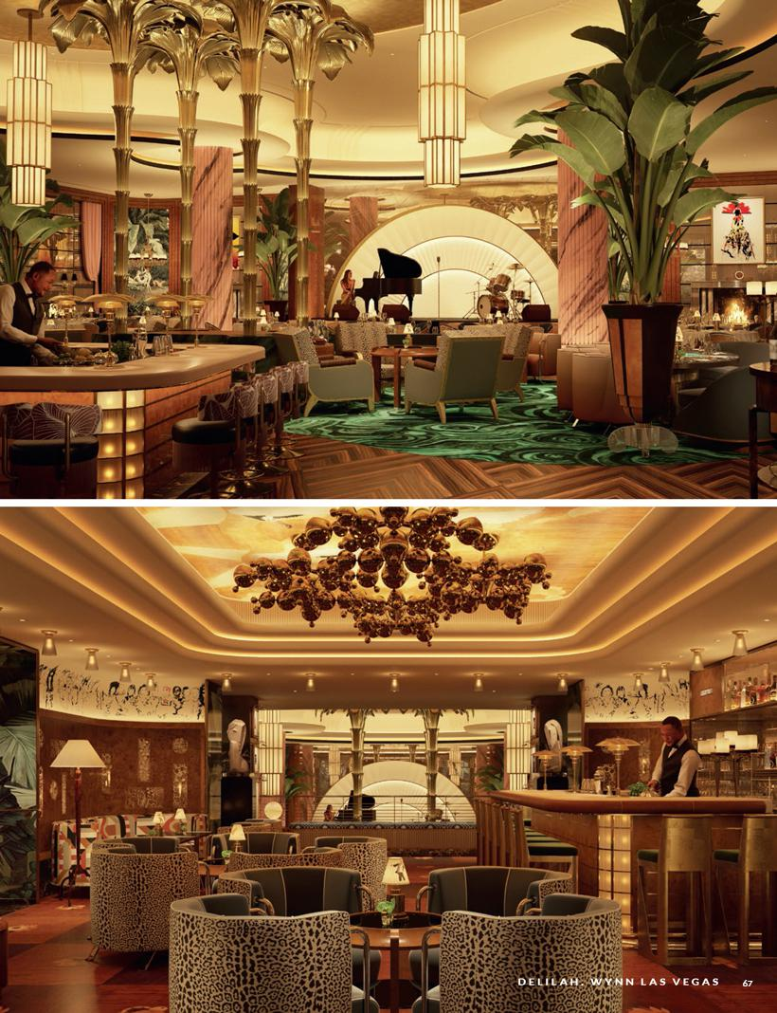

Table of Contents


Table of Contents

Proposal 1: Election of directors

At the recommendation of the Company’s Nominating and Corporate Governance Committee, the Board is nominating the following individuals for election as Class I directors:

- Betsy S. Atkins

- Matthew O. Maddox

- Philip G. Satre

- Darnell O. Strom

The Board has nominated the four individuals listed above to serve as Class I directors for terms that commence upon election at the 2021 Annual Meeting. If elected at the 2021 Annual Meeting, each nominee would serve until the 2024 Annual Meeting and until his or her successor has been duly elected and qualified, or until his or her earlier death, resignation, removal or retirement. The persons designated as proxies will have discretion to cast votes for other persons in the event any nominee for director is unable to serve, or the Board may choose to reduce the size of the Board. At present, it is not anticipated that any nominee will be unable to serve. If any director nominee is not elected at the 2021 Annual Meeting, the remaining members of the Board may fill the resulting vacancy, or the Board may choose to reduce the size of the Board. Biographical and other information for our nominees and our current directors is provided in the “Director Biographies” section.

OUR BOARD OF DIRECTORS RECOMMENDS THAT YOU VOTE

FOR THE ELECTION OF THE NOMINEES LISTED ABOVE.

Proposal 2: Ratification of appointment

of independent auditors

The Audit Committee of the Board has selected Ernst & Young LLP, a registered public accounting firm, as our independent auditors to examine and report to our shareholders on the consolidated financial statements of our Company and its subsidiaries for the fiscal year ending December 31, 2021. Representatives of Ernst & Young LLP will participate in the virtual Annual Meeting and will be given an opportunity to make a statement. They also will be available to respond to appropriate questions.

As a matter of good corporate governance, the Audit Committee has determined to seek shareholder ratification of its selection of Ernst & Young LLP as the Company’s independent auditors, although this is not required under Nevada law, the Company’s Articles or Bylaws, SEC rules or applicable listing standards. If the shareholders do not ratify the selection of Ernst & Young LLP as the Company’s independent auditors for 2021, the Audit Committee will evaluate what would be in the best interests of the Company and its shareholders and consider whether to select new independent auditors. Even if the shareholders ratify the selection of Ernst & Young LLP, the Audit Committee, in its discretion, may direct the appointment of a different independent public accounting firm at any time during the year if the Audit Committee determines that such a change would be in the best interests of the Company and its shareholders.

69

Table of Contents

2021 PROXY STATEMENT

AUDIT AND OTHER FEES

The following table presents the aggregate fees billed (or expected to be billed) to the Company for audit and other services provided by
Ernst & Young LLP, the Company’s independent auditor, for each of the fiscal years ended December 31, 2020, and December 31, 2019:

 |  | AGGREGATE FEES
CATEGORY |  | 2020 |  | 2019
Audit fees | $ | 4,468,680 | $ | 4,019,537
Audit-related fees | $ | 35,000 | $ | 39,000
Tax fees | $ | 10,000 | $ | 5,000
All other fees |  | - |  | -

“Audit fees” includes the aggregate fees for professional services rendered for the reviews of our consolidated financial statements for the quarterly periods ended March 31, June 30 and September 30, for the audit of our consolidated financial statements and the consolidated financial statements of certain of our subsidiaries for the years ended December 31, 2020 and 2019, and for the audit of our internal controls over financial reporting as of December 31, 2020 and 2019. “Audit fees” also include fees for services provided in connection with securities offerings, audit-related accounting consultations and statutory audits of certain subsidiaries of the Company. “Audit-related fees” include the aggregate fees for the audit of the Company’s defined contribution employee benefit plan. “Tax fees” include fees for domestic tax planning and other research.

PRE-APPROVAL POLICY

The Audit Committee’s policy is to pre-approve all audit and non-audit services provided by the independent registered public accountants by pre-approving certain types of services at usual and customary rates. These services may include audit services, audit-related services, tax services and other permissible non-audit services. The pre-approval authority details the particular service or category of service that the independent registered public accountants will perform. Management reports to the Audit Committee on the actual fees charged by the independent registered public accountants for each category of service.

During the year, circumstances may arise when it becomes necessary to engage the independent registered public accountants for additional services not contemplated in the original pre-approval authority. In those instances, management submits a request to the Audit Committee describing a specific project at a specific fee or rate and, if deemed appropriate and necessary, the Audit Committee approves the services before we engage the independent registered public accountants.

The Audit Committee pre-approved all fees related to services provided by Ernst & Young LLP in 2020.

REPORT OF THE AUDIT COMMITTEE

The Audit Committee is comprised of the five members named below. As required by our committee charter, each member of the Audit Committee has been determined to be an independent director, as defined under the NASDAQ listing rules and the rules of SEC. In addition, the Board has determined that three of the five committee members (Mr. Byrne, Adm. Johnson and Ms. Webb) are Audit Committee financial experts, as defined by SEC rules.

During 2020, we held seven full committee meetings.

Our purpose and responsibilities are set forth in our committee charter, which is approved and adopted by the Board and is available on the Company’s website at http://www.wynnresorts.com under the heading “Corporate Governance” on the Company Information page. The Audit Committee charter is reviewed and updated, as appropriate, to address changes in regulatory requirements, authoritative guidance, evolving oversight practices and investor feedback.

- Foundation for the Future

Table of Contents

Our role is to oversee, on behalf of the Board, the accounting and financial reporting processes of the Company and the audits of the Company’s financial statements, including review of the Company’s guidelines and policies with respect to risk assessment and risk management related to financial reporting and internal controls, major financial risk exposures of the Company and the steps the Company’s management has taken to monitor and control such exposures. The Company’s management is responsible for the preparation, presentation and integrity of our financial statements, and for maintaining appropriate accounting and financial reporting principles and policies, and internal controls and procedures that are reasonably designed to assure compliance with accounting standards and applicable laws and regulations. The independent auditors are responsible for auditing our financial statements and expressing an opinion as to their conformity with generally accepted accounting principles in the United States of America and for auditing and providing an attestation report on the effectiveness of our internal control over financial reporting.

In fulfilling our oversight duties, at each regular quarterly meeting of the Audit Committee, we met separately in executive session with Ernst & Young LLP, our independent registered public accountants, as well with each of the Company’s General Counsel, Chief Audit Executive (who heads internal audit), Chief Financial Officer, and Global Chief Compliance Officer. During these meetings, we discussed the quality of the Company’s accounting and financial reporting processes and the adequacy and effectiveness of its internal controls and procedures; reviewed significant audit findings prepared by each of the independent registered public accountants and internal audit department, together with management’s responses; reviewed the overall scope and plans for the audits by the internal audit department and the independent registered public accountants; reviewed critical accounting policies and the significant estimates and judgments management used in preparing the financial statements and their appropriateness for the Company’s business and current circumstances; and reviewed each Company press release concerning Company earnings prior to its release.

Ernst & Young LLP has served as the Company’s independent registered public accountants since 2006. In evaluating and selecting the Company’s independent registered public accounting firm, we consider, among other things, the historical and recent performance of our current firm, the firm’s global reach, external data on audit quality and performance, including Public Company Accounting Oversight Board (“PCAOB”) reports, industry experience, audit fee revenues, firm capabilities and audit approach, and the independence and tenure of the accounting firm. As discussed above, we have engaged Ernst & Young LLP to serve as our independent registered public accountants for the year ending December 31, 2021.

In addition to the activities discussed above, prior to the Company’s filing of its Annual Report on Form 10-K for the year ended December 31, 2020 with the SEC, we reviewed and discussed with management the Company’s audited financial statements for the year ended December 31, 2020. We discussed with the independent registered public accounting firm the matters required to be discussed by the applicable standards of the PCAOB, including the quality, not just the acceptability, of the accounting principles, the reasonableness of significant judgments and the clarity of the disclosures in the financial statements. We received the written disclosures and the letter from the independent auditors required by applicable requirements of the PCAOB regarding the independent auditors’ communications with the audit committee concerning independence and have discussed with the independent auditors their firm’s independence. Based on the review and discussions described in this report, we recommended to the Board that the audited financial statements referred to above be included in the Company’s Annual Report on Form 10-K for the year ended December 31, 2020, filed with the SEC.

Audit Committee

Winifred M. Webb, Chair
Richard J. Byrne
Jay L. Johnson
Patricia Mulroy
Darnell O. Strom

OUR BOARD OF DIRECTORS RECOMMENDS THAT YOU VOTE FOR THE RATIFICATION OF THE APPOINTMENT OF ERNST & YOUNG LLP AS THE COMPANY’S INDEPENDENT AUDITORS FOR THE YEAR 2021.

71

Table of Contents

2021 PROXY STATEMENT

Proposal 3: Advisory vote to approve the compensation of named executive officers

In accordance with Section 14A of the Exchange Act (which was added by the Dodd-Frank Wall Street Reform and Consumer Protection Act (the “Dodd Frank Act”)) and the related rules of the SEC, the Company will present a resolution at the Annual Meeting to enable our shareholders to approve, on an advisory and non-binding basis, the compensation of our NEOs as disclosed in the Compensation Discussion and Analysis, the accompanying compensation tables and the related narrative disclosure in this Proxy Statement.

This proposal, commonly known as a “Say-on-Pay” proposal, allows our shareholders the opportunity to express their views on our NEOs’ compensation. In considering this proposal, we urge shareholders to read the Compensation Discussion and Analysis, the accompanying compensation tables and the related narrative disclosure. Although this vote is advisory only, and therefore non-binding, the Board and the Compensation Committee will review and evaluate the voting result when considering future executive compensation decisions.

As the Company continues its transition from a compensation program oriented around a founder whose long-term focus was aligned with shareholders through his extensive stock ownership, to a more traditional compensation program, the Board determined to move from a triannual to an annual Say-on-Pay vote to provide for additional input from and further engagement with our shareholders. The Compensation Committee determined to right-size executive pay, to revamp our long-term incentive program to eliminate periodic grants and transition to annual grants, and to ensure that a majority of equity awards will be granted in performance-based stock to ensure a superior focus on operational excellence and better align executives’ interests with those of long-term shareholders.

As described in detail in the Compensation Discussion and Analysis, the majority of our executives’ total compensation is at-risk, tied to achieving annual and long-term goals that enhance the value of our reputation and brand, sustain the performance and attractiveness of our resorts and drive long-term shareholder value. In 2018, the Compensation Committee committed to right-sizing executive compensation by benchmarking total compensation at the median of our peer group. Because product quality and service excellence are at the core of our strategy, we use annually focused, operations-based pay to reflect the critical importance of performing well each year for each customer. The design of our long-term incentives coupled with robust stock ownership guidelines ensure that our executives’ interests are aligned with those of long-term shareholders.

Therefore, in accordance with Section 14A of the Exchange Act and as a matter of good corporate governance, we are asking shareholders to approve the following advisory resolution at the Annual Meeting:

“RESOLVED, that the shareholders of Wynn Resorts, Limited (the “Company”) approve, on an advisory basis, the compensation of the Company’s named executive officers as disclosed in the Compensation Discussion and Analysis and the tabular disclosure regarding each named executive officer’s compensation (together with the accompanying narrative disclosure) in the Proxy Statement, as disclosed pursuant to Item 402 of Regulation S-K, for the 2021 Annual Meeting of Shareholders.”

OUR BOARD OF DIRECTORS RECOMMENDS THAT YOU VOTE FOR THE APPROVAL OF THE ADVISORY RESOLUTION ON OUR NAMED EXECUTIVE OFFICE COMPENSATION.

- Foundation for the Future

Table of Contents

General Information

OUR 2021 ANNUAL MEETING OF SHAREHOLDERS

This Proxy Statement is furnished to the shareholders of Wynn Resorts in connection with the solicitation by the Board of proxies for its 2021 Annual Meeting of Shareholders (the “Annual Meeting”) that will be held entirely online due to the uncertain nature of travel and other restrictions that may be in place at the time of the meeting. Our 2021 Annual Meeting will be held on May 5, 2021, via live webcast accessed at this website: http://www.virtualshareholdermeeting.com/WYNN2021, at 9:00 am (local time), and at any adjournments or postponements thereof. Our principal executive offices are 3131 Las Vegas Boulevard South, Las Vegas, Nevada 89109. Matters to be considered and acted upon at the Annual Meeting are set forth in the Notice of Annual Meeting of Shareholders accompanying this Proxy Statement and are more fully described herein.

THE BOARD RECOMMENDS A VOTE AS FOLLOWS:

PROPOSAL |  | BOARD
NUMBER | PROPOSAL | RECOMMENDATION
1 | Election of the four Class I director nominees named in this Proxy Statement to serve until the 2024 Annual Meeting | “FOR” each nominee
 | of Shareholders
2 | Ratification of the appointment of Ernst & Young LLP as our independent registered public accounting firm for the fiscal | “FOR”
 | year ending December 31, 2021
3 | Approval, on a non-binding advisory basis, of the compensation of our named executive officers as described in this | “FOR”
 | Proxy Statement

VOTING AND SOLICITATION

Only holders of record of shares of the Company’s common stock, par value $0.01 (“Common Stock”), as of the close of business on March 12, 2021, the record date fixed by the Board (the “Record Date”), are entitled to notice of, and to vote at, the Annual Meeting and at any adjournments or postponements thereof. As of the Record Date, there were 115,640,358 shares of Common Stock outstanding. Each shareholder is entitled to one vote for each share of Common Stock held as of the Record Date on all matters presented at the Annual Meeting.

At least a majority of the outstanding shares of Common Stock must be represented at the Annual Meeting, in person or by proxy, to constitute a quorum and to transact business at the Annual Meeting. Abstentions and broker non-votes are counted for purposes determining whether there is a quorum.

For each item to be acted upon at the Annual Meeting, the item will be approved if the number of votes cast in favor of the item by the shareholders entitled to vote exceeds the number of votes cast in opposition to the item. You may vote “for,” “against” or abstain from voting on these proposals, and in the case of Proposal 1, you may vote “for,” “against” or abstain from voting on each director nominee. Abstentions will not be counted as votes cast on an item and, therefore, will not affect the outcome of these proposals. Broker non-votes will not be counted as votes cast on Proposals 1 and 3 and, therefore, will not affect the outcome of these proposals. Shares represented by properly executed and unrevoked proxies will be voted at the Annual Meeting in accordance with the directions of shareholders indicated in their proxies. If no specification is made, shares represented by properly executed and unrevoked proxies will be voted in accordance with the specific recommendations of the Board set forth above. If any other matter properly comes before the Annual Meeting, the shares will be voted in the discretion of the persons voting pursuant to the respective proxies.

For a shareholder who holds his or her shares through an intermediary, such as a broker, bank or other nominee (referred to as “beneficial owners”), such intermediary will not be permitted to vote on Proposal 1 (the election of directors) or Proposal 3 (approval of the compensation of our named executive officers (known as a “Say-on-Pay” vote)) (this situation is called a “broker non-vote”). Accordingly, we encourage you to vote your shares on all matters being considered at the Annual Meeting. Notwithstanding the occurrence of a broker non-vote, the intermediary may still vote the shareholder’s shares on Proposal 2 (ratification of Ernst & Young LLP as our independent auditor).

73

Table of Contents

2021 PROXY STATEMENT

The following table summarizes the voting requirements to elect directors and to approve each of the proposals in this Proxy Statement:

PROPOSAL |  |  | BROKER DISCRETIONARY
NUMBER | PROPOSAL | VOTE REQUIRED | VOTING ALLOWED
1 | Election of the four Class I directors | Number of votes cast in favor exceeds number of votes | No
 |  | cast in opposition
2 | Ratification of Ernst & Young LLP | Number of votes cast in favor exceeds number of votes | Yes
 |  | cast in opposition
3 | Advisory Vote to Approve the Compensation of Named | Number of votes cast in favor exceeds number of votes | No
 | Executive Officers | cast in opposition

HOW YOU CAN VOTE

Shareholders of Record. For shareholders of record, there are four different ways you can vote:

- By Internet. To vote via the Internet, use the website on the enclosed proxy card.

- By Telephone. To vote by telephone, call the toll-free number on the enclosed proxy card.

- By Mail. To vote by mail, follow the instructions on the enclosed proxy card.

- By Participating in the Virtual Annual Meeting. To vote electronically during the virtual Annual Meeting, visit http://www.virtualshareholdermeeting.com/WYNN2021, log in using the 16-digit control number printed in the box marked by the arrow on your proxy card, click on the vote button on the screen and follow the instructions provided.

The Internet and telephone voting procedures are designed to authenticate your identity, to allow you to vote your shares and to confirm that your voting instructions have been properly recorded. Specific instructions are set forth on the enclosed proxy card. In order to be timely processed, an Internet or telephone vote must be received by 11:59 p.m. Eastern Time on May 4, 2021. Regardless of the method you choose, your vote is important. Please vote by following the specific instructions on your proxy card.

Beneficial Shareholders. For shareholders who own shares of the Company’s Common Stock through an intermediary, such as a broker, bank or other nominee, the ultimate intermediary is the shareholder of record but will vote your shares in accordance with your instructions. In order to have your shares voted, you will need to follow the instructions for voting provided by your broker, bank or other nominee.

REVOCABILITY OF PROXIES

Shareholders of Record. If you are a shareholder of record and you deliver a proxy pursuant to this solicitation, you may revoke that proxy at any time before it is voted by (a) giving written notice to our Corporate Secretary at the address set forth below, (b) delivering to our Corporate Secretary a later dated proxy, (c) submitting another proxy by telephone or over the Internet (your latest telephone or Internet voting instructions are followed), or (d) voting electronically during the Annual Meeting. Written notice of revocation or subsequent proxy should be sent to:

Wynn Resorts, Limited
c/o Corporate Secretary
3131 Las Vegas Boulevard South

Las Vegas, Nevada 89109

Beneficial Shareholders. If your shares are held through an intermediary, such as a bank, broker or other nominee, you must contact that person if you wish to revoke previously given voting instructions. In this case, attendance at the Annual Meeting, in and of itself, does not revoke a prior proxy.

PARTICIPATING IN THE ANNUAL MEETING

Control Number. You will need the 16-digit control number that is printed in the box marked by the arrow on your proxy card to enter the virtual Annual Meeting.

- Foundation for the Future

Table of Contents

Notice of Internet Availability of Proxy Materials. Under rules adopted by the U.S. Securities and Exchange Commission (the “SEC”), we are furnishing proxy materials to some shareholders via the Internet, instead of mailing printed copies of those materials to each shareholder. On or about March 25, 2021, we mailed to shareholders either a printed copy of our Annual Meeting materials or a Notice of Internet Availability containing instructions on how to access our Annual Meeting materials, including this Proxy Statement and our Annual Report for the fiscal year ending December 31, 2020. The Notice of Internet Availability also explains how to vote through the Internet or by telephone.

This electronic access process expedites shareholders’ receipt of our Annual Meeting materials, lowers the cost of our Annual Meeting and conserves natural resources. However, if you would prefer to receive a printed copy of our Annual Meeting materials, a paper proxy card or voting instructions card, please follow the instructions included in the Notice of Internet Availability. If you have previously elected to receive our Annual Meeting materials electronically or by mail, you will continue to receive these materials in that format unless you elect otherwise.

PROXY PROCEDURE AND EXPENSES OF SOLICITATION

We have retained Broadridge Financial Solutions, an independent tabulator, to receive and tabulate the proxies, to serve as an inspector of elections, and to certify the results. In addition, we have engaged Innisfree M&A Incorporated (“Innisfree”), a professional proxy solicitation firm, to assist in the solicitation of proxies for the Annual Meeting. The Company has agreed to pay Innisfree a fee of $17,500, plus reimbursement for out of pocket expenses. The address of Innisfree is 501 Madison Avenue, 20th Floor, New York, New York 10022. If you need assistance in completing your proxy card or have questions regarding the Annual Meeting, please contact Innisfree toll-free at (888) 750-5834.

All expenses incurred in connection with the solicitation of proxies will be borne by us. We will also reimburse banks, brokers and other nominees for their expenses in forwarding proxy materials to beneficial owners of Common Stock held in their names.

Solicitation may be undertaken by mail, telephone, personal contact or other similar means by directors, officers and employees without additional compensation.

SHAREHOLDER PROPOSALS

Shareholders intending to present a proposal at the 2022 Annual Meeting of Shareholders for inclusion in our proxy statement for that meeting pursuant to Rule 14a-8 of the Exchange Act must submit the proposal in writing to Wynn Resorts, Limited, Attention: Corporate Secretary, 3131 Las Vegas Boulevard South, Las Vegas, Nevada 89109. Such proposals must comply with the requirements of Rule 14a-8 of the Exchange Act and must be received by the Company no later than December 31, 2021.

In addition, our Bylaws provide notice procedures for shareholders to nominate a person as a director and to propose business to be considered by shareholders at a meeting when nomination and/or the other business are not submitted for inclusion in the Company’s proxy statement. Generally, notice of a nomination or proposal not submitted pursuant to Rule 14a-8 must be delivered to us not later than the close of business on the 90th day, nor earlier than the close of business on the 120th day, prior to the first anniversary of the preceding year’s annual meeting. However, if the date of the annual meeting is more than 30 days before or more than 70 days after such anniversary date, notice must be delivered to us not earlier than the close of business on the 120th day prior to such annual meeting date and not later than the close of business on the later of the 90th day prior to such annual meeting or the 10th day following the day on which public announcement of the date of such meeting is first made.

Accordingly, for our 2022 Annual Meeting, notice of a nomination or proposal must be delivered to us no later than February 4, 2022 and no earlier than January 5, 2022. Nominations and proposals also must satisfy other requirements set forth in the Bylaws. If a shareholder complies with the forgoing notice provisions and with certain additional procedural requirements in the Bylaws and SEC rules, the Company will have authority to vote shares under proxies we solicit when and if the nomination or proposal is raised at the Annual Meeting. The Chair of the Board may refuse to acknowledge the introduction of any shareholder proposal not made in compliance with the foregoing procedures.

75

Table of Contents

2021 PROXY STATEMENT

ANNUAL REPORT

Our financial statements for the year ended December 31, 2020, are included in our 2020 Annual Report to Shareholders, which we are providing to our shareholders at the same time as this Proxy Statement. Our Annual Report and this Proxy Statement are also posted on the Internet at http://www.wynnresorts.com on the Company Information page under the “Annual Meeting” heading. If you would like to receive a printed copy of these materials, please call our Investor Relations department at (702) 770-7555 or send a written request to the Company at Wynn Resorts, Limited, c/o Investor Relations, 3131 Las Vegas Boulevard South, Las Vegas, Nevada 89109, and we will send a copy to you without charge.

HOUSEHOLDING

Shareholders who are beneficial owners, but not the record holders, of the Company’s securities and share a single address may receive only one copy of the Company’s proxy materials, unless the broker, bank or other nominee delivering the materials has received contrary instructions from one or more of the shareholders. The Company will deliver promptly, upon written or oral request, a separate copy of the proxy materials to a shareholder at a shared address to which a single copy of the document was delivered. A shareholder who wishes to receive a separate copy of the proxy materials, now or in the future, should submit his or her request to the Company by telephone at

- 770-7555 or by submitting a written request to Wynn Resorts, Limited, c/o Investor Relations, 3131 Las Vegas Boulevard South, Las Vegas, Nevada 89109. Beneficial owners sharing an address who are receiving multiple copies of the proxy materials and wish to receive a single copy of such materials in the future will need to contact their broker, bank or other nominee to request that only a single copy be mailed to all shareholders at the shared address in the future.

OTHER BUSINESS

The Company is not aware of any other matters to be presented at the Annual Meeting. If any other matters should properly come before the Annual Meeting, the persons named in the proxy will vote the executed proxies on such matters as they determine appropriate in their discretion.

- Foundation for the Future

Table of Contents


Table of Contents


Table of Contents
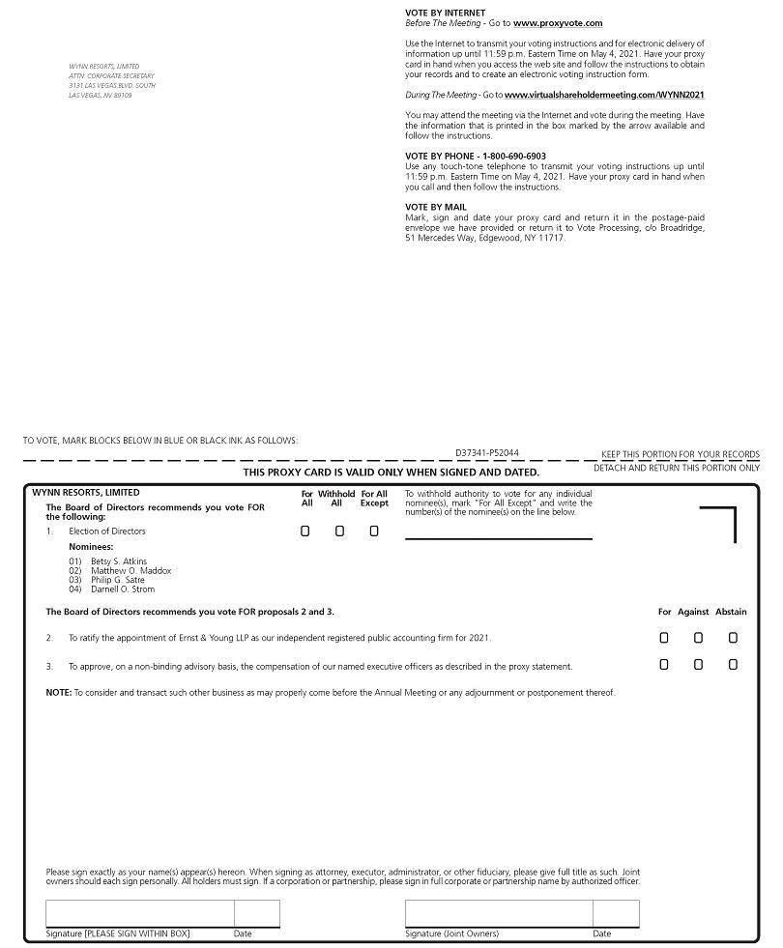

Table of Contents


