UNITED STATES

SECURITIES AND EXCHANGE COMMISSION

Washington, D.C. 20549

FORM 8-K

CURRENT REPORT

PURSUANT TO SECTION 13 OR 15(d)

OF THE SECURITIES EXCHANGE ACT OF 1934

Date of Report (Date of earliest event reported): December 9, 2019

WYNN RESORTS, LIMITED

(Exact name of registrant as specified in its charter)

 |  | Nevada |  | 000-50028 |  | 46-0484987
 |  | (State or other jurisdiction |  |  | (Commission | (I.R.S. Employer
 |  | of incorporation) |  |  | File Number) | Identification No.)
 | 3131 Las Vegas Boulevard South
 |  | Las Vegas, Nevada |  |  |  | 89109
 | (Address of principal executive offices) |  |  |  |  |  | (Zip Code)
 |  |  |  | (702) 770-7555
 |  |  |  | (Registrant’s telephone number, including area code)
 |  |  |  | Not Applicable
 |  |  |  | (Former name or former address, if changed since last report)
Securities registered pursuant to Section 12(b) of the Act:
 | Title of each class |  |  | Trading Symbol(s) |  | Name of each exchange on which registered
Common stock, par value $0.01 |  |  |  | WYNN |  | Nasdaq Global Select Market

Check the appropriate box below if the Form 8-K filing is intended to simultaneously satisfy the filing obligation of the registrant under any of the following provisions:

☐Written communications pursuant to Rule 425 under the Securities Act (17 CFR 230.425)

☐Soliciting material pursuant to Rule 14a-12 under the Exchange Act (17 CFR 240.14a-12)

☐Pre-commencement communications pursuant to Rule 14d-2(b) under the Exchange Act (17 CFR 240.14d-2(b))

☐Pre-commencement communications pursuant to Rule 13e-4(c) under the Exchange Act (17 CFR 240.13e-4(c))

Indicate by check mark whether the registrant is an emerging growth company as defined in Rule 405 of the Securities Act of 1933 (§230.405 of this chapter) or Rule 12b-2 of the Securities Exchange Act of 1934 (§240.12b-2 of this chapter).

Emerging growth company ☐

If an emerging growth company, indicate by check mark if the registrant has elected not to use the extended transition period for complying with any new or revised financial accounting standards provided pursuant to Section 13(a) of the Exchange Act. ☐

Item 7.01 Regulation FD Disclosure.

On December 9, 2019, Wynn Macau, Limited (“Wynn Macau”), an indirect subsidiary of Wynn Resorts, Limited (the “Wynn Resorts” or the “Company”) with its ordinary shares of common stock listed on The Stock Exchange of Hong Kong Limited (the “HKSE”), filed with the HKSE an announcement (the “Announcement”) of Wynn Macau’s proposed issuance of senior notes (the “Offering”). Wynn Resorts owns approximately 72% of Wynn Macau’s ordinary shares of common stock. The Announcement is furnished herewith as Exhibit 99.1.

In connection with the Offering, Wynn Macau intends to provide potential investors with preliminary financial information for the Macau operations of Wynn Resorts for the month ended October 31, 2019, and certain other information. A summary of this information is attached to this report as Exhibit 99.2 and is incorporated herein by reference.

The information furnished pursuant to this Item 7.01 (including Exhibits 99.1 and 99.2 hereto) shall not be deemed to be “filed” for purposes of Section 18 of the Securities Exchange Act of 1934, as amended (the “Exchange Act”), or otherwise subject to the liabilities of that section, nor shall it be deemed incorporated by reference in any filing under the Securities Act of 1933, as amended (the “Securities Act”), or the Exchange Act, except as shall be expressly set forth by specific reference in such a filing.

This Current Report on Form 8-K contains forward-looking statements within the meaning of Section 27A of the Securities Act and Section 21E of the Exchange Act. Such forward-looking statements are subject to numerous assumptions, risks and uncertainties that could cause actual results to differ materially from those described in such statements. Such forward-looking statements are based on management’s expectations or beliefs as of December 9, 2019. Factors that might cause such differences include, but are not limited to, a variety of economic, competitive, and regulatory factors, many of which are beyond the Company’s control and are described in Wynn Resorts’ Annual Report on Form 10-K filed by Wynn Resorts, Limited on February 28, 2019 with the Securities and Exchange Commission (the “SEC”) and the other reports Wynn Resorts files from time to time with the SEC. Wynn Resorts undertakes no obligation to revise or publicly release any updates to such statements based on future information or actual results.

Item 9.01 |  | Financial Statements and Exhibits.
(d) Exhibits.
Exhibit No. |  | Description
99.1 |  | Announcement of Wynn Macau, Limited, dated December 9, 2019
99.2 |  | Investor Materials

SIGNATURES

Pursuant to the requirements of the Securities Exchange Act of 1934, the Registrant has duly caused this report to be signed on its behalf by the undersigned hereunto duly authorized.

WYNN RESORTS, LIMITED

Dated: December 9, 2019

By: /s/ Craig S. Billings

Craig S. Billings

President, Chief Financial Officer and Treasurer

(Principal Financial and Accounting Officer)

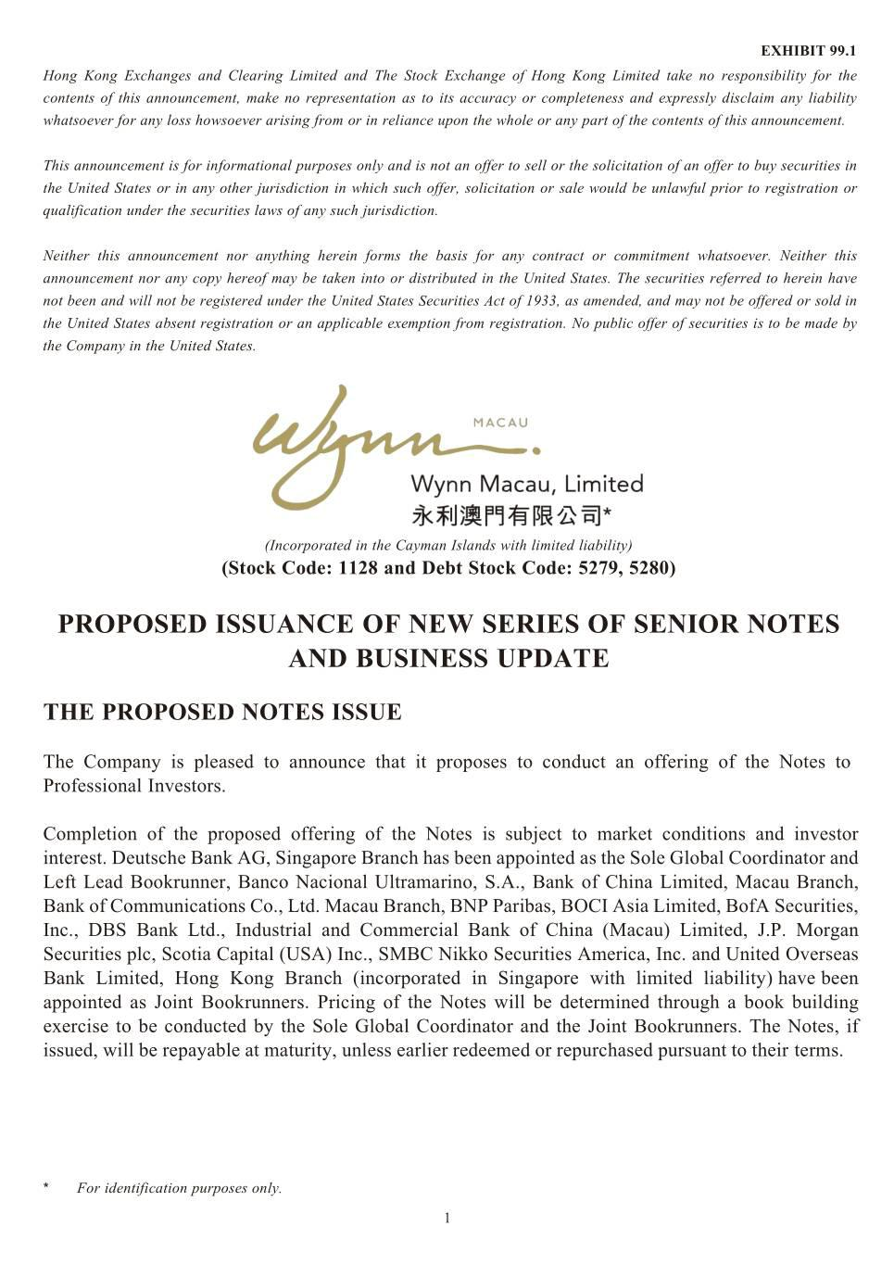

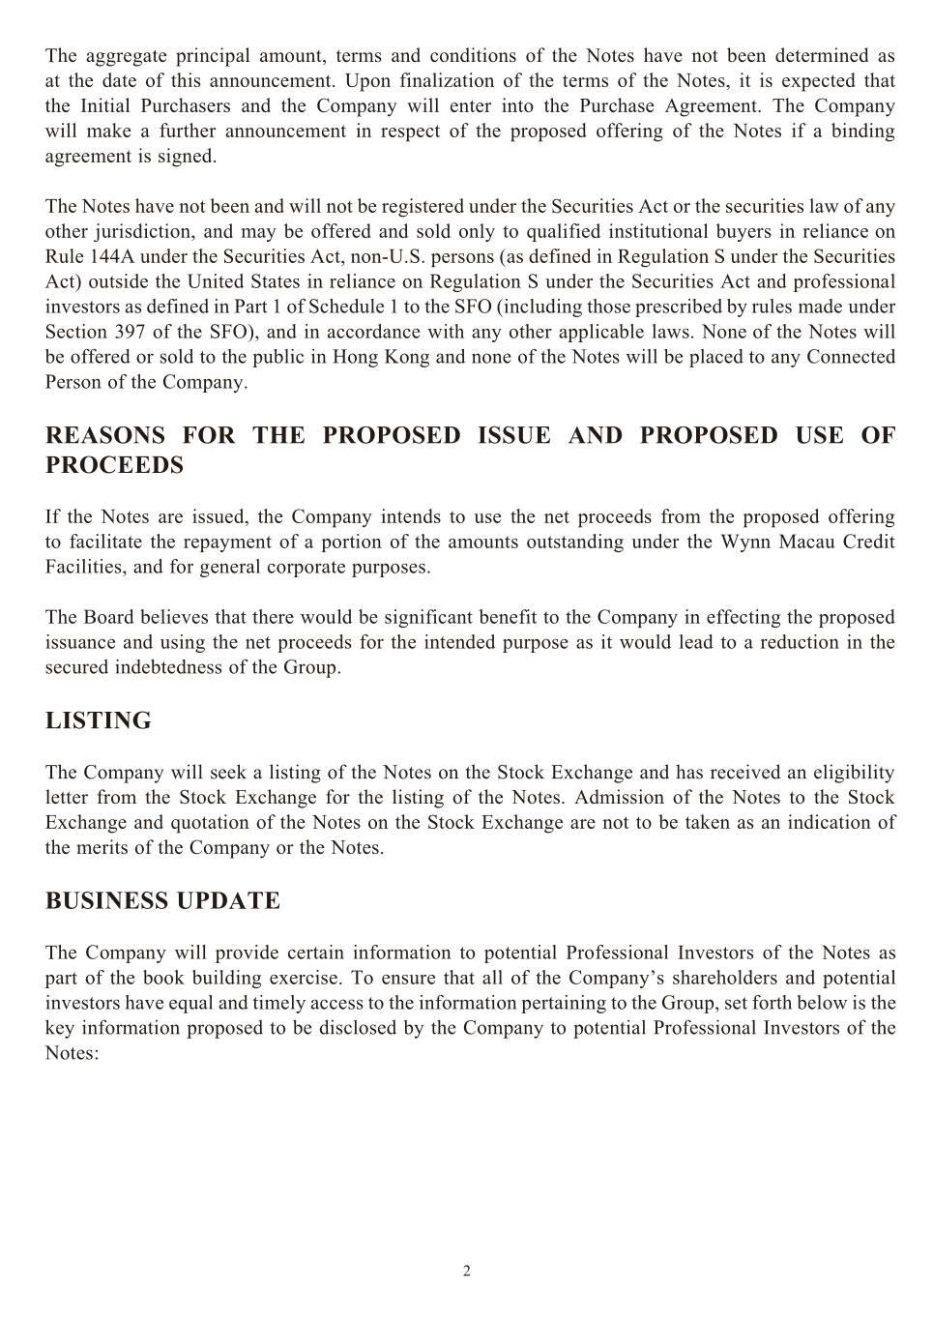

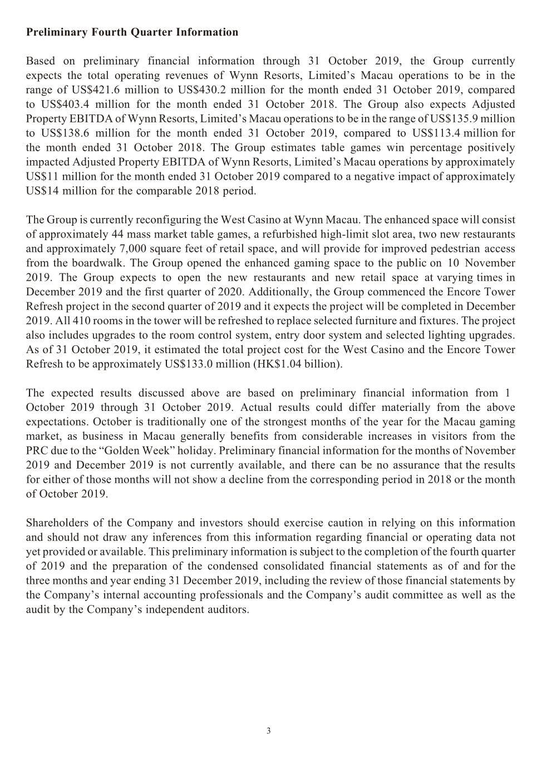

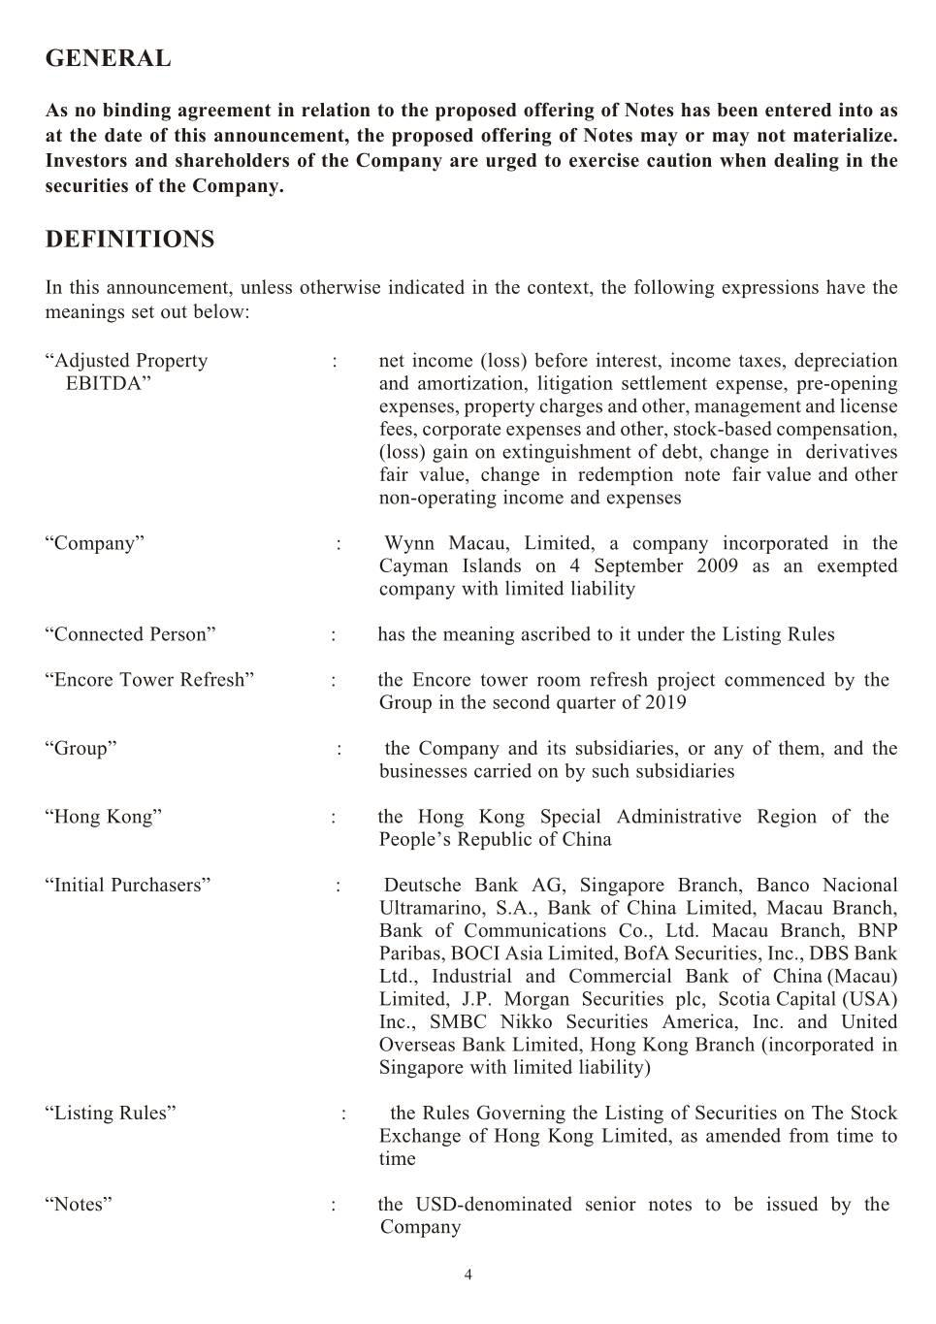

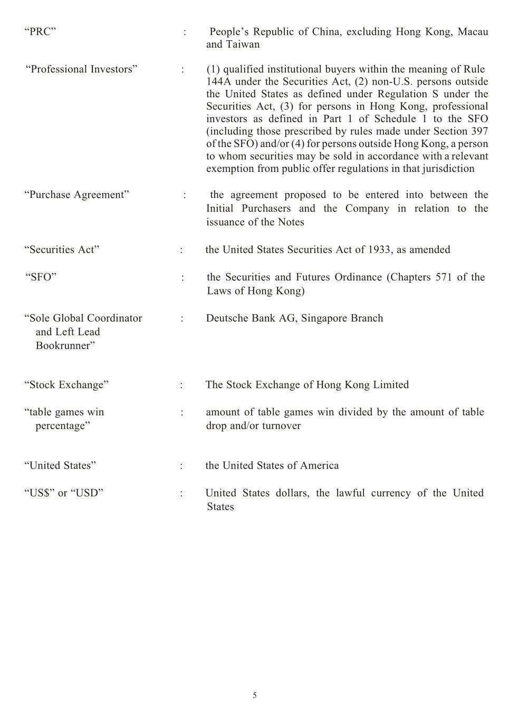

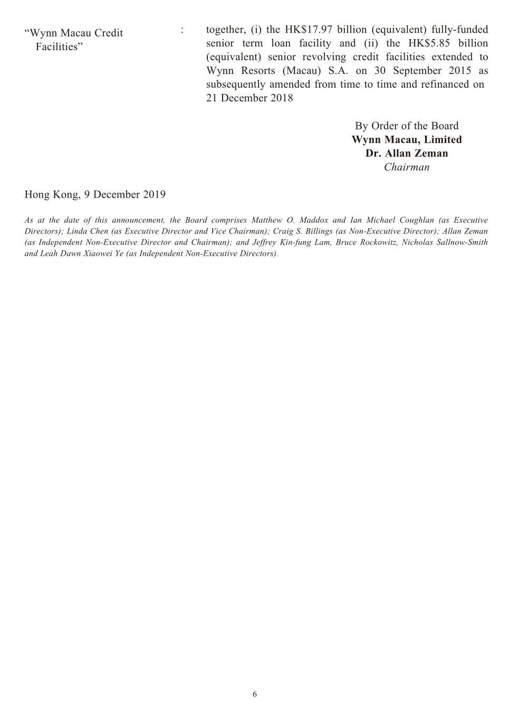

Exhibit 99.2

Preliminary Fourth Quarter Information

Based on preliminary financial information through October 31, 2019, Wynn Macau currently expects the total operating revenues of the integrated Wynn Palace resort and casino and the Wynn Macau casino hotel resort and Encore at the Wynn Macau casino hotel resort (“Wynn Resorts’ Macau Operations”) to be in the range of US$421.6 million to US$430.2 million for the month ended October 31, 2019, compared to US$403.4 million for the month ended October 31, 2018. Wynn Macau also expects Adjusted Property EBITDA of Wynn Resorts’ Macau Operations to be in the range of US$135.9 million to US$138.6 million for the month ended October 31, 2019, compared to US$113.4 million for the month ended October 31, 2018. Wynn Macau estimates table games win percentage positively impacted Adjusted Property EBITDA by approximately US$11 million for the month ended October 31, 2019 compared to a negative impact of approximately US$14 million for the comparable 2018 period.

Wynn Macau is currently reconfiguring the West Casino at the Wynn Macau casino hotel resort. The enhanced space will consist of approximately 44 mass market table games, a refurbished high-limit slot area, two new restaurants and approximately 7,000 square feet of retail space, and will provide for improved pedestrian access from the boardwalk. Wynn Macau opened the enhanced gaming space to the public on November 10, 2019. Wynn Macau expects to open the new restaurants and new retail space at varying times in December 2019 and the first quarter of 2020. Additionally, Wynn Macau commenced an Encore tower room refresh (the “Encore Tower Refresh”) project in the second quarter of 2019 and we expect the project will be completed in December 2019. All 410 rooms in the tower will be refreshed to replace selected furniture and fixtures. The project also includes upgrades to the room control system, entry door system and selected lighting upgrades. As of October 31, 2019, Wynn Macau estimated the total project cost for the West Casino and the Encore Tower Refresh to be approximately US$133.0 million (HK$1.04 billion).

Wynn Resorts uses Adjusted Property EBITDA to manage the operating results of its segments. Adjusted Property EBITDA of Wynn Resorts is net income (loss) before interest, income taxes, depreciation and amortization, litigation settlement expense, pre-opening expenses, property charges and other, management and license fees, corporate expenses and other, stock-based compensation, (loss) gain on extinguishment of debt, change in derivatives fair value, change in Redemption Note fair value and other non-operating income and expenses. Adjusted Property EBITDA is presented exclusively as a supplemental disclosure because Wynn Resorts believes that it is widely used to measure the performance, and as a basis for valuation, of gaming companies. Wynn Resorts uses Adjusted Property EBITDA as a measure of the operating performance of its segments and to compare the operating performance of its properties with those of its competitors, as well as a basis for determining certain incentive compensation. Wynn Resorts also presents Adjusted Property EBITDA because it is used by some investors to measure a company's ability to incur and service debt, make capital expenditures and meet working capital requirements. Gaming companies have historically reported EBITDA as a supplement to generally accepted accounting principles in the United States (“GAAP”). In order to view the operations of their casinos on a more stand-alone basis, gaming companies, including Wynn Resorts, have historically excluded from their EBITDA calculations pre-opening expenses, property charges, corporate expenses and stock-based compensation, that do not relate to the management of specific casino properties. However, Adjusted Property EBITDA should not be considered as an alternative to operating income as an indicator of Wynn Resorts’ performance, as an alternative to cash flows from operating activities as a measure of liquidity, or as an alternative to any other measure determined in accordance with GAAP. Unlike net income, Adjusted Property EBITDA does not include depreciation or interest expense and therefore does not reflect current or future capital expenditures or the cost of capital. Wynn Resorts has significant uses of cash flows, including capital expenditures, interest payments, debt principal repayments, income taxes and other non-recurring charges, which are not reflected in Adjusted Property EBITDA. Also, Wynn Resorts’ calculation of Adjusted Property EBITDA may be different from the calculation methods used by other companies and, therefore, comparability may be limited.

The expected results discussed above are based on preliminary financial information from October 1, 2019 through October 31, 2019. Actual results could differ materially from the above expectations. October is traditionally one of the strongest months of the year for the Macau gaming market, as business in Macau generally benefits from considerable increases in visitors from the PRC due to the "Golden Week" holiday. Preliminary financial information for the months of November 2019 and December 2019 is not currently available, and there can be no assurance that the results for either of those months will not show a decline from the corresponding period in 2018 or the month of October 2019. Our results could be materially adversely affected by any of the risks set forth in Wynn Resorts’ SEC filings. Investors should exercise caution in relying on this information and should not draw any inferences from this information regarding financial or operating data not yet provided or available. This preliminary information is subject to the completion of the fourth quarter of 2019 and the preparation of the condensed consolidated financial statements as of and for the three months and year ending December 31,

2019, including the review of those financial statements by Wynn Resorts’ and Wynn Macau’s internal accounting professionals and audit committees as well as the audit by Wynn Resorts’ and Wynn Macau’s independent auditors.

