UNITED STATES

SECURITIES AND EXCHANGE COMMISSION
Washington, D.C. 20549

SCHEDULE 14A

Proxy Statement Pursuant to Section 14(a) of

The Securities Exchange Act of 1934

Filed by the Registrant ☒ Filed by a Party other than the Registrant ☐

Check the appropriate box:

- Preliminary Proxy Statement

- Confidential, for Use of the Commission Only (as permitted by Rule 14a-6(e)(2))

- Definitive Proxy Statement

- Definitive Additional Materials

- Soliciting Material Pursuant to §240.14a-12

WYNN RESORTS, LIMITED

(Name of Registrant as Specified In Its Charter)

(Name of Person(s) Filing Proxy Statement, if other than the Registrant)

Payment of Filing Fee (Check the appropriate box):

- No fee required.

- Fee computed on table below per Exchange Act Rules 14a-6(i)(1) and 0-11.

  - Title of each class of securities to which transaction applies:

  - Aggregate number of securities to which transaction applies:

  - Per unit price or other underlying value of transaction computed pursuant to Exchange Act Rule 0-11 (set forth the amount on which the filing fee is calculated and state how it was determined):

  - Proposed maximum aggregate value of transaction:

  - Total fee paid:

- Fee paid previously with preliminary materials.

- Check box if any part of the fee is offset as provided by Exchange Act Rule 0-11(a)(2) and identify the filing for which the offsetting fee was paid previously. Identify the previous filing by registration statement number, or the Form or Schedule and the date of its filing.
  - Amount Previously Paid:

  - Form, Schedule or Registration Statement No.:

  - Filing Party:

  - Date Filed:

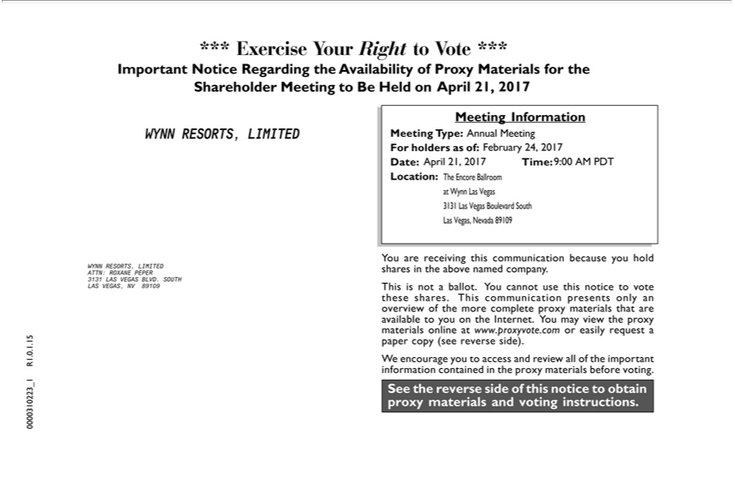

*** Exercise Your Right to Vote ***
MeetingImportantInformationNoticeRegarding the Availability of Proxy Materials for the Shareholder Meeting to Be Held on <mtgdate> April 21, 2017 .
WYNN RESORTS, LIMITED Meeting Type: Annual <mtgtype> Meeting
For holders as of: February <recdate> 24, 2017
Date: April 21, 2017 Time: 9:00 <mtgtime> AM PDT
Location: The Encore Ballroom_{communication}Wynn Las Vegas 3131 Las Vegas Boulevard South Las Vegas, Nevada 89109
You are receiving this because you hold WYNN RESORTS, LIMITED shares in the above named company.
ATTN: ROXANE PEPER
3131 LAS VEGAS BLVD. SOUTH
LAS VEGAS, NV 89109 This is not_{materials}ballot. You cannot use this notice to vote these shares. This communication presents only an overview of the more complete proxy materials that are available to you on the
Internet. You may view the proxy online at www.proxyvote.com or easily request a 15 . paper copy (see reverse side).
. ¹
R10 We encourage you to access and review all of the important
_information1 contained in the proxy materials before voting.
See the reverse side of this notice to obtain 0000310223 proxy materials and voting instructions.

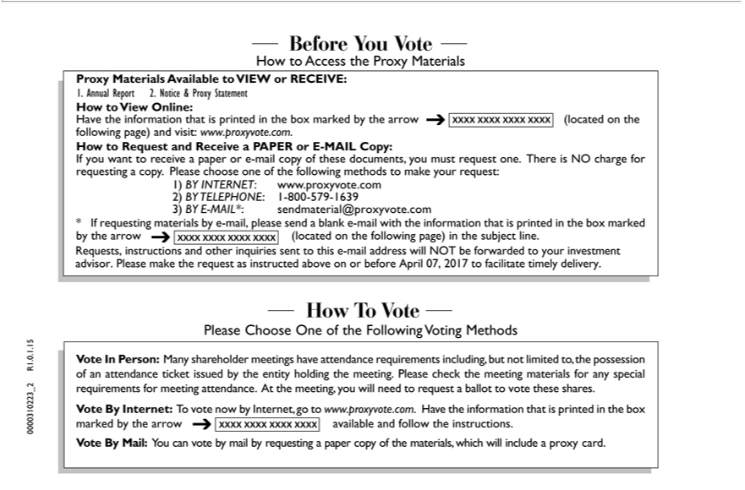

Before You Vote
How to Access the Proxy Materials
Proxy Materials Available to VIEW or RECEIVE:
1. Annual Report 2. Notice & Proxy Statement
ow to View Online:
Have the information that is printed in the box marked by the arrow (located on the
? following page) and visit: www.proxyvote.com.
How to Request and Receive a PAPER or E-MAIL Copy:
If you want to receive a paper or -mail copy of these documents, you must request one. There is NO charge for requesting a copy. Please choose one of the following methods to make your request:
1) | INTERNET www.proxyvote.com
2) |  | 1-800-579-1639 | .com
3) BY TELEPHONE:-MAIL*: |  |  | .com
* If requesting materialssendmaterial@proxyvoteby-mail,pleasesend a blank e-mail with the information that is printed in the box marked by the arrow ? (located on the following page) in the subject line.
Requests, instructions and other inquiries sent to this e-mail address will NOT be forwarded to your investment advisor. Please make the request as instructed above on or before April 07, 2017 to facilitate timely delivery.
Please Choose One of the Following Voting Methods
. 15 . 1
R10 Vote In Person: Many shareholder meetings have attendance requirements including, but not limited to, the possession
of an attendance ticket issued by the entity holding the meeting. Please check the meeting materials for any special _ 2 requirements for meeting attendance. At the meeting, you will need to request a ballot to vote these shares.
Vote By Internet: To vote now by Internet, go to www.proxyvote.com. Have the information that is printed in the box marked by the arrow available and follow the instructions.
0000310223 ?
Vote By Mail: You can vote by mail by requesting a paper copy of the materials, which will include a proxy card.

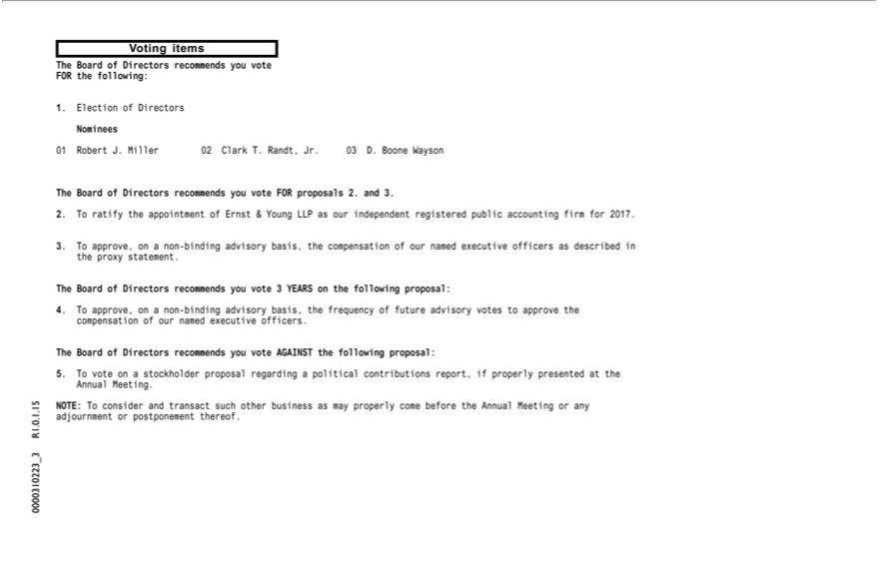

Voting items
1.TheElectionBoard ofof DirectorsDirectors recommends you vote FOR the following:
Nominees
The01RobertBoardJ.ofMillerDirectors02ClarkrecommendsT.Randt,youJr. vote03D.FORBooneproposalsWayson2. and 3.
2 ratify the of Ernst & Young LLP as our independent registered public accounting firm for 2017.
The3.ToBoardapprove,ofDirectorsonappointmentnon-recommendsbindingadvisoryyou votebasis,3 theYEARScompensationthefollowingofournamedproposal:executive officers as described in the proxy statement.
4. To approve, on a non-binding advisory basis, the frequency of future advisory votes to approve the compensation of our named executive officers.
15The.ToBoardvote onof aDirectorsstockholderrecommendsproposal regardingyouvoteAGAINSTapolitical contributionsthefollowing report,proposal:ifproperly presented at the Annual Meeting.
0 . R1NOTE:.30000310223Toconsider _and transact such other business as may properly come before the Annual Meeting or any 1 . adjournment or postponement thereof.



0000310223_4 R1.0.1.15

