UNITED STATES

SECURITIES AND EXCHANGE COMMISSION
Washington, D.C. 20549

SCHEDULE 14A INFORMATION

Proxy Statement Pursuant to Section 14(a) of the

Securities Exchange Act of 1934
(Amendment No. )

Filed by the Registrant ☒ Filed by a Party other than the Registrant ☐

Check the appropriate box:

- Preliminary Proxy Statement

- Confidential, for Use of the Commission Only (as permitted by Rule 14a-6(e)(2))

- Definitive Proxy Statement

- Definitive Additional Materials

- Soliciting Material under Rule 14a-12

Wynn Resorts, Limited

(Name of registrant as specified in its charter)

(Name of person(s) filing proxy statement, if other than the registrant)

Payment of Filing Fee (Check the appropriate box):

- No fee required.

- Fee computed on table below per Exchange Act Rules 14a-6(i)(4) and 0-11.

  - Title of each class of securities to which transaction applies:

  - Aggregate number of securities to which transaction applies:

  - Per unit price or other underlying value of transaction computed pursuant to Exchange Act Rule 0-11 (set forth the amount on which the filing fee is calculated and state how it was determined):

  - Proposed maximum aggregate value of transaction:

  - Total fee paid:

- Fee paid previously with preliminary materials.

- Check box if any part of the fee is offset as provided by Exchange Act Rule 0-11(a)(2) and identify the filing for which the offsetting fee was paid previously. Identify the previous filing by registration statement number, or the Form or Schedule and the date of its filing:

  - Amount Previously Paid:

  - Form, Schedule or Registration Statement No.:

  - Filing Party:

  - Date Filed:



Wynn Resorts, Limited

2015 Annual Meeting of Stockholders

Key Considerations

1


WYNN RESORTS BOARD’S COMMITMENT: WILL APPOINT ANOTHER QUALIFIED, DIVERSE INDEPENDENT DIRECTOR BY END OF 2015

- The Wynn Resorts Board is taking steps to enhance the Board's independence, broaden its skills and experience, and increase its effectiveness.

- The Nominating and Governance Committee seeks to have the Board represent a diversity of backgrounds and experiences and assesses potential nominees in light of the Board’s current size and composition.

- In response to questions from our stockholders, the Corporate Governance Committee wants there to be no doubt that the Board is committedto prioritizing women and diverse candidates in its search, and WILLname one or more diverse directors to the Board by the end of 2015.

2


WYNN RESORTS HAS A TRACK RECORD OF PROMOTING DIVERSITY

- Wynn Resorts’commitment to diversity is reflected by the number of women in senior leadership roles throughout the Company.

- In fact, 34% of employees at the Vice President and above level and 38% of employees at the Executive Director or Assistant Vice President level are women.

- Key leadership positions held by women at Wynn Resorts include:

– Linda Chen, Director on the Board of Wynn Macau, Ltd.; Chief Operating Officer of Wynn Macau, Ltd; President, Wynn International Marketing Ltd.

– Kim Sinatra, Executive Vice President, General Counsel and Secretary, Wynn Resorts Ltd.

– Teri Peers, Chief Accounting Officer, Wynn Resorts, Ltd.

– Debra Nutton, Executive Vice President of Gaming Operations, Wynn/Encore Las Vegas

– Chris Flatt, Executive Vice President of Hotel Sales and Marketing, Wynn/Encore Las Vegas

– Carrie Messina, Senior Vice President of Human Resources, Wynn/Encore Las Vegas

– Stacie Michaels, General Counsel, Wynn/Encore Las Vegas

- Importantly, the Nominating and Corporate Governance Committee recognizes that gender diversity is important for the Board, not only to make sure that the

Board and the Company benefit from diverse perspectives, but also to set the

right “tone at the top.” | 3


IT IS THE VIEW OF THE WYNN NOMINATING AND CORPORATE GOVERNANCE COMMITTEE THAT MS. WYNN’S INTERESTS ARE NOT ALIGNED WITH THOSE OF ALL OTHER STOCKHOLDERS

The Nominating and Corporate Governance Committee determinedtonotrecommend that Ms. Wynn be re-nominated due to its concerns over:

- Actual and potential conflicts of interest: The Nominating and Corporate Governance Committee believes that Ms. Wynn has placed her individual interests ahead of her director duties.

- Ms. Wynn's cross claims: Ms. Wynn’s lawsuit and ongoing dispute with the Company's CEO have reduced the effectiveness of her participation on the Board.

- Lack of independence: Ms. Wynn is not meaningfully contributing to the Board’s discussion and work and is unable to serve as a board committee member due to a lack of independence under NASDAQ listing standards.

4


MS. WYNN’S INTERESTS ARE NOT ALIGNED WITH THOSE OF ALL OTHER STOCKHOLDERS

The Board’s concerns include:

- Stockholders Agreement Litigation: If Ms. Wynn is successful in her lawsuit against the Company’s CEO seeking to be released from her Stockholders Agreement, and is free to sell more shares than she previously agreed to, it increases the possibility that a “change of control” covenant could be triggered under the Company’s outstanding debt securities, requiring the Company to offer to redeem that debt at a premium to its face amount.

- Lawsuit Interfering with Boardroom Conduct: It is the view of the independent directors of the Board that Ms. Wynn’s efforts to separate her actions in her litigation from her role as a director have been ineffective and have impaired her ability to participate effectively as a director. This was reinforced recently when Ms. Wynn relied on her claim against Mr. Wynn to serve litigation discovery requests on each of the independent directors, demanding that they produce documents related to the Board’s decision not to re-nominate her as a director.

5


MS. WYNN’S INTERESTS ARE NOT ALIGNED WITH THOSE OF ALL OTHER STOCKHOLDERS

…additional examples of concerns:

TreatmentofExecutiveCompensationRestructuring:In the contextof the Compensation

Committee’s efforts to restructure Mr. Wynn’s compensation by providing for performance-

contingent equity awards, MsWynn. sought an amendment to her stockholder agreement

with Mr. Wynn to increase the amount of stock that she is permitted to sell. These actions left

the independent directors with the sense that she was acting primarily as a litigant rather than

an advocate of the average stockholder of the Company.

TradingPolicy:Ms. Wynntook the positionthat herpersonalfoundationisnot subjectto the Company’s insider trading policy and that her foundation acted within its rights when it sold $10millionworth of the Company’scommonstockduringa “blackoutperiod” shortlybefore

the Company announced its earnings (even though directors are not permitted to sell Company common stock during such “blackout periods”).

LandTransaction:Overthe courseof severalyears,Ms. Wynnparticipatedin Boardmeetings

in which Wynn Resorts’plans to acquire property in Las Vegas were discussed at length. At no time did Ms. Wynn recuse herself from the Board discussions or inform the Board that her nephew was involved in a competing bid. Ultimately, the land that Wynn Resorts wanted was purchased by a group that included Ms. Wynn’s nephew.

6

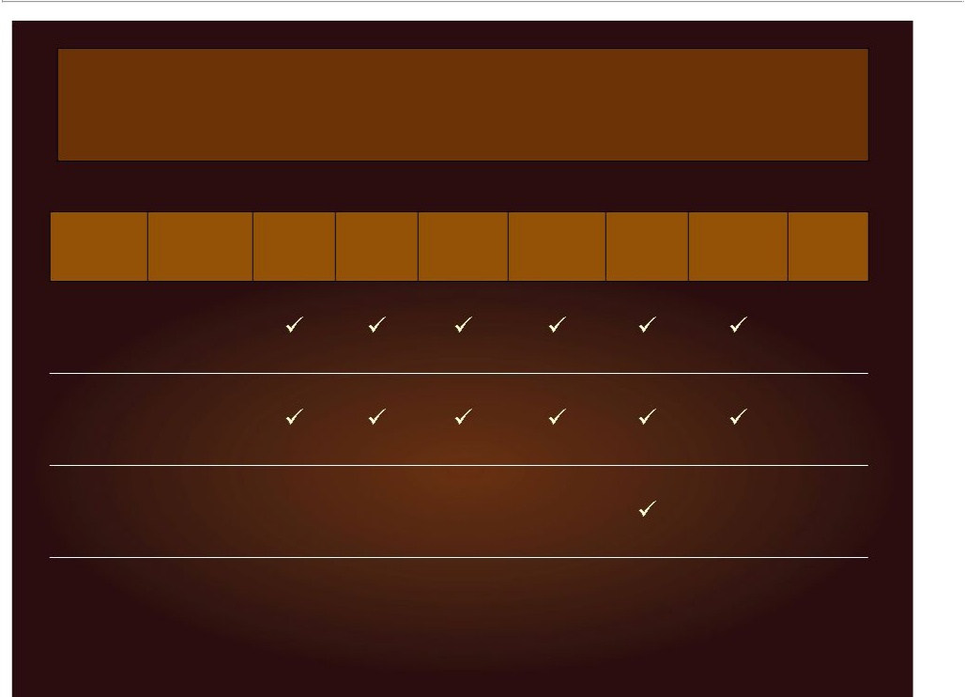
THE NOMINATING AND CORPORATE GOVERNANCE COMMITTEE SEEKS TO HAVE THE BOARD REPRESENT A DIVERSITY

OF BACKGROUNDS AND EXPERIENCE

 |  | Chairman | Financial & | International | Real Estate &
 | Board | Chairman | Capital | International | Land | Gaming
Director | Board | & CEO | Capital | Investment | Land | Gaming | Independence | Tenure
Director | Committees | & CEO | Markets | Investment | Development | Experience | Independence | Tenure
 | Committees | Experience | Markets | Experience | Development | Experience
 |  | Experience | Experience | Experience | Experience
John J. | Compensation
John J. | & Audit |  |  |  |  |  |  | 3 years
Hagenbuch* | & Audit |  |  |  |  |  |  | 3 years
Hagenbuch* | Committees
 | Compensation
J. Edward | & Nominating
J. Edward | and Corporate |  |  |  |  |  |  | 3 years
Virtue* | and Corporate |  |  |  |  |  |  | 3 years
Virtue* | Governance
 | Committees
Elaine P. |  |  |  |  |  |  |  | 13 years
Wynnx |  |  |  |  |  |  |  | 13 years

* Wynn Resorts’nominees x Elaine P. Wynn’s nominee

7


Security holders are advised to read the Wynn Resorts, Limited Definitive Proxy Statement and, as they become available, other documents related to the solicitation of proxies by Wynn Resorts, Limited for the 2015 Annual Meeting of Stockholders. For information on voting your WHITE PROXY CARD, please contact D.F. King & Co., Inc., toll-free at (877) 732-3619.

FORWARD LOOKING STATEMENTS

This presentation contains forward-looking statements regarding operating trends and future results of operations. Such forward-looking statements are subject to a number of risks and uncertainties that could cause actual results to differ materially from those we express in these forward-looking statements, including, but not limited to, our dependence on existing management, results of regulatory or enforcement actions and probity investigations, pending or future legal proceedings, uncertainties over the development and success of new gaming and resort properties, adverse tourism trends, general global macroeconomic conditions, changes in gaming laws or regulations, volatility and weakness in world-wide credit and financial markets, and our substantial indebtedness and leverage. Additional information concerning potential factors that could affect the Company’s financial results is included in the Company’s Annual Report on Form 10-K for the year ended December 31, 2014 and the Company’s other periodic reports filed with the Securities and Exchange Commission. The Company is under no obligation to (and expressly disclaims any such obligation to) update or revise its forward-looking statements as a result of new information, future events or otherwise.

8

