UNITED STATES
SECURITIES AND EXCHANGE COMMISSION
Washington, D.C. 20549

SCHEDULE 14A
Proxy Statement Pursuant to Section 14(a) of the
Securities Exchange Act of 1934

Filed by the Registrant ☒ Filed by a Party other than the Registrant ☐
Check the appropriate box:

☐ |  | Preliminary Proxy Statement
☐ |  | Confidential, For Use of the Commission Only (as permitted by Rule 14a-6(e)(2))
☐ |  | Definitive Proxy Statement
☒ |  | Definitive Additional Materials
☐ |  | Soliciting Material Pursuant to § 240.14a-12
WYNN RESORTS, LIMITED
(Name of Registrant as Specified in Its Charter)

(Name of Person(s) Filing Proxy Statement, if Other Than the Registrant)
Payment of Filing Fee (Check the appropriate box):
☒ |  | No fee required.
☐ |  | Fee computed on table below per Exchange Act Rules 14a-6(i)(1) and 0-11.
 |  | (1) |  | Title of each class of securities to which transaction applies:
 |  | (2) |  | Aggregate number of securities to which transaction applies:
 |  | (3) |  | Per unit price or other underlying value of transaction computed pursuant to Exchange Act Rule 0-11 (set forth the amount on which the filing fee is calculated and state how it was determined):
 |  | (4) |  | Proposed maximum aggregate value of transaction:
 |  | (5) |  | Total fee paid:
☐ |  | Fee paid previously with preliminary materials.
☐ |  | Check box if any part of the fee is offset as provided by Exchange Act Rule 0-11(a)(2) and identify the filing for which the offsetting fee was paid previously. Identify the previous filing by registration statement number, or the Form or Schedule and the date of its filing.
 |  | (1) |  | Amount previously paid:
 |  | (2) |  | Form, Schedule or Registration Statement No.:
 |  | (3) |  | Filing Party:
 |  | (4) |  | Date Filed:

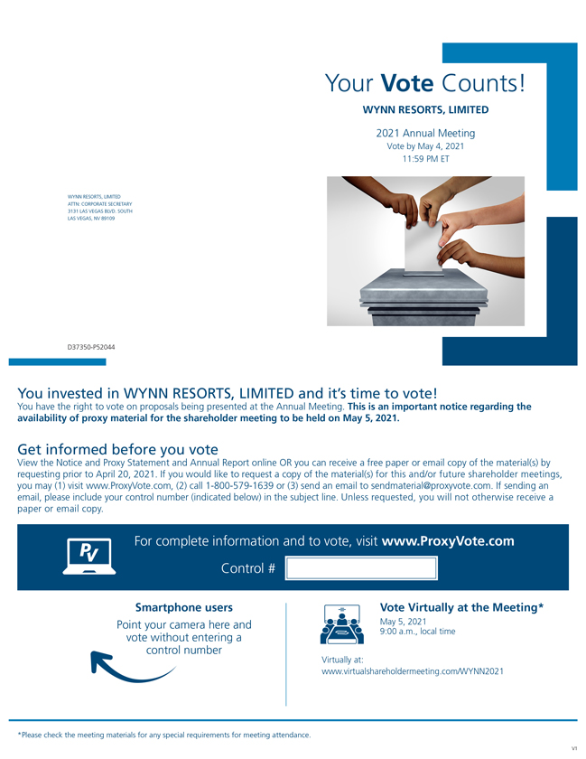
Youre Vote Counts! WYNN RESORTS, LIMITED 2021 Annual Meeting Vote by May 4, 2021 11:59 PM ET WYNN RESORTS, LIMITED ATTN: CORPORATE SECRETARY 3131 LAS VEGAS BLVD. SOUTH LAS VEGAS, NV 89109 D37350-P52044 You invested in WYNN RESORTS, LIMITED and its time to vote! You have the right to vote on proposals being presented at the Annual Meeting. This is an important notice regarding the availability of proxy material for the shareholder meeting to be held on May 5, 2021. Get informed before you vote View the Notice and Proxy Statement and Annual Report online OR you can receive a free paper or email copy of the material(s) by requesting prior to April 20, 2021. If you would like to request a copy of the material(s) for this and/or future shareholder meetings, you may (1) visit www.ProxyVote.com, (2) call 1-800-579-1639 or (3) send an email to sendmaterial@proxyvote.com. If sending an email, please include your control number (indicated below) in the subject line. Unless requested, you will not otherwise receive a paper or email copy. For complete information and to vote, visit www.ProxyVote.com Control # Smartphone users Vote Virtually at the Meeting* Point your camera here and May 5, 2021 9:00 a.m., local time vote without entering a control number Virtually at: www.virtualshareholdermeeting.com/WYNN2021 *Please check the meeting materials for any special requirements for meeting attendance. V1

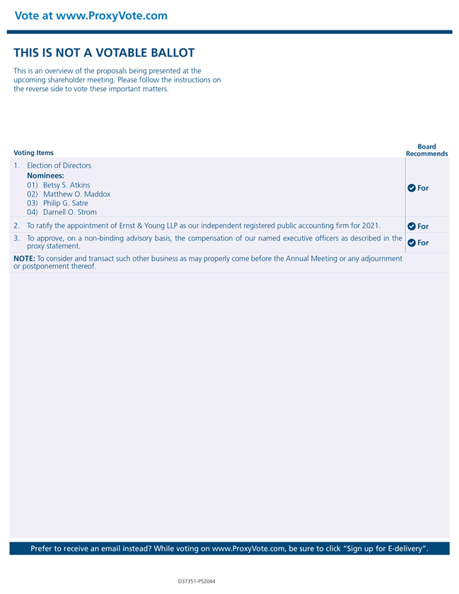
Vote at www.ProxyVote.com THIS IS NOT A VOTABLE BALLOT This is an overview of the proposals being presented at the upcoming shareholder meeting. Please follow the instructions on the reverse side to vote these important matters. Voting Items Board Recommends 1. Election of Directors Nominees: 01) Betsy S. Atkins For 02) Matthew O. Maddox 03) Philip G. Satre 04) Darnell O. Strom 2. To ratify the appointment of Ernst & Young LLP as our independent registered public accounting firm for 2021. For 3. To approve, on a non-binding advisory basis, the compensation of our named executive officers as described in the proxy statement. For NOTE: To consider and transact such other business as may properly come before the Annual Meeting or any adjournment or postponement thereof. Prefer to receive an email instead? While voting on www.ProxyVote.com, be sure to click Sign up for E-delivery.

