UNITED STATES

SECURITIES AND EXCHANGE COMMISSION
Washington, D.C. 20549

SCHEDULE 14A

Proxy Statement Pursuant to Section 14(a) of the

Securities Exchange Act of 1934

Filed by the Registrant ☒ Filed by a Party other than the Registrant ☐

Check the appropriate box:

- Preliminary Proxy Statement

- Confidential, For Use of the Commission Only (as permitted by Rule 14a-6(e)(2))

- Definitive Proxy Statement

- Definitive Additional Materials

- Soliciting Material under § 240.14a-12

WYNN RESORTS, LIMITED

(Name of Registrant as Specified in Its Charter)

(Name of Person(s) Filing Proxy Statement, if Other Than the Registrant)

Payment of Filing Fee (Check the appropriate box):

- No fee required.

- Fee paid previously with preliminary materials.

- Fee computed on table in exhibit required by Item 25(b) per Exchange Act Rules 14a-6(a)(I) and 0-11.

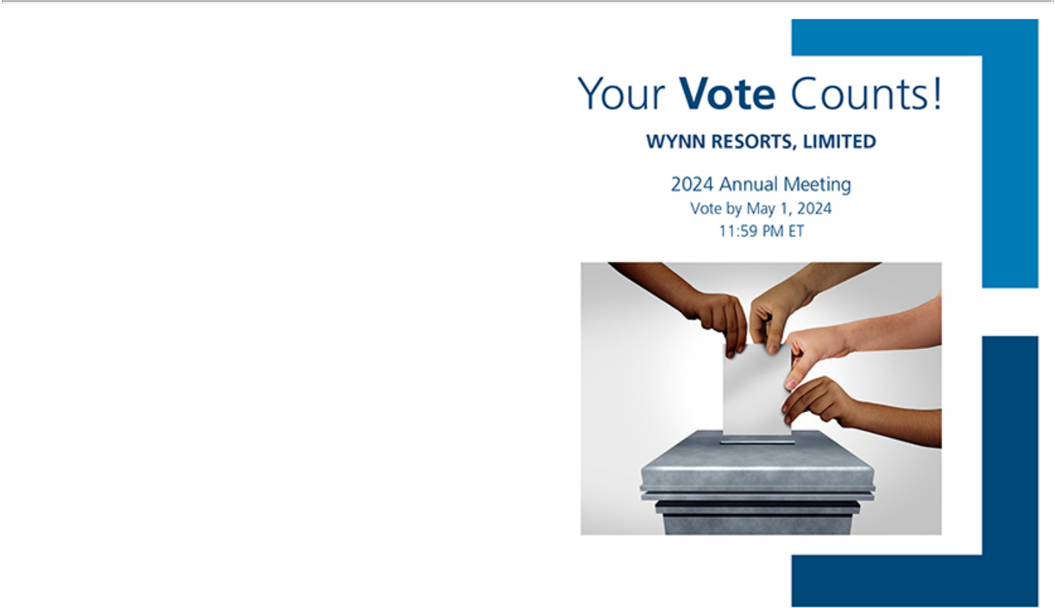

WYNN RESORTS, LIMITED

ATTN: CORPORATE SECRETARY

3131 LAS VEGAS BLVD. SOUTH

LAS VEGAS, NV 89109

V33261-P05197

You invested in WYNN RESORTS, LIMITED and it’s time to vote!

You have the right to vote on proposals being presented at the Annual Meeting. This is an important notice regarding the availability of proxy material for the shareholder meeting to be held on May 2, 2024.

Get informed before you vote

View the Notice and Proxy Statement and Annual Report online OR you can receive a free paper or email copy of the material(s) by requesting prior to April 18, 2024. If you would like to request a copy of the material(s) for this and/or future shareholder meetings, you may (1) visit www.ProxyVote.com, (2) call 1-800-579-1639 or (3) send an email to sendmaterial@proxyvote.com. If sending an email, please include your control number (indicated below) in the subject line. Unless requested, you will not otherwise receive a paper or email copy.


Smartphone users |  |  | Vote Virtually at the Meeting*
Point your camera here and |  |  | May 2, 2024
vote without entering a |  |  | 9:00 AM PDT
control number |  | Virtually at:
 |  | www.virtualshareholdermeeting.com/WYNN2024



*Please check the meeting materials for any special requirements for meeting attendance.

Vote at www.ProxyVote.com

THIS IS NOT A VOTABLE BALLOT

This is an overview of the proposals being presented at the upcoming shareholder meeting. Please follow the instructions on the reverse side to vote these important matters.

Voting Items
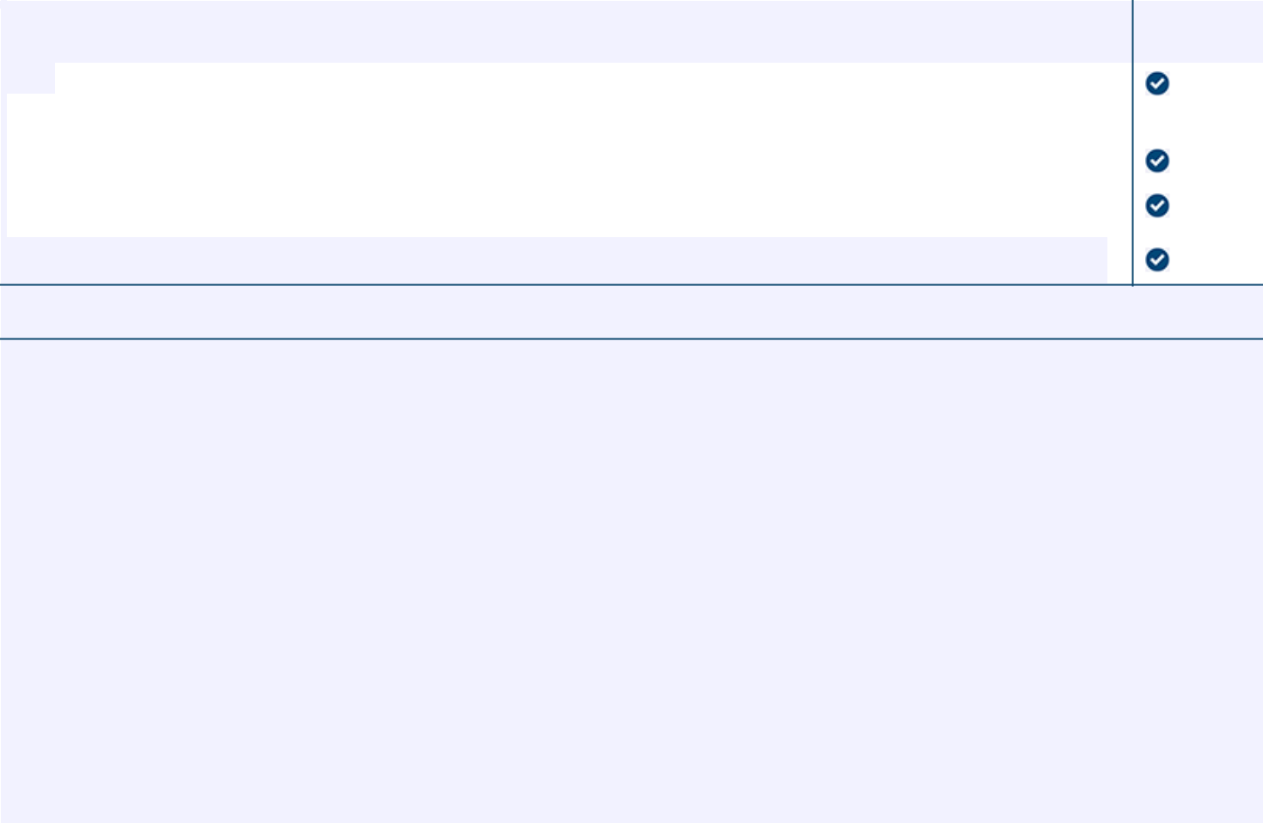

Board

Recommends

- Election of Directors

Nominees:

 |  | 01) Betsy S. Atkins |  | For
 |  | 02) Paul Liu
 |  | 03) Darnell O. Strom
 | 2. | To ratify the appointment of Ernst & Young LLP as our independent registered public accounting firm for 2024. |  | For
 | 3. | To approve, on a non-binding advisory basis, the compensation of our named executive officers as described in |  | For
 |  | the proxy statement. |  | For
 | 4. | To approve, an amendment to our 2014 Omnibus Incentive Plan to increase the authorized shares by |  | For
 |  | 2,000,000 shares. |  | For

NOTE: To consider and transact such other business as may properly come before the Annual Meeting or any adjournment or postponement thereof.

Prefer to receive an email instead? While voting on www.ProxyVote.com, be sure to click “Delivery Settings”.

V33262-P05197

